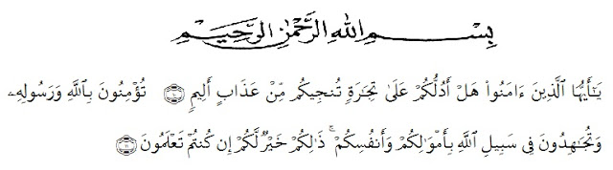
ACKNOWLEDGMENT

Artinya :
“Hai orang – orang beriman, maukah kamu aku tunjukan suatu perniagaan yang dapat menyelamatkanmu dari azab yang pedih?. Yaitu kamu beriman kepada Allah dan Rasul-Nya dan berjihad di jalan Allah dengan harta dan jiwamu. Itulah yang lebih baik bagimu, jika kamu mengetahui.”

In the name of Allah the beneficient the merciful
Praise be to the presence of Allah Subhnahu wa Ta’ala who has given grace and gifts as well as health so that the researcher can complete this thesis on time.Peace and blessing be upon Prophet Muhammad SAW, his families, his relatives,and all his followers.

In the proces of finishing this thesis, the writer has been given many supports and valuable knowledge from many people therefore, the researcher would like to express her great appreciation and thanks:
- KRT.Hardi Mulyono K. Surbakti as the Rector of Universitas Muslim Nusantara Al- Washliyah Medan.
- Drs. Samsul Bahri M.Si, as Dean of Teacher Training Faculty of Universitas Muslim Nusantara Al – Washliyah.
- Zulfitri, S.S, M.A, as Head of English Education Department of Universitas Muslim Nusantara Al- Washliyah.
- Nazriani Lubis, S.Pd, M.Hum, as Adviser who help and provided ideas and suggestions for the completion of this thesis.
- Dahlia Sirait, S.Pd, M.Hum and Azrai Harahap , as my examiner who have provided input and assistance during testing and given best value to my thesis.
- Mrs. Santaria Tarigan, SE, The Headmaster of Y.P SMK KARYA PEMBANGUNAN DELITUA, who has given permission the writer to conduct the research.
- Mr. Riski Ardi S.Pd, The English teacher who has helped me in carrying out research to compile this thesis.
- Her Beloved Parents, Parwati, S.Pd, M.Hum and Adil Arwanto who have given support and who always pray and everything for her live until the researcher can finish the study from the university.
- All her classmates who given helps during lectures for four years period in university.
- All her Best Friends, Thank you for the support and care.
- All her Foreigners Friends, Thank you so much fr support and motivation until the end of present day.

The words are not enough to express my gratitude for all their help in finishing this ‘Thesis’. The writer realized that this ‘thesis’ is far for being perfect. Therefore, it is pleasure for her to get critiques and suggestion to make this ‘thesis’ better.
Medan,30 June 2021
Researcher

Windy Ayu Paradila

