Appendix I
LESSON PLAN
School : SMA SWASTA BANDUNG
Grade/ Semester : XI/ I
Subject : English
Topic : Narrative Text
Time Allocation : 2 x 45 minutes/ meeting
- Core Competence
KI 1 Appreciate and practice the teachings of the religion adopted.

KI 2: Realizing and practicing honesty, discipline, responsibility, caring (farmers, cooperative behavior, tolerance, peace), polite, responsive, and proactiveand show attitude as part of problem solving in interactingeffectively with the social and natural environment and in placingourselves as a reflection of the nation in the association of the world.

KI 3: Understanding, applying, and analyzing factual, conceptual,procedural and metacognitive based on his curiosity about scienceinsightful knowledge, technology, arts, culture, and humanitieshumanity, nationality, state, and civilization related to the causes of phenomenaand events, as well as applying procedural knowledge in relevant fields of studyspecific according to their talents and interests to solve problems.

KI 4: Processing, reasoning, and presenting in the concrete and related abstract realmswith the development of what he learned in school independently, acteffective and creative and able to use methods according to the rulesScience.

- Basic Competence and indicator
No | Basic Competence | Indicator
1 | Show polite and caring attitude behavior in carrying out interpersonal communication with teachers and friends. | Shows courteous and caring attitude in doing the task of learning English.
2 | Demonstrate behavior responsibility, care, cooperation, and love of peace, incarry out functional Communication | Demonstrate honest, disciplined, and responsible attitude in doing the tasks of learning English.
3 | Distinguishing social functions, text structures, and linguistic elements of some narrative texts orally and in writing by providing information related to folk legend, simple, appropriate with the context of use | Demonstrate an active attitude of inquiring and arguing in discussions and presentations.  Identify social functions and linguistic elements in narrative text simple in the form of a folk legend, appropriate with the context of use  Identifying the meaning of the word or sentences in narrative text Identifying meaning related to function social and linguistic elements of narrative text short story/legend  Define a generic structure on narrative text
4 | capturing meaning contextually related to social functions, text structure, and elements of narrative text language, spoken and written simple related to folk legend | Answering questions based on the text they read. Present the information obtained in the text of the narrative text.

- Learning Objective
- Identify social functions and linguistic elements in simple narrative texts in the form of folk legends, according to the context of their use.
- Identify the meaning of narrative text
- Determine the generic structure of narrative text

IV. Learning Material
- Narrative Text Narrative text is a fictional text that aims to entertain the readers such as legends, myths, fairy tales, science fictions, roman novels and historical fiction. Generally, narrative text uses past tense to tell the story.
- Generic Structure of Narrative Text
- Orientation It contains the thesis of the text. In this level, the character of the story, introduce the students. In the story happened and who is involved on the story.
- Complication This part tells the sequence of the story. The problem faced by the character. The complication makes they story more interesting because the character is prevented to reach his or her wants. It is in the middle of the story.
- Resolution It tells the reader (students). How the problem was solved it also called solving problem. A satisfying narrative we well give the resolution of the problem.
- Re-orientation It tells what the story has told or tells again the character and contains the message of moral value to the readers
- Language Features of Narrative Text
- Using part action verb
- Using specific noun as pronoun of person, animal of the story
- Using adjectives which are for noun phrase
- Using time connectives and conjunctions to arrange the events
- Using dialogue to elicit an emotional response from the reader
- Using past tense
- Using of variety of simple, compound, and complex sentences.

Ali Baba and The Forty Thieves
Ali Baba was such a poor man that he had only had one shoe for his two feet. Even the mice in his house werehungry.
One day, his wife said, "We have no food in the house. No rice. No potatoes. Go and collect leaves in the forest so that I can make asoup."
Ali was a lazy man. He looked for leaves for about ten minutes and then he climbed a tree to sleep. He was afraid of wolves. When he woke up, he was surprised to see forty thieves on forty horses. They stopped in front of a big rock.
"Open Sesame!" shouted the leader. A door on the rock opened. The thieves carried sacks full of gold into the cave. When they had finished, the leader shouted.
"Close Sesame!" and the door closed. As soon as the thieves had disappeared Ali Baba jumped down from the tree, said, "Open Sesame" and went into thecave.
There were shelves all around the walls. The shelves were full of sacks. And the sacks were full of gold. Ali took a sack home with him. Unfortunately, one of the thieves saw Ali's footprints on the sand. He followed them to Ali's home. He took out his knife and made a cross on the door.
"Now I shall know which house it is," he said. He rode off to get the other thieves. But Ali had seen the thief. He and his wife took brooms and swept away the footprints. Then he made crosses on every door at the street. When the forty thieves arrived they had their knives between their teeth. But they couldn't find either Ali or the gold. And Ali and his wife lived happily ever after.

- Teaching Method
Genre Based Approach

- Media, Tools and Learning Resource
- Media : Test sheets, mobile phone
- Tools : Marker, Whiteboard, Mobile Phone
- Learning Resource : a. Text : in wattpad Application

- Learning Activity
No | Learning Activity |  | Time Allocation
 | Teacher’s Activity | Students’ Activity
1 | Preliminary  Orientation  - The teacher starts the learning by greeting, prayer and checking student attendance.  - The teacher focuses the student's attention on the material to be learned.  Apperception  The teacher gives the students an early perception of the material that will be taught  Motivation  - The teacher provides an overview of the benefits of learning the material to be taught  - The teacher provides encouragement or motivation that can arouse learners' learning interests.  Reference  - Teacher gives science study to be studied.  - Teacher explains the subject matter and description of the subject matter in outline  - Teacher explains the method of learning  - Teacher explains the mechanism of implementation of the learning experience (in accordance with the plan of learning steps)  - Teacher delivers KD and learning objectives | - Students respond to the teacher to greeting and pray  - Students focus their attention on the material that will be taught.  - Students listen and pay attention to the teacher about the material perception that will be taught.  - Students listen and prepare the material that will be taught.  - -Students have the spirit and motivation to learn about the material that will be taught.  - Students record the study of science that will be taught.  - Students listen and record teacher explanations.  - Students discuss the method to be used.  - Students follow the teacher's instructions.  - Students record it and understand it | 10 Minutes
2 | Core Activity  Phase 1  - Teacher introduces the students about Wattpad application, how to use, and the advantage and disadvantage of the application.  - Teacher explains Narrative text to the students  - Teachers gives an example of Narrative text by using the Wattpad application  - Teacher explains the generic structure and language feature of narrative text  - Teacher asks students to find out the generic structure and language feature in the text given.  Phase 2  - The teacher makes a group for students; one group consists of 2 people.  - Teacher gives the students a text of narrative text.  Phase 3  - The teacher asks the students to read carefully the text and answer the questions given by the teacher  Phase 4  - The teacher monitors the students when they are doing their tasks. | - Students pay attention to the teacher‟s explanation  - Students pay attention to the teacher  - Students pay attention to the teacher and ask questions related to the generic structure and language feature  - Students find out the generic structure and language feature of Narrative text given by the teacher  - Students make a group.  - Students accept the topic that is given  - Studentsread the text to find the answer  - Students write their answers on the paper. | 30 minutes  5minutes  10 minutes  20 minutes
2. | Closing  - The teacher collects the students‟ work  - Teacher asks the students to make a summary based on the investigation they have made  - Teacher together learners do prayers - The teacher closes the lesson to say goodbye | - Students collect their work to the teacher  - Students make a summary based on the investigation they have made  - Students pray together  - Students say goodbye

- Appraisal
Assesment Technique : Reading Comprehension Text Form
Instrument : Reading a text about reading comprehension achievement trough Wattpad media

 |  | Bandar setia, 17 juli 2021
English Teacher |  | Researcher
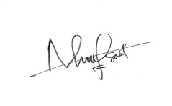 |  | 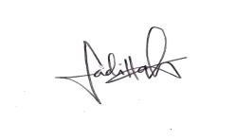
Nurhalimah, S.Pd |  | SEPTIANI FADILLAH

Bandar setia, 17 juli 2021
Head Master of SMA SWASTA BANDUNG
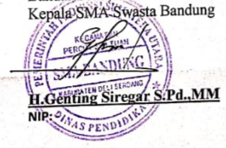

Appendix II
LESSON PLAN
School : SMA SWASTA BANDUNG
Grade/ Semester : XI/ I
Subject : English
Topic : Narrative Text
Time Allocation : 2 x 45 minutes/ meeting
- Core Competence
KI 1: Living and practicing religious teachings which are embraced.

KI 2: Realizing and practicing honest, disciplined, responsible, caring (pleasant,cooperative, tolerant, peaceful) behavior, polite, responsive and pro-activeand showing attitude as part of the solution to problems in interactingeffectively with the social and natural environment and in placingourselves as a reflection of the nation in the association of the world.

KI 3: Understanding, applying, analyzing factual, conceptual, proceduralknowledge-based on his knowledge of science, technology, art, culture,and humanities with the insights into humanity, nationality, state andcivilization on the causes of phenomena and events, and applyingprocedural knowledge to the field of study specified in accordance with histalents and interests to solve problems.

K1 4: Processing, reasoning, and chanting in the realm of concrete and abstractspheres are related to the development of self-study in schools
independently, and capable of using methods according to scientific rules.

- Basic Competence and indicator
No | Basic Competence | Indicator
1 | Show polite and caring attitude behavior in carrying out interpersonal communication with teachers and friends. | Shows courteous and caring attitude in doing the task of learning English.
2 | Demonstrate behavior responsibility, care, cooperation, and love of peace, incarry out functional Communication | Demonstrate honest, disciplined, and responsible attitude in doing the tasks of learning English.
3 | Distinguishing social functions, text structures, and linguistic elements of some narrative texts orally and in writing by providing information related to folk legend, simple, appropriate with the context of use | Demonstrate an active attitude of inquiring and arguing in discussions and presentations.  Identify social functions and linguistic elements in narrative text simple in the form of a folk legend, appropriate with the context of use  Identifying the meaning of the word or sentences in narrative text Identifying meaning related to function social and linguistic elements of narrative text short story/legend  Define a generic structure on narrative text
4 | Capturingmeaning contextually related to social functions, text structure, and elements of narrative text language, spoken and written simple related to folk legend | Answering questions based on the text they read. Present the information obtained in the text of the narrative text.

- Learning Objective
- Identify social functions and linguistic elements in simple narrative texts in the form of folk legends, according to the context of their use.
- Identify the meaning of narrative text
- Determine the generic structure of narrative text

IV. Learning Material
- Narrative Text Narrative text is a fictional text that aims to entertain the readers such as legends, myths, fairy tales, science fictions, roman novels and historical fiction. Generally, narrative text uses past tense to tell the story.
- Generic Structure of Narrative Text
- Orientation It contains the thesis of the text. In this level, the character of the story, introduce the students. In the story happened and who is involved on the story.
- Complication This part tells the sequence of the story. The problem faced by the character. The complication makes they story more interesting because the character is prevented to reach his or her wants. It is in the middle of the story.
- Resolution It tells the reader (students). How the problem was solved it also called solving problem. A satisfying narrative we well give the resolution of the problem.
- Re-orientation It tells what the story has told or tells again the character and contains the message of moral value to the readers
- Language Features of Narrative Text
- Using part action verb
- Using specific noun as pronoun of person, animal of the story
- Using adjectives which are for noun phrase
- Using time connectives and conjunctions to arrange the events
- Using dialogue to elicit an emotional response from the reader
- Using past tense
- Using of variety of simple, compound, and complex sentences.

Ali Baba and The Forty Thieves

Ali Baba was such a poor man that he had only had one shoe for his two feet. Even the mice in his house werehungry.
One day, his wife said, "We have no food in the house. No rice. No potatoes. Go and collect leaves in the forest so that I can make asoup."
Ali was a lazy man. He looked for leaves for about ten minutes and then he climbed a tree to sleep. He was afraid of wolves. When he woke up, he was surprised to see forty thieves on forty horses. They stopped in front of a big rock.
"Open Sesame!" shouted the leader. A door on the rock opened. The thieves carried sacks full of gold into the cave. When they had finished, the leader shouted.
"Close Sesame!" and the door closed. As soon as the thieves had disappeared Ali Baba jumped down from the tree, said, "Open Sesame" and went into thecave.
There were shelves all around the walls. The shelves were full of sacks. And the sacks were full of gold. Ali took a sack home with him. Unfortunately, one of the thieves saw Ali's footprints on the sand. He followed them to Ali's home. He took out his knife and made a cross on the door.
"Now I shall know which house it is," he said. He rode off to get the other thieves. But Ali had seen the thief. He and his wife took brooms and swept away the footprints. Then he made crosses on every door at the street. When the forty thieves arrived they had their knives between their teeth. But they couldn't find either Ali or the gold. And Ali and his wife lived happily ever after.

- Teaching Method
Genre Based Approach

- Media, Tools and Learning Resource
- Media : Test sheets, mobile phone
- Tools : Marker, Whiteboard, Mobile Phone
- Learning Resource : a. Text : in wattpad Application

- Learning Activity
No | Learning Activity |  | Time Allocation
 | Teacher’s Activity | Students’ Activity
1 | Preliminary  Orientation  - The teacher starts the learning by greeting, prayer and checking student attendance.  - The teacher focuses the student's attention on the material to be learned.  Apperception  The teacher gives the students an early perception of the material that will be taught  Motivation  - The teacher provides an overview of the benefits of learning the material to be taught  - The teacher provides encouragement or motivation that can arouse learners' learning interests.  Reference  - Teacher gives science study to be studied.  - Teacher explains the subject matter and description of the subject matter in outline  - Teacher explains the method of learning  - Teacher explains the mechanism of implementation of the learning experience (in accordance with the plan of learning steps)  - Teacher delivers KD and learning objectives | - Students respond to the teacher to greeting and pray  - Students focus their attention on the material that will be taught.  - Students listen and pay attention to the teacher about the material perception that will be taught.  - Students listen and prepare the material that will be taught.  - -Students have the spirit and motivation to learn about the material that will be taught.  - Students record the study of science that will be taught.  - Students listen and record teacher explanations.  - Students discuss the method to be used.  - Students follow the teacher's instructions.  - Students record it and understand it | 10 Minutes
2 | Core Activity  Phase 1  - Teacher introduces the students about Wattpad application, how to use, and the advantage and disadvantage of the application.  - Teacher explains Narrative text to the students  - Teachers gives an example of Narrative text by using the Wattpad application  - Teacher explains the generic structure and language feature of narrative text  - Teacher asks students to find out the generic structure and language feature in the text given.  Phase 2  - The teacher makes a group for students, one group consists of 2 people.  - Teacher gives the students a text of narrative text.  Phase 3  - The teacher asks the students to read carefully the text and answer the questions given by the teacher  Phase 4  - The teacher monitors the students when they are doing their tasks. | - Students pay attention to the teacher’s explanation  - Students pay attention to the teacher  - Students pay attention to the teacher and ask questions related to the generic structure and language feature  - Students find out the generic structure and language feature of Narrative text given by the teacher  - Students make a group.  - Students accept the topic that is given  - Studentsread the text to find theanswer  - Students write their answers on the paper. | 30 minutes  5minutes  10 minutes  20 minutes
2. | Closing  - The teacher collects the students‟ work  - Teacher asks the students to make a summary based on the investigation they have made  - Teacher together learners do prayers  - The teacher closes the lesson to say goodbye | - Students collect their work to the teacher  - Students make a summary based on the investigation they have made  - Students pray together  - Students say goodbye

- Appraisal
Assesment Technique : Reading Comprehension Text Form
Instrument : Reading a text about reading comprehension achievement trough Wattpad media

 |  | Bandar setia, 17 juli 2021
English Teacher |  | Researcher
Nurhalimah, S.Pd |  | SEPTIANI FADILLAH

Bandar setia, 17 juli 2021
Head Master of SMA SWASTA BANDUNG

Appendix III

INSTRUMENTS OF RESEARCH (PRE-TEST,CYCLE 1)
ALI BABA AND THE FORTY THIEVES
Ali Baba was such a poor man that he had only had one shoe for his two feet. Even the mice in his house werehungry.
One day, his wife said, "We have no food in the house. No rice. No potatoes. Go and collect leaves in the forest so that I can make asoup."
Ali was a lazy man. He looked for leaves for about ten minutes and then he climbed a tree to sleep. He was afraid of wolves. When he woke up, he was surprised to see forty thieves on forty horses. They stopped in front of a big rock.
"Open Sesame!" shouted the leader. A door on the rock opened. The thieves carried sacks full of gold into the cave. When they had finished, the leader shouted.
"Close Sesame!" and the door closed. As soon as the thieves had disappeared Ali Baba jumped down from the tree, said, "Open Sesame" and went into thecave.
There were shelves all around the walls. The shelves were full of sacks. And the sacks were full of gold. Ali took a sack home with him. Unfortunately, one of the thieves saw Ali's footprints on the sand. He followed them to Ali's home. He took out his knife and made a cross on the door.
"Now I shall know which house it is," he said. He rode off to get the other thieves. But Ali had seen the thief. He and his wife took brooms and swept away the footprints. Then he made crosses on every door at the street. When the forty thieves arrived they had their knives between their teeth. But they couldn't find either Ali or the gold. And Ali and his wife lived happily ever after.

Read the following text and answer the questions:
- Who is the main character of the story?
- Ali babe’s wife
- Ali baba
- The forty thieves
- Ali baba and the forty thieves
- Where did Ali Baba found thegold?
- In the forest
- Ali baba’shome
- In the cave
- In thetree
- Ali baba was such a poorman
The synonym of the underlined word is?
- Miserable
- Rich
- Good
- Bad
- How did ali and the forty thieves can opened the door on therock?
- The leader of forty thieves had thekey
- By kick thedoor
- By shouted (OpenSesame!)
- Opened the door with theknife
- Which paragraph had shown that ali found the gold?
- 6
- 1
- 7
- 5
- When did Ali’s wifesaid “we have no food in thehouse?”
- In themorning
- One sunnymorning
- Yesterday
- Oneday
- Why did ali baba and his wife swept away ali‟sfootprint?
- Because oneofthethievessawAli’sfootprintswhenhetookthegold
- They want to clean thesand
- The thieves asked them to dothat
- It can made them know Ali’shomehe rode off to get the otherthieves”
- The underlined word on the seventh paragraph refers to....
- Ali baba
- Thethieve
- Ali baba’swife
- Wolves
- What can we learn from thestory?
- Don’t be athieves
- We should be a lazy man if we want to live happily like AliBaba
- Don’t be a lazyman
- We should not be a greedy person in ourlife
- What is the main idea of thetext?
- Ali baba and the fortythieves
- Ali baba is a lazyman
- Ali baba was once a poor man who found gold and had people trying to kill him
- The forty thieves had a gold
- Where did the story happen?
- Forest
- Baghdad
- Cave
- House
- What is the means of living of Ali Baba ?
- Hunter
- Farmer
- Thieve
- Wood cutter
- When Ali Baba was in the forest, what was he discovered?
- Soldier
- Lovely girl
- Troop of thieved on horseback
- Money
- In Ali Baba and the fourty thieves, How did the fourty thieves get into their secret cave?
- They used a key
- They used a hammer
- They used a password
- They used a tunnel
- What is their secret code in opening the cave?
- Open barley
- Open treasure
- Open cave
- Open sesame
- What is found inside the cave?
- Treasure
- Money
- People
- Animals
- When the fourty thieves left the cave, what did ali baba do?
- He ignored what happen
- He attempted to open the cave
- He continued his work
- Scared
- What does a thief do to close the door?
- open sesame
- closed sesame
- abracadabra
- Please come in
- What did his wife tell his wife to look for in the forest?
- Looking for leaves to make soup
- Looking for a thief
- Looking for a big cave
- Sleeping on the tree
- What sneaky thing did Ali do to trick the thief?
- Make a cross mark in every house so that thieves don't find it
- disappeared without a trace
- kill thief with knife
- d. makes thieves can't meet him because he lives in the forest
INSTRUMENTS OF RESEARCH (CYCLE 2)

Why Does the Cock Eat the Millipede?
Long ago the cock had a pair of beautiful horns on his head. But at that time there was a dragon who was prevented from ascending into heaven because he lacked a pair of horns. And so he offered the millipede as a guarantor, and borrowed the horns from the cock!
When the millipede came for the horns, he said to the cock: "When you want your horns back, you must call out at dawn: 'Give me back my horns!' and they will be returned to you at once. You need have no occasion to be concerned in theleast."
The kind cock knew how difficult it was to ascend to heaven, so, reassured by the good security the millipede offered, he loaned his horns without hesitation, just twisting them right off his head. He also thought to himself that when the dragon returned from his visit to heaven, they could sit down and have a good conversation; he would ask the dragon to tell him how things were in heaven, and if it really was beautiful there, as he had always heard. If it was true, he might consider going there himself someday, he thought.
So, next morning at daybreak (for the dragon's visit was scheduled to be brief), the cock called out loudly: "Give me back my horns!" But, even though he repeated this demand ten times over, there was no sign at all of either the dragon or the horns. Worried, the cock promptly went off to complain to the millipede, who soothed him, saying: "If the dragon has not returned the horns this morning, then he will certainly do so tomorrow. At the very latest, the day after that. Just learn to be a little patient and your horns will soon be back on your head, just as before."
The cock did wait several days, but although he called out every morning at sunrise: "Give me back my horns!" They never did reappear. The cock was extremely annoyed at this deception and loss, as you can well imagine, therefore he ordered all the members of his family to eat millipedes on sight.
Even so, the cock has not yet given up hope of getting his horns returned. He ordered his descendants always to call out at the break of day: "Give me back my horns!" He still hopes that the dragon may hearhim!

Read the following text and answer the questions:
- When did this storyhappened?
- Longago
- Today
- One yearsago
- Two yearsago
- Why didn‟t the cock have horn on hishead?
- Because the dragon was borrowed the horns of thecock
- Because the millipede want the cock‟shorns
- The cock didn‟t like hishorns
- The millipede was stole it from thecock
- Where did the dragon want togo?
- Into the cave
- Into the cloud
- Into thehell
- Intoheaven
- Who was offered as a guarantor by thedragon?
- Thecock
- Thedragon
- Themillipede
- The millipede‟shorns
- Which paragraph shows that the cock knew he had been lied by themillipede?
- 6
- 3
- 5
- 1
- How did the cock get his revenge to themillipede?
- He eat themillipedes
- He took the millipede‟shorns
- He stepped on themillipedes
- He didn‟t do anyrevenge
- What should the cock call out if he wants the hornsback?
- Please! I want my hornsback
- My horns, please back tome!
- Give me my hornsback!
- What should I do to get my hornsback!
- Did the cock stop hoping to get his hornsback?
- Yes, hedid
- Hedidn‟tcareanymore
- Hedidn‟tthinkaboutit
- No, he didn‟t stophoping
- “The kind cock knew how difficult to ascend to heaven” The synonym of the underlined word is...
- Easy
- Hard
- Heavy
- Serious
- What is the main idea of thetext?
- The dragon borrow the cock‟shorns
- The cock lost his horns because the millipede deceived him by saying that the dragon will return back hishorns
- Why does the cock eat themillipede?
- The dragon offered the millipede as aguarantor
- What is the reason why dragons can't ascend to heaven...?
- Have No Wings
- Is Sick
- Have No Horns
- It's Late
- Who has the horn that can make the dragon rise heaven.....?
- The millipede
- The chicken
- The rhino
- The deer
- How do dragons get what they want...?
- Ask the guardian of heaven for help
- Ordered the millipede
- Waiting for a miracle
- Look at the sky
- What did the millipede say to the rooster to get his horns back
- "When you want your horns back, you must shout at dawn: 'Give me back my horns!'
- "Summoning the millipede!"
- "Waiting for rain"
- "Sleeping in the cage"
- What happens tomorrow after the rooster screams?
- The sound of the rooster has disappeared
- He forgot what the millipede said
- The rooster enters the house again
- The dragon never came
- Why do chickens order their families to eat millipedes?
- Because the rooster lost its horn
- Because millipedes love it
- Chicken can't eat other than millipede
- When dawn comes the chicken has to eat a thousand feet
- Why do dragons borrow horns from chickens?
- To go to hell
- So you can go to heaven
- So that the dragon can go far away
- So that chickens don't eat millipedes
- Why does the millipede command the chicken to scream at dawn?
- So he can see the dragon
- So that the chicken can tell the dragon
- So that the chicken can get its horn back
- So that the chicken can fool the dragon
- Who is the bad guy in the story?
- chicken
- dragon snake
- Dragon
- Centipede
- What is the reason the rooster lent his horn to the dragon?
- because he knows that to ascend to heaven is not easy and he without hesitation to lend it
- for the millipede to believe that he is a kind cock
- so that the dragon can meet him in heaven later
- so that the chicken can see the dragon happy

Appendix IV
THE STUDENT’S ANSWER SHEET PRE-TEST
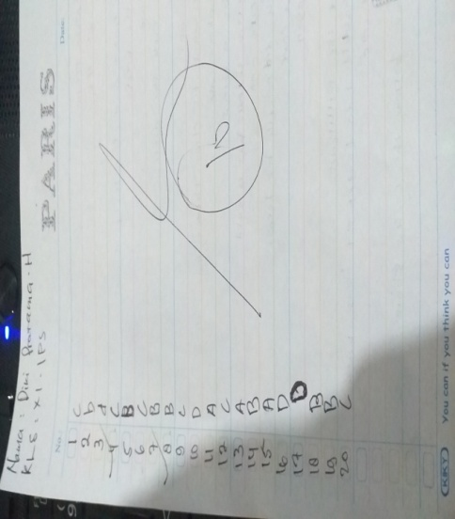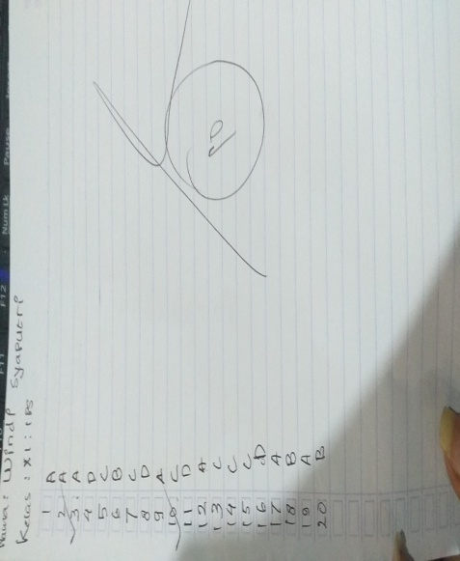
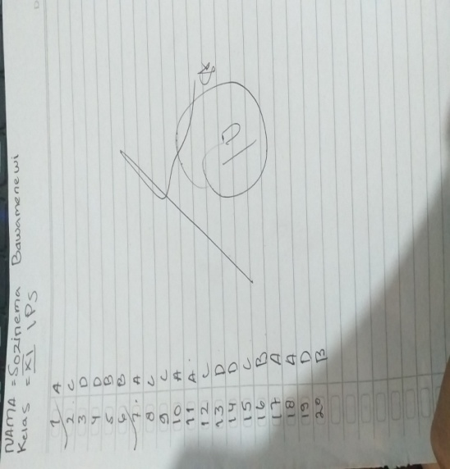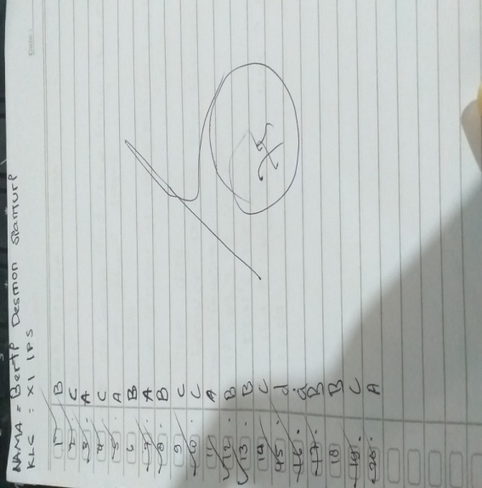
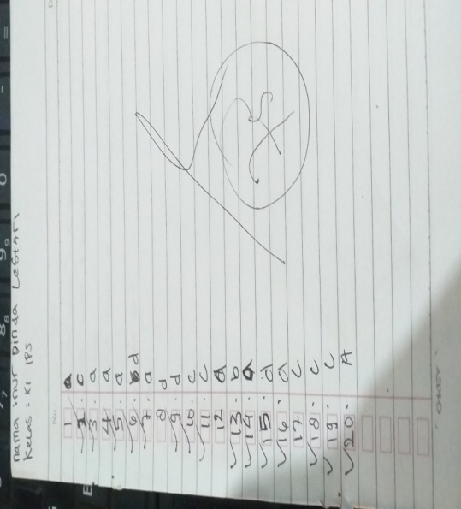
THE STUDENT’S ANSWER SHEET POST TEST 1 (CYCLE 1)75

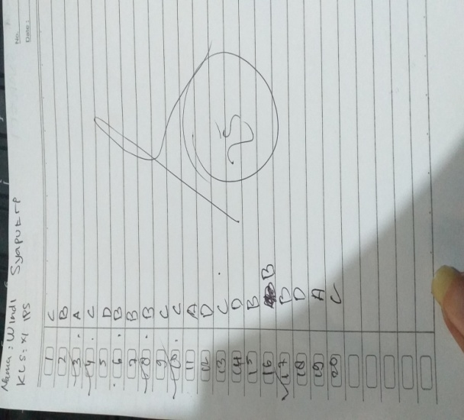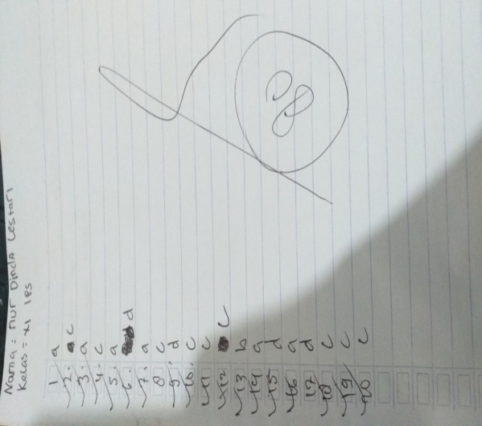

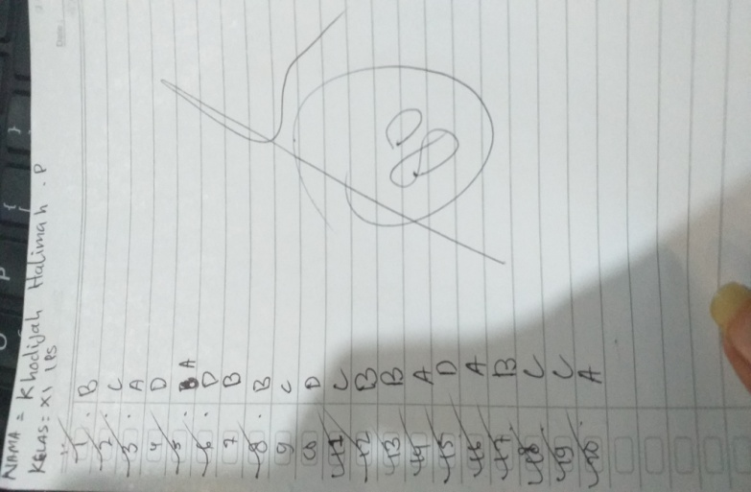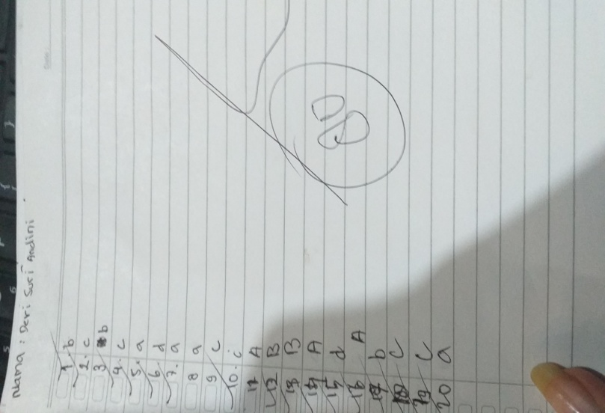

THE STUDENT’S ANSWER SHEET POST TEST 2 (CYCLE 2)76

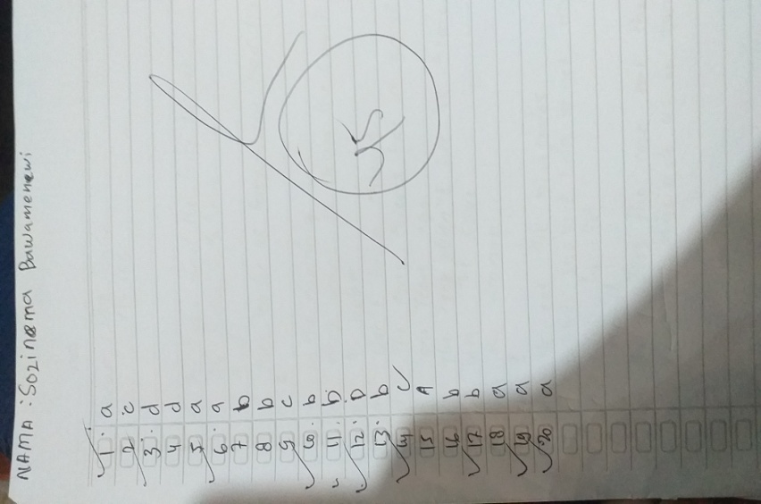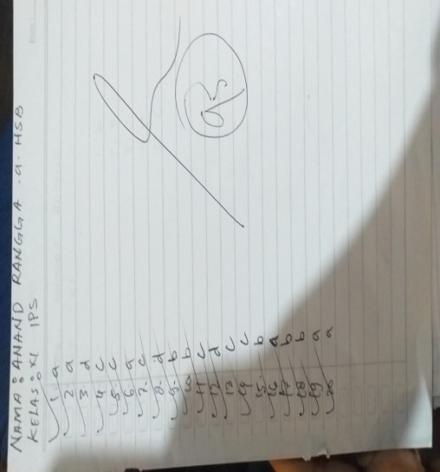
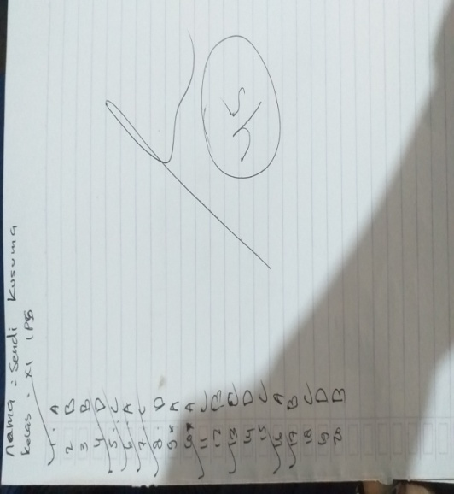

Appendix V
List of Student’s Initial Name

School : SMA Swasta Bandung
Year : 2020-2021
Class : XI IPS

No. | Student’s name | Student’s Initial Name
1 | AnandaRangga a Hsb | AR
2 | BertiDesmonSianturi | BDS
3 | CikeNania | CN
4 | Devi suriAndini | DSA
5 | Dea Amelia | DA
6 | DimanPrasetyo | DP
7 | DikiPratama H. | DPH
8 | EkaHdRisuya | HER
9 | FauzanNurKhalifah | FNK
10 | Jessica | J
11 | Kevin Hidayat S. | KHS
12 | Kartika | K
13 | Khilojahhalimah P. | KHP
14 | lastiurSianturi | LS
15 | Muhammad Rafikus S. | MR
16 | M. Farhan al-Hafizh | MFH
17 | Nazwa Nabila | NN
18 | NurDinda Lestari | NDL
19 | RahmadFebriansyah | RF
20 | RanggaPermana P. | RP
21 | RiekkySyahputra | RS
22 | Riska Gita S. | RGS
23 | RiskaAprilia | RA
24 | RiskiNaylaPutri | RNP
25 | SilvimayuniLubis | SML
26 | SozinemaBawamenewi | SB
27 | SendiKusuma | SK
28 | WindaAdelia | WA
29 | WindiSyaputri | WS
30 | Yeni Lestari | YL

Appendix VI

Student’s Observation Sheet in Teaching Learning Activity by Applying Wattpad Media (Cycle 1)

No. | Name | Class | Student's Activities
 |  |  | Interest | Attention | Participation
1 | AnandaRangga a Hsb | 11 IPS 1 | 2 | 3 | 3
2 | BertiDesmonSianturi | 11 IPS 1 | 3 | 3 | 4
3 | CikeNania | 11 IPS 1 | 2 | 4 | 4
4 | Devi suriAndini | 11 IPS 1 | 2 | 3 | 4
5 | Dea Amelia | 11 IPS 1 | 3 | 4 | 4
6 | DimanPrasetyo | 11 IPS 1 | 2 | 3 | 4
7 | DikiPratama H. | 11 IPS 1 | 2 | 4 | 3
8 | EkaHdRisuya | 11 IPS 1 | 2 | 4 | 3
9 | FauzanNurKhalifah | 11 IPS 1 | 2 | 4 | 3
10 | Jessica | 11 IPS 1 | 2 | 4 | 3
11 | Kevin Hidayat S. | 11 IPS 1 | 2 | 4 | 3
12 | Kartika | 11 IPS 1 | 2 | 4 | 3
13 | Khilojahhalimah P. | 11 IPS 1 | 2 | 4 | 2
14 | lastiurSianturi | 11 IPS 1 | 2 | 4 | 2
15 | Muhammad Rafikus S. | 11 IPS 1 | 2 | 3 | 2
16 | M. Farhan al-Hafizh | 11 IPS 1 | 2 | 2 | 4
17 | Nazwa Nabila | 11 IPS 1 | 3 | 2 | 4
18 | NurDinda Lestari | 11 IPS 1 | 3 | 3 | 3
19 | RahmadFebriansyah | 11 IPS 1 | 2 | 3 | 3
20 | RanggaPermana P. | 11 IPS 1 | 3 | 3 | 3
21 | RiekkySyahputra | 11 IPS 1 | 3 | 2 | 3
22 | Riska Gita S. | 11 IPS 1 | 2 | 2 | 4
23 | RiskaAprilia | 11 IPS 1 | 2 | 2 | 3
24 | RiskiNaylaPutri | 11 IPS 1 | 2 | 2 | 4
25 | SilvimayuniLubis | 11 IPS 1 | 3 | 2 | 3
26 | SozinemaBawamenewi | 11 IPS 1 | 3 | 3 | 3
27 | SendiKusuma | 11 IPS 1 | 2 | 4 | 4
28 | WindaAdelia | 11 IPS 1 | 2 | 2 | 3
29 | WindiSyaputri | 11 IPS 1 | 2 | 2 | 4
30 | Yeni Lestari | 11 IPS 1 | 2 | 4 | 3
Total Score |  |  | 68 | 93 | 98
Percentage |  |  | 56.67% | 77.50% | 81.67%
Mean |  |  | 64.75%
Criteria |  |  | Active

Appendix VII

Student’s Observation Sheet in Teaching Learning Activity by Applying Herringbone Technique
(Cycle 2)
no. | Name | Class | Student's Activities
 |  |  | Interest | Attention | Participation
1 | AnandaRangga a Hsb | 11 IPS 1 | 2 | 3 | 3
2 | BertiDesmonSianturi | 11 IPS 1 | 3 | 3 | 4
3 | CikeNania | 11 IPS 1 | 4 | 4 | 4
4 | Devi suriAndini | 11 IPS 1 | 4 | 3 | 4
5 | Dea Amelia | 11 IPS 1 | 4 | 4 | 4
6 | DimanPrasetyo | 11 IPS 1 | 4 | 3 | 4
7 | DikiPratama H. | 11 IPS 1 | 4 | 4 | 3
8 | EkaHdRisuya | 11 IPS 1 | 3 | 4 | 3
9 | FauzanNurKhalifah | 11 IPS 1 | 3 | 4 | 3
10 | Jessica | 11 IPS 1 | 3 | 4 | 3
11 | Kevin Hidayat S. | 11 IPS 1 | 4 | 4 | 3
12 | Kartika | 11 IPS 1 | 4 | 4 | 4
13 | Khilojahhalimah P. | 11 IPS 1 | 4 | 4 | 4
14 | lastiurSianturi | 11 IPS 1 | 4 | 4 | 2
15 | Muhammad Rafikus S. | 11 IPS 1 | 4 | 3 | 2
16 | M. Farhan al-Hafizh | 11 IPS 1 | 2 | 3 | 2
17 | Nazwa Nabila | 11 IPS 1 | 3 | 4 | 2
18 | NurDinda Lestari | 11 IPS 1 | 3 | 2 | 4
19 | RahmadFebriansyah | 11 IPS 1 | 4 | 2 | 3
20 | RanggaPermana P. | 11 IPS 1 | 4 | 2 | 3
21 | RiekkySyahputra | 11 IPS 1 | 4 | 4 | 3
22 | Riska Gita S. | 11 IPS 1 | 4 | 2 | 4
23 | RiskaAprilia | 11 IPS 1 | 2 | 3 | 3
24 | RiskiNaylaPutri | 11 IPS 1 | 2 | 4 | 4
25 | SilvimayuniLubis | 11 IPS 1 | 3 | 2 | 3
26 | SozinemaBawamenewi | 11 IPS 1 | 3 | 3 | 3
27 | SendiKusuma | 11 IPS 1 | 2 | 4 | 4
28 | WindaAdelia | 11 IPS 1 | 2 | 2 | 3
29 | WindiSyaputri | 11 IPS 1 | 2 | 2 | 4
30 | Yeni Lestari | 11 IPS 1 | 2 | 4 | 3
Total Score |  |  | 96 | 98 | 98
Percentage |  |  | 80.00% | 81.67% | 81.67%
Mean |  |  | 73.00%
Criteria |  |  | Active

Rating Conversion
Value range | Categories
81-100 | Very active
61-80 | active
41-60 | enough
21-40 | less
0-20 | passive

Score Descriptions
4 | very good
3 | Good
2 | Enough
1 | Less

Appendix VIII

The Student’s Score in Pre-Test, Cycle 1, and Cycle 2
No | The Student's Initial | Pre-Test |  | Cycle 1 | Cycle 2
1 | AnandaRangga a Hsb | 25 |  | 40 | 95
2 | BertiDesmonSianturi | 75 |  | 45 | 90
3 | CikeNania | 40 |  | 40 | 90
4 | Devi suriAndini | 30 |  | 80 | 90
5 | Dea Amelia | 25 |  | 35 | 90
6 | DimanPrasetyo | 15 |  | 30 | 90
7 | DikiPratama H. | 10 |  | 30 | 90
8 | EkaHdRisuya | 20 |  | 35 | 90
9 | FauzanNurKhalifah | 25 |  | 40 | 90
10 | Jessica | 30 |  | 75 | 90
11 | Kevin Hidayat S. | 25 |  | 50 | 90
12 | Kartika | 30 |  | 45 | 90
13 | Khilojahhalimah P. | 35 |  | 80 | 90
14 | lastiurSianturi | 25 |  | 45 | 90
15 | Muhammad Rafikus S. | 30 |  | 35 | 90
16 | M. Farhan al-Hafizh | 40 |  | 50 | 90
17 | Nazwa Nabila | 40 |  | 45 | 90
18 | NurDinda Lestari | 75 |  | 80 | 90
19 | RahmadFebriansyah | 35 |  | 50 | 85
20 | RanggaPermana P. | 25 |  | 35 | 80
21 | RiekkySyahputra | 30 |  | 35 | 65
22 | Riska Gita S. | 25 |  | 30 | 65
23 | RiskaAprilia | 25 |  | 40 | 65
24 | RiskiNaylaPutri | 30 |  | 35 | 80
25 | SilvimayuniLubis | 15 |  | 30 | 50
26 | SozinemaBawamenewi | 10 |  | 30 | 45
27 | SendiKusuma | 35 |  | 75 | 45
28 | WindaAdelia | 25 |  | 30 | 55
29 | WindiSyaputri | 10 |  | 25 | 65
30 | Yeni Lestari | 35 |  | 45 | 65
∑X= |  | 895 |  | 1340 | 2390
X= |  | 29.83 | 44.67 |  | 79.67

From the table above, it could be seen from the mean of the student’s score during the research, the researcher applied the following formula:
$$\text{M= }\frac{\text{Σx}}{\text{Ν}}$$
Where:
M = The mean of the students’ score
∑x = The total score
N = Number of the students
From the table score above, it could be conclude that there was improvement student’s reading ability in pre-test, Cycle 1, and Cycle 2.
In pre-test, the total score of the students was 895 and the number of the students was 30, so the mean was :M = $\frac{895}{30}$ = 29.83
In Cycle 1, the total score of the students was 1340 and the number of the students was 30, so the mean was: M = $\frac{1340}{30}$ = 44.67
In Cycle 2, the total score of the students was 2390 and the number of the students was 30, so the mean was: M = $\frac{2390}{30}$ = 79.67.
no | Criteria | Score | Pre-Test | Cycle 1 | Cycle 2
1. | Passed KKM | 75-100 | 2 | 5 | 21
2. | Failed | 0-74 | 28 | 25 | 9
Percentage |  |  | 6.67 % | 16.67 % | 70.00%
To categorize the number of master students the researcher used the following formula:
passed, the researcher applied the following formula:
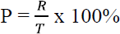
P0 = $\frac{2}{30}×$ 100% = 6.67%
P1 = $\frac{5}{30}×$ 100% = 16.67%
P2 = $\frac{21}{30}×$ 100% = 70.00%
Where:
P: the percentage of students getting score ≥ 75
R: the number of the students who getting point ≥ 75
T: the total number of the students who did the test
P1: the percentage of the students who get point 75 to 100 in cycle 1
P2: the percentage of the students who get point 75 to 100 in cycle 2.

Appendix IX

ANSWER KEY
Pre-Test and Cycle 1 Cycle 2
1. B 1. A
2. C 2. A
3. A 3. D
4. C 4. C
5. A 5. C
6. D 6. A
7. A 7. C
8. B 8. D
9. D 9. B
10. C 10. B
11. C 11. C
12. B 12. D
13. B 13. C
14. A 14. C
15. D 15. D
16. A 16. A
17. B 17. B
18. C 18. B
19. C 19. A
20. A 20. A

Appendix X
Validity and Reliability
Validity
no. | Nama | kelas | no.item |  |  |  |  |  |  |  |  |  |  |  |  |  |  |  |  |  |  |  | Xt | Xt^2
 |  |  | 1 | 2 | 3 | 4 | 5 | 6 | 7 | 8 | 9 | 10 | 11 | 12 | 13 | 14 | 15 | 16 | 17 | 18 | 19 | 20
1 | AnandaRangga a Hsb | 11 ips 1 | 1 | 1 | 1 | 1 | 1 | 1 | 1 | 1 | 1 | 0 | 1 | 1 | 1 | 1 | 1 | 1 | 1 | 1 | 1 | 1 | 19 | 361
2 | BertiDesmonSianturi | 11 ips 1 | 0 | 1 | 1 | 1 | 1 | 0 | 1 | 1 | 1 | 1 | 1 | 1 | 1 | 1 | 1 | 1 | 1 | 1 | 1 | 1 | 18 | 324
3 | CikeNania | 11 ips 1 | 1 | 1 | 0 | 1 | 0 | 1 | 1 | 1 | 1 | 1 | 1 | 1 | 1 | 1 | 1 | 1 | 1 | 1 | 1 | 1 | 18 | 324
4 | Devi suriAndini | 11 ips 1 | 1 | 1 | 1 | 0 | 1 | 1 | 1 | 1 | 1 | 1 | 0 | 1 | 1 | 1 | 1 | 1 | 1 | 1 | 1 | 1 | 18 | 324
5 | Dea Amelia | 11 ips 1 | 1 | 1 | 1 | 1 | 1 | 1 | 1 | 1 | 1 | 1 | 1 | 1 | 1 | 1 | 1 | 0 | 1 | 0 | 1 | 1 | 18 | 324
6 | DimanPrasetyo | 11 ips 1 | 1 | 1 | 1 | 1 | 1 | 1 | 1 | 1 | 1 | 1 | 1 | 1 | 1 | 1 | 1 | 1 | 0 | 0 | 1 | 1 | 18 | 324
7 | DikiPratama H. | 11 ips 1 | 1 | 1 | 1 | 1 | 1 | 1 | 1 | 1 | 1 | 1 | 1 | 1 | 1 | 1 | 1 | 1 | 1 | 0 | 0 | 1 | 18 | 324
8 | EkaHdRisuya | 11 ips 1 | 1 | 1 | 0 | 0 | 1 | 1 | 1 | 1 | 1 | 1 | 1 | 1 | 1 | 1 | 1 | 1 | 1 | 1 | 1 | 1 | 18 | 324
9 | FauzanNurKhalifah | 11 ips 1 | 1 | 1 | 1 | 1 | 1 | 1 | 0 | 1 | 0 | 1 | 1 | 1 | 1 | 1 | 1 | 1 | 1 | 1 | 1 | 1 | 18 | 324
10 | Jessica | 11 ips 1 | 1 | 1 | 1 | 1 | 1 | 1 | 1 | 1 | 1 | 1 | 1 | 1 | 1 | 0 | 0 | 1 | 1 | 1 | 1 | 1 | 18 | 324
11 | Kevin Hidayat S. | 11 ips 1 | 1 | 1 | 1 | 1 | 1 | 0 | 1 | 1 | 1 | 1 | 1 | 1 | 0 | 1 | 1 | 1 | 1 | 1 | 1 | 1 | 18 | 324
12 | Kartika | 11 ips 1 | 1 | 1 | 1 | 1 | 1 | 1 | 1 | 1 | 1 | 0 | 0 | 1 | 1 | 1 | 1 | 1 | 1 | 1 | 1 | 1 | 18 | 324
13 | Khilojahhalimah P. | 11 ips 1 | 1 | 1 | 1 | 1 | 1 | 0 | 1 | 1 | 1 | 1 | 1 | 0 | 1 | 1 | 1 | 1 | 1 | 1 | 1 | 1 | 18 | 324
14 | lastiurSianturi | 11 ips 1 | 1 | 1 | 0 | 1 | 1 | 1 | 1 | 1 | 1 | 1 | 1 | 1 | 1 | 1 | 1 | 1 | 1 | 1 | 0 | 1 | 18 | 324
15 | Muhammad Rafikus S. | 11 ips 1 | 1 | 1 | 1 | 1 | 1 | 1 | 1 | 1 | 1 | 0 | 1 | 1 | 1 | 1 | 1 | 0 | 1 | 1 | 1 | 1 | 18 | 324
16 | M. Farhan al-Hafizh | 11 ips 1 | 0 | 0 | 1 | 1 | 1 | 1 | 1 | 1 | 1 | 1 | 1 | 1 | 1 | 1 | 1 | 1 | 1 | 1 | 1 | 1 | 18 | 324
17 | Nazwa Nabila | 11 ips 1 | 1 | 0 | 1 | 1 | 1 | 1 | 1 | 1 | 1 | 1 | 1 | 1 | 0 | 1 | 1 | 1 | 1 | 1 | 1 | 1 | 18 | 324
18 | NurDinda Lestari | 11 ips 1 | 0 | 1 | 1 | 0 | 1 | 1 | 1 | 1 | 1 | 1 | 1 | 1 | 1 | 1 | 1 | 1 | 1 | 1 | 1 | 1 | 18 | 324
19 | RahmadFebriansyah | 11 ips 1 | 0 | 0 | 1 | 1 | 1 | 0 | 1 | 1 | 1 | 1 | 1 | 1 | 1 | 1 | 1 | 1 | 1 | 1 | 1 | 1 | 17 | 289
20 | RanggaPermana P. | 11 ips 1 | 1 | 0 | 1 | 1 | 1 | 1 | 1 | 1 | 0 | 0 | 1 | 1 | 1 | 1 | 1 | 1 | 1 | 0 | 1 | 1 | 16 | 256
21 | RiekkySyahputra | 11 ips 1 | 1 | 1 | 1 | 0 | 1 | 1 | 0 | 0 | 0 | 1 | 0 | 1 | 1 | 1 | 1 | 1 | 1 | 1 | 0 | 0 | 13 | 169
22 | Riska Gita S. | 11 ips 1 | 0 | 0 | 0 | 1 | 0 | 1 | 0 | 1 | 1 | 0 | 1 | 1 | 1 | 1 | 0 | 1 | 1 | 1 | 1 | 1 | 13 | 169
23 | RiskaAprilia | 11 ips 1 | 1 | 1 | 1 | 1 | 1 | 0 | 1 | 1 | 1 | 0 | 1 | 0 | 0 | 0 | 1 | 0 | 1 | 1 | 1 | 0 | 13 | 169
24 | RiskiNaylaPutri | 11 ips 1 | 1 | 0 | 1 | 1 | 0 | 1 | 1 | 1 | 1 | 1 | 0 | 0 | 1 | 1 | 1 | 1 | 1 | 1 | 1 | 1 | 16 | 256
25 | SilvimayuniLubis | 11 ips 1 | 0 | 1 | 1 | 0 | 0 | 0 | 0 | 0 | 1 | 0 | 0 | 1 | 0 | 1 | 1 | 0 | 1 | 1 | 1 | 1 | 10 | 100
26 | SozinemaBawamenewi | 11 ips 1 | 1 | 1 | 0 | 0 | 0 | 0 | 1 | 1 | 0 | 0 | 1 | 0 | 1 | 0 | 0 | 1 | 0 | 0 | 1 | 1 | 9 | 81
27 | SendiKusuma | 11 ips 1 | 0 | 1 | 0 | 0 | 0 | 1 | 1 | 1 | 1 | 0 | 0 | 1 | 0 | 1 | 0 | 0 | 1 | 0 | 0 | 1 | 9 | 81
28 | WindaAdelia | 11 ips 1 | 1 | 1 | 0 | 0 | 1 | 1 | 1 | 1 | 1 | 1 | 0 | 0 | 1 | 0 | 1 | 0 | 0 | 0 | 0 | 1 | 11 | 121
29 | WindiSyaputri | 11 ips 1 | 1 | 0 | 0 | 1 | 1 | 1 | 0 | 1 | 1 | 1 | 1 | 1 | 1 | 0 | 1 | 1 | 1 | 0 | 0 | 0 | 13 | 169
30 | Yeni Lestari | 11 ips 1 | 1 | 0 | 1 | 0 | 1 | 1 | 0 | 1 | 0 | 1 | 0 | 1 | 1 | 1 | 1 | 1 | 1 | 1 | 1 | 1 | 15 | 225
Np |  |  | 23 | 22 | 22 | 21 | 24 | 23 | 24 | 28 | 25 | 21 | 22 | 25 | 25 | 25 | 26 | 24 | 27 | 22 | 24 | 27 | 480 | 7954

Based of the table above, The number of correct questions is divided by the number of questions, the researcher uses the correlation formula to find out the number of R counts. Furthermore, it is known that the R table is 0.361 in questions 1,2,6,9,13 R count is lower than the r table so that the question instrument is declared not valid. And on questions 3,4,5,7,8,9,10,11,12,13,14,15 to 20 it is declared valid that R count is greater than R table. In this study, it can be seen that there are 15 valid questions and 5 invalid questions

Reliability
No | Nama | No. Item |  |  |  |  |  |  |  |  |  |  |  |  |  |  |  |  |  |  |  | jumlah
 |  | 1 | 2 | 3 | 4 | 5 | 6 | 7 | 8 | 9 | 10 | 11 | 12 | 13 | 14 | 15 | 16 | 17 | 18 | 19 | 20
1 | AnandaRangga a Hsb | 1 | 1 | 1 | 1 | 1 | 1 | 1 | 1 | 1 | 0 | 1 | 1 | 1 | 1 | 1 | 1 | 1 | 1 | 1 | 1 | 19
2 | BertiDesmonSianturi | 0 | 1 | 1 | 1 | 1 | 0 | 1 | 1 | 1 | 1 | 1 | 1 | 1 | 1 | 1 | 1 | 1 | 1 | 1 | 1 | 18
3 | CikeNania | 1 | 1 | 0 | 1 | 0 | 1 | 1 | 1 | 1 | 1 | 1 | 1 | 1 | 1 | 1 | 1 | 1 | 1 | 1 | 1 | 18
4 | Devi suriAndini | 1 | 1 | 1 | 0 | 1 | 1 | 1 | 1 | 1 | 1 | 0 | 1 | 1 | 1 | 1 | 1 | 1 | 1 | 1 | 1 | 18
5 | Dea Amelia | 1 | 1 | 1 | 1 | 1 | 1 | 1 | 1 | 1 | 1 | 1 | 1 | 1 | 1 | 1 | 0 | 1 | 0 | 1 | 1 | 18
6 | DimanPrasetyo | 1 | 1 | 1 | 1 | 1 | 1 | 1 | 1 | 1 | 1 | 1 | 1 | 1 | 1 | 1 | 1 | 0 | 0 | 1 | 1 | 18
7 | DikiPratama H. | 1 | 1 | 1 | 1 | 1 | 1 | 1 | 1 | 1 | 1 | 1 | 1 | 1 | 1 | 1 | 1 | 1 | 0 | 0 | 1 | 18
8 | EkaHdRisuya | 1 | 1 | 0 | 0 | 1 | 1 | 1 | 1 | 1 | 1 | 1 | 1 | 1 | 1 | 1 | 1 | 1 | 1 | 1 | 1 | 18
9 | FauzanNurKhalifah | 1 | 1 | 1 | 1 | 1 | 1 | 0 | 1 | 0 | 1 | 1 | 1 | 1 | 1 | 1 | 1 | 1 | 1 | 1 | 1 | 18
10 | Jessica | 1 | 1 | 1 | 1 | 1 | 1 | 1 | 1 | 1 | 1 | 1 | 1 | 1 | 0 | 0 | 1 | 1 | 1 | 1 | 1 | 18
11 | Kevin Hidayat S. | 1 | 1 | 1 | 1 | 1 | 0 | 1 | 1 | 1 | 1 | 1 | 1 | 0 | 1 | 1 | 1 | 1 | 1 | 1 | 1 | 18
12 | Kartika | 1 | 1 | 1 | 1 | 1 | 1 | 1 | 1 | 1 | 0 | 0 | 1 | 1 | 1 | 1 | 1 | 1 | 1 | 1 | 1 | 18
13 | Khilojahhalimah P. | 1 | 1 | 1 | 1 | 1 | 0 | 1 | 1 | 1 | 1 | 1 | 0 | 1 | 1 | 1 | 1 | 1 | 1 | 1 | 1 | 18
14 | lastiurSianturi | 1 | 1 | 0 | 1 | 1 | 1 | 1 | 1 | 1 | 1 | 1 | 1 | 1 | 1 | 1 | 1 | 1 | 1 | 0 | 1 | 18
15 | Muhammad Rafikus S. | 1 | 1 | 1 | 1 | 1 | 1 | 1 | 1 | 1 | 0 | 1 | 1 | 1 | 1 | 1 | 0 | 1 | 1 | 1 | 1 | 18
16 | M. Farhan al-Hafizh | 0 | 0 | 1 | 1 | 1 | 1 | 1 | 1 | 1 | 1 | 1 | 1 | 1 | 1 | 1 | 1 | 1 | 1 | 1 | 1 | 18
17 | Nazwa Nabila | 1 | 0 | 1 | 1 | 1 | 1 | 1 | 1 | 1 | 1 | 1 | 1 | 0 | 1 | 1 | 1 | 1 | 1 | 1 | 1 | 18
18 | NurDinda Lestari | 0 | 1 | 1 | 0 | 1 | 1 | 1 | 1 | 1 | 1 | 1 | 1 | 1 | 1 | 1 | 1 | 1 | 1 | 1 | 1 | 18
19 | RahmadFebriansyah | 0 | 0 | 1 | 1 | 1 | 0 | 1 | 1 | 1 | 1 | 1 | 1 | 1 | 1 | 1 | 1 | 1 | 1 | 1 | 1 | 17
20 | RanggaPermana P. | 1 | 0 | 1 | 1 | 1 | 1 | 1 | 1 | 0 | 0 | 1 | 1 | 1 | 1 | 1 | 1 | 1 | 0 | 1 | 1 | 16
21 | RiekkySyahputra | 1 | 1 | 1 | 0 | 1 | 1 | 0 | 0 | 0 | 1 | 0 | 1 | 1 | 1 | 1 | 1 | 1 | 1 | 0 | 0 | 13
22 | Riska Gita S. | 0 | 0 | 0 | 1 | 0 | 1 | 0 | 1 | 1 | 0 | 1 | 1 | 1 | 1 | 0 | 1 | 1 | 1 | 1 | 1 | 13
23 | RiskaAprilia | 1 | 1 | 1 | 1 | 1 | 0 | 1 | 1 | 1 | 0 | 1 | 0 | 0 | 0 | 1 | 0 | 1 | 1 | 1 | 0 | 13
24 | RiskiNaylaPutri | 1 | 0 | 1 | 1 | 0 | 1 | 1 | 1 | 1 | 1 | 0 | 0 | 1 | 1 | 1 | 1 | 1 | 1 | 1 | 1 | 16
25 | SilvimayuniLubis | 0 | 1 | 1 | 0 | 0 | 0 | 0 | 0 | 1 | 0 | 0 | 1 | 0 | 1 | 1 | 0 | 1 | 1 | 1 | 1 | 10
26 | SozinemaBawamenewi | 1 | 1 | 0 | 0 | 0 | 0 | 1 | 1 | 0 | 0 | 1 | 0 | 1 | 0 | 0 | 1 | 0 | 0 | 1 | 1 | 9
27 | SendiKusuma | 0 | 1 | 0 | 0 | 0 | 1 | 1 | 1 | 1 | 0 | 0 | 1 | 0 | 1 | 0 | 0 | 1 | 0 | 0 | 1 | 9
28 | WindaAdelia | 1 | 1 | 0 | 0 | 1 | 1 | 1 | 1 | 1 | 1 | 0 | 0 | 1 | 0 | 1 | 0 | 0 | 0 | 0 | 1 | 11
29 | WindiSyaputri | 1 | 0 | 0 | 1 | 1 | 1 | 0 | 1 | 1 | 1 | 1 | 1 | 1 | 0 | 1 | 1 | 1 | 0 | 0 | 0 | 13
30 | Yeni Lestari | 1 | 0 | 1 | 0 | 1 | 1 | 0 | 1 | 0 | 1 | 0 | 1 | 1 | 1 | 1 | 1 | 1 | 1 | 1 | 1 | 15
r table |  | 0,361 | 0,361 | 0,361 | 0,361 | 0,361 | 0,361 | 0,361 | 0,361 | 0,361 | 0,361 | 0,361 | 0,361 | 0,361 | 0,361 | 0,361 | 0,361 | 0,361 | 0,361 | 0,361 | 0,361
r hitung |  | 0.235 | 0.050 | 0.474 | 0.554 | 0.579 | 0.235 | 0.386 | 0.398 | 0.266 | 0.457 | 0.449 | 0.385 | 0.355 | 0.474 | 0.487 | 0.469 | 0.368 | 0.399 | 0.386 | 0.386
r hit > r tabel = valid |  | Invalid | invalid | valid | valid | valid | invalid | valid | valid | Invalid | valid | valid | valid | invalid | valid | valid | valid | valid | valid | valid | Valid

From the table above, researcher measured the reliability of each item using Kuder-Richardson 21 (KR 21). The KR 21 formula is as follows:
$$r11=\left(\frac{n}{n-1}\right)\left(1-\frac{Mt \left(n-Mt\right)}{\left(n\right)\left({ S}_{t}^{2}\right)}\right)$$
$Mt=\frac{∑xt}{N}$ = $\frac{480}{30}$ = 16
$s_{t}^{2}= \frac{∑x_{t}^{2}}{N}$ =$\frac{274}{30}$ = 9.13
$$∑x_{t}^{2}= ∑x_{t}^{2}- \frac{\left(\sum{xt}\right){}^{2}}{N}$$
= 7954 – $\frac{\left(480\right){}^{2}}{30}$
= 7954 – $\frac{230400}{30}$
=7954 – 7680= 274
$$r11=\left(\frac{n}{n-1}\right)\left(1-\frac{Mt \left(n-Mt\right)}{\left(n\right)\left({ S}_{t}^{2}\right)}\right)$$
= $\left(\frac{20}{20-1}\right)\left(1- \frac{16 \left(20-16\right)}{\left(20\right)\left(9.13\right)}\right)$
=$\left(\frac{20}{19}\right)\left(1- \frac{16\left(4\right)}{182.6}\right)$=1.05263157895 $\left(1- \frac{64}{182.6}\right)$
=$\left(1.05263157895\right)\left(1-0.35049288061\right)$
=$\left(1.05263157895\right)\left(0.64950711939\right)$=0.68369170462 (𝑟11 > 0.361 = 𝑟𝑒𝑙𝑖𝑎𝑏𝑙𝑒)
It is known that r table is 0.361 < r count. then the instrument is reliable or r count > r table. then the instrument is reliable. then the category of the correlation coefficient is 0.61-0.80 = high reliability

Appendix XI
Research Permition
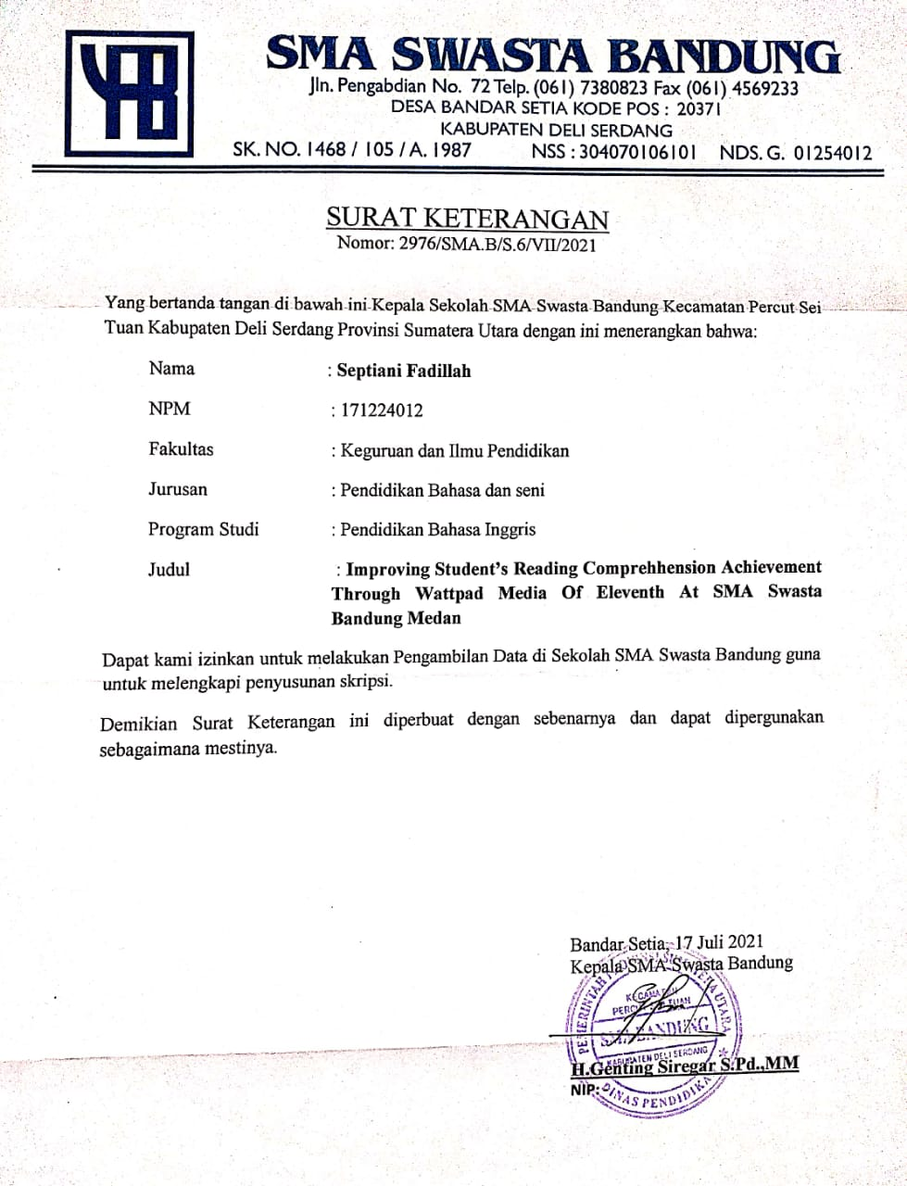

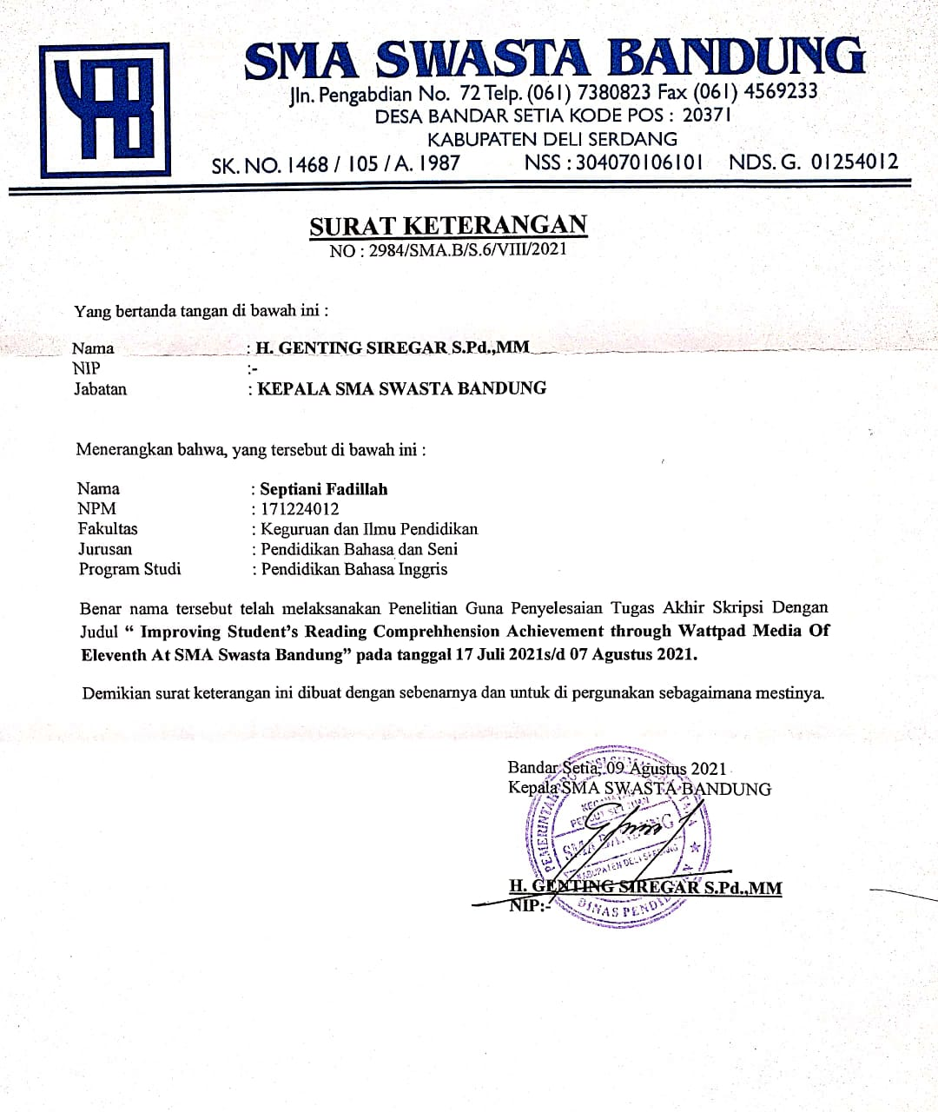

Appendix XII
Documentation
