ACKNOWLEGMENT
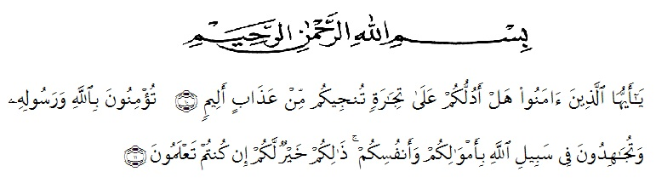
Meaning : O you who believe. Shall I show you a trade that can save you from a painful punishment? (10). (i.e.) you believe in Allah and His Messenger and strive in the way of Allah with your wealth and your soul. That is better for you, if you only knew (11) (as-shaff Verse 10-11)
Peace be upon you, and Allah mercy and blessings Praised to Allah SWT. The Almighty for giving me a healthy, opportunity and the ability to complete this thesis.peace and his blessing mercy is into beloved and our dear holly Prophet Muhammad SAW. This thesis is submitted to the department of English education faculty teacher training and education of Muslim Nusantara Al-washiyah, Medan as partial fulfillment of the requirements for degree of Bachelor of Education, under the title" improving students’ reading comprehension achievement through Wattpad media of eleventh grade at SmaSwasta Bandung ".
In the process of finishing the thesis, from writing the proposal to the preparation of the thesis.the writer has received much help from many persons. Therefore, the writer would like to the deepest gratitude to the most special to his beloved father Rusliand his beloved mother DewiAstutiWho has nurtured, raised, guided, educated, patient, and always encouraged the writer and alwaysPrayed for the writer incessantly and gave support to the writer, sacrificed in the form of tireless material, and give a lot of encouragement and motivation to the writer to be able to complete education until the completion of this thesis.
The writer also expressed many thanks to all parties who have given their assistance and quidance, and the writer wants to convey a big opportunity, nemely for:
- Mr. Dr. KRT.HardiMulyono K Surbaktias rector of university of Muslim Nusantara Al-washiyah Medan
- Mr. Dr. SamsulBahri, M.Si as Dean of the faculty of teacher training and education, university of Muslim Nusantara Al-washiyah, Medan
- Mrs. Dra. Hj.NurjannahDalimunthe, M.Si as vice dean 1 of the faculty of teacher education, university of Muslim Nusantara Al-washiyah Medan.
- Mrs. Zulfitri, S.S., M.A as head of English education.
- Mr. TeguhSatria Amin, S.pd.,M.Hum as my adviser Who Has given me suggestions, guidance during the writing of this thesis.
- Alllectures in English department of education who have guided and imparted a variety of Knowledge during I studied at faculty of teacher training and Education University of Muslim Nusantara Al-washiyah Medan.
- Allteachers at Bandung private high school, especially H. GintingSiregar, S.Pd., MM as a principal of Bandung private high school and Nurhalimah, S.Pd as English teacher who helped me during the researcher was Done and all students at grade XI private high school Bandung.
- My young sister DindaAprilia who give the writer support in prayers, moral for me in finishing my thesis.
- My beloved M. Reza Hanafi who has always been patient and encouraged me in the process of making this thesis
- last but not least. I wanna thank me for believing in me, for doing all this hard work, for having no days off, for never quitting, for just being me at all times.
I would be a pleasure to accept some critic's and corrections to this thesis because I believe that it is still far from perfect finally, I hope this thesis Will be beneficial for those who read in the field of education.

Medan, 20 Oktober 2021

SEPTIANI FADILLAH

