**APPENDIX 1**

**SUBJECT OF THE RESEARCH**

|  |  |
| --- | --- |
| **No.** | **Name** |
| 1 | AHW |
| 2 | AR |
| 3 | ARS |
| 4 | DHAS |
| 5 | EPW |
| 6 | KR |
| 7 | MAR |
| 8 | MBP |
| 9 | RHP |
| 10 | RMS |
| 11 | SMA |
| 12 | S |
| 13 | SH |
| 14 | SM |
| 15 | SN |
| 16 | ZFAS |
| 17 | TS |
| 18 | SN |
| 19 | SN |
| 20 | TPN |
| 21 | WPR |
| 22 | NAAU |
| 23 | AAP |

**APPENDIX 2**

**SILABUS**

Sekolah : MTs Al Washliyah Jati Rejo Kec. Galang

Kelas : VIII (Delapan )

Mata Pelajaran : Bahasa Inggris

Semester : I (Satu)

Standar Kompetensi : Berbicara

3. Mengungkapkan makna dalam teks lisan fungsional dan monolog pendek sederhana berbentuk *recount,* dan *narrative* untuk berinteraksi dengan lingkungan sekitar

|  |  |  |  |  |  |  |  |  |  |
| --- | --- | --- | --- | --- | --- | --- | --- | --- | --- |
| Kompetensi  Dasar | Materi  Pokok/Pembelajaran | Kegiatan  Pembelajaran | Indikator | Penilaian | | | Alokasi  Waktu | Sumber  Belajar | Karakter |
| Teknik | Bentuk  Instrumen | Contoh  Instrumen |
| 10.1 Mengungkapkan makna dalam teks lisan fungsional pendek sederhana dengan menggunakan ragam bahasa lisan secara akurat, lancar dan berterima untuk berinteraksi dengan lingkungan sekitar  10.2 Mengungkap kan makna dalam monolog pendek sederhana dengan menggunakan ragam bahasa lisan secara akurat, lancar, dan berterima untuk berinteraksi dengan lingkungan sekitar dalam teks berbentuk *recount* dan *narrative* | •Teks fungsional pendek :  - Undangan  - Pengumuman  -Pesan singkat  • Teks monolog  berbentuk *narrative* | 1.Review kosakata dan ungkapan yang digunakan dalam teks fungsional pendek terkait materi  2.Membuat kalimat sederhana untuk:  - mengundang- mengumumkan  - memberi pesan  3. Membahas gambitgambit yang sering muncul dalam teks fungsional terkait  4. Mengungkapkan secara lisan:  - undangan - pengumuman  - pesan singkat dengan santun dan komunikatif  1. Review kosakata dan tata bahasa terkait jenis teks narrative dan tema yang dipilih  2. Membuat kalimat sederhana secara lisan terkait ciri-ciri kebahasaan teks narrative  - *simple past*  - *past continuous*  - *temporal conjunctions*  - *connective words*  - *adverbs* - *adjective*s  3. Menceritakan kembali cerita populer di kotanya menggunakan gambit-gambit yang sesuai. Contoh: *Really? That’s* *terrible!, How then?,* *First,...., then....,finally... dengan percaya diri dan komunikatif*  4. Menceritakan kembali teks narative yang pernah didengar dengan semangat  . | • Mengungkapkan secara lisan teks fungsional :  - Pengumuman  - Undangan  - Pesan singkat  • Bertanya dan menjawab secara lisan berbagai info dalam teks pengumuman, undangan, pesan singkat  • Melakukan monolog pendek sederhana dalam bentuk *narrative* dan *recount* | Tes lisan  Tes lisan | *Performance*  *Performance* | *1. Invite your friend orally to join a discussion on the danger of drugs.*  *2.Give announcement orally about the plan of the trip to Borobudur Temple.*  *3. Tell your friend to wait for you after school.*  *1. Retell a stor that you know very well.*  *2. Tell a story based on theseries of a pictures given.* | 2 x 40 menit  4 x 40 menit | 1. Buku teks yang relevan  2.Gambar terkait materi dan topik  3.Benda sekitar  4.Teks bentuk khusus:  - undangan,  pengumuman  pesan singkat  1.Buku teks yang relevan  2.Gambar yang relevan  3.Benda sekitar  4. Buku cerita dalam bahasa Inggris | Aantun  Percaya diri  Komunikatif  Cermat  Semangat |

# Galang, September 2020

# Mengetahui

# Kepala Sekolah Guru Mata Pelajaran,

# MTs Al Washliyah Jati Rejo

# 

# Mahdaleni, S.Pd.I Chinta Rahayu

# APPENDIX 3

# RENCANAAN PELAKSANAAN PEMBELAJARAN

# (RPP)

# Satuan pendidikan : MTs Al Washliyah Jati Rejo Kec. Galang

# Mata pelajaran : Bahasa inggris

# Kelas : VIII

# Materi : Narrative text

# Alokasi Waktu : 2JP x 40 Menit

1. **Kompetensi inti**

KI 1 Menghayati dan menghargai pelajaran agama

KI 2 Menunjukkan perilaku jujur,disiplin,tanggung jawab, peduli, santun, percaya diridalam berinteraksi secara efektif dengan lingkungan social dan alam dalam jangkauan pergaulan dan keberadaannya

# Kompetensi dasar dan indicator pencapaian kompetensi

|  |  |  |
| --- | --- | --- |
| **NO.** | **Kompetensi dasar** | **Indikator** |
| 1. | 3.13 Memahami teks narrative berbentuk fable sederhana | * + 1. Menjelaskan fungsi social dari teks narrative berbentuk fable,sesuai dengan konteks penggunaannya     2. Menjelaskan unsur kebahasaan dari teks narrative berbentuk fable, sesuai dengan konteks penggunaanya     3. Menjelaskan struktur teks dari teks   narrative berbentuk fable , sesuai dengan konteks penggunaannya |
| 2. | 4.13Menyusun teks narrative berbentuk fable pendek dan sederhana | 4.13.1 Menggali informasi rinci dari teks narrative lisan dan tulisan |

1. **Tujuan pembelajaran**
   1. Membaca sebuah teks pendek tentang fable
   2. Mencari informasi mengenai teks pendek tentang fable
   3. Mengungkapkan makna dalam teks narrative dan mampu menggunakan simple past dalam kehidupan sehari-hari

# Materi Pembelajaran

* 1. Fungsi social

Memperoleh hiburan,menghibur,dan mengajarkan nilai-nilai luhur melalui cerita

* 1. Struktur teks
     1. Memperkenalkan tokoh,tempat,waktu, terjadinya cerita (orientasi)
     2. Memperkenalkan krisis yang terjadi terhada tokoh utama (Komplikasi)
     3. Memaparkan akhir cerita (resolusi)
     4. Memberikan alas an atau komenttar umum (orientasi)
  2. Unsur kebahasaan
* Tata bahasa : Simple past tense, past continuous tense
* Kalimat langsung dan tidak langsung
* Ejaan dan tanda baca

# Metode pembelajaran

* 1. Pendekatan : Scienfic Approach
  2. Teknik : Ceramah, diskusi, Tanya jawab, pemberian tugas

# Media pembelajaran

* 1. Media : Buku cetak, Video, gambar, poster, foto
  2. Alat/bahan : Spidol,gambar,laptop

# Langkah-langkah pembelajaran

|  |  |  |
| --- | --- | --- |
| **Kegiatan** | **Deskripsi kegiatan** | **Alokasi waktu** |
| Pendahuluan | Guru mengucapkan salam dan mengecek kehadiran siswa   * Guru menanyakan materi yang dipelajari sebelumnya * Guru menyampaikan materi dan menguraikan kegiatan * Guru menyampaikan tujuan pembelajaran yang akan dicapai | 10 menit |
| Inti | * Mengamati * Menanya * Mengeksplorasi * Mengasosiasi | 60 menit |
| Penutup | * Guru beserta siswa membuat rangkuman pelajaran * Guru memberikan tugas pekerjaan rumah * Guru menyampaikan rencana pembelajaran untuk pertemuan yang akan dating | 10 menit |

1. **Penilaian**
   1. Pilihan berganda
   2. Essay

# Galang, September 2020

# Mengetahui

# Kepala Sekolah Guru Mata Pelajaran,

# MTs Al Washliyah Jati Rejo

**Mahdaleni, S.Pd.I Chinta Rahayu**

**EPPENDIX 4**

**QUIZ**

Soal Teks Narrative Legend 1

Long, long ago, when the gods and goddesses used to mingle in the affairs of mortals, there was a small kingdom on the slope of Mount Wayang in West Java.  The King, named Sang Prabu, was a wise man.  He had an only daughter, called Princess Teja Nirmala, who was famous for her beauty but she was not married.  One day Sang Prabu made up his mind to settle the matter by a show of strength.

After that, Prince of Blambangan, named Raden Begawan had won the competition.  Unfortunately, the wicked fairy, Princess Segara fell in love with Raden Begawan and used magic power to render him unconscious and he forgot his wedding.  When Sang Prabu was searching, Raden Begawan saw him and soon realized that he had been enchanted by the wicked fairy.  The fairy could not accept this, so she killed Raden Begawan.  When Princess Teja Nirmala heard this, she was very sad.  So a nice fairy took her to the Kahyangan.

1. Which one of the following statements is false about Sang Prabu?
2. Sang Prabu was a father of his only daughter
3. Sang Prabu was a king of a kingdom in West Java
4. **Sang Prabu was  taken to Kahyangan by a wicked fairy**
5. Sang Prabu was a wise man
6. Sang Prabu didn’t have a son
7. Why the wicked fairy did used her magic to make Raden Begawan unconscious?
8. She didn’t like Raden Begawan
9. She didn’t want Raden Prabu marry the princess
10. She wanted Teja Nirmala to forget about her wedding
11. **She didn’t want the prince of Blambangan marry the princess**
12. She didn’t want the prince of Blambangan feel love with her
13. What do you think will happen if gods or goddesses cannot mingle in the affairs of people in the earth at that time?
14. Princess Segara will have married with Raden Begawan
15. Sang Prabu will not hold strength competition
16. Raden Begawan will not die
17. Teja Nirmala will stay in the Kahyangan
18. **Wicked Fairy will not take Raden Begawan’s life**
19. So a nice fairy took her to the Kahyangan.  (Paragraph 2) The word her in the sentence refers to…
20. The wicked fairy
21. The nice fairy
22. **Princess Nirmala**
23. Prince Teja
24. The prince of Blambangan
25. The similarity between fairy and human according to the text.
26. The place they live
27. **The jealousy that they posses**
28. The way they don’t feel a love
29. The strength they have
30. Their life that is immortal

Soal Teks Narrative Legend 2

A long time ago, there lived on the island of Bali a giant-like creature named Kbo Iwo.  The people of Bali used to say that Kbo Iwo was everything, a destroyer as well as a creator.  He was satisfied with the meal, but this meant for the Balinese people enough food for a thousand men.

Difficulties arose when for the first time the barns were almost empty and the new harvest was still a long way off.  This made Kbo Iwo wild with great anger.  In his hunger, he destroyed all the houses and even all the temples.  It made the Balinese turn to rage.

So, they came together to plan steps to oppose this powerful giant by using his stupidity.  They asked Kbo Iwo to build them a very deep well, and rebuild all the houses and temples he had destroyed.  After they fed Kbo Iwo, he began to dig a deep hole.

One day he had eaten too much, he fell asleep in the hole.  The oldest man in the village gave a sign, and the villagers began to throw the limestone they had collected before into the hole.  The limestone made the water inside the hole boiling .  Kbo Iwo was buried alive.  Then the water in the well rose higher and higher until at last it overflowed and formed Lake Batur.  The mound of earth dug from the well by Kbo Iwo is known as Mount Batur.

1. Which the following fact is true about Kbo Iwo?
2. Kebo Iwo ate a little amount of meat
3. Kebo Iwo is a destroyer that cannot make anything
4. Kebo Iwo was angry because his food was stolen by Balinese people
5. Kebo Iwo destroyed all the house but not the temple
6. **Kebo eat food was equal for food of thousand people**
7. Why did Kbo Iwo feel angry to the Balinese people?
8. Because Balinese people ate his meal
9. Because Balinese people took his food so his barns was empty
10. **Because Balinese people didn’t give him food**
11. Because Balinese people were in hunger
12. Because Balinese people turned to rage
13. According to the story, if Kbo Iwa is never existed in Bali island, what do you think will happen?
14. There will be no Bali island
15. Bali People will never be angry
16. All Bali people will live in a prosperous way
17. **We are not able see the beauty of Lake Batur**
18. Mount Batur will not be a sacred place now
19. “So, they came together to plan steps to oppose this powerful giant……”(Paragraph 3). The antonym of the word “oppose “ is….
20. **Support**
21. Defeat
22. Turn Against
23. Beat
24. Change
25. What is mount batur?
26. A lake build by Kbo Iwa
27. A well dug by Kbo iwa
28. The mountain build by Kbo Iwa
29. **A mound of earth dug from the well by Kbo iwa**
30. A home build by Balinese people to Kbo Iwa

Soal Teks Narrative Legend 3

A long time ago, very few people lived in the New Territories.  There were only a few villages.  If the people wanted to go from one village to another, they often had to pass through wild and unsafe forest.

One day, a farmer’s young wife went to the next village to visit her own mother and brother.  She brought along her baby son.  When it was time for her to leave, her brother said “ it is getting dark.  Let my son, Ah Tim go with you though the forest.”

So Ah Tim led the way and the young woman followed behind, carrying her baby.  When they were in the forest, suddenly they saw a group of wolves.  They began to run to avoid the danger, but Ah Tim kicked against a stone and fell down.  At once the wolves caught him.  The young woman cried to the wolves, “ please eat my own son instead.” Then, she put her baby son on the ground in front of the wolves and took her nephew away.  Everyone understood that this was because the woman was very good and kind.  She had offered her own son’s life to save her nephew.

They ran back to the house and called for help.  All men in the village fetched thick sticks and went back with her into the forest.  When they got there, they saw something very strange.  Instead of eating the woman’s baby the wolves were playing with him.

1. What separated between one village to another a long time ago in the New Territories ?
2. Another village
3. Mountains
4. **Forests**
5. Hills
6. Towers and logs
7. Who was Ah Tim ?
8. The young woman’s brother
9. The young woman’s son
10. The young woman’s brother and nephew
11. **The young woman’s brother’s son**
12. One of the men who fetched a stick.
13. Who walked in front when they were in the forest ?
14. **Ah Tm**
15. The woman
16. The woman’s son
17. Her brother’s nephew
18. The baby and his mother
19. How could the wolves catch Ah Tim ?
20. He was afraid
21. **He was stumbled by a stone**
22. He ran slowly
23. The woman cried
24. The wolves were good runners
25. The woman gave her son to the wolves because
26. She loved her nephew than her son.
27. **She thought about how her brother would be**
28. She wanted her son was eaten by the wolves
29. She was crazy
30. She kept a grudge on his brother
31. What did the villagers bring sticks for ?
32. **For the weapon to beat the wolves**
33. To bring the woman’s nephew
34. For the fire woods.
35. For play
36. For building a house for the woman.
37. “ all men in the village fetched thick stick … “ The word “ fetched” has a similar meaning to :
38. Received
39. Caught
40. **Got**
41. Hit
42. Lifted
43. From the passage we learn that the villages were ….
44. Located in one huge area
45. Situated in a large district
46. **Separated by untamed jungles.**
47. Wild and unsafe
48. Dark and very dangerous
49. The brother let her son go with his aunt as she left home because ….
50. Ah Tim wanted to see the wolves
51. His aunt wanted him to come long
52. Ah Tim was bored to live with his parents
53. The baby was too cute to be alone
54. **Ah Tim would be a guardian for them**
55. What is the purpose of the writer by writing the story above ?
56. To describe the danger of the villages
57. **To entertain the readers of the story**
58. To tell the villagers’ relationship
59. To explain how important a relative is
60. To narrate how the wolves were playing with the bab

Soal Teks Narrative Legend 4

Once upon a time in west java, lived a writer king who had a beautiful daughter.  Her name was Dayang Sumbi.  She liked weaving very much.  Once she was weaving a cloth when one of her tools fell to the ground.  She was very tired, at the same time she was too lazy to take it.  Then she just shouted out loudly.

Anybody there! Bring me my tool.  I will give you special present.  If you are female.  I will consider you as my sister if you are male, I will marry you sunddenly a male dog, its name was Tumang came.  He brought her the falling tool.  Dayang Sumbi was very surprised.  She regretted her words but she could not deny it.  So she had marry Tumang and leave her father.  Then they lived in a small village.  Several months later they had a son.  His name was Sangkuriang.  He was a handsome and healthy boy.

Sangkuriang liked hunting very much, especially deer.  He often hunted to the wood usying his arrow.  When he went hunting , Tumang was always with him.

One day Dayang Sumbi wanted to have deer’s  heart so she asked Sangkuriang to hunt for a deer.  Then Sangkuriang when to the wood with his arrow and his faithful dog.  Tumang, but afher several days in the wood Sangkuriang could not find any deer.  Then where all disappeared.  Sangkuriang was exhausted and desperate.  He did not want to disappoint her mother so he killed Tumang.  He did not know that Tumang was his father.  Tumang’s  heart to her mother.  But Dayang Sumbi knew that it was Tumang’s heart.  She was so angry that she could not control her emotion.  She hit Sangkuriang at his head Sangkuriang was wounded.  There was a scar in his head.  She also repelled her son.  Sangkuriang left her mother in sadness.

Many years passed and Sangkuriang became a strong young man.  He wandered everywhere.  One day he arrived.  at his own village but he did not realize it.  There he met Dayang Sumbi.  At the time Dayang Sumbi was given an eternal beauty by God so she stayed young forever.  Both of them did know each other.  So they fall in love and then they decided to marry.  But then Dayang Sumbi recognized a scar on Sangkuriang’s head.  She knew that Sangkuriang was his son.  It was impossible for them to marry.  She told him but he did not beliave her.  He wished that they marry soon.  So Dayang Sumbi gave very difficult condition.  She asked Sangkuriang  to build a lake and a boat in one night! She said she needed that for honeymoon.

Sangkuriang agreed.  With the help of genie and spiritis, Sangkuriang tired to build them.  By midnight he had completed the lake by building a dam in Citarum river.  Then he started making the boat.  It was almost dawn when he almost finished it.  Meanwhile Dayang Sumbi kept watching on him.  She was very worried when she knew this.  So she made lights in the east.  Then the spiritis thought that was already dawn.  It was time for them to leave.  They left Sangkuriang alone.  Without their help he could not finish the boat.  
Sangkuriang was angry.  He kicked the boat.  Then the boat turned upside down.  It, leter, became Mounth Tangkuban Perahu.  Which means an upside-down boat.  From a distant the mount really looks like an upside down boat.

1. What is the story about?
2. A wrath son
3. West java’s tales
4. Tumang a Dog husband
5. **The legend of Tangkuban Perahu**
6. Dayang Sumbi’s rejection to marry Sangkuriang
7. According to he story, Tumang was….
8. actually a handsome prince
9. **married to Dayang Sumbi**i
10. Sangkuriang pet dog
11. good at hunting deer
12. in fact Dayang Sumbi’s father
13. What did Dayang Sumbi look like?
14. She liked weaving clothers
15. She looked for the heart of a deer
16. **She was beautiful**
17. She was looking at her fallen tool
18. She and her son were alike
19. What made Dayang Sumbi stay young?
20. She set up conditions in doing things
21. A young man fall in love with her
22. She married a dog
23. She knew how to take care her body
24. **God gave her an eternal beauty**
25. Who are the main caracthers in the story?
26. **Dayang Sumbi and Sangkuriang**
27. The king Dayang Sumbi, the dog and Sangkuriang
28. The king, Dayang Sumbi, the dog, Sangkuriang, the ganie, and the spiritis
29. The king, Dayang Sumbi, the dog, Sangkuriang, the mount, the boat, the genie, and the spiritis
30. The king, Dayang Sumbi, sister, daughter, the dog, a young man, Sangkuriang, the mount, the boat, the genie, the spiritis and God

**APPENDIX 5**

**ANSWER KEY**

1. C.
2. D.
3. E.
4. C.
5. B.
6. E.
7. C.
8. D.
9. A.
10. D.
11. C.
12. D.
13. A.
14. B.
15. B.
16. A.
17. C.
18. C.
19. E.
20. B.
21. D.
22. .B.
23. C.
24. E.
25. A.

**APPENDIX 6**

Student Answer Sheets

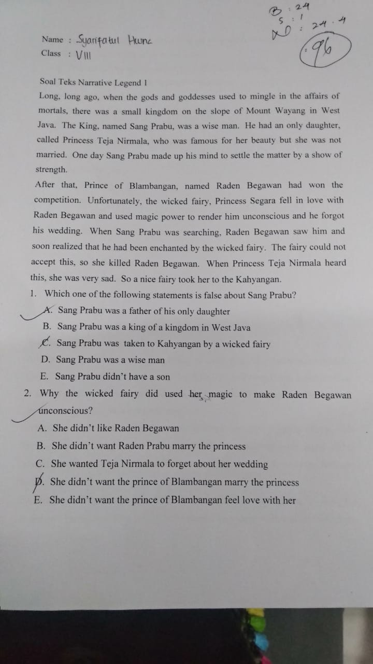

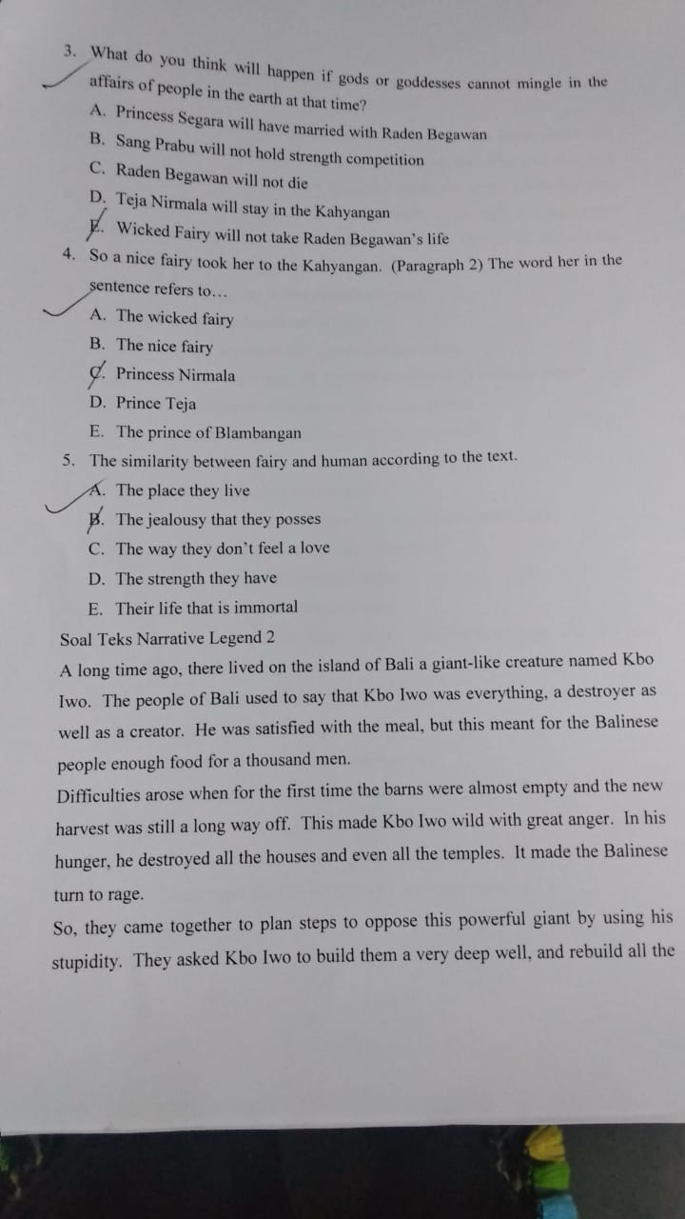

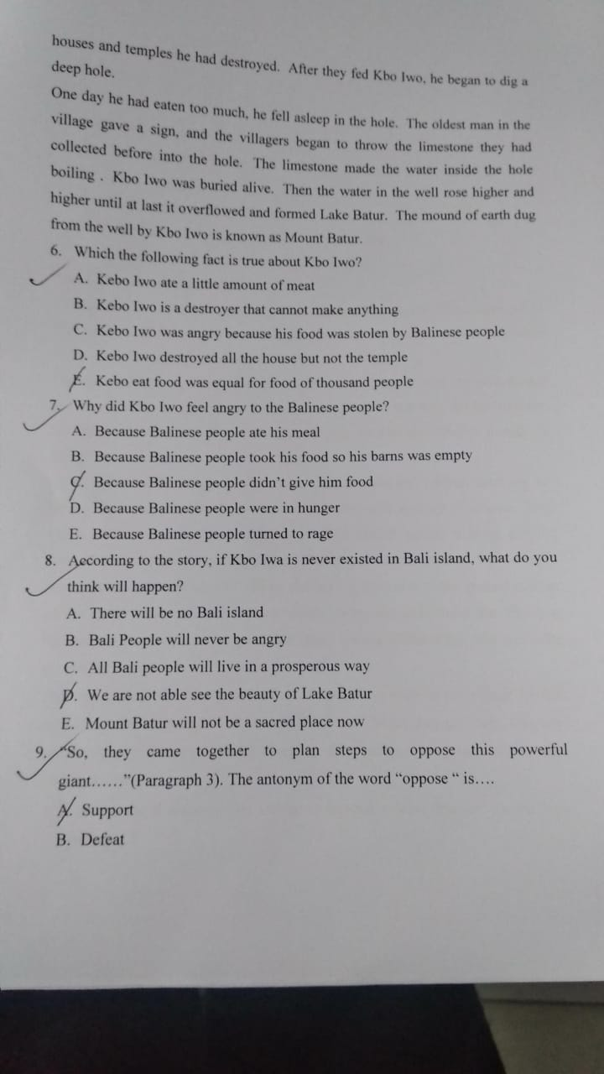

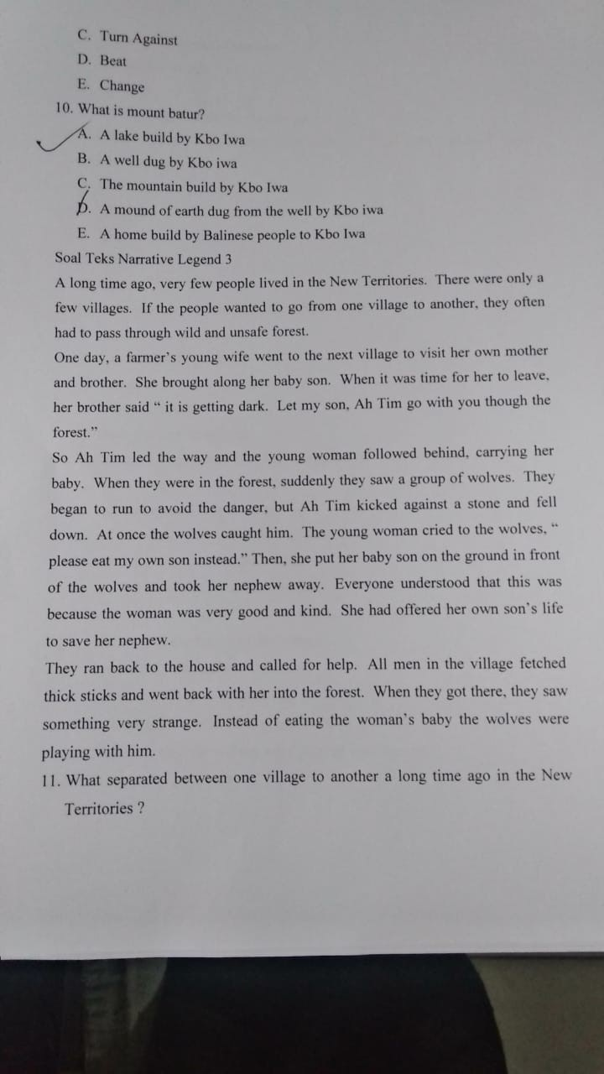

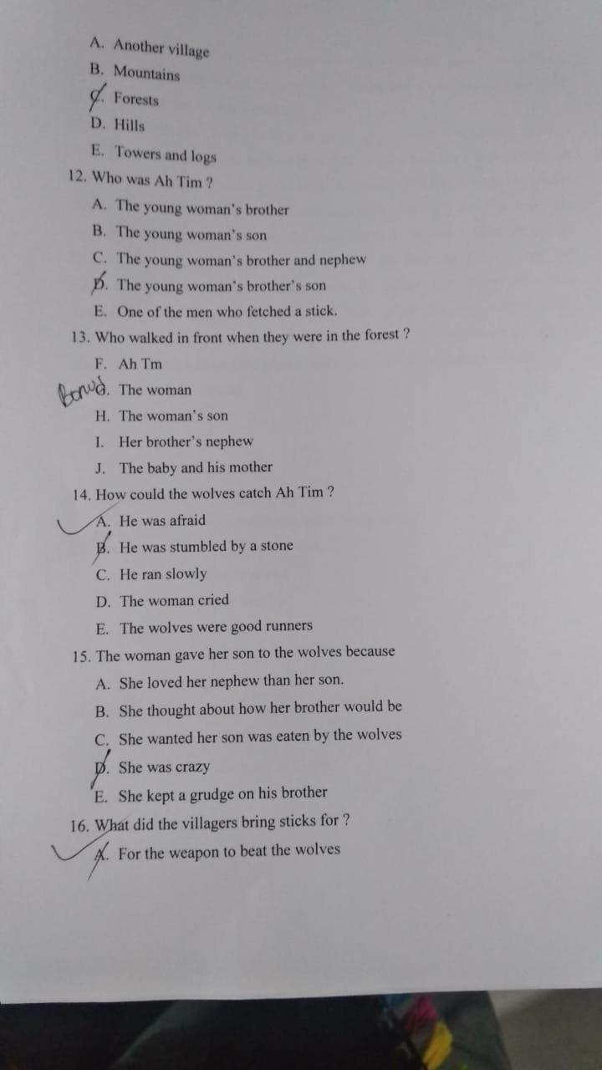

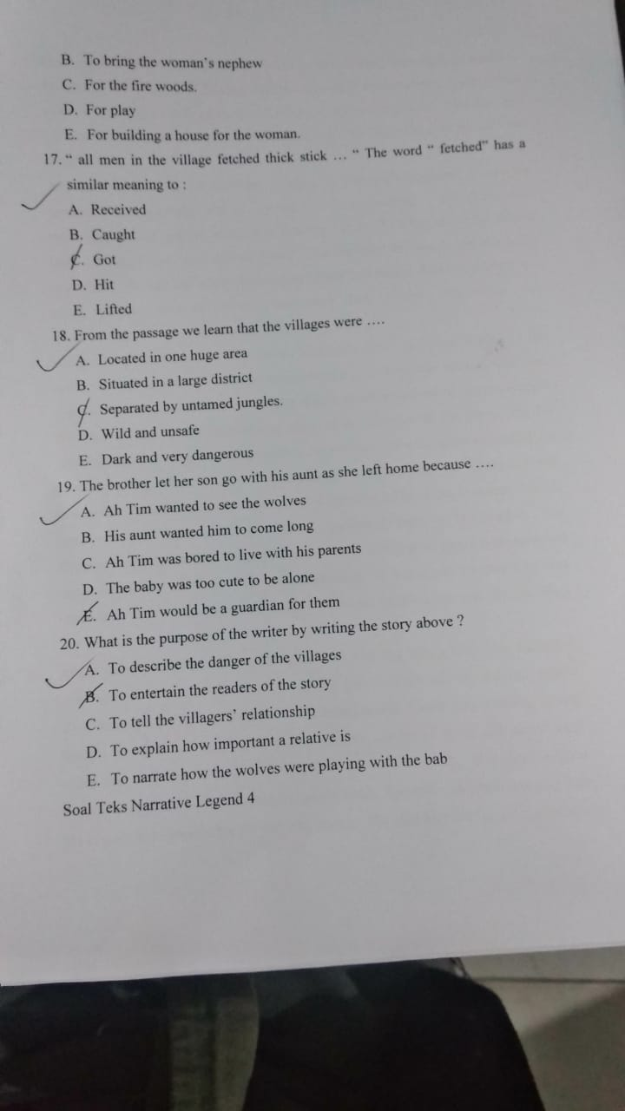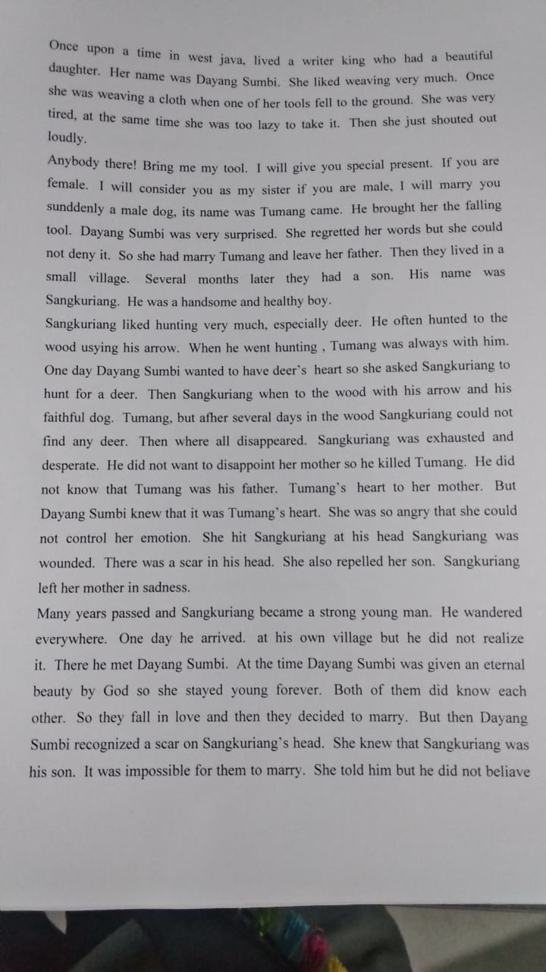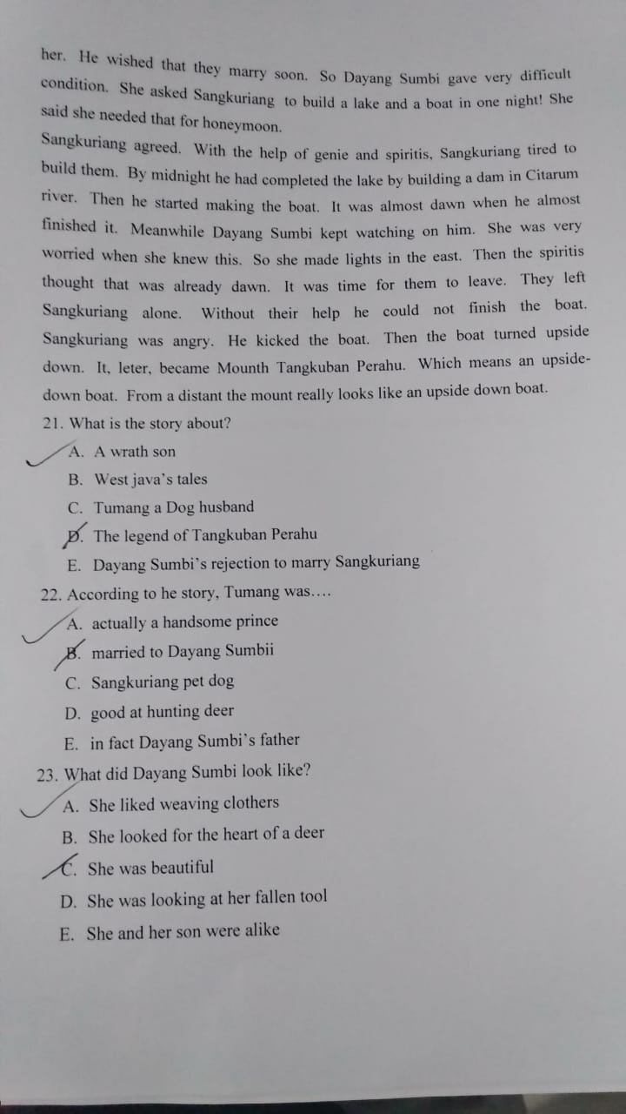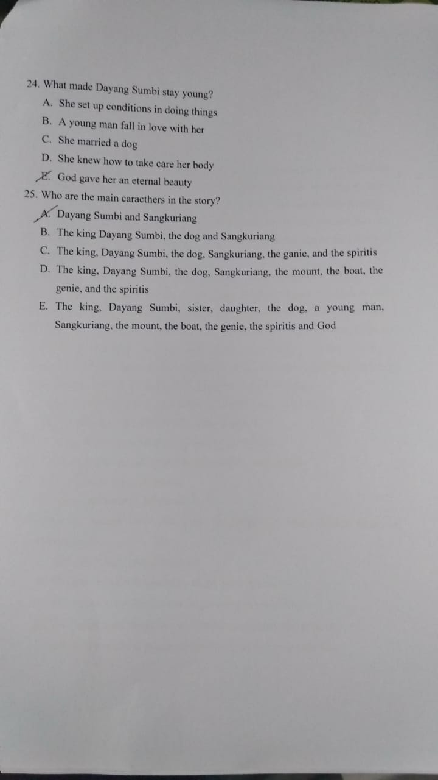

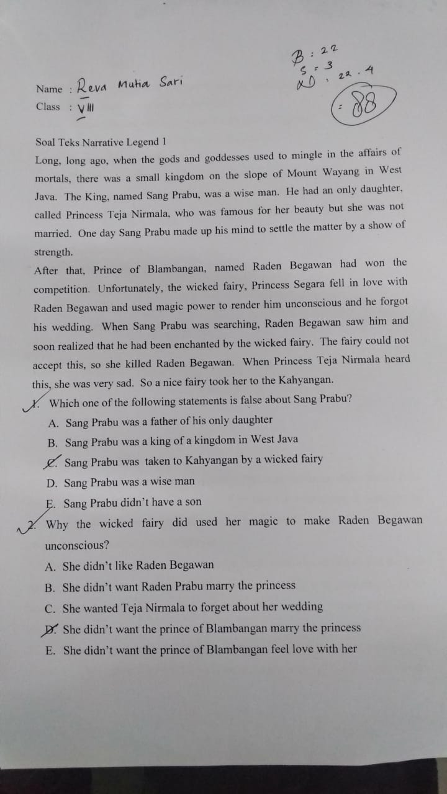

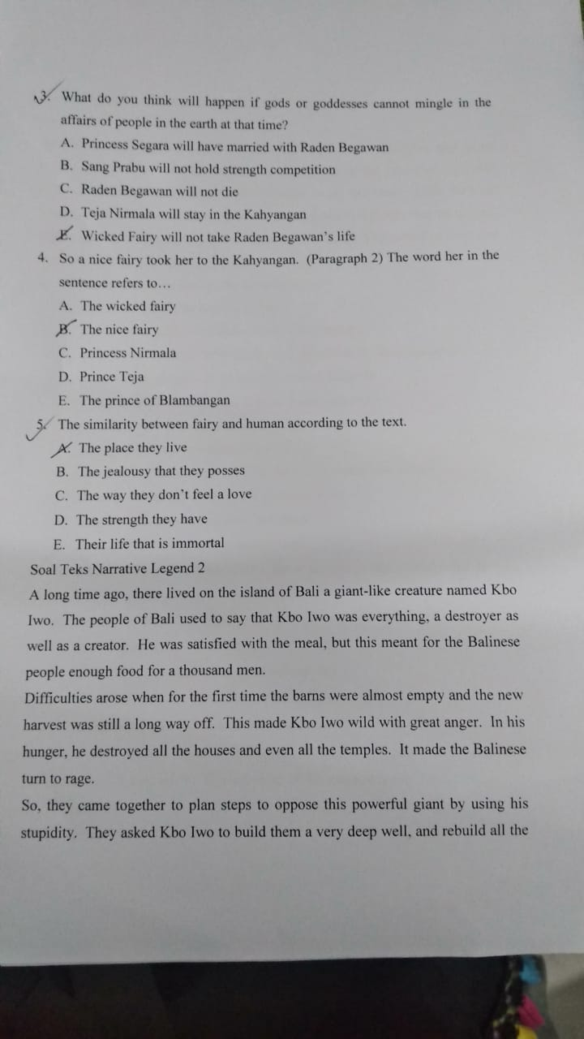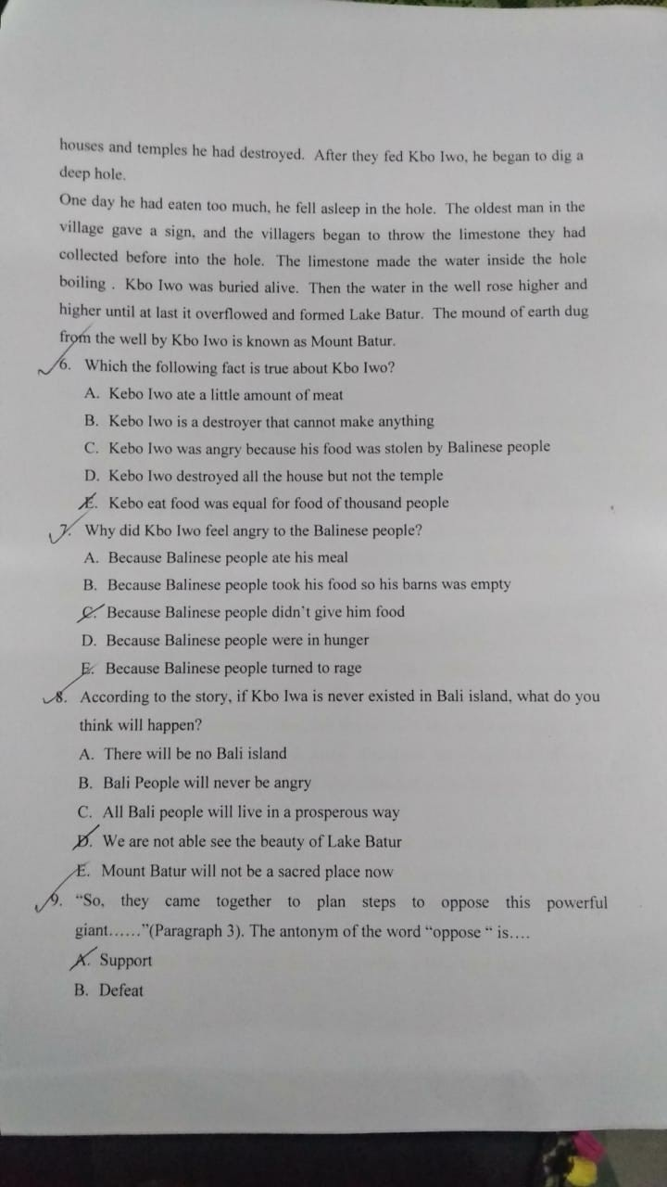

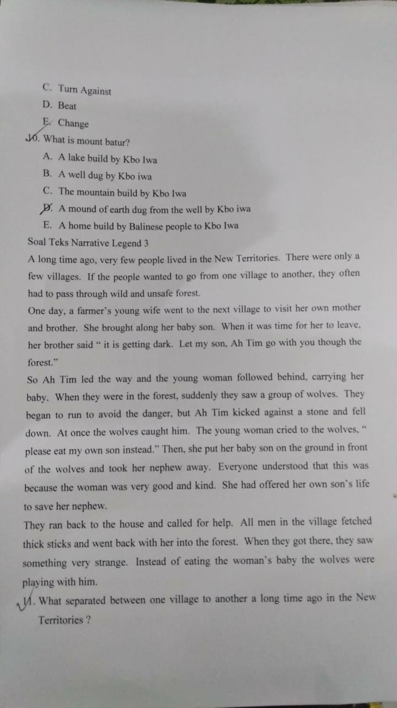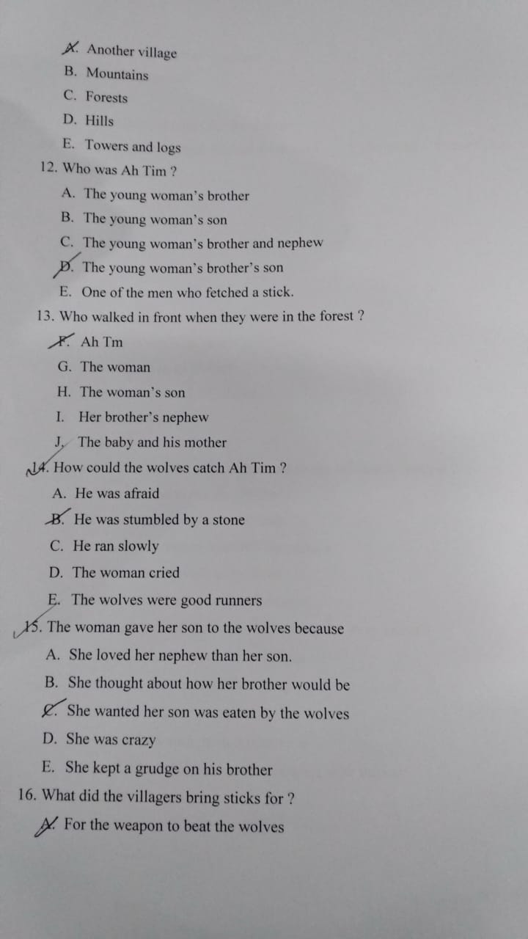

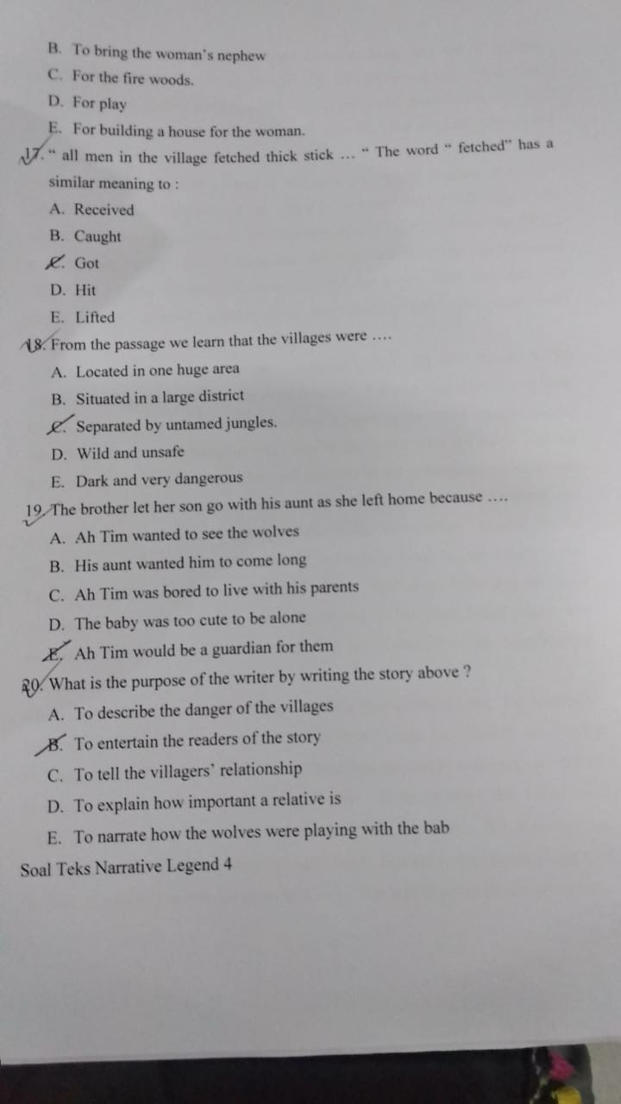



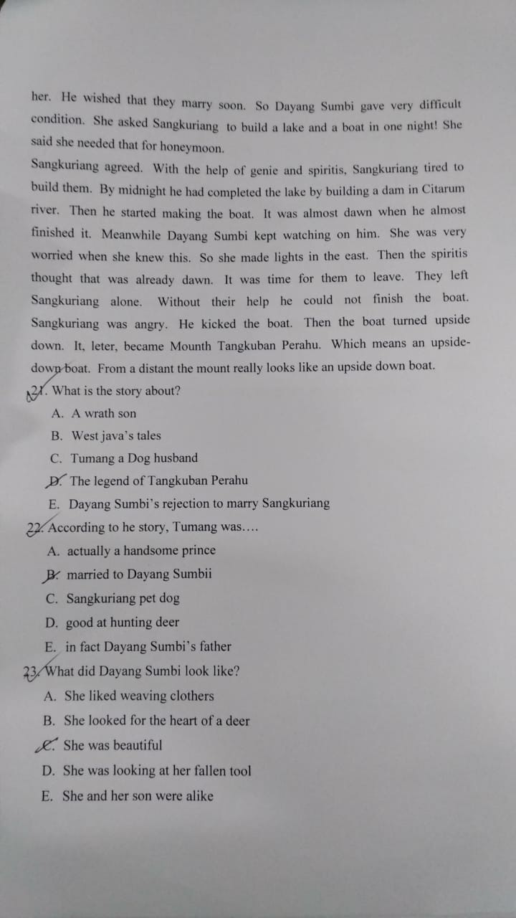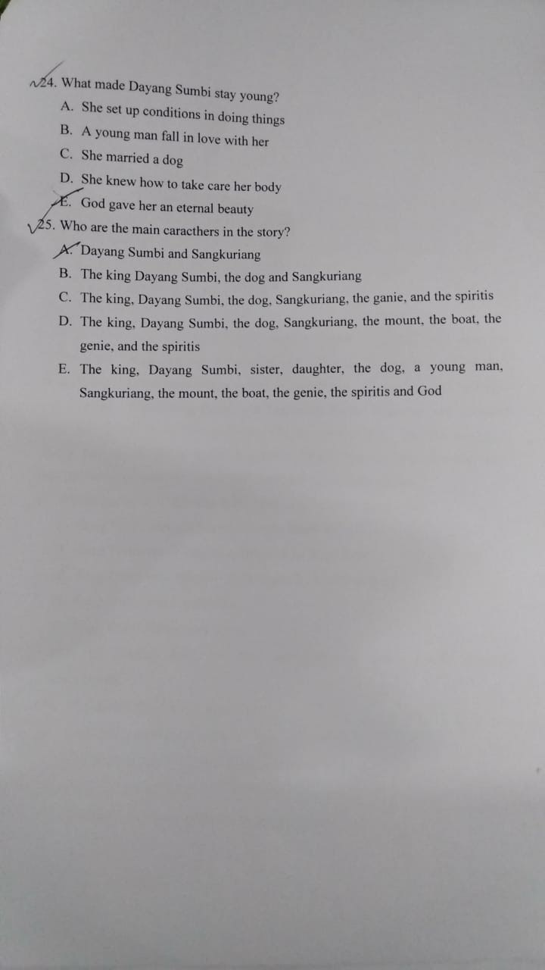

**APPENDIX 7**

**SCHOOL’S PROFILE**



JATI REJO

|  |
| --- |
| **Alamat : Jln.Galang KM.8 Desa Jatirejo Kecamatan Pagar Merbau Kab. Deli Serdang. Kode Pos. 20551** |

**PROFIL SEKOLAH**

1. Nama Sekolah : **MTSs. Al Washliyah Jati Rejo**
2. Alamat :
3. Jalan : **Jl. Galang km 8**
4. Desa/ Kelurahan : **Jati Rejo**
5. Kecamatan : **Pagar Merbau**
6. Kabupaten/ Kota : **Deli Serdang**
7. Provinsi : **Sumatera Utara**
8. Kode Pos : **20551**
9. No. Telepon/HP : 0821 6436 8742
10. Mulai operasional : Tahun 1991
11. Luas Tanah : 1072 m2
12. Luas Bangunan : 256 m2
13. Status Tanah : Wakaf
14. Status Bangunan : Wakaf
15. Terakreditasi : B
16. Visi, Misi dan Tujuan Sekolah
17. Visi Sekolah

”Belajar, Bekerja dan Beramal Adalah Prioritas Utama Dalam Menuju Masa Depan Yang Lebih Baik”

1. Misi Sekolah
2. Menjadikan Siswa-Siswi Mampu Bersaing Dalam Menggapai Ilmu untuk menjadi yang terbaik
3. Menciptakan Suasana Belajar yang Nyaman, Harmonis dan Islami.
4. Membina Siswa-Siswi untuk Dapat Beretika dan Berakhlak Mulia Didalam Keluarga dan Masyarakat.
5. Melahirkan Lulusan yang Handal yang Berwawasan Islam Sehingga Berguna Bagi Keluarga, Agama, Bangsa dan Negara.
6. Motto di MTSs. Al Washliyah Jati Rejo

Do’a : Ikhlas dan Sabar

Usaha : Gigih Tak Kenal Putus Asa

Ikhlas : Berbuat Sesuatu Karena Allah SWT.

Taqwa : Beriman Kepada Allah SWT.

1. Jumlah Guru dan Tenaga Pendukung
2. Jumlah PTK berdasarkan tingkat Kualifikasi Akademik

|  |  |  |  |  |  |  |  |  |
| --- | --- | --- | --- | --- | --- | --- | --- | --- |
| No | Status/ Jabatan | Tingkat Pendidikan Terakhir | | | | | | |
| < SLTP | SLTA | D2 | D3 | S1*) | S2 | S3 |
| 1. | Kepala Sekolah | - | - | - | - | 1 | - | - |
| 2. | Guru PNS | - | - | - | - | 1 | - | - |
| 3. | Guru Sertifikasi Honor | - | - | - | - | 2 | - | - |
| 4. | Guru Sukwan/Honor | - | - | - | - | 10 | - | - |
| 5. | Penjaga sekolah | 1 | - | - | - | - | - | - |

|  |  |  |  |  |  |  |  |  |  |  |  |  |  |  |  |
| --- | --- | --- | --- | --- | --- | --- | --- | --- | --- | --- | --- | --- | --- | --- | --- |
| **DAFTAR PEMBAGIAN TUGAS GURU MTs. AL- WASHLIYAH JATIREJO TAHUN PELAJARAN 2020 / 2021** | | | | | | | | | | | | | | | |
|  |  |  |  |  |  |  |  |  |  |  |  |  |  |  |  |
| No | Nama Sekolah dan alamat | Nama / NUPTK | L/P | Jabatan | Pendidikan | MAPEL yang Diajarkan | Beban Kerja di SATMINKAL | | | Tugas Tambahan pada SATMINKAL | | | | Total Beban JMT | Ket |
| Berdasarkan Jam Tatap Muka Dikelas | | | Kepla Madrasah | Wakil Kepala Madrasah | Wali Kelas | Ekskul Kir |
| VII | VIII | IX |
| 1 | Mts. Al-washliyah Jatirejo | **Mahdaleni, S.Pd.I** | L | Guru | S-1 | B. Inggris | - | - | 4 | 18 | - | - | - | 22 | GBS |
| Jalan Galang km. 8 |  |  | - | - |  |
| 2 | Kec. Pagar Merbau | **Sukarmin, S.Pd.I** | L | Guru | S-1 | A. Akhlak | 2 | 2 | 2 | - | - | - | - | 24 | GSS |
| Kab. Deli Serdang | 9944746649200100 | FIQIH | 2 | 2 | 2 |
|  |  | Al. Hadist | 2 | 2 | 2 |
|  |  | SKI | 2 | 2 | 2 |
| 3 | Status Akreditas Diakui ( B ) | **Siti Fatimah, S.Pd.I** | P | Guru | S-1 | B. Arab | 3 | 3 | 3 | - | 12 | - | - | 27 | GSS |
| NSM 121.212.070.028 | 1645751653300070 | Nahwu Sharaf | 2 | 2 | 2 |
| 4 |  | **Arini** | P | Guru | MAN | IPA Terpadu | 4 | 4 | 4 | - | - | 6 | - | 18 | GBS |
|  | 3434765666300030 |  |  |  |  |
| 6 |  | **Lisma Hanum, S.Pd.I** | P | Guru | S-1 | Qira'ah | 2 | 2 | 2 | - | - | 6 | - | 12 | GBS |
|  | 2134764666300050 |  |  |  |  |
| 7 |  | **Novita Astria, S.Pd** | P | Guru | S-1 | Seni Budaya | 2 | 2 | 2 | - | - | - | - | 12 | GBS |
|  | - | PKN | 2 | 2 | 2 |
| 8 |  | **Azis Mawardi** | L | Guru | S-1 | Penjas | 2 | 2 | 2 | - | - | - | - | 6 | GBS |
|  | - |  |  |  |  |
| 9 |  | **Syahruni Rahmida Abdul,S.Pd** | P | Guru | S-1 | Prakarya | 2 | 2 | 2 | - | - | - | - | 6 | GBS |
|  | - |  |  |  |  |
| 10 |  | **Raisa Maulia Abdul** | P | Guru | MAN | Tata Usaha | 4 | 4 | 4 | - | - | 6 | - | 18 | GBS |
|  | - |  |  |  |  |
| 11 |  | **Chinta Rahayu** | P | Guru | MAN | B. Inggris | 4 | 4 | - | - | - | - | - | 8 | GBS |
|  | - |  |  |  |  |
| 12 |  | **Sury Irma Andriani, S.Pd** | P | Guru | S-1 | B.Indonesia | 4 | 4 | 4 | **-** | **-** | **-** | **-** | 12 | GBS |
|  | - |  |  |  |  |
| 13 |  | **Nury Hidayatika, S.Pd** | P | Guru | S-1 | Matematika | 4 | 4 | 4 | **-** | **-** | - | **-** | 18 | GBS |
|  | - |  |  |  |  |
| 14 |  | **Sarimadani Dalimunthe, S.Pd** | P | Guru | S-1 | IPS Terpadu | 4 | 4 | 4 | **-** | **-** | - | **-** | 12 | GBS |
|  | - |  |  |  |  |
|  | Ket : |  |  |  |  |  |  |  |  |  |  |  |  |  |  |
|  | GSS : Guru Sudah Sertifikasi | |  |  |  |  |  |  |  | Jati Rejo, 2021 | | |  |  |  |
|  | GBS : Guru Belum Sertifikasi | |  |  |  |  |  |  |  | Kepala Madrasah, | | |  |  |  |
|  | GPS : Guru Lagi Proses Sertifikasi | |  |  |  |  |  |  |  |  |  |  |  |  |  |
|  |  |  |  |  |  |  |  |  |  | dto |  |  |  |  |  |
|  |  |  |  |  |  |  |  |  |  |  |  |  |  |  |  |
|  |  |  |  |  |  |  |  |  |  | Mahdaleni, S.Pd.I | | |  |  |  |