**ACKNOWLEDGEMENTS**

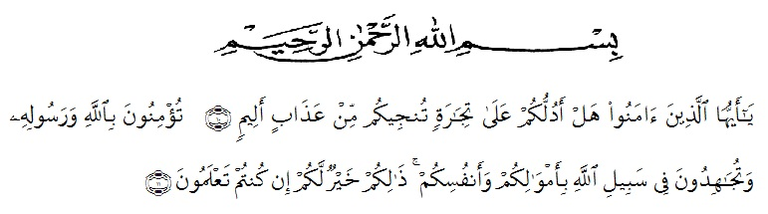

Meanings: "O you who believe, do you like me to show you a trade that can save you from a painful punishment? (ie) you believe in Allah and His Messenger and fight in His way with your wealth and soul, that is better for you if you know." (Surah ash-Shaff: 10-12).

Alhamdulillahi rabbil ‘alamin, the writer expresses her highest gratitude to Allah Subhanahu wa ta’ala for blessing, love, opportunity, health, and mercy in completing this thesis entitled “Improving Student’s Reading Comprehension Through Question-Answer Relationship of MTs Al-Washliyah Jati Rejo, Kec.Galang Academic Year 2019/2020” as the fulfillment to get degree of Sarjana Pendidikan at English Department, University of Muslim Nusantara Al Washliyah Medan. Shalawat is also sent to Prophet Muhammad shallallahu ‘alaihi wa sallam who had delivered the truth to human beings in general and Muslim in particular.

Therefore, the writer would like to express her great appreciation and special thanks to :

1. Dr. H. KRT Hardi Mulyono K Surbakti, SE., MAP as the rector University of Muslim Nusantara Al Wasliyah Medan.
2. Dr. Azhary Tambusai, M.A.as the first adviser who has contributed his time, knowledge, suggestion, guidance, comment or correction since the preliminary of manuscript until the completion of this thesis and to help the writer on supervising the draft writing it this thesis.
3. Zulfitri, S.S., M.A.the second adviser who has contributed her time, knowledge, suggestion, and comment to help the writer on supervising the draft writing this thesis.
4. All lectures at the English Department who have dedicated their valuable knowledge for her during the academic year at UMN Al Washliyah Medan.
5. Her beloved parents Legimin and Suwartik for all helps, attention, hard work, material support, and pray which give the writer spirit to finish the thesis.
6. Her beloved husband Bambang Sumantri who give spirit and pray which give writer to finish the thesis.
7. Her beloved brother and young sister Chandra syahputra and Silvia lestari who give spirit and attention to finish this thesis.
8. Her beloved friends Risdawanti, Santika dewi prayogi, Wilma, Wiwit, and Icha who give spirit, attention, and motivated the writer to finish this thesis
9. Her beloved classmates in FKIP UMN Al Washliyah Medan especially the VIII-A, her best friends in class, Tasya, Yolandri Lestari,
10. Dini Alvionita, Silvi Dewi Handayani, Aisyah, Ninda, Nurina, for all helps, attention and motivated for the writer to finish this thesis.

Finally, the writer offers her regards and blessing to all of those whose supported her in any respect during completion of this thesis, the writer cannot mention their name one by one.

Galang, August 2020

The writer

**Chinta Rahayu**