Rencana Pelaksanaan Pembelajaran
(RPP)

Satuan Pendidikan : SMA
Mata Pelajaran : Bahasa Inggris
Kelas/Semester : XI/1 (Experimental Class)
Skill/Keterampilan : Public Speaking

Standar Kompetensi :
Menyajikan pidato dengan baik dengan kemampuan komunikasi verbal dan non-verbal.

Kompetensi Dasar :
Menyajikan pidato (motivational speech) dengan baik dengan menggunakan komunikasi verbal dan non-verbal secara tepat dan berani.

- Tujuan Pembelajaran
Di akhir kegiatan pembelajaran siswa dapat:
- Memberikan motivasi kepada para pendengar melalui pidato yang dibawakan.
- Memahami komunikasi verbal dan non-verbal yang terdapat dalam public speaking.
- Berani dan percaya diri dalam menyampaikan suara di depan publik.

- Materi Pembelajaran
Motivational Speeches

RM of BTS – Speak Yourself
Maybe I made a mistake yesterday. But, yesterday’s me is still me. Today, I am who I am with all my faults and my mistakes. Tomorrow, I might be a tiny bit wiser, and that would be me too. These faults and mistakes are what I am.
I have come to love myself for who I am, for who I was, and for who I hope to become. So, let’s all take one more step. We have learned to love ourselves, so now I urge you to speak yourself.
I would like to ask all of you, “What is your name?” “What excites you and makes your heartbeat?” Tell me your story. I want to hear your voice. I want to hear your conviction – no matter who you are or where you’re from, your skin color, your gender identity. Just speak yourself. Find your name and find your voice by speaking yourself.

Selena Gomez – Trust Yourself
I’m surrounded by people who are supposed to guide me and some of them have and others haven’t. They pressure me, there’s so much pressure, you’ve got to be cute, you’ve got to be nice, you’ve got to be all these things!
And I’m sure you can all relate, you all have pressure that you have to deal with every day. I’m sure at school, at work, with friends, with parents, with family, parents, I know, sometimes with mine, they tell me what to wear, how to look, what I should say, how I should be. Until recently, I had given in to that pressure. I lost sight of who I was. I listened to opinions of people and I tried to change who I am because I thought that others would accept me for it. And I realized I don’t know how to be anything but myself.
The most important thing is that we learn and we continue to learn from each other. Please stay true to yourself, please just remain who you are and know that we have each other’s back, all of us have each other’s back. Be proud of yourselves.

- Teknik Pembelajaran : Role Play

- Langkah-langkah Kegiatan :
- Kegiatan Pendahuluan
- Memberi salam
- Berdoa
- Mengecek kehadiran
- Memperkenal topik
- Menjelaskan tujuan pembelajaran
- Kegiatan Inti
- Memperkenalkan public speaking dan role play
- Memberikan speech scripts pada masing-masing siswa
- Memberikan waktu pada siswa untuk mempelajari script dan mendalami peran
- Meminta siswa untuk membuat video dengan membawakan script dan peran yang sudah ditentukan
- Kegiatan Penutup
- Menilai penampilan video siswa
- Menyimpulkan materi pembelajaran

- Sumber Belajar
Video Youtube

- Penilaian
- Teknik : Tes Lisan
- Bentuk : Role Play
- Rubrik Penilaian

Criteria | No | Description | Rating Scores
 |  |  | High | Average |  |  |  | Low
 |  |  | 5 | 4 | 3 |  | 2 | 1
Content | 1 | States the purpose. | 5 | 4 |  | 3 | 2 | 1
 | 2 | Organizes the content. | 5 | 4 |  | 3 | 2 | 1
 | 3 | Supports ideas. | 5 | 4 |  | 3 | 2 | 1
 | 4 | Incorporates stories and examples. | 5 | 4 |  | 3 | 2 | 1
 | 5 | Summarizes the main idea(s). | 5 | 4 |  | 3 | 2 | 1
Delivery | 6 | Demonstrates awareness of listener’s needs. | 5 | 4 |  | 3 | 2 | 1
 | 7 | Speaks clearly with appropriate vocabulary and information. | 5 | 4 |  | 3 | 2 | 1
 | 8 | Uses tone, speed, and volume as tools. | 5 | 4 |  | 3 | 2 | 1
 | 9 | Demonstrates complexity of vocabulary and thought. | 5 | 4 |  | 3 | 2 | 1
 | 10 | Appears comfortable with audience. | 5 | 4 |  | 3 | 2 | 1

$$Total score=\frac{total rating scores}{50} x 100$$

Medan, Juni 2021
Mengetahui,
Kepala Sekolah | Guru Praktikum Bahasa Inggris
Ibrahim Arbi, S.Ag., S.Pd.I | Suria Suchi Dwi Putri

Rencana Pelaksanaan Pembelajaran
(RPP)

Satuan Pendidikan : SMA
Mata Pelajaran : Bahasa Inggris
Kelas/Semester : XI/1 (Control Class)
Skill/Keterampilan : Public Speaking

Standar Kompetensi :
Menyajikan pidato dengan baik dengan kemampuan komunikasi verbal dan non-verbal.

Kompetensi Dasar :
Menyajikan pidato (motivational speech) dengan baik dengan menggunakan komunikasi verbal dan non-verbal secara tepat dan berani.

- Tujuan Pembelajaran
Di akhir kegiatan pembelajaran siswa dapat:
- Memberikan motivasi kepada para pendengar melalui pidato yang dibawakan.
- Memahami komunikasi verbal dan non-verbal yang terdapat dalam public speaking.
- Berani dan percaya diri dalam menyampaikan suara di depan publik.

- Materi Pembelajaran
Motivational Speeches

RM of BTS – Speak Yourself
Maybe I made a mistake yesterday. But, yesterday’s me is still me. Today, I am who I am with all my faults and my mistakes. Tomorrow, I might be a tiny bit wiser, and that would be me too. These faults and mistakes are what I am.
I have come to love myself for who I am, for who I was, and for who I hope to become. So, let’s all take one more step. We have learned to love ourselves, so now I urge you to speak yourself.
I would like to ask all of you, “What is your name?” “What excites you and makes your heartbeat?” Tell me your story. I want to hear your voice. I want to hear your conviction – no matter who you are or where you’re from, your skin color, your gender identity. Just speak yourself. Find your name and find your voice by speaking yourself.

Selena Gomez – Trust Yourself
I’m surrounded by people who are supposed to guide me and some of them have and others haven’t. They pressure me, there’s so much pressure, you’ve got to be cute, you’ve got to be nice, you’ve got to be all these things!
And I’m sure you can all relate, you all have pressure that you have to deal with every day. I’m sure at school, at work, with friends, with parents, with family, parents, I know, sometimes with mine, they tell me what to wear, how to look, what I should say, how I should be. Until recently, I had given in to that pressure. I lost sight of who I was. I listened to opinions of people and I tried to change who I am because I thought that others would accept me for it. And I realized I don’t know how to be anything but myself.
The most important thing is that we learn and we continue to learn from each other. Please stay true to yourself, please just remain who you are and know that we have each other’s back, all of us have each other’s back. Be proud of yourselves.

Opening:
- Say greetings then introducing yourself.
- Introduce the speech you will bring, such as:
- An honorable to deliver/bring a speech by … with the title …
- I would like to deliver/bring a speech by … entitled …
- I would like to share these great speech by … entitled …
- Etc,.
Content:
Deliver the speech properly with verbal and non-verbal communication aspects.
Closing:
Close your performance with say thank you and greetings.

- Teknik Pembelajaran : Conventional

- Langkah-langkah Kegiatan :
- Kegiatan Pendahuluan
- Memberi salam
- Berdoa
- Mengecek kehadiran
- Memperkenal topik
- Menjelaskan tujuan pembelajaran
- Kegiatan Inti
- Memperkenalkan public speaking
- Memberikan speech scripts pada masing-masing siswa
- Memberikan waktu pada siswa untuk mempelajari script dan mendalami peran
- Meminta siswa untuk membuat video dengan membawakan script dan peran yang sudah ditentukan
- Kegiatan Penutup
- Menilai penampilan video siswa
- Menyimpulkan materi pembelajaran
- Sumber Belajar
Video Youtube

- Penilaian
- Teknik : Tes Lisan
- Bentuk : Oral
- Rubrik Penilaian

Criteria | No | Description | Rating Scores
 |  |  | High | Average |  |  |  | Low
 |  |  | 5 | 4 | 3 |  | 2 | 1
Content | 1 | States the purpose. | 5 | 4 |  | 3 | 2 | 1
 | 2 | Organizes the content. | 5 | 4 |  | 3 | 2 | 1
 | 3 | Supports ideas. | 5 | 4 |  | 3 | 2 | 1
 | 4 | Incorporates stories and examples. | 5 | 4 |  | 3 | 2 | 1
 | 5 | Summarizes the main idea(s). | 5 | 4 |  | 3 | 2 | 1
Delivery | 6 | Demonstrates awareness of listener’s needs. | 5 | 4 |  | 3 | 2 | 1
 | 7 | Speaks clearly with appropriate vocabulary and information. | 5 | 4 |  | 3 | 2 | 1
 | 8 | Uses tone, speed, and volume as tools. | 5 | 4 |  | 3 | 2 | 1
 | 9 | Demonstrates complexity of vocabulary and thought. | 5 | 4 |  | 3 | 2 | 1
 | 10 | Appears comfortable with audience. | 5 | 4 |  | 3 | 2 | 1

$$Total score=\frac{total rating scores}{50} x 100$$

Medan, Juni 2021
Mengetahui,
Kepala Sekolah | Guru Praktikum Bahasa Inggris
Ibrahim Arbi, S.Ag., S.Pd.I | Suria Suchi Dwi Putri

Explanation of Public Speaking Rubric
Criteria | No | Description | Rating Scores
 |  |  | High | Average |  |  |  | Low
 |  |  | 5 | 4 | 3 |  | 2 | 1
Content | 1 | States the purpose. | 5 | 4 |  | 3 | 2 | 1
 | 2 | Organizes the content. | 5 | 4 |  | 3 | 2 | 1
 | 3 | Supports ideas. | 5 | 4 |  | 3 | 2 | 1
 | 4 | Incorporates stories and examples. | 5 | 4 |  | 3 | 2 | 1
 | 5 | Summarizes the main idea(s). | 5 | 4 |  | 3 | 2 | 1
Delivery | 6 | Demonstrates awareness of listener’s needs. | 5 | 4 |  | 3 | 2 | 1
 | 7 | Speaks clearly with appropriate vocabulary and information. | 5 | 4 |  | 3 | 2 | 1
 | 8 | Uses tone, speed, and volume as tools. | 5 | 4 |  | 3 | 2 | 1
 | 9 | Demonstrates complexity of vocabulary and thought. | 5 | 4 |  | 3 | 2 | 1
 | 10 | Appears comfortable with audience. | 5 | 4 |  | 3 | 2 | 1

Score on a scale of 5 to 1
Use whole numbers only. Below are descriptions of some of the range. A score of 4 or 2 are in the middle. For #1, for example, a “4” would be “somewhat” clear, a “2” would be somewhat evident but not entirely. Please print out and use the rubric above, circling the applicable numbers.
Content
- States the purpose.
_{Points} _{Criteria}
5 | The purpose is clear and captures the listener’s attention.
3 | The purpose is apparent.
1 | The purpose is not evident.

- Organizes the content.
_{Points} _{Criteria}
5 | The content is organized logically with fluid transitions to capture and hold the listener’s attention throughout the entire presentation.
3 | The organization of the content is congruent; transitions are evident.
1 | The content lacks organization; transitions are abrupt and distracting.

- Support ideas.
_{Points} _{Criteria}
5 | Important details add to the interest and depth of the presentation; details work to connect the listener to the speech.
3 | The speaker provides the basic details necessary for the listeners to understand the premise of the presentation.
1 | The majority of ideas are unsupported by additional information or explanation.

- Incorporates stories and examples.
_{Points} _{Criteria}
5 | Relevant examples or stories work to interest the listener and further develop main ideas.
3 | Stories and examples obviously relate to the content of the speech.
1 | Stories and examples are missing or unrelated.

- Summarizes the main idea(s).
_{Points} _{Criteria}
5 | The conclusion unites the important points of the presentation and encourages future discussion.
3 | The conclusion summarizes the main ideas.
1 | The speech ends without a summary.

Delivery
- Demonstrates awareness of listener’s needs.
_{Points} _{Criteria}
5 | The choices of language, examples, and aids work together to heighten the listener’s interest and connection to the topic.
3 | The speaker’s word choices, explanations, and enthusiasm are appropriate for the topic and for each point; appropriate aids are incorporated.
1 | The presentation is uninteresting.

- Speaks clearly with appropriate vocabulary and information.
_{Points} _{Criteria}
5 | The vocabulary is descriptive and accurate, engaging the listener through imagery.
3 | The vocabulary provides clarity and avoids confusion.
1 | The vocabulary is awkward or inappropriate for the topic, making the speaker difficult to understand.

- Uses tone, speed, and volume as tools.
_{Points} _{Criteria}
5 | The speaker manipulates tone, speed, and volume, using these tools to emphasize important ideas and hold the listener’s attention.
3 | The speaker avoids distracting vocal fillers or physical mannerisms and uses adequate speed and volume throughout the presentation.
1 | Vocal fillers are present throughout the presentation. Speed and volume are inappropriate for the presentation.

- Demonstrates complexity of thought and vocabulary.
_{Points} _{Criteria}
5 | Variation of sentence structure and word choice works to keep the listener interested and provides multiple examples and descriptions.
3 | Sentence structure and word choice are varied to avoid monotony of tone and repetition of ideas.
1 | Sentence structure and word choice are monotonous and uninteresting.

- Appears comfortable with audience.
_{Points} _{Criteria}
5 | Eye contact, interaction with aids, and physical gestures demonstrate the speaker’s energy and interest, guiding the listener through the presentation.
3 | Eye contact, interaction with aids, and physical gestures are natural and fluid.
1 | Eye contact with the audience is lacking. Gestures are missing or awkward. The speaker depends heavily on the written speech or notes.

Class XI – MIPA 1 Pre-Test (Experimental Class)
No | Name | Content |  |  |  |  | Delivery |  |  |  |  | Score | Total Score
 |  | 1 | 2 | 3 | 4 | 5 | 6 | 7 | 8 | 9 | 10
1 | Adi Wangsa | 3 | 3 | 5 | 5 | 5 | 3 | 2 | 1 | 3 | 1 | 31 | 62
2 | Ayu Nanda Putri | 2 | 2 | 5 | 5 | 5 | 3 | 1 | 1 | 3 | 1 | 28 | 56
3 | Az-Zahra Andini | 3 | 3 | 5 | 5 | 5 | 3 | 3 | 1 | 3 | 3 | 34 | 68
4 | Delfanza Balqis | 3 | 3 | 5 | 5 | 5 | 3 | 2 | 1 | 3 | 1 | 31 | 62
5 | Desta Andrian Wijaya | 3 | 3 | 5 | 5 | 5 | 3 | 2 | 1 | 3 | 1 | 31 | 62
6 | Dhea Alfyonita Fadhila | 3 | 3 | 5 | 5 | 5 | 3 | 2 | 1 | 3 | 1 | 31 | 62
7 | Dio Fahry Ramadhan | 4 | 4 | 5 | 5 | 5 | 3 | 4 | 4 | 3 | 4 | 41 | 82
8 | Hairun Tsaniah Azhari | 3 | 3 | 5 | 5 | 5 | 3 | 2 | 1 | 3 | 2 | 32 | 64
9 | Khairunnisa Nst | 3 | 3 | 5 | 5 | 5 | 3 | 3 | 2 | 3 | 2 | 34 | 68
10 | Kharisma | 2 | 2 | 5 | 5 | 5 | 3 | 2 | 2 | 3 | 2 | 31 | 62
11 | Khairul Arifin | 3 | 3 | 5 | 5 | 5 | 3 | 3 | 2 | 3 | 3 | 35 | 70
12 | Maily Chung | 4 | 4 | 5 | 5 | 5 | 3 | 4 | 4 | 3 | 4 | 41 | 82
13 | Mifthahul Jannah Adha Nasution | 4 | 4 | 5 | 5 | 5 | 3 | 4 | 4 | 3 | 3 | 40 | 80
14 | Muhammad Arief Ikhsan | 3 | 3 | 5 | 5 | 5 | 3 | 2 | 3 | 3 | 2 | 34 | 68
15 | M. Aqmal Lubis | 2 | 2 | 5 | 5 | 5 | 3 | 2 | 1 | 3 | 1 | 29 | 58
16 | M. Fhadlan Ananda | 2 | 2 | 5 | 5 | 5 | 3 | 1 | 2 | 3 | 1 | 29 | 58
17 | M. Fadhlin Ananda | 2 | 2 | 5 | 5 | 5 | 3 | 2 | 2 | 3 | 1 | 30 | 60
18 | M. Hafis | 3 | 3 | 5 | 5 | 5 | 3 | 3 | 3 | 3 | 2 | 35 | 70
19 | M. Rifaldy Chery | 1 | 1 | 5 | 5 | 5 | 3 | 1 | 1 | 3 | 1 | 26 | 52
20 | Nabila Putri | 2 | 2 | 5 | 5 | 5 | 3 | 2 | 2 | 3 | 1 | 30 | 60
21 | Nadilla Muthalib | 2 | 2 | 5 | 5 | 5 | 3 | 2 | 2 | 3 | 1 | 30 | 60
22 | Naila Putri Siregar | 3 | 3 | 5 | 5 | 5 | 3 | 3 | 3 | 3 | 3 | 36 | 72
23 | Nazwa Maisya Nasution | 3 | 3 | 5 | 5 | 5 | 3 | 4 | 4 | 3 | 3 | 38 | 76
24 | Novita Savitri A. | 3 | 3 | 5 | 5 | 5 | 3 | 2 | 2 | 3 | 2 | 33 | 66
25 | Nurul Nisrina | 3 | 3 | 5 | 5 | 5 | 3 | 3 | 3 | 3 | 3 | 35 | 72
26 | Qamaruddin Fadhilah Harahap | 3 | 3 | 5 | 5 | 5 | 3 | 3 | 3 | 3 | 2 | 35 | 70
27 | Revita Dewi | 2 | 2 | 5 | 5 | 5 | 3 | 3 | 1 | 3 | 1 | 30 | 60
28 | Risna Putri Ariani | 3 | 3 | 5 | 5 | 5 | 3 | 2 | 2 | 3 | 2 | 33 | 66
29 | Rizky Ashandi Pulungan | 1 | 1 | 5 | 5 | 5 | 3 | 1 | 2 | 3 | 1 | 27 | 54
30 | Roffi Qosbi | 1 | 1 | 5 | 5 | 5 | 3 | 2 | 2 | 3 | 1 | 28 | 56
31 | Salsabila Nofitria | 2 | 2 | 5 | 5 | 5 | 3 | 2 | 1 | 3 | 1 | 29 | 58
32 | Sarifah Hidayah | 3 | 3 | 5 | 5 | 5 | 3 | 2 | 2 | 3 | 2 | 33 | 66
33 | Sartika Mahari Nst | 3 | 3 | 5 | 5 | 5 | 3 | 2 | 2 | 3 | 2 | 33 | 66
34 | Sri Wahyuni Putri | 2 | 2 | 5 | 5 | 5 | 3 | 2 | 1 | 3 | 2 | 30 | 60
35 | Tatia Ramadhani | 3 | 3 | 5 | 5 | 5 | 3 | 3 | 2 | 3 | 2 | 34 | 68
36 | Zaki Asyrof Ibrahim | 2 | 2 | 5 | 5 | 5 | 3 | 2 | 1 | 3 | 1 | 29 | 58
Mean Score |  |  |  |  |  |  |  |  |  |  |  |  | 64.83

Class XI – MIPA 1 Post-Test (Experimental Class)
No | Name | Content |  |  |  |  | Delivery |  |  |  |  | Score | Total Score
 |  | 1 | 2 | 3 | 4 | 5 | 6 | 7 | 8 | 9 | 10
1 | Adi Wangsa | 3 | 3 | 5 | 5 | 5 | 3 | 2 | 2 | 3 | 2 | 33 | 66
2 | Ayu Nanda Putri | 3 | 3 | 5 | 5 | 5 | 3 | 2 | 2 | 3 | 2 | 33 | 66
3 | Az-Zahra Andini | 3 | 3 | 5 | 5 | 5 | 3 | 3 | 2 | 3 | 3 | 35 | 70
4 | Delfanza Balqis | 3 | 3 | 5 | 5 | 5 | 3 | 3 | 2 | 3 | 2 | 34 | 68
5 | Desta Andrian Wijaya | 3 | 3 | 5 | 5 | 5 | 3 | 3 | 2 | 3 | 2 | 34 | 68
6 | Dhea Alfyonita Fadhila | 3 | 3 | 5 | 5 | 5 | 3 | 3 | 2 | 3 | 2 | 34 | 68
7 | Dio Fahry Ramadhan | 4 | 4 | 5 | 5 | 5 | 3 | 5 | 4 | 3 | 4 | 43 | 86
8 | Hairun Tsaniah Azhari | 3 | 3 | 5 | 5 | 5 | 3 | 3 | 2 | 3 | 3 | 35 | 70
9 | Khairunnisa Nst | 3 | 3 | 5 | 5 | 5 | 3 | 4 | 3 | 3 | 3 | 37 | 74
10 | Kharisma | 3 | 3 | 5 | 5 | 5 | 3 | 3 | 3 | 3 | 3 | 36 | 72
11 | Khairul Arifin | 3 | 3 | 5 | 5 | 5 | 3 | 4 | 3 | 3 | 3 | 37 | 74
12 | Maily Chung | 4 | 5 | 5 | 5 | 5 | 3 | 5 | 4 | 3 | 5 | 44 | 88
13 | Mifthahul Jannah Adha Nasution | 4 | 5 | 5 | 5 | 5 | 3 | 5 | 4 | 3 | 4 | 43 | 86
14 | Muhammad Arief Ikhsan | 3 | 3 | 5 | 5 | 5 | 3 | 3 | 3 | 3 | 3 | 36 | 72
15 | M. Aqmal Lubis | 3 | 3 | 5 | 5 | 5 | 3 | 3 | 2 | 3 | 2 | 34 | 68
16 | M. Fhadlan Ananda | 3 | 3 | 5 | 5 | 5 | 3 | 2 | 3 | 3 | 2 | 34 | 68
17 | M. Fadhlin Ananda | 3 | 3 | 5 | 5 | 5 | 3 | 3 | 3 | 3 | 2 | 35 | 70
18 | M. Hafis | 3 | 3 | 5 | 5 | 5 | 3 | 4 | 4 | 3 | 3 | 38 | 76
19 | M. Rifaldy Chery | 3 | 3 | 5 | 5 | 5 | 3 | 2 | 2 | 3 | 2 | 33 | 66
20 | Nabila Putri | 3 | 3 | 5 | 5 | 5 | 3 | 3 | 3 | 3 | 2 | 35 | 70
21 | Nadilla Muthalib | 3 | 3 | 5 | 5 | 5 | 3 | 3 | 3 | 3 | 2 | 35 | 70
22 | Naila Putri Siregar | 3 | 4 | 5 | 5 | 5 | 3 | 4 | 3 | 3 | 4 | 39 | 78
23 | Nazwa Maisya Nasution | 4 | 5 | 5 | 5 | 5 | 3 | 5 | 4 | 3 | 5 | 44 | 88
24 | Novita Savitri A. | 3 | 3 | 5 | 5 | 5 | 3 | 3 | 3 | 3 | 3 | 36 | 72
25 | Nurul Nisrina | 4 | 5 | 5 | 5 | 5 | 3 | 4 | 4 | 3 | 4 | 42 | 84
26 | Qamaruddin Fadhilah Harahap | 3 | 3 | 5 | 5 | 5 | 3 | 4 | 3 | 3 | 3 | 37 | 74
27 | Revita Dewi | 3 | 3 | 5 | 5 | 5 | 3 | 4 | 2 | 3 | 2 | 35 | 70
28 | Risna Putri Ariani | 3 | 3 | 5 | 5 | 5 | 3 | 3 | 3 | 3 | 3 | 36 | 72
29 | Rizky Ashandi Pulungan | 2 | 2 | 5 | 5 | 5 | 3 | 1 | 2 | 3 | 2 | 30 | 60
30 | Roffi Qosbi | 2 | 2 | 5 | 5 | 5 | 3 | 3 | 2 | 3 | 2 | 32 | 64
31 | Salsabila Nofitria | 3 | 3 | 5 | 5 | 5 | 3 | 3 | 2 | 3 | 2 | 34 | 68
32 | Sarifah Hidayah | 3 | 3 | 5 | 5 | 5 | 3 | 3 | 3 | 3 | 3 | 36 | 72
33 | Sartika Mahari Nst | 3 | 3 | 5 | 5 | 5 | 3 | 3 | 3 | 3 | 3 | 36 | 72
34 | Sri Wahyuni Putri | 3 | 3 | 5 | 5 | 5 | 3 | 3 | 2 | 3 | 3 | 35 | 70
35 | Tatia Ramadhani | 3 | 3 | 5 | 5 | 5 | 3 | 3 | 3 | 3 | 3 | 36 | 72
36 | Zaki Asyrof Ibrahim | 3 | 3 | 5 | 5 | 5 | 3 | 3 | 3 | 3 | 3 | 36 | 72
Mean Score |  |  |  |  |  |  |  |  |  |  |  |  | 72.38

Class XI – MIPA 2 Pre-Test (Control Class)
No | Name | Content |  |  |  |  | Delivery |  |  |  |  | Score | Total Score
 |  | 1 | 2 | 3 | 4 | 5 | 6 | 7 | 8 | 9 | 10
1 | Alfiya Tsabilah | 2 | 2 | 5 | 5 | 5 | 3 | 2 | 2 | 3 | 1 | 30 | 60
2 | Amanda Amelia Setyorini | 2 | 2 | 5 | 5 | 5 | 3 | 2 | 1 | 3 | 1 | 29 | 58
3 | Amanda Putri Salsabila | 2 | 2 | 5 | 5 | 5 | 3 | 3 | 2 | 3 | 1 | 31 | 62
4 | Andini Dwi Puspita Sari | 2 | 2 | 5 | 5 | 5 | 3 | 2 | 1 | 3 | 1 | 29 | 58
5 | Arriyaan Rizqi Ramadhan P | 2 | 2 | 5 | 5 | 5 | 3 | 2 | 1 | 3 | 1 | 29 | 58
6 | Arza Ratu Zahra | 3 | 3 | 5 | 5 | 5 | 3 | 3 | 2 | 3 | 1 | 33 | 66
7 | Ayu Lestari | 3 | 3 | 5 | 5 | 5 | 3 | 3 | 3 | 3 | 3 | 36 | 72
8 | Az Zahra Dwi Putri | 3 | 3 | 5 | 5 | 5 | 3 | 3 | 3 | 3 | 3 | 36 | 72
9 | Cindy Emalinda Putri S | 2 | 2 | 5 | 5 | 5 | 3 | 3 | 1 | 3 | 1 | 30 | 60
10 | Dhea Ema Nurlia | 3 | 3 | 5 | 5 | 5 | 3 | 3 | 2 | 3 | 2 | 34 | 68
11 | Difa Luthfi Az-Zahra | 2 | 2 | 5 | 5 | 5 | 3 | 2 | 1 | 3 | 1 | 29 | 58
12 | Dimas Eka Pradilla | 3 | 3 | 5 | 5 | 5 | 3 | 2 | 2 | 3 | 2 | 33 | 66
13 | Elvina Nur Annisa | 2 | 2 | 5 | 5 | 5 | 3 | 3 | 2 | 3 | 1 | 31 | 62
14 | Fajri Ramadhan | 3 | 3 | 5 | 5 | 5 | 3 | 3 | 3 | 3 | 3 | 36 | 72
15 | Fitri Amelia | 2 | 2 | 5 | 5 | 5 | 3 | 2 | 1 | 3 | 1 | 29 | 58
16 | Hafiz Khalik Lubis | 2 | 2 | 5 | 5 | 5 | 3 | 2 | 1 | 3 | 1 | 29 | 58
17 | Hanifah Sindy Utami | 2 | 2 | 5 | 5 | 5 | 3 | 2 | 1 | 3 | 1 | 30 | 60
18 | Ihsan Achsan | 2 | 2 | 5 | 5 | 5 | 3 | 3 | 2 | 3 | 2 | 32 | 64
19 | M Khayrul Reza Simbolon | 3 | 3 | 5 | 5 | 5 | 3 | 3 | 3 | 3 | 2 | 35 | 70
20 | Muas Farhanda Friski | 2 | 2 | 5 | 5 | 5 | 3 | 1 | 1 | 3 | 1 | 28 | 56
21 | M Rozan Pratama | 3 | 3 | 5 | 5 | 5 | 3 | 3 | 3 | 3 | 3 | 36 | 72
22 | Nadine Rara Pranosa | 2 | 2 | 5 | 5 | 5 | 3 | 2 | 2 | 3 | 2 | 31 | 62
23 | Najma Khairunnisa Nst | 3 | 3 | 5 | 5 | 5 | 3 | 2 | 2 | 3 | 2 | 33 | 66
24 | Nayara Sabila Lubis | 2 | 2 | 5 | 5 | 5 | 3 | 2 | 1 | 3 | 1 | 29 | 58
25 | Nayla Hadisti | 3 | 3 | 5 | 5 | 5 | 3 | 4 | 4 | 3 | 4 | 39 | 78
26 | Nirmala Rahmadani | 3 | 3 | 5 | 5 | 5 | 3 | 2 | 2 | 3 | 3 | 34 | 68
27 | Putri Maharani | 2 | 2 | 5 | 5 | 5 | 3 | 2 | 1 | 3 | 2 | 30 | 60
28 | Ranti Artika Lestari | 2 | 2 | 5 | 5 | 5 | 3 | 1 | 1 | 3 | 1 | 28 | 56
29 | Ratna Triana | 2 | 2 | 5 | 5 | 5 | 3 | 1 | 1 | 3 | 2 | 29 | 58
30 | Retno Triani | 2 | 2 | 5 | 5 | 5 | 3 | 2 | 1 | 3 | 2 | 30 | 60
31 | Rizki Fatahillah Hutasuhut | 3 | 3 | 5 | 5 | 5 | 3 | 4 | 4 | 3 | 3 | 38 | 76
32 | Rosa Sari Amalia Nst | 3 | 3 | 5 | 5 | 5 | 3 | 3 | 3 | 3 | 3 | 36 | 72
33 | Sigit Dwi Cahyo | 3 | 3 | 5 | 5 | 5 | 3 | 3 | 2 | 3 | 2 | 34 | 68
34 | Siti Laila Karimah | 3 | 3 | 5 | 5 | 5 | 3 | 2 | 3 | 3 | 3 | 35 | 70
35 | Zahra Maulida Rasyida | 3 | 3 | 5 | 5 | 5 | 3 | 2 | 3 | 3 | 2 | 34 | 68
Mean Score |  |  |  |  |  |  |  |  |  |  |  |  | 64.28

Class XI – MIPA 2 Post-Test (Control Class)
No | Name | Content |  |  |  |  | Delivery |  |  |  |  | Score | Total Score
 |  | 1 | 2 | 3 | 4 | 5 | 6 | 7 | 8 | 9 | 10
1 | Alfiya Tsabilah | 3 | 3 | 5 | 5 | 5 | 3 | 3 | 3 | 3 | 3 | 36 | 72
2 | Amanda Amelia Setyorini | 3 | 3 | 5 | 5 | 5 | 3 | 2 | 2 | 3 | 2 | 33 | 66
3 | Amanda Putri Salsabila | 3 | 3 | 5 | 5 | 5 | 3 | 3 | 3 | 3 | 3 | 36 | 72
4 | Andini Dwi Puspita Sari | 3 | 3 | 5 | 5 | 5 | 3 | 2 | 2 | 3 | 2 | 33 | 66
5 | Arriyaan Rizqi Ramadhan P | 3 | 3 | 5 | 5 | 5 | 3 | 2 | 2 | 3 | 2 | 33 | 66
6 | Arza Ratu Zahra | 3 | 3 | 5 | 5 | 5 | 3 | 3 | 3 | 3 | 2 | 35 | 70
7 | Ayu Lestari | 3 | 3 | 5 | 5 | 5 | 3 | 4 | 4 | 3 | 4 | 39 | 78
8 | Az Zahra Dwi Putri | 3 | 3 | 5 | 5 | 5 | 3 | 3 | 4 | 3 | 4 | 38 | 76
9 | Cindy Emalinda Putri S | 2 | 2 | 5 | 5 | 5 | 3 | 3 | 2 | 3 | 2 | 32 | 64
10 | Dhea Ema Nurlia | 4 | 4 | 5 | 5 | 5 | 3 | 4 | 3 | 3 | 3 | 39 | 76
11 | Difa Luthfi Az-Zahra | 4 | 4 | 5 | 5 | 5 | 3 | 4 | 3 | 3 | 3 | 39 | 78
12 | Dimas Eka Pradilla | 3 | 3 | 5 | 5 | 5 | 3 | 3 | 2 | 3 | 3 | 35 | 70
13 | Elvina Nur Annisa | 3 | 3 | 5 | 5 | 5 | 3 | 3 | 3 | 3 | 2 | 35 | 70
14 | Fajri Ramadhan | 3 | 3 | 5 | 5 | 5 | 3 | 3 | 4 | 3 | 4 | 38 | 76
15 | Fitri Amelia | 3 | 3 | 5 | 5 | 5 | 3 | 2 | 2 | 3 | 2 | 33 | 66
16 | Hafiz Khalik Lubis | 3 | 3 | 5 | 5 | 5 | 3 | 3 | 2 | 3 | 2 | 34 | 68
17 | Hanifah Sindy Utami | 3 | 3 | 5 | 5 | 5 | 3 | 2 | 2 | 3 | 2 | 33 | 66
18 | Ihsan Achsan | 3 | 3 | 5 | 5 | 5 | 3 | 3 | 2 | 3 | 3 | 35 | 70
19 | M Khayrul Reza Simbolon | 3 | 3 | 5 | 5 | 5 | 3 | 3 | 4 | 3 | 3 | 37 | 74
20 | Muas Farhanda Friski | 3 | 3 | 5 | 5 | 5 | 3 | 1 | 2 | 3 | 2 | 32 | 64
21 | M Rozan Pratama | 4 | 5 | 5 | 5 | 5 | 3 | 4 | 5 | 3 | 5 | 44 | 88
22 | Nadine Rara Pranosa | 3 | 3 | 5 | 5 | 5 | 3 | 2 | 3 | 3 | 3 | 35 | 70
23 | Najma Khairunnisa Nst | 3 | 3 | 5 | 5 | 5 | 3 | 2 | 3 | 3 | 3 | 35 | 70
24 | Nayara Sabila Lubis | 3 | 3 | 5 | 5 | 5 | 3 | 2 | 2 | 3 | 3 | 34 | 68
25 | Nayla Hadisti | 5 | 4 | 5 | 5 | 5 | 3 | 5 | 4 | 3 | 5 | 44 | 88
26 | Nirmala Rahmadani | 3 | 3 | 5 | 5 | 5 | 3 | 3 | 3 | 3 | 3 | 36 | 72
27 | Putri Maharani | 3 | 3 | 5 | 5 | 5 | 3 | 2 | 2 | 3 | 3 | 34 | 68
28 | Ranti Artika Lestari | 3 | 3 | 5 | 5 | 5 | 3 | 3 | 2 | 3 | 2 | 34 | 68
29 | Ratna Triana | 3 | 3 | 5 | 5 | 5 | 3 | 2 | 2 | 3 | 3 | 34 | 68
30 | Retno Triani | 3 | 3 | 5 | 5 | 5 | 3 | 2 | 2 | 3 | 3 | 34 | 68
31 | Rizki Fatahillah Hutasuhut | 4 | 5 | 5 | 5 | 5 | 3 | 5 | 5 | 3 | 4 | 44 | 88
32 | Rosa Sari Amalia Nst | 3 | 3 | 5 | 5 | 5 | 3 | 4 | 3 | 3 | 4 | 38 | 76
33 | Sigit Dwi Cahyo | 4 | 4 | 5 | 5 | 5 | 3 | 4 | 3 | 3 | 4 | 40 | 80
34 | Siti Laila Karimah | 3 | 3 | 5 | 5 | 5 | 3 | 3 | 3 | 3 | 4 | 37 | 74
35 | Zahra Maulida Rasyida | 4 | 4 | 5 | 5 | 5 | 3 | 3 | 4 | 3 | 4 | 40 | 80
Mean Score |  |  |  |  |  |  |  |  |  |  |  |  | 72.4

Speak Yourself
By RM of BTS

Maybe I made a mistake yesterday. But, yesterday’s me is still me. Today, I am who I am with all my faults and my mistakes. Tomorrow, I might be a tiny bit wiser, and that would be me too. These faults and mistakes are what I am.
I have come to love myself for who I am, for who I was, and for who I hope to become. So, let’s all take one more step. We have learned to love ourselves, so now I urge you to speak yourself.
I would like to ask all of you, “What is your name?” “What excites you and makes your heartbeat?” Tell me your story. I want to hear your voice. I want to hear your conviction – no matter who you are or where you’re from, your skin color, your gender identity. Just speak yourself. Find your name and find your voice by speaking yourself.

Trust Yourself
By Selena Gomez

I’m surrounded by people who are supposed to guide me and some of them have and others haven’t. They pressure me, there’s so much pressure, you’ve got to be cute, you’ve got to be nice, you’ve got to be all these things!
And I’m sure you can all relate, you all have pressure that you have to deal with every day. I’m sure at school, at work, with friends, with parents, with family, parents, I know, sometimes with mine, they tell me what to wear, how to look, what I should say, how I should be. Until recently, I had given in to that pressure. I lost sight of who I was. I listened to opinions of people and I tried to change who I am because I thought that others would accept me for it. And I realized I don’t know how to be anything but myself.
The most important thing is that we learn and we continue to learn from each other. Please stay true to yourself, please just remain who you are and know that we have each other’s back, all of us have each other’s back. Be proud of yourselves.

Documentations

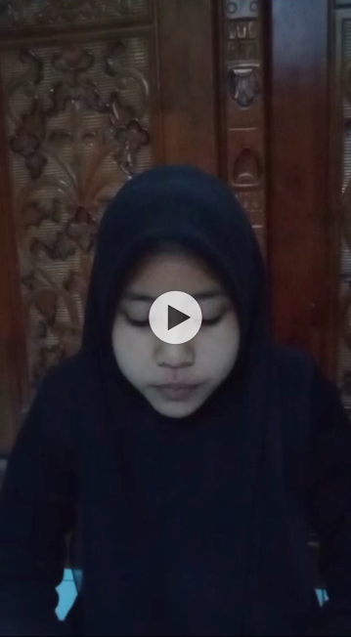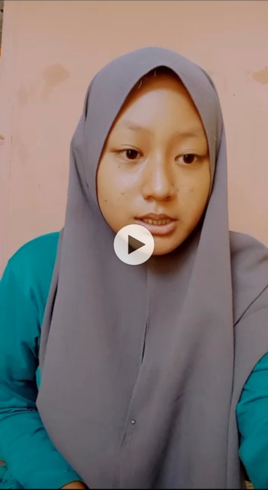

(Videos of Pre-Test)

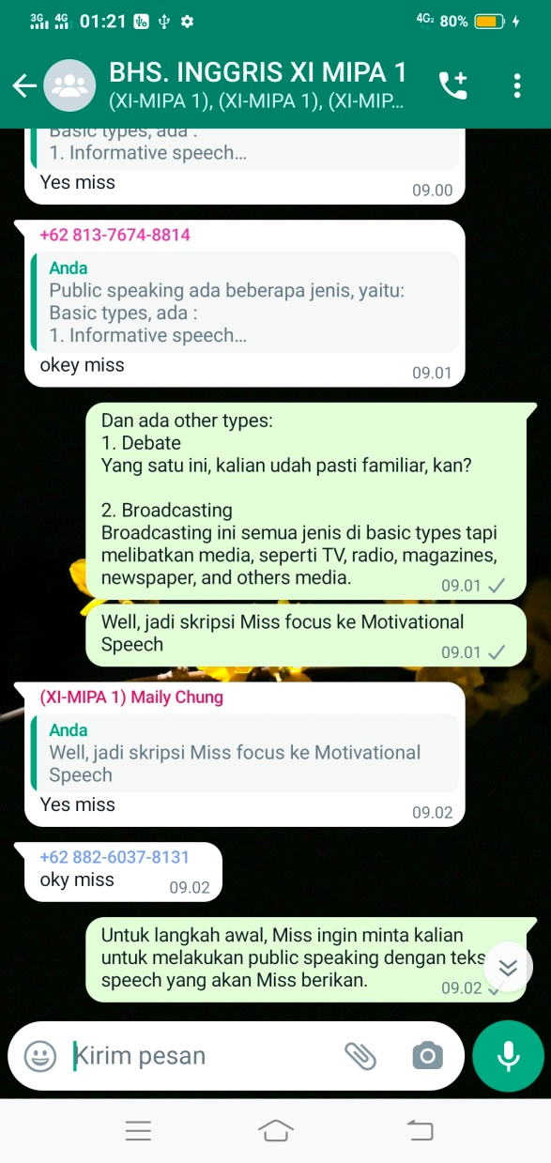
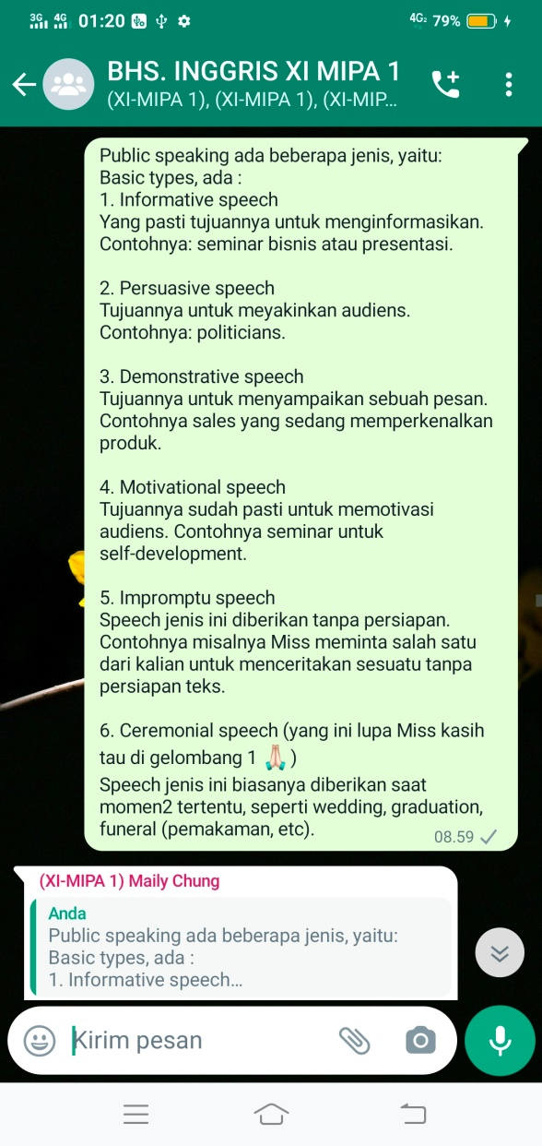

(Treatment Experimental Class)

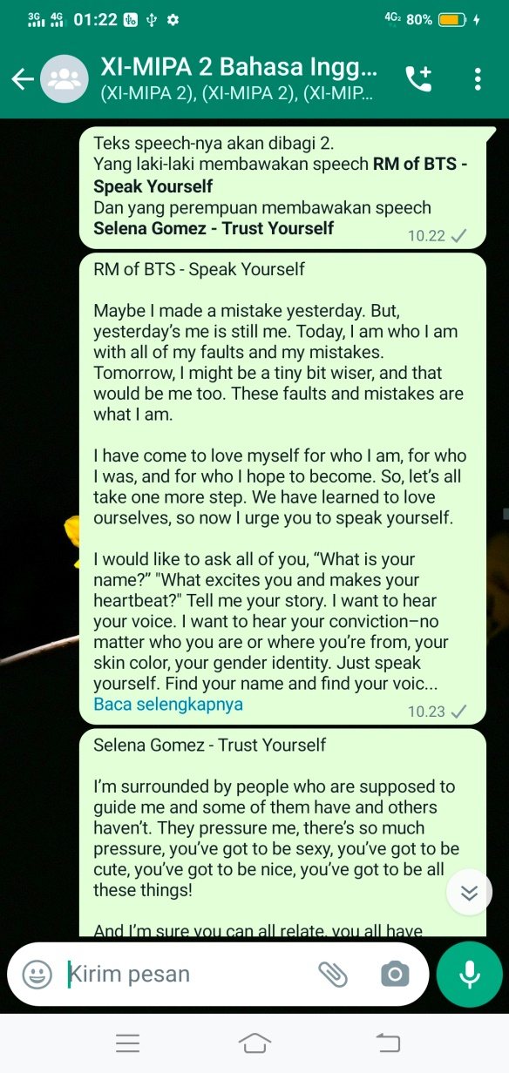

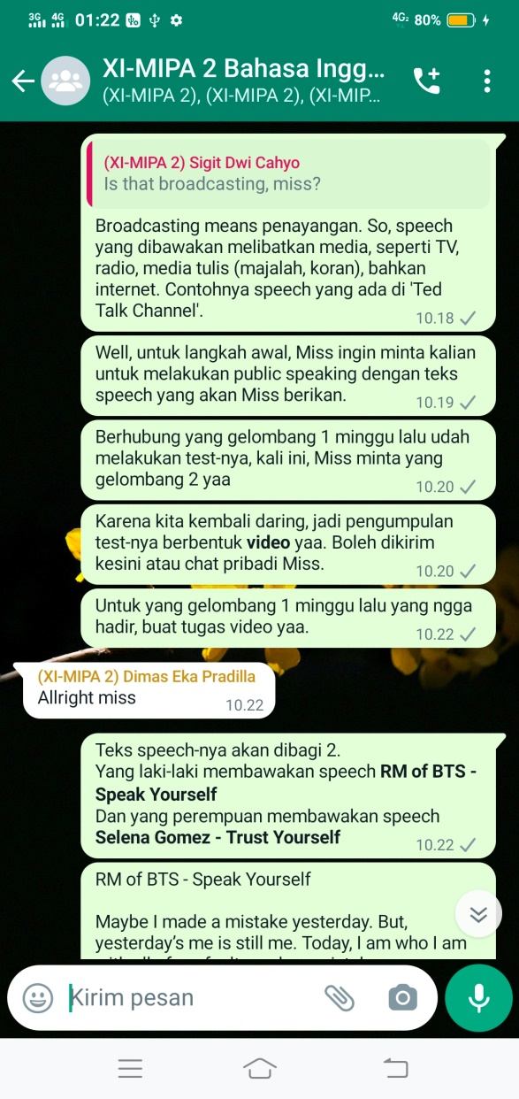
(Treatment Control Class)

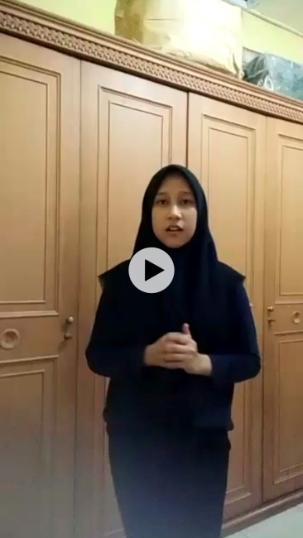
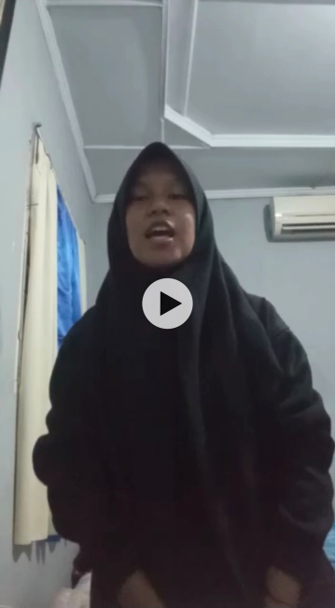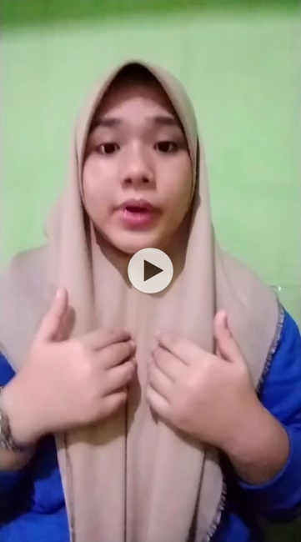

(Videos of Post-Test)

