ACKNOWLEDGEMENT

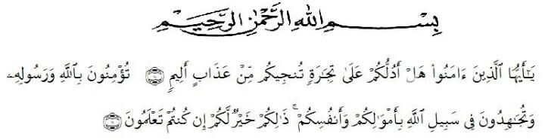
Artinya: “ Hai orang-orang yang beriman, maukah kamu aku tunjukkan suatu perniagaan yang dapat menyelamatkanmu dari azab yang pedih? (10). (yaitu) kamu beriman kepada Allah dan Rasul-nya dan berjihad di jalan Allah dengan harta dan jiwamu. Itulah yang lebih baik bagimu, jika kamu mengetahuinya. (11)”. (Quran Surah As-Shaff: 10-11)
The researcher expresses her highest gratitude to Allah SWT for blessing, love, opportunity, health, and mercy to complete this undergraduate thesis. Shalawat and salam be upon the prophet Muhammad SAW, his family and his followers.
This undergraduate thesis entitled “The Effect of Role Play on the Students’ Public Speaking Skill” is submitted as the final requirement in accomplishing undergraduate degree at English Education Department of Universitas Muslim Nusantara Al-Washliyah Medan.
With all humility and sincerity, the researcher would like to thanks to beloved parents (Suritono and Supriatin) who always give their greatest love, endless prayer, valuable support, and they also give their best to her. Then, she thanks to her beloved brother (Suria Darma Syahputra) and beloved sister (Suria Tria Ningrum) who always love and support her in writing this undergraduate thesis. The researcher prays up to Allah SWT, may they always be healthy, be in peace, be with characteristic of pious, and devoted human beings.
Furthermore, the researcher would also like to thank:
- Mrs. Rini Fadhillah Putri, S.Pd., M.Hum as the Adviser who has guided and provided constructive suggestions from the beginning to the completion of this undergraduate thesis writing.
- Mr. Dr. H. Hardi Mulyono Surbakti, SE., MAP as the Rector of the Universitas Muslim Nusantara Al-Washliyah Medan who accepted me as a student.
- Mr. Drs. Samsul Bahri, M.Si, as the Head of the Faculty of Teacher Training and Education at the Universitas Muslim Nusantara Al-Washliyah Medan who gave the research permit.
- Mrs. Zulfitri, SS., M.A as the Head of the English Language Education Department who has given me permission to approve the title of the undergraduate thesis.
- Mr. Asnawi, S.Pd., M.Hum as Academic Supervisor who always give motivation and guide during her study.
- The lecturers of the English Language Department of FKIP Universitas Muslim Nusantara Al-Washliyah Medan for their nice and valuable discussing to enrich the research’s knowledge.
- The Headmaster of Cerdas Murni Islamic School for the facilities given to her in conducting this research.
- The English teachers of for helping the researcher done the research at Cerdas Murni Islamic School.
- Her beloved bestfriend (Ariyani Hermaiyah, S.Pd) who always support, give motivation and accompany her.
- Her bestfriends (Aulia Noor Rizarni, S.Pd., Elvira Glaudia Lubis, S.Pd., Ichara Sinta, S.Pd., Ika Aprilia Putri, S.Pd., Maulidya Mayang Widhari, S.Pd., and Abdi Zihan Nanda) who always support, care and help her and even share the ideas to finish this undergraduate thesis.
- Her childhood bestfriend (Firdha Chairama, S.Akun) who always support and motivated her.
- Her classmates (PBI A 2017) and friends in English Education Department for sharing knowledges and joyful times.
- The librarians of Universitas Muslim Nusantara Al-Washliyah Medan for the facilities of the books that the researcher needed in writing this undergraduate thesis.
- The administration staff of Universitas Muslim Nusantara Al-Washliyah Medan for the help in managing the files needed by the researcher in writing this undergraduate thesis.
- To any other person who cannot be mentioned one by one for their contribution to the research during finishing her undergraduate thesis. The words are not enough to say any appreciations for their helps.
At last, the researcher realizes that this undergraduate thesis is still far from perfection. Therefore, any constructive criticism and suggestions for the improvement of this undergraduate thesis are highly appreciated. Then, the researcher hope that this undergraduate thesis is able to give contribution to the readers and useful for the teaching and learning process.

Medan, November 2021
Author

Suria Suchi Dwi Putri
171224059

