Appendix 1
LESSON PLAN

School : SMA Swasta Rakyat Pancur Batu
Course : English
Classs/Semester : X / 2
Skill Aspect : Vocabulary
Time Allocation : 2 x 45 minutes

A. CORE COMPETENCIES (KI)
KI.1. Appreciate and live the teachings of their religion.
KI.2. Appreciate and live honest behavior, discipline, responsibility, caring (tolerance, mutual cooperation), polite, confident, in interacting effectively with the social and natural environment within the reach of the association and its existence.
KI.3. Understanding knowledge (factual, conceptual and procedural) based on his curiosity about science, technology, art, culture related to visible phenomena and events.
KI.4. Trying, processing, and presenting in the concrete realm (using, parsing, assembling, modifying, and creating) and abstract realms (writing, reading, counting, drawing, and composing) according to what is learned in school and other sources in the same perspective or theory.

B. BASIC COMPETENCY
1. Be grateful for the opportunity to learn English as the language of
instruction for international communication which is manifested in the spirit of learning

2. Demonstrate responsible, caring, cooperative, and peace-loving behavior, in carrying out functional communication.
3. Demonstrate polite and caring behavior in carrying out interpersonal communication with teachers and friends.

C. INDICATORS
1. Saying words well and clearly.
2. Spell the word correctly.
3. Able to identify each word.
4. Write the vocabulary according to the writing.
5. Listen to the vocabulary correctly.

D. GOALS
After studying it, students can:
1. Students can pronounce words well and clearly.
2. Students can spell words correctly.
3. Students can identify each word and make it into a sentence.
4. Students are able to write vocabulary according to their writing.
5. Students can hear the word correctly.

E. LEARNING MATERIAL
1. Subject matter
Vocabulary
2. Social function
Introduce, identify, mention.
3. Material structure
Basic Vocabulary.

F. TOPIC
Vocabulary
G. LEARNING METHOD
- Approach : Scientific learning
- Method : Cooperative Learning
H. LEARNING MEDIA
Snowball Throwing with tools and materials, Snowball Throwing, paper,book
E. LEARNING SOURCE
Internet, teacher material and dictionary
- STEPS
1. Preliminary activities (10 minutes)
• The teacher enters the class and immediately greets the students using English.
• Teacher absent the students.
• Teachers give motivation and appreciation.
• The teacher conveys the learning objectives.
2. Core activities (15 minutes)
1. Observing
a) Students pay attention to writing vocabulary on the blackboard
2. Asking
a) With the guidance and direction of the teacher, students question the differences
between speech, word stress, intonation of the vocabulary written on the blackboard.
3. Explore
a) Students read/listen/write down the vocabulary that has been written on the
blackboard.
4. Communicating
a) Students write down problems in using English vocabulary.
3. Closing (5 minutes)
1. The teacher together with the students and/or themselves make a summary/conclusion
of the lesson
2. The teacher evaluates and or reflects on activities that have been carried out consistently and programmed
- The teacher provides feedback on the learning process and results

I. ASSESSMENT
1. Technique : Written.
2. Form : 20 multiple choice

J. ASSESMENT FORMULA
To find out the student scores, the researchers used the formula:
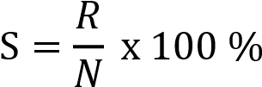
S: Total score
R: The correct answer
N: Number of questions

Appendix 2
1. Andi's bag is broken. Andi is very ...., now.
A. confuse
B. sad
C. happy
D. charm
2. The barbie is so.... He makes all kids laugh and happy.
A. cute
B. quiet
C. noisy
D. disgusting
3. Vina is celebrating her birthday. Now Vina feels ....
A. angry
B. dusty
C. easy
D. happy

4) A school is the place where students... with their teachers.
A. teach
B. work
C. play
D. study
5. You can find ... in your kitchen.
A. pillow
B. knife
C. television
D. sofa
6. We can find pearl in the ..
A. Sea
B. Forest
C. Ground
D. Air

7. These are parts of the body we use to see something.
A. Lungs
B. Heart
C. Eyes
D. Ears
8. Mia : Adi, your shoes are so fit in your ... You look georgeus.
Adi : Thank you.
A. finger
B. lip
C. hand
D. feet
9. The clown is so..... He makes all kids taugh and happy.
A funny
B. quiet
C. noisy
D. disgusting

10. I am so hungry. So, I.....a meal.
A. prepare
B. walk
C. kick
D. wear
11. Rina :I want to wear my white gown to Amanda's party. What do you think?
Lisa : I think the red one is better. Rina : Ok. I will ...... the red gown
A. wrap
B. go
C. wear
D. give
12. The carpet is ..... I want to clean it.
A. large
B. shiny
C. dirty
D. soft

13. A : When did you get up in this morning?
B: ......
A. I got up at 5.00
B. I had my breakfast
C. I was sleepy
D. I went to school
14. My father is a doctor. He examines ... carefully.
A. Patients
B. Fashions
C. Students
D. Books
15. Where do you usually find the books?
A. On the street
B. In the garden
C. In the library
D. In the hospital

16. I bring something with my...
A. foot
B. nose
C. mouth
D. hand
17. How many legs do a chicken have?
A two
B. three
C. four
D. six
18. Your father's wife is your...
A. mother
B. sister
C. grandmother
D. aunt

19.... is grandfather's wife.
A. Mother
B. Grandmother
C. Aunt
D. Grandson
20. A... likes bananas. It cam climb a tree.
A. monkey
B. bird
C. sheep
D. elephant

Appendix 3
Answer Key
1. B. Sad 11. C. Wear
2. A. Cute 12. C. Dirty
3. D. Happy 13. A I got up at 5.00
4. B.Work 14. A. Patients
5. A. Television 15. C. In the library
6. C. Ground 16. D.Hand
7. D. Ears 17. A. Two
8. A. Finger 18. A. Mother
9. A. Funny 19. B. Grandmother
10. A. Preapare 20. A. Monkey

Appendix 4
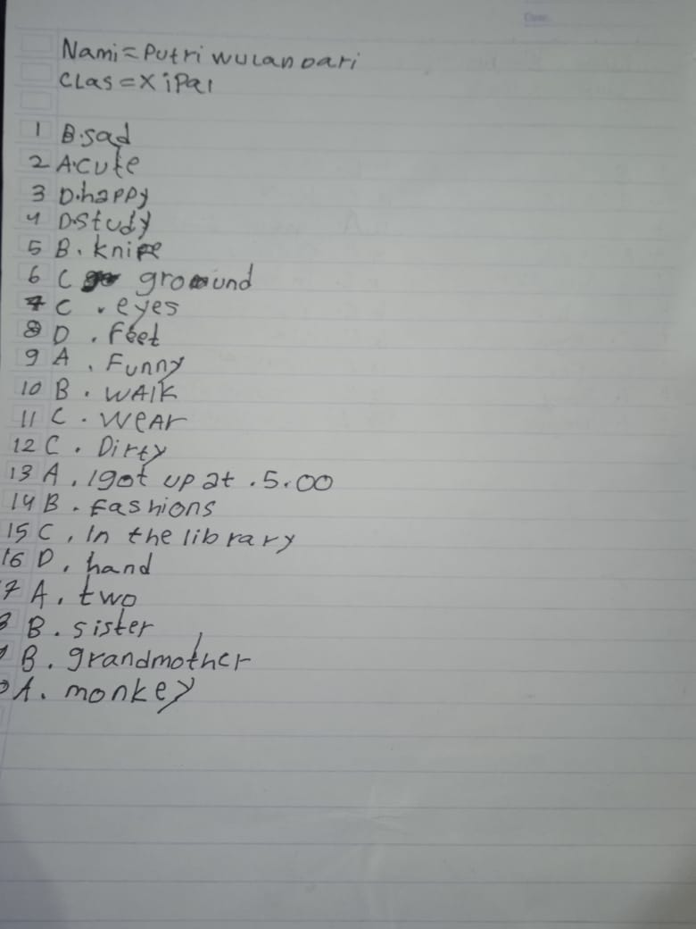
The Result of Students’ worksheet

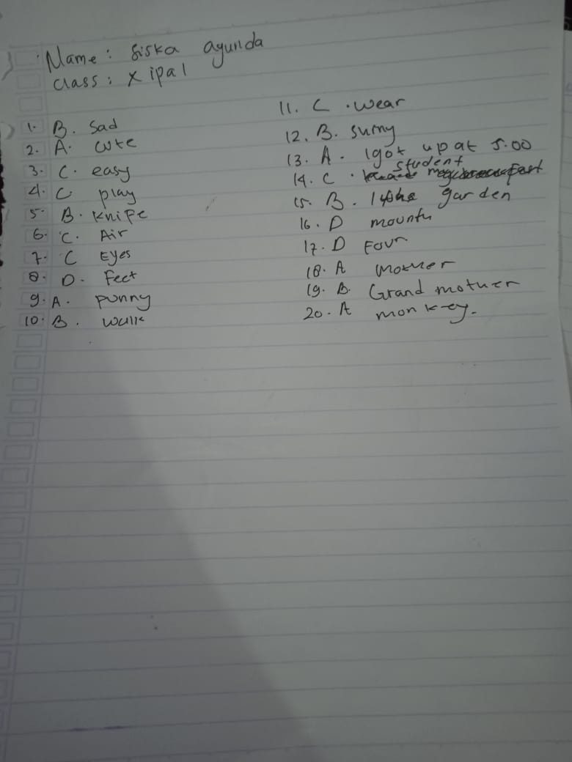

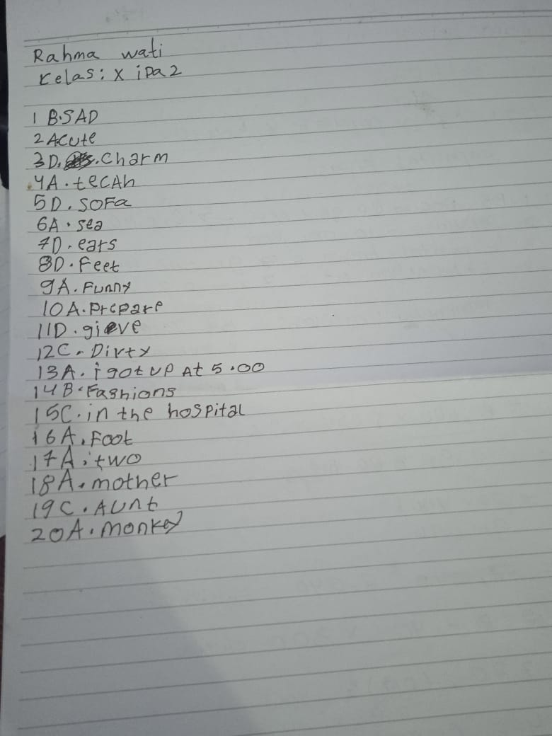

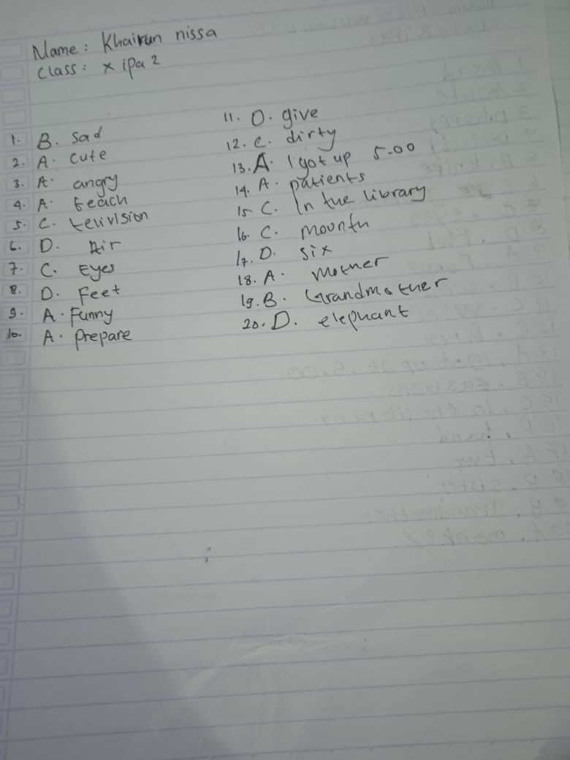

Appendix 5
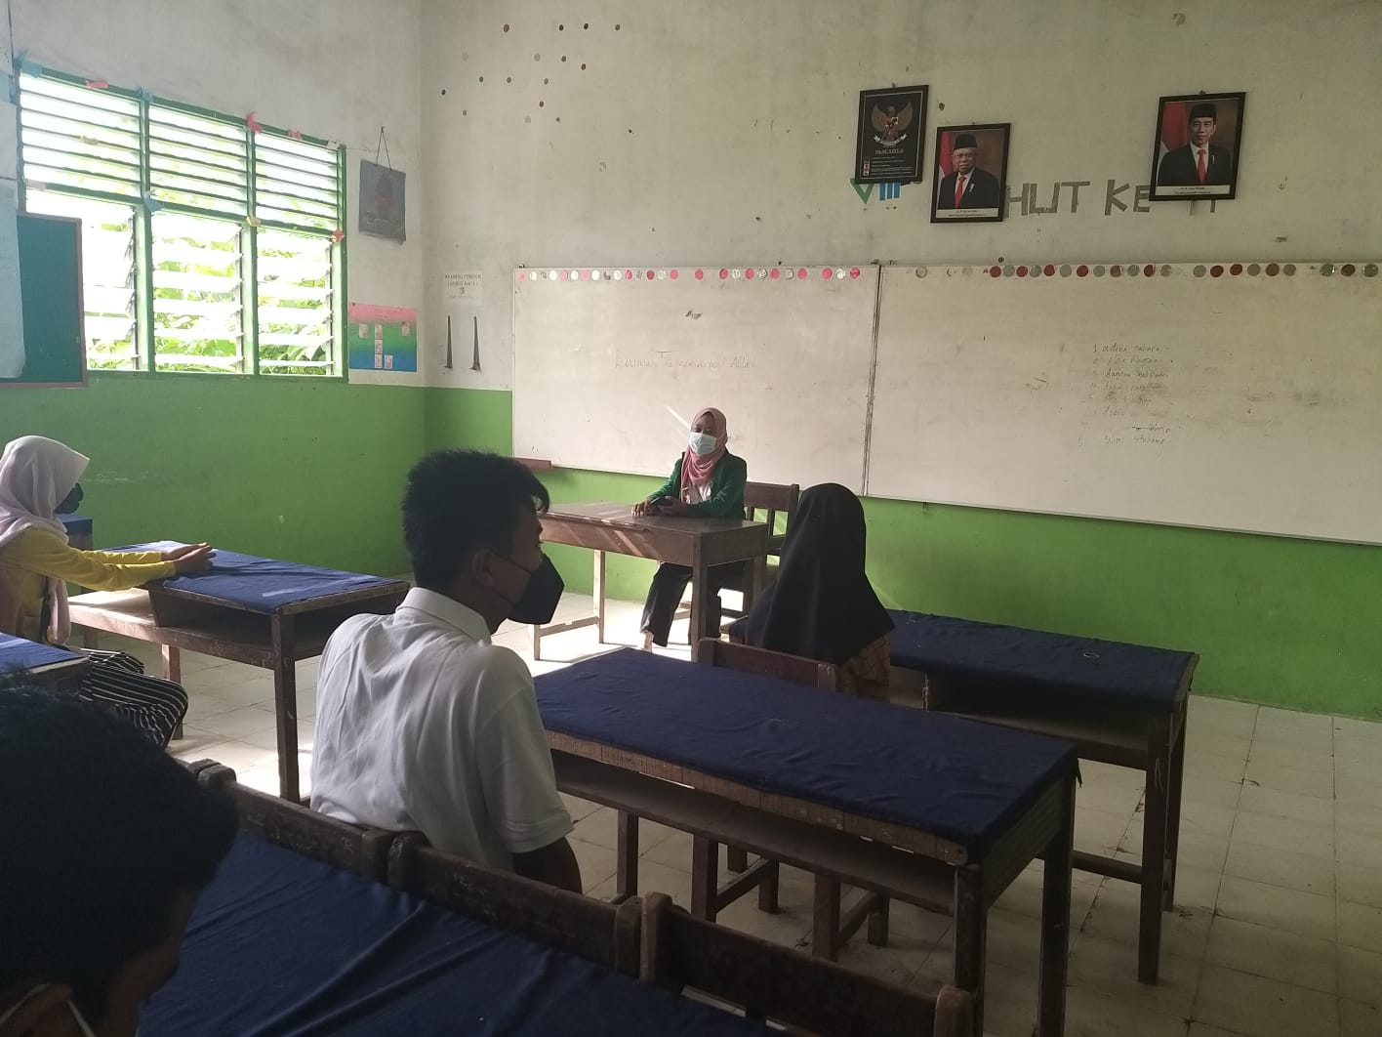
DOCUMENTATION

