ABSTRAK
SYSTEMATIC LITERATURE REVIEW : PENGARUH MODEL PEMBELAJARAN KOOPERATIF TIPE TEAMS GAMES TOURNAMENT TERHADAP AKTIVITAS DAN
KEMAMPUAN KOMUNIKASI
MATEMATIS SISWA

DITA IQLIMA MARDIAH
Tujuan penelitian ini adalah untuk menganalisis Aktivitas dan Kemampuan Komunikasi matematis berdasarkan penggunaan model pembelajaran Teams Games Tournament. Penelitian ini merupakan penelitian jenis Studi literature dengan pendekatan kualitatif dengan sumber data berupa artikel dari 20 jurnal terkait 10 jurnal aktivitas belajar matematika dan 10 jurnal berdasarkan penggunaan model pembelajaran Teams Games Tournament. Teknik pengumpulan data yang digunakan adalah Studi literature. Tujuan penelitian ini adalah (1) Untuk mendeskripsikan pengaruh model pembelajaran kooperatif Teams Games Tournament terhadap aktivitas dan kemampuan komunikasi matematis siswa (2) Untuk menganalisis pengaruh model pembelajaran kooperatif Teams Games Tournament terhadap aktivitas dan kemampuan komunikasi matematis siswa. Hasil penelitian menunjukkan : (1) Penggunaan model pembelajaran kooperatif Teams Games Tournament memberikan dampak positif terhadap peningkatan maupun pengaruh yang signifikan terhadap aktivitas dan kemampuan komunikasi matematis siswa, (2) Model pembelajaran kooperatif Teams Games Tournament merupakan salah satu faktor atau solusi bagi peningkatan aktivitas dan kemampuan komunikasi matmatis siswa..
Kata kunci : Model Pembelajaran Kooperatif Teams Games Tournament, Aktivitas, Kemampuan komunikasi Matematis

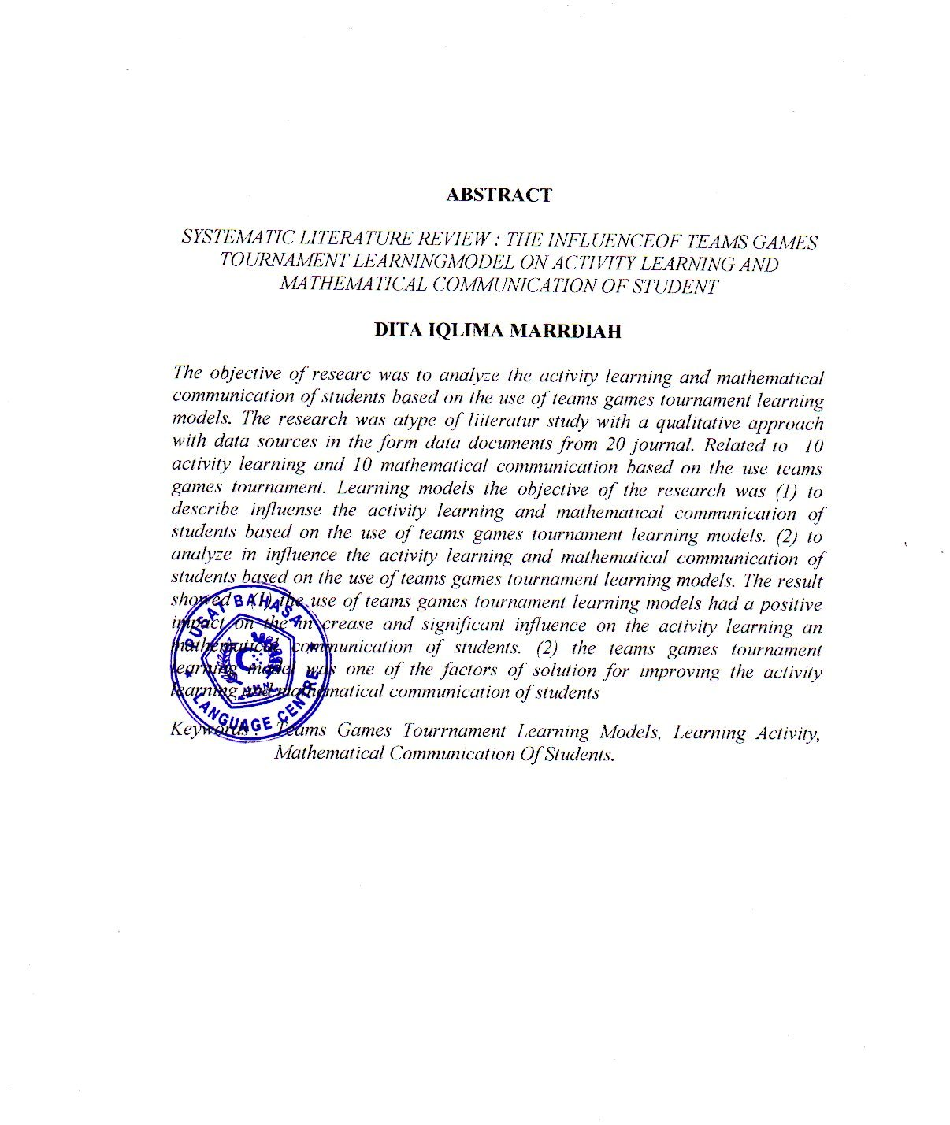
ABSTRACT
SYSTEMATIC LITERATURE REVIEW : THE INFLUENCEOF TEAMS GAMES
TOURNAMENT LEARNINGMODEL ON ACTIVITY LEARNING AND
MATHEMATICAL COMMUNICATION OF STUDENT

DITA IQLIMA MARRDIAH

The objective of researc was to analyze the activity learning and mathematical communication of students based on the use of teams games tournament learning models. The research was atype of liiteratur study with a qualitative approach with data sources in the form data documents from 20 journal. Related to 10 activity learning and 10 mathematical communication based on the use teams games tournament. Learning models the objective of the research was (1) to describe influense the activity learning and mathematical communication of students based on the use of teams games tournament learning models. (2) to analyze in influence the activity learning and mathematical communication of students based on the use of teams games tournament learning models. The result showed : (1) the use of teams games tournament learning models had a positive impact on the in crease and significant influence on the activity learning an mathematical communication of students. (2) the teams games tournament learning model was one of the factors of solution for improving the activity learning and mathematical communication of students
Keywords : Teams Games Tourrnament Learning Models, Learning Activity, Mathematical Communication Of Students.

