Model Summary^{b}
Model | R | R Square | Adjusted R Square | Std. Error of the Estimate | Durbin-Watson
1 | .320ª | .102 | .036 | .0278848 | 1.387
a. Predictors: (Constant), DER, CR
b. Dependent Variable: PROFITABILITAS

ANOVA^{b}
Model |  | Sum of Squares | df | Mean Square | F | Sig.
1 | Regression | .002 | 2 | .001 | 1.535 | .234ª
 | Residual | .021 | 27 | .001
 | Total | .023 | 29
a. Predictors: (Constant), DER, CR
b. Dependent Variable: PROFITABILITAS

Coefficientsª
Model |  | Unstandardized Coefficients |  | Standardized Coefficients | t | Sig.
 |  | B | Std. Error | Beta
1 | (Constant) | .065 | .015 |  | 4.426 | .000
 | CR | -.002 | .004 | -.124 | -.626 | .536
 | DER | -.012 | .007 | -.346 | -1.752 | .091
a. Dependent Variable: PROFITABILITAS

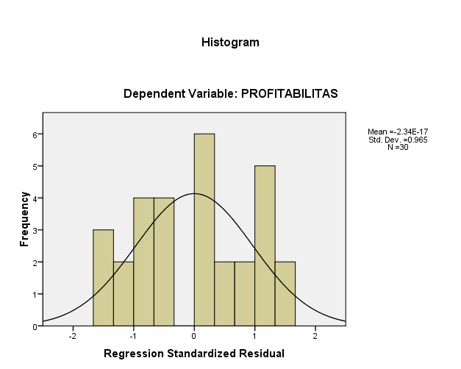

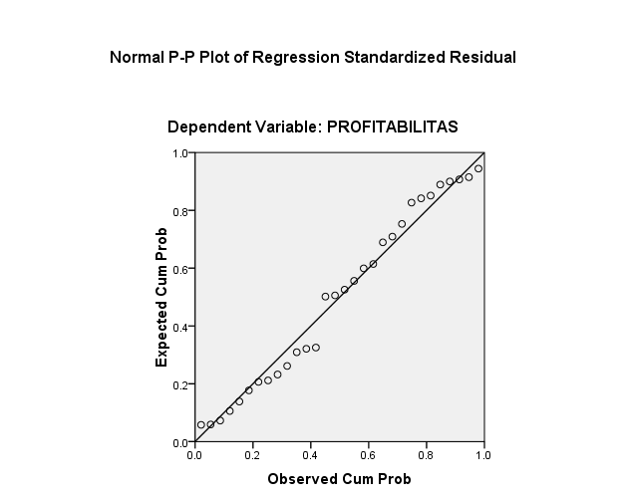

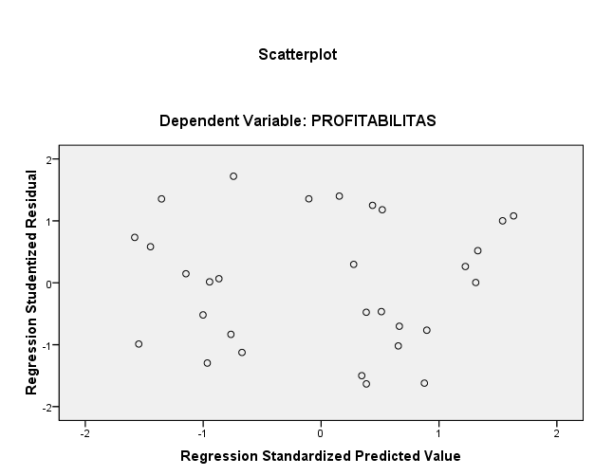

Coefficientsª
Model |  | Collinearity Statistics
 |  | Tolerance | VIF
1 | CR | .852 | 1.174
 | DER | .852 | 1.174
a. Dependent Variable: PROFITABILITAS

Model Summary
Model | R | R Square | Adjusted R Square | Std. Error of the Estimate
1 | .320ª | .102 | .036 | .0278848
a. Predictors: (Constant), DER, CR

One-Sample Kolmogorov-Smirnov Test
 |  | Unstandardized Residual
N |  | 30
Normal Parametersª | Mean | .000000
 | Std. Deviation | .0269061
Most Extreme Differences | Absolute | .114
 | Positive | .114
 | Negative | -.102
Kolmogorov-Smirnov Z |  | .623
Asymp. Sig. (2-tailed) |  | .832
a. Test distribution is Normal.

