Lampiran 1
Tabel Jumlah Responden Terhadap 5 Item soal variabel X
SUBJEK | SKOR ITEM
 | 1 | 2 | 3 | 4 | 5 |  | TOTAL
1 | 4 | 4 | 4 | 4 | 4 |  | 20
2 | 5 | 5 | 5 | 4 | 5 |  | 24
3 | 4 | 4 | 4 | 4 | 4 |  | 20
4 | 5 | 5 | 5 | 4 | 5 |  | 24
5 | 5 | 5 | 4 | 4 | 5 |  | 23
6 | 4 | 5 | 4 | 4 | 5 |  | 22
7 | 5 | 5 | 5 | 4 | 5 |  | 24
8 | 4 | 4 | 4 | 4 | 4 |  | 20
9 | 5 | 5 | 5 | 4 | 5 |  | 24
10 | 4 | 5 | 4 | 4 | 5 |  | 22
11 | 4 | 4 | 5 | 5 | 4 |  | 22
12 | 5 | 5 | 4 | 4 | 4 |  | 22
13 | 5 | 4 | 5 | 5 | 4 |  | 23
14 | 5 | 5 | 4 | 4 | 5 |  | 23
15 | 4 | 5 | 4 | 4 | 5 |  | 22
16 | 4 | 4 | 4 | 4 | 4 |  | 20
17 | 5 | 5 | 5 | 5 | 5 |  | 25
18 | 4 | 4 | 4 | 4 | 4 |  | 20
19 | 5 | 3 | 5 | 5 | 3 |  | 21
20 | 4 | 5 | 4 | 4 | 5 |  | 22
21 | 4 | 4 | 4 | 4 | 4 |  | 20
22 | 4 | 5 | 4 | 4 | 5 |  | 22
23 | 4 | 4 | 4 | 4 | 4 |  | 20
24 | 4 | 4 | 4 | 5 | 4 |  | 21
25 | 4 | 4 | 4 | 4 | 4 |  | 20
26 | 4 | 4 | 4 | 4 | 4 |  | 20
27 | 4 | 5 | 4 | 4 | 5 |  | 22
28 | 4 | 4 | 4 | 4 | 4 |  | 20
29 | 4 | 4 | 4 | 4 | 4 |  | 20
30 | 4 | 4 | 4 | 4 | 4 |  | 20
31 | 5 | 3 | 5 | 5 | 3 |  | 21
32 | 3 | 3 | 4 | 4 | 4 |  | 18
33 | 4 | 4 | 4 | 4 | 4 |  | 20
34 | 5 | 5 | 4 | 4 | 4 |  | 22
35 | 4 | 4 | 4 | 4 | 4 |  | 20
36 | 4 | 4 | 4 | 4 | 4 |  | 20
37 | 4 | 4 | 4 | 4 | 4 |  | 20
38 | 4 | 5 | 4 | 4 | 5 |  | 22
39 | 5 | 5 | 5 | 5 | 5 |  | 25
40 | 4 | 5 | 4 | 4 | 5 |  | 22
41 | 4 | 4 | 4 | 4 | 4 |  | 20
42 | 4 | 5 | 4 | 4 | 5 |  | 22
43 | 5 | 3 | 5 | 5 | 3 |  | 21
44 | 5 | 5 | 5 | 5 | 5 |  | 25
45 | 4 | 5 | 4 | 4 | 5 |  | 22
46 | 5 | 5 | 5 | 5 | 5 |  | 25
47 | 4 | 4 | 4 | 4 | 4 |  | 20
48 | 4 | 4 | 4 | 4 | 4 |  | 20
49 | 4 | 4 | 4 | 4 | 4 |  | 20
50 | 4 | 5 | 4 | 4 | 5 |  | 22
51 | 5 | 5 | 5 | 5 | 5 |  | 25
52 | 4 | 4 | 4 | 4 | 4 |  | 20
53 | 5 | 5 | 5 | 5 | 5 |  | 25
54 | 4 | 4 | 4 | 4 | 4 |  | 20
55 | 5 | 3 | 5 | 5 | 3 |  | 21
56 | 4 | 4 | 4 | 4 | 5 |  | 21
57 | 4 | 5 | 4 | 4 | 5 |  | 22
58 | 5 | 5 | 4 | 5 | 4 |  | 23
59 | 4 | 4 | 4 | 4 | 4 |  | 20
60 | 4 | 4 | 4 | 4 | 4 |  | 20
61 | 4 | 4 | 4 | 4 | 4 |  | 20
62 | 4 | 4 | 4 | 4 | 4 |  | 20
63 | 5 | 5 | 5 | 5 | 5 |  | 25
64 | 4 | 4 | 4 | 4 | 4 |  | 20
65 | 5 | 5 | 5 | 5 | 5 |  | 25
66 | 4 | 4 | 4 | 4 | 4 |  | 20
67 | 5 | 3 | 5 | 5 | 3 |  | 21
68 | 4 | 4 | 4 | 4 | 3 |  | 19
69 | 4 | 4 | 4 | 4 | 4 |  | 20
70 | 4 | 4 | 4 | 4 | 3 |  | 19
71 | 4 | 5 | 4 | 5 | 5 |  | 23
72 | 4 | 5 | 4 | 4 | 5 |  | 22
73 | 5 | 5 | 5 | 5 | 5 |  | 25
74 | 4 | 5 | 4 | 4 | 5 |  | 22
75 | 5 | 3 | 5 | 5 | 3 |  | 21
76 | 5 | 4 | 5 | 5 | 4 |  | 23
77 | 3 | 3 | 4 | 5 | 4 |  | 19
78 | 4 | 4 | 4 | 4 | 4 |  | 20
79 | 4 | 4 | 4 | 4 | 4 |  | 20
80 | 5 | 3 | 5 | 5 | 3 |  | 21
81 | 3 | 3 | 4 | 5 | 4 |  | 19
82 | 4 | 4 | 4 | 4 | 4 |  | 20
83 | 4 | 4 | 4 | 4 | 4 |  | 20
84 | 5 | 4 | 4 | 5 | 5 |  | 23
85 | 4 | 5 | 5 | 4 | 4 |  | 22
86 | 4 | 5 | 4 | 4 | 4 |  | 21
87 | 5 | 4 | 4 | 5 | 5 |  | 23
88 | 4 | 4 | 4 | 4 | 4 |  | 20
89 | 3 | 3 | 3 | 3 | 3 |  | 15
90 | 5 | 5 | 5 | 5 | 5 |  | 25
91 | 5 | 5 | 4 | 5 | 5 |  | 24
92 | 5 | 5 | 5 | 5 | 5 |  | 25
93 | 4 | 5 | 4 | 4 | 4 |  | 21
94 | 5 | 4 | 4 | 5 | 5 |  | 23
95 | 4 | 5 | 4 | 4 | 4 |  | 21
96 | 5 | 4 | 4 | 5 | 5 |  | 23
97 | 5 | 5 | 5 | 5 | 5 |  | 25
98 | 5 | 5 | 4 | 5 | 5 |  | 24
99 | 5 | 4 | 4 | 5 | 5 |  | 23
100 | 4 | 4 | 4 | 4 | 4 |  | 20
Σ |  |  |  |  |  |  | 2.154

Lampiran 2
Tabel Jumlah Responden Terhadap 5 Item soal variabel Y
SUBJEK | SKOR ITEM
 | 1 | 2 | 3 | 4 | 5 |  | TOTAL
1 | 4 | 4 | 4 | 4 | 4 |  | 20
2 | 5 | 5 | 5 | 5 | 5 |  | 25
3 | 4 | 4 | 4 | 4 | 4 |  | 20
4 | 5 | 5 | 4 | 3 | 5 |  | 22
5 | 5 | 5 | 4 | 4 | 4 |  | 22
6 | 5 | 5 | 4 | 4 | 5 |  | 23
7 | 3 | 3 | 4 | 5 | 5 |  | 20
8 | 4 | 4 | 4 | 4 | 4 |  | 20
9 | 5 | 5 | 4 | 5 | 5 |  | 24
10 | 4 | 4 | 4 | 5 | 4 |  | 21
11 | 3 | 3 | 4 | 4 | 4 |  | 18
12 | 5 | 5 | 4 | 4 | 4 |  | 22
13 | 4 | 4 | 4 | 4 | 5 |  | 21
14 | 5 | 5 | 4 | 4 | 5 |  | 23
15 | 5 | 5 | 4 | 4 | 5 |  | 23
16 | 4 | 4 | 4 | 4 | 4 |  | 20
17 | 4 | 4 | 4 | 5 | 5 |  | 22
18 | 5 | 5 | 4 | 4 | 4 |  | 22
19 | 4 | 4 | 4 | 4 | 4 |  | 20
20 | 4 | 4 | 4 | 5 | 5 |  | 22
21 | 5 | 5 | 4 | 4 | 4 |  | 22
22 | 5 | 5 | 4 | 4 | 4 |  | 22
23 | 5 | 5 | 4 | 4 | 4 |  | 22
24 | 5 | 5 | 4 | 4 | 4 |  | 22
25 | 4 | 4 | 4 | 4 | 5 |  | 21
26 | 5 | 5 | 4 | 4 | 4 |  | 22
27 | 4 | 4 | 4 | 4 | 4 |  | 20
28 | 4 | 4 | 4 | 4 | 4 |  | 20
29 | 4 | 4 | 4 | 4 | 4 |  | 20
30 | 5 | 5 | 4 | 4 | 4 |  | 22
31 | 4 | 4 | 4 | 4 | 4 |  | 20
32 | 3 | 3 | 4 | 4 | 4 |  | 18
33 | 4 | 4 | 4 | 4 | 4 |  | 20
34 | 5 | 5 | 4 | 4 | 4 |  | 22
35 | 5 | 5 | 4 | 4 | 4 |  | 22
36 | 5 | 5 | 4 | 4 | 4 |  | 22
37 | 5 | 5 | 5 | 5 | 5 |  | 25
38 | 5 | 5 | 4 | 4 | 5 |  | 23
39 | 4 | 4 | 4 | 4 | 4 |  | 20
40 | 4 | 4 | 4 | 4 | 3 |  | 19
41 | 4 | 4 | 4 | 4 | 4 |  | 20
42 | 4 | 4 | 5 | 4 | 4 |  | 21
43 | 5 | 5 | 4 | 4 | 4 |  | 22
44 | 4 | 4 | 5 | 5 | 5 |  | 23
45 | 4 | 4 | 4 | 5 | 4 |  | 21
46 | 5 | 5 | 4 | 5 | 4 |  | 23
47 | 5 | 5 | 5 | 4 | 4 |  | 23
48 | 5 | 5 | 5 | 5 | 5 |  | 25
49 | 5 | 5 | 4 | 5 | 5 |  | 24
50 | 5 | 5 | 5 | 5 | 4 |  | 24
51 | 5 | 5 | 4 | 5 | 4 |  | 23
52 | 5 | 5 | 5 | 4 | 4 |  | 23
53 | 5 | 5 | 4 | 5 | 5 |  | 24
54 | 5 | 5 | 4 | 4 | 4 |  | 22
55 | 4 | 4 | 4 | 4 | 5 |  | 21
56 | 4 | 4 | 4 | 4 | 5 |  | 21
57 | 4 | 4 | 4 | 5 | 3 |  | 20
58 | 5 | 5 | 4 | 5 | 4 |  | 23
59 | 3 | 3 | 4 | 5 | 3 |  | 18
60 | 4 | 4 | 4 | 5 | 4 |  | 21
61 | 4 | 4 | 4 | 4 | 5 |  | 21
62 | 4 | 4 | 4 | 4 | 5 |  | 21
63 | 4 | 4 | 4 | 3 | 5 |  | 20
64 | 4 | 4 | 4 | 5 | 4 |  | 21
65 | 4 | 4 | 4 | 4 | 5 |  | 21
66 | 4 | 4 | 4 | 5 | 5 |  | 22
67 | 4 | 4 | 4 | 4 | 4 |  | 20
68 | 4 | 4 | 4 | 4 | 3 |  | 19
69 | 4 | 4 | 4 | 3 | 4 |  | 19
70 | 4 | 4 | 4 | 4 | 3 |  | 19
71 | 5 | 5 | 4 | 4 | 5 |  | 23
72 | 5 | 5 | 4 | 4 | 4 |  | 22
73 | 5 | 5 | 4 | 5 | 4 |  | 23
74 | 5 | 5 | 4 | 4 | 5 |  | 23
75 | 5 | 5 | 4 | 4 | 5 |  | 23
76 | 4 | 4 | 4 | 5 | 5 |  | 22
77 | 3 | 3 | 4 | 5 | 4 |  | 19
78 | 4 | 4 | 4 | 4 | 4 |  | 20
79 | 5 | 5 | 4 | 4 | 5 |  | 23
80 | 4 | 4 | 4 | 4 | 5 |  | 21
81 | 4 | 4 | 4 | 3 | 4 |  | 19
82 | 5 | 5 | 4 | 5 | 4 |  | 23
83 | 4 | 4 | 4 | 4 | 4 |  | 20
84 | 5 | 5 | 5 | 4 | 5 |  | 24
85 | 5 | 4 | 4 | 5 | 4 |  | 22
86 | 4 | 4 | 4 | 5 | 4 |  | 21
87 | 5 | 5 | 5 | 5 | 5 |  | 25
88 | 4 | 4 | 4 | 4 | 4 |  | 20
89 | 4 | 3 | 3 | 4 | 3 |  | 17
90 | 5 | 5 | 5 | 5 | 5 |  | 25
91 | 5 | 5 | 5 | 4 | 5 |  | 24
92 | 5 | 5 | 5 | 5 | 5 |  | 25
93 | 5 | 4 | 4 | 5 | 4 |  | 22
94 | 5 | 5 | 5 | 4 | 5 |  | 24
95 | 5 | 4 | 4 | 5 | 4 |  | 22
96 | 5 | 5 | 5 | 4 | 5 |  | 24
97 | 5 | 5 | 5 | 5 | 5 |  | 25
98 | 5 | 5 | 5 | 5 | 5 |  | 25
99 | 5 | 5 | 5 | 4 | 5 |  | 24
100 | 4 | 4 | 4 | 4 | 4 |  | 20
Σ |  |  |  |  |  |  | 2.146

Validitas Sistem Antrian
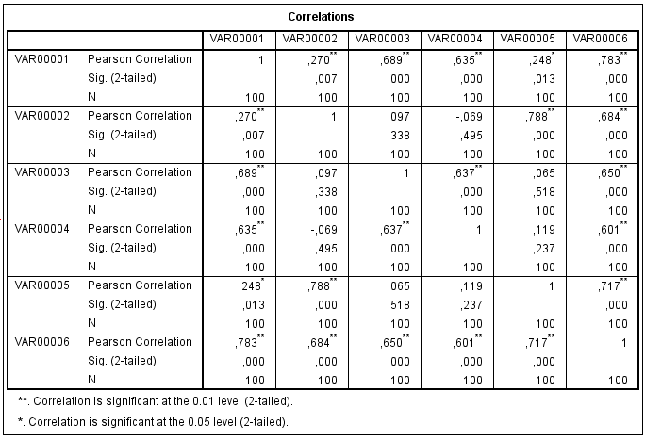
Reliability Statistics
Cronbach's Alpha | N of Items
0,716 | 5
Validitas Kepuasan Nasabah
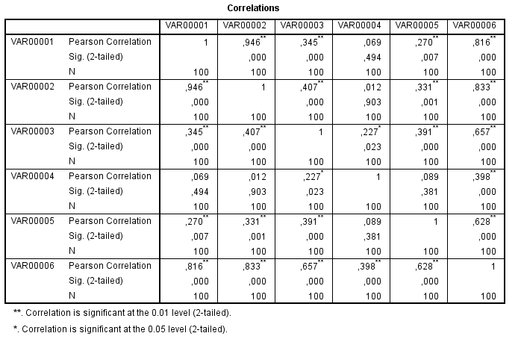
Reliability Statistics
Cronbach's Alpha | N of Items
0,688 | 5

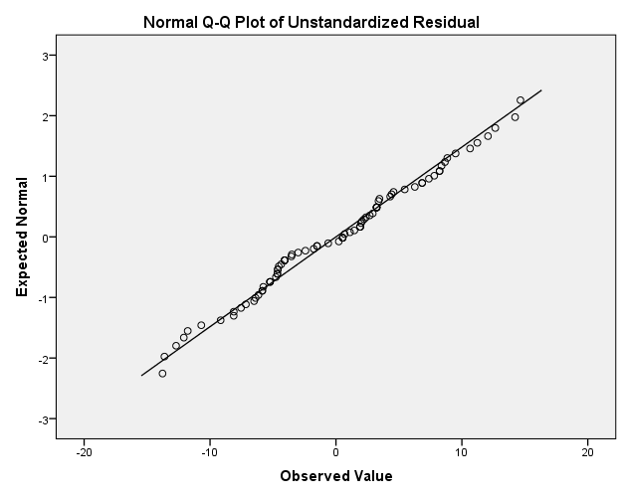
Normalitas

One-Sample Kolmogorov-Smirnov Test
 |  | Unstandardized Residual
N |  | 100
Normal Parameters^{a,b} | Mean | ,0000000
 | Std. Deviation | ,07174530
Most Extreme Differences | Absolute | ,083
 | Positive | ,082
 | Negative | -,083
Test Statistic |  | ,083
Asymp. Sig. (2-tailed) |  | ,083^{c}
a. Test distribution is Normal.
b. Calculated from data.
c. Lilliefors Significance Correction.

Grafik Normalitas

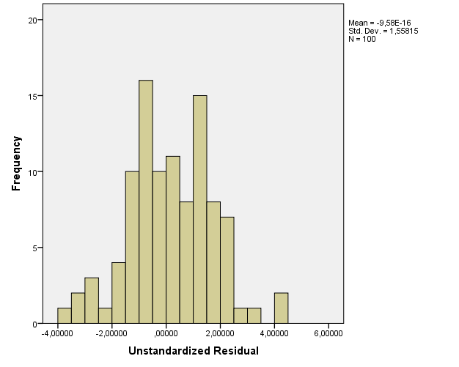

Coefficientsª
Model |  | Unstandardized Coefficients |  | Standardized Coefficients | T | Sig.
 |  | B | Std. Error | Beta
1 | (Constant) | 1,491 | ,245 |  | 6,093 | ,000
 | Sistem antrian | ,516 | ,080 | ,547 | 6,466 | ,000
a. Dependent Variable: kepuasaan nasabah

Model Summary^{b}
Model | R | R Square | Adjusted R Square | Std. Error of the Estimate
1 | ,547ª | ,299 | ,292 | ,07211
a. Predictors: (Constant), Sistem antrian
b. Dependent Variable: kepuasaan nasabah

Tabel Nilai-nilai Distribusi t
Pr | 0.25 | 0.10 | 0.05 | 0.025 | 0.01 | 0.005 | 0.001
Df | 0.50 | 0.20 | 0.10 | 0.050 | 0.02 | 0.010 | 0.002
1 | 1.00000 | 3.07768 | 6.31375 | 12.70620 | 31.82052 | 63.65674 | 318.30884
2 | 0.81650 | 1.88562 | 2.91999 | 4.30265 | 6.96456 | 9.92484 | 22.32712
3 | 0.76489 | 1.63774 | 2.35336 | 3.18245 | 4.54070 | 5.84091 | 10.21453
4 | 0.74070 | 1.53321 | 2.13185 | 2.77645 | 3.74695 | 4.60409 | 7.17318
5 | 0.72669 | 1.47588 | 2.01505 | 2.57058 | 3.36493 | 4.03214 | 5.89343
6 | 0.71756 | 1.43976 | 1.94318 | 2.44691 | 3.14267 | 3.70743 | 5.20763
7 | 0.71114 | 1.41492 | 1.89458 | 2.36462 | 2.99795 | 3.49948 | 4.78529
8 | 0.70639 | 1.39682 | 1.85955 | 2.30600 | 2.89646 | 3.35539 | 4.50079
9 | 0.70272 | 1.38303 | 1.83311 | 2.26216 | 2.82144 | 3.24984 | 4.29681
10 | 0.69981 | 1.37218 | 1.81246 | 2.22814 | 2.76377 | 3.16927 | 4.14370
11 | 0.69745 | 1.36343 | 1.79588 | 2.20099 | 2.71808 | 3.10581 | 4.02470
12 | 0.69548 | 1.35622 | 1.78229 | 2.17881 | 2.68100 | 3.05454 | 3.92963
13 | 0.69383 | 1.35017 | 1.77093 | 2.16037 | 2.65031 | 3.01228 | 3.85198
14 | 0.69242 | 1.34503 | 1.76131 | 2.14479 | 2.62449 | 2.97684 | 3.78739
15 | 0.69120 | 1.34061 | 1.75305 | 2.13145 | 2.60248 | 2.94671 | 3.73283
16 | 0.69013 | 1.33676 | 1.74588 | 2.11991 | 2.58349 | 2.92078 | 3.68615
17 | 0.68920 | 1.33338 | 1.73961 | 2.10982 | 2.56693 | 2.89823 | 3.64577
18 | 0.68836 | 1.33039 | 1.73406 | 2.10092 | 2.55238 | 2.87844 | 3.61048
19 | 0.68762 | 1.32773 | 1.72913 | 2.09302 | 2.53948 | 2.86093 | 3.57940
20 | 0.68695 | 1.32534 | 1.72472 | 2.08596 | 2.52798 | 2.84534 | 3.55181
21 | 0.68635 | 1.32319 | 1.72074 | 2.07961 | 2.51765 | 2.83136 | 3.52715
22 | 0.68581 | 1.32124 | 1.71714 | 2.07387 | 2.50832 | 2.81876 | 3.50499
23 | 0.68531 | 1.31946 | 1.71387 | 2.06866 | 2.49987 | 2.80734 | 3.48496
24 | 0.68485 | 1.31784 | 1.71088 | 2.06390 | 2.49216 | 2.79694 | 3.46678
25 | 0.68443 | 1.31635 | 1.70814 | 2.05954 | 2.48511 | 2.78744 | 3.45019
26 | 0.68404 | 1.31497 | 1.70562 | 2.05553 | 2.47863 | 2.77871 | 3.43500
27 | 0.68368 | 1.31370 | 1.70329 | 2.05183 | 2.47266 | 2.77068 | 3.42103
28 | 0.68335 | 1.31253 | 1.70113 | 2.04841 | 2.46714 | 2.76326 | 3.40816
29 | 0.68304 | 1.31143 | 1.69913 | 2.04523 | 2.46202 | 2.75639 | 3.39624
30 | 0.68276 | 1.31042 | 1.69726 | 2.04227 | 2.45726 | 2.75000 | 3.38518
31 | 0.68249 | 1.30946 | 1.69552 | 2.03951 | 2.45282 | 2.74404 | 3.37490
32 | 0.68223 | 1.30857 | 1.69389 | 2.03693 | 2.44868 | 2.73848 | 3.36531
33 | 0.68200 | 1.30774 | 1.69236 | 2.03452 | 2.44479 | 2.73328 | 3.35634
34 | 0.68177 | 1.30695 | 1.69092 | 2.03224 | 2.44115 | 2.72839 | 3.34793
35 | 0.68156 | 1.30621 | 1.68957 | 2.03011 | 2.43772 | 2.72381 | 3.34005
36 | 0.68137 | 1.30551 | 1.68830 | 2.02809 | 2.43449 | 2.71948 | 3.33262
37 | 0.68118 | 1.30485 | 1.68709 | 2.02619 | 2.43145 | 2.71541 | 3.32563
38 | 0.68100 | 1.30423 | 1.68595 | 2.02439 | 2.42857 | 2.71156 | 3.31903
39 | 0.68083 | 1.30364 | 1.68488 | 2.02269 | 2.42584 | 2.70791 | 3.31279
40 | 0.68067 | 1.30308 | 1.68385 | 2.02108 | 2.42326 | 2.70446 | 3.30688
41 | 0.68052 | 1.30254 | 1.68288 | 2.01954 | 2.42080 | 2.70118 | 3.30127
42 | 0.68038 | 1.30204 | 1.68195 | 2.01808 | 2.41847 | 2.69807 | 3.29595
43 | 0.68024 | 1.30155 | 1.68107 | 2.01669 | 2.41625 | 2.69510 | 3.29089
44 | 0.68011 | 1.30109 | 1.68023 | 2.01537 | 2.41413 | 2.69228 | 3.28607
45 | 0.67998 | 1.30065 | 1.67943 | 2.01410 | 2.41212 | 2.68959 | 3.28148
46 | 0.67986 | 1.30023 | 1.67866 | 2.01290 | 2.41019 | 2.68701 | 3.27710
47 | 0.67975 | 1.29982 | 1.67793 | 2.01174 | 2.40835 | 2.68456 | 3.27291
48 | 0.67964 | 1.29944 | 1.67722 | 2.01063 | 2.40658 | 2.68220 | 3.26891
49 | 0.67953 | 1.29907 | 1.67655 | 2.00958 | 2.40489 | 2.67995 | 3.26508
50 | 0.67943 | 1.29871 | 1.67591 | 2.00856 | 2.40327 | 2.67779 | 3.26141
51 | 0.67933 | 1.29837 | 1.67528 | 2.00758 | 2.40172 | 2.67572 | 3.25789
52 | 0.67924 | 1.29805 | 1.67469 | 2.00665 | 2.40022 | 2.67373 | 3.25451
53 | 0.67915 | 1.29773 | 1.67412 | 2.00575 | 2.39879 | 2.67182 | 3.25127
54 | 0.67906 | 1.29743 | 1.67356 | 2.00488 | 2.39741 | 2.66998 | 3.24815
55 | 0.67898 | 1.29713 | 1.67303 | 2.00404 | 2.39608 | 2.66822 | 3.24515
56 | 0.67890 | 1.29685 | 1.67252 | 2.00324 | 2.39480 | 2.66651 | 3.24226
57 | 0.67882 | 1.29658 | 1.67203 | 2.00247 | 2.39357 | 2.66487 | 3.23948
58 | 0.67874 | 1.29632 | 1.67155 | 2.00172 | 2.39238 | 2.66329 | 3.23680
59 | 0.67867 | 1.29607 | 1.67109 | 2.00100 | 2.39123 | 2.66176 | 3.23421
60 | 0.67860 | 1.29582 | 1.67065 | 2.00030 | 2.39012 | 2.66028 | 3.23171
61 | 0.67853 | 1.29558 | 1.67022 | 1.99962 | 2.38905 | 2.65886 | 3.22930
62 | 0.67847 | 1.29536 | 1.66980 | 1.99897 | 2.38801 | 2.65748 | 3.22696
63 | 0.67840 | 1.29513 | 1.66940 | 1.99834 | 2.38701 | 2.65615 | 3.22471
64 | 0.67834 | 1.29492 | 1.66901 | 1.99773 | 2.38604 | 2.65485 | 3.22253
65 | 0.67828 | 1.29471 | 1.66864 | 1.99714 | 2.38510 | 2.65360 | 3.22041
66 | 0.67823 | 1.29451 | 1.66827 | 1.99656 | 2.38419 | 2.65239 | 3.21837
67 | 0.67817 | 1.29432 | 1.66792 | 1.99601 | 2.38330 | 2.65122 | 3.21639
68 | 0.67811 | 1.29413 | 1.66757 | 1.99547 | 2.38245 | 2.65008 | 3.21446
69 | 0.67806 | 1.29394 | 1.66724 | 1.99495 | 2.38161 | 2.64898 | 3.21260
70 | 0.67801 | 1.29376 | 1.66691 | 1.99444 | 2.38081 | 2.64790 | 3.21079
71 | 0.67796 | 1.29359 | 1.66660 | 1.99394 | 2.38002 | 2.64686 | 3.20903
72 | 0.67791 | 1.29342 | 1.66629 | 1.99346 | 2.37926 | 2.64585 | 3.20733
73 | 0.67787 | 1.29326 | 1.66600 | 1.99300 | 2.37852 | 2.64487 | 3.20567
74 | 0.67782 | 1.29310 | 1.66571 | 1.99254 | 2.37780 | 2.64391 | 3.20406
75 | 0.67778 | 1.29294 | 1.66543 | 1.99210 | 2.37710 | 2.64298 | 3.20249
76 | 0.67773 | 1.29279 | 1.66515 | 1.99167 | 2.37642 | 2.64208 | 3.20096
77 | 0.67769 | 1.29264 | 1.66488 | 1.99125 | 2.37576 | 2.64120 | 3.19948
78 | 0.67765 | 1.29250 | 1.66462 | 1.99085 | 2.37511 | 2.64034 | 3.19804
79 | 0.67761 | 1.29236 | 1.66437 | 1.99045 | 2.37448 | 2.63950 | 3.19663
80 | 0.67757 | 1.29222 | 1.66412 | 1.99006 | 2.37387 | 2.63869 | 3.19526
81 | 0.67753 | 1.29209 | 1.66388 | 1.98969 | 2.37327 | 2.63790 | 3.19392
82 | 0.67749 | 1.29196 | 1.66365 | 1.98932 | 2.37269 | 2.63712 | 3.19262
83 | 0.67746 | 1.29183 | 1.66342 | 1.98896 | 2.37212 | 2.63637 | 3.19135
84 | 0.67742 | 1.29171 | 1.66320 | 1.98861 | 2.37156 | 2.63563 | 3.19011
85 | 0.67739 | 1.29159 | 1.66298 | 1.98827 | 2.37102 | 2.63491 | 3.18890
86 | 0.67735 | 1.29147 | 1.66277 | 1.98793 | 2.37049 | 2.63421 | 3.18772
87 | 0.67732 | 1.29136 | 1.66256 | 1.98761 | 2.36998 | 2.63353 | 3.18657
88 | 0.67729 | 1.29125 | 1.66235 | 1.98729 | 2.36947 | 2.63286 | 3.18544
89 | 0.67726 | 1.29114 | 1.66216 | 1.98698 | 2.36898 | 2.63220 | 3.18434
90 | 0.67723 | 1.29103 | 1.66196 | 1.98667 | 2.36850 | 2.63157 | 3.18327
91 | 0.67720 | 1.29092 | 1.66177 | 1.98638 | 2.36803 | 2.63094 | 3.18222
92 | 0.67717 | 1.29082 | 1.66159 | 1.98609 | 2.36757 | 2.63033 | 3.18119
93 | 0.67714 | 1.29072 | 1.66140 | 1.98580 | 2.36712 | 2.62973 | 3.18019
94 | 0.67711 | 1.29062 | 1.66123 | 1.98552 | 2.36667 | 2.62915 | 3.17921
95 | 0.67708 | 1.29053 | 1.66105 | 1.98525 | 2.36624 | 2.62858 | 3.17825
96 | 0.67705 | 1.29043 | 1.66088 | 1.98498 | 2.36582 | 2.62802 | 3.17731
97 | 0.67703 | 1.29034 | 1.66071 | 1.98472 | 2.36541 | 2.62747 | 3.17639
98 | 0.67700 | 1.29025 | 1.66055 | 1.98447 | 2.36500 | 2.62693 | 3.17549
99 | 0.67698 | 1.29016 | 1.66039 | 1.98422 | 2.36461 | 2.62641 | 3.17460
100 | 0.67695 | 1.29007 | 1.66023 | 1.98397 | 2.36422 | 2.62589 | 3.17374
120 | 0.67654 | 1.28865 | 1.65765 | 1.97993 | 2.35782 | 2.61742 | 3.15954
∞

LAMPIRAN 1
KUESIONER

Kuesioner Penelitian
Responden Yth,
Saya adalah mahasiswa Universitas Muslim Nusantara Al-Washliyah (UMN) Sumatera Utara Falkutas Ekonomi semester akhir. Saya sedang melakukan penelitian yang berjudul “Pengaruh Sistem Antrian Teller Terhadap Kepuasan Nasabah Pada Bank Sumut Kantor Cabang Pembantu Perbaungan “. Salah satu bagian penting dalam penelitian ini adalah pengumpulan data melalui kuesioner yang di isi oleh nasabah Bank Sumut Capem Perbaungan.
Bersamaan dengan kuesioner ini, saya mohon untuk ketersediaan anda memberikan tanggapan menurut pendapat masing-masing, dengan cara memberikan tanda silang pada jawaban yang telah tersedia pada pertanyaan yang telah disajikan. Jawaban anda akan diperlakukan dengan sangat rahasia. Saya mengucapkan terima kasih atas waktu da kesempatan anda untuk mengisi kuesioner ini.
Hormat Saya,

Tiya Dwi Ariska
163114200

Karakteristik Responden
Berikan tanda silang (X) pada jawaban disamping kanan pertanyaan yang sesuai dengan jawaban anda. Adapun penjelasan mengenai jawaban tersebut sebagai berikut:
- Jenis Kelamin :
- Laki – laki
- Perempuan

- Usia :
- Kurang dari ≤ 25 Tahun : ………. Tahun
- Antara 26-30 Tahun : ………. Tahun
- Antara 31-35 Tahun : ………. Tahun
- Antara 36-40 Tahun : ………. Tahun
- Diatas ≥ 40 Tahun : ………. Tahun

- Pendidikan terakhir :
- SMA atau sederajat
- D3
- S1
- Lain-lain
Petunjuk Pengisian
Berikan tanda silang (√) pada jawaban disamping kanan pertanyaan yang sesuai dengan jawaban anda. Adapun penjelasan mengenai jawaban tersebut sebagai berikut :
SS : Sangat Setuju
S : Setuju
KS : Kurang Setuju
TS : Tidak Setuju
STS : Sangat Tidak Setuju
- Pertanyaan yang berhubungan dengan Antrian
No. | Pertanyaan | Jawaban
 |  | SS | S | KS | TS | STS
Pola Kedangan
1. | Saya percaya jika Pola kedatangan nasabah yang tidak menentu, membuat pegawai harus selalu sigap dalam memberikan pelayanan.
Perilaku Konsumen
2. | Saya yakin jika perilaku konsumen harus ditanggapin dengan baik oleh Bank Sumut Capem Perbaungan.
Aturan Antrian
3. | Saya percaya sistem antrian yang diterapkan pihak Bank Sumut sudah efektif dalam memberikan pelayanan kepada nasabah.
Sistem Pelayanan
4. | Saya setuju jika sistem pelayanan yang diterapkan oleh Bank Sumut Capem Perbaungan, Sudah bagus dan efektif dalam melayanin nasabah.
Tertib
5. | Saya yakin jika nasabah yang datang untuk melakukan transaksi akan tertib dalam mendapatkan pelayaan dari Bank Sumut Capem Perbaungan.

2. Pertanyaan yang berhubungan dengan Kepuasan Nasabah
No. | Pertanyaan | Jawaban
 |  | SS | S | KS | TS | STS
Keandalan (Reliability)
1. | Saya setuju jika Bank Sumut Capem Perbaungan selalu memenuhi pelayanan yang dijanjikan dan memberikan perhatian terhadap masalah nasabah.
Daya Tanggap (Responsiveness)
2. | Saya percaya bahwa pihak Bank Sumut Capem Perbaungan selalu menjelaskan secara detail produk yang diminati nasabah dan bersedia membantu nasabah.
Administrasi Jaminan (Assurance)
3. | Saya setuju jika Bank Sumut Capem Perbaungan memberikan jaminan kenyamana kepada nasabah, agar nasabah merasa aman melakukan transaksi dengan bank.
Empati (Empathy)
4. | Saya percaya bahwaBank Sumut Capem Perbaungan selalu memberikan informasi terbaru tentang produk dan pelayanan
Bukti Fisik (Tangibles)
5. | Saya yakin bahwa jenis formulir tersedia dan nasabah tidak mengalami kesulitan mengisinya, serta setiap transaksi pihak Bank Sumut Capem Perbaungan selalu memberikan tanda terima atau tanda bukti transaksi yang dilakukan.

