Lampiran 1. Surat Hasil Determinasi Tanaman Jeruk Manis (Citrus sinensis L.)
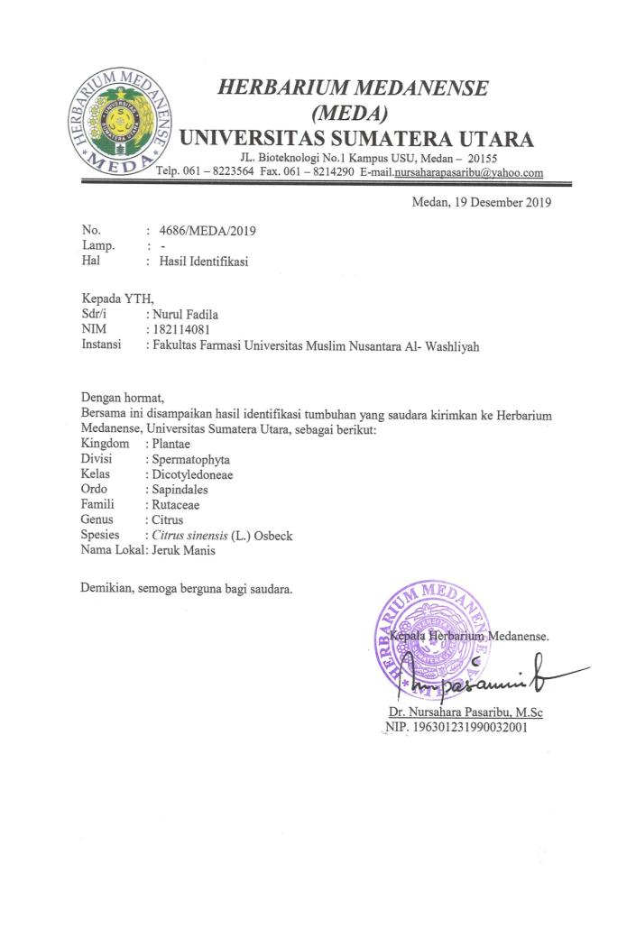

Lampiran 2. Bagan Alir Prosedur Kerja

Pengumpulan sampel kulit jeruk manis (Citrus sinensis L.)

Kulit jeruk manis segar
Disortasi basah
Dicuci dengan air kran mengalir
Ditiriskan
Dirajang tipis-tipis
Ditimbang

Berat basah kulit jeruk manis

Dikeringkan dalam lemari pengering dengan suhu ±40ºC
Disortasi kering
Ditimbang kembali

Berat kering simplisia kulit jeruk manis

Dihaluskan menggunakan blender
Disimpan dalam wadah tertutup rapat

Berat serbuk simplisia kulit jeruk manis

Karakterisasi simplisia

Lampiran 3. Bagan Alir Karakterisasi Simplisia Kulit Jeruk Manis (citrus sinensis L.)

Simplisia kulit jeruk manis segar

Pemeriksaan Makroskopik

Pemeriksaan Mikroskopis

- Kadar air
- Kadar sari larut air
- Kadar sari larut etanol
- Kadar abu total
- Kadar abu tidak larut asam

Lampiran 4. Bagan Alir Ekstraksi Serbuk Simplisia Kulit Jeruk Manis (Citrus sinensis L.)

Serbuk simplisia kulit jeruk manis

Ditimbang serbuk simplisia 500 gram
Dimasukkan kedalam bejana maserasi
Ditambahkan 75 bagian pelarut yaitu 3750 ml etanol 96%
Didiamkan selama 5 hari sambil diaduk
Disaring

Ampas
Maserat

Ditambahkan 25 bagian pelarut yaitu 1250 ml etanol 96% (sampai 5000 ml)
Diendapkan 2 hari

Maserat

Maserat yang diperoleh di uapkan menggunakan Rotary evavorator

Ekstrak kental kulit jeruk manis

Lampiran 5. Bagan Alir Skrining Fitokimia Simplisia dan Ekstrak Kulit Jeruk Manis (Citrus sinensis L.)

Ekstrak kulit jeruk manis
Serbuk simplisia kulit jeruk manis

Skrining fitokimia

Golongan tanin
Golongan saponin
Golongan flavonoid
Golongan alkaloid

Golongan glikosida

Golongan triterpenoid/steroid
Golongan glikosida antrakinon

Lampiran 6. Bagan Alir Uji Sitotoksisitas Ekstrak Kulit Jeruk Manis (Citrus sinensis L.)
50 mg ekstrak kulit jeruk manis

Dilarutkan dengan air garam 10 ml

Konsentrasi 5000 µg/ml (LIB 1)

Dibuat dalam beberapa variasi konsetrasi

100 µg/ml
200 µg/ml
300 µg/ml
400 µg/ml
kontrol

150 µg/ml
500 µg/ml
350 µg/ml
250 µg/ml

Disiapkan vial yang telah berisi 10 ekor larva artemia salina dalam 10 ml ekstrak yang sudah dilarutkan dengan air garam
Masing-masing konsentrasi dibuat dengan 3 kali pengulangan
Mortalitas dihitung setelah 24 jam

% Mortalitas

Lampiran 7. Pengelolaan Sampel Kulit Jeruk Manis (Citrus sinensis L.)

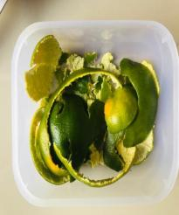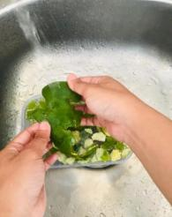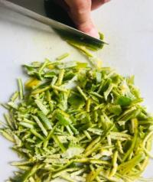
Perajangan
Pencucian
Sortasi basah

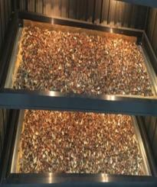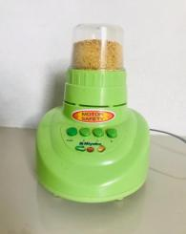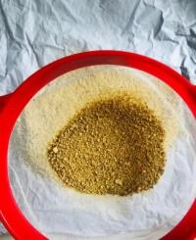
Pengayakan
Penghalusan
Pengeringan

Lampiran 8. Perhitungan Susut Pengeringan

Diketahui :
Bobot tumbuhan segar = 10.000 gram
Bobot simplisia = 1200 gram
% susut pengeringan = $\frac{Berat tumbuhan segar-bobot simplisia}{berat tumbuhan segar}$ x 100%

% susut pengeringan = $\frac{10.000 gram-1200 gram}{10.000 gram}$ x 100%
= 88 %

Lampiran 9. Proses Ekstraksi Kulit Jeruk Manis (Citrus sinensis L.)

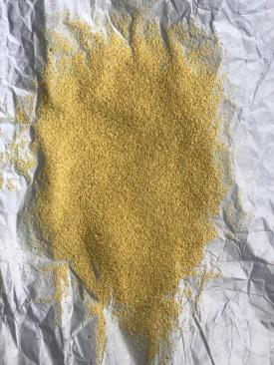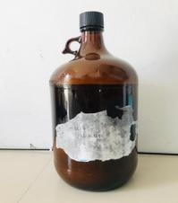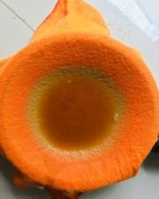
Penyaringan larutan
Wadah maserasi
Serbuk simplisia kulit jeruk manis

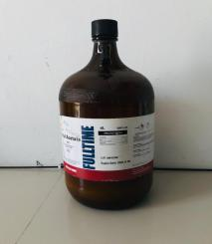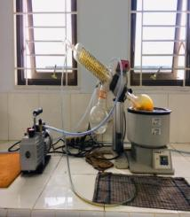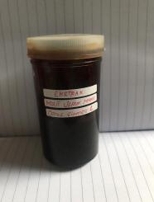
Pengentalan ektrak kulit jeruk manis
Hasil maserat kulit jeruk manis
Ekstrak kental kulit jeruk manis

Lampiran 10. Perhitungan Randemen Ekstrak

Diketahui :
Bobot serbuk simplisia = 500 gram
Volume pelarut = 5000 ml
Bobot ekstrak = 98,594 gram

% Rendemen ekstrak = $\frac{bobot ekstrak}{bobot serbuk simplisia}$ x 100 %
% Rendemen ekstrak = $\frac{98,594 gram}{500 gram }$ x 100 %
= 19,72 %

Lampiran 11. Pemeriksaan Mikroskopik Simplisia Kulit Jeruk Manis (Citrus sinensis L.)

1
1
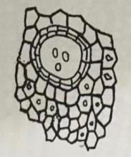
2
2
3
3

Keterangan hasil :
- Minyak atsiri
- Epidermis
- Kristal kalsium oksalat berbentuk prisma
Lampiran 12. Perhitungan Penetapan Kadar Air Simplisia Kulit Jeruk Manis (Citrus sinensis L.)

% kadar air = $\frac{V1-V0}{Berat sampel}$ x 100%
Keterangan : V₀ = Volume destilasi dari penjenuhan toluen
V₁ = Volume destilasi air dari simplisia
- Sampel pengulangan I
V₀ = 1,2 ml
V₁ = 1,6 ml
Berat simplisia = 5 gram
% kadar air = $\frac{1,6 ml - 1,2 ml}{5 g}$ x 100% = 8 %
- Sampel pengulangan II
V₀ = 1,5 ml
V₁ = 1,8 ml
Berat simplisia = 5 gram
% kadar air = $\frac{1,8 ml - 1,5 ml}{5 g}$ x 100% = 6 %
- Sampel pengulangan III
V₀ = 1,3 ml
V₁ = 1,6 ml
Berat simplisia = 5 gram
% kadar air = $\frac{1,6 ml - 1,3 ml}{5 g}$ x 100% = 6 %
Kadar air rata-rata = $\frac{8\%+6\%+6\% }{3}$ = 6,66%
Lampiran 13. Perhitungan Penetapan Kadar Sari Larut Air dan Kadar Sari Larut
Etanol Simplisia Kulit Jeruk Manis (Citrus sinensis L.)

- Perhitungan penetapan kadar sari larut air
% kadar = $\frac{[\left(berat cawan+sampel\right)-berat cawan kosong)] x 5}{berat sampel}$ x 100%
- Pengulangan 1
Berat sampel = 5 gram
Berat cawan kosong = 31,69 gram
B₁ = 31,92 gram
B₂ = 31,90 gram
B₃ = 31,90 gram
B_{rata-rata} = 31,90 gram
% kadar = $\frac{[\left(31,90 gram\right)-31,69 gram] x 5}{5 gram}$ x 100% = 21 %
- Pengulangan 2
Berat sampel = 5 gram
Berat cawan kosong = 32,16 gram
B₁ = 32,36 gram
B₂ = 32,37 gram
B₃ = 32,37 gram
B_{rata-rata} = 32,36 gram
% kadar = $\frac{[\left(32,36 gram\right)-32,16 gram] x 5}{5 gram}$ x 100% = 20 %

Lampiran 13. (Lanjutan)
- Pengulangan 3
Berat sampel = 5 gram
Berat cawan kosong = 32,27 gram
B₁ = 32,52 gram
B₂ = 32,50 gram
B₃ = 32,50 gram
B_{rata-rata} = 32,50 gram
% kadar = $\frac{[\left(32,50 gram\right)-32,27 gram] x 5}{5 gram}$ x 100% = 23 %
Kadar sari larut air rata-rata = $\frac{21\% + 20\% + 23\%}{3}$ = 21,33 %
- Perhitungan penetapan kadar sari larut etanol
% kadar = $\frac{[\left(berat cawan+sampel\right)-berat cawan kosong)] x 5}{berat sampel}$ x 100%
- Pengulangan 1
Berat sampel = 5 gram
Berat cawan kosong = 31,83 gram
B₁ = 32,07 gram
B₂ = 32,06 gram
B₃ = 32,06 gram
B_{rata-rata} = 32,06 gram
% kadar = $\frac{[\left(32,06 gram\right)-31,83 gram] x 5}{5 gram}$ x 100% = 23 %

Lampiran 13. (Lanjutan)
- Pengulangan 2
Berat sampel = 5 gram
Berat cawan kosong = 32,09 gram
B₁ = 32,35 gram
B₂ = 32,38 gram
B₃ = 32,38 gram
B_{rata-rata} = 32,37 gram
% kadar = $\frac{[\left(32,37 gram\right)-32,09 gram] x 5}{5 gram}$ x 100% = 28 %
- Pengulangan 3
Berat sampel = 5 gram
Berat cawan kosong = 31,90 gram
B₁ = 32,14 gram
B₂ = 32,17 gram
B₃ = 32,17 gram
B_{rata-rata} = 32,16 gram
% kadar = $\frac{[\left(32,16 gram\right)-31,90 gram] x 5}{5 gram}$ x 100% = 26 %

kadar sari larut etanol rata-rata = $\frac{23\%+28\%+26\%}{3}$ x 100% = 25,67 %

Lampiran 14. Perhitungan Penetapan Kadar Abu Total dan Kadar Abu Tidak Larut Asam Simplisia Kulit Jeruk Manis (Citrus sinensis L.)

- Perhitungan penetapan kadar abu total
% kadar = $\frac{[\left(berta cawan+berat isi\right)-berat cawan kosong] }{berat sampel}$ x 100%
- Pengulangan 1
Berat sampel = 2 gram
Berat cawan kosong = 59,81 gram
B₁ = 59,88 gram
B₂ = 59,91 gram
B₁ = 59,91 gram
B_{rata-rata} = 59,90 gram
% kadar = $\frac{[\left(59,90 gram\right)-59,81 gram] }{2 gram}$ x 100% = 4,5 %
- Pengulangan 2
Berat sampel = 2 gram
Berat cawan kosong = 60,53 gram
B₁ = 60,63 gram
B₂ = 60,65 gram
B₁ = 60,65 gram
B_{rata-rata} = 60,64 gram
% kadar = $\frac{[\left(60,64 gram\right)-60,53 gram] }{2 gram}$ x 100% = 5,5 %

Lampiran 14. (Lanjutan)
- Pengulangan 3
Berat sampel = 2 gram
Berat cawan kosong = 60,77 gram
B₁ = 60,87 gram
B₂ = 60,84 gram
B₁ = 60,84 gram
B_{rata-rata} = 60,85 gram
% kadar = $\frac{[\left(60,85 gram\right)-60,77 gram] }{2 gram}$ x 100% = 4 %
Kadar abut total rata-rata = $\frac{4,5 \%+5,5 \%+4 \%}{3}$ = 4,67%
- Perhitungan penetapan kadar abu tidak larut asam
% kadar = $\frac{[\left(berta cawan+berat isi\right)-berat cawan kosong] }{berat sampel}$ x 100%
- Pengulangan 1
Berat sampel = 2 gram
Berat cawan kosong = 59,81 gram
B₁ = 59,83 gram
B₂ = 59,82 gram
B₃ = 59,82 gram
B_{rata-rata} = 59,82 gram
% kadar = $\frac{[\left(59,82 gram\right)-59,81 gram] }{2 gram}$ x 100% = 0,5 %

Lampiran 14. (Lampiran)
- Pengulangan 2
Berat sampel = 2 gram
Berat cawan kosong = 60,53 gram
B₁ = 60,53 gram
B₂ = 60,56 gram
B₃ = 60,56 gram
B_{rata-rata} = 60,55 gram
% kadar = $\frac{[\left(60,55 gram\right)-60,53 gram] }{2 gram}$ x 100% = 1 %
- Pengulangan 3
Berat sampel = 2 gram
Berat cawan kosong = 60,77 gram
B₁ = 60,77 gram
B₂ = 60,79 gram
B₃ = 60,79 gram
B_{rata-rata} = 60,78 gram
% kadar = $\frac{[\left(60,78 gram\right)-60,77 gram] }{2 gram}$ x 100% = 0,5 %
% kadar = $\frac{0,5 \%+1\%+0,5\% }{3}$ x 100% = 0,67 %

Lampiran 15. Uji Sitotoksisitas Ekstrak Kulit Jeruk Manis (Citrus sinensis L.)

- Penetasan telur artemia
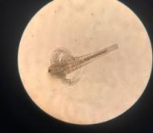
Artemia salina
Proses penetasan
Telur artemia
Air garam buatan

- Pengenceran ekstrak kulit jeruk manis dalam beberapa konsentrasi
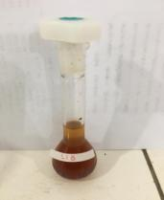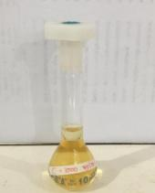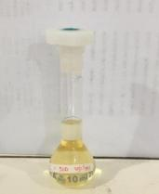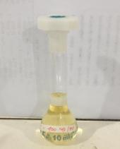
1000 µg/mL
500 µg/mL
400 µg/mL
LIB

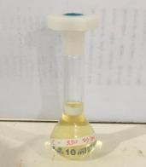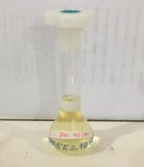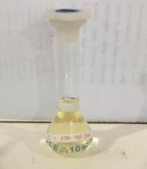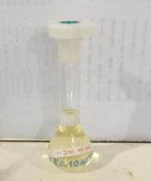
250 µg/mL
300 µg/mL
350 µg/mL
200 µg/mL

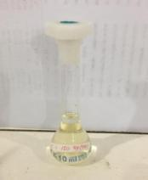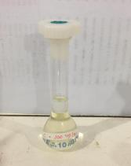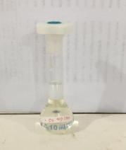
50 µg/mL
100 µg/mL
150 µg/mL

Lampiran 15. (Lanjutan)

- Pengujian sitotoksisitas ekstrak etanol kulit jeruk manis (Citrus sinensis L.) dengan berbagai variasi konsentrasi

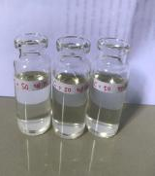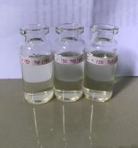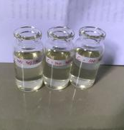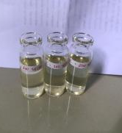
200 µg/mL

150 µg/mL
100 µg/mL
50 µg/mL

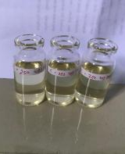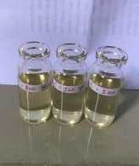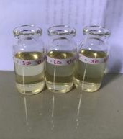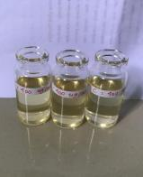
250 µg/mL
350 µg/mL
400 µg/mL
300 µg/mL

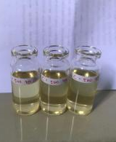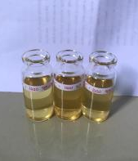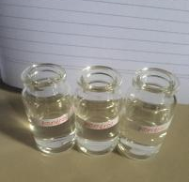
kontrol
1000 µg/mL
500 µg/mL

Lampiran 16. Perhitungan Pembuatan Variasi Pengenceran Ekstrak Kulit Jeruk Manis (Citrus sinensis L.)

50 mg ekstrak kulit jeruk manis dalam labu tentukur 10 ml
Lib 1 = 50 mg (C = 50.000 µg/10 mL) maka C = 5.000 µg/mL

C₁ = 5000 µg/mL X 2 ml = $\frac{10000 µg/mL}{10 ml}$ = 1000 µg/mL
C₂ = 5000 µg/mL X 1 ml = $\frac{5000 µg/mL}{10 ml}$ = 500 µg/mL
C₄ = 5000 µg/mL X 0,8 ml = $\frac{4000 µg/mL}{10 ml}$ = 400 µg/mL
C₅ = 5000 µg/mL X 0,7 ml = $\frac{3500 µg/mL}{10 ml}$ = 350 µg/mL
C₆ = 5000 µg/mL X 0,6 ml = $\frac{3000 µg/mL}{10 ml}$ = 300 µg/mL
C₇ = 5000 µg/mL X 0,5 ml = $\frac{2500 µg/mL}{10 ml}$ = 250 µg/mL
C₈ = 5000 µg/mL X 0,4 ml = $\frac{2000 µg/mL}{10 ml}$ = 200 µg/mL
C₉ = 5000 µg/mL X 0,3 ml = $\frac{1500 µg/mL}{10 ml}$ = 150 µg/mL
C₁₀ = 5000 µg/mL X 0,2 ml = $\frac{1000 µg/mL}{10 ml}$ = 100 µg/mL
C₁₁ = 5000 µg/mL X 0,1 ml = $\frac{500 µg/mL}{10 ml}$ = 50 µg/mL

Lampiran 17. Perhitungan LC₅₀ Ekstrak Kulit Jeruk Manis (Citrus sinensis L.)

% Kematian Larva = $\frac{jumlah kematian larva uji}{jumlah larva uji}$ x 100%

d (C(µg /mL)) | N (jumlah larva) | r (jmlh larva mati) | P (% mortalitas) | X  (log C) | Y (Nilai probit) | XY | X²
100 | 30 | 7 | 23,33 | 2,0000 | 4,2710 | 8,542 | 4,0000
150 | 30 | 11 | 36,66 | 2,1761 | 4,6602 | 10,1410 | 4,7354
200 | 30 | 12 | 40 | 2,3010 | 4,7467 | 10,9221 | 5,2946
250 | 30 | 16 | 53,33 | 2,3979 | 5,0828 | 12,1880 | 5,7499
300 | 30 | 19 | 63,33 | 2,4771 | 5,3398 | 13,0670 | 6,1360
350 | 30 | 21 | 70 | 2,5441 | 5,5244 | 14,0546 | 6,4724
400 | 30 | 25 | 83,33 | 2,6020 | 5,9661 | 15,5238 | 6,7704
 |  |  |  | ƩX =  16,4982 | ƩY =  35,591 | ƩXY =  84,4385 | ƩX² =  39,1587

Persamaan garis regresi linier : Y = b X + a
Y = konsentrasi kematian
X = log konsentrasi
b = $\frac{n \left(ƩXY\right)-(ƩXƩY)}{n \left(ƩX^{2}\right)-(Ʃ{X)}^{2}}$
b = $\frac{7 \left(84,4385\right)-(16,4982 X 35,591)}{7 \left(39,1587\right)-(16,4982)^{2}}$
b = $\frac{7 \left(84,4385\right)-(587,1874)}{7 \left(39,1587\right)-(272,1906)}$
b = $\frac{591,0695 - 587,1874}{274,1109 -272,1906}$
b = $\frac{3,8821}{1,9203}$ = 2,0216
Lampiran 17. (Lanjutan)
a = $\frac{ƩY-b ƩX}{n}$
a = $\frac{35,591 - 2,0216 (16,4982)}{7}$
a = $\frac{35,591 - 33,3528}{7}$
a = 0,3197

Nilai LC₅₀ diperoleh dari antilog X, dimana X merupakan logaritma konsentrasi bahan toksik pada Y = 5, yaitu nilai probit 50% hewan uji. Sehingaa diperoleh persamaan regresi Y = 2,0216 X + 0,3197
Jadi, 5 = 2,0216 X + 0,3197
X = $\frac{5-0,3197}{2,0216}$
X = 2,31
Maka nilai LC₅₀ antilog 2,31 = 204,17 µg/mL.

Lampiran 18. Kurva Hubungan Antara Log Konsentrasi (x) dan Nilai Probit (y) Menggunakan SPSS 20 for windows

Variables Entered/Removedª
Model | Variables Entered | Variables Removed | Method
1 | Log C^{b} | . | Enter

a. Dependent Variable: Nilai Probit
b. All requested variables entered.

Model Summary
Model | R | R Square | Adjusted R Square | Std. Error of the Estimate
1 | .967ª | .935 | .922 | .161

a. Predictors: (Constant), Log C

Coefficientsª
Model |  | Unstandardized Coefficients |  | Standardized Coefficients | t | Sig.
 |  | B | Std. Error | Beta
1 | (Constant) | -1.056 | .726 |  | -1.455 | .205
 | Log C | 2.605 | .307 | .967 | 8.493 | .000

- Dependent Variable: Nilai Probit
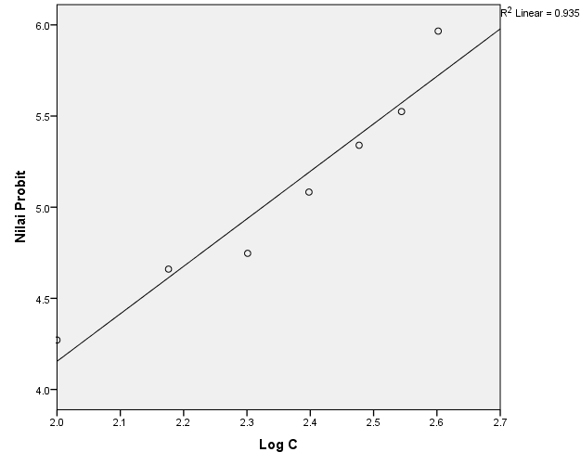
Lampiran 19. Tabel Probit
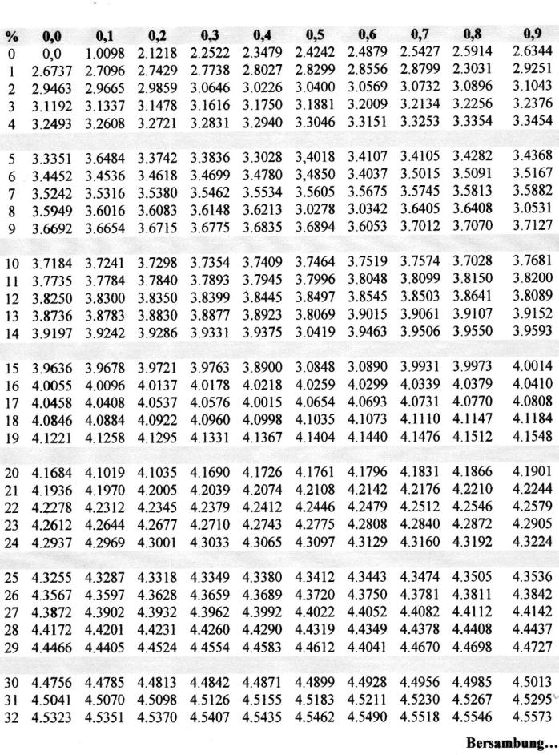
Nilai Probit

Lampiran 19. (Lanjutan)
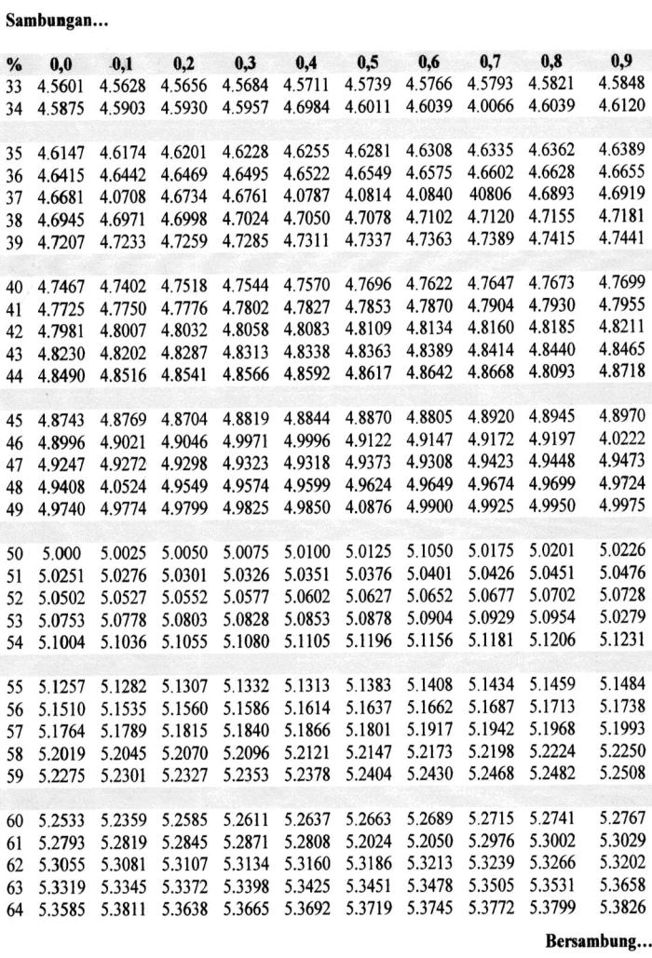

Lampiran 19. (Lanjutan)
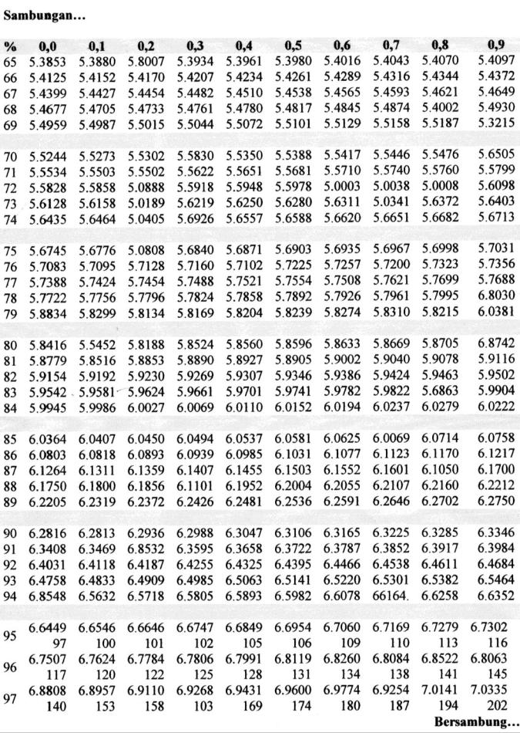

Lampiran 19. (Lanjutan)
