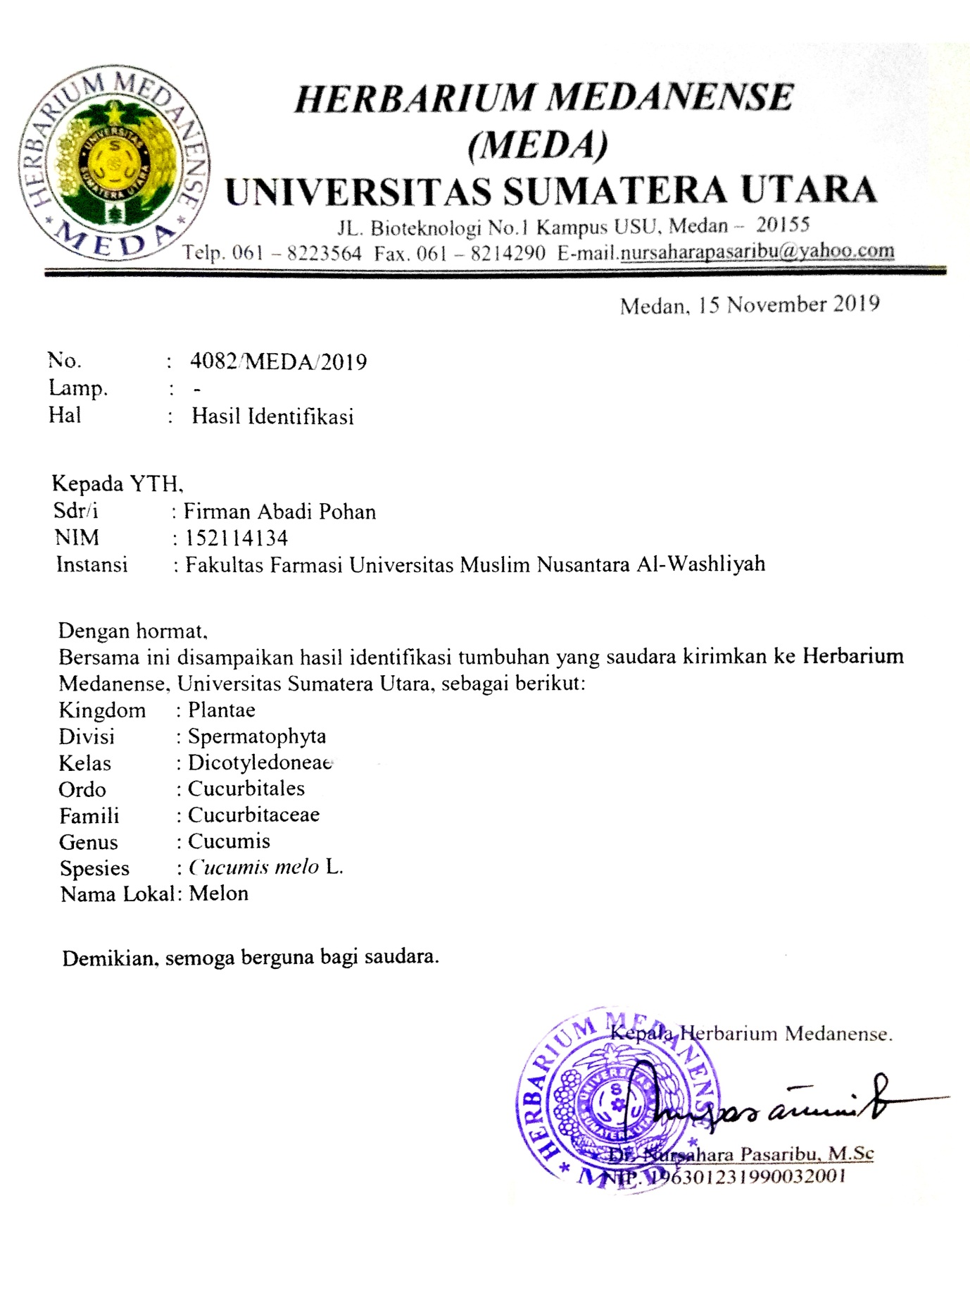**Lampiran 1**. Hasil identifikasi buah melon *(Cucumis melo L.)*

Medan, 15 Oktober 2019

**Lampiran 2**. Sertifikat baku pembanding

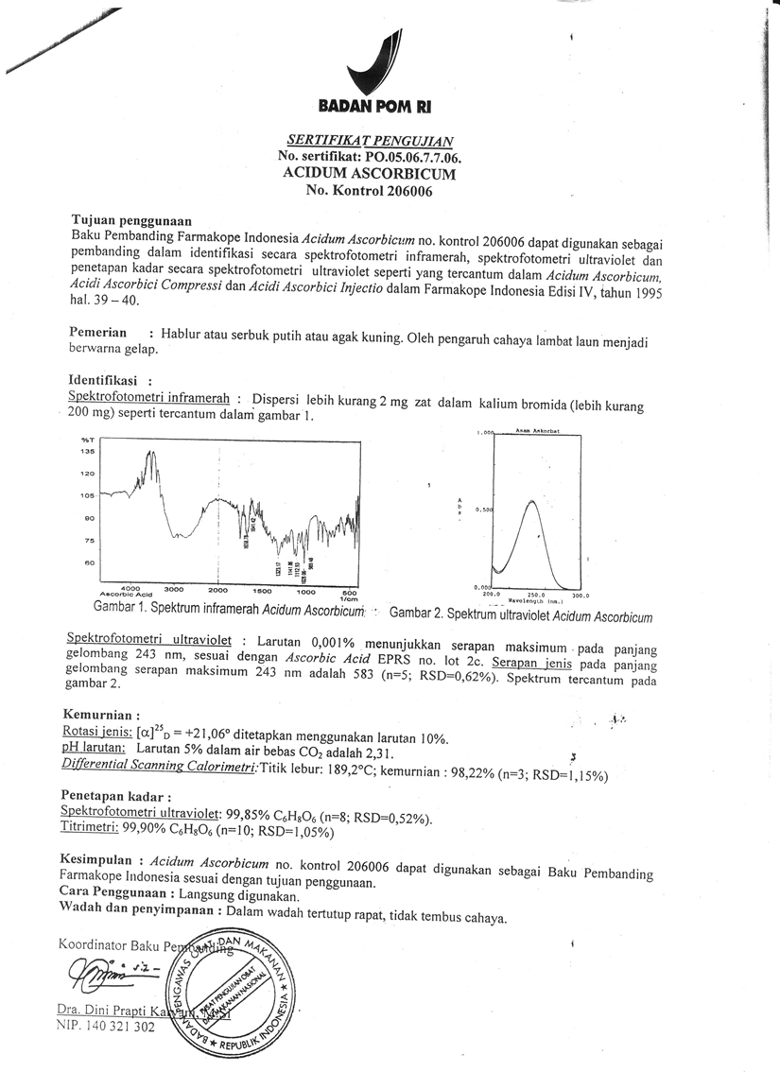

**Lampiran 3.** Buah melon, Jus melon dan Hasil titrasi

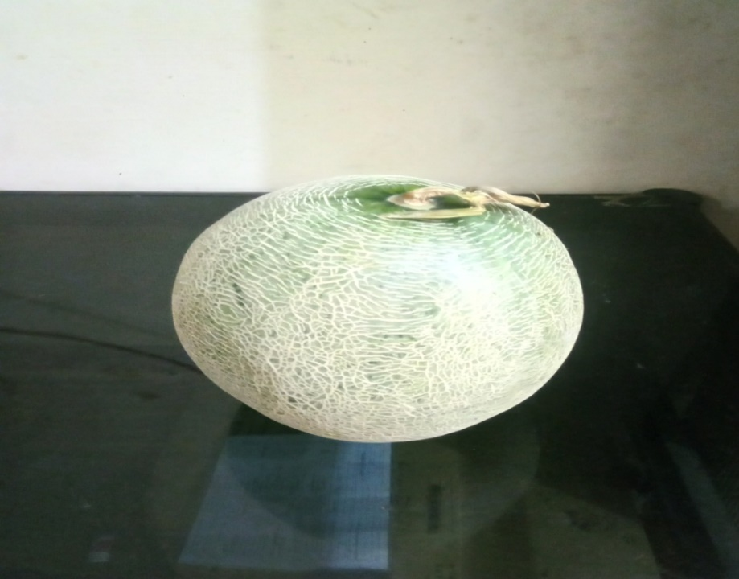

1. Buah melon

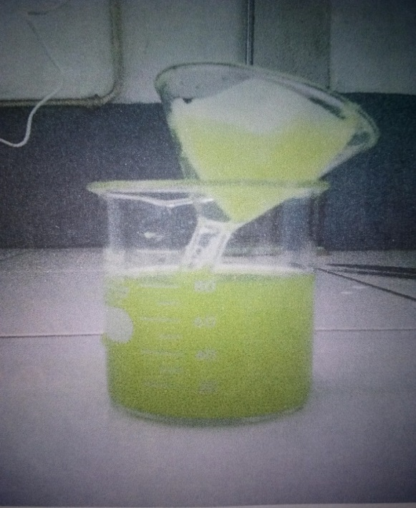 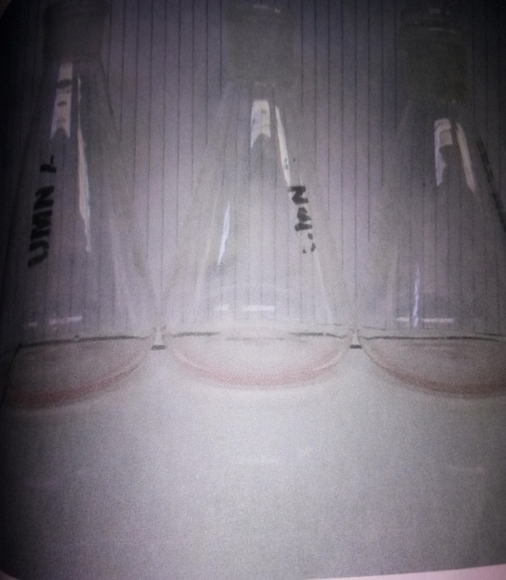

B. Jus melon C. Hasil titrasi

**Lampiran 4.** Penyiapan Larutan Sampel

Buah Melon

Dicuci bersih lalu dibersihkan

Ditimbang sekitar 500 g

Dipotong menjadi beberapa potongan

Dimasukkan kedalam *juicer*, lalu dijus

Jus Buah Melon

Ditimbang lebih kurang 10g

Dimasukkan kedalam labu tentukur 100 mL

Ditambahkan larutan asam metafosfat 3%

Sampai garis tanda (pada masing-masing

Titik waktu: 0, 3, 6, dan 9 jam).

Di homogenkan

Di Saring

Filtrat

**Lampiran 5.** Penetapan Kadar Vitamin C dari Larutan Sampel

Filtrat

Dipipet 2 mL

Dimasukkan kedalam erlenmeyer

Ditambahkan 5 mL larutan asam metafosfat 3% kedalam masing-masing erlenmeyer

Dititrasi dengan 2,6-diklorofenol indofenol

sampai terbentuk warna merah jambu mantap

Hasil

Dilakukan penetapan kadar vitamin C dalam jus buah melon pada beberapa penyimpanan setelah jus diproses, antara lain pada 0 jam, 3 jam, 6 jam, 9 jam hingga diperoleh profil penurunan kadar vitamin C dari jus buah melon

Kemudian dibandingkan profil penurunan kadar vitamin C pada jus melon.

Hasil

**Lampiran 6**. Contoh Perhitungan Kesetaraan KadarVit. C Dalam Sampel Jus Buah Melon

Bobot sampel = 10,02 g

Dilarutkan dalam labu tentukur sampai 100 ml

Dipipet 20 ml, (volume aliquat) untuk dititrasi dengan larutan 2,6-Diklorofenolindofenol

Volume pentiter untuk titrasi sampel( VA) = 10,40 ml

Volume pentiter untukt itrasi blanko rata-rata (VB) = 0,10 ml

Tiap ml larutan 2,6-Dikloro fenol indofenol setara dengan 0,0577 mg Vit.C.

|  |  |  |  |
| --- | --- | --- | --- |
| Kadar Vit.C (%) = | (VA - VB) ml x volume larutan sampel Kesetaraan | x 100% |  |
| Volume sampel yang dipipet x Bobotsampel |

|  |  |  |  |
| --- | --- | --- | --- |
| Kadar Vit.C (%) = | (10,40 - 0,01 ) ml x 0,0577 mg | x 100% =0,2966 mg/100g |  |
| 20 ml x 10,02 mg |

Kadar Vit.C = 29,66 mg/100 g.

**Lampiran 7.** Perhitungan Kesetaraan Baku Vitamin C Dengan Larutan Pentiter 2,6

Diklorofenol indofenol

Persen kemurnian Vitamin C baku = 99,90%

Ditimbang 50,05 mg, dilarutkan dalam labu tentukur 100 ml

Dipipet 2 ml,untuk dititrasi dengan larutan 2,6 Diklorofenol indofenol

Volume pentiter untuk titrasi sampel ( VA ) =

9,00 ml

8,05 ml

9,00 ml

Volume pentiter untuk titrasi blanko =

0, 05 ml

0, 05 ml

0, 05 ml

Volume pentiter untuk titrasi blanko rata-rata (VB) = 0,5 ml

|  |  |  |
| --- | --- | --- |
| Kesetaraan Vit.C = | BobotVit.C x KemurnianVit C x Faktorpengenceran |  |
| (VA - VB) ml |

|  |  |  |  |
| --- | --- | --- | --- |
| Kesetaraan Vit.C = | 50 mg x 99,90/100 x 2ml/50ml | = 09,1259 mg/ml | 0.2237 |
| (9 - 0,05) ml |

|  |  |  |  |
| --- | --- | --- | --- |
| Kesetaraan Vit.C = | 50 mg x 99,90/100 x 2ml/50ml | = 0,1263 mg/ml | 0.2502 |
| (8,05 - 0,05) ml |

|  |  |  |  |
| --- | --- | --- | --- |
| Kesetaraan Vit.C = | 50 mg x 99,90/100 x 2ml/50ml | = 09,1259 mg/ml | 0.2237 |
| (9 - 0,05) ml |

|  |  |  |
| --- | --- | --- |
| Kesetaraan Vit.C = rata-rata | (0,2237 + 0,2502 + 0,2237) mg/ml | = 0,2325 mg/ml |
| 3 |

Kesetaraan Vit. C rata-rata = 0,2325 mg/ml

Tiap ml larutan 2,6-Diklorofenol indofenol setara dengan 0,2325 mg Vit.C.

**Lampiran 8**. Data dan Hasil Perhitungan Kadar Vit C Dari Jus Buah Melon Secara Titrasi

2,6 Diklorofenol Indofeno

|  |  |  |  |  |  |  |  |
| --- | --- | --- | --- | --- | --- | --- | --- |
| Sampel | Berat sampel yang ditimbang (mg) | Violume larutan sampel (ml) | Volume larutan sampel yang dipipet (ml) | Kesetaraan vitamin C terhadap larutan 2,6 diklorofenol indofenol (mg) | Volume Pentiter untuk titrasi blanko (ml) | Volume Pentiter untuk titrasi sampel (ml) | Kadar Vitamin C (mg/100 g) |
|
|
| Jus buah melon yang baru dibuat | 100.00 | 1000.00 | 25.00 | 0.2325 | 0.50 | 2.30 | 16.74 |
| 100.05 | 1000.00 | 25.00 | 2.20 | 15.80 |
| 100.10 | 1000.00 | 25.00 | 2.15 | 15.33 |
| 100.00 | 1000.00 | 25.00 | 2.15 | 15.35 |
| 100.20 | 1000.00 | 25.00 | 2.20 | 15.78 |
| 100.05 | 1000.00 | 25.00 | 2.15 | 15.34 |
| Kadar vitamin C rata-rata = | | | 15.72 |  |  |  |
| Standar deviasi = | | | 0.55 |  |  |  |
| Kadar vitamin C sebenarnya = | | | 15.72 | ± | 0.90 |  |
| Jus buah melon setelah didiamkan selama 3 jam pada suhu dingin | 100.00 | 1000.00 | 25.00 | 0.2325 | 0.50 | 2.25 | 16.28 |
| 100.05 | 1000.00 | 25.00 | 2.10 | 14.87 |
| 100.10 | 1000.00 | 25.00 | 2.05 | 14.40 |
| 100.00 | 1000.00 | 25.00 | 2.40 | 17.67 |
| 100.20 | 1000.00 | 25.00 | 2.00 | 13.92 |
| 100.05 | 1000.00 | 25.00 | 2.00 | 13.94 |
| Kadar vitamin C rata-rata = | | | 15.18 |  |  |  |
| Standar deviasi = | | | 1.50 |  |  |  |
| Kadar vitamin C sebenarnya = | | | 15.18 | ± | 2.466 |  |
| Jus buah melon setelah didiamkan selama 3 jam pada suhu kamar | 100.00 | 1000.00 | 25.00 | 0.2325 | 0.50 | 2.20 | 15.81 |
| 100.05 | 1000.00 | 25.00 | 2.10 | 14.87 |
| 100.10 | 1000.00 | 25.00 | 2.05 | 14.40 |
| 100.00 | 1000.00 | 25.00 | 2.05 | 14.42 |
| 100.20 | 1000.00 | 25.00 | 2.10 | 14.85 |
| 100.05 | 1000.00 | 25.00 | 2.05 | 14.41 |
| Kadar vitamin C rata-rata = | | | 14.79 |  |  |  |
| Standar deviasi = | | | 0.55 |  |  |  |
| Kadar vitamin C sebenarnya = | | | 14.79 | ± | 0.898 |  |
| Jus buah melon setelah didiamkan selama 6 jam pada suhu dingin | 100.00 | 1000.00 | 25.00 | 0.2325 | 0.50 | 2.10 | 14.88 |
| 100.05 | 1000.00 | 25.00 | 2.00 | 13.94 |
| 100.10 | 1000.00 | 25.00 | 2.05 | 14.40 |
| 100.00 | 1000.00 | 25.00 | 2.00 | 13.95 |
| 100.20 | 1000.00 | 25.00 | 1.95 | 13.46 |
| 100.05 | 1000.00 | 25.00 | 1.90 | 13.01 |
| Kadar vitamin C rata-rata = | | | 13.94 |  |  |  |
| Standar deviasi = | | | 0.66 |  |  |  |
| Kadar vitamin C sebenarnya = | | | 13.94 | ± | 1.089 |  |
| Jus buah melon setelah didiamkan selama 6 jam pada suhu kamar | 100.00 | 1000.00 | 25.00 | 0.2325 | 0.50 | 2.05 | 14.42 |
| 100.05 | 1000.00 | 25.00 | 2.00 | 13.94 |
| 100.10 | 1000.00 | 25.00 | 2.05 | 14.40 |
| 100.00 | 1000.00 | 25.00 | 1.90 | 13.02 |
| 100.20 | 1000.00 | 25.00 | 1.85 | 12.53 |
| 100.05 | 1000.00 | 25.00 | 1.95 | 13.48 |
| Kadar vitamin C rata-rata = | | | 13.63 |  |  |  |
| Standar deviasi = | | | 0.76 |  |  |  |
| Kadar vitamin C sebenarnya = | | | 13.63 | ± | 1.257 |  |
| Jus buah melon setelah didiamkan selama 9 jam pada suhu dingin | 100.00 | 1000.00 | 25.00 | 0.2325 | 0.50 | 2.00 | 13.95 |
| 100.05 | 1000.00 | 25.00 | 1.95 | 13.48 |
| 100.10 | 1000.00 | 25.00 | 1.80 | 12.08 |
| 100.00 | 1000.00 | 25.00 | 1.85 | 12.56 |
| 100.20 | 1000.00 | 25.00 | 1.90 | 12.99 |
| 100.05 | 1000.00 | 25.00 | 1.75 | 11.62 |
| Kadar vitamin C rata-rata = | | | 12.78 |  |  |  |
| Standar deviasi = | | | 0.87 |  |  |  |
| Kadar vitamin C sebenarnya = | | | 12.78 | ± | 1.434 |  |
| Jus buah melon setelah didiamkan selama 9 jam pada suhu kamar | 100.00 | 1000.00 | 25.00 | 0.2325 | 0.50 | 1.95 | 13.49 |
| 100.05 | 1000.00 | 25.00 | 1.80 | 12.08 |
| 100.10 | 1000.00 | 25.00 | 1.50 | 9.29 |
| 100.00 | 1000.00 | 25.00 | 1.75 | 11.63 |
| 100.20 | 1000.00 | 25.00 | 1.80 | 12.07 |
| 100.05 | 1000.00 | 25.00 | 1.85 | 12.55 |
| Kadar vitamin C rata-rata = | | | 11.85 |  |  |  |
| Standar deviasi = | | | 1.40 |  |  |  |
| Kadar vitamin C sebenarnya = | | | 11.85 | ± | 2.31 |  |

**Lampiran 9.** Hasil Data Perhitungan Kesetaraan Dadar Vitamin C Dari Jus Buah Melon

Dengan Larutan Pentiter 2,6 Diklorofenol Indofenol Dengan Interval Waktu

Penyimpan 0,3,6, Hingga 9 Jam Pada Suhu Kamar.

| **Descriptives** | | | | | | | | |
| --- | --- | --- | --- | --- | --- | --- | --- | --- |
| kadar vitamin C pada buah melon | | | | | | | | |
|  | N | Mean | Std. Deviation | Std. Error | 95% Confidence Interval for Mean | | Minimum | Maximum |
| Lower Bound | Upper Bound |
| 0 jam | 6 | 15,7233 | ,54474 | ,22239 | 15,1517 | 16,2950 | 15,33 | 16,74 |
| 3 jam | 6 | 14,7933 | ,54474 | ,22239 | 14,2217 | 15,3650 | 14,40 | 15,81 |
| 6 jam | 6 | 13,6317 | ,76390 | ,31186 | 12,8300 | 14,4333 | 12,53 | 14,42 |
| 9 jam | 6 | 11,8517 | 1,40591 | ,57396 | 10,3763 | 13,3271 | 9,29 | 13,49 |
| Total | 24 | 14,0000 | 1,69230 | ,34544 | 13,2854 | 14,7146 | 9,29 | 16,74 |

| **ANOVA** | | | | | |
| --- | --- | --- | --- | --- | --- |
| kadar vitamin C pada buah melon | | | | | |
|  | Sum of Squares | Df | Mean Square | F | Sig. |
| Between Groups | 50,102 | 3 | 16,701 | 21,183 | ,000 |
| Within Groups | 15,768 | 20 | ,788 |  |  |
| Total | 65,870 | 23 |  |  |  |

| **kadar vitamin C pada buah melon** | | | | |
| --- | --- | --- | --- | --- |
| Duncana | | | | |
| waktu penyimpanan pada suhu kamar | N | Subset for alpha = 0.05 | | |
| 1 | 2 | 3 |
| 9 jam | 6 | 11,8517c |  |  |
| 6 jam | 6 |  | 13,6317b |  |
| 3 jam | 6 |  |  | 14,7933a |
| 0 jam | 6 |  |  | 15,7233a |
| Sig. |  | 1,000 | 1,000 | ,085 |

**Lampiran10**. Hasil Data Perhitungan Kesetaraan Kadar Vitamin C Dari Jus Buah Melon

Dengan Larutan Pentiter 2,6 Diklorofenol Indofenol Dengan Interval Waktu

Penyimpanan 0,3,6, Hingga 9 Jam Pada Suhu Kulkas.

| **Descriptives** | | | | | | | | |
| --- | --- | --- | --- | --- | --- | --- | --- | --- |
| kadar vitamin C pada jus buah melon | | | | | | | | |
|  | N | Mean | Std. Deviation | Std. Error | 95% Confidence Interval for Mean | | Minimum | Maximum |
| Lower Bound | Upper Bound |
| 0 jam | 6 | 15,7233 | ,54474 | ,22239 | 15,1517 | 16,2950 | 15,33 | 16,74 |
| 3 jam | 6 | 15,1800 | 1,49932 | ,61209 | 13,6066 | 16,7534 | 13,92 | 17,67 |
| 6 jam | 6 | 13,9400 | ,66191 | ,27022 | 13,2454 | 14,6346 | 13,01 | 14,88 |
| 9 jam | 6 | 12,7800 | ,87029 | ,35529 | 11,8667 | 13,6933 | 11,62 | 13,95 |
| Total | 24 | 14,4058 | 1,47256 | ,30059 | 13,7840 | 15,0276 | 11,62 | 17,67 |

| **ANOVA** | | | | | |
| --- | --- | --- | --- | --- | --- |
| kadar vitamin C pada jus buah melon | | | | | |
|  | Sum of Squares | df | Mean Square | F | Sig. |
| Between Groups | 31,173 | 3 | 10,391 | 11,113 | ,000 |
| Within Groups | 18,701 | 20 | ,935 |  |  |
| Total | 49,874 | 23 |  |  |  |

| **kadar vitamin C pada buah melon** | | | |
| --- | --- | --- | --- |
| Duncana | | | |
| waktu penyimpanan pada suhu dingin | N | Subset for alpha = 0.05 | |
| 1 | 2 |
| 9 jam | 6 | 12,7800b |  |
| 6 jam | 6 | 13,9400b |  |
| 3 jam | 6 |  | 15,1800a |
| 0 jam | 6 |  | 15,7233a |
| Sig. |  | ,051 | ,342 |

**Lampiran 11.** Perbedaan Kadar Vitamin C Dari Jus Buah Melon Dengan Beberapa Suhu

Penyimpanan 3,6, Hingga 9 Jam Pada Suhu Kamar Dan Kulkas.

1. Waktu penyimpanan 3 jam suhu kamar dan suhu kulkas pada jus buah melon

| **Group Statistics** | | | | | |
| --- | --- | --- | --- | --- | --- |
|  | waktu penyimpanan | N | Mean | Std. Deviation | Std. Error Mean |
| kadar vitamin C | 3 JAM SUHU KAMAR 3 JAM SUHU KULKAS | 6 | 14,7933 | ,54474 | ,22239 |
| 2,00 | 6 | 15,1800 | 1,49932 | ,61209 |

| **Independent Samples Test** | | | | | | | | | | |
| --- | --- | --- | --- | --- | --- | --- | --- | --- | --- | --- |
|  | | Levene's Test for Equality of Variances | | t-test for Equality of Means | | | | | | |
| F | Sig. | t | df | Sig. (2-tailed) | Mean Difference | Std. Error Difference | 95% Confidence Interval of the Difference | |
| Lower | Upper |
| kadar vitamin C | Equal variances assumed | 6,107 | ,033 | -,594 | 10 | ,566 | -,38667 | ,65124 | -1,83773 | 1,06439 |
| Equal variances not assumed |  |  | -,594 | 6,297 | ,573 | -,38667 | ,65124 | -1,96213 | 1,18880 |

1. Waktu penyimpanan 6 jam suhu kamar dan suhu kulkas pada jus buah melon

| **Group Statistics** | | | | | |
| --- | --- | --- | --- | --- | --- |
|  | waktu penyimpanan | N | Mean | Std. Deviation | Std. Error Mean |
| kadar vitamin C | 6 JAM SUHU KAMAR 6 JAM SUHU DINGIN | 6 | 13,6317 | ,76390 | ,31186 |
| 2,00 | 6 | 13,9400 | ,66191 | ,27022 |

| **Independent Samples Test** | | | | | | | | | | |
| --- | --- | --- | --- | --- | --- | --- | --- | --- | --- | --- |
|  | | Levene's Test for Equality of Variances | | t-test for Equality of Means | | | | | | |
| F | Sig. | t | df | Sig. (2-tailed) | Mean Difference | Std. Error Difference | 95% Confidence Interval of the Difference | |
| Lower | Upper |
| kadar vitamin C | Equal variances assumed | ,471 | ,508 | -,747 | 10 | ,472 | -,30833 | ,41265 | -1,22776 | ,61110 |
| Equal variances not assumed |  |  | -,747 | 9,801 | ,472 | -,30833 | ,41265 | -1,23030 | ,61363 |

1. Waktu penyimpanan 9 jam suhu kamar dan suhu kulkas jus buah melon

| **Group Statistics** | | | | | |
| --- | --- | --- | --- | --- | --- |
|  | waktu penyimpanan | N | Mean | Std. Deviation | Std. Error Mean |
| kadar vitamin C | 9 JAM SUHU KAMAR 9 JAM SUHU DINGIN | 6 | 12,7800 | ,87029 | ,35529 |
| 2,00 | 6 | 11,8517 | 1,40591 | ,57396 |

| **Independent Samples Test** | | | | | | | | | | |
| --- | --- | --- | --- | --- | --- | --- | --- | --- | --- | --- |
|  | | Levene's Test for Equality of Variances | | t-test for Equality of Means | | | | | | |
| F | Sig. | t | df | Sig. (2-tailed) | Mean Difference | Std. Error Difference | 95% Confidence Interval of the Difference | |
| Lower | Upper |
| kadar vitamin C | Equal variances assumed | ,293 | ,600 | 1,375 | 10 | ,199 | ,92833 | ,67503 | -,57572 | 2,43239 |
| Equal variances not assumed |  |  | 1,375 | 8,341 | ,205 | ,92833 | ,67503 | -,61727 | 2,47393 |

**Lampiran 12.** Validasi Metode (Perhitungan persen recovery)

Contoh perhitungan :

Bobot sampel yang di timbang = 100 g

Vitamin C baku yang di tambahkan = 5 mg/100 g

Volume pentiter sebelum di tambahkan baku = 5,40 ml

Volume pentiter setelah di tambahkan baku = 6,85 ml

Kadar vitamin C sebelum di tambahkan baku :

= ( 5,40 - 0,5)ml x 0,2325 (mg)x 100 x 1000 ml =  17,91

100 25

Kadar vitamin C setelah di tambahkan baku :

= (6,85 – 0,5)ml x 0,2325 (mg)x 100 x 1000 ml = 22,77

10025

Persen recovery ( 22,77-17,91)mg)/100g x 100 % = 97,25 %

23mg/100g

Dengan cara yang sama dilakukan pengulangan samapai 6 kali, hasilnya dapat di lihatsebagai berikut :

Persen recovery rata rata = 100,51

Standar deviasi = 2,09

Persen recovery rata rata = standar deviasi x 100%

Persen recovery rata rata

= 2,09 x 100% = 2,08

100,51

*Persen recovery*  vitamin C yang di peroleh adalah 100,51% dengan presisi (%RSD = 2,08 %) Menurut Abdul Rohman nilai recovery (nilai kecermatan anatara 80 – 120 % sedangkan hasil yang di peroleh dari penelitian adalah 100.51%. Hal ini menunjukkan metode titrasi diklorofenol indofenol yang di gunakan pada penetapan kadar Vitamin C memenuhi persyaratan uji recovery. Sehingga dapat disimpulkan metode ini tepat untuk di gunakan penetapan kadar Vitamin C.