**Lampiran 1.** Surat Keterangan Uji Identifikasi Sampel

**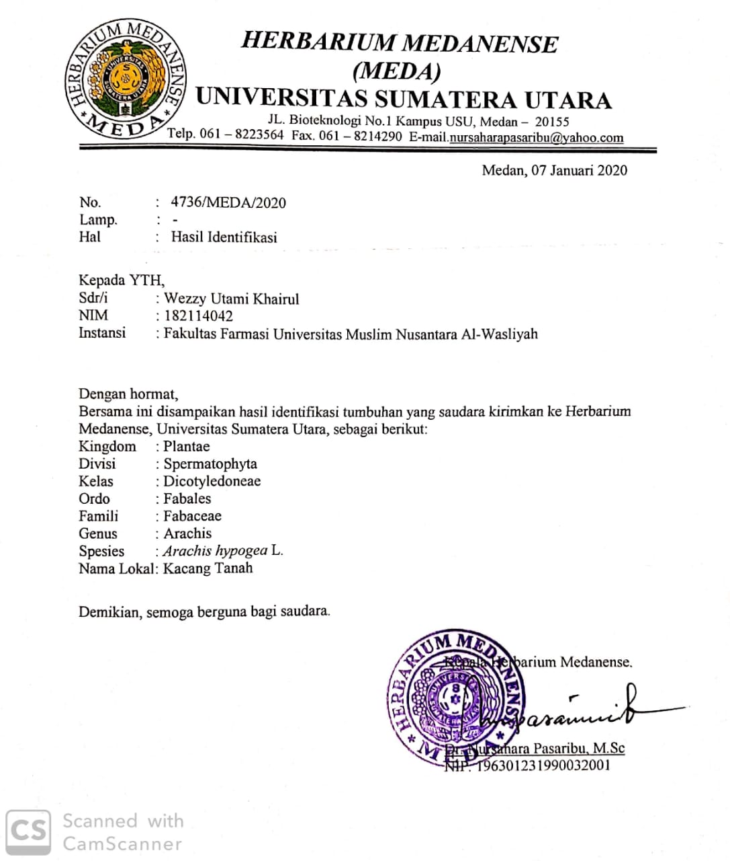**

**Lampiran 2.** Bagan Alir Pembuatan Serbuk Simplisia

Kulit dan biji kacang tanah segar

Disortasi basah

Dicuci dengan air kran mengalir

Ditiriskan

Ditimbang

Berat basah kulit kacang tanah 6300 g

Berat basah biji kacang tanah 6700 g

Dikeringkan dalam lemari pengering pada suhu 40-60℃

Disortasi kering

Ditimbang kembali

Berat simplisia kulit kacang tanah 2400 g

Berat simplisia biji kacang tanah 4235 g

Dihaluskan menggunakan blender

Disimpan dalam wadah tertututp rapat

Serbuk Simplisia

Kulit kacang tanah = 1670 g

Biji kacang tanah = 3830 g

Karakterisasi simplisia

**Lampiran 3.** Bagan Alir Karakterisasi Simplisia

1. Penetapan kadar air

Toluen : Air

100 : 1

Dimasukkan ke dalam labu alas bulat

Dipasang dan didestilasi selama 2 jam

Dinginkan selama 30 menit, sampai toluen dan air memisah

Dihitung volume air dalam tabung penerima

Volume Air Awal

Dimasukkan 2,5 gram serbuk simplisia dalam labu alas bulat berisi toluen yang telah jenuh

Dipanaskan selama 15 menit, sampai toluen mendidih, diatur kecepatan tetesan 2 tetes per detik

Dibiarkan sampai semua air terdestilasi

Dibiarkan tabung penerima dingin sampai air dan toluen memisah sempurna

Dihitung volume air dalam tabung penerima

Volume Air Akhir

**Lampiran 3.** (lanjutan)

1. Penetapan kadar sari larut air

Serbuk simplisia

Ditimbang 5 gram

Dimaserasi dengan 100 ml air dan 0,25 ml kloroform selama 24 jam sambil sesekali diaduk

Disaring

Filtrat

Diambil 20 ml diuapkan dalam cawan porselen yang telah ditara pada suhu 105oC sampai bobot tetap

Ditimbang

Berat Sari

1. Penetapan kadar sari larut etanol

Serbuk simplisia

Ditimbang 5 gram

Dimaserasi dengan 100 ml etanol selama 24 jam sambil sesekali diaduk

Disaring

Filtrat

Diambil 20 ml diuapkan dalam cawan porselen yang telah ditara pada suhu 105oC sampai bobot tetap

Ditimbang

Berat Sari

**Lampiran 3.** (lanjutan)

1. Penetapan kadar abu total

Serbuk simplisia

Ditimbang 3 gram

Dimasukkan ke dalam krus porselen yang telah dipijar dan ditara

Dimasukkan krus porselen dalam tanur, dipijar pada suhu 600oc selama 3 jam

Dikeluarkan, dan didinginkan

Ditimbang

Berat Abu

1. Penetapan kadar abu tidak larut asam

Abu

Dimasukkan dalam cawan

Ditambahkan 25 ml HCl encer

Didihkan selama 15 menit

Disaring dengan kertas saring bebas abu

Dipijar dalam tanur

Dinginkan dan ditimbang

Berat Abu

**Lampiran 4.** Bagan Alir Pembuatan Ekstrak

Simplisia

* Ditimbang 500 gram
* Dimasukan dalam bejana
* Ditambahkan 75 bagian etanol 96% (3750ml) diamkan selama 5 hari
* Diaduk sekali dan disaring

Ampas 1

Maserat 1

* Ditambahkan 25 bagian etanol 96% (1250ml) didiamkan selama 2 hari
* Diaduk sekali dan disaring

Maserat 2

Ampas 2

Maserat 1 dan 2 dicampur

* dipekatkan dengan *rotary evaporator*

Ekstrak kental

Kulit kacang tanah 49,50 g (Rendemen ekstrak 9,90 %)

Biji kacang tanah 47,40 g (Rendemen ekstrak 9,48 %)

Lampiran5. Bagan Alir Skrining Fitokimia

**Ekstrak Kental Etanol biji & kulit kacang tanah**

**Tanin (+)**

0,5g +10ml aquadest,kocok dan saring,lalu ambil 2ml + 2 tts Fecl3 timbulnya warna biru kehitaman/hijau kehitaman positif tanin

**Steroid (+)**

1g + 20ml

n-heksan diamkan 2 jam lalu saring. Filtrat 5ml uapkan di cawan penguap sampai kering + 20 tts as. asetat anhidrat + 1 tts as sulfat pekat Timbulnya warna biru atau biru hijau positif steroida,

**Saponin (+)**

0,5g + 10ml air panas,dinginkan kocok kuat selama 10 dtk,terbentuk buih/busa tdk kurang setinggi 1-10cm +HCL 2N apabila tdk hilang positif saponin

**Flavonoid (+)**

1g +10ml air panaskan 5m lalu saring.ambil filtrate 5ml +0,1g serbuk mg + 1ml HCL P + amilalkohol lalu kocok biarakn memisah jika terbentuk warna merah,kuning,jingga pd lapisan alkohol positif flavonoid

**Alkaloid (+)**

0,5 g + 1 ml as. klorida 2N dan 9 ml aquadest, panas 2 ml dinginkan dan saring.

**\**

**Uji mayer**

Filtrat 1ml + 2tts mayer terbentuk endapan warna putih/kuning

**Uji dragendroff**

Filtrat 1ml + 2tts dragendroff terbentuk warna merah/jingga

**Uji bouchardat**

Filtrat 1ml + 2tts bouchardat terbentuk endapan warna coklat hingga hitam

**Lampiran 6.** Skema Pembuatan Gel Tabir Surya

Kerbopol 940 dikembangkan ke dalam aquadest (20 x berat karbopol)

ditambahkan TEA sedikit demi sedikit

ditambahkan propilen glikol, metil paraben, dan propil paraben

digerus homogen

Basis Gel

ditambah ekstrak etanol kulit dan biji kacang tanah

ditambahkan sisa aquadest sedikit demi sedikit sambil digerus

digerus sampai terbentuk gel yang homogen

Gel tabir surya

**Lampiran 7.** Skema Pengujian Gel Tabir Surya

1. Uji Organoleptis

Gel

Bau

Warna

Bentuk

1. Uji Homogenitas

Gel

Oleskan pada sekeping kaca transparan

Replikasi 3 kali

Amati adanya pemisahan fase

1. Viskositas

Gel

Viskometer

Spindel L-3 30 rpm

Amati hasil

**Lampiran 7.** (lanjutan)

1. Daya sebar

0,5 g Gel

Kaca bulat berskala

Tutup dengan kaca bulat yang telah ditimbang dan diketahui bobotnya

Tambah beban 50 g

5 menit

Catat diameter penyebaran

Replikasi 3 kali

1. Daya lekat

Gel

Oleskan pada Kaca dan ditutup

3 menit

Tambah beban 100 g

Lepaskan kaca dan hitung waktu pelepasan

Replikasi 3 kali

**Lampiran 7.** (lanjutan)

1. Uji stabilitas *(Cycling test)*

Gel

Disimpan dikulkas suhu 4oC

Dilakukan 3 siklus

Disimpan di oven suhu 40oC

24 jam

1 siklus

24 jam

Viskositas

Daya sebar

Organoleptis

Homogenitas

pH

Daya lekat

**Lampiran 8.**  Skema Uji Aktivitas Tabir Surya

1. Kalibrasi spekrofotometri Uv-Vis

1 ml etanol p.a

Kuvet

Spektrofotometri Uv-VIs

1. Uji SPF gel tabir surya

Gel Tabir Surya

ditimbang 0,02 gram

ditambahkan 5 ml etanol p.a

diaduk homogen

Larutan Gel Tabir Surya

diambil 1 ml

dimasukkan kedalam kuvet

diukur serapan dengan spektrofotometer UV pada panjang gelombang 290-320 dengan interval 5 nm

Absorbansi

dihitung menggunakan rumus Mansur

Nilai SPF

**Lampiran 9.** Kulit danbiji kacang tanah (*Arachis hipogeae* L.)

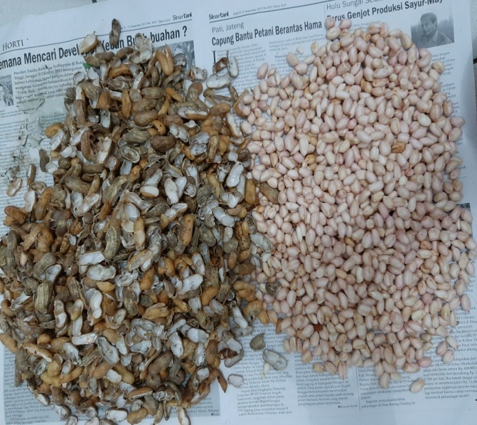

**Lampiran 10.** Serbuk dan Ekstrak Kulit danBiji Kacang Tanah (*Arachis hipogeae* L.)

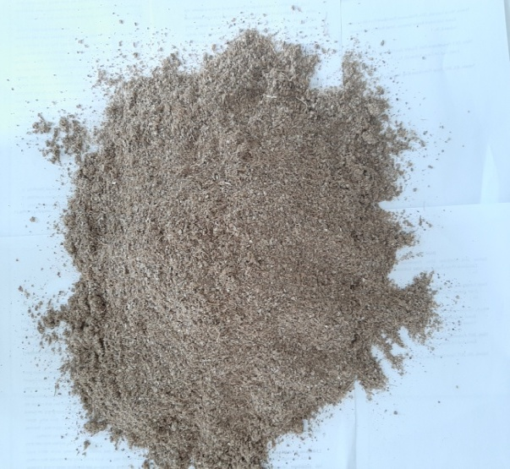 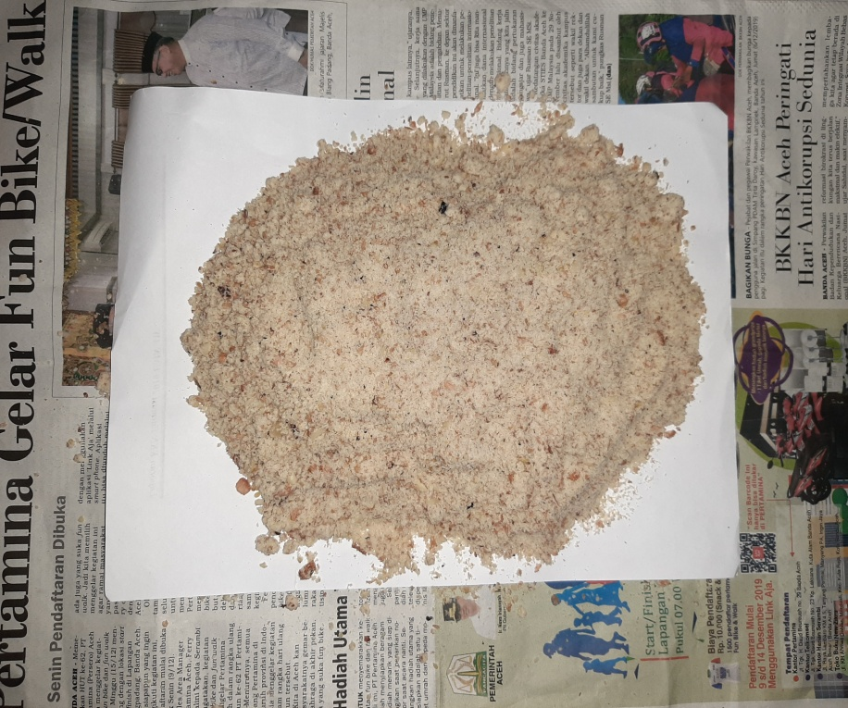

Serbuk kulit kacang tanah

Serbuk kulit kacang tanah

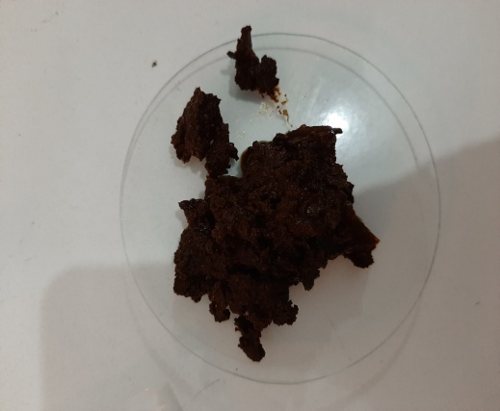 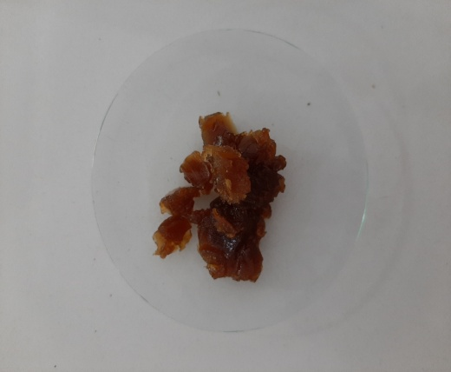

Ekstrak biji kacang tanah

Ekstrak kulit kacang tanah

**Lampiran 11.** Skrining Fitokimia

|  |  |  |  |  |  |
| --- | --- | --- | --- | --- | --- |
| **No** | **Identifikasi Golongan Senyawa** | **Ekstrak kulit kacang tanah** | **Ekstrak biji kacang tanah** | **Hasil Uji** | **Keterangan** |
| **1** | C:\Users\wezzyutami\AppData\Local\Microsoft\Windows\INetCache\Content.Word\20200206_111640.jpgC:\Users\wezzyutami\AppData\Local\Microsoft\Windows\INetCache\Content.Word\20200206_112736.jpgC:\Users\wezzyutami\AppData\Local\Microsoft\Windows\INetCache\Content.Word\20200206_111852.jpgAlkaloid | C:\Users\wezzyutami\AppData\Local\Microsoft\Windows\INetCache\Content.Word\20200206_124727.jpg  C:\Users\wezzyutami\AppData\Local\Microsoft\Windows\INetCache\Content.Word\20200206_124930.jpgC:\Users\wezzyutami\AppData\Local\Microsoft\Windows\INetCache\Content.Word\20200206_124842.jpg |  | + | Terbentuk larutan agak keruh dan terlihat ada endapan menggumpal warna kuning (mayer), endapan berwarna coklat (bouchardart), warna merah (dragendrof) (Depkes RI, 1995) |
| **2** | C:\Users\wezzyutami\AppData\Local\Microsoft\Windows\INetCache\Content.Word\20200208_111151.jpgFlavonoid | C:\Users\wezzyutami\AppData\Local\Microsoft\Windows\INetCache\Content.Word\20200208_112049.jpg |  | + | Warna jingga pada lapisan alkohol (Franswort, 1966) |
| **3** | C:\Users\wezzyutami\AppData\Local\Microsoft\Windows\INetCache\Content.Word\20200206_113832.jpgTanin | C:\Users\wezzyutami\AppData\Local\Microsoft\Windows\INetCache\Content.Word\20200206_120621.jpg |  | + | Terbentuk Biru kehitaman (Depkes RI, 1995) |
| **4** | C:\Users\wezzyutami\AppData\Local\Microsoft\Windows\INetCache\Content.Word\20200206_103607.jpgSaponin | C:\Users\wezzyutami\AppData\Local\Microsoft\Windows\INetCache\Content.Word\20200206_124100.jpg |  | - | Tidak terbentuk busa yang stabil |
| **5** | C:\Users\wezzyutami\AppData\Local\Microsoft\Windows\INetCache\Content.Word\20200206_130803.jpgSteroid/ triterpenoid |  | C:\Users\wezzyutami\AppData\Local\Microsoft\Windows\INetCache\Content.Word\20200206_123458.jpg | + | Terbentuknya warna ungu sampai merah ungu triterpenoid |

**Lampiran 12.** Alat Spektrofotometer UV-Vis

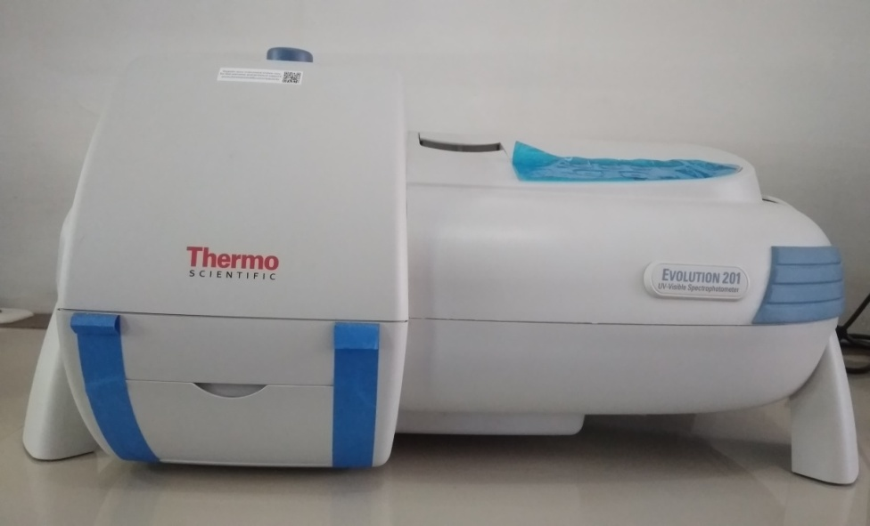

Spektrofotometer UV-Vis

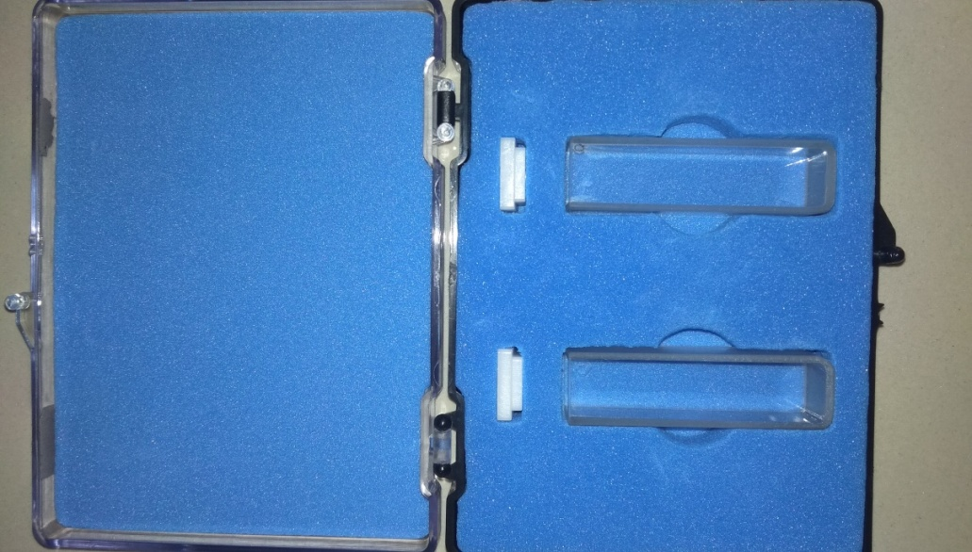

Kuvet

**Lampiran 13.** Evaluasi Sediaan Gel Tabir Surya Kulit dan Biji Kacang Tanah (*Arachis hypogeae* L.)

1. Dokumentasi Organoleptis

**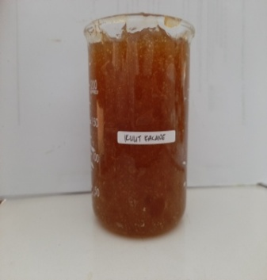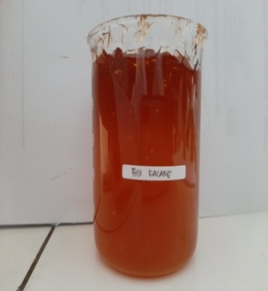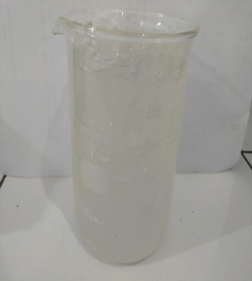**

c

b

a

1. Penentuan Homogenitas

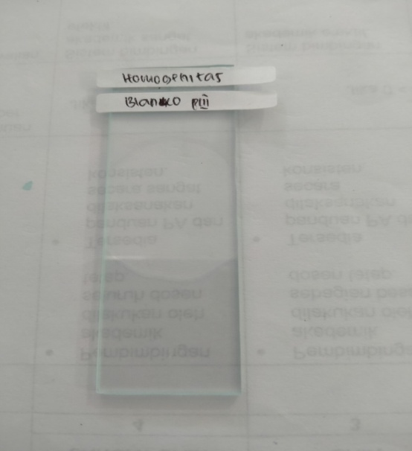

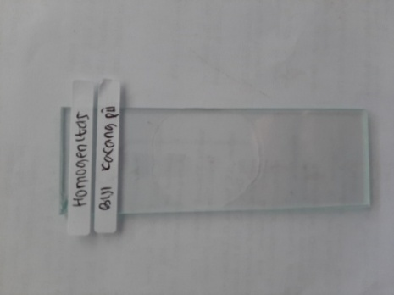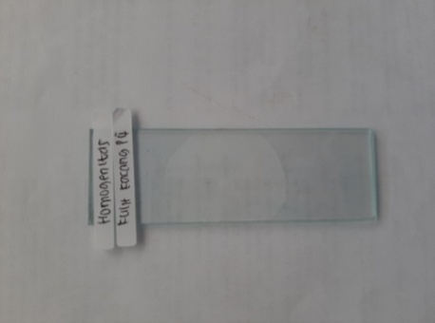

b

c

a

Keterangan:

1. Blanko
2. Gel Tabir Surya Ekstrak Kulit Kacang Tanah
3. Gel Tabir Surya Ekstrak Biji Kacang Tanah

**Lampiran 13.** (lanjutan)

1. Pengukuran pH

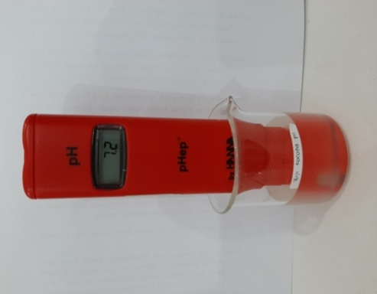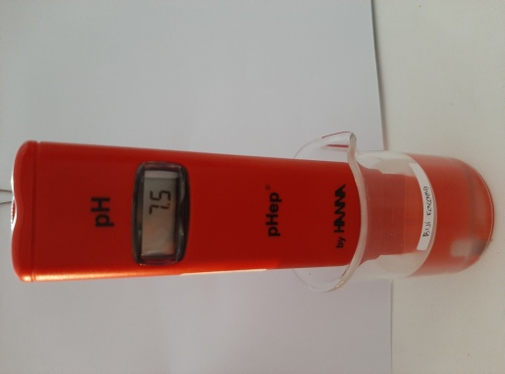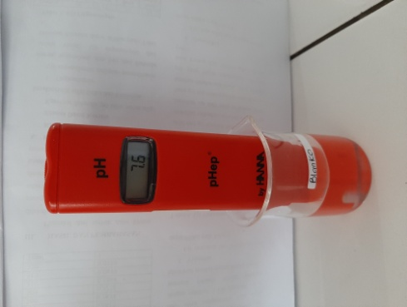

c

b

a

1. Pengukuran viskositas 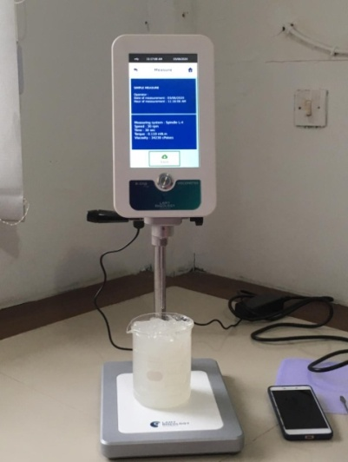

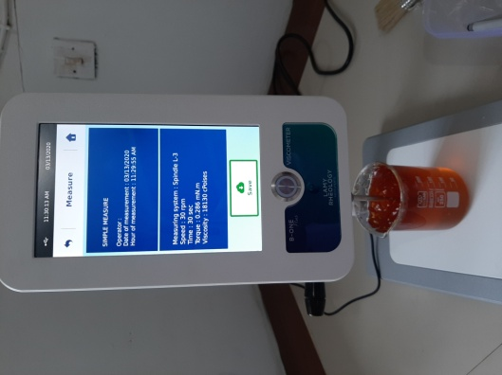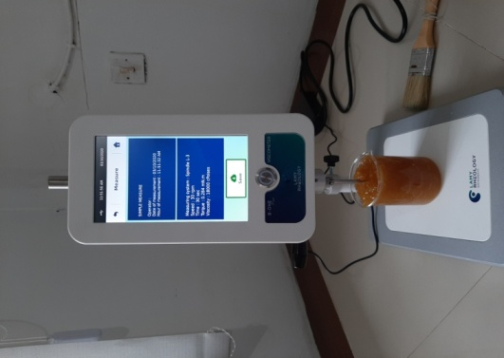

c

b

a

Keterangan:

1. Blanko
2. Gel Tabir Surya Ekstrak Kulit Kacang Tanah
3. Gel Tabir Surya Ekstrak Biji Kacang Tanah

**Lampiran 14.** Penentuan nilai SPF

1. Blanko (3 Replikasi)

**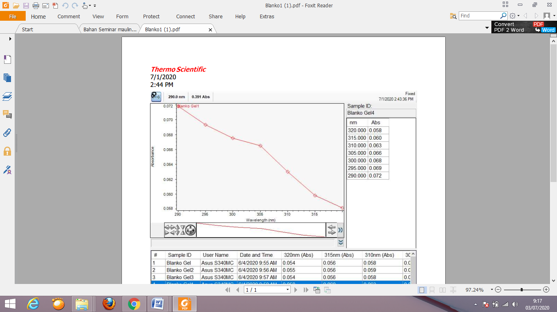**

Kurva Absorbansi SPF Blanko (1)

**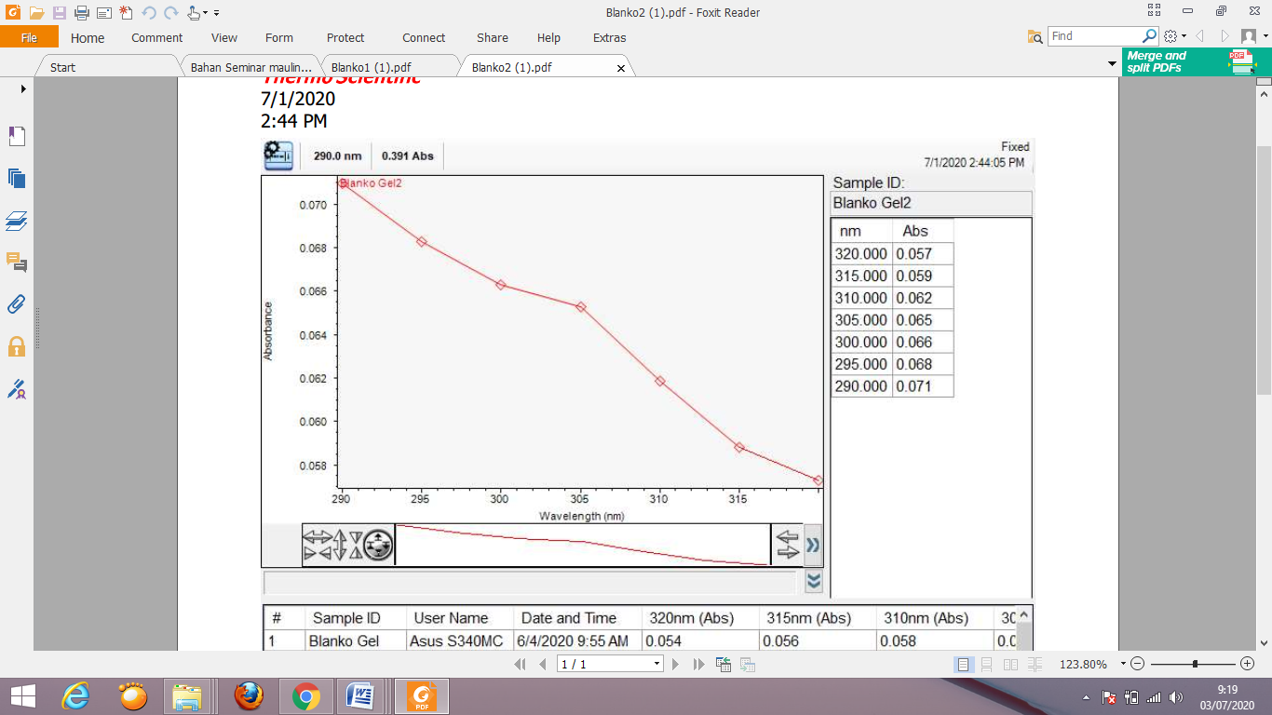**

Kurva Absorbansi SPF Blanko (2)

**Lampiran 14.** (lanjutan)

**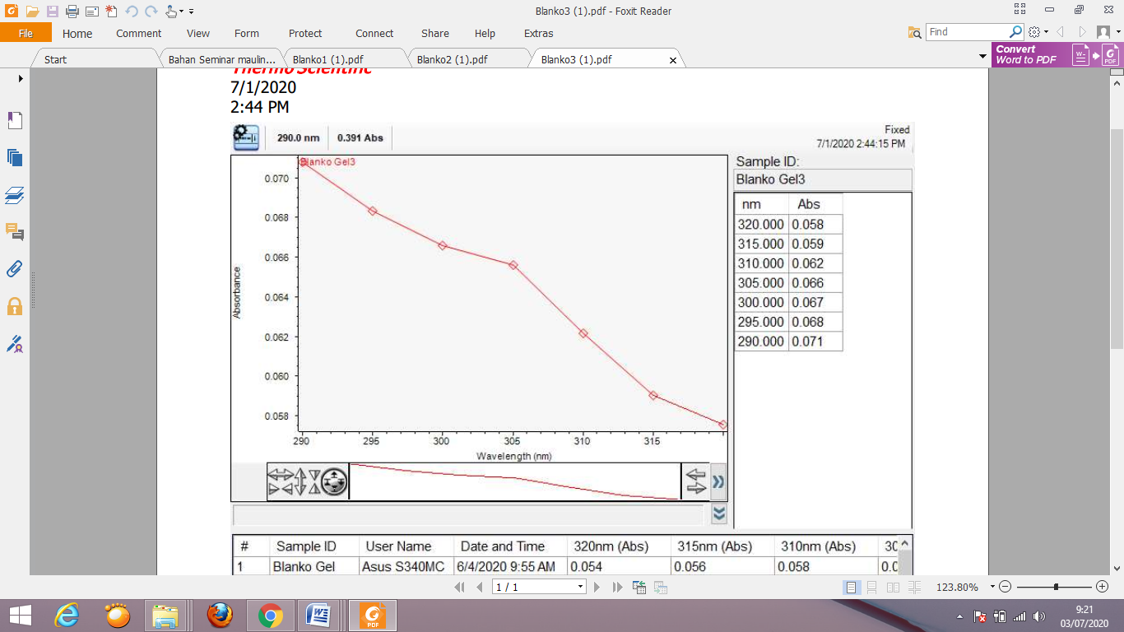**

Kurva Absorbansi SPF Blanko (3)

1. Gel spf kulit kacang tanah (3 Replikasi)

**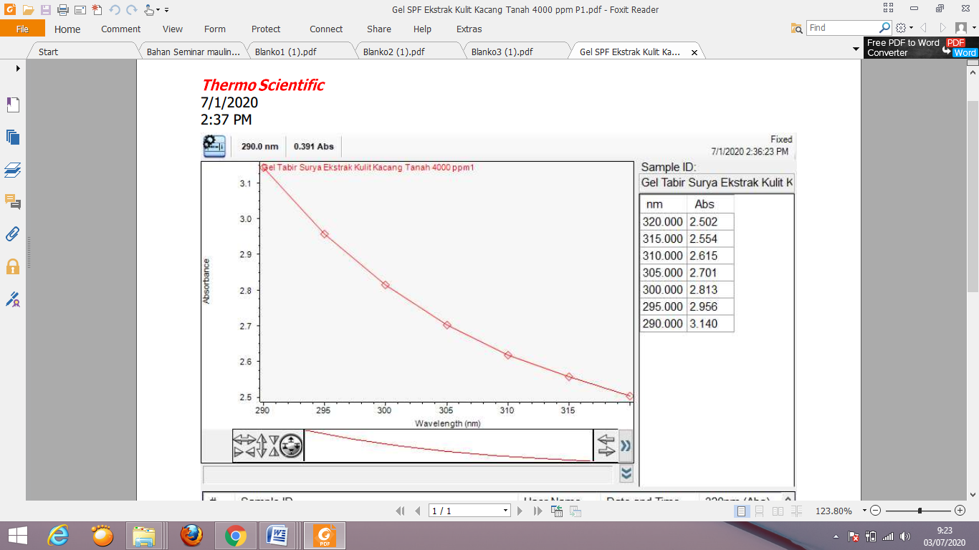**

Kurva Absorbansi SPF Gel Tabir Surya Ekstrak Kulit Kacang Tanah (1)

**Lampiran 14.** (lanjutan)

**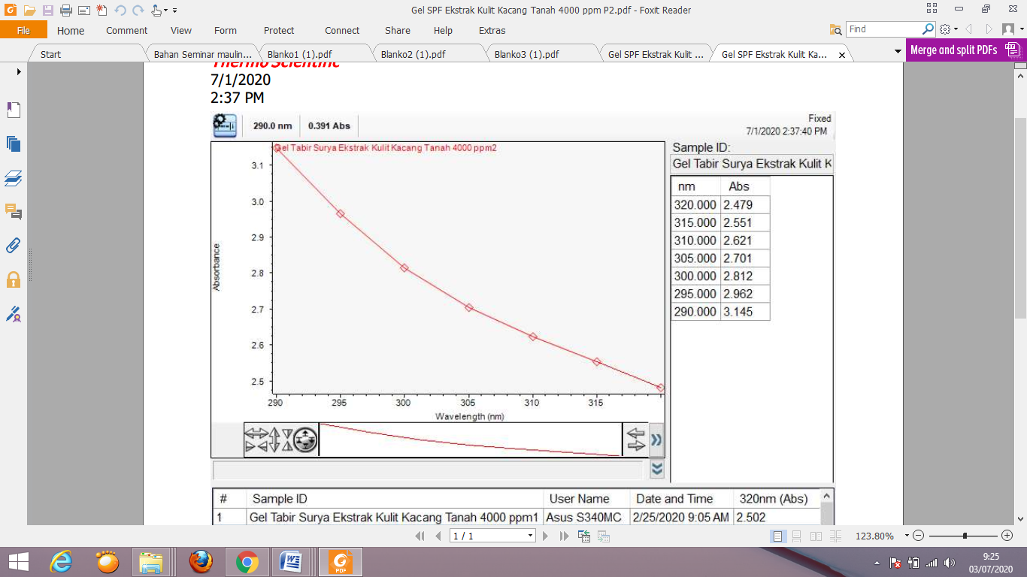**

Kurva Absorbansi SPF Gel Tabir Surya Ekstrak Kulit Kacang Tanah (2)

**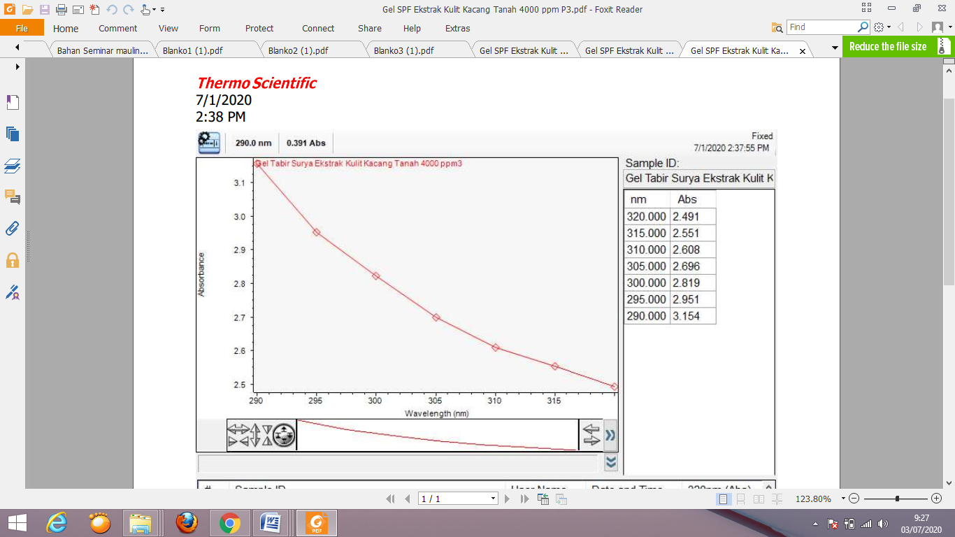**

Kurva Absorbansi SPF Gel Tabir Surya Ekstrak Kulit Kacang Tanah (3)

**Lampiran 14.** (lanjutan)

1. Gel spf biji kacang tanah (3 Replikasi)

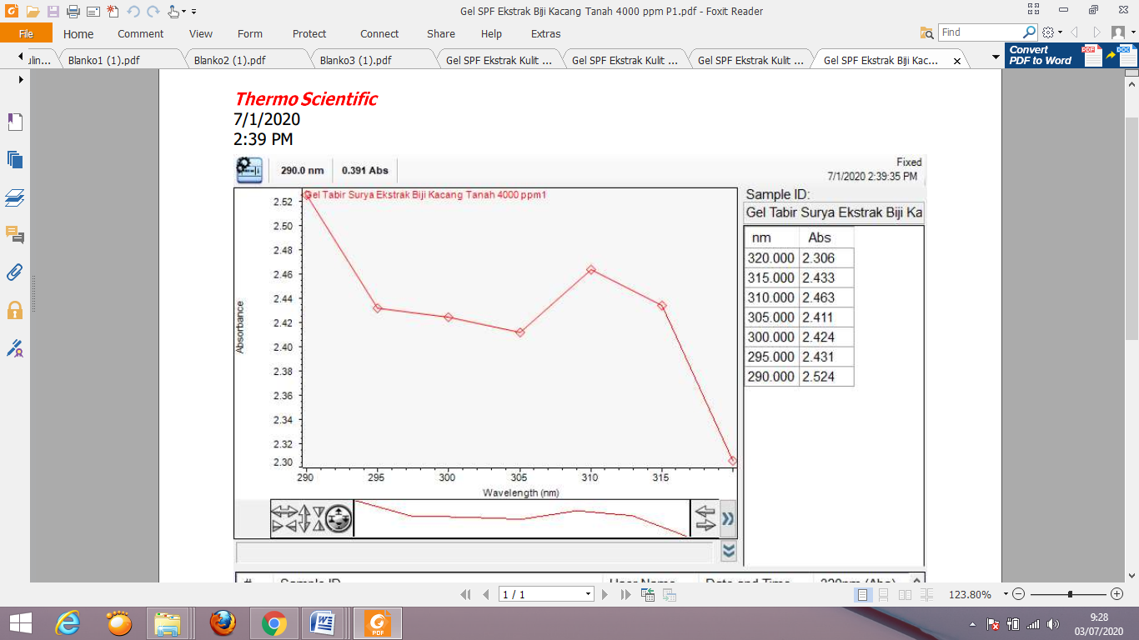

Kurva Absorbansi SPF Gel Tabir Surya Ekstrak Biji Kacang Tanah (1)

Kurva Absorbansi SPF Gel Tabir Surya Ekstrak Kulit Biji Tanah (2)

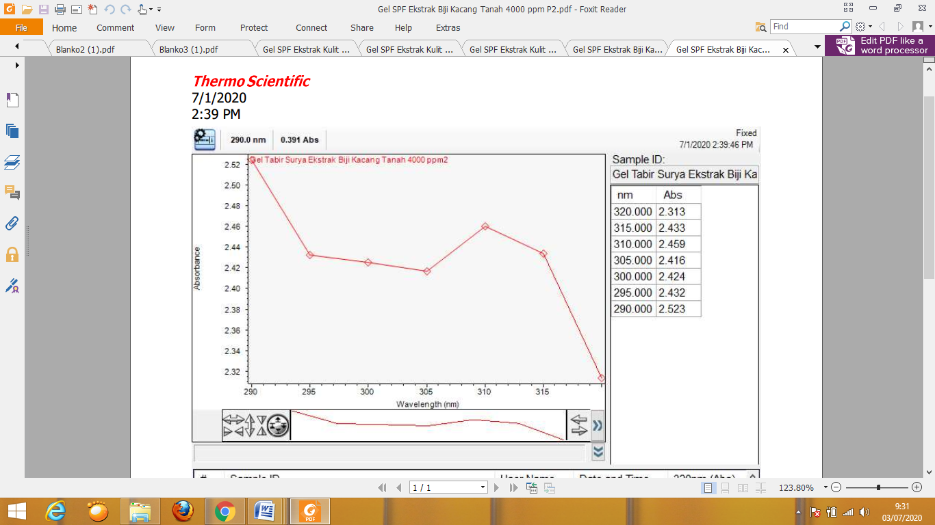

**Lampiran 14.** (lanjutan)

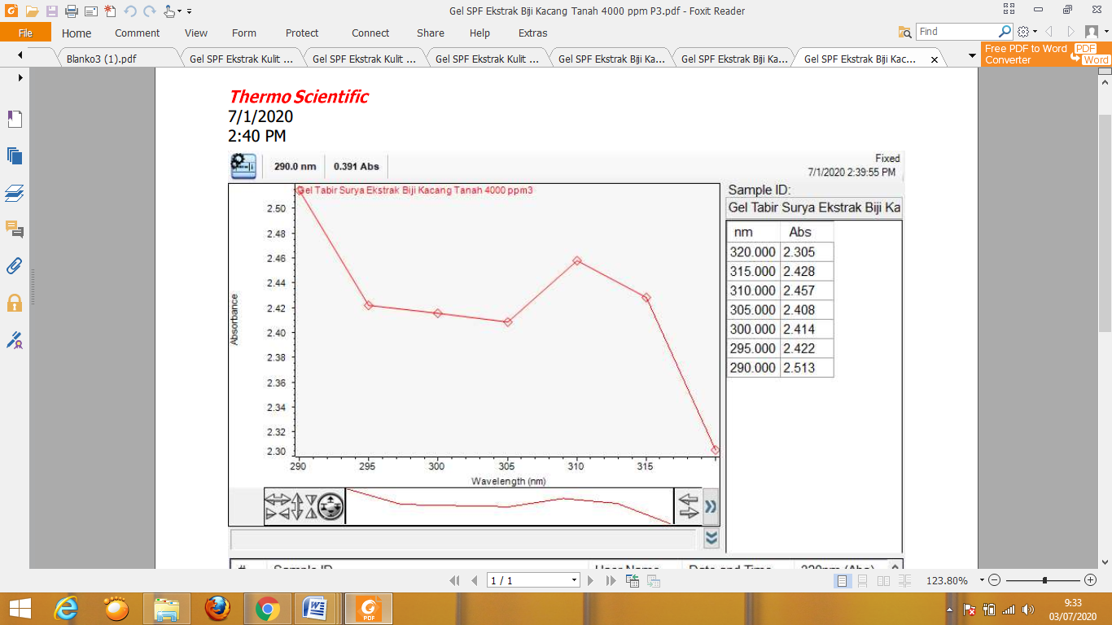

Kurva Absorbansi SPF Gel Tabir Surya Ekstrak Biji Kacang Tanah (1)

**Lampiran 15.** Perhitungan Rendemen Simplisia dan Rendemen Ekstrak

1. **Rendemen Simplisia**
2. **Kulit kacang tanah**

Rendemen simplisia = $\frac{Bobot simplisia (akhir)}{Bobot simplisia (awal)} x 100\%$

= $\frac{2400 gram}{6300 gram} x 100\%$

= 38,99%

1. **Biji kacang tanah**

Rendemen simplisia = $\frac{Bobot simplisia (akhir)}{Bobot simplisia (awal)} x 100\%$

= $\frac{4235 gram}{6700 gram} x 100\%$

= 63,20%

1. **Rendemen Ekstrak**
2. **Kulit kacang tanah**

Rendemen simplisia = $\frac{Bobot ekstrak}{Bobot serbuk} x 100\%$

= $\frac{49,5035 gram}{500 gram} x 100\%$

= 9,90%

1. **Biji kacang tanah**

Rendemen simplisia = $\frac{Bobot ekstrak}{Bobot serbuk} x 100\%$

= $\frac{47,4078 gram}{500 gram} x 100\%$

= 9,48%

**Lampiran 16.** Perhitungan Karakterisasi Simplisia

1. Kadar air
2. Kulit kacang tanah

* Pengulangan I

Volume awal air (V1) = 16 tetes

V1 =

= 0,8 mL

Volume akhir air (V2) = 18 tetes

V2 =

= 0,9 mL

Kadar air = $\frac{V2-V1}{Berat sampel} x 100\%$

= $\frac{0,9 mL-0,8 mL}{2,5 gram} x 100\%$

= 4 %

* Pengulangan II

Volume awal air (V1) = 16 tetes

V1 =

= 0,8 mL

Volume akhir air (V2) = 19 tetes

V2 =

= 0,95 mL

Kadar air = $\frac{V2-V1}{Berat sampel} x 100\%$

= $\frac{0,95 mL-0,8 mL}{2,5 gram} x 100\%$

= 6 %

* Pengulangan III

Volume awal air (V1) = 15 tetes

V1 =

= 0,75 mL

Volume akhir air (V2) = 18 tetes

V2 =

= 0,9 mL

**Lampiran 16.** (lanjutan)

Kadar air = $\frac{V2-V1}{Berat sampel} x 100\%$

= $\frac{0,9 mL-0,75 mL}{2,5 gram} x 100\%$

= 6 %

Rata-rata kadar air = $\frac{PI+PII+PIII}{3}$

= $\frac{6\%+4\%+6\%}{3}$

= 5,33%

1. Biji kacang tanah

* Pengulangan I

Volume awal air (V1) = 8 tetes

V1 =

= 0,4 mL

Volume akhir air (V2) = 11 tetes

V2 =

= 0,55 mL

Kadar air = $\frac{V2-V1}{Berat sampel} x 100\%$

= $\frac{0,55 mL-0,4 mL}{2,5 gram} x 100\%$

= 6 %

* Pengulangan II

Volume awal air (V1) = 4 tetes

V1 =

= 0,2 mL

Volume akhir air (V2) = 7 tetes

V2 =

= 0,35 mL

Kadar air = $\frac{V2-V1}{Berat sampel} x 100\%$

= $\frac{0,35 mL-0,2 mL}{2,5 gram} x 100\%$

= 6 %

**Lampiran 16.** (lanjutan)

* Pengulangan III

Volume awal air (V1) = 7 tetes

V1 =

= 0,35 mL

Volume akhir air (V2) = 10 tetes

V2 =

= 0,5 mL

Kadar air = $\frac{V2-V1}{Berat sampel} x 100\%$

= $\frac{0,5 mL-0,35 mL}{2,5 gram} x 100\%$

= 6 %

Rata-rata kadar air = $\frac{PI+PII+PIII}{3}$

= $\frac{6\%+6\%+6\%}{3}$

= 6%

**Lampiran 16.** (lanjutan)

1. Kadar Sari Larut Air
2. Kulit Kacang Tanah

|  |  |  |  |  |
| --- | --- | --- | --- | --- |
| **No** | **Berat Sampel (g)** | **Berat Cawan Kosong (g)** | **Berat Setelah Diuapkan (g)** | **Berat sari kering (g)** |
| 1 | 5 | 28,8453 | 28,8940 | 0,0487 |
| 2 | 5 | 32,6470 | 32,6918 | 0,0448 |
| 3 | 5 | 32,7170 | 32,7631 | 0,0461 |

Kadar sari larut air = $\frac{bobot sari setelah dikeringkan \left(g\right)x 5}{bobot sampel mula-mula (g)} x 100\%$

* Pengulangan I

Kadar sari larut air = $\frac{0,0487 g x 5}{5 g} x 100\%$

= 4,87 %

* Pengulangan II

Kadar sari larut air = $\frac{0,0448 g x 5}{5 g} x 100\%$

= 4,48 %

* Pengulangan III

Kadar sari larut air = $\frac{0,0461 g x 5}{5 g} x 100\%$

= 4,61 %

Rata-rata kadar sari larut air = $\frac{PI+PII+PIII}{3}$

= $\frac{4,87\%+4,48\%+4,61\%}{3}$

= 4,65%

**Lampiran 16.** (lanjutan)

1. Biji Kacang Tanah

|  |  |  |  |  |
| --- | --- | --- | --- | --- |
| **No** | **Berat Sampel (g)** | **Berat Cawan Kosong (g)** | **Berat Setelah Diuapkan (g)** | **Berat sari kering (g)** |
| 1 | 5 | 29,1827 | 29,3318 | 0,1491 |
| 2 | 5 | 32,4852 | 32,6264 | 0,1421 |
| 3 | 5 | 28,7213 | 28,8916 | 0,1403 |

Kadar sari larut air = $\frac{bobot sari setelah dikeringkan \left(g\right)x 5}{bobt sampel mula-mula (g)} x 100\%$

* Pengulangan I

Kadar sari larut air = $\frac{0,1491 g x 5}{5 g} x 100\%$

= 14,91 %

* Pengulangan II

Kadar sari larut air = $\frac{0,1421 g x 5}{5 g} x 100\%$

= 14,21 %

* Pengulangan III

Kadar sari larut air = $\frac{0,1403 g x 5}{5 g} x 100\%$

= 14,03 %

Rata-rata kadar sari larut air = $\frac{PI+PII+PIII}{3}$

= $\frac{14,91\%+14,12\%+14,03\%}{3}$

= 14,35%

**Lampiran 16.** (lanjutan)

1. Kadar Sari Larut Etanol
2. Kulit Kacang Tanah

|  |  |  |  |  |
| --- | --- | --- | --- | --- |
| **No** | **Berat Sampel (g)** | **Berat Cawan Kosong (g)** | **Berat Setelah Diuapkan (g)** | **Berat sari kering (g)** |
| 1 | 5 | 35,0355 | 35,0502 | 0,0147 |
| 2 | 5 | 26,3682 | 26,3868 | 0,0186 |
| 3 | 5 | 28,3506 | 28,3681 | 0,0175 |

Kadar sari larut etanol = $\frac{bobot sari setelah dikeringkan \left(g\right)x 5}{bobt sampel mula-mula (g)} x 100\%$

* Pengulangan I

Kadar sari larut etanol = $\frac{0,0147 g x 5}{5 g} x 100\%$

= 1,47 %

* Pengulangan II

Kadar sari larut etanol = $\frac{0,0186 g x 5}{5 g} x 100\%$

= 1,86 %

* Pengulangan III

Kadar sari larut etanol = $\frac{0,0175 g x 5}{5 g} x 100\%$

= 1,75 %

Rata-rata kadar sari larut air = $\frac{PI+PII+PIII}{3}$

= $\frac{1,47\%+1,86\%+1,75\%}{3}$

= 1,69

**Lampiran 16.** (lanjutan)

1. Biji Kacang Tanah

|  |  |  |  |  |
| --- | --- | --- | --- | --- |
| **No** | **Berat Sampel (g)** | **Berat Cawan Kosong (g)** | **Berat Setelah Diuapkan (g)** | **Berat sari kering (g)** |
| 1 | 5 | 31,5288 | 31,7112 | 0,1824 |
| 2 | 5 | 58,2760 | 58,4543 | 0,1783 |
| 3 | 5 | 32,5391 | 32,7183 | 0,1792 |

Kadar sari larut etanol = $\frac{bobot sari setelah dikeringkan \left(g\right)x 5}{bobt sampel mula-mula (g)} x 100\%$

* Pengulangan I

Kadar sari larut etanol = $\frac{0,1824 g x 5}{5 g} x 100\%$

= 18,24 %

* Pengulangan II

Kadar sari larut etanol = $\frac{0,1783 g x 5}{5 g} x 100\%$

= 17,83 %

* Pengulangan III

Kadar sari larut etanol = $\frac{0,1792 g x 5}{5 g} x 100\%$

= 17,92 %

Rata-rata kadar sari larut air = $\frac{PI+PII+PIII}{3}$

= $\frac{18,24\%+17,83\%+17,92\%}{3}$

= 17,99 %

**Lampiran 16.** (lanjutan)

1. Kadar Abu Total
2. Kulit Kacang Tanah

|  |  |  |  |  |
| --- | --- | --- | --- | --- |
| **No** | **Berat Sampel (g)** | **Berat Krus Kosong (g)** | **Berat Krus Setelah Dipijar (g)** | **Berat Abu (g)** |
| 1 | 2 | 53,3175 | 53,3499 | 0,0324 |
| 2 | 2 | 58,1356 | 58,1588 | 0,0232 |
| 3 | 2 | 53,6492 | 53,6811 | 0,0319 |

Kadar abu total = $\frac{bobot abu yang diperoleh \left(g\right)}{bobt sampel mula-mula (g)} x 100\%$

* Pengulangan I

Kadar abu total = $\frac{0,0324 g }{2 g} x 100\%$

= 1,62 %

* Pengulangan II

Kadar abu total = $\frac{0,0232 g }{2 g} x 100\%$

= 1,16 %

* Pengulangan III

Kadar abu total = $\frac{0,0319 g }{2 g} x 100\%$

= 1,59 %

Rata-rata kadar abu total = $\frac{PI+PII+PIII}{3}$

= $\frac{1,62\%+1,16\%+1,59\%}{3}$

= 1,45 %

**Lampiran 16.** (lanjutan)

1. Biji Kacang Tanah

|  |  |  |  |  |
| --- | --- | --- | --- | --- |
| **No** | **Berat Sampel (g)** | **Berat Krus Kosong (g)** | **Berat Krus Setelah Dipijar (g)** | **Berat Abu (g)** |
| 1 | 2 | 53,8021 | 53,8458 | 0,0437 |
| 2 | 2 | 53,7347 | 53,7768 | 0,0421 |
| 3 | 2 | 52,4137 | 52,4536 | 0,0426 |

Kadar abu total = $\frac{bobot abu yang diperoleh \left(g\right)}{bobot sampel mula-mula (g)} x 100\%$

* Pengulangan I

Kadar abu total = $\frac{0,0437 g}{2 g} x 100\%$

= 2,18 %

* Pengulangan II

Kadar abu total = $\frac{0,0421 g}{2 g} x 100\%$

= 2,10 %

* Pengulangan III

Kadar abu total = $\frac{0,0426 g}{2 g} x 100\%$

= 2,13 %

Rata-rata kadar abu total = $\frac{PI+PII+PIII}{3}$

= $\frac{2,18\%+2,10\%+2,13\%}{3}$

= 2,13 %

**Lampiran 16.** (lanjutan)

1. Kadar Tidak Larut Asam
2. Kulit Kacang Tanah

|  |  |  |  |  |
| --- | --- | --- | --- | --- |
| **No** | **Berat Sampel (g)** | **Berat Krus Kosong (g)** | **Berat Krus Setelah Dipijar (g)** | **Berat Abu tdk larut asam (g)** |
| 1 | 2 | 53,3175 | 53,3177 | 0,0002 |
| 2 | 2 | 58,1356 | 58,1359 | 0,0003 |
| 3 | 2 | 53,6492 | 53,6493 | 0,0001 |

Kadar abu tidak larut asam = $\frac{bobot abu setelah dipijar \left(g\right)}{bobot sampel abu mula-mula (g)} x 100\%$

* Pengulangan I

Kadar abu tidak larut asam = $\frac{0,0002 g }{0,0324 g} x 100\%$

= 0,61 %

* Pengulangan II

Kadar abu tidak larut asam = $\frac{0,0003 g }{0,0232 g} x 100\%$

= 1,92 %

* Pengulangan III

Kadar abu tidak larut asam = $\frac{0,0001 g }{0,0319 g} x 100\%$

= 0,31 %

Rata-rata kadar abu tidak larut asam = $\frac{PI+PII+PIII}{3}$

= $\frac{0,61\%+1,29\%+0,31\%}{3}$

= 0,74 %

**Lampiran 16.** (lanjutan)

1. Biji Kacang Tanah

|  |  |  |  |  |
| --- | --- | --- | --- | --- |
| **No** | **Berat Sampel (g)** | **Berat Krus Kosong (g)** | **Berat Krus Setelah Dipijar (g)** | **Berat Abu tdk larut asam (g)** |
| 1 | 2 | 53,8021 | 53,8021 | 0,0003 |
| 2 | 2 | 53,7347 | 53,7354 | 0,0007 |
| 3 | 2 | 52,4137 | 52,4142 | 0,0005 |

Kadar abu tidak larut asam = $\frac{bobot abu setelah dipijar \left(g\right)}{bobt sampel abu mula-mula (g)} x 100\%$

* Pengulangan I

Kadar abu tidak larut asam = $\frac{0,0003 g }{0,0437 g} x 100\%$

= 0,68 %

* Pengulangan II

Kadar abu tidak larut asam = $\frac{0,0007 g }{0,0421 g} x 100\%$

= 1,66 %

* Pengulangan III

Kadar abu tidak larut asam = $\frac{0,0005 g }{0,0426 g} x 100\%$

= 1,17 %

Rata-rata kadar abu tidak larut asam = $\frac{PI+PII+PIII}{3}$

= $\frac{0,68\%+1,66\%+1,17\%}{3}$

= 0,73 %

**Lampiran 17.** Perhitungan nilai SPF

1. Nilai spf blanko 4000ppm (3 replikasi)

|  |  |  |  |
| --- | --- | --- | --- |
| Panjang gelombang | Absorbansi | EE x 1 | Abs x EE x 1 |
| 290 | 0.072 | 0,0150 | 0.0010 |
| 295 | 0.069 | 0,0817 | 0.0056 |
| 300 | 0.068 | 0,2874 | 0.0195 |
| 305 | 0.066 | 0,3278 | 0.0216 |
| 310 | 0.063 | 0,1864 | 0.0117 |
| 315 | 0.060 | 0,0839 | 0.0050 |
| 320 | 0.058 | 0,0180 | 0.0010 |
|  | | Σ320 Abs x EE x 1  290 | 0.0654 |

SPF = CF x Σ320 Abs x EE x 1

290

= 10 x 0.0654

= 0.654

|  |  |  |  |
| --- | --- | --- | --- |
| Panjang gelombang | Absorbansi | EE x 1 | Abs x EE x 1 |
| 290 | 0.071 | 0,0150 | 0.0010 |
| 295 | 0.068 | 0,0817 | 0.0055 |
| 300 | 0.066 | 0,2874 | 0.0189 |
| 305 | 0.065 | 0,3278 | 0.0213 |
| 310 | 0.062 | 0,1864 | 0.0115 |
| 315 | 0.059 | 0,0839 | 0.0049 |
| 320 | 0.057 | 0,0180 | 0.0010 |
|  | | Σ320 Abs x EE x 1  290 | 0.0641 |

SPF = CF x Σ320 Abs x EE x 1

290

= 10 x 0.0641

= 0.641

**Lampiran 17.** (lanjutan)

|  |  |  |  |
| --- | --- | --- | --- |
| Panjang gelombang | Absorbansi | EE x 1 | Abs x EE x 1 |
| 290 | 0.071 | 0,0150 | 0.0010 |
| 295 | 0.068 | 0,0817 | 0.0055 |
| 300 | 0.067 | 0,2874 | 0.0192 |
| 305 | 0.066 | 0,3278 | 0.0216 |
| 310 | 0.062 | 0,1864 | 0.0115 |
| 315 | 0.059 | 0,0839 | 0.0049 |
| 320 | 0.058 | 0,0180 | 0.0010 |
|  | | Σ320 Abs x EE x 1  290 | 0.0647 |

SPF = CF x Σ320 Abs x EE x 1

290

= 10 x 0.0647

= 0.647

Rata-rata SPF = P1 + P2 + P3

3

= 0,654 + 0,641+ 0,647

3

= 0,647

1. Nilai spf gel biji kacang tanah 4000ppm (3 replikasi)

|  |  |  |  |
| --- | --- | --- | --- |
| Panjang gelombang | Absorbansi | EE x 1 | Abs x EE x 1 |
| 290 | 3.140 | 0,0150 | 0,0471 |
| 295 | 2.958 | 0,0817 | 0,2416 |
| 300 | 2.813 | 0,2874 | 0,8084 |
| 305 | 2.701 | 0,3278 | 0,8853 |
| 310 | 2.615 | 0,1864 | 0,4874 |
| 315 | 2.554 | 0,0839 | 0,2142 |
| 320 | 2.502 | 0,0180 | 0,0450 |
|  | | Σ320 Abs x EE x 1  290 | 2,729 |

**Lampiran 17.** (lanjutan)

SPF = CF x Σ320 Abs x EE x 1

290

= 10 x 2,729

= 27,29

|  |  |  |  |
| --- | --- | --- | --- |
| Panjang gelombang | Absorbansi | EE x 1 | Abs x EE x 1 |
| 290 | 3.145 | 0,0150 | 0,0471 |
| 295 | 2.962 | 0,0817 | 0,2419 |
| 300 | 2.813 | 0,2874 | 0,8084 |
| 305 | 2.701 | 0,3278 | 0,8853 |
| 310 | 2.621 | 0,1864 | 0,4885 |
| 315 | 2.551 | 0,0839 | 0,2140 |
| 320 | 2.479 | 0,0180 | 0,0446 |
|  | | Σ320 Abs x EE x 1  290 | 2,7298 |

SPF = CF x Σ320 Abs x EE x 1

290

= 10 x 2,7298

= 27,298

|  |  |  |  |
| --- | --- | --- | --- |
| Panjang gelombang | Absorbansi | EE x 1 | Abs x EE x 1 |
| 290 | 3.154 | 0,0150 | 0,0473 |
| 295 | 2.951 | 0,0817 | 0,2410 |
| 300 | 2.819 | 0,2874 | 0,8101 |
| 305 | 2.696 | 0,3278 | 0,8837 |
| 310 | 2.608 | 0,1864 | 0,4861 |
| 315 | 2.551 | 0,0839 | 0,2140 |
| 320 | 2.491 | 0,0180 | 0,0448 |
|  | | Σ320 Abs x EE x 1  290 | 2,727 |

SPF = CF x Σ320 Abs x EE x 1

290

= 10 x 2,727

= 27,27

**Lampiran 17.** (lanjutan)

Rata-rata SPF = P1 + P2 + P3

3

= 27,29 + 27,298 + 27,27

3

= 27,286 (Ultra)

1. Nilai spf gel ekstrak kulit kacang tanah 4000ppm (3 replikasi)

|  |  |  |  |
| --- | --- | --- | --- |
| Panjang gelombang | Absorbansi | EE x 1 | Abs x EE x 1 |
| 290 | 2.524 | 0,0150 | 0,0378 |
| 295 | 2.431 | 0,0817 | 0,1986 |
| 300 | 2.424 | 0,2874 | 0,6966 |
| 305 | 2.411 | 0,3278 | 0,7903 |
| 310 | 2.463 | 0,1864 | 0,4591 |
| 315 | 2.433 | 0,0839 | 0,2041 |
| 320 | 2.306 | 0,0180 | 0,0415 |
|  | | Σ320 Abs x EE x 1  290 | 2,428 |

SPF = CF x Σ320 Abs x EE x 1

290

= 10 x 2,428

= 24,28

|  |  |  |  |
| --- | --- | --- | --- |
| Panjang gelombang | Absorbansi | EE x 1 | Abs x EE x 1 |
| 290 | 2.523 | 0,0150 | 0,0378 |
| 295 | 2.432 | 0,0817 | 0,1986 |
| 300 | 2.424 | 0,2874 | 0,6966 |
| 305 | 2.416 | 0,3278 | 0,7919 |
| 310 | 2.459 | 0,1864 | 0,4583 |
| 315 | 2.433 | 0,0839 | 0,2041 |
| 320 | 2.313 | 0,0180 | 0,0416 |
|  | | Σ320 Abs x EE x 1  290 | 2,4289 |

**Lampiran 17.** (lanjutan)

SPF = CF x Σ320 Abs x EE x 1

290

= 10 x 2,4289

= 24,289

|  |  |  |  |
| --- | --- | --- | --- |
| Panjang gelombang | Absorbansi | EE x 1 | Abs x EE x 1 |
| 290 | 2.513 | 0,0150 | 0,0376 |
| 295 | 2.422 | 0,0817 | 0,1978 |
| 300 | 2.414 | 0,2874 | 0,6937 |
| 305 | 2.408 | 0,3278 | 0,7893 |
| 310 | 2.457 | 0,1864 | 0,4579 |
| 315 | 2.428 | 0,0839 | 0,2037 |
| 320 | 2.305 | 0,0180 | 0,0414 |
|  | | Σ320 Abs x EE x 1  290 | 2,4214 |

SPF = CF x Σ320 Abs x EE x 1

290

= 10 x 2,4214

= 24,214

Rata-rata SPF = P1 + P2 + P3

3

= 24,28 + 24,289 + 24,214

3

= 24,261 (Ultra)

**Lampiran 18.** Data SPSS Uji Evaluasi Sediaan Gel Tabir Surya

* + 1. **Data SPSS Uji pH Sediaan Tabir Surya**

**Oneway**

|  |  |  |  |  |  |  |  |  |  |
| --- | --- | --- | --- | --- | --- | --- | --- | --- | --- |
| **Descriptives** | | | | | | | | | |
|  | | N | Mean | Std. Deviation | Std. Error | 95% Confidence Interval for Mean | | Minimum | Maximum |
| Lower Bound | Upper Bound |
| Sebelum | F0 | 3 | 7,6000 | ,00000 | ,00000 | 7,6000 | 7,6000 | 7,60 | 7,60 |
| F1 | 3 | 7,5333 | ,05774 | ,03333 | 7,3899 | 7,6768 | 7,50 | 7,60 |
| F2 | 3 | 7,4333 | ,05774 | ,03333 | 7,2899 | 7,5768 | 7,40 | 7,50 |
| Total | 9 | 7,5222 | ,08333 | ,02778 | 7,4582 | 7,5863 | 7,40 | 7,60 |
| s1 | F0 | 3 | 7,6000 | ,00000 | ,00000 | 7,6000 | 7,6000 | 7,60 | 7,60 |
| F1 | 3 | 7,4667 | ,05774 | ,03333 | 7,3232 | 7,6101 | 7,40 | 7,50 |
| F2 | 3 | 7,3333 | ,11547 | ,06667 | 7,0465 | 7,6202 | 7,20 | 7,40 |
| Total | 9 | 7,4667 | ,13229 | ,04410 | 7,3650 | 7,5684 | 7,20 | 7,60 |
| s2 | F0 | 3 | 7,6000 | ,00000 | ,00000 | 7,6000 | 7,6000 | 7,60 | 7,60 |
| F1 | 3 | 7,4667 | ,05774 | ,03333 | 7,3232 | 7,6101 | 7,40 | 7,50 |
| F2 | 3 | 7,3000 | ,17321 | ,10000 | 6,8697 | 7,7303 | 7,20 | 7,50 |
| Total | 9 | 7,4556 | ,15899 | ,05300 | 7,3333 | 7,5778 | 7,20 | 7,60 |
| s3 | F0 | 3 | 7,6000 | ,00000 | ,00000 | 7,6000 | 7,6000 | 7,60 | 7,60 |
| F1 | 3 | 7,5333 | ,05774 | ,03333 | 7,3899 | 7,6768 | 7,50 | 7,60 |
| F2 | 3 | 7,2000 | ,00000 | ,00000 | 7,2000 | 7,2000 | 7,20 | 7,20 |
| Total | 9 | 7,4444 | ,18782 | ,06261 | 7,3001 | 7,5888 | 7,20 | 7,60 |

**Lampiran 18.** (lanjutan)

|  |  |  |  |  |
| --- | --- | --- | --- | --- |
| **Test of Homogeneity of Variances** | | | | |
|  | Levene Statistic | df1 | df2 | Sig. |
| Sebelum | 8,000 | 2 | 6 | ,020 |
| s1 | 9,600 | 2 | 6 | ,013 |
| s2 | 11,200 | 2 | 6 | ,009 |
| s3 | 16,000 | 2 | 6 | ,004 |

|  |  |  |  |  |  |  |
| --- | --- | --- | --- | --- | --- | --- |
| **ANOVA** | | | | | | |
|  | | Sum of Squares | Df | Mean Square | F | Sig. |
| Sebelum | Between Groups | ,042 | 2 | ,021 | 9,500 | ,014 |
| Within Groups | ,013 | 6 | ,002 |  |  |
| Total | ,056 | 8 |  |  |  |
| s1 | Between Groups | ,107 | 2 | ,053 | 9,600 | ,013 |
| Within Groups | ,033 | 6 | ,006 |  |  |
| Total | ,140 | 8 |  |  |  |
| s2 | Between Groups | ,136 | 2 | ,068 | 6,100 | ,036 |
| Within Groups | ,067 | 6 | ,011 |  |  |
| Total | ,202 | 8 |  |  |  |
| s3 | Between Groups | ,276 | 2 | ,138 | 124,000 | ,000 |
| Within Groups | ,007 | 6 | ,001 |  |  |
| Total | ,282 | 8 |  |  |  |

**Lampiran 18.** (lanjutan)

**Post Hoc Tests**

|  |  |  |  |  |  |  |  |
| --- | --- | --- | --- | --- | --- | --- | --- |
| **Multiple Comparisons** | | | | | | | |
| Tukey HSD | | | | | | | |
| Dependent Variable  (1) | (I) Formula  (2) | (J) Formula  (3) | Mean Difference (I-J) (4) | Std. Error  (5) | Sig.  (6) | 95% Confidence Interval | |
| Lower Bound (7) | Upper Bound (8) |

|  |  |  |  |  |  |  |  |
| --- | --- | --- | --- | --- | --- | --- | --- |
| Sebelum | F0 | F1 | ,06667 | ,03849 | ,269 | -,0514 | ,1848 |
|  |  | F2 | ,16667\* | ,03849 | ,012 | ,0486 | ,2848 |
|  | F1 | F0 | -,06667 | ,03849 | ,269 | -,1848 | ,0514 |
|  |  | F2 | ,10000 | ,03849 | ,090 | -,0181 | ,2181 |
|  | F2 | F0 | -,16667\* | ,03849 | ,012 | -,2848 | -,0486 |
|  |  | F1 | -,10000 | ,03849 | ,090 | -,2181 | ,0181 |
| s1 | F0 | F1 | ,13333 | ,06086 | ,151 | -,0534 | ,3201 |
|  |  | F2 | ,26667\* | ,06086 | ,011 | ,0799 | ,4534 |
|  | F1 | F0 | -,13333 | ,06086 | ,151 | -,3201 | ,0534 |
|  |  | F2 | ,13333 | ,06086 | ,151 | -,0534 | ,3201 |
|  | F2 | F0 | -,26667\* | ,06086 | ,011 | -,4534 | -,0799 |
|  |  | F1 | -,13333 | ,06086 | ,151 | -,3201 | ,0534 |
| s2 | F0 | F1 | ,13333 | ,08607 | ,336 | -,1307 | ,3974 |
|  |  | F2 | ,30000\* | ,08607 | ,030 | ,0359 | ,5641 |
|  | F1 | F0 | -,13333 | ,08607 | ,336 | -,3974 | ,1307 |
|  |  | F2 | ,16667 | ,08607 | ,209 | -,0974 | ,4307 |
|  | F2 | F0 | -,30000 | ,08607 | ,030 | -,5641 | -,0359 |

|  |  |  |  |  |  |  |  |  |  |  |  |  |  |  |  |  |  |  |  |  |  |  |  |  |  |  |  |  |  |  |  |  |  |  |  |  |  |  |  |  |  |  |  |  |  |  |  |  |  |  |  |  |  |  |  |  |  |  |
| --- | --- | --- | --- | --- | --- | --- | --- | --- | --- | --- | --- | --- | --- | --- | --- | --- | --- | --- | --- | --- | --- | --- | --- | --- | --- | --- | --- | --- | --- | --- | --- | --- | --- | --- | --- | --- | --- | --- | --- | --- | --- | --- | --- | --- | --- | --- | --- | --- | --- | --- | --- | --- | --- | --- | --- | --- | --- | --- |
| **Lampiran 18.** (lanjutan)   |  |  |  |  |  |  |  |  | | --- | --- | --- | --- | --- | --- | --- | --- | | (1) | (2) | (3) | (4) | (5) | (6) | (7) | (8) | | s3 |  | F1 | -,16667 | ,08607 | ,209 | -,4307 | ,0974 | | F0 | F1 | ,06667 | ,02722 | ,109 | -,0168 | ,1502 | |  | F2 | ,40000\* | ,02722 | ,000 | ,3165 | ,4835 | | F1 | F0 | -,06667 | ,02722 | ,109 | -,1502 | ,0168 | |  | F2 | ,33333\* | ,02722 | ,000 | ,2498 | ,4168 | | F2 | F0 | -,40000\* | ,02722 | ,000 | -,4835 | -,3165 | |  | F1 | -,33333\* | ,02722 | ,000 | -,4168 | -,2498 |   \*. The mean difference is significant at the 0.05 level. |

**Homogeneous Subsets**

|  |  |  |  |
| --- | --- | --- | --- |
| **Sebelum** | | | |
| Tukey HSDa | | | |
| Formula | N | Subset for alpha = 0.05 | |
| 1 | 2 |
| F2 | 3 | 7,4333 |  |
| F1 | 3 | 7,5333 | 7,5333 |
| F0 | 3 |  | 7,6000 |
| Sig. |  | ,090 | ,269 |
| Means for groups in homogeneous subsets are displayed. | | | |
| a. Uses Harmonic Mean Sample Size = 3,000. | | | |

**Lampiran 18.** (lanjutan)

|  |  |  |  |
| --- | --- | --- | --- |
| **s1** | | | |
| Tukey HSDa | | | |
| Formula | N | Subset for alpha = 0.05 | |
| 1 | 2 |
| F2 | 3 | 7,3333 |  |
| F1 | 3 | 7,4667 | 7,4667 |
| F0 | 3 |  | 7,6000 |
| Sig. |  | ,151 | ,151 |
| Means for groups in homogeneous subsets are displayed. | | | |
| a. Uses Harmonic Mean Sample Size = 3,000. | | | |

|  |  |  |  |
| --- | --- | --- | --- |
| **s2** | | | |
| Tukey HSDa | | | |
| Formula | N | Subset for alpha = 0.05 | |
| 1 | 2 |
| F2 | 3 | 7,3000 |  |
| F1 | 3 | 7,4667 | 7,4667 |
| F0 | 3 |  | 7,6000 |
| Sig. |  | ,209 | ,336 |
| Means for groups in homogeneous subsets are displayed. | | | |
| a. Uses Harmonic Mean Sample Size = 3,000. | | | |

|  |  |  |  |
| --- | --- | --- | --- |
| **s3** | | | |
| Tukey HSDa | | | |
| Formula | N | Subset for alpha = 0.05 | |
| 1 | 2 |
| F2 | 3 | 7,2000 |  |
| F1 | 3 |  | 7,5333 |
| F0 | 3 |  | 7,6000 |
| Sig. |  | 1,000 | ,109 |
| Means for groups in homogeneous subsets are displayed. | | | |
| a. Uses Harmonic Mean Sample Size = 3,000. | | | |

**Lampiran 18.** (lanjutan)

* + 1. **Data SPSS Uji Viskositas Sediaan Tabir Surya**

**Oneway**

|  |  |  |  |  |  |  |  |  |  |
| --- | --- | --- | --- | --- | --- | --- | --- | --- | --- |
| **Descriptives** | | | | | | | | | |
|  | | N | Mean | Std. Deviation | Std. Error | 95% Confidence Interval for Mean | | Minimum | Maximum |
| Lower Bound | Upper Bound |
| Sebelum | F0 | 3 | 28031,6667 | 17,55942 | 10,13794 | 27988,0466 | 28075,2867 | 28015,00 | 28050,00 |
| F1 | 3 | 18066,6667 | 61,10101 | 35,27668 | 17914,8833 | 18218,4500 | 18000,00 | 18120,00 |
| F2 | 3 | 13141,6667 | 22,54625 | 13,01708 | 13085,6587 | 13197,6747 | 13120,00 | 13165,00 |
| Total | 9 | 19746,6667 | 6569,60853 | 2189,86951 | 14696,8185 | 24796,5148 | 13120,00 | 28050,00 |
| S1 | F0 | 3 | 28353,3333 | 34,03430 | 19,64971 | 28268,7875 | 28437,8792 | 28315,00 | 28380,00 |
| F1 | 3 | 21241,6667 | 20,20726 | 11,66667 | 21191,4691 | 21291,8643 | 21220,00 | 21260,00 |
| F2 | 3 | 18135,0000 | 13,22876 | 7,63763 | 18102,1379 | 18167,8621 | 18125,00 | 18150,00 |
| Total | 9 | 22576,6667 | 4536,58737 | 1512,19579 | 19089,5369 | 26063,7964 | 18125,00 | 28380,00 |
| S2 | F0 | 3 | 31331,6667 | 20,20726 | 11,66667 | 31281,4691 | 31381,8643 | 31310,00 | 31350,00 |
| F1 | 3 | 21311,6667 | 10,40833 | 6,00925 | 21285,8109 | 21337,5224 | 21300,00 | 21320,00 |
| F2 | 3 | 18438,3333 | 22,54625 | 13,01708 | 18382,3253 | 18494,3413 | 18415,00 | 18460,00 |
| Total | 9 | 23693,8889 | 5861,91670 | 1953,97223 | 19188,0208 | 28199,7569 | 18415,00 | 31350,00 |
| S3 | F0 | 3 | 26948,3333 | 25,65801 | 14,81366 | 26884,5953 | 27012,0714 | 26920,00 | 26970,00 |
| F1 | 3 | 17561,6667 | 17,55942 | 10,13794 | 17518,0466 | 17605,2867 | 17545,00 | 17580,00 |
| F2 | 3 | 17118,3333 | 10,40833 | 6,00925 | 17092,4776 | 17144,1891 | 17110,00 | 17130,00 |
| Total | 9 | 20542,7778 | 4808,02851 | 1602,67617 | 16846,9999 | 24238,5557 | 17110,00 | 26970,00 |

**Lampiran 18**. (lanjutan)

|  |  |  |  |  |
| --- | --- | --- | --- | --- |
| **Test of Homogeneity of Variances** | | | | |
|  | Levene Statistic | df1 | df2 | Sig. |
| Sebelum | 2,826 | 2 | 6 | ,137 |
| S1 | 1,932 | 2 | 6 | ,225 |
| S2 | ,616 | 2 | 6 | ,571 |
| S3 | 1,251 | 2 | 6 | ,351 |

|  |  |  |  |  |  |  |
| --- | --- | --- | --- | --- | --- | --- |
| **ANOVA** | | | | | | |
|  | | Sum of Squares | df | Mean Square | F | Sig. |
| Sebelum | Between Groups | 345268950,000 | 2 | 172634475,000 | 113824,929 | ,000 |
| Within Groups | 9100,000 | 6 | 1516,667 |  |  |
| Total | 345278050,000 | 8 |  |  |  |
| S1 | Between Groups | 164641516,667 | 2 | 82320758,333 | 141796,522 | ,000 |
| Within Groups | 3483,333 | 6 | 580,556 |  |  |
| Total | 164645000,000 | 8 |  |  |  |
| S2 | Between Groups | 274894488,889 | 2 | 137447244,444 | 402284,618 | ,000 |
| Within Groups | 2050,000 | 6 | 341,667 |  |  |
| Total | 274896538,889 | 8 |  |  |  |
| S3 | Between Groups | 184934955,556 | 2 | 92467477,778 | 258048,775 | ,000 |
| Within Groups | 2150,000 | 6 | 358,333 |  |  |
| Total | 184937105,556 | 8 |  |  |  |

**Lampiran 18.** (lanjutan)

**Post Hoc Tests**

|  |  |  |  |  |  |  |  |
| --- | --- | --- | --- | --- | --- | --- | --- |
| **Multiple Comparisons** | | | | | | | |
| Tukey HSD | | | | | | | |
| Dependent Variable | (I) Formula | (J) Formula | Mean Difference (I-J) | Std. Error | Sig. | 95% Confidence Interval | |
| Lower Bound | Upper Bound |
| Sebelum | F0 | F1 | 9965,00000\* | 31,79797 | ,000 | 9867,4351 | 10062,5649 |
| F2 | 14890,00000\* | 31,79797 | ,000 | 14792,4351 | 14987,5649 |
| F1 | F0 | -9965,00000\* | 31,79797 | ,000 | -10062,5649 | -9867,4351 |
| F2 | 4925,00000\* | 31,79797 | ,000 | 4827,4351 | 5022,5649 |
| F2 | F0 | -14890,00000\* | 31,79797 | ,000 | -14987,5649 | -14792,4351 |
| F1 | -4925,00000\* | 31,79797 | ,000 | -5022,5649 | -4827,4351 |
| S1 | F0 | F1 | 7111,66667\* | 19,67326 | ,000 | 7051,3037 | 7172,0296 |
| F2 | 10218,33333\* | 19,67326 | ,000 | 10157,9704 | 10278,6963 |
| F1 | F0 | -7111,66667\* | 19,67326 | ,000 | -7172,0296 | -7051,3037 |
| F2 | 3106,66667\* | 19,67326 | ,000 | 3046,3037 | 3167,0296 |
| F2 | F0 | -10218,33333\* | 19,67326 | ,000 | -10278,6963 | -10157,9704 |
| F1 | -3106,66667\* | 19,67326 | ,000 | -3167,0296 | -3046,3037 |
| S2 | F0 | F1 | 10020,00000\* | 15,09231 | ,000 | 9973,6927 | 10066,3073 |
| F2 | 12893,33333\* | 15,09231 | ,000 | 12847,0260 | 12939,6407 |
| F1 | F0 | -10020,00000\* | 15,09231 | ,000 | -10066,3073 | -9973,6927 |
| F2 | 2873,33333\* | 15,09231 | ,000 | 2827,0260 | 2919,6407 |
| F2 | F0 | -12893,33333\* | 15,09231 | ,000 | -12939,6407 | -12847,0260 |
| F1 | -2873,33333\* | 15,09231 | ,000 | -2919,6407 | -2827,0260 |
| S3 | F0 | F1 | 9386,66667\* | 15,45603 | ,000 | 9339,2433 | 9434,0900 |
| F2 | 9830,00000\* | 15,45603 | ,000 | 9782,5767 | 9877,4233 |
| F1 | F0 | -9386,66667\* | 15,45603 | ,000 | -9434,0900 | -9339,2433 |
| F2 | 443,33333\* | 15,45603 | ,000 | 395,9100 | 490,7567 |
| F2 | F0 | -9830,00000\* | 15,45603 | ,000 | -9877,4233 | -9782,5767 |
| F1 | -443,33333\* | 15,45603 | ,000 | -490,7567 | -395,9100 |
| \*. The mean difference is significant at the 0.05 level. | | | | | | | |

**Lampiran 18.** (lanjutan)

**Homogeneous Subsets**

|  |  |  |  |  |
| --- | --- | --- | --- | --- |
| **Sebelum** | | | | |
| Tukey HSDa | | | | |
| Formula | N | Subset for alpha = 0.05 | | |
| 1 | 2 | 3 |
| F2 | 3 | 13141,6667 |  |  |
| F1 | 3 |  | 18066,6667 |  |
| F0 | 3 |  |  | 28031,6667 |
| Sig. |  | 1,000 | 1,000 | 1,000 |
| Means for groups in homogeneous subsets are displayed. | | | | |
| a. Uses Harmonic Mean Sample Size = 3,000. | | | | |

|  |  |  |  |  |
| --- | --- | --- | --- | --- |
| **S1** | | | | |
| Tukey HSDa | | | | |
| Formula | N | Subset for alpha = 0.05 | | |
| 1 | 2 | 3 |
| F2 | 3 | 18135,0000 |  |  |
| F1 | 3 |  | 21241,6667 |  |
| F0 | 3 |  |  | 28353,3333 |
| Sig. |  | 1,000 | 1,000 | 1,000 |
| Means for groups in homogeneous subsets are displayed. | | | | |
| a. Uses Harmonic Mean Sample Size = 3,000. | | | | |

|  |  |  |  |  |
| --- | --- | --- | --- | --- |
| **S2** | | | | |
| Tukey HSDa | | | | |
| Formula | N | Subset for alpha = 0.05 | | |
| 1 | 2 | 3 |
| F2 | 3 | 18438,3333 |  |  |
| F1 | 3 |  | 21311,6667 |  |
| F0 | 3 |  |  | 31331,6667 |
| Sig. |  | 1,000 | 1,000 | 1,000 |
| Means for groups in homogeneous subsets are displayed. | | | | |
| a. Uses Harmonic Mean Sample Size = 3,000. | | | | |

**Lampiran 18.** (lanjutan)

|  |  |  |  |  |
| --- | --- | --- | --- | --- |
| **S3** | | | | |
| Tukey HSDa | | | | |
| Formula | N | Subset for alpha = 0.05 | | |
| 1 | 2 | 3 |
| F2 | 3 | 17118,3333 |  |  |
| F1 | 3 |  | 17561,6667 |  |
| F0 | 3 |  |  | 26948,3333 |
| Sig. |  | 1,000 | 1,000 | 1,000 |
| Means for groups in homogeneous subsets are displayed. | | | | |
| a. Uses Harmonic Mean Sample Size = 3,000. | | | | |

**Lampiran 18.** (lanjutan)

* + 1. **Data SPSS Uji Daya Sebar Sediaan Tabir Surya**

**Oneway**

|  |  |  |  |  |  |  |  |  |  |
| --- | --- | --- | --- | --- | --- | --- | --- | --- | --- |
| **Descriptives** | | | | | | | | | |
|  | | N | Mean | Std. Deviation | Std. Error | 95% Confidence Interval for Mean | | Minimum | Maximum |
| Lower Bound | Upper Bound |
| Sebelum | F0 | 3 | 3,1083 | ,07638 | ,04410 | 2,9186 | 3,2981 | 3,03 | 3,18 |
| F1 | 3 | 3,1583 | ,02887 | ,01667 | 3,0866 | 3,2300 | 3,13 | 3,18 |
| F2 | 3 | 3,0750 | ,06614 | ,03819 | 2,9107 | 3,2393 | 3,00 | 3,13 |
| Total | 9 | 3,1139 | ,06387 | ,02129 | 3,0648 | 3,1630 | 3,00 | 3,18 |
| S1 | F0 | 3 | 3,1067 | ,06526 | ,03768 | 2,9446 | 3,2688 | 3,05 | 3,18 |
| F1 | 3 | 3,9500 | ,04330 | ,02500 | 3,8424 | 4,0576 | 3,93 | 4,00 |
| F2 | 3 | 3,9833 | ,12332 | ,07120 | 3,6770 | 4,2897 | 3,90 | 4,13 |
| Total | 9 | 3,6800 | ,43640 | ,14547 | 3,3446 | 4,0154 | 3,05 | 4,13 |
| S2 | F0 | 3 | 3,1333 | ,08036 | ,04640 | 2,9337 | 3,3330 | 3,08 | 3,23 |
| F1 | 3 | 3,8250 | ,04330 | ,02500 | 3,7174 | 3,9326 | 3,80 | 3,88 |
| F2 | 3 | 3,7333 | ,09465 | ,05465 | 3,4982 | 3,9685 | 3,63 | 3,80 |
| Total | 9 | 3,5639 | ,33192 | ,11064 | 3,3087 | 3,8190 | 3,08 | 3,88 |
| S3 | F0 | 3 | 3,1100 | ,05766 | ,03329 | 2,9668 | 3,2532 | 3,05 | 3,17 |
| F1 | 3 | 3,6000 | ,21794 | ,12583 | 3,0586 | 4,1414 | 3,35 | 3,75 |
| F2 | 3 | 3,6333 | ,16073 | ,09280 | 3,2341 | 4,0326 | 3,45 | 3,75 |
| Total | 9 | 3,4478 | ,28905 | ,09635 | 3,2256 | 3,6700 | 3,05 | 3,75 |

|  |  |  |  |  |
| --- | --- | --- | --- | --- |
| Lampiran 18. (lanjutan)  **Test of Homogeneity of Variances** | | | | |
|  | Levene Statistic | df1 | df2 | Sig. |
| Sebelum | 1,494 | 2 | 6 | ,297 |
| S1 | 2,957 | 2 | 6 | ,128 |
| S2 | 1,642 | 2 | 6 | ,270 |
| S3 | 3,650 | 2 | 6 | ,092 |

|  |  |  |  |  |  |  |
| --- | --- | --- | --- | --- | --- | --- |
| **ANOVA** | | | | | | |
|  | | Sum of Squares | Df | Mean Square | F | Sig. |
| Sebelum | Between Groups | ,011 | 2 | ,005 | 1,434 | ,310 |
| Within Groups | ,022 | 6 | ,004 |  |  |
| Total | ,033 | 8 |  |  |  |
| S1 | Between Groups | 1,481 | 2 | ,740 | 104,083 | ,000 |
| Within Groups | ,043 | 6 | ,007 |  |  |
| Total | 1,524 | 8 |  |  |  |
| S2 | Between Groups | ,847 | 2 | ,423 | 73,458 | ,000 |
| Within Groups | ,035 | 6 | ,006 |  |  |
| Total | ,881 | 8 |  |  |  |
| S3 | Between Groups | ,515 | 2 | ,258 | 10,079 | ,012 |
| Within Groups | ,153 | 6 | ,026 |  |  |
| Total | ,668 | 8 |  |  |  |

**Lampiran 18.** (lanjutan)

**Post Hoc Tests**

|  |  |  |  |  |  |  |  |
| --- | --- | --- | --- | --- | --- | --- | --- |
| **Multiple Comparisons** | | | | | | | |
| Tukey HSD | | | | | | | |
| Dependent Variable | (I) Formula | (J) Formula | Mean Difference (I-J) | Std. Error | Sig. | 95% Confidence Interval | |
| Lower Bound | Upper Bound |
| Sebelum | F0 | F1 | -,05000 | ,04953 | ,598 | -,2020 | ,1020 |
| F2 | ,03333 | ,04953 | ,787 | -,1187 | ,1853 |
| F1 | F0 | ,05000 | ,04953 | ,598 | -,1020 | ,2020 |
| F2 | ,08333 | ,04953 | ,286 | -,0687 | ,2353 |
| F2 | F0 | -,03333 | ,04953 | ,787 | -,1853 | ,1187 |
| F1 | -,08333 | ,04953 | ,286 | -,2353 | ,0687 |
| S1 | F0 | F1 | -,84333\* | ,06887 | ,000 | -1,0546 | -,6320 |
| F2 | -,87667\* | ,06887 | ,000 | -1,0880 | -,6654 |
| F1 | F0 | ,84333\* | ,06887 | ,000 | ,6320 | 1,0546 |
| F2 | -,03333 | ,06887 | ,881 | -,2446 | ,1780 |
| F2 | F0 | ,87667\* | ,06887 | ,000 | ,6654 | 1,0880 |
| F1 | ,03333 | ,06887 | ,881 | -,1780 | ,2446 |
| S2 | F0 | F1 | -,69167\* | ,06199 | ,000 | -,8819 | -,5015 |
| F2 | -,60000\* | ,06199 | ,000 | -,7902 | -,4098 |
| F1 | F0 | ,69167\* | ,06199 | ,000 | ,5015 | ,8819 |
| F2 | ,09167 | ,06199 | ,364 | -,0985 | ,2819 |
| F2 | F0 | ,60000\* | ,06199 | ,000 | ,4098 | ,7902 |
| F1 | -,09167 | ,06199 | ,364 | -,2819 | ,0985 |
| S3 | F0 | F1 | -,49000\* | ,13052 | ,022 | -,8905 | -,0895 |
| F2 | -,52333\* | ,13052 | ,017 | -,9238 | -,1229 |
| F1 | F0 | ,49000\* | ,13052 | ,022 | ,0895 | ,8905 |
| F2 | -,03333 | ,13052 | ,965 | -,4338 | ,3671 |
| F2 | F0 | ,52333\* | ,13052 | ,017 | ,1229 | ,9238 |
| F1 | ,03333 | ,13052 | ,965 | -,3671 | ,4338 |
| \*. The mean difference is significant at the 0.05 level. | | | | | | | |

**Lampiran 18.** (lanjutan)

**Homogeneous Subsets**

|  |  |  |
| --- | --- | --- |
| **Sebelum** | | |
| Tukey HSDa | | |
| Formula | N | Subset for alpha = 0.05 |
| 1 |
| F2 | 3 | 3,0750 |
| F0 | 3 | 3,1083 |
| F1 | 3 | 3,1583 |
| Sig. |  | ,286 |
| Means for groups in homogeneous subsets are displayed. | | |
| a. Uses Harmonic Mean Sample Size = 3,000. | | |

|  |  |  |  |
| --- | --- | --- | --- |
| **S1** | | | |
| Tukey HSDa | | | |
| Formula | N | Subset for alpha = 0.05 | |
| 1 | 2 |
| F0 | 3 | 3,1067 |  |
| F1 | 3 |  | 3,9500 |
| F2 | 3 |  | 3,9833 |
| Sig. |  | 1,000 | ,881 |
| Means for groups in homogeneous subsets are displayed. | | | |
| a. Uses Harmonic Mean Sample Size = 3,000. | | | |

|  |  |  |  |
| --- | --- | --- | --- |
| **S2** | | | |
| Tukey HSDa | | | |
| Formula | N | Subset for alpha = 0.05 | |
| 1 | 2 |
| F0 | 3 | 3,1333 |  |
| F2 | 3 |  | 3,7333 |
| F1 | 3 |  | 3,8250 |
| Sig. |  | 1,000 | ,364 |
| Means for groups in homogeneous subsets are displayed. | | | |
| a. Uses Harmonic Mean Sample Size = 3,000. | | | |
|  | | | |

**Lampiran 18.** (lanjutan)

|  |  |  |  |
| --- | --- | --- | --- |
| **S3** | | | |
| Tukey HSDa | | | |
| Formula | N | Subset for alpha = 0.05 | |
| 1 | 2 |
| F0 | 3 | 3,1100 |  |
| F1 | 3 |  | 3,6000 |
| F2 | 3 |  | 3,6333 |
| Sig. |  | 1,000 | ,965 |
| Means for groups in homogeneous subsets are displayed. | | | |
| a. Uses Harmonic Mean Sample Size = 3,000. | | | |

Lampiran 18. (lanjutan)

* + 1. **Data SPSS Uji Daya Lekat Sediaan Tabir Surya**

**Oneway**

|  |  |  |  |  |  |  |  |  |  |
| --- | --- | --- | --- | --- | --- | --- | --- | --- | --- |
| **Descriptives** | | | | | | | | | |
|  | | N | Mean | Std. Deviation | Std. Error | 95% Confidence Interval for Mean | | Minimum | Maximum |
| Lower Bound | Upper Bound |
| Sebelum | F0 | 3 | 5,0600 | ,05000 | ,02887 | 4,9358 | 5,1842 | 5,01 | 5,11 |
| F1 | 3 | 5,0867 | ,03055 | ,01764 | 5,0108 | 5,1626 | 5,06 | 5,12 |
| F2 | 3 | 6,1467 | ,07024 | ,04055 | 5,9722 | 6,3211 | 6,08 | 6,22 |
| Total | 9 | 5,4311 | ,53874 | ,17958 | 5,0170 | 5,8452 | 5,01 | 6,22 |
| S1 | F0 | 3 | 5,2033 | ,02517 | ,01453 | 5,1408 | 5,2658 | 5,18 | 5,23 |
| F1 | 3 | 4,3000 | ,12490 | ,07211 | 3,9897 | 4,6103 | 4,16 | 4,40 |
| F2 | 3 | 4,2333 | ,24090 | ,13908 | 3,6349 | 4,8318 | 4,07 | 4,51 |
| Total | 9 | 4,5789 | ,48861 | ,16287 | 4,2033 | 4,9545 | 4,07 | 5,23 |
| S2 | F0 | 3 | 5,4467 | ,04509 | ,02603 | 5,3347 | 5,5587 | 5,40 | 5,49 |
| F1 | 3 | 4,3300 | ,19000 | ,10970 | 3,8580 | 4,8020 | 4,14 | 4,52 |
| F2 | 3 | 5,1433 | ,08327 | ,04807 | 4,9365 | 5,3502 | 5,05 | 5,21 |
| Total | 9 | 4,9733 | ,51120 | ,17040 | 4,5804 | 5,3663 | 4,14 | 5,49 |
| S3 | F0 | 3 | 4,4400 | ,12000 | ,06928 | 4,1419 | 4,7381 | 4,32 | 4,56 |
| F1 | 3 | 3,1033 | ,08021 | ,04631 | 2,9041 | 3,3026 | 3,02 | 3,18 |
| F2 | 3 | 3,5300 | ,03606 | ,02082 | 3,4404 | 3,6196 | 3,49 | 3,56 |
| Total | 9 | 3,6911 | ,59593 | ,19864 | 3,2330 | 4,1492 | 3,02 | 4,56 |

Lampiran 18. (lanjutan)

|  |  |  |  |  |
| --- | --- | --- | --- | --- |
| **Test of Homogeneity of Variances** | | | | |
|  | Levene Statistic | df1 | df2 | Sig. |
| Sebelum | ,680 | 2 | 6 | ,542 |
| S1 | 6,464 | 2 | 6 | ,032 |
| S2 | 1,556 | 2 | 6 | ,286 |
| S3 | ,938 | 2 | 6 | ,442 |

|  |  |  |  |  |  |  |
| --- | --- | --- | --- | --- | --- | --- |
| **ANOVA** | | | | | | |
|  | | Sum of Squares | df | Mean Square | F | Sig. |
| Sebelum | Between Groups | 2,305 | 2 | 1,153 | 413,275 | ,000 |
| Within Groups | ,017 | 6 | ,003 |  |  |
| Total | 2,322 | 8 |  |  |  |
| S1 | Between Groups | 1,761 | 2 | ,881 | 35,575 | ,000 |
| Within Groups | ,149 | 6 | ,025 |  |  |
| Total | 1,910 | 8 |  |  |  |
| S2 | Between Groups | 2,000 | 2 | 1,000 | 66,584 | ,000 |
| Within Groups | ,090 | 6 | ,015 |  |  |
| Total | 2,091 | 8 |  |  |  |
| S3 | Between Groups | 2,797 | 2 | 1,398 | 189,544 | ,000 |
| Within Groups | ,044 | 6 | ,007 |  |  |
| Total | 2,841 | 8 |  |  |  |

Lampiran 18. (lanjutan)

**Post Hoc Tests**

|  |  |  |  |  |  |  |  |
| --- | --- | --- | --- | --- | --- | --- | --- |
| **Multiple Comparisons** | | | | | | | |
| Tukey HSD | | | | | | | |
| Dependent Variable | (I) Formula | (J) Formula | Mean Difference (I-J) | Std. Error | Sig. | 95% Confidence Interval | |
| Lower Bound | Upper Bound |
| Sebelum | F0 | F1 | -,02667 | ,04312 | ,816 | -,1590 | ,1056 |
| F2 | -1,08667\* | ,04312 | ,000 | -1,2190 | -,9544 |
| F1 | F0 | ,02667 | ,04312 | ,816 | -,1056 | ,1590 |
| F2 | -1,06000\* | ,04312 | ,000 | -1,1923 | -,9277 |
| F2 | F0 | 1,08667\* | ,04312 | ,000 | ,9544 | 1,2190 |
| F1 | 1,06000\* | ,04312 | ,000 | ,9277 | 1,1923 |
| S1 | F0 | F1 | ,90333\* | ,12847 | ,001 | ,5092 | 1,2975 |
| F2 | ,97000\* | ,12847 | ,001 | ,5758 | 1,3642 |
| F1 | F0 | -,90333\* | ,12847 | ,001 | -1,2975 | -,5092 |
| F2 | ,06667 | ,12847 | ,865 | -,3275 | ,4608 |
| F2 | F0 | -,97000\* | ,12847 | ,001 | -1,3642 | -,5758 |
| F1 | -,06667 | ,12847 | ,865 | -,4608 | ,3275 |
| S2 | F0 | F1 | 1,11667\* | ,10007 | ,000 | ,8096 | 1,4237 |
| F2 | ,30333 | ,10007 | ,052 | -,0037 | ,6104 |
| F1 | F0 | -1,11667\* | ,10007 | ,000 | -1,4237 | -,8096 |
| F2 | -,81333\* | ,10007 | ,000 | -1,1204 | -,5063 |
| F2 | F0 | -,30333 | ,10007 | ,052 | -,6104 | ,0037 |
| F1 | ,81333\* | ,10007 | ,000 | ,5063 | 1,1204 |
| S3 | F0 | F1 | 1,33667\* | ,07013 | ,000 | 1,1215 | 1,5519 |
| F2 | ,91000\* | ,07013 | ,000 | ,6948 | 1,1252 |
| F1 | F0 | -1,33667\* | ,07013 | ,000 | -1,5519 | -1,1215 |
| F2 | -,42667\* | ,07013 | ,002 | -,6419 | -,2115 |
| F2 | F0 | -,91000\* | ,07013 | ,000 | -1,1252 | -,6948 |
| F1 | ,42667\* | ,07013 | ,002 | ,2115 | ,6419 |
| \*. The mean difference is significant at the 0.05 level. | | | | | | | |

**Homogeneous Subsets**

|  |  |  |  |
| --- | --- | --- | --- |
| **Sebelum** | | | |
| Tukey HSDa | | | |
| Formula | N | Subset for alpha = 0.05 | |
| 1 | 2 |
| F0 | 3 | 5,0600 |  |
| F1 | 3 | 5,0867 |  |
| F2 | 3 |  | 6,1467 |
| Sig. |  | ,816 | 1,000 |
| Means for groups in homogeneous subsets are displayed. | | | |
| a. Uses Harmonic Mean Sample Size = 3,000. | | | |

|  |  |  |  |
| --- | --- | --- | --- |
| **S1** | | | |
| Tukey HSDa | | | |
| Formula | N | Subset for alpha = 0.05 | |
| 1 | 2 |
| F2 | 3 | 4,2333 |  |
| F1 | 3 | 4,3000 |  |
| F0 | 3 |  | 5,2033 |
| Sig. |  | ,865 | 1,000 |
| Means for groups in homogeneous subsets are displayed. | | | |
| a. Uses Harmonic Mean Sample Size = 3,000. | | | |

|  |  |  |  |
| --- | --- | --- | --- |
| **S2** | | | |
| Tukey HSDa | | | |
| Formula | N | Subset for alpha = 0.05 | |
| 1 | 2 |
| F1 | 3 | 4,3300 |  |
| F2 | 3 |  | 5,1433 |
| F0 | 3 |  | 5,4467 |
| Sig. |  | 1,000 | ,052 |
| Means for groups in homogeneous subsets are displayed. | | | |
| a. Uses Harmonic Mean Sample Size = 3,000. | | | |

**Lampiran 18.** (lanjutan)

|  |  |  |  |  |
| --- | --- | --- | --- | --- |
| **S3** | | | | |
| Tukey HSDa | | | | |
| Formula | N | Subset for alpha = 0.05 | | |
| 1 | 2 | 3 |
| F1 | 3 | 3,1033 |  |  |
| F2 | 3 |  | 3,5300 |  |
| F0 | 3 |  |  | 4,4400 |
| Sig. |  | 1,000 | 1,000 | 1,000 |
| Means for groups in homogeneous subsets are displayed. | | | | |
| a. Uses Harmonic Mean Sample Size = 3,000. | | | | |

**Lampiran 19**. Data SPSS Penentuan Nilai Sun Protection Factor

**Oneway**

|  |  |  |  |  |  |  |  |  |
| --- | --- | --- | --- | --- | --- | --- | --- | --- |
| **Descriptives** | | | | | | | | |
| SPF | | | | | | | | |
|  | N | Mean | Std. Deviation | Std. Error | 95% Confidence Interval for Mean | | Minimum | Maximum |
| Lower Bound | Upper Bound |
| F0 | 3 | ,6443 | ,00306 | ,00176 | ,6367 | ,6519 | ,64 | ,65 |
| F1 | 3 | 27,2860 | ,01442 | ,00833 | 27,2502 | 27,3218 | 27,27 | 27,30 |
| F2 | 3 | 24,2610 | ,04095 | ,02364 | 24,1593 | 24,3627 | 24,21 | 24,29 |
| Total | 9 | 17,3971 | 12,63269 | 4,21090 | 7,6868 | 27,1075 | ,64 | 27,30 |

|  |  |  |  |
| --- | --- | --- | --- |
| **Test of Homogeneity of Variances** | | | |
| SPF | | | |
| Levene Statistic | df1 | df2 | Sig. |
| 8,288 | 2 | 6 | ,019 |

Lampiran 19. (lanjutan)

|  |  |  |  |  |  |
| --- | --- | --- | --- | --- | --- |
| **ANOVA** | | | | | |
| SPF | | | | | |
|  | Sum of Squares | df | Mean Square | F | Sig. |
| Between Groups | 1276,676 | 2 | 638,338 | 1010917,099 | ,000 |
| Within Groups | ,004 | 6 | ,001 |  |  |
| Total | 1276,680 | 8 |  |  |  |

**Post Hoc Tests**

|  |  |  |  |  |  |  |
| --- | --- | --- | --- | --- | --- | --- |
| **Multiple Comparisons** | | | | | | |
| Dependent Variable: SPF | | | | | | |
| Tukey HSD | | | | | | |
| (I) Formula | (J) Formula | Mean Difference (I-J) | Std. Error | Sig. | 95% Confidence Interval | |
| Lower Bound | Upper Bound |
| F0 | F1 | -26,64167\* | ,02052 | ,000 | -26,7046 | -26,5787 |
| F2 | -23,61667\* | ,02052 | ,000 | -23,6796 | -23,5537 |
| F1 | F0 | 26,64167\* | ,02052 | ,000 | 26,5787 | 26,7046 |
| F2 | 3,02500\* | ,02052 | ,000 | 2,9620 | 3,0880 |
| F2 | F0 | 23,61667\* | ,02052 | ,000 | 23,5537 | 23,6796 |
| F1 | -3,02500\* | ,02052 | ,000 | -3,0880 | -2,9620 |
| \*. The mean difference is significant at the 0.05 level. | | | | | | |

Lampiran 19. (lanjutan)

**Homogeneous Subsets**

|  |  |  |  |  |
| --- | --- | --- | --- | --- |
| **SPF** | | | | |
| Tukey HSDa | | | | |
| Formula | N | Subset for alpha = 0.05 | | |
| 1 | 2 | 3 |
| F0 | 3 | ,6443 |  |  |
| F2 | 3 |  | 24,2610 |  |
| F1 | 3 |  |  | 27,2860 |
| Sig. |  | 1,000 | 1,000 | 1,000 |
| Means for groups in homogeneous subsets are displayed. | | | | |
| a. Uses Harmonic Mean Sample Size = 3,000. | | | | |