# DAFTAR PUTAKA

Anastasia, H. 2009. *Cantik, Sehat & Sukses Berbisnis Spa*. Yogyakarta: Kanisius. Hal. 90.

Anjali *et al*., 2017; Jagetia 2017; Yadav *Et Al.,* 2011, Dalam Silalahi, Mariana. 2018. *Jamblang (Syzygium Cumini (L.) Dan Bioaktivitasnya***.** Universitas Kristen Indonesia, Prodi Pendidikan Biologi. Jurnal Terpadu Ilmu Kesehatan. Jakarta**.** Vol 7, No 2.Hal: 125-126.

Aramo. 2012. *Skin and hair diagnosis system*. Sungan: Aram Huvis Korea Ltd. Hal: 1-10

Ardhi, M.A. 2011. *Radikal Bebas dan Peran Antioksidan dalam Mencegah Penuaan*. Jakarta: Scientific Journal Of Pharmaceutical Development and Medical Apliction. Vol. 24., No. 1. Hal: 4-9

Basuki KS. 2007. *Tampil Cantik Dengan Perawatan Sendiri*. Jakarta: PT Gramedia Pustaka Utama.

Bentley, Vicci. 2005. *Siasat Jitu Awet Muda*. Jakarta: Erlangga. Hal: 12-18.

Dalimartha, Setiawan. 2003. *Atlas Tumbuhan Obat Indonesia Jilid 3*. Jakarta: Puspa Swara. Hal: 19.

Depkes RI. 1979. *Farmakope Indonesia*. Edisi III. Jakarta: Departemen Kesehatan R.I.

Depkes RI. 1995. *Farmakope Indonesia*. Edisi IV. Jakarta: Departemen Kesehatan R.I.

Ditjen POM. *Formularium Kosmetika Indonesia*. Jakarta: Departemen Kesehatan R.I.; 1985.

Ditjen POM. 2000. *Parameter Standar Umum Ekstrak Tumbuhan Obat*. Jakarta: Departemen Kesehatan R.I. Hal: 2, 5-6, 10-31.

Dungira, S.G. Katja, D.G., dan Kamua, V.S. (2012). *Aktivitas Antioksidan Ekstrak Fenolik Dari Kulit Buah Manggis* (Garcinia mangostanaL.). *Jurnal MIPA*. 1(1):14.

Ellis, L. 2017. *It’s About Your Flare Of Beauty.* Solo: PT. Tiga Serangkai Pustaka Mandiri. Hal: 52-57.

Emilan T, Kurnia A, Utami B, Diyani LN, Maulana A. 2011. *Konsep Herbal Indonesia : Pemastian Mutu Produk Herbal*. Thesis-Dissertation. Jakarta: Universitas Indonesia. Hal:27.

Firdiyani. *et al*. 2015. *Ekstraksi Senyawa Bioaktif Sebagai Antioksidan Alami Spirulina platensis Segar dengan Pelarut yang Berbeda.* in JPHPI. Vol.18. No.1.

Garg, A. *et al*. 2000. *Spreading of Semisolid Formulation : An Update. Journal Pharmaceutical Technology*, Vol.20. No.2. Hal: 84-102.

Gibson, Jhon. 2002. *Fisiologi & Anatomi Modern Untuk Perawat Edisi 2*. Jakarta: Egc. Hal: 230-231.

Harry R, Rieger M. *Harry’s Cosmeticology*. Boston: Chemical Pub. Co.; 2000.

Jaelani. 2009. *Kosmetik Nabati*. Jakarta: Pustaka Populer Obor. Hal: 153-154.

Jusup, L. 2010. *Kiat Mencegah Proses Penuaan Lebih Cepat*. Jakarta: PT. Gramedia Pustaka Utama. Hal: 6.

Lachman, L. 1994. *Teori dan Praktek Farmasi Industri Edisi 2*. Jakarta: Universitas Indonesia.

Maharani, A. 2015*. Penyakit kulit*. Yogyakarta: Pustaka Baru Press. Hal: 1-3.

Marliana, Lia. *et al*. 2014. *Aktivitas Antioksidan Daun Dan Buah Jamblang (Syzigium Cumini L.) Skeel.* Prosiding Snapp2014Sains, Teknologi, Dan Kesehatan. Bandung*.* Hal: 201-206*.*

Maulana, A. *et al*. 2019. *Analisa Aktivitas Antioksidan Ekstrak Biji Nangka (Artocarpus heterophyllus Lam) dengan Metode Frap (Ferric Reducing Antioxidant Power).* Jurnal Bionature. 20(1):27-33.

Muliyawan, D dan Neti, S. 2013. *A-Z Tentang Kosmetik*. Jakarta: PT. Elex Media Komputindo.

Naim, Muhammad Dan Hisani, Wakifatul. 2018. *Dentifikasi Dan Karakterisasi Jenis Juwet (Syzygium Cumini) Pada Berbagai Daerah Di Sulawesi Selatan*. Jurnal Perbal. Sulawesi. Vol. 6. No. 3. Hal: 76-88

Noer SF. 2011. *Pengaruh Kadar Etanol dalam Sediaan Gel Antiseptika Terhadap Pertumbuhan Bakteri* *Salmonella thyposa*. *Iltek*. Vol.6., No.12. Hal:887-891.

Novita, W. 2009. *Merawat Kecantikan di Rumah*. Jakarta: PT. Gramedia Pustaka Utama. Hal: 45.

Pearce, Evelyn C. 2010. *Anatomi Dan Fisiologi Untuk Paramedis*. Jakarta: PT. Gramadia. Hal: 242-243.

Putro, D.S. 1997. *Agar Awet Muda*. Purwodadi: Trubus Agrisarana. Hal. 8-9.

Ramadhan, P. 2015. *Mengenal Antioksidan*. Yogyakarta: Graha Ilmu. Hal: 27.

Rowe R., Sheskey P., dan Quinn M. 2009. *Handbook of Pharmaceutical Excipients*. London: Pharmaceutical Press.

Sari. Ayu Nirmala. 2017. *Potensi Antioksidan Alami Pada Ekstrak Daun Jamblang (Syzigium Cumini (L.) Skeels).*Eksakta. Aceh. Vol. 18. No. 2. Hal: 107-112.

Septiani S. *et al*. 2011. *Formulasi Sediaan Masker Gel Antioksidan dari Ekstrak Etanol Biji Belinjo*. Fakultas Farmasi Universitas Padjajaran. Hal: 2-4.

Sinala, Santi. *et al*. 2019. *Formulasi Dan Sediaan Masker Gel Peel-Off Dari Sari Buah Dengen (Dillenia serrata).* Media Farmasi. Vol. XV. No. 2. Hal: 178.

Sudewo, B. 2009. *Buku Pintar Hidup Sehat Cara Mas Dewo*. Ciganjur, Jagakarsa, Jakarta Selatan: PT. Agro Media Pustaka. Hal. 74.

Sutriningsih. *et al*. 2017. *Uji Antioksidan Dan Formulasi Sediaan Masker Peel-Off Dari Ekstrak Biji Alpukat (Persea Americanamill.) Dengan Perbedaan Konsentrasi Pva (Polivinil Alkohol).* Indonesia Natural Research Pharmaceutical Journal. Jakarta. Vol. 1. No. 2. Hal: 68.

Swami, S.B., Thakor, N.S.J., Patil, M.M., & Haldankar, P.M. (2012). Jamun (*Syzygium cumini* (L.)): A review of its food and medicinal uses. *Food and Nutrition Sciences* 3: 1100-1117.

Syamsuni HA. 2015. *Ilmu Resep*. Jakarta: PT EGC.

Trangono, Retno Iswardi., Dan Latifah, Fatma. 2007. *Buku Pegangan Ilmu Pengetahuan Kosmetik.* Jakarta: Gramedia Pustaka Utama. Hal: 6-11.

Veigas, J., Narayan, M.S., Laxman, P.M., dan Neelwarne, B. 2007. “Chemical nature, stability and bioefficacies of anthocyanins from fruit peel of *Syzygium cumini* Skeels”. Food Chemistry. Vol 105: 619-627.

Viera, Rafael Pinto., *et al*. 2009. *Physical And Physicochemical Stability Evaluation Of Cosmetic Formulations Containing Soybean Extract Fermented By Bifidobacterium Animalis****.*** Brazilian Journal Of Pharmaceutical Sciences. Brazil. Vol. 45. No. 3. Hal: 515-525.

Voight R. 1994. *Buku Pelajaran Teknologi Farmasi*. Yogyakarta: Gajah Mada Universitas Press.

Wahdaningsih, Sri. *et al*. 2011. *Aktivitas Penangkap Radikal Bebas Dari Batang Pakis (Alsophila Glauca J. Sm).* Majalah Obat Tradisional. Pontianak Dan Jogyakarta. Vol. 16. No.3. Hal: 157.

Warrier, P.K., Nambiar, V.P., & Ramankutty, C. (1996). *Indian Medicinal Plants. A Compendium of 500 Species*. Orient Longman Ltd., Chennai, India Vol. 5: 229-231.

Wasiatulrrahmah, yusrinie dan Jannah, Raudhatul. 2018. *Formulasi dan Uji Sifat Fisik Gel Hand Sanitizer dari Ekastrak Daun Salam (Syzigium polyanthum).* Borneo Jurnal Of Pharmascientech. Vol. 2. No. 2.Hal: 87-94

Wibowo, S. Daniel. 2005. *Anatomi Tubuh Manusi*. Jakarta: Pt. Grasindo. Hal: 25-26.

Winarsi, Hery. 2007. *Antioksidan Alami Dan Radikal Bebas*. Yogyakarta: Kanisius Hal: 11-25.

Yuslianti, Euis Reni. 2018. *Pengantar Radikal Bebas Dan Antioksidan*. Yogyakarta: Deepublish. Hal: 2-34.

Zainuddin. *et al*. 2019. *Formulasi Sediaan Masker Peel Off Dari Ekstrak Daun Belimbing Wuluh (Averrhoa Bilimbi L) Menggunakan Basis Carbopol 934*. Media Farmasi. Volume 15. Nomor 2. Hal: 185-191.

# Lampiran 1. Hasil Identifikasi Sampel Jamblang(*Syzygium cumini* (L.) Skeels)

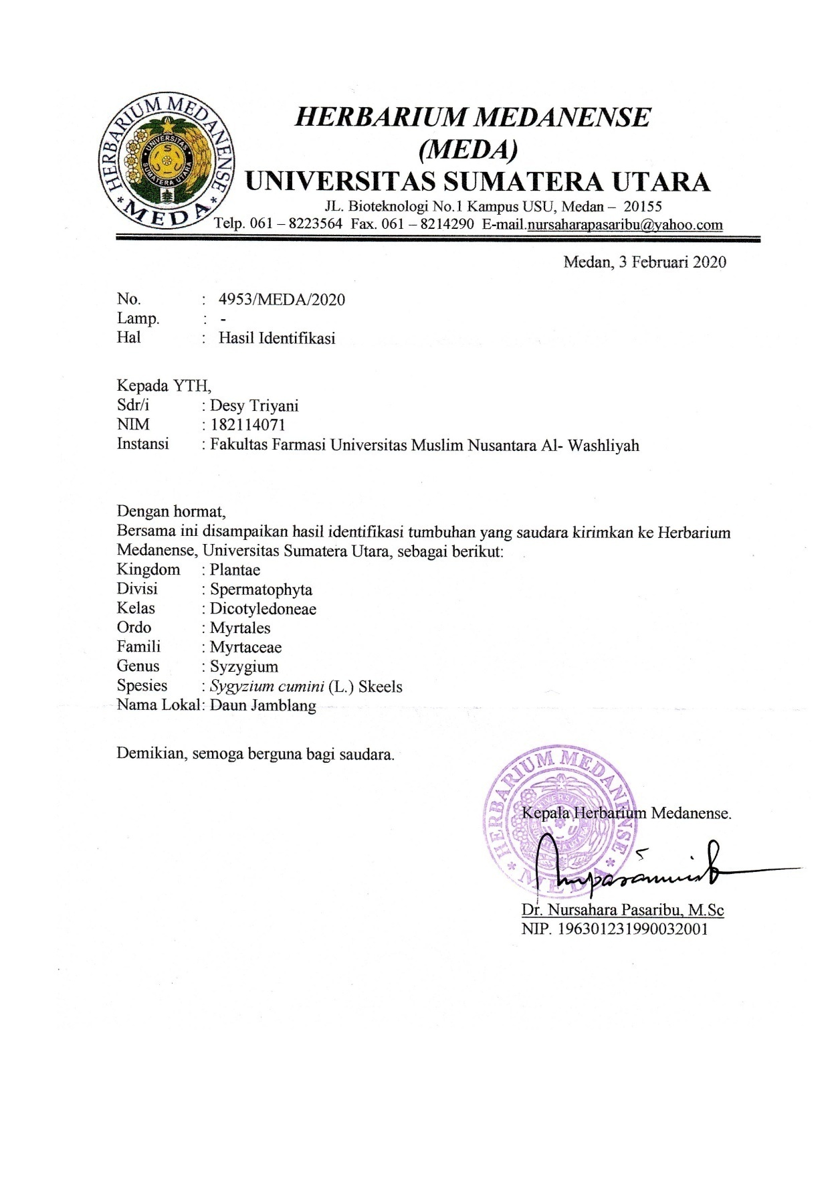

# Lampiran 2. Sampel yang diuji pada penelitian

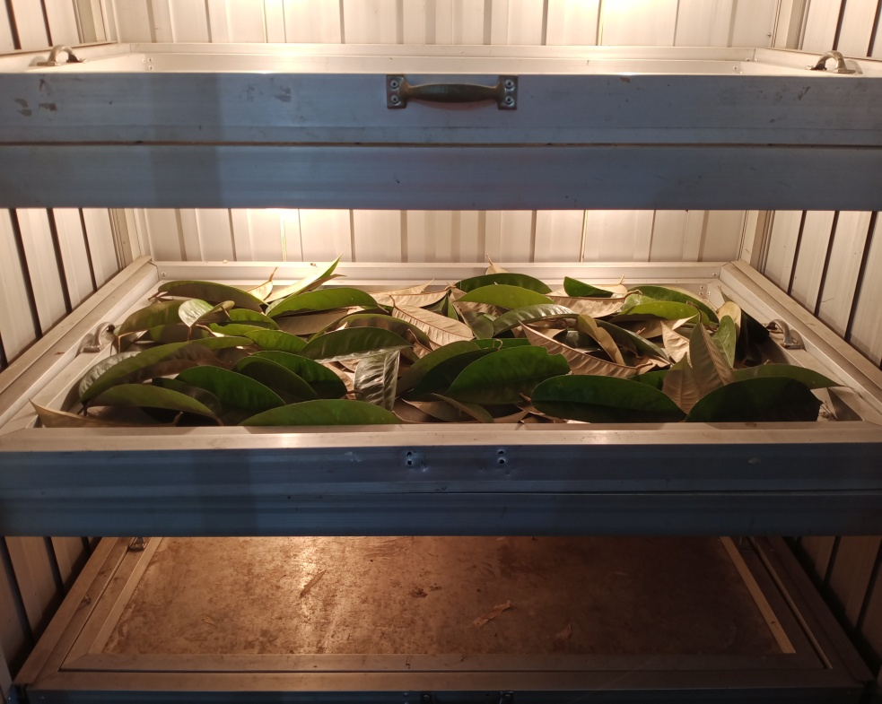

Sampel Segar Daun Jamblang (*Syzygium* *cumini* (L.) Skeels)

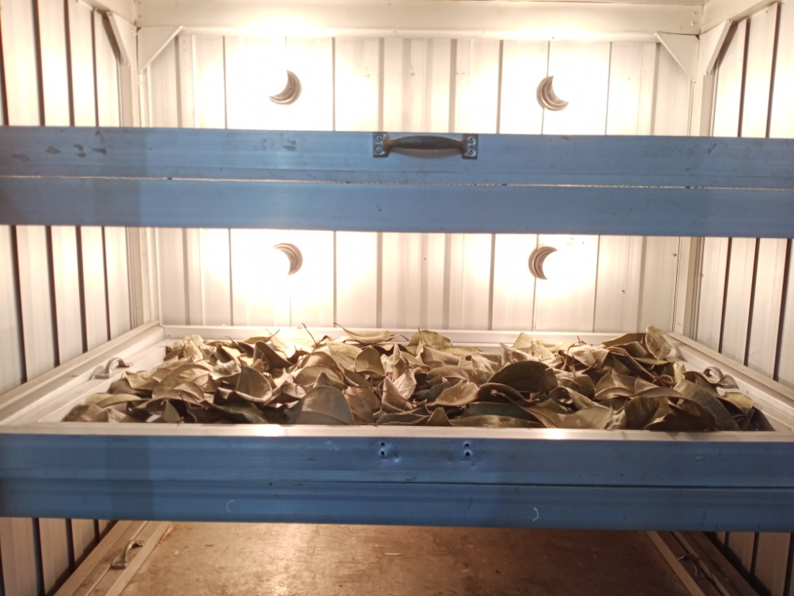

Sampel Daun Jamblang (*Syzygium* *cumini* (L.) Skeels) Dikeringkan

**Lampiran 2.** (Lanjutan)

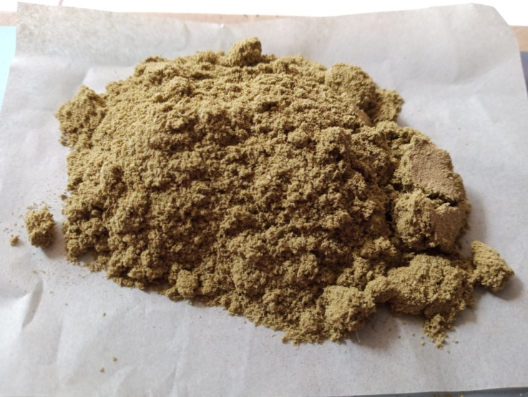

Serbuk Kering Daun Jamblang (*Syzygium* *cumini* (L.) Skeels)

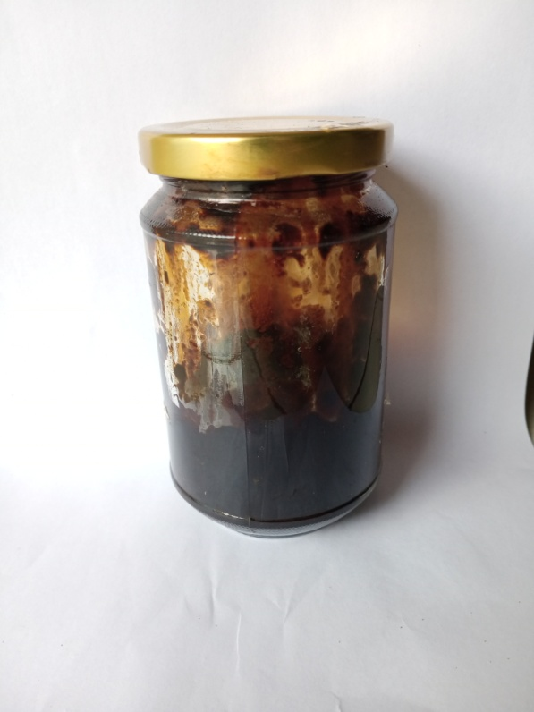

Ekstrak Etanol Daun Jamblang (*Syzygium* *cumini* (L.) Skeels)

**Lampiran 3.** Perhitungan penetapan kadar air simplisia daun Jamblang (*Syzygium cumini* (L.) Skeels)

%Kadar air = $\frac{Volume akhir-volume awal}{Berat sampel (gr)}$ x 100%

|  |  |  |
| --- | --- | --- |
| **No** | **Berat Sampel (gr)** | **V. Akhir - V. Awal** |
| 1. | 5 | 0,3 |
| 2. | 5 | 0,25 |
| 3. | 5 | 0,25 |

1. %Kadar air = $\frac{1,7-1,4}{5 (gr)}$ x 100% = 6%
2. %Kadar air = $\frac{1,8-1,55}{5(gr)}$ x 100% = 5%
3. %Kadar air = $\frac{2-1,75}{5 (gr)}$ x 100%= 5%

Rata-Rata = = $\frac{6\%+5\%+5\%}{3}$ = 5,33%

Syarat: Tidak boleh dari 10%

**Lampiran 4.** Perhitungan penetapan kadar sari larut dalam air

%Kadar = $\frac{Cawan isi-cawan kosong x 5}{Berat sampel (gr)}$ x 100%

|  |  |  |  |
| --- | --- | --- | --- |
| **No** | **Berat Sampel (gr)** | **Berat Cawan Kosong** | **Berat Setelah Diuapkan (gr)** |
| 1. | 5 | 22,46 | 22,71 |
| 2. | 5 | 113,06 | 113,34 |
| 3. | 5 | 122,74 | 123,02 |

1. %Kadar = $\frac{0,25 x 5}{5 (gr)}$ x 100% = 25%
2. %Kadar = $\frac{0,28 x 5}{5 (gr)}$ x 100% = 28%
3. %Kadar = $\frac{0,78 x 5}{5 (gr)}$ x 100% = 28%

Rata-rata = $\frac{25+28+28}{3}$ = 27%

Syarat: Tidak kurang dari 6%

**Lampiran 5.** Perhitungan penetapan kadar sari larut dalam etanol

%Kadar = $\frac{Cawan isi-cawan kosong x 5}{Berat sampel (gr)}$ x 100%

|  |  |  |  |
| --- | --- | --- | --- |
| **No** | **Berat Sampel (gr)** | **Berat Cawan Kosong** | **Berat Setelah Diuapkan (gr)** |
| 1. | 5 | 55,21 | 55,54 |
| 2. | 5 | 34,96 | 35,32 |
| 3. | 5 | 53,42 | 53,81 |

1. %Kadar = $\frac{0,33 x 5}{5 (gr)}$ x 100% = 33%
2. %Kadar = $\frac{0,36x 5}{5 (gr)}$ x 100% = 36%
3. %Kadar = $\frac{0,39 x 5}{5 (gr)}$ x 100% = 39%

Rata-rata = $\frac{33+36+39}{3}$ = 36%

Syarat: Tidak kurang dari 6%

# Lampiran 6. Perhitungan penetapan kadar abu total

%Kadar = $\frac{Cawan isi-cawan kosong }{Berat sampel (gr)}$ x 100%

|  |  |  |  |
| --- | --- | --- | --- |
| **No** | **Berat Sampel (gr)** | **Berat Cawan Kosong** | **Berat Setelah Diuapkan (gr)** |
| 1. | 2 | 64,11 | 64,22 |
| 2. | 2 | 67,21 | 67,30 |
| 3. | 2 | 63,13 | 63,22 |

1. %Kadar = $\frac{0,11}{2(gr)}$ x 100% = 5,5%

1. %Kadar = $\frac{0,09}{2(gr)}$ x 100% = 4,5%
2. %Kadar = $\frac{0,09 }{2 (gr)}$ x 100% = 4,5%

Rata-rata = $\frac{5,5+4,5+4,5}{3}$ = 4,8%

Syarat: Tidak boleh dari 6%

**Lampiran 7.** Perhitungan penetapan kadar abu tidak larut asam

%Kadar = $\frac{Cawan isi-cawan kosong }{Berat sampel (gr)}$ x 100%

|  |  |  |  |
| --- | --- | --- | --- |
| **No** | **Berat Sampel (gr)** | **Berat Cawan Kosong** | **Berat Setelah Diuapkan (gr)** |
| 1. | 2 | 64,11 | 64,12 |
| 2. | 2 | 67,21 | 67,23 |
| 3. | 2 | 63,13 | 63,14 |

1. %Kadar = $\frac{0,01}{2(gr)}$ x 100% = 0,5%
2. %Kadar = $\frac{0,02}{2(gr)}$ x 100% = 1%
3. %Kadar = $\frac{0,01 }{2 (gr)}$ x 100% = 0,5%

Rata-rata = $\frac{0,5+1+0,5}{3}$ = 0,6%

Syarat: Tidak boleh dari 1%

# Lampiran 8. Perhitungan susut pengeringan dan % rendemen

|  |  |
| --- | --- |
| Berat segar | 8 kg |
| Berat kering | 5 kg |
| Berat serbuk | 4 kg |
| Berat ekstrak | 318,66 g |

Susut pengeringan = $\frac{Berat segar-Berat kering (g)}{Berat segar (g)}$ x 100%

= $\frac{8- 5 (g)}{5 (g)}$ x 100%

= 60 %

% Rendemen = $\frac{Bobot Ekstrak (g)}{Bobot Simplisia (g)}$ x 100%

% Rendemen = $\frac{318,66 (g)}{900 (g)}$ x 100% = 35,4 %

**Lampiran 9.** Bagan Alir Pembuatan Ekstrak Etanol Daun Jamblang (*Syzygium* *cumini* (L.) Skeels)

Daun Jamblang

Disortasi dan dicuci

Ditiriskan

Ditimbang

Daun Jamblang 8 kg

Dikeringkan dan dihaluskan

Ditimbang

Serbuk Simplisia 900 gr

maserasi dengan 75 bagian (6.750 mL) cairan penyari etanol 96% selama 5 hari

Disaring

Residu

Filtrat I

Dimaserasi 25 bagian (2.250 mL) etanol 96% selama 2 hari

Filtrat I + Filtrat II 7000 mL

Dipekatkan dengan *rotary evaporator*

Ekstrak kental 318,66 gram

# Lampiran 10. Bagan Alir Pembuatan Sediaan Masker Gel *Peel-off* Ekstrak Daun

# Jamblang (*Syzygium* *cumini* (L.) Skeels)

Hidroksipropilmetilcellulosa (HPMC)

Polivinil alkohol (PVA)

Ditimbang

Ditambahkan air panas

Dipanaskan hingga larut

Ditimbang

Ditambahkan air panas

Digerus sampai homogen

Masker gel *peel-off* ekstrak etanol daun Jamblang

Dilarutkan

Ditambahkan ekstrak etanol daun Jamblang konsentrasi 7%, 11% dan 15%

Basis masker gel *peel-off*

Digerus sampai tercampur dan homogen

Campuran

Massa 3

Propilenglikol, propil paraben dan metil paraben

Massa 2

Massa 1

# Lampiran 11. Masker Gel *Peel-off* Ekstrak Etanol Daun Jamblang

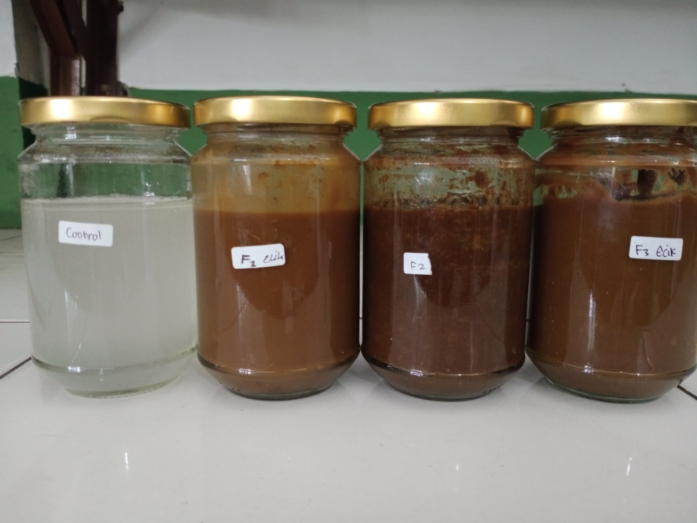

Sediaan setelah dibuat

Keterangan:

F0: Blanko

F1: Konsentrasi EEDJ 7%

F2: Konsentrasi EEDJ 11%

F3: Konsentrasi EEDJ 15%

# Lampiran 12. Uji Homogenitas

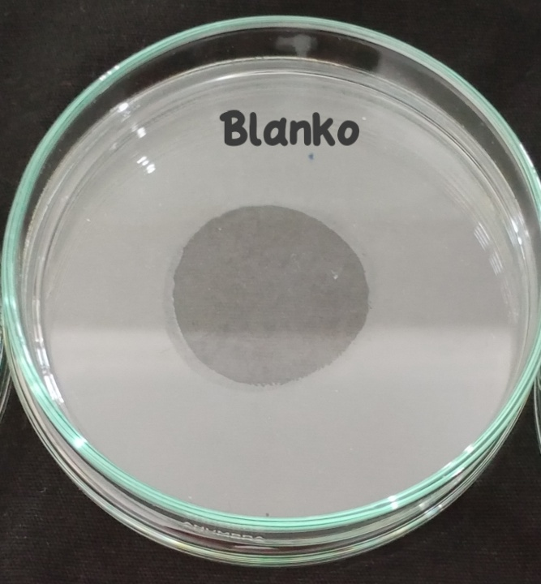

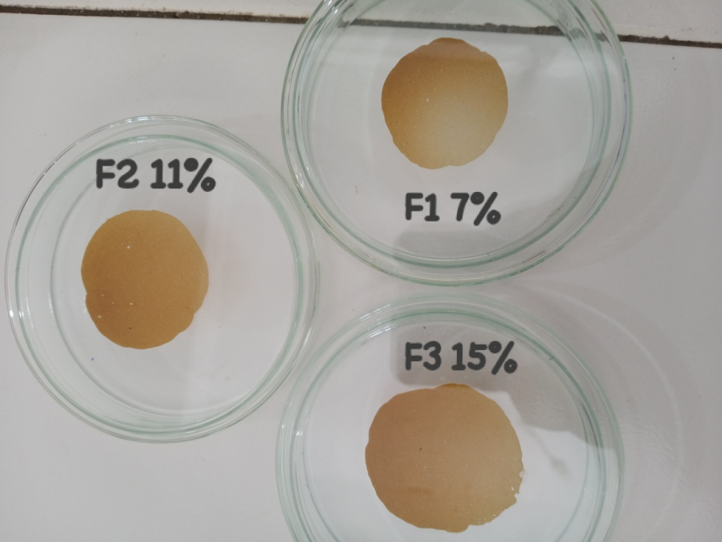

# Lampiran 13. Hasil Uji pH

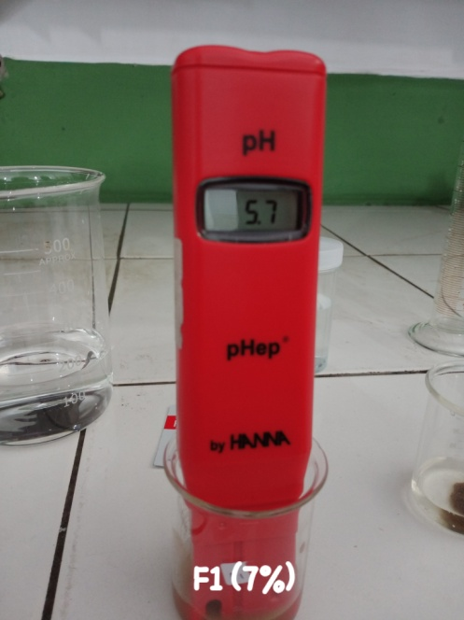

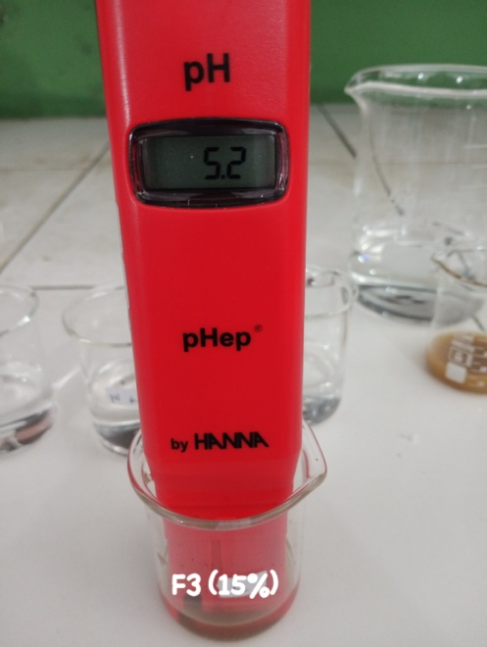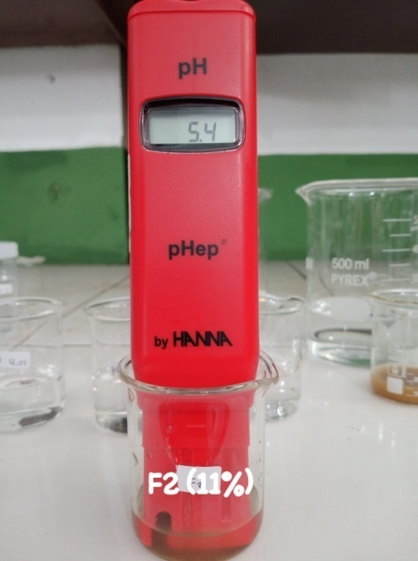

# Lampiran 14. Hasil Uji Daya Sebar

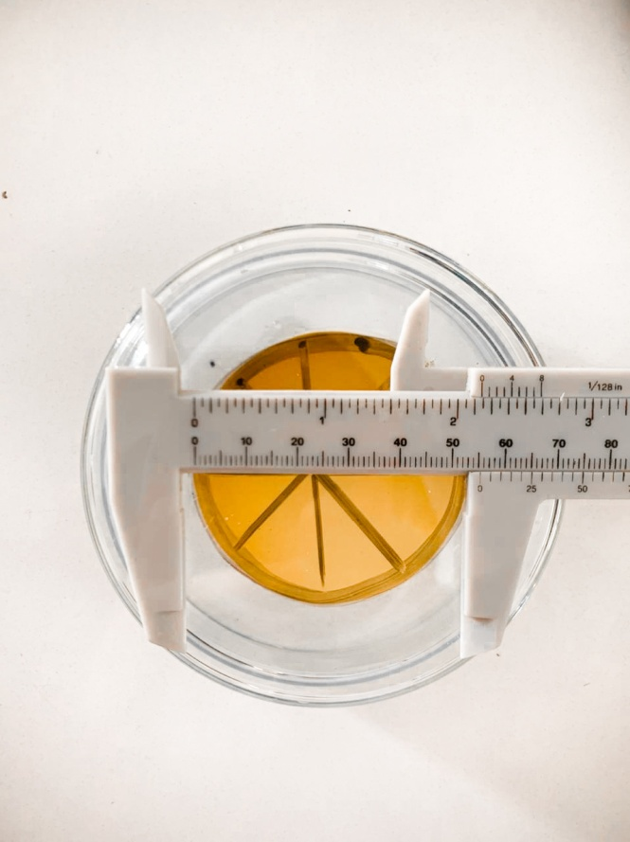

# Lampiran 15. Hasil Uji Viskositas

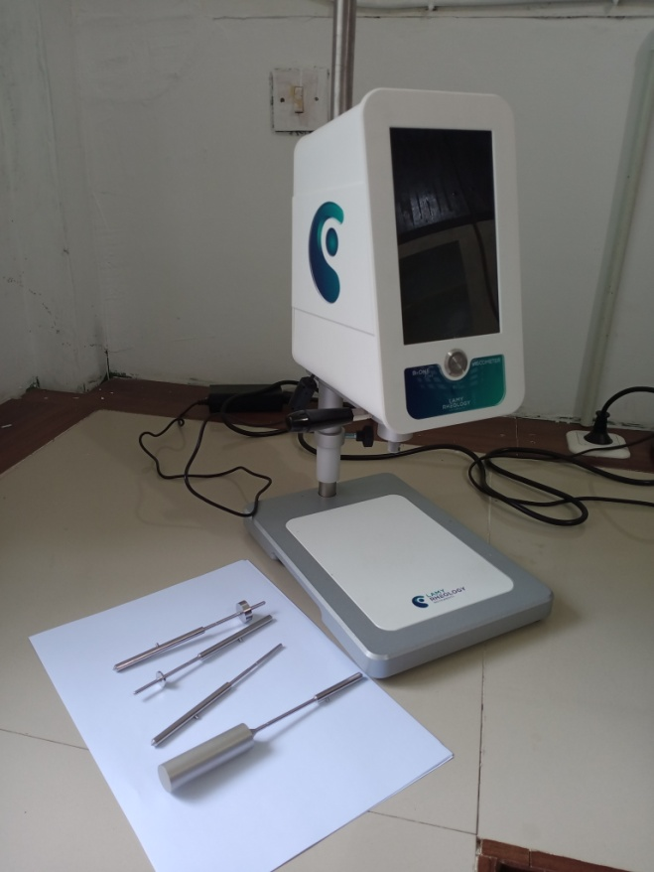

**Lampiran 16.** Hasil Uji iritasi terhadap sediaan Masker Gel *Peel-off* Ekstrak Etanol Daun Jamblang (*Syzygium cuminu* (L.) Skeels)

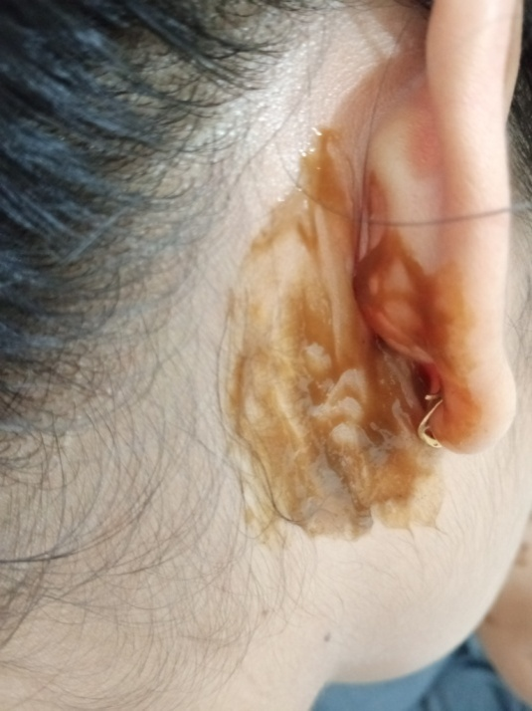

Saat dioleskan pada bagian belakang telinga

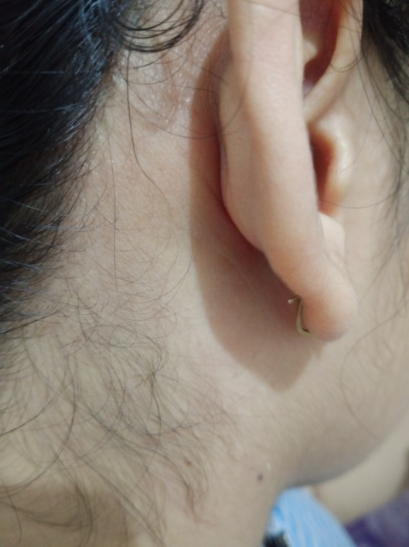

Hasil setelah pengolesan uji iritas

# Lampiran 17. Hasil Uji Waktu Kering

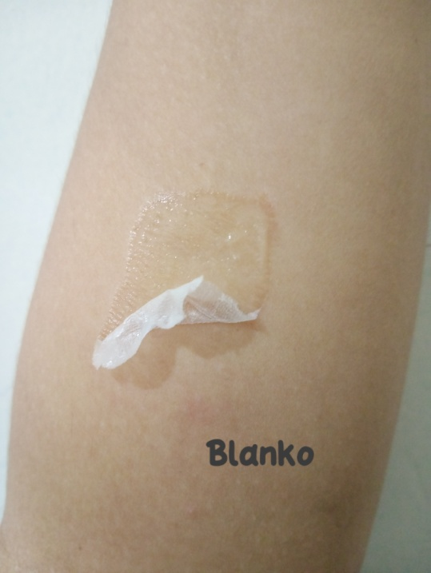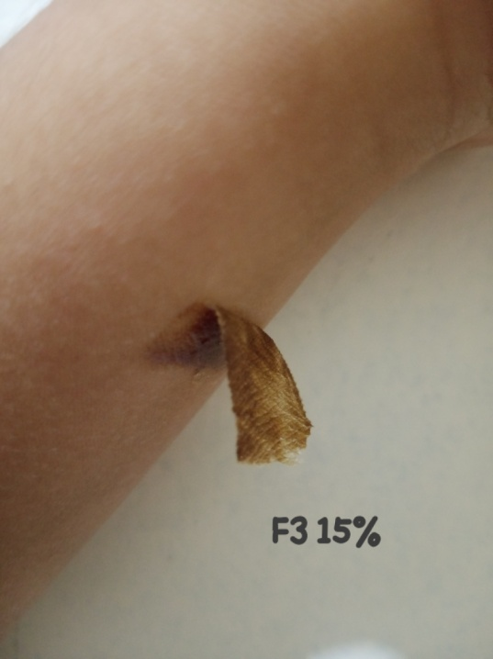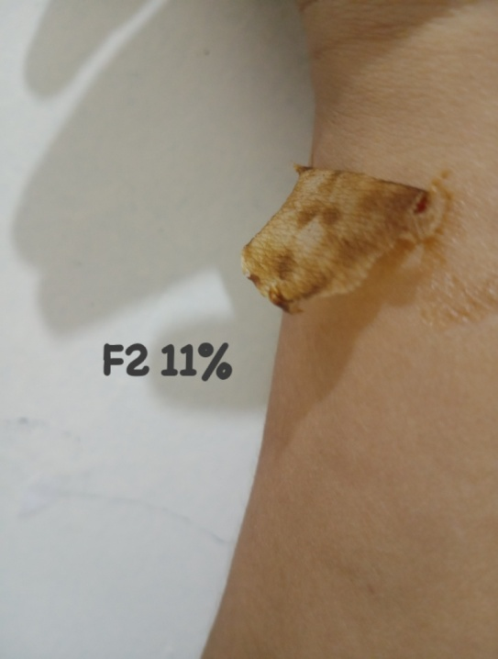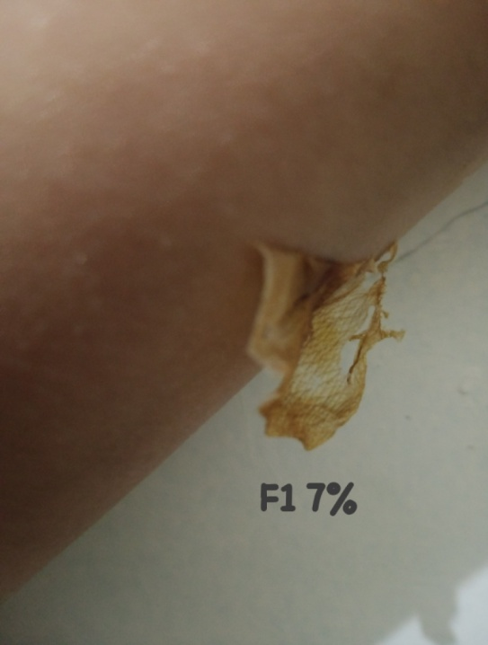

# Lampiran18. Penggunaan Masker Pada Sukarelawan

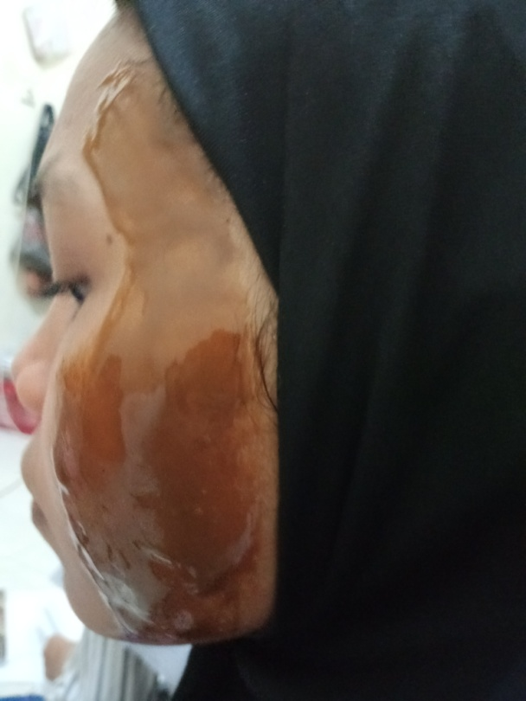

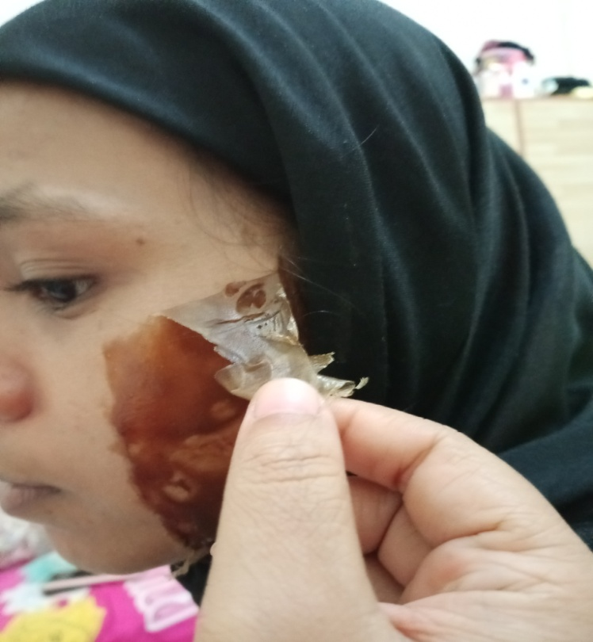

# Lampiran 19. Hasil uji Masker gel *peel-off* ekstrak etanol daun Jamblang (*Syzygium cumini* (L.) Skeels) dengan alat *skin* *analyzer* pada kulit wajah sukarelawan

* 1. Moisture (Kadar Air/ Kelembaban)

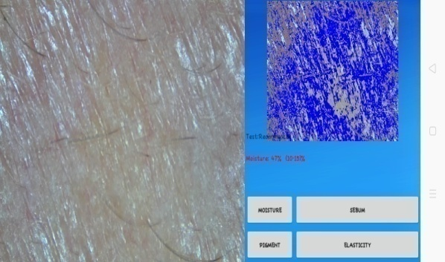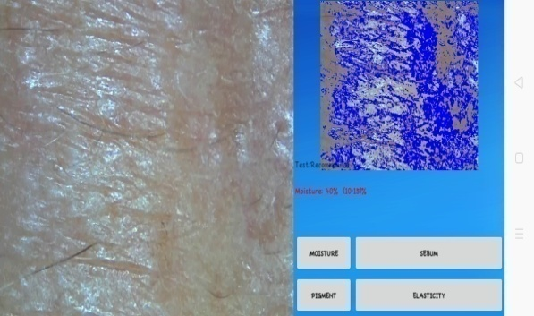

Kondisi Awal



Minggu 1



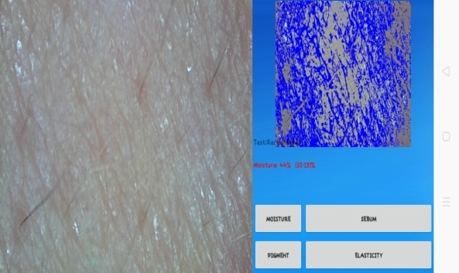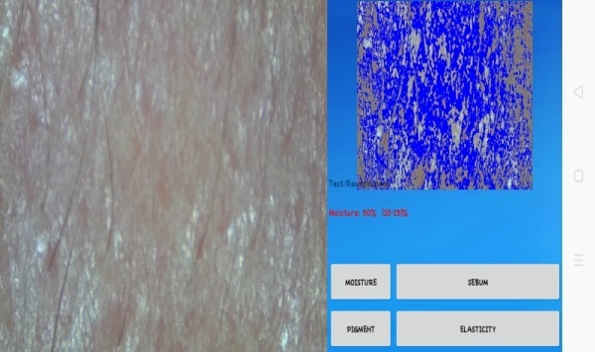

Minggu 3



Minggu 2



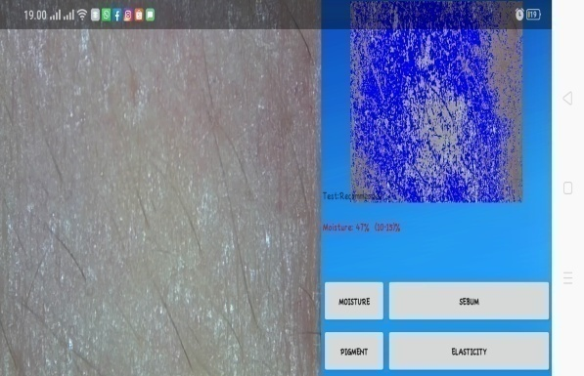

Minggu 4



**Lampiran 19.** (Lanjutan)

* 1. Elastisitas

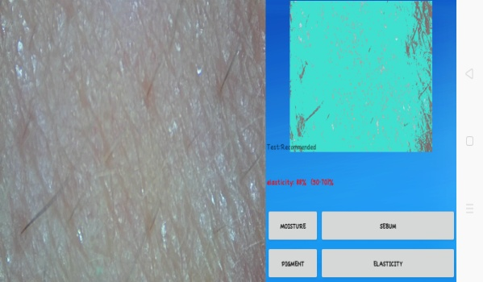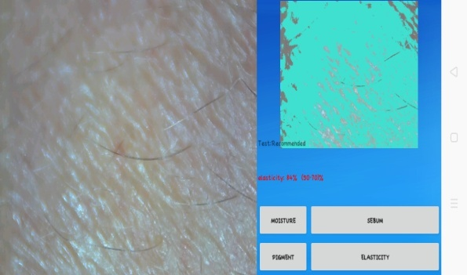

Minggu 1

Kondisi Awal

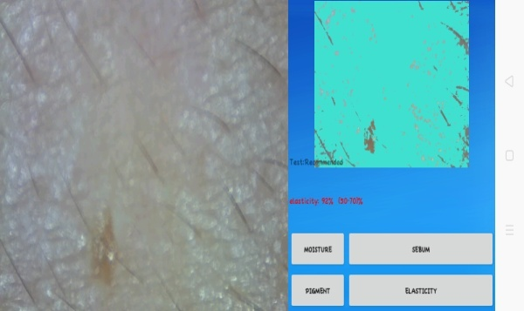

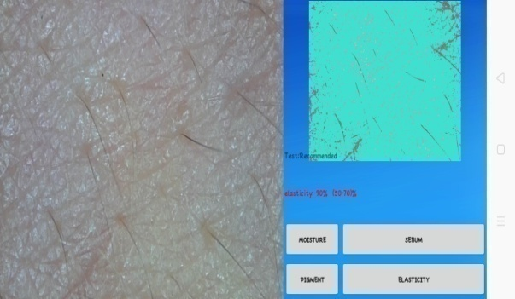

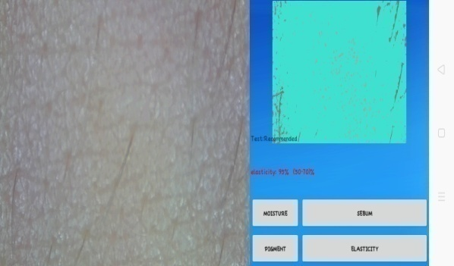

Minggu 4

Minggu 3

Minggu 2

**Lampiran 19.** (Lanjutan)

* 1. Pigment

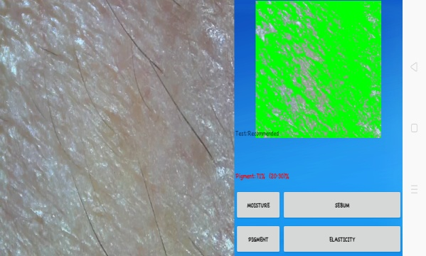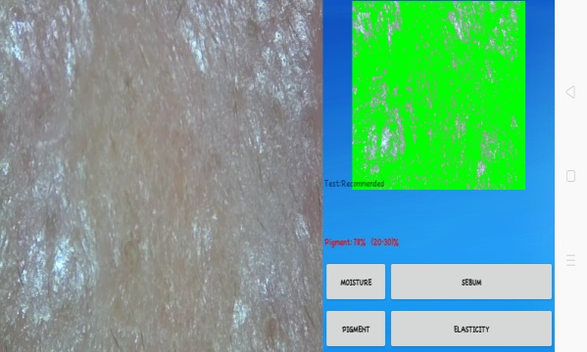

Minggu 1

Kondisi Awal

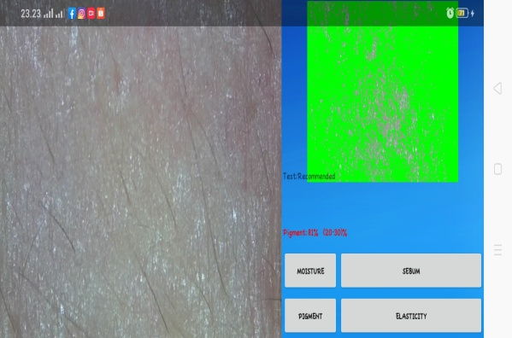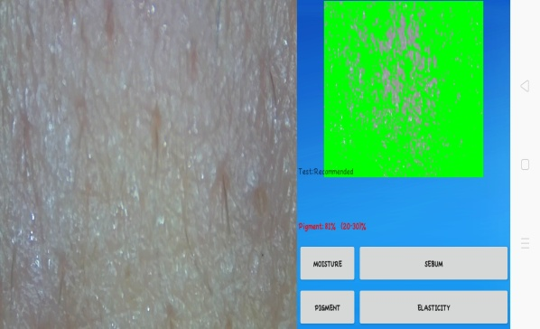

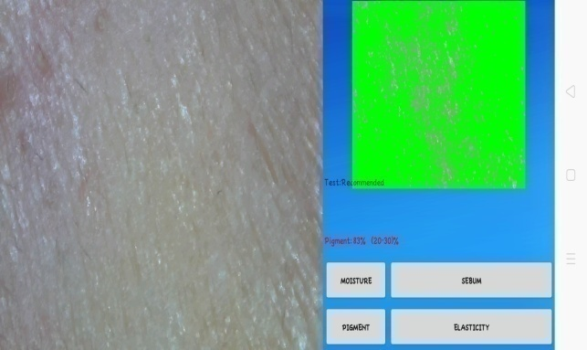

Minggu 4

Minggu 3

Minggu 2

# Lampiran 20. Data Hasil Statistik *One Way ANOVA*

* 1. Moisture

|  |  |  |  |  |  |  |  |  |  |  |  |
| --- | --- | --- | --- | --- | --- | --- | --- | --- | --- | --- | --- |
| **Tests of Normality** | | | | | | | | | | | |
|  | KELEMBABAN | Kolmogorov-Smirnova | | | | | | Shapiro-Wilk | | | |
|  | Statistic | | df | | Sig. | | Statistic | | df | Sig. |
| FO | M0 | ,175 | | 3 | | . | | 1,000 | | 3 | 1,000 |
| M1 | ,175 | | 3 | | . | | 1,000 | | 3 | 1,000 |
| M2 | ,175 | | 3 | | . | | 1,000 | | 3 | 1,000 |
| M3 | ,253 | | 3 | | . | | ,964 | | 3 | ,637 |
| M4 | ,253 | | 3 | | . | | ,964 | | 3 | ,637 |
| F1 | M0 | ,175 | | 3 | | . | | 1,000 | | 3 | 1,000 |
| M1 | ,253 | | 3 | | . | | ,964 | | 3 | ,637 |
| M2 | ,253 | | 3 | | . | | ,964 | | 3 | ,637 |
| M3 | ,253 | | 3 | | . | | ,964 | | 3 | ,637 |
| M4 | ,175 | | 3 | | . | | 1,000 | | 3 | 1,000 |
| F2 | M0 | ,253 | | 3 | | . | | ,964 | | 3 | ,637 |
| M1 | ,253 | | 3 | | . | | ,964 | | 3 | ,637 |
| M2 | ,253 | | 3 | | . | | ,964 | | 3 | ,637 |
| M3 | ,292 | | 3 | | . | | ,923 | | 3 | ,463 |
| M4 | ,292 | | 3 | | . | | ,923 | | 3 | ,463 |
| F3 | M0 | ,175 | | 3 | | . | | 1,000 | | 3 | 1,000 |
| M1 | ,175 | | 3 | | . | | 1,000 | | 3 | 1,000 |
| M2 | ,175 | | 3 | | . | | 1,000 | | 3 | 1,000 |
| M3 | ,253 | | 3 | | . | | ,964 | | 3 | ,637 |
| M4 | ,253 | | 3 | | . | | ,964 | | 3 | ,637 |
| a. Lilliefors Significance Correction | | | | | | | | | | | |
| Test of Homogeneity of Variances | | | | | | | | | | | |
|  | Levene Statistic | | df1 | | df2 | | Sig. | |
| FO | ,453 | | 4 | | 10 | | ,769 | |
| F1 | ,421 | | 4 | | 10 | | ,790 | |
| F2 | ,312 | | 4 | | 10 | | ,864 | |
| F3 | ,453 | | 4 | | 10 | | ,769 | |

**Lampiran 20.** (Lanjutan)

|  |  |  |  |  |  |  |
| --- | --- | --- | --- | --- | --- | --- |
| **ANOVA** | | | | | | |
|  | | Sum of Squares | df | Mean Square | F | Sig. |
| FO | Between Groups | 14,667 | 4 | 3,667 | 2,391 | ,020 |
| Within Groups | 15,333 | 10 | 1,533 |  |  |
| Total | 30,000 | 14 |  |  |  |
| F1 | Between Groups | 31,600 | 4 | 7,900 | 4,389 | ,026 |
| Within Groups | 18,000 | 10 | 1,800 |  |  |
| Total | 49,600 | 14 |  |  |  |
| F2 | Between Groups | 72,000 | 4 | 18,000 | 5,745 | ,011 |
| Within Groups | 31,333 | 10 | 3,133 |  |  |
| Total | 103,333 | 14 |  |  |  |
| F3 | Between Groups | 289,600 | 4 | 72,400 | 47,217 | ,000 |
| Within Groups | 15,333 | 10 | 1,533 |  |  |
| Total | 304,933 | 14 |  |  |  |

|  |  |  |  |
| --- | --- | --- | --- |
| **FO** | | | |
| Duncana | | | |
| KELEMBABAN | N | Subset for alpha = 0.05 | |
| 1 | 2 |
| M0 | 3 | 35,00 |  |
| M1 | 3 | 35,00 |  |
| M2 | 3 | 36,00 | 36,00 |
| M3 | 3 | 36,33 | 36,33 |
| M4 | 3 |  | 37,67 |
| Sig. |  | ,247 | ,146 |
| Means for groups in homogeneous subsets are displayed. | | | |
| a. Uses Harmonic Mean Sample Size = 3,000. | | | |

**Lampiran 20.** (Lanjutan)

|  |  |  |  |
| --- | --- | --- | --- |
| **F1** | | | |
| Duncana | | | |
| KELEMBABAN | N | Subset for alpha = 0.05 | |
| 1 | 2 |
| M0 | 3 | 37,00 |  |
| M1 | 3 | 37,33 |  |
| M2 | 3 | 38,33 |  |
| M3 | 3 | 39,33 | 39,33 |
| M4 | 3 |  | 41,00 |
| Sig. |  | ,075 | ,159 |
| Means for groups in homogeneous subsets are displayed. | | | |
| a. Uses Harmonic Mean Sample Size = 3,000. | | | |

|  |  |  |  |  |
| --- | --- | --- | --- | --- |
| **F2** | | | | |
| Duncana | | | | |
| KELEMBABAN | N | Subset for alpha = 0.05 | | |
| 1 | 2 | 3 |
| M0 | 3 | 39,67 |  |  |
| M1 | 3 | 40,33 | 40,33 |  |
| M2 | 3 | 42,33 | 42,33 | 42,33 |
| M3 | 3 |  | 43,67 | 43,67 |
| M4 | 3 |  |  | 45,67 |
| Sig. |  | ,108 | ,052 | ,052 |
| Means for groups in homogeneous subsets are displayed. | | | | |
| a. Uses Harmonic Mean Sample Size = 3,000. | | | | |

|  |  |  |  |  |  |  |
| --- | --- | --- | --- | --- | --- | --- |
| **F3** | | | | | | |
| Duncana | | | | | | |
| KELEMBABAN | N | Subset for alpha = 0.05 | | | | |
| 1 | 2 | 3 | 4 | 5 |
| M0 | 3 | 41,00 |  |  |  |  |
| M1 | 3 |  | 44,00 |  |  |  |
| M2 | 3 |  |  | 47,00 |  |  |
| M3 | 3 |  |  |  | 49,67 |  |
| M4 | 3 |  |  |  |  | 53,67 |
| Sig. |  | 1,000 | 1,000 | 1,000 | 1,000 | 1,000 |
| Means for groups in homogeneous subsets are displayed. | | | | | | |
| a. Uses Harmonic Mean Sample Size = 3,000. | | | | | | |

**Lampiran 20.** (Lanjutan)

* 1. Elastisitas

|  |  |  |  |  |  |  |  |
| --- | --- | --- | --- | --- | --- | --- | --- |
| **Tests of Normality** | | | | | | | |
|  | ELASTISITAS | Kolmogorov-Smirnova | | | Shapiro-Wilk | | |
|  | Statistic | Df | Sig. | Statistic | df | Sig. |
| FO | M0 | ,253 | 3 | . | ,964 | 3 | ,637 |
| M1 | ,175 | 3 | . | 1,000 | 3 | 1,000 |
| M2 | ,253 | 3 | . | ,964 | 3 | ,637 |
| M3 | ,175 | 3 | . | 1,000 | 3 | 1,000 |
| M4 | ,175 | 3 | . | 1,000 | 3 | 1,000 |
| F1 | M0 | ,175 | 3 | . | 1,000 | 3 | 1,000 |
| M1 | ,219 | 3 | . | ,987 | 3 | ,780 |
| M2 | ,292 | 3 | . | ,923 | 3 | ,463 |
| M3 | ,253 | 3 | . | ,964 | 3 | ,637 |
| M4 | ,175 | 3 | . | 1,000 | 3 | 1,000 |
| F2 | M0 | ,253 | 3 | . | ,964 | 3 | ,637 |
| M1 | ,175 | 3 | . | 1,000 | 3 | 1,000 |
| M2 | ,253 | 3 | . | ,964 | 3 | ,637 |
| M3 | ,175 | 3 | . | 1,000 | 3 | 1,000 |
| M4 | ,253 | 3 | . | ,964 | 3 | ,637 |
| F3 | M0 | ,175 | 3 | . | 1,000 | 3 | 1,000 |
| M1 | ,175 | 3 | . | 1,000 | 3 | 1,000 |
| M2 | ,253 | 3 | . | ,964 | 3 | ,637 |
| M3 | ,253 | 3 | . | ,964 | 3 | ,637 |
| M4 | ,175 | 3 | . | 1,000 | 3 | 1,000 |
| a. Lilliefors Significance Correction | | | | | | | |

|  |  |  |  |  |
| --- | --- | --- | --- | --- |
| **Test of Homogeneity of Variances** | | | | |
|  | Levene Statistic | df1 | df2 | Sig. |
| FO | ,453 | 4 | 10 | ,769 |
| F1 | 1,118 | 4 | 10 | ,401 |
| F2 | ,421 | 4 | 10 | ,790 |
| F3 | 1,341 | 4 | 10 | ,321 |

**Lampiran 20.** (Lanjutan)

|  |  |  |  |  |  |  |
| --- | --- | --- | --- | --- | --- | --- |
| **ANOVA** | | | | | | |
|  | | Sum of Squares | df | Mean Square | F | Sig. |
| FO | Between Groups | 58,267 | 4 | 14,567 | 9,500 | ,002 |
| Within Groups | 15,333 | 10 | 1,533 |  |  |
| Total | 73,600 | 14 |  |  |  |
| F1 | Between Groups | 87,333 | 4 | 21,833 | 7,278 | ,005 |
| Within Groups | 30,000 | 10 | 3,000 |  |  |
| Total | 117,333 | 14 |  |  |  |
| F2 | Between Groups | 159,333 | 4 | 39,833 | 22,130 | ,000 |
| Within Groups | 18,000 | 10 | 1,800 |  |  |
| Total | 177,333 | 14 |  |  |  |
| F3 | Between Groups | 211,600 | 4 | 52,900 | 11,669 | ,001 |
| Within Groups | 45,333 | 10 | 4,533 |  |  |
| Total | 256,933 | 14 |  |  |  |

|  |  |  |  |
| --- | --- | --- | --- |
| **FO** | | | |
| Duncana | | | |
| ELASTISITAS | N | Subset for alpha = 0.05 | |
| 1 | 2 |
| M0 | 3 | 74,67 |  |
| M1 | 3 | 76,00 |  |
| M2 | 3 |  | 78,33 |
| M3 | 3 |  | 79,00 |
| M4 | 3 |  | 80,00 |
| Sig. |  | ,217 | ,146 |
| Means for groups in homogeneous subsets are displayed. | | | |
| a. Uses Harmonic Mean Sample Size = 3,000. | | | |

**Lampiran 20.** (Lanjutan)

|  |  |  |  |  |
| --- | --- | --- | --- | --- |
| **F1** | | | | |
| Duncana | | | | |
| ELASTISITAS | N | Subset for alpha = 0.05 | | |
| 1 | 2 | 3 |
| M0 | 3 | 78,00 |  |  |
| M1 | 3 | 80,33 | 80,33 |  |
| M2 | 3 |  | 81,67 |  |
| M3 | 3 |  | 83,33 | 83,33 |
| M4 | 3 |  |  | 85,00 |
| Sig. |  | ,130 | ,070 | ,266 |
| Means for groups in homogeneous subsets are displayed. | | | | |
| a. Uses Harmonic Mean Sample Size = 3,000. | | | | |

|  |  |  |  |  |
| --- | --- | --- | --- | --- |
| **F2** | | | | |
| Duncana | | | | |
| ELASTISITAS | N | Subset for alpha = 0.05 | | |
| 1 | 2 | 3 |
| M0 | 3 | 81,33 |  |  |
| M1 | 3 | 83,00 |  |  |
| M2 | 3 |  | 85,67 |  |
| M3 | 3 |  | 88,00 | 88,00 |
| M4 | 3 |  |  | 90,33 |
| Sig. |  | ,159 | ,059 | ,059 |
| Means for groups in homogeneous subsets are displayed. | | | | |
| a. Uses Harmonic Mean Sample Size = 3,000. | | | | |

|  |  |  |  |  |  |
| --- | --- | --- | --- | --- | --- |
| **F3** | | | | | |
| Duncana | | | | | |
| ELASTISITAS | N | Subset for alpha = 0.05 | | | |
| 1 | 2 | 3 | 4 |
| M0 | 3 | 84,00 |  |  |  |
| M1 | 3 |  | 88,00 |  |  |
| M2 | 3 |  | 89,33 | 89,33 |  |
| M3 | 3 |  |  | 92,33 | 92,33 |
| M4 | 3 |  |  |  | 95,00 |
| Sig. |  | 1,000 | ,461 | ,115 | ,156 |
| Means for groups in homogeneous subsets are displayed. | | | | | |
| a. Uses Harmonic Mean Sample Size = 3,000. | | | | | |

**Lampiran 20.** (Lanjutan)

* 1. Pigment

|  |  |  |  |  |  |  |  |
| --- | --- | --- | --- | --- | --- | --- | --- |
| **Tests of Normality** | | | | | | | |
|  | PIGMENT | Kolmogorov-Smirnova | | | Shapiro-Wilk | | |
|  | Statistic | df | Sig. | Statistic | df | Sig. |
| FO | M0 | ,175 | 3 | . | 1,000 | 3 | 1,000 |
| M1 | ,175 | 3 | . | 1,000 | 3 | 1,000 |
| M2 | ,253 | 3 | . | ,964 | 3 | ,637 |
| M3 | ,175 | 3 | . | 1,000 | 3 | 1,000 |
| M4 | ,253 | 3 | . | ,964 | 3 | ,637 |
| F1 | M0 | ,314 | 3 | . | ,893 | 3 | ,363 |
| M1 | ,175 | 3 | . | 1,000 | 3 | 1,000 |
| M2 | ,253 | 3 | . | ,964 | 3 | ,637 |
| M3 | ,253 | 3 | . | ,964 | 3 | ,637 |
| M4 | ,175 | 3 | . | 1,000 | 3 | 1,000 |
| F2 | M0 | ,253 | 3 | . | ,964 | 3 | ,637 |
| M1 | ,175 | 3 | . | 1,000 | 3 | 1,000 |
| M2 | ,253 | 3 | . | ,964 | 3 | ,637 |
| M3 | ,175 | 3 | . | 1,000 | 3 | 1,000 |
| M4 | ,175 | 3 | . | 1,000 | 3 | 1,000 |
| F3 | M0 | ,253 | 3 | . | ,964 | 3 | ,637 |
| M1 | ,175 | 3 | . | 1,000 | 3 | 1,000 |
| M2 | ,253 | 3 | . | ,964 | 3 | ,637 |
| M3 | ,175 | 3 | . | 1,000 | 3 | 1,000 |
| M4 | ,175 | 3 | . | 1,000 | 3 | 1,000 |
| a. Lilliefors Significance Correction | | | | | | | |

|  |  |  |  |  |
| --- | --- | --- | --- | --- |
| **Test of Homogeneity of Variances** | | | | |
|  | Levene Statistic | df1 | df2 | Sig. |
| FO | ,453 | 4 | 10 | ,769 |
| F1 | ,980 | 4 | 10 | ,461 |
| F2 | ,453 | 4 | 10 | ,769 |
| F3 | ,453 | 4 | 10 | ,769 |

**Lampiran 20.** (Lanjutan)

|  |  |  |  |  |  |  |
| --- | --- | --- | --- | --- | --- | --- |
| **ANOVA** | | | | | | |
|  | | Sum of Squares | df | Mean Square | F | Sig. |
| FO | Between Groups | 20,400 | 4 | 5,100 | 3,326 | ,045 |
| Within Groups | 15,333 | 10 | 1,533 |  |  |
| Total | 35,733 | 14 |  |  |  |
| F1 | Between Groups | 50,667 | 4 | 12,667 | 3,800 | ,040 |
| Within Groups | 33,333 | 10 | 3,333 |  |  |
| Total | 84,000 | 14 |  |  |  |
| F2 | Between Groups | 164,400 | 4 | 41,100 | 26,804 | ,000 |
| Within Groups | 15,333 | 10 | 1,533 |  |  |
| Total | 179,733 | 14 |  |  |  |
| F3 | Between Groups | 298,267 | 4 | 74,567 | 48,630 | ,000 |
| Within Groups | 15,333 | 10 | 1,533 |  |  |
| Total | 313,600 | 14 |  |  |  |

|  |  |  |  |
| --- | --- | --- | --- |
| **FO** | | | |
| Duncana | | | |
| PIGMENT | N | Subset for alpha = 0.05 | |
| 1 | 2 |
| M0 | 3 | 65,00 |  |
| M1 | 3 | 67,00 | 67,00 |
| M2 | 3 | 67,33 | 67,33 |
| M3 | 3 |  | 68,00 |
| M4 | 3 |  | 68,33 |
| Sig. |  | ,052 | ,247 |
| Means for groups in homogeneous subsets are displayed. | | | |
| a. Uses Harmonic Mean Sample Size = 3,000. | | | |

**Lampiran 20.** (Lanjutan)

|  |  |  |  |
| --- | --- | --- | --- |
| **F1** | | | |
| Duncana | | | |
| PIGMENT | N | Subset for alpha = 0.05 | |
| 1 | 2 |
| M0 | 3 | 72,00 |  |
| M1 | 3 | 74,00 | 74,00 |
| M2 | 3 | 75,33 | 75,33 |
| M3 | 3 |  | 76,67 |
| M4 | 3 |  | 77,00 |
| Sig. |  | ,058 | ,090 |
| Means for groups in homogeneous subsets are displayed. | | | |
| a. Uses Harmonic Mean Sample Size = 3,000. | | | |

|  |  |  |  |  |  |
| --- | --- | --- | --- | --- | --- |
| **F2** | | | | | |
| Duncana | | | | | |
| PIGMENT | N | Subset for alpha = 0.05 | | | |
| 1 | 2 | 3 | 4 |
| M0 | 3 | 70,33 |  |  |  |
| M1 | 3 |  | 73,00 |  |  |
| M2 | 3 |  |  | 75,33 |  |
| M3 | 3 |  |  | 77,00 |  |
| M4 | 3 |  |  |  | 80,00 |
| Sig. |  | 1,000 | 1,000 | ,130 | 1,000 |
| Means for groups in homogeneous subsets are displayed. | | | | | |
| a. Uses Harmonic Mean Sample Size = 3,000. | | | | | |

|  |  |  |  |  |  |
| --- | --- | --- | --- | --- | --- |
| **F3** | | | | | |
| Duncana | | | | | |
| PIGMENT | N | Subset for alpha = 0.05 | | | |
| 1 | 2 | 3 | 4 |
| M0 | 3 | 72,67 |  |  |  |
| M1 | 3 |  | 79,00 |  |  |
| M2 | 3 |  |  | 82,33 |  |
| M3 | 3 |  |  | 84,00 | 84,00 |
| M4 | 3 |  |  |  | 85,00 |
| Sig. |  | 1,000 | 1,000 | ,130 | ,346 |
| Means for groups in homogeneous subsets are displayed. | | | | | |
| a. Uses Harmonic Mean Sample Size = 3,000. | | | | | |

# Lampiran 21. Contoh format surat pernyataan sukarelawan

Surat Pernyataan

Saya yang bertanda tangan di bawah ini:

Nama :

Umur :

Alamat :

Telah mendapat penjelasan secukupnya bahwa wajah saya akan digunakan sebagai daerah yang akan dianalisis. Setelah mendapat penjelasan secukupnya tentang manfaat penelitian ini maka saya menyatakan setuju untuk ikut serta dalam penelitian dari Desy Triyani dengan judul “Formulasi Dan Uji Efektivitas *Anti-Aging* Masker Gel *Peel-off* Dari Ekstrak Etanol Daun Jamblang (*Syzygium cumini (L) Skeels*)*”* sebagai usaha untuk mengetahui apakah sediaan masker gel *peel-off* yang dihasilkan mampu memberikan efek kelembaban serta *efek anti-aging*. Saya menyatakan sukarela dan bersedian untuk mengikuti prosedur penelitian yang telah ditetapkan

Persetujuan ini saya buat dengan penuh kesadaran dan tanpa paksaan dari piham manapun. Demikian surat pernyataan ini dibuat untuk dapat dipergunakan sebagaimana mestinya.

Peneliti, Sukarelawan,