Lampiran 1. Hasil identifikasi daun bunga tahi ayam

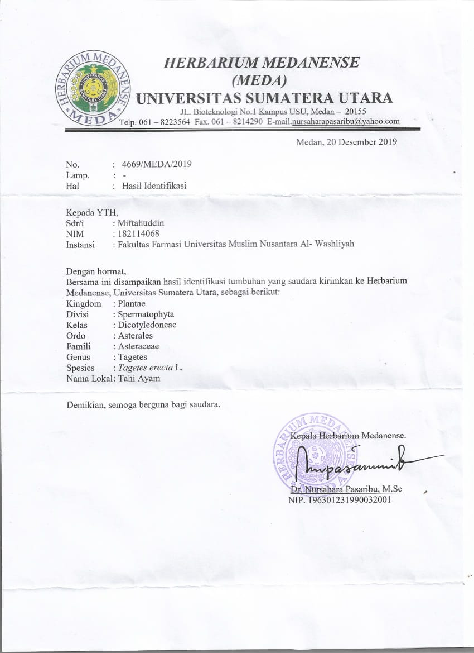

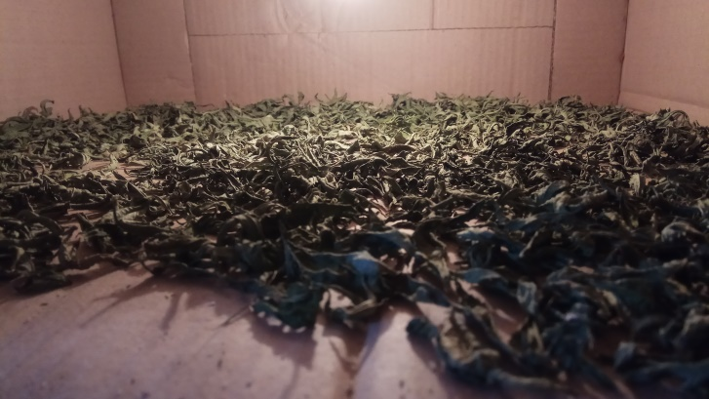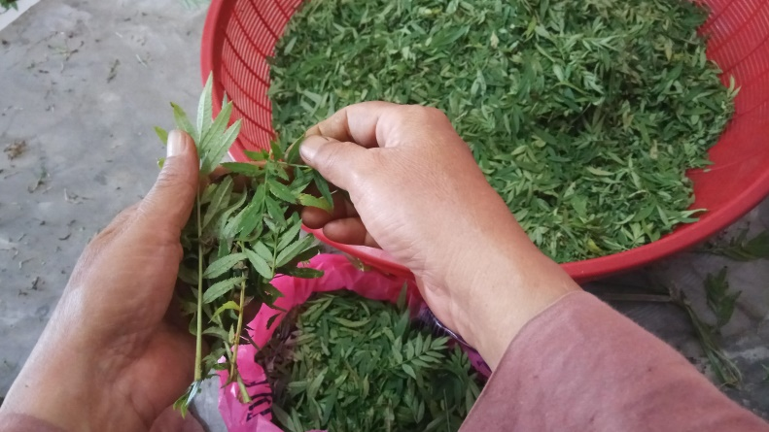Lampiran 2. Tumbuhan daun bunga tahi ayam dan pengolahannya

Daun bunga tahi ayam

Simplisia kering daun bunga tahi ayam

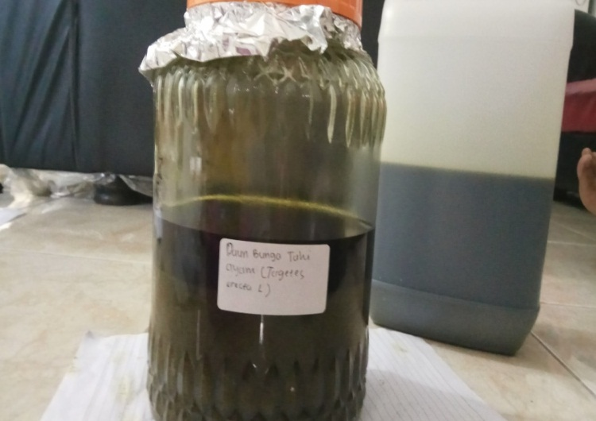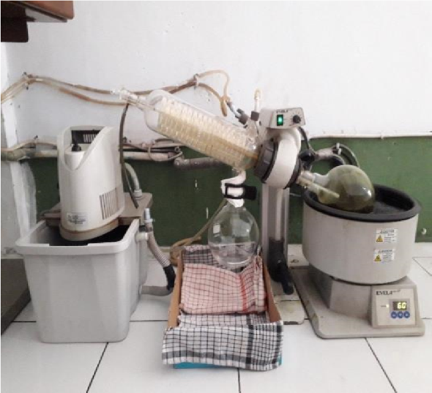

Alat *rotary evapotor*

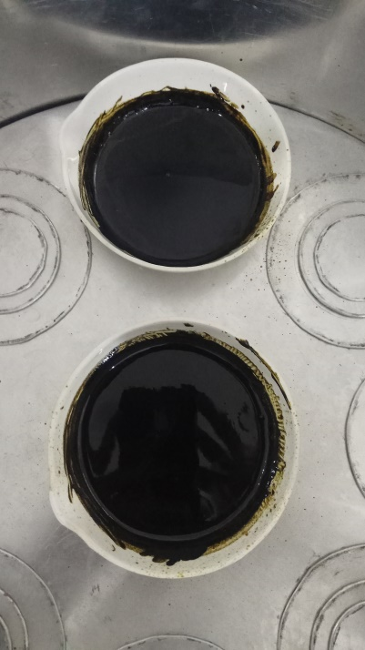

Maserasi daun bunga tahi ayam

Maserat (ekstrak) daun bunga tahi ayam

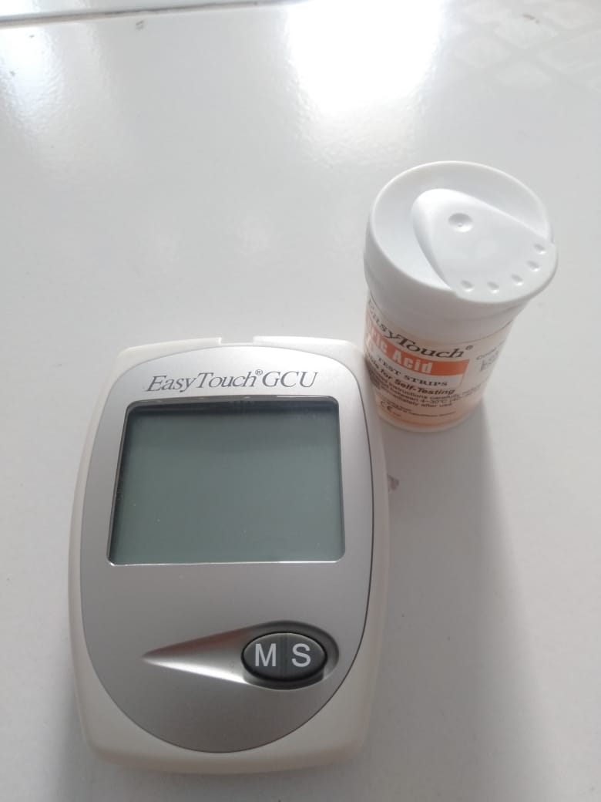Lampiran 3. Alat dan hewan untuk pengujian hiperusemia

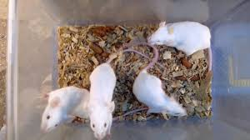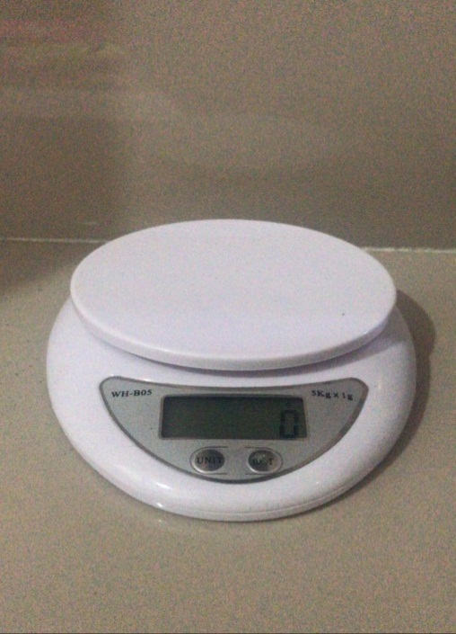

Tikus putih (*Rattus norvegicus* L) sebagai hewan percobaan

Timbangan hewan

*Easy touch GCU*

Lampiran 4. Proses pengujian kadar asam urat berbagai bahan uji pada tikus percobaan

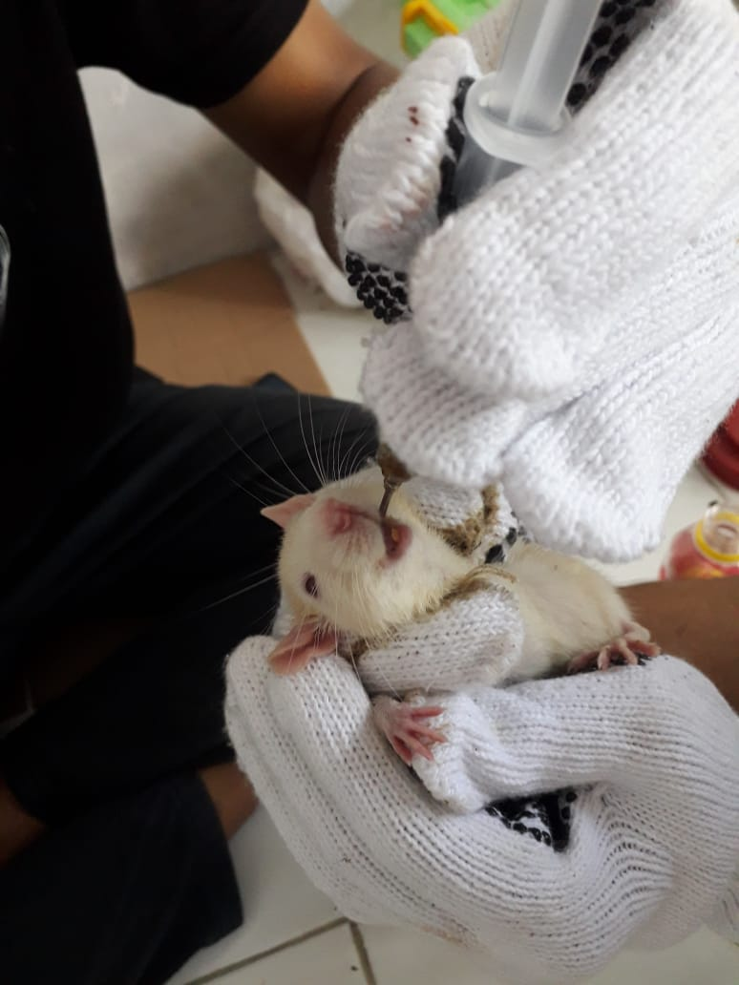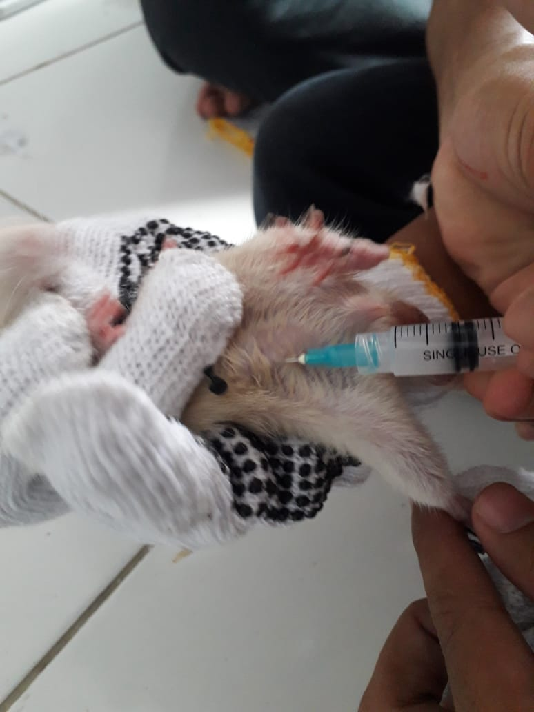

Pemberian penginduksi kalium oksonat

Pemberian EEDBTA secara oral

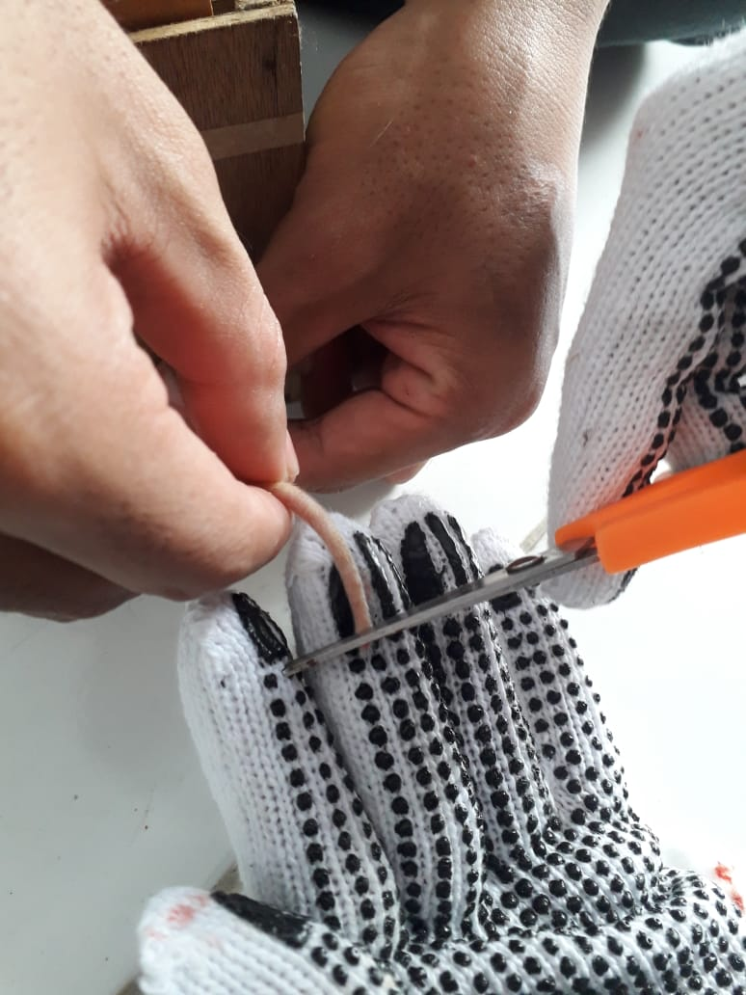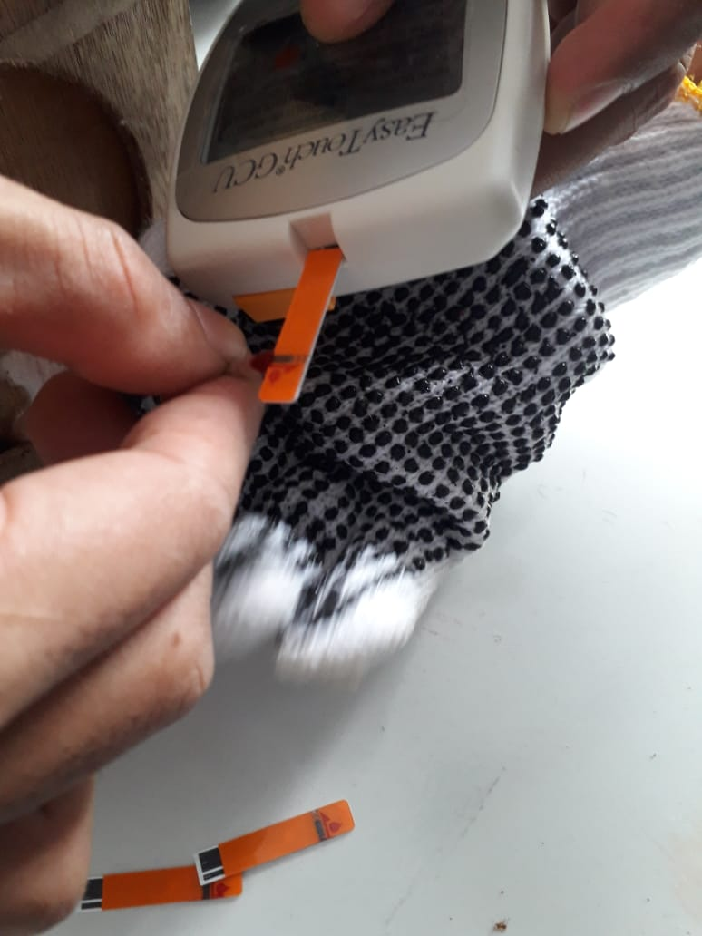

Pengambilan darah hewan uji

Pengecekan kadar asam urat

Lampiran 5. Bagan alir penelitian

Daun bunga tahi ayam 8,5 kg

Dibersihkan dari pengotoran

Dikeringkan dengan cara dikeringkan di lemari pengering suhu 40OC

Simplisia 5 kg

Diserbukkan

Serbuk Simplisia 2,3 kg

Pembuatan Ekstrak

Skrining Fitokimia

Pembuatan Ekstrak

Pemeriksaan Kadar Air

Skrining Fiokimia

Dimaserasi dengan 5000 mL

Etanol 96%

1. Alkaloid
2. Flavonoid Tanin
3. Saponin
4. Tanin
5. Steroid/Triterpenoid
6. Glikosida

7. Antrakuinon

Ekstrak Etanol Cair

Diuapkan dengan rotary evaporator

Ekstrak Kental

Persen penurunan kadar asam urat dari tikus percobaan yang telah diinduksi sebelum dan setelah penggunaan bahan uji berbagai waktu

Pengujian efektivitas Anti hiperurisemia

Lampiran 6. Bagan alir pengujian efektivitas penurunan kadar asam urat pada tikus percobaan

Tikus jantan

Dikondisikan selama 2 minggu

Dipuasakan selama 18 jam

Ditimbang berat badan

Diukur kadar asam urat darah tikus menggunakan alat

*Easy touch*

Kadar asam urat darah puasa (mg/dl)

Diinduksi dengan kalium oksonat

Diukur kadar asam urat

Tikus hiperurisemia

Diberikan perlakuan secara oral setiap kelompok:

K1: Diberikan CMC (Blanko) 0,5%

K2: Diberikan allopurinol 10 mg/kgBB

K3: Diberikan EEDBTA 100 mg/kgBB

K4: Diberikan EEDBTA 200 mg/kgBB

K5: Diberikan EEDBTA 300 mg/kgBB

Diukur kadar asam urat darah

Persen penurunan kadar asam urat darah tikus setelah pemberian bahan uji berbagai dosis, dan diukur asam urat selang waktu 1 jam selama 6 jam

Kadar asam urat darah tikus

Lampiran 7. Tabel volume maksimum larutan sediaan uji yang dapat diberikan hewan uji (Ritscel, 1974)

|  |  |  |  |  |  |
| --- | --- | --- | --- | --- | --- |
| Jenis Hewan uji dan Berat Badan (BB) | Volume maksimal (ml) sesuai jalur pemberian | | | | |
| i.v. | i.m. | i.p. | s.c. | p.o. |
| Mencit (20-30 g) | 0,5 | 0,05 | 1,0 | 0,5-1,0 | 1,0 |
| Tikus (200 g) | 1,0 | 0,1 | 2-5 | 2-5 | 5,0 |
| Hamster (50 g) | - | 0,1 | 1-2 | 2,5 | 2,5 |
| Marmot (250 g) | - | 0,25 | 2-5 | 5,0 | 10,5 |
| Kelinci (2,5 kg) | 5-10 | 0,5 | 10-20 | 5-10 | 20,0 |
| Kucing (3 kg) | 5-10 | 1,0 | 10-20 | 5-10 | 50,0 |
| Anjing (5 kg) | 10-20 | 5,0 | 20-50 | 10,0 | 100,0 |

Keterangan :

i.v = intra vena

i.m = intra muscular

i.p = intra peritoneal

s.c = subcutan

p.o = per oral

Lampiran 8. Tabel konversi perhitungan dosis (Laurence & Bacharach, 1964)

|  |  |  |  |  |  |  |  |  |
| --- | --- | --- | --- | --- | --- | --- | --- | --- |
|  | Mencit 20 g | Tikus 200 g | Marmot 400 g | Kelinci 1,5 kg | Kucing2 kg | Kera 4 kg | Anjing 12 kg | Manusia  70 kg |
| Mencit 20 g | 1.0 | 7.0 | 12.25 | 27.8 | 29.7 | 64.1 | 124.2 | 387.9 |
| Tikus 200 g | 0.14 | 1.0 | 1.74 | 3.9 | 4.2 | 9.2 | 17.8 | 56.0 |
| Marmot 400 g | 0.08 | 0.57 | 1.0 | 2.25 | 2.4 | 5.2 | 10.2 | 31.5 |
| Kelinci 1,5 kg | 0.04 | 0.25 | 0.44 | 1.0 | 1.08 | 2.4 | 4.5 | 14.2 |
| Kucing  2 kg | 0.03 | 0.23 | 0.41 | 0.92 | 1.0 | 2.2 | 4.1 | 13.0 |
| Kera  4 kg | 0.016 | 0.11 | 0.19 | 0.42 | 0.45 | 1.0 | 1.9 | 6.1 |
| Anjing 12 kg | 0.008 | 0.06 | 0.1 | 0.22 | 0.24 | 0.52 | 1.0 | 3.1 |
| Manusia 70 kg | 0.0026 | 0.018 | 0.031 | 0.07 | 0.076 | 0.16 | 0.32 | 1.0 |

Contoh perhitungan :

Berdasarkan konversi perhitungan di atas, maka konversi dosis tikus putih terhadap manusia dapat dilakukan sebagai berikut :

Perhitungan dosis dan volume pemberian bahan pada hewan

1. Perhitungan pemberian allopurinol

Nilai konversi dosis dari manusia ke tikus = 0,018

Dosis allopurinol untuk manusia = 100 mg

Konversi dosis allopurinol dari manusia ke tikus dengan bobot 200 g :

= 0,018 x 100 mg = 1,8 mg

Dibuat suspensi allopurinol dengan konsentrasi 0,1%

Allopurinol yang akan diberikan dalam bentuk suspensi dengan konsentrasi 0,1%,

= 0,1gram/100mL = 100mg/100mL = 1mg/mL

**Lampiran 8.** (Lanjutan)

Dosis allopurinol untuk tikus (BB 200g) berdasarkan hasil perhitungan konversi dari manusia ke tikus =1,8 mg

Allopurinol yang akan diberikan dalam bentuk suspensi dengan konsentrasi 0,1%,

= 0,1gram/100mL = 100mg/100mL = 1mg/mL

Maka volume Allopurinol yang diberikan untuk tikus dengan bobot 200 g

= $\frac{dosis untuk tikus}{konsentrasi allopurinol}$ = $\frac{1,8 mg}{1mg}$ x 1 ml = 1,8 mL

2. Perhitungan volume pemberian larutan kalium oksonat

Dicari konsentrasi permiligram

Persentase = Massa(g)/Volume (mL)

Dibuat larutan kalium oksonat 2,5 % = 2,5 g/100 mL = 25mg/mL

Dosis kalium oksonat yang akan diberikan = 250mg/kgBB

BB tikus putih = 200 g

Dosis tikus $=\frac{200 mg}{1000 mg}$ x 250 g = 50 mg

Volume larutan yang diberikan = $\frac{50 mg}{25mg}$ x 1 ml = 2 mL

3. Perhitungan volume pemberian suspensi ekstrak etanol daun bunga tahi ayam (EEDBTA)

EEDBTA diberikan dosis 100mg/kgBB, 200mg/kgBB dan 300mg/kgBB

Dibuat suspensi EEDBTA 2,0 % = 2,0 g/100 mL = 20mg/mL

1. Dosis EEDBTA 100 mg/kgBB

BB tikus : 200 g

= $\frac{200 g}{1000 g}$ x 100 mg = 20 mg

Volume larutan suspensi EEDBTA diberikan = $\frac{20 mg}{20 mg}$ x 1 ml = 1 mL

1. Dosis EEDBTA 200 mg/kgBB

**Lampiran 8.** (Lanjutan)

BB tikus : 200 g

= $\frac{200 g}{1000 g}$ x 200 mg = 40 mg

Volume larutan suspensi EEDBTA diberikan = $\frac{40 mg}{20mg}$ x 1 ml = 2 mL

1. Dosis EEDBTA 300 mg/kgBB

BB tikus : 200 g

= $\frac{200 g}{1000 g}$ x 300 mg = 60 mg

Volume larutan suspensi EEDBTA diberikan = $\frac{60 mg}{20mg}$ x 1 ml = 3 mL

4. Suspensi CMC 0,5 %

0,5 % = 0,5 g/100mL = 500 mg/100 mL = 5 mg/mL

BB tikus : 200 g

= $\frac{200 mg}{1000 g}$ x 500 g = 10 mg

= $\frac{10 mg}{5 mg}$ x 1 mL = 2 mL

Lampiran 9. Perhitungan hasil pemeriksaan penetapan kadar air

Kadar Air =

1. Pengulangan 1

Volume Akhir Air = 1,5mL

Volume Awal Air = 1,3 mL

Berat Simplia = 5,000 g

Kadar Air = $\frac{1,5 ml - 1,3 ml}{5,000 g }$ x 100% = 4,00%

1. Pengulangan 2

Volume Akhir Air = 1,5 mL

Volume Awal Air = 1,2 mL

Berat Simplia = 5,000 g

Kadar Air = $\frac{1,5 ml - 1.2ml}{5,000 g }$ x 100%= 6,00%

3. Pengulangan 3

Volume Akhir Air = 1,7 mL

Volume Awal Air = 1,5 mL

Berat Simplisia = 5,002 g

Kadar Air = $\frac{1,7 ml - 1.5ml}{5,003 g }$ x 100%= 3,99%

Maka, kadar air rata-rata = $\frac{4,00\%+6.00\%+3,99\%}{3}$ = 4,66%

Lampiran 10. Contoh perhitungan statistik persentase penurunan kadar asam urat pada tikus

Diambil sebagai contoh perhitungan dari data setelah penggunaan Ekstrak etanol daun bunga tahi ayam dosis 100 mg/KgBB pada jam pertama

|  |  |  |  |
| --- | --- | --- | --- |
| **No.** | Presentase penurunan asam urat (%) (X) | **X -** |  |
| 1. | 2,53 | -0,6004 | 0,3604 |
| 2. | 3,21 | 0,0731 | 0,0053 |
| 3. | 2,98 | -0,1558 | 0,0243 |
| 4. | 3,16 | 0,0325 | 0,0011 |
| 5. | 3,75 | 0,6180 | 0,3819 |
| 6. | 3,16 | 0,0325 | 0,0011 |
| **N = 6** | **∑ X =** 18,79 %  **=** 3,13 % | |  |

Standar deviasi (SD) = $\sqrt{\frac{{\sum{(X-\overline{X}})}^{2}}{n-1}}$ = $\frac{0,7741}{5}$ = 0,39

Dasar penolakan data adalah apabila thitung > ttabel dengan tingkat kepercayaan 99%

α = 0,01; n = 6, dk = 5 dan ttabel = 4,032

1. thitung = = = = 3,74
2. thitung = = = = 0,46
3. thitung = = = = 0,97
4. thitung = = = = 0,20
5. thitung = = = = 3,85
6. thitung = = = = 0,20

Seluruh thitung dari ke-6 perlakuan < ttabel, berarti semua data ini bisa diterima.

**Lampiran 10. (**Lanjutan)

**Menghitung hasil sebenarnya =**

Penurunan kadar asam urat rata-rata ± t (1 – ½ α).dk x 

Penurunan kadar asam urat rata-rata () = 3,13 %

Standar deviasi (SD) = 0,39

Penurunan kadar asam urat rata-rata =  ± t (1 – 1/ 2 α) x 4,032 x $\frac{SD}{\sqrt{6}}$

Penurunan kadar asam urat sebenarnya = 3,13 % ± 4,032 x $\frac{0,39}{2,449}$

Penurunan kadar asam urat sebenarnya = (3,13 ± 0,69) %.

Dengan cara yang sama dihitung untuk Perlakuan pada berbagai waktu dan untuk bahan uji lainnya, data selengkapnya dapat dilihat pada lampiran

**Lampiran 11**. Data persen penurunan kadar asam urat hewan percobaan pada bahan uji

Lampiran 11. (Lanjutan)



Lampiran 12. Hasil tes uji homogenitas

|  |  |  |  |  |
| --- | --- | --- | --- | --- |
| **Test of Homogeneity of Variances** | | | | |
|  | **Levene Statistic** | **df1** | **df2** | **Sig.** |
| **J1** | **4,404** | **4** | **25** | **,008** |
| **J2** | **1,189** | **4** | **25** | **,340** |
| **J3** | **4,789** | **4** | **25** | **,005** |
| **J4** | **1,719** | **4** | **25** | **,177** |
| **J5** | **1,377** | **4** | **25** | **,270** |
| **J6** | **,193** | **4** | **25** | **,940** |

Lampiran 13. Hasil uji Anova

|  |  |  |  |  |  |  |
| --- | --- | --- | --- | --- | --- | --- |
| **ANOVA** | | | | | | |
|  | | **Sum of Squares** | **df** | **Mean Square** | **F** | **Sig.** |
| **J1** | **Between Groups** | **202,966** | **4** | **50,742** | **503,741** | **,000** |
| **Within Groups** | **2,518** | **25** | **,101** |  |  |
| **Total** | **205,484** | **29** |  |  |  |
| **J2** | **Between Groups** | **1192,970** | **4** | **298,242** | **1667,606** | **,000** |
| **Within Groups** | **4,471** | **25** | **,179** |  |  |
| **Total** | **1197,441** | **29** |  |  |  |
| **J3** | **Between Groups** | **2798,829** | **4** | **699,707** | **246,500** | **,000** |
| **Within Groups** | **70,964** | **25** | **2,839** |  |  |
| **Total** | **2869,793** | **29** |  |  |  |
| **J4** | **Between Groups** | **4103,342** | **4** | **1025,836** | **6788,308** | **,000** |
| **Within Groups** | **3,778** | **25** | **,151** |  |  |
| **Total** | **4107,120** | **29** |  |  |  |
| **J5** | **Between Groups** | **6045,450** | **4** | **1511,363** | **8900,735** | **,000** |
| **Within Groups** | **4,245** | **25** | **,170** |  |  |
| **Total** | **6049,695** | **29** |  |  |  |
| **J6** | **Between Groups** | **8433,730** | **4** | **2108,432** | **9215,848** | **,000** |
| **Within Groups** | **5,720** | **25** | **,229** |  |  |
| **Total** | **8439,449** | **29** |  |  |  |

Lampiran 14. Hasil uji Tukey HSD

|  |  |  |  |  |  |
| --- | --- | --- | --- | --- | --- |
| **J1** | | | | | |
| **Tukey HSDa** | | | | | |
| **Perlakuan** | **N** | **Subset for alpha = 0.05** | | | |
| **1** | **2** | **3** | **4** |
| **CMC 0,5% (blanko)** | **6** | **3,1317** |  |  |  |
| **EEDBTA 100 mg/kgBB** | **6** | **3,2567** |  |  |  |
| **EEDBTA 200 mg/kgBB** | **6** |  | **4,6967** |  |  |
| **EEDBTA 300 mg/kgBB** | **6** |  |  | **7,7400** |  |
| **Allopurinol 10 mg/kgBB** | **6** |  |  |  | **9,7117** |
| **Sig.** |  | **,959** | **1,000** | **1,000** | **1,000** |
| **Means for groups in homogeneous subsets are displayed.** | | | | | |
| **a. Uses Harmonic Mean Sample Size = 6,000.** | | | | | |

|  |  |  |  |  |  |
| --- | --- | --- | --- | --- | --- |
| **J2** | | | | | |
| **Tukey HSDa** | | | | | |
| **Perlakuan** | **N** | **Subset for alpha = 0.05** | | | |
| **1** | **2** | **3** | **4** |
| **CMC 0,5% (blanko)** | **6** | **4,8033** |  |  |  |
| **EEDBTA 100 mg/kgBB** | **6** | **4,9017** |  |  |  |
| **EEDBTA 200 mg/kgBB** | **6** |  | **10,9150** |  |  |
| **EEDBTA 300 mg/kgBB** | **6** |  |  | **17,0400** |  |
| **Allopurinol 10 mg/kgBB** | **6** |  |  |  | **20,4150** |
| **Sig.** |  | **,994** | **1,000** | **1,000** | **1,000** |
| **Means for groups in homogeneous subsets are displayed.** | | | | | |
| **a. Uses Harmonic Mean Sample Size = 6,000.** | | | | | |

|  |  |  |  |  |  |  |
| --- | --- | --- | --- | --- | --- | --- |
| **J3** | | | | | | |
| **Tukey HSDa** | | | | | | |
| **Perlakuan** | **N** | **Subset for alpha = 0.05** | | | | |
| **1** | **2** | **3** | **4** | **5** |
| **CMC 0,5% (blanko)** | **6** | **6,2650** |  |  |  |  |
| **EEDBTA 100 mg/kgBB** | **6** |  | **9,8150** |  |  |  |
| **EEDBTA 200 mg/kgBB** | **6** |  |  | **17,9967** |  |  |
| **EEDBTA 300 mg/kgBB** | **6** |  |  |  | **26,4350** |  |
| **Allopurinol 10 mg/kgBB** | **6** |  |  |  |  | **31,8467** |
| **Sig.** |  | **1,000** | **1,000** | **1,000** | **1,000** | **1,000** |
| **Means for groups in homogeneous subsets are displayed.** | | | | | | |
| **a. Uses Harmonic Mean Sample Size = 6,000.** | | | | | | |

|  |  |  |  |  |  |  |
| --- | --- | --- | --- | --- | --- | --- |
| **Lampiran 14.** (Lanjutan)  **J4** | | | | | | |
| **Tukey HSDa** | | | | | | |
| **Perlakuan** | **N** | **Subset for alpha = 0.05** | | | | |
| **1** | **2** | **3** | **4** | **5** |
| **CMC 0,5% (blanko)** | **6** | **7,9267** |  |  |  |  |
| **EEDBTA 100 mg/kgBB** | **6** |  | **15,1333** |  |  |  |
| **EEDBTA 200 mg/kgBB** | **6** |  |  | **23,0400** |  |  |
| **EEDBTA 300 mg/kgBB** | **6** |  |  |  | **35,7383** |  |
| **Allopurinol 10 mg/kgBB** | **6** |  |  |  |  | **38,4300** |
| **Sig.** |  | **1,000** | **1,000** | **1,000** | **1,000** | **1,000** |
| **Means for groups in homogeneous subsets are displayed.** | | | | | | |
| **a. Uses Harmonic Mean Sample Size = 6,000.** | | | | | | |

|  |  |  |  |  |  |  |
| --- | --- | --- | --- | --- | --- | --- |
| **J5** | | | | | | |
| **Tukey HSDa** | | | | | | |
| **Perlakuan** | **N** | **Subset for alpha = 0.05** | | | | |
| **1** | **2** | **3** | **4** | **5** |
| **CMC 0,5% (blanko)** | **6** | **9,8167** |  |  |  |  |
| **EEDBTA 100 mg/kgBB** | **6** |  | **20,7800** |  |  |  |
| **EEDBTA 200 mg/kgBB** | **6** |  |  | **30,7783** |  |  |
| **EEDBTA 300 mg/kgBB** | **6** |  |  |  | **44,5317** |  |
| **Allopurinol 10 mg/kgBB** | **6** |  |  |  |  | **47,4850** |
| **Sig.** |  | **1,000** | **1,000** | **1,000** | **1,000** | **1,000** |
| **Means for groups in homogeneous subsets are displayed.** | | | | | | |
| **a. Uses Harmonic Mean Sample Size = 6,000.** | | | | | | |

|  |  |  |  |  |  |
| --- | --- | --- | --- | --- | --- |
| **J6** | | | | | |
| **Tukey HSDa** | | | | | |
| **Perlakuan** | **N** | **Subset for alpha = 0.05** | | | |
| **1** | **2** | **3** | **4** |
| **CMC 0,5% (blanko)** | **6** | **11,8983** |  |  |  |
| **EEDBTA 100 mg/kgBB** | **6** |  | **24,4267** |  |  |
| **EEDBTA 200 mg/kgBB** | **6** |  |  | **38,9633** |  |
| **EEDBTA 300 mg/kgBB** | **6** |  |  |  | **54,4483** |
| **Allopurinol 10 mg/kgBB** | **6** |  |  |  | **54,5850** |
| **Sig.** |  | **1,000** | **1,000** | **1,000** | **,987** |
| **Means for groups in homogeneous subsets are displayed.** | | | | | |
| **a. Uses Harmonic Mean Sample Size = 6,000.** | | | | | |