Lampiran 1. Hasil Identifikasi Tumbuhan
    - Hasil Identifikasi Tumbuhan Bawang Merah (Allium cepa L.)
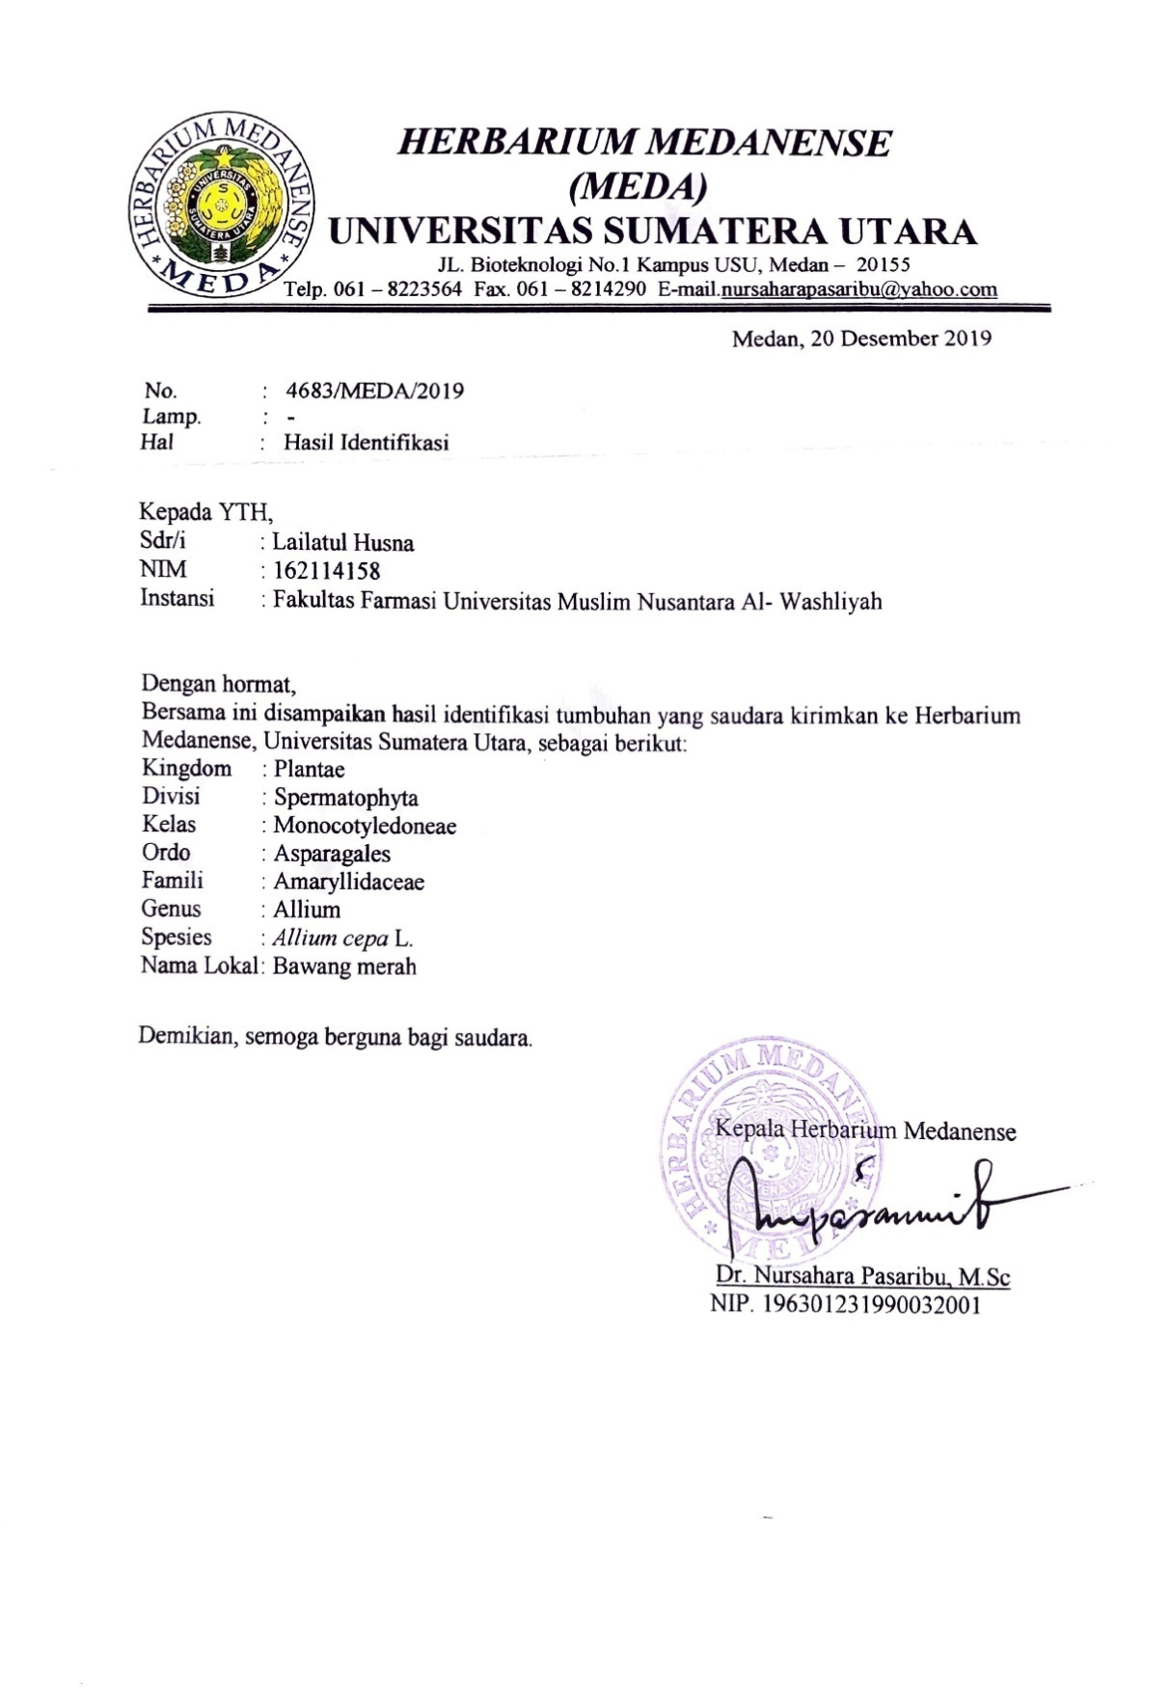

Lampiran 1. (lanjutan)
    - Hasil Identifikasi Tumbuhan Bawang Putih (Allium sativum L.)
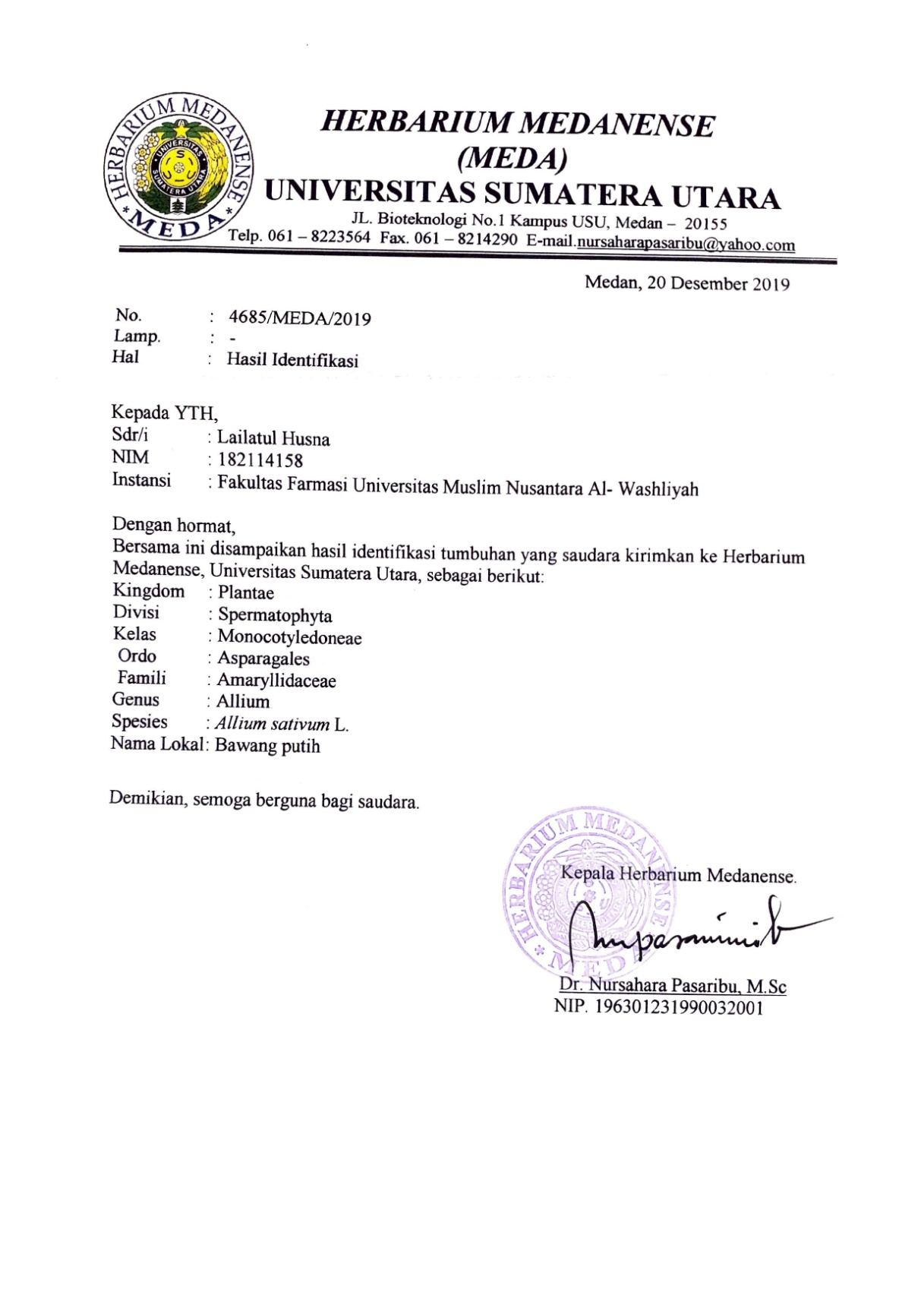

Lampiran 2. Bagan Alir Pembuatan Simplisia kulit bawang merah (Allium cepa L.) dan kulit bawang putih (Allium sativum L.)
Kulit bawang merah dan bawang putih

dibersihkan
dicuci dan ditiriskan
dikeringkan dalam lemari pengering
disortasi kering
Simplisia kulit bawang merah dan bawang putih

dihaluskan menggunakan blender
diayak
Serbuk simplisia kulit bawang merah dan bawang putih

Lampiran 3. Bagan Karakterisasi Simplisia kulit bawang merah (Allium cepa L.) dan kulit bawang putih (Allium sativum L.)

- Penetapan Kadar Air (Metode Azeotrop)
Toluen : Air
(100 : 1)
Dimasukkan dalam labu alas bulat
Dipasang dan didestilasi selama 2 jam
Didinginkan selama 30 menit, sampai Toluen dan air memisah
Dihitung Volume air dalam tabung penerima
Toluen : Air
(100 : 1)
Dimasukkan 2,5 gram serbuk simplisia dalam labu alas bulat berisi toluen yang telah jenuh
Dipanaskan selama 15 menit sampai toluene mendidik diatur kecepatan tetesan 2 tetes perdetik
Dibiarkan sampai semua air terdestilasi
Dibiarkan tabung penerima dingin sampai air dan toluen memisah sempurna
Dihitung volume air dalam tabung penerima
Volume air akhir

Lampiran 3. (lanjutan)
- Penetapan Kadar Sari larut dalam air
Serbuk Simplisia
Ditimbang 5 gram
Dimaserasi dengan 100 ml air dan 0,25 ml kloroform selama 24 jam sambil sesekali dikocok
Disaring
Filtrat
Diambil 20 ml diuapkan dalam cawan poselen yang telah ditara pada suhu 105ºC sampai bobot tetap
Ditimbang
Berat Sari

- Penetapan Kadar Sari larut dalam etanol
Serbuk Simplisia
Ditimbang 5 gram
Dimaserasi dengan 100 ml etanol selama 24 jam sambil sesekali dikocok
Disaring
Filtrat
Diambil 20 ml diuapkan dalam cawan poselen yang telah ditara pada suhu 105ºC sampai bobot tetap
Ditimbang
Berat Sari

Lampiran 3. (lanjutan)
- Penetapan Kadar Abu Total

Serbuk Simplisia
Ditimbang 2 gram
Dimasukkan dalam kurs porselen dalam tanur dipijar dan ditara
Dimasukkan kurs porselen dalam tanur dipijar pada suhu 600ºC selama 3 jam
Dikeluarkan didinginkan
Ditimbang
Berat Abu

- Penetapan Kadar Abu Tidak Larut Asam
Abu
Dimasukkan dalam cawan
Ditambah 25 ml HCL encer
Didihkan selama 15 menit
Disaring dengan kertas saring bebas abu
Dipijar dalam tanur
Berat Abu Tidak Larut Asam
Didinginkan dan ditimbang

Lampiran 4. Bagan Pembuatan Ekstrak Etanol kulit bawang merah (Allium cepa L.) dan kulit bawang putih (Allium sativum L.)
Serbuk Simplisia
Ditimbang 500 gram
Dimasukkan dalam bejana
Ditambahkan 75 bagian etanol 96% (3750 ml) diamkan selama 5 hari
Diaduk sesekali dan disaring
Ampas I
Maserat I
Ditambahkan 25 bagian etanol 96% (1250 ml) didiamkan selama 2 hari
Diaduk sesekali dan disaring
Maserat I
Ampas II
Dibuang
Maserat I dan II
dicampur
Dipekatkan dengan rotary evapator
Ekstrak Kental

Lampiran 5. Bagan Pembuatan Gel Tabir Surya
Kerbopol 940 dikembangkan ke dalam aquadest
(20 x berat karbopol)

ditambahkan TEA sedikit demi sedikit
ditambahkan propilen glikol, metil paraben, dan propil paraben
digerus homogen
Basis Gel

ditambah ekstrak etanol kulit bawang merah dan kulit bawang putih
ditambahkan sisa aquadest sedikit demi sedikit sambil digerus
digerus sampai terbentuk gel yang homogen
Gel tabir surya

Lampiran 6. Bagan Uji Stabilitas (Cycling test) Sedaan Gel Tabir Surya

Gel Tabir Surya

Disimpan dalam suhu kulkas 4°C selama 24 jam

satu siklus
Disimpan dalam suhu ruangan 40°C selama 24 jam

Homogenitass
pH
Organoleptis
Viskositas
Daya Sebar
Daya Lekat

Dilakukan sebanyak
tiga siklus

Lampiran 7. Bagan Penentuan Nilai SPF Gel Tabir Surya

Gel Tabir Surya

ditimbang 0,02 gram
ditambahkan 5 ml etanol p.a
diaduk homogen
Larutan Gel tabir surya

diambil 1 ml
dimasukkan kedalam kuvet
diukur serapan dengan spektrofotometer UV-Vis pada panjang gelombang 290-320 dengan interval 5 nm
Absrobansi

dihitung menggunakan rumus Mansur
Nilai SPF

Lampiran 8. Perhitungan Hasil Penetapan Kadar Air
$$Kadar air=\frac{Volume akhir air-Volume awal air}{Berat sample mula-mula (g)}x100\%$$

- Kadar air kulit bawang merah

Pegulangan 1.
Volume awal air (V₀) = 0,1 ml
Volime akhir air (V₁) = 0,3 ml
Berat sampel = 2,5 gram

Kadar air = $\frac{V1-V0}{Berat sampel}x 100\%$
= $\frac{0,3 ml – 0,1 ml}{2,5 gram}x 100\%$
= 8%

Pengulangan 2.
Volume awal air (V₀) = 0,4 ml
Volime akhir air (V₁) = 0,6 ml
Berat sampel = 2,5 gram

Kadar air = $\frac{V1-V0}{Berat sampel}x 100\%$
= $\frac{0,4 ml – 0,6 ml}{2,5 gram}x 100\%$
= 8%

Rata-rata kadar air = $\frac{8\% + 8\%}{2}$
= 8%

Lampiran 8. (lanjutan)
- Kadar air kulit bawang putih

Pegulangan 1.
Volume awal air (V₀) = 0,15 ml
Volime akhir air (V₁) = 0,3 ml
Berat sampel = 2,5 gram

Kadar air = $\frac{V1-V0}{Berat sampel}x 100\%$
= $\frac{0,3 ml – 0,15 ml}{2,5 gram}x 100\%$
= 6%

Pengulangan 2.
Volume awal air (V₀) = 0,15 ml
Volime akhir air (V₁) = 0,35 ml
Berat sampel = 2,5 gram

Kadar air = $\frac{V1-V0}{Berat sampel}x 100\%$
= $\frac{0,35 ml – 0,15 ml}{2,5 gram}x 100\%$
= 8%

Rata-rata kadar air = $\frac{6\% + 8\%}{2}$
= 7%

Lampiran 9. Perhitungan Hasil Penetapan Kadar Sari Larut Air

$$Kadar sari larut air=\frac{Berat sari setelah dikeringkan \left(g\right) x 5 }{Berat sample mula-mula (g)}x100\%$$

- Penenetapan Kadar Sari Larut Air Kulit Bawang Merah

Pengulangan 1.
Berat cawan kosong = 32,3251 gram
Berat cawan + sari = 32,3735 gram
Berat sari kering = (Berat cawan + sari) – (Berar cawan kosong)
= 32,3735 gram - 32,3251 gram
= 0,0484 gram

Kadar sari larut air = $\frac{0,0484 gram x 5}{5 gram}x 100\%$
= 4,84 %

Pengulangan 2.
Berat cawan kosong = 26, 9688 gram
Berat cawan + sari = 27, 0066 gram
Berat sari kering = (Berat cawan + sari) – (Berar cawan kosong)
= 27, 0066 gram - 26, 9688 gram
= 0,0378 gram

Kadar sari larut air = $\frac{0,0378 gram x 5}{5 gram}x 100\%$
= 3,78 %

Rata-rata kadar sari larut air = $\frac{4,84 \% +3,78\%}{2}$
= 4,31%
Lampiran 9. (lanjutan)
- Penenetapan Kadar Sari Larut Air Kulit Bawang Putih

Pengulangan 1.
Berat cawan kosong = 58,8530 gram
Berat cawan + sari = 58,9439 gram
Berat sari kering = (Berat cawan + sari) – (Berar cawan kosong)
= 58,9439 gram - 58,8530 gram
= 0,0909 gram

Kadar sari larut air = $\frac{0,0909 gram x 5}{5 gram}x 100\%$
= 9,09 %

Pengulangan 2.
Berat cawan kosong = 55,7421 gram
Berat cawan + sari = 55,8402 gram
Berat sari kering = (Berat cawan + sari) – (Berar cawan kosong)
= 55,8402 gram - 55,7421 gram
= 0,0981 gram

Kadar sari larut air = $\frac{0,0981 gram x 5}{5 gram}x 100\%$
= 9,81 %

Rata-rata kadar sari larut air = $\frac{9,09 \% +9,81\%}{2}$
= 9,45%

Lampiran 10. Perhitungan Hasil Penetapan Kadar Sari Larut Etanol

$$Kadar sari larut etanol=\frac{Berat sari setelah dikeringkan \left(g\right) x 5 }{Berat sample mula-mula (g)}x100\%$$

- Penenetapan Kadar Sari Larut Etanol Kulit Bawang Merah

Pengulangan 1.
Berat cawan kosong = 32,3251 gram
Berat cawan + sari = 32,3268 gram
Berat sari kering = (Berat cawan + sari) – (Berar cawan kosong)
= 32, 3268 gram - 32,3251 gram
= 0,0431 gram

Kadar sari larut etanol = $\frac{0,0431 gram x 5}{5 gram}x 100\%$
= 4,31 %
Pengulangan 2.
Berat cawan kosong = 26, 9688 gram
Berat cawan + sari = 27, 0261 gram
Berat sari kering = (Berat cawan + sari) – (Berar cawan kosong)
= 27, 0261 gram - 26, 9688 gram
= 0,0573 gram

Kadar sari larut etanol = $\frac{0,0573 gram x 5}{5 gram}x 100\%$
= 5,73 %

Rata-rata kadar sari larut etanol = $\frac{4,31 \% +5,73\%}{2}$
= 5,02%
Lampiran 10. (lanjutan)

- Penenetapan Kadar Sari Larut Etanol Kulit Bawang Putih

Pengulangan 1.
Berat cawan kosong = 58,8530 gram
Berat cawan + sari = 58,8810 gram
Berat sari kering = (Berat cawan + sari) – (Berar cawan kosong)
= 58, 901 gram - 58,8530 gram
= 0,048 gram

Kadar sari larut etanol = $\frac{0,028 gram x 5}{5 gram}x 100\%$
= 4,8 %

Pengulangan 2.
Berat cawan kosong = 26, 9688 gram
Berat cawan + sari = 26,9960 gram
Berat sari kering = (Berat cawan + sari) – (Berar cawan kosong)
= 27,016gram - 26, 9688 gram
= 0,0472 gram

Kadar sari larut etanol = $\frac{0,0272 gram x 5}{5 gram}x 100\%$
= 4,72 %

Rata-rata kadar sari larut etanol = $\frac{4,8 \% +4,72\%}{2}$
= 4,76%

Lampiran 11. Perhitungan Hasil Penetapan Kadar Abu Total

$$Kadar Abu Total=\frac{Berat abu yang diperoleh \left(g\right) }{Berat sample mula-mula (g)}x100\%$$

- Penenetapan Kadar Abu Total Kulit Bawang Merah

Pengulangan 1.
Berat krus kosong = 59,53 gram
Berat krus + abu = 59,69 gram
Berat abu = (Berat krus + abu) – (Berat krus kosong)
= 59,69 gram - 59,53 gram
= 0,161 gram

Kadar Abu total = $\frac{0,16 gram }{3 gram}x 100\%$
= 5,3 %

Pengulangan 2.
Berat krus kosong = 64,13 gram
Berat krus + abu = 63,26 gram
Berat abu = (Berat krus + abu) – (Berat krus kosong)
= 63,26 gram - 64,13 gram
= 0,15 gram

Kadar Abu total = $\frac{0,15 gram }{3 gram}x 100\%$
= 5 %

Rata-rata kadar Abu total = $\frac{5,3 \% +5\%}{2}$
= 5,15%
Lampiran 11. (lanjutan)

- Penenetapan Kadar Abu Total Kulit Bawang Putih

Pengulangan 1.
Berat krus kosong = 52,82 gram
Berat krus + abu = 52,95 gram
Berat abu = (Berat krus + abu) – (Berat krus kosong)
= 52,95 gram - 52,82 gram
= 0,13 gram

Kadar Abu total = $\frac{0,13 gram }{3 gram}x 100\%$
= 4,3 %

Pengulangan 2.
Berat krus kosong = 52,79 gram
Berat krus + abu = 52,91 gram
Berat abu = (Berat krus + abu) – (Berat krus kosong)
= 52,91 gram - 52,79 gram
= 0,12 gram

Kadar Abu total = $\frac{0,12 gram }{3 gram}x 100\%$
= 4 %

Rata-rata kadar Abu total = $\frac{4,3 \% +4\%}{2}$
= 4,15%

Lampiran 12. Perhitungan Hasil Penetapan Kadar Abu Tidak Larut Asam
$$Kadar Abu Total=\frac{Berat abu sisa dipijar \left(g\right) }{Berat sample abu mula-mula (g)}x100\%$$

- Penenetapan Kadar Abu Total Kulit Bawang Merah

Pengulangan 1.
Berat abu mula-mula = 0,16
Berat krus kosong = 59,5350 gram
Berat krus + abu tidak larut asam = 59,5361 gram
Berat abu = (Berat krus + abu tidak larut asam) – (Berat krus kosong)
= 59,5361 gram - 59,5350 gram
= 0,0011 gram

Kadar Abu tidak larut asam = $\frac{0,0011 gram }{0,16 gram}x 100\%$
= 0,6875 %

Pengulangan 2.
Berat abu mula-mula = 0,15
Berat krus kosong = 63,1445 gram
Berat krus + abu tidak larut asam = 63,1459 gram
Berat abu = (Berat krus + abu tidak larut asam) – (Berat krus kosong)
= 63,1459 gram - 63,1445 gram
= 0,008 gram

Kadar Abu tidak larut asam = $\frac{0,008 gram }{0,15 gram}x 100\%$
= 0,5333 %
Rata-rata kadar Abu total = $\frac{0,6875 \% +0,5333\%}{2}$
= 0,6194%
Lampiran 12. (lanjutan)
- Penenetapan Kadar Abu Total Kulit Bawang Putih

Pengulangan 1.
Berat abu mula-mula = 0,13
Berat krus kosong = 52,8203 gram
Berat krus + abu tidak larut asam = 52,8211 gram
Berat abu = (Berat krus + abu tidak larut asam) – (Berat krus kosong)
= 52,8211 gram - 52,8203 gram
= 0,0008 gram

Kadar Abu tidak larut asam = $\frac{0,0008 gram }{0,13 gram}x 100\%$
= 0,6153 %

Pengulangan 2.
Berat abu mula-mula = 0,12
Berat krus kosong = 57,7911 gram
Berat krus + abu tidak larut asam = 57,7920 gram
Berat abu = (Berat krus + abu tidak larut asam) – (Berat krus kosong)
= 57,79 gram - 57,79 gram
= 0,0009 gram

Kadar Abu tidak larut asam = $\frac{0 gram }{0,12 gram}x 100\%$
= 0,75 %
Rata-rata kadar Abu total = $\frac{0,6153 \% +0,75\%}{2}$
= 0,6826%

Lampiran 13. Perhitungan Rendemen Ekstrak Kulit Bawang Merah (Allium cepa L.) dan kulit bawang putih (Allium sativum L.)

- Rendemen Ekstrak Kulit Kulit Bawang Merah (Allium cepa L.)

Berat simplisia kulit Bawang Merah = 1000 gram
Berat ekstrak kental kulit Bawang Merah = 84,62 gram

% Rendemen = $\frac{Berat Ekstrak Kental}{Berat Simplisia kering}$ x 100%
= $\frac{84,62 gram}{1000 gram }$ x 100%
= 8,462 %

- Rendemen Ekstrak Kulit Kulit Bawang Putih (Allium sativum L.)

Berat simplisia kulit Bawang Merah = 1000 gram
Berat ekstrak kental kulit Bawang Merah = 52,33 gram

% Rendemen = $\frac{Berat Ekstrak Kental}{Berat Simplisia kering}$ x 100%
= $\frac{52,33 gram}{1000 gram }$ x 100%
= 5,233 %

Lampiran 14. Perhitungan Nilai SPF Sediaan Blanko

Pengulangan 1

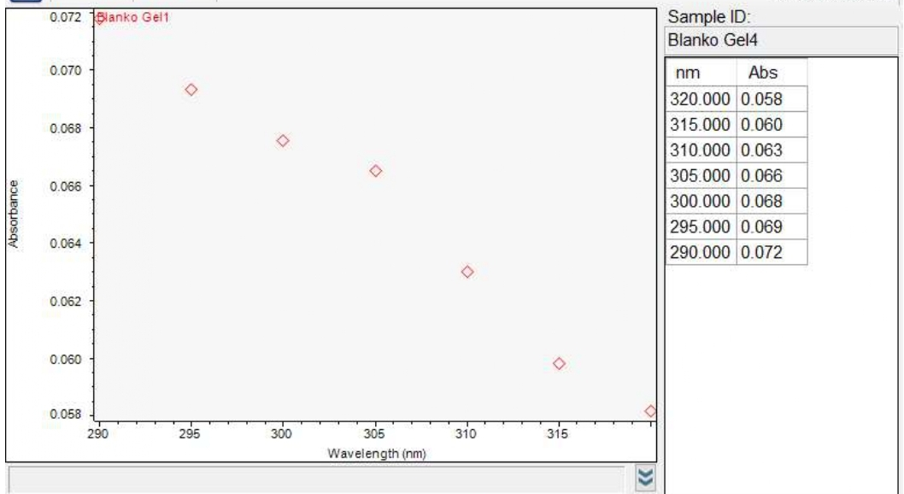

Panjang Gelombang  (nm) | Absorbansi | EE x I | Abs x EE x I
290 | 0.058 | 0,0150 | 0,0008
295 | 0,060 | 0,0817 | 0,0047
300 | 0,063 | 0,2874 | 0,0181
305 | 0,066 | 0,3278 | 0,0216
310 | 0,068 | 0,1864 | 0,0126
315 | 0,069 | 0,0839 | 0,0057
320 | 0,072 | 0,0180 | 0,0129
$\sum_{290}^{320}{Abs}$x EE x I |  |  | 0.0764

SPF = CF ×$\sum_{290}^{320}{Abs}$ x EE x I
= 10 x 0.0764
= 0,7646

Lampiran 14. (lanjutan)
Pengulangan 2

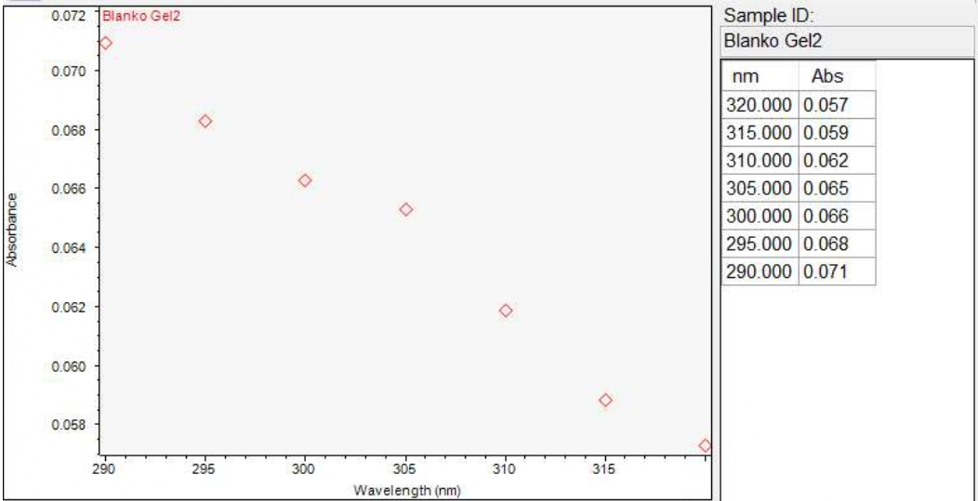

Panjang Gelombang  (nm) | Absorbansi | EE x I | Abs x EE x I
290 | 0,057 | 0,0150 | 0,0008
295 | 0,059 | 0,0817 | 0,0048
300 | 0,062 | 0,2874 | 0,0178
305 | 0,065 | 0,3278 | 0,0213
310 | 0,066 | 0,1864 | 0,0123
315 | 0,068 | 0,0839 | 0,0026
320 | 0,071 | 0,0180 | 0,0012
$\sum_{290}^{320}{Abs}$x EE x I |  |  | 0,0608

SPF = CF ×$\sum_{290}^{320}{Abs}$ x EE x I
= 10 x 0,0608
= 0,608

Lampiran 14. (lanjutan)
Pengulangan 3.

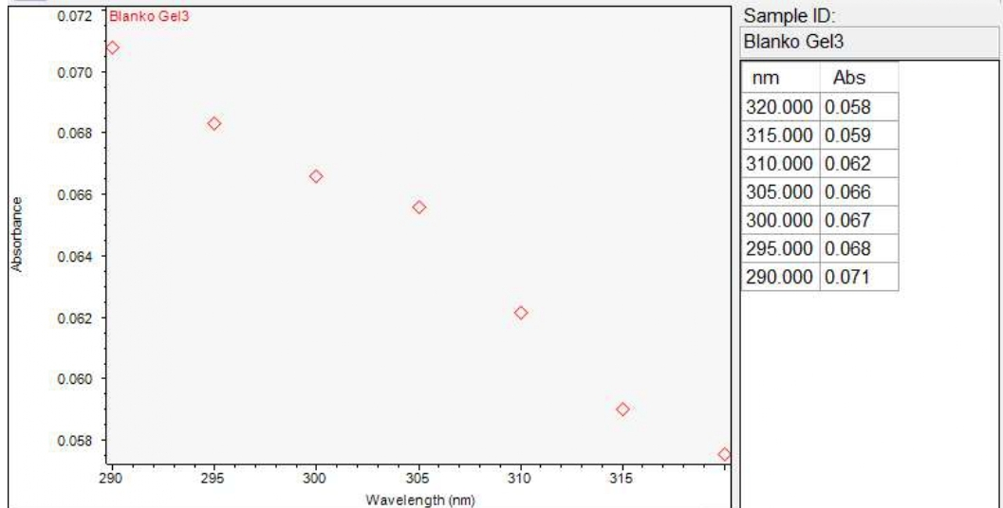

Panjang Gelombang  (nm) | Absorbansi | EE x I | Abs x EE x I
290 | 0,058 | 0,0150 | 0,0008
295 | 0,059 | 0,0817 | 0,0048
300 | 0,062 | 0,2874 | 0,0178
305 | 0,066 | 0,3278 | 0,0216
310 | 0,087 | 0,1864 | 0,0162
315 | 0,068 | 0,0839 | 0,0057
320 | 0,071 | 0,0180 | 0,0012
$\sum_{290}^{320}{Abs}$x EE x I |  |  | 0,0681

SPF = CF ×$\sum_{290}^{320}{Abs}$ x EE x I
= 10 x 0,0681
= 0,681
Rata-rata nilai SPF = $\frac{P1 + P2 + P3}{3}$
= 0,7646+ 0,608 + 0,681
= 0,6845
Lampiran 15. Perhitungan Nilai SPF Gel Tabir Surya Ekstrak Etanol Kulit Bawang Merah (Allium cepa L.)

Pengulangan 1

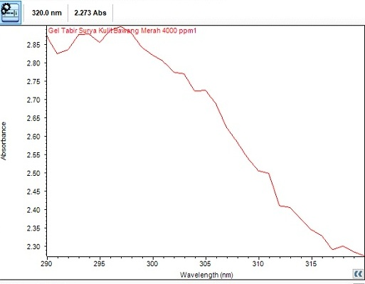

Panjang Gelombang  (nm) | Absorbansi | EE x I | Abs x EE x I
290 | 2.872 | 0,0150 | 0,0430
295 | 2.855 | 0,0817 | 0,2332
300 | 2.820 | 0,2874 | 0,8104
305 | 2.724 | 0,3278 | 0,8929
310 | 2.506 | 0,1864 | 0,4671
315 | 2.343 | 0,0839 | 0,1965
320 | 2.273 | 0,0180 | 0,0409
$\sum_{290}^{320}{Abs}$x EE x I |  |  | 2,6840

SPF = CF ×$\sum_{290}^{320}{Abs}$ x EE x I
= 10 x 2,6840
= 26, 684
Lampiran 15. (lanjutan)
Pengulangan 2

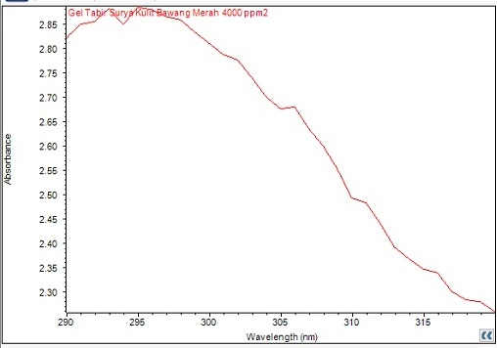

Panjang Gelombang  (nm) | Absorbansi | EE x I | Abs x EE x I
290 | 2.820 | 0,0150 | 0,0423
295 | 2.881 | 0,0817 | 0,2353
300 | 2.809 | 0,2874 | 0,8073
305 | 2.677 | 0,3278 | 0,8775
310 | 2.490 | 0,1864 | 0,4641
315 | 2.346 | 0,0839 | 0,1968
320 | 2.258 | 0,0180 | 0,0406
$\sum_{290}^{320}{Abs}$x EE x I |  |  | 2,6639

SPF = CF ×$\sum_{290}^{320}{Abs}$ x EE x I
= 10 x 2,6639
= 26, 639
Lampiran 15. (lanjutan)
Pengulangan 3.

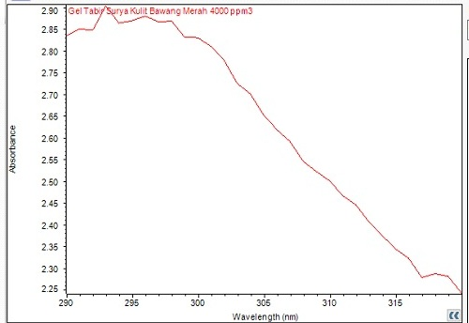

Panjang Gelombang  (nm) | Absorbansi | EE x I | Abs x EE x I
290 | 2.836 | 0,0150 | 0,0425
295 | 2.868 | 0,0817 | 0,2343
300 | 2.827 | 0,2874 | 0,8124
305 | 2.653 | 0,3278 | 0,8696
310 | 2.498 | 0,1864 | 0,4659
315 | 2.343 | 0,0839 | 0,1965
320 | 2.242 | 0,0180 | 0,0403
$\sum_{290}^{320}{Abs}$x EE x I |  |  | 2,6612

SPF = CF ×$\sum_{290}^{320}{Abs}$ x EE x I
= 10 x 2,6612
= 26, 612
Rata-rata nilai SPF = $\frac{P1 + P2 + P3}{3}$
= 26, 684 + 26, 639 + 26, 612
= 26,697
Lampiran 16. Perhitungan Nilai SPF Sediaan Gel Tabir Surya Kulit Bawang Putih

Pengulangan 1.
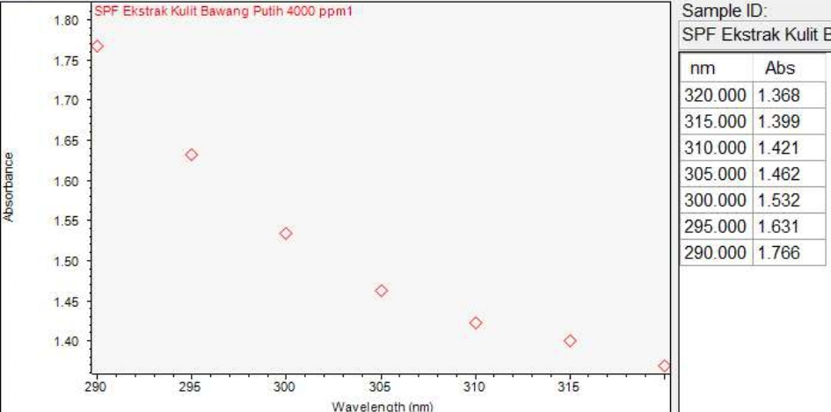

Panjang Gelombang  (nm) | Absorbansi | EE x I | Abs x EE x I
290 | 1,368 | 0,0150 | 0,0205
295 | 1,399 | 0,0817 | 0,1142
300 | 1,421 | 0,2874 | 0,4083
305 | 1,462 | 0,3278 | 0,4792
310 | 1,532 | 0,1864 | 0,2855
315 | 1,631 | 0,0839 | 0,1368
320 | 1,766 | 0,0180 | 0,0317
$\sum_{290}^{320}{Abs}$x EE x I |  |  | 1,4763

SPF = CF ×$\sum_{290}^{320}{Abs}$ x EE x I
= 10 x 1,4763
= 14,763

Lampiran 16. (lanjutan)
Pengulangan 2.
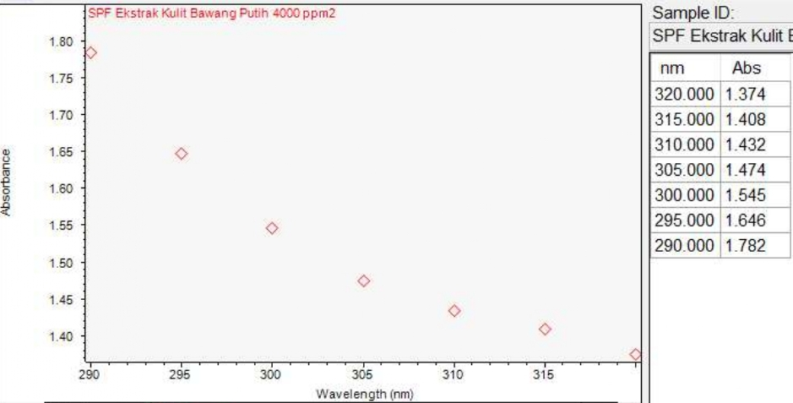

Panjang Gelombang  (nm) | Absorbansi | EE x I | Abs x EE x I
290 | 1,374 | 0,0150 | 0,0206
295 | 1,408 | 0,0817 | 0,1150
300 | 1,432 | 0,2874 | 0,4115
305 | 1,474 | 0,3278 | 0,4831
310 | 1,545 | 0,1864 | 0,2579
315 | 1,646 | 0,0839 | 0,1380
320 | 1,782 | 0,0180 | 0,0320
$\sum_{290}^{320}{Abs}$x EE x I |  |  | 1,4881

SPF = CF ×$\sum_{290}^{320}{Abs}$ x EE x I
= 10 x 1,4881
= 14,881

Lampiran 16. (lanjutan)
Pengulangan 3.
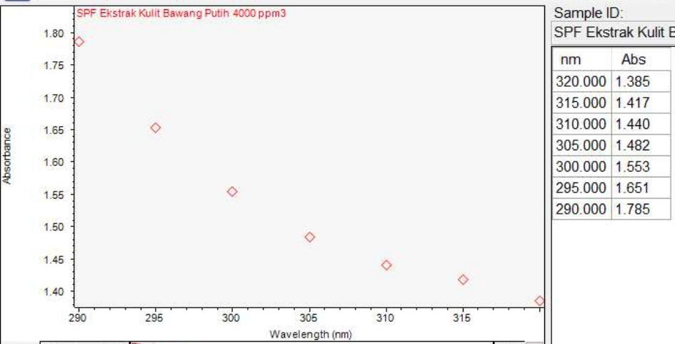
Panjang Gelombang  (nm) | Absorbansi | EE x I | Abs x EE x I
290 | 1,385 | 0,0150 | 0,0207
295 | 1,417 | 0,0817 | 0,1157
300 | 1,440 | 0,2874 | 0,4138
305 | 1,482 | 0,3278 | 0,4857
310 | 1,553 | 0,1864 | 0,2894
315 | 1,651 | 0,0839 | 0,1385
320 | 1,785 | 0,0180 | 0,0321
$\sum_{290}^{320}{Abs}$x EE x I |  |  | 1,4959

SPF = CF ×$\sum_{290}^{320}{Abs}$ x EE x I
= 10 x1,4959
= 14,959
Rata-rata nilai SPF = $\frac{P1 + P2 + P3}{3}$
= 14,763 + 14,881+ 14,959
= 14,876

Lampiran 17. Perhitungan Lama Proteksi Sediaan Gel Tabir Surya
- Blanko
Nilai SPF : 0,6847
Lama proteksi = 0,6847 x 10 = 6,87
= $\frac{6,87}{60}$ = 0.11 jam
- Gel Ekstrak Kulit Bawang Merah
Nilai SPF : 26,274
Lama proteksi = 26,274 x 10 = 262,74
= $\frac{262,74}{60}$ = 4,379 jam
- Gel Ekstrak Kulit Bawang Putih
Nilai SPF : 14,867
Lama proteksi = 14,867 x 10 = 148,67
= $\frac{148,67}{60}$ = 2,477 jam

Lampiran 18. Data SPSS Uji Evaluasi Sediaan Gel Tabir Surya
    - Data SPSS Uji pH Sediaan Tabir Surya
Oneway
Descriptives
 |  | N | Mean | Std. Deviation | Std. Error | 95% Confidence Interval for Mean |  | Minimum | Maximum
 |  |  |  |  |  | Lower Bound | Upper Bound
sebelum | F0 | 3 | 7,0000 | ,00000 | ,00000 | 7,0000 | 7,0000 | 7,00 | 7,00
 | F1 | 3 | 7,6333 | ,05774 | ,03333 | 7,4899 | 7,7768 | 7,60 | 7,70
 | F2 | 3 | 7,3667 | ,05774 | ,03333 | 7,2232 | 7,5101 | 7,30 | 7,40
 | Total | 9 | 7,3333 | ,27839 | ,09280 | 7,1193 | 7,5473 | 7,00 | 7,70
s1 | F0 | 3 | 7,0000 | ,00000 | ,00000 | 7,0000 | 7,0000 | 7,00 | 7,00
 | F1 | 3 | 7,1000 | ,00000 | ,00000 | 7,1000 | 7,1000 | 7,10 | 7,10
 | F2 | 3 | 7,0667 | ,05774 | ,03333 | 6,9232 | 7,2101 | 7,00 | 7,10
 | Total | 9 | 7,0556 | ,05270 | ,01757 | 7,0150 | 7,0961 | 7,00 | 7,10
s2 | F0 | 3 | 7,0000 | ,00000 | ,00000 | 7,0000 | 7,0000 | 7,00 | 7,00
 | F1 | 3 | 6,9667 | ,05774 | ,03333 | 6,8232 | 7,1101 | 6,90 | 7,00
 | F2 | 3 | 7,1000 | ,00000 | ,00000 | 7,1000 | 7,1000 | 7,10 | 7,10
 | Total | 9 | 7,0222 | ,06667 | ,02222 | 6,9710 | 7,0735 | 6,90 | 7,10
s3 | F0 | 3 | 7,0000 | ,00000 | ,00000 | 7,0000 | 7,0000 | 7,00 | 7,00
 | F1 | 3 | 7,0333 | ,05774 | ,03333 | 6,8899 | 7,1768 | 7,00 | 7,10
 | F2 | 3 | 6,9667 | ,05774 | ,03333 | 6,8232 | 7,1101 | 6,90 | 7,00
 | Total | 9 | 7,0000 | ,05000 | ,01667 | 6,9616 | 7,0384 | 6,90 | 7,10

Lampiran 18. (lanjutan)
Test of Homogeneity of Variances
 | Levene Statistic | df1 | df2 | Sig.
sebelum | 8,000 | 2 | 6 | ,020
s1 | 16,000 | 2 | 6 | ,004
s2 | 16,000 | 2 | 6 | ,004
s3 | 8,000 | 2 | 6 | ,020

ANOVA
 |  | Sum of Squares | df | Mean Square | F | Sig.
sebelum | Between Groups | ,607 | 2 | ,303 | 136,500 | ,000
 | Within Groups | ,013 | 6 | ,002
 | Total | ,620 | 8
s1 | Between Groups | ,016 | 2 | ,008 | 7,000 | ,027
 | Within Groups | ,007 | 6 | ,001
 | Total | ,022 | 8
s2 | Between Groups | ,029 | 2 | ,014 | 13,000 | ,007
 | Within Groups | ,007 | 6 | ,001
 | Total | ,036 | 8
s3 | Between Groups | ,007 | 2 | ,003 | 1,500 | ,296
 | Within Groups | ,013 | 6 | ,002
 | Total | ,020 | 8

Lampiran 18. (lanjutan)

    - Data SPSS Uji Viskositas Sediaan Tabir Surya
Descriptives
 |  | N | Mean | Std. Deviation | Std. Error | 95% Confidence Interval for Mean |  | Minimum | Maximum
 |  |  |  |  |  | Lower Bound | Upper Bound
S0 | F0 | 3 | 33686,6667 | 1190,05602 | 687,07916 | 30730,4036 | 36642,9297 | 32490,00 | 34870,00
 | F1 | 3 | 26283,3333 | 1620,16460 | 935,40247 | 22258,6213 | 30308,0453 | 24650,00 | 27890,00
 | F2 | 3 | 16023,3333 | 1792,04725 | 1034,63896 | 11571,6412 | 20475,0255 | 14330,00 | 17900,00
 | Total | 9 | 25331,1111 | 7798,84197 | 2599,61399 | 19336,3905 | 31325,8317 | 14330,00 | 34870,00
S1 | F0 | 3 | 31470,0000 | 951,41999 | 549,30259 | 29106,5417 | 33833,4583 | 30550,00 | 32450,00
 | F1 | 3 | 23260,0000 | 1833,22121 | 1058,41076 | 18706,0261 | 27813,9739 | 21640,00 | 25250,00
 | F2 | 3 | 18096,6667 | 1579,56745 | 911,96369 | 14172,8036 | 22020,5297 | 16340,00 | 19400,00
 | Total | 9 | 24275,5556 | 5983,64461 | 1994,54820 | 19676,1192 | 28874,9920 | 16340,00 | 32450,00
S2 | F0 | 3 | 31653,3333 | 3530,95360 | 2038,59701 | 22881,9583 | 40424,7083 | 28010,00 | 35060,00
 | F1 | 3 | 26723,3333 | 3215,80990 | 1856,64871 | 18734,8187 | 34711,8480 | 23550,00 | 29980,00
 | F2 | 3 | 17370,0000 | 1426,21878 | 823,42779 | 13827,0762 | 20912,9238 | 16420,00 | 19010,00
 | Total | 9 | 25248,8889 | 6759,15757 | 2253,05252 | 20053,3405 | 30444,4373 | 16420,00 | 35060,00
S3 | F0 | 3 | 28980,0000 | 1791,84263 | 1034,52082 | 24528,8162 | 33431,1838 | 26970,00 | 30410,00
 | F1 | 3 | 26993,3333 | 680,09803 | 392,65478 | 25303,8762 | 28682,7905 | 26320,00 | 27680,00
 | F2 | 3 | 15330,0000 | 622,17361 | 359,21210 | 13784,4351 | 16875,5649 | 14620,00 | 15780,00
 | Total | 9 | 23767,7778 | 6465,51772 | 2155,17257 | 18797,9409 | 28737,6146 | 14620,00 | 30410,00

Lampiran 18. (lanjutan)
Test of Homogeneity of Variances
 | Levene Statistic | df1 | df2 | Sig.
S0 | ,219 | 2 | 6 | ,810
S1 | ,786 | 2 | 6 | ,498
S2 | ,634 | 2 | 6 | ,563
S3 | 3,202 | 2 | 6 | ,113

ANOVA
 |  | Sum of Squares | df | Mean Square | F | Sig.
S0 | Between Groups | 472070288,889 | 2 | 236035144,444 | 97,635 | ,000
 | Within Groups | 14505200,000 | 6 | 2417533,333
 | Total | 486575488,889 | 8
S1 | Between Groups | 272910155,556 | 2 | 136455077,778 | 60,549 | ,000
 | Within Groups | 13521866,667 | 6 | 2253644,444
 | Total | 286432022,222 | 8
S2 | Between Groups | 315803355,556 | 2 | 157901677,778 | 19,068 | ,003
 | Within Groups | 49686333,333 | 6 | 8281055,556
 | Total | 365489688,889 | 8
S3 | Between Groups | 326302688,889 | 2 | 163151344,444 | 120,545 | ,000
 | Within Groups | 8120666,667 | 6 | 1353444,444
 | Total | 334423355,556 | 8

Lampiran 18. (lanjutan)
    - Data SPSS Uji Daya Sebar Sediaan Tabir Surya
Oneway
Descriptives
 |  | N | Mean | Std. Deviation | Std. Error | 95% Confidence Interval for Mean |  | Minimum | Maximum
 |  |  |  |  |  | Lower Bound | Upper Bound
S0 | F0 | 3 | 3,3743 | ,29390 | ,16968 | 2,6442 | 4,1044 | 3,05 | 3,62
 | F1 | 3 | 3,8000 | ,04330 | ,02500 | 3,6924 | 3,9076 | 3,78 | 3,85
 | F2 | 3 | 4,0250 | ,09014 | ,05204 | 3,8011 | 4,2489 | 3,93 | 4,10
 | Total | 9 | 3,7331 | ,32556 | ,10852 | 3,4829 | 3,9834 | 3,05 | 4,10
S1 | F0 | 3 | 3,1050 | ,00866 | ,00500 | 3,0835 | 3,1265 | 3,10 | 3,12
 | F1 | 3 | 3,8333 | ,03819 | ,02205 | 3,7385 | 3,9282 | 3,80 | 3,88
 | F2 | 3 | 3,9350 | ,04093 | ,02363 | 3,8333 | 4,0367 | 3,90 | 3,98
 | Total | 9 | 3,6244 | ,39308 | ,13103 | 3,3223 | 3,9266 | 3,10 | 3,98
S2 | F0 | 3 | 103,7850 | 174,25731 | 100,60750 | -329,0942 | 536,6642 | 3,13 | 305,00
 | F1 | 3 | 3,7100 | ,07697 | ,04444 | 3,5188 | 3,9012 | 3,63 | 3,78
 | F2 | 3 | 3,9833 | ,12332 | ,07120 | 3,6770 | 4,2897 | 3,90 | 4,13
 | Total | 9 | 37,1594 | 100,44073 | 33,48024 | -40,0461 | 114,3650 | 3,13 | 305,00
S3 | F0 | 3 | 4,2167 | ,20966 | ,12105 | 3,6958 | 4,7375 | 3,98 | 4,35
 | F1 | 3 | 3,5417 | ,26497 | ,15298 | 2,8834 | 4,1999 | 3,30 | 3,83
 | F2 | 3 | 3,7333 | ,68023 | ,39273 | 2,0436 | 5,4231 | 2,95 | 4,18
 | Total | 9 | 3,8306 | ,48473 | ,16158 | 3,4580 | 4,2032 | 2,95 | 4,35

Lampiran 18. (lanjutan)
Test of Homogeneity of Variances
 | Levene Statistic | df1 | df2 | Sig.
S0 | 4,766 | 2 | 6 | ,058
S1 | 2,353 | 2 | 6 | ,176
S2 | 15,982 | 2 | 6 | ,004
S3 | 4,823 | 2 | 6 | ,056

ANOVA
 |  | Sum of Squares | df | Mean Square | F | Sig.
S0 | Between Groups | ,655 | 2 | ,328 | 10,197 | ,012
 | Within Groups | ,193 | 6 | ,032
 | Total | ,848 | 8
S1 | Between Groups | 1,230 | 2 | ,615 | 574,927 | ,000
 | Within Groups | ,006 | 6 | ,001
 | Total | 1,236 | 8
S2 | Between Groups | 19975,453 | 2 | 9987,727 | ,987 | ,426
 | Within Groups | 60731,261 | 6 | 10121,877
 | Total | 80706,714 | 8
S3 | Between Groups | ,726 | 2 | ,363 | 1,888 | ,231
 | Within Groups | 1,154 | 6 | ,192
 | Total | 1,880 | 8

Lampiran 18. (lanjutan)
    - Data SPSS Uji Daya Lekat Sediaan Tabir Surya
Oneway
Descriptives
 |  |  | N | Mean | Std. Deviation | Std. Error | 95% Confidence Interval for Mean |  | Minimum | Maximum
 |  |  |  |  |  |  | Lower Bound | Upper Bound
 | S0 | F0 | 3 | 4,4500 | ,26963 | ,15567 | 3,7802 | 5,1198 | 4,14 | 4,63
 |  | F1 | 3 | 5,6933 | ,17954 | ,10366 | 5,2473 | 6,1393 | 5,49 | 5,83
 |  | F2 | 3 | 4,2667 | ,24786 | ,14310 | 3,6510 | 4,8824 | 4,09 | 4,55
 |  | Total | 9 | 4,8033 | ,70246 | ,23415 | 4,2634 | 5,3433 | 4,09 | 5,83
 | S1 | F0 | 3 | 5,0200 | ,42790 | ,24705 | 3,9570 | 6,0830 | 4,53 | 5,32
 |  | F1 | 3 | 6,1133 | ,09074 | ,05239 | 5,8879 | 6,3387 | 6,03 | 6,21
 |  | F2 | 3 | 4,4667 | ,37899 | ,21881 | 3,5252 | 5,4081 | 4,06 | 4,81
 |  | Total | 9 | 5,2000 | ,78126 | ,26042 | 4,5995 | 5,8005 | 4,06 | 6,21
 | S2 | F0 | 3 | 4,5100 | ,38197 | ,22053 | 3,5611 | 5,4589 | 4,21 | 4,94
 |  | F1 | 3 | 6,1267 | ,23756 | ,13715 | 5,5365 | 6,7168 | 5,97 | 6,40
 |  | F2 | 3 | 3,9167 | ,09609 | ,05548 | 3,6780 | 4,1554 | 3,83 | 4,02
 |  | Total | 9 | 4,8511 | 1,01691 | ,33897 | 4,0694 | 5,6328 | 3,83 | 6,40
 | S3 | F0 | 3 | 4,4767 | ,39145 | ,22600 | 3,5043 | 5,4491 | 4,03 | 4,76
 |  | F1 | 3 | 5,2433 | ,46090 | ,26610 | 4,0984 | 6,3883 | 4,80 | 5,72
 |  | F2 | 3 | 4,0467 | ,10504 | ,06064 | 3,7857 | 4,3076 | 3,94 | 4,15
 |  | Total | 9 | 4,5889 | ,60808 | ,20269 | 4,1215 | 5,0563 | 3,94 | 5,72

Lampiran 18. (lanjutan)
Test of Homogeneity of Variances
 | Levene Statistic | df1 | df2 | Sig.
S0 | ,581 | 2 | 6 | ,588
S1 | 2,941 | 2 | 6 | ,129
S2 | 3,403 | 2 | 6 | ,103
S3 | 1,996 | 2 | 6 | ,217

ANOVA
 |  | Sum of Squares | df | Mean Square | F | Sig.
S0 | Between Groups | 3,615 | 2 | 1,807 | 32,592 | ,001
 | Within Groups | ,333 | 6 | ,055
 | Total | 3,948 | 8
S1 | Between Groups | 4,213 | 2 | 2,107 | 18,866 | ,003
 | Within Groups | ,670 | 6 | ,112
 | Total | 4,883 | 8
S2 | Between Groups | 7,850 | 2 | 3,925 | 55,654 | ,000
 | Within Groups | ,423 | 6 | ,071
 | Total | 8,273 | 8
S3 | Between Groups | 2,205 | 2 | 1,102 | 8,779 | ,017
 | Within Groups | ,753 | 6 | ,126
 | Total | 2,958 | 8

Lampiran 19. Data SPSS Penentuan Nilai Sun Protecting Action
Oneway

Descriptives
SPF
 | N | Mean | Std. Deviation | Std. Error | 95% Confidence Interval for Mean |  | Minimum | Maximum
 |  |  |  |  | Lower Bound | Upper Bound
F0 | 3 | ,6845 | ,07836 | ,04524 | ,4899 | ,8792 | ,61 | ,76
F1 | 3 | 26,7253 | ,10345 | ,05973 | 26,4683 | 26,9823 | 26,64 | 26,84
F2 | 3 | 14,8673 | ,09921 | ,05728 | 14,6209 | 15,1138 | 14,76 | 14,96
Total | 9 | 14,0924 | 11,29126 | 3,76375 | 5,4132 | 22,7716 | ,61 | 26,84

Test of Homogeneity of Variances
SPF
Levene Statistic | df1 | df2 | Sig.
,205 | 2 | 6 | ,820

ANOVA
SPF
 | Sum of Squares | Df | Mean Square | F | Sig.
Between Groups | 1019,887 | 2 | 509,944 | 57329,416 | ,000
Within Groups | ,053 | 6 | ,009
Total | 1019,941 | 8

Lampiran 20. Hasil Uji skrining fitokimia
- Ekstrak kulit bawang
No | Golongan senyawa | Perlakuan | Gambar |  | Hasil Uji | Keterangan
 |  |  | Serbuk | Ekstrak
1. | Alkaloid | 0,5 gram sampel + 1 ml HCl 2N + Aquadest 4,5 ml, dipanaskan 2 menit, dinginkan, disaring. Filtrat dibagi 3 bagian, masing-masing ditambah 2 tetes :  - Mayer  - Dragendrof  - Buochardat  (Depkes RI, 1995) | 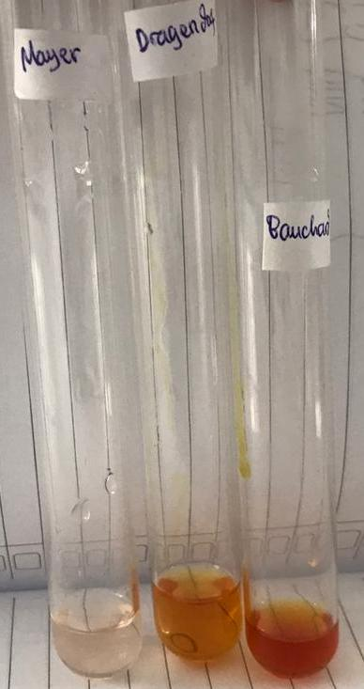 | 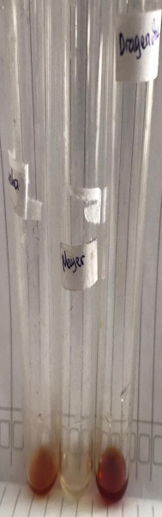 | + | - Mayer  Tidak terbentuk endapan putih  (-)  - Dragendrof  Terbentuk endapan merah – merah kecoklatan (+)  (Depkes RI, 1995)  - Buochardat  Terbentuk larutan merah kekuningan (+)  (Depkes RI, 1995)
2. | Flavonoid | 1gram smpel +10 ml air, didihkan selama 5 menit, disaring. Diambil 5 ml filtrat + 0,1 gram serbuk Mg, dan 1 ml HCl p dan 2 ml amil alkohol, dikocok, biarkan memisah (Franswort, 1966) |  | 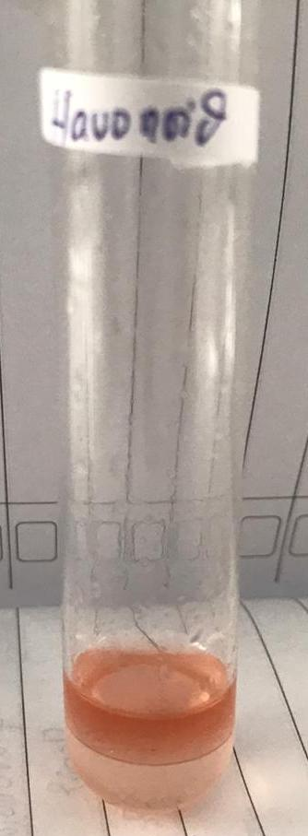 | + | Terbentuk lapisan jingga-merah pada lapisan alkohol  (Franswort, 1966).
Lampiran 20. (lanjutan)
3. | Tanin | 0,5 gram sampel + 10 ml aquades, dikocok, disaring, diambil 2 ml larutan + 1 tts FeCl₃ (Depkes RI, 1995). |  |  | + | Terbentuk Larutan biru pekat (Depkes RI, 1995).
4. | saponin | 0,5gram sampel + 10 ml air panas, dinginkan, kocok kuat selama 10 detik. + HCl  (Depkes RI, 1995). | 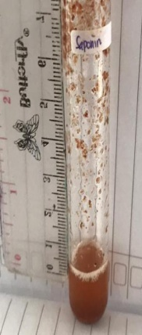 | 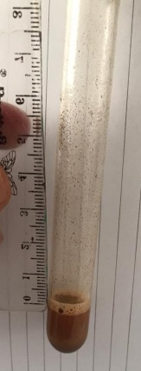 | _ | Tidak terbentuk busa yang stabil  (Depkes RI, 1995).
5. | Glikosida antrakuinon | 0,1 gram sampel + 5 ml benzen, dikocok, diamkan, lapisan benzen dipisahkan + 1 ml NaOH 2N, kocok dan diamkan  (Depkes RI, 1995). | 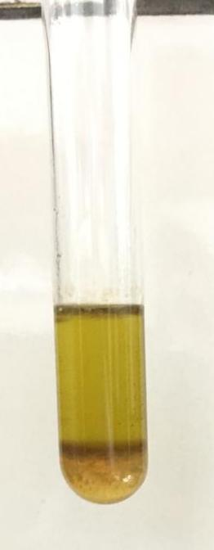 | 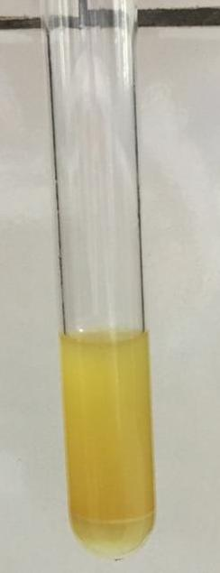 | _ | Tidak terbentuk lapisan air bewarna merah  (Depkes RI, 1995).

Lampiran 20. (lanjutan)
6. | Steroid/  Triterpenoid | 0,5 gram sampel + 10 ml eter dimaserasi selama 2 jam, disaring. Filrat diuapkan dalam cawan penguap + 5 tts H₂SO₄ p + 5 tts asam asetat anhidrat (pereaksi liberman-burchard) (Depkes RI, 1995). | 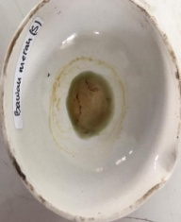 | 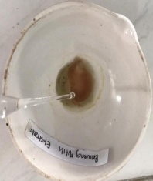 | + | Terbentuk warna hijau kehitaman (steroid) (Depkes RI, 1995).

Lampiran 20. (lanjutan)
- Ekstrak kulit bawang putih
No | Golongan senyawa | Perlakuan | Gambar |  | Hasil Uji | Keterangan
 |  |  | Serbuk | Ekstrak
1. | alkaloid | 0,5 gram sampel + 1 ml HCl 2N + Aquadest 4,5 ml, dipanaskan 2 menit, dinginkan, disaring. Filtrat dibagi 3 bagian, masing-masing ditambah 2 tetes :  - Mayer  - Dragendrof  - Buochardat  (Depkes RI, 1995) | 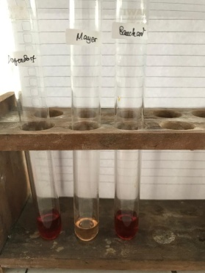 | 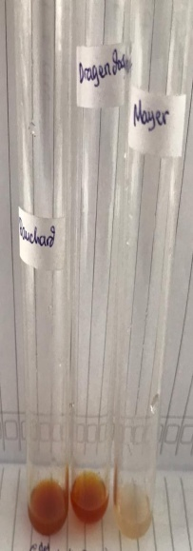 | + | - Mayer  Tidak terbentuk endapan putih  (-)  - Dragendrof  Terbentuk endapan merah – merah kecoklatan (+)  (Depkes RI, 1995)  - Buochardat  Terbentuk larutan merah kekuningan (+)  (Depkes RI, 1995)
2. | Flavonoid | 1gram smpel +10 ml air, didihkan selama 5 menit, disaring. Diambil 5 ml filtrat + 0,1 gram serbuk Mg, dan 1 ml HCl p dan 2 ml amil alkohol, dikocok, biarkan memisah (Franswort, 1966) | 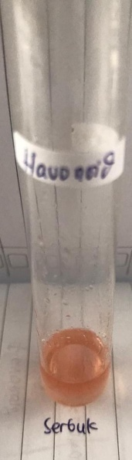 | 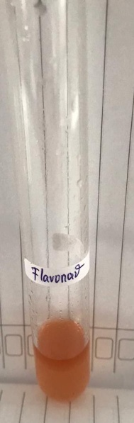 | + | Terbentuk lapisan jingga-merah pada lapisan alkohol  (Franswort, 1966).
Lampiran 20. (lanjutan)
3. | Tanin | 0,5 gram sampel + 10 ml aquades, dikocok, disaring, diambil 2 ml larutan + 1 tts FeCl₃ (Depkes RI, 1995). | 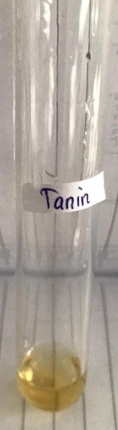 | 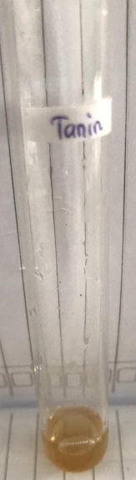 | _ | Tidak terbentuk Larutan biru pekat (Depkes RI, 1995).
4. | saponin | 0,5gram sampel + 10 ml air panas, dinginkan, kocok kuat selama 10 detik. + HCl  (Depkes RI, 1995). | 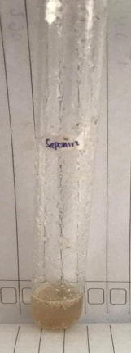 | 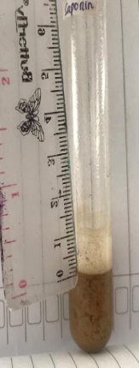 | _ | Tidak terbentuk busa yang stabil  (Depkes RI, 1995).
5. | Glikosida antrakuinon | 0,1 gram sampel + 5 ml benzen, dikocok, diamkan, lapisan benzen dipisahkan + 1 ml NaOH 2N, kocok dan diamkan  (Depkes RI, 1995). | 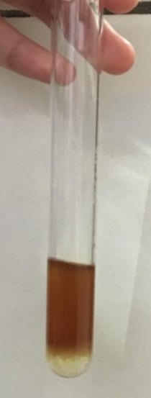 |  | + | Terbentuk lapisan air bewarna merah  (Depkes RI, 1995).
Lampiran 20. (lanjutan)
6. | Steroid/  Triterpenoid | 0,5 gram sampel + 10 ml eter dimaserasi selama 2 jam, disaring. Filrat diuapkan dalam cawan penguap + 5 tts H₂SO₄ p + 5 tts asam asetat anhidrat (pereaksi liberman-burchard) (Depkes RI, 1995). | 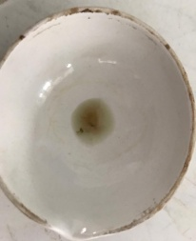 | 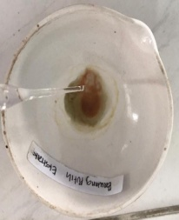 | + | Terbentuk warna hijau kehitaman (steroid) (Depkes RI, 1995).

Lampiran 21. Kulit Bawang Merah (Allium cepa L.) dan Kulit Bawang Putih (Allium sativum L.)

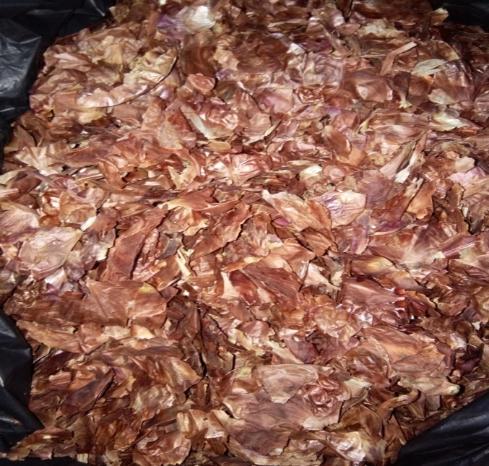
Kulit Bawang Merah

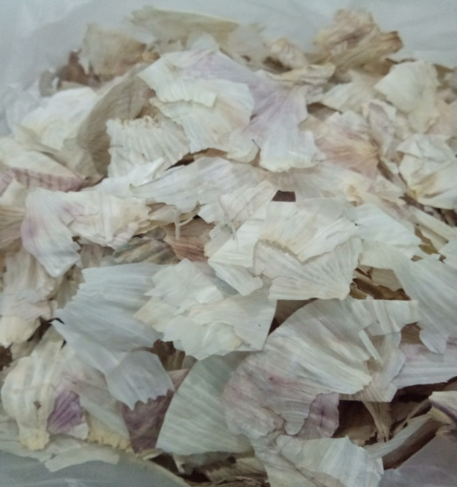
Kulit Bawang Putih

Lampiran 22. Seruk dan Ekstrak Kulit Bawang Merah (Allium cepa L.) dan Kulit Bawang Putih (Allium sativum L.)

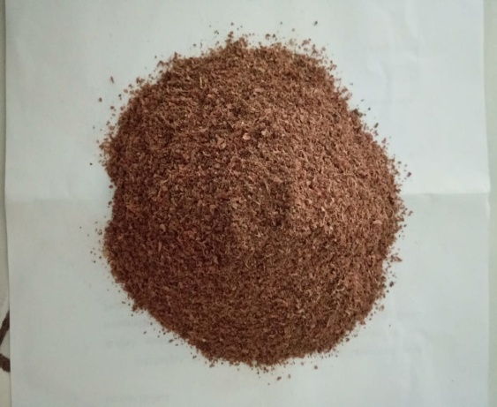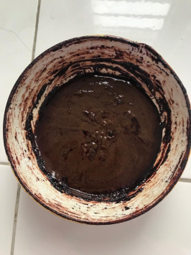
Serbuk Kulit Bawang Merah Ekstrak Kulit Bawang Merah

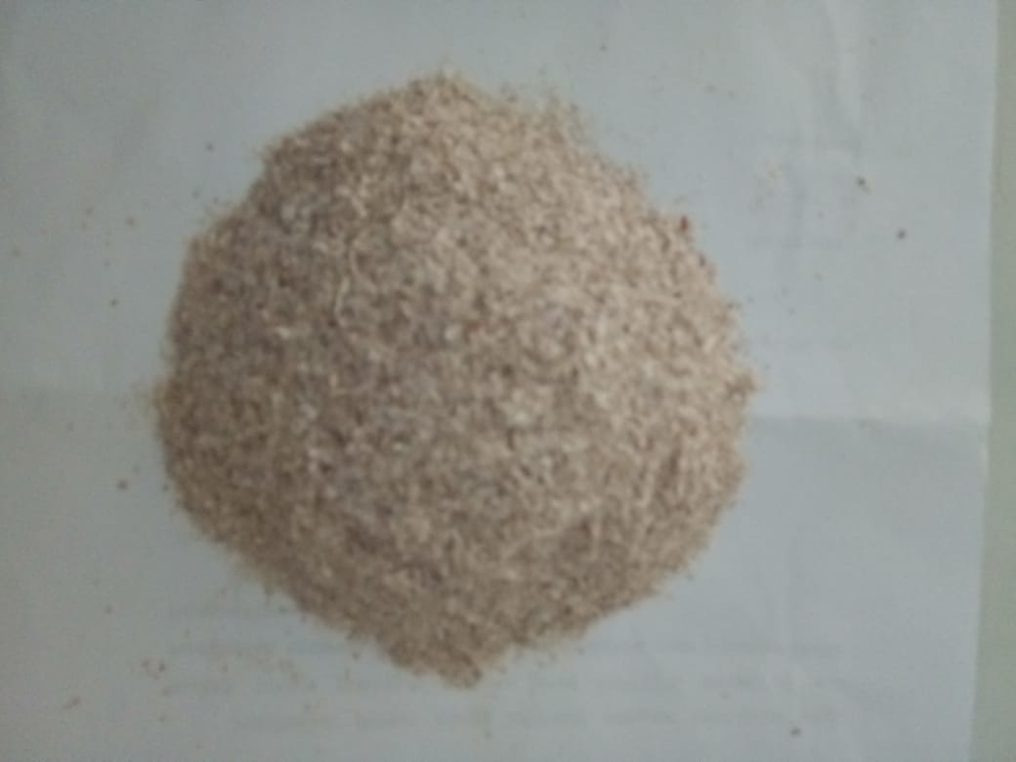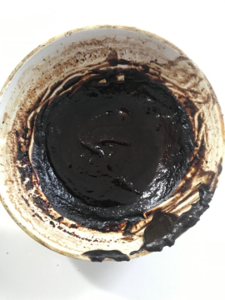
Serbuk Kulit Bawang Putih Ekstrak Kulit Bawang Putih

Lampiran 23. Alat Spektrofotometer UV-Vis

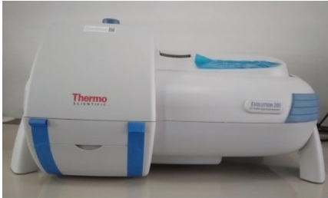
Spektrofotometer UV-Vis

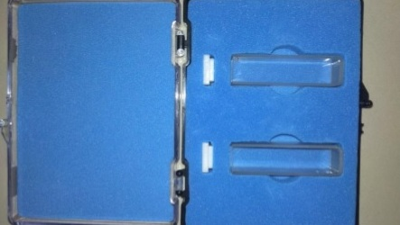
Kuvet

Lampiran 24.Penentuan Nilai SPF Gel Tabir Surya Ekstrak Etanol Kulit Bawang Merah (Allium cepa L.) dan Kulit Bawang Putih (Allium sativum L.)

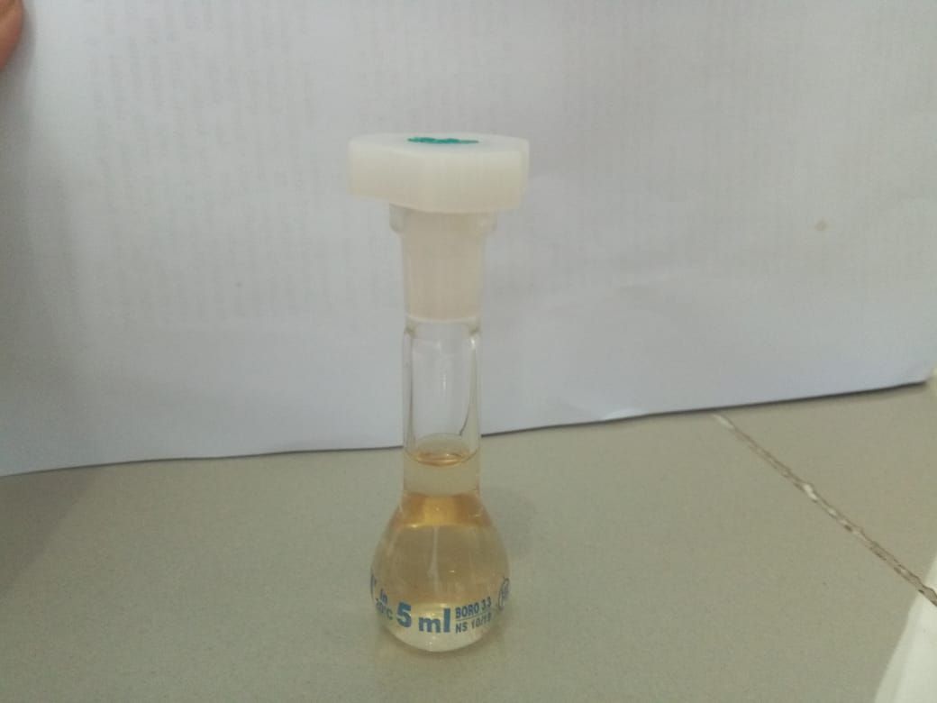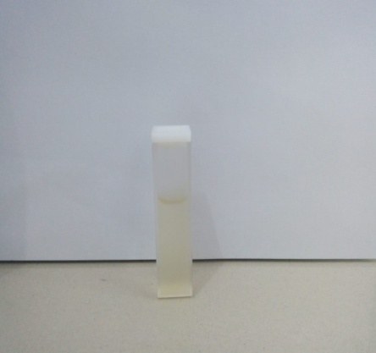
Larutan Gel Ekstrak Etanol Kulit Bawang Merah dalam kuvet

Pengenceran Gel Ekstrak Etanol Kulit Bawang Merah

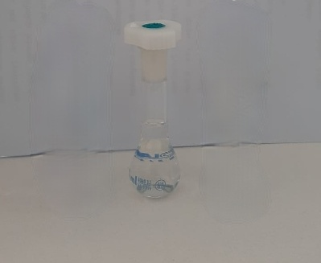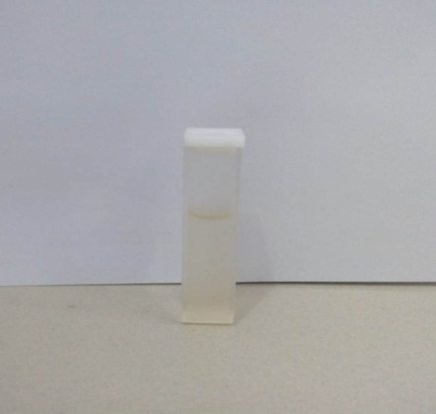
Pengenceran Gel Ekstrak Etanol Kulit Bawang Putih

Larutan Gel Ekstrak Etanol Kulit Bawang Putih
dalam kuvet

Lampiran 25. Evaluasi Sediaan Gel Tabir Surya Ekstrak Etanol Kulit Bawang Merah (Allium cepa L.) dan Kulit Bawang Putih (Allium sativum L.)

- Organoleptis

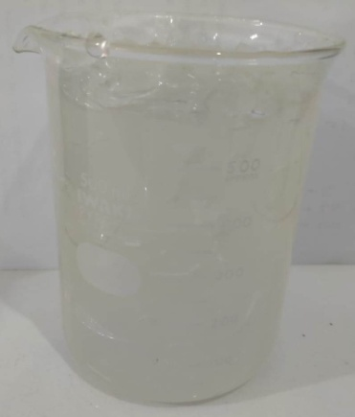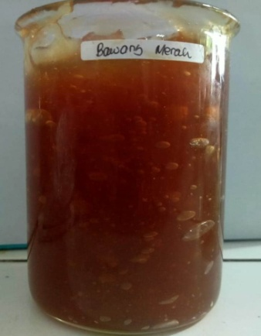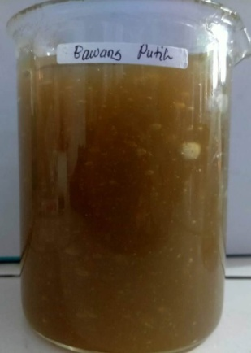
Blanko
Gel Tabir Surya Ekstrak Etanol Kulit Bawang Putih
Gel Tabir Surya Ekstrak Etanol Kulit Bawang Merah

- Homogenitas

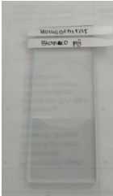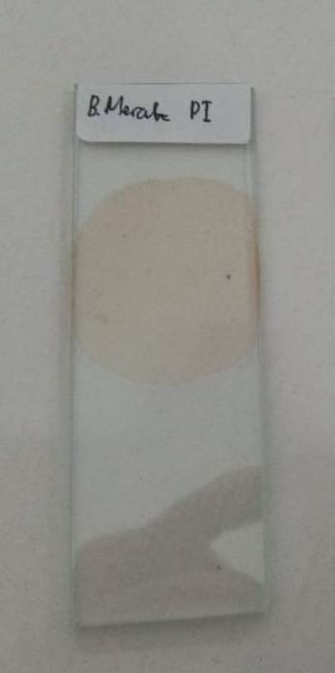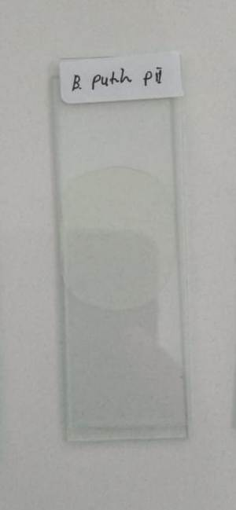
Gel Tabir Surya Ekstrak Etanol Kulit Bawang Putih
Gel Tabir Surya Ekstrak Etanol Kulit Bawang Merah
Blanko

Lampiran 25. (lanjutan)
- Pengukuran pH
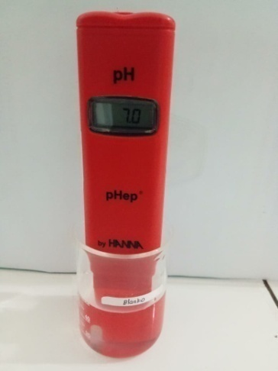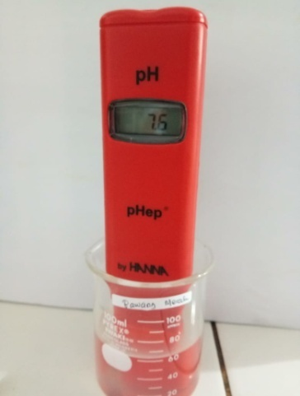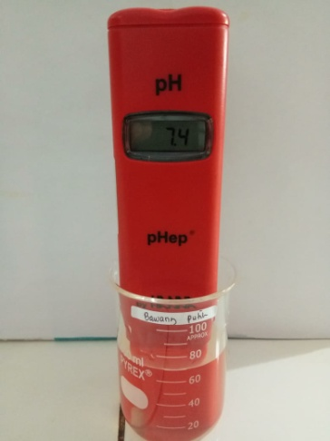
Gel Tabir Surya Ekstrak Etanol Kulit Bawang Putih
Gel Tabir Surya Ekstrak Etanol Kulit Bawang Merah
Blanko

- Pengukuran Viskositas

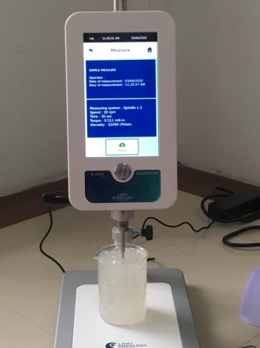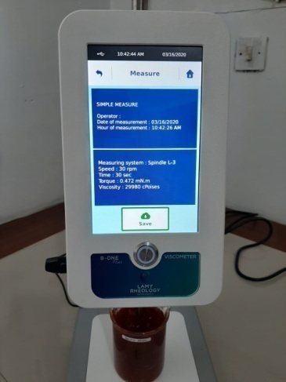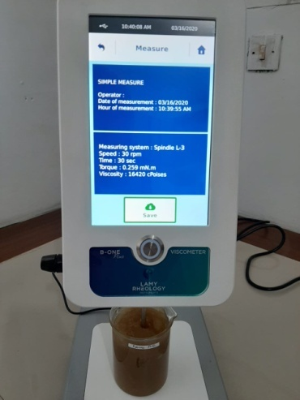
Gel Tabir Surya Ekstrak Etanol Kulit Bawang Putih
Gel Tabir Surya Ekstrak Etanol Kulit Bawang Merah
Blanko

Lampiran 25. (lanjutan)

- Pengukuran Daya Sebar

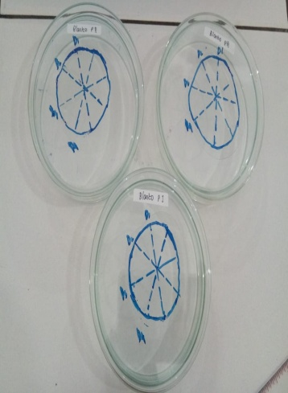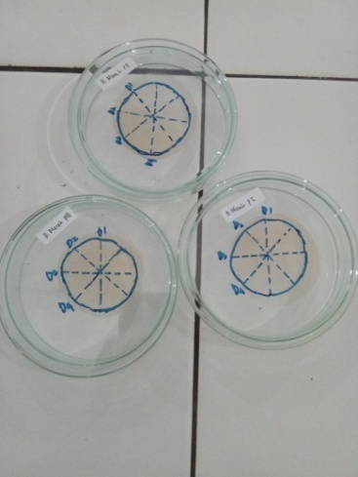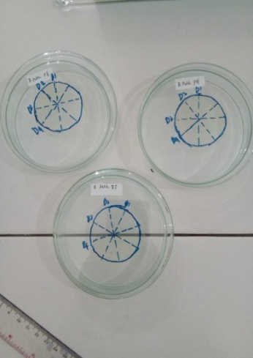
Gel Tabir Surya Ekstrak Etanol Kulit Bawang Putih
Gel Tabir Surya Ekstrak Etanol Kulit Bawang Merah
Blanko

Lampiran 26. Sediaan Gel Tabir Surya Ekstrak Etanol Kulit Bawang Merah (Allium cepa L.) dan Kulit Bawang Putih (Allium sativum L.)

