Lampiran 1. Hasil Identifikasi Tumbuhan.
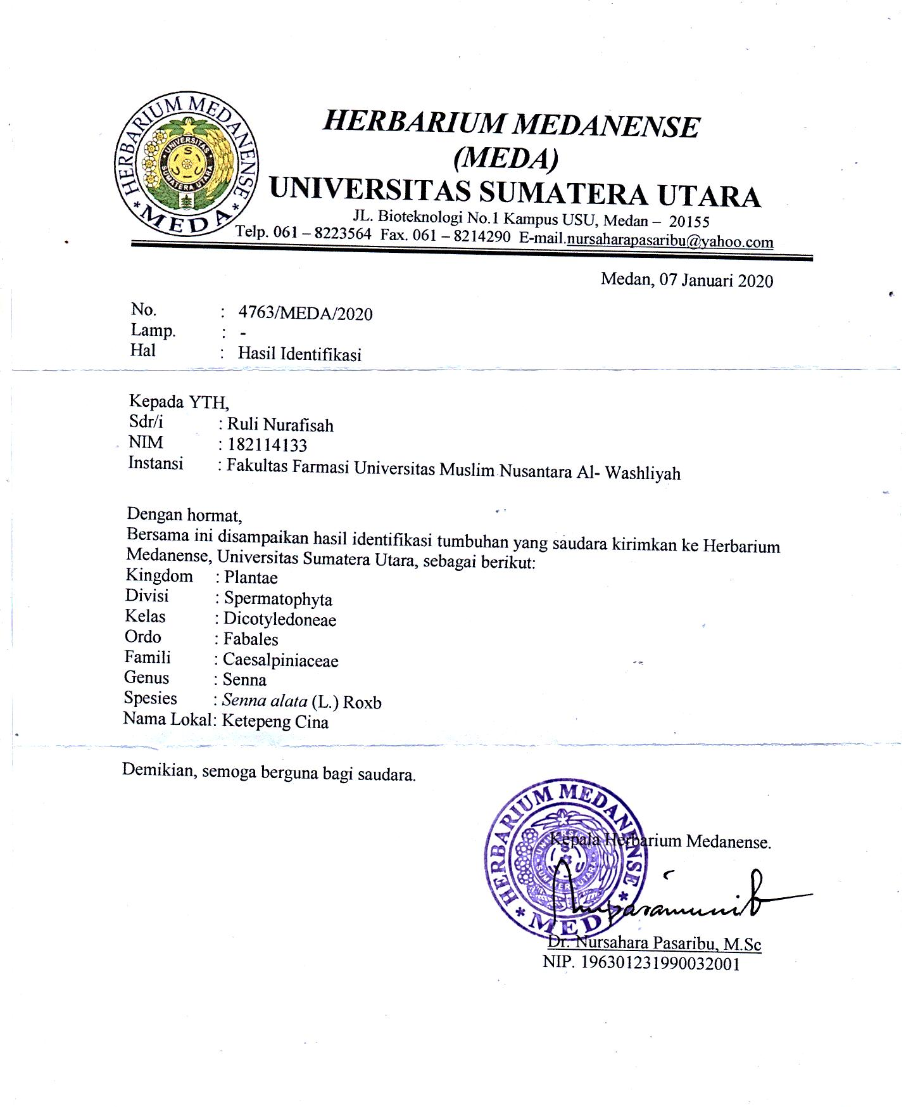

Lampiran 2. Surat Rekomendasi Persetujuan Etik Penelitian.

Lampiran 3. Tumbuhan Ketepeng Cina ( Senna alata L.)

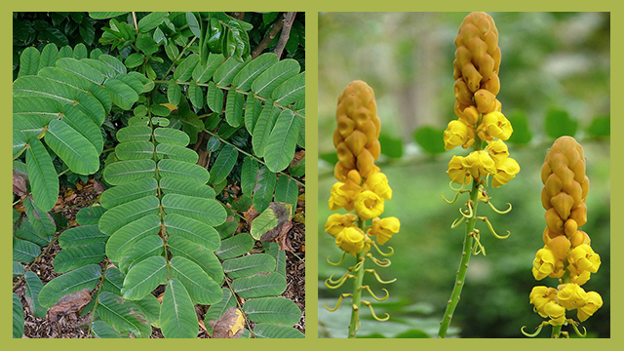
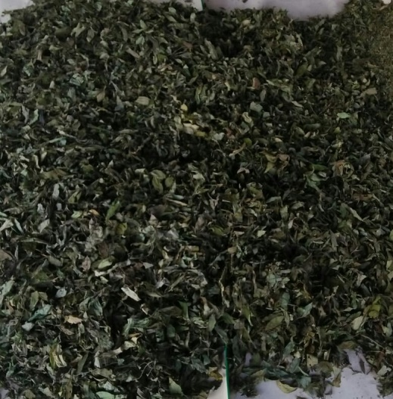

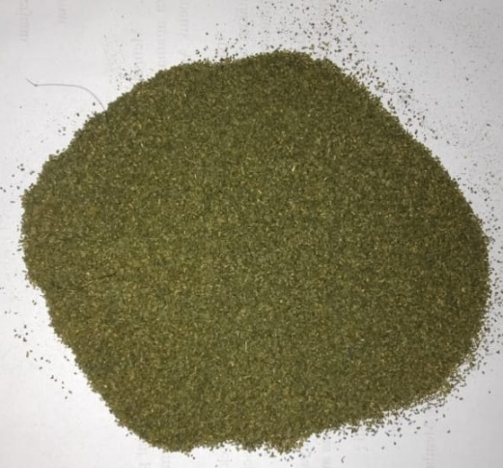

Lampiran 4. Makroskopik daun ketepng cina ( Senna Alata L.)

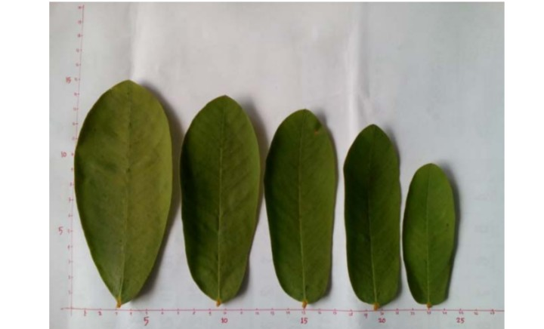

Lampiran 5 Mikroskopik daun ketepeng cina
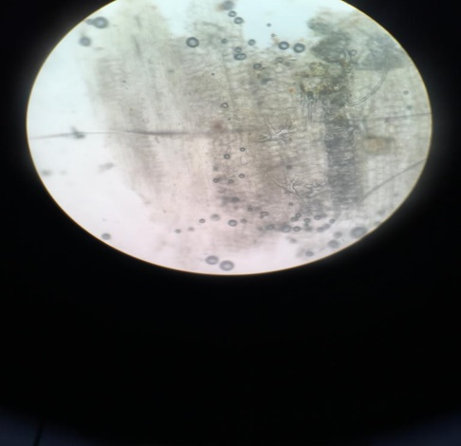

1
3
2

1

Keterangan :
1. Parenkim
2. Berkas pembuluh
3. Serabut sklerenkim

Lampiran 6. Alat Rotary Evaporator

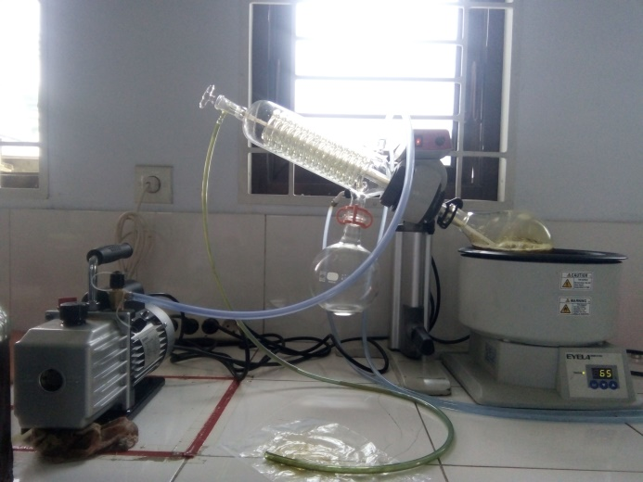

Lampiran 7. Mencit Saat Pengamatan
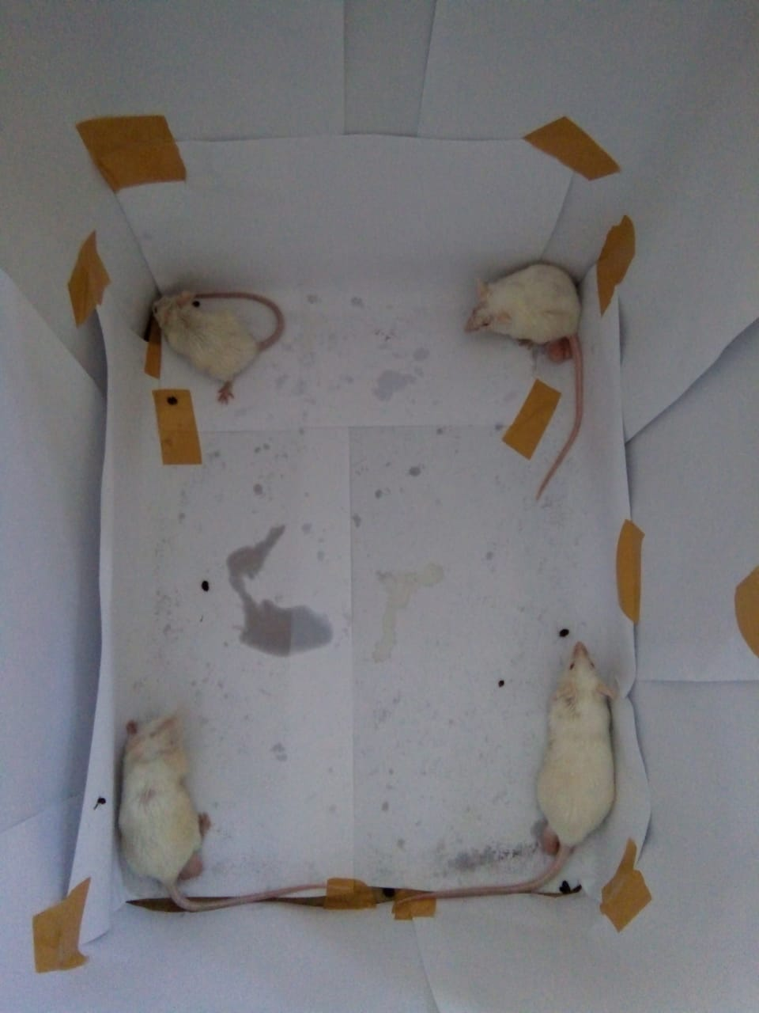

mencit Normal

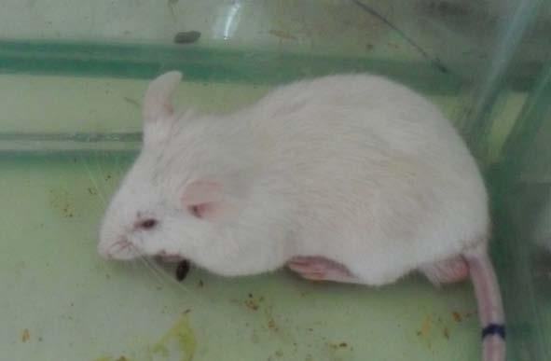

Mencit dalam keadaan diare

Lampiran 8. feses Mencit
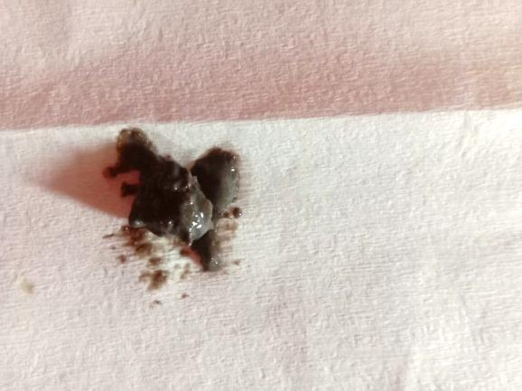
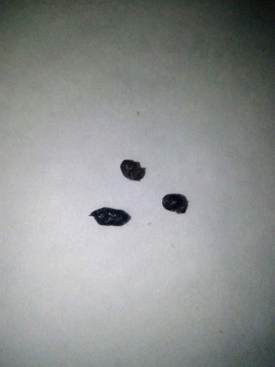

Feses Normal Feses Lembek

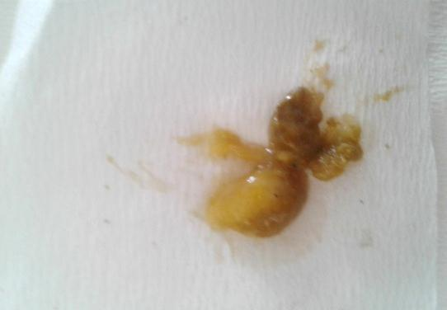

feses Berlendir

Lampiran 9. Bagan Alir Skrining Fitokimia dan Karakterisasi
Simplisia Daun ketepeng cina 10 kg

Di bersihkan dari pengotor kemudian
Di cuci bersih dan di tiriskan

Simplisia Daun Ketepeng cina

kemudian di keringkan di lemari pengering
Di timbang
Simplisia Kering Daun Ketepeng cina 3kg

Di haluskan
Di timbang
Serbuk Simplisia Daun Ketepeng cina 2,7 kg

Dibuat Ekstrak
Karakterisasi
Skrining Fitokimia
Dimaserasi
Dengan Etanol 96%
- Makroskospik
- Mikroskospik
- PenetapanKadar Air
- Penetapan Kadar Sari Larut Dalam Air
- Penetapan Kadar Sari Larut Dalam Etanol
- Penetapan Kadar Abu Total
- Penetapan Kadar Abu Tidak Larut Dalam asam
- Pemeriksaan alkaloid
- Pemeriksaan flavonoid
- Pemeriksaan Glikosida
- Pemeriksaan Glikosida Antrakuinon
- Pemeriksaan Saponin
- Pemeriksaan Tanin
- Pemeriksaan Steroid
maserat
Diuapkan dengan
Rotary evavorator
Ekstrak kental

Uji anti diare
SkriningFitokimia
Hasil

Lampiran 10. Bagan Alir Pembuatan Ekstrak Daun Ketepeng
500 g serbuk simplisia daun ketepeng cina

Dimasukkan kedalam bejana
Ditambahkan etanol 96%
Didiamkan selama 5 hari sambil diaduk
Disaring
Ampas
Maserat I

Dimasukkan dengan etanol 96%
Dimaserasi kembali selama 2 hari sambil diaduk
Disaring
Maserat II

Maserat daun Ketepeng

Diperlukan dengan rotary evaporator pada
suhu 60˚C Diuapkan dengan pen
Ekstrak daun Ketepeng cina

Lampiran 11. Bagan Pengujian Ekstrak pada Mencit
25 Ekor Mencit jantan putih

Di masukkan kedalam kandang yang bersih dan memiliki ventilasi yang baik
Diberi makan jagung dan diberi minum
Dikondisikan lebih kurang selama 2 minggu
30 Ekor Mencit jantan putih telah terkondisi dengan baik

Dikelompokkan menjadi 5 kelompok
Dipuasakan selama 18 Jam
Diinduksi Olium ricini secara oral
Didiamkan selama 1 jam

Kel. IV
(Diberi EDKC 100 mg/kg BB)

Kel. I
(Diberi CMC 0,5 % BB)
Kel.II
(Diberi diatab)

Kel . III
(Diberi EDKC 50 mg/kg BB)
Kel.V
(Diberi EDKC150 mg/kg BB)

Diamati dalam waktu 6 jam
Hasil uji antidiare

Lampiran 12. Perhitungan Hasil Pemeriksaan Penetapan Kadar Air Simplisia
Berat sampel | Volume awal | Volume akhir
5,05 | 5,05 | 0,8
5,07 | 5,07 | 0,9
5,04 | 5,04 | 0,7
% Kadar air simplisia = $\frac{Volume akhir-Volume awal}{Berat sampel}$ x 100%

- Berat simplisia I = 5 g
% Kadar air = $\frac{0,8 ml-0,5 ml}{5 g}$ x 100% = 6%
- Berat simplisia II = 5 g
% Kadar air = $\frac{0,9 ml-0,75 ml}{5 g}$ x 100% = 3%
- Berat simplisia III = 5 g
% Kadar air = $\frac{0,6 ml-0,7 ml}{5 g}$ x 100% = 2

Lampiran 13. Perhitungan Hasil Pemeriksaan Penetapan Kadar Sari Larut Dalam
Air

Berat sampel | Berat cawan kosong | Berat cawan berisi | Berat sari
5 g | 57,47 g | 75,43 g | 56,89 g
5 g | 65,22g | 82,80 g | 64,35 g
5 g | 50,75 g | 64,08 g | 50,80 g
% Kadar sari larut dalam air = $\frac{\left(Berat cawan berisi - Berat cawan kosong\right) x 5}{Berat sampel}$ x 100%

- Berat simplisia I = 5 g
% Kadar sari larut dalam air = $\frac{0,13 x 5}{5 g}$ x 100% = 13 %
- Berat simplisia I I = 5 g
% Kadar sari larut dalam air = $\frac{0,12 x 5}{5 g}$ x 100% = 12 %
- Berat simplisia I II = 5 g
% Kadar sari larut dalam air = $\frac{0,15 x 5}{5 g}$ x 100% = 15 %

% Kadar sari dalam air rata-rata = $\frac{ 13\%+12 \%+15 \%}{3}$ = 13,3

Lampiran 14. Perhitungan Hasil Pemeriksaan Penetapan Kadar Sari Larut Dalam
Etanol

Berat sampel | Berat cawan kosong | Berat cawan berisi | Berat cawan kering
5 g | 58,54 g | 72,60 g | 57,90 g
5 g | 64,21 g | 78,67 g | 64,25 g
5 g | 50,78 g | 64.74 g | 50,89 g
% Kadar sari larut dalam etanol = $\frac{\left(Berat cawan berisi - Berat cawan kosong\right) x 5}{Berat sampel}$ x 100%

- Berat simplisia I = 5 g
% Kadar sari larut etanol = $\frac{0,3x5}{5}$x100% = 13%
- Berat simplisia I I = 5 g
% Kadar sari larut etanol = $\frac{0,2 x 5}{ 5 g}$ x 100% = 12%
- Berat simplisia I II = 5 g
% Kadar sari larut etanol = $\frac{ 0,1x 5}{5 g}$ x 100% = 11%
$\frac{13\%+12\%+12\%}{3}$ = 12 %

Lampiran 15. Perhitungan Hasil Pemeriksaan Penetapan Kadar Abu Total

Berat sampel | Berat abu
2 g | 0,13
2 g | 0,05
2 g | 0,06

% Kadar abu total = $\frac{\left(Berat cawan berisi - Berat cawan kosong\right)}{Berat sampel}$ x 100%

- Berat simplisia I = 5 g
% Kadar abu total = $\frac{0,13}{2 g}$ x 100% = 6,5 %
- Berat simplisia I I = 5 g
% Kadar abu total = $\frac{0,05}{2}$ x 100% = 2,5 %
- Berat simplisia I II = 5 g
% Kadar abu total = $\frac{0,06}{2 g}$ x 100% = 3 %

% Kadar abu total rata-rata = $\frac{ 6,5 \% + 2,5 \% + 3 \%}{3}$ = 4 %

Lampiran 16. Perhitungan Hasil Pemeriksaan Penetapan Kadar Abu Tidak Larut
dalam Asam

Berat sampel | Berat abu
2 g | 0,03 g
2 g | 0,02 g
2 g | 0,03 g

% Kadar abu tidak larut asam = $\frac{\left(Berat cawan berisi - Berat cawan kosong\right)}{Berat sampel}$ x 100%

- Berat simplisia I = 5 g
% Kadar abu tidak larut asam = $\frac{0,3 g}{2 g}$ x 100% = 0,1,5 %
- Berat simplisia I I = 5 g
% Kadar abu tidak larut asam = $\frac{0,02 g}{2 g}$ x 100% = 1 %
- Berat simplisia I II = 5 g
% Kadar abu tidak larut asam = $\frac{0,3 g}{2 g}$ x 100% = 1,5 %

% Kadar abu tidak larut asam rata-rata = $\frac{ 1,5\% + 1\% + 1,5\%}{3}$ = 1,3 %

Lampiran 17.Perhitungan Dosis Diatab®
- Dosis diatab®
Konversi dosis manusia ke dosis mencit
Dosis lazim diatab pada manusia 600mg
Manusia = 70kg ke mencit 20gr = 0,0026
Dosis terapi ke mencit:
Dosis terapi manusia X 0,0026
= 600mg X 0,0026 = 1,56mg
= $\frac{1000}{20}$ X 1,56 = 78mg/kg BB
Pada konsentrasi 1%
= 1mg/100ml = 10mg/ml
dosis mencit 35gr = $\frac{78}{1000}$ X 35gr = 2,73mg
volume = $\frac{dosis}{konsentrasi}$ =
$\frac{2,73}{10 mg/ml}$
$\frac{2,34mg}{10mg/ml}$ = 0,734ml
- $\frac{1000mg}{100}=10mg/ml$Perhitungan dosis Volume Pemberian Suspensi EDKC
Konsentrasi EDKC = 1% =
Maka untuk membuat suspensi EDKC dengan konsentrasi 1% sebanyak 10ml, EDKC yang diambil sebanyak
$$\frac{10ml}{100ml} x 1g=100mg$$

- Dosis EDKC 50mg/kg BB
Volume pemberian suspensi EDKC 50 mg/kg BB:
Jika berat badan mencit 30 g, maka EDKC yang diberikan tiap mencit sebanyak

30g
= X 50 mg = 1,5 mg
1000 g
1,5 mg
Maka, volume yang diberikan = = 0,15 ml
10mg/ml

- Dosis EDKC 100mg/kg BB
Volume pemberian suspensi EDKC 100 mg/kg BB:
Jika berat badan mencit 30 g, maka EDKC yang diberikan tiap mencit sebanyak
30g
= X 100 mg = 3 mg
1000 g
3 mg
Maka, volume yang diberikan = = 0,3 ml
10mg/ml

- Dosis EDKC150mg/kgBB
Volume pemberian suspensi EDKC 150 mg/kg BB:
Jika berat badan mencit 30 g, maka EDKC yang diberikan tiap mencit sebanyak
30 g
= X 150 mg = 4,5 mg
1000 g
4,5 mg
Maka, volume yang diberikan = = 0,45 ml
10mg/ml

Lampiran 18. Tabel Konversi Antara Jenis Hewan Dengan Manusia (Harmita dan Radji, 2008)

 | Mencit  20 g | Tikus  200 g | Marmut  400 g | Kelinci  1,5 kg | Kera  4 kg | Anjing  12 kg | Manusia  70 kg
Mencit  20 g | 1,0 | 7,0 | 12,25 | 27,8 | 64,1 | 124,3 | 387,9
Tikus  200 g | 0,14 | 1,0 | 1,74 | 3,0 | 9,2 | 17,8 | 56,0
Marmut  400 g | 0,008 | 0,57 | 1,0 | 2,25 | 5,2 | 10,2 | 31,5
Kelinci  1,5 kg | 0,04 | 0,25 | 0,44 | 1,0 | 2,4 | 4,5 | 14,2
Kera  4 kg | 0,016 | 0,11 | 0,19 | 0,42 | 1,0 | 1,9 | 6,1
Anjing  12 kg | 0,008 | 0,06 | 0,10 | 0,22 | 0,52 | 1,0 | 3,1
Manusia  70 kg | 0,0026 | 0,018 | 0,031 | 0,07 | 0,16 | 0,32 | 1,0

Lampiran 19. Volume Maksimum Sediaan Uji Yang Diberikan Pada Hewan Uji (Harmita dan Radji, 2008).

Jenis Hewan Uji | Volume maksimum (ml) sesuai jalur pemberian
 | i.v | i.m | i.p | s.c | p.o
Mencit (20-30 g) | 0,5 | 0,05 | 1,0 | 0,5-1,0 | 1,0
Tikus (200 g) | 1,0 | 0,1 | 2-5 | 2-5 | 5,0
Hamster (50 g) | - | 0,1 | 1-2 | 2-5 | 2,5
Marmut (300 g) | - | 0,25 | 2-5 | 5,0 | 10,0
Kelinci (2,5 kg) | 5-10 | 0,5 | 10-20 | 5-10 | 20,0
Kucing (3 kg) | 5-10 | 1,0 | 10-20 | 5-10 | 50,0
Anjing (5 kg) | 10-20 | 5,0 | 20-50 | 10,0 | 100,0

Keterangan :
i.v = intravena
i.m = intramuskular
i.p = intraperitonial
s.c = subcutan
p.o = peroral

Lampiran 20. Hasil Pengamatan Mulai Terjadi Diare yang Diinduksi olium
ricini Setelah Pemberian Kontrol Positif, Kontrol Negatif dan
Ekstrak Daun Ketepeng cina
Perlakuan | Mulai diare  (menit ke) |  |  |  |  | Jumlah | Rata- Rata  (menit )
 | 1 | 2 | 3 | 4 | 5
OR+ CMC 0,5 % | 60 | 60 | 65 | 70 | 70 | 325 | 65
OR +Diatap® | 110 | 130 | 130 | 130 | 135 | 635 | 127
OR+ EDKC 50 mg/kg BB | 70 | 75 | 80 | 80 | 80 | 385 | 77
OR+ EDKC 100 mg/kg BB | 110 | 110 | 125 | 130 | 130 | 605 | 121
OR+ EDKC 150 mg/ kg BB | 110 | 130 | 135 | 140 | 140 | 655 | 131

OR : Oleum ricini
EDKC : Ekstrak Daun Ketepeng Cina

Lampiran 21. Hasil Pengamatan Konsistensi Feses (berlendir, lembek, normal) Meliputi Diameter Serapan dan Berat Feses Setelah Pemberian Kontrol Positif, Kontrol Negatif dan Ekstrak Daun ketepeng cina
      - Konsistensi Feses Berlendir
Perlakuan | Diameter serapan air (cm) | Berat feses  (g)
OR+ CMC 0,5% | 1,28 | 0,24
OR+ Diatab® 600 mg | 1,23 | 0,25
OR+ EDKC 50 mg/kg BB | 1,57 | 0,22
OR+ EDKC 100 mg/kg BB | 1,32 | 0,21
OR+ EDKC 150 mg/kg BB | 1,43 | 0,22

2. Konsistensi Feses Lembek
Perlakuan | Diameter serapan air (cm) | Berat feses  (g)
OR+ CMC 0,5 % | 1,62 | 0,18
OR+ Diatab® 600 mg | 1,86 | 0,19
OR+ EDKC 50 mg/kg BB | 1,96 | 0,18
OR+ EDKC 100 mg/kg BB | 1,32 | 0,22
OR+ EDKC 150 mg/kg BB | 0,92 | 0,21

- Konsistensi Feses Normal
Perlakuan | Diameter serapan air (cm) | Berat feses  (g)
OR+ CMC 0,5% | 1,28 | 0,09
OR+ Diatab® 600 mg | 1,23 | 0,12
OR+ EDKC 50 mg/kg BB | 1,57 | 0,15
OR+ EDKC 100 mg/kg BB | 1,32 | 0,13
OR+ EDKC 200 mg/kg BB | 1,43 | 0,11

Lampiran 22. Hasil Pengamatan Frekuensi Diare dan Lama Terjadinya Diare pada Mencit yang Telah Diinduksi Oleum ricini Setelah Pemberian Kontrol Negatif, Kontrol Positif dan Ekstrak Daun ketepeng cina

- Pengamatan Frekuensi Diare
Perlakuan | Hewan |  |  |  |  | Jumlah | Rata- Rata
 | 1 | 2 | 3 | 4 | 5
OR+CMC 0,5% BB | 7 | 7 | 8 | 7 | 7 | 36 | 7,2
OR+Diatab ® | 4 | 4 | 3 | 3 | 3 | 17 | 3,4
OR+EDKC 50 mg/kg BB | 6 | 6 | 6 | 6 | 4 | 28 | 5,6
OR+ EDKC 100 mg/kg BB | 4 | 4 | 4 | 3 | 3 | 18 | 3,6
OR+ EDKC 150 mg/ kg BB | 3 | 3 | 3 | 3 | 2 | 14 | 2,8

- Pengamatan Lama Terjadinya Diare Setelah Pemberian Oleum ricini
Perlakuan | Hewan |  |  |  |  | Jumlah | Rata- Rata
 | I | 2 | 3 | 4 | 5
 | T2-T1 | T2-T1 | T2-T1 | T2-T1 | T2-T1
CMC 0,5 % | 265 | 245 | 271 | 266 | 271 | 1318 | 263.6
OR+ Diatab® | 155 | 135 | 174 | 102 | 95 | 661 | 132.2
OR + 50 Mg/ Kg BB | 184 | 176 | 306 | 231 | 195 | 1092 | 218.4
OR+ EDKC 100 Mg/Kg BB | 136 | 128 | 100 | 147 | `148 | 511 | 127.75
OR+EDKC 150 Mg/ Kg BB | 89 | 122 | 55 | 75 | 81 | 422 | 84.4

Lampiran 23. Hasil Deskriptif Data
Descriptives
 | N | Mean |  | Std. Deviation |  | Std. Error |  | 95% Confidence Interval for Mean |  |  |  | Minimum |  | Maximum
 |  |  |  |  |  |  |  | Lower Bound |  | Upper Bound
CMC 0,5 % | 5 | 65.0000 |  | 5.00000 |  | 2.23607 |  | 58.7917 |  | 71.2083 |  | 60.00 |  | 70.00
DIATAB® 600 mg | 5 | 127.0000 |  | 9.74679 |  | 4.35890 |  | 114.8978 |  | 139.1022 |  | 110.00 |  | 135.00
EDKC 50 mg/kg BB | 5 | 77.0000 |  | 4.47214 |  | 2.00000 |  | 71.4471 |  | 82.5529 |  | 70.00 |  | 80.00
EDKC 100 mg/kg BB | 5 | 121.0000 |  | 10.24695 |  | 4.58258 |  | 108.2767 |  | 133.7233 |  | 110.00 |  | 130.00
EDKC 150 kg/mg BB | 5 | 131.0000 |  | 12.44990 |  | 5.56776 |  | 115.5414 |  | 146.4586 |  | 110.00 |  | 140.00
Total | 25 | 104.2000 |  | 29.28595 |  | 5.85719 |  | 92.1114 |  | 116.2886 |  | 60.00 |  | 140.00
Descriptives
BERAT FESES BERLENDIR
 | N | Mean | Std. Deviation |  | Std. Error |  | 95% Confidence Interval for Mean |  |  |  | Minimum |  | Maximum
 |  |  |  |  |  |  | Lower Bound |  | Upper Bound
CMC 0,5 % | 5 | .2480 | .00837 |  | .00374 |  | .2376 |  | .2584 |  | .24 |  | .26
DIATAB® 600 mg | 5 | .2520 | .01643 |  | .00735 |  | .2316 |  | .2724 |  | .23 |  | .27
EDKC 50 mg/kg BB | 5 | .2260 | .02510 |  | .01122 |  | .1948 |  | .2572 |  | .19 |  | .25
EDKC 100 mg/kg BB | 5 | .2160 | .03578 |  | .01600 |  | .1716 |  | .2604 |  | .18 |  | .26
EDKC 150 kg/mg BB | 5 | .2240 | .04450 |  | .01990 |  | .1687 |  | .2793 |  | .17 |  | .28
Total | 25 | .2332 | .03024 |  | .00605 |  | .2207 |  | .2457 |  | .17 |  | .28
Lampiran 23 (Lanjutan)
Descriptives
BERAT FESES LEMBEK
 | N | Mean | Std. Deviation |  | Std. Error |  | 95% Confidence Interval for Mean |  |  |  | Minimum |  | Maximum
 |  |  |  |  |  |  | Lower Bound |  | Upper Bound
CMC 0,5 % | 5 | .1840 | .05941 |  | .02657 |  | .1102 |  | .2578 |  | .12 |  | .27
DIATAB® 600 mg | 5 | .1940 | .03975 |  | .01778 |  | .1446 |  | .2434 |  | .16 |  | .25
EDKC 50 mg/kg BB | 5 | .1840 | .05683 |  | .02542 |  | .1134 |  | .2546 |  | .14 |  | .26
EDKC 100 mg/kg BB | 5 | .2220 | .03493 |  | .01562 |  | .1786 |  | .2654 |  | .18 |  | .26
EDKC 150 kg/mg BB | 5 | .2120 | .05070 |  | .02267 |  | .1491 |  | .2749 |  | .14 |  | .26
Total | 25 | .1992 | .04760 |  | .00952 |  | .1796 |  | .2188 |  | .12 |  | .27

Descriptives
BERAT FESES NORMAL
 | N | Mean | Std. Deviation | Std. Error | 95% Confidence Interval for Mean |  | Minimum | Maximum
 |  |  |  |  | Lower Bound | Upper Bound
CMC 0,5 % | 5 | .1220 | .06458 | .02888 | .0418 | .2022 | .06 | .23
DIATAB® 600 mg | 5 | .1280 | .06380 | .02853 | .0488 | .2072 | .04 | .22
EDKC 50 mg/kg BB | 5 | .1500 | .03742 | .01673 | .1035 | .1965 | .12 | .20
EDKC 100 mg/kg BB | 5 | .1380 | .04817 | .02154 | .0782 | .1978 | .08 | .20
EDKC 150 kg/mg BB | 5 | .1100 | .02550 | .01140 | .0783 | .1417 | .09 | .15
Total | 25 | .1296 | .04791 | .00958 | .1098 | .1494 | .04 | .23
Lampiran 23 (Lanjutan)
Descriptives
DIAMETER FESES BERLENDIR
 | N | Mean | Std. Deviation | Std. Error | 95% Confidence Interval for Mean |  | Minimum | Maximum
 |  |  |  |  | Lower Bound | Upper Bound
CMC 0,5 % | 5 | 1.4500 | .05958 | .02665 | 1.3760 | 1.5240 | 1.40 | 1.55
DIATAB® 600 mg | 5 | 1.2380 | .07855 | .03513 | 1.1405 | 1.3355 | 1.13 | 1.35
EDKC 50 mg/kg BB | 5 | 1.5720 | .41560 | .18586 | 1.0560 | 2.0880 | 1.12 | 2.12
EDKC 100 mg/kg BB | 5 | 1.3260 | .10526 | .04707 | 1.1953 | 1.4567 | 1.20 | 1.45
EDKC 150 kg/mg BB | 5 | 1.4360 | .09864 | .04411 | 1.3135 | 1.5585 | 1.34 | 1.57
Total | 25 | 1.4044 | .21776 | .04355 | 1.3145 | 1.4943 | 1.12 | 2.12

Descriptives
DIAMETER FESES LEMBEK
 | N | Mean | Std. Deviation | Std. Error | 95% Confidence Interval for Mean |  | Minimum | Maximum
 |  |  |  |  | Lower Bound | Upper Bound
CMC 0,5 % | 5 | 1.6240 | .08989 | .04020 | 1.5124 | 1.7356 | 1.47 | 1.70
DIATAB® 600 mg | 5 | 1.8640 | .15437 | .06904 | 1.6723 | 2.0557 | 1.74 | 2.13
EDKC 50 mg/kg BB | 5 | 1.9640 | .03362 | .01503 | 1.9223 | 2.0057 | 1.92 | 2.01
EDKC 100 mg/kg BB | 5 | 1.3220 | .14498 | .06484 | 1.1420 | 1.5020 | 1.14 | 1.48
EDKC 150 kg/mg BB | 5 | .9280 | .20584 | .09205 | .6724 | 1.1836 | .65 | 1.12
Total | 25 | 1.5404 | .40595 | .08119 | 1.3728 | 1.7080 | .65 | 2.13
Lampiran 23 (Lanjutan)
Descriptives
DIAMETER FESES NORMAL
 | N | Mean | Std. Deviation | Std. Error | 95% Confidence Interval for Mean |  | Minimum | Maximum
 |  |  |  |  | Lower Bound | Upper Bound
CMC 0,5 % | 5 | 1.6240 | .08989 | .04020 | 1.5124 | 1.7356 | 1.47 | 1.70
DIATAB® 600 mg | 5 | 1.8640 | .15437 | .06904 | 1.6723 | 2.0557 | 1.74 | 2.13
EDKC 50 mg/kg BB | 5 | 1.9640 | .03362 | .01503 | 1.9223 | 2.0057 | 1.92 | 2.01
EDKC 100 mg/kg BB | 5 | 1.3220 | .14498 | .06484 | 1.1420 | 1.5020 | 1.14 | 1.48
EDKC 150 kg/mg BB | 5 | .9280 | .20584 | .09205 | .6724 | 1.1836 | .65 | 1.12
Total | 25 | 1.5404 | .40595 | .08119 | 1.3728 | 1.7080 | .65 | 2.13

Descriptives
Frekuensi diare
 | N | Mean | Std. Deviation | Std. Error | 95% Confidence Interval for Mean |  | Minimum | Maximum
 |  |  |  |  | Lower Bound | Upper Bound
CMC 0,5 % | 5 | 7.2000 | .44721 | .20000 | 6.6447 | 7.7553 | 7.00 | 8.00
DIATAB® 600 mg | 5 | 3.4000 | .54772 | .24495 | 2.7199 | 4.0801 | 3.00 | 4.00
EDKC 50 mg/kg BB | 5 | 5.6000 | .89443 | .40000 | 4.4894 | 6.7106 | 4.00 | 6.00
EDKC 100 mg/kg BB | 5 | 3.4000 | .54772 | .24495 | 2.7199 | 4.0801 | 3.00 | 4.00
EDKC 150 kg/mg BB | 5 | 2.8000 | .44721 | .20000 | 2.2447 | 3.3553 | 2.00 | 3.00
Total | 25 | 4.4800 | 1.78232 | .35646 | 3.7443 | 5.2157 | 2.00 | 8.00

Lampiran 23 (Lanjutan)

Descriptives
Lama Waktu Terjadinya Diare
 | N | Mean | Std. Deviation | Std. Error | 95% Confidence Interval for Mean |  | Minimum | Maximum
 |  |  |  |  | Lower Bound | Upper Bound
CMC 0,5 % | 5 | 263.6000 | 10.76104 | 4.81248 | 250.2384 | 276.9616 | 245.00 | 271.00
DIATAB® 600 mg | 5 | 132.2000 | 33.80385 | 15.11754 | 90.2270 | 174.1730 | 95.00 | 174.00
EDKC 50 mg/kg BB | 5 | 218.2000 | 52.88383 | 23.65037 | 152.5360 | 283.8640 | 176.00 | 305.00
EDKC 100 mg/kg BB | 5 | 131.8000 | 19.60102 | 8.76584 | 107.4621 | 156.1379 | 100.00 | 148.00
EDKC 150 kg/mg BB | 5 | 84.4000 | 24.49081 | 10.95263 | 53.9906 | 114.8094 | 55.00 | 122.00
Total | 25 | 166.0400 | 72.53245 | 14.50649 | 136.1001 | 195.9799 | 55.00 | 305.00
Lampiran 24. Hasil Analisis Statistik Menggunakan SPSS Dengan Metode Anova
ANOVA
Waktu Mulai Terjadinya Diare
 | Sum of Squares | Df | Mean Square | F | Sig.
Between Groups | 18984.000 | 4 | 4746.000 | 59.325 | .000
Within Groups | 1600.000 | 20 | 80.000
Total | 20584.000 | 24

ANOVA
BERAT FESES BERLENDIR
 | Sum of Squares | df | Mean Square | F | Sig.
Between Groups | .005 | 4 | .001 | 1.485 | .244
Within Groups | .017 | 20 | .001
Total | .022 | 24

ANOVA
BERAT FESES LEMBEK
 | Sum of Squares | df | Mean Square | F | Sig.
Between Groups | .006 | 4 | .001 | .604 | .664
Within Groups | .049 | 20 | .002
Total | .054 | 24

ANOVA
BERAT FESES NORMAL
 | Sum of Squares | df | Mean Square | F | Sig.
Between Groups | .005 | 4 | .001 | .462 | .763
Within Groups | .050 | 20 | .003
Total | .055 | 24

ANOVA
DIAMETER FESES BERLENDIR
 | Sum of Squares | df | Mean Square | F | Sig.
Between Groups | .325 | 4 | .081 | 1.999 | .134
Within Groups | .813 | 20 | .041
Total | 1.138 | 24

Lampiran 24 ( Lanjutan )
ANOVA
DIAMETER FESES LEMBEK
 |  | Sum of Squares |  | df |  | Mean Square |  | F |  | Sig.
Between Groups |  | 3.569 |  | 4 |  | .892 |  | 46.269 |  | .000
Within Groups |  | .386 |  | 20 |  | .019
Total |  | 3.955 |  | 24
 | ANOVA
 | DIAMETER FASES NORMAL
 |  |  | Sum of Squares |  | Df |  | Mean Square |  | F |  | Sig.
 | Between Groups |  | .054 |  | 4 |  | .014 |  | .872 |  | .498
 | Within Groups |  | .312 |  | 20 |  | .016
 | Total |  | .366 |  | 24
 | ANOVA
 | Frekuensi diare
 |  |  | Sum of Squares |  | df |  | Mean Square |  | F |  | Sig.
 | Between Groups |  | 69.040 |  | 4 |  | 17.260 |  | 47.944 |  | .000
 | Within Groups |  | 7.200 |  | 20 |  | .360
 | Total |  | 76.240 |  | 24

ANOVA
Lama Waktu Terjadinya Diare
 | Sum of Squares | df | Mean Square | F | Sig.
Between Groups | 106106.160 | 4 | 26526.540 | 26.320 | .000
Within Groups | 20156.800 | 20 | 1007.840
Total | 126262.960 | 24

Lampiran 25. Hasil Analisis Statistik Menggunakan SPSS Dengan Metode Tukey
Waktu Mulai Terjadinya Diare
Tukey HSD
PERLAKUAN | N | Subset for alpha = 0.05
 |  | 1 | 2
CMC 0,5 % | 5 | 65.0000
EDKC 50 mg/kg BB | 5 | 77.0000
EDKC 100 mg/kg BB | 5 |  | 121.0000
DIATAB® 600 mg | 5 |  | 127.0000
EDKC 150 kg/mg BB | 5 |  | 131.0000
Sig. |  | .250 | .418

BERAT FESES BERLENDIR
Tukey HSD
PERLAKUAN | N | Subset for alpha = 0.05
 |  | 1
EDKC 100 mg/kg BB | 5 | .2160
EDKC 150 kg/mg BB | 5 | .2240
EDKC 50 mg/kg BB | 5 | .2260
CMC 0,5 % | 5 | .2480
DIATAB® 600 mg | 5 | .2520
Sig. |  | .322

DIAMETER FESES LEMBEK
Tukey HSD
PERLAKUAN | N | Subset for alpha = 0.05
 |  | 1 | 2 |  | 3 | 4
EDKC 150 kg/mg BB | 5 | .9280
EDKC 100 mg/kg BB | 5 |  | 1.3220
CMC 0,5 % | 5 |  |  |  | 1.6240
DIATAB® 600 mg | 5 |  |  |  | 1.8640 | 1.8640
EDKC 50 mg/kg BB | 5 |  |  |  |  | 1.9640
Sig. |  | 1.000 | 1.000 |  | .084 | .785
DIAMETER FESES NORMAL
Tukey HSD
PERLAKUAN | N | Subset for alpha = 0.05
 |  | 1
EDKC 150 kg/mg BB | 5 | .2600
EDKC 50 mg/kg BB | 5 | .2600
DIATAB® 600 mg | 5 | .3200
CMC 0,5 % | 5 | .3400
EDKC 100 mg/kg BB | 5 | .3800
Sig. |  | .563

Frekuensi diare
Tukey HSD
PERLAKUAN | N | Subset for alpha = 0.05
 |  | 1 | 2 | 3
EDKC 150 kg/mg BB | 5 | 2.8000
DIATAB® 600 mg | 5 | 3.4000
EDKC 100 mg/kg BB | 5 | 3.4000
EDKC 50 mg/kg BB | 5 |  | 5.6000
CMC 0,5 % | 5 |  |  | 7.2000
Sig. |  | .525 | 1.000 | 1.000

Lama Terjadinya Diare
Tukey HSD
PERLAKUAN | N | Subset for alpha = 0.05
 |  | 1 | 2
EDKC 150 kg/mg BB | 5 | 84.4000
EDKC 100 mg/kg BB | 5 | 131.8000
DIATAB® 600 mg | 5 | 132.2000
EDKC 50 mg/kg BB | 5 |  | 218.2000
CMC 0,5 % | 5 |  | 263.6000
Sig. |  | .162 | .199

