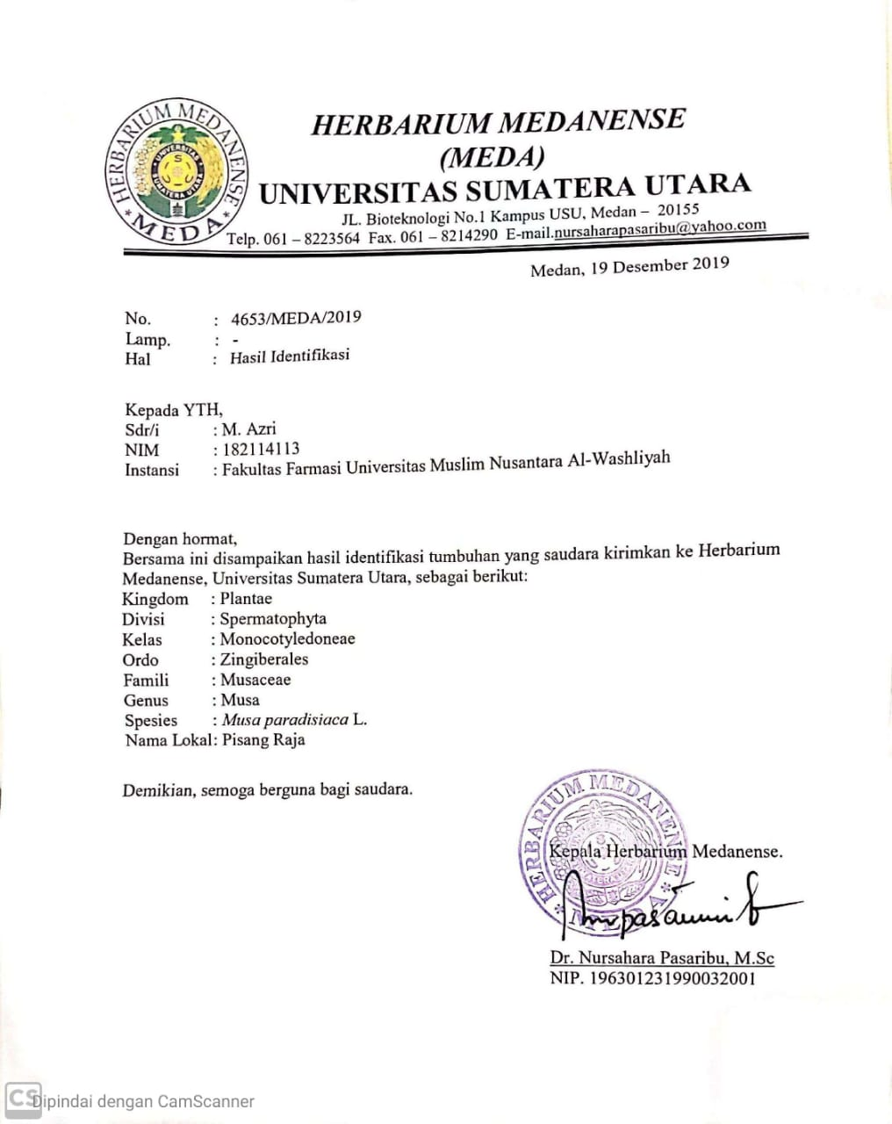
Lampiran 1. Hasil identifikasi tumbuhan pisang raja

Lampiran 2. Tumbuhan pisang raja
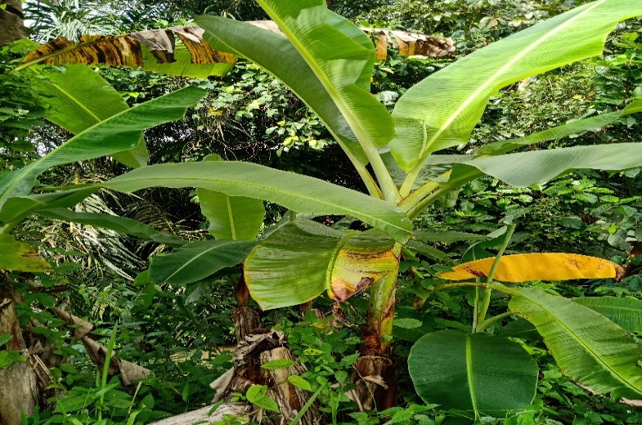

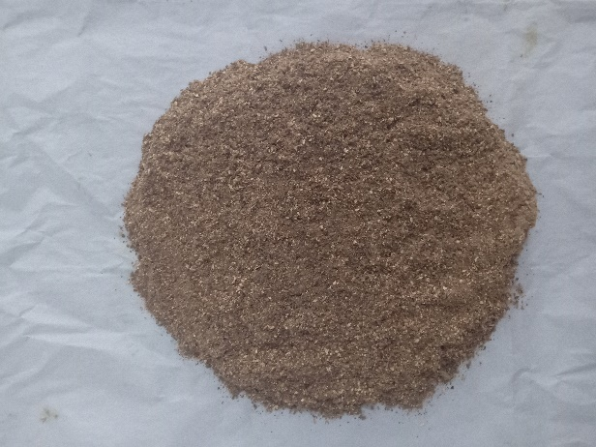
Tumbuhan Pisang Raja (Musa Paradisiaca L.)

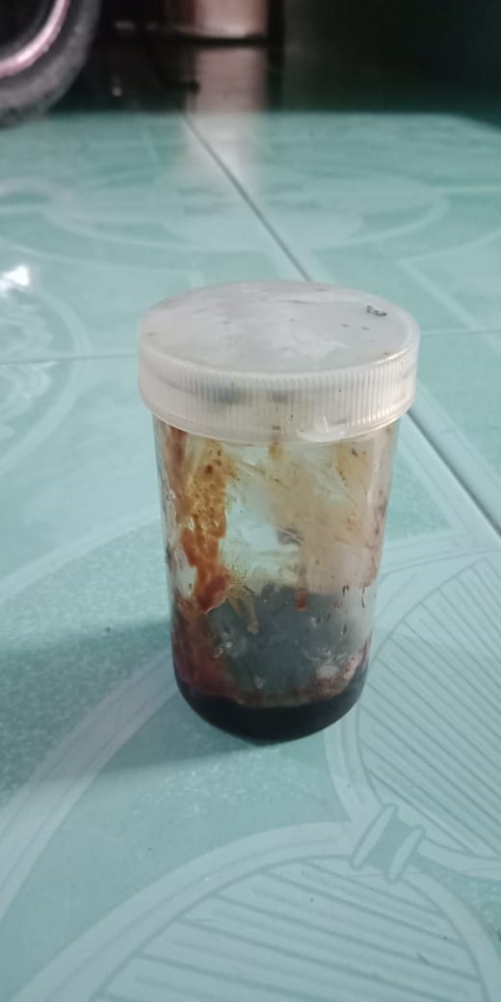
Simplisia Bonggol Pisang
Ekstrak Bongol Pisang
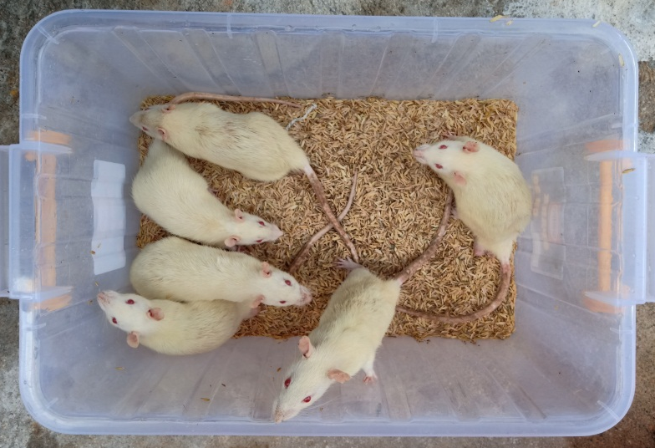
Lampiran 3. Pengujian hewan
Tikus Putih (Rattus novergicus)
Penyuntikan Kaki Tikus Secara Intraplantar
Tapak Kaki Tikus Sebelum Diinkubasi Karagenan

Lampiran 3. (Lanjutan)
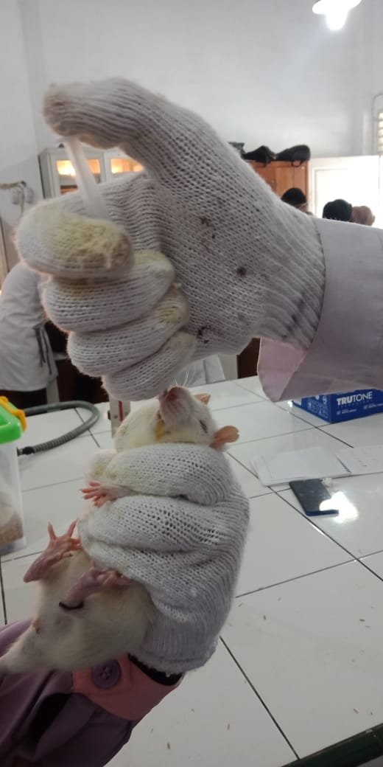
Tapak Kaki Tikus Setelah Diinkubasi Karagenan
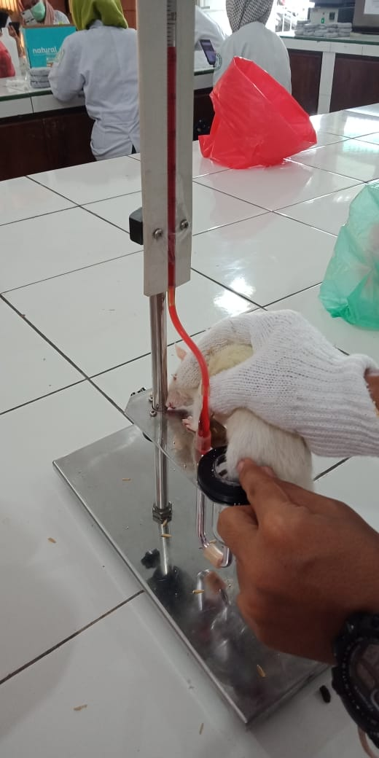
Pemberian Oral Pada Tikus
Pengukuran Inflamasi Dengan Plestismometer

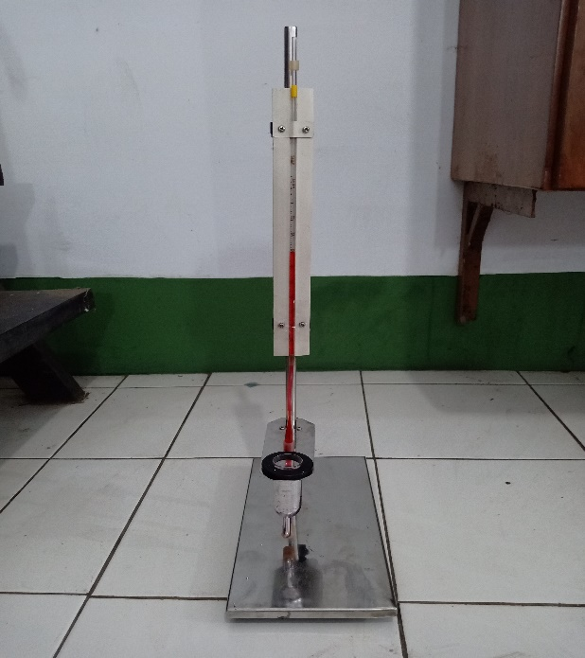
Lampiran 4. Alat penelitian

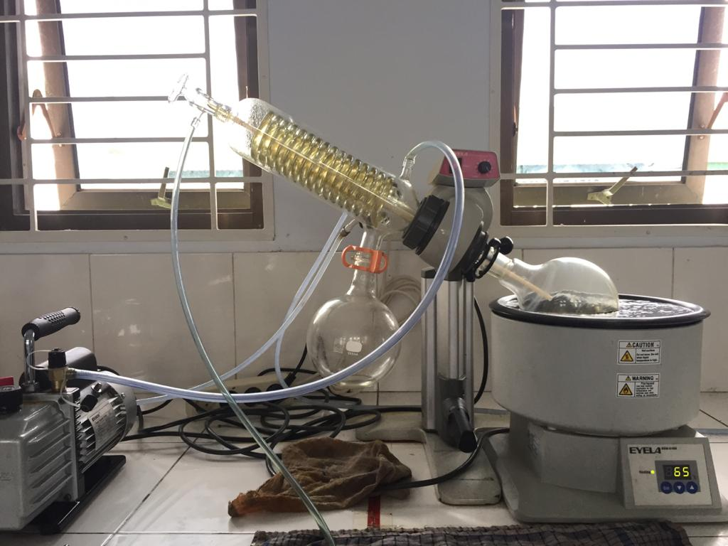
Plestismometer
Rotary Evaporator

Lampiran 5. Bagan alir penelitian
Bonggol pisang 10 kg

Dibersihkan dari pengotor
Dicuci bersih dan ditiriskan
Diangin-anginkan
Ditimbang
Bonggol pisang

Dikeringkan pada suhu 40˚C
Ditimbang
Simplisia kering 1 kg
Dihaluskan
Ditimbang
Serbuk simplisia 1 kg

Dimaserasi dengan etanol 96%
Karakterisasi simplisia :
- Pemeriksaan makroskopik dan mikroskopik
- Penetapan kadar air
- Penetapan kadar sari larut dalam air
- Penetapan kadar sari larut dalam etanol
- Penetapan kadar abu total
- Penetepan kadar abu tidak larut asam
Ekstrak cair
Dipekatkan dengan
rotary evaporator
Skrining fitokimia
- Alkaloid
- Flavonoid
- Steroid/triterpenoid
- Saponin
- Tanin
- Glikosida
Ekstrak kental

Uji antiinflamasi
- %Radang
- %Inbihasi Radang

Lampiran 6. Bagan alir pembuatan simplisia
Bonggol pisang

Dibersihkan dari pengotor
Dicuci bersih dengan air
mengalir
Ditiriskan
Diangin-anginkan
Ditimbang
Berat bonggol pisang setelah dibersihkan

Dikeringkan didalam
lemari pengering
pada suhu 40℃
Disortasi kering
Ditimbang
Berat simplisia 1,3 kg

Dihaluskan menggunakan
blender
Ditimbang
Berat serbuk simplisia 1 kg

Dimasukkan kedalam
wadah
Tertutup rapat
Serbuk simplisia

Lampiran 7. Bagan alir pembuatan ekstrak
5 kg serbuk simplisia bonggol pisang

Dimasukkan kedalam bejana
Ditambahkan etanol 96%
sebanyak 75 bagian (37.500 ml) diaduk
Didiamkan selama 5 hari sambil diaduk
Disaring
Ampas
Maserat I

Dimasukkan dengan etanol 96% sebanyak 25 bagian (12.500 ml) dan diaduk
Dimaserasi kembali selama 2 hari sambil diaduk
Disaring
Maserat II

Maserat bonggol pisang

Diperlukan dengan rotary evaporator pada
suhu 60˚C Diuapkan dengan penangas air
Ekstrak etanol bonggol pisang

Lampiran 8. Perhitungan hasil pemeriksaan karakteristik simplisia
- Penetapan kadar air
Kadar air = $\frac{\left(Volume Akhir Air-Volume Awal Air\right)ml}{Bobot Simplisia} x 100\%$
- Pengulangan I
Berat sampel = 5 gr
Volume akhir = 0,35 ml
Volume awal = 0,15 ml
Kadar Air = $\frac{0,35 ml-0,15 ml}{5 g } x 100\%$ = 4 %
- Pengulangan II
Berat sampel = 5 gr
Volume akhir = 0,35 ml
Volume awal = 0,15 ml
Kadar air = $\frac{0,35 ml-0,15 ml}{5 g } x 100\%$ = 4 %
- Pengulangan III
Berat sampel = 5 gr
Volume akhir = 0,4 ml
Volume awal = 0,15 ml
Kadar air = $\frac{0,4 ml-0,15 ml}{5 g } x 100\%$ = `5 %
kadar air rata-rata =$\frac{4\%+4\%+5\%}{3}$ = 4,3%

Lampiran 8. (Lanjutan)
- Penetapan kadar sari larut dalam air
Kadar sari larut air = $\frac{\left(Berat cawan+sampel\right)-berat cawan kosong) x5}{Bobot Sampel (g)} x100\%$
- Sampel pengulangan I
Berat sampel = 5 gr
Berat Cawan Kosong = 50,8442
B1 = 51,0370
B2 = 51,0369
B3 = 51,0369
Bobot rata-rata = 51,0369
Kadar sari larut air = $\frac{51,0369 g-50,8442 g x 5}{5 g} x 100\%$ = 19,27%
- Sampel pengulangan II
Berat sampel = 5 gr
Berat Cawan Kosong = 105,3764
B1 = 105,6146
B2 = 105,6146
B3 = 105,6146
Bobot rata-rata =105,6146
Kadar sari larut air = $\frac{105,6146 g-105,3764 g x 5}{5 g} x 100\%$ = 23,82%

Lampiran 8. (Lanjutan)
Kadar sari larut air rata-rata = $\frac{19,27\%+23,82\%+23,01\%}{3} x100\%$= 22,03%
- Sampel pengulangan III
Berat sampel = 5 gr
Berat Cawan Kosong = 64,3604
B1 = 64,5906
B2 = 64,5905
B3 = 64,5905
Bobot rata-rata = 64,5905
Kadar sari larut air = $\frac{64,5905 g-64,3604 g x 5}{5 g} x 100\%$ = 23,01%
Kadar sari larut etanol = $\frac{\left(Berat cawan+sampel\right)-berat cawan kosong) x5}{Bobot Sampel (g)} x100\%$
- Penetapan kadar sari larut dalam etanol
- Sampel pengulangan I
Berat sampel = 5 gr
Berat Cawan Kosong = 63,0727
B1 = 63,0958
B2 = 63,0956
B3 = 63,0956
Bobot rata-rata = 63,0956
Kadar sari larut etanol = $\frac{63,0956 g-63,0727 g x 5}{5 g} x 100\%$ = 2,29%

Lampiran 8. (Lanjutan)
- Sampel pengulangan II
Berat sampel = 5 gr
Berat Cawan Kosong = 61,3690
B1 = 61,3912
B2 = 61,3911
B3 = 61,3911
Bobot rata-rata = 61,3911
Kadar sari larut etanol = $\frac{61,3911 g-61,3690 g x 5}{5 g} x 100\%$ = 2,21%
- Sampel pengulangan III
Berat sampel = 5 gr
Berat Cawan Kosong = 61,5021
B1 = 61,5302
B2 = 61,5302
B3 = 61,5302
Bobot rata-rata = 61,5302
Kadar sari larut etanol = $\frac{61,5302 g- 61,5021 g x 5}{5 g} x 100\%$ = 2,81%
Kadar sari larut etanol rata-rata = $\frac{2,29\%+2,21\%+2,81\%}{3} x100\%$ = 2,43%

Lampiran 8. (Lanjutan)
- Penetapan kadar abu total
Kadar abu total = $\frac{\left(Berat cawan+sampel\right)-berat cawan kosong)}{Bobot Sampel (g)} x100\%$
- Sampel pengulangan I
Berat sampel = 2 gr
Berat Cawan Kosong = 26,7637
B1 = 26,7942
B2 = 26,7640
B3 = 26,7640
Bobot rata-rata = 26,7640
Kadar abu total = $\frac{26,7940 g - 26,7637 g}{2 g} x 100\%$ = 1,51%
- Sampel pengulangan II
Berat sampel = 2 gr
Berat Cawan Kosong = 54,3665
B1 = 54,3970
B2 = 54,3970
B3 = 54,3970
Bobot rata-rata = 54,3970
Kadar abu total = $\frac{54,3970 g - 54,3665 g}{2 g} x 100\%$ = 1,52%

Lampiran 8. (Lanjutan)
- Sampel pengulangan III
Berat sampel = 2 gr
Berat Cawan Kosong = 57,9020
B1 = 57,9357
B2 = 57,9356
B3 = 57,9356
Bobot rata-rata = 57,9356
Kadar abu total = $\frac{57,9356 g-57,9020 g }{2 g} x 100\%$ = 1,68%
Kadar abu total rata-rata = $\frac{1,51\% +1,52\% + 1,68\%}{3} x100\%$ = 1,57%
- Penetapan kadar abu tidak larut dalam asam
Kadar abu larut asam = $\frac{\left(Berat cawan+sampel\right)-berat cawan kosong)}{Bobot Sampel (g)} x100\%$
- Sampel pengulangan I
Berat sampel = 0,0303 gr
Berat Cawan Kosong = 52,8518
B1 = 52,8522
B2 = 52,8520
B3 = 52,8520
Bobot rata-rata = 52,8520
Kadar abu larut asam = $\frac{52,8520 g- 52,8518 g }{0,0303 g} x 100\%$ = 0,66%

Lampiran 8. (Lanjutan)
- Sampel pengulangan II
Berat sampel = 0,0305 gr
Berat Cawan Kosong = 52,7267
B1 = 52,7270
B2 = 52,7270
B3 = 52,7270
Bobot rata-rata = 52,7270
Kadar abu larut asam = $\frac{52,7270 g- 52,7267 g }{0,0305 g} x 100\%$ = 0,98 %
- Sampel pengulangan III
Berat sampel = 0,0336 gr
Berat Cawan Kosong = 52,4849
B1 = 52,4851
B2 = 52,4851
B3 = 52,4851
Bobot rata-rata = 52,4851
Kadar abu larut asam = $\frac{52,4851 g- 52,4849 g }{0,0336 g} x 100\%$ = 0,59%
Kadar abu larut asam rata-rata = $\frac{0,66\% +0,98\% + 0,59\%}{3} x100\%$ = 0,74%

Lampiran 9. Tabel konversi perhitungan dosis (Laurence & Bacharach, 1964)
 | Mencit 20 g | Tikus 200 g | Marmot 400 g | Kelinci 1,5 kg | Kucing2 kg | Kera 4 kg | Anjing 12 kg | Manusia 70 kg
Mencit 20 g | 1.0 | 7.0 | 12.25 | 27.8 | 29.7 | 64.1 | 124.2 | 387.9
Tikus 200 g | 0.14 | 1.0 | 1.74 | 3.9 | 4.2 | 9.2 | 17.8 | 56.0
Marmot 400 g | 0.08 | 0.57 | 1.0 | 2.25 | 2.4 | 5.2 | 10.2 | 31.5
Kelinci 1,5 kg | 0.04 | 0.25 | 0.44 | 1.0 | 1.08 | 2.4 | 4.5 | 14.2
Kucing  2 kg | 0.03 | 0.23 | 0.41 | 0.92 | 1.0 | 2.2 | 4.1 | 13.0
Kera 4 kg | 0.016 | 0.11 | 0.19 | 0.42 | 0.45 | 1.0 | 1.9 | 6.1
Anjing 12 kg | 0.008 | 0.06 | 0.1 | 0.22 | 0.24 | 0.52 | 1.0 | 3.1
Manusia 70 kg | 0.0026 | 0.018 | 0.031 | 0.07 | 0.076 | 0.16 | 0.32 | 1.0

Lampiran 10. Perhitungan dosis Kontrol positif (Na. diklofenak 25 mg)
Kontrol positif (Na. diklofenak 25 mg) dalam 100 ml
= $\frac{25 mg }{100 ml}=0,25 mg/ml$= 0,025%
Konversi dosis pada tikus = 0,018
Dosis = 25 mg $x$0,018 = 0,45 mg / 0,2 kg = 2,25 mg/kgBB
Hewan I
Berat = 202 g
= $\frac{2,25 mg}{0,25 mg/ml}=9 ml$
= $\frac{9 ml }{1000 g} x$ 202 g = 1,818 ml
Hewan II
Berat = 210 g
= $\frac{9 ml}{1000 g} x$ 210 g = 1,890 ml
Hewan III
Berat = 206 g
= $\frac{9 ml }{1000 g} x$ 206 g = 1,854 ml

Lampiran 10. (Lanjutan)
Hewan IV
Berat = 198 g
= $\frac{9 ml}{1000 g} x$ 198 g = 1,782 ml
Hewan V
Berat = 201 g
= $\frac{9 ml }{1000 g} x$ 201 g = 1,809 ml
Hewan VI
Berat = 216 g
= $\frac{9 ml}{1000 g} x$ 216 g = 1,944 ml

Lampiran 11. Perhitungan dosis Ekstraak etanol bonggol pisang (EEBP)
      - Ekstrak etanol bonggol pisang (EEBP)
        - EEBP dosis 100 mg
Hewan I
Berat = 193 g
= $\frac{100 mg }{1000 g}x193 g$ = 19,3 mg
= $\frac{19,3 mg }{20 mg/ml}$ = 0,965 ml
Hewan II
Berat = 210 g
= $\frac{100 mg }{1000 g}x210 g$ = 21 mg
= $\frac{21 mg }{20 mg/ml}$ = 1,05 ml
Hewan III
Berat = 214 g
= $\frac{100 mg }{1000 g}x214 g$ = 21,4 mg
= $\frac{21,4 mg }{20 mg/ml}$ = 1,07 ml
Hewan IV
Berat = 192 g
= $\frac{100 mg }{1000 g}x192 g$ = 19,2 mg
= $\frac{19,2 mg }{20 mg/ml}$ = 0,96 ml

Lampiran 11. (Lanjutan)
Hewan V
Berat = 196 g
= $\frac{100 mg }{1000 g}x196 g$ = 19,6 mg
= $\frac{19,6 mg }{20 mg/ml}$ = 0,98 ml
Hewan VI
Berat = 209 g
= $\frac{100 mg }{1000 g}x209 g$ = 20,9 mg
= $\frac{20,9 mg }{20 mg/ml}$ = 1,045 ml
        - EEBP dosis 200 mg
Hewan I
Berat = 220 g
= $\frac{200 mg }{1000 g}x 220 g$ = 44 mg
= $\frac{44 mg }{20 mg/ml}$ = 2,2 ml
Hewan II
Berat = 208 g
= $\frac{200 mg }{1000 g}x 208 g$ = 41,6 mg
= $\frac{41,6 mg }{20 mg/ml}$ = 2,08 ml
Hewan III
Berat = 219 g
= $\frac{200 mg }{1000 g}x 219 g$ = 43,8 mg
= $\frac{43,8 mg }{20 mg/ml}$ = 2,19 ml
Lampiran 11. (Lanjutan)
Hewan IV
Berat = 190 g
= $\frac{200 mg }{1000 g}x 190 g$ = 38 mg
= $\frac{38 mg }{20 mg/ml}$ = 1,9 ml
Hewan V
Berat = 211 g
= $\frac{200 mg }{1000 g}x 211 g$ = 42,2 mg
= $\frac{42,2 mg }{20 mg/ml}$ = 21,1 ml
Hewan VI
Berat = 192 g
= $\frac{200 mg }{1000 g}x192 g$ = 38,4 mg
= $\frac{38,4 mg }{20 mg/ml}$ = 1,92 ml
        - EEBP dosis 300 mg
Hewan I
Berat = 203 g
= $\frac{300 mg }{1000 g}x 203 g$ = 60,9 mg
= $\frac{60,9 mg }{20 mg/ml}$ = 3,04 ml
Hewan II
Berat = 200 g
= $\frac{300 mg }{1000 g}x 200 g$ = 60 mg
= $\frac{60 mg }{20 mg/ml}$ = 3 ml
Lampiran 11. (Lanjutan)
Hewan III
Berat = 214 g
= $\frac{100 mg }{1000 g}x 214 g$ = 21,4 mg
= $\frac{21,4 mg }{20 mg/ml}$ = 1,07 ml
Hewan IV
Berat = 203 g
= $\frac{300 mg }{1000 g}x 203 g$ = 60,9 mg
= $\frac{60,9 mg }{20 mg/ml}$ = 3,04 ml
Hewan V
Berat = 193 g
= $\frac{300 mg }{1000 g}x 196 g$ = 58,8 mg
= $\frac{58,8 mg }{20 mg/ml}$ = 2,94 ml
Hewan VI
Berat = 218 g
= $\frac{300 mg }{1000 g}x 218 g$ = 65,4 mg
= $\frac{65,4 mg }{20 mg/ml}$ = 3,27 ml

Lampiran 12. Makroskopis bonggol pisang raja (Musa paradisiaca L.)
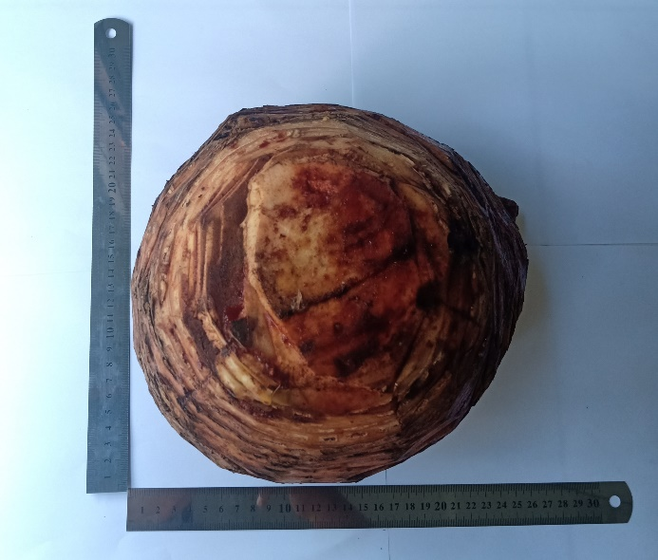

Keterangan
Bentuk : Bulat
Ukuran : Panjang 25,5 cm
Lebar 26 cm
Warna : Coklatan
Bau : Lemah
Rasa : Tawar

Lampiran 13. Mikroskopis bonggol pisang raja (Musa paradisiaca L.)
a
b
c

Keterangan Gambar :
- Parenkim
- Ruang antar sel berisi hablur kalsium oksalat
- Epidermis

Lampiran 14. Data perlakuan hewan uji
Perlakuan | V0 | Jam ke 1 |  |  |  | Jam ke 2 |  |  |  | Jam ke 3 |  |  |  | Jam ke 4 |  |  |  | Jam ke 5 |  |  |  | Jam ke 6
 |  | V1 | %R | %IR | V2 |  | %R | %IR | V3 |  | %R | %IR | V4 |  | %R | %IR | V5 |  | %R | %IR | V6 |  | %R | %IR
CMC 0,5% | 0,04 | 0,072 | 80 |  | 0,074 |  | 85 |  | 0,072 |  | 80 |  | 0,070 |  | 75 |  | 0,070 |  | 75 |  | 0,068 |  | 70
 | 0,04 | 0,078 | 95 |  | 0,080 |  | 100 |  | 0,078 |  | 95 |  | 0,072 |  | 80 |  | 0,072 |  | 80 |  | 0,070 |  | 75
 | 0,04 | 0,080 | 100 |  | 0,082 |  | 105 |  | 0,082 |  | 105 |  | 0,076 |  | 90 |  | 0,072 |  | 80 |  | 0,072 |  | 80
 | 0,04 | 0,074 | 85 |  | 0,078 |  | 95 |  | 0,076 |  | 90 |  | 0,076 |  | 90 |  | 0,076 |  | 90 |  | 0,072 |  | 80
 | 0,04 | 0,080 | 100 |  | 0,082 |  | 105 |  | 0,082 |  | 105 |  | 0,078 |  | 95 |  | 0,076 |  | 90 |  | 0,070 |  | 75
 | 0,04 | 0,080 | 100 |  | 0,082 |  | 105 |  | 0,082 |  | 105 |  | 0,074 |  | 85 |  | 0,072 |  | 80 |  | 0,068 |  | 70
Rata-rata |  |  | 93,33 |  |  |  | 99,16 |  |  |  | 96,66 |  |  |  | 85,83 |  |  |  | 82,5 |  |  |  | 75
Na.  Diklofenak | 0,04 | 0,060 | 50 | 37,5 | 0,068 |  | 70 | 17,65 | 0,062 |  | 55 | 31,25 | 0,050 |  | 25 | 66,67 | 0,048 |  | 20 | 73,33 | 0,042 |  | 70 | 92,86
 | 0,04 | 0,070 | 75 | 21,05 | 0,076 |  | 90 | 10 | 0,074 |  | 85 | 10,53 | 0,062 |  | 55 | 68,75 | 0,050 |  | 25 | 68,75 | 0,040 |  | 75 | 100
 | 0,03 | 0,052 | 73,33 | 26,67 | 0,056 |  | 86,67 | 17,46 | 0,054 |  | 80 | 23,81 | 0,046 |  | 53,33 | 66,67 | 0,038 |  | 26,67 | 66,67 | 0,032 |  | 80 | 91,67
 | 0,03 | 0,050 | 66,67 | 21,57 | 0,054 |  | 80 | 15,79 | 0,052 |  | 73,33 | 18,52 | 0,048 |  | 60 | 33,33 | 0,040 |  | 33,33 | 62,96 | 0,030 |  | 80 | 100
 | 0,04 | 0,070 | 75 | 25 | 0,078 |  | 95 | 9,52 | 0,070 |  | 75 | 28,57 | 0,066 |  | 65 | 31,58 | 0,052 |  | 30 | 66,67 | 0,040 |  | 75 | 100
 | 0,04 | 0,072 | 80 | 20 | 0,078 |  | 95 | 9,52 | 0,068 |  | 70 | 33,33 | 0,050 |  | 25 | 70,59 | 0,048 |  | 20 | 75 | 0,042 |  | 70 | 92,86
Rata-rata |  |  | 70 | 25,29 |  |  | 86,11 | 13,32 |  |  | 73,05 | 24,33 |  |  | 47,22 | 56,26 |  |  | 25,83 | 68,26 |  |  | 2,77 | 96,23
EEBP 100  mg/kgBB | 0,04 | 0,070 | 75 | 6,25 | 0,078 |  | 95 | -11,7 | 0,074 |  | 85 | -6,25 | 0,070 |  | 75 | 0 | 0,068 |  | 70 | 6,667 | 0,065 |  | 62,5 | 10,71
 | 0,04 | 0,072 | 80 | 15,79 | 0,080 |  | 100 | 0 | 0,074 |  | 85 | 10,53 | 0,072 |  | 80 | 0 | 0,072 |  | 80 | 0 | 0,068 |  | 70 | 6,667
 | 0,03 | 0,054 | 80 | 20 | 0,058 |  | 93,33 | 11,11 | 0,056 |  | 86,67 | 17,46 | 0,054 |  | 80 | 11,11 | 0,050 |  | 66,67 | 16,67 | 0,046 |  | 53,33 | 33,33
 | 0,04 | 0,070 | 75 | 11,76 | 0,080 |  | 100 | -5,26 | 0,072 |  | 80 | 11,11 | 0,070 |  | 75 | 16,67 | 0,068 |  | 70 | 22,22 | 0,064 |  | 60 | 25
 | 0,03 | 0,054 | 80 | 20 | 0,058 |  | 93,33 | 11,11 | 0,056 |  | 86,67 | 17,46 | 0,052 |  | 73,33 | 22,8 | 0,050 |  | 66,67 | 25,93 | 0,048 |  | 60 | 20
 | 0,04 | 0,070 | 75 | 25 | 0,080 |  | 100 | 4,76 | 0,072 |  | 80 | 23,81 | 0,070 |  | 75 | 11,76 | 0,068 |  | 70 | 12,5 | 0,064 |  | 60 | 14,29
Rata-rata |  |  | 77,5 | 16,46 |  |  | 96,94 | 1,65 |  |  | 83,88 | 12,35 |  |  | 76,38 | 10,39 |  |  | 70,55 | 13,99 |  |  | 60,97 | 18,33

Lampiran 14. (Lanjutan)
Perlakuan | V0 | Jam ke 1 |  |  |  | Jam ke 2 |  |  |  | Jam ke 3 |  |  |  | Jam ke 4 |  |  |  | Jam ke 5 |  |  |  | Jam ke 6
 |  | V1 | %R | %IR | V2 |  | %R | %IR | V3 |  | %R | %IR | V4 |  | %R | %IR | V5 |  | %R | %IR | V6 |  | %R | %IR
EEBP 200  mg/kgBB | 0,04 | 0,068 | 70 | 12,5 | 0,076 |  | 90 | -5,88 | 0,072 |  | 80 | 0 | 0,070 |  | 75 | 0 | 0,060 |  | 50 | 33,33 | 0,050 |  | 25 | 64,29
 | 0,04 | 0,072 | 80 | 15,79 | 0,078 |  | 95 | 5 | 0,074 |  | 85 | 10,53 | 0,072 |  | 80 | 0 | 0,060 |  | 50 | 37,5 | 0,052 |  | 30 | 60
 | 0,03 | 0,054 | 80 | 20 | 0,060 |  | 100 | 4,76 | 0,056 |  | 86,67 | 17,46 | 0,052 |  | 73,33 | 18,52 | 0,046 |  | 53,33 | 33,33 | 0,038 |  | 26,67 | 66,67
 | 0,04 | 0,072 | 80 | 5,882 | 0,078 |  | 95 | 0 | 0,072 |  | 80 | 11,11 | 0,070 |  | 75 | 16,67 | 0,062 |  | 55 | 38,89 | 0,050 |  | 25 | 68,75
 | 0,04 | 0,070 | 75 | 25 | 0,076 |  | 90 | 19,29 | 0,072 |  | 80 | 23,81 | 0,070 |  | 75 | 21,05 | 0,058 |  | 45 | 50 | 0,050 |  | 25 | 66,67
 | 0,04 | 0,068 | 70 | 30 | 0,076 |  | 90 | 14,29 | 0,070 |  | 75 | 28,57 | 0,068 |  | 70 | 2,647 | 0,060 |  | 50 | 37,5 | 0,054 |  | 35 | 50
Rata-rata |  |  | 75,83 | 18,19 |  |  | 93,33 | 6,24 |  |  | 81,11 | 15,24 |  |  | 74,72 | 9,81 |  |  | 50,55 | 38,42 |  |  | 27,77 | 62,72
EEBP 300  mg/kgBB | 0,04 | 0,068 | 70 | 12,5 | 0,074 |  | 85 | 0 | 0,074 |  | 85 | -6,25 | 0,068 |  | 70 | 6,667 | 0,060 |  | 50 | 33,33 | 0,044 |  | 10 | 85,71
 | 0,04 | 0,072 | 80 | 15,79 | 0,076 |  | 90 | 10 | 0,070 |  | 75 | 21,05 | 0,064 |  | 60 | 25 | 0,056 |  | 40 | 50 | 0,046 |  | 15 | 80
 | 0,03 | 0,052 | 73,33 | 26,67 | 0,058 |  | 93,33 | 11,11 | 0,054 |  | 80 | 23,81 | 0,048 |  | 60 | 33,33 | 0,042 |  | 40 | 50 | 0,034 |  | 13,33 | 83,33
 | 0,04 | 0,072 | 80 | 5,882 | 0,076 |  | 90 | 5,263 | 0,070 |  | 75 | 16,67 | 0,064 |  | 60 | 33,33 | 0,054 |  | 35 | 61,11 | 0,046 |  | 15 | 81,25
 | 0,04 | 0,068 | 70 | 30 | 0,076 |  | 90 | 14,29 | 0,072 |  | 80 | 23,81 | 0,062 |  | 55 | 42,11 | 0,056 |  | 40 | 55,56 | 0,046 |  | 15 | 80
 | 0,04 | 0,068 | 70 | 30 | 0,076 |  | 90 | 14,29 | 0,070 |  | 75 | 28,57 | 0,064 |  | 60 | 29,41 | 0,052 |  | 30 | 62,5 | 0,044 |  | 10 | 85,71
Rata-rata |  |  | 73,88 | 20,13 |  |  | 89,72 | 9,15 |  |  | 78,33 | 17,94 |  |  | 60,83 | 28,30 |  |  | 39,16 | 52,08 |  |  | 13,05 | 82,66

Lampiran 15. Hasil persentase radang uji ANOVA
ANOVA
 |  | Sum of Squares | df | Mean Square | F | Sig.
J1 | Between Groups | 1944.533 | 4 | 486.133 | 9.822 | .000
 | Within Groups | 1237.333 | 25 | 49.493
 | Total | 3181.867 | 29
J2 | Between Groups | 677.667 | 4 | 169.417 | 4.365 | .008
 | Within Groups | 970.333 | 25 | 38.813
 | Total | 1648.000 | 29
J3 | Between Groups | 1871.467 | 4 | 467.867 | 9.225 | .000
 | Within Groups | 1268.000 | 25 | 50.720
 | Total | 3139.467 | 29
J4 | Between Groups | 5475.800 | 4 | 1368.950 | 16.701 | .000
 | Within Groups | 2049.167 | 25 | 81.967
 | Total | 7524.967 | 29
J5 | Between Groups | 12680.467 | 4 | 3170.117 | 107.900 | .000
 | Within Groups | 734.500 | 25 | 29.380
 | Total | 13414.967 | 29
J6 | Between Groups | 23082.667 | 4 | 5770.667 | 355.775 | .000
 | Within Groups | 405.500 | 25 | 16.220
 | Total | 23488.167 | 29

Lampiran 16. Hasil persentase radang uji Tukey HSD

J1
Tukey HSD
% Radang | N | Subset for alpha = 0.05
 |  | 1 | 2
Na. Diklofenak 25 mg/kgBB | 6 | 69.8333
300 mg/kgBB | 6 | 73.8333
200 mg/kgBB | 6 | 75.8333
100 mg/kgBB | 6 | 77.5000
CMC 0,5% | 6 |  | 93.3333
Sig. |  | .350 | 1.000
Means for groups in homogeneous subsets are displayed.
a. Uses Harmonic Mean Sample Size = 6.000.

J2
Tukey HSD
% Radang | N | Subset for alpha = 0.05
 |  | 1 | 2
Na. Diklofenak 25 mg/kgBB | 6 | 86.0000
300 mg/kgBB | 6 | 89.6667 | 89.6667
200 mg/kgBB | 6 | 93.3333 | 93.3333
100 mg/kgBB | 6 |  | 96.8333
CMC 0,5% | 6 |  | 99.1667
Sig. |  | .278 | .093
Means for groups in homogeneous subsets are displayed.
a. Uses Harmonic Mean Sample Size = 6.000.

J3
Tukey HSD
% Radang | N | Subset for alpha = 0.05
 |  | 1 | 2
Na. Diklofenak 25 mg/kgBB | 6 | 73.0000
300 mg/kgBB | 6 | 78.3333
200 mg/kgBB | 6 | 81.0000
100 mg/kgBB | 6 | 83.6667
CMC 0,5% | 6 |  | 96.6667
Sig. |  | .102 | 1.000
Means for groups in homogeneous subsets are displayed.
a. Uses Harmonic Mean Sample Size = 6.000.

Lampiran 16. (Lanjutan)
J4
Tukey HSD
% Radang | N | Subset for alpha = 0.05
 |  | 1 | 2 | 3
Na. Diklofenak 25 mg/kgBB | 6 | 47.1667
300 mg/kgBB | 6 | 60.8333 | 60.8333
200 mg/kgBB | 6 |  | 74.6667 | 74.6667
100 mg/kgBB | 6 |  |  | 76.3333
CMC 0,5% | 6 |  |  | 85.8333
Sig. |  | .098 | .092 | .237
Means for groups in homogeneous subsets are displayed.
a. Uses Harmonic Mean Sample Size = 6.000.

J5
Tukey HSD
% Radang | N | Subset for alpha = 0.05
 |  | 1 | 2 | 3 | 4 | 5
Na. Diklofenak 25 mg/kgBB | 6 | 25.6667
300 mg/kgBB | 6 |  | 39.1667
200 mg/kgBB | 6 |  |  | 50.5000
100 mg/kgBB | 6 |  |  |  | 70.3333
CMC 0,5% | 6 |  |  |  |  | 82.5000
Sig. |  | 1.000 | 1.000 | 1.000 | 1.000 | 1.000
Means for groups in homogeneous subsets are displayed.
a. Uses Harmonic Mean Sample Size = 6.000.

J6
Tukey HSD
% Radang | N | Subset for alpha = 0.05
 |  | 1 | 2 | 3 | 4 | 5
Na. Diklofenak 25 mg/kgBB | 6 | 2.6667
300 mg/kgBB | 6 |  | 13.0000
200 mg/kgBB | 6 |  |  | 27.6667
100 mg/kgBB | 6 |  |  |  | 60.8333
CMC 0,5% | 6 |  |  |  |  | 75.0000
Sig. |  | 1.000 | 1.000 | 1.000 | 1.000 | 1.000
Means for groups in homogeneous subsets are displayed.
a. Uses Harmonic Mean Sample Size = 6.000.

Lampiran 17. Hasil persentase inhibisi radang uji ANOVA
ANOVA
 |  | Sum of Squares | df | Mean Square | F | Sig.
J1 | Between Groups | 264.333 | 3 | 88.111 | 1.258 | .316
 | Within Groups | 1401.000 | 20 | 70.050
 | Total | 1665.333 | 23
J2 | Between Groups | 386.333 | 3 | 128.778 | 2.957 | .057
 | Within Groups | 871.000 | 20 | 43.550
 | Total | 1257.333 | 23
J3 | Between Groups | 459.792 | 3 | 153.264 | 1.446 | .259
 | Within Groups | 2119.167 | 20 | 105.958
 | Total | 2578.958 | 23
J4 | Between Groups | 8473.125 | 3 | 2824.375 | 17.123 | .000
 | Within Groups | 3298.833 | 20 | 164.942
 | Total | 11771.958 | 23
J5 | Between Groups | 9690.167 | 3 | 3230.056 | 48.805 | .000
 | Within Groups | 1323.667 | 20 | 66.183
 | Total | 11013.833 | 23
J6 | Between Groups | 20800.125 | 3 | 6933.375 | 162.469 | .000
 | Within Groups | 853.500 | 20 | 42.675
 | Total | 21653.625 | 23

Lampiran 18. Hasil persentase inhibisi radang uji Tukey HSD
J1
Tukey HSD
% Inhibisi Radang | N | Subset for alpha = 0.05
 |  | 1
100 mg/kgBB | 6 | 16.1667
200 mg/kgBB | 6 | 17.8333
300 mg/kgBB | 6 | 19.6667
Na. Diklofenak 25 mg/kgBB | 6 | 25.0000
Sig. |  | .290
Means for groups in homogeneous subsets are displayed.
a. Uses Harmonic Mean Sample Size = 6,000.

J2
Tukey HSD
% Inhibisi Radang | N | Subset for alpha = 0.05
 |  | 1 | 2
100 mg/kgBB | 6 | 1.6667
200 mg/kgBB | 6 | 7.8333 | 7.8333
300 mg/kgBB | 6 | 9.0000 | 9.0000
Na. Diklofenak 25 mg/kgBB | 6 |  | 12.8333
Sig. |  | .250 | .566
Means for groups in homogeneous subsets are displayed.
a. Uses Harmonic Mean Sample Size = 6,000.

J3
Tukey HSD
% Inhibisi Radang | N | Subset for alpha = 0.05
 |  | 1
100 mg/kgBB | 6 | 12.0000
200 mg/kgBB | 6 | 14.8333
300 mg/kgBB | 6 | 17.5000
Na. Diklofenak 25 mg/kgBB | 6 | 23.8333
Sig. |  | .224
Means for groups in homogeneous subsets are displayed.
a. Uses Harmonic Mean Sample Size = 6,000.

Lampiran 18. (Lanjutan)
J4
Tukey HSD
% Inhibisi Radang | N | Subset for alpha = 0.05
 |  | 1 | 2
200 mg/kgBB | 6 | 9.5000
100 mg/kgBB | 6 | 10.0000
300 mg/kgBB | 6 | 28.0000
Na. Diklofenak 25 mg/kgBB | 6 |  | 55.6667
Sig. |  | .091 | 1.000
Means for groups in homogeneous subsets are displayed.
a. Uses Harmonic Mean Sample Size = 6,000.

J5
Tukey HSD
% Inhibisi Radang | N | Subset for alpha = 0.05
 |  | 1 | 2 | 3 | 4
100 mg/kgBB | 6 | 13.5000
200 mg/kgBB | 6 |  | 38.0000
300 mg/kgBB | 6 |  |  | 51.8333
Na. Diklofenak 25 mg/kgBB | 6 |  |  |  | 68.3333
Sig. |  | 1.000 | 1.000 | 1.000 | 1.000
Means for groups in homogeneous subsets are displayed.
a. Uses Harmonic Mean Sample Size = 6,000.

J6
Tukey HSD
% Inhibisi Radang | N | Subset for alpha = 0.05
 |  | 1 | 2 | 3 | 4
100 mg/kgBB | 6 | 18.0000
200 mg/kgBB | 6 |  | 62.3333
300 mg/kgBB | 6 |  |  | 82.3333
Na. Diklofenak 25 mg/kgBB | 6 |  |  |  | 95.8333
Sig. |  | 1.000 | 1.000 | 1.000 | 1.000
Means for groups in homogeneous subsets are displayed.
a. Uses Harmonic Mean Sample Size = 6,000.

