Lampiran 1. Surat Determinasi Buah Jeruk Bali
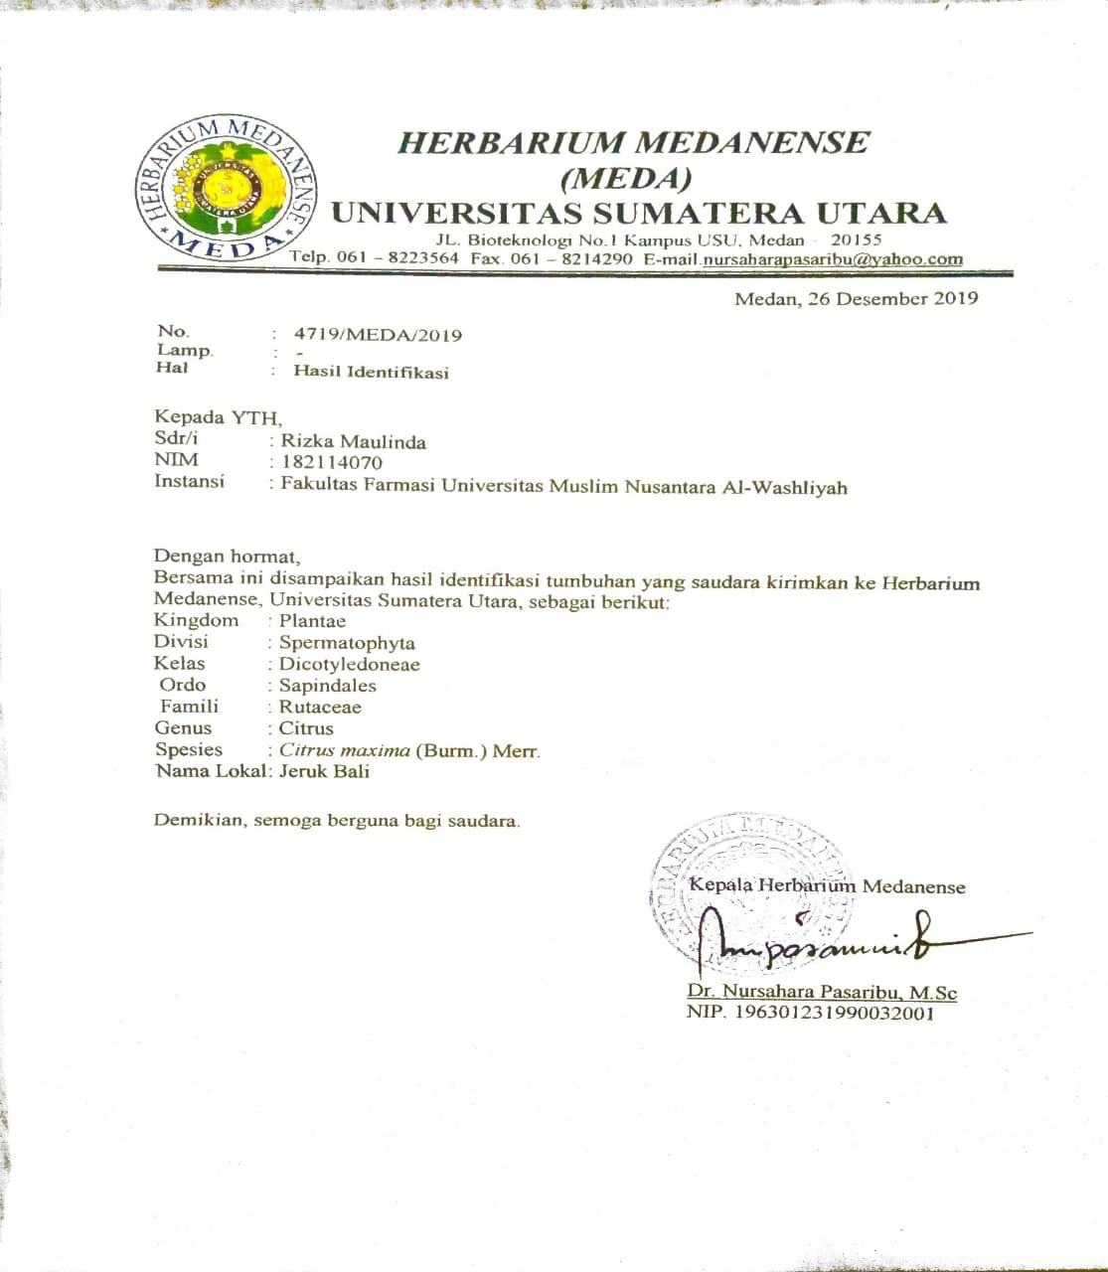

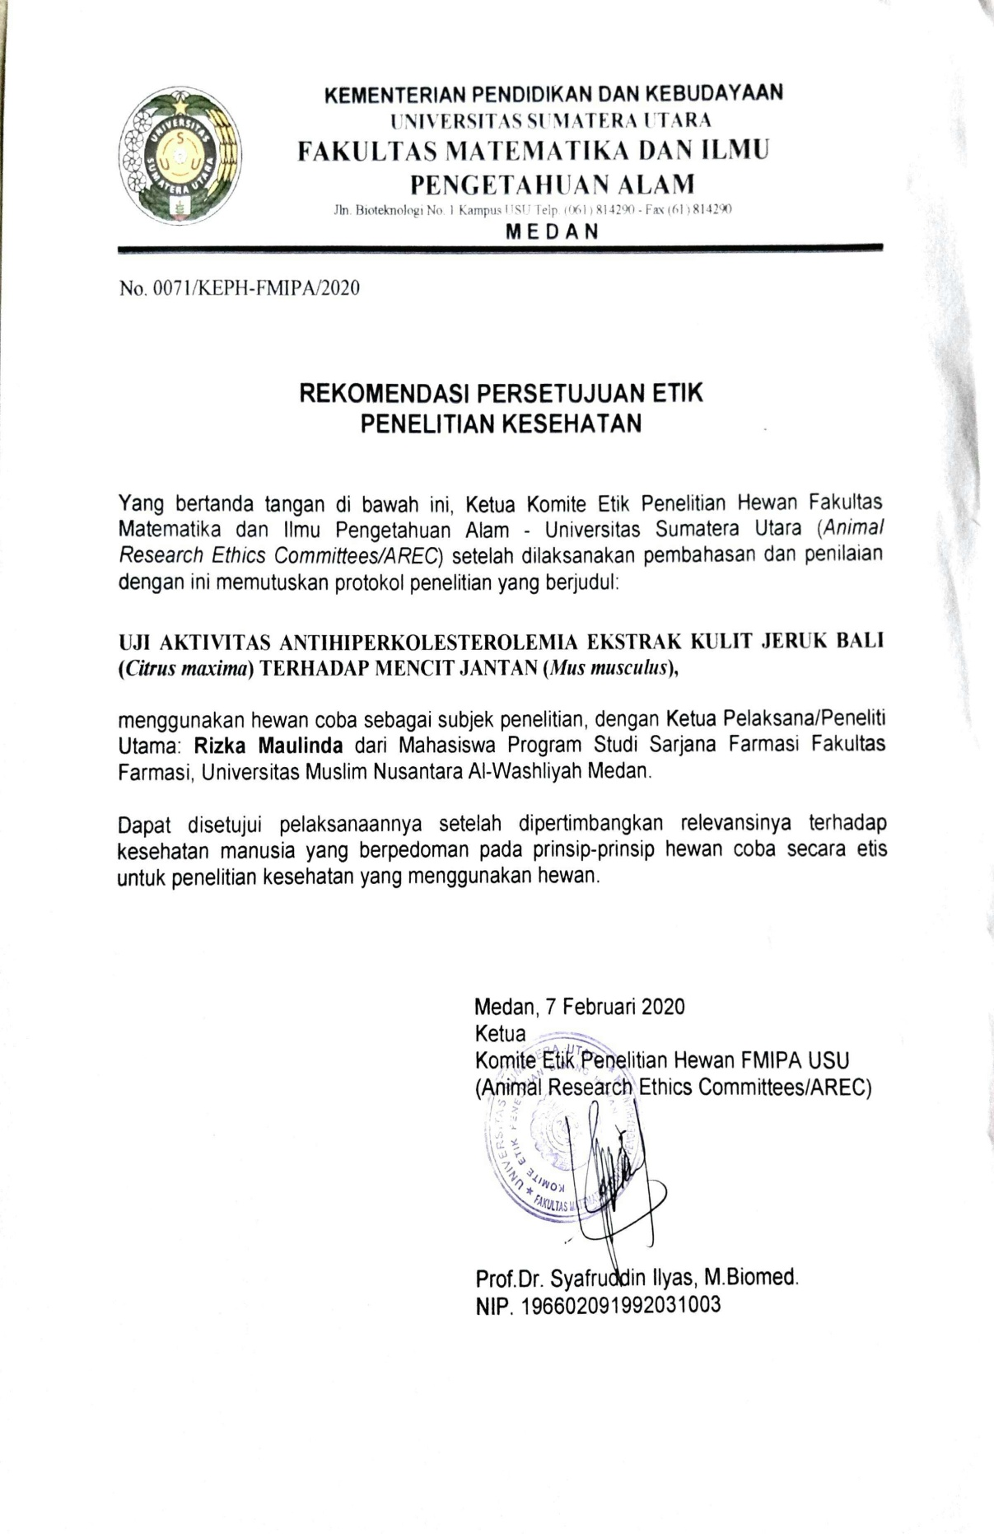
Lampiran 2. Surat Rekomendasi Persetujuan Etik Penelitian

Lampiran 3. Bagan Alir Penelitian
Kulit jeruk bali
gram
Disortasi basah, dicuci, ditimbang, dikeringkan, disortasi kering dan ditimbang
Simplisia kering
gram
Serbuk simplia
gram
Dihaluskan dengan blender, ditimbang dan disimpan dalam wadah bertutup rapat
Skrining kulit jeruk bali
karakterisasi
Pembuatan ekstrak etanol kulit jeruk bali (EEKJB)
- Alkaloid
- Flavonoid
- Tanin
- Saponin
- Steroid/triterpenoid
- Glikosida
- Glikosida antrakuinon
- Makroskopik
- Kadar air
- Kadar sari larut air
- Kadar sari larut etanol
- Kadar abu total
- Kadar abu tidak larut asam
Dimaserasi dengan etanol 96% dan diuapkan dengan Vacum rotary evaporator
Ekstrak etanol kulit jeruk bali
Kulit jeruk bali
gram
Disortasi basah, dicuci, ditimbang, dikeringkan, disortasi kering dan ditimbang
Simplisia kering
gram
Serbuk simplia
gram
Dihaluskan dengan blender, ditimbang dan disimpan dalam wadah bertutup rapat
Skrining kulit jeruk bali
karakterisasi
Pembuatan ekstrak etanol kulit jeruk bali (EEKJB)
- Alkaloid
- Flavonoid
- Tanin
- Saponin
- Steroid/triterpenoid
- Glikosida
- Glikosida antrakuinon
- Makroskopik
- Kadar air
- Kadar sari larut air
- Kadar sari larut etanol
- Kadar abu total
- Kadar abu tidak larut asam
Dimaserasi dengan etanol 96% dan diuapkan dengan Vacum rotary evaporator
Ekstrak etanol kulit jeruk bali

Lampiran 3. (Lanjutan)
Mencit
Dikelompokkan menjadi 5 kelompok

Aklimatisasi selama 2 minggu
Pemberian bahan uji secara oral
Kelompok 1
Kelompok 2
Kelompok 3
Simvastatin
Larutan Na-CMC
Dosis Rendah 200 mg EKJB
Dosis Sedang 400 mg EKJB
Dosis
Tinggi
600 mg EKJB
Pengamatan dilakukan setelah pemberian ekstrak selama 14 hari
Pengukuran kadar kolesterol dalam darah pada mencit diukur menggunakan alat
Kadar kolesterol mencit
Kelompok
4
Kelompok 5
Induksi kuning telur angsa
Diukur kadar kolesterol mencit
Mencit
Dikelompokkan menjadi 5 kelompok

Aklimatisasi selama 2 minggu
Pemberian bahan uji secara oral
Kelompok 1
Kelompok 2
Kelompok 3
Simvastatin
Larutan Na-CMC
Dosis Rendah 200 mg EKJB
Dosis Sedang 400 mg EKJB
Dosis
Tinggi
600 mg EKJB
Pengamatan dilakukan setelah pemberian ekstrak selama 14 hari
Pengukuran kadar kolesterol dalam darah pada mencit diukur menggunakan alat
Kadar kolesterol mencit
Kelompok
4
Kelompok 5
Induksi kuning telur angsa
Diukur kadar kolesterol mencit

Lampiran 4. Sampel yang digunakan

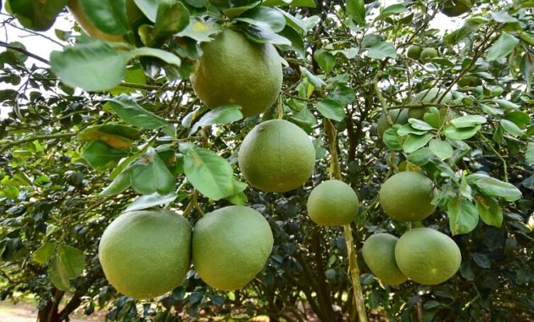
Buah jeruk bali

Lampiran 5. Hasil Identifikasi Makroskopik
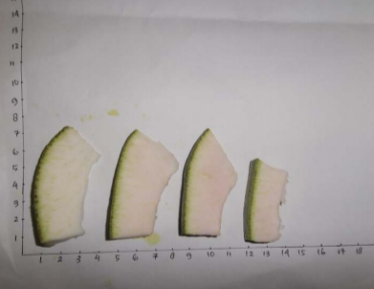

Kulit buah jeruk bali

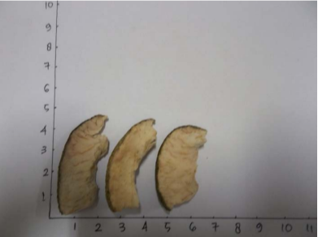
Simplisia kulit jeruk bali

Lampiran 6. Hasil Identifikasi Mikroskopik
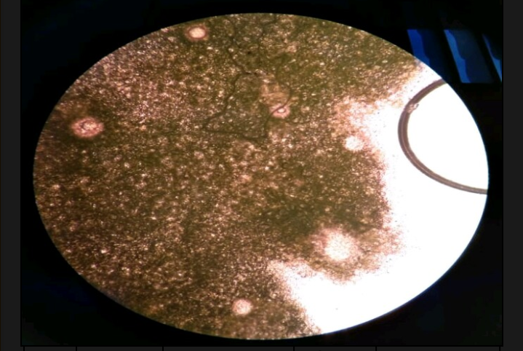

1

Hasil mikroskopik penampang melintang kulit jeruk bali perbesaran 400 x

Keterangan:
- Fragmen rongga minyak skizolisigen

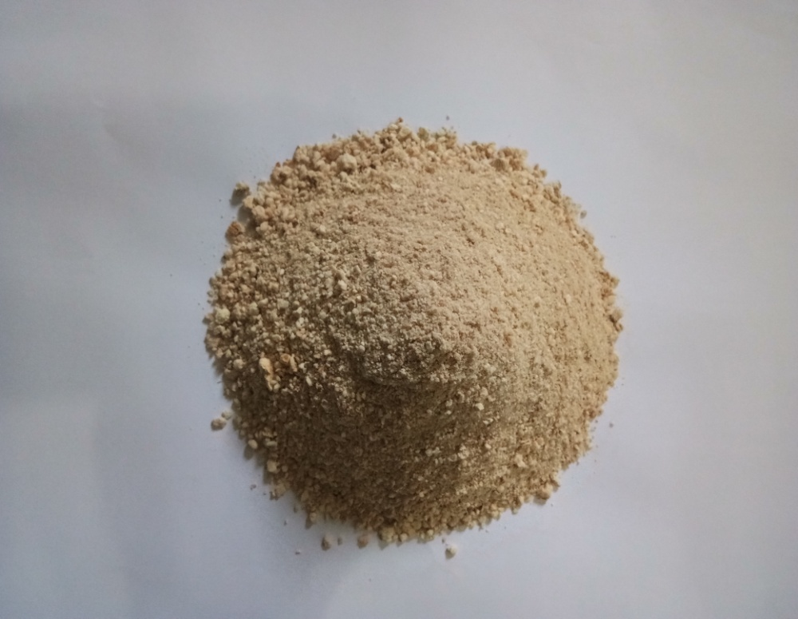
Lampiran 7. Proses Ekstraksi

Serbuk simplisia kulit jeruk bali

Ekstraksi Maserasi

Lampiran 8. Vacum rotary evaporator dan pengukuran kadar air
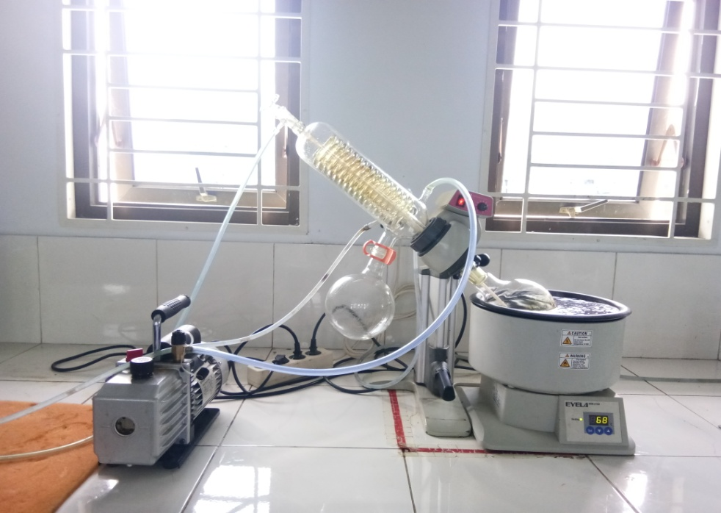

Pengentalan ekstrak menggunakan vacum rotary evaporator

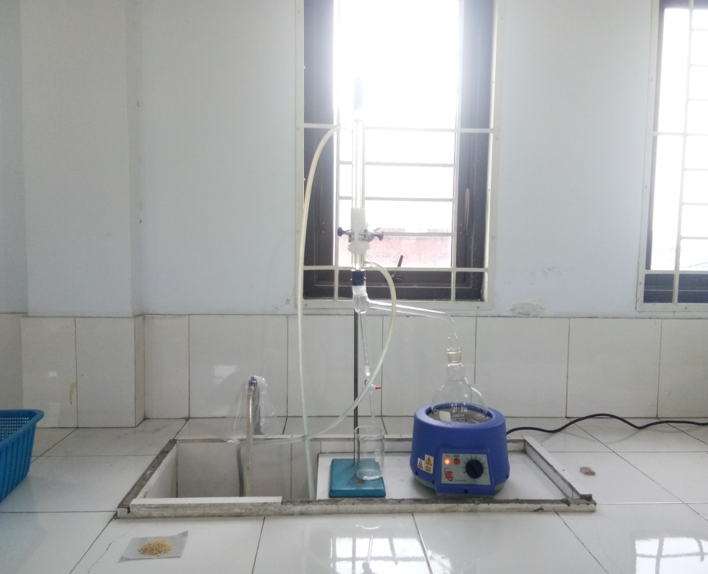

Pengukuran kadar air

Lampiran 9. Ekstrak kulit jeruk bali dan pengujian antihiperkolestrolemia

Ekstrak kulit jeruk bali

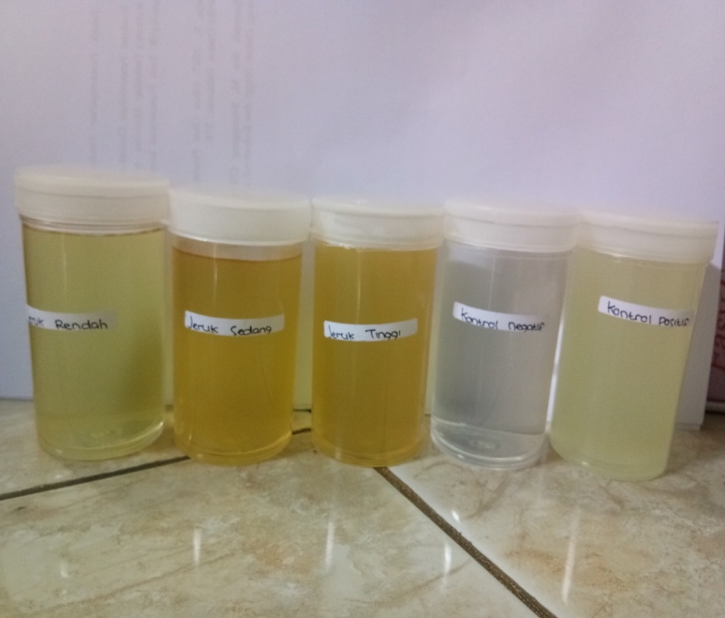

Larutan uji

Lampiran 10. Hasil uji skrinning fitokimia
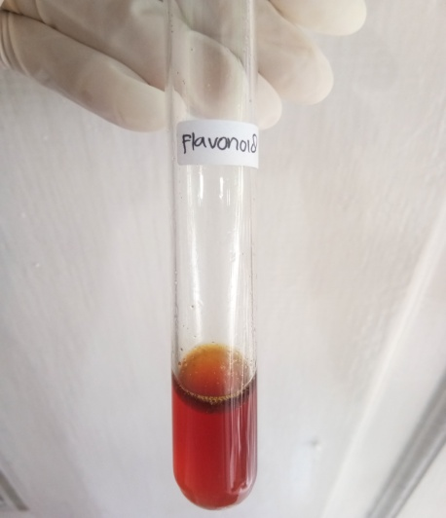
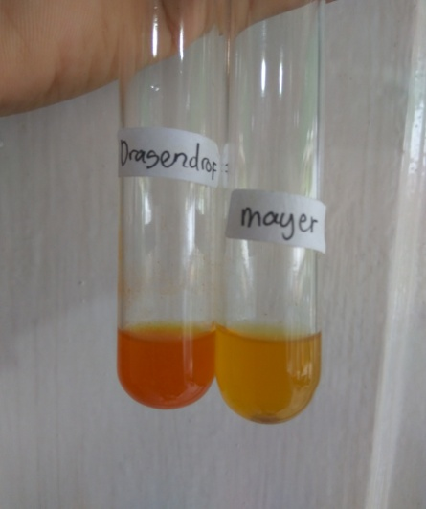

Alkaloid Flavonoid
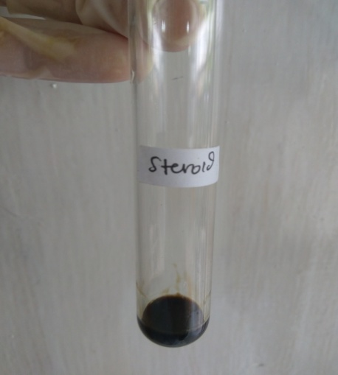
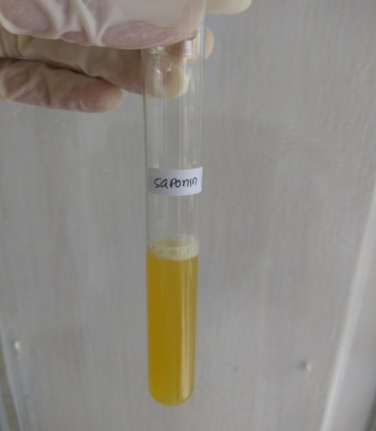

Saponin Steroid
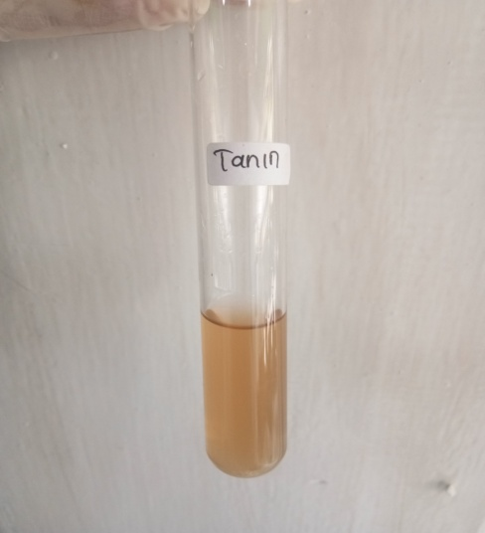

Tanin

Lampiran 11. Perhitungan hasil karakterisasi simplisia
1. Penetapan Kadar sari yang larut dalam Air
Berat Cawan mula-mula = $\frac{29,8257gr+29,8258gr+29,8255gr}{3}$ = $29,82566$gr
Berat Cawan + Zat terlarut = $\frac{30,2642gr+30,2642gr+30,2640gr}{3}$ = $30,26413$gr
Massa Zat Terlarut = (Berat Cawan + Zat terlarut) - Berat Cawan mula-mula
= $30,26413$gr - $29,82566$
= 0,43847gr
%Kadar sari larut dalam air = $\frac{massa zat terlarut}{massa awal}$x100%
= $\frac{0,43847 gr}{1 gr}$x100%
= 43,847%
2. Penetapan Kadar sari yang larut dalam Etanol
Berat Cawan mula-mula = $\frac{29,8257gr+29,8258gr+29,8255gr}{3}$ = $29,82566$gr
Berat Cawan + Zat terlarut = $\frac{30,0502gr+30,0501gr+30,0509gr}{3}$ = $30,0504$gr
Massa Zat Terlarut = (Berat Cawan + Zat terlarut) - Berat Cawan mula-mula
= $30,0504$gr - $29,82566$gr
= 0,22474 gr
%Kadar sari larut dalam etanol = $\frac{massa zat terlarut}{massa awal}$x100%
= $\frac{0,22474gr}{1 gr}$x100%
= 22,474%
3. Penetapan Kadar Abu Total
Berat Cawan mula-mula (A) = $\frac{12,1176gr+12,1176gr+12,1172gr}{3}$ = $12,11746$gr
Berat Cawan mula-mula + Sampel sebelum ditanur = $12,11746$gr + 2,0010gr
= $12,11846$gr
Berat Cawan + Sampel setelah ditanur (B) = $\frac{12,2017gr+12,2018gr+12,2020gr}{3}$ = $12,20183$gr

Lampiran 11. (Lanjutan)
Massa Abu Total = B-A
= $12,20183$gr - $12,11746$gr
= 0,08437gr
%Kadar Abu Total = $\frac{massa abu total}{sampel sebelum ditanur}$x100%
= $\frac{0,08437gr}{2,0010 gr}$x100%
= 4,216%
4. Penetapan Kadar Abu Yang Tidak Larut Dalam Asam
Berat kertas saring = $\frac{1,0350gr+1,0355gr+1,0356gr}{3}$ = 1,0353gr
Berat kertas saring + residu = $\frac{1,6886gr+1,6880gr+1,6880gr}{3}$ = $1,6882$gr
Residu = (Berat kertas saring + residu) – (Berat kertas saring)
= $1,6882$gr - 1,0353gr
= 0,3352gr
%Kadar Abu Yang Tidak Larut Dalam Asam= $\frac{Residu}{massa abu total}$x100%
= $\frac{0,3352 gr}{0,08437gr}$x100%
= 3,97%
5.Penetapan kadar air
Diperoleh V1= 0,6 dan V2 = 0,75
% kadar air = $\frac{V2-V1}{2,5 g}$ x 100%
= $\frac{0,75-0,6}{2,5 g}$ x 100%
= 6 %

Lampiran 12. Tabel Konversi Perhitungan Dosis Antara Jenis Hewan dan Manusia
Hewan dan BB rata-rata | Mencit  20 g | Tikus  200 g | Marmut  400 g | Kelinci  1,5 Kg | Kucing  2 Kg | Kera  4 Kg | Anjing  12 Kg | Manusia  70 Kg
Mencit  20 g | 1,0 | 7,0 | 12,29 | 27,8 | 28,7 | 64,1 | 124,2 | 387,9
Tikus  200 g | 0,14 | 1,0 | 1,74 | 3,9 | 4,2 | 9,2 | 17,8 | 60,5
Marmut  400 g | 0,08 | 0,57 | 1,0 | 2,25 | 2,4 | 5,2 | 10,2 | 31,5
Kelinci  1,5 Kg | 0,04 | 0,25 | 0,44 | 1,0 | 1,06 | 2,4 | 4,5 | 14,2
Kucing  2 Kg | 0,03 | 0,23 | 0,41 | 0,92 | 1,0 | 2,2 | 4,1 | 13,0
Kera  4 Kg | 0,016 | 0,11 | 0,19 | 0,42 | 0,45 | 1,0 | 1,9 | 6,1
Anjing  12 Kg | 0,008 | 0,06 | 0,10 | 0,22 | 0,24 | 0,52 | 1,0 | 3,1
Manusia  70 Kg | 0,0026 | 0,018 | 0,031 | 0,07 | 0,76 | 0,16 | 0,32 | 1,0

Lampiran 13. Perhitungan Dosis Sediaan
- Dosis Simvastatin
Konversi dosis manusia ke dosis mencit
Dosis lazim simvastatin pada manusia : 10 mg
Dosis tikus : 0,0026
Berat badan mencit : 20 g
10 mg x 0,0026 = 0,026 mg/ 20 g
= 0,026 mg/0,02 Kg
= 1,3 mg/KgBB
Suspensi simvastatin dibuat dengan cara melarutkan 10 mg simvastatin dalam 50 ml Na CMC 0,5%. Jadi, konsentrasi nya :
= 10 mg/50 ml
= 0,2 mg/ml
Dosis untuk mencit 20 g yaitu :

Dosis =$\frac{Dosis Simvastatin}{1000} x berat badan mencit$

$$Volume=\frac{Dosis}{Konsentrasi}$$

Contoh :
$Dosis=\frac{1,3 mg/Kg BB}{1000}X 20 g$ = 0,026 mg
Volume$=\frac{0,026 mg}{0,2 mg/ml}=0,13$ ml
Jadi, volume simvastatin yang diberikan adalah 0,13 ml

Lampiran 13. (Lanjutan)
2.Dosis CMC
Suspensi CMC 0,5 %
0,5 % = 0,5 g/ 100 ml
= 500 mg/100 ml
= 5 mg/ml
Berat badan mencit = 20 g
Dosis : 50 mg/kgBB
$\frac{0,05 g}{1000 g BB}$ = 0,00005 g BB x 20 g = 0,001 g = 1 mg
Volume suspensi yang diberikan = $\frac{1 mg}{5 mg/ml}$ = 0,2 ml
- EKJB dosis 200 mg/Kg BB (0,2 g/kg BB)
Berat badan mencit = 20 g
Konsentrasi = 1 g/ml

Dosis =$\frac{Dosis (g)}{100} x berat badan mencit (g)$

Contoh :
$\frac{0,2 g x 20 g}{100}$= 0,04 ml
- EKJB dosis 400 mg/Kg BB (0,4g/kg BB)
Berat badan mencit = 20 g
Konsentrasi= 1 g/ml

Dosis =$\frac{Dosis (g)}{100} x berat badan mencit (g)$

Lampiran 13. (Lanjutan)
Contoh :
$\frac{0,4 g x 20 g}{100}$= 0,08 ml
- EKJB dosis 600 mg/Kg BB (0,6 g/kg BB)
Berat Badan Mencit = 20 g
Konsentrasi= 1 g/ ml

Dosis =$\frac{Dosis (g)}{100} x berat badan mencit (g)$

Contoh :
$\frac{0,6 g x 20 g}{100}$= 0,12 ml

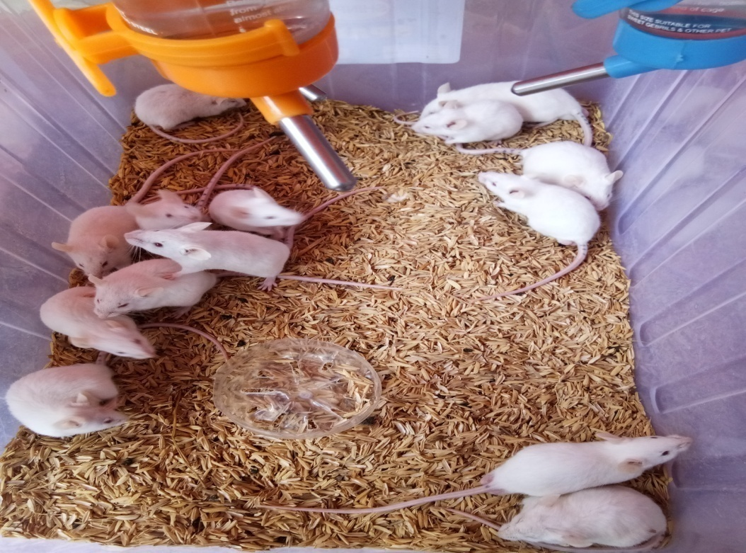
Lampiran 14. Gambar hewan, alat dan strip kolesterol

Hewan percobaan
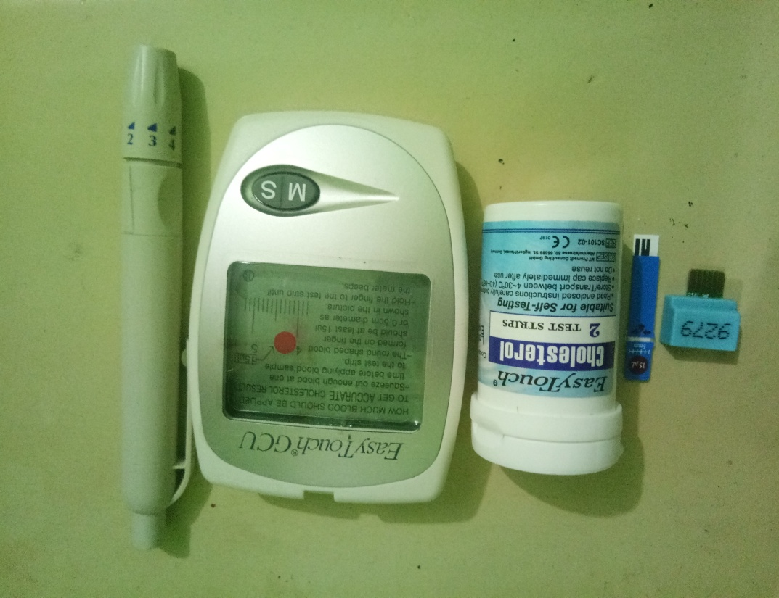

Strip kolesterol dan alat pengukuran kadar kolesterol

Lampiran 15. Induksi dan pengambilan darah

Mencit diberikan perlakuan secara oral

Ekor mencit dipotong

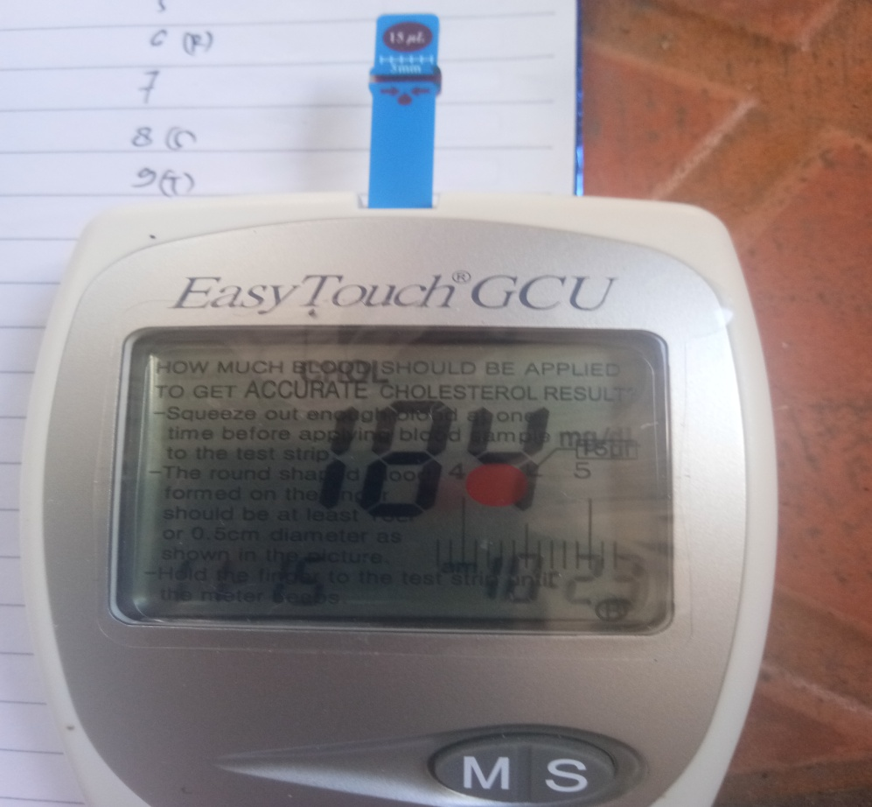
Lampiran 16. Pengukuran kadar kolesterol pada mencit

Hasil pengukuran kadar kolesterol dalam darah pada mencit

Lampiran 17. Hasil data kadar kolesterol mencit
- Kelompok kontrol negatif (larutan Na-CMC 0,5%)
No | Induksi | Hari ke 11 | Hari ke 21
1 | 185 | 187 | 188
2 | 140 | 140 | 146
3 | 160 | 160 | 164
4 | 139 | 140 | 141
5 | 128 | 129 | 130
Rata-rata | 150,4 | 151,2 | 153,8

- Kelompok kontrol positif (Simvastatin)
No | Induksi | Hari ke 11 | Hari ke 21
1 | 190 | 80 | 65
2 | 188 | 90 | 80
3 | 195 | 78 | 60
4 | 184 | 88 | 80
5 | 177 | 89 | 81
Rata-rata | 186,8 | 85 | 73,2

- Ekstrak kulit jeruk bali (EKJB) 200 mg/kg BB
No | induksi | hari ke 11 | hari ke 21
1 | 185 | 188 | 153
2 | 140 | 144 | 146
3 | 160 | 157 | 165
4 | 139 | 120 | 128
5 | 128 | 128 | 130
Rata-rata | 150,4 | 147,4 | 144,4

- Ekstrak kulit jeruk bali (EKJB) 400 mg/kg BB
No | Induksi | Hari ke 11 | Hari ke 21
1 | 146 | 127 | 110
2 | 151 | 126 | 112
3 | 119 | 114 | 102
4 | 162 | 130 | 105
5 | 199 | 160 | 120
Rata-rata | 155,4 | 131,4 | 109,8

Lampiran 17. (Lanjutan)
- Ekstrak kulit jeruk bali (EKJB) 600 mg/kg BB

No | Induksi | Hari ke 11 | Hari ke 21
1 | 211 | 160 | 130
2 | 180 | 141 | 105
3 | 195 | 155 | 102
4 | 199 | 145 | 103
5 | 201 | 160 | 112
Rata-rata | 197,2 | 152,2 | 110,4

Lampiran 18. Data hasil statistik One Way ANOVA
- Uji Normalitas
 | kelompok_perlakuan | Kolmogorov-Smirnovª |  |  | Shapiro-Wilk
 |  | Statistic | df | Sig. | Statistic | df | Sig.
Normal | Dosis 600 mg/kg BB | ,210 | 5 | ,200* | ,908 | 5 | ,457
 | Dosis 400 mg/kg BB | ,215 | 5 | ,200* | ,926 | 5 | ,567
 | Dosis 200 mg/kg BB | ,315 | 5 | ,117 | ,784 | 5 | ,060
 | Na CMC | ,246 | 5 | ,200* | ,939 | 5 | ,660
 | Simvastatin | ,333 | 5 | ,073 | ,782 | 5 | ,058
Induksi | Dosis 600 mg/kg BB | ,223 | 5 | ,200* | ,956 | 5 | ,778
 | Dosis 400 mg/kg BB | ,210 | 5 | ,200* | ,963 | 5 | ,830
 | Dosis 200 mg/kg BB | ,183 | 5 | ,200* | ,950 | 5 | ,736
 | Na CMC | ,278 | 5 | ,200* | ,909 | 5 | ,463
 | Simvastatin | ,170 | 5 | ,200* | ,984 | 5 | ,955
hari_ke_11 | Dosis 600 mg/kg BB | ,225 | 5 | ,200* | ,861 | 5 | ,230
 | Dosis 400 mg/kg BB | ,333 | 5 | ,074 | ,849 | 5 | ,192
 | Dosis 200 mg/kg BB | ,215 | 5 | ,200* | ,899 | 5 | ,403
 | Na CMC | ,165 | 5 | ,200* | ,946 | 5 | ,710
 | Simvastatin | ,305 | 5 | ,145 | ,830 | 5 | ,140
hari_ke_21 | Dosis 600 mg/kg BB | ,279 | 5 | ,200* | ,798 | 5 | ,078
 | Dosis 400 mg/kg BB | ,176 | 5 | ,200* | ,967 | 5 | ,855
 | Dosis 200 mg/kg BB | ,222 | 5 | ,200* | ,930 | 5 | ,595
 | Na CMC | ,263 | 5 | ,200* | ,813 | 5 | ,103
 | Simvastatin | ,353 | 5 | ,041 | ,783 | 5 | ,058
*. This is a lower bound of the true significance.
Lampiran 18. (Lanjutan)
- Uji Homogenitas
Test of Homogeneity of Variances
 | Levene Statistic | df1 | df2 | Sig.
Normal | 1,377 | 4 | 20 | ,278
Induksi | 1,768 | 4 | 20 | ,175
hari_ke_11 | 2,005 | 4 | 20 | ,133
hari_ke_21 | 2,385 | 4 | 20 | ,086
- Uji ANOVA
ANOVA
 |  | Sum of Squares | df | Mean Square | F | Sig.
Normal | Between Groups | 2923,760 | 4 | 730,940 | 10,603 | ,000
 | Within Groups | 1378,800 | 20 | 68,940
 | Total | 4302,560 | 24
Induksi | Between Groups | 8859,040 | 4 | 2214,760 | 5,759 | ,003
 | Within Groups | 7691,200 | 20 | 384,560
 | Total | 16550,240 | 24
hari_ke_11 | Between Groups | 14945,440 | 4 | 3736,360 | 14,509 | ,000
 | Within Groups | 5150,400 | 20 | 257,520
 | Total | 20095,840 | 24
hari_ke_21 | Between Groups | 17457,760 | 4 | 4364,440 | 22,256 | ,000
 | Within Groups | 3922,000 | 20 | 196,100
 | Total | 21379,760 | 24

Lampiran 18. (Lanjutan)
- Uji Tukey
Multiple Comparisons
Tukey HSD
Dependent Variable | (I) kelompok_perlakuan | (J) kelompok_perlakuan | Mean Difference (I-J) | Std. Error | Sig. | 95% Confidence Interval
 |  |  |  |  |  | Lower Bound | Upper Bound
normal | Dosis 600 mg/kg BB | Dosis 400 mg/kg BB | 18,400* | 5,251 | ,017 | 2,69 | 34,11
 |  | Dosis 200 mg/kg BB | -5,800 | 5,251 | ,802 | -21,51 | 9,91
 |  | Na CMC | 14,800 | 5,251 | ,071 | -,91 | 30,51
 |  | Simvastatin | -8,200 | 5,251 | ,537 | -23,91 | 7,51
 | Dosis 400 mg/kg BB | Dosis 600 mg/kg BB | -18,400* | 5,251 | ,017 | -34,11 | -2,69
 |  | Dosis 200 mg/kg BB | -24,200* | 5,251 | ,001 | -39,91 | -8,49
 |  | Na CMC | -3,600 | 5,251 | ,957 | -19,31 | 12,11
 |  | Simvastatin | -26,600* | 5,251 | ,001 | -42,31 | -10,89
 | Dosis 200 mg/kg BB | Dosis 600 mg/kg BB | 5,800 | 5,251 | ,802 | -9,91 | 21,51
 |  | Dosis 400 mg/kg BB | 24,200* | 5,251 | ,001 | 8,49 | 39,91
 |  | Na CMC | 20,600* | 5,251 | ,007 | 4,89 | 36,31
 |  | Simvastatin | -2,400 | 5,251 | ,990 | -18,11 | 13,31
 | Na CMC | Dosis 600 mg/kg BB | -14,800 | 5,251 | ,071 | -30,51 | ,91
 |  | Dosis 400 mg/kg BB | 3,600 | 5,251 | ,957 | -12,11 | 19,31
 |  | Dosis 200 mg/kg BB | -20,600* | 5,251 | ,007 | -36,31 | -4,89
 |  | Simvastatin | -23,000* | 5,251 | ,002 | -38,71 | -7,29
 | Simvastatin | Dosis 600 mg/kg BB | 8,200 | 5,251 | ,537 | -7,51 | 23,91
 |  | Dosis 400 mg/kg BB | 26,600* | 5,251 | ,001 | 10,89 | 42,31
 |  | Dosis 200 mg/kg BB | 2,400 | 5,251 | ,990 | -13,31 | 18,11
 |  | Na CMC | 23,000* | 5,251 | ,002 | 7,29 | 38,71
induksi | Dosis 600 mg/kg BB | Dosis 400 mg/kg BB | 41,800* | 12,403 | ,023 | 4,69 | 78,91
 |  | Dosis 200 mg/kg BB | 39,600* | 12,403 | ,033 | 2,49 | 76,71
 |  | Na CMC | 46,800* | 12,403 | ,009 | 9,69 | 83,91
 |  | Simvastatin | 10,400 | 12,403 | ,915 | -26,71 | 47,51
 | Dosis 400 mg/kg BB | Dosis 600 mg/kg BB | -41,800* | 12,403 | ,023 | -78,91 | -4,69
 |  | Dosis 200 mg/kg BB | -2,200 | 12,403 | 1,000 | -39,31 | 34,91
 |  | Na CMC | 5,000 | 12,403 | ,994 | -32,11 | 42,11
 |  | Simvastatin | -31,400 | 12,403 | ,123 | -68,51 | 5,71
 | Dosis 200 mg/kg BB | Dosis 600 mg/kg BB | -39,600* | 12,403 | ,033 | -76,71 | -2,49
 |  | Dosis 400 mg/kg BB | 2,200 | 12,403 | 1,000 | -34,91 | 39,31
 |  | Na CMC | 7,200 | 12,403 | ,976 | -29,91 | 44,31
 |  | Simvastatin | -29,200 | 12,403 | ,169 | -66,31 | 7,91
 | Na CMC | Dosis 600 mg/kg BB | -46,800* | 12,403 | ,009 | -83,91 | -9,69
 |  | Dosis 400 mg/kg BB | -5,000 | 12,403 | ,994 | -42,11 | 32,11
 |  | Dosis 200 mg/kg BB | -7,200 | 12,403 | ,976 | -44,31 | 29,91
 |  | Simvastatin | -36,400 | 12,403 | ,056 | -73,51 | ,71
 | Simvastatin | Dosis 600 mg/kg BB | -10,400 | 12,403 | ,915 | -47,51 | 26,71
 |  | Dosis 400 mg/kg BB | 31,400 | 12,403 | ,123 | -5,71 | 68,51
 |  | Dosis 200 mg/kg BB | 29,200 | 12,403 | ,169 | -7,91 | 66,31
 |  | Na CMC | 36,400 | 12,403 | ,056 | -,71 | 73,51
hari_ke_11 | Dosis 600 mg/kg BB | Dosis 400 mg/kg BB | 20,800 | 10,149 | ,280 | -9,57 | 51,17
 |  | Dosis 200 mg/kg BB | 8,600 | 10,149 | ,912 | -21,77 | 38,97
 |  | Na CMC | 4,800 | 10,149 | ,989 | -25,57 | 35,17
 |  | Simvastatin | 67,200* | 10,149 | ,000 | 36,83 | 97,57
 | Dosis 400 mg/kg BB | Dosis 600 mg/kg BB | -20,800 | 10,149 | ,280 | -51,17 | 9,57
 |  | Dosis 200 mg/kg BB | -12,200 | 10,149 | ,750 | -42,57 | 18,17
 |  | Na CMC | -16,000 | 10,149 | ,528 | -46,37 | 14,37
 |  | Simvastatin | 46,400* | 10,149 | ,002 | 16,03 | 76,77
 | Dosis 200 mg/kg BB | Dosis 600 mg/kg BB | -8,600 | 10,149 | ,912 | -38,97 | 21,77
 |  | Dosis 400 mg/kg BB | 12,200 | 10,149 | ,750 | -18,17 | 42,57
 |  | Na CMC | -3,800 | 10,149 | ,995 | -34,17 | 26,57
 |  | Simvastatin | 58,600* | 10,149 | ,000 | 28,23 | 88,97
 | Na CMC | Dosis 600 mg/kg BB | -4,800 | 10,149 | ,989 | -35,17 | 25,57
 |  | Dosis 400 mg/kg BB | 16,000 | 10,149 | ,528 | -14,37 | 46,37
 |  | Dosis 200 mg/kg BB | 3,800 | 10,149 | ,995 | -26,57 | 34,17
 |  | Simvastatin | 62,400* | 10,149 | ,000 | 32,03 | 92,77
 | Simvastatin | Dosis 600 mg/kg BB | -67,200* | 10,149 | ,000 | -97,57 | -36,83
 |  | Dosis 400 mg/kg BB | -46,400* | 10,149 | ,002 | -76,77 | -16,03
 |  | Dosis 200 mg/kg BB | -58,600* | 10,149 | ,000 | -88,97 | -28,23
 |  | Na CMC | -62,400* | 10,149 | ,000 | -92,77 | -32,03
hari_ke_21 | Dosis 600 mg/kg BB | Dosis 400 mg/kg BB | ,600 | 8,857 | 1,000 | -25,90 | 27,10
 |  | Dosis 200 mg/kg BB | -34,000* | 8,857 | ,008 | -60,50 | -7,50
 |  | Na CMC | -33,600* | 8,857 | ,009 | -60,10 | -7,10
 |  | Simvastatin | 37,200* | 8,857 | ,004 | 10,70 | 63,70
 | Dosis 400 mg/kg BB | Dosis 600 mg/kg BB | -,600 | 8,857 | 1,000 | -27,10 | 25,90
 |  | Dosis 200 mg/kg BB | -34,600* | 8,857 | ,007 | -61,10 | -8,10
 |  | Na CMC | -34,200* | 8,857 | ,008 | -60,70 | -7,70
 |  | Simvastatin | 36,600* | 8,857 | ,004 | 10,10 | 63,10
 | Dosis 200 mg/kg BB | Dosis 600 mg/kg BB | 34,000* | 8,857 | ,008 | 7,50 | 60,50
 |  | Dosis 400 mg/kg BB | 34,600* | 8,857 | ,007 | 8,10 | 61,10
 |  | Na CMC | ,400 | 8,857 | 1,000 | -26,10 | 26,90
 |  | Simvastatin | 71,200* | 8,857 | ,000 | 44,70 | 97,70
 | Na CMC | Dosis 600 mg/kg BB | 33,600* | 8,857 | ,009 | 7,10 | 60,10
 |  | Dosis 400 mg/kg BB | 34,200* | 8,857 | ,008 | 7,70 | 60,70
 |  | Dosis 200 mg/kg BB | -,400 | 8,857 | 1,000 | -26,90 | 26,10
 |  | Simvastatin | 70,800* | 8,857 | ,000 | 44,30 | 97,30
 | Simvastatin | Dosis 600 mg/kg BB | -37,200* | 8,857 | ,004 | -63,70 | -10,70
 |  | Dosis 400 mg/kg BB | -36,600* | 8,857 | ,004 | -63,10 | -10,10
 |  | Dosis 200 mg/kg BB | -71,200* | 8,857 | ,000 | -97,70 | -44,70
 |  | Na CMC | -70,800* | 8,857 | ,000 | -97,30 | -44,30
Lampiran 18. (Lanjutan)
*. The mean difference is significant at the 0.05 level.

Normal
Tukey HSDª
kelompok_perlakuan | N | Subset for alpha = 0.05
 |  | 1 | 2 | 3
Dosis 400 mg/kg BB | 5 | 48,20
Na CMC | 5 | 51,80 | 51,80
Dosis 600 mg/kg BB | 5 |  | 66,60 | 66,60
Dosis 200 mg/kg BB | 5 |  |  | 72,40
Simvastatin | 5 |  |  | 74,80
Sig. |  | ,957 | ,071 | ,537
Means for groups in homogeneous subsets are displayed.
a. Uses Harmonic Mean Sample Size = 5,000.

Induksi
Tukey HSDª
kelompok_perlakuan | N | Subset for alpha = 0.05
 |  | 1 | 2
Na CMC | 5 | 150,40
Dosis 400 mg/kg BB | 5 | 155,40
Dosis 200 mg/kg BB | 5 | 157,60
Simvastatin | 5 | 186,80 | 186,80
Dosis 600 mg/kg BB | 5 |  | 197,20
Sig. |  | ,056 | ,915
Means for groups in homogeneous subsets are displayed.
a. Uses Harmonic Mean Sample Size = 5,000.

Lampiran 18. (Lanjutan)
hari_ke_11
Tukey HSDª
kelompok_perlakuan | N | Subset for alpha = 0.05
 |  | 1 | 2
Simvastatin | 5 | 85,00
Dosis 400 mg/kg BB | 5 |  | 131,40
Dosis 200 mg/kg BB | 5 |  | 143,60
Na CMC | 5 |  | 147,40
Dosis 600 mg/kg BB | 5 |  | 152,20
Sig. |  | 1,000 | ,280
Means for groups in homogeneous subsets are displayed.
a. Uses Harmonic Mean Sample Size = 5,000.

hari_ke_21
Tukey HSDª
kelompok_perlakuan | N | Subset for alpha = 0.05
 |  | 1 | 2 | 3
Simvastatin | 5 | 73,20
Dosis 400 mg/kg BB | 5 |  | 109,80
Dosis 600 mg/kg BB | 5 |  | 110,40
Na CMC | 5 |  |  | 144,00
Dosis 200 mg/kg BB | 5 |  |  | 144,40
Sig. |  | 1,000 | 1,000 | 1,000
Means for groups in homogeneous subsets are displayed.
a. Uses Harmonic Mean Sample Size = 5,000.

