Lampiran 1. Hasil Determinasi Tumbuhan
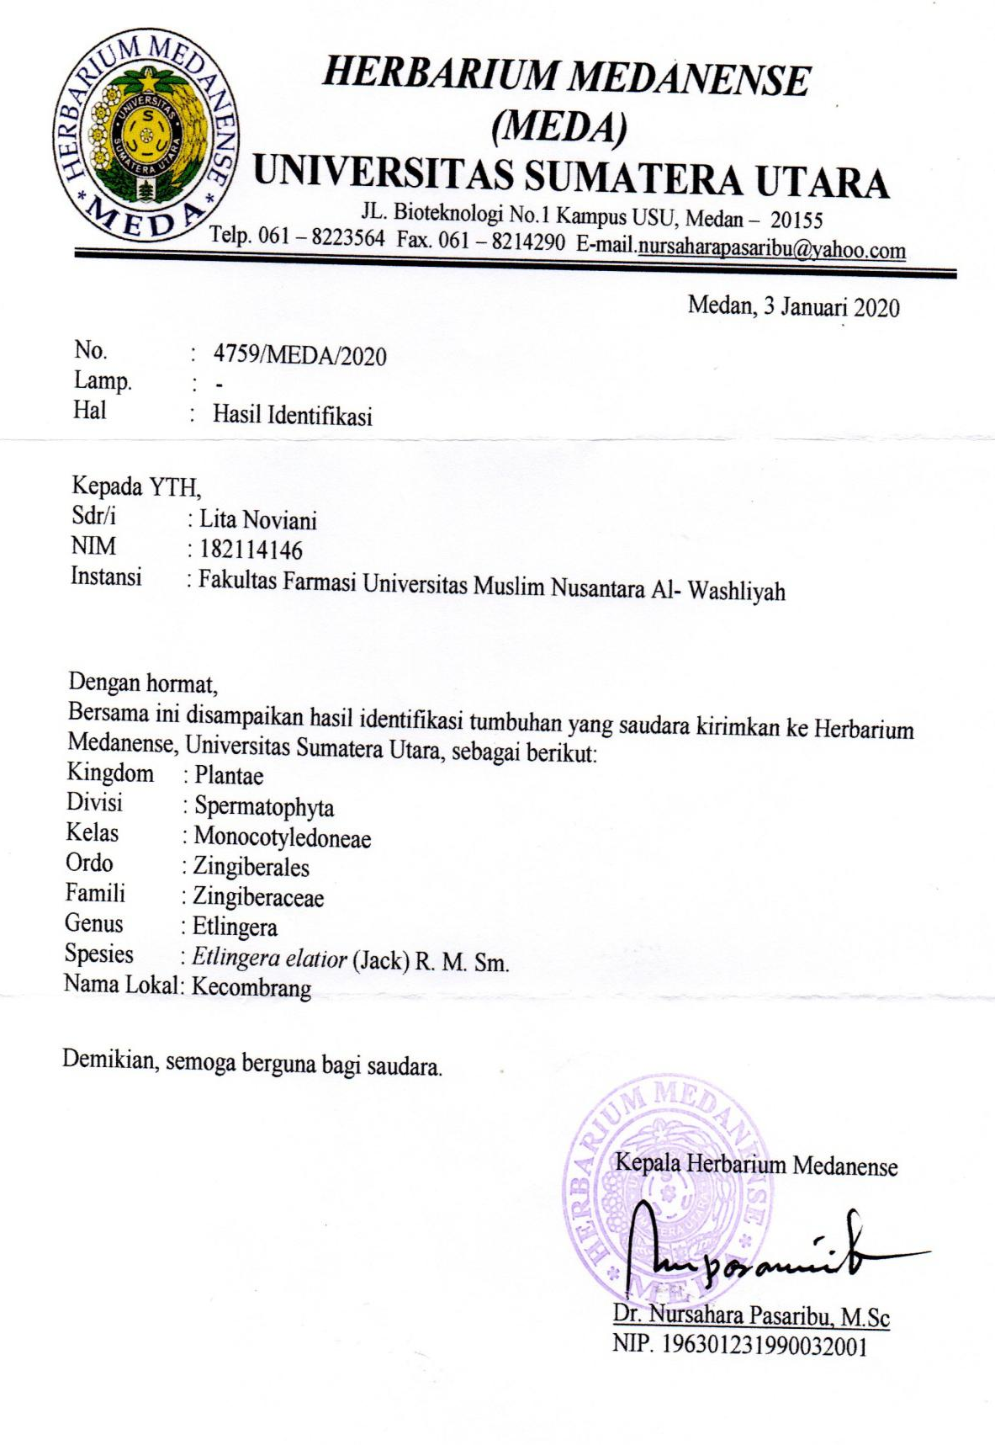

Lampiran 2. Rekomendasi Persetujuan Etik Penelitian Kesehatan
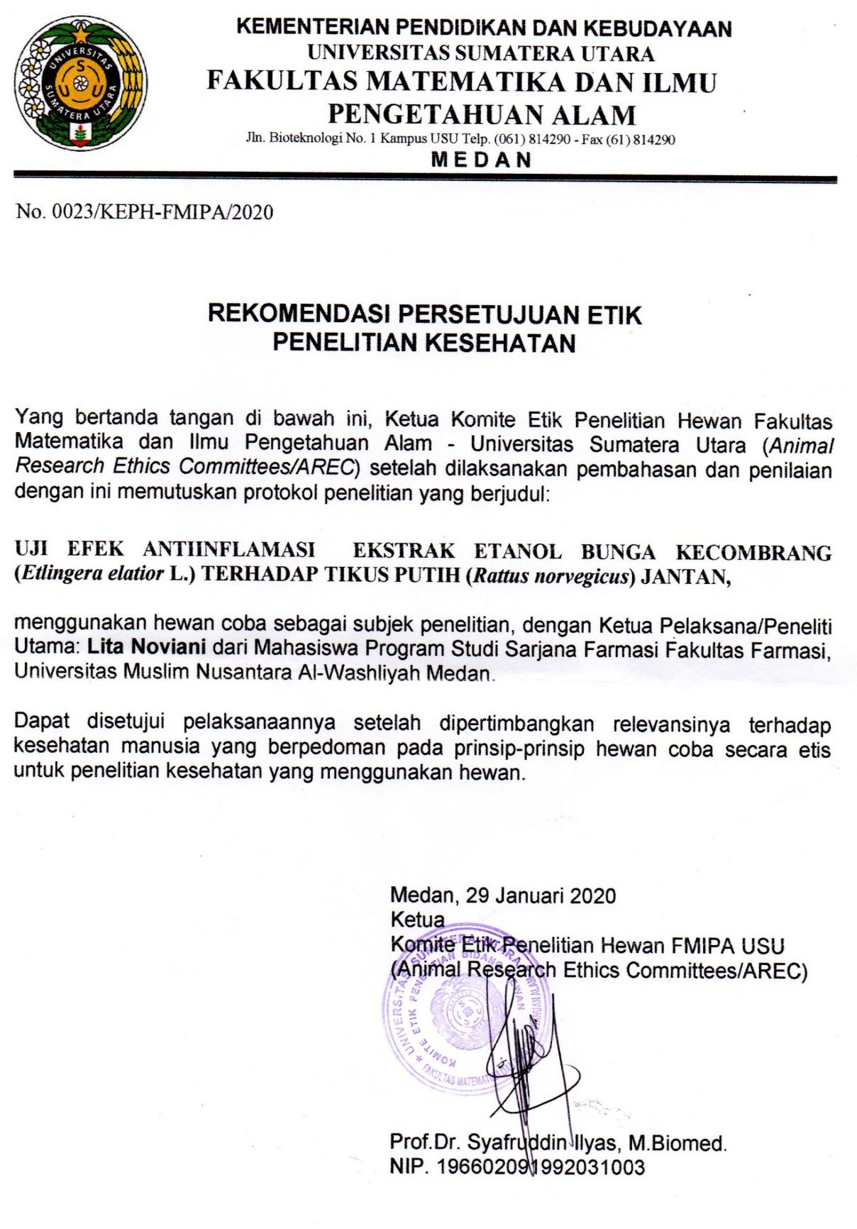

Lampiran 3. Dokumentasi Makroskopis Sampel Bunga Kecombrang

Tangkai

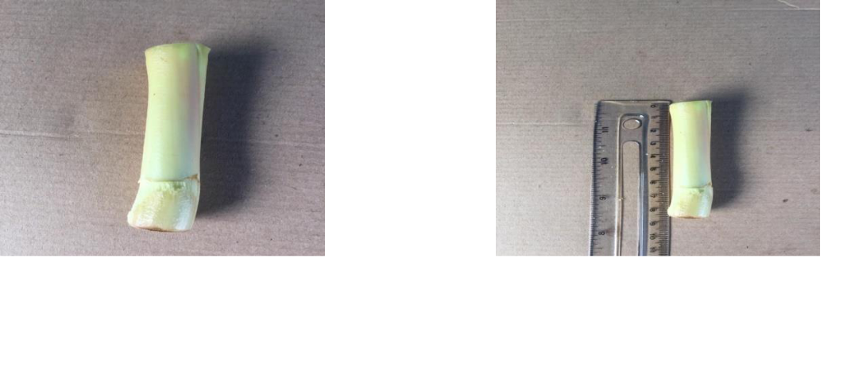

Tangkai bunga kecombrang Tangkai bunga dengan
panjang 8,5 cm

Bunga

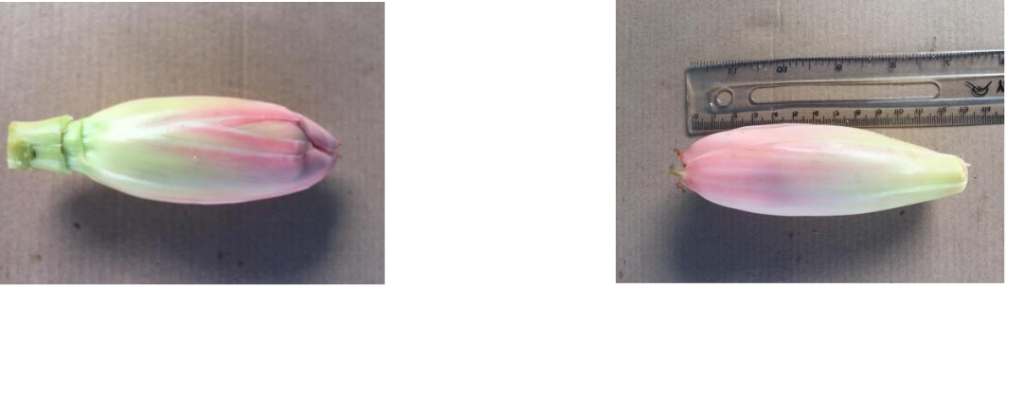

Bunga berbentuk bonggol Bonggol bunga panjang 13 cm
Helaian bunga
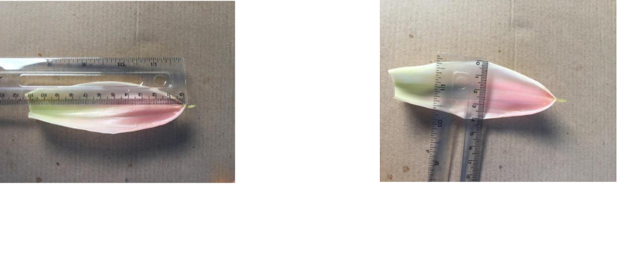

Panjang helaian bunga 11 cm Lebar helaian bunga 4 cm

Lampiran 4. Mikroskopik Serbuk Bunga Kecombrang
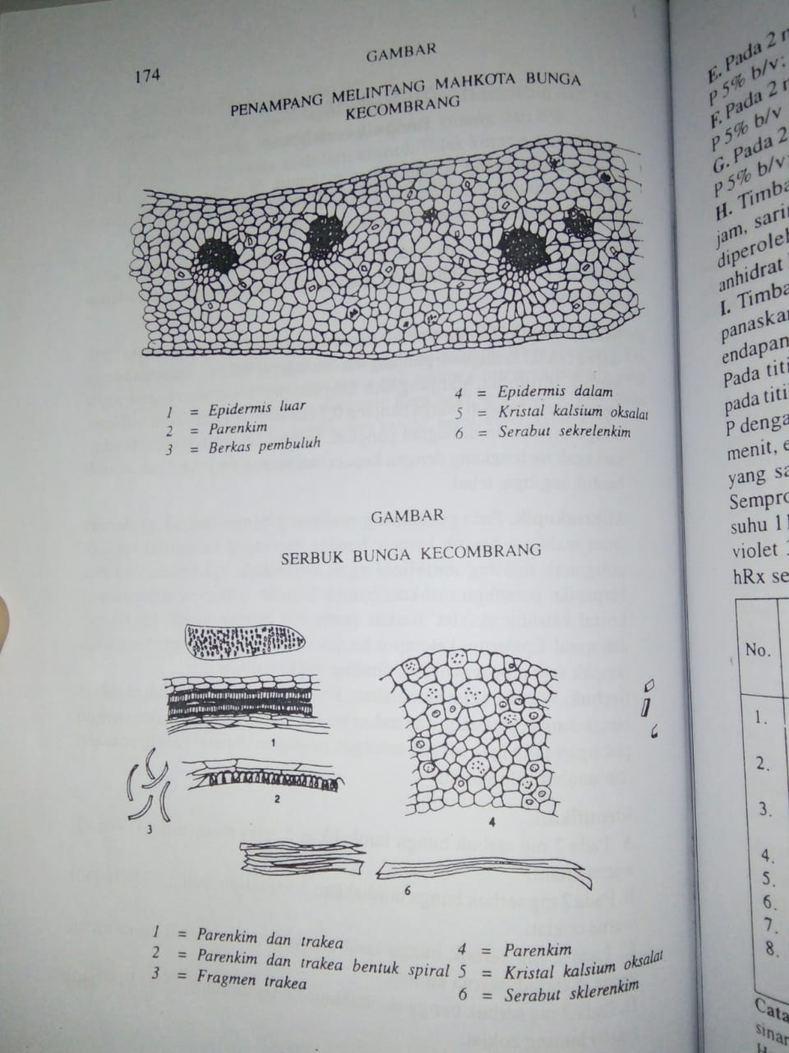

Perbesaran 400x
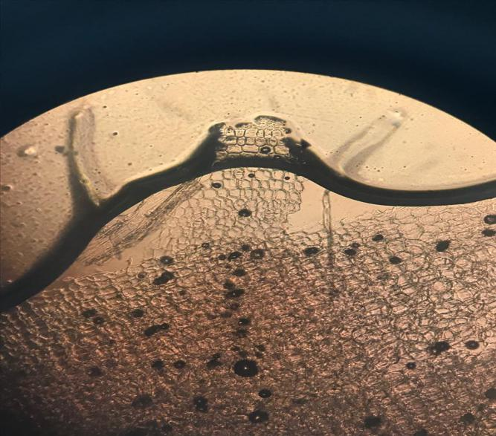

5. Kristal kalsium oksalat

6. Serabut Sklerenkim

4. Parenkim

Lampiran 5. Pembuatan Simplisia Bunga Kecombrang
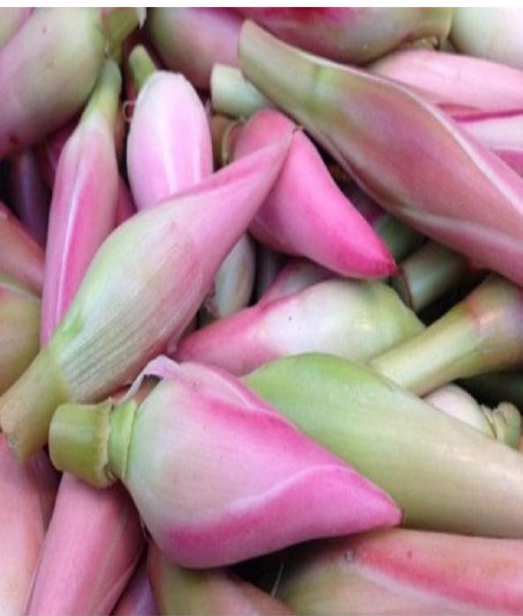
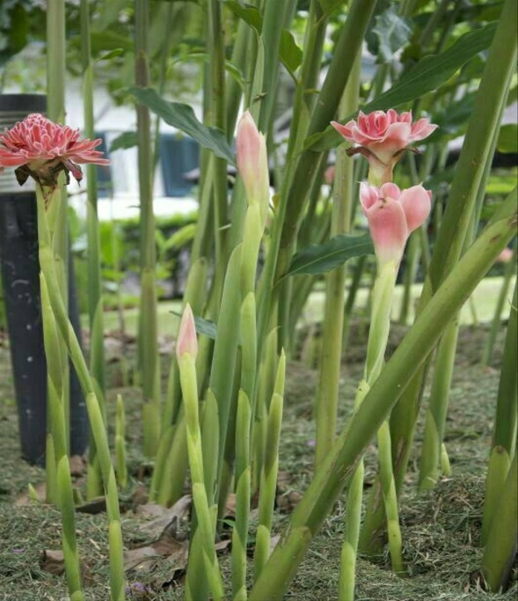

Tumbuhan Kecombrang Bunga Kecombrang

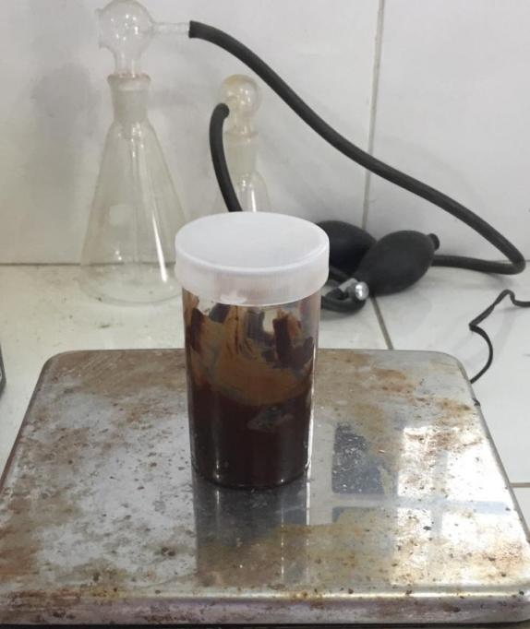
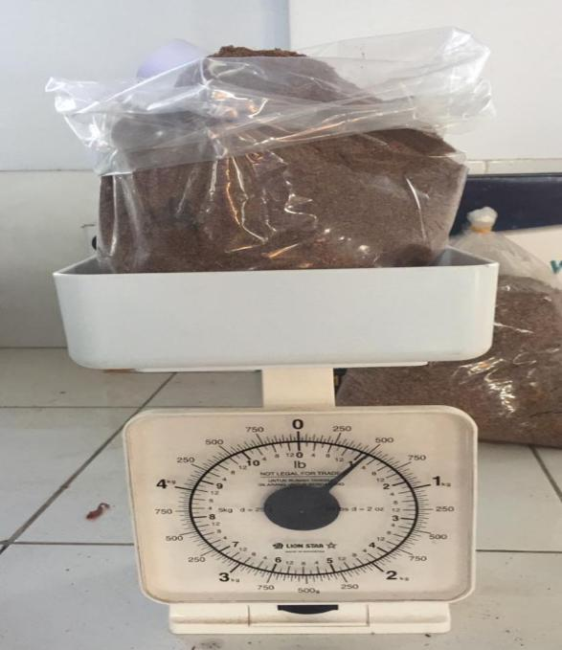
Serbuk simplisia Ekstrak etanol bunga kecombrang

Lampiran 6. Hasil Uji Skrining Fitokimia

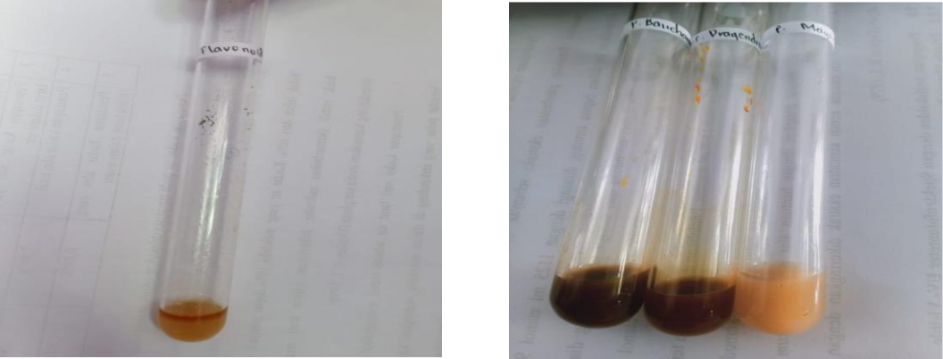

Flavonoid Alkaloid

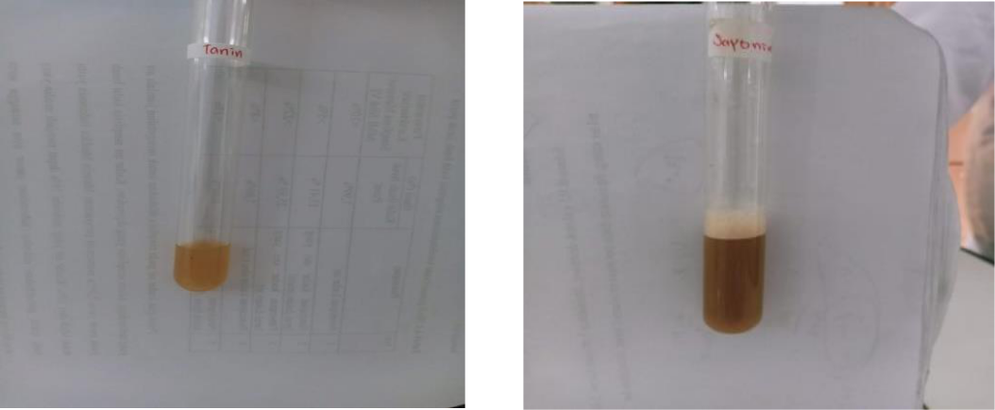

Tanin Saponin

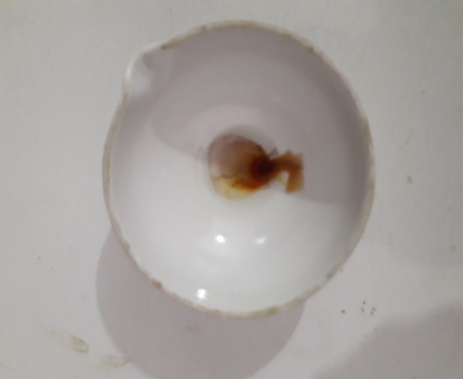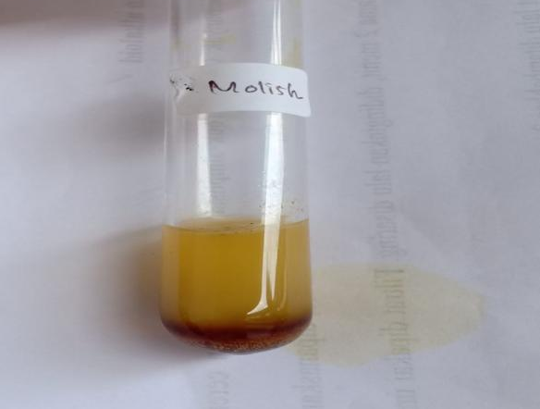
Triterpenoid Glikosida

Lampiran 7. Pembuatan Suspensi

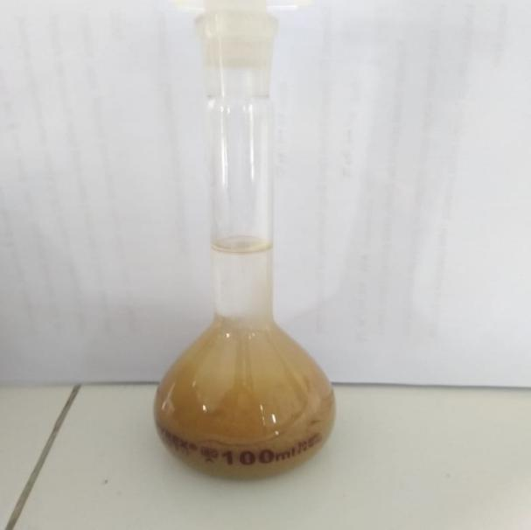

Suspensi Natrium Diklofenak Suspensi Ekstrak Etanol Bunga
Kecombrang

Lampiran 8. Pengujian Farmakologi

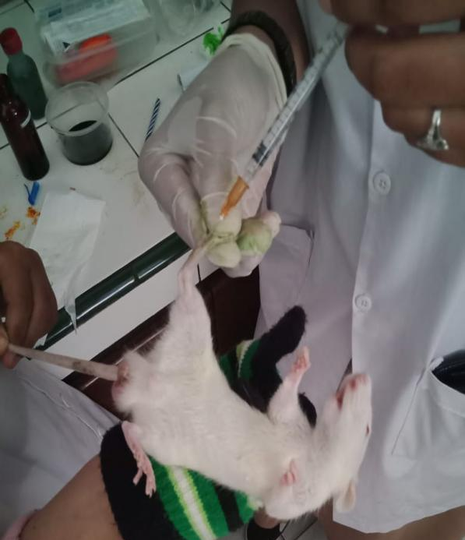
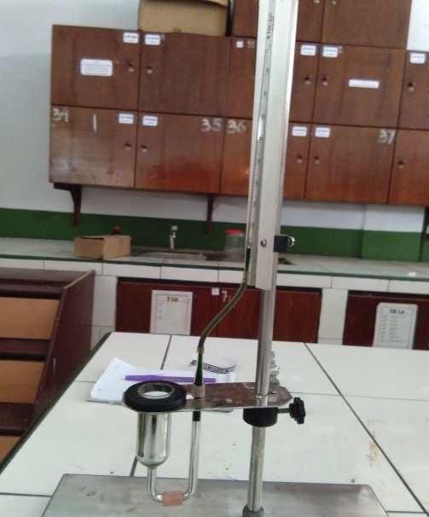

Alat plestismometer Penyuntikan λ-karagenan

Sebelum diinduksi λ-karagenan Sesudah diinduksi λ-karagenan

Lampiran 9. Bagan Alir Penelitian
Bunga kecombrang

Dibersihkan
Dicuci bersih
Ditiriskan
Ditimbang
Bunga kecombrang 5 kg

Dikeringkan
Ditimbang
Simplisia kering 800 gr
Dihaluskan
Ditimbang
Serbuk simplisia 530 gr

Serbuk simplisia 500 gr
Pemeriksaan karakteristik
Dilakukan skrining fitokimia serbuk dan ekstrak
Di maserasi
1. makroskopik
2. mikroskopik
3. penetapan kadar air
4.penetapan kadar sari larut dalam air
5.penetapan kadar sari larut dalam etanol
6.penetapan kadar abu total
7. penetapan kadar abu tidak larut dalam asam

Maserat
1. alkaloida
2. tanin
3. flavonida
4. glikosida
5. steroida/
triterpenoid
6. saponin

Diuapkan dengan
rotari evaporatory
Ekstrak kental 60,53 gr
Dilakukan uji antiinflamasi

Lampiran 10. Bagan Alir Pengujian Farmakologi
25 ekor tikus putih jantan
Dipuasakan ± 18 jam

Kelompok 5
(5 ekor)
Kelompok 4
(5 ekor)
Kelompok 3
(5 ekor)
Kelompok 2
(5 ekor)
Kelompok 1
(5 ekor)

Pengukuran volume awal kaki tikus

Pengukuran volume awal 1 jam setelah pemberian karagenan 1%

Diberi EEBK 500 mg/kgBB
Diberi EEBK 300 mg/kg BB
Diberi EEBK 100 mg/kg BB
Kontrol positif diberi suspensi Na diklofenak

Kontrol negatif diberi suspensi CMC 0,5%

Pengukuran pengukuran volume kaki tikus setelah 60 menit sekali selama 6 jam

Analisis data

Lampiran 11. Perhitungan Karakterisasi Simplisia

- Perhitungan Hasil Penetapan Kadar air

No | Berat Sampel (g) | Volume Awal (V0)  (ml) | Volume Akhir (V1)  (ml)
1 | 5 | 0,2 | 0,5
2 | 5 | 0,3 | 0,5
3 | 5 | 0,2 | 0,6
Kadar air = $\frac{Volume akhir air \left(V1\right)-Volume awal air (V0)}{Berat Sampel mula-mula (g)}x 100\%$

Pengulangan 1
V₀ = 0,2 ml
V₁ = 0,5 ml
Sampel = 5 g

Kadar air = $\frac{V1-V0}{Berat Sampel }x 100\%$
= $\frac{0,5 ml -0,2 ml}{5 gram}x 100\%$
= 6%
Pengulangan 2
V₀ = 0,3 ml
V₁ = 0,5 ml
Sampel = 5 g
Kadar air =$\frac{V1-V0}{Berat Sampel }x 100\%$
= $\frac{0,5 ml -0,3 ml}{5 gram}x 100\%$
= 4%
Pengulangan 3
V₀ = 0,2 ml
V₁ = 0,6 ml
Sampel = 5 g
Kadar air =$\frac{V1-V0}{Berat Sampel }x 100\%$

= $\frac{0,6 ml -0,2 ml}{5 gram}x 100\%$
= 8 %
Rata-rata kadar air = $\frac{6\% + 4\% + 8\%}{3}$
= 6%

Lampiran 11. (Lanjutan)

- Perhitungan Hasil Penetapan Kadar Sari larut dalam Air

No | Berat Sampel (g) | Berat Cawan Kosong (g) | Berat Setelah Diuapkan (g)
1 | 5 | 35,9146 | 35,9765
2 | 5 | 28,9432 | 28,8613
3 | 5 | 42,6679 | 42,6170
% Kadar sari larut dalam air =$\frac{Bobot sari setelah dikeringkan (g)X5}{Bobot simplisia (g)}$x 100%

Pengulangan 1
% Kadar sari larut dalam air $=\frac{0,06 g x 5}{5 g}$$=\frac{0,06 g x 5}{5 g}$ x 100%
= 6 %

Pengulangan 2

% Kadar sari larut dalam air$=\frac{0,08 g x 5}{5 g}$x 100 %
$=8\%$

Pengulangan 3

% Kadar sari larut dalam air$=\frac{0,05g x 5}{5 g}$x 100 %
$=5\%$

% Rata-Rata kadar sari larut dalam air= $\frac{6\%+8\%+5\%}{3}$
$=6,3 \%$

Lampiran 11. (Lanjutan)

- Perhitungan Hasil Penetapan Kadar Sari Larut Dalam Etanol

No | Berat Sampel (g) | Berat Cawan Kosong (g) | Berat Setelah Diuapkan (g)
1 | 5 | 36,8853 | 36,8453
2 | 5 | 32,1257 | 32,9702
3 | 5 | 36,8837 | 36,8456

% Kadar sari larut dalam etanol=$\frac{Bobot sari setelah dikeringkan (g)X5}{Bobot simplisia (g)}$x 100%

Pengulangan 1

% Kadar sari larut dalam etanol $=\frac{0,042 g x 5}{5 g}$x 100 %
$=4\%$
Pengulangan 2

% Kadar sari larut dalam etanol $=\frac{0,04 g x 5}{5 g}$x 100 %
$=4 \%$

Pengulangan 3
% Kadar sari larut dalam etanol $=\frac{0,03 g x 5}{5 g}$x 100 %
$=3\%$

% Rata-Rata kadar sari larut etanol = $\frac{4\%+4\%+3\%}{3}$
=$3,6 \%$

Lampiran 11. (Lanjutan)

- Perhitungan Hasil Penetapan Kadar Abu Total

No | Berat Sampel (g) | Berat Krus Kosong (g) | Berat Krus Setelah Dipijar (g)
1 | 2 | 60,8648 | 61,0897
2 | 2 | 59,8621 | 60,0837
3 | 2 | 52,0128 | 52,2396
% Kadar Abu Total = $\frac{bobot abu yang diperoleh (g)}{Bobot simplisia (g)}$ x 100%

Pengulangan 1
% Kadar Abu Total = $\frac{0,22093}{2}$ x 100%
= $11,045\%$
Pengulangan 2
% Kadar Abu Total = $\frac{0,2216}{2}$ x 100%
$=11,08$%
Pengulangan 3
% Kadar Abu Total = $\frac{0,2268}{2}$ x 100%
$=11,34$%
% Rata-Rata kadar abu total $=\frac{11,04\%+11,08\%+11,34}{3}$
= 11,15%

Lampiran 11. (Lanjutan)

- Perhitungan Hasil Penetapan Kadar Abu Tidak Larut Asam

No | Berat Sampel (g) | Berat Krus Kosong (g) | Berat Krus Setelah Dipijar (g)
1 | 0,0333 | 60,8648 | 60,8619
2 | 0,0301 | 59,8621 | 59,8657
3 | 0,0297 | 52,0128 | 52,0177
% Kadar Abu Tidak Larut Asam= $\frac{bobot abu sisa dipijar (g)}{Bobot sampel abu mula-mula(g)}$ x 100%

Pengulangan 1
% Kadar Abu tidak larut asam = $\frac{0,0029}{2}$ x 100%
= $0,14 \%$
Pengulangan 2
% Kadar Abu tidak larut asam = $\frac{0,0036}{2}$ x 100%
= $0,18 \%$
Pengulangan 3
% Kadar Abu tidak larut asam = $\frac{0,00491}{2}$ x 100%
= $0,24 \%$

% Rata-Rata kadar abu tidak larut asam $=\frac{0,14\%+0,18\%+0,24\%}{3}$
= 0,19 %

Lampiran 12. Tabel konversi dosis (g); tabel volume maksimum lambung pada hewan (ml) dan contoh perhitungan dosis
Konvesi | Mencit 20 g | Tikus 200 g | Marmut 400 g | Kelinci 1,5 kg | Kucing 1,5 kg | Kera 4 kg | Anjing 12 kg | Manusia 70 kg
Mencit 20 g | 1,0 | 7,0 | 12,23 | 27,80 | 29,70 | 64,10 | 124,20 | 387,9
Tikus 200 g | 0,14 | 1,0 | 1,74 | 3,90 | 4,20 | 9,20 | 17,80 | 56,0
Marmut 400 g | 0,08 | 0,57 | 1,0 | 2,25 | 2,40 | 5,20 | 10,20 | 31,50
Kelinci 1,5 g | 0,04 | 0,25 | 0,44 | 1,0 | 1,08 | 2,40 | 4,50 | 14,20
Kucing 1,5 g | 0,03 | 0,23 | 0,41 | 0,92 | 1,0 | 2,20 | 4,10 | 13,0
Kera 4kg | 0,016 | 0,11 | 0,19 | 0,42 | 0,43 | 0,1 | 1,9 | 6,1
Anjing 12 kg | 0,008 | 0,06 | 0,10 | 0,22 | 1,24 | 0,52 | 1,0 | 3,10
Manusia 70 kg | 0,0026 | 0,018 | 0,031 | 0,07 | 0,076 | 0,16 | 0,32 | 1,0

Lampiran 12. (Lanjutan)
Tabel konversi dosis hewan percobaan dengan manusia
Jenis hewan uji | Volume maksimum (ml) sesuai jalur pemberian
 | i.v | i.m | i.p | s.c | p.o
Mencit  (20-30 g) | 0,5 | 0,05 | 1,0 | 0,5-1,0 | 1,0
Tikus  (200 g) | 1,0 | 0,1 | 2-5 | 2-5 | 5,0
Hamster  (50 g) | - | 0,1 | 1-2 | 2,5 | 2,5
Maemut  (250 g) | - | 0,25 | 2-5 | 5,0 | 10,0
Kelinci  (3 kg) | 5-10 | 0,5 | 10-20 | 5-10 | 20,0
Kucing  (3 kg) | 5-10 | 1,0 | 10-20 | 5-10 | 50,0
Anjing  (5 kg) | 10-20 | 5,0 | 20-50 | 10,0 | 100,0

Lampiran 13. Perhitungan Dosis
1. Perhitungan Dosis CMC 0,5%
CMC 0,5% = Jumlah cmc / Volume Suspensi
= 0,5 g / 100 ml
= 500 mg / 100 ml
= 5 mg / ml
Perhitungan CMC 0,5% pada tikus dengan BB =200 g
=$\frac{0,5}{100}$ x200 g
= 1 ml
2. Perhitungan Dosis Na Diklofenak
Konversi dosis Na diklofenak dari manusia (70 kg) ke tikus (200 g) = 0,018
Dosis Na diklofenak untuk manusia dewasa dengan BB (70 kg) = 25 mg
Maka dosis pada tikus Na diklofenak = dosis terapi manusia x 0,018
= 0,45 mg/0,2 kg
= 2,25 mg/kgBB
Konsentrasi Suspensi Na diklofenak
Suspensi Na diklofenak 0,025% = Jumlah Na diklofenak / Volume Suspensi

= 25 mg / 100 ml
= 0,25 mg / ml

Dosis untuk tikus (200 g) = 2,25/1000 g x 200 g
= 0,45 mg

Volume suspensi yang diambil = $\frac{Dosis Na diklofenak untuk tikus}{Konsentrasi suspensi Na diklofenak}$

= $\frac{0.45 mg}{0,25 mg/ml}$
$\frac{0.9 mg}{0.5 mg/ml}$ = 1,8 ml

Lampiran 13. (Lanjutan)
3. Perhitungan Dosis EEBK 100 mg/kg BB
- Konsentrasi suspensi EEBK
Konsentrasi EEBK 1% = Jumlah EEBK / Volume Suspensi
= 1000 mg / 100 ml
= 10 mg/ml
- BB tikus 200 g atau 0,2 kg
- Perhitungan dosis 100 mg/kgBB
= $\frac{100}{1000}$ x 200 g = 20 mg

Volume suspensi yang diberikan =$\frac{Dosis EEBK}{Konsentrasi}$
= $\frac{20 mg}{10 mg/ml}$
= 2 ml
4. Perhitungan Dosis EEBK 300 mg/kg BB
- Konsentrasi suspensi EEBK
Konsentrasi EEBK 3% = Jumlah EEBK / Volume Suspensi
= 3000 mg / 100 ml
= 30 mg/ml
- BB tikus 200 g atau 0,2 kg
- Perhitungan dosis 300 mg/kgBB
= $\frac{300 mg}{1000 g}$ x 200 g = 60 mg

- Volume suspensi yang diberikan =$\frac{Dosis EEBK}{Konsentrasi}$
= $\frac{60 mg}{30 mg/ml}$
= 2 ml

Lampiran 13. (Lanjutan)
- Perhitungan Dosis EEBK 500 mg/kg BB
- Konsentrasi suspensi EEBK
Konsentrasi EEBK 5% = Jumlah EEBK / Volume Suspensi
= 5000 mg / 100 ml
= 50 mg/ml
- BB tikus 200 g atau 0,2 kg
- Perhitungan dosis 500 mg/kgBB
= $\frac{500 mg}{1000 g}$ x 200 g
= 100 mg

- Volume suspensi yang diberikan =$\frac{Dosis EEBK}{Konsentrasi}$
= $\frac{100 mg}{50 mg/ml}$
= 2 ml

Lampiran 14. Perhitungan Persen Radang dan Persen Inhibisi Radang
- Persen Radang
$$\frac{Vt-V0}{V0}$$
Vt =Volume kaki setelah radang
V0 = Volume kaki sebelum radang
Misalnya:
Ekstrak bunga kecombrang dosis 100 mg/kg BB pada menit ke-60
Diketahui:
Vt = 0.062
Vo =0.052
$\frac{0.062-0.052}{0.052}$x 100% = 16.12%
- Persen Inhibisi Radang
(%IR) = $\frac{a-b}{a}$x 100%
a = Persen radang rata-rata kelompok kontrol
b= Persen radang rata-rata kelompok perlakuan mendapat bahan uji atau obat pembanding
Misalnya
Ekstrak etanol bunga kecombrang 100 mg/kg BB pada menit ke 60
a= 16.10
b= 11.45
Persen radang inhibisi =$\frac{16.10-11.45}{16.10}$x 100%= 28.88%

Lampiran 15. Data Perlakuan Hewan Uji

Perlakuan | Vo | 60 menit |  | 120 menit |  | 180 menit |  | 240 menit |  | 300 menit |  | 360 menit
 |  | V1 | % Radang | V2 | % Radang | V3 | % Radang | V4 | % Radang | V5 | % Radang | V6 | % Radang
Na CMC 0.5% | 0.056 | 0.065 | 16.07 | 0.07 | 25.00 | 0.073 | 30.36 | 0.078 | 39.29 | 0.085 | 51.79 | 0.087 | 55.36
 | 0.054 | 0.062 | 14.81 | 0.068 | 25.93 | 0.071 | 31.48 | 0.077 | 42.59 | 0.091 | 68.52 | 0.093 | 72.22
 | 0.06 | 0.07 | 16.67 | 0.074 | 23.33 | 0.075 | 25.00 | 0.085 | 41.67 | 0.087 | 45.00 | 0.091 | 51.67
 | 0.057 | 0.067 | 17.54 | 0.071 | 24.56 | 0.076 | 33.33 | 0.086 | 50.88 | 0.093 | 63.16 | 0.094 | 64.91
 | 0.052 | 0.06 | 15.38 | 0.065 | 25.00 | 0.07 | 34.62 | 0.081 | 55.77 | 0.088 | 69.23 | 0.092 | 76.92
Rata-Rata |  |  | 16.10 |  | 24.76 |  | 30.96 |  | 46.04 |  | 59.54 |  | 64.22
Na Diklofenak | 0.059 | 0.064 | 8.47 | 0.067 | 13.56 | 0.071 | 20.34 | 0.067 | 13.56 | 0.063 | 6.78 | 0.062 | 5.08
 | 0.067 | 0.069 | 2.99 | 0.072 | 7.46 | 0.075 | 11.94 | 0.072 | 7.46 | 0.07 | 4.48 | 0.068 | 1.49
 | 0.048 | 0.051 | 6.25 | 0.055 | 14.58 | 0.057 | 18.75 | 0.057 | 18.75 | 0.055 | 14.58 | 0.05 | 4.17
 | 0.069 | 0.074 | 7.25 | 0.081 | 17.39 | 0.085 | 23.19 | 0.082 | 18.84 | 0.078 | 13.04 | 0.075 | 8.70
 | 0.063 | 0.066 | 4.76 | 0.07 | 11.11 | 0.073 | 15.87 | 0.067 | 6.35 | 0.065 | 3.17 | 0.065 | 3.17
Rata-Rata |  |  | 5.94 |  | 12.82 |  | 18.02 |  | 12.99 |  | 8.41 |  | 4.52
EEBK 100 mg/kg bb | 0.045 | 0.05 | 11.11 | 0.054 | 20.00 | 0.058 | 28.89 | 0.059 | 31.11 | 0.053 | 17.78 | 0.052 | 15.56
 | 0.052 | 0.062 | 19.23 | 0.067 | 28.85 | 0.07 | 34.62 | 0.068 | 30.77 | 0.063 | 21.15 | 0.06 | 15.38
 | 0.057 | 0.062 | 8.77 | 0.068 | 19.30 | 0.07 | 22.81 | 0.07 | 22.81 | 0.067 | 17.54 | 0.065 | 14.04
 | 0.062 | 0.066 | 6.45 | 0.075 | 20.97 | 0.080 | 29.03 | 0.078 | 25.81 | 0.075 | 20.97 | 0.071 | 14.52
 | 0.06 | 0.067 | 11.67 | 0.073 | 21.67 | 0.078 | 30.00 | 0.075 | 25.00 | 0.072 | 20.00 | 0.069 | 15.00
Rata-Rata |  |  | 11.45 |  | 22.16 |  | 29.07 |  | 27.10 |  | 19.49 |  | 14.90
Lampiran 15. (Lanjutan)
EEBK 300 mg/kg bb | 0.049 | 0.055 | 12.24 | 0.057 | 16.33 | 0.062 | 26.53 | 0.06 | 22.45 | 0.056 | 14.29 | 0.055 | 12.24
 | 0.053 | 0.058 | 9.43 | 0.063 | 18.87 | 0.066 | 24.53 | 0.064 | 20.75 | 0.061 | 15.09 | 0.06 | 13.21
 | 0.061 | 0.068 | 11.48 | 0.07 | 14.75 | 0.074 | 21.31 | 0.072 | 18.03 | 0.069 | 13.11 | 0.068 | 11.48
 | 0.060 | 0.066 | 10.00 | 0.072 | 20.00 | 0.078 | 30.00 | 0.077 | 28.33 | 0.070 | 16.67 | 0.067 | 11.67
 | 0.059 | 0.064 | 8.47 | 0.068 | 15.25 | 0.073 | 23.73 | 0.07 | 18.64 | 0.068 | 15.25 | 0.065 | 10.17
Rata –Rata |  |  | 10.33 |  | 17.04 |  | 25.22 |  | 21.64 |  | 14.88 |  | 11.75
EEBK 500 mg/kg bb | 0.058 | 0.061 | 5.17 | 0.064 | 10.34 | 0.071 | 22.41 | 0.068 | 17.24 | 0.064 | 10.34 | 0.06 | 3.45
 | 0.051 | 0.055 | 7.84 | 0.058 | 13.73 | 0.062 | 21.57 | 0.06 | 17.65 | 0.057 | 11.76 | 0.054 | 5.88
 | 0.044 | 0.047 | 6.82 | 0.051 | 15.91 | 0.055 | 25.00 | 0.053 | 20.45 | 0.049 | 11.36 | 0.046 | 4.55
 | 0.056 | 0.059 | 5.36 | 0.068 | 21.43 | 0.073 | 30.36 | 0.070 | 25.00 | 0.065 | 16.07 | 0.064 | 14.29
 | 0.061 | 0.066 | 8.20 | 0.072 | 18.03 | 0.07 | 14.75 | 0.067 | 9.84 | 0.067 | 9.84 | 0.062 | 1.64
Rata –Rata |  |  | 6.68 |  | 15.89 |  | 22.82 |  | 18.04 |  | 11.88 |  | 5.96

Lampiran 16. Hasil Uji SPSS Normalitsa Persen Udem
ANOVA
 |  | Sum of Squares | df | Mean Square | F | Sig.
Menit_60 | Between Groups | .000 | 4 | .000 | 1.021 | .421
 | Within Groups | .001 | 20 | .000
 | Total | .001 | 24
Menit_120 | Between Groups | .000 | 4 | .000 | .717 | .590
 | Within Groups | .001 | 20 | .000
 | Total | .001 | 24
Menit_180 | Between Groups | .000 | 4 | .000 | .623 | .652
 | Within Groups | .001 | 20 | .000
 | Total | .001 | 24
Menit_240 | Between Groups | .001 | 4 | .000 | 4.376 | .011
 | Within Groups | .001 | 20 | .000
 | Total | .002 | 24
Menit_300 | Between Groups | .003 | 4 | .001 | 12.585 | .000
 | Within Groups | .001 | 20 | .000
 | Total | .003 | 24
Menit_360 | Between Groups | .004 | 4 | .001 | 19.495 | .000
 | Within Groups | .001 | 20 | .000
 | Total | .005 | 24

Menit_60
Tukey HSDª
Volume Radang | N | Subset for alpha = 0.05
 |  | 1
EEBK 500 mg/kgBB | 5 | .05760
EEBK 100 mg/kgBB | 5 | .06140
EEBK 300 mg/kgBB | 5 | .06220
CMC 0,5% | 5 | .06480
Na.Diklofenak | 5 | .06480
Sig. |  | .438
Means for groups in homogeneous subsets are displayed.
a. Uses Harmonic Mean Sample Size = 5.000.

Menit_120
Tukey HSDª
Volume Radang | N | Subset for alpha = 0.05
 |  | 1
EEBK 500 mg/kgBB | 5 | .06260
EEBK 300 mg/kgBB | 5 | .06600
EEBK 100 mg/kgBB | 5 | .06740
Na.Diklofenak | 5 | .06900
CMC 0,5% | 5 | .06960
Sig. |  | .574
Means for groups in homogeneous subsets are displayed.
a. Uses Harmonic Mean Sample Size = 5.000.

Menit_180
Tukey HSDª
Volume Radang | N | Subset for alpha = 0.05
 |  | 1
EEBK 500 mg/kgBB | 5 | .06620
EEBK 300 mg/kgBB | 5 | .07060
EEBK 100 mg/kgBB | 5 | .07120
Na.Diklofenak | 5 | .07220
CMC 0,5% | 5 | .07300
Sig. |  | .615
Means for groups in homogeneous subsets are displayed.
a. Uses Harmonic Mean Sample Size = 5.000.

Menit_240
Tukey HSDª
Volume Radang | N | Subset for alpha = 0.05
 |  | 1 | 2
EEBK 500 mg/kgBB | 5 | .06360
EEBK 300 mg/kgBB | 5 | .06860 | .06860
Na.Diklofenak | 5 | .06900 | .06900
EEBK 100 mg/kgBB | 5 | .07000 | .07000
CMC 0,5% | 5 |  | .08140
Sig. |  | .610 | .062
Means for groups in homogeneous subsets are displayed.
a. Uses Harmonic Mean Sample Size = 5.000.

Menit_300
Tukey HSDª
Volume Radang | N | Subset for alpha = 0.05
 |  | 1 | 2
EEBK 500 mg/kgBB | 5 | .06040
EEBK 300 mg/kgBB | 5 | .06480
EEBK 100 mg/kgBB | 5 | .06600
Na.Diklofenak | 5 | .06620
CMC 0,5% | 5 |  | .08880
Sig. |  | .694 | 1.000
Means for groups in homogeneous subsets are displayed.
a. Uses Harmonic Mean Sample Size = 5.000.

Menit_360
Tukey HSDª
Volume Radang | N | Subset for alpha = 0.05
 |  | 1 | 2
EEBK 500 mg/kgBB | 5 | .05720
EEBK 300 mg/kgBB | 5 | .06300
EEBK 100 mg/kgBB | 5 | .06340
Na.Diklofenak | 5 | .06400
CMC 0,5% | 5 |  | .09140
Sig. |  | .529 | 1.000
Means for groups in homogeneous subsets are displayed.
a. Uses Harmonic Mean Sample Size = 5.000.

Lampiran 17. Hasil Uji Spss Normalitsa Persen Radang
ANOVA
 |  | Sum of Squares | df | Mean Square | F | Sig.
Menit_60 | Between Groups | 333.862 | 4 | 83.465 | 12.569 | .000
 | Within Groups | 132.811 | 20 | 6.641
 | Total | 466.673 | 24
Menit_120 | Between Groups | 469.147 | 4 | 117.287 | 11.127 | .000
 | Within Groups | 210.813 | 20 | 10.541
 | Total | 679.960 | 24
Menit_180 | Between Groups | 526.928 | 4 | 131.732 | 7.096 | .001
 | Within Groups | 371.295 | 20 | 18.565
 | Total | 898.222 | 24
Menit_240 | Between Groups | 3254.700 | 4 | 813.675 | 27.981 | .000
 | Within Groups | 581.601 | 20 | 29.080
 | Total | 3836.301 | 24
Menit_300 | Between Groups | 8749.669 | 4 | 2187.417 | 72.031 | .000
 | Within Groups | 607.353 | 20 | 30.368
 | Total | 9357.021 | 24
Menit_360 | Between Groups | 12426.642 | 4 | 3106.661 | 104.684 | .000
 | Within Groups | 593.533 | 20 | 29.677
 | Total | 13020.175 | 24

Menit_60
Tukey HSDª
Persen Radang | N | Subset for alpha = 0.05
 |  | 1 | 2 | 3
Na.Diklofenak | 5 | 5.94400
EEBK 500 mg/kgBB | 5 | 6.67800 | 6.67800
EEBK 300 mg/kgBB | 5 | 10.32400 | 10.32400
EEBK 100 mg/kgBB | 5 |  | 11.44600 | 11.44600
CMC 0,5% | 5 |  |  | 16.09400
Sig. |  | .092 | .057 | .066
Means for groups in homogeneous subsets are displayed.
a. Uses Harmonic Mean Sample Size = 5.000.

Menit_120
Tukey HSDª
Persen Radang | N | Subset for alpha = 0.05
 |  | 1 | 2 | 3
Na.Diklofenak | 5 | 12.82000
EEBK 500 mg/kgBB | 5 | 15.88800
EEBK 300 mg/kgBB | 5 | 17.04000 | 17.04000
EEBK 100 mg/kgBB | 5 |  | 22.15800 | 22.15800
CMC 0,5% | 5 |  |  | 24.76400
Sig. |  | .277 | .132 | .712
Means for groups in homogeneous subsets are displayed.
a. Uses Harmonic Mean Sample Size = 5.000.

Menit_180
Tukey HSDª
Persen Radang | N | Subset for alpha = 0.05
 |  | 1 | 2
Na.Diklofenak | 5 | 18.01800
EEBK 500 mg/kgBB | 5 | 22.81800 | 22.81800
EEBK 300 mg/kgBB | 5 | 25.22000 | 25.22000
EEBK 100 mg/kgBB | 5 |  | 29.07000
CMC 0,5% | 5 |  | 30.95800
Sig. |  | .100 | .051
Means for groups in homogeneous subsets are displayed.
a. Uses Harmonic Mean Sample Size = 5.000.

Menit_240
Tukey HSDª
Persen Radang | N | Subset for alpha = 0.05
 |  | 1 | 2 | 3
Na.Diklofenak | 5 | 12.99200
EEBK 500 mg/kgBB | 5 | 18.03600 | 18.03600
EEBK 300 mg/kgBB | 5 | 21.64000 | 21.64000
EEBK 100 mg/kgBB | 5 |  | 27.10000
CMC 0,5% | 5 |  |  | 46.04000
Sig. |  | .122 | .097 | 1.000
Means for groups in homogeneous subsets are displayed.
a. Uses Harmonic Mean Sample Size = 5.000.

Menit_300
Tukey HSDª
Persen Radang | N | Subset for alpha = 0.05
 |  | 1 | 2 | 3
Na.Diklofenak | 5 | 8.41000
EEBK 500 mg/kgBB | 5 | 11.87400 | 11.87400
EEBK 300 mg/kgBB | 5 | 14.88200 | 14.88200
EEBK 100 mg/kgBB | 5 |  | 19.48800
CMC 0,5% | 5 |  |  | 59.54000
Sig. |  | .371 | .226 | 1.000
Means for groups in homogeneous subsets are displayed.
a. Uses Harmonic Mean Sample Size = 5.000.

Menit_360
Tukey HSDª
Persen Radang | N | Subset for alpha = 0.05
 |  | 1 | 2 | 3
Na.Diklofenak | 5 | 4.52200
EEBK 500 mg/kgBB | 5 | 5.96200 | 5.96200
EEBK 300 mg/kgBB | 5 | 11.75400 | 11.75400
EEBK 100 mg/kgBB | 5 |  | 14.90000
CMC 0,5% | 5 |  |  | 64.21600
Sig. |  | .259 | .109 | 1.000
Means for groups in homogeneous subsets are displayed.
a. Uses Harmonic Mean Sample Size = 5.000.

Lampiran 18. Hasil Uji Spss Normalitsa Persen Inhibisi Radang
ANOVA
 |  | Sum of Squares | df | Mean Square | F | Sig.
Menit_60 | Between Groups | 2812.121 | 3 | 937.374 | 6.276 | .005
 | Within Groups | 2389.859 | 16 | 149.366
 | Total | 5201.981 | 19
Menit_120 | Between Groups | 2713.076 | 3 | 904.359 | 5.464 | .009
 | Within Groups | 2648.024 | 16 | 165.502
 | Total | 5361.100 | 19
Menit_180 | Between Groups | 2585.464 | 3 | 861.821 | 4.089 | .025
 | Within Groups | 3372.004 | 16 | 210.750
 | Total | 5957.468 | 19
Menit_240 | Between Groups | 2582.801 | 3 | 860.934 | 5.074 | .012
 | Within Groups | 2714.658 | 16 | 169.666
 | Total | 5297.459 | 19
Menit_300 | Between Groups | 865.618 | 3 | 288.539 | 6.439 | .005
 | Within Groups | 716.968 | 16 | 44.811
 | Total | 1582.586 | 19
Menit_360 | Between Groups | 891.603 | 3 | 297.201 | 11.491 | .000
 | Within Groups | 413.834 | 16 | 25.865
 | Total | 1305.436 | 19

Menit_60
Tukey HSDª
Persen Inhibisi Radang | N | Subset for alpha = 0.05
 |  | 1 | 2 | 3
EEBK 300 mg/kgBB | 5 | 35.84000
EEBK 100 mg/kgBB | 5 | 39.08800 | 39.08800
EEBK 500 mg/kgBB | 5 |  | 58.03000 | 58.03000
Na.Diklofenak | 5 |  |  | 63.47400
Sig. |  | .974 | .107 | .894
Means for groups in homogeneous subsets are displayed.
a. Uses Harmonic Mean Sample Size = 5.000.

Menit_120
Tukey HSDª
Persen Inhibisi Radang | N | Subset for alpha = 0.05
 |  | 1 | 2
EEBK 100 mg/kgBB | 5 | 15.30200
EEBK 300 mg/kgBB | 5 | 31.24600 | 31.24600
EEBK 500 mg/kgBB | 5 | 35.62600 | 35.62600
Na.Diklofenak | 5 |  | 47.84600
Sig. |  | .098 | .215
Means for groups in homogeneous subsets are displayed.
a. Uses Harmonic Mean Sample Size = 5.000.

Menit_180
Tukey HSDª
Persen Inhibisi Radang | N | Subset for alpha = 0.05
 |  | 1 | 2
EEBK 100 mg/kgBB | 5 | 9.95800
EEBK 300 mg/kgBB | 5 | 18.18000 | 18.18000
EEBK 500 mg/kgBB | 5 | 24.79400 | 24.79400
Na.Diklofenak | 5 |  | 40.92800
Sig. |  | .398 | .102
Means for groups in homogeneous subsets are displayed.
a. Uses Harmonic Mean Sample Size = 5.000.

Menit_240
Tukey HSDª
Persen Inhibisi Radang | N | Subset for alpha = 0.05
 |  | 1 | 2
EEBK 100 mg/kgBB | 5 | 39.65600
EEBK 300 mg/kgBB | 5 | 52.34600 | 52.34600
EEBK 500 mg/kgBB | 5 | 59.76200 | 59.76200
Na.Diklofenak | 5 |  | 70.91200
Sig. |  | .109 | .151
Means for groups in homogeneous subsets are displayed.
a. Uses Harmonic Mean Sample Size = 5.000.

Menit_300
Tukey HSDª
Persen Inhibisi Radang | N | Subset for alpha = 0.05
 |  | 1 | 2
EEBK 100 mg/kgBB | 5 | 66.74400
EEBK 300 mg/kgBB | 5 | 74.56400 | 74.56400
EEBK 500 mg/kgBB | 5 |  | 79.58800
Na.Diklofenak | 5 |  | 84.54600
Sig. |  | .289 | .126
Means for groups in homogeneous subsets are displayed.
a. Uses Harmonic Mean Sample Size = 5.000.

Menit_360
Tukey HSDª
Persen Inhibisi Radang | N | Subset for alpha = 0.05
 |  | 1 | 2
EEBK 100 mg/kgBB | 5 | 76.31600
EEBK 300 mg/kgBB | 5 | 81.23800
EEBK 500 mg/kgBB | 5 |  | 90.53800
Na.Diklofenak | 5 |  | 92.63000
Sig. |  | .444 | .914
Means for groups in homogeneous subsets are displayed.
a. Uses Harmonic Mean Sample Size = 5.000.

