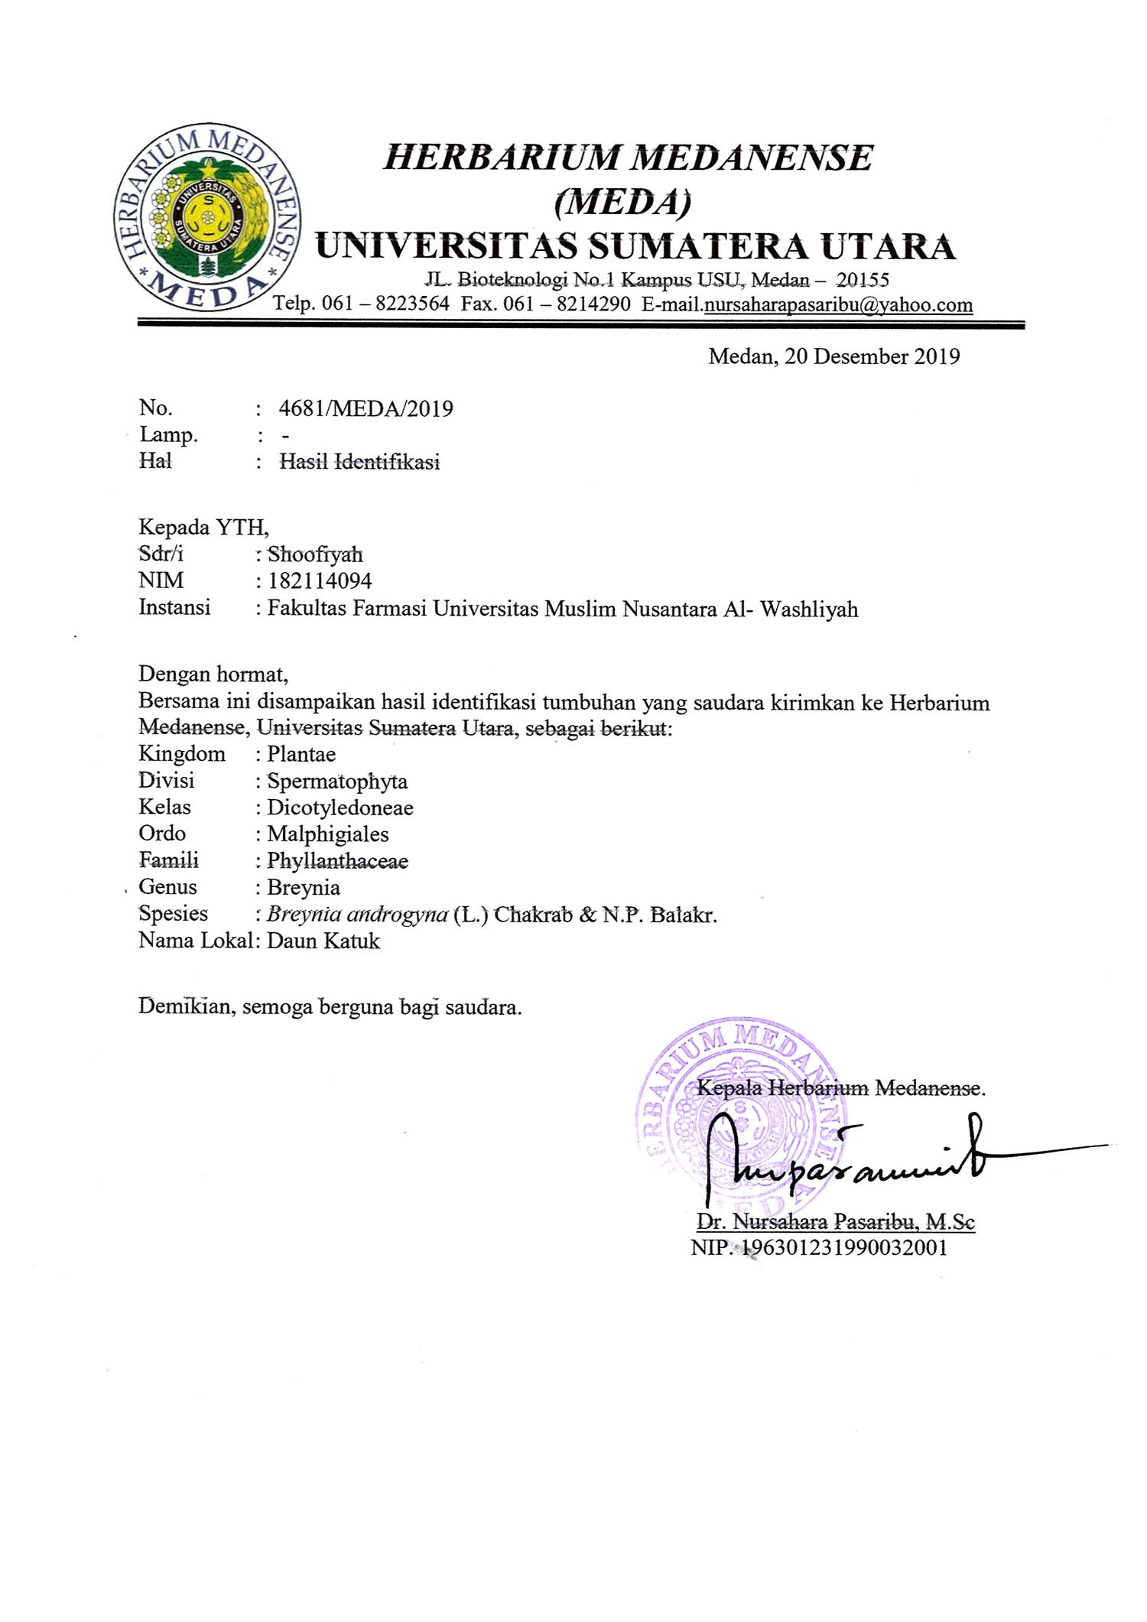**Lampiran 1.** Herbarium Medanense (MEDA)

**Lampiran 2.** Tumbuhan katuk (*Breynia androgyna* (L.) Chakrab)

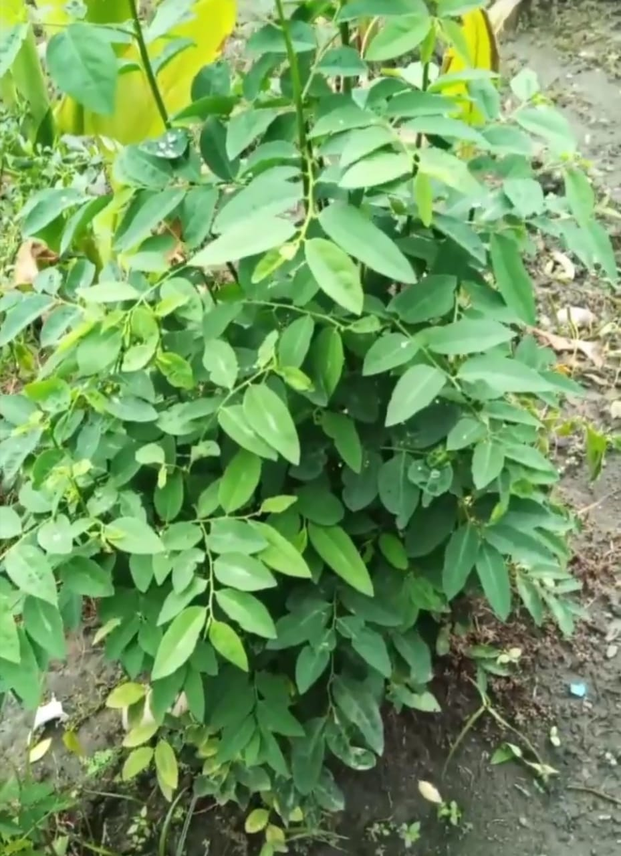

Tumbuhan katuk (*Breynia androgyna* (L.) Chakrab)

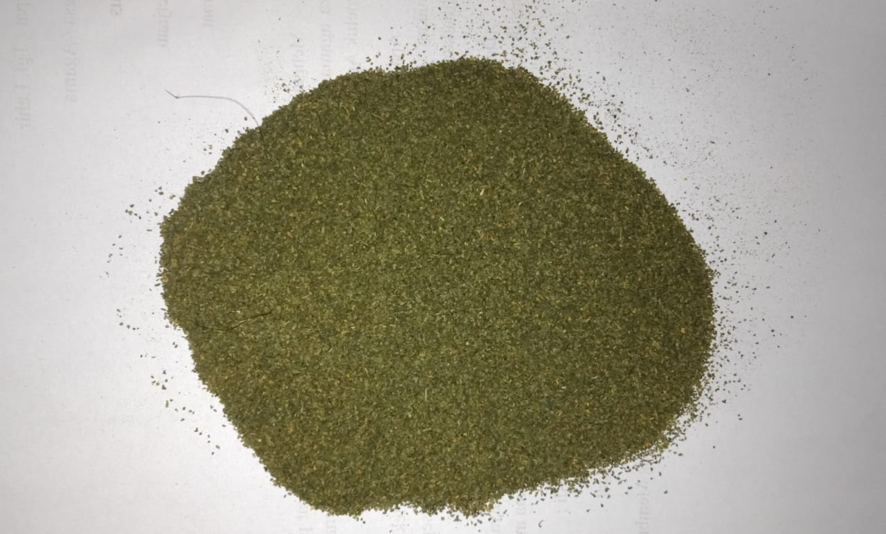

Simplisia Daun katuk (*Breynia androgyna* (L.) Chakrab)

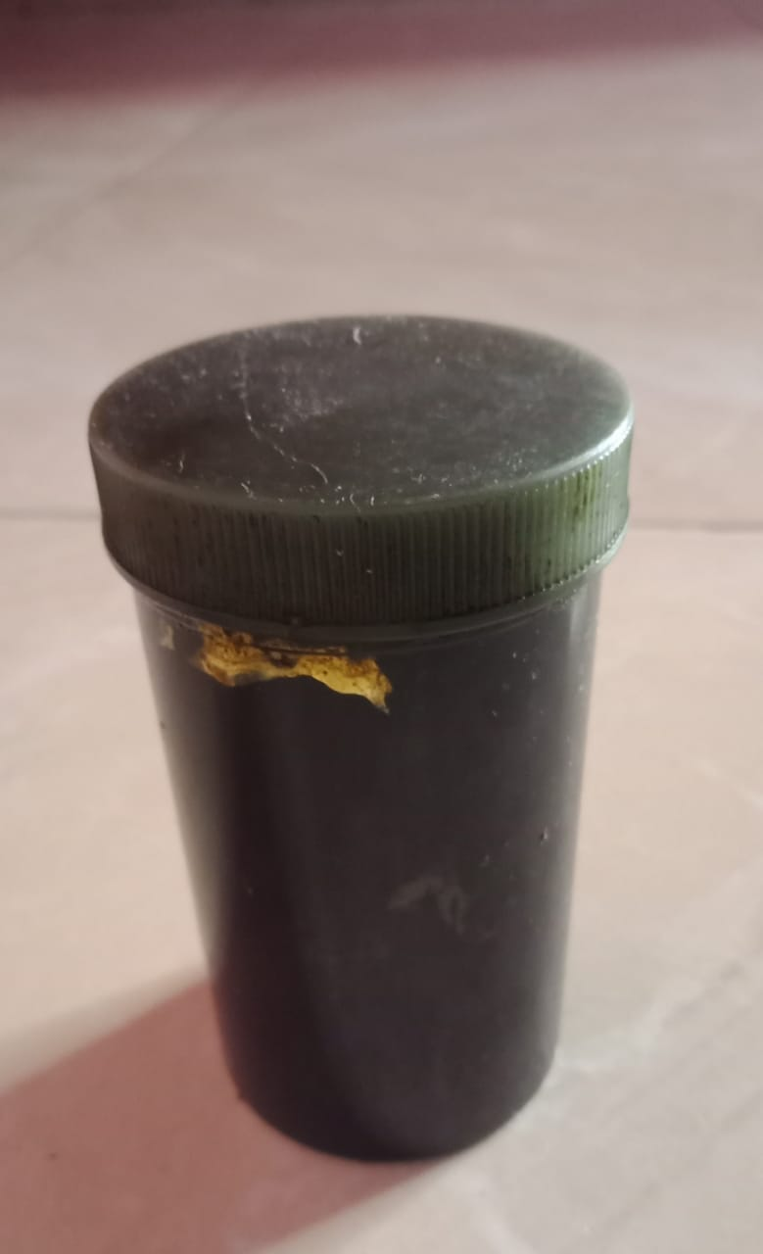

Ekstrak Daun katuk (*Breynia androgyna* (L.) Chakrab)

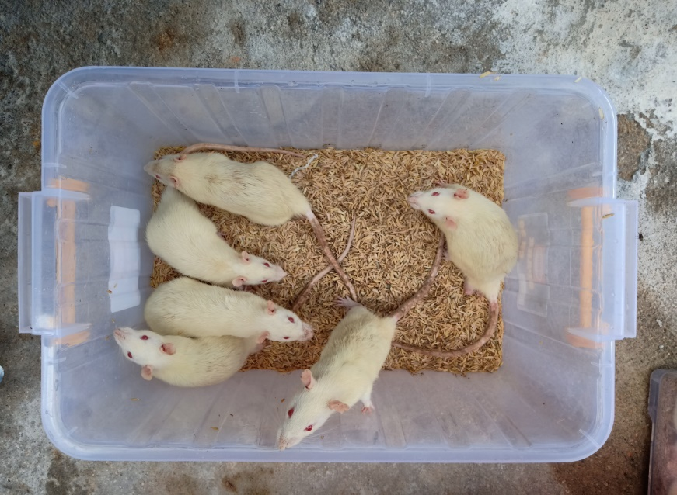**Lampiran 3.** Pengujian hewan

Tikus Putih (*Rattus novergicus*)

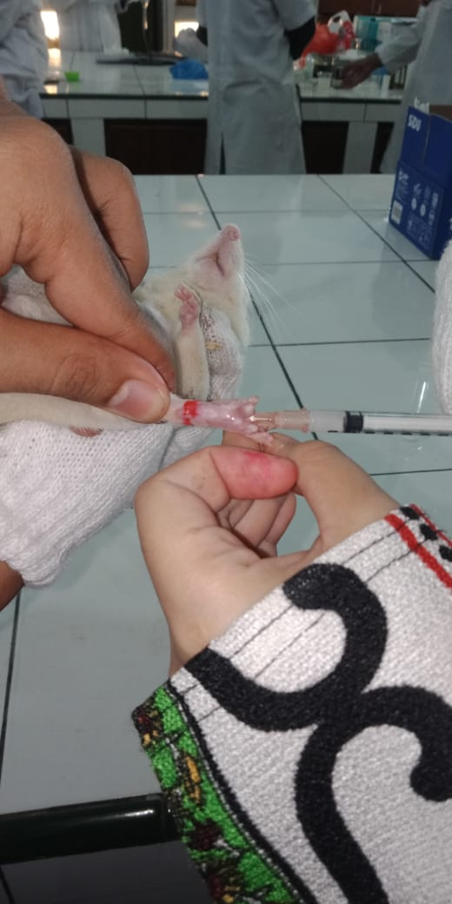

Penyuntikan Kaki Tikus Secara Intraplantar

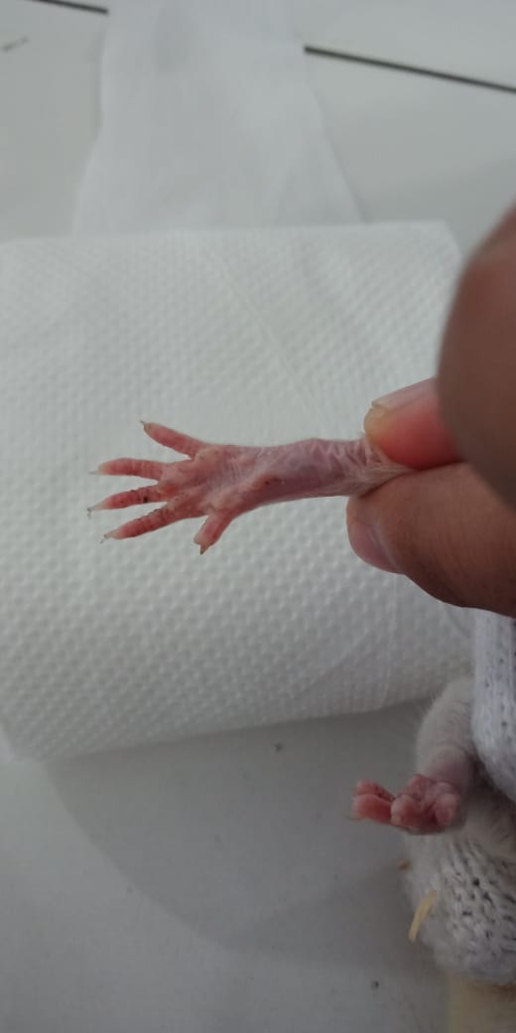

Tapak Kaki Tikus Sebelum Diinkubasi Karagenan

**Lampiran 3.** (Lanjutan)

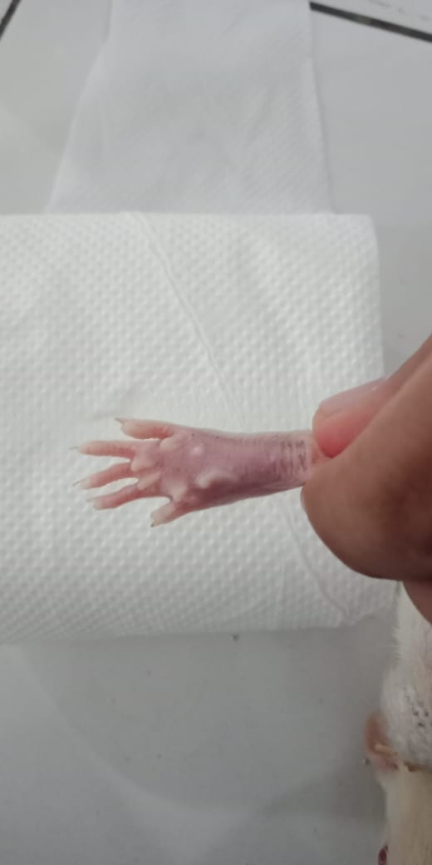

Tapak Kaki Tikus Setelah Diinkubasi Karagenan

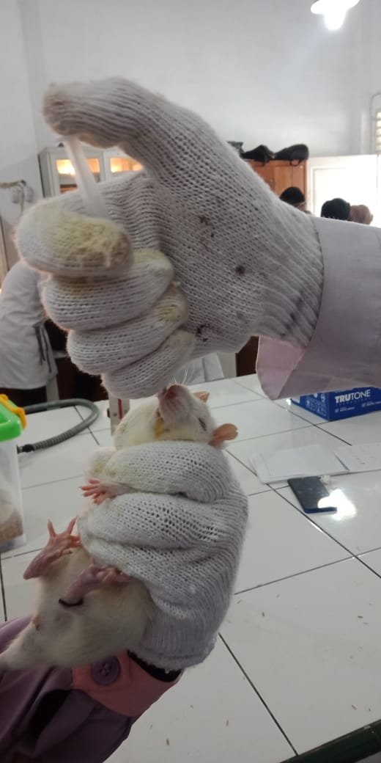

Pemberian Oral Pada Tikus

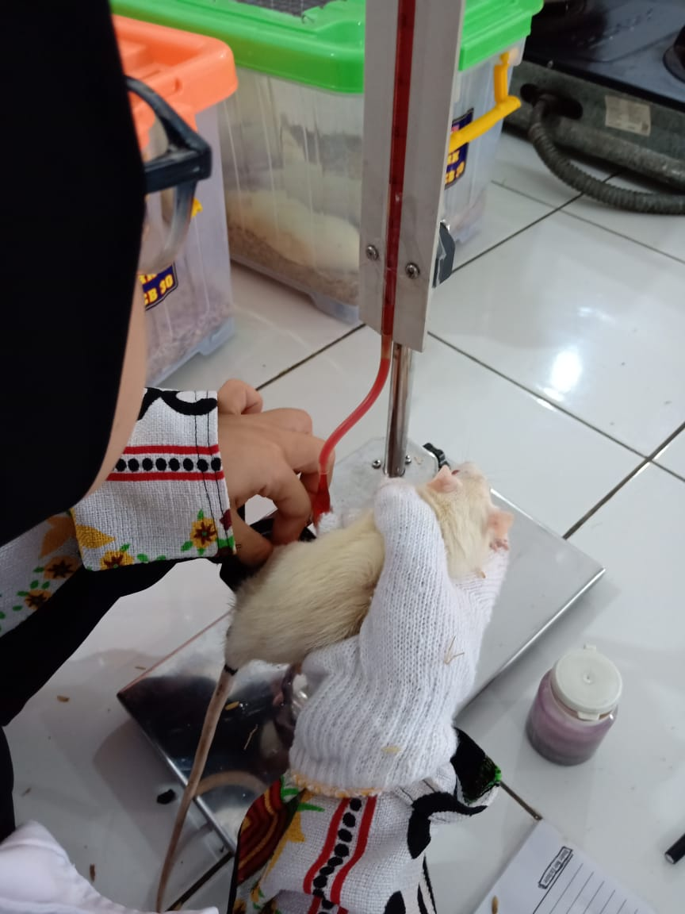

Pengukuran Inflamasi Dengan Plestismometer

**Lampiran 4.** Gambar alat

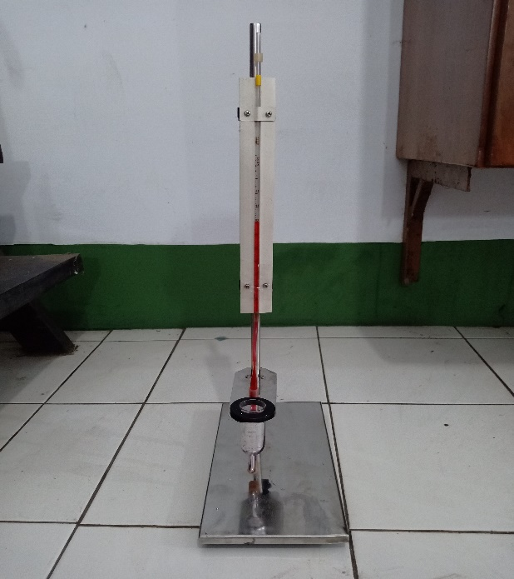

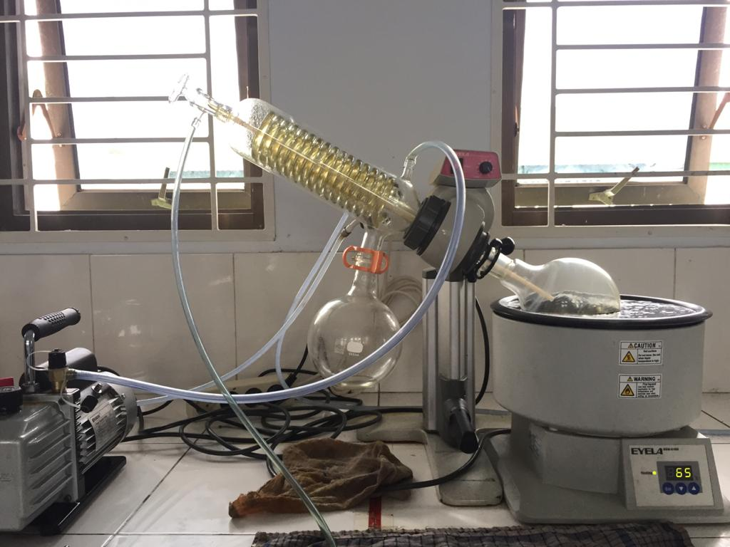Plestismometer

Rotary Evaporator

**Lampiran 5.** Bagan alir penelitian

Daun katuk 10 kg

dibersihkan dari pengotor

dicuci bersih dan ditiriskan

diangin-anginkan

ditimbang

Daun katuk

dikeringkan pada suhu 40˚C

ditimbang

Simplisia kering 1,5 kg

dihaluskan

ditimbang

Serbuk simplisia 1,3 kg

dimaserasi dengan etanol 96%

Karakterisasi simplisia :

* Pemeriksaan makroskopik dan mikroskopik
* Penetapan kadar air
* Penetapan kadar abu
* Penetepan kadar abu tidak larut asam
* Penetapan kadar sari larut dalam air

Ekstrak cair

dipekatkan dengan

rotary evaporator

Skrining fitokimia

* Alkaloid
* Flavonoid
* Steroid/triterpenoid
* Saponin
* Tanin
* Glikosida

Ekstrak kental

Uji antiinflamasi

- % Radang

- % Inbihasi Radang

**Lampiran 6**. Bagan alir pembuatan simplisia

Daun katuk

dibersihkan dari pengotor

dicuci bersih dengan air

mengalir

ditiriskan

diangin-anginkan

Ditimbang

Berat Daun katuk setelah dibersihkan

dikeringkan didalam

lemari pengering

pada suhu 40℃

disortasi kering

ditimbang

Berat simplisia 1,5 kg

dihaluskan menggunakan

blender

ditimbang

Berat serbuk simplisia 1,3 kg

dimasukkan kedalam

wadah

Tertutup rapat

Serbuk simplisia

**Lampiran 7.** Bagan alir pembuatan ekstrak

500 g serbuk simplisia daun katuk

dimasukkan kedalam bejana

ditambahkan etanol 96%

sebanyak 75 bagian (37.500 ml) diaduk

didiamkan selama 5 hari sambil diaduk

disaring

Ampas

Maserat I

dimasukkan dengan etanol 96% sebanyak 25 bagian (12.500 ml) dan diaduk

dimaserasi kembali selama 2 hari sambil diaduk

disaring

Maserat II

Maserat daun katuk

diperlukan dengan rotary evaporator pada

suhu 60˚C diuapkan dengan penangas air

Ekstrak etanol daun katuk

**Lampiran 8.** Bagan alir pengujian efek penurunan kadar radang

Tikus jantan

dikondisikan selama 2 minggu

dipuasakan selama 18 jam

ditimbang berat badan

diukur kaki dengan plestimometer dan diberi tanda

Kaki tikus jantan sebelum di induksi

diinduksi dengan karagenan 2%

diukur radang pada kaki tikus

Tikus inflamasi

diberikan perlakuan secara oral setiap kelompok

K1: Diberikan CMC (Blanko) 0,5%

K2: Diberikan Na. diklofenak 25mg/kgBB

K3: diberikan EEDK 100 mg/kgBB

K4: diberikan EEDK 200 mg/kgBB

K5: diberikan EEDK 300 mg/kgBB

diukur kadar radang pada kaki tikus selama 6 jam

Persen penurunan radang tikus setelah pemberian bahan uji berbagai waktu

Kadar radang tikus

**Lampiran 9.** Makroskopis daun katuk (*Breynia androgyna* (L.) Chakrab)

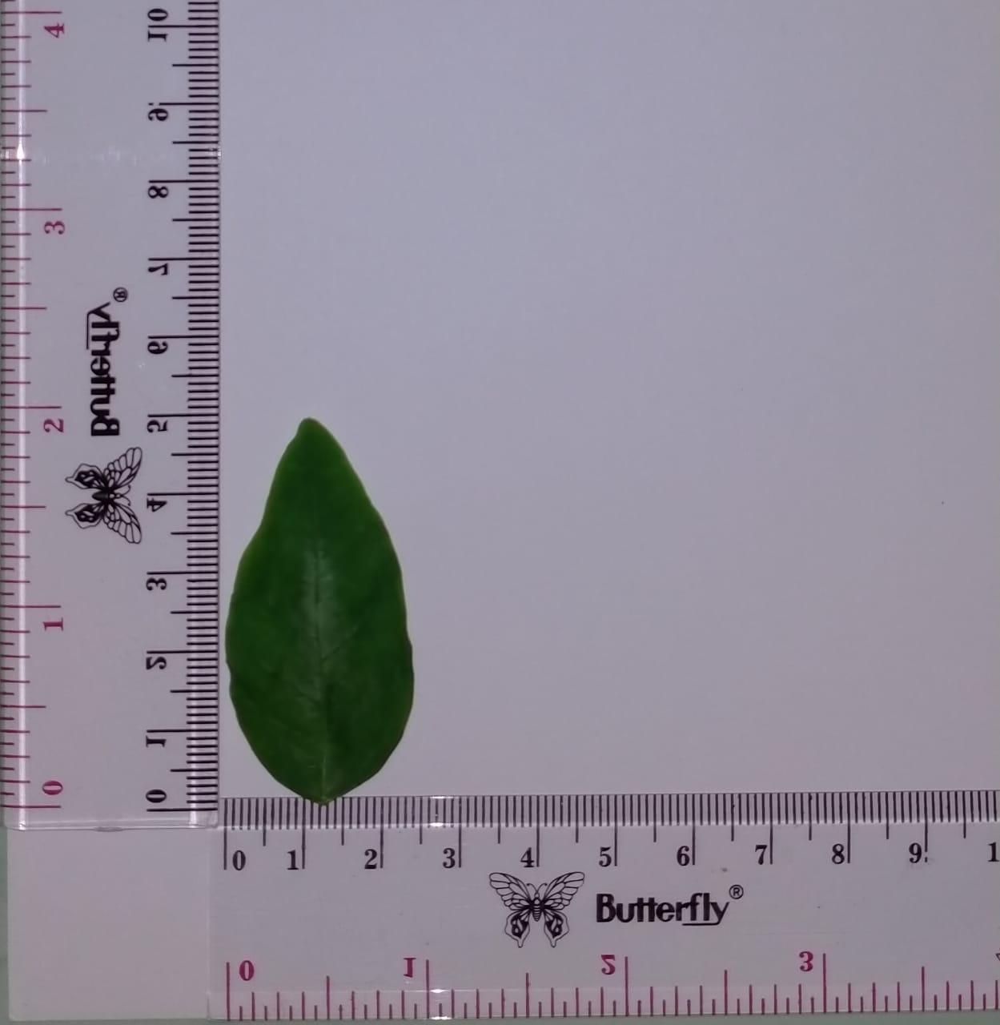

Keterangan

Bentuk : Bundar telur memanjang

Ukuran : Panjang 5 cm

Lebar 2,5 cm

Warna : hijau

Bau : Lemah

Rasa : Tawar

**Lampiran 10.** Mikroskopik daun katuk (*Breynia androgyna* (L.) Chakrab)

1. Mikroskopik serbuk daun katuk

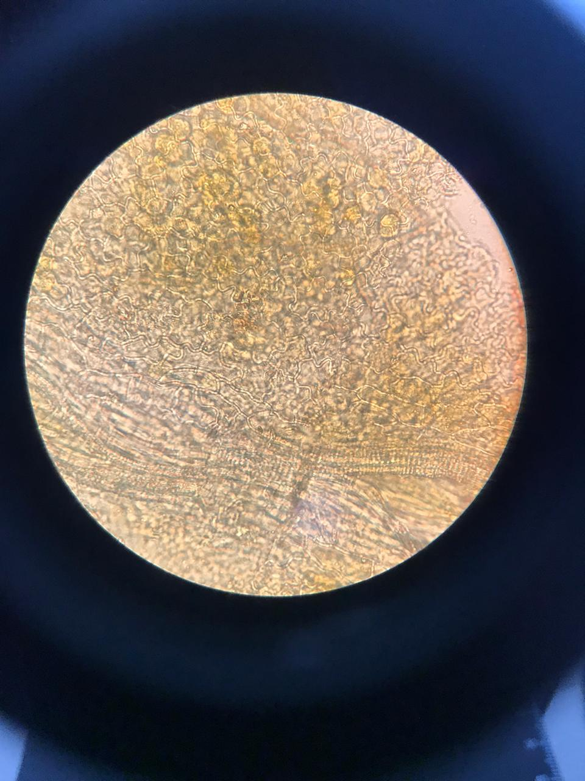

a. hablur kalsium oksalat

b. epidermis atas

c. pembuluh kayu

1. Pembanding mikroskopis serbuk daun katuk

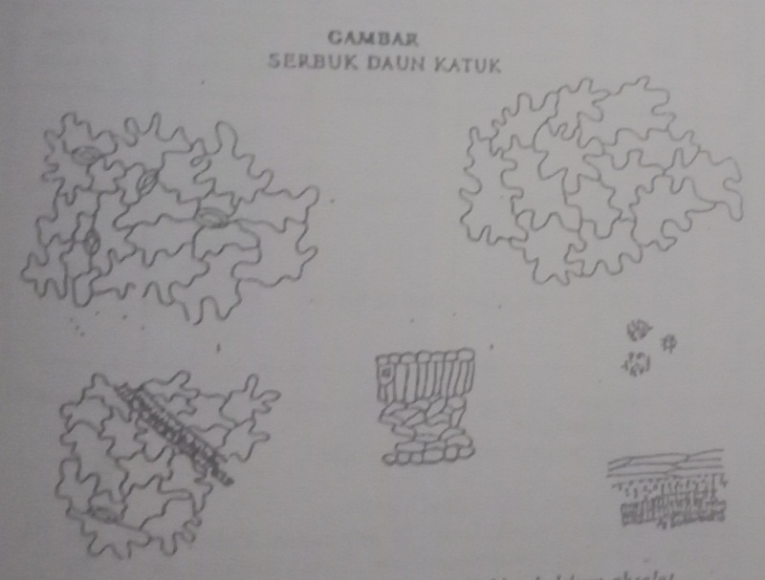

hablur kalsium oksalat

pembuluh kayu

epidermis atas

**Lampiran 11.** Perhitungan hasil pemeriksaan karakteristik simplisia

1. **Penetapan kadar air**

Kadar air = $\frac{\left(Volume Akhir Air-Volume Awal Air\right)ml}{Bobot Simplisia} x 100\%$

* **Pengulangan I**

Berat sampel = 5 gr

Volume akhir = 0,35 ml

Volume awal = 0,2 ml

Kadar Air = $\frac{0,35 ml-0,2ml}{5 g } x 100\%$ = 3 %

* **Pengulangan II**

Berat sampel = 5 gr

Volume akhir = 0,3 ml

Volume awal = 0,2 ml

Kadar air = $\frac{0,35 ml-0,15 ml}{5 g } x 100\%$ $\frac{0,3 ml-0,2 ml}{5 g } x 100\%$ = 2 %

* **Pengulangan III**

Berat sampel = 5 gr

Volume akhir = 0,35 ml

Volume awal = 0,2 ml

Kadar air = $\frac{0,35ml-0,2ml}{5 g } x 100\%$ = 3 %

kadar air rata-rata = $\frac{(3+2,6+3)\%}{3}$ $\frac{3\%+2\%+3\%}{3}$ = 2,6 %

**Lampiran 11.** (Lanjutan)

1. **Penetapan kadar sari larut dalam air**

Kadar sari larut air = $\frac{\left(Berat cawan+sampel\right)-berat cawan kosong) x5}{Bobot Sampel (g)} x100\%$

* **Sampel pengulangan I**

Berat sampel = 5 gr

Berat Cawan Kosong = 49,9952

B1 = 50,3269

B2 = 50,3270

B3 = 50,3269

Bobot rata-rata = 50,3269

Kadar sari larut air = $\frac{50,3269 g-49,9952 g x 5}{5 g} x 100\%$ = 33,07%

* **Sampel pengulangan II**

Berat sampel = 5 gr

Berat Cawan Kosong = 60,5669

B1 = 60,8854

B2 = 60,8852

B3 = 60,8854

Bobot rata-rata = 60,8853

Kadar sari larut air = $\frac{60,8853 g-60,5669 g x 5}{5 g} x 100\%$ = 31,84%

**Lampiran 11.** (Lanjutan)

* **Sampel pengulangan III**

Berat sampel = 5 gr

Berat Cawan Kosong = 60,6732

B1 = 60,9940

B2 = 60,9942

B3 = 60,9942

Bobot rata-rata = 60,9940

Kadar sari larut air = $\frac{60,9940g-60,6732 g x 5}{5 g} x 100\%$ = 32,08%

Kadar sari larut air rata-rata = $\frac{(33,07+31,84+32,08)\%}{3}$ = 32,33%

1. **Penetapan kadar sari larut dalam etanol**

Kadar sari larut etanol = $\frac{\left(Berat cawan+sampel\right)-berat cawan kosong) x5}{Bobot Sampel (g)} x100\%$

* Sampel pengulangan I

Berat sampel = 5 gr

Berat Cawan Kosong = 65,3441

B1 = 65,5553

B2 = 65,5556

B3 = 65,5553

Bobot rata-rata = 65,5554

Kadar sari larut etanol = $\frac{65,5554 g-65,3441g x 5}{5 g} x 100\%$ = 21,13%

**Lampiran 11.** (Lanjutan)

* Sampel pengulangan II

Berat sampel = 5 gr

Berat Cawan Kosong = 64,5885

B1 = 64,8651

B2 = 64,8651

B3 = 64,8648

Bobot rata-rata = 64,8650

Kadar sari larut etanol = $\frac{64,8650 g-64,5885 g x 5}{5 g} x 100\%$ = 27,65%

* Sampel pengulangan III

Berat sampel = 5 gr

Berat Cawan Kosong = 60,3302

B1 = 60,6133

B2 = 60,6234

B3 = 60,6234

Bobot rata-rata = 60,6200

Kadar sari larut etanol = $\frac{60,6200g- 60,3302 g x 5}{5 g} x 100\%$ = 28,98%

Kadar sari larut etanol rata-rata = $\frac{(21,13+27,65+28,98)\%}{3}$ = 25,92%

**Lampiran 11.** (Lanjutan)

1. **Penetapan kadar abu total**

Kadar abu total = $\frac{\left(Berat cawan+sampel\right)-berat cawan kosong)}{Bobot Sampel (g)} x100\%$

* **Sampel pengulangan I**

Berat sampel = 2 gr

Berat Cawan Kosong = 25,6872

B1 = 25,8651

B2 = 25,8651

B3 = 25,8655

Bobot rata-rata = 25,8652

Kadar abu total = $\frac{25,8652g - 25,6872 g}{2 g} x 100\%$ = 8,9%

* **Sampel pengulangan II**

Berat sampel = 2 gr

Berat Cawan Kosong = 26,7954

B1 = 26,9692

B2 = 26,9689

B3 = 26,9689

Bobot rata-rata = 26,9690

Kadar abu total = $\frac{26,9690 g - 26,7954 g}{2 g} x 100\%$ = 8,68%

**Lampiran 11.** (Lanjutan)

* **Sampel pengulangan III**

Berat sampel = 2 gr

Berat Cawan Kosong = 26,5934

B1 = 26,7654

B2 = 26,7654

B3 = 26,7650

Bobot rata-rata = 26,7652

Kadar abu total = $\frac{26,7652 g-26,5934 g }{2 g} x 100\%$ = 8,59%

Kadar abu total rata-rata = $\frac{(8,9 +8,68 + 8,59)\%}{3}$ = 8,72%

1. **Penetapan kadar abu tidak larut dalam asam**

Kadar abu larut asam = $\frac{\left(Berat cawan+sampel\right)-berat cawan kosong)}{Bobot Sampel (g)} x100\%$

* **Sampel pengulangan I**

Berat sampel = 0,0880 gr

Berat Cawan Kosong = 26,5611

B1 = 26,5616

B2 = 26,5615

B3 = 26,5616

Bobot rata-rata = 26,5615

Kadar abu larut asam = $\frac{26,5615 g- 26,5611 g }{0,0880 g} x 100\%$ = 0,45%

**Lampiran 11.** (Lanjutan)

* **Sampel pengulangan II**

Berat sampel = 0,0868 gr

Berat Cawan Kosong = 25,8960

B1 = 25,8965

B2 = 25,8964

B3 = 25,8965

Bobot rata-rata = 25,8964

Kadar abu larut asam = $\frac{25,8964 g- 25,8960g }{0,0868 g} x 100\%$ = 0,46 %

* **Sampel pengulangan III**

Berat sampel = 0,0859 gr

Berat Cawan Kosong = 26,3951

B1 = 26,3955

B2 = 26,3956

B3 = 26,3955

Bobot rata-rata = 26,3955

Kadar abu larut asam = $\frac{26,3955 g- 26,3951 g }{0,0859 g} x 100\%$ = 0,46%

Kadar abu larut asam rata-rata = $\frac{(0,45+0,46+ 0,46)\%}{3}$ = 0,45%

**Lampiran 12.** Tabel konversi perhitungan dosis (Laurence & Bacharach, 1964)

|  |  |  |  |  |  |  |  |  |
| --- | --- | --- | --- | --- | --- | --- | --- | --- |
|  | Mencit 20 g | Tikus 200 g | Marmot 400 g | Kelinci 1,5 kg | Kucing 2 kg | Kera 4 kg | Anjing 12 kg | Manusia 70 kg |
| Mencit 20 g | 1.0 | 7.0 | 12.25 | 27.8 | 29.7 | 64.1 | 124.2 | 387.9 |
| Tikus 200 g | 0.14 | 1.0 | 1.74 | 3.9 | 4.2 | 9.2 | 17.8 | 56.0 |
| Marmot 400 g | 0.08 | 0.57 | 1.0 | 2.25 | 2.4 | 5.2 | 10.2 | 31.5 |
| Kelinci 1,5 kg | 0.04 | 0.25 | 0.44 | 1.0 | 1.08 | 2.4 | 4.5 | 14.2 |
| Kucing  2 kg | 0.03 | 0.23 | 0.41 | 0.92 | 1.0 | 2.2 | 4.1 | 13.0 |
| Kera 4 kg | 0.016 | 0.11 | 0.19 | 0.42 | 0.45 | 1.0 | 1.9 | 6.1 |
| Anjing 12 kg | 0.008 | 0.06 | 0.1 | 0.22 | 0.24 | 0.52 | 1.0 | 3.1 |
| Manusia 70 kg | 0.0026 | 0.018 | 0.031 | 0.07 | 0.076 | 0.16 | 0.32 | 1.0 |

Dosis absolut tikus 200 gr = 300 mg/kgBB x 0,2 kg

= 60 mg

Dosis manusia = 60 mg x 56,0

= 3.360 mg

Untuk manusia 60 kg = 3.360 mg/ 60 kg

= 56 mg/kgBB

**Lampiran 13.** Perhitungan dosis kontrol positif dan kontrol negatif

Kontrol positif (Na. diklofenak 25 mg) dalam 100 ml

= $\frac{25 mg }{100 ml}=0,25 mg/ml$ = 0,025%

Konversi dosis pada tikus = 0,018

Dosis = 25 mg $x$ 0,018 = 0,45 mg / 0,2 kg = 2,25 mg/kgBB

**Hewan I**

Berat = 210 g

= $\frac{2,25 mg}{0,25 mg/ml}=9 ml$

= $\frac{9 ml }{1000 g} x$ 210 g = 1,890 ml

**Hewan II**

Berat = 198 g

= $\frac{9 ml}{1000 g} x$ 198 g = 1,782 ml

**Hewan III**

Berat = 195 g

= $\frac{9 ml }{1000 g} x$ 195 g = 1,755 ml

**Hewan IV**

Berat = 205 g

= $\frac{9 ml}{1000 g} x$ 205 g = 1,845 ml

**Hewan V**

Berat = 200 g

= $\frac{9 ml }{1000 g} x$ 200 g = 1,800 ml

**Lampiran 13.** (Lanjutan)

**Hewan VI**

Berat = 207 g

= $\frac{9 ml}{1000 g} x$ 207 g = 1,863 ml

Kontrol negatif (CMC 0,5 gr) dalam 100 ml

Berat = 200 g

= $\frac{200 g}{100 ml} x 0,5$ g = 1 ml

**Lampiran 14.** Perhitungan dosis ekstrak etanol daun katuk (EEDK)

* + - 1. **Ekstrak etanol daun katuk (EEDK)**
         1. **EEDK dosis 100 mg**

**Hewan I**

Berat = 195 g

= $\frac{100 mg }{1000 g}x195 g$ = 19,5 mg

= $\frac{19,5 mg }{20 mg/ml}$ = 0,975 ml

**Hewan II**

Berat = 212 g

= $\frac{100 mg }{1000 g}x212 g$ = 21,2 mg

= $\frac{21,2 mg }{20 mg/ml}$ = 1,06 ml

**Hewan III**

Berat = 214 g

= $\frac{100 mg }{1000 g}x214 g$ = 21,4 mg

= $\frac{21,4 mg }{20 mg/ml}$ = 1,07 ml

**Hewan IV**

Berat = 198 g

= $\frac{100 mg }{1000 g}x198 g$ = 19,8 mg

= $\frac{19,8 mg }{20 mg/ml}$ = 0,99 ml

**Lampiran 14.** (Lanjutan)

**Hewan V**

Berat = 196 g

= $\frac{100 mg }{1000 g}x196 g$ = 19,6 mg

= $\frac{19,6 mg }{20 mg/ml}$ = 0,98 ml

**Hewan VI**

Berat = 215 g

= $\frac{100 mg }{1000 g}x215 g$ = 21,5 mg

= $\frac{21,5 mg }{20 mg/ml}$ = 1,075 ml

* + - * 1. **EEDK dosis 200 mg**

**Hewan I**

Berat = 210 g

= $\frac{200 mg }{1000 g}x 210 g$ = 42 mg

= $\frac{42 mg }{20 mg/ml}$ = 2,1 ml

**Hewan II**

Berat = 218 g

= $\frac{200 mg }{1000 g}x 218 g$ = 43,6 mg

= $\frac{43,6 mg }{20 mg/ml}$ = 2,18 ml

**Hewan III**

Berat = 215 g

= $\frac{200 mg }{1000 g}x 215 g$ = 43 mg

**Lampiran 14.** (Lanjutan)

= $\frac{43 mg }{20 mg/ml}$ = 2,15 ml

**Hewan IV**

Berat = 217 g

= $\frac{200 mg }{1000 g}x 217 g$ = 43,4 mg

= $\frac{43,4 mg }{20 mg/ml}$ = 2,17 ml

**Hewan V**

Berat = 210 g

= $\frac{200 mg }{1000 g}x 210 g$ = 42 mg

= $\frac{42 mg }{20 mg/ml}$ = 2,1 ml

**Hewan VI**

Berat = 200 g

= $\frac{200 mg }{1000 g}x 200g$ = 40 mg

= = 2 ml

* + - * 1. **EEDK dosis 300 mg**

**Hewan I**

Berat = 205 g

= $\frac{300 mg }{1000 g}x 205 g$ = 61,5 mg

= $\frac{61,5 mg }{20 mg/ml}$ = 3,07 ml

**Hewan II**

Berat = 200 g

**Lampiran 14.** (Lanjutan)

= $\frac{300 mg }{1000 g}x 200 g$ = 60 mg

= $\frac{60 mg }{20 mg/ml}$ = 3 ml

**Hewan III**

Berat = 218 g

= $\frac{300 mg }{1000 g}x 218 g$ = 65,4 mg

= $\frac{65,4 mg }{20 mg/ml}$ = 3,27 ml

**Hewan IV**

Berat = 208 g

= $\frac{300 mg }{1000 g}x 208 g$ = 62,4mg

= $\frac{62,4 mg }{20 mg/ml}$ = 3,12 ml

**Hewan V**

Berat = 193 g

= $\frac{300 mg }{1000 g}x 193 g$ = 57,9 mg

= $\frac{57,9 mg }{20 mg/ml}$ = 2,89 ml

**Hewan VI**

Berat = 220 g

= $\frac{300 mg }{1000 g}x 220 g$ = 66 mg

= $\frac{66 mg }{20 mg/ml}$ = 3,3 ml

**Lampiran 15.** Contoh perhitungan data secara statistik

Diambil sebagai contoh perhitungan dari data setelah penggunaan ekstrak etanol daun katuk dosis 100mg/KgBB pada jam pertama.

|  |  |  |  |
| --- | --- | --- | --- |
| **No.** | **Kadar (%)** | **X- X** |  |
| 1. | 70.00 | 4.43 | 19.0249 |
| 2. | 73.30 | 1.13 | 1.2769 |
| 3. | 73.30 | 1.13 | 1.2769 |
| 4. | 80.00 | -5.57 | 31.0249 |
| 5. | 70.00 | 4.43 | 19.6249 |
| 6. | 80.00 | 5.57 | 31.0249 |
| **N = 6** | **∑ X =** 446,6  **=** 74,43 | |  |

Standar deviasi ( SD) = $\sqrt{\frac{∑ (X - X)2}{n-1}}$ = $\frac{102.6534}{5 }$

Standar deviasi (SD) = 4.53

Dasar penolakan data adalah apabila thitung > ttabel dengan tingkat kepercayaan 99%

α = 0,01; n = 6, dk = 5 dan ttabel = 4,032

1. thitung = = = = 2,39
2. thitung = = = = 0,61
3. thitung = = = = 0,61
4. thitung = = = = 3,01
5. thitung = = = = 2,39

**Lampiran 15.** (Lanjutan)

1. thitung = = = = 3.01

Seluruh thitung dari ke-6 perlakuan < ttabel, berarti semua data ini bisa diterima

**Menghitung hasil sebenarnya =**

Penurunan kadar Radang rata-rata ± t (1 – ½ α).dk x 

Penurunan kadar Radang rata-rata () = 74,43 %

Standar deviasi (SD) = 4,53

Penurunan kadar Radang rata-rata =  ± t (1 – 1/ 2 α) x 4,032 x $\frac{SD}{\sqrt{6}}$

Penurunan kadar Radang sebenarnya = 74,43 % ± 4,032 x $\frac{4,53}{2,449}$ $\frac{4.56}{2,449}$

Penurunan kadar Radang sebenarnya = 74,43 ± 7.45

Dengan cara yang sama dihitung untuk perlakuan pada berbagai waktu dan untuk bahan lainnya, data selengkapnya dapat dilihat pada lampiran 16 halaman 84.

**Lampiran 16.** Data perlakuan hewan uji

|  |  |  |  |  |  |  |  |  |  |  |  |  |  |  |  |
| --- | --- | --- | --- | --- | --- | --- | --- | --- | --- | --- | --- | --- | --- | --- | --- |
| Perlakuan | Ulangan | Vo | Jam ke 1 | | Jam ke 2 | | Jam ke 3 | | Jam ke 4 | | | Jam ke 5 | | Jam ke 6 | |
| V1 | %R | V2 | %R | V3 | %R | V4 | %R | | V5 | %R | 0,068 | %R |
| CMC  (Blanko) | 1 | 0,040 | 0,070 | 75.00 | 0,072 | 80.00 | 0,070 | 75.00 | 0,068 | 70.00 | | 0,068 | 70.00 | 0,066 | 65.00 |
| 2 | 0,040 | 0,072 | 80.00 | 0,074 | 85.00 | 0,072 | 80.00 | 0,070 | 75.00 | | 0,070 | 75.00 | 0,068 | 70.00 |
| 3 | 0,040 | 0,080 | 100.00 | 0,084 | 110.00 | 0,082 | 105.00 | 0,078 | 95.00 | | 0,076 | 90.00 | 0,074 | 85.00 |
| 4 | 0,040 | 0,080 | 100.00 | 0,082 | 105.00 | 0,080 | 100.00 | 0,076 | 90.00 | | 0,074 | 85.00 | 0,072 | 80.00 |
| 5 | 0,040 | 0,078 | 95.00 | 0,080 | 100.00 | 0,078 | 95.00 | 0,074 | 85.00 | | 0,072 | 80.00 | 0,070 | 75.00 |
| 6 | 0,040 | 0,080 | 100.00 | 0,082 | 105.00 | 0,080 | 100.00 | 0,072 | 80.00 | | 0,070 | 75.00 | 0,068 | 70.00 |
| Rata- Rata % Radang = 91.67  Standar deviasi = 11.25  Hasil sebenarnya = 91.67 ± 18.51 | | | | | | = 97.50  = 12.14  = 97.50 ± 19.98 | | = 92.50  = 11.19  = 92.50 ± 18.42 | | | = 82.50  = 9.35  = 82.50 ± 15.39 | | = 79.17  = 7.35  = 82,50 ± 12.10 | | = 74.17  = 7.35  = 74.17 ± 12.10 |
| Na. Diklofenak | 1 | 0,040 | 0,064 | 60.00 | 0,068 | 70.00 | 0,060 | 50.00 | 0,056 | 40.00 | | 0,050 | 25.00 | 0,044 | 10.00 |
| 2 | 0,040 | 0,066 | 65.00 | 0,076 | 90.00 | 0,072 | 80.00 | 0,056 | 40.00 | | 0,048 | 20.00 | 0,042 | 5.00 |
| 3 | 0,040 | 0,070 | 75.00 | 0,072 | 80.00 | 0,069 | 72.50 | 0,050 | 25.00 | | 0,046 | 15.00 | 0,040 | 0.00 |
| 4 | 0,040 | 0,060 | 50.00 | 0,079 | 97.50 | 0,074 | 85.00 | 0,064 | 60.00 | | 0,050 | 25.00 | 0,042 | 5.00 |
| 5 | 0,030 | 0,054 | 80.00 | 0,056 | 86.60 | 0,052 | 73.30 | 0,044 | 46.60 | | 0,036 | 20.00 | 0,033 | 10.00 |
| 6 | 0,040 | 0,070 | 75.00 | 0,078 | 95.00 | 0,074 | 85.00 | 0,048 | 20.00 | | 0,044 | 10.00 | 0,040 | 0.00 |
| Rata- Rata % Radang = 67.50  Standar deviasi = 9.85  Hasil sebenarnya = 67.50 ± 16.21 | | | | | | = 86,52  = 10.19  = 86,52 ± 16.77 | | = 74.30  = 13.08  = 74.30 ± 21.53 | | | = 38.60  = 14.54  = 38.60 ± 23.93 | | = 19.17  = 8.41  = 19.17± 13.84 | | = 2,50  = 4.47  = 5.00 ± 7.35 |
| EEDK 100 mg/kg BB | 1 | 0,040 | 0,068 | 70.00 | 0,072 | 80.00 | 0,069 | 72.50 | 0,068 | 70.00 | | 0,066 | 65.00 | 0,058 | 45.00 |
| 2 | 0,030 | 0,052 | 73.30 | 0,056 | 86.60 | 0,054 | 80.00 | 0,052 | 73.30 | | 0,048 | 60.00 | 0,044 | 46.60 |
| 3 | 0,030 | 0,052 | 73.30 | 0,060 | 100.00 | 0,054 | 80.00 | 0,048 | 60.00 | | 0,046 | 53.30 | 0,042 | 40.00 |
| 4 | 0,040 | 0,072 | 80.00 | 0,080 | 100.00 | 0,076 | 90.00 | 0,074 | 85.00 | | 0,068 | 70.00 | 0,066 | 65.00 |
| 5 | 0,040 | 0,068 | 70.00 | 0,080 | 100.00 | 0,074 | 85.00 | 0,072 | 80.00 | | 0,066 | 65.00 | 0,056 | 40.00 |
| 6 | 0,040 | 0,072 | 80.00 | 0,076 | 90.00 | 0,054 | 85.00 | 0,068 | 70.00 | | 0,048 | 60.00 | 0,050 | 25.00 |
| Rata-Rata % Radang = 74.43  Standar deviasi = 4.53  Hasil sebenarnya = 74.43± 7.45 | | | | | | = 92.77  = 8.55  = 92,77 ± 14.07 | | = 82.08  = 6.00  = 82.08 ± 9.87 | | | = 73.05  = 8.71  = 73.05 ± 14.33 | | = 62.22  = 5.75  = 62.22 ± 9.46 | | = 43.60  = 12.96  = 43.60 ± 21.33 |

**Lampiran 16.** (Lanjutan)

|  |  |  |  |  |  |  |  |  |  |  |  |  |  |  |  |
| --- | --- | --- | --- | --- | --- | --- | --- | --- | --- | --- | --- | --- | --- | --- | --- |
| Perlakuan | Ula ngan | Vo | Jam ke 1 | | Jam ke 2 | | Jam ke 3 | | | Jam ke 4 | | Jam ke 5 | | Jam ke 6 | |
| V1 | %R | V2 | %R | V3 | %R | | V4 | %R | V5 | %R | V6 | %R |
| EEDK 200 mg/kg BB | 1 | 0,040 | 0,067 | 67.50 | 0,070 | 75.00 | 0,068 | 70.00 | | 0,066 | 65.00 | 0,058 | 45.00 | 0,054 | 35.00 |
| 2 | 0,030 | 0,066 | 65.00 | 0,054 | 80.00 | 0,052 | 73.30 | | 0,050 | 66.60 | 0,046 | 53.30 | 0,042 | 40.00 |
| 3 | 0,040 | 0,068 | 70.00 | 0,072 | 80.00 | 0,068 | 70.00 | | 0,060 | 50.00 | 0,058 | 45.00 | 0,053 | 32.50 |
| 4 | 0,040 | 0,070 | 75.00 | 0,076 | 90.00 | 0,069 | 72.50 | | 0,068 | 70.00 | 0,048 | 60.00 | 0,056 | 40.00 |
| 5 | 0,040 | 0,066 | 65.00 | 0,078 | 95.00 | 0,072 | 80.00 | | 0,070 | 75.00 | 0,058 | 45.00 | 0,050 | 25.00 |
| 6 | 0,030 | 0,052 | 73.30 | 0,054 | 80.00 | 0,052 | 73.30 | | 0,048 | 60.00 | 0,046 | 53.30 | 0,033 | 10.00 |
| Rata-Rata % Radang = 63.30  Standar deviasi = 4.22  Hasil sebenarnya = 63.30 ± 6.94 | | | | | | = 83.33  = 7.53  = 83,33 ± 12.39 | | = 73.18  = 3.67  = 73.18 ± 6,03 | | | = 64.43  = 8.67  = 64.43 ± 14.27 | | = 50.27  = 6.27  = 50.27 ± 10.32 | | = 30.42  = 11.44  = 30.42 ± 18.83 |
| EEDK 300 mg/kg BB | 1 | 0,040 | 0,066 | 65.00 | 0,068 | 70.00 | 0,067 | 67.50 | | 0,065 | 62.50 | 0,058 | 45.00 | 0,056 | 40.00 |
| 2 | 0,030 | 0,048 | 60.00 | 0,052 | 73.30 | 0,050 | 66.60 | | 0,048 | 60.00 | 0,042 | 40.00 | 0,038 | 26.60 |
| 3 | 0,040 | 0,066 | 65.00 | 0,072 | 80.00 | 0,065 | 62.50 | | 0,056 | 40.00 | 0,054 | 35.00 | 0,050 | 25.00 |
| 4 | 0,040 | 0,068 | 70.00 | 0,072 | 80.00 | 0,068 | 70.00 | | 0,048 | 60.00 | 0,058 | 45.00 | 0,054 | 35.00 |
| 5 | 0,040 | 0,048 | 60.00 | 0,076 | 90.00 | 0,066 | 65.00 | | 0,060 | 50.00 | 0,054 | 35.00 | 0,050 | 25.00 |
| 6 | 0,040 | 0,066 | 65.00 | 0,068 | 70.00 | 0,048 | 60.00 | | 0,058 | 45.00 | 0,050 | 25.00 | 0,042 | 5.00 |
| Rata-Rata % Radang = 64.17  Standar deviasi = 3.76  Hasil sebenarnya = 64.17 ± 6.18 | | | | | | = 77,22  = 7.73  = 77,22 ± 12.72 | | | = 65.27  = 3.60  = 65.27 ± 5.92 | | = 52.92  = 9.27  = 52.92 ± 15.26 | | = 37.50  = 7.58  = 37.50 ± 12.47 | | = 26.10  = 12.00  = 26.10 ± 19.75 |

**Lampiran 17.** Hasil uji ANOVA

|  |  |  |  |  |  |  |
| --- | --- | --- | --- | --- | --- | --- |
| **ANOVA** | | | | | | |
|  | | Sum of Squares | df | Mean Square | F | Sig. |
| Menit_60 | Between Groups | 2630.088 | 4 | 657.522 | 13.520 | .000 |
| Within Groups | 1167.220 | 24 | 48.634 |  |  |
| Total | 3797.308 | 28 |  |  |  |
| Menit_120 | Between Groups | 1700.301 | 4 | 425.075 | 5.079 | .004 |
| Within Groups | 2008.787 | 24 | 83.699 |  |  |
| Total | 3709.088 | 28 |  |  |  |
| Menit_180 | Between Groups | 2528.487 | 4 | 632.122 | 12.737 | .000 |
| Within Groups | 1141.422 | 23 | 49.627 |  |  |
| Total | 3669.909 | 27 |  |  |  |
| Menit_240 | Between Groups | 7160.822 | 4 | 1790.205 | 17.679 | .000 |
| Within Groups | 2430.231 | 24 | 101.260 |  |  |
| Total | 9591.053 | 28 |  |  |  |
| Menit_300 | Between Groups | 12196.586 | 4 | 3049.147 | 81.002 | .000 |
| Within Groups | 903.428 | 24 | 37.643 |  |  |
| Total | 13100.014 | 28 |  |  |  |
| Menit_360 | Between Groups | 15169.156 | 4 | 3792.289 | 73.343 | .000 |
| Within Groups | 1137.529 | 22 | 51.706 |  |  |
| Total | 16306.685 | 26 |  |  |  |

**Lampiran 18.** Hasil uji *Tukey HSD*

|  |  |  |  |
| --- | --- | --- | --- |
| **Menit_60** | | | |
| Tukey HSD | | | |
| Perlakuan | N | Subset for alpha = 0.05 | |
| 1 | 2 |
| EEDK 300 mg | 6 | 64.167 |  |
| EEDK 200 mg | 6 | 69.300 |  |
| Kontrol positif ( Na. diklofenak 1%) | 5 | 71.000 |  |
| EEDK 100 mg | 6 | 74.433 |  |
| Kontrol Negatif (CMC 0,5%) | 6 |  | 91.667 |
| Sig. |  | .124 | 1.000 |
| Means for groups in homogeneous subsets are displayed. | | | |
| a. Uses Harmonic Mean Sample Size = 5.769. | | | |
| b. The group sizes are unequal. The harmonic mean of the group sizes is used. Type I error levels are not guaranteed. | | | |

|  |  |  |  |
| --- | --- | --- | --- |
| **Menit_120** | | | |
| Tukey HSD | | | |
| Perlakuan | N | Subset for alpha = 0.05 | |
| 1 | 2 |
| EEDK 300 mg | 5 | 74.660 |  |
| EEDK 200 mg | 6 |  | 83.333 |
| Kontrol positif ( Na. diklofenak 1%) | 6 |  | 86.517 |
| EEDK 100 mg | 6 |  | 92.767 |
| Kontrol Negatif (CMC 0,5%) | 6 |  | 97.500 |
| Sig. |  | .213 | .096 |
| Means for groups in homogeneous subsets are displayed. | | | |
| a. Uses Harmonic Mean Sample Size = 5.769. | | | |
| b. The group sizes are unequal. The harmonic mean of the group sizes is used. Type I error levels are not guaranteed. | | | |

|  |  |  |  |  |
| --- | --- | --- | --- | --- |
| **Menit_180** | | | | |
| Tukey HSD | | | | |
| Perlakuan | N | Subset for alpha = 0.05 | | |
| 1 | 2 | 3 |
| EEDK 300 mg | 6 | 65.267 |  |  |
| EEDK 200 mg | 5 |  | 71.820 |  |
| Kontrol positif ( Na. diklofenak 1%) | 5 |  | 79.160 |  |
| EEDK 100 mg | 6 |  | 82.083 | 82.083 |
| Kontrol Negatif (CMC 0,5%) | 6 |  |  | 92.500 |
| Sig. |  | .542 | .143 | .134 |
| Means for groups in homogeneous subsets are displayed. | | | | |
| a. Uses Harmonic Mean Sample Size = 5.556. | | | | |
| b. The group sizes are unequal. The harmonic mean of the group sizes is used. Type I error levels are not guaranteed. | | | | |

|  |  |  |  |  |
| --- | --- | --- | --- | --- |
| **Menit_240** | | | | |
| Tukey HSD | | | | |
| Perlakuan | N | Subset for alpha = 0.05 | | |
| 1 | 2 | 3 |
| Kontrol positif ( Na. diklofenak 1%) | 6 | 38.600 |  |  |
| EEDK 300 mg | 6 |  | 52.917 |  |
| EEDK 200 mg | 5 |  |  | 67.320 |
| EEDK 100 mg | 6 |  |  | 73.050 |
| Kontrol Negatif (CMC 0,5%) | 6 |  |  | 82.500 |
| Sig. |  | .145 | .141 | .110 |
| Means for groups in homogeneous subsets are displayed. | | | | |
| a. Uses Harmonic Mean Sample Size = 5.769. | | | | |
| b. The group sizes are unequal. The harmonic mean of the group sizes is used. Type I error levels are not guaranteed. | | | | |

|  |  |  |  |  |  |
| --- | --- | --- | --- | --- | --- |
| **Menit_300** | | | | | |
| Tukey HSD | | | | | |
| Perlakuan | N | Subset for alpha = 0.05 | | | |
| 1 | 2 | 3 | 4 |
| Kontrol positif ( Na. diklofenak 1%) | 6 | 19.167 |  |  |  |
| EEDK 300 mg | 5 |  | 40.000 |  |  |
| EEDK 200 mg | 6 |  | 50.267 |  |  |
| EEDK 100 mg | 6 |  |  | 62.217 |  |
| Kontrol Negatif (CMC 0,5%) | 6 |  |  |  | 79.167 |
| Sig. |  | 1.000 | .062 | 1.000 | 1.000 |
| Means for groups in homogeneous subsets are displayed. | | | | | |
| a. Uses Harmonic Mean Sample Size = 5.769. | | | | | |
| b. The group sizes are unequal. The harmonic mean of the group sizes is used. Type I error levels are not guaranteed. | | | | | |

|  |  |  |  |  |  |
| --- | --- | --- | --- | --- | --- |
| **Menit_360** | | | | | |
| Tukey HSD | | | | | |
| Perlakuan | N | Subset for alpha = 0.05 | | | |
| 1 | 2 | 3 | 4 |
| Kontrol positif ( Na. diklofenak 1%) | 6 | 5.000 |  |  |  |
| EEDK 300 mg | 5 |  | 30.320 |  |  |
| EEDK 200 mg | 5 |  |  | 34.500 |  |
| EEDK 100 mg | 5 |  |  | 47.320 |  |
| Kontrol Negatif (CMC 0,5%) | 6 |  |  |  | 74.167 |
| Sig. |  | 1.000 | .873 | .055 | 1.000 |
| Means for groups in homogeneous subsets are displayed. | | | | | |
| a. Uses Harmonic Mean Sample Size = 5.357. | | | | | |
| b. The group sizes are unequal. The harmonic mean of the group sizes is used. Type I error levels are not guaranteed. | | | | | |