Lampiran . Sertifikat Analysis *Sweet Orange Oil®* dan Bagan Alir Pembuatan *Sweet Orange Oil®*

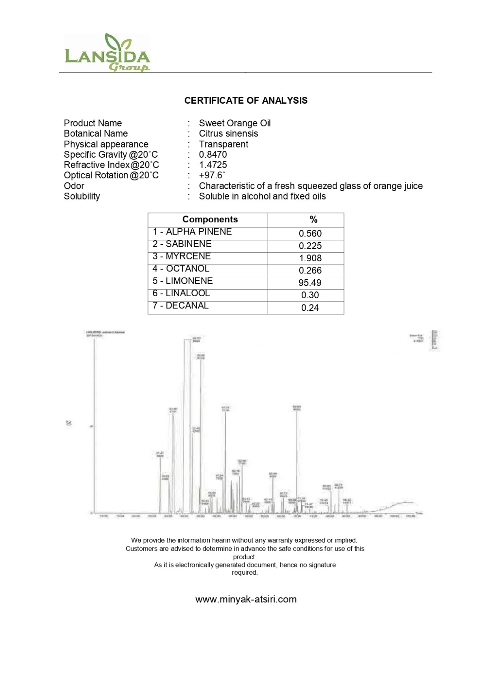

**Lampiran 1**. (Lanjutan)

Bagan alir pembuatan *Sweet Orange Oil®*

Pembuatan sweet orange oil meliputi beberapa tahapan yang dilakukan, metode pembuatan sweet orange oil menggunakan metode penyulingan eteris. Adapun bagan alir proses penyulingan sebagai berikut :

|  |  |
| --- | --- |
| 1. Contoh mesin penyulingan eteris skala industry |  |
| b.Diagram alir proses penyulingan eteris |  |

Lampiran 2. Bagan Alir Pembuatan Lilin Aromaterapi

Paraffin Padat + Asam Stearat

dimasukkan kedalam cawan

dilarutkan

dimasukkan sumbu

diamkan selama 10 Menit

dikeringkan

Lilin Padat

Lampiran 3. Bagan Alir Pembuatan Lilin Aromaterapi

Paraffin Padat + As.Stearat+Cera Alba

dimasukkan dalam beaker glass

dilebur diatas hot plate

dimasukkan *Sweet Orange Oil®*

diaduk

dimasukkan ke beaker glass

Beaker Glass

dituangkan menjadi tiga

Bagian di dalam beaker glass

dimasukan warna

Hijau

Merah

Kuning

di tuang ke cetakan satu persatu sampai mengerasnya lilin

Lilin Aromaterapi

Lampiran 4. Contoh Lembar Penilaian (kuisioner) Uji kesukaan (*Hedonic Test*) dan Terhadap Sukarelawan

|  |  |  |  |
| --- | --- | --- | --- |
| Nama | Umur | Pekerjaan | Pertanyaan |
|  |  |  | 1. Bagaimanapenilaianpanelispadaujikesukaan (*Hedonic test*) aroma minyak jeruk manisdengankonsentrasi 15ml ?   a.STS = Sangattidaksuka  b. TS = Tidaksuka  c. KS = Kurangsuka  d. S= Suka  e. SS = Sangatsuka   1. Bagaimanapenilaianpanelispadaujikesukaan (*Hedonic test*) aroma minyakjeruk manisdengankonsentrasi 25 ml ?   a.STS = Sangattidaksuka  b. TS = Tidaksuka  c. KS = Kurangsuka  d. S= Suka  e. SS = Sangatsuka   1. Bagaimanapenilaianpanelispadaujikesukaan (*Hedonic test*) aroma minyakjeruk manisdengankonsentrasi 50 ml ?   a.STS = Sangattidaksuka  b.TS = Tidaksuka  c.KS = Kurangsuka  d.S= Suka  e. SS = Sangatsuka |

Lampiran 5. Benang Katun (sumbu) dan Cetakan pada Pembuatan Lilin Aromaterapi

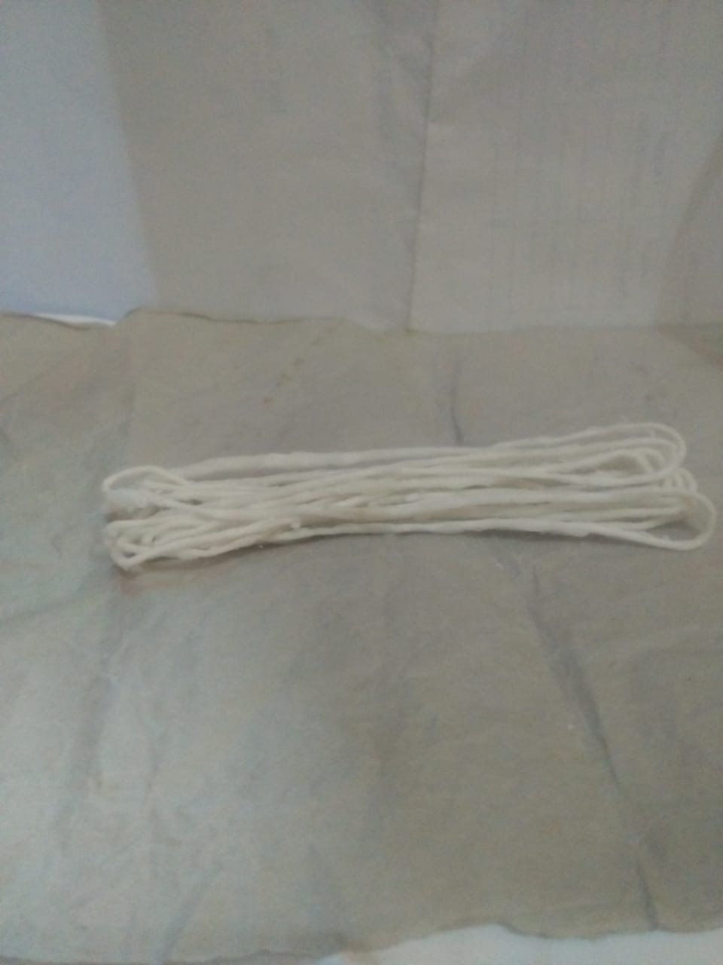

**A.** Benang Katun (Sumbu) Lilin

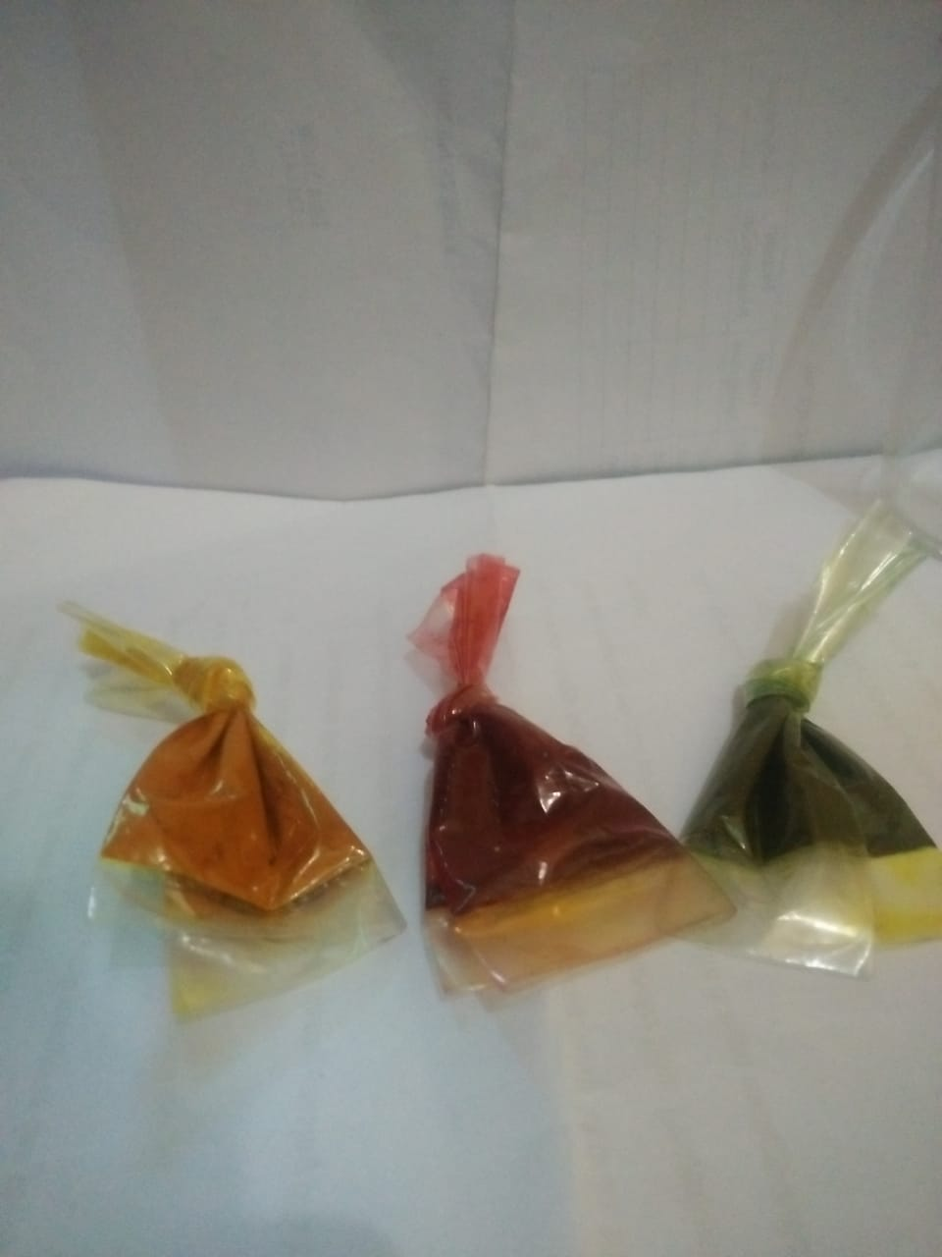

**B.** Pewarna Lilin

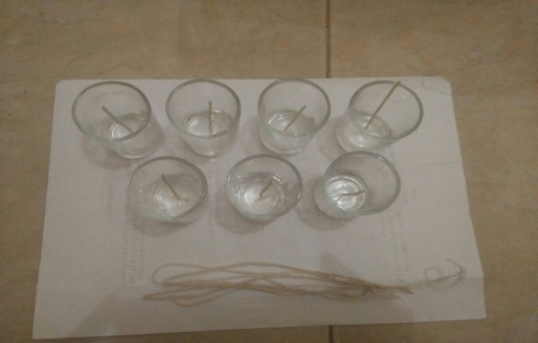

**C**. Cetakan lilin yang telah dilengkapi sumbu

Lampiran 6. Bahan Untuk Pembuatan Lilin Aromaterapi

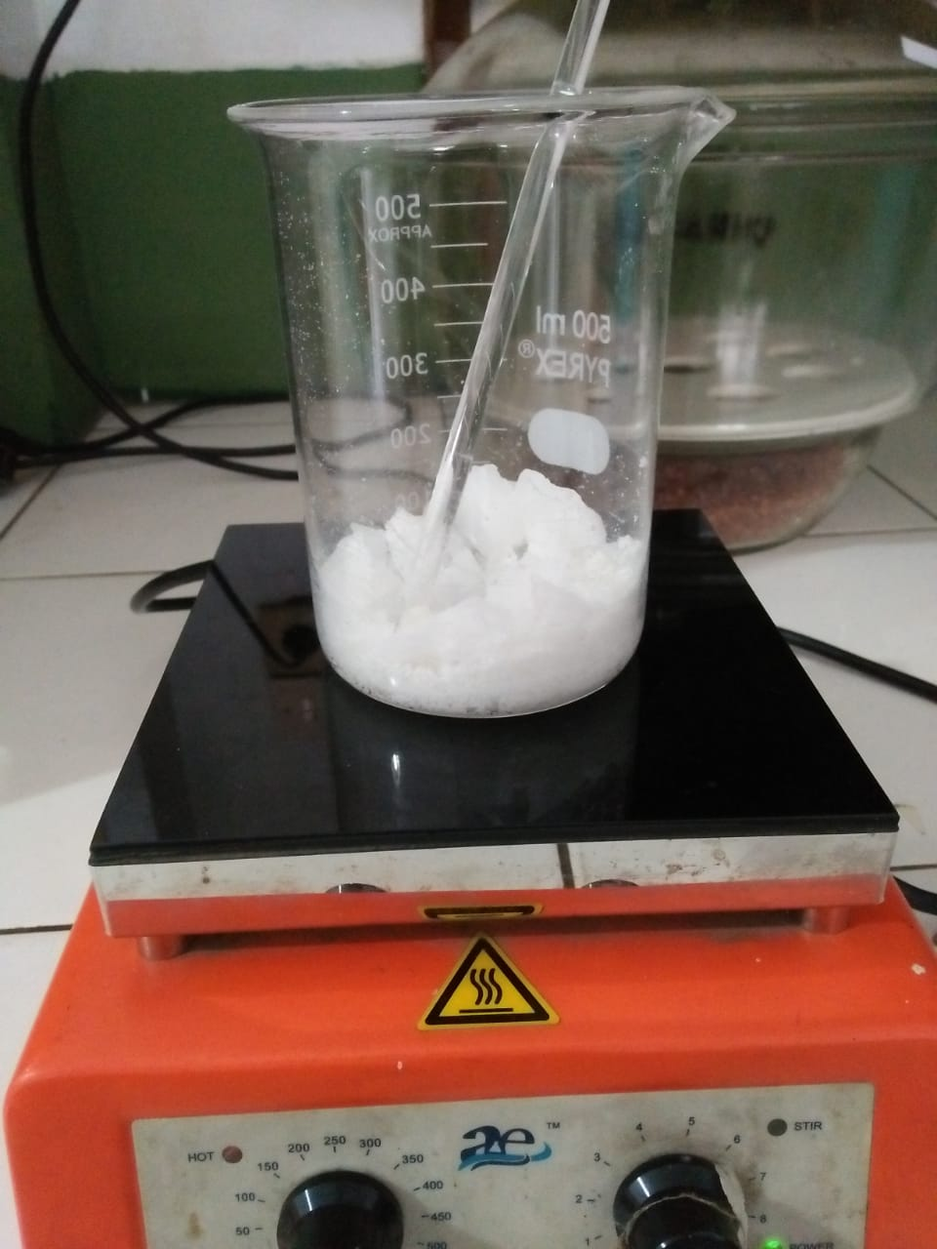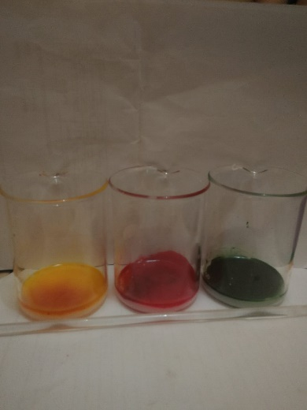

**Lampiran 7.** Kuisioner Uji Kesukaan *(Hedonic Test)* Terhadap Sediaan Lilin

Aromaterapi *Sweet Orange Oil®”*

|  |  |  |  |  |  |  |  |  |  |
| --- | --- | --- | --- | --- | --- | --- | --- | --- | --- |
| **NO** | **NAMA** | **B_WR** | **B_AR** | **B_B** | **B_KS** | **LK15_WR** | **LK15_AR** | **LK15_B** | **LK15_KS** |
| 01 | E | 5 | 3 | 5 | 5 | 5 | 4 | 5 | 5 |
| 02 | A | 5 | 4 | 5 | 5 | 5 | 4 | 5 | 5 |
| 03 | Z | 5 | 3 | 4 | 5 | 5 | 4 | 4 | 5 |
| 04 | W | 5 | 3 | 4 | 4 | 5 | 3 | 4 | 4 |
| 05 | Z | 4 | 3 | 5 | 5 | 5 | 4 | 5 | 4 |
| 06 | L | 5 | 3 | 4 | 4 | 4 | 4 | 4 | 4 |
| 07 | S | 5 | 4 | 5 | 5 | 5 | 5 | 5 | 5 |
| 08 | N | 5 | 4 | 4 | 5 | 5 | 4 | 4 | 5 |
| 09 | A | 4 | 3 | 4 | 5 | 4 | 4 | 4 | 4 |
| 10 | S | 5 | 4 | 5 | 4 | 5 | 4 | 4 | 4 |
| 11 | H | 5 | 4 | 5 | 5 | 5 | 5 | 5 | 5 |
| 12 | K | 4 | 2 | 4 | 4 | 5 | 4 | 3 | 1 |
| 13 | F | 4 | 3 | 4 | 5 | 5 | 5 | 4 | 5 |
| 14 | D | 5 | 4 | 5 | 5 | 5 | 4 | 4 | 4 |
| 15 | R | 5 | 3 | 5 | 5 | 5 | 4 | 4 | 5 |
| 16 | M | 5 | 3 | 5 | 4 | 5 | 4 | 5 | 5 |
| 17 | M | 5 | 3 | 5 | 5 | 4 | 4 | 5 | 5 |
| 18 | M | 4 | 4 | 4 | 5 | 5 | 4 | 4 | 4 |
| 19 | D | 5 | 4 | 4 | 4 | 5 | 4 | 4 | 4 |
| 20 | F | 5 | 3 | 5 | 5 | 4 | 4 | 5 | 5 |
| 21 | I | 5 | 4 | 5 | 5 | 5 | 5 | 5 | 5 |
| 22 | J | 4 | 4 | 4 | 4 | 4 | 4 | 4 | 4 |
| 23 | S | 5 | 4 | 5 | 4 | 5 | 4 | 5 | 4 |
| 24 | Y | 5 | 2 | 5 | 4 | 4 | 4 | 4 | 4 |
| 25 | M | 4 | 4 | 5 | 5 | 5 | 5 | 4 | 5 |
| 26 | A | 5 | 4 | 5 | 5 | 5 | 4 | 5 | 4 |
| 27 | S | 5 | 3 | 4 | 5 | 5 | 3 | 3 | 3 |
| 28 | D | 4 | 3 | 5 | 5 | 4 | 4 | 5 | 5 |
| 29 | R | 4 | 3 | 4 | 4 | 4 | 3 | 4 | 4 |
| 30 | A | 4 | 4 | 4 | 4 | 4 | 4 | 4 | 4 |

**Lampiran 7.** ( Lanjutan )

Keterangan :

|  |  |  |
| --- | --- | --- |
| B_WR | : | Pengujian *blangko* dari segi *warna* |
| B_AR | : | Pengujian *blangko* dari segi *aroma* |
| B_B | : | Pengujian *blangko* dari segi *bentuk* |
| B_KS | : | Pengujian *blangko* dari segi *keseluruhan* |
| LK15_WR | : | Pengujian *Lilin konsentrasi 15%* dari segi *warna* |
| LK15_AR | : | Pengujian *Lilin konsentrasi 15%* dari segi *aroma* |
| LK15_B | : | Pengujian *Lilin konsentrasi 15%* dari segi *bentuk* |
| LK15_KS | : | Pengujian *Lilin konsentrasi 15%* dari segi *keseluruhan* |
| LK25_WR | : | Pengujian *Lilin konsentrasi 25%* dari segi *warna* |
| LK25_AR | : | Pengujian *Lilin konsentrasi 25%* dari segi *aroma* |
| LK25_B | : | Pengujian *Lilin konsentrasi 25%* dari segi *bentuk* |
| LK25_KS | : | Pengujian *Lilin konsentrasi 25%* dari segi *keseluruhan* |
| LK50_WR | : | Pengujian *Lilin konsentrasi 50%* dari segi *warna* |
| LK50_AR | : | Pengujian *Lilin konsentrasi 50%* dari segi *aroma* |
| LK50_B | : | Pengujian *Lilin konsentrasi 50%* dari segi *bentuk* |
| LK50_KS | : | Pengujian *Lilin konsentrasi 50%* dari segi *keseluruhan* |

**Lampiran 8.** Print out SPSS 22

**BLANKO**

|  |  |
| --- | --- |
| **Reliability Statistics** | |
| Cronbach's Alpha | N of Items |
| .472 | 4 |

|  |  |  |  |  |
| --- | --- | --- | --- | --- |
| **Item-Total Statistics** | | | | |
|  | Scale Mean if Item Deleted | Scale Variance if Item Deleted | Corrected Item-Total Correlation | Cronbach's Alpha if Item Deleted |
| B_WARNA | 12.60 | 1.214 | .261 | .412 |
| B_AROMA | 13.87 | 1.085 | .192 | .499 |
| B_BENTUK | 12.70 | 1.045 | .408 | .271 |
| B_KESELURUHAN | 12.63 | 1.206 | .254 | .418 |

|  |  |  |  |  |  |  |  |  |  |
| --- | --- | --- | --- | --- | --- | --- | --- | --- | --- |
| **Descriptive Statistics** | | | | | | | | | |
|  | N | Range | MIN | MAX | Sum | Mean | | Std. Deviation | Variance |
| Statistic | Statistic | Statistic | Statistic | Statistic | Statistic | Std. Error | Statistic | Statistic |
| B_WARNA | 30 | 1 | 4 | 5 | 140 | 4.67 | .088 | .479 | .230 |
| B_AROMA | 30 | 2 | 2 | 4 | 102 | 3.40 | .113 | .621 | .386 |
| B_BENTUK | 30 | 1 | 4 | 5 | 137 | 4.57 | .092 | .504 | .254 |
| B_KESELURUHAN | 30 | 1 | 4 | 5 | 139 | 4.63 | .089 | .490 | .240 |
| Valid N (listwise) | 30 |  |  |  |  |  |  |  |  |

|  |  |  |  |  |  |  |
| --- | --- | --- | --- | --- | --- | --- |
| **Lampiran 8.** ( Lanjutan )  **Correlations** | | | | | | |
|  | | B_WARNA | B_AROMA | B_BENTUK | B_KESELURUHAN | TB |
| B_WARNA | Pearson Correlation | 1 | .116 | .381* | .049 | .585** |
| Sig. (2-tailed) |  | .543 | .038 | .797 | .001 |
| N | 30 | 30 | 30 | 30 | 30 |
| B_AROMA | Pearson Correlation | .116 | 1 | .132 | .158 | .626** |
| Sig. (2-tailed) | .543 |  | .486 | .403 | .000 |
| N | 30 | 30 | 30 | 30 | 30 |
| B_BENTUK | Pearson Correlation | .381* | .132 | 1 | .312 | .703** |
| Sig. (2-tailed) | .038 | .486 |  | .094 | .000 |
| N | 30 | 30 | 30 | 30 | 30 |
| B_KESELURUHAN | Pearson Correlation | .049 | .158 | .312 | 1 | .587** |
| Sig. (2-tailed) | .797 | .403 | .094 |  | .001 |
| N | 30 | 30 | 30 | 30 | 30 |
| TB | Pearson Correlation | .585** | .626** | .703** | .587** | 1 |
| Sig. (2-tailed) | .001 | .000 | .000 | .001 |  |
| N | 30 | 30 | 30 | 30 | 30 |

**FORMULA 15%**

|  |  |  |  |  |  |  |
| --- | --- | --- | --- | --- | --- | --- |
| |  |  | | --- | --- | | **Reliability Statistics** | | | Cronbach's Alpha | N of Items | | .599 | 4 | |
|  |
| |  |  |  |  |  | | --- | --- | --- | --- | --- | | **Item-Total Statistics** | | | | | |  | Scale Mean if Item Deleted | Scale Variance if Item Deleted | Corrected Item-Total Correlation | Cronbach's Alpha if Item Deleted | | LK15_WARNA | 12.83 | 1.799 | .138 | .677 | | LK15_AROMA | 13.43 | 1.426 | .463 | .476 | | LK15_BENTUK | 13.17 | 1.316 | .441 | .479 | | LK15_KESELURUHAN | 13.17 | 1.040 | .514 | .408 | |
| |  |  |  |  |  |  |  | | --- | --- | --- | --- | --- | --- | --- | | **Lampiran 8.** ( Lanjutan )  **Correlations** | | | | | | | |  | | LK15_WARNA | LK15_AROMA | LK15_BENTUK | LK15_KESELURUHAN | TK15 | | LK15_WARNA | Pearson Correlation | 1 | .292 | .040 | .033 | .440* | | Sig. (2-tailed) |  | .117 | .834 | .862 | .015 | | N | 30 | 30 | 30 | 30 | 30 | | LK15_AROMA | Pearson Correlation | .292 | 1 | .245 | .418* | .698** | | Sig. (2-tailed) | .117 |  | .192 | .021 | .000 | | N | 30 | 30 | 30 | 30 | 30 | | LK15_BENTUK | Pearson Correlation | .040 | .245 | 1 | .553** | .718** | | Sig. (2-tailed) | .834 | .192 |  | .002 | .000 | | N | 30 | 30 | 30 | 30 | 30 | | LK15_KESELURUHAN | Pearson Correlation | .033 | .418* | .553** | 1 | .806** | | Sig. (2-tailed) | .862 | .021 | .002 |  | .000 | | N | 30 | 30 | 30 | 30 | 30 | | TK15 | Pearson Correlation | .440* | .698** | .718** | .806** | 1 | | Sig. (2-tailed) | .015 | .000 | .000 | .000 |  | | N | 30 | 30 | 30 | 30 | 30 | |
| |  |  |  |  |  |  |  |  |  |  | | --- | --- | --- | --- | --- | --- | --- | --- | --- | --- | | **Lampiran 8**. (Lanjutan)  **Descriptive Statistics** | | | | | | | | | | |  | N | Range | MIN | MAX | Sum | Mean | | Std. Deviation | Variance | | Statistic | Statistic | Statistic | Statistic | Statistic | Statistic | Std. Error | Statistic | Statistic | | LK15_WARNA | 30 | 1 | 4 | 5 | 141 | 4.70 | .085 | .466 | .217 | | LK15_AROMA | 30 | 2 | 3 | 5 | 123 | 4.10 | .088 | .481 | .231 | | LK15_BENTUK | 30 | 2 | 3 | 5 | 131 | 4.37 | .102 | .556 | .309 | | LK15_KESELURUHAN | 30 | 3 | 2 | 5 | 131 | 4.37 | .122 | .669 | .447 | | Valid N (listwise) | 30 |  |  |  |  |  |  |  |  | |

**Lampiran 8.** ( Lanjutan )

**FORMULA 25 %**

|  |  |  |  |  |  |  |
| --- | --- | --- | --- | --- | --- | --- |
| |  |  | | --- | --- | | **Reliability Statistics** | | | Cronbach's Alpha | N of Items | | .656 | 4 | |
|  |
| |  |  |  |  |  | | --- | --- | --- | --- | --- | | **Item-Total Statistics** | | | | | |  | Scale Mean if Item Deleted | Scale Variance if Item Deleted | Corrected Item-Total Correlation | Cronbach's Alpha if Item Deleted | | LK25_WARNA | 13.27 | 1.720 | .473 | .564 | | LK25_AROMA | 13.60 | 1.697 | .513 | .530 | | LK25_BENTUK | 13.47 | 2.464 | .259 | .687 | | LK25_KESELURUHAN | 13.37 | 1.964 | .522 | .535 | |
| |  |  |  |  |  |  |  | | --- | --- | --- | --- | --- | --- | --- | | **Correlations** | | | | | | | |  | | LK25_WARNA | LK25_AROMA | LK25_BENTUK | LK25_KESELURUHAN | TK25 | | LK25_WARNA | Pearson Correlation | 1 | .431* | .168 | .409* | .757** | | Sig. (2-tailed) |  | .018 | .374 | .025 | .000 | | N | 30 | 30 | 30 | 30 | 30 | | LK25_AROMA | Pearson Correlation | .431* | 1 | .205 | .447* | .775** | | Sig. (2-tailed) | .018 |  | .278 | .013 | .000 | | N | 30 | 30 | 30 | 30 | 30 | | LK25_BENTUK | Pearson Correlation | .168 | .205 | 1 | .247 | .515** | | Sig. (2-tailed) | .374 | .278 |  | .187 | .004 | | N | 30 | 30 | 30 | 30 | 30 | | LK25_KESELURUHAN | Pearson Correlation | .409* | .447* | .247 | 1 | .737** | | Sig. (2-tailed) | .025 | .013 | .187 |  | .000 | | N | 30 | 30 | 30 | 30 | 30 | | TK25 | Pearson Correlation | .757** | .775** | .515** | .737** | 1 | | Sig. (2-tailed) | .000 | .000 | .004 | .000 |  | | N | 30 | 30 | 30 | 30 | 30 | |
| |  |  |  |  |  |  |  |  |  |  | | --- | --- | --- | --- | --- | --- | --- | --- | --- | --- | | **Lampiran 8.** ( Lanjutan )  **Descriptive Statistics** | | | | | | | | | | |  | N | Range | MIN | MAX | Sum | Mean | | Std. Deviation | Variance | | Statistic | Statistic | Statistic | Statistic | Statistic | Statistic | Std. Error | Statistic | Statistic | | LK25_WARNA | 30 | 3 | 2 | 5 | 139 | 4.63 | .131 | .718 | .516 | | LK25_AROMA | 30 | 3 | 2 | 5 | 129 | 4.30 | .128 | .702 | .493 | | LK25_BENTUK | 30 | 1 | 4 | 5 | 133 | 4.43 | .092 | .504 | .254 | | LK25_KESELURUHAN | 30 | 2 | 3 | 5 | 136 | 4.53 | .104 | .571 | .326 | | Valid N (listwise) | 30 |  |  |  |  |  |  |  |  | |

|  |
| --- |
| **FORMULA 50 %** |
| |  |  | | --- | --- | | **Reliability Statistics** | | | Cronbach's Alpha | N of Items | | .482 | 4 | |
| |  |  |  |  |  | | --- | --- | --- | --- | --- | | **Item-Total Statistics** | | | | | |  | Scale Mean if Item Deleted | Scale Variance if Item Deleted | Corrected Item-Total Correlation | Cronbach's Alpha if Item Deleted | | LK50_WARNA | 13.10 | 1.817 | .381 | .304 | | LK50_AROMA | 12.20 | 3.131 | .142 | .523 | | LK50_BENTUK | 12.13 | 3.016 | .260 | .431 | | LK50_KESELURUHAN | 11.97 | 2.723 | .383 | .332 | |
| **Lampiran 8.** ( Lanjutan )   |  |  |  |  |  |  |  | | --- | --- | --- | --- | --- | --- | --- | | **Correlations** | | | | | | | |  | | LK50_  WARNA | LK50_  AROMA | LK50_  BENTUK | LK50_KESELURUHAN | TK50 | | LK50_WARNA | Pearson Correlation | 1 | .309 | .114 | .308 | .785** | | Sig. (2-tailed) |  | .097 | .548 | .098 | .000 | | N | 30 | 30 | 30 | 30 | 30 | | LK50_AROMA | Pearson Correlation | .309 | 1 | -.047 | -.068 | .493** | | Sig. (2-tailed) | .097 |  | .805 | .720 | .006 | | N | 30 | 30 | 30 | 30 | 30 | | LK50_BENTUK | Pearson Correlation | .114 | -.047 | 1 | .535** | .553** | | Sig. (2-tailed) | .548 | .805 |  | .002 | .002 | | N | 30 | 30 | 30 | 30 | 30 | | LK50_KESELURUHAN | Pearson Correlation | .308 | -.068 | .535** | 1 | .653** | | Sig. (2-tailed) | .098 | .720 | .002 |  | .000 | | N | 30 | 30 | 30 | 30 | 30 | | TK50 | Pearson Correlation | .785** | .493** | .553** | .653** | 1 | | Sig. (2-tailed) | .000 | .006 | .002 | .000 |  | | N | 30 | 30 | 30 | 30 | 30 | |  | | | | | | | |
| |  |  |  |  |  |  |  |  |  |  | | --- | --- | --- | --- | --- | --- | --- | --- | --- | --- | | **Descriptive Statistics** | | | | | | | | | | |  | N | Range | MIN | MAX | Sum | Mean | | Std. Deviation | Variance | | Statistic | Statistic | Statistic | Statistic | Statistic | Statistic | Std. Error | Statistic | Statistic | | LK50_WARNA | 30 | 3 | 2 | 5 | 101 | 3.37 | .195 | 1.066 | 1.137 | | LK50_AROMA | 30 | 2 | 3 | 5 | 128 | 4.27 | .135 | .740 | .547 | | LK50_BENTUK | 30 | 2 | 3 | 5 | 130 | 4.33 | .121 | .661 | .437 | | LK50_KESELURUHAN | 30 | 3 | 2 | 5 | 135 | 4.50 | .125 | .682 | .466 | | Valid N (listwise) | 30 |  |  |  |  |  |  |  |  | |