LAMPIRAN

Lampiran 1. Hasil identifikasi sampel daun kersen
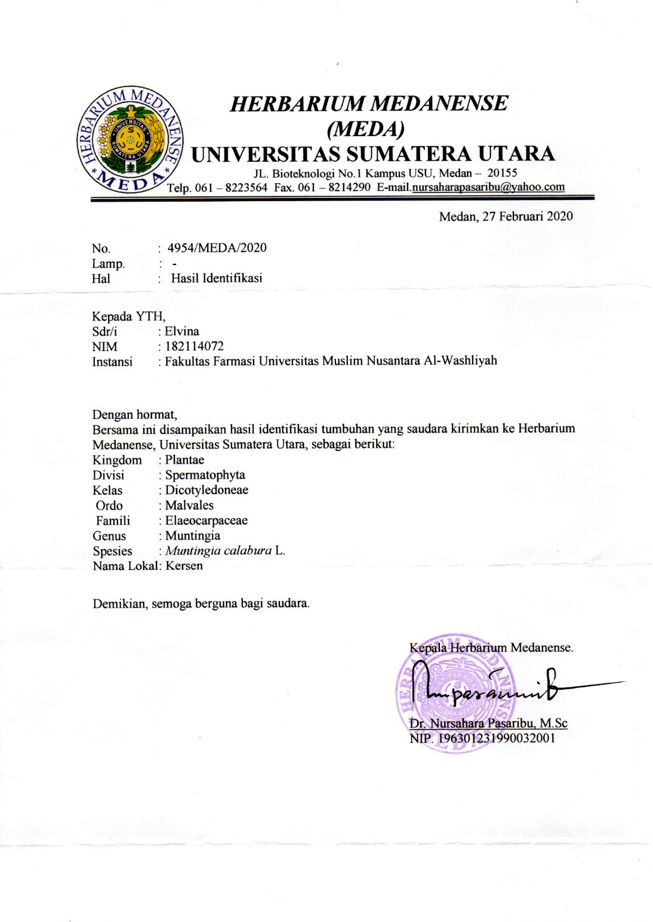
Lampiran 2. Pembuatan simplisia daun kersen (Muntingia calabura L.)
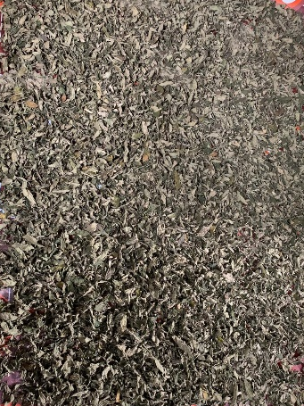
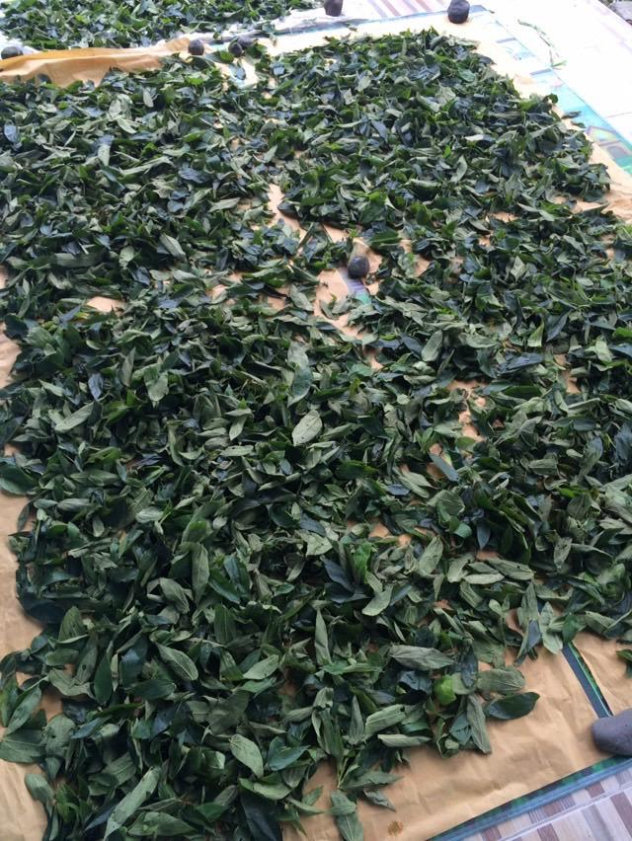

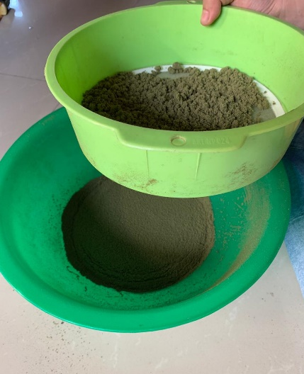
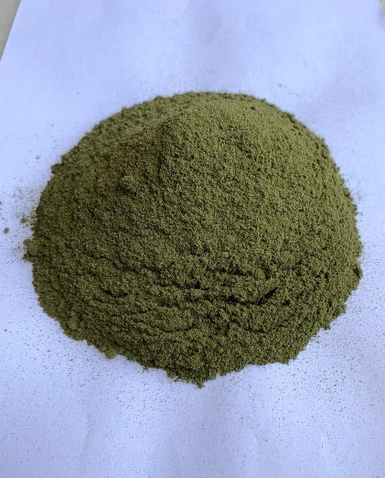
Daun Kersen (Muntingia calabura L.) yang sudah kering
Serbuk simplisia daun kersen (Muntingia calabura L.)
Proses pengayakan serbuk simplisia
Sampel segar daun kersen (Muntingia calabura L.)
Lampiran 3. Pembuatan ekstrak etanol daun kersen (Muntingia calabura L.)
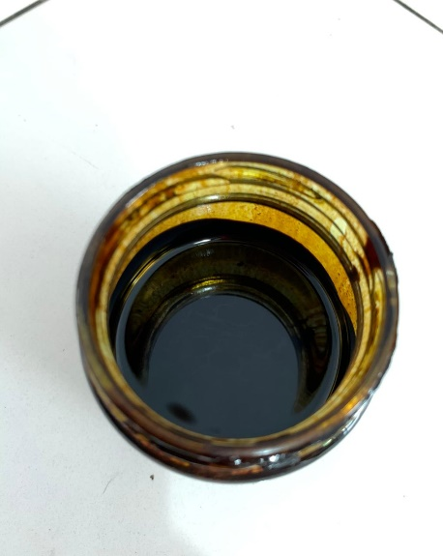
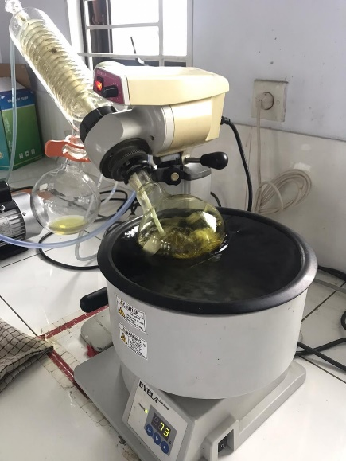
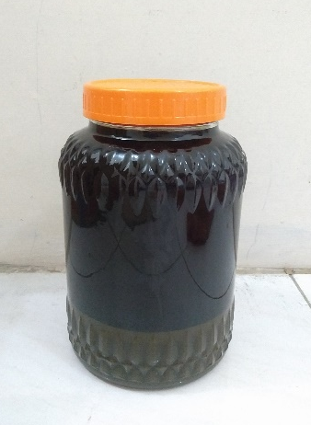
Ekstrak etanol daun kersen (Muntingia calabura L.)
Pemekatan ekstrak dengan vacuum rotary evaporator
Proses perendaman simplisia dengan pelarut etanol
(metode maserasi)
Lampiran 4. Perhitungan penetapan kadar air

No | Berat Sampel  (g) | Volume awal  (mL) | Volume akhir  (mL)
1. | 5 | 1,4 | 1,6
2. | 5 | 1,5 | 1,8
3. | 5 | 1,6 | 1,8

Perhitungan
Rumus : %Kadar air = $\frac{Volume akhir-volume awal}{Berat sampel (gr)}$x 100%

- %Kadar air = $\frac{1,6-1,4}{5 (g)}$x 100% = 4%

- %Kadar air = $\frac{1,8-1,5}{5(g)}$x 100% =6%

- %Kadar air = $\frac{1,8-1,6}{5 (g)}$x 100% =4%

Hasil Rata-Rata = $\frac{4\%+6\%+4\% }{3}$ = 4,6%

Persyaratan menurut MMI Edisi 6 Tidak lebih dari 10%

Lampiran 5. Perhitungan penetapan kadar sari larut dalam air

No | Berat Sampel  (g) | Berat Cawan Kosong (g) | Berat Cawan Isi  (g)
1. | 5 | 53,47 | 53,64
2. | 5 | 55,22 | 55,43
3. | 5 | 34,95 | 35,14

Perhitungan
Rumus : %Kadar = $\frac{Cawan isi-cawan kosong x 5}{Berat sampel (gr)}$x 100%

- %Kadar = $\frac{0,17 x 5}{5 (gr)}$x 100% = 17%

- %Kadar = $\frac{0,21 x 5}{5 (gr)}$x 100% = 21%

- %Kadar = $\frac{0,19 x 5}{5 (gr)}$x 100% = 19%

Hasil Rata-rata = $\frac{17+21+19}{3}$= 19%

Persyaratan menurut MMI Edisi 6 Tidak kurang dari 1%

Lampiran 6. Perhitungan penetapan kadar sari larut dalam etanol

No | Berat Sampel  (g) | Berat Cawan Kosong (g) | Berat Cawan Isi  (g)
1. | 5 | 122,77 | 123,06
2. | 5 | 113, 05 | 113,30
3. | 5 | 22,43 | 22,71

Perhitungan
Rumus : %Kadar = $\frac{Cawan isi-cawan kosong x 5}{Berat sampel (gr)}$x 100%

- %Kadar = $\frac{0,29 x 5}{5 (gr)}$x 100% = 29%

- %Kadar = $\frac{0, 25x 5}{5 (gr)}$x 100% = 25%

- %Kadar = $\frac{0,28 x 5}{5 (gr)}$x 100% = 28%

Hasil Rata-rata = $\frac{29+25+28}{3}$ = 27%

Persyaratan menurut MMI Edisi 6 Tidak kurang dari 2%

Lampiran 7. Perhitungan penetapan kadar abu total

No | Berat Sampel  (g) | Berat Cawan Kosong (g) | Berat Cawan Isi  (g)
1. | 2 | 63,13 | 63,25
2. | 2 | 65,75 | 65,81
3. | 2 | 64,11 | 64,15

Perhitungan
Rumus: %Kadar = $\frac{Cawan isi-cawan kosong }{Berat sampel (gr)}$x 100%

- %Kadar = $\frac{0,12}{2(g)}$x 100% = 6%

- %Kadar = $\frac{0,06}{2(g)}$x 100% = 3%

- %Kadar = $\frac{0,04 }{2 (g)}$x 100% = 2%

Hasil Rata-rata = $\frac{6+3+2}{3}$ = 3,6%

Persyaratan menurut MMI Edisi 6 Tidak lebih dari 4%

Lampiran 8. Perhitungan penetapan kadar abu tidak larut dalam asam

No | Berat Sampel  (g) | Berat Cawan Kosong (g) | Berat Cawan Isi  (g)
1. | 2 | 63,13 | 63,15
2. | 2 | 65,75 | 65,76
3. | 2 | 64,11 | 64,13

Perhitungan
Rumus: %Kadar = $\frac{Cawan isi-cawan kosong }{Berat sampel (g)}$ x 100%

- %Kadar = $\frac{0,02}{2(g)}$ x 100% = 1%

- %Kadar = $\frac{0,01}{2(g)}$ x 100% = 0,5%

- %Kadar = $\frac{0,02 }{2 (g)}$ x 100% = 1%

Hasil Rata-rata = $\frac{1+0,5+1}{3}$ = 0,83%

Persyaratan menurut MMI Edisi 6 Tidak lebih dari 1%

Lampiran 9. Perhitungan susut pengeringan dan persen rendemen

Berat daun segar | 6,5 kg
Berat daun kering | 2,8 kg
Berat serbuk | 2,3 kg
Berat ekstrak | 172,82 g

Rumus :
Susut pengeringan = $\frac{Berat segar-Berat kering (g)}{Berat segar (g)}$x 100%
= $\frac{6,5- 2,8 (g)}{6,5 (g)}$x 100%
= 57 %

Rumus :
Rendemen = $\frac{Bobot Ekstrak (g)}{Bobot Simplisia (g)}$ x 100%
= $\frac{172,82 (g)}{900 (g)}$ x 100%
= 19,20 %

Lampiran 10. Bagan alir pembuatan ekstrak etanol daun kersen

Simplisia Daun Kersen
ditimbang sebanyak 900 gram
dimasukkan ke dalam bejana maserasi
ditambahkan 75 bagian larutan penyari etanol 96%
dibiarkan selama 5 hari, sesekali diaduk
disaring dengan kain flannel
Sisa ampas
Maserat Daun Kersen

ditambahkan 25 bagian larutan penyari etanol 96%
dibiarkan selama 2 hari dan terlindungi dari cahaya matahari

dipekatkan dengan vacuum evaporator
Ekstrak Kental Daun Kersen
172 gram

Lampiran 11. Bagan alir pembuatan sediaan masker gel peel-off ekstrak etanol daun kersen

PVA

Massa 1

dikembangkan dalam air panas, gerus sampai homogen

dimasukkan Massa 1 ke dalam Massa 2, gerus sampai homogen
Massa 2

Masker Gel Peel-Off Ekstrak Etanol Daun Kersen

Carbopol 940

dikembangkan dalam air panas, gerus sampai homogen
ditambahkan TEA, dan gerus sampai homogen
ditambahkan nipagin yang sudah dilarutkan dalam gliserin, gerus sampai homogen
ditambahkan ekstrak daun kersen, gerus homogen

Lampiran 12. Sediaan masker gel peel-off ekstrak etanol daun kersen (Muntingia calabura L.)
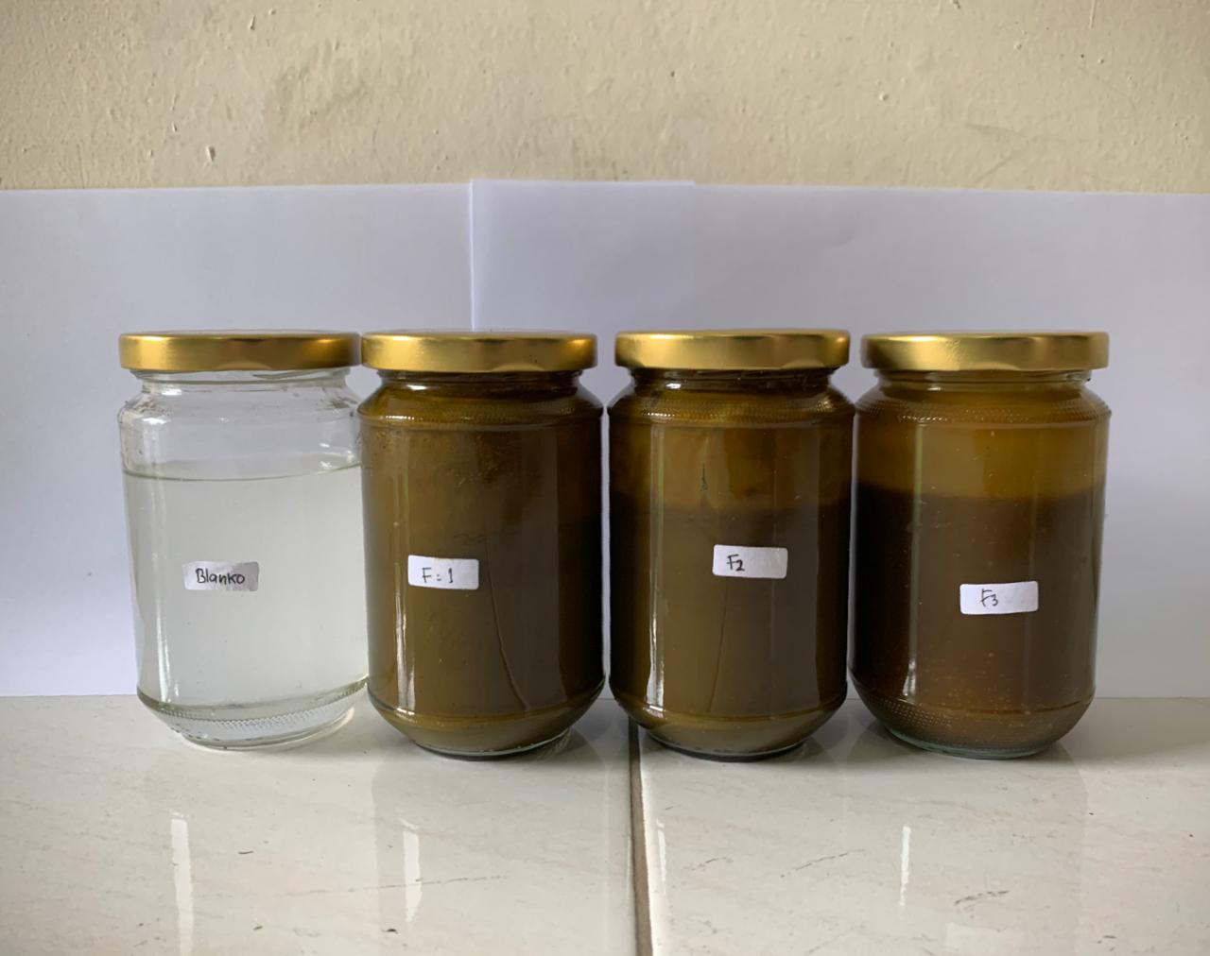

Keterangan:
F0: Blanko
F1: Ekstrak Etanol Daun Kersen Konsentrasi 4%
F2: Ekstrak Etanol Daun Kersen Konsentrasi 8%
F3: Ekstrak Etanol Daun Kersen Konsentrasi 12%

Lampiran 13. Uji homogenitas

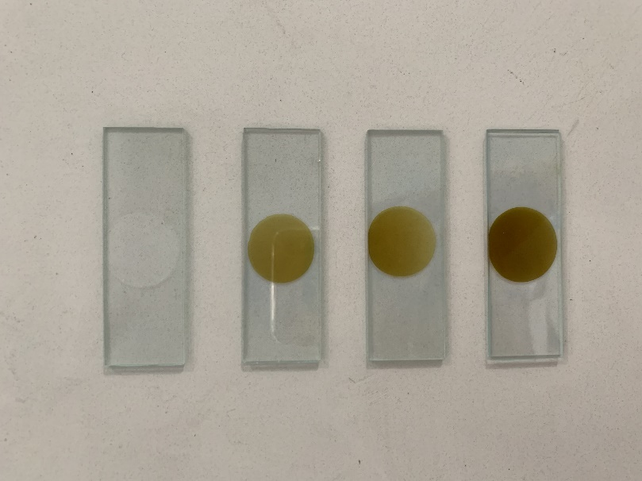
F0
(Blanko)
F1
(4%)
F2
(8%)
F3
(12%)

Lampiran 14. Uji pH
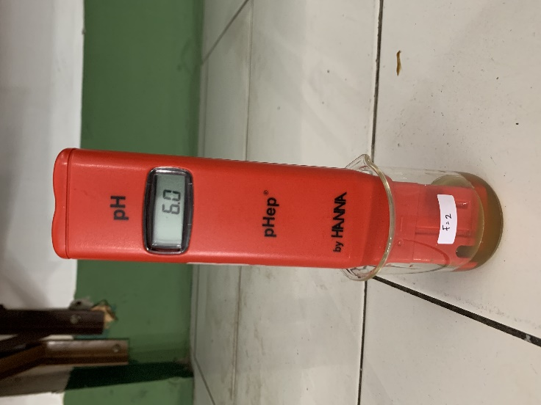
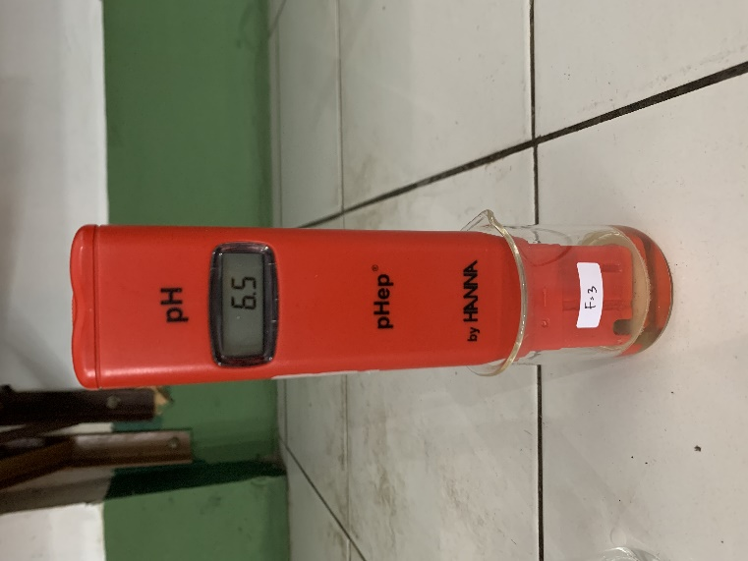
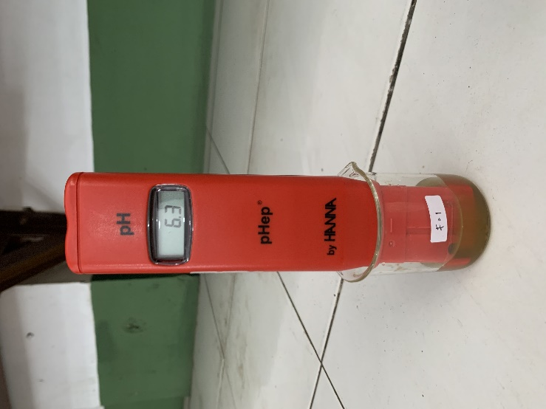
F3 (12%)

F1 (4%)

F2 (8%)

Lampiran 15. Uji daya sebar
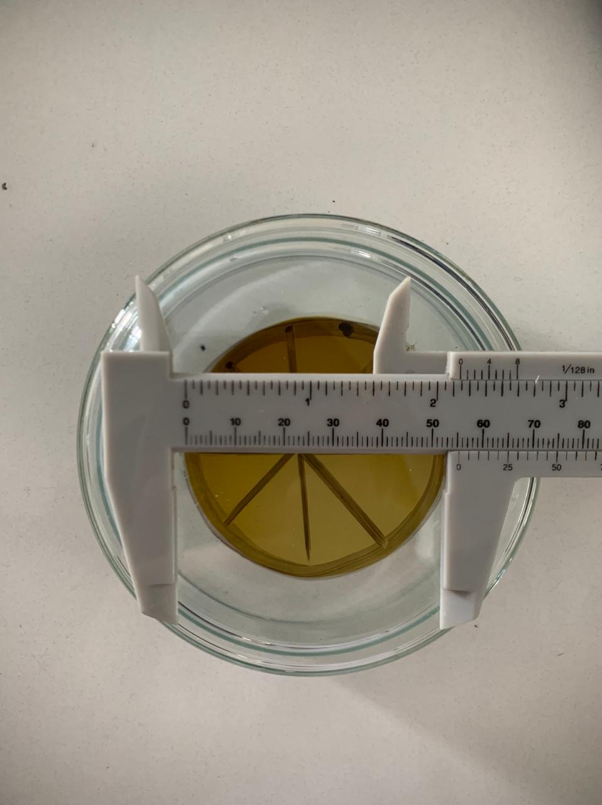

Lampiran 16. Uji viskositas

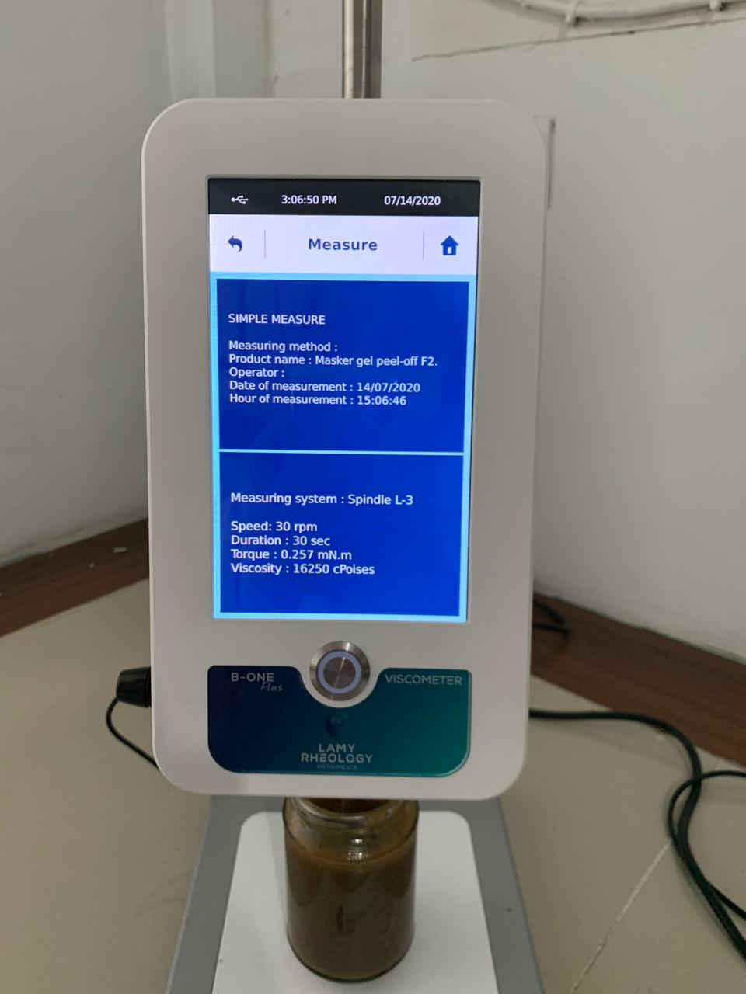

Lampiran 17. Uji iritasi
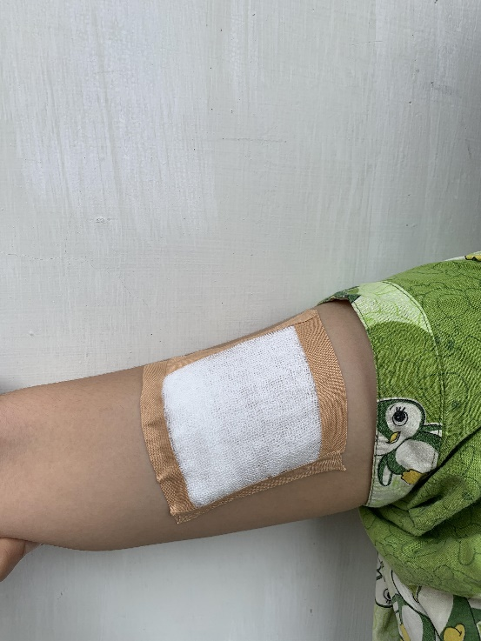
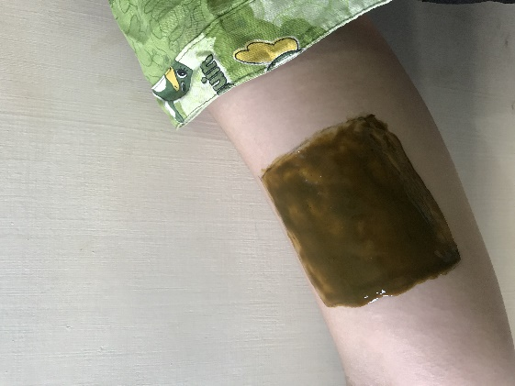
Masker gel peel-off saat dioleskan pada lengan atas

Ditutup dengan kain kasa

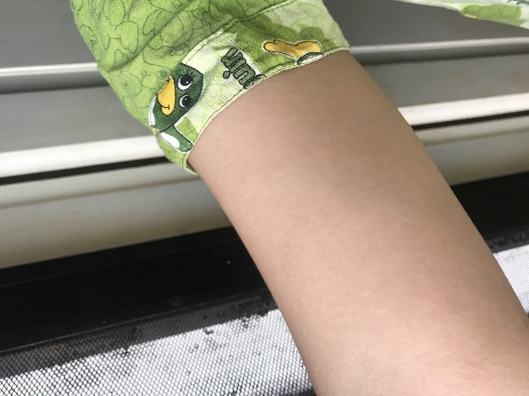
Hasil uji iritasi setelah pengolesan masker gel peel-off

Lampiran 18. Uji waktu mengering
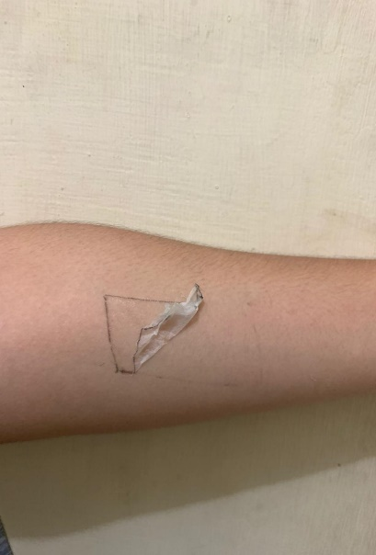
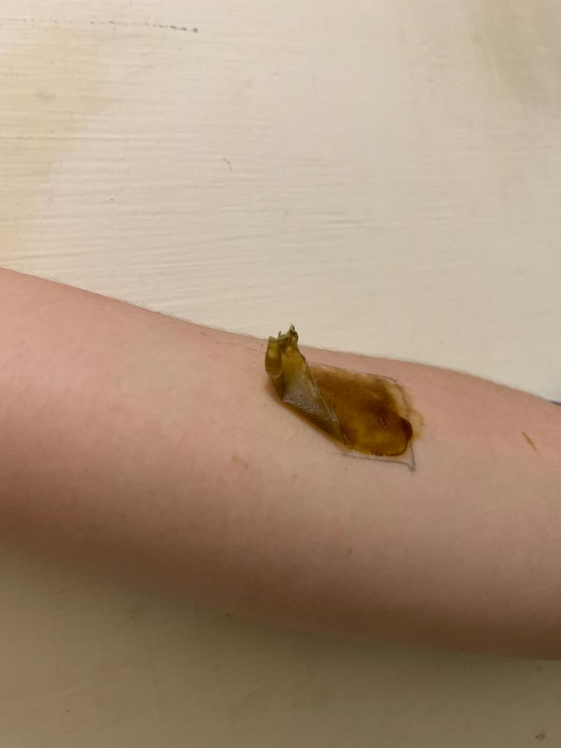
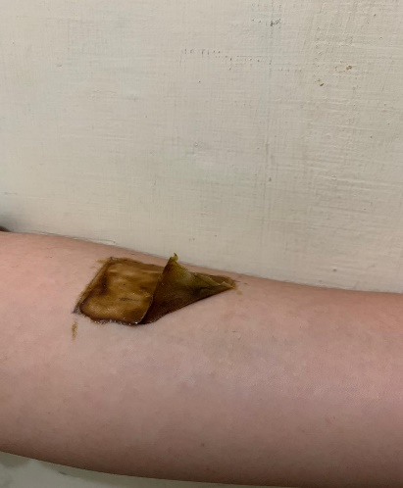
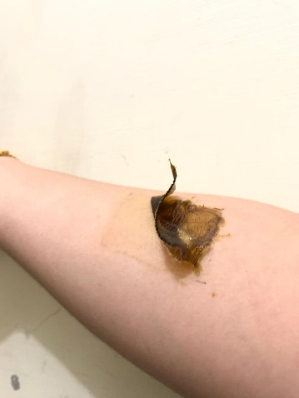
F0 (Blanko)

F3 (12%)

F2 (8%)

F1 (4%)

Lampiran 19. Penggunaan masker pada sukarelawan

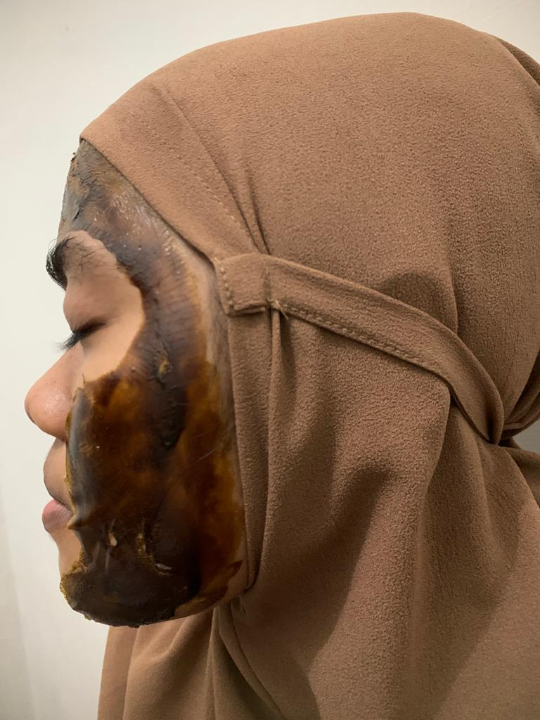

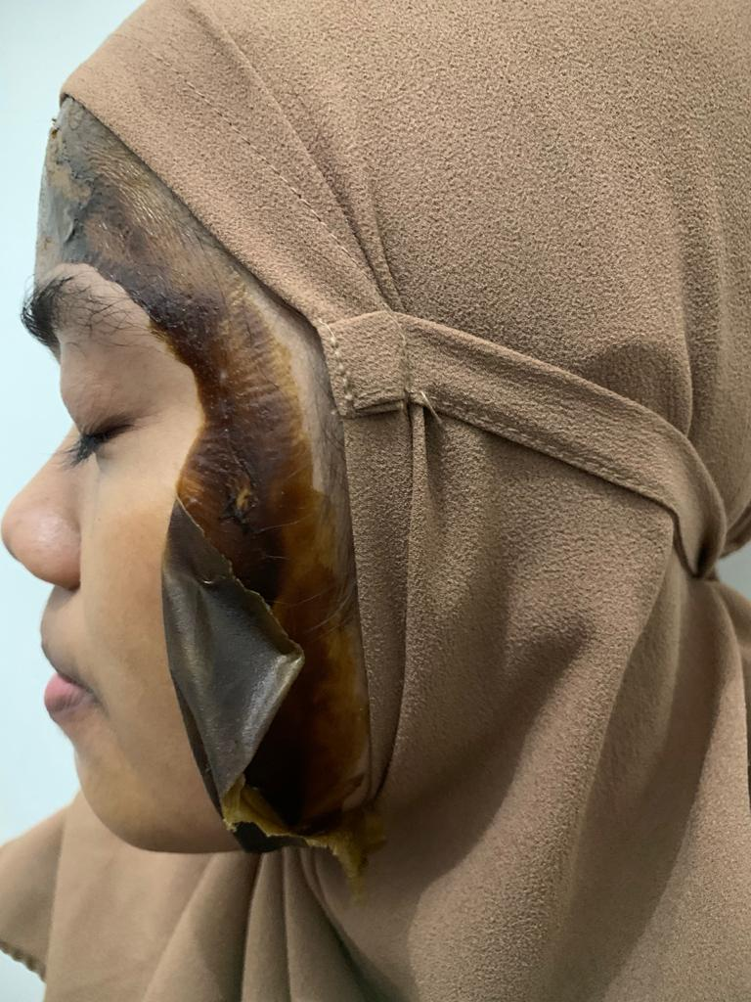

Lampiran 20. Uji masker gel peel-off dengan alat skin analyzer

- Kelembaban (Moisture)
Range (10-15)%
Kondisi awal = 35%

Minggu ke 1 = 38%

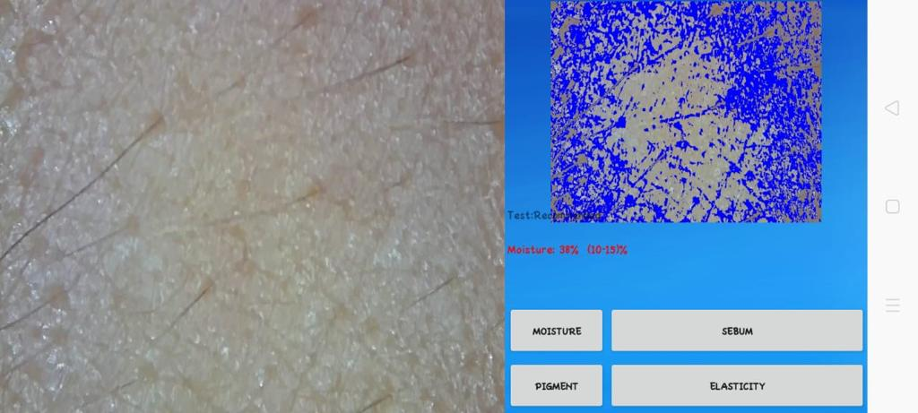
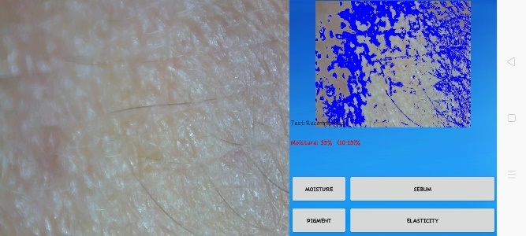

Minggu ke 3 = 45%

Minggu ke 2 = 42%

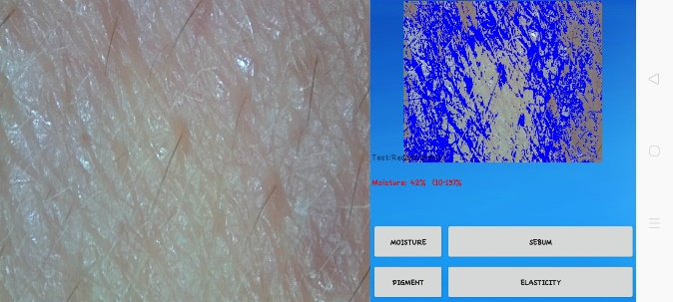
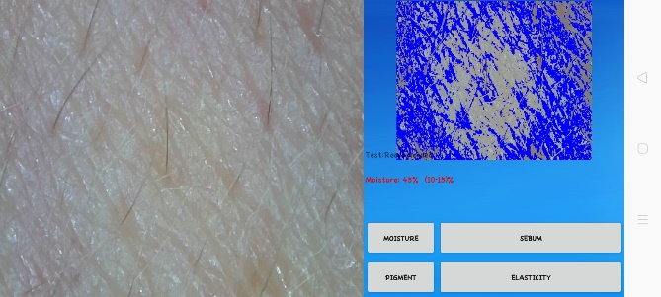

Minggu ke 4 = 48%

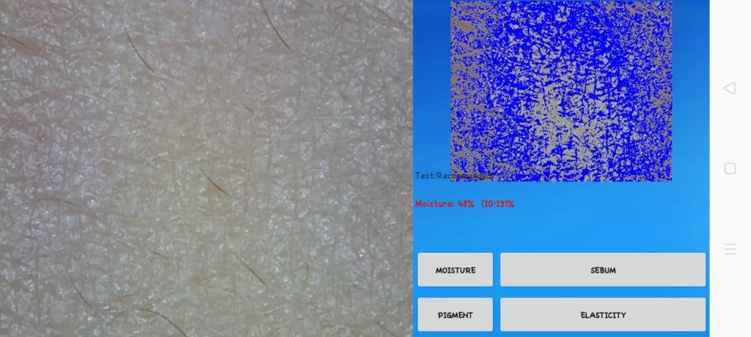

Lampiran 20. (Lanjutan)

- Elastisitas (Elasticity)
Range (50-70)%

Minggu ke 1 = 84%

Kondisi awal = 81%

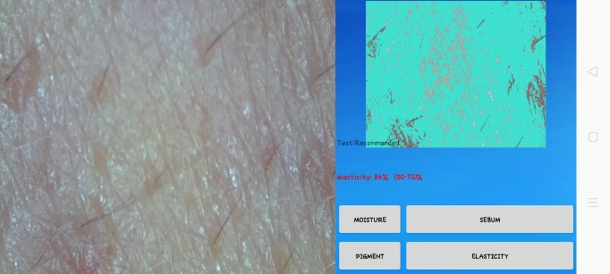
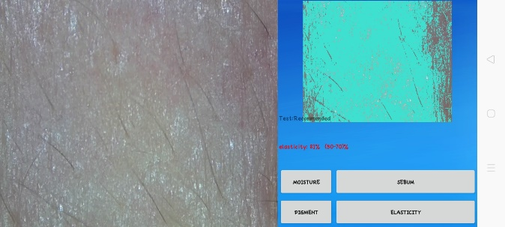

Minggu ke 3 = 91%

Minggu ke 2 = 87%

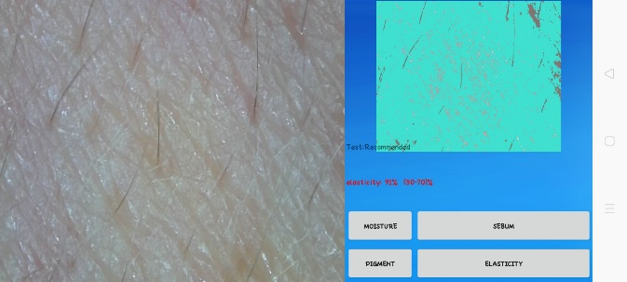
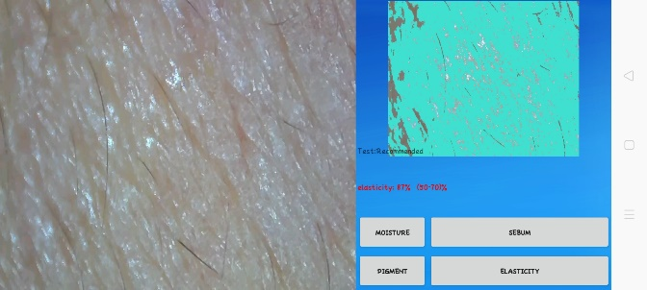

Minggu ke 4 = 95%

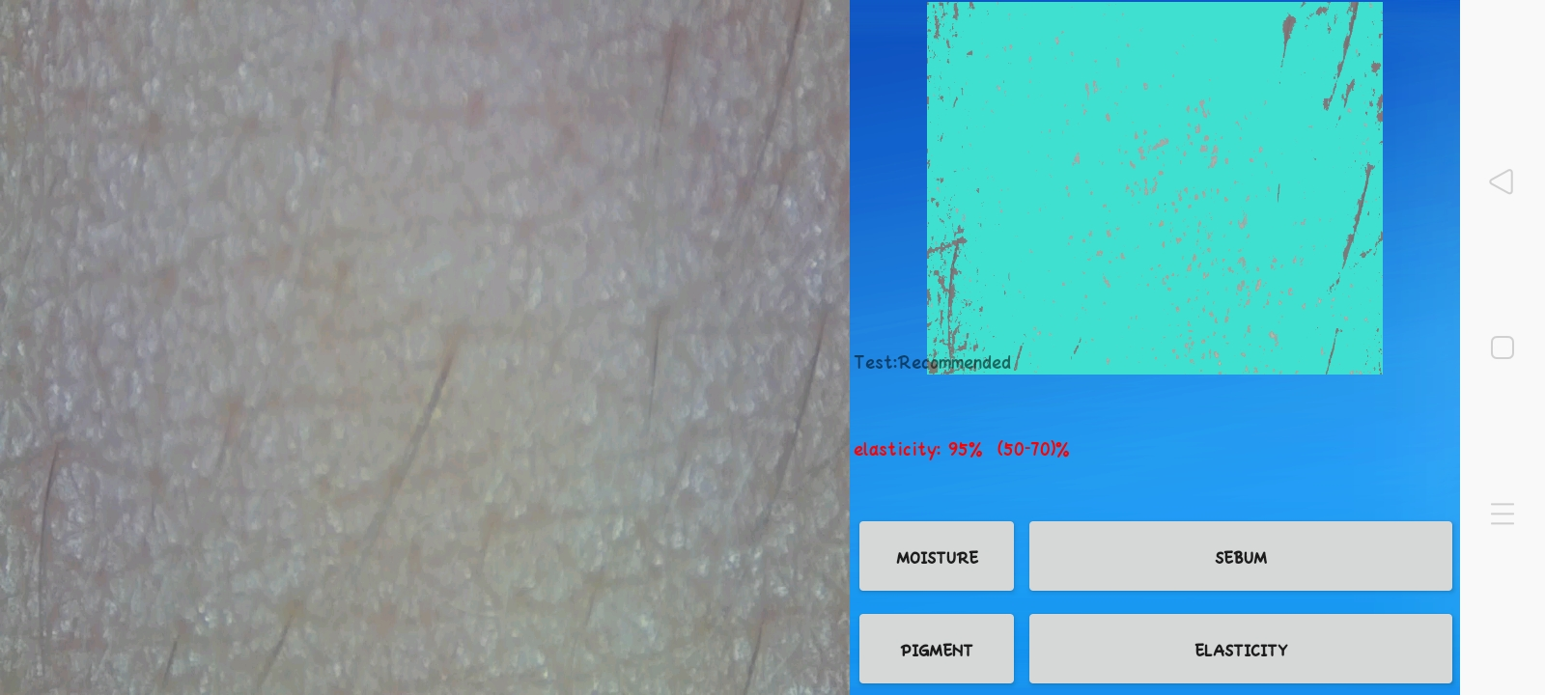

Lampiran 20. (Lanjutan)

- Kecerahan (Pigment)
Range (20-30)%

Minggu ke 1 = 65%

Kondisi awal = 63%

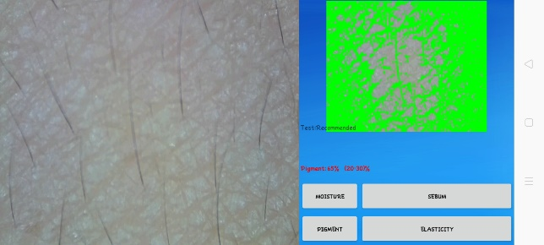
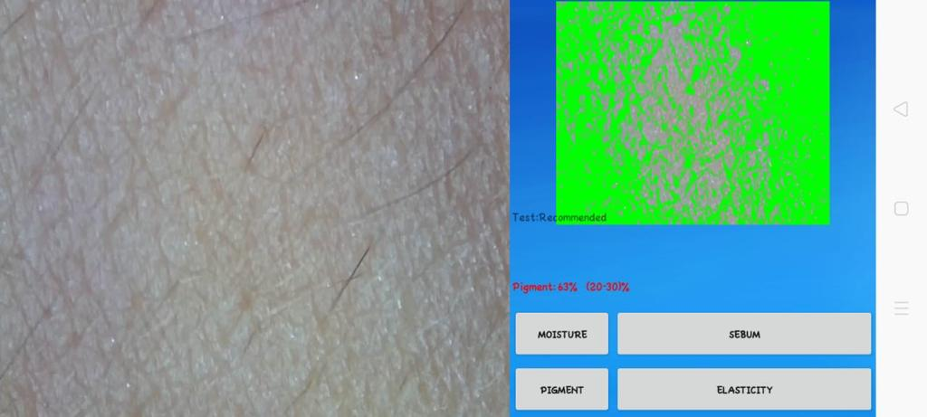

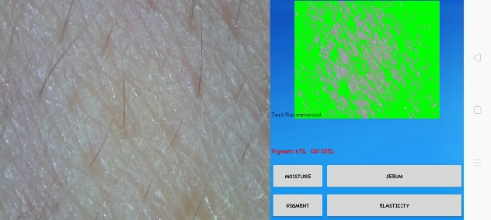
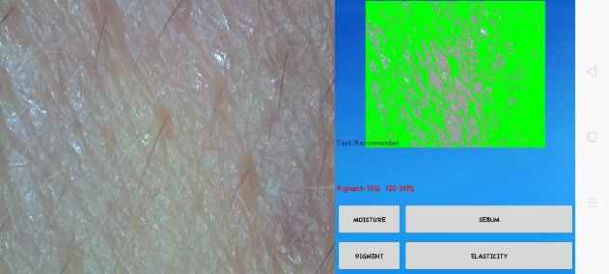
Minggu ke 3 = 70%

Minggu ke 2 = 67%

Minggu ke 4 = 74%

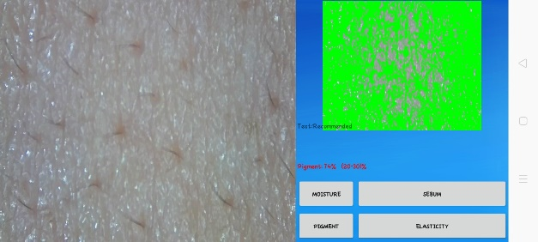

Lampiran 21. Data hasil statistik one way ANOVA

- Kelembaban (moisture)

Tests of Normality
 | MOISTURE | Kolmogorov-Smirnovª |  |  | Shapiro-Wilk
 |  | Statistic | df | Sig. | Statistic | df | Sig.
F0 | M0 | .175 | 3 | . | 1.000 | 3 | 1.000
 | M1 | .175 | 3 | . | 1.000 | 3 | 1.000
 | M2 | .175 | 3 | . | 1.000 | 3 | 1.000
 | M3 | .253 | 3 | . | .964 | 3 | .637
 | M4 | .253 | 3 | . | .964 | 3 | .637
F1 | M0 | .175 | 3 | . | 1.000 | 3 | 1.000
 | M1 | .253 | 3 | . | .964 | 3 | .637
 | M2 | .253 | 3 | . | .964 | 3 | .637
 | M3 | .253 | 3 | . | .964 | 3 | .637
 | M4 | .175 | 3 | . | 1.000 | 3 | 1.000
F2 | M0 | .253 | 3 | . | .964 | 3 | .637
 | M1 | .253 | 3 | . | .964 | 3 | .637
 | M2 | .253 | 3 | . | .964 | 3 | .637
 | M3 | .292 | 3 | . | .923 | 3 | .463
 | M4 | .292 | 3 | . | .923 | 3 | .463
F3 | M0 | .175 | 3 | . | 1.000 | 3 | 1.000
 | M1 | .175 | 3 | . | 1.000 | 3 | 1.000
 | M2 | .175 | 3 | . | 1.000 | 3 | 1.000
 | M3 | .253 | 3 | . | .964 | 3 | .637
 | M4 | .253 | 3 | . | .964 | 3 | .637
a. Lilliefors Significance Correction

Test of Homogeneity of Variances
 | Levene Statistic | df1 | df2 | Sig.
F0 | .453 | 4 | 10 | .769
F1 | .421 | 4 | 10 | .790
F2 | .312 | 4 | 10 | .864
F3 | .453 | 4 | 10 | .769

Lampiran 21. (Lanjutan)

ANOVA
 |  | Sum of Squares | df | Mean Square | F | Sig.
F0 | Between Groups | 14.667 | 4 | 3.667 | 2.391 | .120
 | Within Groups | 15.333 | 10 | 1.533
 | Total | 30.000 | 14
F1 | Between Groups | 31.600 | 4 | 7.900 | 4.389 | .026
 | Within Groups | 18.000 | 10 | 1.800
 | Total | 49.600 | 14
F2 | Between Groups | 72.000 | 4 | 18.000 | 5.745 | .011
 | Within Groups | 31.333 | 10 | 3.133
 | Total | 103.333 | 14
F3 | Between Groups | 289.600 | 4 | 72.400 | 47.217 | .000
 | Within Groups | 15.333 | 10 | 1.533
 | Total | 304.933 | 14

F0
Duncanª
MOISTURE | N | Subset for alpha = 0.05
 |  | 1 | 2
M0 | 3 | 34.00
M1 | 3 | 34.00
M2 | 3 | 35.00 | 35.00
M3 | 3 | 35.33 | 35.33
M4 | 3 |  | 36.67
Sig. |  | .247 | .146
Means for groups in homogeneous subsets are displayed.
a. Uses Harmonic Mean Sample Size = 3.000.

Lampiran 21. (Lanjutan)
F1
Duncanª
MOISTURE | N |  | Subset for alpha = 0.05
 |  |  | 1 |  | 2
M0 | 3 |  | 36.00
M1 | 3 |  | 36.33
M2 | 3 |  | 37.33
M3 | 3 |  | 38.33 |  | 38.33
M4 | 3 |  |  |  | 40.00
Sig. |  |  | .075 |  | .159
Means for groups in homogeneous subsets are displayed.
a. Uses Harmonic Mean Sample Size = 3.000.
F2
Duncanª
MOISTURE | N | Subset for alpha = 0.05
 |  | 1 |  | 2 |  | 3
M0 | 3 | 38.67
M1 | 3 | 39.33 |  | 39.33
M2 | 3 | 41.33 |  | 41.33 |  | 41.33
M3 | 3 |  |  | 42.67 |  | 42.67
M4 | 3 |  |  |  |  | 44.67
Sig. |  | .108 |  | .052 |  | .052
Means for groups in homogeneous subsets are displayed.
a. Uses Harmonic Mean Sample Size = 3.000.

F3
Duncanª
MOISTURE | N | Subset for alpha = 0.05
 |  | 1 | 2 | 3 | 4 | 5
M0 | 3 | 40.00
M1 | 3 |  | 43.00
M2 | 3 |  |  | 46.00
M3 | 3 |  |  |  | 48.67
M4 | 3 |  |  |  |  | 52.67
Sig. |  | 1.000 | 1.000 | 1.000 | 1.000 | 1.000
Means for groups in homogeneous subsets are displayed.
a. Uses Harmonic Mean Sample Size = 3.000.
Lampiran 21. (Lanjutan)

- Elastisitas (elasticity)

Tests of Normality
 |  | ELASTICITY |  | Kolmogorov-Smirnovª |  |  |  | Shapiro-Wilk
 |  |  |  | Statistic | df |  | Sig. | Statistic |  | df |  | Sig.
F0 |  | M0 |  | .253 | 3 |  | . | .964 |  | 3 |  | .637
 |  | M1 |  | .175 | 3 |  | . | 1.000 |  | 3 |  | 1.000
 |  | M2 |  | .253 | 3 |  | . | .964 |  | 3 |  | .637
 |  | M3 |  | .175 | 3 |  | . | 1.000 |  | 3 |  | 1.000
 |  | M4 |  | .175 | 3 |  | . | 1.000 |  | 3 |  | 1.000
F1 |  | M0 |  | .175 | 3 |  | . | 1.000 |  | 3 |  | 1.000
 |  | M1 |  | .219 | 3 |  | . | .987 |  | 3 |  | .780
 |  | M2 |  | .292 | 3 |  | . | .923 |  | 3 |  | .463
 |  | M3 |  | .253 | 3 |  | . | .964 |  | 3 |  | .637
 |  | M4 |  | .253 | 3 |  | . | .964 |  | 3 |  | .637
F2 |  | M0 |  | .253 | 3 |  | . | .964 |  | 3 |  | .637
 |  | M1 |  | .175 | 3 |  | . | 1.000 |  | 3 |  | 1.000
 |  | M2 |  | .253 | 3 |  | . | .964 |  | 3 |  | .637
 |  | M3 |  | .175 | 3 |  | . | 1.000 |  | 3 |  | 1.000
 |  | M4 |  | .253 | 3 |  | . | .964 |  | 3 |  | .637
F3 |  | M0 |  | .175 | 3 |  | . | 1.000 |  | 3 |  | 1.000
 |  | M1 |  | .175 | 3 |  | . | 1.000 |  | 3 |  | 1.000
 |  | M2 |  | .253 | 3 |  | . | .964 |  | 3 |  | .637
 |  | M3 |  | .253 | 3 |  | . | .964 |  | 3 |  | .637
 |  | M4 |  | .175 | 3 |  | . | 1.000 |  | 3 |  | 1.000
a. Lilliefors Significance Correction

 | Test of Homogeneity of Variances
 |  |  | Levene Statistic |  |  | df1 |  |  | df2 |  | Sig.
 | F0 |  | .453 |  |  | 4 |  |  | 10 |  | .769
 | F1 |  | .784 |  |  | 4 |  |  | 10 |  | .561
 | F2 |  | .421 |  |  | 4 |  |  | 10 |  | .790
 | F3 |  | 1.341 |  |  | 4 |  |  | 10 |  | .321
Lampiran 21. (Lanjutan)

ANOVA
 |  | Sum of Squares | Df | Mean Square | F | Sig.
F0 | Between Groups | 75.067 | 4 | 18.767 | 5.745 | .011
 | Within Groups | 32.667 | 10 | 3.267
 | Total | 107.733 | 14
F1 | Between Groups | 58.267 | 4 | 14.567 | 9.500 | .002
 | Within Groups | 15.333 | 10 | 1.533
 | Total | 73.600 | 14
F2 | Between Groups | 211.600 | 4 | 52.900 | 11.669 | .001
 | Within Groups | 45.333 | 10 | 4.533
 | Total | 256.933 | 14
F3 | Between Groups | 159.333 | 4 | 39.833 | 22.130 | .000
 | Within Groups | 18.000 | 10 | 1.800
 | Total | 177.333 | 14

F0
Duncanª
ELASTICITY | N | Subset for alpha = 0.05
 |  | 1 | 2
M0 | 3 | 73.67
M1 | 3 | 75.00
M2 | 3 |  | 77.33
M3 | 3 |  | 78.00
M4 | 3 |  | 79.00
Sig. |  | .217 | .146
Means for groups in homogeneous subsets are displayed.
a. Uses Harmonic Mean Sample Size = 3.000.

Lampiran 21. (Lanjutan)
F1
Duncanª
ELASTICITY | N |  | Subset for alpha = 0.05
 |  |  | 1 |  | 2 |  | 3
M0 | 3 |  | 77.00
M1 | 3 |  | 79.33 |  | 79.33
M2 | 3 |  |  |  | 80.67 |  | 80.67
M3 | 3 |  |  |  | 82.33 |  | 82.33
M4 | 3 |  |  |  |  |  | 83.33
Sig. |  |  | .145 |  | .081 |  | .115
Means for groups in homogeneous subsets are displayed.
a. Uses Harmonic Mean Sample Size = 3.000.
F2
Duncanª
ELASTICITY |  | N |  | Subset for alpha = 0.05
 |  |  |  | 1 |  | 2 |  | 3
M0 |  | 3 |  | 80.33
M1 |  | 3 |  | 82.00
M2 |  | 3 |  |  |  | 84.67
M3 |  | 3 |  |  |  | 87.00 |  | 87.00
M4 |  | 3 |  |  |  |  |  | 89.33
Sig. |  |  |  | .159 |  | .059 |  | .059
Means for groups in homogeneous subsets are displayed.
a. Uses Harmonic Mean Sample Size = 3.000.

F3
Duncanª
ELASTICITY | N | Subset for alpha = 0.05
 |  | 1 | 2 | 3 | 4
M0 | 3 | 83.00
M1 | 3 |  | 87.00
M2 | 3 |  | 88.33 | 88.33
M3 | 3 |  |  | 91.33 | 91.33
M4 | 3 |  |  |  | 94.00
Sig. |  | 1.000 | .461 | .115 | .156
Means for groups in homogeneous subsets are displayed.
a. Uses Harmonic Mean Sample Size = 3.000.
Lampiran 21. (Lanjutan)

- Kecerahan (pigment)
Tests of Normality
 | PIGMENT | Kolmogorov-Smirnovª |  |  | Shapiro-Wilk
 |  | Statistic | Df | Sig. | Statistic | df | Sig.
F0 | M0 | .175 | 3 | . | 1.000 | 3 | 1.000
 | M1 | .175 | 3 | . | 1.000 | 3 | 1.000
 | M2 | .253 | 3 | . | .964 | 3 | .637
 | M3 | .175 | 3 | . | 1.000 | 3 | 1.000
 | M4 | .385 | 3 | . | .750 | 3 | .000
F1 | M0 | .314 | 3 | . | .893 | 3 | .363
 | M1 | .175 | 3 | . | 1.000 | 3 | 1.000
 | M2 | .253 | 3 | . | .964 | 3 | .637
 | M3 | .253 | 3 | . | .964 | 3 | .637
 | M4 | .175 | 3 | . | 1.000 | 3 | 1.000
F2 | M0 | .253 | 3 | . | .964 | 3 | .637
 | M1 | .175 | 3 | . | 1.000 | 3 | 1.000
 | M2 | .253 | 3 | . | .964 | 3 | .637
 | M3 | .175 | 3 | . | 1.000 | 3 | 1.000
 | M4 | .175 | 3 | . | 1.000 | 3 | 1.000
F3 | M0 | .253 | 3 | . | .964 | 3 | .637
 | M1 | .175 | 3 | . | 1.000 | 3 | 1.000
 | M2 | .253 | 3 | . | .964 | 3 | .637
 | M3 | .175 | 3 | . | 1.000 | 3 | 1.000
 | M4 | .175 | 3 | . | 1.000 | 3 | 1.000
a. Lilliefors Significance Correction

Test of Homogeneity of Variances
 | Levene Statistic | df1 | df2 | Sig.
F0 | .364 | 4 | 10 | .829
F1 | .980 | 4 | 10 | .461
F2 | .453 | 4 | 10 | .769
F3 | .453 | 4 | 10 | .769

Lampiran 21. (Lanjutan)
ANOVA
 |  | Sum of Squares | df | Mean Square | F | Sig.
F0 | Between Groups | 50.667 | 4 | 12.667 | 3.800 | .040
 | Within Groups | 33.333 | 10 | 3.333
 | Total | 84.000 | 14
F1 | Between Groups | 23.067 | 4 | 5.767 | 4.325 | .027
 | Within Groups | 13.333 | 10 | 1.333
 | Total | 36.400 | 14
F2 | Between Groups | 164.400 | 4 | 41.100 | 26.804 | .000
 | Within Groups | 15.333 | 10 | 1.533
 | Total | 179.733 | 14
F3 | Between Groups | 298.267 | 4 | 74.567 | 48.630 | .000
 | Within Groups | 15.333 | 10 | 1.533
 | Total | 313.600 | 14

F0
Duncanª
PIGMENT | N | Subset for alpha = 0.05
 |  | 1 | 2
M0 | 3 | 64.00
M1 | 3 | 66.00 | 66.00
M2 | 3 |  | 66.33
M3 | 3 |  | 67.00
M4 | 3 |  | 67.67
Sig. |  | .060 | .130
Means for groups in homogeneous subsets are displayed.
a. Uses Harmonic Mean Sample Size = 3.000.

Lampiran 21. (Lanjutan)
F1
Duncanª
PIGMENT |  |  | N |  |  | Subset for alpha = 0.05
 |  |  |  |  |  | 1 |  |  |  |  | 2
M0 |  |  | 3 |  |  | 71.00
M1 |  |  | 3 |  |  | 73.00 |  |  |  |  | 73.00
M2 |  |  | 3 |  |  | 74.33 |  |  |  |  | 74.33
M3 |  |  | 3 |  |  |  |  |  |  |  | 75.67
M4 |  |  | 3 |  |  |  |  |  |  |  | 76.00
Sig. |  |  |  |  |  | .058 |  |  |  |  | .090
Means for groups in homogeneous subsets are displayed.
a. Uses Harmonic Mean Sample Size = 3.000.
F2
Duncanª
PIGMENT |  | N |  |  | Subset for alpha = 0.05
 |  |  |  |  | 1 |  |  | 2 |  | 3 |  |  | 4
M0 |  | 3 |  |  | 69.33
M1 |  | 3 |  |  |  |  |  | 72.00
M2 |  | 3 |  |  |  |  |  |  |  | 74.33
M3 |  | 3 |  |  |  |  |  |  |  | 76.00
M4 |  | 3 |  |  |  |  |  |  |  |  |  |  | 79.00
Sig. |  |  |  |  | 1.000 |  |  | 1.000 |  | .130 |  |  | 1.000
Means for groups in homogeneous subsets are displayed.
a. Uses Harmonic Mean Sample Size = 3.000.

F3
Duncanª
PIGMENT | N |  |  | Subset for alpha = 0.05
 |  |  |  | 1 |  |  | 2 |  | 3 |  |  | 4
M0 | 3 |  |  | 71.67
M1 | 3 |  |  |  |  |  | 78.00
M2 | 3 |  |  |  |  |  |  |  | 81.33
M3 | 3 |  |  |  |  |  |  |  | 83.00 |  |  | 83.00
M4 | 3 |  |  |  |  |  |  |  |  |  |  | 84.00
Sig. |  |  |  | 1.000 |  |  | 1.000 |  | .130 |  |  | .346
Means for groups in homogeneous subsets are displayed.
a. Uses Harmonic Mean Sample Size = 3.000.
Lampiran 22. Surat pernyataan sukarelawan uji iritasi

SURAT PERNYATAAN

Saya yang bertanda tangan dibawah ini:
Nama :
Umur :
Alamat :
Menyatakan bersedia untuk ikut berpartisipasi sebagai responden uji iritasi dalam penelitian yang dilakukan oleh Mahasiswi Universitas Muslim Nusantara Al-Washliyah, yang bernama Elvina, NPM 182114072 dengan judul “Formulasi dan Uji Efektivitas Anti-Aging Masker Gel Peel-Off dari Ekstrak Etanol Daun Kersen (Muntingia Calabura L.).” dan memenuhi kriteria sebagai sukarelawan uji sebagai berikut (Ditjen POM, 1985).
1. Wanita berbadan sehat
2. Usia antara 20-30 tahun
3. Tidak ada riwayat penyakit yang berhubungan dengan alergi
4. Bersedia menjadi relawan

Demikian surat pernyataan ini dibuat sebagai pernyataan bahwa tidak akan menuntut apabila terjadi hal-hal yang tidak diinginkan selama kegiatan ini berlangsung.
Medan, 2020
Responden

(...................................)
Lampiran 23. Surat pernyataan sukarelawan menggunakan masker gel peel-off

SURAT PERNYATAAN
Saya yang bertanda tangan di bawah ini:
Nama :
Umur :
Alamat :
Telah mendapat penjelasan secukupnya bahwa wajah saya akan digunakan sebagai daerah yang akan dianalisis. Setelah mendapat penjelasan secukupnya tentang manfaat penelitian ini maka saya menyatakan setuju untuk ikut serta dalam penelitian dari Elvina dengan judul “Formulasi dan Uji Efektivitas Anti-Aging Masker Gel Peel-Off dari Ekstrak Etanol Daun Kersen (Muntingia Calabura L.).” sebagai usaha untuk mengetahui apakah sediaan masker gel peel-off yang dihasilkan mampu memberikan efek anti aging. Saya menyatakan sukarela dan bersedian untuk mengikuti prosedur penelitian yang telah ditetapkan
Persetujuan ini saya buat dengan penuh kesadaran dan tanpa paksaan dari pihak manapun. Demikian surat pernyataan ini dibuat untuk dapat dipergunakan sebagaimana mestinya.

Peneliti, Sukarelawan,

(Nama Peneliti) (Nama Sukarelawan)

