Lampiran 1. Sampel air sumur bor dan sumur gali
Sumur bor
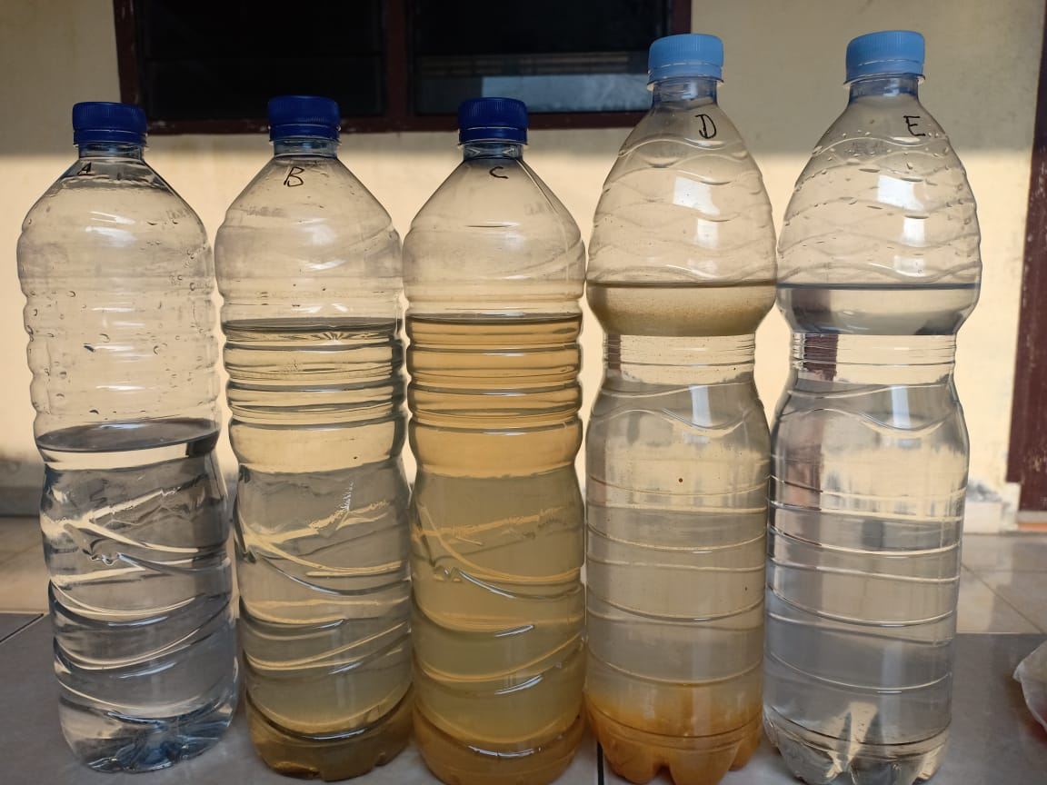

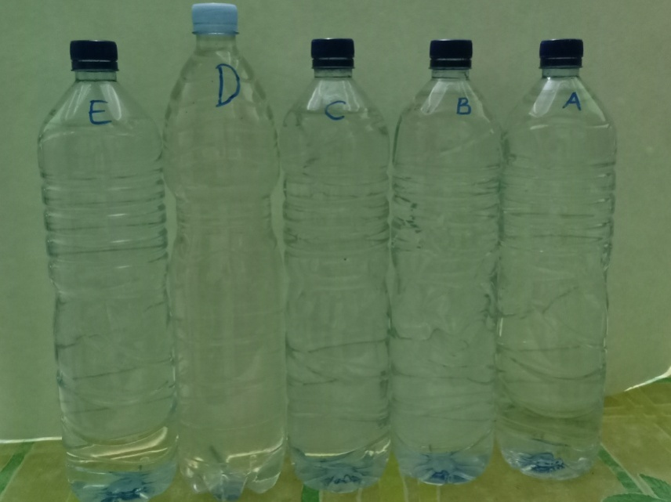

Sumur gali

Lampiran 2. Bagan kerja penentuan kesadahan total
50 ml sampel air sumur gali atau sumur bor di dalam labu Erlenmeyer

Ditambahkan 1 ml NaOH 4N sampai pH 10 dan ditambahkan 5 ml buffer salmaniak

Sampel air sumur gali atau sumur bor yang telah di buffer pH 10
Ditambahkan indikator eriokrom
menghasilkan warna merah anggur

Larutan berwarna merah anggur

Dititrasi dengan larutan Na-EDTA 0,01M

Larutan berwarna biru

Dicatat volume titrasi

Dihitung kesadahan total
Diperoleh data

Lampiran 3. Perhitungan pembakuan larutan Na-EDTA
1. Pembuatan Larutan Na-EDTA 0,01 M
BM Na-EDTA = 372, 24
Molaritas (M) = $\frac{Bobot Na₂EDTA (g)}{BM Na₂EDTA (\frac{g}{mol})}$
0,01 M =$\frac{Bobot Na₂EDTA (g)}{372,24 g/mol}$
Bobot Na-EDTA yang ditimbang = 0,01 x 372,24 = 3.7224 g
Ditimbang 3.7224 g Na-EDTA dilarutkan dengan akuades sampai 1 liter
2. Pembuatan Larutan Zink sulfat 0,01 M
BM ZnSO4 7H,0 =287,54
Molaritas (M) = $\frac{Bobot Zink Sulfat (g)}{BM Zink Sulfat (\frac{g}{mol})}$
Dibuat sebanyak 100 ml
0,01 M=$\frac{Bobot Zink Sulfat (g)}{287,54}×\frac{100 ml}{1000 ml}$
Bobot yang ditimbang = 0,01 M x 287.54 g/mol x$\frac{100 ml}{1000 ml }=0,2875$g
Ditimbang 0,2875g Zink sulfat dilarutkan dengan akuades sampai 100 ml
Molaritas Zink sulfat=$\frac{0,2875 g}{287,54}x\frac{1000 ml}{100 ml }=0,0100 M$
3. Pembakuan Larutan Na-EDTA
Rumus perhitungan: V₁x M₁ = V₂ x M₂
Molaritas ZnSO4 = 0.0100 M
Volume ZnSO4 = 10,00 ml
Volume Na₋ - EDTA:
VI = 10,30 ml ; V2 = 10,35 ml ; V3 = 10,30 ml
Volume. rata-rata Na-EDTA= 10,32 ml
Molaritas Na- EDTA =$\frac{10,00 x 0,0100 M}{10,32}=$ 0,0097 M
Lampiran 4. Contoh perhitungan kesadahan di dalam sampel
Diambil contoh dari sumur gali 2, diperoleh data sebagai berikut :
No. | Volume Sampel  (ml) | Normalitas Na EDTA (N) | Volume  Na EDTA pada titrasi total (ml) | Volume  Na EDTA pada titrasi partial (ml)
1. | 50 | 0,0097 | 9,15 | 6,50
2. | 50 | 0,0097 | 9,20 | 6,30
3. | 50 | 0,0097 | 9,15 | 6,30
4. | 50 | 0,0097 | 9,20 | 6,40
5. | 50 | 0,0097 | 9,30 | 6,50
6. | 50 | 0,0097 | 9,20 | 6,50

- Kesadahan total$=\frac{Volume Na-EDTA x N.Na-EDTA x 100 x 1000 }{Volume sampel (ml)}$
$$1. =\frac{ 9,15x 0,0097x 100x 1000}{50 }=177,51 mg/liter$$
$$2.=\frac{ 9,20 x 0,0097x 100x 1000}{50 }=178,48 mg/liter \\ 3. =\frac{ 9,15 x 0,0097x 100x 1000}{50 }=177,51 mg/liter$$
$$4. =\frac{ 9,20 x 0,0097x 100x 1000}{50 }=178,48 mg/liter$$
$$5. =\frac{ 9,30 x 0,0097x 100x 1000}{50 }=180,42 mg/liter$$
$$6. =\frac{ 9,20 x 0,0097x 100x 1000}{50 }=178,48 mg/liter$$
- Kesadahan Partial (Kalsium) $=\frac{ Volume Na-EDTA x N.Na-EDTA x 40 x 1000}{Volume sampel (ml)}$
$$1.=\frac{6,50 x 0,0097x 40 x 1000}{50 }=50,44 mg/liter$$
$$2.=\frac{6,30 x 0,0097x 40 x 1000}{50 }=48,89 mg/liter$$
$$3.=\frac{6,30 x 0,0097x 40 x 1000}{50 }=48,89 mg/liter$$
$$4.=\frac{ 6,40 x 0,0097x 40 x 1000}{50 }=49,66 mg/liter$$
$$5.=\frac{ 6,50 x 0,0097x 40 x 1000}{50 }=50,44 mg/liter$$
$$6.=\frac{ 6,50 x 0,0097x 40 x 1000}{50 }=50,44 mg/liter$$
- Kesadahan Partial (Magnesium)
$$\frac{ Vol. Na-EDTA(titrasi total-titrasi partial kalsium)xN.Na-EDTA x 24 x 1000}{Volume sampel (ml)}$$
$$1. =\frac{ (9,15-6,50) x 0,0097x 24 x 1000}{50 }=12,34 mg/liter$$
$$2.=\frac{ (9,20-6,30) x 0,0097x 24 x 1000}{50 }=13,50 mg/liter$$
$$3.=\frac{ (9,15-6,30) x 0,0097x 24 x 1000}{50 }=13,27 mg/liter$$
$$4.=\frac{ (9,20-6,40) x 0,0097x 24 x 1000}{50 }=13,04 mg/liter$$
$$5.=\frac{ (9,30-6,50) x 0,0097x 24 x 1000}{50 }=13,04 mg/liter$$
$$6.=\frac{ (9,20-6,50) x 0,0097x 24 x 1000}{50 }=12,57 mg/liter$$
Dengan cara yang sama dihitung untuk sampel lainnya, data dan hasil perhitungan selengkapnya dapat dilihat pada lampiran 6

Lampiran 5.Contoh perhitungan standar deviasi kesadahan
Sebagai contoh diambil data dari sampel air sumur gali 2
No. | Kesadahan total  (mg/liter) ($×$) | $$(X-\overline{X)}$$ | $$(X-{\overline{X)}}^{2}$$
1. | 177,51 | -0,8083 | 0,6534
2. | 178,48 | 0,1617 | 0,0261
3. | 177,51 | -0,8083 | 0,6534
4. | 178,48 | 0,1617 | 0,0261
5. | 179,45 | 1,1317 | 1,2807
6. | 178,48 | 0,1617 | 0,0261
N = 6 | ∑ X = 1070,91  $\overline{x}$=178,32 | ∑$(X-\overline{X})^{2}$ = 2,6659
St.deviasi (SD) =$\sqrt{\frac{Σ(Χ-{\overline{X})}^{2}}{n-1}}$=$\sqrt{\frac{2,6659}{5}}$= 0,73
Dasar penolakan data adalah apabila t _{hitung} > t _{tabel} dengan tingkat kepercayaan 99,99%, α = 0,01 : n=6, dk = 5 dan t tabel = 4,032
1. t_{hitung} =$\frac{\left|x-\overline{x}\right|}{\frac{SD}{\sqrt{n}}}= \frac{\left|177,51-178,32\right|}{\frac{0,73}{\sqrt{6}}}= \frac{0,8083}{0,2982}$= 2,71
2. t_{hitung} =$\frac{\left|x-\overline{x}\right|}{\frac{SD}{\sqrt{n}}}= \frac{\left|178,48-178,32\right|}{\frac{0,73}{\sqrt{6}}}= \frac{0,1617}{0,2982}$= 0,54
3. t_{hitung} =$\frac{\left|x-\overline{x}\right|}{\frac{SD}{\sqrt{n}}}= \frac{\left|177,51-178,32\right|}{\frac{0,73}{\sqrt{6}}}= \frac{0,8083}{0,2982}$= 2,71
4. t_{hitung} =$\frac{\left|x-\overline{x}\right|}{\frac{SD}{\sqrt{n}}}= \frac{\left|178,48-178,32\right|}{\frac{0,73}{\sqrt{6}}}= \frac{0,1617}{0,2982}$= 0,54
5. t_{hitung} =$\frac{\left|x-\overline{x}\right|}{\frac{SD}{\sqrt{n}}}= \frac{\left|178,45-178,32\right|}{\frac{0,73}{\sqrt{6}}}= \frac{1,1317}{0,2982}$= 3,80
6. t_{hitung} =$\frac{\left|x-\overline{x}\right|}{\frac{SD}{\sqrt{n}}}= \frac{\left|178,48-178,32\right|}{\frac{0,73}{\sqrt{6}}}= \frac{0,1617}{0,2982}$= 0,54
Seluruh t _{hitung} yang diperoleh dari ke-6 perlakuan < t _{tabel} , berarti semua data ini bisa diterima.
Menghitung kesadahan total sebenarnya :
Kesadahan total rata-rata $(\overline{x)}$= 178,48 mg/liter
Standar deviasi = 1,06
Kesadahan total sebenarnya = $\overline{x}$ ± t _{(1-1/2α dk)} ᵡ $\frac{SD}{\sqrt{n }}$
Kesadahan total sebenarnya = $\overline{x}$ ± t _{(1-1/2α dk)} ᵡ $\frac{1,06}{\sqrt{6 }}$
Kesadahan total sebenarnya = 178,48 ± 4,032 ᵡ $\frac{1,06}{2,449}$
Kesadahan total sebenarnya = ( 126,48 ± 1,05) mg/liter
Dengan cara yang sama dihitung untuk sampel lainnya, data dan hasil perhitungan selengkapnya dapat dilihat pada lampiran 6

Lampiran 6. Data hasil perhitungan kesadahan dari sampel air
Sampel |  | Volume Sampel  (ml) |  | Kesadahan Total |  |  |  |  |  | Kesadahan Partial Kalsium |  |  | Partial Sebagai Magnesium (mg/l)
 |  |  |  | Volume  Na-EDTA (ml) |  | Normalitas  Na-EDTA  (N) |  | Kesadahan Total Sebagai CaCO₃ (mg/l) |  | Volume Na-EDTA (ml) |  | Partial Sebagai Kalsium (mg/l)
Sumur gali  1 |  | 50,00 |  | 26,65 |  | 0,0097 |  | 517,01 |  | 21,50 |  | 166,84 | 23,98
 |  |  |  | 26,60 |  | 0,0097 |  | 516,04 |  | 22,00 |  | 170,72 | 21,42
 |  |  |  | 26,55 |  | 0,0097 |  | 515,07 |  | 21,50 |  | 166,84 | 23,51
 |  |  |  | 26,50 |  | 0,0097 |  | 514,10 |  | 22,00 |  | 170,72 | 20,95
 |  |  |  | 26,55 |  | 0,0097 |  | 515,07 |  | 21,50 |  | 166,84 | 23,51
 |  |  |  | 26,65 |  | 0,0097 |  | 517,01 |  | 21,50 |  | 166,84 | 23,98
Kesadahan total rata-rata = 515,72 mg/liter
Standar deviasi = 1,17
Kesadahan total sebenarnya = 515,72mg/liter ±1,93
Kesadahan kalsium rata-rata = 168,13mg/liter
Standar deviasi = 2,00
Kesadahan kalsium sebenarnya = 168,13 mg/liter ±3,30
Kesadahan magnesium rata-rata = 22,89mg/liter
Standar deviasi = 1,35
Kesadahan magnesium sebenarnya = 22,89mg/liter ±2,22
Sumur gali  2 |  | 50,00 |  | 9,15 |  | 0,0097 |  | 177,51 |  | 6,50 |  | 50,44 | 12,34
 |  |  |  | 9,20 |  | 0,0097 |  | 178,48 |  | 6,30 |  | 48,89 | 13,50
 |  |  |  | 9,15 |  | 0,0097 |  | 177,51 |  | 6,30 |  | 48,89 | 13,27
 |  |  |  | 9,20 |  | 0,0097 |  | 178,48 |  | 6,40 |  | 49,66 | 13,04
 |  |  |  | 9,30 |  | 0,0097 |  | 180,42 |  | 6,50 |  | 50,44 | 13,04
 |  |  |  | 9,20 |  | 0,0097 |  | 178,48 |  | 6,50 |  | 50,44 | 12,57
Kesadahan total rata-rata = 178,32 mg/liter
Standar deviasi = 0,73
Kesadahan total sebenarnya = 178,32 ± 1,20 mg/liter
Kesadahan kalsium rata-rata = 49,79 mg/liter
Standar deviasi = 0,76
Kesadahan kalsium sebenarnya = 49,79 ± 1,26 mg/liter
Kesadahan magnesium rata-rata = 12,92 mg/liter
Standar deviasi = 0,44
Kesadahan magnesium sebenarnya = 12,92 ± 0,72 mg/liter
Sumur gali  3 | 50,00 |  | 11,65 |  | 0,0097 |  | 153,26 |  | 3,30 |  | 25,61 |  |  | 21,42
 |  |  | 11,70 |  | 0,0097 |  | 151,32 |  | 3,00 |  | 23,28 |  |  | 22,35
 |  |  | 11,55 |  | 0,0097 |  | 149,38 |  | 3,00 |  | 23,28 |  |  | 21,88
 |  |  | 11,60 |  | 0,0097 |  | 153,26 |  | 3,30 |  | 25,61 |  |  | 21,42
 |  |  | 11,65 |  | 0,0097 |  | 153,26 |  | 3,20 |  | 24,83 |  |  | 21,88
 |  |  | 11,70 |  | 0,0097 |  | 151,32 |  | 3,10 |  | 24,06 |  |  | 21,88
Kesadahan total rata-rata = 151,97 mg/liter
Standar deviasi = 1,58
Kesadahan total sebenarnya = 151,97 ± 2,61 mg/liter
Kesadahan kalsium rata-rata = 24,44 mg/liter
Standar deviasi = 0,63
Kesadahan kalsium sebenarnya = 24,44 ± 1,76 mg/liter
Kesadahan magnesium rata-rata = 21,81 mg/liter
Standar deviasi = 0,35
Kesadahan magnesium sebenarnya = 21,81 ± 0,58 mg/liter
Lampiran 6. Data hasil perhitungan kesadahan dari sampel air (sambungan)

Sumur gali  4 | 50,00 | 9,15 | 0,0097 |  | 82,45 |  | 3,50 | 27,16 |  | 3,49
 |  | 9,20 | 0,0097 |  | 83,42 |  | 3,50 | 27,16 |  | 3,72
 |  | 9,15 | 0,0097 |  | 81,48 |  | 3,70 | 28,71 |  | 2,33
 |  | 9,20 | 0,0097 |  | 83,42 |  | 3,60 | 27,94 |  | 3,26
 |  | 9,30 | 0,0097 |  | 80,51 |  | 3,70 | 28,71 |  | 2,10
 |  | 9,20 | 0,0097 |  | 81,48 |  | 3,60 | 27,94 |  | 2,79
Kesadahan total rata-rata = 82,13 mg/liter
Standar deviasi = 1,17
Kesadahan total sebenarnya = 82,13 ± 1,93 mg/liter
Kesadahan kalsium rata-rata = 27,94 mg/liter
Standar deviasi = 0,69
Kesadahan kalsium sebenarnya = 27,94 ± 1,14 mg/liter
Kesadahan magnesium rata-rata = 2,95 mg/liter
Standar deviasi = 0,65
Kesadahan magnesium sebenarnya = 2,95 ± 0,89 mg/liter
Sumur gali  5 | 50,00 | 11,65 | 0,0097 | 162,96 |  | 4,00 |  |  | 31,04 |  | 20,49
 |  | 11,70 | 0,0097 | 161,99 |  | 3,80 |  |  | 29,49 |  | 21,18
 |  | 11,55 | 0,0097 | 162,96 |  | 3,90 |  |  | 30,26 |  | 20,95
 |  | 11,60 | 0,0097 | 164,90 |  | 4,00 |  |  | 31,04 |  | 20,95
 |  | 11,65 | 0,0097 | 164,90 |  | 3,80 |  |  | 29,49 |  | 21,88
 |  | 11,70 | 0,0097 | 162,96 |  | 3,90 |  |  | 30,26 |  | 20,95
Kesadahan total rata-rata = 163,45 mg/liter
Standar deviasi = 1,19
Kesadahan total sebenarnya = 163,45 ± 1,96 mg/liter
Kesadahan kalsium rata-rata = 36,26 mg/liter
Standar deviasi = 0,69
Kesadahan kalsium sebenarnya = 36,26 ± 1,14 mg/liter
Kesadahan magnesium rata-rata = 21,07 mg/liter
Standar deviasi = 0,46
Kesadahan magnesium sebenarnya = 21,07 ± 0,76 mg/liter
Sumur bor  1 | 50,00 | 9,15 | 0,0097 | 77,60 |  | 3,50 |  |  | 27,16 |  | 2,33
 |  | 9,20 | 0,0097 | 77,60 |  | 3,60 |  |  | 27,94 |  | 1,86
 |  | 9,15 | 0,0097 | 81,48 |  | 3,40 |  |  | 26,38 |  | 3,72
 |  | 9,20 | 0,0097 | 79,54 |  | 3,70 |  |  | 28,71 |  | 1,86
 |  | 9,30 | 0,0097 | 81,48 |  | 3,50 |  |  | 27,16 |  | 3,26
 |  | 9,20 | 0,0097 | 79,54 |  | 3,60 |  |  | 27,94 |  | 2,33
Kesadahan total rata-rata = 76,54 mg/liter
Standar deviasi = 1,74
Kesadahan total sebenarnya = 76,54 ± 2,86 mg/liter
Kesadahan kalsium rata-rata = 27,55 mg/liter
Standar deviasi = 0,81
Kesadahan kalsium sebenarnya = 27,55 ± 1,34 mg/liter
Kesadahan magnesium rata-rata = 2,56 mg/liter
Standar deviasi = 0,77
Kesadahan magnesium sebenarnya = 2,56 ± 0,96 mg/liter

Lampiran 6. Data hasil perhitungan kesadahan dari sampel air (sambungan)

Sumur bor  2 | 50,00 | 11,65 | 0,0097 | 112,52 | 4,70 | 36,47 | 5,12
 |  | 11,70 | 0,0097 | 116,40 | 4,60 | 35,70 | 6,52
 |  | 11,55 | 0,0097 | 114,46 | 4,50 | 34,92 | 6,52
 |  | 11,60 | 0,0097 | 112,52 | 4,60 | 35,70 | 5,59
 |  | 11,65 | 0,0097 | 114,46 | 4,60 | 35,70 | 6,05
 |  | 11,70 | 0,0097 | 114,46 | 4,70 | 36,47 | 5,59
Kesadahan total rata-rata = 114,14 mg/liter
Standar deviasi = 1,46
Kesadahan total sebenarnya = 114,14 ± 2,40 mg/liter
Kesadahan kalsium rata-rata = 35,83 mg/liter
Standar deviasi = 0,58
Kesadahan kalsium sebenarnya = 35,83 ± 0,96 mg/liter
Kesadahan magnesium rata-rata = 5,90 mg/liter
Standar deviasi = 0,56
Kesadahan magnesium sebenarnya = 5,90 ± 0,93 mg/liter
Sumur bor  3 | 50,00 | 9,15 | 0,0097 | 147,44 | 5,50 | 42,68 | 9,78
 |  | 9,20 | 0,0097 | 147,44 | 5,60 | 43,46 | 9,31
 |  | 9,15 | 0,0097 | 145,50 | 5,80 | 45,01 | 7,92
 |  | 9,20 | 0,0097 | 147,44 | 5,70 | 44,23 | 8,85
 |  | 9,30 | 0,0097 | 147,44 | 5,60 | 43,46 | 9,31
 |  | 9,20 | 0,0097 | 145,50 | 5,60 | 43,46 | 8,85
Kesadahan total rata-rata = 146,79 mg/liter
Standar deviasi = 1,00
Kesadahan total sebenarnya = 146,79 ± 1,65 mg/liter
Kesadahan kalsium rata-rata = 43,71 mg/liter
Standar deviasi = 0,80
Kesadahan kalsium sebenarnya = 43,71 ± 1,32 mg/liter
Kesadahan magnesium rata-rata = 9,00 mg/liter
Standar deviasi = 0,64
Kesadahan magnesium sebenarnya = 9,00 ± 1,05 mg/liter
Sumur bor  4 | 50,00 | 11,65 | 0,0097 | 87,30 | 3,50 | 27,16 | 4,66
 |  | 11,70 | 0,0097 | 89,24 | 3,40 | 26,38 | 5,59
 |  | 11,55 | 0,0097 | 87,30 | 3,50 | 27,16 | 4,66
 |  | 11,60 | 0,0097 | 87,30 | 3,50 | 27,16 | 4,66
 |  | 11,65 | 0,0097 | 89,24 | 3,60 | 27,94 | 4,66
 |  | 11,70 | 0,0097 | 87,30 | 3,50 | 27,16 | 4,66
Kesadahan total rata-rata = 87,95 mg/liter
Standar deviasi = 1,00
Kesadahan total sebenarnya = 87,95 ± 1,65 mg/liter
Kesadahan kalsium rata-rata = 27,16 mg/liter
Standar deviasi = 0,49
Kesadahan kalsium sebenarnya = 27,16 ± 0,81 mg/liter
Kesadahan magnesium rata-rata = 4,81 mg/liter
Standar deviasi = 0,38
Kesadahan magnesium sebenarnya = 4,81 ± 0,63 mg/liter

Sumur bor  5 | 50,00 | 9,15 | 0,0097 | 69,84 | 2,60 | 20,18 | 4,66
 |  | 9,20 | 0,0097 | 71,78 | 2,60 | 20,18 | 5,12
 |  | 9,15 | 0,0097 | 71,78 | 2,70 | 20,95 | 4,66
 |  | 9,20 | 0,0097 | 69,84 | 2,80 | 21,73 | 3,72
 |  | 9,30 | 0,0097 | 73,72 | 2,70 | 20,95 | 5,12
 |  | 9,20 | 0,0097 | 71,78 | 2,70 | 20,95 | 4,66
Kesadahan total rata-rata = 71,46 mg/liter
Standar deviasi = 1,46
Kesadahan total sebenarnya = 71,46 ± 2,40 mg/liter
Kesadahan kalsium rata-rata = 20,82 mg/liter
Standar deviasi = 0,58
Kesadahan kalsium sebenarnya = 20,82 ± 0,96 mg/liter
Kesadahan magnesium rata-rata = 4,66 mg/liter
Standar deviasi = 0,51
Kesadahan magnesium sebenarnya = 4,66 ± 0,84 mg/liter

Lampiran 7. Data distribusi t

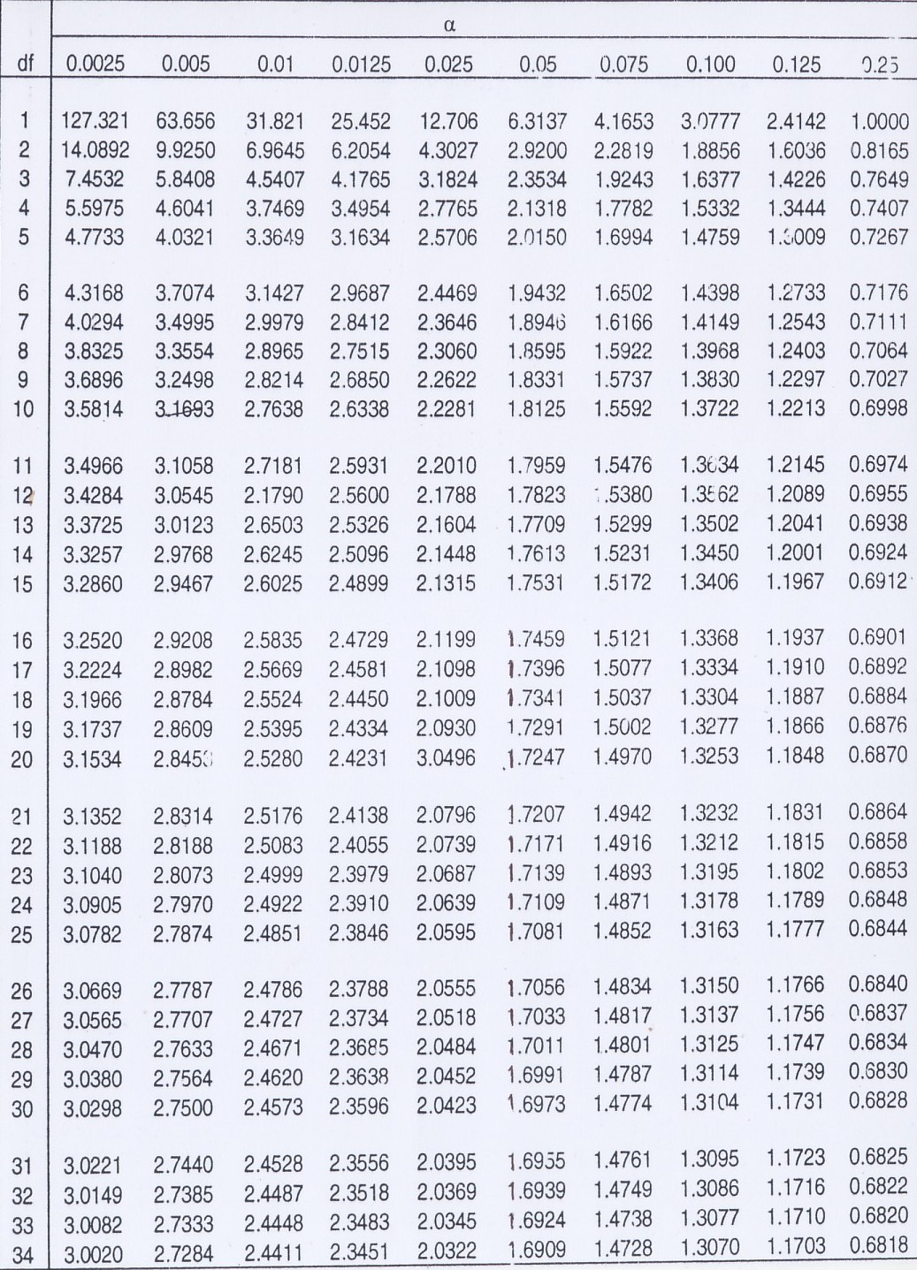

Lampiran 8. Persyaratan kualitas air minum PERMENKES no. 492 tahun 2010
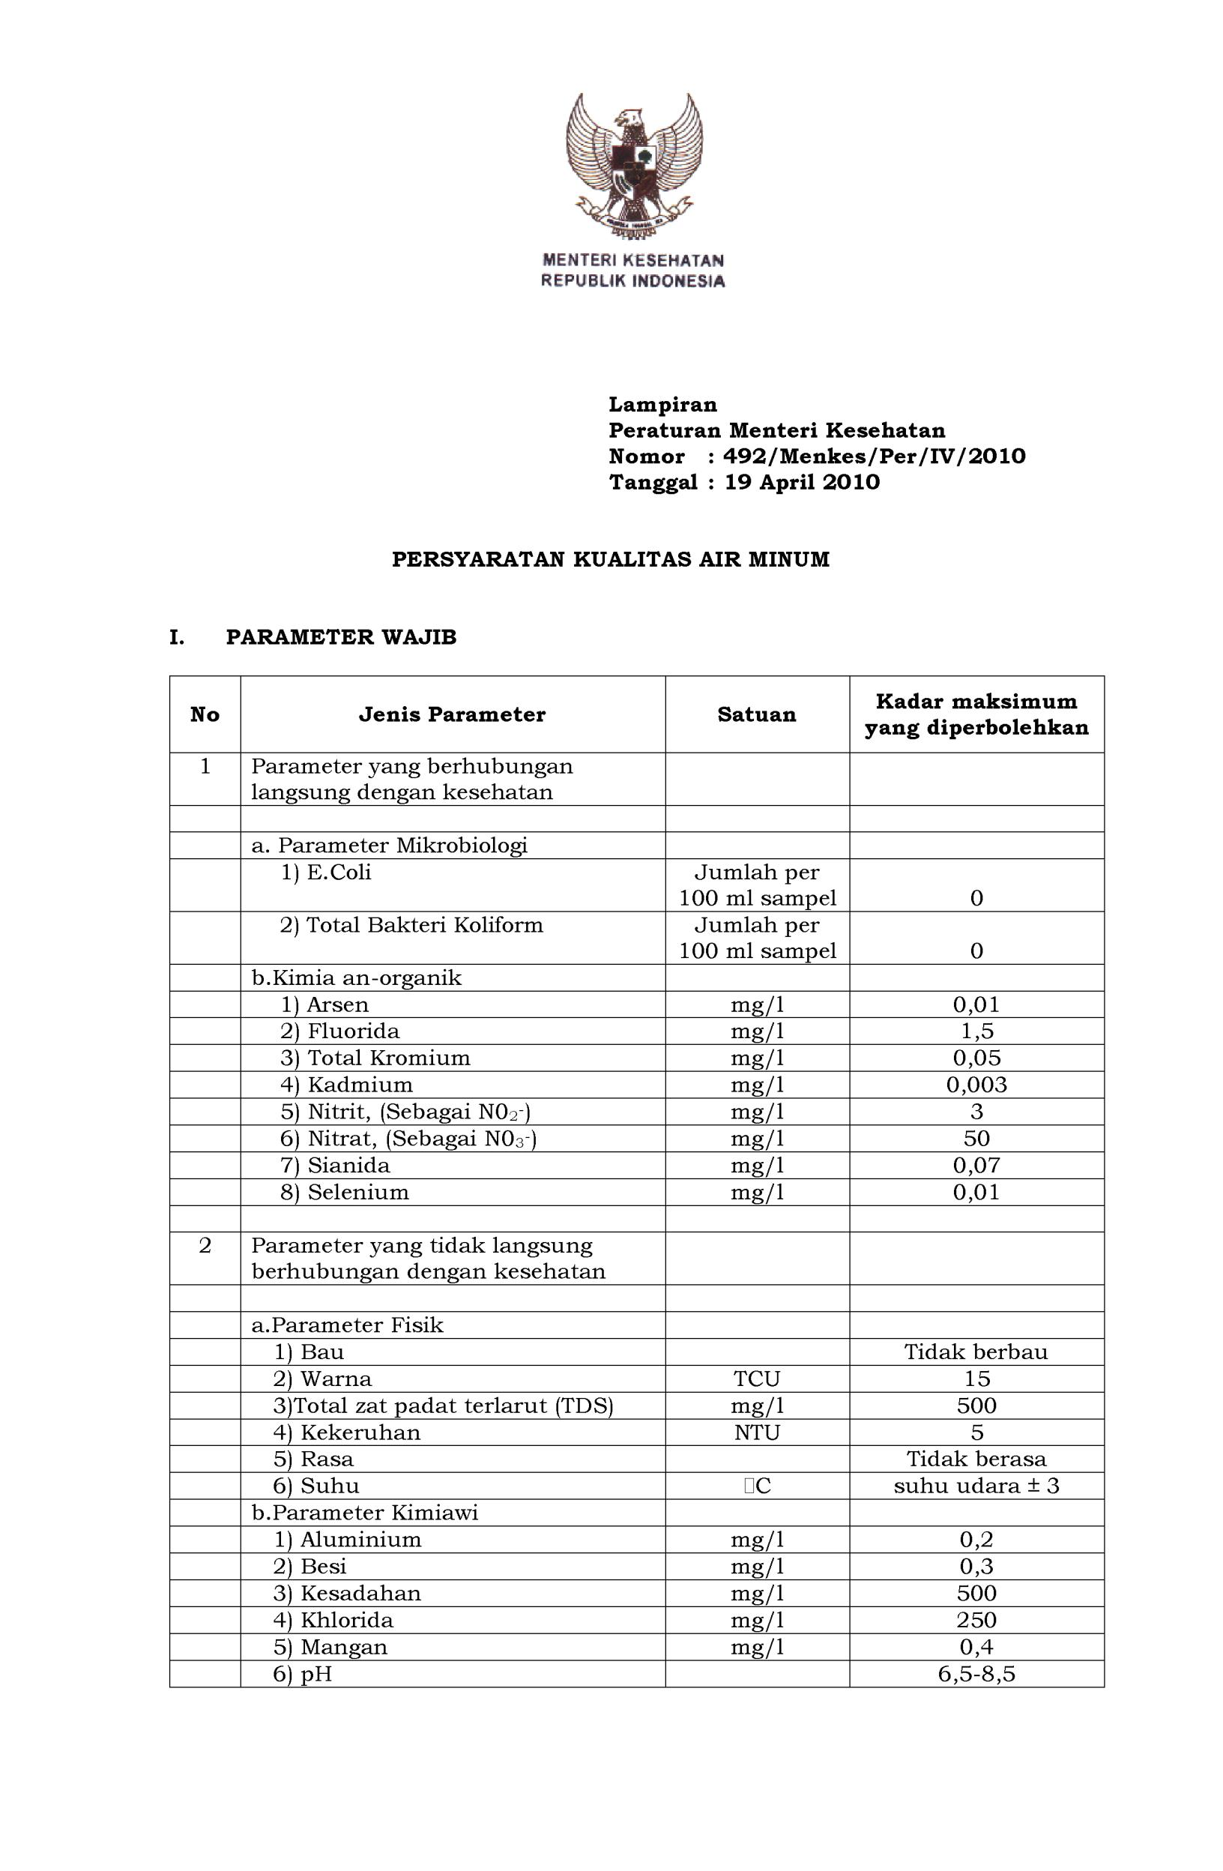

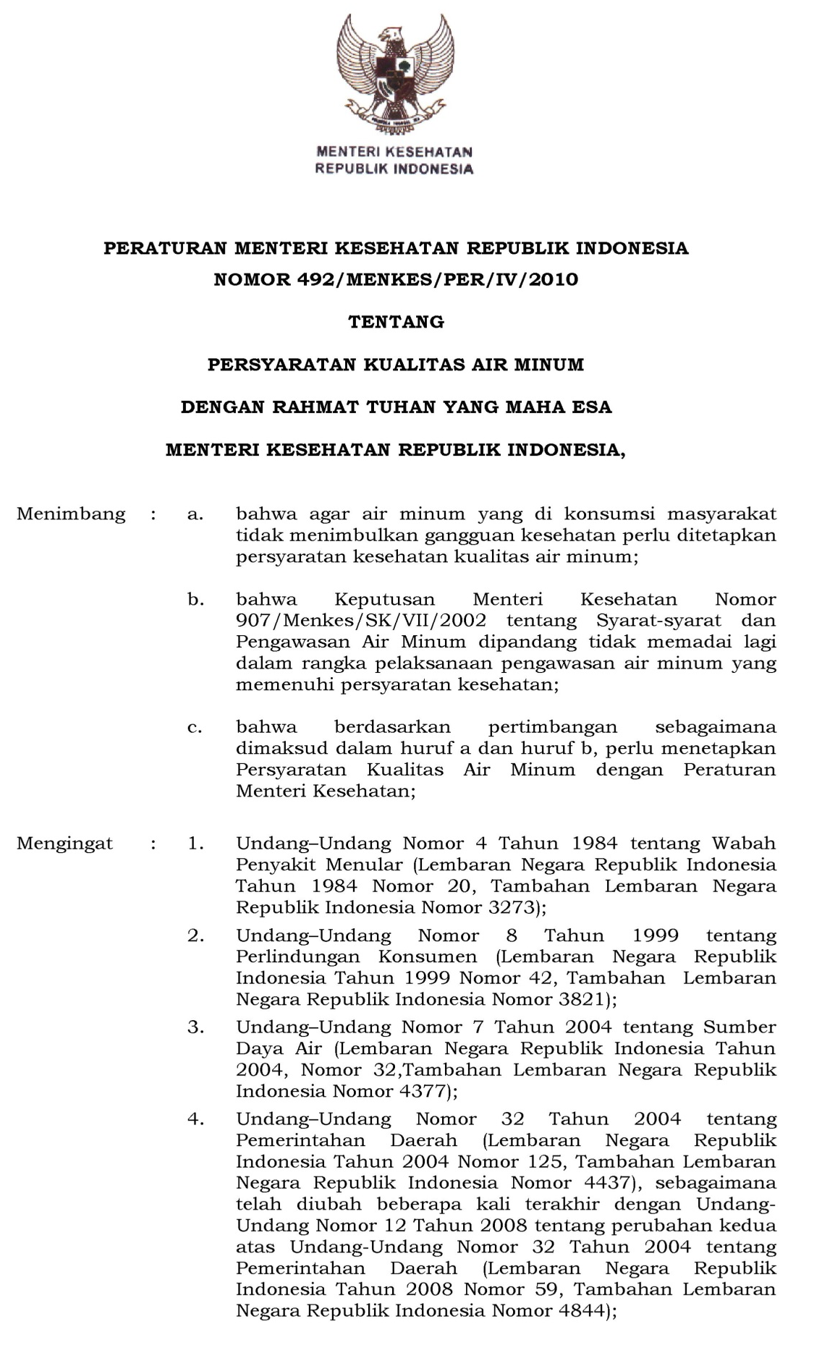
Lampiran 9. SK PERMENKES no.492 tahun 2010

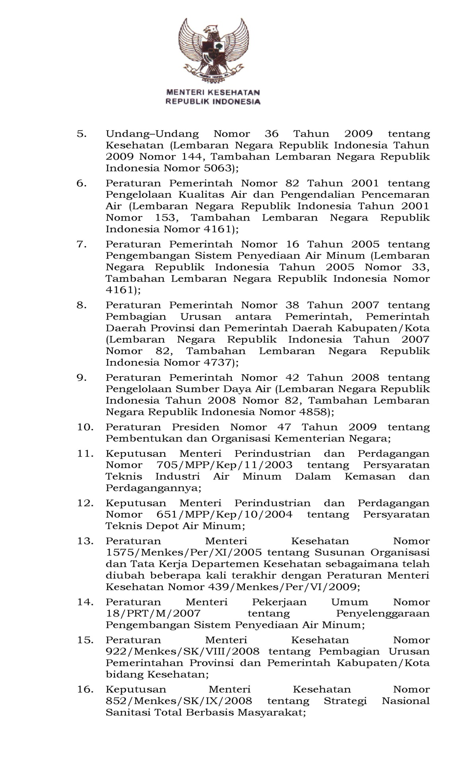
Lampiran 9. SK PERMENKES no.492 tahun 2010 (sambungan)

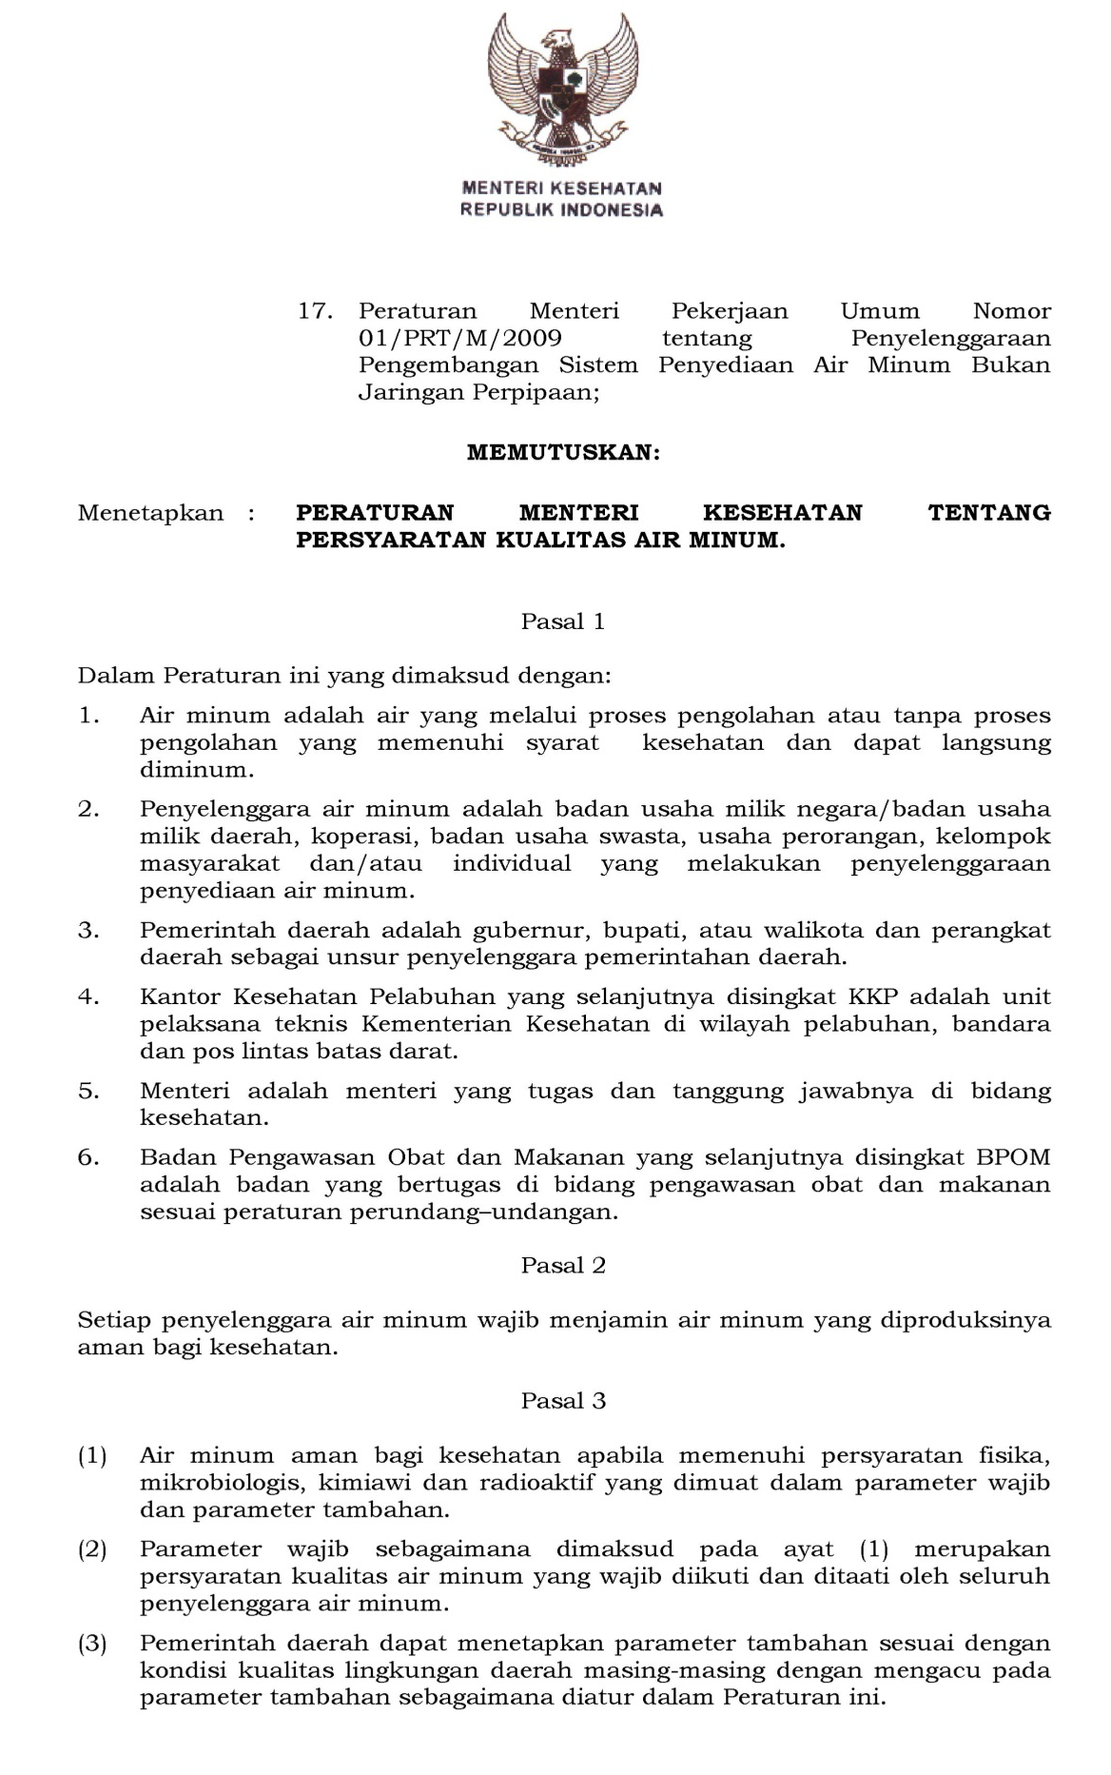
Lampiran 9. SK PERMENKES no.492 tahun 2010 (sambungan)

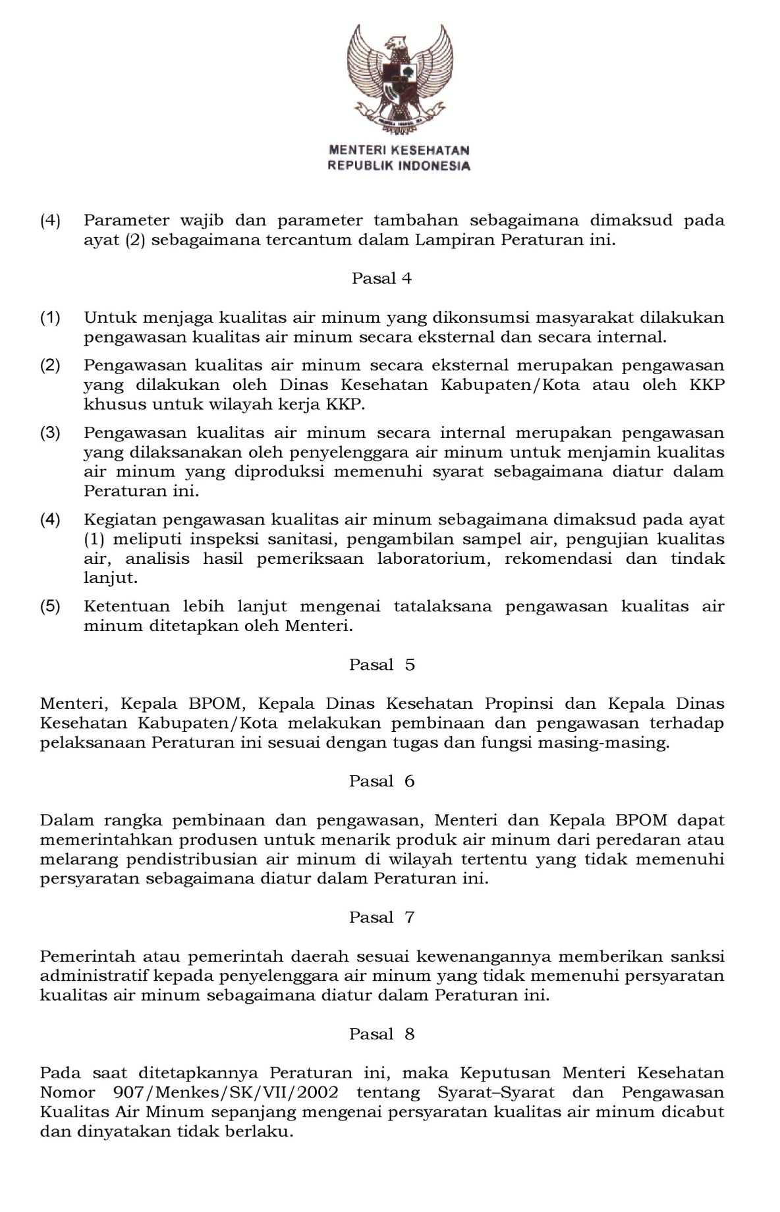
Lampiran 9. SK PERMENKES no.492 tahun 2010 (sambungan)

Lampiran 9. SK PERMENKES no.492 tahun 2010 (sambungan)
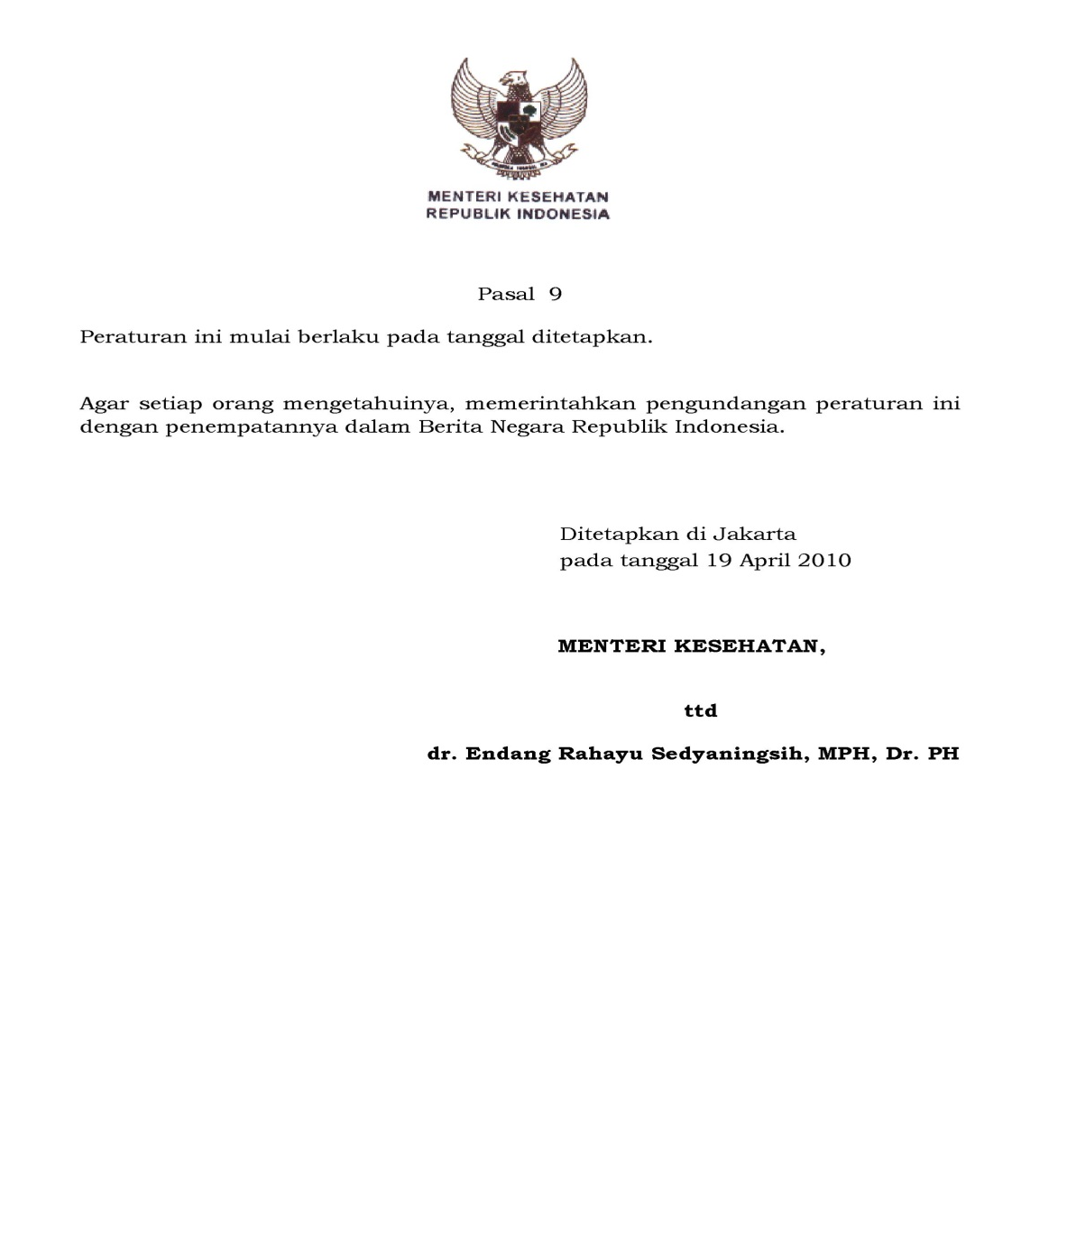

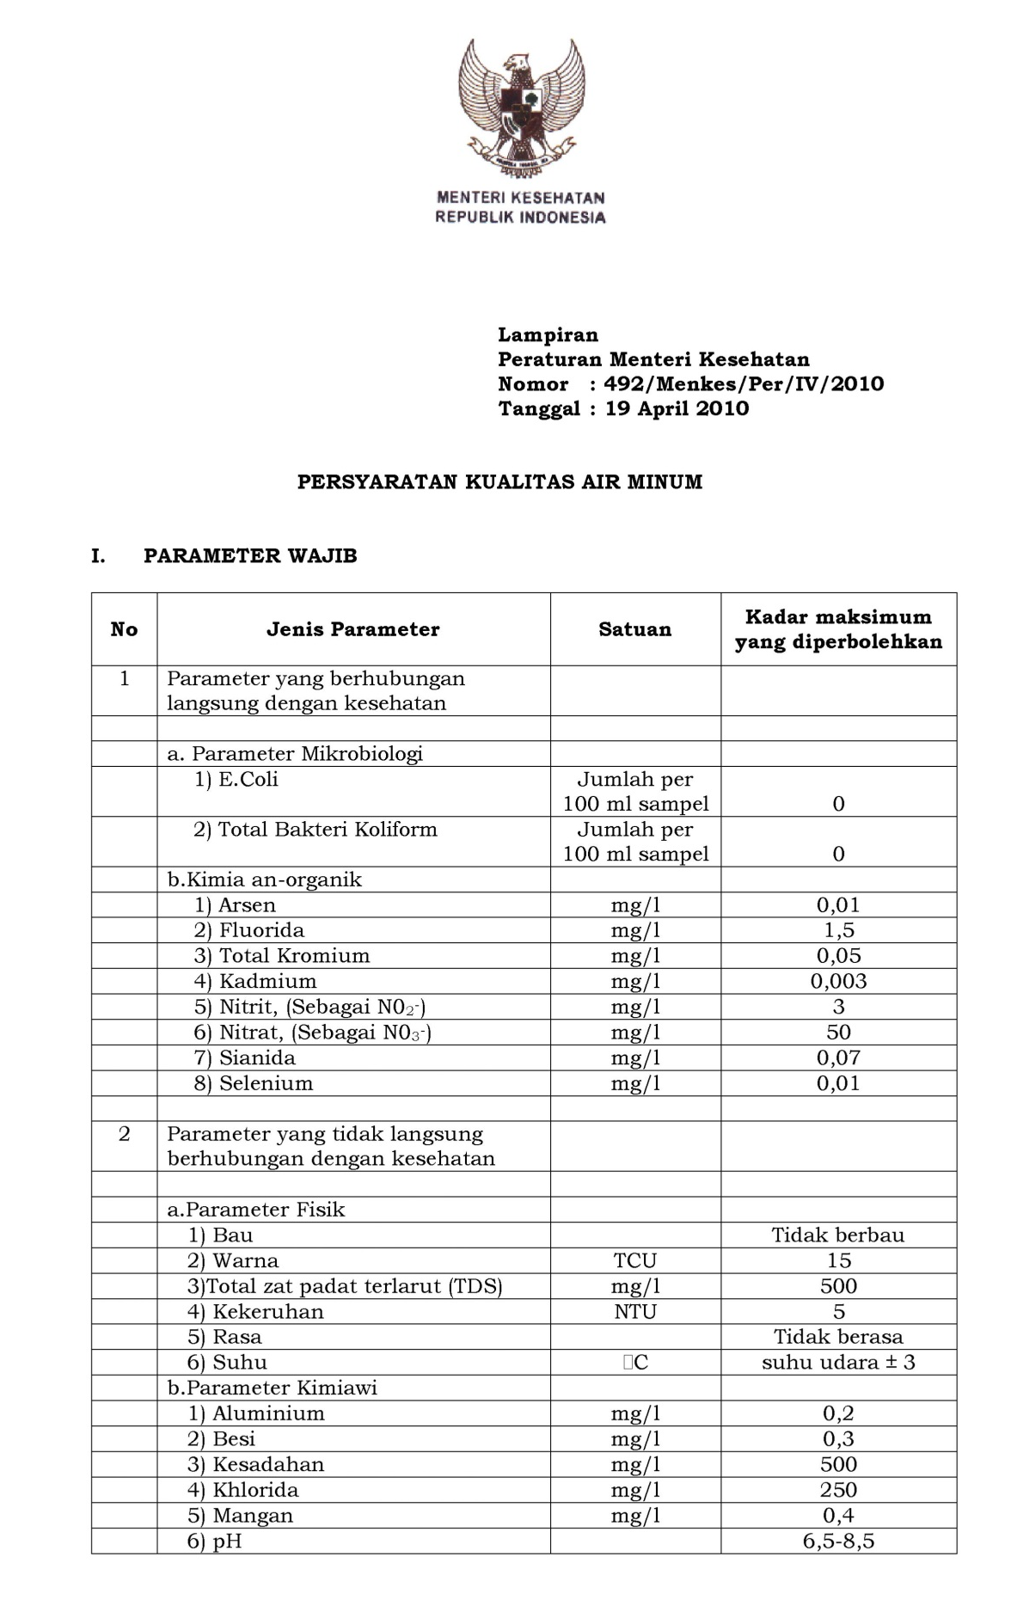
Lampiran 9. SK PERMENKES no.492 tahun 2010 (sambungan)

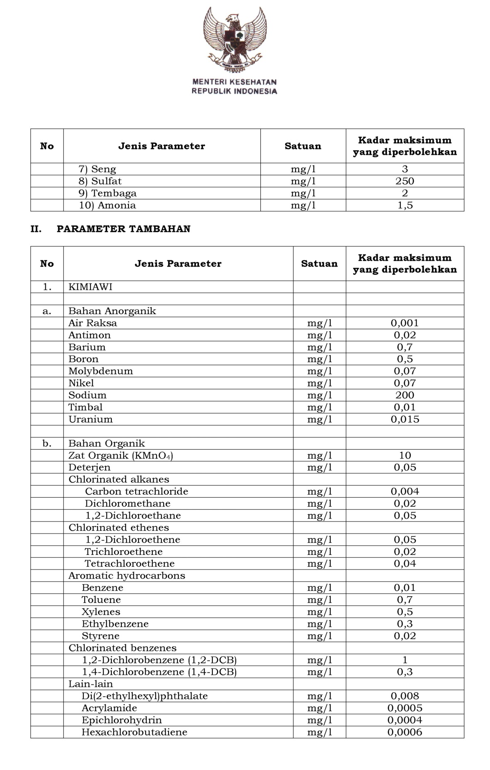
Lampiran 9. SK PERMENKES no.492 tahun 2010 (sambungan)

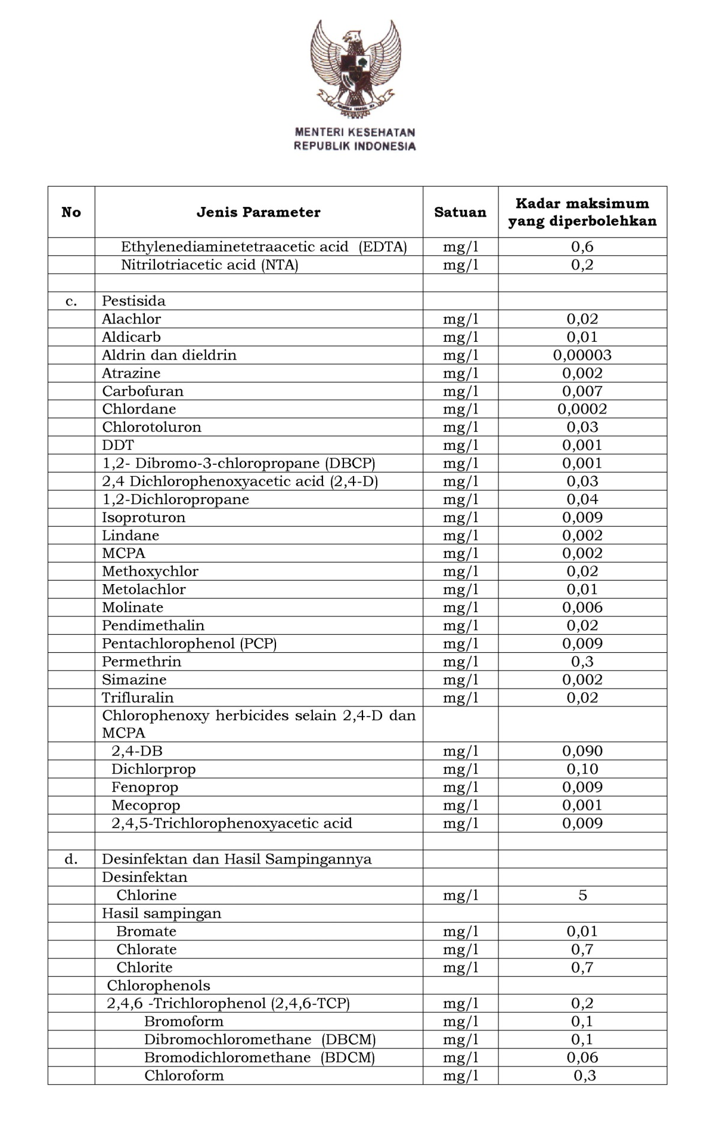
Lampiran 9. SK PERMENKES no.492 tahun 2010 (sambungan)

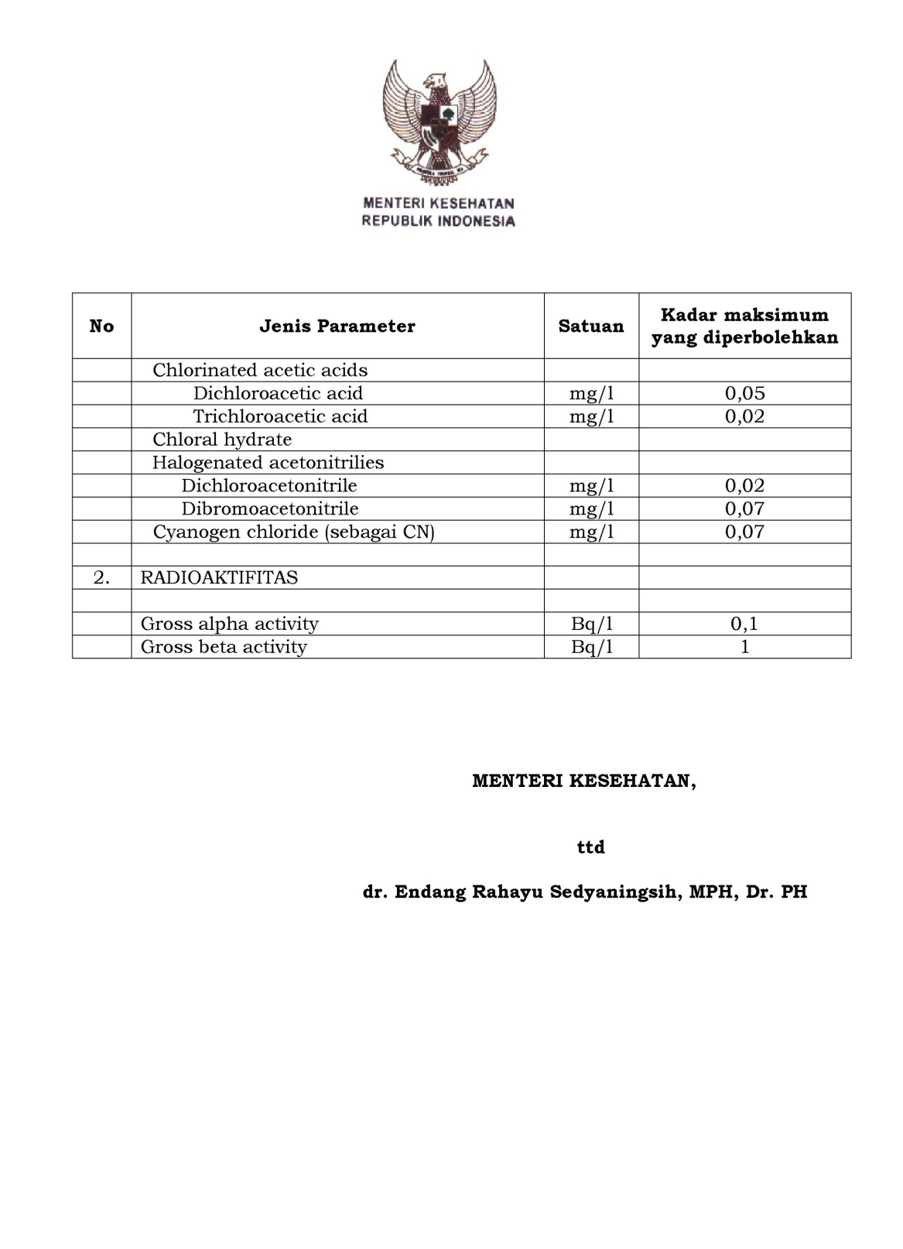
Lampiran 9. SK PERMENKES no.492 tahun 2010 (sambungan)

