Lampiran 1. Hasil Identifikasi Daun Selada air (Nasturtium officinale)
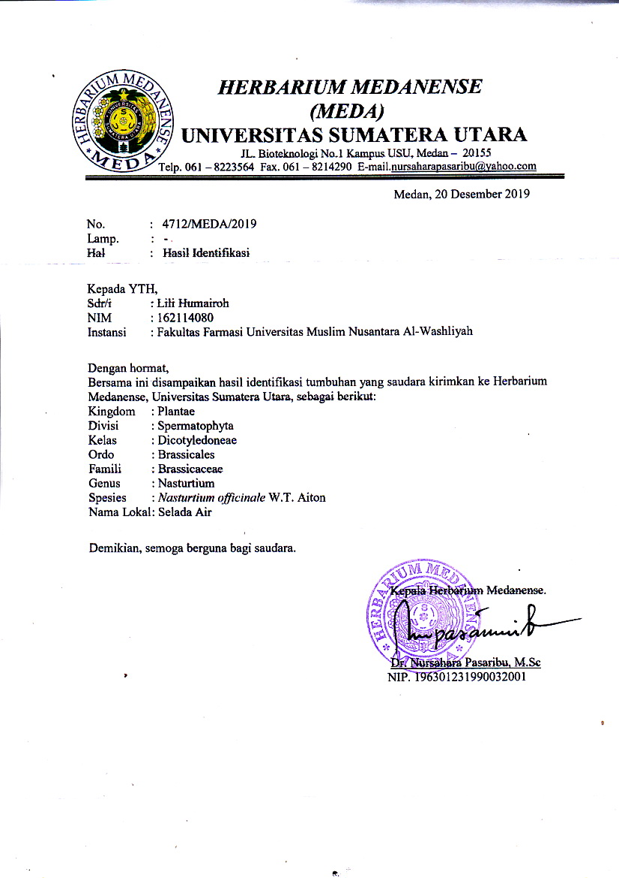

LAMPIRAN

Lampiran 2. Rekomendasi Persetujuan Etik Penelitian Kesehatan
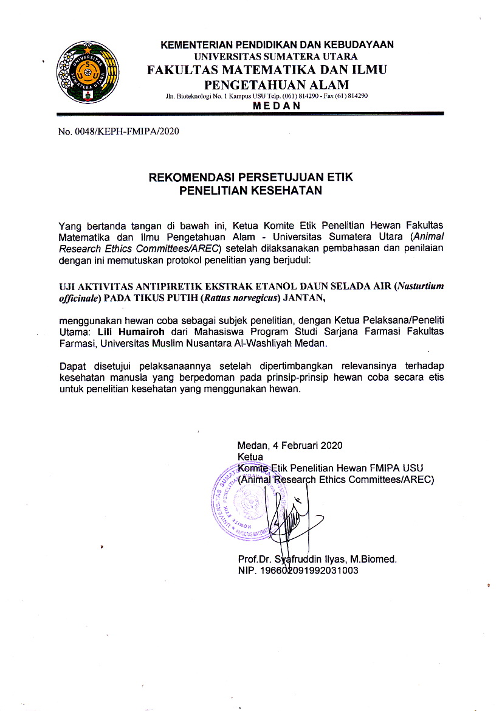

Lampiran 3. Tumbuhan Daun Selada Air Segar, Simplisia dan Serbuk Simplisia daun Selada Air
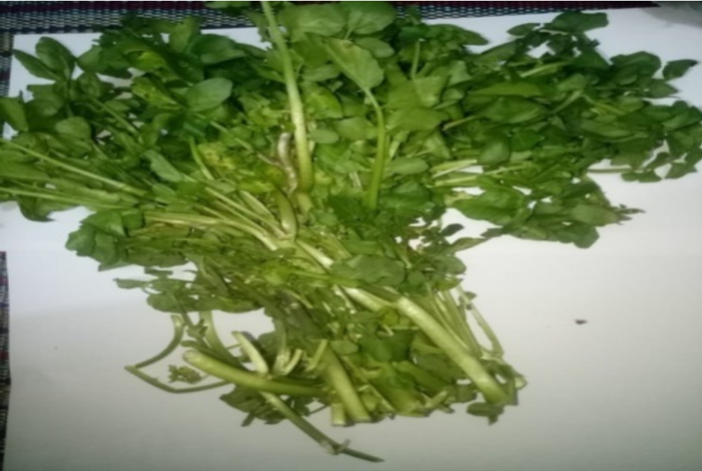
Daun Selada Air Segar

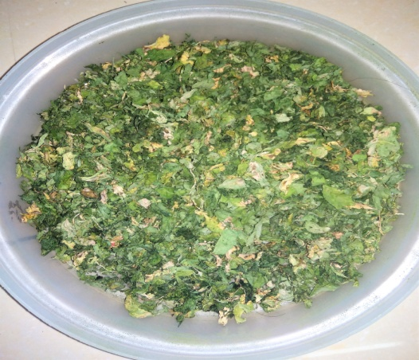

Simplisia Daun Selada Air
Lampiran 3. (Lanjutan)

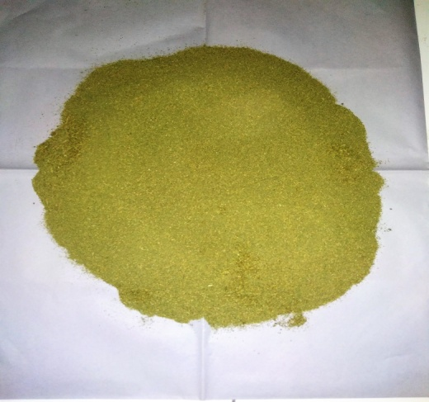

Serbuk Daun Selada Air

Lampiran 4. Ekstraksi Cara Maserasi dan Ekstrak Etanol Daun Selada Air
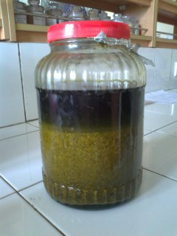

Maserasi Daun Selada Air
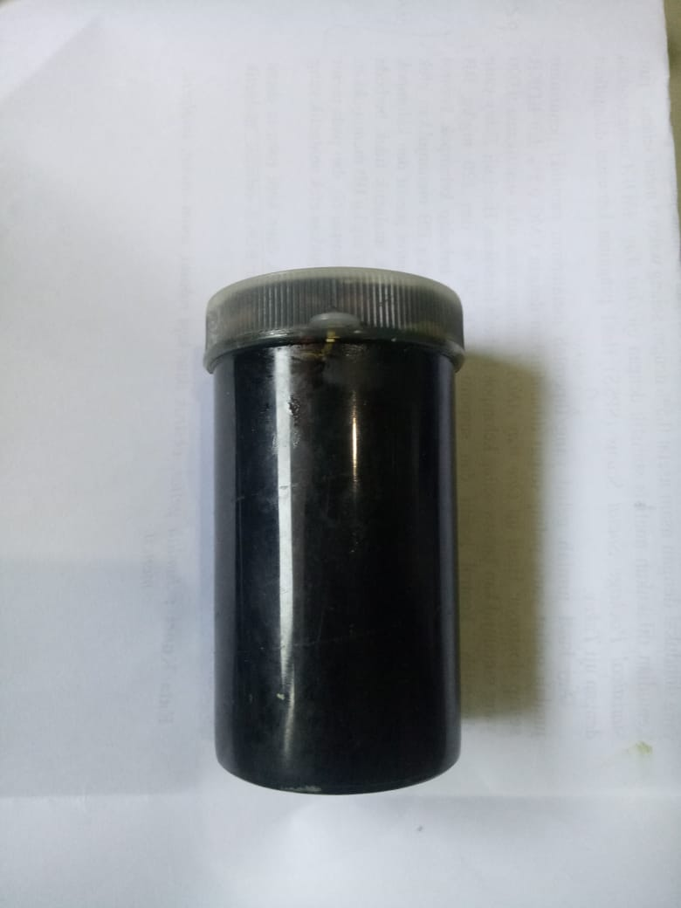

Ekstrak Etanol Daun Selada Air
Lampiran 5. Mikroskopik Daun Selada Air (Nasturtium officinale)

Jaringan bunga karang

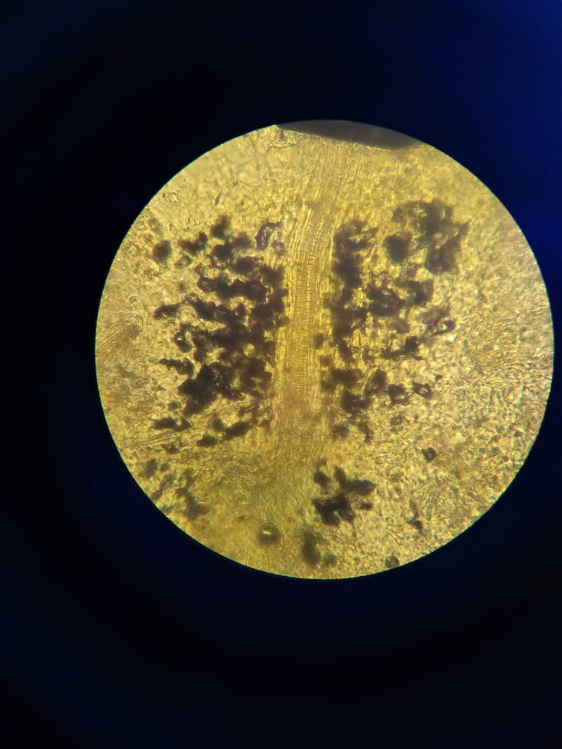

Jaringan epidermis
Lampiran 5(Lanjutan)

Lampiran 6. Alat rotary evaporato

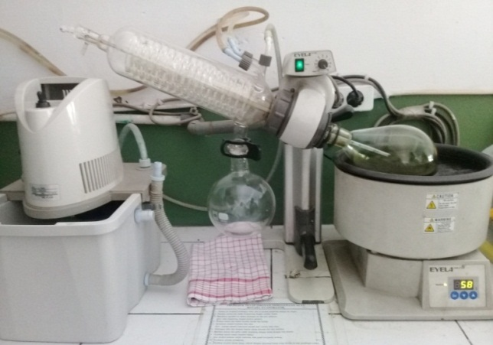

Lampiran 7. Kandang tikus, tikus, Thermometer digital,Tablet paracetamol dan Vaksin DPT-HB-Hib.
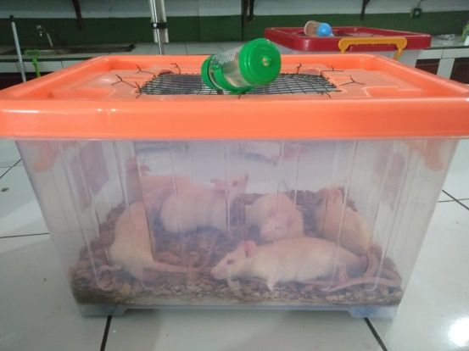
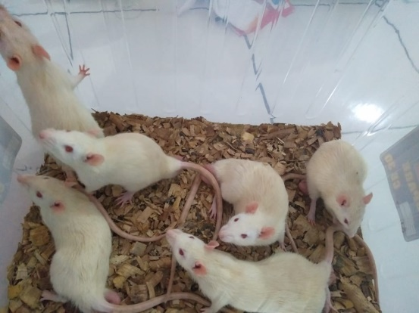
Kandang mencit
Tikus
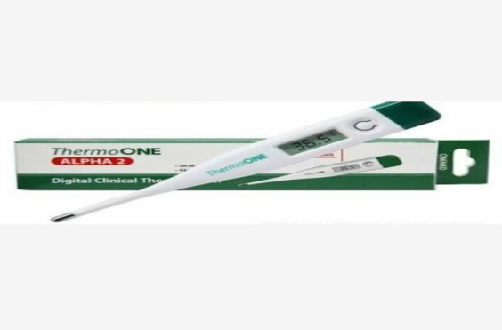
Lampiran 7. (Lanjutan)

Thermometer digital
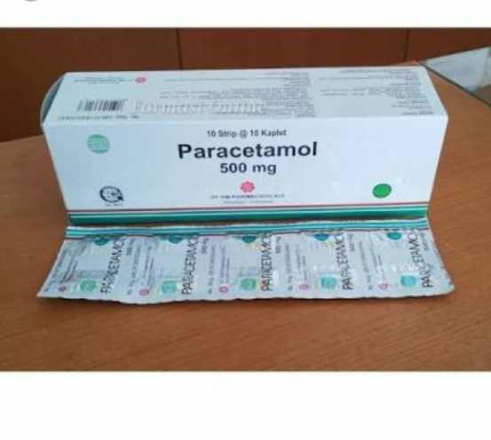

Tablet paracetamol 500 mg
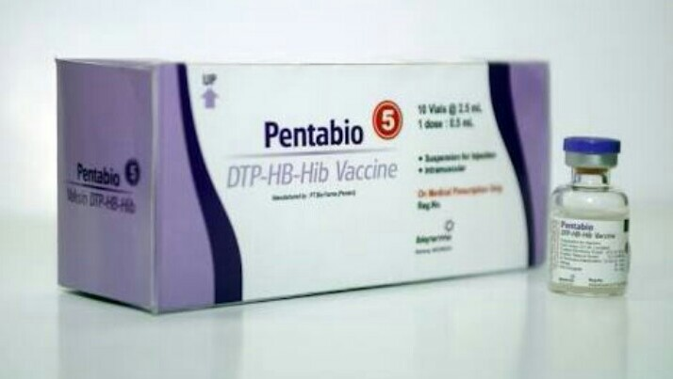
Lampiran 7. (Lanjutan)

Vaksin DPT-HB

Lampiran 8. Bagan alir penelitian
Daun selada air
Dibersihkan
Dicuci bersih
Ditiriskan
Ditimbang
Daun selada air 7000 gr

Dikeringkan
Ditimbang
Simplisia kering 800 gr

Dihaluskan
Ditimbang
Serbuk simplisia 530 gr

Dilakukan skrining fitokimia serbuk dan ekstrak
Serbuk simplisia 500 gr
Pemeriksaan karakterisasi

- Makroskopik
- Mikroskopik
- Penetapan kadar air
- Penetapan kadar sari larut dalam air
- Penetapan kadar sari larut dalam etanor
- Penetapan kadar abu total
- Penetapan kadar abu tidak larut dalam asam
Di masersi
- Alkaloid
- Tannin
- Flavonoid
- Glikosida
- Steroid/ triterpenoid
- saponin
Maserat

Diuapkan dengan rotari evaporatory
Ekstrak kental 120 gr

Dilakukan uji antipiretik

Lampiran 9. Bagan alir penelitian farmakologi

25 ekor tikus putih jantan
Dipuasakan ± 18 jam

Kelompok 1
(5 ekor)
Kelompok 2
(5 ekor)
Kelompok 3
(5 ekor)
Kelompok 4
(5 ekor)
Kelompok 5
(5 ekor)

Pengukuran suhu awal

Pengkuran suhu awal 1 jam setelah pemberian vaksin DPT-HB

Kontrol negatif diberi suspense CMC 0,5%

Kontrol positif diberi suspensi Paracetamol 0,5%

Diberi EEDSA 100 mg/kg BB

Diberi EEDSA 200 mg/kg BB

Diberi EEDSA 400 mg/kg BB

Pengkuran suhu rektal dilakukan setiap 30 menit selama 3 jam

Analisis data

Lampiran 10. Hasil Perhitungan Parameter Karakteristik Serbuk Simplisia

Beratkering=800 gram
Beratserbuk = 500 gram
Beratekstrak = 120 gram
% Randemen = Bobot ekstrak yang di dapat x 100%
Bobot bahan simplisia yang di ekstrak
= 120 gram x 100% = 24%
500 gram
- PerhitunganHasilPenetapanKadar Air (< 10 %).
Kadar Air : Volume I – Volume II x 100%
Berat Sampel

Sampel I
Beratsampel : 5g
Volume I : 1,8ml
Volume II : 2,3 ml
= 2,3 ml – 1,8 ml × 100%
5 g
= 0,5 ml x 100% = 10%
5 g
Sampel II
Beratsampel : 5g
Volume I : 2,1ml
Volume II : 2,6 ml
= 2.6 ml – 2,1 ml x 100%
5 g
= 0,5 ml x 100% = 10%
5 g
Sampel III
Beratsampel : 5g
Volume I : 2,4ml
Volume II : 2,8 ml
= 2,8 ml – 2,4 ml x 100%
5 g
= 0,4 ml x 100% = 8%
5 g

Kadar air rata-rata: = 10% + 10% + 8% = 9,33%
3

Kadar air padadaunselada airmemenuhisyaratyaitu 9,33 %, tidaklebihdari 10%.

- Perhitungan Kadar Sari Larutdalam Air (>40 %).
Kadar Sari Larut Air : Berat sari x Faktor pengenceran x 100%
Berat sampel

Sampel 1
Beratsampel : 5 g
Beratcawankosong : 60,8 g
Beratcawan$+$sampel : 61,2 g
= (61,2 g – 60,8 g) x 5 x 100%
5 g
= 2 g x 100 % = 40%
5 g
Sampel II
Beratsampel :5 g
Berat cawan kosng : 42,5 g
Beratcawan$+$ sampel : 43 g
= (43 g – 42,5 g) x 5 x 100%
5 g
= 2,5 g x 100% = 50%
5 g
Sampel II
Beratsampel :5 g
Beratcawankosong : 47,3 g
Beratcawan$+$sampel : 47,8 g
= (47,8 g – 47,3 g) x 5 x 100%
5 g
= 2,5 g x 100% = 50%
5 g
Kadar sari larut dalam air rata-rata: = 40% + 50% +50% = 46,67 %
3
Kadar sari larut dalam air pada daunselada air tidakmemenuhi syarat yaitu 46,67%, lebih dari 40%.

- Perhitungan Kadar Sari LarutdalamEtanol (> 9 %).

Kadar sari larut dalam etanol : Berat sari x Faktor pengenceran x 100%
Berat sampel

Sampel I
Beratsampel :5 g
Beratcawankosong :65,44 g
Beratcawan$+$sampel :65,78 g
= (65,78 g – 65,44 g) x 5 x 100%
5 g

= 1,7 g x 100% = 34%
5 g

Sampel II
Berat sampel :5 g
Berat cawan kosong :64,48 g
Berat cawan$+$ sampel :64,76g
= (64,76 g – 64.48 g) x 5 x 100%
5 g
= 1,4 g x 100% = 28%
5 g
Sampel III
Beratsampel :5 g
Beratcawankosong :68,07 g
Berat cawan$+$ sampel :68,34 g
= (68,34 g – 68,07 g) x 5 x 100%
5 g
= 1,3 g x 100% = 27%
5 g
Kadar sari larut dalam etanol rata-rata: = 34% + 28% + 27% = 29,66%
3
Kadar sari larut dalam etanol pada daunselada air memenuhi syarat yaitu 29,66%, lebih dari 9 %.

- PerhitunganPenetapan Kadar Abu Total(<18 %)
Kadar Abu : Berat abu x 100%
Berat sampel

Sampel I
Beratsampel :2g
Beratcawankosong :64,56 g
Beratcawan$+$ sampel :64,75 g
= 58,0 g – 57.82 g x 5
2 g
= 0,19 g x 100% = 9,5%
2 g
Sampel II
Berat sampel :2 g
Berat cawan kosong :57,82 g
Berat cawan$+$ sampel :58,0 g
= 58,0 g – 57,82 g x 100%
2 g
= 0,18 g x 100% = 9%
2 g
Sampel III
Berat sampel :2 g
Berat cawan kosong :64,36 g
Berat cawan$+$ sampel :64,55 g
= (64,55 g – 64,36 g) x 100%
2 g
= 0,19 g x 100% = 9,5%
2 g
Kadar abu total rata-rata = 9,5% + 9% + 9,5% = 9,33%
3
Kadar abu total pada daun selada air memenuhi syarat yaitu 9,33%,tidaklebihdari 18 %.

- Perhitungan Kadar Abu tidakLarutdalamAsam (<5 %).
Kadar abu tidak larut asam= Berat abux 100%
Berat sampel

Sampel I
Berat sampel :2g
Berat cawan kosong :59,14 g
Berat cawan$+$ sampel :59,15 g
= 59,15 g – 59,14 g x 100%
2 g
= 0,01 g x 100% = 0,5 %
2 g
Sampel II
Berat sampel :2 g
Berat cawan kosong :63,54 g
Berat cawan$+$ sampel :63,55 g
= 63,55 g – 63, 54 g x 100%
2 g
= 0,01 g x 100% = 0,5%
2 g
Sampel III
Berat sampel :2 g
Berat cawan kosong :63,93g
Berat cawan$+$sampel :63,94 g
= 63,94 g – 63,93 g x 100%
2 g
= 0,01 g x 100%= 0,5%
2 g
Kadar abu tidak larut dalam asam rata-rata: 0,5% + 0,5% + 0,5% = 1%
3
Kadar abu tidak larut dalam asam pada daun selada air memenuhi syarat yaitu 0,5%, tidak lebih dari 5 %.

Lampiran 11. Tabel konversi dosis (g)
Konversi | Mencit  20 g | Tikus  200 g | Marmut  400 g | Kelinci  1,5 kg | Kucing  1,5 kg | Kera  4 kg | Anjing  12 kg | Manusia  70 kg
Mencit  20 g | 1.0 | 7,0 | 12,23 | 27,80 | 29,70 | 64,10 | 124,20 | 387,9
Tikus  200 g | 0,14 | 1,0 | 1,74 | 3,90 | 4,20 | 9,20 | 17,80 | 56,0
Marmut  400 g | 0,08 | 0,57 | 1,0 | 2,25 | 2,40 | 5,20 | 10,20 | 31,50
Kelinci  1,5 kg | 0,04 | 0,25 | 0,44 | 1,0 | 1,08 | 2,40 | 4,50 | 14,20
Kucing  1,5 kg | 0,03 | 0,23 | 0,41 | 0,92 | 1,0 | 2,20 | 4,10 | 13,0
Kera  4 kg | 0,016 | 0,11 | 0,19 | 0,42 | 0,43 | 0,1 | 1,9 | 6,1
Anjing  12 kg | 0,008 | 0,06 | 0,10 | 0,22 | 1,24 | 0,52 | 1,0 | 3,10
Manusia  70 kg | 0,0026 | 0,018 | 0,031 | 0,07 | 0,076 | 0,16 | 0,32 | 1,0

Lampiran 11. (Lanjutan)
Tabel volume maksimum lambung pada hewan (ml)
Mencit  (20-30 g) | 0,5 | 0,05 | 1,0 | 0,5 – 1,0 | 1,0
Tikus  (200 g) | 1,0 | 0,1 | 2 - 5 | 2 – 5 | 5,0
Hamster  (50 g) | - | 0,1 | 1 - 2 | 2,5 | 2,5
Marmut  (250 g) | - | 0,25 | 2 - 5 | 5,0 | 10,0
Kelinci  (3 kg) | 5 – 10 | 0,5 | 10 - 20 | 5 – 10 | 20,0
Kucing  (3 kg) | 5 – 10 | 1,0 | 10 - 20 | 5 – 10 | 50,0
Anjing  (5 kg) | 10 – 20 | 5,0 | 20 - 50 | 10,0 | 100,0
Jenis hewan uji
Volume maksimum (ml) sesuai jalur pemberian
p.o
s.c
i.p
i.m
i.v

Lampiran 12. Perhitungan dosis
1. Perhitungan dosis CMC 0,5%
CMC 0,5% = Jumlah cmc / Volume Suspensi
= 0,5 g / 100 ml
= 500 mg / 100 ml
= 5 mg / ml
Perhitungan CMC 0,5% pada tikus dengan BB = 200 g
=$\frac{0,5}{100}$ x 200 g
= 1 ml
2.Perhitungan dosis paracetamol
Koversi dosis paracetamol dari manusia (70 kg) ke tikus (200 g) = 0,018
Dosis paracetamol untuk manusia dewasa dengan BB (70 kg) = 500 mg
Maka dosis paracetamol pada tikus = dosis terapi manusia x 0.018
= 500 mg x 0,018
= 9 mg
Tikus 200 g 0,2 kg
= $\frac{9ml}{0,2kg}$
= 45 mg / kg BB
Konsentrasi Suspensi Paracetamol
Suspensi paracetamol 0,5% = Jumlah paracetamol / Volume suspense
= 5 g / 100 ml
= 500 mg / 100 ml
= 5 mg / ml

Lampiran 12. (Lanjutan)
Dosis untuk tikus = Dosis paracetamol x BB
= 45 mg x 0,2 kg = 9 mg
Volume suspense yang diambil = $\frac{Dosis paracetamol untu ktikus}{Konsentrasi suspensi paracetamol}$
= $\frac{9mg}{5mg/ml}$
= 1,8 ml

3.Perhitungan Dosis EEDSA 100 mg/kg BB
- Konsentrasi suspense EEDSA
Konsentrasi EEDSA 5% = Jumlah EEDSA / Volume Suspensi
= 5000 mg / 100 ml
= 50 mg/ml
- BB tikus 200 g atau 0,2 kg
- Perhitungan dosis 100 mg/kg BB
= $\frac{100}{1000}$ x 200 g

= 20 mg

Volume suspense yang diberikan = $\frac{Dosis EEDSA}{Konsentrasi}$

= $\frac{20 mg}{50 mg/ml}$

= 0,4 ml

Lampiran 12. (Lanjutan)
4. Perhitungan Dosis EEDSA 200 mg/kg BB
- Konsentrasi suspense EEDSA
Konsentrasi EEDSA 5% = Jumlah EEDSA / Volume Suspensi
= 5000 mg / 100 ml
= 50 mg/ml
- BB tikus 200 g atau 0,2 kg
- Perhitungan dosis 200 mg/kg BB
= $\frac{200}{1000}$ x 200 g

= 40 mg

Volume suspense yang diberikan = $\frac{Dosis EEDSA}{Konsentrasi}$

= $\frac{40 mg}{50 mg/ml}$

= 0,8 ml

5.Perhitungan Dosis EEDSA 400 mg/kg BB
- Konsentrasi suspense EEDSA
Konsentrasi EEDSA 5% = Jumlah EEDSA / Volume Suspensi
= 5000 mg / 100 ml
= 50 mg/ml
- BB tikus 200 g atau 0,2 kg
- Perhitungan dosis 200 mg/kg BB
= $\frac{400}{1000}$ x 200 g

= 80 mg

Lampiran 12. (Lanjutan)

Volume suspense yang diberikan = $\frac{Dosis EEDSA}{Konsentrasi}$

= $\frac{80 mg}{50 mg/ml}$

= 1,6 ml

Lampiran 13. Data perlakuan Hewan
Perlakuan | Hewan | Suhu Awal | Suhu Demam | Suhu Rektal Tikus (⁰C) Selang Waktu 30 Menit
 |  |  |  | 30 | 60 | 90 | 120 | 150 | 180
Kontrol Negatif CMC 0,5% | 1 | 37.8 | 39.1 | 38.9 | 38.7 | 38.5 | 38.2 | 38 | 38
 | 2 | 37.6 | 38.7 | 38.8 | 38.6 | 38.6 | 38.4 | 38.3 | 38.2
 | 3 | 37.3 | 38.8 | 38.7 | 38.6 | 38.5 | 38.3 | 38.3 | 38.2
 | 4 | 37.3 | 38.7 | 38.6 | 38.6 | 38.5 | 38.3 | 38.2 | 38
 | 5 | 37.5 | 38.7 | 38.5 | 38.5 | 38.4 | 38.3 | 38.2 | 38.1
Kontrol Positif Paracetamol | 1 | 37.3 | 38.7 | 38.3 | 37.7 | 37.6 | 37.2 | 37.1 | 37
 | 2 | 37.2 | 38.7 | 38.2 | 37.5 | 37.4 | 37.5 | 36.9 | 37
 | 3 | 37.1 | 38.6 | 38.2 | 37.8 | 37.7 | 37.4 | 37 | 37.1
 | 4 | 37.3 | 38.6 | 38.1 | 37.6 | 37.4 | 37.2 | 37 | 36.9
 | 5 | 37.1 | 38.4 | 37.7 | 37.4 | 37.4 | 37.2 | 37 | 37
EEDSA 100 mg/kg BB | 1 | 37.6 | 38.8 | 38.5 | 38.2 | 38.1 | 37.7 | 37.6 | 37.3
 | 2 | 37.5 | 38.7 | 38.5 | 38.2 | 37.6 | 37.5 | 37.3 | 37.3
 | 3 | 37.5 | 38.5 | 38.5 | 38.3 | 37.9 | 37.8 | 37.5 | 37.4
 | 4 | 37.5 | 38.5 | 38.5 | 38.2 | 37.8 | 37.6 | 37.4 | 37.3
 | 5 | 36.9 | 38 | 38 | 37.6 | 37.6 | 37.4 | 37.2 | 37.2
EEDSA 200 mg/kg BB | 1 | 37.2 | 39 | 38.4 | 38.1 | 37.7 | 37.5 | 37.4 | 37.3
 | 2 | 37.3 | 38.9 | 38.6 | 38.1 | 37.6 | 37.4 | 37.2 | 37.1
 | 3 | 37.2 | 38.9 | 38.3 | 38 | 37.8 | 37.5 | 37.2 | 37.2
 | 4 | 37.1 | 38.5 | 38.2 | 38 | 37.6 | 37.5 | 37.3 | 37.2
 | 5 | 37.2 | 38.2 | 38 | 37.8 | 37.8 | 37.6 | 37.4 | 37.2
EEDSA 400 mg/kg BB | 1 | 37.3 | 39 | 38.1 | 38.1 | 37.6 | 37.4 | 37.3 | 37.1
 | 2 | 37.4 | 38.7 | 38.6 | 37.7 | 37.6 | 37.4 | 37.1 | 37
 | 3 | 37.3 | 38.6 | 38.3 | 37.8 | 37.8 | 37.5 | 37.3 | 37.2
 | 4 | 37.4 | 38.5 | 38.1 | 37.8 | 37.5 | 37.4 | 37.2 | 37.2
 | 5 | 37.1 | 38.2 | 37.9 | 37.6 | 37.5 | 37.3 | 37.1 | 37

Lampiran 14. Hasil Uji Normalitas
Tests of Normality
 | Kelompok | Kolmogorov-Smirnovª |  |  | Shapiro-Wilk
 |  | Statistic | df | Sig. | Statistic | df | Sig.
Normal | Kontrol negatif CMC 0,5% | ,227 | 5 | ,200* | ,910 | 5 | ,468
 | Kontrol positif PCT 0,5% | ,241 | 5 | ,200* | ,821 | 5 | ,119
 | EEDSA 100 mg/kg BB | ,438 | 5 | ,002 | ,676 | 5 | ,005
 | EEDSA 200 mg/kg BB | ,300 | 5 | ,161 | ,883 | 5 | ,325
 | EEDSA 400 mg/kg BB | ,300 | 5 | ,161 | ,833 | 5 | ,146
Demam | Kontrol negatif CMC 0,5% | ,318 | 5 | ,109 | ,701 | 5 | ,010
 | Kontrol positif PCT 0,5% | ,300 | 5 | ,161 | ,833 | 5 | ,146
 | EEDSA 100 mg/kg BB | ,300 | 5 | ,161 | ,885 | 5 | ,334
 | EEDSA 200 mg/kg BB | ,322 | 5 | ,098 | ,858 | 5 | ,221
 | EEDSA 400 mg/kg BB | ,166 | 5 | ,200* | ,989 | 5 | ,977
Menit30 | Kontrol negatif CMC 0,5% | ,136 | 5 | ,200* | ,987 | 5 | ,967
 | Kontrol positif PCT 0,5% | ,300 | 5 | ,161 | ,813 | 5 | ,103
 | EEDSA 100 mg/kg BB | ,473 | 5 | ,001 | ,552 | 5 | ,000
 | EEDSA 200 mg/kg BB | ,127 | 5 | ,200* | ,999 | 5 | 1,000
 | EEDSA 400 mg/kg BB | ,247 | 5 | ,200* | ,942 | 5 | ,679
Menit60 | Kontrol negatif CMC 0,5% | ,300 | 5 | ,161 | ,883 | 5 | ,325
 | Kontrol positif PCT 0,5% | ,136 | 5 | ,200* | ,987 | 5 | ,967
 | EEDSA 100 mg/kg BB | ,438 | 5 | ,002 | ,676 | 5 | ,005
 | EEDSA 200 mg/kg BB | ,300 | 5 | ,161 | ,833 | 5 | ,146
 | EEDSA 400 mg/kg BB | ,300 | 5 | ,161 | ,908 | 5 | ,453
Menit90 | Kontrol negatif CMC 0,5% | ,300 | 5 | ,161 | ,883 | 5 | ,325
 | Kontrol positif PCT 0,5% | ,360 | 5 | ,033 | ,767 | 5 | ,042
 | EEDSA 100 mg/kg BB | ,227 | 5 | ,200* | ,910 | 5 | ,468
 | EEDSA 200 mg/kg BB | ,241 | 5 | ,200* | ,821 | 5 | ,119
 | EEDSA 400 mg/kg BB | ,300 | 5 | ,161 | ,833 | 5 | ,146
Menit120 | Kontrol negatif CMC 0,5% | ,300 | 5 | ,161 | ,883 | 5 | ,325
 | Kontrol positif PCT 0,5% | ,360 | 5 | ,033 | ,767 | 5 | ,042
 | EEDSA 100 mg/kg BB | ,136 | 5 | ,200* | ,987 | 5 | ,967
 | EEDSA 200 mg/kg BB | ,300 | 5 | ,161 | ,883 | 5 | ,325
 | EEDSA 400 mg/kg BB | ,300 | 5 | ,161 | ,883 | 5 | ,325
Menit150 | Kontrol negatif CMC 0,5% | ,300 | 5 | ,161 | ,833 | 5 | ,146
 | Kontrol positif PCT 0,5% | ,300 | 5 | ,161 | ,883 | 5 | ,325
 | EEDSA 100 mg/kg BB | ,136 | 5 | ,200* | ,987 | 5 | ,967
 | EEDSA 200 mg/kg BB | ,241 | 5 | ,200* | ,821 | 5 | ,119
 | EEDSA 400 mg/kg BB | ,241 | 5 | ,200* | ,821 | 5 | ,119
Menit180 | Kontrol negatif CMC 0,5% | ,241 | 5 | ,200* | ,821 | 5 | ,119
 | Kontrol positif PCT 0,5% | ,300 | 5 | ,161 | ,883 | 5 | ,325
 | EEDSA 100 mg/kg BB | ,300 | 5 | ,161 | ,883 | 5 | ,325
 | EEDSA 200 mg/kg BB | ,300 | 5 | ,161 | ,883 | 5 | ,325
 | EEDSA 400 mg/kg BB | ,241 | 5 | ,200* | ,821 | 5 | ,119
*. This is a lower bound of the true significance.
a. Lilliefors Significance Correction

Lampiran 15. Hasil Uji Homogenitas
Test of Homogeneity of Variances
 | Levene Statistic | df1 | df2 | Sig.
Normal | 1,964 | 4 | 20 | ,139
Demam | 1,310 | 4 | 20 | ,300
Menit30 | ,233 | 4 | 20 | ,917
Menit60 | 1,375 | 4 | 20 | ,278
Menit90 | 1,926 | 4 | 20 | ,145
Menit120 | 2,667 | 4 | 20 | ,062
Menit150 | ,952 | 4 | 20 | ,455
Menit180 | ,923 | 4 | 20 | ,470

Lampiran 16. Hasil Uji Anova
ANOVA
 |  | Sum of Squares | df | Mean Square | F | Sig.
Normal | Between Groups | ,340 | 4 | ,085 | 2,742 | ,057
 | Within Groups | ,620 | 20 | ,031
 | Total | ,960 | 24
Demam | Between Groups | ,260 | 4 | ,065 | ,956 | ,453
 | Within Groups | 1,360 | 20 | ,068
 | Total | 1,620 | 24
Menit30 | Between Groups | 1,060 | 4 | ,265 | 5,300 | ,004
 | Within Groups | 1,000 | 20 | ,050
 | Total | 2,060 | 24
Menit60 | Between Groups | 2,840 | 4 | ,710 | 22,188 | ,000
 | Within Groups | ,640 | 20 | ,032
 | Total | 3,480 | 24
Menit90 | Between Groups | 3,140 | 4 | ,785 | 41,316 | ,000
 | Within Groups | ,380 | 20 | ,019
 | Total | 3,520 | 24
Menit120 | Between Groups | 3,140 | 4 | ,785 | 65,417 | ,000
 | Within Groups | ,240 | 20 | ,012
 | Total | 3,380 | 24
Menit150 | Between Groups | 4,240 | 4 | 1,060 | 81,538 | ,000
 | Within Groups | ,260 | 20 | ,013
 | Total | 4,500 | 24
Menit180 | Between Groups | 3,860 | 4 | ,965 | 137,857 | ,000
 | Within Groups | ,140 | 20 | ,007
 | Total | 4,000 | 24

Lampiran 17. Hasil Uji Tukey
Normal
Tukey HSD
Kelompok | N | Subset for alpha = 0.05
 |  | 1
Kontrol positif PCT 0,5% | 5 | 37,200
EEDSA 200 mg/kg BB | 5 | 37,200
EEDSA 400 mg/kg BB | 5 | 37,300
EEDSA 100 mg/kg BB | 5 | 37,400
Kontrol negatif CMC 0,5% | 5 | 37,500
Sig. |  | ,091
Means for groups in homogeneous subsets are displayed.
a. Uses Harmonic Mean Sample Size = 5,000.

Demam
Tukey HSD
Kelompok | N | Subset for alpha = 0.05
 |  | 1
EEDSA 100 mg/kg BB | 5 | 38,500
Kontrol positif PCT 0,5% | 5 | 38,600
EEDSA 400 mg/kg BB | 5 | 38,600
EEDSA 200 mg/kg BB | 5 | 38,700
Kontrol negatif CMC 0,5% | 5 | 38,800
Sig. |  | ,391
Means for groups in homogeneous subsets are displayed.
a. Uses Harmonic Mean Sample Size = 5,000.

Menit30
Tukey HSD
Kelompok | N | Subset for alpha = 0.05
 |  | 1 | 2
Kontrol positif PCT 0,5% | 5 | 38,100
EEDSA 400 mg/kg BB | 5 | 38,200
EEDSA 200 mg/kg BB | 5 | 38,300 | 38,300
EEDSA 100 mg/kg BB | 5 | 38,400 | 38,400
Kontrol negatif CMC 0,5% | 5 |  | 38,700
Sig. |  | ,250 | ,070
Means for groups in homogeneous subsets are displayed.
a. Uses Harmonic Mean Sample Size = 5,000.

Menit60
Tukey HSD
Kelompok | N | Subset for alpha = 0.05
 |  | 1 | 2 | 3
Kontrol positif PCT 0,5% | 5 | 37,600
EEDSA 400 mg/kg BB | 5 | 37,800 | 37,800
EEDSA 200 mg/kg BB | 5 |  | 38,000
EEDSA 100 mg/kg BB | 5 |  | 38,100
Kontrol negatif CMC 0,5% | 5 |  |  | 38,600
Sig. |  | ,418 | ,098 | 1,000
Means for groups in homogeneous subsets are displayed.
a. Uses Harmonic Mean Sample Size = 5,000.

Menit90
Tukey HSD
Kelompok | N | Subset for alpha = 0.05
 |  | 1 | 2 | 3
Kontrol positif PCT 0,5% | 5 | 37,500
EEDSA 400 mg/kg BB | 5 | 37,600 | 37,600
EEDSA 200 mg/kg BB | 5 | 37,700 | 37,700
EEDSA 100 mg/kg BB | 5 |  | 37,800
Kontrol negatif CMC 0,5% | 5 |  |  | 38,500
Sig. |  | ,188 | ,188 | 1,000
Means for groups in homogeneous subsets are displayed.
a. Uses Harmonic Mean Sample Size = 5,000.

Menit120
Tukey HSD
Kelompok | N | Subset for alpha = 0.05
 |  | 1 | 2 | 3
Kontrol positif PCT 0,5% | 5 | 37,300
EEDSA 400 mg/kg BB | 5 | 37,400 | 37,400
EEDSA 200 mg/kg BB | 5 | 37,500 | 37,500
EEDSA 100 mg/kg BB | 5 |  | 37,600
Kontrol negatif CMC 0,5% | 5 |  |  | 38,300
Sig. |  | ,062 | ,062 | 1,000
Means for groups in homogeneous subsets are displayed.
a. Uses Harmonic Mean Sample Size = 5,000.

Menit150
Tukey HSD
Kelompok | N | Subset for alpha = 0.05
 |  | 1 | 2 | 3
Kontrol positif PCT 0,5% | 5 | 37,000
EEDSA 400 mg/kg BB | 5 | 37,200 | 37,200
EEDSA 200 mg/kg BB | 5 |  | 37,300
EEDSA 100 mg/kg BB | 5 |  | 37,400
Kontrol negatif CMC 0,5% | 5 |  |  | 38,200
Sig. |  | ,078 | ,078 | 1,000
Means for groups in homogeneous subsets are displayed.
a. Uses Harmonic Mean Sample Size = 5,000.

Menit180
Tukey HSD
Kelompok | N | Subset for alpha = 0.05
 |  | 1 | 2 | 3 | 4
Kontrol positif PCT 0,5% | 5 | 37,000
EEDSA 400 mg/kg BB | 5 | 37,100 | 37,100
EEDSA 200 mg/kg BB | 5 |  | 37,200 | 37,200
EEDSA 100 mg/kg BB | 5 |  |  | 37,300
Kontrol negatif CMC 0,5% | 5 |  |  |  | 38,100
Sig. |  | ,354 | ,354 | ,354 | 1,000
Means for groups in homogeneous subsets are displayed.
a. Uses Harmonic Mean Sample Size = 5,000.

