**Lampiran 1.** Hasil Identifikasi Tumbuhan

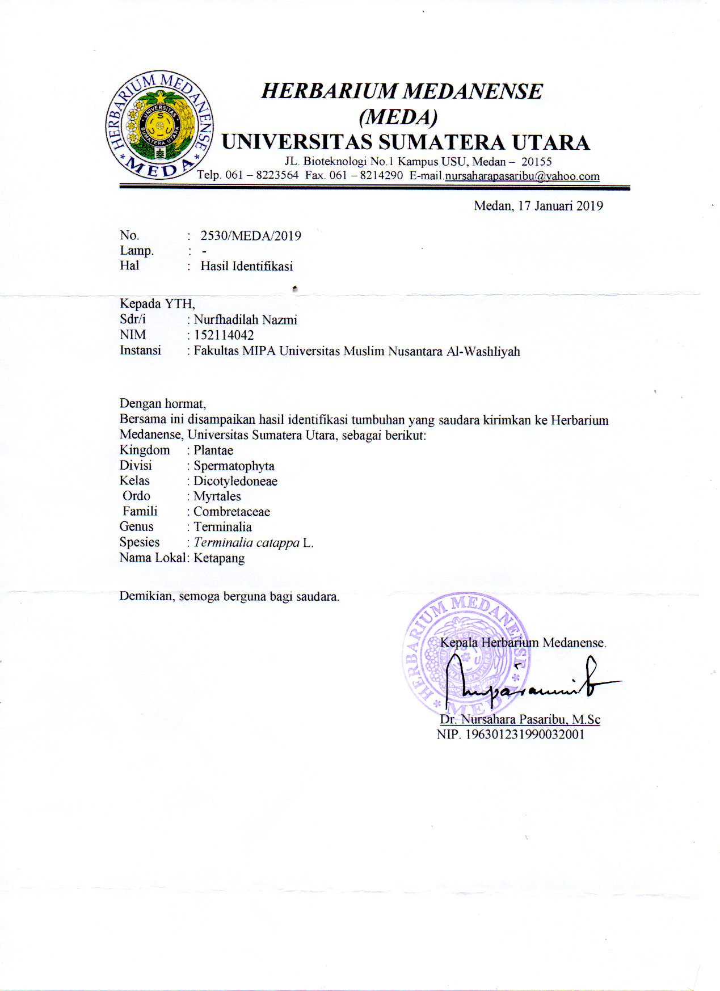

**Lampiran 2.**Makroskopik Daun Ketapang

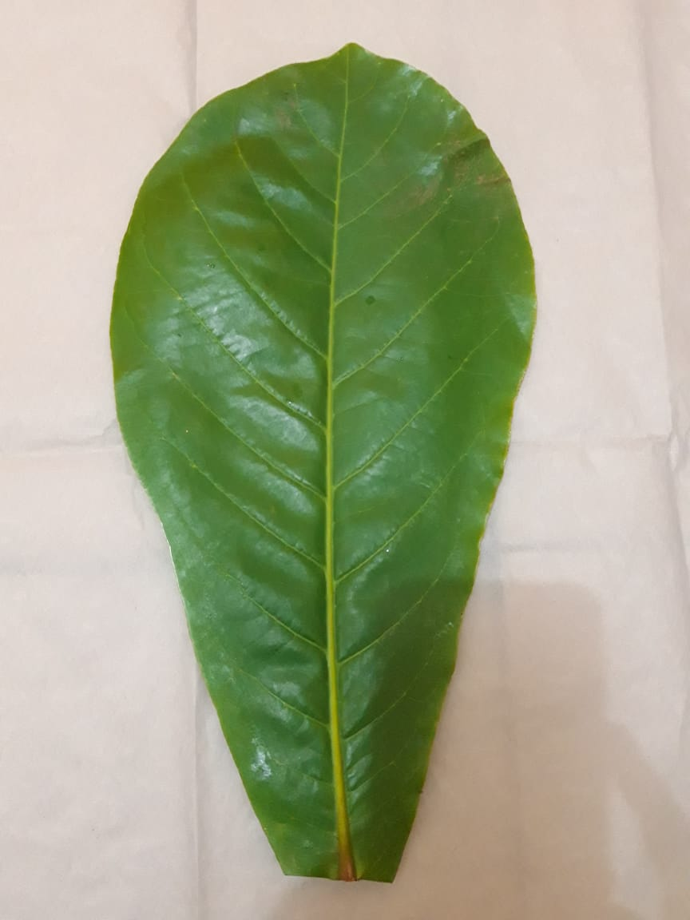 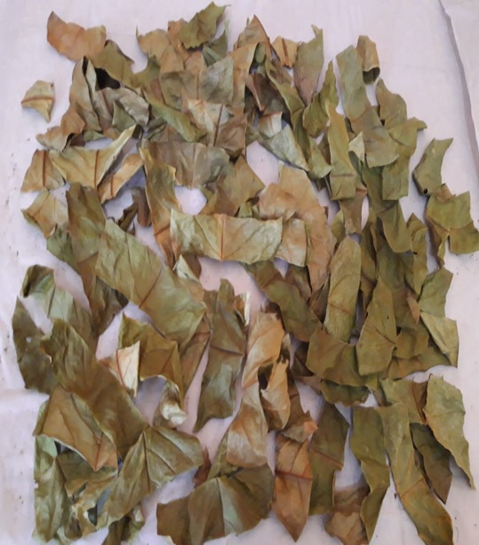

Daun Ketapang Simplisia Daun Ketapang

(*Terminalia catappa* L.) Segar (*Terminalia catappa* L.)

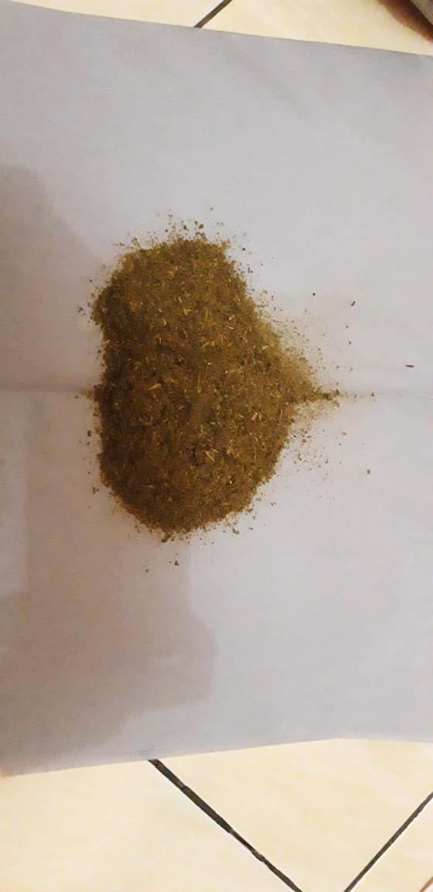

Serbuk Simplisia Daun Ketapang

(*Terminalia catappa* L.)

**Lampiran 3.** Mikroskopik Daun Ketapang

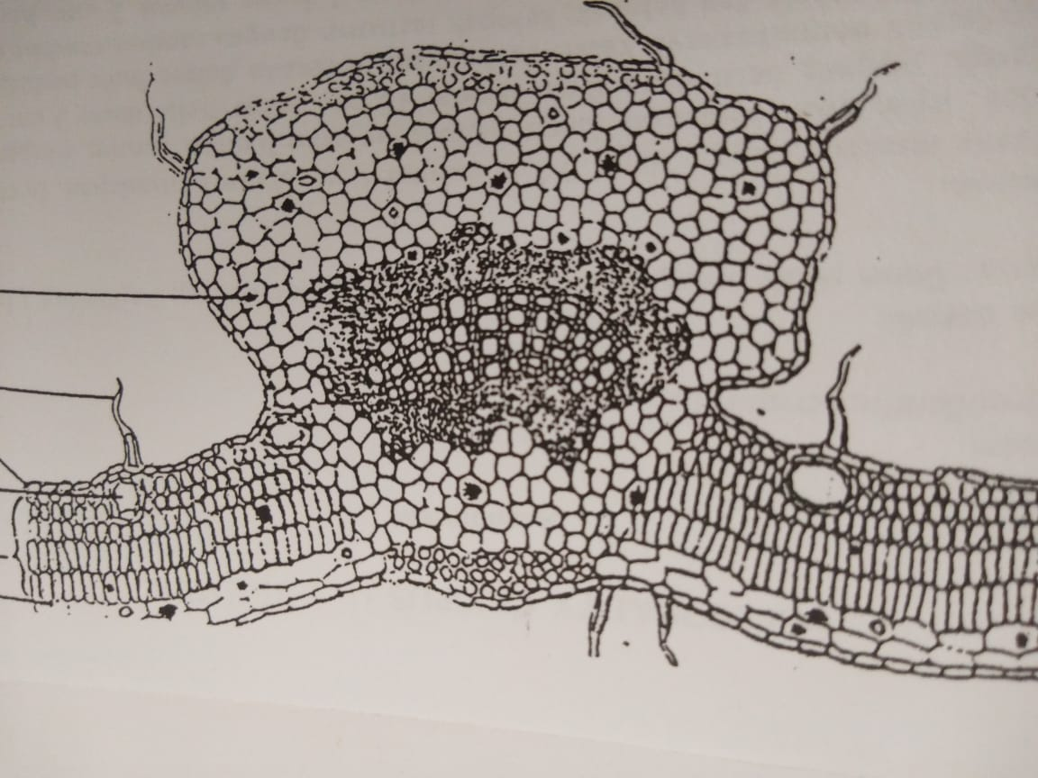

2

7

6

1

4

3

5

Penampang Melintang Menurut

Materia Medika Indonesia (MMI)

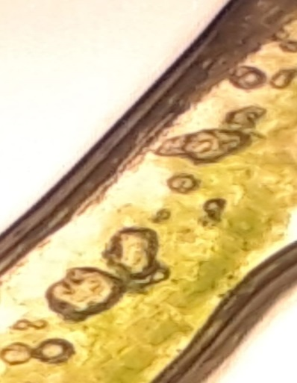 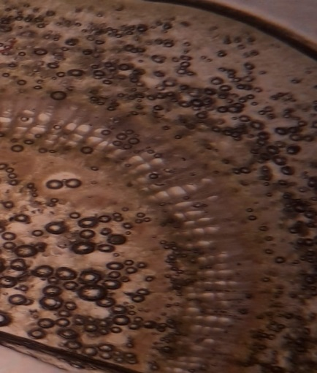

7

6

5

4

3

2

1

Penampang Melintang Daun Ketapang

(*Terminalia catappa* L.)

Keterangan :

1. Stomata
2. Jaringan Palisade
3. Epidermis Atas
4. Epidermis Bawah
5. Floem
6. Xilem
7. Kolenkim

**Lampiran 4.**Bagan Alir Pembuatan Simplisia Daun Ketapang

Daun Ketapang

Disortasi basah

Dicuci dengan air mengalir

Ditiriskan

5110 g Daun Ketapang

Makroskopik

Mikroskopik

Dikeringkan dalam lemari pengering pada suhu 40°C

Disortasi kering

Ditimbang berat kering

1300 g Simplisia

Dihaluskan

Dimasukkan dalam wadah tertutup rapat

1120 g Serbuk Simplisia Daun Ketapang

Ekstraksi dengan pelarut etanol 96 %

Karakterisasi Simplisia:

1. PK. air
2. PK. sari larut dalam air
3. PK. sari larut dalam etanol
4. PK. abu total
5. PK. abu yang tidak larut dalam asam

Skrining Fitokimia:

1. Alkaloida
2. Flavonoida
3. Tannin
4. Saponin
5. Antrakuinon
6. Steroida / Triterpenoida

**Lampiran 5.** Pemeriksaan Karakterisasi Simplisia

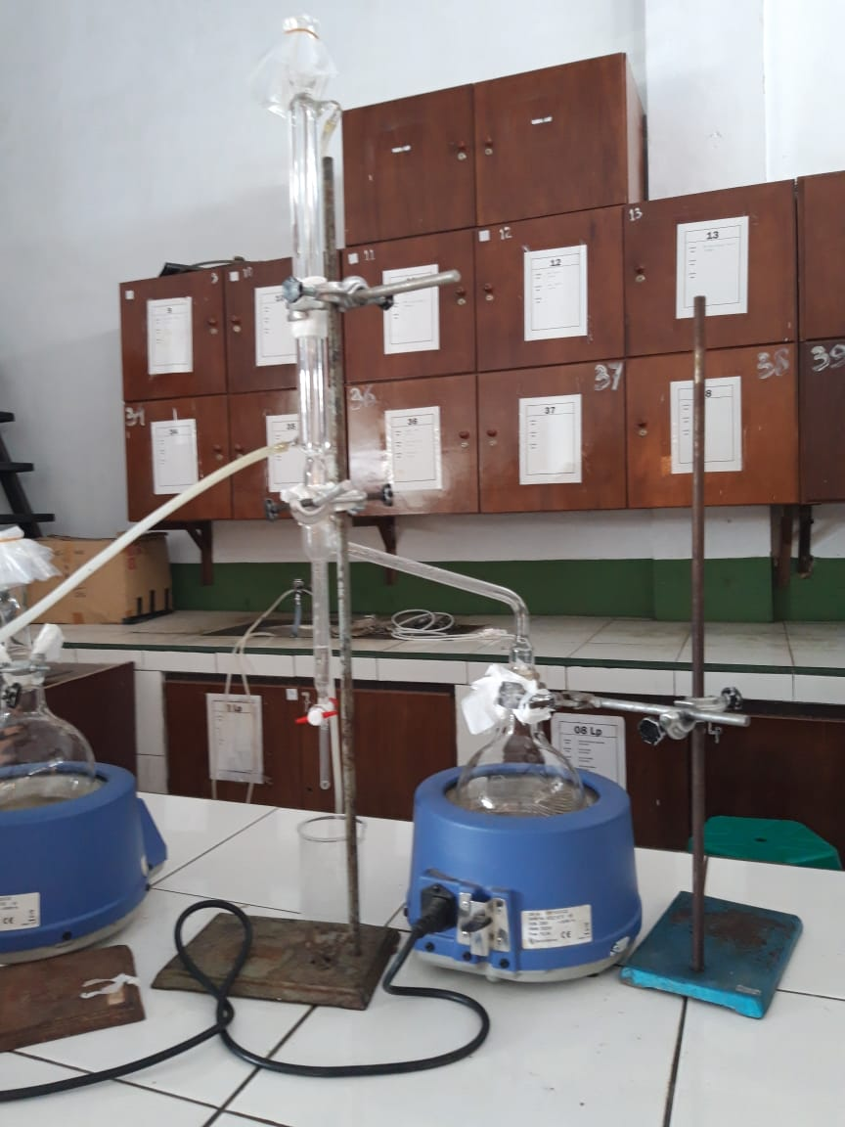 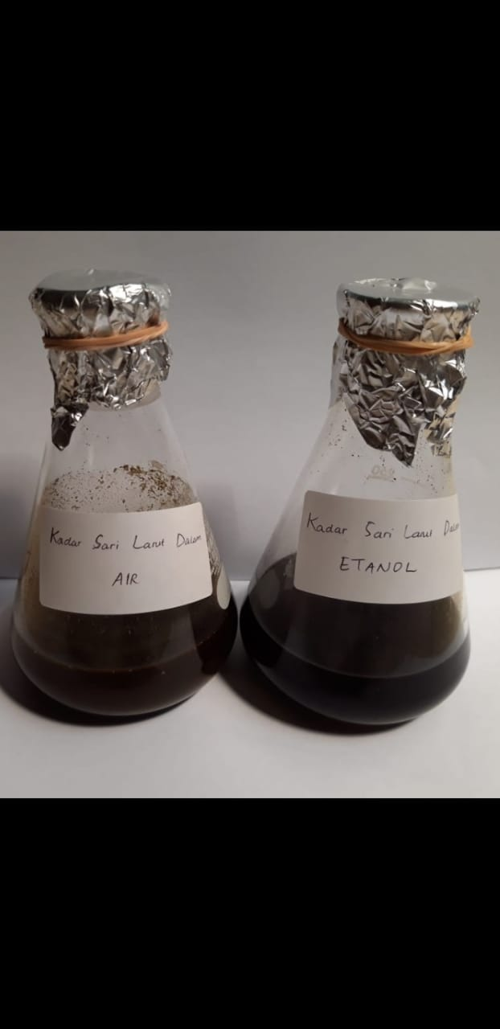

Penetapan Kadar Air Penetapan Kadar Sari Larut Dalam

(Metode Azeotrop) Air dan Etanol

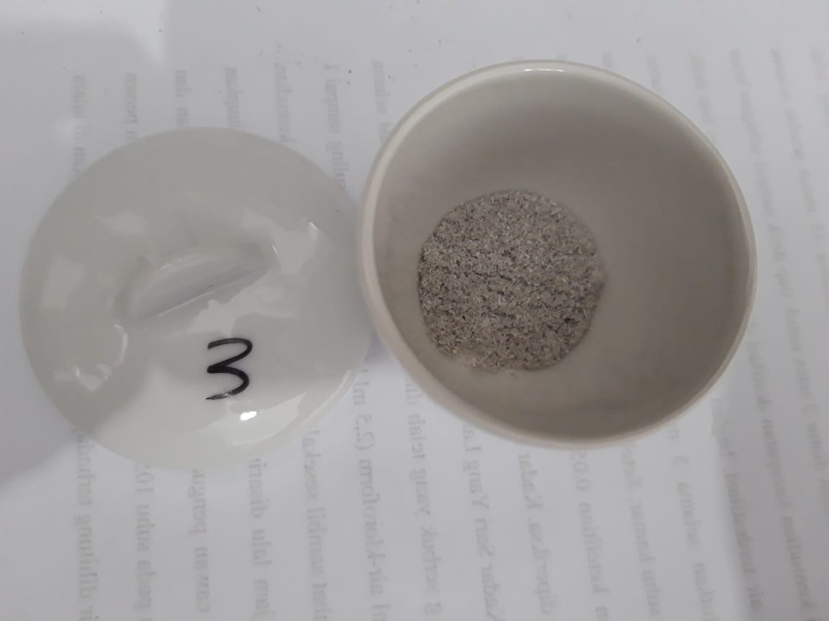 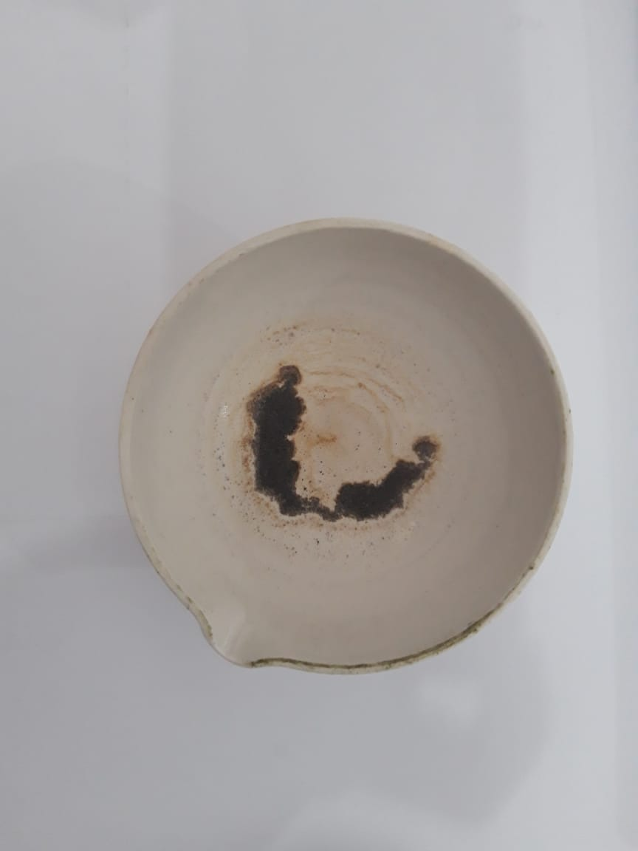

Penetapan Kadar Abu Total Penetapan Kadar Abu yang

Larut Dalam Asam

**Lampiran6.** Perhitungan Kadar Karakterisasi Tumbuhan

1. **Penetapan Kadar Air**

Kadar Air = $\frac{V2-V1}{Berat Sampel (g)}$ x 100 %

Sampel I

* Berat Sampel = 5,02 g
* V1 = 1,2 ml
* V2 = 1,5 ml
* Kadar Air = $\frac{1,5 ml-1,2 ml}{5,02 g}$ x 100 % = 5,98 %

Sampel II

* Berat Sampel = 5,00 g
* V1 = 1,3 ml
* V2 = 1,6 ml
* Kadar Air = $\frac{1,6 ml-1,3 ml}{5,00 g}$ x 100 % = 6 %

Sampel III

* Berat Sampel = 5,0006 g
* V1 = 1,5 ml
* V2 = 1,7 ml
* Kadar Air = $\frac{1,7 ml-1,5 ml}{5,06 g}$ x 100 % = 3,95 %

Kadar Air Rata-rata = $\frac{5,98 \%+6 \%+4 \% }{3}$ = 5,31 %

**Lampiran 6.** (Lanjutan)

1. **Penetapan Kadar Sari Larut Air**

Kadar Sari Larut Air = $\frac{\left[\left(Berat Cawan+isi\right)-Berat Cawan \right]x 5}{Berat Sampel (g)}$ x 100 %

Sampel I

* Berat sampel = 5,03 g
* Berat cawan + isi = 65,68 g
* Berat cawan = 65,48 g
* Kadar Sari Larut Air = $\frac{65,68 g-65,48 g}{5,03 g}$ x 100 % = 19,88 %

Sampel II

* Berat sampel = 5,00 g
* Berat cawan + isi = 64,15 g
* Berat cawan = 63,88 g
* Kadar Sari Larut Air = $\frac{64,15 g-63,88 g}{5,00 g}$ x 100 % = 27 %

Sampel III

* Berat sampel = 5,05 g
* Berat cawan + isi = 65,71 g
* Berat cawan = 65,48 g
* Kadar Sari Larut Air = $\frac{65,71 g-65,48 g}{5,05 g}$ x 100 % = 22,77 %

Kadar Sari Larut Air Rata-rata = $\frac{19,88 \%+27 \%+22,77 \% }{3}$ = 23,22 %

**Lampiran 6.** (Lanjutan)

1. **Penetapan Kadar Sari Larut Etanol**

Kadar Sari Larut Etanol= $\frac{\left[\left(Berat Cawan+isi\right)-Berat Cawan \right]x 5}{Berat Sampel (g)}$ x 100 %

Sampel I

* Berat sampel = 5,00 g
* Berat cawan + isi = 64,05 g
* Berat cawan = 63,88 g
* Kadar Sari Larut Etanol = $\frac{64,05 g-63,88 g}{5,00 g}$ x 100 % = 17 %

Sampel II

* Berat sampel = 5,05 g
* Berat cawan + isi = 38,71 g
* Berat cawan = 38,58 g
* Kadar Sari Larut Etanol = $\frac{38,71 g-38,58 g}{5,05 g}$ x 100 % = 12,87 %

Sampel III

* Berat sampel = 5,12 g
* Berat cawan + isi = 67,69 g
* Berat cawan = 67,48 g
* Kadar Sari Larut Etanol = $\frac{67,69 g-67,48 g}{5,12 g}$ x 100 % = 20,51 %

Kadar Sari Larut Etanol Rata-rata = $\frac{17 \%+12,87 \%+20,51 \% }{3}$ = 16,79 %

**Lampiran 6.** (Lanjutan)

1. **Penetapan Kadar Abu Total**

Kadar Abu Total = $\frac{Berat Abu}{Berat Sampel (g)}$ x100 %

Sampel I

* Berat sampel = 2,00 g
* Berat abu = 0,17 g
* Kadar Abu Total = $\frac{0,17 g}{2,00 g}$ x 100 % = 8,5 %

Sampel II

* Berat sampel = 2,00 g
* Berat abu = 0,15 g
* Kadar Abu Total = $\frac{0,15 g}{ 2,00 g}$ x 100 % = 7,5 %

Sampel III

* Berat sampel = 2,00 g
* Berat abu = 0,12 g
* Kadar Abu Total = $\frac{0,12 g}{2,00 g}$ x 100 % = 6 %

Kadar Abu Total Rata-rata = $\frac{8,5 \%+7,5 \%+6 \% }{3}$ = 7,33 %

**Lampiran 6.** (Lanjutan)

1. **Penetapan Kadar Abu Tidak Larut Asam**

Kadar Abu Total= $\frac{Berat Abu}{Berat Sampel (g)}$ x 100 %

Sampel I

* Berat sampel = 2,00 g
* Berat abu = 0,04 g
* Kadar Abu Total = $\frac{0,04 g}{2,00 g}$ x 100 % = 2 %

Sampel II

* Berat sampel = 2,00 g
* Berat abu = 0,03 g
* Kadar Abu Total = $\frac{0,03 g}{2,00 g}$ x 100 % = 1,5 %

Sampel III

* Berat sampel = 2,00 g
* Berat abu = 0,03 g
* Kadar Abu Total = $\frac{0,03 g}{ 2,00 g}$ x 100 % = 1,5 %

Kadar Abu Total Rata-rata = $\frac{2 \%+1,5 \%+1,5 \% }{3}$ = 1,67 %

**Lampiran 7.**Bagan Alir Pembuatan Ekstrak Etanol Daun Ketapang

500 g serbuk simplisia daun ketapang

Dimasukkan dalam wadah

Dimasukkan 3750 ml etanol 96 %

Didiamkan selama 5 hari sesekali diaduk

Diserkai dan disaring, dimasukkan dalam wadah tertutup rapat

Ampas

Maserat 1

Ditambah 1250 ml etanol 96 %

Diserkai dan disaring

Dimasukkan dalam wadah tertutup rapat

Ampas

Maserat 2

Dienaptuangkan selama 2 hari

Diuapkan dengan alat *rotary evaporator*

dengan suhu 45-50°C

Ekstrak etanol 108 g

**Lampiran 8.** Bagan Alir Pembuatan Fraksi Etil Asetat dan Fraksi N-Heksan Daun Ketapang

Ektrak Etanol

Dilarutkan dengan sedikit etanol 96 %

Dimasukkan dalam corong pisah

Dimasukkan 100 ml n-heksan

Digojlok secara perlahan, dipisahkan lapisan n-heksan (atas) dan sisa (bawah)

Sisa

Larutan N-Heksan

Dimasukkan 100 ml Etil Asetat

Diuapkan dengan rotary evaporator dengan suhu 45-50°C

Digojlok secara perlahan dan dipisahkan

Larutan Etil Asetat (Lapisan Atas)

Sisa (Lapisan bawah)

Fraksi N-Heksan

Diuapkan dengan rotary evaporator dengan suhu 45-50°C

Fraksi Etil Asetat

**Lampiran 9.** Fraksinasi

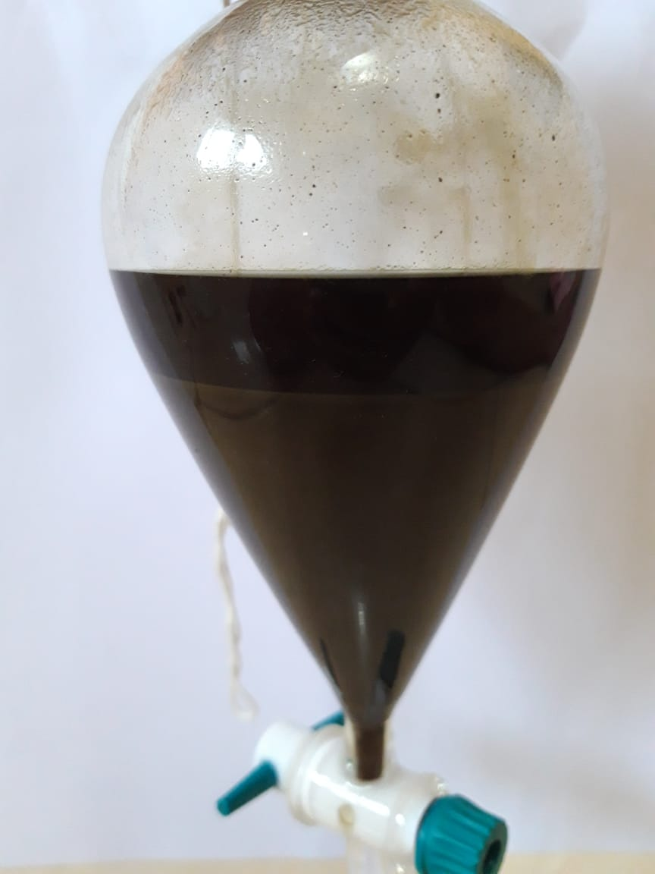

Fraksi N-Heksan

Sisa

Fraksinasi N-Heksan

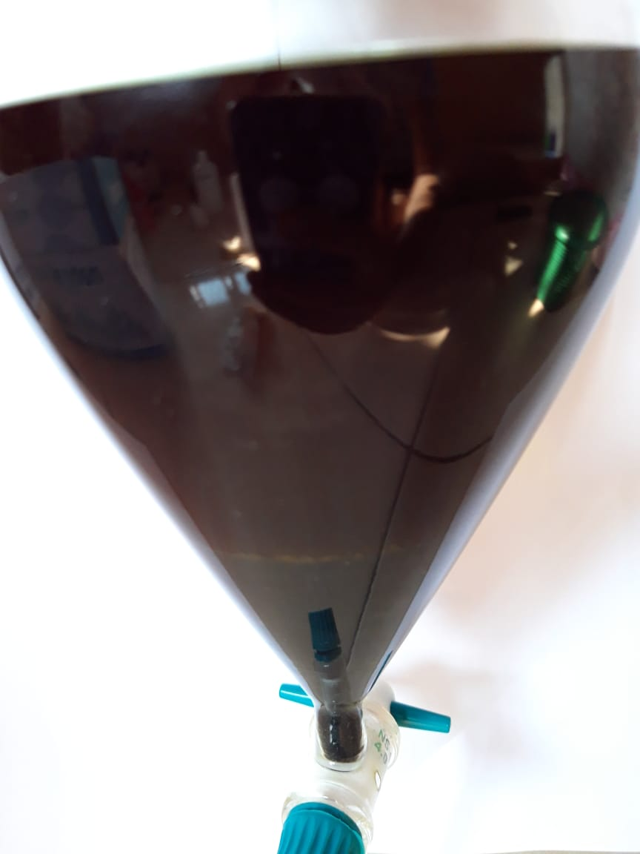

Fraksi Etil Asetat

Sisa

Fraksinasi Etil Asetat

**Lampiran 10.** Maserasi, Ekstrak Etanol, Fraksi Etil Asetat dan Fraksi N-Heksan Daun Ketapang

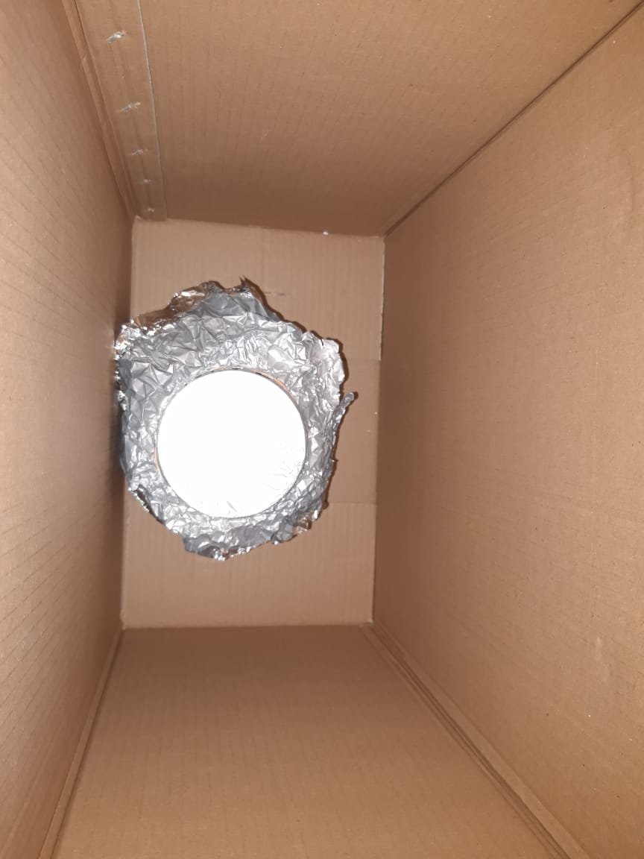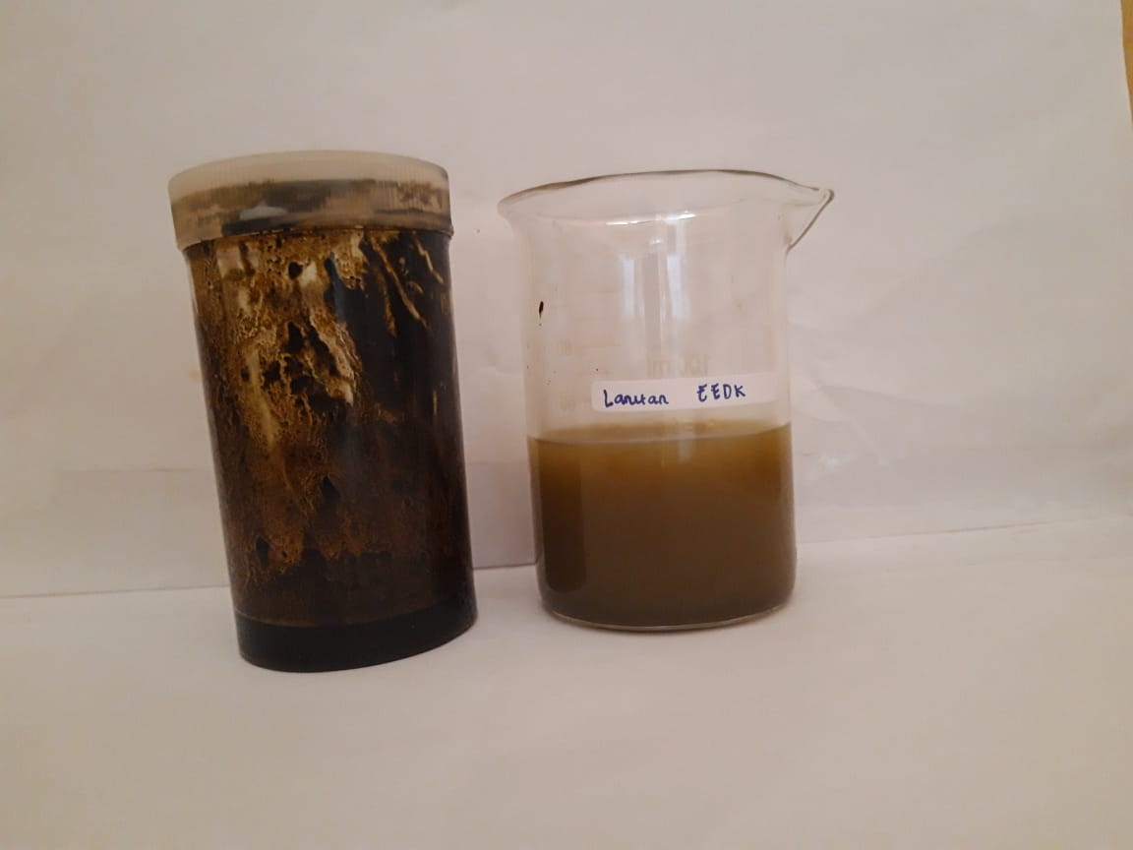

Maserasi Daun Ketapang Ekstrak Etanol Daun Ketapang

(*Terminalia catappa* L.) (*Terminalia catappa* L.)

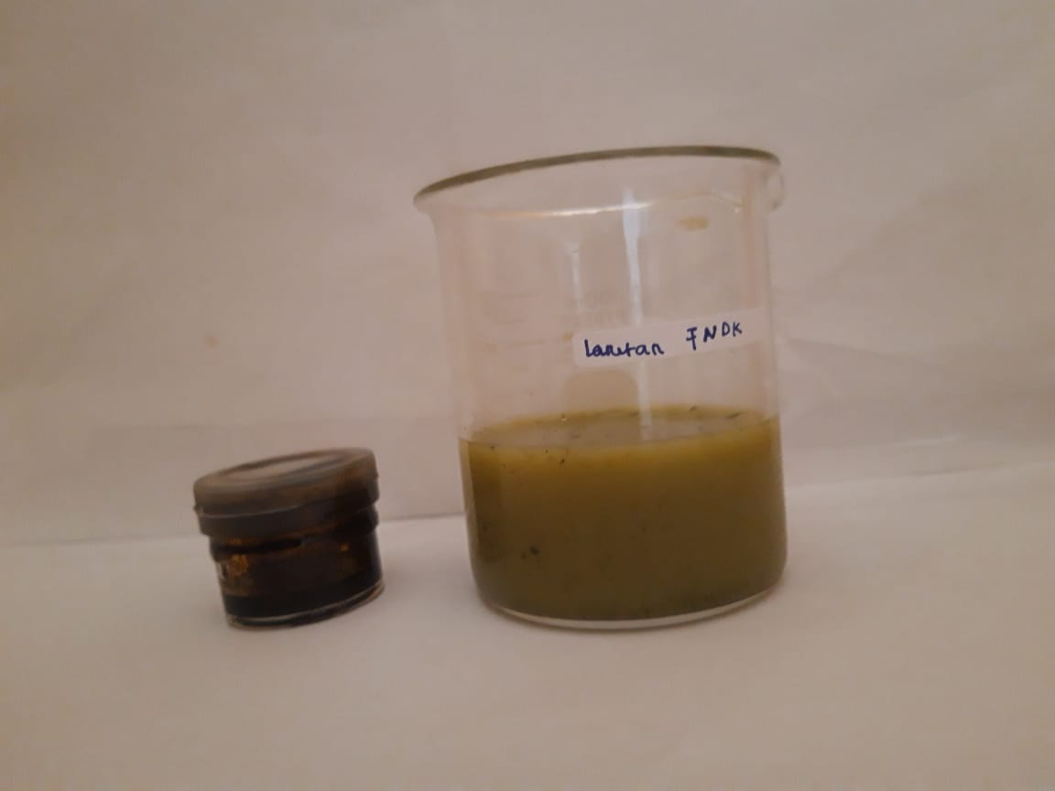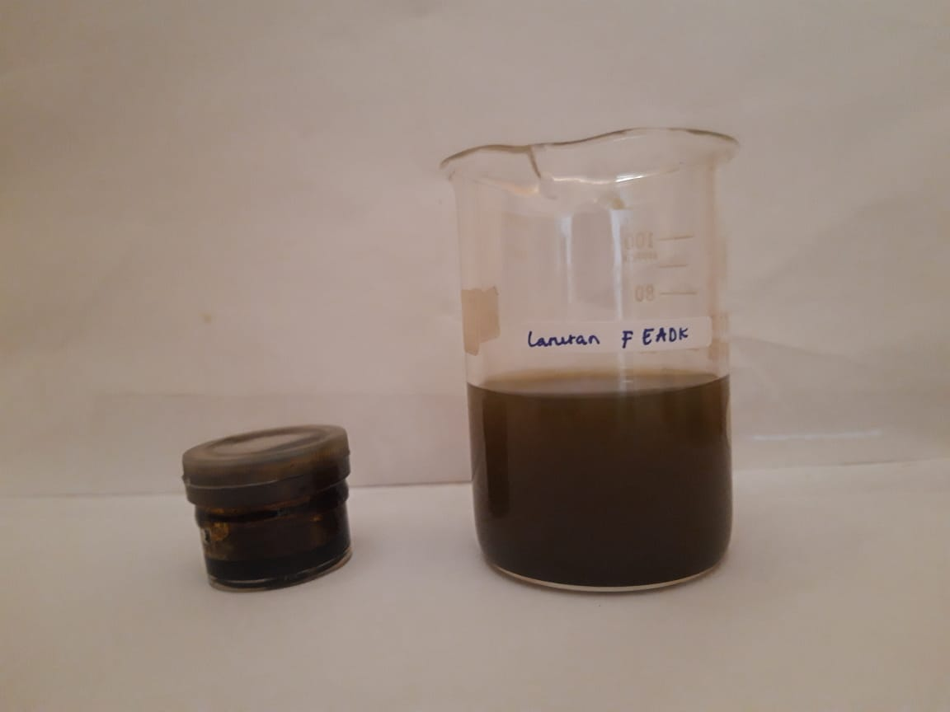

Fraksi N-Heksan Daun Ketapang Fraksi Etil Asetat Daun Ketapang

(*Terminalia catappa* L.) (*Terminalia catappa* L.)

**Lampiran 11.** Hasil Etik Penelitian

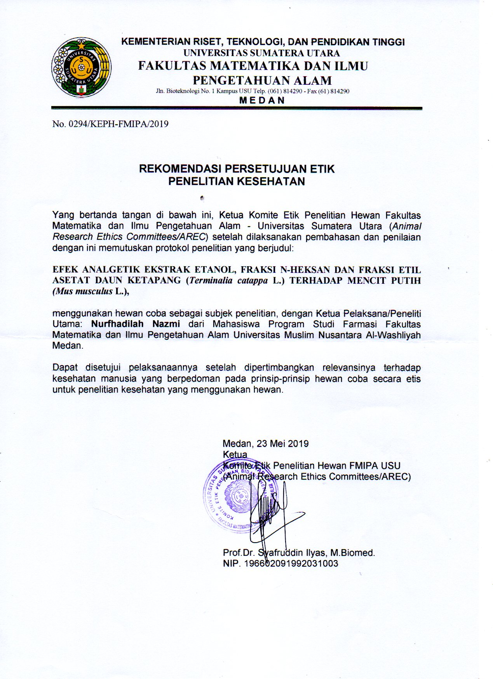

**Lampiran 12.** Hewan Penelitian

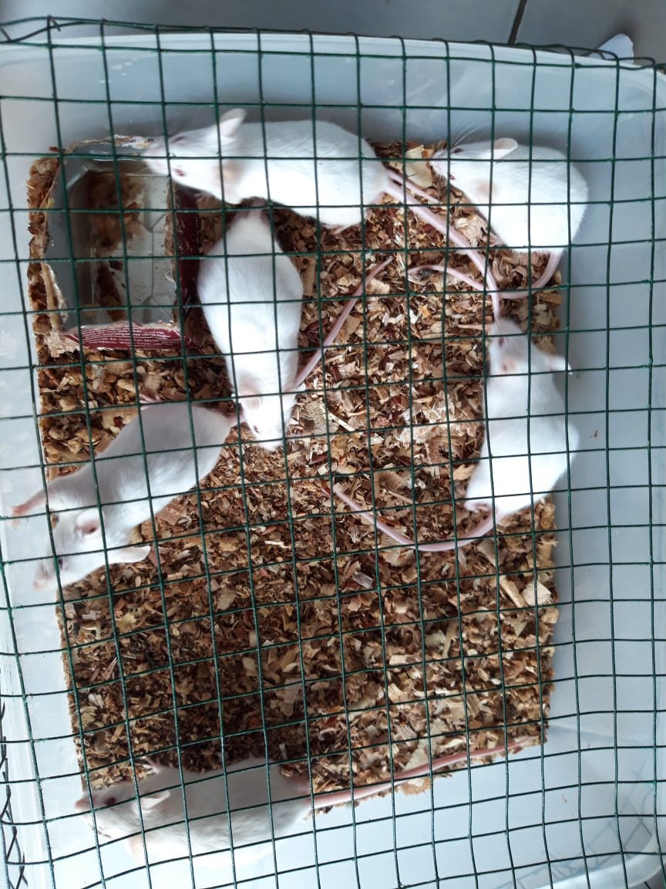

Mencit Putih (*Mus musculus* L.)

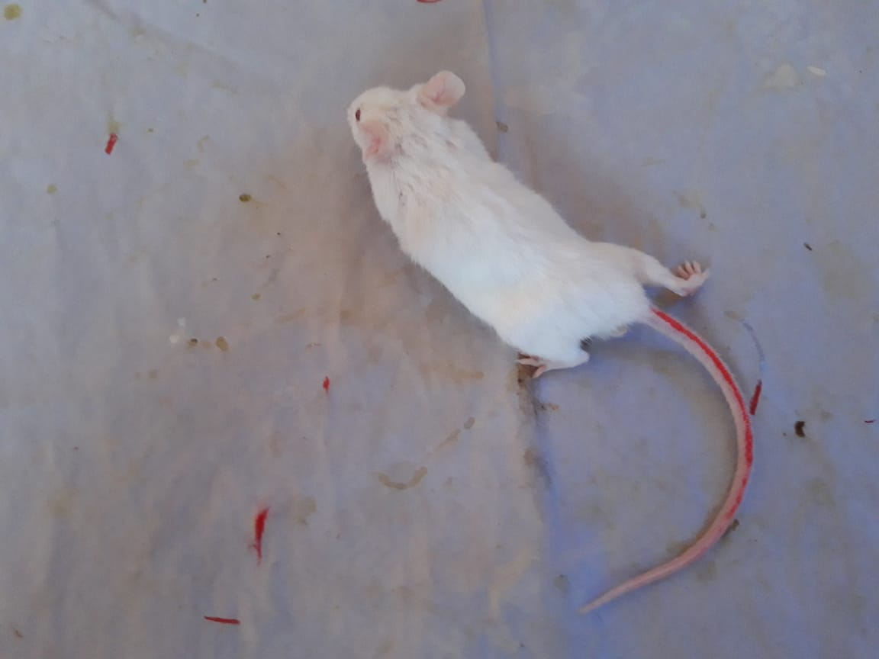

Geliat Mencit Putih *Mus musculus* L.)

**Lampiran 13.** Bagan Alir Uji Analgetik

Mencit

Diaklimatisasi selama 2 minggu

Dipuasakan 18-24 jam

Ditimbang berat badan

Dikelompokkan secara acak (5 ekor/kelompok)

Diinduksi asam asetat 0,5 % secara i.p

Mencit Nyeri

Setelah 10 menit diberi perlakuan secara per oral:

Kel I CMC 0,5 %

Kel II Asam Mefenamat 1 %

Kel III EEDK 100 mg/kgBB

Kel IV EEDK 200 mg/kgBB

Kel V EEDK 300 mg/kgBB

Kel VI EEDK 400 mg/kgBB

Kel VII FNHDK 100 mg/kgBB

Kel VIII FNHDK 200 mg/kgBB

Kel IX FNHDK 300 mg/kgBB

Kel X FNHDK 400 mg/kgBB

Kel XI FEADK 100 mg/kgBB

Kel XII FEADK 200 mg/kgBB

Kel XIII FEADK 300 mg/kgBB

Kel XIV FEADK 400 mg/kgBB

Diamati geliat dan dihitung jumlah geliat selang 5 menit selama 1 jam

Jumlah Geliat Mencit

**Lampiran 14.** Tabel Konversi Dosis (g), Volume Maksimum Lambung Hewan (ml) dan Contoh Perhitungan Dosis Asam Mefenamat

|  |  |  |  |  |  |  |  |  |
| --- | --- | --- | --- | --- | --- | --- | --- | --- |
| Konversi | Mencit 20 g | Tikus 200 g | Marmut 400 g | Kelinci 1,5 kg | Kucing 1,5 kg | Kera 4 kg | Anjing 12 kg | Manusia 70 kg |
| Mencit 20 g | 1,0 | 7,0 | 12,23 | 27,80 | 29,70 | 64,10 | 124,20 | 387,9 |
| Tikus 200 g | 0,14 | 1,0 | 1,74 | 3,90 | 4,20 | 9,20 | 17,80 | 56,0 |
| Marmut 400 g | 0,08 | 0,57 | 1,0 | 2,25 | 2,40 | 5,20 | 10,20 | 31,50 |
| Kelinci 1,5 kg | 0,04 | 0,25 | 0,44 | 1,0 | 1,08 | 2,40 | 4,50 | 14,20 |
| Kucing 1,5 kg | 0,03 | 0,23 | 0,41 | 0,92 | 1,0 | 2,20 | 4,10 | 13,0 |
| Kera 4 kg | 0,016 | 0,11 | 0,19 | 0,42 | 0,43 | 0,1 | 1,9 | 6,1 |
| Anjing 12 kg | 0,008 | 0,06 | 0,10 | 0,22 | 1,24 | 0,52 | 1,0 | 3,10 |
| Manusia 70 kg | 0,0026 | 0,018 | 0,031 | 0,07 | 0,076 | 0,16 | 0,32 | 1,0 |

Tabel konversi dosis hewan percobaan dengan manusia

|  |  |  |  |  |  |
| --- | --- | --- | --- | --- | --- |
| Jenis Hewan Uji | Volume maksimum (ml) sesuai jalur pemberian | | | | |
| i.v | i.m | i.p | s.c | p.o |
| Mencit (20-30 g) | 0,5 | 0,05 | 1,0 | 0,5-1,0 | 1,0 |
| Tikus (200 g) | 1,0 | 0,1 | 2-5 | 2-5 | 5,0 |
| Hamster (50 g) | - | 0,1 | 1-2 | 2,5 | 2,5 |
| Marmut (250 g) | - | 0,25 | 2-5 | 5,0 | 10,0 |
| Kelinci (3 kg) | 5-10 | 0,5 | 10-20 | 5-10 | 20,0 |
| Kucing (3 kg) | 5-10 | 1,0 | 10-20 | 5-10 | 50,0 |
| Anjing (5 kg) | 10-20 | 5,0 | 20-50 | 10,0 | 100,0 |

Tabel volume maksimum larutan yang dapat diberikan pada hewan

**Lampiran 14.** (Lanjutan)

Perhitungan konversi dosis Asam Mefenamat

Dosis Asam Mefenamat adalah 2-3 kali 250-500 mg sehari (Gunawan, 2007).

Dosis terapi minimal : 250 mg

Dosis terapi maksimal : 500 mg

Konversi dosis manusia (70 kg) ke mencit (20 g) = 0,0026

Dosis asam mefenamat pada mencit = dosis terapi manusia x 0,0026

= 500 mg x 0,0026

= 1,3 mg

1. Perhitungan dosis suspensi asam mefenamat 1 %

Asam Mefenamat 1 % = $\frac{1 g}{100 ml}$ = 10 mg/ml

Mencit (20 g) = $\frac{1,3 mg}{0,02 kg}$ = 65 mg/kgBB

Dosis = $\frac{20 g}{1000 g}$ x 65 mg/kgBB = 1,3 mg

Volume pemberian = $\frac{1,3 mg}{10 mg/ml}$ = 0,13 ml

1. Perhitungan dosis suspensi CMC 0,5 %

Suspensi CMC dibuat dengan cara melarutkan 500 mg CMC dalam 100 ml aquadest.

Konsentrasi CMC = 500 mg/ 100 ml

= 5 mg/ml

Volume suspensi yang diberikan = 0,5 ml

1. Perhitungan dosis suspensi ekstrak etanol, fraksi n-heksan dan fraksi etil asetat daun ketapang

Dosis untuk mencit 20 g

* Dosis 100 mg/kgBB = $\frac{20 g}{1000 g}$ x 100 mg/kgBB = 2 mg

Volume yang diberikan = $\frac{2 mg}{10 mg/ml}$ = 0,2 ml

* Dosis 200 mg/kgBB = $\frac{20 g}{1000 g}$ x 200 mg/kgBB = 4 mg

Volume yang diberikan = $\frac{4 mg}{10 mg/ml}$ = 0,4 ml

**Lampiran 14.** (Lanjutan)

* Dosis 300 mg/kgBB = $\frac{20 g}{1000 g}$ x 300 mg/kgBB = 6 mg

Volume yang diberikan = $\frac{6 mg}{10 mg/ml}$ = 0,6 ml

* Dosis 400 mg/kgBB = $\frac{20 g}{1000 g}$ x 400 mg/kgBB = 8 mg

Volume yang diberikan = $\frac{8 mg}{10 mg/ml}$ = 0,8 ml

Suspensi dibuat dengan cara melarutkan 1 g bahan uji dengan CMC 0,5 % dan dicukupkan hingga 100 ml dalam labu tentukur 100 ml.

**Lampiran 15.** Jumlah Geliat Mencit Selang Waktu 5 Menit Selama 1 Jam

|  |  |  |  |  |  |  |  |  |  |  |  |  |  |  |
| --- | --- | --- | --- | --- | --- | --- | --- | --- | --- | --- | --- | --- | --- | --- |
| Perlakuan | Mencit ke- | Waktu (Menit) ke- | | | | | | | | | | | | Jumlah Geliat |
| 5 | 10 | 15 | 20 | 25 | 30 | 35 | 40 | 45 | 50 | 55 | 60 |
| Suspensi CMC 0,5 % | I | 26 | 23 | 20 | 19 | 17 | 14 | 10 | 10 | 8 | 7 | 7 | 4 | 165 |
| II | 21 | 25 | 23 | 19 | 16 | 12 | 10 | 8 | 8 | 5 | 4 | 2 | 153 |
| III | 24 | 21 | 20 | 17 | 15 | 15 | 13 | 11 | 10 | 8 | 8 | 7 | 169 |
| IV | 25 | 24 | 21 | 18 | 16 | 14 | 12 | 12 | 10 | 9 | 7 | 5 | 173 |
| V | 21 | 24 | 22 | 20 | 17 | 15 | 11 | 10 | 9 | 7 | 5 | 4 | 165 |
| Suspensi Asam Mefenamat 1% | I | 10 | 13 | 15 | 12 | 7 | 6 | 3 | 3 | 2 | 2 | 1 | 1 | 75 |
| II | 11 | 12 | 11 | 10 | 8 | 6 | 6 | 5 | 3 | 3 | 2 | 1 | 78 |
| III | 15 | 17 | 13 | 12 | 10 | 8 | 7 | 2 | 0 | 1 | 1 | 0 | 86 |
| IV | 6 | 12 | 12 | 9 | 7 | 5 | 5 | 4 | 4 | 3 | 3 | 2 | 72 |
| V | 10 | 14 | 12 | 10 | 8 | 8 | 7 | 5 | 3 | 1 | 2 | 2 | 82 |
| EEDK 100 mg/kgBB | I | 12 | 18 | 15 | 14 | 12 | 10 | 8 | 6 | 6 | 4 | 2 | 2 | 109 |
| II | 18 | 16 | 13 | 11 | 10 | 9 | 6 | 5 | 4 | 3 | 2 | 3 | 100 |
| III | 13 | 16 | 13 | 13 | 11 | 9 | 7 | 6 | 4 | 2 | 1 | 2 | 97 |
| IV | 14 | 17 | 14 | 13 | 13 | 10 | 9 | 7 | 5 | 4 | 3 | 3 | 112 |
| V | 14 | 17 | 15 | 14 | 12 | 8 | 7 | 7 | 6 | 3 | 1 | 1 | 105 |
| EEDK 200 mg/kgBB | I | 13 | 15 | 12 | 10 | 9 | 9 | 8 | 6 | 6 | 5 | 4 | 2 | 99 |
| II | 12 | 14 | 13 | 10 | 7 | 5 | 6 | 3 | 3 | 2 | 3 | 2 | 80 |
| III | 10 | 13 | 11 | 11 | 10 | 8 | 5 | 5 | 4 | 4 | 2 | 3 | 86 |
| IV | 14 | 15 | 12 | 11 | 8 | 7 | 6 | 5 | 5 | 4 | 3 | 3 | 93 |
| V | 12 | 14 | 14 | 13 | 9 | 6 | 4 | 3 | 2 | 2 | 1 | 1 | 81 |
| EEDK 300 mg/kgBB | I | 10 | 14 | 10 | 9 | 8 | 7 | 4 | 4 | 3 | 3 | 2 | 3 | 77 |
| II | 13 | 15 | 10 | 9 | 6 | 6 | 5 | 4 | 2 | 2 | 1 | 2 | 75 |
| III | 12 | 13 | 9 | 8 | 7 | 6 | 6 | 9 | 6 | 4 | 3 | 1 | 84 |
| IV | 11 | 17 | 11 | 8 | 8 | 7 | 6 | 5 | 3 | 3 | 2 | 2 | 83 |
| V | 11 | 15 | 9 | 6 | 6 | 8 | 3 | 3 | 4 | 2 | 1 | 1 | 69 |
| EEDK 400 mg/kgBB | I | 5 | 6 | 5 | 5 | 4 | 3 | 3 | 0 | 2 | 0 | 3 | 0 | 36 |
| II | 4 | 7 | 2 | 6 | 4 | 4 | 2 | 3 | 2 | 2 | 1 | 1 | 38 |
| III | 3 | 6 | 6 | 5 | 5 | 4 | 4 | 2 | 0 | 2 | 1 | 2 | 40 |
| IV | 7 | 5 | 4 | 4 | 3 | 3 | 2 | 2 | 3 | 1 | 0 | 0 | 34 |
| V | 5 | 7 | 6 | 5 | 5 | 2 | 0 | 3 | 3 | 3 | 2 | 1 | 42 |

**Lampiran 15.** (Lanjutan)

|  |  |  |  |  |  |  |  |  |  |  |  |  |  |  |
| --- | --- | --- | --- | --- | --- | --- | --- | --- | --- | --- | --- | --- | --- | --- |
| FNHDK 100 mg/kgBB | I | 15 | 18 | 15 | 14 | 11 | 9 | 9 | 8 | 5 | 4 | 2 | 1 | 111 |
| II | 17 | 15 | 13 | 11 | 9 | 8 | 7 | 6 | 6 | 3 | 2 | 1 | 98 |
| III | 20 | 18 | 16 | 14 | 13 | 10 | 8 | 8 | 6 | 2 | 1 | 2 | 118 |
| IV | 20 | 15 | 14 | 10 | 10 | 8 | 8 | 6 | 5 | 5 | 4 | 3 | 108 |
| V | 14 | 21 | 14 | 13 | 11 | 9 | 9 | 5 | 4 | 3 | 3 | 4 | 110 |
| FNHDK 200 mg/kgBB | I | 10 | 16 | 12 | 10 | 6 | 6 | 3 | 3 | 2 | 2 | 3 | 1 | 76 |
| II | 8 | 14 | 11 | 10 | 8 | 8 | 6 | 5 | 3 | 3 | 2 | 0 | 78 |
| III | 7 | 15 | 12 | 9 | 6 | 5 | 5 | 4 | 4 | 2 | 0 | 2 | 71 |
| IV | 11 | 15 | 10 | 9 | 9 | 8 | 7 | 5 | 4 | 3 | 2 | 1 | 84 |
| V | 9 | 16 | 11 | 11 | 8 | 7 | 6 | 6 | 5 | 4 | 4 | 2 | 89 |
| FNHDK 300 mg/kgBB | I | 4 | 9 | 9 | 7 | 8 | 6 | 5 | 5 | 2 | 2 | 1 | 1 | 59 |
| II | 7 | 12 | 10 | 10 | 8 | 8 | 6 | 4 | 3 | 3 | 1 | 0 | 72 |
| III | 10 | 11 | 10 | 9 | 7 | 7 | 5 | 5 | 3 | 3 | 0 | 2 | 72 |
| IV | 7 | 14 | 11 | 9 | 10 | 7 | 7 | 3 | 2 | 0 | 2 | 1 | 73 |
| V | 5 | 12 | 11 | 8 | 7 | 6 | 6 | 4 | 4 | 2 | 2 | 0 | 67 |
| FNHDK 400 mg/kgBB | I | 5 | 9 | 9 | 6 | 3 | 2 | 2 | 1 | 0 | 1 | 2 | 0 | 40 |
| II | 5 | 8 | 6 | 6 | 4 | 4 | 1 | 2 | 3 | 0 | 1 | 1 | 41 |
| III | 9 | 10 | 9 | 7 | 5 | 3 | 3 | 2 | 0 | 1 | 0 | 2 | 51 |
| IV | 6 | 9 | 7 | 5 | 5 | 4 | 4 | 3 | 3 | 2 | 2 | 0 | 50 |
| V | 6 | 8 | 7 | 5 | 4 | 3 | 2 | 1 | 2 | 0 | 0 | 1 | 39 |
| FEADK 100 mg/kgBB | I | 16 | 13 | 12 | 12 | 11 | 9 | 9 | 7 | 7 | 5 | 4 | 3 | 108 |
| II | 18 | 15 | 11 | 11 | 10 | 9 | 7 | 8 | 6 | 4 | 3 | 3 | 105 |
| III | 19 | 16 | 17 | 14 | 12 | 8 | 6 | 6 | 4 | 4 | 3 | 2 | 111 |
| IV | 17 | 18 | 17 | 12 | 10 | 8 | 6 | 5 | 5 | 3 | 2 | 2 | 105 |
| V | 14 | 15 | 12 | 11 | 11 | 10 | 7 | 6 | 5 | 3 | 2 | 1 | 97 |
| FEADK 200 mg/kgBB | I | 8 | 9 | 9 | 7 | 8 | 8 | 7 | 9 | 6 | 4 | 3 | 3 | 81 |
| II | 10 | 12 | 10 | 8 | 7 | 7 | 6 | 5 | 4 | 4 | 2 | 2 | 77 |
| III | 12 | 10 | 9 | 7 | 9 | 9 | 8 | 7 | 3 | 2 | 1 | 1 | 78 |
| IV | 12 | 10 | 8 | 8 | 7 | 5 | 6 | 5 | 4 | 1 | 2 | 1 | 69 |
| V | 11 | 13 | 8 | 6 | 6 | 5 | 4 | 3 | 2 | 1 | 1 | 2 | 62 |
| FEADK 300 mg/kgBB | I | 5 | 9 | 8 | 8 | 5 | 5 | 4 | 3 | 3 | 2 | 0 | 2 | 54 |
| II | 5 | 9 | 9 | 7 | 5 | 5 | 3 | 0 | 2 | 0 | 2 | 1 | 48 |
| III | 8 | 14 | 14 | 11 | 8 | 6 | 4 | 2 | 3 | 2 | 1 | 1 | 74 |
| IV | 9 | 15 | 11 | 7 | 7 | 4 | 5 | 2 | 4 | 3 | 0 | 2 | 69 |
| V | 7 | 11 | 10 | 6 | 6 | 4 | 5 | 3 | 2 | 4 | 1 | 0 | 59 |
| FEADK 400 mg/kgBB | I | 2 | 4 | 1 | 0 | 2 | 2 | 1 | 3 | 4 | 1 | 2 | 0 | 22 |
| II | 5 | 4 | 6 | 3 | 3 | 2 | 1 | 0 | 3 | 2 | 2 | 1 | 32 |
| III | 7 | 3 | 4 | 4 | 3 | 1 | 2 | 1 | 3 | 0 | 1 | 1 | 30 |
| IV | 7 | 6 | 5 | 5 | 4 | 3 | 0 | 2 | 2 | 1 | 1 | 0 | 36 |
| V | 9 | 7 | 4 | 4 | 2 | 0 | 3 | 2 | 2 | 0 | 0 | 2 | 35 |

**Lampiran 16.** Perhitungan Persentase Daya Analgetik

% Daya Analgetik = {100 - $\frac{Jumlah rata-rata geliat kelompok bahan uji}{Jumlah rata-rata kelompok kontrol negatif}$ x 100 %}

1. Kontrol Positif (Asam Mefenamat 1 %)

Menit ke-5 = 100 - $\frac{10,4}{23,4}$ x 100 % = 55,56 %

Menit ke-10 = 100 - $\frac{13,6}{23,4}$ x 100 % = 41,88 %

Menit ke-15 = 100 - $\frac{12,6}{21,2}$ x 100 % = 40,57 %

Menit ke-20 = 100 - $\frac{10,6}{18,6}$ x 100 % = 43,01 %

Menit ke-25 = 100 - $\frac{8}{16,2}$ x 100 % = 50,62 %

Menit ke-30 = 100 - $\frac{6,6}{14}$ x 100 % = 52,86 %

Menit ke-35 = 100 - $\frac{5,6}{11,2}$ x 100 % = 50,00 %

Menit ke-40 = 100 - $\frac{3,8}{10,2}$ x 100 % = 62,75 %

Menit ke-45 = 100 - $\frac{2,4}{9}$ x 100 % = 73,33 %

Menit ke-50 = 100 - $\frac{2}{7,2}$ x 100 % = 72,22 %

Menit ke-55 = 100 - $\frac{1,8}{6,2}$ x 100 % = 70,97 %

Menit ke-60 = 100 - $\frac{1,2}{4,4}$ x 100 % = 72,73 %

1. Ekstrak Etanol Daun Ketapang (EEDK) 100 mg/kgBB

Menit ke-5 = 100 - $\frac{14,2}{23,4}$ x 100 % = 39,32 %

Menit ke-10 = 100 - $\frac{16,8}{23,4}$ x 100 % = 28,21 %

Menit ke-15 = 100 - $\frac{14}{21,2}$ x 100 % = 33,96 %

Menit ke-20 = 100 - $\frac{13}{18,6}$ x 100 % = 30,11 %

Menit ke-25 = 100 - $\frac{11,6}{16,2}$ x 100 % = 28,39 %

Menit ke-30 = 100 - $\frac{9,2}{14}$ x 100 % = 34,29 %

Menit ke-35 = 100 - $\frac{7,4}{11,2}$ x 100 % = 33,93 %

Menit ke-40 = 100 - $\frac{6,2}{10,2}$ x 100 % = 39,22 %

Menit ke-45 = 100 - $\frac{5}{9}$ x 100 % = 44,44 %

Menit ke-50 = 100 - $\frac{3,2}{7,2}$ x 100 % = 55,55 %

Menit ke-55 = 100 - $\frac{1,8}{6,2}$ x 100 % = 70,97 %

Menit ke-60 = 100 - $\frac{2,2}{4,4}$ x 100 % = 50,00 %

**Lampiran 16.**(Lanjutan)

1. Ekstrak Etanol Daun Ketapang (EEDK) 200 mg/kgBB

Menit ke-5 = 100 - $\frac{12,2}{23,4}$ x 100 % = 47,86 %

Menit ke-10 = 100 - $\frac{14,2}{23,4}$ x 100 % = 39,32 %

Menit ke-15 = 100 - $\frac{12,4}{21,2}$ x 100 % = 41,51 %

Menit ke-20 = 100 - $\frac{11}{18,6}$ x 100 % = 40,86 %

Menit ke-25 = 100 - $\frac{8,6}{16,2}$ x 100 % = 46,91 %

Menit ke-30 = 100 - $\frac{7}{14}$ x 100 % = 50,00 %

Menit ke-35 = 100 - $\frac{5,8}{11,2}$ x 100 % = 48,21 %

Menit ke-40 = 100 - $\frac{4,4}{10,2}$ x 100 % = 56,86 %

Menit ke-45 = 100 - $\frac{4}{9}$ x 100 % = 55,55 %

Menit ke-50 = 100 - $\frac{3,4}{7,2}$ x 100 % = 52,78 %

Menit ke-55 = 100 - $\frac{2,6}{6,2}$ x 100 % = 58,06 %

Menit ke-60 = 100 - $\frac{2,2}{4,4}$ x 100 % = 50,00 %

1. Ekstrak Etanol Daun Ketapang (EEDK) 300 mg/kgBB

Menit ke-5 = 100 - $\frac{11,4}{23,4}$ x 100 % = 51,28 %

Menit ke-10 = 100 - $\frac{14,8}{23,4}$ x 100 % = 36,75 %

Menit ke-15 = 100 - $\frac{9,8}{21,2}$ x 100 % = 53,77 %

Menit ke-20 = 100 - $\frac{8}{18,6}$ x 100 % = 56,99 %

Menit ke-25 = 100 - $\frac{7}{16,2}$ x 100 % = 56,79 %

Menit ke-30 = 100 - $\frac{6,8}{14}$ x 100 % = 51,43 %

Menit ke-35 = 100 - $\frac{4,8}{11,2}$ x 100 % = 57,14 %

Menit ke-40 = 100 - $\frac{5}{10,2}$ x 100 % = 50,98 %

Menit ke-45 = 100 - $\frac{3,6}{9}$ x 100 % = 60 %

Menit ke-50 = 100 - $\frac{2,8}{7,2}$ x 100 % = 61,11 %

Menit ke-55 = 100 - $\frac{1,8}{6,2}$ x 100 % = 70,97 %

Menit ke-60 = 100 - $\frac{1,8}{4,4}$ x 100 % = 59,09 %

**Lampiran 16.**(Lanjutan)

1. Ekstrak Etanol Daun Ketapang (EEDK) 400 mg/kgBB

Menit ke-5 = 100 - $\frac{4,8}{23,4}$ x 100 % = 79,49 %

Menit ke-10 = 100 - $\frac{6,2}{23,4}$ x 100 % = 73,50 %

Menit ke-15 = 100 - $\frac{4,6}{21,2}$ x 100 % = 78,30 %

Menit ke-20 = 100 - $\frac{5}{18,6}$ x 100 % = 73,12 %

Menit ke-25 = 100 - $\frac{4,2}{16,2}$ x 100 % = 74,07 %

Menit ke-30 = 100 - $\frac{3,2}{14}$ x 100 % = 77,14 %

Menit ke-35 = 100 - $\frac{2,2}{11,2}$ x 100 % = 80,36 %

Menit ke-40 = 100 - $\frac{2}{10,2}$ x 100 % = 80,39 %

Menit ke-45 = 100 - $\frac{2}{9}$ x 100 % = 77,78 %

Menit ke-50 = 100 - $\frac{1,6}{7,2}$ x 100 % = 77,78 %

Menit ke-55 = 100 - $\frac{1,4}{6,2}$ x 100 % = 77,42 %

Menit ke-60 = 100 - $\frac{0,8}{4,4}$ x 100 % = 81,82 %

1. Fraksi N-Heksan Daun Ketapang (FNHDK) 100 mg/kgBB

Menit ke-5 = 100 - $\frac{17,2}{23,4}$ x 100 % = 26,49 %

Menit ke-10 = 100 - $\frac{17,4}{23,4}$ x 100 % = 25,64 %

Menit ke-15 = 100 - $\frac{14,4}{21,2}$ x 100 % = 31,75 %

Menit ke-20 = 100 - $\frac{12,4}{18,6}$ x 100 % = 33,33 %

Menit ke-25 = 100 - $\frac{10,8}{16,2}$ x 100 % = 33,33 %

Menit ke-30 = 100 - $\frac{8,8}{14}$ x 100 % = 37,14 %

Menit ke-35 = 100 - $\frac{8,2}{11,2}$ x 100 % = 26,79 %

Menit ke-40 = 100 - $\frac{6,6}{10,2}$ x 100 % = 35,29 %

Menit ke-45 = 100 - $\frac{5,2}{9}$ x 100 % = 42,22 %

Menit ke-50 = 100 - $\frac{3,4}{7,2}$ x 100 % = 52,77 %

Menit ke-55 = 100 - $\frac{2,4}{6,2}$ x 100 % = 61,29 %

Menit ke-60 = 100 - $\frac{2,2}{4,4}$ x 100 % = 50,00 %

**Lampiran 16.**(Lanjutan)

1. Fraksi N-Heksan Daun Ketapang (FNHDK) 200 mg/kgBB

Menit ke-5 = 100 - $\frac{9}{23,4}$ x 100 % = 61,54 %

Menit ke-10 = 100 - $\frac{15,2}{23,4}$ x 100 % = 35,04 %

Menit ke-15 = 100 - $\frac{11,2}{21,2}$ x 100 % = 47,17 %

Menit ke-20 = 100 - $\frac{9,8}{18,6}$ x 100 % = 47,31 %

Menit ke-25 = 100 - $\frac{7,4}{16,2}$ x 100 % = 54,32 %

Menit ke-30 = 100 - $\frac{6,8}{14}$ x 100 % = 51,43 %

Menit ke-35 = 100 - $\frac{5,4}{11,2}$ x 100 % = 51,79 %

Menit ke-40 = 100 - $\frac{4,6}{10,2}$ x 100 % = 54,90 %

Menit ke-45 = 100 - $\frac{3,6}{9}$ x 100 % = 60,00 %

Menit ke-50 = 100 - $\frac{2,8}{7,2}$ x 100 % = 61,11 %

Menit ke-55 = 100 - $\frac{2,2}{6,2}$ x 100 % = 64,52 %

Menit ke-60 = 100 - $\frac{1,2}{4,4}$ x 100 % = 72,73 %

1. Fraksi N-Heksan Daun Ketapang (FNHDK) 300 mg/kgBB

Menit ke-5 = 100 - $\frac{6,6}{23,4}$ x 100 % = 71,79 %

Menit ke-10 = 100 - $\frac{11,6}{23,4}$ x 100 % = 50,43 %

Menit ke-15 = 100 - $\frac{10,2}{21,2}$ x 100 % = 51,89 %

Menit ke-20 = 100 - $\frac{8,6}{18,6}$ x 100 % = 53,76 %

Menit ke-25 = 100 - $\frac{8}{16,2}$ x 100 % = 50,62 %

Menit ke-30 = 100 - $\frac{6,8}{14}$ x 100 % = 51,43 %

Menit ke-35 = 100 - $\frac{5,8}{11,2}$ x 100 % = 48,25 %

Menit ke-40 = 100 - $\frac{4,2}{10,2}$ x 100 % = 58,82 %

Menit ke-45 = 100 - $\frac{2,8}{9}$ x 100 % = 68,89 %

Menit ke-50 = 100 - $\frac{2}{7,2}$ x 100 % = 72,22 %

Menit ke-55 = 100 - $\frac{1,2}{6,2}$ x 100 % = 80,65 %

Menit ke-60 = 100 - $\frac{0,8}{4,4}$ x 100 % = 81,82 %

**Lampiran 16.**(Lanjutan)

1. Fraksi N-Heksan Daun Ketapang (FNHDK) 400 mg/kgBB

Menit ke-5 = 100 - $\frac{6,2}{23,4}$ x 100 % = 73,50 %

Menit ke-10 = 100 - $\frac{8,8}{23,4}$ x 100 % = 62,39 %

Menit ke-15 = 100 - $\frac{7,6}{21,2}$ x 100 % = 64,15 %

Menit ke-20 = 100 - $\frac{5,8}{18,6}$ x 100 % = 68,82 %

Menit ke-25 = 100 - $\frac{4,2}{16,2}$ x 100 % = 74,07 %

Menit ke-30 = 100 - $\frac{3,2}{14}$ x 100 % = 77,14 %

Menit ke-35 = 100 - $\frac{2,4}{11,2}$ x 100 % = 78,57 %

Menit ke-40 = 100 - $\frac{1,8}{10,2}$ x 100 % = 82,35 %

Menit ke-45 = 100 - $\frac{1,6}{9}$ x 100 % = 82,22 %

Menit ke-50 = 100 - $\frac{0,8}{7,2}$ x 100 % = 88,89 %

Menit ke-55 = 100 - $\frac{1}{6,2}$ x 100 % = 83,87 %

Menit ke-60 = 100 - $\frac{0,8}{4,4}$ x 100 % = 81,82 %

1. Fraksi Etil Asetat Daun Ketapang (FEADK) 100 mg/kgBB

Menit ke-5 = 100 - $\frac{16,8}{23,4}$ x 100 % = 28,21 %

Menit ke-10 = 100 - $\frac{15,4}{23,4}$ x 100 % = 34,19 %

Menit ke-15 = 100 - $\frac{13,8}{21,2}$ x 100 % = 34,91 %

Menit ke-20 = 100 - $\frac{12}{18,6}$ x 100 % = 35,48 %

Menit ke-25 = 100 - $\frac{10,8}{16,2}$ x 100 % = 33,33 %

Menit ke-30 = 100 - $\frac{8,8}{14}$ x 100 % = 37,14 %

Menit ke-35 = 100 - $\frac{7}{11,2}$ x 100 % = 37,50 %

Menit ke-40 = 100 - $\frac{6,4}{10,2}$ x 100 % = 37,25 %

Menit ke-45 = 100 - $\frac{5,4}{9}$ x 100 % = 40,00 %

Menit ke-50 = 100 - $\frac{3,8}{7,2}$ x 100 % = 47,22 %

Menit ke-55 = 100 - $\frac{2,8}{6,2}$ x 100 % = 54,84 %

Menit ke-60 = 100 - $\frac{2,2}{4,4}$ x 100 % = 50,00 %

**Lampiran 16.** (Lanjutan)

1. Fraksi Etil Asetat Daun Ketapang (FEADK) 200 mg/kgBB

Menit ke-5 = 100 - $\frac{10,6}{23,4}$ x 100 % = 54,70 %

Menit ke-10 = 100 - $\frac{10,8}{23,4}$ x 100 % = 53,85 %

Menit ke-15 = 100 - $\frac{8,8}{21,2}$ x 100 % = 58,49 %

Menit ke-20 = 100 - $\frac{7,2}{18,6}$ x 100 % = 61,29 %

Menit ke-25 = 100 - $\frac{7,4}{16,2}$ x 100 % = 54,32 %

Menit ke-30 = 100 - $\frac{6,8}{14}$ x 100 % = 51,43 %

Menit ke-35 = 100 - $\frac{6,2}{11,2}$ x 100 % = 44,64 %

Menit ke-40 = 100 - $\frac{5,8}{10,2}$ x 100 % = 43,14 %

Menit ke-45 = 100 - $\frac{3,8}{9}$ x 100 % = 57,78 %

Menit ke-50 = 100 - $\frac{2,4}{7,2}$ x 100 % = 66,67 %

Menit ke-55 = 100 - $\frac{1,8}{6,2}$ x 100 % = 70,97 %

Menit ke-60 = 100 - $\frac{1,8}{4,4}$ x 100 % = 59,09 %

1. Fraksi Etil Asetat Daun Ketapang (FEADK) 300 mg/kgBB

Menit ke-5 = 100 - $\frac{6,8}{23,4}$ x 100 % = 70,94 %

Menit ke-10 = 100 - $\frac{11,6}{23,4}$ x 100 % = 50,43 %

Menit ke-15 = 100 - $\frac{10,4}{21,2}$ x 100 % = 50,94 %

Menit ke-20 = 100 - $\frac{7,8}{18,6}$ x 100 % = 58,06 %

Menit ke-25 = 100 - $\frac{6,2}{16,2}$ x 100 % = 61,73 %

Menit ke-30 = 100 - $\frac{4,8}{14}$ x 100 % = 65,71 %

Menit ke-35 = 100 - $\frac{4,2}{11,2}$ x 100 % = 62,55 %

Menit ke-40 = 100 - $\frac{2}{10,2}$ x 100 % = 80,39 %

Menit ke-45 = 100 - $\frac{2,8}{9}$ x 100 % = 68,89 %

Menit ke-50 = 100 - $\frac{2,2}{7,2}$ x 100 % = 69,44 %

Menit ke-55 = 100 - $\frac{0,8}{6,2}$ x 100 % = 87,10 %

Menit ke-60 = 100 - $\frac{1,2}{4,4}$ x 100 % = 72,72 %

**Lampiran 16.**(Lanjutan)

1. Fraksi Etil Asetat Daun Ketapang (FEADK) 400 mg/kgBB

Menit ke-5 = 100 - $\frac{6}{23,4}$ x 100 % = 74,36 %

Menit ke-10 = 100 - $\frac{4,8}{23,4}$ x 100 % = 79,49 %

Menit ke-15 = 100 - $\frac{4}{21,2}$ x 100 % = 81,13 %

Menit ke-20 = 100 - $\frac{3,2}{18,6}$ x 100 % = 82,80 %

Menit ke-25 = 100 - $\frac{2,8}{16,2}$ x 100 % = 82,72 %

Menit ke-30 = 100 - $\frac{1,6}{14}$ x 100 % = 88,57 %

Menit ke-35 = 100 - $\frac{1,4}{11,2}$ x 100 % = 87,50 %

Menit ke-40 = 100 - $\frac{1,6}{10,2}$ x 100 % = 84,31 %

Menit ke-45 = 100 - $\frac{2,8}{9}$ x 100 % = 68,89 %

Menit ke-50 = 100 - $\frac{0,8}{7,2}$ x 100 % = 88,89 %

Menit ke-55 = 100 - $\frac{1,2}{6,2}$ x 100 % = 80,65 %

Menit ke-60 = 100 - $\frac{0,8}{4,4}$ x 100 % = 81,82 %

**Lampiran 17.** Uji Distribusi Normalitas Terhadap Jumlah Geliat Masing-masing Kelompok

Tujuan : Untuk mengetahui distribusi normalitas jumlah geliat masing-masing kelompok

Hipotesis:

Ho : Data jumlah geliat terdistribusi normal

Ha : Data jumlah geliat tidak terdistribusi normal

Kriteria uji:

Ho ditolak bila Sig. <0,05

Ho diterima bila Sig. >0,05

Hasil:

|  |  |  |  |  |  |  |  |
| --- | --- | --- | --- | --- | --- | --- | --- |
| **Tests of Normality** | | | | | | | |
|  | Kelompok Perlakuan | Kolmogorov-Smirnova | | | Shapiro-Wilk | | |
|  | Statistic | df | Sig. | Statistic | df | Sig. |
| Jumlah Geliat | CMC 0,5 % | .300 | 5 | .161 | .908 | 5 | .453 |
| Asam Mefenamat 1 % | .143 | 5 | .200* | .981 | 5 | .941 |
| EEDK 100 mg/kgBB | .171 | 5 | .200* | .962 | 5 | .824 |
| EEDK 200 mg/kgBB | .199 | 5 | .200* | .917 | 5 | .511 |
| EEDK 300 mg/kgBB | .210 | 5 | .200* | .937 | 5 | .642 |
| EEDK 400 mg/kgBB | .136 | 5 | .200* | .987 | 5 | .967 |
| FNHDK 100 mg/kgBB | .245 | 5 | .200* | .945 | 5 | .698 |
| FNHDK 200 mg/kgBB | .190 | 5 | .200* | .979 | 5 | .929 |
| FNHDK 300 mg/kgBB | .319 | 5 | .106 | .805 | 5 | .090 |
| FNHDK 400 mg/kgBB | .309 | 5 | .133 | .801 | 5 | .082 |
| FEADK 100 mg/kgBB | .285 | 5 | .200* | .924 | 5 | .559 |
| FEADK 200 mg/kgBB | .279 | 5 | .200* | .908 | 5 | .457 |
| FEADK 300 mg/kgBB | .179 | 5 | .200* | .961 | 5 | .812 |
| FEADK 400 mg/kgBB | .229 | 5 | .200* | .891 | 5 | .363 |
| *. This is a lower bound of the true significance. | | | | | | | |
| a. Lilliefors Significance Correction | | | | | | | |

Kesimpulan : Ho diterima artinya uji normalitas jumlah geliat seluruh kelompok hewan uji terdistribusi normal

**Lampiran 18.**Uji Homogenitas Varians Terhadap Jumlah Geliat Masing-masing Kelompok

Tujuan : Untuk mengetahui homogenitas varians jumlah geliat masing-masing kelompok

Hipotesis :

Ho : Data jumlah geliat bervariasi homogen

Ha : Data jumlah geliat tidak bervariasi homogen

Kriteria uji:

Ho ditolak bila Sig. <0,05

Ho diterima bila Sig. >0,05

Hasil:

|  |  |  |  |
| --- | --- | --- | --- |
| **Test of Homogeneity of Variances** | | | |
| Jumlah Geliat | | | |
| Levene Statistic | df1 | df2 | Sig. |
| .897 | 13 | 56 | .561 |

Kesimpulan : Ho diterima artinya data bervariasi homogen

**Lampiran 19.**Uji Analisis Varians Satu Arah Masing-masing Kelompok Perlakuan Terhadap Jumlah Geliat

Tujuan : Untuk mengetahui ada atau tidaknya perbedaan yang bermakna terhadap jumlah geliat antar kelompok perlakuan

Hipotesis :

Ho : Data jumlah geliat antar kelompok perlakuan tidak berbeda secara bermakna

Ha : Data jumlah geliat antar kelompok perlakuan berbeda secara bermakna

Kriteria uji:

Ho ditolak bila Sig. <0,05

Ho diterima bila Sig. >0,05

Hasil:

|  |  |  |  |  |  |  |  |  |
| --- | --- | --- | --- | --- | --- | --- | --- | --- |
| **Descriptives** | | | | | | | | |
| Jumlah Geliat | | | | | | | | |
|  | N | Mean | Std. Deviation | Std. Error | 95% Confidence Interval for Mean | | Min. | Max. |
| Lower Bound | Upper Bound |
| CMC 0,5 % | 5 | 165.00 | 7.483 | 3.347 | 155.71 | 174.29 | 153 | 173 |
| Asam Mefenamat 1 % | 5 | 78.60 | 5.550 | 2.482 | 71.71 | 85.49 | 72 | 86 |
| EEDK 100 mg/kgBB | 5 | 104.60 | 6.189 | 2.768 | 96.92 | 112.28 | 97 | 112 |
| EEDK 200 mg/kgBB | 5 | 87.80 | 8.106 | 3.625 | 77.74 | 97.86 | 80 | 99 |
| EEDK 300 mg/kgBB | 5 | 77.60 | 6.148 | 2.750 | 69.97 | 85.23 | 69 | 84 |
| EEDK 400 mg/kgBB | 5 | 38.00 | 3.162 | 1.414 | 34.07 | 41.93 | 34 | 42 |
| FNHDK 100 mg/kgBB | 5 | 109.00 | 7.211 | 3.225 | 100.05 | 117.95 | 98 | 118 |
| FNHDK 200 mg/kgBB | 5 | 79.60 | 7.021 | 3.140 | 70.88 | 88.32 | 71 | 89 |
| FNHDK 300 mg/kgBB | 5 | 68.60 | 5.857 | 2.619 | 61.33 | 75.87 | 59 | 73 |
| FNHDK 400 mg/kgBB | 5 | 44.20 | 5.805 | 2.596 | 36.99 | 51.41 | 39 | 51 |
| FEADK 100 mg/kgBB | 5 | 105.20 | 5.215 | 2.332 | 98.72 | 111.68 | 97 | 111 |
| FEADK 200 mg/kgBB | 5 | 73.40 | 7.765 | 3.473 | 63.76 | 83.04 | 62 | 81 |
| FEADK 300 mg/kgBB | 5 | 60.80 | 10.663 | 4.769 | 47.56 | 74.04 | 48 | 74 |
| FEADK 400 mg/kgBB | 5 | 31.00 | 5.568 | 2.490 | 24.09 | 37.91 | 22 | 36 |
| Total | 70 | 80.24 | 33.917 | 4.054 | 72.16 | 88.33 | 22 | 173 |

**Lampiran 19.** (Lanjutan)

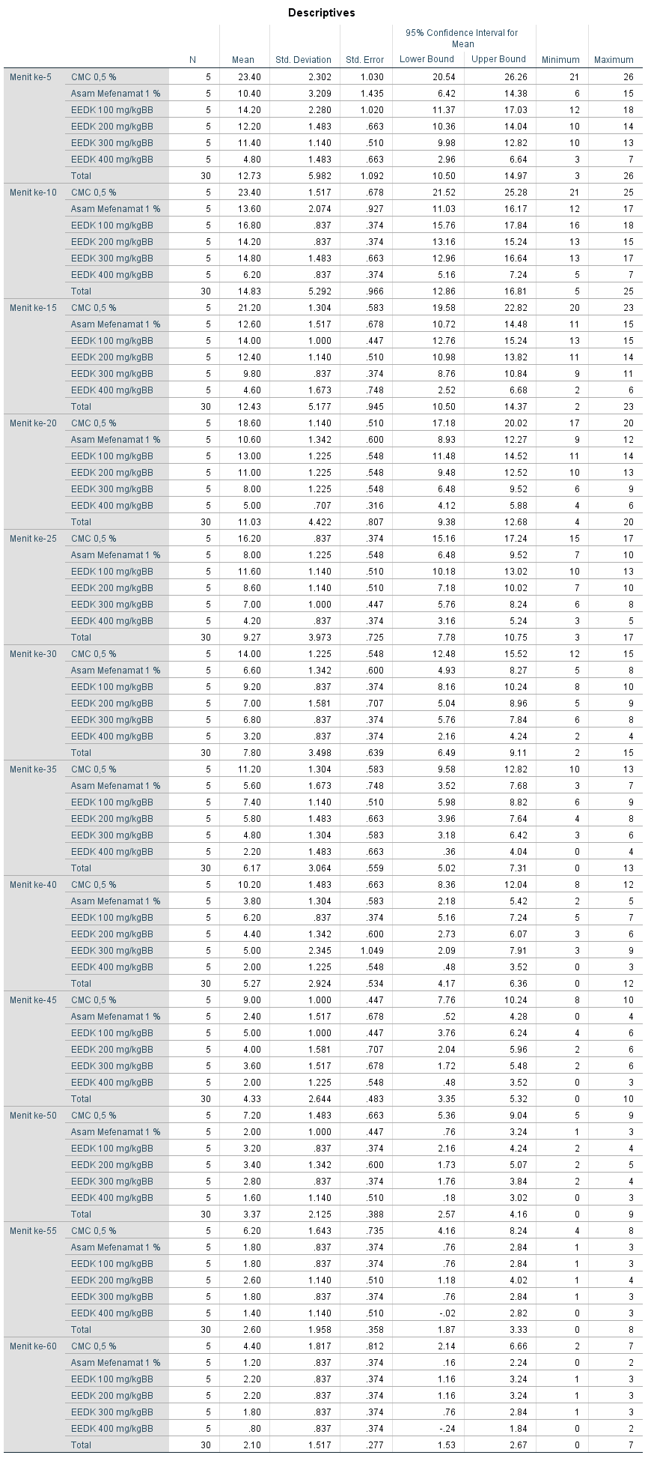

**Lampiran 19.** (Lanjutan)

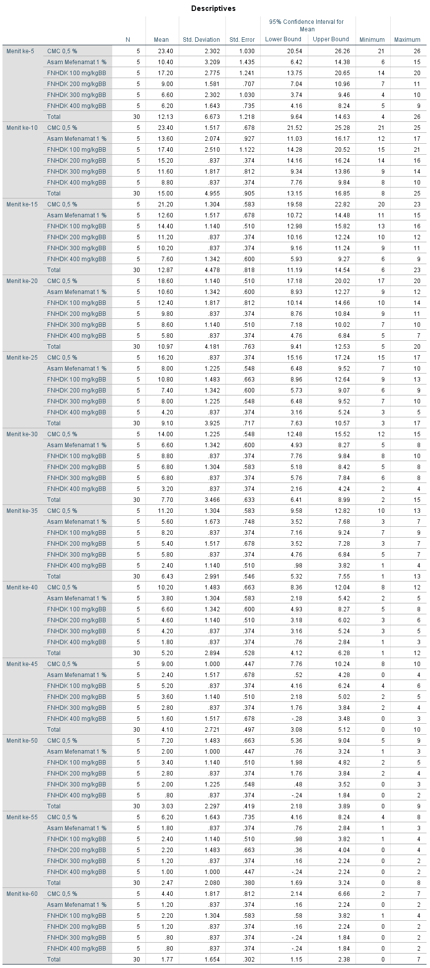

**Lampiran 19.** (Lanjutan)

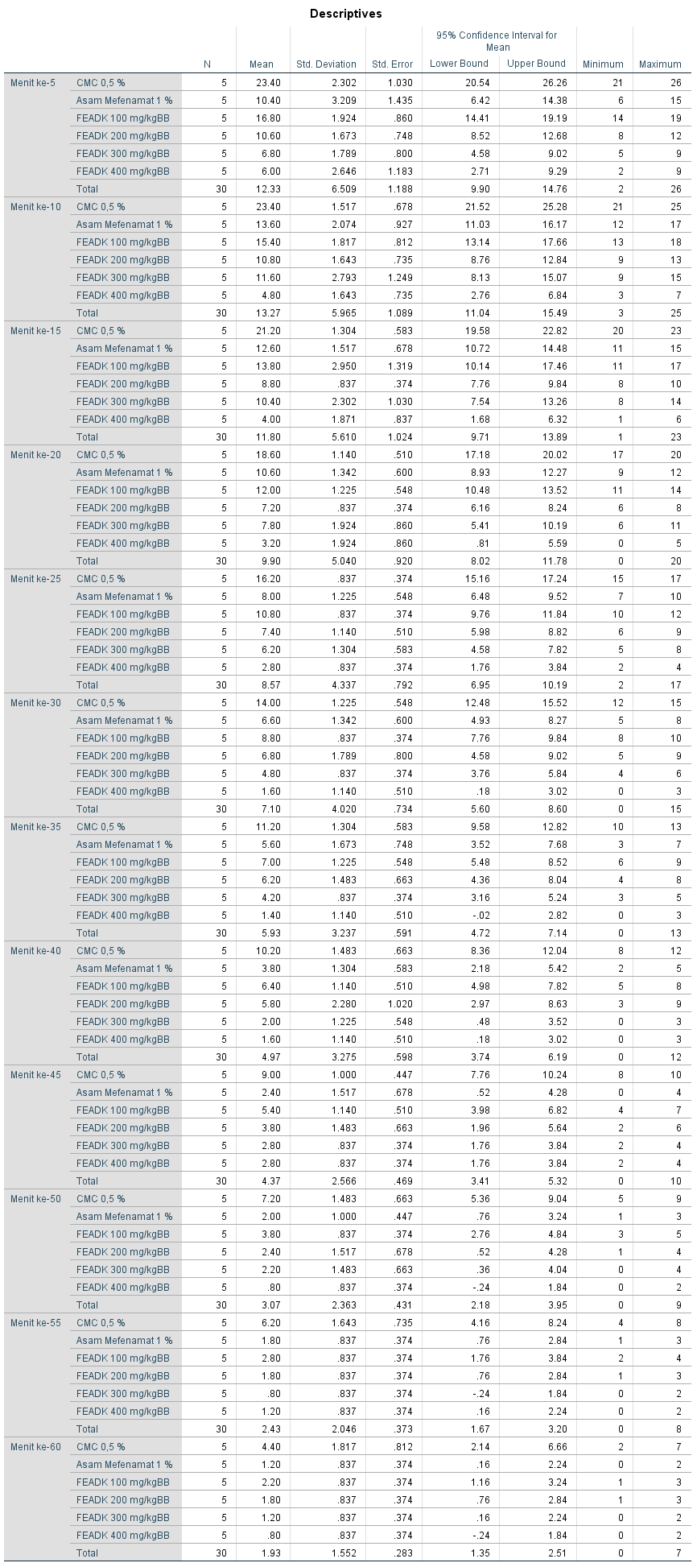

|  |  |  |  |  |  |  |  |  |  |  |  |  |  |  |  |  |  |  |  |  |  |  |  |  |  |  |  |  |  |  |  |  |  |  |  |  |  |  |  |  |  |  |  |  |  |  |  |  |  |  |  |  |  |  |  |  |  |  |  |  |  |  |  |  |  |  |  |  |  |  |  |  |  |  |  |  |  |  |  |  |  |  |  |  |  |  |  |  |  |  |  |  |  |  |  |  |  |  |  |  |  |  |  |  |  |  |  |  |  |  |  |  |  |  |  |  |  |  |  |  |  |  |  |  |  |  |  |  |  |  |  |  |  |  |  |  |  |  |  |  |  |  |  |  |  |  |  |  |  |  |  |  |  |  |  |  |  |  |  |  |  |  |  |  |  |  |  |  |  |  |  |  |  |  |  |  |  |  |  |  |  |  |  |  |  |  |  |  |  |  |  |  |  |  |  |  |  |  |  |  |  |  |  |  |  |  |  |  |  |  |  |  |  |  |  |  |  |  |  |  |  |  |  |  |  |  |  |  |  |  |  |  |  |  |  |
| --- | --- | --- | --- | --- | --- | --- | --- | --- | --- | --- | --- | --- | --- | --- | --- | --- | --- | --- | --- | --- | --- | --- | --- | --- | --- | --- | --- | --- | --- | --- | --- | --- | --- | --- | --- | --- | --- | --- | --- | --- | --- | --- | --- | --- | --- | --- | --- | --- | --- | --- | --- | --- | --- | --- | --- | --- | --- | --- | --- | --- | --- | --- | --- | --- | --- | --- | --- | --- | --- | --- | --- | --- | --- | --- | --- | --- | --- | --- | --- | --- | --- | --- | --- | --- | --- | --- | --- | --- | --- | --- | --- | --- | --- | --- | --- | --- | --- | --- | --- | --- | --- | --- | --- | --- | --- | --- | --- | --- | --- | --- | --- | --- | --- | --- | --- | --- | --- | --- | --- | --- | --- | --- | --- | --- | --- | --- | --- | --- | --- | --- | --- | --- | --- | --- | --- | --- | --- | --- | --- | --- | --- | --- | --- | --- | --- | --- | --- | --- | --- | --- | --- | --- | --- | --- | --- | --- | --- | --- | --- | --- | --- | --- | --- | --- | --- | --- | --- | --- | --- | --- | --- | --- | --- | --- | --- | --- | --- | --- | --- | --- | --- | --- | --- | --- | --- | --- | --- | --- | --- | --- | --- | --- | --- | --- | --- | --- | --- | --- | --- | --- | --- | --- | --- | --- | --- | --- | --- | --- | --- | --- | --- | --- | --- | --- | --- | --- | --- | --- | --- | --- | --- | --- | --- | --- | --- | --- | --- | --- | --- | --- | --- | --- | --- | --- | --- |
| **Lampiran 19.** (Lanjutan)   |  |  |  |  |  |  |  | | --- | --- | --- | --- | --- | --- | --- | | ANOVA EEDK | | Sum of Squares | Df | Mean Square | F | Sig. | | Menit ke-5 | Between Groups | 931.867 | 5 | 186.373 | 42.198 | .000 | | Within Groups | 106.000 | 24 | 4.417 |  |  | | Total | 1037.867 | 29 |  |  |  | | Menit ke-10 | Between Groups | 768.567 | 5 | 153.713 | 84.613 | .000 | | Within Groups | 43.600 | 24 | 1.817 |  |  | | Total | 812.167 | 29 |  |  |  | | Menit ke-15 | Between Groups | 738.167 | 5 | 147.633 | 90.388 | .000 | | Within Groups | 39.200 | 24 | 1.633 |  |  | | Total | 777.367 | 29 |  |  |  | | Menit ke-20 | Between Groups | 534.567 | 5 | 106.913 | 79.195 | .000 | | Within Groups | 32.400 | 24 | 1.350 |  |  | | Total | 566.967 | 29 |  |  |  | | Menit ke-25 | Between Groups | 431.867 | 5 | 86.373 | 79.729 | .000 | | Within Groups | 26.000 | 24 | 1.083 |  |  | | Total | 457.867 | 29 |  |  |  | | Menit ke-30 | Between Groups | 323.200 | 5 | 64.640 | 49.094 | .000 | | Within Groups | 31.600 | 24 | 1.317 |  |  | | Total | 354.800 | 29 |  |  |  | | Menit ke-35 | Between Groups | 224.567 | 5 | 44.913 | 22.645 | .000 | | Within Groups | 47.600 | 24 | 1.983 |  |  | | Total | 272.167 | 29 |  |  |  | | Menit ke-40 | Between Groups | 194.267 | 5 | 38.853 | 17.397 | .000 | | Within Groups | 53.600 | 24 | 2.233 |  |  | | Total | 247.867 | 29 |  |  |  | | Menit ke-45 | Between Groups | 160.267 | 5 | 32.053 | 18.143 | .000 | | Within Groups | 42.400 | 24 | 1.767 |  |  | | Total | 202.667 | 29 |  |  |  | | Menit ke-50 | Between Groups | 100.167 | 5 | 20.033 | 15.610 | .000 | | Within Groups | 30.800 | 24 | 1.283 |  |  | | Total | 130.967 | 29 |  |  |  | | Menit ke-55 | Between Groups | 81.600 | 5 | 16.320 | 13.232 | .000 | | Within Groups | 29.600 | 24 | 1.233 |  |  | | Total | 111.200 | 29 |  |  |  | | Menit ke-60 | Between Groups | 39.500 | 5 | 7.900 | 6.971 | .000 | | Within Groups | 27.200 | 24 | 1.133 |  |  | | Total | 66.700 | 29 |  |  |  |   **ANOVA** |
| **Lampiran 19.** (Lanjutan)   |  |  |  |  |  |  |  | | --- | --- | --- | --- | --- | --- | --- | | ANOVA FEADK | | Sum of Squares | df | Mean Square | F | Sig. | | Menit ke-5 | Between Groups | 1099.467 | 5 | 219.893 | 40.847 | .000 | | Within Groups | 129.200 | 24 | 5.383 |  |  | | Total | 1228.667 | 29 |  |  |  | | Menit ke-10 | Between Groups | 939.467 | 5 | 187.893 | 48.803 | .000 | | Within Groups | 92.400 | 24 | 3.850 |  |  | | Total | 1031.867 | 29 |  |  |  | | Menit ke-15 | Between Groups | 824.000 | 5 | 164.800 | 44.541 | .000 | | Within Groups | 88.800 | 24 | 3.700 |  |  | | Total | 912.800 | 29 |  |  |  | | Menit ke-20 | Between Groups | 685.900 | 5 | 137.180 | 64.809 | .000 | | Within Groups | 50.800 | 24 | 2.117 |  |  | | Total | 736.700 | 29 |  |  |  | | Menit ke-25 | Between Groups | 518.967 | 5 | 103.793 | 94.358 | .000 | | Within Groups | 26.400 | 24 | 1.100 |  |  | | Total | 545.367 | 29 |  |  |  | | Menit ke-30 | Between Groups | 431.900 | 5 | 86.380 | 56.335 | .000 | | Within Groups | 36.800 | 24 | 1.533 |  |  | | Total | 468.700 | 29 |  |  |  | | Menit ke-35 | Between Groups | 263.067 | 5 | 52.613 | 30.949 | .000 | | Within Groups | 40.800 | 24 | 1.700 |  |  | | Total | 303.867 | 29 |  |  |  | | Menit ke-40 | Between Groups | 258.167 | 5 | 51.633 | 23.470 | .000 | | Within Groups | 52.800 | 24 | 2.200 |  |  | | Total | 310.967 | 29 |  |  |  | | Menit ke-45 | Between Groups | 158.167 | 5 | 31.633 | 23.146 | .000 | | Within Groups | 32.800 | 24 | 1.367 |  |  | | Total | 190.967 | 29 |  |  |  | | Menit ke-50 | Between Groups | 125.467 | 5 | 25.093 | 16.545 | .000 | | Within Groups | 36.400 | 24 | 1.517 |  |  | | Total | 161.867 | 29 |  |  |  | | Menit ke-55 | Between Groups | 96.567 | 5 | 19.313 | 18.690 | .000 | | Within Groups | 24.800 | 24 | 1.033 |  |  | | Total | 121.367 | 29 |  |  |  | | Menit ke-60 | Between Groups | 42.667 | 5 | 8.533 | 7.529 | .000 | | Within Groups | 27.200 | 24 | 1.133 |  |  | | Total | 69.867 | 29 |  |  |  | |
| **Lampiran 19.** (Lanjutan)   |  |  |  |  |  |  |  | | --- | --- | --- | --- | --- | --- | --- | | ANOVAFNHDK | | Sum of Squares | df | Mean Square | F | Sig. | | Menit ke-5 | Between Groups | 1156.267 | 5 | 231.253 | 41.051 | .000 | | Within Groups | 135.200 | 24 | 5.633 |  |  | | Total | 1291.467 | 29 |  |  |  | | Menit ke-10 | Between Groups | 641.600 | 5 | 128.320 | 43.745 | .000 | | Within Groups | 70.400 | 24 | 2.933 |  |  | | Total | 712.000 | 29 |  |  |  | | Menit ke-15 | Between Groups | 547.467 | 5 | 109.493 | 77.289 | .000 | | Within Groups | 34.000 | 24 | 1.417 |  |  | | Total | 581.467 | 29 |  |  |  | | Menit ke-20 | Between Groups | 470.567 | 5 | 94.113 | 62.053 | .000 | | Within Groups | 36.400 | 24 | 1.517 |  |  | | Total | 506.967 | 29 |  |  |  | | Menit ke-25 | Between Groups | 413.100 | 5 | 82.620 | 59.014 | .000 | | Within Groups | 33.600 | 24 | 1.400 |  |  | | Total | 446.700 | 29 |  |  |  | | Menit ke-30 | Between Groups | 319.900 | 5 | 63.980 | 54.068 | .000 | | Within Groups | 28.400 | 24 | 1.183 |  |  | | Total | 348.300 | 29 |  |  |  | | Menit ke-35 | Between Groups | 221.367 | 5 | 44.273 | 27.962 | .000 | | Within Groups | 38.000 | 24 | 1.583 |  |  | | Total | 259.367 | 29 |  |  |  | | Menit ke-40 | Between Groups | 209.200 | 5 | 41.840 | 29.886 | .000 | | Within Groups | 33.600 | 24 | 1.400 |  |  | | Total | 242.800 | 29 |  |  |  | | Menit ke-45 | Between Groups | 181.500 | 5 | 36.300 | 26.241 | .000 | | Within Groups | 33.200 | 24 | 1.383 |  |  | | Total | 214.700 | 29 |  |  |  | | Menit ke-50 | Between Groups | 123.367 | 5 | 24.673 | 20.005 | .000 | | Within Groups | 29.600 | 24 | 1.233 |  |  | | Total | 152.967 | 29 |  |  |  | | Menit ke-55 | Between Groups | 91.067 | 5 | 18.213 | 12.707 | .000 | | Within Groups | 34.400 | 24 | 1.433 |  |  | | Total | 125.467 | 29 |  |  |  | | Menit ke-60 | Between Groups | 48.167 | 5 | 9.633 | 7.410 | .000 | | Within Groups | 31.200 | 24 | 1.300 |  |  | | Total | 79.367 | 29 |  |  |  |   Kesimpulan : Ho ditolak artinya jumlah geliat antar kelompok berbeda secara bermakna |

**Lampiran 20.** Uji Tukey HSD

Tujuan : Untuk mengetahui pada kelompok mana terdapat perbedaan jumlah geliat yang bermakna

Hipotesis :

Ho : Data jumlah geliat antar kelompok perlakuan tidak berbeda secara bermakna

Ha : Data jumlah geliat antar kelompok perlakuan berbeda secara bermakna

Kriteria uji:

Ho ditolak bila Sig. <0,05

Ho diterima bila Sig. >0,05

Hasil:

|  |  |  |  |  |  |  |  |
| --- | --- | --- | --- | --- | --- | --- | --- |
| **Jumlah Geliat** | | | | | | | |
| Tukey HSDa | | | | | | | |
| Kelompok Perlakuan | N | Subset for alpha = 0.05 | | | | | |
| 1 | 2 | 3 | 4 | 5 | 6 |
| FEADK 400 mg/kgBB | 5 | 31.00 |  |  |  |  |  |
| EEDK 400 mg/kgBB | 5 | 38.00 |  |  |  |  |  |
| FNHDK 400 mg/kgBB | 5 | 44.20 |  |  |  |  |  |
| FEADK 300 mg/kgBB | 5 |  | 60.80 |  |  |  |  |
| FNHDK 300 mg/kgBB | 5 |  | 68.60 | 68.60 |  |  |  |
| FEADK 200 mg/kgBB | 5 |  | 73.40 | 73.40 | 73.40 |  |  |
| EEDK 300 mg/kgBB | 5 |  |  | 77.60 | 77.60 |  |  |
| Asam Mefenamat 1 % | 5 |  |  | 78.60 | 78.60 |  |  |
| FNHDK 200 mg/kgBB | 5 |  |  | 79.60 | 79.60 |  |  |
| EEDK 200 mg/kgBB | 5 |  |  |  | 87.80 |  |  |
| EEDK 100 mg/kgBB | 5 |  |  |  |  | 104.60 |  |
| FEADK 100 mg/kgBB | 5 |  |  |  |  | 105.20 |  |
| FNHDK 100 mg/kgBB | 5 |  |  |  |  | 109.00 |  |
| CMC 0,5 % | 5 |  |  |  |  |  | 165.00 |
| Sig. |  | .140 | .190 | .381 | .071 | .999 | 1.000 |
| Means for groups in homogeneous subsets are displayed. | | | | | | | |
| a. Uses Harmonic Mean Sample Size = 5.000. | | | | | | | |

**Lampiran 20**. (Lanjutan)

EEDK

|  |  |  |  |  |
| --- | --- | --- | --- | --- |
| **Menit ke-5** | | | | |
| Tukey HSDa | | | | |
| Kelompok Perlakuan | N | Subset for alpha = 0.05 | | |
| 1 | 2 | 3 |
| EEDK 400 mg/kgBB | 5 | 4.80 |  |  |
| Asam Mefenamat 1 % | 5 |  | 10.40 |  |
| EEDK 300 mg/kgBB | 5 |  | 11.40 |  |
| EEDK 200 mg/kgBB | 5 |  | 12.20 |  |
| EEDK 100 mg/kgBB | 5 |  | 14.20 |  |
| CMC 0,5 % | 5 |  |  | 23.40 |
| Sig. |  | 1.000 | .082 | 1.000 |
| Means for groups in homogeneous subsets are displayed. | | | | |
| a. Uses Harmonic Mean Sample Size = 5.000. | | | | |

|  |  |  |  |  |  |
| --- | --- | --- | --- | --- | --- |
| **Menit ke-10** | | | | | |
| Tukey HSDa | | | | | |
| Kelompok Perlakuan | N | Subset for alpha = 0.05 | | | |
| 1 | 2 | 3 | 4 |
| EEDK 400 mg/kgBB | 5 | 6.20 |  |  |  |
| Asam Mefenamat 1 % | 5 |  | 13.60 |  |  |
| EEDK 200 mg/kgBB | 5 |  | 14.20 | 14.20 |  |
| EEDK 300 mg/kgBB | 5 |  | 14.80 | 14.80 |  |
| EEDK 100 mg/kgBB | 5 |  |  | 16.80 |  |
| CMC 0,5 % | 5 |  |  |  | 23.40 |
| Sig. |  | 1.000 | .722 | .055 | 1.000 |
| Means for groups in homogeneous subsets are displayed. | | | | | |
| a. Uses Harmonic Mean Sample Size = 5.000. | | | | | |

|  |  |  |  |  |  |
| --- | --- | --- | --- | --- | --- |
| **Menit ke-15** | | | | | |
| Tukey HSDa | | | | | |
| Kelompok Perlakuan | N | Subset for alpha = 0.05 | | | |
| 1 | 2 | 3 | 4 |
| EEDK 400 mg/kgBB | 5 | 4.60 |  |  |  |
| EEDK 300 mg/kgBB | 5 |  | 9.80 |  |  |
| EEDK 200 mg/kgBB | 5 |  |  | 12.40 |  |
| Asam Mefenamat 1 % | 5 |  |  | 12.60 |  |
| EEDK 100 mg/kgBB | 5 |  |  | 14.00 |  |
| CMC 0,5 % | 5 |  |  |  | 21.20 |
| Sig. |  | 1.000 | 1.000 | .382 | 1.000 |
| Means for groups in homogeneous subsets are displayed. | | | | | |
| a. Uses Harmonic Mean Sample Size = 5.000. | | | | | |

**Lampiran 20**. (Lanjutan)

|  |  |  |  |  |  |  |
| --- | --- | --- | --- | --- | --- | --- |
| **Menit ke-20** | | | | | | |
| Tukey HSDa | | | | | | |
| Kelompok Perlakuan | N | Subset for alpha = 0.05 | | | | |
| 1 | 2 | 3 | 4 | 5 |
| EEDK 400 mg/kgBB | 5 | 5.00 |  |  |  |  |
| EEDK 300 mg/kgBB | 5 |  | 8.00 |  |  |  |
| Asam Mefenamat 1 % | 5 |  |  | 10.60 |  |  |
| EEDK 200 mg/kgBB | 5 |  |  | 11.00 | 11.00 |  |
| EEDK 100 mg/kgBB | 5 |  |  |  | 13.00 |  |
| CMC 0,5 % | 5 |  |  |  |  | 18.60 |
| Sig. |  | 1.000 | 1.000 | .994 | .107 | 1.000 |
| Means for groups in homogeneous subsets are displayed. | | | | | | |
| a. Uses Harmonic Mean Sample Size = 5.000. | | | | | | |

|  |  |  |  |  |  |
| --- | --- | --- | --- | --- | --- |
| **Menit ke-25** | | | | | |
| Tukey HSDa | | | | | |
| Kelompok Perlakuan | N | Subset for alpha = 0.05 | | | |
| 1 | 2 | 3 | 4 |
| EEDK 400 mg/kgBB | 5 | 4.20 |  |  |  |
| EEDK 300 mg/kgBB | 5 |  | 7.00 |  |  |
| Asam Mefenamat 1 % | 5 |  | 8.00 |  |  |
| EEDK 200 mg/kgBB | 5 |  | 8.60 |  |  |
| EEDK 100 mg/kgBB | 5 |  |  | 11.60 |  |
| CMC 0,5 % | 5 |  |  |  | 16.20 |
| Sig. |  | 1.000 | .186 | 1.000 | 1.000 |
| Means for groups in homogeneous subsets are displayed. | | | | | |
| a. Uses Harmonic Mean Sample Size = 5.000. | | | | | |

|  |  |  |  |  |  |
| --- | --- | --- | --- | --- | --- |
| **Menit ke-30** | | | | | |
| Tukey HSDa | | | | | |
| Kelompok Perlakuan | N | Subset for alpha = 0.05 | | | |
| 1 | 2 | 3 | 4 |
| EEDK 400 mg/kgBB | 5 | 3.20 |  |  |  |
| Asam Mefenamat 1 % | 5 |  | 6.60 |  |  |
| EEDK 300 mg/kgBB | 5 |  | 6.80 |  |  |
| EEDK 200 mg/kgBB | 5 |  | 7.00 | 7.00 |  |
| EEDK 100 mg/kgBB | 5 |  |  | 9.20 |  |
| CMC 0,5 % | 5 |  |  |  | 14.00 |
| Sig. |  | 1.000 | .993 | .057 | 1.000 |
| Means for groups in homogeneous subsets are displayed. | | | | | |
| a. Uses Harmonic Mean Sample Size = 5.000. | | | | | |

**Lampiran 20**. (Lanjutan)

|  |  |  |  |  |
| --- | --- | --- | --- | --- |
| **Menit ke-35** | | | | |
| Tukey HSDa | | | | |
| Kelompok Perlakuan | N | Subset for alpha = 0.05 | | |
| 1 | 2 | 3 |
| EEDK 400 mg/kgBB | 5 | 2.20 |  |  |
| EEDK 300 mg/kgBB | 5 | 4.80 | 4.80 |  |
| Asam Mefenamat 1 % | 5 |  | 5.60 |  |
| EEDK 200 mg/kgBB | 5 |  | 5.80 |  |
| EEDK 100 mg/kgBB | 5 |  | 7.40 |  |
| CMC 0,5 % | 5 |  |  | 11.20 |
| Sig. |  | .072 | .072 | 1.000 |
| Means for groups in homogeneous subsets are displayed. | | | | |
| a. Uses Harmonic Mean Sample Size = 5.000. | | | | |

|  |  |  |  |  |
| --- | --- | --- | --- | --- |
| **Menit ke-40** | | | | |
| Tukey HSDa | | | | |
| Kelompok Perlakuan | N | Subset for alpha = 0.05 | | |
| 1 | 2 | 3 |
| EEDK 400 mg/kgBB | 5 | 2.00 |  |  |
| Asam Mefenamat 1 % | 5 | 3.80 | 3.80 |  |
| EEDK 200 mg/kgBB | 5 | 4.40 | 4.40 |  |
| EEDK 300 mg/kgBB | 5 |  | 5.00 |  |
| EEDK 100 mg/kgBB | 5 |  | 6.20 |  |
| CMC 0,5 % | 5 |  |  | 10.20 |
| Sig. |  | .152 | .152 | 1.000 |
| Means for groups in homogeneous subsets are displayed. | | | | |
| a. Uses Harmonic Mean Sample Size = 5.000. | | | | |

|  |  |  |  |  |
| --- | --- | --- | --- | --- |
| **Menit ke-45** | | | | |
| Tukey HSDa | | | | |
| Kelompok Perlakuan | N | Subset for alpha = 0.05 | | |
| 1 | 2 | 3 |
| EEDK 400 mg/kgBB | 5 | 2.00 |  |  |
| Asam Mefenamat 1 % | 5 | 2.40 |  |  |
| EEDK 300 mg/kgBB | 5 | 3.60 | 3.60 |  |
| EEDK 200 mg/kgBB | 5 | 4.00 | 4.00 |  |
| EEDK 100 mg/kgBB | 5 |  | 5.00 |  |
| CMC 0,5 % | 5 |  |  | 9.00 |
| Sig. |  | .203 | .566 | 1.000 |
| Means for groups in homogeneous subsets are displayed. | | | | |
| a. Uses Harmonic Mean Sample Size = 5.000. | | | | |

**Lampiran 20**. (Lanjutan)

|  |  |  |  |
| --- | --- | --- | --- |
| **Menit ke-50** | | | |
| Tukey HSDa | | | |
| Kelompok Perlakuan | N | Subset for alpha = 0.05 | |
| 1 | 2 |
| EEDK 400 mg/kgBB | 5 | 1.60 |  |
| Asam Mefenamat 1 % | 5 | 2.00 |  |
| EEDK 300 mg/kgBB | 5 | 2.80 |  |
| EEDK 100 mg/kgBB | 5 | 3.20 |  |
| EEDK 200 mg/kgBB | 5 | 3.40 |  |
| CMC 0,5 % | 5 |  | 7.20 |
| Sig. |  | .160 | 1.000 |
| Means for groups in homogeneous subsets are displayed. | | | |
| a. Uses Harmonic Mean Sample Size = 5.000. | | | |

|  |  |  |  |
| --- | --- | --- | --- |
| **Menit ke-55** | | | |
| Tukey HSDa | | | |
| Kelompok Perlakuan | N | Subset for alpha = 0.05 | |
| 1 | 2 |
| EEDK 400 mg/kgBB | 5 | 1.40 |  |
| Asam Mefenamat 1 % | 5 | 1.80 |  |
| EEDK 100 mg/kgBB | 5 | 1.80 |  |
| EEDK 300 mg/kgBB | 5 | 1.80 |  |
| EEDK 200 mg/kgBB | 5 | 2.60 |  |
| CMC 0,5 % | 5 |  | 6.20 |
| Sig. |  | .540 | 1.000 |
| Means for groups in homogeneous subsets are displayed. | | | |
| a. Uses Harmonic Mean Sample Size = 5.000. | | | |

|  |  |  |  |
| --- | --- | --- | --- |
| **Menit ke-60** | | | |
| Tukey HSDa | | | |
| Kelompok Perlakuan | N | Subset for alpha = 0.05 | |
| 1 | 2 |
| EEDK 400 mg/kgBB | 5 | .80 |  |
| Asam Mefenamat 1 % | 5 | 1.20 |  |
| EEDK 300 mg/kgBB | 5 | 1.80 |  |
| EEDK 100 mg/kgBB | 5 | 2.20 |  |
| EEDK 200 mg/kgBB | 5 | 2.20 |  |
| CMC 0,5 % | 5 |  | 4.40 |
| Sig. |  | .331 | 1.000 |
| Means for groups in homogeneous subsets are displayed. | | | |
| a. Uses Harmonic Mean Sample Size = 5.000. | | | |

**Lampiran 20**. (Lanjutan)

FNHDK

|  |  |  |  |  |
| --- | --- | --- | --- | --- |
| **Menit ke-5** | | | | |
| Tukey HSDa | | | | |
| Kelompok Perlakuan | N | Subset for alpha = 0.05 | | |
| 1 | 2 | 3 |
| FNHDK 400 mg/kgBB | 5 | 6.20 |  |  |
| FNHDK 300 mg/kgBB | 5 | 6.60 |  |  |
| FNHDK 200 mg/kgBB | 5 | 9.00 |  |  |
| Asam Mefenamat 1 % | 5 | 10.40 |  |  |
| FNHDK 100 mg/kgBB | 5 |  | 17.20 |  |
| CMC 0,5 % | 5 |  |  | 23.40 |
| Sig. |  | .092 | 1.000 | 1.000 |
| Means for groups in homogeneous subsets are displayed. | | | | |
| a. Uses Harmonic Mean Sample Size = 5.000. | | | | |

|  |  |  |  |  |  |  |
| --- | --- | --- | --- | --- | --- | --- |
| **Menit ke-10** | | | | | | |
| Tukey HSDa | | | | | | |
| Kelompok Perlakuan | N | Subset for alpha = 0.05 | | | | |
| 1 | 2 | 3 | 4 | 5 |
| FNHDK 400 mg/kgBB | 5 | 8.80 |  |  |  |  |
| FNHDK 300 mg/kgBB | 5 | 11.60 | 11.60 |  |  |  |
| Asam Mefenamat 1 % | 5 |  | 13.60 | 13.60 |  |  |
| FNHDK 200 mg/kgBB | 5 |  |  | 15.20 | 15.20 |  |
| FNHDK 100 mg/kgBB | 5 |  |  |  | 17.40 |  |
| CMC 0,5 % | 5 |  |  |  |  | 23.40 |
| Sig. |  | .140 | .457 | .681 | .355 | 1.000 |
| Means for groups in homogeneous subsets are displayed. | | | | | | |
| a. Uses Harmonic Mean Sample Size = 5.000. | | | | | | |

|  |  |  |  |  |  |  |
| --- | --- | --- | --- | --- | --- | --- |
| **Menit ke-15** | | | | | | |
| Tukey HSDa | | | | | | |
| Kelompok Perlakuan | N | Subset for alpha = 0.05 | | | | |
| 1 | 2 | 3 | 4 | 5 |
| FNHDK 400 mg/kgBB | 5 | 7.60 |  |  |  |  |
| FNHDK 300 mg/kgBB | 5 |  | 10.20 |  |  |  |
| FNHDK 200 mg/kgBB | 5 |  | 11.20 | 11.20 |  |  |
| Asam Mefenamat 1 % | 5 |  |  | 12.60 | 12.60 |  |
| FNHDK 100 mg/kgBB | 5 |  |  |  | 14.40 |  |
| CMC 0,5 % | 5 |  |  |  |  | 21.20 |
| Sig. |  | 1.000 | .767 | .449 | .199 | 1.000 |
| Means for groups in homogeneous subsets are displayed. | | | | | | |
| a. Uses Harmonic Mean Sample Size = 5.000. | | | | | | |

**Lampiran 20**. (Lanjutan)

|  |  |  |  |  |  |
| --- | --- | --- | --- | --- | --- |
| **Menit ke-20** | | | | | |
| Tukey HSDa | | | | | |
| Kelompok Perlakuan | N | Subset for alpha = 0.05 | | | |
| 1 | 2 | 3 | 4 |
| FNHDK 400 mg/kgBB | 5 | 5.80 |  |  |  |
| FNHDK 300 mg/kgBB | 5 |  | 8.60 |  |  |
| FNHDK 200 mg/kgBB | 5 |  | 9.80 |  |  |
| Asam Mefenamat 1 % | 5 |  | 10.60 | 10.60 |  |
| FNHDK 100 mg/kgBB | 5 |  |  | 12.40 |  |
| CMC 0,5 % | 5 |  |  |  | 18.60 |
| Sig. |  | 1.000 | .144 | .228 | 1.000 |
| Means for groups in homogeneous subsets are displayed. | | | | | |
| a. Uses Harmonic Mean Sample Size = 5.000. | | | | | |

|  |  |  |  |  |  |
| --- | --- | --- | --- | --- | --- |
| **Menit ke-25** | | | | | |
| Tukey HSDa | | | | | |
| Kelompok Perlakuan | N | Subset for alpha = 0.05 | | | |
| 1 | 2 | 3 | 4 |
| FNHDK 400 mg/kgBB | 5 | 4.20 |  |  |  |
| FNHDK 200 mg/kgBB | 5 |  | 7.40 |  |  |
| Asam Mefenamat 1 % | 5 |  | 8.00 |  |  |
| FNHDK 300 mg/kgBB | 5 |  | 8.00 |  |  |
| FNHDK 100 mg/kgBB | 5 |  |  | 10.80 |  |
| CMC 0,5 % | 5 |  |  |  | 16.20 |
| Sig. |  | 1.000 | .964 | 1.000 | 1.000 |
| Means for groups in homogeneous subsets are displayed. | | | | | |
| a. Uses Harmonic Mean Sample Size = 5.000. | | | | | |

|  |  |  |  |  |  |
| --- | --- | --- | --- | --- | --- |
| **Menit ke-30** | | | | | |
| Tukey HSDa | | | | | |
| Kelompok Perlakuan | N | Subset for alpha = 0.05 | | | |
| 1 | 2 | 3 | 4 |
| FNHDK 400 mg/kgBB | 5 | 3.20 |  |  |  |
| Asam Mefenamat 1 % | 5 |  | 6.60 |  |  |
| FNHDK 200 mg/kgBB | 5 |  | 6.80 | 6.80 |  |
| FNHDK 300 mg/kgBB | 5 |  | 6.80 | 6.80 |  |
| FNHDK 100 mg/kgBB | 5 |  |  | 8.80 |  |
| CMC 0,5 % | 5 |  |  |  | 14.00 |
| Sig. |  | 1.000 | 1.000 | .074 | 1.000 |
| Means for groups in homogeneous subsets are displayed. | | | | | |
| a. Uses Harmonic Mean Sample Size = 5.000. | | | | | |

**Lampiran 20**. (Lanjutan)

|  |  |  |  |  |  |
| --- | --- | --- | --- | --- | --- |
| **Menit ke-35** | | | | | |
| Tukey HSDa | | | | | |
| Kelompok Perlakuan | N | Subset for alpha = 0.05 | | | |
| 1 | 2 | 3 | 4 |
| FNHDK 400 mg/kgBB | 5 | 2.40 |  |  |  |
| FNHDK 200 mg/kgBB | 5 |  | 5.40 |  |  |
| Asam Mefenamat 1 % | 5 |  | 5.60 |  |  |
| FNHDK 300 mg/kgBB | 5 |  | 5.80 | 5.80 |  |
| FNHDK 100 mg/kgBB | 5 |  |  | 8.20 |  |
| CMC 0,5 % | 5 |  |  |  | 11.20 |
| Sig. |  | 1.000 | .996 | .059 | 1.000 |
| Means for groups in homogeneous subsets are displayed. | | | | | |
| a. Uses Harmonic Mean Sample Size = 5.000. | | | | | |

|  |  |  |  |  |  |
| --- | --- | --- | --- | --- | --- |
| **Menit ke-40** | | | | | |
| Tukey HSDa | | | | | |
| Kelompok Perlakuan | N | Subset for alpha = 0.05 | | | |
| 1 | 2 | 3 | 4 |
| FNHDK 400 mg/kgBB | 5 | 1.80 |  |  |  |
| Asam Mefenamat 1 % | 5 | 3.80 | 3.80 |  |  |
| FNHDK 300 mg/kgBB | 5 |  | 4.20 |  |  |
| FNHDK 200 mg/kgBB | 5 |  | 4.60 | 4.60 |  |
| FNHDK 100 mg/kgBB | 5 |  |  | 6.60 |  |
| CMC 0,5 % | 5 |  |  |  | 10.20 |
| Sig. |  | .118 | .889 | .118 | 1.000 |
| Means for groups in homogeneous subsets are displayed. | | | | | |
| a. Uses Harmonic Mean Sample Size = 5.000. | | | | | |

|  |  |  |  |  |
| --- | --- | --- | --- | --- |
| **Menit ke-45** | | | | |
| Tukey HSDa | | | | |
| Kelompok Perlakuan | N | Subset for alpha = 0.05 | | |
| 1 | 2 | 3 |
| FNHDK 400 mg/kgBB | 5 | 1.60 |  |  |
| Asam Mefenamat 1 % | 5 | 2.40 |  |  |
| FNHDK 300 mg/kgBB | 5 | 2.80 |  |  |
| FNHDK 200 mg/kgBB | 5 | 3.60 | 3.60 |  |
| FNHDK 100 mg/kgBB | 5 |  | 5.20 |  |
| CMC 0,5 % | 5 |  |  | 9.00 |
| Sig. |  | .115 | .296 | 1.000 |
| Means for groups in homogeneous subsets are displayed. | | | | |
| a. Uses Harmonic Mean Sample Size = 5.000. | | | | |

**Lampiran 20**. (Lanjutan)

|  |  |  |  |  |
| --- | --- | --- | --- | --- |
| **Menit ke-50** | | | | |
| Tukey HSDa | | | | |
| Kelompok Perlakuan | N | Subset for alpha = 0.05 | | |
| 1 | 2 | 3 |
| FNHDK 400 mg/kgBB | 5 | .80 |  |  |
| Asam Mefenamat 1 % | 5 | 2.00 | 2.00 |  |
| FNHDK 300 mg/kgBB | 5 | 2.00 | 2.00 |  |
| FNHDK 200 mg/kgBB | 5 | 2.80 | 2.80 |  |
| FNHDK 100 mg/kgBB | 5 |  | 3.40 |  |
| CMC 0,5 % | 5 |  |  | 7.20 |
| Sig. |  | .083 | .375 | 1.000 |
| Means for groups in homogeneous subsets are displayed. | | | | |
| a. Uses Harmonic Mean Sample Size = 5.000. | | | | |

|  |  |  |  |
| --- | --- | --- | --- |
| **Menit ke-55** | | | |
| Tukey HSDa | | | |
| Kelompok Perlakuan | N | Subset for alpha = 0.05 | |
| 1 | 2 |
| FNHDK 400 mg/kgBB | 5 | 1.00 |  |
| FNHDK 300 mg/kgBB | 5 | 1.20 |  |
| Asam Mefenamat 1 % | 5 | 1.80 |  |
| FNHDK 200 mg/kgBB | 5 | 2.20 |  |
| FNHDK 100 mg/kgBB | 5 | 2.40 |  |
| CMC 0,5 % | 5 |  | 6.20 |
| Sig. |  | .455 | 1.000 |
| Means for groups in homogeneous subsets are displayed. | | | |
| a. Uses Harmonic Mean Sample Size = 5.000. | | | |

|  |  |  |  |
| --- | --- | --- | --- |
| **Menit ke-60** | | | |
| Tukey HSDa | | | |
| Kelompok Perlakuan | N | Subset for alpha = 0.05 | |
| 1 | 2 |
| FNHDK 300 mg/kgBB | 5 | .80 |  |
| FNHDK 400 mg/kgBB | 5 | .80 |  |
| Asam Mefenamat 1 % | 5 | 1.20 |  |
| FNHDK 200 mg/kgBB | 5 | 1.20 |  |
| FNHDK 100 mg/kgBB | 5 | 2.20 | 2.20 |
| CMC 0,5 % | 5 |  | 4.40 |
| Sig. |  | .403 | .055 |
| Means for groups in homogeneous subsets are displayed. | | | |
| a. Uses Harmonic Mean Sample Size = 5.000. | | | |

**Lampiran 20**. (Lanjutan)

FEADK

|  |  |  |  |  |  |
| --- | --- | --- | --- | --- | --- |
| **Menit ke-5** | | | | | |
| Tukey HSDa | | | | | |
| Kelompok Perlakuan | N | Subset for alpha = 0.05 | | | |
| 1 | 2 | 3 | 4 |
| FEADK 400 mg/kgBB | 5 | 6.00 |  |  |  |
| FEADK 300 mg/kgBB | 5 | 6.80 | 6.80 |  |  |
| Asam Mefenamat 1 % | 5 | 10.40 | 10.40 |  |  |
| FEADK 200 mg/kgBB | 5 |  | 10.60 |  |  |
| FEADK 100 mg/kgBB | 5 |  |  | 16.80 |  |
| CMC 0,5 % | 5 |  |  |  | 23.40 |
| Sig. |  | .061 | .139 | 1.000 | 1.000 |
| Means for groups in homogeneous subsets are displayed. | | | | | |
| a. Uses Harmonic Mean Sample Size = 5.000. | | | | | |

|  |  |  |  |  |  |
| --- | --- | --- | --- | --- | --- |
| **Menit ke-10** | | | | | |
| Tukey HSDa | | | | | |
| Kelompok Perlakuan | N | Subset for alpha = 0.05 | | | |
| 1 | 2 | 3 | 4 |
| FEADK 400 mg/kgBB | 5 | 4.80 |  |  |  |
| FEADK 200 mg/kgBB | 5 |  | 10.80 |  |  |
| FEADK 300 mg/kgBB | 5 |  | 11.60 | 11.60 |  |
| Asam Mefenamat 1 % | 5 |  | 13.60 | 13.60 |  |
| FEADK 100 mg/kgBB | 5 |  |  | 15.40 |  |
| CMC 0,5 % | 5 |  |  |  | 23.40 |
| Sig. |  | 1.000 | .250 | .053 | 1.000 |
| Means for groups in homogeneous subsets are displayed. | | | | | |
| a. Uses Harmonic Mean Sample Size = 5.000. | | | | | |

|  |  |  |  |  |  |
| --- | --- | --- | --- | --- | --- |
| **Menit ke-15** | | | | | |
| Tukey HSDa | | | | | |
| Kelompok Perlakuan | N | Subset for alpha = 0.05 | | | |
| 1 | 2 | 3 | 4 |
| FEADK 400 mg/kgBB | 5 | 4.00 |  |  |  |
| FEADK 200 mg/kgBB | 5 |  | 8.80 |  |  |
| FEADK 300 mg/kgBB | 5 |  | 10.40 | 10.40 |  |
| Asam Mefenamat 1 % | 5 |  |  | 12.60 |  |
| FEADK 100 mg/kgBB | 5 |  |  | 13.80 |  |
| CMC 0,5 % | 5 |  |  |  | 21.20 |
| Sig. |  | 1.000 | .774 | .093 | 1.000 |
| Means for groups in homogeneous subsets are displayed. | | | | | |
| a. Uses Harmonic Mean Sample Size = 5.000. | | | | | |

**Lampiran 20**. (Lanjutan)

|  |  |  |  |  |  |  |
| --- | --- | --- | --- | --- | --- | --- |
| **Menit ke-20** | | | | | | |
| Tukey HSDa | | | | | | |
| Kelompok Perlakuan | N | Subset for alpha = 0.05 | | | | |
| 1 | 2 | 3 | 4 | 5 |
| FEADK 400 mg/kgBB | 5 | 3.20 |  |  |  |  |
| FEADK 200 mg/kgBB | 5 |  | 7.20 |  |  |  |
| FEADK 300 mg/kgBB | 5 |  | 7.80 | 7.80 |  |  |
| Asam Mefenamat 1 % | 5 |  |  | 10.60 | 10.60 |  |
| FEADK 100 mg/kgBB | 5 |  |  |  | 12.00 |  |
| CMC 0,5 % | 5 |  |  |  |  | 18.60 |
| Sig. |  | 1.000 | .985 | .056 | .654 | 1.000 |
| Means for groups in homogeneous subsets are displayed. | | | | | | |
| a. Uses Harmonic Mean Sample Size = 5.000. | | | | | | |

|  |  |  |  |  |  |
| --- | --- | --- | --- | --- | --- |
| **Menit ke-25** | | | | | |
| Tukey HSDa | | | | | |
| Kelompok Perlakuan | N | Subset for alpha = 0.05 | | | |
| 1 | 2 | 3 | 4 |
| FEADK 400 mg/kgBB | 5 | 2.80 |  |  |  |
| FEADK 300 mg/kgBB | 5 |  | 6.20 |  |  |
| FEADK 200 mg/kgBB | 5 |  | 7.40 |  |  |
| Asam Mefenamat 1 % | 5 |  | 8.00 |  |  |
| FEADK 100 mg/kgBB | 5 |  |  | 10.80 |  |
| CMC 0,5 % | 5 |  |  |  | 16.20 |
| Sig. |  | 1.000 | .109 | 1.000 | 1.000 |
| Means for groups in homogeneous subsets are displayed. | | | | | |
| a. Uses Harmonic Mean Sample Size = 5.000. | | | | | |

|  |  |  |  |  |  |
| --- | --- | --- | --- | --- | --- |
| **Menit ke-30** | | | | | |
| Tukey HSDa | | | | | |
| Kelompok Perlakuan | N | Subset for alpha = 0.05 | | | |
| 1 | 2 | 3 | 4 |
| FEADK 400 mg/kgBB | 5 | 1.60 |  |  |  |
| FEADK 300 mg/kgBB | 5 |  | 4.80 |  |  |
| Asam Mefenamat 1 % | 5 |  | 6.60 | 6.60 |  |
| FEADK 200 mg/kgBB | 5 |  | 6.80 | 6.80 |  |
| FEADK 100 mg/kgBB | 5 |  |  | 8.80 |  |
| CMC 0,5 % | 5 |  |  |  | 14.00 |
| Sig. |  | 1.000 | .148 | .090 | 1.000 |
| Means for groups in homogeneous subsets are displayed. | | | | | |
| a. Uses Harmonic Mean Sample Size = 5.000. | | | | | |

**Lampiran 20**. (Lanjutan)

|  |  |  |  |  |  |
| --- | --- | --- | --- | --- | --- |
| **Menit ke-35** | | | | | |
| Tukey HSDa | | | | | |
| Kelompok Perlakuan | N | Subset for alpha = 0.05 | | | |
| 1 | 2 | 3 | 4 |
| FEADK 400 mg/kgBB | 5 | 1.40 |  |  |  |
| FEADK 300 mg/kgBB | 5 |  | 4.20 |  |  |
| Asam Mefenamat 1 % | 5 |  | 5.60 | 5.60 |  |
| FEADK 200 mg/kgBB | 5 |  | 6.20 | 6.20 |  |
| FEADK 100 mg/kgBB | 5 |  |  | 7.00 |  |
| CMC 0,5 % | 5 |  |  |  | 11.20 |
| Sig. |  | 1.000 | .187 | .546 | 1.000 |
| Means for groups in homogeneous subsets are displayed. | | | | | |
| a. Uses Harmonic Mean Sample Size = 5.000. | | | | | |

|  |  |  |  |  |
| --- | --- | --- | --- | --- |
| **Menit ke-40** | | | | |
| Tukey HSDa | | | | |
| Kelompok Perlakuan | N | Subset for alpha = 0.05 | | |
| 1 | 2 | 3 |
| FEADK 400 mg/kgBB | 5 | 1.60 |  |  |
| FEADK 300 mg/kgBB | 5 | 2.00 |  |  |
| Asam Mefenamat 1 % | 5 | 3.80 | 3.80 |  |
| FEADK 200 mg/kgBB | 5 |  | 5.80 |  |
| FEADK 100 mg/kgBB | 5 |  | 6.40 |  |
| CMC 0,5 % | 5 |  |  | 10.20 |
| Sig. |  | .215 | .097 | 1.000 |
| Means for groups in homogeneous subsets are displayed. | | | | |
| a. Uses Harmonic Mean Sample Size = 5.000. | | | | |

|  |  |  |  |  |
| --- | --- | --- | --- | --- |
| **Menit ke-45** | | | | |
| Tukey HSDa | | | | |
| Kelompok Perlakuan | N | Subset for alpha = 0.05 | | |
| 1 | 2 | 3 |
| Asam Mefenamat 1 % | 5 | 2.40 |  |  |
| FEADK 300 mg/kgBB | 5 | 2.80 |  |  |
| FEADK 400 mg/kgBB | 5 | 2.80 |  |  |
| FEADK 200 mg/kgBB | 5 | 3.80 | 3.80 |  |
| FEADK 100 mg/kgBB | 5 |  | 5.40 |  |
| CMC 0,5 % | 5 |  |  | 9.00 |
| Sig. |  | .430 | .290 | 1.000 |
| Means for groups in homogeneous subsets are displayed. | | | | |
| a. Uses Harmonic Mean Sample Size = 5.000. | | | | |

**Lampiran 20**. (Lanjutan)

|  |  |  |  |  |
| --- | --- | --- | --- | --- |
| **Menit ke-50** | | | | |
| Tukey HSDa | | | | |
| Kelompok Perlakuan | N | Subset for alpha = 0.05 | | |
| 1 | 2 | 3 |
| FEADK 400 mg/kgBB | 5 | .80 |  |  |
| Asam Mefenamat 1 % | 5 | 2.00 | 2.00 |  |
| FEADK 300 mg/kgBB | 5 | 2.20 | 2.20 |  |
| FEADK 200 mg/kgBB | 5 | 2.40 | 2.40 |  |
| FEADK 100 mg/kgBB | 5 |  | 3.80 |  |
| CMC 0,5 % | 5 |  |  | 7.20 |
| Sig. |  | .343 | .228 | 1.000 |
| Means for groups in homogeneous subsets are displayed. | | | | |
| a. Uses Harmonic Mean Sample Size = 5.000. | | | | |

|  |  |  |  |  |
| --- | --- | --- | --- | --- |
| **Menit ke-55** | | | | |
| Tukey HSDa | | | | |
| Kelompok Perlakuan | N | Subset for alpha = 0.05 | | |
| 1 | 2 | 3 |
| FEADK 300 mg/kgBB | 5 | .80 |  |  |
| FEADK 400 mg/kgBB | 5 | 1.20 | 1.20 |  |
| Asam Mefenamat 1 % | 5 | 1.80 | 1.80 |  |
| FEADK 200 mg/kgBB | 5 | 1.80 | 1.80 |  |
| FEADK 100 mg/kgBB | 5 |  | 2.80 |  |
| CMC 0,5 % | 5 |  |  | 6.20 |
| Sig. |  | .634 | .167 | 1.000 |
| Means for groups in homogeneous subsets are displayed. | | | | |
| a. Uses Harmonic Mean Sample Size = 5.000. | | | | |

|  |  |  |  |
| --- | --- | --- | --- |
| **Menit ke-60** | | | |
| Tukey HSDa | | | |
| Kelompok Perlakuan | N | Subset for alpha = 0.05 | |
| 1 | 2 |
| FEADK 400 mg/kgBB | 5 | .80 |  |
| Asam Mefenamat 1 % | 5 | 1.20 |  |
| FEADK 300 mg/kgBB | 5 | 1.20 |  |
| FEADK 200 mg/kgBB | 5 | 1.80 |  |
| FEADK 100 mg/kgBB | 5 | 2.20 |  |
| CMC 0,5 % | 5 |  | 4.40 |
| Sig. |  | .331 | 1.000 |
| Means for groups in homogeneous subsets are displayed. | | | |
| a. Uses Harmonic Mean Sample Size = 5.000. | | | |