Lampiran 1. Informed Consent
PERMOHONAN RESPONDEN
Saya yang bertanda tangan di bawah ini :
Nama : Ramayani br.Hutabarat
NIM : 162114178
Semester : VIII
Adalah Mahasiswa Program Studi S1 Farmasi Universitas Muslim Nusantara Al-Washliyah Medan yang akan melaksanakan Penelitian dengan judul: “GAMBARAN TINGKAT PENGETAHUAN PASIEN DEWASA TERHADAP ANTIBIOTIK DAN PENGGUNAANNYA DI RUMAH SAKIT ESTOMIHI”. Oleh karena itu, peneliti memohon kesediaan ibu menjadi responden dalam penelitian ini. Penelitian ini tidak menimbulkan dampak yang merugikan pada ibu sebagai responden, serta semua informasi yang diberikan akan dijaga kerahasiaannya dan hanya dimanfaatkan untuk keperluan penelitian.

Medan, Agustus 2020
Peneliti

Ramayani br. Hutabarat
PERSETUJUAN RESPONDEN
Yang bertanda tangan di bawah ini :
Nama :
Umur :
Jenis kelamain :
Dengan ini menyatakan bersedia menjadi responden penelitian yang dilakukan oleh Ramayani br. Hutabarat Program Studi S1 Farmasi Universitas Muslim Nusantara Al- Washliyah Medan yang berjudul “GAMBARAN TINGKAT PENGETAHUAN PASIEN DEWASA TERHADAP ANTIBIOTIK DAN PENGGUNAANNYA DI RUMAH SAKIT ESTOMIHI” saya mengerti dan memahami bahwa penelitian ini tidak akan berakibat negative terhadap saya, oleh karena itu saya bersedia untuk menjadi responden pada penelitian ini.

Medan, Agustus 2020

(Responden)

Lampiran 2: Kuesioner Penelitian
KUESIONER TENTANG PENGETAHUAN DAN PENGGUNAAN ANTIBIOTIK DI RUMAH SAKIT ESTOMIHI MEDAN
DATA PASIEN
Nama :
Umur :
Jenis kelamin :
Jawablah pertanyaan di bawah ini sesuai yang anda ketahui dengan ketentuan sebagai berikut untuk
    - Untuk soal no 1 - 20 jawaban boleh lebih dari satu
    - Jawaban cukup diberi tanda silang
Pertanyaan pengetahuan
1. Manakah di bawah ini obat antibiotik yang anda ketahui?
1.Amoxicillin
2.Cefixime
3.Cefadroxil
4.Azitromycin
5.Ciprofloxcacin
2. Dari mana anda memperoleh antibiotik?
- Dokter
- Perawat
- Bidan
- Apoteker
- Keluarga
3. Efek samping antibiotik yang sering muncul?
- Gatal
- Alergi
- Mual
- Muntah
- Diare
4. Dimana anda membeli antibiotik?
- Apotek
- Toko obat
- Supermarket
- Warung
- Rumah sakit
5. contoh sediaan antibiotik?
- Salep
- Oral
- Sirup
- Tetes
- Injeksi
6. Contoh golongan cephalosporine yang sering anda gunakan?
- Cefxime
- Cephalexime
- Cephadroxil
- Cefaletan
- Cefaclor
7. Contoh golongan penisiline yang sering anda gunakan?
- Ampiciline
- Amoxicilline
- Nafciline
- Oxacycline
- Penisiline G
8. Penyakit yang memerlukan antibiotik ?
- Infeksi sinus
- Infeksi saluran kemih
- Radang tenggorokan
- Infeksi telinga
- pneumonia
9. Aturan pemakaian antibiotik?
- 1x1
- 2x1
- 3x1
- 4x1
- 5x1
10. Dari manakah anda mengetahui antibiotik?
- Media elektronik
- Media cetak
- Tenaga medis
- Teman
- Keluarga
PERTANYAAN PENGGUNAAN ANTIBIOTIK
1. Penggunaan antibiotik harus lebih hati-hati kepada pasien?
1.Ibu hamil
2.Bayi
3.Anak-anak
4.Lansia
5.Sistem imun rendah
2. Berapa faktor yang membuat resistensi?
- Penggunaan yang kurang tepat
- Peresepan dalam jumlah besar yang tidak terlalu penting
- Perilaku hidup kurang sehat
- Adanya infeksi endemic ataupun epidemic
- Berbagai faktor yang berhubungan dengan pasien
3. Tempat penyimpanan antibiotik?
- Kulkas
- Lemari obat
- Pada suhu ruangan yang terkontrol
- Kotak obat
- Tempat kering
4. Kapan sebaiknya penggunaan antibiotik dihentikan?
- Gejala klinis sudah hilang
- Obat sudah habis
- Sudah merasa lebih baik
- Sesuai anjuran dokter
- Alergi
5. Bagaimana cara pemilihan antibiotik yang tepat?
- Jenis kuman
- Data epidemiologi
- Umur pasien
- Gejala klinis penyakit
- Keluhan pasien
6. Bagaimana pemilihan antibiotik?
- Sesuai pengobatan
- Sesuai jenis antibiotik
- Interaksi dengan obat lain
- Efek samping antibiotik terhadap pasien
- Reaksi alergi terhadap pasien
7. Cara penggunaan antibiotik?
- Dioleskan
- Diminum
- Ditabur
- Diteteskan
- Disuntikan
8. Apakah yang harus dilakukan jika sudah resistensi?
- Konsultasi ke dokter
- Mengganti langsung golongan antibiotik dengan jenis yang berbeda
- Meningkatkan dosis minum
- Mengkombinasi dengan obat lain
- Konsultasi ke tenaga medis lain seperti: bidan, perawat apoteker
9. Bagaimana dasar pemilihan jenis dan dosis antibiotik?
- Sensitivitas
- Biaya
- Kondisi klinis pasien
- Ketersediaan antibiotik
- Efikasi klinik dan keamanan berdasarkan hasil uji klinik
10. Gejala tidak cocok antibiotik?
- gatal
- panas
- mual dan muntah
- gangguan penglihatan
- kulit melepuh

Lampiran 3 : Data Nilai Kuesioner Pengetahuan Dan penggunaan
DATA NILAI KUESIONER PENGETAHUAN DAN PENGGUNAAN
NO | Nama Pasien | Umur | Jenis Kelamin | NILAI PENGETAHUAN |  |  |  |  |  |  |  |  |  | Total | NILAI PENGGUNAAN |  |  |  |  |  |  |  |  |  | Total
1 | Azry yandi | 23 | L | 6 | 2 | 4 | 4 | 6 | 4 | 4 | 2 | 4 | 4 | 40 | 10 | 6 | 4 | 4 | 4 | 6 | 2 | 8 | 6 | 6 | 56
2 | Irwansyah rizal | 53 | L | 6 | 4 | 2 | 2 | 4 | 2 | 2 | 4 | 2 | 6 | 34 | 10 | 6 | 6 | 6 | 6 | 6 | 8 | 4 | 6 | 6 | 64
3 | Painal sitinjak | 29 | L | 4 | 2 | 2 | 4 | 4 | 2 | 2 | 2 | 4 | 6 | 32 | 6 | 2 | 2 | 4 | 2 | 4 | 2 | 2 | 2 | 4 | 30
4 | Clara oktavia | 23 | P | 4 | 2 | 4 | 6 | 4 | 6 | 4 | 6 | 6 | 4 | 46 | 10 | 2 | 4 | 4 | 2 | 4 | 2 | 2 | 2 | 4 | 36
5 | Ahmad fauzi | 31 | L | 10 | 8 | 4 | 10 | 6 | 2 | 10 | 4 | 10 | 2 | 66 | 10 | 2 | 2 | 4 | 4 | 4 | 2 | 2 | 4 | 2 | 36
6 | Rodna hombing | 50 | P | 6 | 4 | 4 | 4 | 4 | 4 | 4 | 4 | 4 | 6 | 44 | 4 | 2 | 4 | 4 | 6 | 6 | 2 | 4 | 6 | 4 | 42
7 | Mardiah | 41 | P | 8 | 0 | 6 | 2 | 4 | 8 | 4 | 6 | 6 | 8 | 52 | 2 | 2 | 2 | 2 | 2 | 2 | 2 | 2 | 2 | 2 | 20
8 | Lio nio nio | 36 | P | 2 | 2 | 2 | 2 | 2 | 2 | 2 | 2 | 2 | 2 | 20 | 6 | 6 | 4 | 4 | 10 | 6 | 6 | 6 | 6 | 4 | 58
9 | Adian | 59 | P | 10 | 6 | 6 | 8 | 10 | 8 | 4 | 4 | 4 | 4 | 64 | 4 | 4 | 2 | 2 | 2 | 4 | 2 | 4 | 4 | 6 | 34
10 | Astri | 30 | P | 8 | 2 | 4 | 6 | 6 | 6 | 2 | 6 | 6 | 6 | 52 | 4 | 4 | 6 | 4 | 4 | 4 | 4 | 6 | 4 | 8 | 48
11 | Chatarina | 27 | P | 8 | 4 | 6 | 10 | 6 | 2 | 4 | 4 | 2 | 4 | 50 | 2 | 2 | 2 | 2 | 2 | 2 | 2 | 2 | 2 | 2 | 20
12 | Nurmaya | 50 | P | 6 | 4 | 4 | 4 | 2 | 2 | 2 | 4 | 2 | 2 | 32 | 6 | 4 | 4 | 4 | 6 | 4 | 2 | 4 | 4 | 8 | 46
13 | Tetty | 31 | P | 10 | 6 | 10 | 2 | 10 | 10 | 8 | 10 | 8 | 8 | 82 | 6 | 2 | 2 | 4 | 2 | 4 | 2 | 2 | 2 | 4 | 30
14 | Melati | 58 | P | 4 | 4 | 4 | 6 | 4 | 4 | 2 | 0 | 4 | 4 | 36 | 10 | 2 | 4 | 2 | 2 | 4 | 2 | 2 | 2 | 4 | 34
15 | Elvi | 36 | P | 4 | 4 | 4 | 0 | 4 | 4 | 4 | 4 | 6 | 6 | 40 | 8 | 8 | 8 | 8 | 8 | 8 | 8 | 8 | 8 | 8 | 80
16 | Jampol | 45 | L | 10 | 10 | 6 | 4 | 8 | 8 | 4 | 6 | 6 | 8 | 70 | 4 | 2 | 4 | 6 | 6 | 6 | 2 | 4 | 6 | 6 | 46
17 | ELBERT | 28 | L | 2 | 4 | 2 | 2 | 4 | 4 | 2 | 4 | 4 | 2 | 30 | 10 | 6 | 6 | 10 | 10 | 6 | 6 | 4 | 8 | 8 | 74
18 | Ulfa | 26 | P | 10 | 4 | 6 | 4 | 4 | 8 | 4 | 4 | 8 | 6 | 58 | 2 | 2 | 2 | 10 | 10 | 4 | 2 | 4 | 6 | 6 | 48
19 | Tiomas | 47 | P | 4 | 4 | 4 | 4 | 2 | 2 | 2 | 2 | 2 | 2 | 28 | 10 | 2 | 4 | 6 | 8 | 6 | 6 | 2 | 4 | 4 | 52
20 | AQILA | 26 | P | 2 | 4 | 2 | 2 | 2 | 2 | 2 | 2 | 2 | 2 | 22 | 6 | 4 | 6 | 2 | 6 | 4 | 6 | 4 | 2 | 4 | 44
21 | Qori | 24 | P | 6 | 4 | 8 | 6 | 6 | 6 | 6 | 4 | 4 | 6 | 56 | 6 | 6 | 2 | 2 | 2 | 2 | 2 | 2 | 2 | 2 | 28
22 | Fx mujiono | 46 | L | 2 | 2 | 4 | 4 | 2 | 6 | 4 | 4 | 4 | 6 | 38 | 6 | 4 | 4 | 4 | 6 | 4 | 2 | 4 | 4 | 8 | 46
23 | Rachman | 54 | L | 2 | 2 | 2 | 2 | 2 | 2 | 2 | 2 | 2 | 2 | 20 | 4 | 4 | 2 | 2 | 6 | 4 | 4 | 4 | 2 | 4 | 36
24 | Tiurlan | 55 | P | 2 | 2 | 2 | 2 | 2 | 2 | 2 | 2 | 2 | 2 | 20 | 2 | 2 | 2 | 2 | 2 | 2 | 2 | 2 | 2 | 2 | 20
25 | Netty | 44 | P | 4 | 2 | 4 | 4 | 4 | 6 | 2 | 4 | 8 | 4 | 42 | 4 | 4 | 6 | 6 | 4 | 4 | 4 | 6 | 4 | 8 | 50
26 | Nurhayati | 59 | P | 6 | 6 | 4 | 4 | 0 | 0 | 6 | 4 | 4 | 6 | 40 | 4 | 4 | 2 | 2 | 2 | 4 | 2 | 4 | 4 | 6 | 34
27 | Neli | 58 | P | 4 | 6 | 4 | 6 | 8 | 6 | 2 | 2 | 4 | 6 | 48 | 4 | 4 | 2 | 2 | 2 | 2 | 2 | 4 | 4 | 6 | 32
28 | Supianto | 53 | L | 8 | 4 | 4 | 4 | 4 | 4 | 4 | 2 | 2 | 4 | 40 | 6 | 6 | 4 | 4 | 10 | 6 | 6 | 6 | 6 | 4 | 58
29 | Mariono | 45 | L | 2 | 4 | 6 | 6 | 4 | 4 | 2 | 8 | 2 | 8 | 46 | 4 | 4 | 4 | 4 | 4 | 4 | 4 | 4 | 4 | 4 | 40
30 | Yohana | 26 | P | 6 | 6 | 4 | 6 | 4 | 6 | 6 | 4 | 6 | 4 | 52 | 10 | 2 | 6 | 8 | 8 | 4 | 8 | 8 | 4 | 6 | 64
31 | Jimin azriel | 29 | L | 2 | 2 | 2 | 2 | 2 | 2 | 2 | 2 | 6 | 6 | 28 | 2 | 2 | 4 | 2 | 6 | 4 | 4 | 2 | 6 | 6 | 38
32 | Kemisah | 33 | L | 2 | 2 | 2 | 2 | 6 | 4 | 2 | 2 | 4 | 4 | 30 | 4 | 4 | 4 | 2 | 8 | 6 | 6 | 6 | 4 | 6 | 50
33 | Juniar | 56 | P | 10 | 10 | 10 | 4 | 8 | 6 | 10 | 10 | 10 | 10 | 88 | 2 | 2 | 2 | 2 | 6 | 6 | 4 | 4 | 4 | 8 | 40
34 | Aslamiyah | 22 | P | 6 | 2 | 4 | 8 | 4 | 2 | 4 | 4 | 8 | 2 | 44 | 6 | 4 | 2 | 4 | 2 | 4 | 2 | 6 | 4 | 6 | 40
35 | Sriwatini | 42 | P | 10 | 10 | 10 | 10 | 10 | 10 | 10 | 10 | 8 | 10 | 98 | 6 | 6 | 4 | 6 | 4 | 6 | 6 | 4 | 6 | 4 | 52
36 | Ika | 37 | P | 10 | 8 | 10 | 10 | 10 | 10 | 6 | 6 | 8 | 10 | 88 | 4 | 4 | 6 | 6 | 4 | 4 | 2 | 8 | 2 | 8 | 48
37 | Dhita | 26 | P | 6 | 2 | 2 | 10 | 4 | 4 | 2 | 4 | 4 | 4 | 42 | 8 | 4 | 4 | 4 | 4 | 4 | 4 | 2 | 2 | 4 | 40
38 | Marisi | 28 | P | 6 | 2 | 4 | 2 | 4 | 2 | 4 | 2 | 4 | 2 | 32 | 4 | 6 | 4 | 6 | 8 | 6 | 2 | 2 | 4 | 6 | 48
39 | Nasriyani | 34 | P | 4 | 4 | 4 | 4 | 4 | 4 | 4 | 4 | 4 | 4 | 40 | 6 | 6 | 4 | 4 | 0 | 0 | 6 | 4 | 4 | 6 | 40
40 | Arfana | 25 | L | 8 | 6 | 6 | 6 | 8 | 6 | 10 | 6 | 8 | 10 | 74 | 6 | 6 | 6 | 6 | 8 | 4 | 4 | 4 | 8 | 8 | 60
41 | Dito | 25 | L | 8 | 6 | 6 | 6 | 6 | 8 | 6 | 10 | 4 | 8 | 68 | 6 | 6 | 6 | 4 | 4 | 6 | 6 | 6 | 8 | 4 | 56
42 | Hansen | 21 | L | 6 | 4 | 4 | 6 | 8 | 6 | 4 | 4 | 6 | 10 | 58 | 6 | 4 | 6 | 2 | 6 | 6 | 6 | 6 | 2 | 4 | 48
43 | Nurnica | 48 | P | 2 | 2 | 2 | 2 | 2 | 2 | 2 | 2 | 2 | 2 | 20 | 4 | 4 | 6 | 8 | 8 | 6 | 6 | 6 | 6 | 4 | 58
44 | Agus | 26 | L | 2 | 2 | 2 | 2 | 2 | 2 | 2 | 0 | 2 | 2 | 18 | 4 | 4 | 4 | 6 | 4 | 6 | 4 | 4 | 4 | 4 | 44
45 | Rismawaty | 41 | P | 4 | 4 | 4 | 2 | 2 | 2 | 2 | 2 | 2 | 2 | 26 | 6 | 4 | 4 | 4 | 4 | 6 | 4 | 2 | 6 | 4 | 44
46 | Srimariyani | 26 | P | 6 | 4 | 6 | 8 | 10 | 8 | 6 | 0 | 8 | 6 | 62 | 6 | 4 | 6 | 10 | 10 | 4 | 4 | 8 | 8 | 4 | 64
47 | Darimin | 37 | L | 4 | 2 | 6 | 6 | 6 | 4 | 4 | 4 | 6 | 8 | 50 | 10 | 10 | 10 | 10 | 10 | 8 | 2 | 10 | 10 | 8 | 88
48 | Tengku | 55 | L | 6 | 2 | 4 | 6 | 6 | 6 | 2 | 2 | 4 | 2 | 40 | 10 | 6 | 8 | 10 | 10 | 10 | 10 | 6 | 10 | 10 | 90
49 | Nakser | 30 | L | 6 | 2 | 4 | 6 | 6 | 4 | 4 | 4 | 4 | 4 | 44 | 10 | 2 | 8 | 6 | 10 | 10 | 6 | 6 | 8 | 8 | 74
50 | Yoharim | 21 | L | 4 | 2 | 2 | 2 | 2 | 4 | 2 | 2 | 2 | 2 | 24 | 8 | 2 | 8 | 6 | 10 | 4 | 6 | 6 | 8 | 8 | 66
51 | Saut masna | 42 | L | 6 | 6 | 4 | 6 | 6 | 6 | 4 | 4 | 6 | 10 | 58 | 8 | 4 | 6 | 4 | 6 | 6 | 8 | 10 | 8 | 8 | 68
52 | Intan | 27 | P | 4 | 2 | 2 | 2 | 2 | 2 | 4 | 4 | 2 | 2 | 26 | 8 | 4 | 6 | 2 | 6 | 8 | 8 | 8 | 8 | 8 | 66
53 | Saibatul | 29 | P | 4 | 2 | 2 | 4 | 2 | 2 | 4 | 4 | 6 | 6 | 36 | 4 | 4 | 4 | 2 | 4 | 6 | 2 | 4 | 4 | 8 | 42
54 | Hasudungan | 34 | L | 10 | 6 | 4 | 10 | 6 | 4 | 10 | 4 | 10 | 10 | 74 | 10 | 8 | 8 | 4 | 4 | 4 | 2 | 4 | 4 | 2 | 50
55 | Amaludin | 41 | L | 6 | 4 | 4 | 6 | 6 | 8 | 6 | 6 | 6 | 8 | 60 | 4 | 4 | 4 | 6 | 2 | 4 | 4 | 2 | 4 | 4 | 38
56 | Juwita | 32 | P | 6 | 2 | 2 | 4 | 2 | 4 | 2 | 2 | 4 | 2 | 30 | 4 | 4 | 4 | 2 | 6 | 2 | 4 | 4 | 2 | 6 | 38
57 | Rafael | 25 | L | 6 | 2 | 2 | 4 | 4 | 6 | 2 | 2 | 6 | 4 | 38 | 4 | 4 | 4 | 4 | 4 | 6 | 4 | 4 | 4 | 4 | 42
58 | Wagimah | 75 | P | 8 | 6 | 6 | 6 | 8 | 6 | 10 | 10 | 10 | 10 | 80 | 6 | 2 | 2 | 6 | 6 | 4 | 2 | 4 | 2 | 2 | 36
59 | Nalirudin | 27 | L | 8 | 8 | 6 | 8 | 6 | 4 | 2 | 0 | 4 | 10 | 56 | 6 | 4 | 4 | 4 | 6 | 2 | 4 | 6 | 4 | 2 | 42
60 | Ari | 25 | L | 6 | 2 | 6 | 4 | 6 | 4 | 4 | 0 | 6 | 6 | 44 | 4 | 4 | 4 | 4 | 6 | 4 | 2 | 4 | 4 | 8 | 44
61 | Yuliani | 51 | P | 4 | 2 | 2 | 6 | 6 | 6 | 4 | 0 | 4 | 6 | 40 | 10 | 6 | 4 | 2 | 8 | 4 | 2 | 4 | 6 | 8 | 54
62 | Rusmidah | 57 | P | 2 | 2 | 2 | 2 | 2 | 2 | 2 | 2 | 2 | 2 | 20 | 10 | 4 | 4 | 4 | 4 | 2 | 4 | 2 | 2 | 2 | 38
63 | Verawati | 44 | P | 2 | 2 | 2 | 2 | 4 | 4 | 2 | 2 | 4 | 6 | 30 | 4 | 4 | 4 | 4 | 4 | 6 | 4 | 4 | 4 | 2 | 40
64 | Isman | 25 | L | 2 | 2 | 2 | 4 | 4 | 4 | 2 | 2 | 2 | 4 | 28 | 4 | 2 | 4 | 6 | 4 | 4 | 2 | 0 | 2 | 4 | 32
65 | Saur | 54 | P | 4 | 4 | 4 | 4 | 2 | 4 | 4 | 4 | 4 | 4 | 38 | 2 | 2 | 4 | 2 | 2 | 4 | 2 | 2 | 2 | 4 | 26
66 | Rosita | 46 | P | 6 | 6 | 2 | 10 | 8 | 4 | 2 | 4 | 4 | 6 | 52 | 2 | 2 | 4 | 2 | 2 | 4 | 2 | 2 | 2 | 4 | 26
67 | Tiomas | 35 | P | 4 | 2 | 2 | 2 | 2 | 4 | 4 | 2 | 4 | 4 | 30 | 2 | 6 | 6 | 2 | 4 | 4 | 4 | 4 | 4 | 4 | 40
68 | Rumiati | 39 | P | 6 | 2 | 4 | 4 | 2 | 6 | 6 | 2 | 0 | 4 | 36 | 8 | 4 | 4 | 4 | 4 | 4 | 4 | 6 | 4 | 4 | 46
69 | Nurhaida | 42 | P | 2 | 2 | 4 | 4 | 0 | 4 | 8 | 2 | 2 | 4 | 32 | 4 | 2 | 6 | 2 | 4 | 8 | 0 | 2 | 2 | 4 | 34
70 | Lindon | 20 | L | 4 | 0 | 4 | 2 | 0 | 0 | 0 | 2 | 0 | 2 | 14 | 10 | 6 | 8 | 2 | 6 | 6 | 4 | 8 | 4 | 6 | 60
71 | Mangaliat | 53 | L | 2 | 2 | 2 | 2 | 2 | 2 | 2 | 2 | 2 | 2 | 20 | 6 | 4 | 6 | 8 | 8 | 10 | 6 | 2 | 6 | 8 | 64
72 | Nurmala | 29 | P | 2 | 2 | 2 | 2 | 2 | 2 | 2 | 2 | 2 | 2 | 20 | 2 | 2 | 2 | 2 | 2 | 2 | 2 | 2 | 2 | 2 | 20
73 | Wiwik | 36 | P | 2 | 4 | 6 | 8 | 2 | 4 | 2 | 6 | 6 | 0 | 40 | 10 | 10 | 8 | 2 | 10 | 6 | 2 | 6 | 4 | 4 | 62
74 | Ida romanti | 32 | P | 0 | 0 | 6 | 4 | 0 | 6 | 4 | 0 | 0 | 2 | 22 | 10 | 6 | 2 | 6 | 6 | 6 | 8 | 6 | 6 | 8 | 64
75 | Ratna | 29 | P | 4 | 4 | 6 | 4 | 4 | 4 | 4 | 4 | 4 | 4 | 42 | 10 | 6 | 8 | 10 | 10 | 6 | 2 | 2 | 4 | 8 | 66
76 | Kharunisa | 20 | P | 6 | 6 | 6 | 6 | 6 | 6 | 6 | 6 | 6 | 2 | 56 | 10 | 6 | 10 | 10 | 10 | 6 | 10 | 10 | 2 | 8 | 82
77 | Litnawati | 34 | P | 10 | 6 | 2 | 2 | 8 | 2 | 2 | 2 | 2 | 2 | 38 | 10 | 6 | 6 | 10 | 10 | 10 | 6 | 10 | 10 | 8 | 86
78 | Halimah | 52 | P | 4 | 2 | 2 | 4 | 2 | 4 | 2 | 4 | 2 | 4 | 30 | 6 | 6 | 2 | 4 | 4 | 8 | 8 | 2 | 2 | 10 | 52
79 | Megawati | 30 | P | 8 | 2 | 4 | 6 | 8 | 8 | 8 | 2 | 2 | 4 | 52 | 10 | 2 | 6 | 4 | 2 | 6 | 4 | 8 | 8 | 6 | 56
80 | Linda | 30 | P | 2 | 4 | 6 | 4 | 4 | 6 | 4 | 4 | 4 | 2 | 40 | 4 | 4 | 4 | 4 | 4 | 4 | 4 | 0 | 4 | 4 | 36
81 | Ester | 23 | P | 2 | 2 | 2 | 2 | 2 | 2 | 2 | 2 | 2 | 2 | 20 | 10 | 10 | 2 | 10 | 10 | 4 | 8 | 4 | 8 | 8 | 74
82 | Siti fatimah | 27 | P | 2 | 2 | 4 | 2 | 2 | 2 | 4 | 2 | 2 | 2 | 24 | 10 | 4 | 8 | 10 | 10 | 8 | 8 | 4 | 8 | 8 | 78
83 | Emil | 26 | L | 2 | 2 | 6 | 2 | 2 | 6 | 2 | 2 | 2 | 6 | 32 | 6 | 4 | 6 | 6 | 4 | 6 | 2 | 4 | 4 | 8 | 50
84 | Luvina | 51 | P | 4 | 4 | 2 | 4 | 2 | 6 | 2 | 4 | 4 | 4 | 36 | 2 | 2 | 2 | 2 | 2 | 2 | 2 | 2 | 2 | 2 | 20
85 | Agus Supriadi | 32 | L | 0 | 0 | 2 | 4 | 2 | 4 | 0 | 4 | 2 | 2 | 20 | 2 | 2 | 2 | 2 | 2 | 2 | 2 | 2 | 2 | 2 | 20
86 | Marianti | 26 | P | 2 | 2 | 2 | 2 | 2 | 2 | 2 | 2 | 2 | 6 | 24 | 2 | 4 | 2 | 2 | 2 | 4 | 2 | 4 | 4 | 4 | 30
87 | Liliani | 29 | P | 2 | 2 | 6 | 2 | 4 | 6 | 2 | 2 | 2 | 6 | 34 | 6 | 2 | 2 | 2 | 2 | 2 | 4 | 4 | 4 | 4 | 32
88 | Punguan | 23 | L | 2 | 2 | 4 | 4 | 2 | 2 | 6 | 4 | 4 | 8 | 38 | 8 | 2 | 6 | 6 | 6 | 4 | 4 | 4 | 4 | 4 | 48
89 | Firman | 53 | L | 10 | 10 | 4 | 2 | 4 | 4 | 4 | 2 | 10 | 2 | 52 | 2 | 2 | 2 | 2 | 2 | 4 | 2 | 2 | 4 | 6 | 28
90 | Andrew | 38 | L | 2 | 2 | 10 | 2 | 2 | 2 | 10 | 4 | 6 | 2 | 42 | 4 | 2 | 4 | 4 | 4 | 4 | 2 | 4 | 4 | 6 | 38
91 | Eben | 49 | L | 4 | 4 | 8 | 6 | 8 | 8 | 8 | 8 | 4 | 0 | 58 | 4 | 4 | 4 | 4 | 4 | 4 | 4 | 2 | 4 | 2 | 36
92 | Ahmad fadli | 32 | L | 2 | 2 | 6 | 4 | 4 | 4 | 4 | 4 | 4 | 0 | 34 | 6 | 4 | 4 | 4 | 8 | 4 | 4 | 2 | 4 | 8 | 48
93 | Rumuris | 45 | P | 2 | 2 | 6 | 2 | 2 | 2 | 2 | 2 | 2 | 0 | 22 | 2 | 2 | 2 | 2 | 2 | 2 | 2 | 2 | 4 | 4 | 24
94 | Lina | 33 | P | 2 | 2 | 2 | 2 | 2 | 2 | 2 | 2 | 0 | 4 | 20 | 2 | 2 | 2 | 2 | 4 | 4 | 2 | 2 | 4 | 4 | 28
95 | Megawati | 30 | P | 4 | 4 | 4 | 2 | 6 | 8 | 2 | 4 | 2 | 2 | 38 | 4 | 2 | 4 | 8 | 2 | 6 | 4 | 8 | 2 | 6 | 46
96 | Imran | 43 | L | 4 | 0 | 6 | 6 | 6 | 0 | 0 | 0 | 4 | 4 | 30 | 6 | 4 | 6 | 6 | 6 | 6 | 6 | 6 | 4 | 4 | 54
97 | Helen | 41 | P | 2 | 2 | 6 | 2 | 2 | 2 | 6 | 2 | 2 | 2 | 28 | 2 | 2 | 4 | 2 | 4 | 4 | 2 | 2 | 2 | 6 | 30
98 | Royana | 48 | P | 2 | 0 | 6 | 2 | 2 | 6 | 6 | 2 | 2 | 4 | 32 | 6 | 4 | 4 | 6 | 8 | 6 | 4 | 4 | 6 | 6 | 54
99 | L.halomoan | 32 | L | 2 | 2 | 10 | 2 | 0 | 0 | 8 | 4 | 4 | 10 | 42 | 10 | 4 | 10 | 10 | 10 | 8 | 8 | 4 | 8 | 6 | 78
100 | Habibudin | 56 | L | 2 | 0 | 2 | 2 | 0 | 0 | 4 | 0 | 0 | 4 | 14 | 6 | 4 | 4 | 10 | 10 | 6 | 4 | 4 | 6 | 6 | 60
101 | Sumihar | 29 | L | 4 | 4 | 4 | 0 | 4 | 4 | 4 | 4 | 4 | 4 | 36 | 6 | 4 | 6 | 4 | 4 | 4 | 4 | 6 | 4 | 8 | 50
102 | Andre | 20 | L | 2 | 4 | 10 | 8 | 8 | 10 | 8 | 10 | 6 | 2 | 68 | 4 | 2 | 4 | 4 | 6 | 8 | 4 | 2 | 4 | 6 | 44
103 | Rosmiati | 58 | P | 4 | 4 | 6 | 6 | 4 | 8 | 6 | 6 | 6 | 8 | 58 | 2 | 2 | 2 | 2 | 2 | 2 | 2 | 2 | 2 | 2 | 20
104 | M.amin | 52 | L | 2 | 2 | 8 | 2 | 2 | 4 | 8 | 6 | 10 | 8 | 52 | 2 | 2 | 2 | 2 | 4 | 2 | 6 | 4 | 2 | 4 | 30
105 | Nuraini | 34 | P | 6 | 4 | 6 | 4 | 6 | 8 | 4 | 4 | 10 | 8 | 60 | 2 | 2 | 6 | 4 | 4 | 6 | 6 | 2 | 2 | 6 | 40
106 | Agustina | 50 | P | 6 | 4 | 8 | 2 | 4 | 10 | 8 | 6 | 2 | 10 | 60 | 2 | 2 | 4 | 2 | 2 | 4 | 4 | 2 | 2 | 2 | 26
107 | Siti sarifah | 50 | P | 2 | 4 | 6 | 4 | 2 | 2 | 6 | 2 | 2 | 8 | 38 | 2 | 2 | 2 | 6 | 2 | 6 | 4 | 2 | 2 | 6 | 34
108 | Agephito | 46 | L | 4 | 2 | 6 | 4 | 2 | 4 | 4 | 4 | 2 | 8 | 40 | 4 | 4 | 8 | 6 | 6 | 4 | 2 | 2 | 4 | 6 | 46
109 | Hadi | 47 | L | 2 | 2 | 2 | 2 | 2 | 2 | 2 | 2 | 2 | 2 | 20 | 4 | 4 | 4 | 2 | 2 | 2 | 2 | 4 | 4 | 6 | 34
110 | Benhard | 47 | L | 4 | 4 | 8 | 2 | 6 | 6 | 6 | 4 | 2 | 2 | 44 | 4 | 2 | 6 | 2 | 4 | 8 | 6 | 2 | 6 | 6 | 46

Lampiran 4 : Hasil Analisis Statistik
Hasil Analisis Statistik
Pengetahuan Antibiotik Correlations
 |  | X1 | X2 | X3 | X4 | X5 | X6 | X7 | X8 | X9 | X10 | TOTAL_X
X1 | Pearson Correlation | 1 | ,679** | ,285** | ,487** | ,672** | ,428** | ,387** | ,374** | ,546** | ,411** | ,751**
 | Sig. (2-tailed) |  | ,000 | ,003 | ,000 | ,000 | ,000 | ,000 | ,000 | ,000 | ,000 | ,000
 | N | 110 | 110 | 110 | 110 | 110 | 110 | 110 | 110 | 110 | 110 | 110
X2 | Pearson Correlation | ,679** | 1 | ,364** | ,414** | ,590** | ,380** | ,417** | ,476** | ,520** | ,377** | ,732**
 | Sig. (2-tailed) | ,000 |  | ,000 | ,000 | ,000 | ,000 | ,000 | ,000 | ,000 | ,000 | ,000
 | N | 110 | 110 | 110 | 110 | 110 | 110 | 110 | 110 | 110 | 110 | 110
X3 | Pearson Correlation | ,285** | ,364** | 1 | ,267** | ,408** | ,494** | ,647** | ,554** | ,395** | ,376** | ,669**
 | Sig. (2-tailed) | ,003 | ,000 |  | ,005 | ,000 | ,000 | ,000 | ,000 | ,000 | ,000 | ,000
 | N | 110 | 110 | 110 | 110 | 110 | 110 | 110 | 110 | 110 | 110 | 110
X4 | Pearson Correlation | ,487** | ,414** | ,267** | 1 | ,573** | ,355** | ,297** | ,313** | ,422** | ,285** | ,623**
 | Sig. (2-tailed) | ,000 | ,000 | ,005 |  | ,000 | ,000 | ,002 | ,001 | ,000 | ,003 | ,000
 | N | 110 | 110 | 110 | 110 | 110 | 110 | 110 | 110 | 110 | 110 | 110
X5 | Pearson Correlation | ,672** | ,590** | ,408** | ,573** | 1 | ,644** | ,349** | ,433** | ,526** | ,382** | ,790**
 | Sig. (2-tailed) | ,000 | ,000 | ,000 | ,000 |  | ,000 | ,000 | ,000 | ,000 | ,000 | ,000
 | N | 110 | 110 | 110 | 110 | 110 | 110 | 110 | 110 | 110 | 110 | 110
X6 | Pearson Correlation | ,428** | ,380** | ,494** | ,355** | ,644** | 1 | ,391** | ,535** | ,407** | ,382** | ,708**
 | Sig. (2-tailed) | ,000 | ,000 | ,000 | ,000 | ,000 |  | ,000 | ,000 | ,000 | ,000 | ,000
 | N | 110 | 110 | 110 | 110 | 110 | 110 | 110 | 110 | 110 | 110 | 110
X7 | Pearson Correlation | ,387** | ,417** | ,647** | ,297** | ,349** | ,391** | 1 | ,541** | ,510** | ,419** | ,697**
 | Sig. (2-tailed) | ,000 | ,000 | ,000 | ,002 | ,000 | ,000 |  | ,000 | ,000 | ,000 | ,000
 | N | 110 | 110 | 110 | 110 | 110 | 110 | 110 | 110 | 110 | 110 | 110
X8 | Pearson Correlation | ,374** | ,476** | ,554** | ,313** | ,433** | ,535** | ,541** | 1 | ,493** | ,384** | ,713**
 | Sig. (2-tailed) | ,000 | ,000 | ,000 | ,001 | ,000 | ,000 | ,000 |  | ,000 | ,000 | ,000
 | N | 110 | 110 | 110 | 110 | 110 | 110 | 110 | 110 | 110 | 110 | 110
X9 | Pearson Correlation | ,546** | ,520** | ,395** | ,422** | ,526** | ,407** | ,510** | ,493** | 1 | ,450** | ,747**
 | Sig. (2-tailed) | ,000 | ,000 | ,000 | ,000 | ,000 | ,000 | ,000 | ,000 |  | ,000 | ,000
 | N | 110 | 110 | 110 | 110 | 110 | 110 | 110 | 110 | 110 | 110 | 110
X10 | Pearson Correlation | ,411** | ,377** | ,376** | ,285** | ,382** | ,382** | ,419** | ,384** | ,450** | 1 | ,644**
 | Sig. (2-tailed) | ,000 | ,000 | ,000 | ,003 | ,000 | ,000 | ,000 | ,000 | ,000 |  | ,000
 | N | 110 | 110 | 110 | 110 | 110 | 110 | 110 | 110 | 110 | 110 | 110
TOTAL_X | Pearson Correlation | ,751** | ,732** | ,669** | ,623** | ,790** | ,708** | ,697** | ,713** | ,747** | ,644** | 1
 | Sig. (2-tailed) | ,000 | ,000 | ,000 | ,000 | ,000 | ,000 | ,000 | ,000 | ,000 | ,000
 | N | 110 | 110 | 110 | 110 | 110 | 110 | 110 | 110 | 110 | 110 | 110
**. Correlation is significant at the 0.01 level (2-tailed).

Reliability Statistics
Cronbach's Alpha | N of Items
,770 | 11

KODE_X
 |  | Frequency | Percent | Valid Percent | Cumulative Percent
Valid | KURANG | 20 | 18,2 | 18,2 | 18,2
 | CUKUP | 60 | 54,5 | 54,5 | 72,7
 | BAIK | 22 | 20,0 | 20,0 | 92,7
 | BAIK SEKALI | 8 | 7,3 | 7,3 | 100,0
 | Total | 110 | 100,0 | 100,0

Penggunaan Antibiotik Correlations
 |  | Y1 | Y2 | Y3 | Y4 | Y5 | Y6 | Y7 | Y8 | Y9 | Y10 | TOTAL_Y
Y1 | Pearson Correlation | 1 | ,497** | ,526** | ,476** | ,503** | ,393** | ,427** | ,442** | ,477** | ,316** | ,728**
 | Sig. (2-tailed) |  | ,000 | ,000 | ,000 | ,000 | ,000 | ,000 | ,000 | ,000 | ,001 | ,000
 | N | 110 | 110 | 110 | 110 | 110 | 110 | 110 | 110 | 110 | 110 | 110
Y2 | Pearson Correlation | ,497** | 1 | ,408** | ,330** | ,440** | ,261** | ,309** | ,417** | ,436** | ,317** | ,609**
 | Sig. (2-tailed) | ,000 |  | ,000 | ,000 | ,000 | ,006 | ,001 | ,000 | ,000 | ,001 | ,000
 | N | 110 | 110 | 110 | 110 | 110 | 110 | 110 | 110 | 110 | 110 | 110
Y3 | Pearson Correlation | ,526** | ,408** | 1 | ,490** | ,563** | ,537** | ,419** | ,493** | ,471** | ,399** | ,741**
 | Sig. (2-tailed) | ,000 | ,000 |  | ,000 | ,000 | ,000 | ,000 | ,000 | ,000 | ,000 | ,000
 | N | 110 | 110 | 110 | 110 | 110 | 110 | 110 | 110 | 110 | 110 | 110
Y4 | Pearson Correlation | ,476** | ,330** | ,490** | 1 | ,660** | ,476** | ,436** | ,355** | ,547** | ,417** | ,744**
 | Sig. (2-tailed) | ,000 | ,000 | ,000 |  | ,000 | ,000 | ,000 | ,000 | ,000 | ,000 | ,000
 | N | 110 | 110 | 110 | 110 | 110 | 110 | 110 | 110 | 110 | 110 | 110
Y5 | Pearson Correlation | ,503** | ,440** | ,563** | ,660** | 1 | ,550** | ,484** | ,415** | ,622** | ,458** | ,814**
 | Sig. (2-tailed) | ,000 | ,000 | ,000 | ,000 |  | ,000 | ,000 | ,000 | ,000 | ,000 | ,000
 | N | 110 | 110 | 110 | 110 | 110 | 110 | 110 | 110 | 110 | 110 | 110
Y6 | Pearson Correlation | ,393** | ,261** | ,537** | ,476** | ,550** | 1 | ,473** | ,345** | ,561** | ,494** | ,705**
 | Sig. (2-tailed) | ,000 | ,006 | ,000 | ,000 | ,000 |  | ,000 | ,000 | ,000 | ,000 | ,000
 | N | 110 | 110 | 110 | 110 | 110 | 110 | 110 | 110 | 110 | 110 | 110
Y7 | Pearson Correlation | ,427** | ,309** | ,419** | ,436** | ,484** | ,473** | 1 | ,422** | ,458** | ,373** | ,671**
 | Sig. (2-tailed) | ,000 | ,001 | ,000 | ,000 | ,000 | ,000 |  | ,000 | ,000 | ,000 | ,000
 | N | 110 | 110 | 110 | 110 | 110 | 110 | 110 | 110 | 110 | 110 | 110
Y8 | Pearson Correlation | ,442** | ,417** | ,493** | ,355** | ,415** | ,345** | ,422** | 1 | ,507** | ,403** | ,668**
 | Sig. (2-tailed) | ,000 | ,000 | ,000 | ,000 | ,000 | ,000 | ,000 |  | ,000 | ,000 | ,000
 | N | 110 | 110 | 110 | 110 | 110 | 110 | 110 | 110 | 110 | 110 | 110
Y9 | Pearson Correlation | ,477** | ,436** | ,471** | ,547** | ,622** | ,561** | ,458** | ,507** | 1 | ,492** | ,780**
 | Sig. (2-tailed) | ,000 | ,000 | ,000 | ,000 | ,000 | ,000 | ,000 | ,000 |  | ,000 | ,000
 | N | 110 | 110 | 110 | 110 | 110 | 110 | 110 | 110 | 110 | 110 | 110
Y10 | Pearson Correlation | ,316** | ,317** | ,399** | ,417** | ,458** | ,494** | ,373** | ,403** | ,492** | 1 | ,646**
 | Sig. (2-tailed) | ,001 | ,001 | ,000 | ,000 | ,000 | ,000 | ,000 | ,000 | ,000 |  | ,000
 | N | 110 | 110 | 110 | 110 | 110 | 110 | 110 | 110 | 110 | 110 | 110
TOTAL_Y | Pearson Correlation | ,728** | ,609** | ,741** | ,744** | ,814** | ,705** | ,671** | ,668** | ,780** | ,646** | 1
 | Sig. (2-tailed) | ,000 | ,000 | ,000 | ,000 | ,000 | ,000 | ,000 | ,000 | ,000 | ,000
 | N | 110 | 110 | 110 | 110 | 110 | 110 | 110 | 110 | 110 | 110 | 110
**. Correlation is significant at the 0.01 level (2-tailed).

Reliability Statistics
Cronbach's Alpha | N of Items
,770 | 11

KODE_Y
 |  | Frequency | Percent | Valid Percent | Cumulative Percent
Valid | KURANG | 7 | 6,4 | 6,4 | 6,4
 | CUKUP | 69 | 62,7 | 62,7 | 69,1
 | BAIK | 28 | 25,5 | 25,5 | 94,5
 | BAIK SEKALI | 6 | 5,5 | 5,5 | 100,0
 | Total | 110 | 100,0 | 100,0

Lampiran 5: Surat Permohonan Izin Penelitian dari kampus
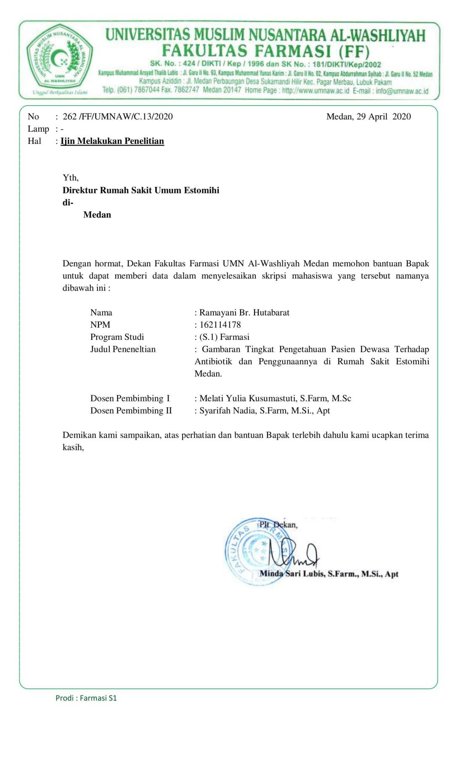

Lampiran 6 : surat izin penelitian dari Rumah Sakit Estomihi

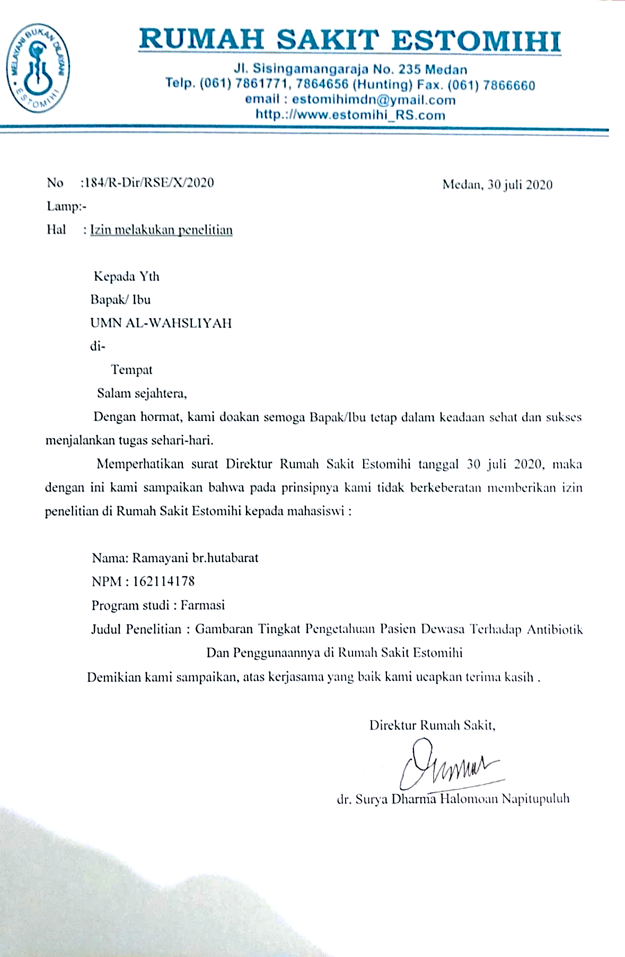

Lampiran 7 : surat izin selesai penelitian

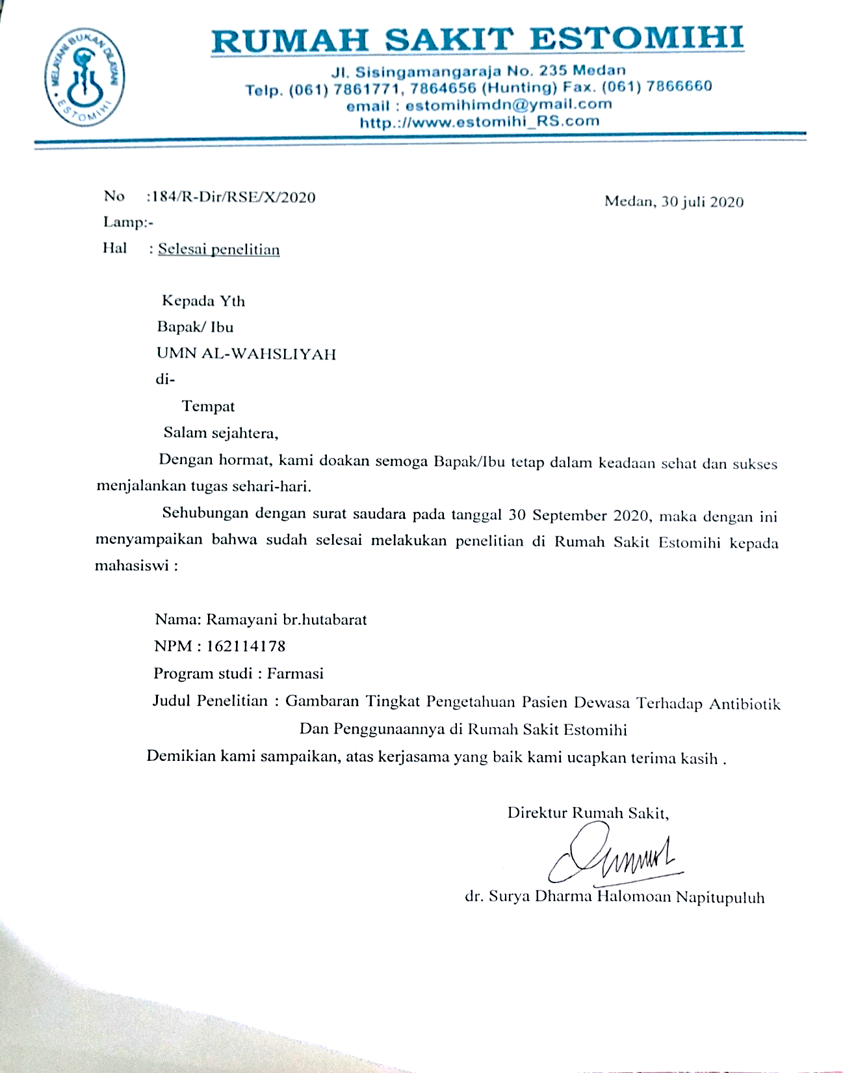

Lampiran 8 : Dokumentasi penelitian

