LAMPIRAN
Lampiran 1. Hasil Determinasi Tumbuhan
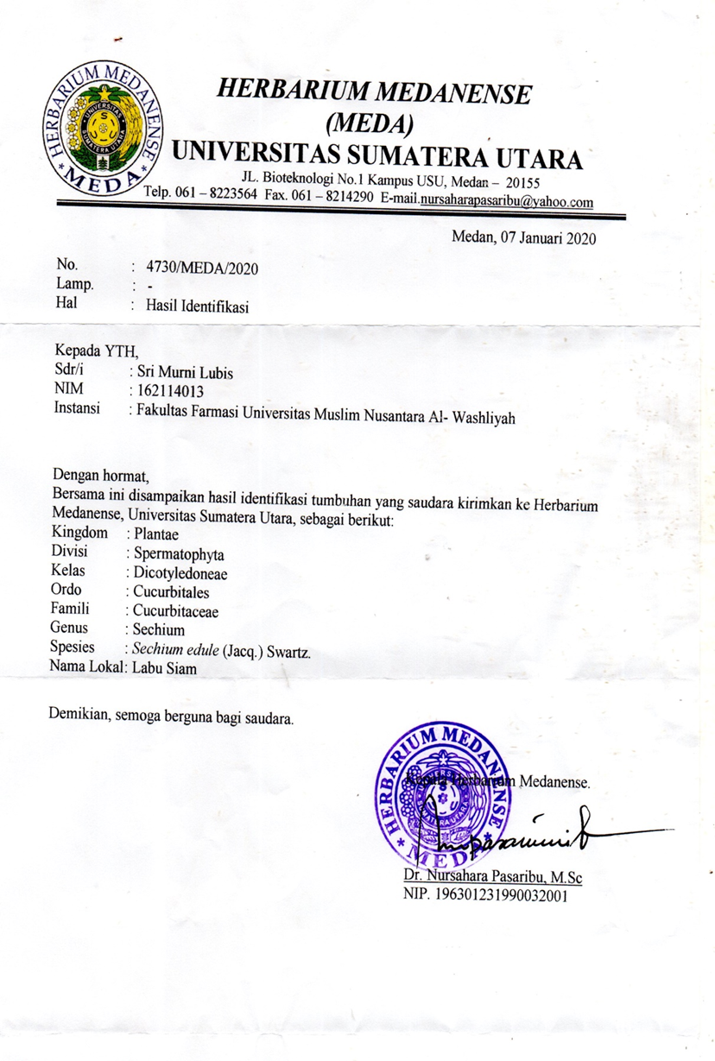

Lampiran 2. Rekomendasi Persetujuan Etik Penelitian Kesehatan
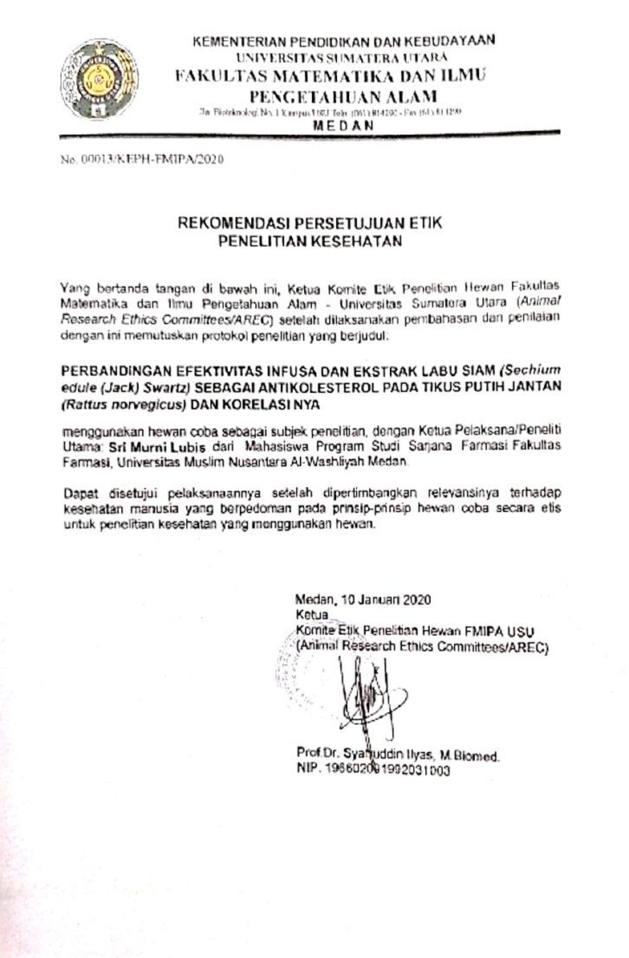

Lampiran 3. Bagan Alir Pembuatan Simplisia
Tumbuhandaun Labu Siam 5 kg

Disortasi basah
Dicuci
Digunting/Dipotong

Beratbasah 4,9 kg

Dikeringkan dilemari pengering

Disortasi kering
Beratkering 1,19 g

Dihaluskan dengan menggunakan blender
Serbuk simplisia daun labu Siam 500 g

Lampiran 4. Bagan Alir Penelitian
Daun Labu Siam
Disaring
Infusa
Dipanaskan dengan suhu 90℃
Serbuk kering
Hasil
Hasil
Karakterisasi
Skerining fitokimia

Serbuk kering
Serbuk kering

Dicuci bersih,ditiriskan, lalu dikeringkan lalu dihaluskan

Lampiran 5. Bagan Alir Skrining Fitokimia dan Karakterisasi
Serbuk Simplisia Daun Labu Siam

Serbuk Simplisia Daun Labu Siam
Serbuk Simplisia Daun Labu Siam

Dipanaskan dengan suhu 90ºC
Infusa DaunLabu Siam
Karakterisasi
SkriningFitokimia

1.PemeriksaanAlkaloida
2.PemeriksaanFlavonoida
3. Pemeriksaan
Tanin
4.PemeriksaanSaponin
5.PemeriksaanSteroida
/Triterpenoida
1.Makroskopik
2.Mikroskopik
3.Penetapan Kadar Air
4.Penetapan Kadar Sari Larut Air
5.Penetapan Kadar Sari LarutEtanol
6.Penetapan Kadar Abu Total
7.Penetapan Kadar Abu TidakLarutdalamAsam

1.Pemeriksaan Alkaloida
2.Pemeriksaan Flavonoida
3. Pemeriksaan
Tanin
4.Pemeriksaan
Saponin
5.Pemeriksaan Steroida/Triterpenoida
Uji Farmakologi

Lampiran 6. Bagan Alir Pengukuran Kadar Kolesterol Darah Tikus Jantan
Tikus

Dikondisikan selama 2 minggu

Dipuasakan Selama 18 Jam
Diukur Kadar Kolesterol Darah Normal

Diteteskan darah pada strip

Kadar Kolesterol Darah Sesudah Diinduksi
Kadar Kolesterol Darah Yang Dinduksi(mg/dl)

Diukur kadar Kolesterol Darah
Tikus hiperkolesterol

Diberikan perlakuan secara oral pada setiap kelompok
- Diberikan Air Matang
- Diberikan Simvastatin 10 mg/kg BB
- Diberika IDLS dosis 80 mg/KgBB
- Diberikan IDLS dosis 160 mg/KgBB
- Diberikan IDLS dosis 240 mg/KgBB

Diukur kadar Kolesterol Darah
kadar Kolesteroldarah tikus (mg/dl)

Lampiran 7. Bagan Alir Pengambilan Darah Tikus Jantan
Tikus
Dipuasakan selama 18 jam

Ekor tikus dibersihkan dengan etanol 70%
Tikus dengan ekor bersih

Dilukai ekor tikus dengan menggunakan jarum suntik

Darah yang keluar diambil secukupnya

Darah diteteskan pada strip asam urat yang telah
dipasang

Angka akan tampil secara otomatis dilayar dan dicatat

kadar Kolesterol darah tikus (mg/dl)

Lampiran 8. Daun Labu Siam Segar Dan Simplisia Daun Labu Siam
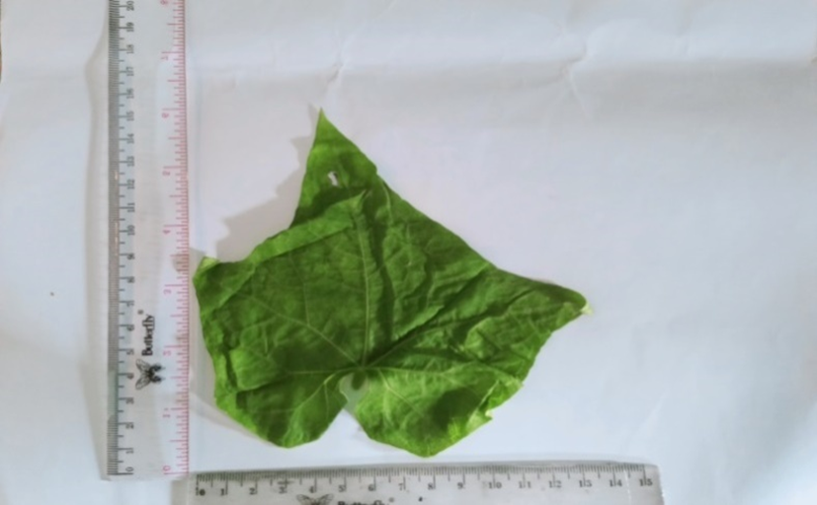
Daun Labu Siam Segar
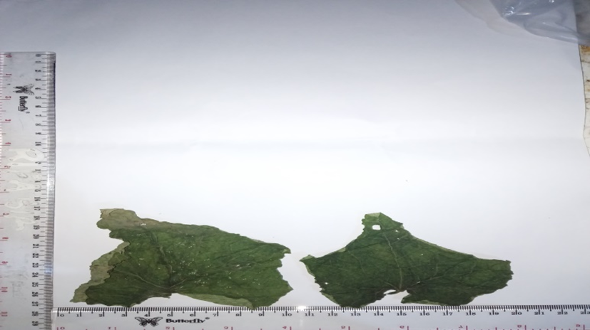
Simplisia Daun Labu Siam

Lampiran 9. Serbuk Daun Labu siam Dan Infusa Daun Labu Siam
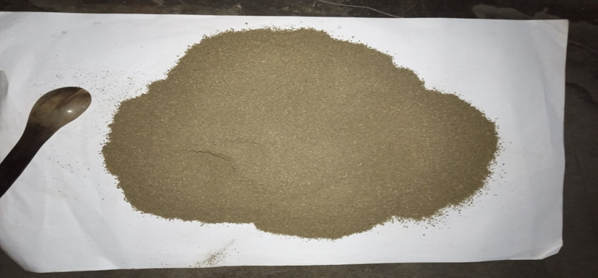
Serbuk Simplisia Daun Labu Siam
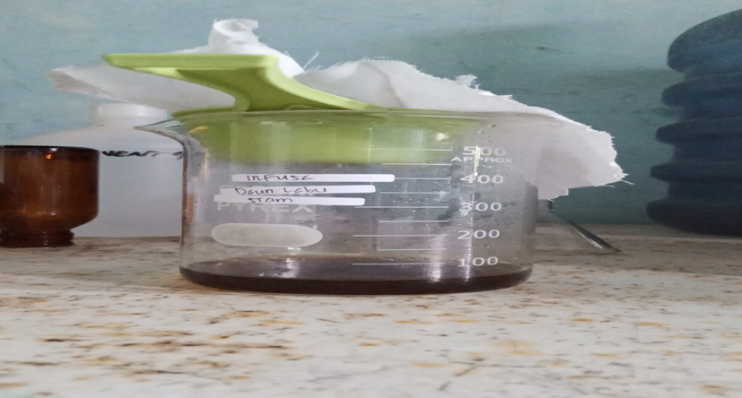
Infusa Daun Labu Siam

Lampiran 10. Mikroskopik Daun Labu Siam (Sechium edule (Jacq) Swartz)
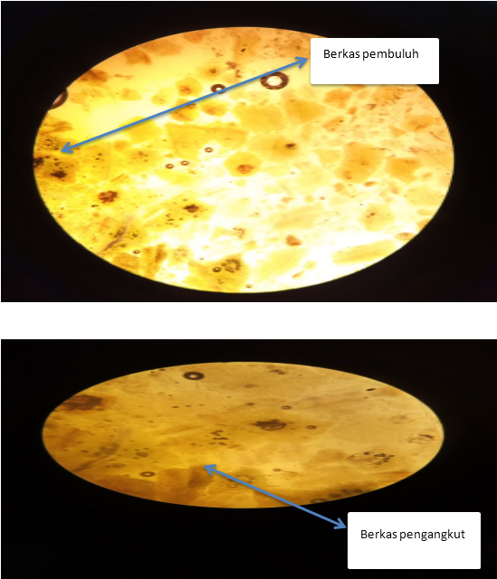

Lampiran 11. Alat Azeotrop, Dan Tanur
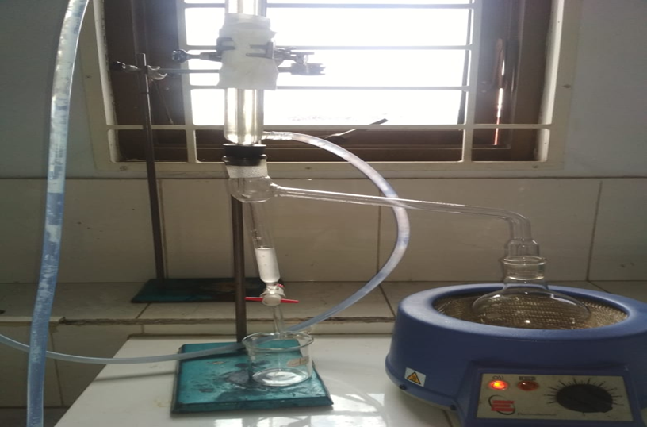
Alat Azeotrop (Penetapan Kadar Air)
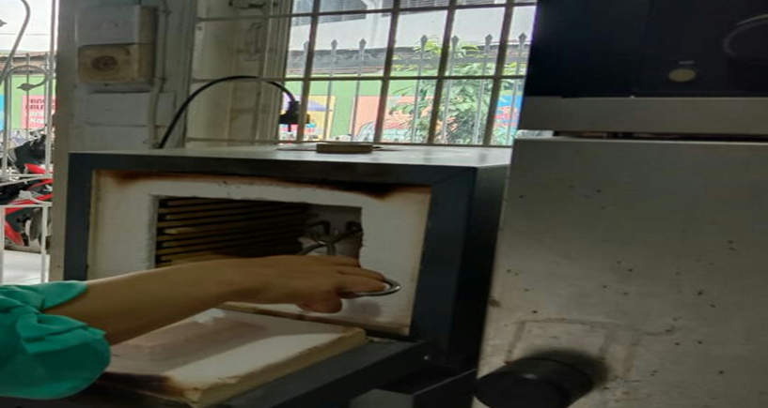
Tanur

Lampiran 12. Hasil Perhitungan Parameter Karakteristik Simplisia
- Perhitungan Hasil Penetapan Kadar Air (Tidak lebih dari 10 %).
$$Kadar Air :\frac{volume II-Volume I}{Berat Sampel}×100 \%$$

Sampel I
Berat sampel : 2,5g
Volume I : 0,7ml
Volume II : 0,9 ml
= $\frac{0,9 ml-0,7 ml}{2,5g}×100 \%=8 \%$
Berat sampel II : 2,5g
Volume I : 0,5ml
Volume II : 0,7ml
= $\frac{0,7 ml-0,5 ml}{2,5g}×100 \%=6 \%$
Berat sampel III : 2,5g
Volume I : 0,6ml
Volume II : 0,8 ml
= $\frac{0,8 ml-0,6 ml}{2,5g}×100 \%=8 \%$
Kadar air rata-rata: =$\frac{8\%+8\%+8 \%}{3}$ = 8%

Kadar air padadaun Labu Siam memenuhi syarat yaitu 8 %, tidak lebih dari 10%.

Lampiran 12. (Lanjutan)
- Perhitungan Kadar Sari Larut dalam Air (8-35 %).
$$kadar sari larut air=\frac{Berat sari ×Faktor pengenceran}{Berat sampel}×100\%$$

Sampel 1
Berat sampel : 5 g
Berat cawan kosong : 57,5 g
Berat cawan$+$sampel : 57,8g
=$\frac{\left(57,5 g-57,8 g\right)×5}{5 g}×100 \%$
=$\frac{0,3 g}{5g}×100\%$ = 30 %
Sampel II
Berat sampel :5 g
Berat cawan kosong :50,7 g
Berat cawan$+$ sampel :51,0 g
= $\frac{\left(50,7 g-51,0 g\right)×5}{5 g}100 \%$
=$\frac{0,3 g}{5 g}×100 \%$ = 30 %
Sampel III
Berat sampel :5 g
Berat cawan kosong :67,74 g
Berat cawan$+$sampel :67,95g
= $\frac{(67,95 g-67,74 g)}{5 g}×100 \%$
= $\frac{0,21 g X 5}{5 g}×100 \%$ = 21 %
Kadar sari larut dalam air rata-rata: =$\frac{30\%+30\%+21 \%}{3}$ = 27 %
Kadar sari larut dalam air pada daun Labu Siam memenuhi syarat yaitu 27% lebih dari 8-35%.

Lampiran 12. (Lanjutan)
- Perhitungan Kadar Sari Larut Dalam Etanol (lebih dari 5-26 %).

Kadar sari larut dalam etanol= $\frac{Berat sari ×Faktor pengenceran }{Berat sampel}×100 \%$

Sampel I
Berat sampel :5 g
Berat cawan kosong :68,15 g
Berat cawan$+$sampel :68,29 g
=$\frac{(68,29g-68,15 g×5}{5 g}×100 \%$
= $\frac{0,14gX5}{5 g}×100 \%$ = 14 %
Sampel II
Berat sampel :5 g
Berat cawan kosong :68,14g
Berat cawan$+$ sampel :68,30g
= $\frac{\left( 68,30g-68,14 g\right)×5}{5 g}×100 \%$
= $\frac{o,16gx5}{5 g}×100 \%$ = 16 %
Sampel III
Berat sampel :5 g
Berat cawan kosong :68,13 g
Berat cawan$+$ sampel :68,31g
= $\frac{\left(68,31 g-68,13 g\right)×5}{5 g}×100 \%$
= $\frac{o,18gx5}{5 g}×100 \%$ = 18 %
Kadar sari larut dalam etanol rata-rata: = $\frac{14\%+16\%+18 \%}{3}$= 16 %
Kadar sari larut dalam etanol pada daun Labu Siam memenuhi syarat yaitu 16 %, lebih dari 5-26 %.

Lampiran 12. (Lanjutan)
- Perhitungan Penetapan Kadar Abu Total (Tidak lebih dari 7-14 %)
Kadar Abu = $\frac{Berat abu }{Berat sampel }×100 \%$

Sampel I
Berat sampel :2g
Berat cawan kosong :65,2 g
Berat cawan$+$ sampel :65,6 g
= $\frac{\left(65,6g-65,2g\right)}{2g}×100 \%$
= $\frac{0,4 g}{2 g}×100 \%$ = 20 %
Sampel II
Berat sampel :2 g
Berat cawan kosong :65,8 g
Berat cawan$+$ sampel :66,2 g
= $\frac{(66,2g-65,8 g}{2 g}×100 \%$
= $\frac{0,4g}{2 g}×100 \%$ = 20 %
Sampel III
Berat sampel :2 g
Berat cawan kosong :64,0 g
Berat cawan$+$ sampel :64,2 g
= $\frac{(64,2 g-64,0g)}{2 g}×100 \%$
= $\frac{0,2 g}{2 g}×100 \%$= 10%
Kadar abu total rata-rata :=$\frac{20 \% +20 \% +10 \%}{3}$= 16,6 %
Kadar abu total pada daun Labu Siam memenuhi syarat yaitu 16,6%,tidak lebih dari 7-14%.

Lampiran 12. (lanjutan)
- Perhitungan Kadar Abu tidak Larut dalam Asam (tidak lebih dari 1-10%).
Kadar abu tidak larut asam = $\frac{Berat abu}{Berat sampel}×100 \%$

Sampel I
Berat sampel :2g
Berat cawan kosong :65,6 g
Berat cawan$+$ sampel :65,11 g
= $\frac{(65,11 g-65,6g}{2 g}×100 \%$ = 25 %
Sampel II
Berat sampel :2 g
Berat cawan kosong :66,2 g
Berat cawan$+$ sampel :65,72 g
= $\frac{(65,72 g-66,2 g}{2 g}×100 \% =25\%$
Sampel III
Berat sampel :2 g
Berat cawan kosong :64,2g
Berat cawan$+$sampel :63,84 g
= $\frac{63,84 g-64,2g}{2 g}×100 \%$= 20 %
Kadar abu tidak larut dalam asam rata-rata =$\frac{25 \% +25 \% +20 \% }{3}$ = 23,3%
Kadar abu tidak larut dalam asam pada daun Labu Siam tidak memenuhi syarat yaitu 23,3%, lebih dari 1-10 %

Lampiran 13. Tabel Konversi Perhitungan Dosis antara Jenis Hewan dan Manusia
Tabel . Konversi Perhitungan Dosis antara Jenis Hewan dan Manusia
Hewan dan BB rata-rata | Mencit  20 g | Tikus  200 g | Marmut  400 g | Kelinci  1,5 Kg | Kucing  2 Kg | Kera  4 Kg | Anjing  12 Kg | Manusia  70 Kg
Mencit  20 g | 1,0 | 7,0 | 12,29 | 27,8 | 28,7 | 64,1 | 124,2 | 387,9
Tikus  200 g | 0,14 | 1,0 | 1,74 | 3,9 | 4,2 | 9,2 | 17,8 | 60,5
Marmut  400 g | 0,08 | 0,57 | 1,0 | 2,25 | 2,4 | 5,2 | 10,2 | 31,5
Kelinci  1,5 Kg | 0,04 | 0,25 | 0,44 | 1,0 | 1,06 | 2,4 | 4,5 | 14,2
Kucing  2 Kg | 0,03 | 0,23 | 0,41 | 0,92 | 1,0 | 2,2 | 4,1 | 13,0
Kera  4 Kg | 0,016 | 0,11 | 0,19 | 0,42 | 0,45 | 1,0 | 1,9 | 6,1
Anjing  12 Kg | 0,008 | 0,06 | 0,10 | 0,22 | 0,24 | 0,52 | 1,0 | 3,1
Manusia  70 Kg | 0,0026 | 0,018 | 0,031 | 0,07 | 0,76 | 0,16 | 0,32 | 1,0

Lampiran 14. Perhitungan Dosis
1.Dosis Simvastatin
Konversi dosis manusia ke dosis tikus
Dosis lazim Simvastatin pada manusia : 10 mg
Dosis tikus : 0,018
Berat badantikus : 200 g
10 mg x 0,018 = 0,18 mg/200 g
= 0,18 mg/0,02 Kg
= 9 mg/KgBB
Konsentrasi 50 mg/ 100 ml
Dosis =$\frac{Dosis (g)}{0,5} x berat badan tikus (g)$

Contoh :
$\frac{0,009 g x 200 g}{0,5}$= 3,6 ml

Lampiran 14. (Lanjutan)
2. IDLS 80 mg/kgBB
Berat Tikus = 200 g
Konsentrasi = 1%
1 g/100ml = 10mg/ml
Dosis = $\frac{ Dosis (g)}{100} x berat badan tikus (g)$

Contoh :
Dosis = $\frac{80 mg}{1000 g}X200 g=16 mg$
Volume = $\frac{Dosis}{Konsentrasi}= \frac{16 mg }{10 mg/ml}=1,6 ml$
3. . IDLS 160 mg/kgBB
Berat Tikus = 200 g
Konsentrasi = 1%
1 g/100ml = 10mg/ml
Dosis = $\frac{ Dosis (g)}{100} x berat badan tikus (g)$

Lampiran 14. (Lanjutan)
Contoh :
Dosis = $\frac{160 mg}{1000 g}X200 g=32 mg$
Volume = $\frac{Dosis}{Konsentrasi}= \frac{32 mg }{10 mg/ml}=3,2 ml$

3. IDLS 240 mg/kgBB
Berat Tikus = 200 g
Konsentrasi = 1%
1 g/100ml = 10mg/ml
Dosis = $\frac{ Dosis (g)}{100} x berat badan tikus (g)$

Contoh :
Dosis = $\frac{240 mg}{1000 g}X200 g=48 mg$
Volume = $\frac{Dosis}{Konsentrasi}= \frac{48 mg }{10 mg/ml}=4,8 ml$

Lampiran 15. Hewan Percobaan Dan Alat untuk mengukur kadar Kolesterol
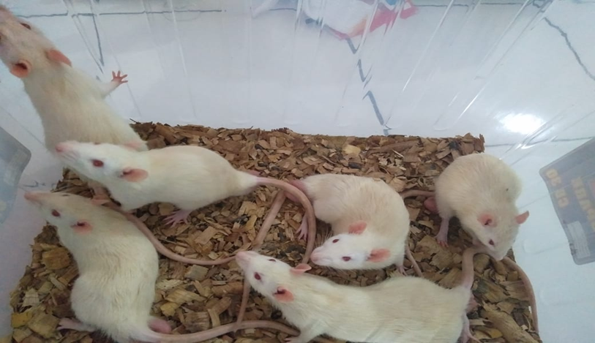
Tikus (Rattus Novergicus)
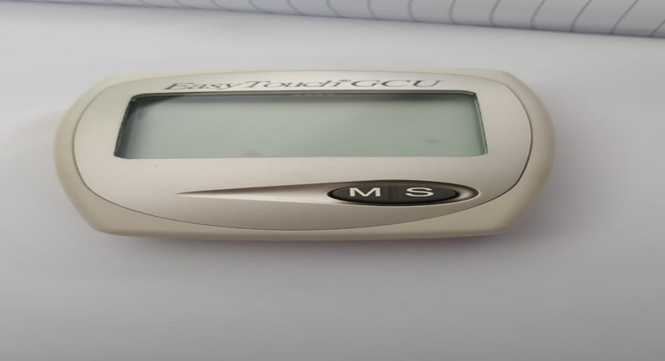
Alat Pengukur Kadar Kolesterol

Lampiran 16. Pengambilan darah, pemberian induksi Telur Bebek ,pemberian oral, Pengukuran kadar Kolesterol Darah
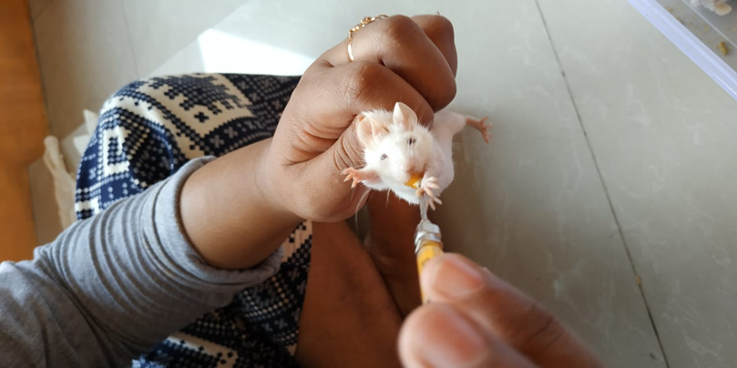
Pemeberiaan Induksi Telur Bebek
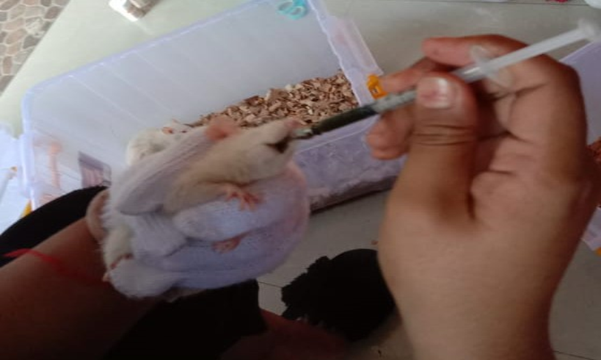
Pemberian secara Oral

Lampiran 16. (lanjutan)
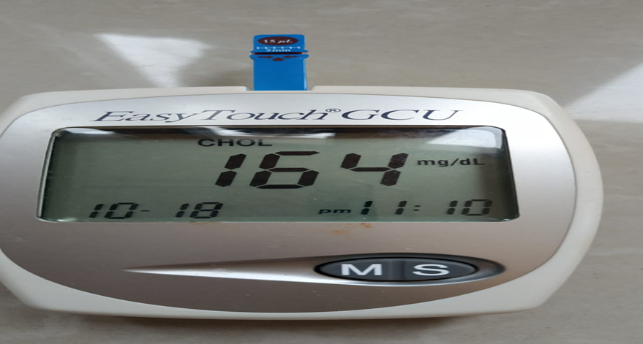
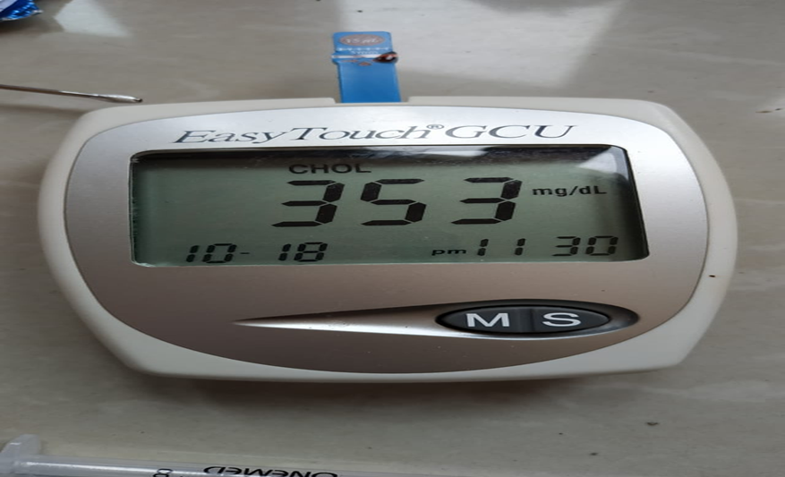
Pengecekan Kadar Kolesterol Darah Pada Tikus Jantan

Lampiran 17. Data Semua Hasil Pengukuran Kolesterol Dalam Darah Tikus Jantan
- Kontrol (-) Air Matang
N0 | KKDN | Induksi | 1 jam | 2 jam | 3 jam | 4 jam | 5 jam | 6 jam
1 | 185 | 395 | 395 | 356 | 350 | 348 | 301 | 260
2 | 180 | 380 | 395 | 340 | 373 | 341 | 348 | 280
3 | 191 | 385 | 376 | 360 | 353 | 330 | 340 | 330
4 | 179 | 388 | 391 | 395 | 350 | 360 | 348 | 340
5 | 190 | 395 | 346 | 300 | 299 | 294 | 290 | 380
rata-rata | 185 | 388,6 | 380,6 | 350,2 | 345 | 334,6 | 325,4 | 318
SD | 5,522681 | 6,503845 | 20,86384 | 34,49928 | 27,44995 | 25,17538 | 27,76329 | 48,16638

- Kontrol + (Simvastatin 10 mg/Kg BB)
N0 | KKDN | Induksi | 1 jam | 2 jam | 3 jam | 4 jam | 5 jam | 6 jam
1 | 170 | 291 | 282 | 273 | 253 | 233 | 195 | 188
2 | 118 | 227 | 217 | 211 | 198 | 195 | 190 | 187
3 | 190 | 256 | 223 | 220 | 199 | 197 | 192 | 175
4 | 176 | 380 | 360 | 240 | 221 | 240 | 200 | 175
5 | 188 | 300 | 280 | 275 | 251 | 210 | 190 | 164
rata-rata | 168,4 | 290,8 | 272,4 | 243,8 | 224,4 | 215 | 193,4 | 177,8
SD | 29,37346 | 57,71222 | 57,73474 | 29,50763 | 26,82909 | 20,6034 | 4,219005 | 9,934787

- Infusa dosis 80 mg/Kg BB
NO | KKDN | Induksi | 1 jam | 2 jam | 3jam | 4 jam | 5 jam | 6 jam
1 | 185 | 395 | 373 | 348 | 280 | 260 | 240 | 210
2 | 180 | 380 | 365 | 341 | 331 | 271 | 246 | 221
3 | 191 | 385 | 361 | 330 | 310 | 295 | 250 | 220
4 | 179 | 388 | 370 | 360 | 331 | 296 | 260 | 230
5 | 190 | 395 | 323 | 294 | 260 | 269 | 240 | 200
rata-rata | 185 | 388,6 | 358,4 | 334,6 | 302,4 | 278,2 | 247,2 | 216,2
SD | 5,522681 | 6,503845 | 20,31748 | 25,17538 | 31,59589 | 16,33095 | 8,318654 | 11,49783

Lampiran 17. (Lanjutan)
- Infusa dosis 160 mg/Kg BB
NO | KKDN | Induksi | 1 jam | 2 jam | 3 jam | 4 jam | 5 jam | 6 jam
1 | 180 | 395 | 350 | 301 | 290 | 246 | 220 | 197
2 | 182 | 395 | 373 | 348 | 307 | 260 | 231 | 198
3 | 186 | 376 | 353 | 340 | 312 | 286 | 250 | 190
4 | 192 | 391 | 350 | 348 | 321 | 300 | 260 | 199
5 | 169 | 300 | 300 | 290 | 278 | 243 | 220 | 189
rata-rata | 181,8 | 371,4 | 345,2 | 325,4 | 301,6 | 267 | 236,2 | 194,6
SD | 8,497058 | 40,67309 | 27,03146 | 27,76329 | 17,358 | 25,07987 | 18,08867 | 4,722288

- Infusa Dosis 240 mg/Kg BB
N0 | KKDN | Induksi | 1 jam | 2 jam | 3 jam | 4 jam | 5 jam | 6 jam
1 | 180 | 356 | 340 | 300 | 295 | 270 | 220 | 175
2 | 190 | 340 | 340 | 332 | 290 | 250 | 200 | 182
3 | 185 | 360 | 351 | 340 | 281 | 230 | 199 | 191
4 | 176 | 395 | 360 | 300 | 310 | 270 | 240 | 180
5 | 166 | 300 | 296 | 286 | 280 | 260 | 235 | 190
rata-rata | 179,4 | 350,2 | 337,4 | 311,6 | 291,2 | 256 | 218,8 | 183,6
SD | 9,154234 | 34,49928 | 24,613 | 23,16894 | 12,2352 | 16,7332 | 19,09712 | 6,80441

Lampiran 18. Hasil SPSS 20

Hasil Tes Uji Normalitas

Tests of Normality
 | Kelompok | Kolmogorov-Smirnovª |  |  | Shapiro-Wilk
 |  | Statistic | df | Sig. | Statistic | df | Sig.
Normal | Kontrol - | .217 | 5 | .200* | .885 | 5 | .331
 | Kontrol + | .322 | 5 | .099 | .789 | 5 | .066
 | IDLS 80 mg/kg BB | .217 | 5 | .200* | .885 | 5 | .331
 | IDLS 160 mg/kg BB | .216 | 5 | .200* | .970 | 5 | .873
 | IDLS 240 mg/kg BB | .155 | 5 | .200* | .980 | 5 | .934
Induksi | Kontrol - | .237 | 5 | .200* | .906 | 5 | .446
 | Kontrol + | .237 | 5 | .200* | .947 | 5 | .714
 | IDLS 80 mg/kg BB | .237 | 5 | .200* | .906 | 5 | .446
 | IDLS 160 mg/kg BB | .345 | 5 | .052 | .693 | 5 | .008
 | IDLS 240 mg/kg BB | .188 | 5 | .200* | .970 | 5 | .877
Jam1 | Kontrol - | .291 | 5 | .193 | .793 | 5 | .071
 | Kontrol + | .234 | 5 | .200* | .896 | 5 | .387
 | IDLS 80 mg/kg BB | .351 | 5 | .043 | .759 | 5 | .036
 | IDLS 160 mg/kg BB | .370 | 5 | .024 | .830 | 5 | .138
 | IDLS 240 mg/kg BB | .342 | 5 | .056 | .843 | 5 | .173
Jam2 | Kontrol - | .188 | 5 | .200* | .970 | 5 | .877
 | Kontrol + | .239 | 5 | .200* | .879 | 5 | .305
 | IDLS 80 mg/kg BB | .228 | 5 | .200* | .917 | 5 | .510
 | IDLS 160 mg/kg BB | .301 | 5 | .159 | .807 | 5 | .093
 | IDLS 240 mg/kg BB | .292 | 5 | .190 | .886 | 5 | .337
Jam3 | Kontrol - | .372 | 5 | .022 | .826 | 5 | .131
 | Kontrol + | .239 | 5 | .200* | .838 | 5 | .158
 | IDLS 80 mg/kg BB | .217 | 5 | .200* | .887 | 5 | .340
 | IDLS 160 mg/kg BB | .222 | 5 | .200* | .953 | 5 | .758
 | IDLS 240 mg/kg BB | .198 | 5 | .200* | .908 | 5 | .456
Jam4 | Kontrol - | .228 | 5 | .200* | .917 | 5 | .510
 | Kontrol + | .209 | 5 | .200* | .877 | 5 | .298
 | IDLS 80 mg/kg BB | .270 | 5 | .200* | .855 | 5 | .211
 | IDLS 160 mg/kg BB | .210 | 5 | .200* | .898 | 5 | .400
 | IDLS 240 mg/kg BB | .201 | 5 | .200* | .881 | 5 | .314
Jam5 | Kontrol - | .301 | 5 | .159 | .807 | 5 | .093
 | Kontrol + | .230 | 5 | .200* | .866 | 5 | .251
 | IDLS 80 mg/kg BB | .207 | 5 | .200* | .891 | 5 | .363
 | IDLS 160 mg/kg BB | .215 | 5 | .200* | .874 | 5 | .284
 | IDLS 240 mg/kg BB | .238 | 5 | .200* | .874 | 5 | .281
Jam6 | Kontrol - | .198 | 5 | .200* | .957 | 5 | .787
 | Kontrol + | .223 | 5 | .200* | .900 | 5 | .409
 | IDLS 80 mg/kg BB | .229 | 5 | .200* | .965 | 5 | .845
 | IDLS 160 mg/kg BB | .294 | 5 | .181 | .825 | 5 | .127
 | IDLS 240 mg/kg BB | .227 | 5 | .200* | .919 | 5 | .525
*. This is a lower bound of the true significance.
a. Lilliefors Significance Correction

Lampiran 18. Hasil SPSS 20 (Lanjutan)
Test Uji Homogenitas

Test of Homogeneity of Variances
 | Levene Statistic | df1 | df2 | Sig.
Normal | 2.646 | 4 | 20 | .064
Induksi | 2.275 | 4 | 20 | .097
Jam1 | 1.679 | 4 | 20 | .194
Jam2 | .229 | 4 | 20 | .919
Jam3 | 1.563 | 4 | 20 | .223
Jam4 | .561 | 4 | 20 | .694
Jam5 | 8.783 | 4 | 20 | .000
Jam6 | 9.511 | 4 | 20 | .000

Lampiran 18. Hasil SPSS 20 (Lanjutan)
Hasil Uji Anova

ANOVA
 |  | Sum of Squares | df | Mean Square | F | Sig.
Normal | Between Groups | 940.640 | 4 | 235.160 | 1.089 | .389
 | Within Groups | 4319.200 | 20 | 215.960
 | Total | 5259.840 | 24
Induksi | Between Groups | 33144.640 | 4 | 8286.160 | 6.619 | .001
 | Within Groups | 25039.200 | 20 | 1251.960
 | Total | 58183.840 | 24
Jam1 | Between Groups | 32916.400 | 4 | 8229.100 | 7.457 | .001
 | Within Groups | 22071.600 | 20 | 1103.580
 | Total | 54988.000 | 24
Jam2 | Between Groups | 33973.440 | 4 | 8493.360 | 10.611 | .000
 | Within Groups | 16009.200 | 20 | 800.460
 | Total | 49982.640 | 24
Jam3 | Between Groups | 37877.440 | 4 | 9469.360 | 16.200 | .000
 | Within Groups | 11690.400 | 20 | 584.520
 | Total | 49567.840 | 24
Jam4 | Between Groups | 37351.360 | 4 | 9337.840 | 20.899 | .000
 | Within Groups | 8936.000 | 20 | 446.800
 | Total | 46287.360 | 24
Jam5 | Between Groups | 49461.200 | 4 | 12365.300 | 39.896 | .000
 | Within Groups | 6198.800 | 20 | 309.940
 | Total | 55660.000 | 24
Jam6 | Between Groups | 66750.960 | 4 | 16687.740 | 31.853 | .000
 | Within Groups | 10478.000 | 20 | 523.900
 | Total | 77228.960 | 24

Lampiran 18. Hasil SPSS 20 (Lanjutan)

Jam1
Tukey HSD
Kelompok | N | Subset for alpha = 0.05
 |  | 1 | 2
Kontrol + | 5 | 272.40
IDLS 240 mg/kg BB | 5 |  | 337.40
IDLS 160 mg/kg BB | 5 |  | 345.20
IDLS 80 mg/kg BB | 5 |  | 358.40
Kontrol - | 5 |  | 380.60
Sig. |  | 1.000 | .277
Means for groups in homogeneous subsets are displayed.
a. Uses Harmonic Mean Sample Size = 5.000.

Jam2
Tukey HSD
Kelompok | N | Subset for alpha = 0.05
 |  | 1 | 2
Kontrol + | 5 | 243.80
IDLS 240 mg/kg BB | 5 |  | 311.60
IDLS 160 mg/kg BB | 5 |  | 325.40
IDLS 80 mg/kg BB | 5 |  | 334.60
Kontrol - | 5 |  | 350.20
Sig. |  | 1.000 | .236
Means for groups in homogeneous subsets are displayed.
a. Uses Harmonic Mean Sample Size = 5.000.

Lampiran 18. Hasil SPSS 20 (Lanjutan)

Jam3
Tukey HSD
kelompok | N | Subset for alpha = 0.05
 |  | 1 | 2 | 3
Kontrol + | 5 | 224.40
IDLS 240 mg/kg BB | 5 |  | 291.20
IDLS 160 mg/kg BB | 5 |  | 301.60 | 301.60
IDLS 80 mg/kg BB | 5 |  | 302.40 | 302.40
Kontrol - | 5 |  |  | 345.00
Sig. |  | 1.000 | .946 | .068
Means for groups in homogeneous subsets are displayed.
a. Uses Harmonic Mean Sample Size = 5.000.

Jam4
Tukey HSD
kelompok | N | Subset for alpha = 0.05
 |  | 1 | 2 | 3
Kontrol + | 5 | 215.00
IDLS 240 mg/kg BB | 5 |  | 256.00
IDLS 160 mg/kg BB | 5 |  | 267.00
IDLS 80 mg/kg BB | 5 |  | 278.20
Kontrol - | 5 |  |  | 334.60
Sig. |  | 1.000 | .479 | 1.000
Means for groups in homogeneous subsets are displayed.
a. Uses Harmonic Mean Sample Size = 5.000.

Lampiran 18. Hasil SPSS 20 (Lanjutan)
Jam5
Tukey HSD
Kelompok | N | Subset for alpha = 0.05
 |  | 1 | 2 | 3
Kontrol + | 5 | 193.40
IDLS 240 mg/kg BB | 5 | 218.80 | 218.80
IDLS 160 mg/kg BB | 5 |  | 236.20
IDLS 80 mg/kg BB | 5 |  | 247.20
Kontrol - | 5 |  |  | 325.40
Sig. |  | .192 | .119 | 1.000
Means for groups in homogeneous subsets are displayed.
a. Uses Harmonic Mean Sample Size = 5.000.

Jam6
Tukey HSD
Kelompok | N | Subset for alpha = 0.05
 |  | 1 | 2
Kontrol + | 5 | 177.80
IDLS 240 mg/kg BB | 5 | 183.60
IDLS 160 mg/kg BB | 5 | 194.60
IDLS 80 mg/kg BB | 5 | 216.20
Kontrol - | 5 |  | 318.00
Sig. |  | .098 | 1.000
Means for groups in homogeneous subsets are displayed.
a. Uses Harmonic Mean Sample Size = 5.000.

Lampiran 19. Korelasi

Data Infusa Vs Data Ekstrak
NO | X | Y | X2 | Y2 | XY
1 | 89 | 188 | 7.921 | 35.344 | 16.732
2 | 87 | 187 | 7.569 | 34.969 | 16.269
3 | 88 | 175 | 7.744 | 30.625 | 15.400
4 | 89 | 175 | 7.921 | 30.625 | 15.575
5 | 90 | 164 | 8.100 | 26.896 | 14,76
∑ | 443 | 889 | 39.255 | 158.459 | 78.736
ẋ | 88,6 | 177,8 | 7.851 | 31.692 | 15.994

r1 = $\frac{n \left(∑xy\right)-(∑x)(∑y)}{√\left[n\left(∑x^{2}\right)-{\left(∑x\right)}^{2}\right][n\left({∑y}^{2}\right)-{\left(∑y\right)}^{2}]}$ =
$$\frac{5 \left(78,736\right)-(443)(889)}{√\left[5\left(39,255\right)-{\left(443\right)}^{2}\right][5\left(158,459\right)-{\left(889\right)}^{2}]}$$
= 0,297

NO | X | Y | X2 | Y2 | XY
1 | 114 | 188 | 12.996 | 7.921 | 21.432
2 | 116 | 187 | 13.456 | 7.569 | 21.692
3 | 115 | 175 | 13.225 | 7.744 | 20.125
4 | 114 | 175 | 12.996 | 7.921 | 19.950
5 | 115 | 164 | 13.225 | 8.100 | 18.860
∑ | 574 | 889 | 65.898 | 39.225 | 102.050
ẋ | 114,8 | 177,8 | 13.180 | 13.080 | 20.412

r2 =$\frac{n \left(∑xy\right)-(∑x)(∑y)}{√\left[n\left(∑x^{2}\right)-{\left(∑x\right)}^{2}\right][n\left({∑y}^{2}\right)-{\left(∑y\right)}^{2}]}$
$$=\frac{5 (102,050)-(574)(889)}{√\left[5\left(65,898\right)-{\left(574\right)}^{2}\right][5\left(39,225\right)-{\left(889\right)}^{2}]}$$
= 0.011

Lampiran 19. Korelasi (lanjutan)

NO | X | Y | X2 | Y2 | XY
1 | 114 | 175 | 12.996 | 30.625 | 25.200
2 | 116 | 182 | 13.456 | 33.124 | 21.112
3 | 115 | 191 | 13.225 | 35.481 | 21.965
4 | 114 | 180 | 12.996 | 32.400 | 20.520
5 | 115 | 190 | 13.225 | 36.100 | 21.850
∑ | 574 | 918 | 65.898 | 167,73 | 110.647
ẋ | 114,8 | 183,6 | 13.180 | 33.546 | 22.129

r3 = $\frac{n \left(∑xy\right)-(∑x)(∑y)}{√\left[n\left(∑x^{2}\right)-{\left(∑x\right)}^{2}\right][n\left({∑y}^{2}\right)-{\left(∑y\right)}^{2}]}$ =
$$\frac{5 \left(110,647\right)-(574)(918)}{√\left[5\left(65,898\right)-{\left(574\right)}^{2}\right][5\left(167,73\right)-{\left(918\right)}^{2}]}$$
= 111,365

R = $\sqrt{\frac{{r1}^{2 }+ {r2}^{2}-2r_{1}r_{2}r_{3}}{1-{r_{3}}^{2}}}$ = $\sqrt{\frac{{(0,297)}^{2}+{(0,011)}^{2}-2(0,297)(0,011)(111,365)}{1-{(111,365)}^{2}}}$
= 2,2705

Fh = $\frac{R^{2}/K}{(1-R^{2})/(n-k-1)}$ =$\frac{{(2,2705}^{2})/2}{(1-\left({2,2705}^{2}\right))/(5-2-1)}$
= - 1,240

Lampiran 20. Tabel Uji F
