**Lampiran 1**. Hasil Determinasi Tumbuhan

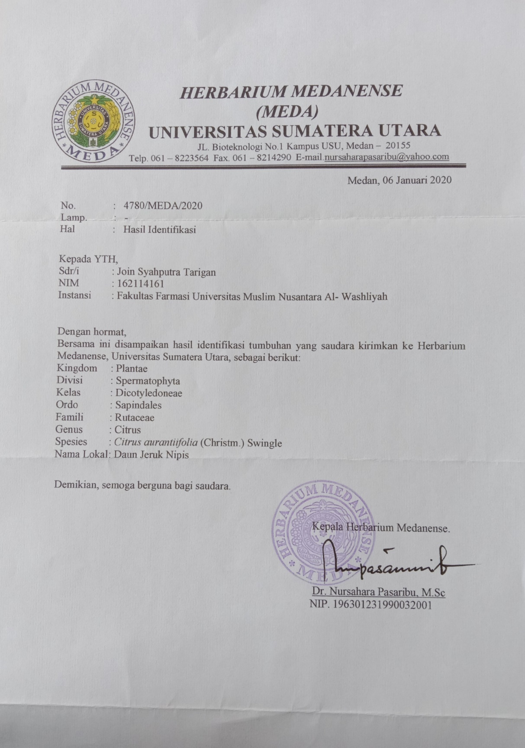

**Lampiran 2.** Gambar tumbuhan daun jeruk nipis dan hasil pengolahannya

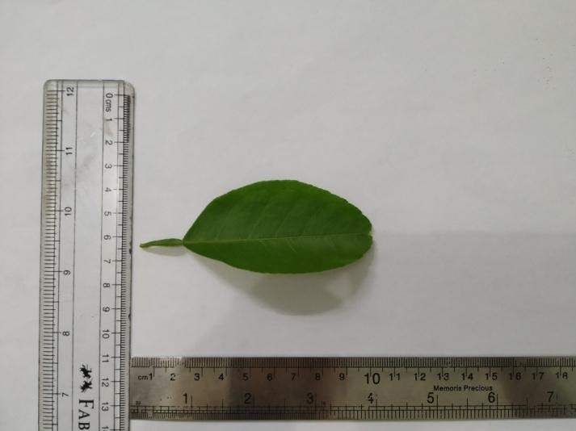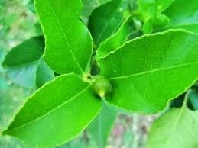

Gambar pohon jeruk nipis Gambar daun jeruk nipis segar

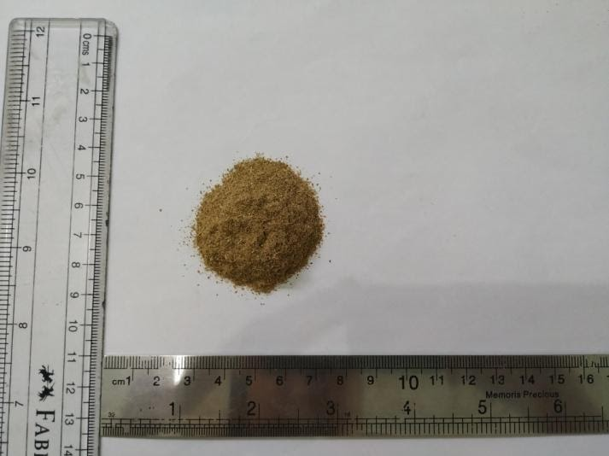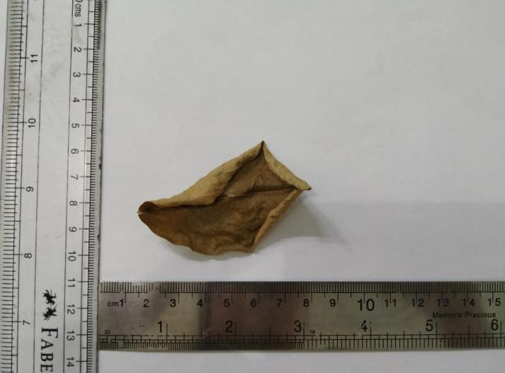

Gambar simplisia daun jeruk nipis Gambar serbuk simplisia daun jeruk nipis

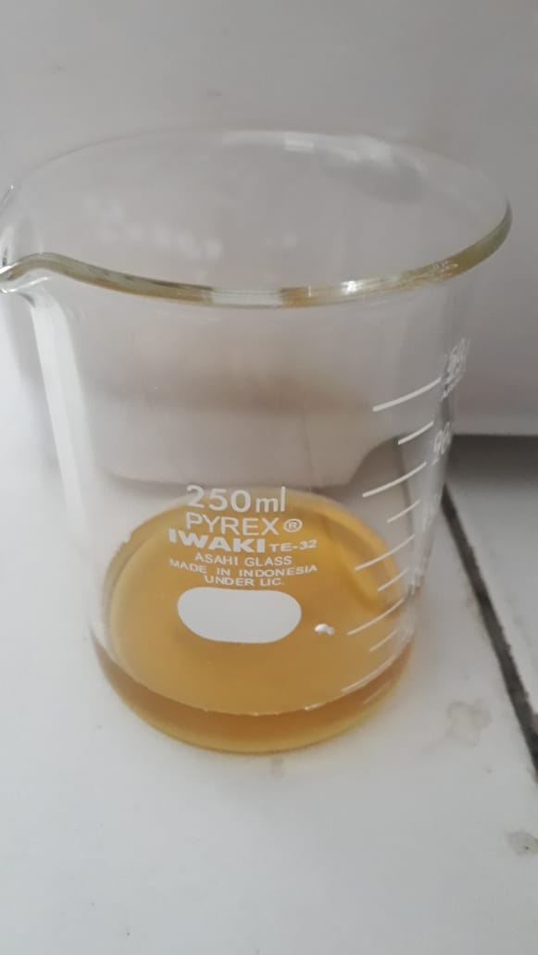

Gambar infusa daun jeruk nipis 2%

**Lampiran 3.** Bagan kerja penelitian

Simplisia daun jeruk nipis 5kg

Dicuci bersih, ditiriskan, dikeringkan, kemudian di haluskan.

Hingga menjadi serbuk

Serbuk simplisia daun jeruk nipis

Serbuk simplisia daun jeruk nipis

karakterisasi

Serbuk simplisia daun jeruk nipis

Skrining fitokimia

1. Pemeriksaan al kaloid
2. Pemeriksaan plavonoid
3. Pemeriksaan tannin
4. Pemeriksaan saponin
5. Pemeriksaan glikosida

Penetapan Kadar Air

Uji efektivitas analgesik

Infusa daun jeruk nipis 2%

**Lampiran 4**. Bagan kerja uji analgesik

25 ekor mencit putih jantan yang sehat

**Lampiran 5.** Bagan kerja penetapan kadar air

Jumlah geliat mencit

Dihitung jumlah geliat tiap 10 menit sampai menit ke 60

Setelah 10 menit diamati setiap kelompok diberikan secara peroral

Kel I : Air suling

Kel II : Metampiron 1%

Kel III : IDJN 100 mg/Kg BB

Kel IV : IDJN 200 mg/Kg BB

Kel V : IDJN 300 mg/Kg BB

Dihitung jumlah geliat tiap 5 menit sampai menit ke 10

Mencit nyeri

Diinduksi asam asetat 1% secara intraperitoneal

Dikelompokkan secara acak menjadi 5 kelompok masing-masing kelompok 5 ekor mencit

Ditimbang berat badan

Dipuaskaan selama 18 jam, dengan tetap diberi air minum

Diadaptasikan selama 1 minggu

Toluen 200 mL

Dimasukana kedalam labudestilasi + air suling 2mL

Dipanaskan selama 15 menit

Disuling sampai tetesan air berakhir

Toluene jenuh

Dibaca volume air awal

Dimasukan 5 gram serbuk daun jeruk nipis

Toluene jenuh + sampel serbuk simplisia daun jeruk nipis

Dipanaskan selama 15 menit

Disuling selama 2 jam sampai tetesan air berakhir

Toluene jenuh + sampel serbuk simplisia daun jeruk nipis yang tidak mengandung air

Didinginkan

Baca volume air akhir

Dihitung kadar air

**Lampiran 6**. Perhitungan kadar air dari Serbuk simplisia daun jeruk nipis

Kadar air (%) = $\frac{Volume akhir air – volumeawal air (mL) }{Berat sampel (g)}$ x 100%

Sampel 1

Berat sampel = 5,069 g

Volume air awal = 2 mL

Volume air akhir = 1,7 mL

Kadar air (%) = $\frac{(2 – 1,7) ml) }{5,069 g}$ x 100% = 5,91 %

Sampel 2

Berat sampel = 5,061 g

Volume air = 2 mL

Volume air akhir = 1,5 mL

Kadar air (%) = $\frac{\left(2-1,5 \right)ml)}{5,061} x 100\%=9, 87 \%$

Sampel 3

Berat sampel = 5,048 g

Volume air = 2 mL

Volume air akhir = 1,7 mL

Kadar air (%) = $\frac{\left( 2-1,7 \right)ml )}{5, 048} x 100 \%=5, 94\%$

Kadar air rata-rata = 5,91+ 9,87+ 5,94 = 7,24 %

3

**Lampiran 7**. Perhitungan dosis dan volume pemberian infusa daun jeruk nipis

1. Untuk Infusa dosis 100mg/kgBB

dibuat dengan konsentrasi 2% = 2g serbuk simplisia daun jeruk nipis/ 100 mL

* 1. Untuk berat mencit 24,6 g = $\frac{24,6 g}{1000 g}$ x 100 mg= 2,46 mg

Volume infusa yang diberikan = $\frac{2,46mg}{2000 mg}$ x 100 mL= 0,123 mL

* 1. Untuk berat mencit 24,9 g = $\frac{24,9 g}{1000 g}$ x 100 mg= 2,49 mg

Volume infusa yang diberikan = $\frac{2,49mg}{2000 mg}$ x 100 mL= 0,124 mL

* 1. Untuk berat mencit 25,5 g = $\frac{25,5 g}{1000 g}$ x 100 mg= 2,55 mg

Volume infusa yang diberikan = $\frac{2,55mg}{2000 mg}$ x 100 mL= 0,127 mL

* 1. Untuk berat mencit 23,9 g = $\frac{23,9 g}{1000 g}$ x 100 mg= 2,39 mg

Volume infusa yang diberikan = $\frac{2,46mg}{2000 mg}$ x 100 mL= 0,119 mL

* 1. Untuk berat mencit 23,7 g = $\frac{23,7 g}{1000 g}$ x 100 mg= 2,37 mg

Volume infusa yang diberikan = $\frac{2,37mg}{2000 mg}$ x 100 mL= 0,118 mL

Dengan cara yang sama dihitung untuk dosis 200 mg/KgBB dan 300mg/KgBB, dengan bebagai berat badan mencit

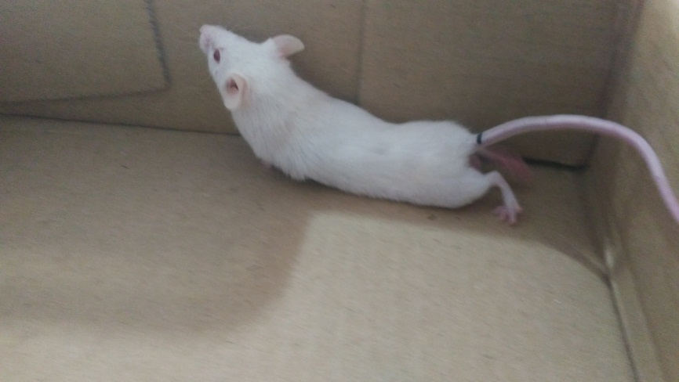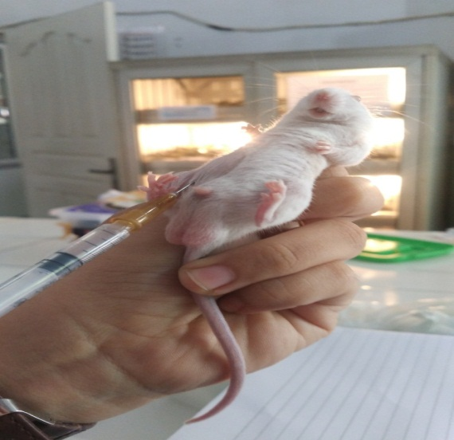**Lampiran8.** Gambar Pengujian Analgesik

induksi asam asetat 1 % secara Gambar Geliat

intra peritoneal (IP)

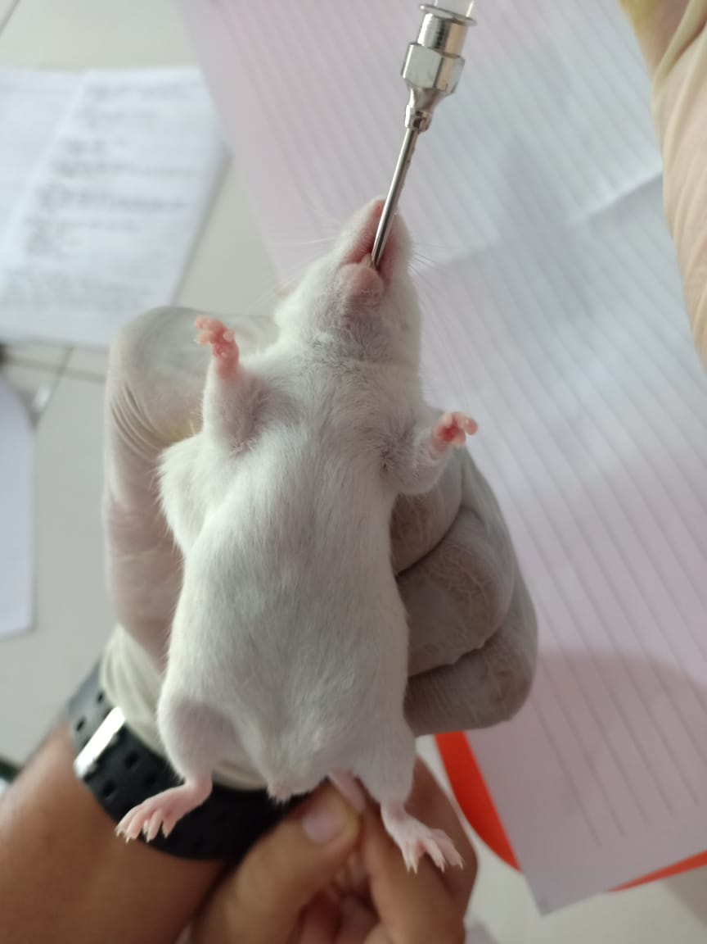

Pemberian Suspensi Secara oral

**Lampiran 9.** Cara perhitungan persen daya analgesik dan persen efektifitas analgesik

$$\% daya analgetik=\{100-\frac{\left(eksperimen × 100\right)}{kontrol negatif}\%\}$$

% daya analgesik pada metampiron pada menit ke-5 per kelompok

$1. \% daya analgetik=\{100-\frac{\left(22 × 100\right)}{24}\%\}$ = 8,33%

$2. \% daya analgetik=\{100-\frac{\left(21 × 100\right)}{23}\%\}$ = 8,70%

$3. \% daya analgetik=\{100-\frac{\left(23 × 100\right)}{25}\%\}$ = 8,00%

$4. \% daya analgetik=\{100-\frac{\left(19 × 100\right)}{21}\%\}$ = 9,52%

$5. \% daya analgetik=\{100-\frac{\left(22 × 100\right)}{25}\%\}$ = 12,00%

Dengan cara yang sama dihitung % daya analgesik untuk dosis 100, 200 dan 300 mg/Kg BB pada menit ke 5,10,20,30,40,50 dan 60. Hasil selengkapnya dapat dilihat pada lampiran 8.

$$\% efektivitas=\frac{\% daya analgetik kelompok bahan uji}{\% daya analgetik kelompok kontrol positif}×100$$

% daya analgesik pada dosis 100 mg/Kg BB pada menit ke-5 per kelompok

$1. \% efektivitas=\frac{4,17}{8,33}×100$ = 50,00%

$2. \% efektivitas=\frac{4,35}{8,70}×100$ = 50,00%

$1. \% efektivitas=\frac{4,00}{8,00}×100$ = 50,00%

$1. \% efektivitas=\frac{4,76}{9,52}×100$ = 50,00%

$1. \% efektivitas=\frac{8,00}{12,00}×100$ = 66,67%

Dengan cara yang sama dihitung % efektivitas untuk dosis 200 dan 300 mg/Kg BB pada menit ke 5,10,20,30,40,50 dan 60. Hasil selengkapnya dapat dilihat pada lampiran 9.

**Lampiran 10.** Pengamatan jumlah geliat dan Hasil Perhitungan Persen Daya Analgesik

**Lampiran 11.** Efektivitas anlgesik

**Lampiran 12.** Tabel Konversi Perhitungan Dosis Dari Manusia Ke Berbagai Hewan

|  |  |  |  |  |  |  |  |
| --- | --- | --- | --- | --- | --- | --- | --- |
|  | Mencit 20 g | Tikus 200 g | Marmut 400 g | Kelinci 1,5 kg | Kera 1,5 kg | Anjing 12 kg | Manusia 70 kg |
| Mencit  20 g | 1,0 | 7,0 | 12,25 | 27,8 | 64,1 | 124,2 | 387,9 |
| Tikus  200 g | 0,14 | 1,0 | 1,74 | 3,9 | 9,2 | 17,8 | 56,0 |
| Marmut 400 g | 0,08 | 0,57 | 1,0 | 2,25 | 5,2 | 10,2 | 31,5 |
| Kelinci 1,5 kg | 0,04 | 0,25 | 0,44 | 1,0 | 2,4 | 4,5 | 14,2 |
| Kera  1,5 kg | 0,016 | 0,11 | 0,19 | 0,42 | 1,0 | 1,9 | 6,1 |
| Anjing 12 kg | 0,008 | 0,06 | 0,10 | 0,22 | 0,52 | 1,0 | 3,1 |
| Manusia 70 kg | 0,0026 | 0,018 | 0,031 | 0,07 | 0,16 | 0,32 | 1,0 |

**Lampiran 13.** Hasil Data SPSS 20

|  |  |  |  |  |  |  |  |  |  |
| --- | --- | --- | --- | --- | --- | --- | --- | --- | --- |
| **Descriptives** | | | | | | | | | |
|  | | N | Mean | Std. Deviation | Std. Error | 95% Confidence Interval for Mean | | Minimum | Maximum |
| Lower Bound | Upper Bound |
| Menit5 | Metampiron | 5 | 9,3100 | 1,60692 | ,71864 | 7,3147 | 11,3053 | 8,00 | 12,00 |
| IDJN 100 mg/kg BB | 5 | 5,0560 | 1,66983 | ,74677 | 2,9826 | 7,1294 | 4,00 | 8,00 |
| IDJN 200 mg/kg BB | 5 | 7,5580 | 1,59057 | ,71133 | 5,5830 | 9,5330 | 4,76 | 8,70 |
| IDJN 300 mg/kg BB | 5 | 8,5100 | ,63419 | ,28362 | 7,7225 | 9,2975 | 8,00 | 9,52 |
| Total | 20 | 7,6085 | 2,10686 | ,47111 | 6,6225 | 8,5945 | 4,00 | 12,00 |
| Menit10 | Metampiron | 5 | 28,4580 | 2,71320 | 1,21338 | 25,0891 | 31,8269 | 24,00 | 31,03 |
| IDJN 100 mg/kg BB | 5 | 5,3700 | 3,71140 | 1,65979 | ,7617 | 9,9783 | 3,45 | 12,00 |
| IDJN 200 mg/kg BB | 5 | 9,7120 | 1,59414 | ,71292 | 7,7326 | 11,6914 | 8,00 | 11,11 |
| IDJN 300 mg/kg BB | 5 | 17,2560 | 1,26003 | ,56350 | 15,6915 | 18,8205 | 16,00 | 18,52 |
| Total | 20 | 15,1990 | 9,27590 | 2,07415 | 10,8577 | 19,5403 | 3,45 | 31,03 |
| Menit20 | Metampiron | 5 | 44,1120 | 2,49308 | 1,11494 | 41,0164 | 47,2076 | 41,18 | 46,43 |
| IDJN 100 mg/kg BB | 5 | 7,6120 | 3,35779 | 1,50165 | 3,4428 | 11,7812 | 4,00 | 12,50 |
| IDJN 200 mg/kg BB | 5 | 18,9580 | 1,25979 | ,56340 | 17,3938 | 20,5222 | 17,65 | 20,75 |
| IDJN 300 mg/kg BB | 5 | 28,3340 | 1,04323 | ,46655 | 27,0387 | 29,6293 | 26,79 | 29,41 |
| Total | 20 | 24,7540 | 13,87086 | 3,10162 | 18,2622 | 31,2458 | 4,00 | 46,43 |
| Menit30 | Metampiron | 5 | 58,1720 | 3,74598 | 1,67525 | 53,5208 | 62,8232 | 52,63 | 62,22 |
| IDJN 100 mg/kg BB | 5 | 14,3060 | 5,97205 | 2,67078 | 6,8907 | 21,7213 | 8,57 | 24,44 |
| IDJN 200 mg/kg BB | 5 | 30,5500 | 1,35002 | ,60375 | 28,8737 | 32,2263 | 28,89 | 31,58 |
| IDJN 300 mg/kg BB | 5 | 42,2340 | 1,75194 | ,78349 | 40,0587 | 44,4093 | 40,00 | 44,74 |
| Total | 20 | 36,3155 | 16,81217 | 3,75931 | 28,4472 | 44,1838 | 8,57 | 62,22 |
| Menit40 | Metampiron | 5 | 71,8900 | 1,97955 | ,88528 | 69,4321 | 74,3479 | 68,97 | 74,29 |
| IDJN 100 mg/kg BB | 5 | 26,0120 | 3,88779 | 1,73867 | 21,1847 | 30,8393 | 20,69 | 30,77 |
| IDJN 200 mg/kg BB | 5 | 46,1540 | 2,53056 | 1,13170 | 43,0119 | 49,2961 | 42,86 | 48,72 |
| IDJN 300 mg/kg BB | 5 | 61,0360 | 1,71426 | ,76664 | 58,9075 | 63,1645 | 58,62 | 62,86 |
| Total | 20 | 51,2730 | 17,82517 | 3,98583 | 42,9306 | 59,6154 | 20,69 | 74,29 |
| Menit50 | Metampiron | 5 | 87,4260 | 2,55806 | 1,14400 | 84,2497 | 90,6023 | 85,71 | 91,43 |
| IDJN 100 mg/kg BB | 5 | 34,8580 | 2,38807 | 1,06798 | 31,8928 | 37,8232 | 31,43 | 37,14 |
| IDJN 200 mg/kg BB | 5 | 64,5720 | 2,55303 | 1,14175 | 61,4020 | 67,7420 | 62,86 | 68,57 |
| IDJN 300 mg/kg BB | 5 | 85,1420 | 2,38807 | 1,06798 | 82,1768 | 88,1072 | 82,86 | 88,57 |
| Total | 20 | 67,9995 | 21,76994 | 4,86791 | 57,8109 | 78,1881 | 31,43 | 91,43 |
| menit60 | Metampiron | 5 | 98,7380 | 1,74061 | ,77842 | 96,5767 | 100,8993 | 96,55 | 100,00 |
| IDJN 100 mg/kg BB | 5 | 46,0800 | 3,85943 | 1,72599 | 41,2879 | 50,8721 | 43,33 | 52,78 |
| IDJN 200 mg/kg BB | 5 | 76,9820 | 2,96418 | 1,32562 | 73,3015 | 80,6625 | 72,41 | 80,56 |
| IDJN 300 mg/kg BB | 5 | 98,1820 | 1,67965 | ,75116 | 96,0964 | 100,2676 | 96,55 | 100,00 |
| Total | 20 | 79,9955 | 22,15376 | 4,95373 | 69,6272 | 90,3638 | 43,33 | 100,00 |

**Lampiran 13. (Lanjutan)**

|  |  |  |  |  |
| --- | --- | --- | --- | --- |
| **Test of Homogeneity of Variances** | | | | |
|  | Levene Statistic | df1 | df2 | Sig. |
| Menit5 | ,749 | 3 | 16 | ,539 |
| Menit10 | 1,290 | 3 | 16 | ,312 |
| Menit20 | 4,913 | 3 | 16 | ,013 |
| Menit30 | 1,791 | 3 | 16 | ,189 |
| Menit40 | 1,372 | 3 | 16 | ,287 |
| Menit50 | ,064 | 3 | 16 | ,978 |
| menit60 | ,622 | 3 | 16 | ,611 |
|  |  |  |  |  |

|  |  |  |  |  |  |  |
| --- | --- | --- | --- | --- | --- | --- |
| **ANOVA** | | | | | | |
|  | | Sum of Squares | df | Mean Square | F | Sig. |
| Menit5 | Between Groups | 51,128 | 3 | 17,043 | 8,211 | ,002 |
| Within Groups | 33,211 | 16 | 2,076 |  |  |
| Total | 84,339 | 19 |  |  |  |
| Menit10 | Between Groups | 1533,744 | 3 | 511,248 | 80,942 | ,000 |
| Within Groups | 101,060 | 16 | 6,316 |  |  |
| Total | 1634,803 | 19 |  |  |  |
| Menit20 | Between Groups | 3574,952 | 3 | 1191,651 | 236,372 | ,000 |
| Within Groups | 80,663 | 16 | 5,041 |  |  |
| Total | 3655,614 | 19 |  |  |  |
| Menit30 | Between Groups | 5151,972 | 3 | 1717,324 | 125,835 | ,000 |
| Within Groups | 218,358 | 16 | 13,647 |  |  |
| Total | 5370,330 | 19 |  |  |  |
| Menit40 | Between Groups | 5923,496 | 3 | 1974,499 | 278,334 | ,000 |
| Within Groups | 113,504 | 16 | 7,094 |  |  |
| Total | 6036,999 | 19 |  |  |  |
| Menit50 | Between Groups | 8906,805 | 3 | 2968,935 | 485,370 | ,000 |
| Within Groups | 97,870 | 16 | 6,117 |  |  |
| Total | 9004,674 | 19 |  |  |  |
| menit60 | Between Groups | 9206,862 | 3 | 3068,954 | 415,671 | ,000 |
| Within Groups | 118,130 | 16 | 7,383 |  |  |
| Total | 9324,992 | 19 |  |  |  |

**Lampiran 13. (Lanjutan)**

|  |  |  |  |
| --- | --- | --- | --- |
| **Menit5** | | | |
| Tukey HSD | | | |
| Perlakuan | N | Subset for alpha = 0.05 | |
| 1 | 2 |
| IDJN 100 mg/kg BB | 5 | 5,0560 |  |
| IDJN 200 mg/kg BB | 5 | 7,5580 | 7,5580 |
| IDJN 300 mg/kg BB | 5 |  | 8,5100 |
| Metampiron | 5 |  | 9,3100 |
| Sig. |  | ,062 | ,258 |
| Means for groups in homogeneous subsets are displayed. | | | |
| a. Uses Harmonic Mean Sample Size = 5,000. | | | |

|  |  |  |  |  |
| --- | --- | --- | --- | --- |
| **Menit10** | | | | |
| Tukey HSD | | | | |
| Perlakuan | N | Subset for alpha = 0.05 | | |
| 1 | 2 | 3 |
| IDJN 100 mg/kg BB | 5 | 5,3700 |  |  |
| IDJN 200 mg/kg BB | 5 | 9,7120 |  |  |
| IDJN 300 mg/kg BB | 5 |  | 17,2560 |  |
| Metampiron | 5 |  |  | 28,4580 |
| Sig. |  | ,064 | 1,000 | 1,000 |
| Means for groups in homogeneous subsets are displayed. | | | | |
| a. Uses Harmonic Mean Sample Size = 5,000. | | | | |

|  |  |  |  |  |  |
| --- | --- | --- | --- | --- | --- |
| **Menit20** | | | | | |
| Tukey HSD | | | | | |
| perlakuan | N | Subset for alpha = 0.05 | | | |
| 1 | 2 | 3 | 4 |
| IDJN 100 mg/kg BB | 5 | 7,6120 |  |  |  |
| IDJN 200 mg/kg BB | 5 |  | 18,9580 |  |  |
| IDJN 300 mg/kg BB | 5 |  |  | 28,3340 |  |
| metampiron | 5 |  |  |  | 44,1120 |
| Sig. |  | 1,000 | 1,000 | 1,000 | 1,000 |
| Means for groups in homogeneous subsets are displayed. | | | | | |
| a. Uses Harmonic Mean Sample Size = 5,000. | | | | | |

**Lampiran 13. (Lanjutan)**

|  |  |  |  |  |  |
| --- | --- | --- | --- | --- | --- |
| **Menit30** | | | | | |
| Tukey HSD | | | | | |
| perlakuan | N | Subset for alpha = 0.05 | | | |
| 1 | 2 | 3 | 4 |
| IDJN 100 mg/kg BB | 5 | 14,3060 |  |  |  |
| IDJN 200 mg/kg BB | 5 |  | 30,5500 |  |  |
| IDJN 300 mg/kg BB | 5 |  |  | 42,2340 |  |
| metampiron | 5 |  |  |  | 58,1720 |
| Sig. |  | 1,000 | 1,000 | 1,000 | 1,000 |
| Means for groups in homogeneous subsets are displayed. | | | | | |
| a. Uses Harmonic Mean Sample Size = 5,000. | | | | | |

|  |  |  |  |  |  |
| --- | --- | --- | --- | --- | --- |
| **Menit40** | | | | | |
| Tukey HSD | | | | | |
| perlakuan | N | Subset for alpha = 0.05 | | | |
| 1 | 2 | 3 | 4 |
| IDJN 100 mg/kg BB | 5 | 26,0120 |  |  |  |
| IDJN 200 mg/kg BB | 5 |  | 46,1540 |  |  |
| IDJN 300 mg/kg BB | 5 |  |  | 61,0360 |  |
| metampiron | 5 |  |  |  | 71,8900 |
| Sig. |  | 1,000 | 1,000 | 1,000 | 1,000 |
| Means for groups in homogeneous subsets are displayed. | | | | | |
| a. Uses Harmonic Mean Sample Size = 5,000. | | | | | |

|  |  |  |  |  |
| --- | --- | --- | --- | --- |
| **Menit50** | | | | |
| Tukey HSD | | | | |
| Perlakuan | N | Subset for alpha = 0.05 | | |
| 1 | 2 | 3 |
| IDJN 100 mg/kg BB | 5 | 34,8580 |  |  |
| IDJN 200 mg/kg BB | 5 |  | 64,5720 |  |
| IDJN 300 mg/kg BB | 5 |  |  | 85,1420 |
| Metampiron | 5 |  |  | 87,4260 |
| Sig. |  | 1,000 | 1,000 | ,483 |
| Means for groups in homogeneous subsets are displayed. | | | | |
| a. Uses Harmonic Mean Sample Size = 5,000. | | | | |

**Lampiran 13. (Lanjutan)**

|  |  |  |  |  |
| --- | --- | --- | --- | --- |
| **menit60** | | | | |
| Tukey HSD | | | | |
| Perlakuan | N | Subset for alpha = 0.05 | | |
| 1 | 2 | 3 |
| IDJN 100 mg/kg BB | 5 | 46,0800 |  |  |
| IDJN 200 mg/kg BB | 5 |  | 76,9820 |  |
| IDJN 300 mg/kg BB | 5 |  |  | 98,1820 |
| Metampiron | 5 |  |  | 98,7380 |
| Sig. |  | 1,000 | 1,000 | ,988 |
| Means for groups in homogeneous subsets are displayed. | | | | |
| a. Uses Harmonic Mean Sample Size = 5,000. | | | | |