**Lampiran 1**. Hasil Identifikasi Tanaman Ubi (*Manihot esculenta)*



Lampiran 2. Surat Persetujuan Etik Penelitian

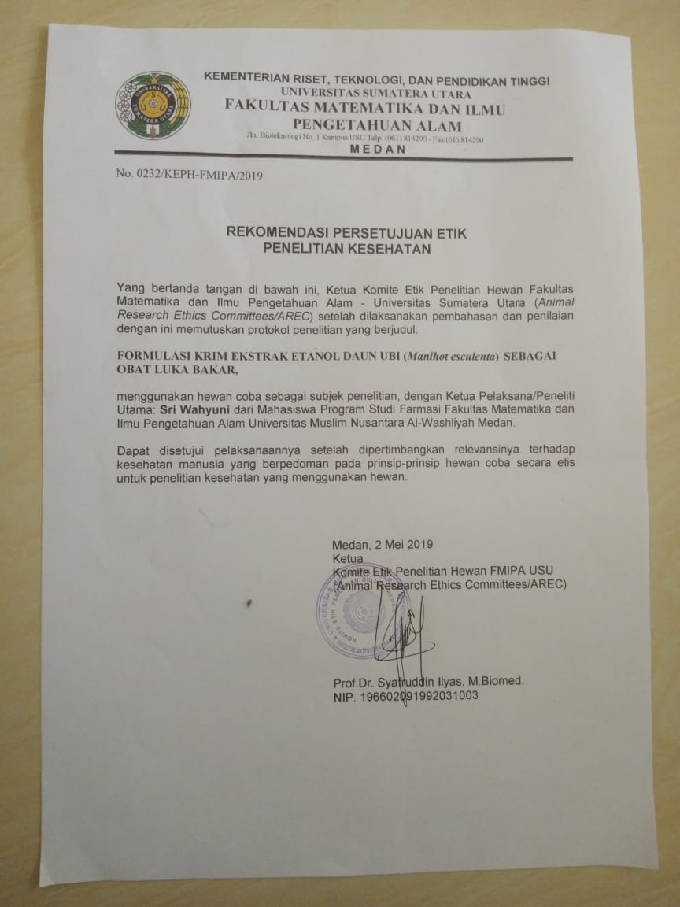 **Lampiran 3**. Gambar Daun Ubi Serbuk Simplisia dan Ekstrak Daun Ubi

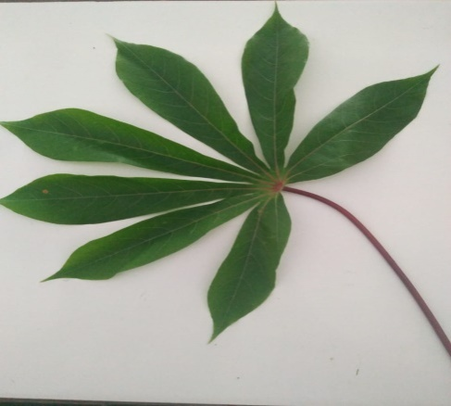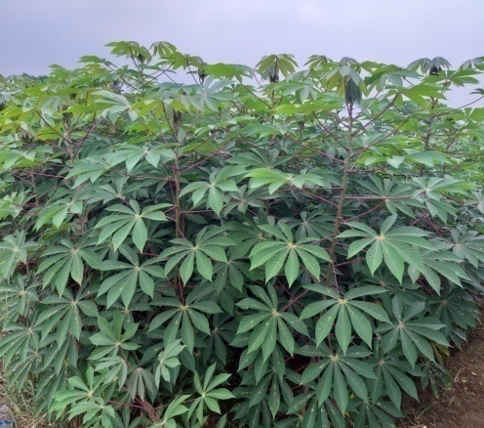

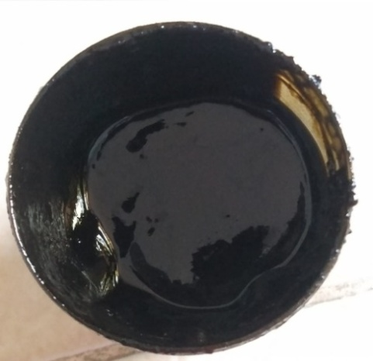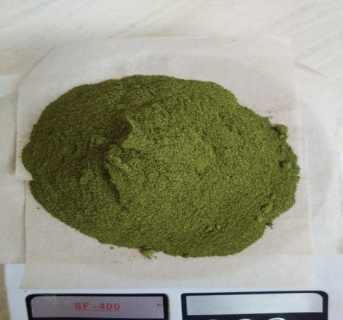Tumbuhan Ubi Daun Ubi

Ekstrak Daun Ubi Serbuk Daun Ubi

**Lampiran 4.**Gambar Hasil Uji Mikroskopik Serbuk Daun Ubi

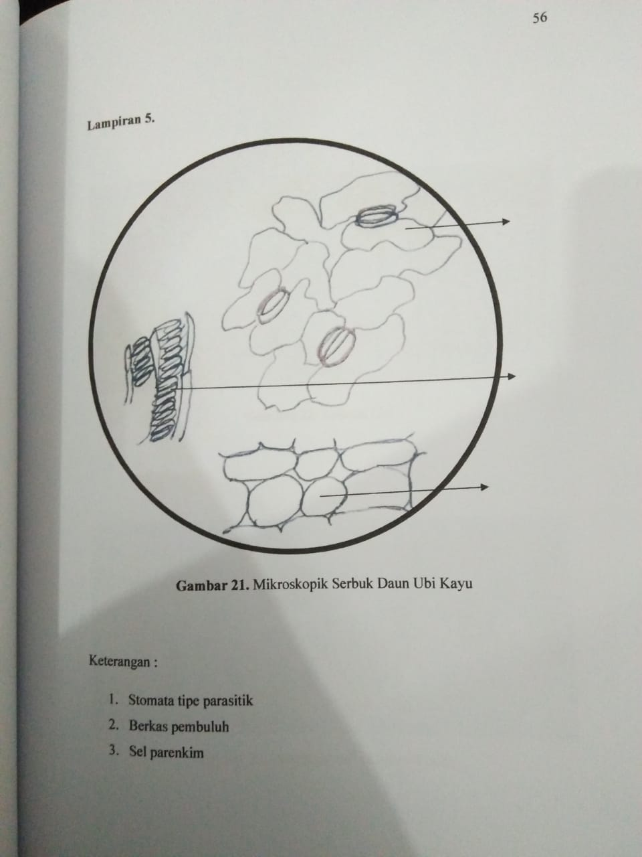

1

2

3

**Keterangan :**

1.Stomata tipe Parasitik

2. Berkas pembuluh

3. Sel Parenkim

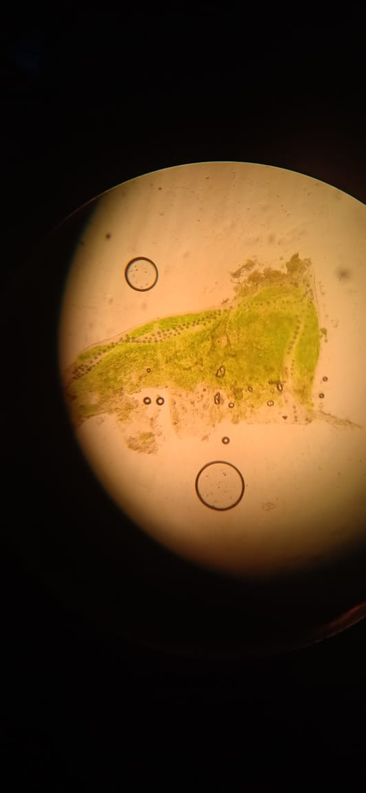

**Lampiran 5.** Perhitungan Karakterisasi Tumbuhan

* 1. **Penetapan Kadar Air**

$$\text{Kadar Air = }\frac{\text{Volume Hasil}}{\text{Berat sampel}}\text{ x 100 \%}$$

Berat sampel = 5,0002 g

Volume I = 0,2 ml

* 1. **Penetapan Kadar Abu Total**

$$\text{Kadar abu =}\frac{\text{Berat abu}}{\text{Berat sampel}}\text{ x 100 \%}$$

Berat sampel = 2,0001 g

Berat abu = 0,0663 g

* 1. **Penetapan Kadar Abu Tidak Larut Asam**

$$\% Kadar Abu yang Tidak Larut dalam Asam=\frac{Berat Abu}{Berat Simplisia}x 100\%$$

Berat simplisia = 2,0008 g

Berat abu = 0,0220 g

* 1. **Kadar Sari Larut Dalam Air**

$$\% Kadar Sari yang Larut dalam Air=\frac{Berat Sari}{Berat Simplisia}x \frac{100}{20} x 100\%$$

1. Berat simplisia = 5,0003 g

Berat sari = 0,1866 g

* 1. **Kadar Sari Larut Dalam Etanol**

$$\% Kadar Sari yang Larut dalam etanol=\frac{Berat Sari}{Berat Simplisia}x \frac{100}{20} x 100\%$$

Sampel I

Berat sampel = 5,015 g

Berat sari = 0,176 g

$$\% Kadar Sari yang Larut dalam etanol=\frac{0,1347}{5,0005}x \frac{100}{20} x 100\%=16,47\%$$

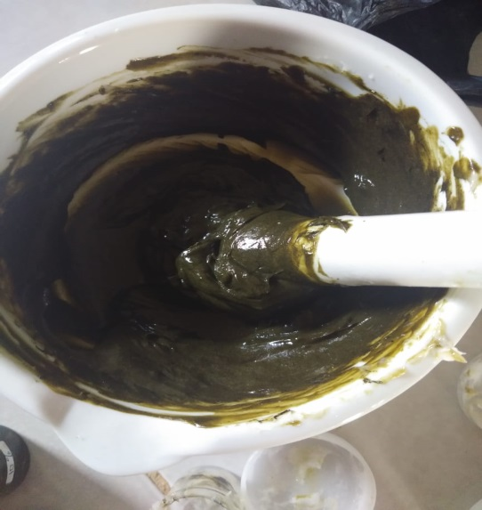**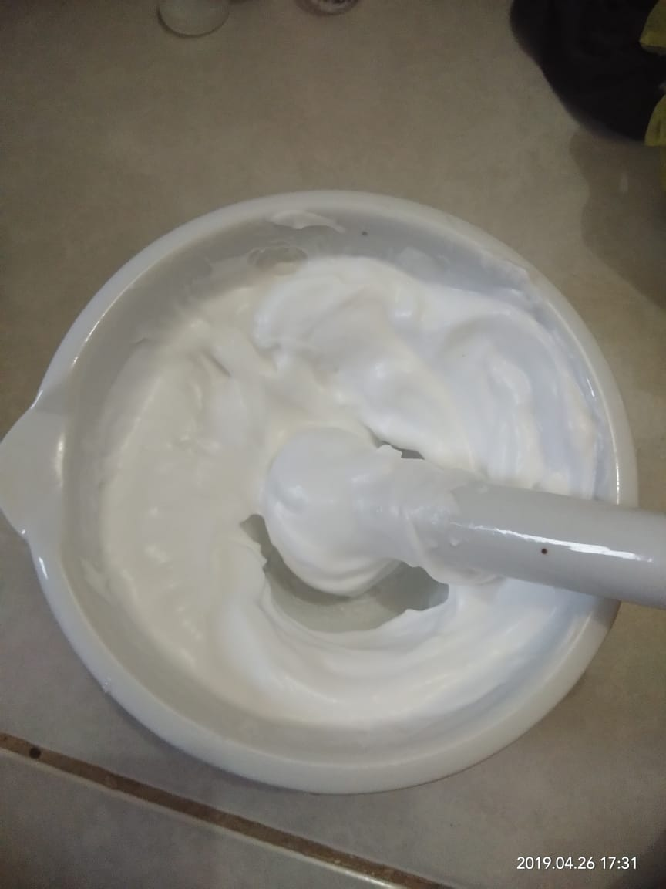Lampiran 6.** Sediaan krim

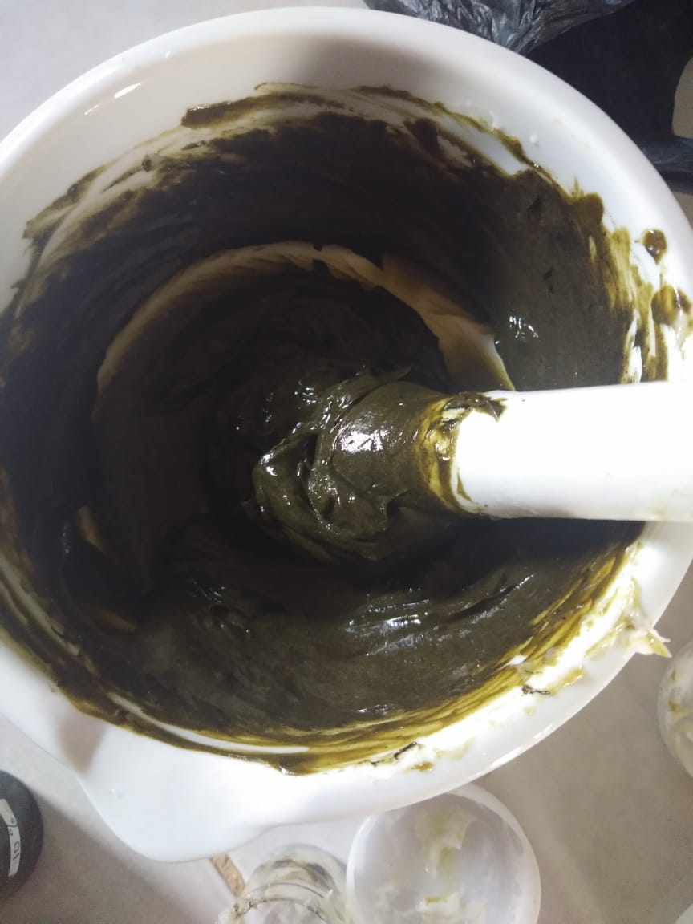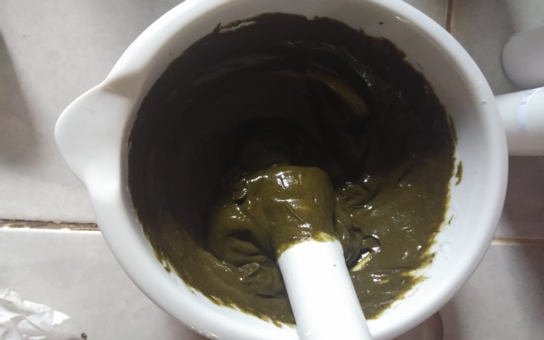Dasar Krim EDU 5%

EDU 7% EDU 10%

**Lampiran 7.**Gambar Alat Rotary Evaporator Dan Azeotrophi

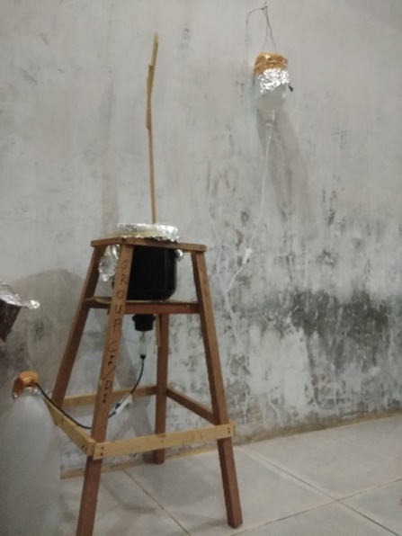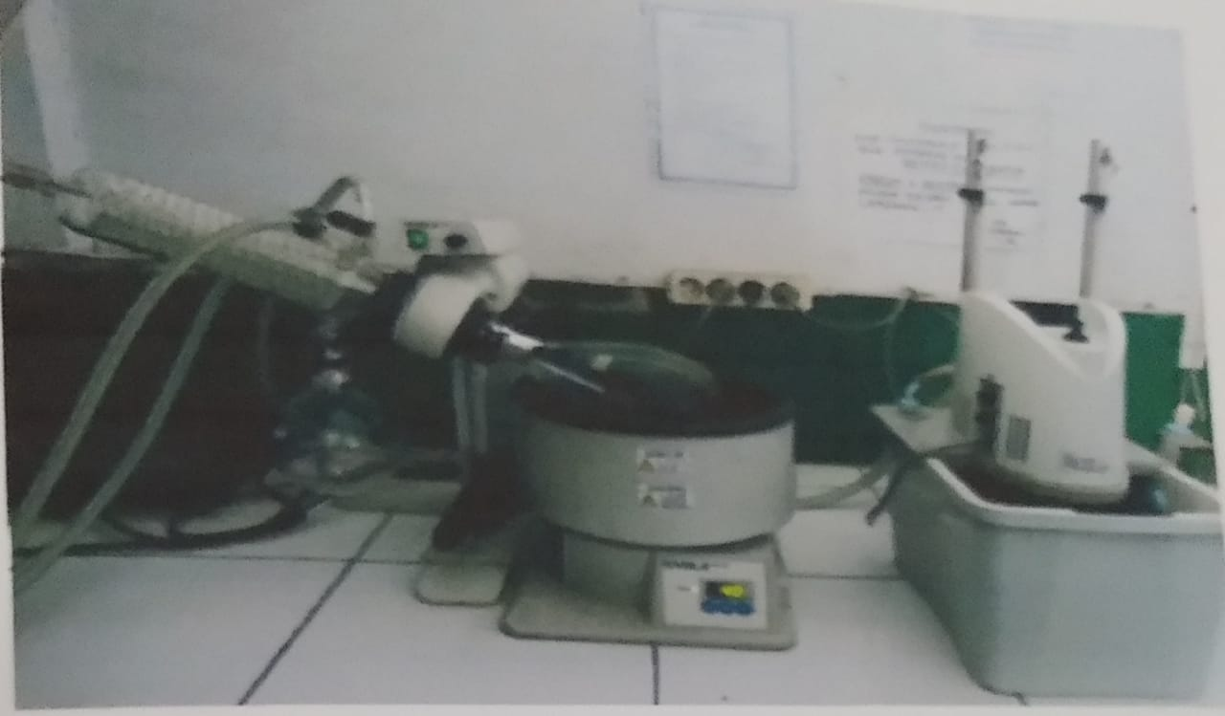

Alat Perkolasi Alat *Rotary evaporator*

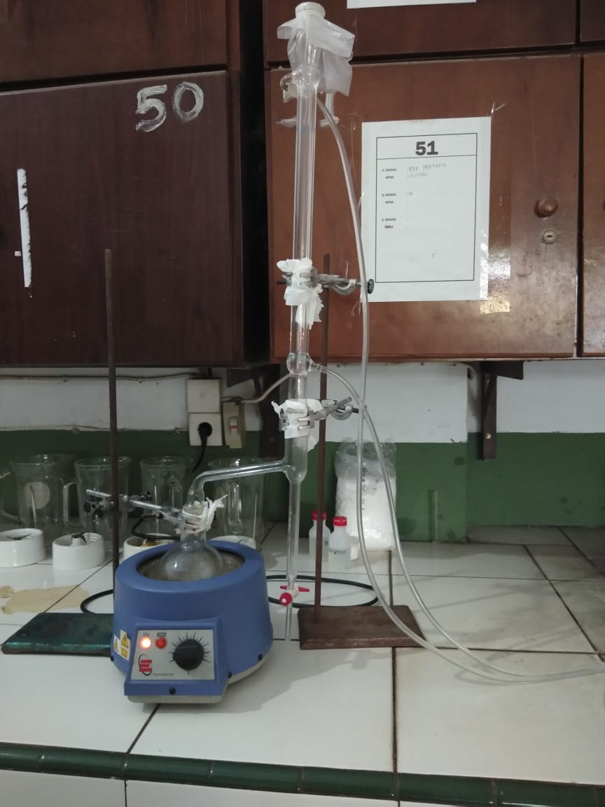

Rangkaian Alat Azeotroph

Dalam Penetapan Kadar Air

**Lampiran 8**. Gambar lempeng, lidocoin dan Burnazin

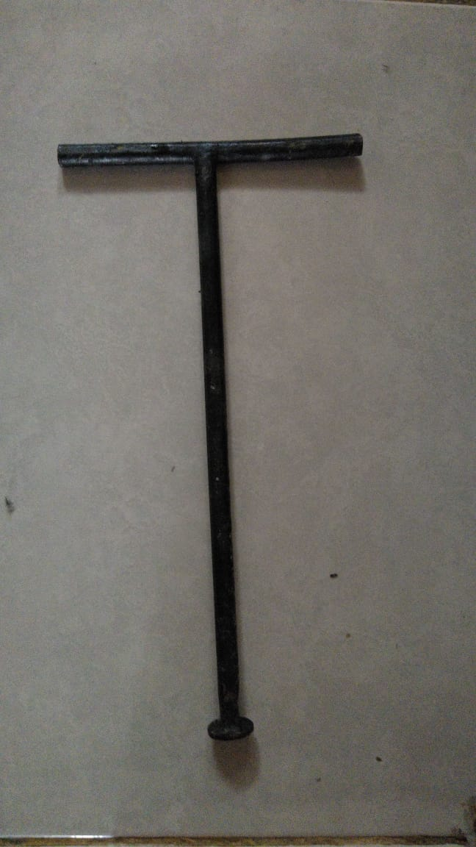

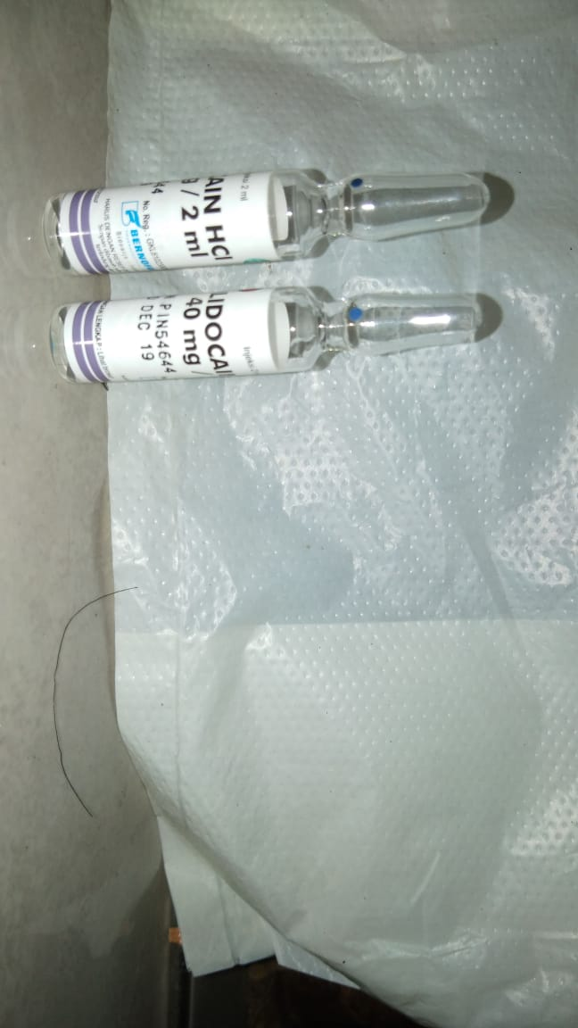Lempeng logam

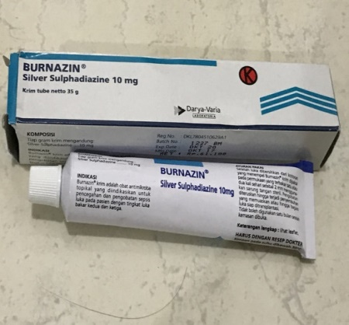Lidocoin

Burnazin

**Lampiran 9.** Bagan Alir Penelitian

5 kg Daun Ubi Segar

Dibersihkan

Dirajang

Ditimbang

Daun Ubi

Dikeringkan

Simplisia kering

Dihaluskan

Ditimbang

500 g serbuk simplisia

Pemeriksaan Perkolasi

karakterisasi serbuk dengan etanol

1. Makroskopik
2. Miskroskopik
3. Penetapan kadar air
4. Penetapan kadar sari larut dalam air
5. Penetapan kadar sari larut dalam etanol
6. Penetapan kadar abu total
7. Penetapan kadar abu yang tidak larut dalam asam

Ampas

Perkolat I

Direperkolasi

Perkolat II

Ampas dibuang

Ditambahkan perkolat

Dirotary

Ekstrak kental

Formulasi Sediaan Gel

Sedian Krim Ekstrak Etanol Daun Ubi

**Lampiran 9. (**Lanjutan) Bagan Alir Pengujian Luka Bakar

Marmut seberat 350 g

Diaklimatisasi selama 2 minggu

Dicukur bulu marmut di punggung marmut dengan jarak ±2 cm

Dibius menggunakan lidokain HCl

Diambil dengan jarum ose steril

Dibakar lempeng dengan nyala api 75oC selama 60 detik

Ditempelkan selama 5 detik pada kulit punggung

Marmut Luka Bakar

Dioleskan formula krim secara tipis dan merata 3 kali sehari

Dilakukan pengamatan setiap hari

Hasil Pengamatan Luka Bakar

**Lampiran 10.** Gambar Perubahan Diameter Luka Bakar Pengobatan Dasar Krim

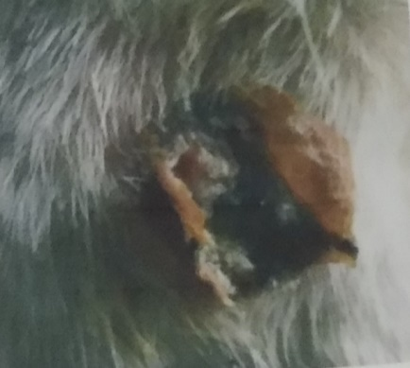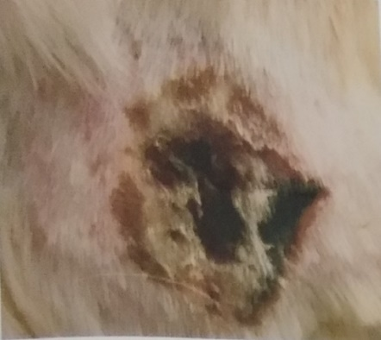

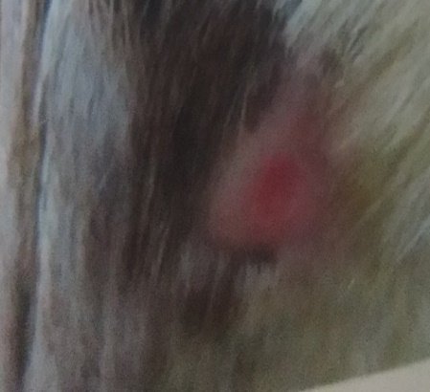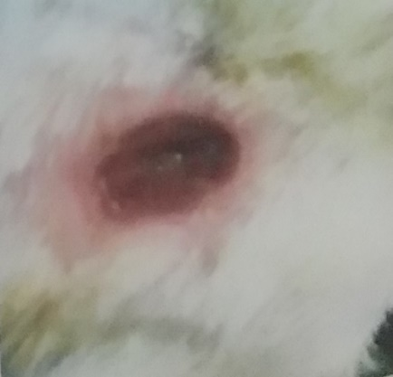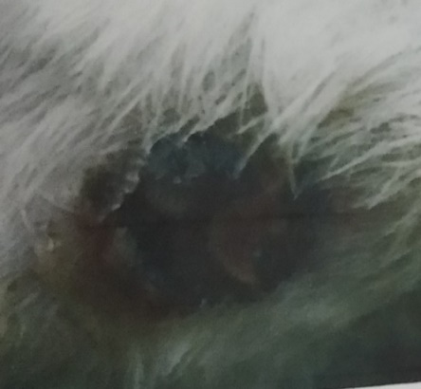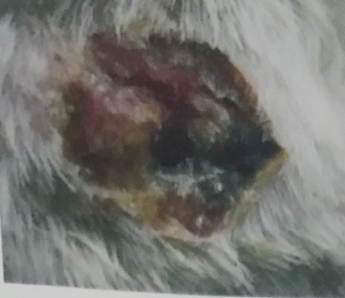Hari Ke-1 Hari Ke-3 Hari Ke-5

Hari Ke-7 Hari Ke-9 Hari Ke-11

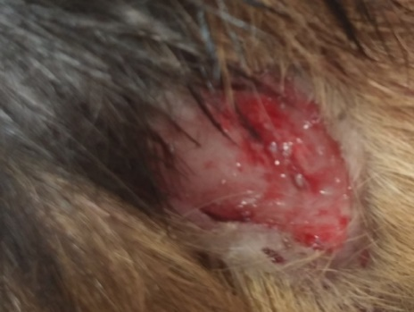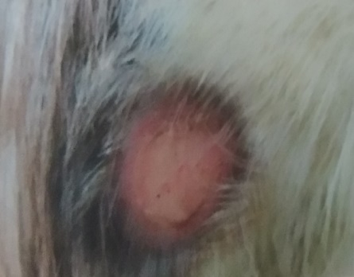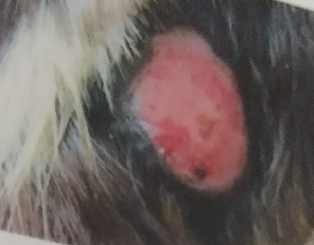**Lampiran 11.**Perubahan Diameter Luka Bakar Pengobatan Krim Konsentrasi 5%

Hari Ke-1 Hari Ke-3 Hari Ke-5

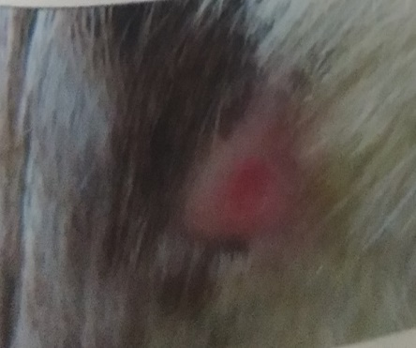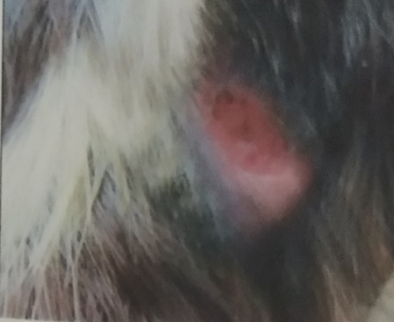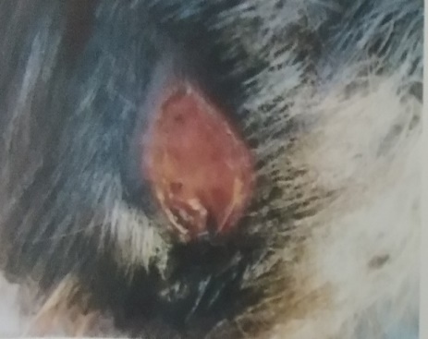

Hari Ke-7 Hari Ke-9 Hari Ke-11

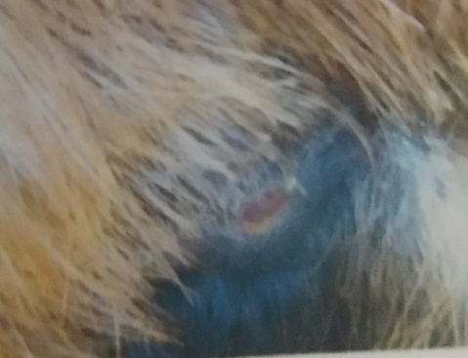

Hari Ke-13 Hari Ke-15

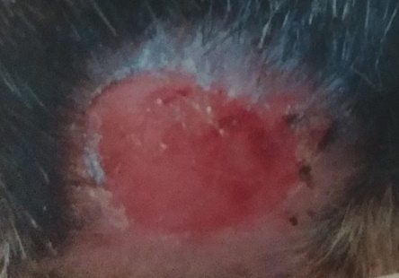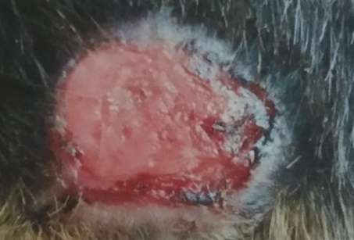**Lampiran 12.**Perubahan Diameter Luka Bakar Pengobatan Krim Konsentrasi 7%

Hari Ke-1 Hari Ke-3

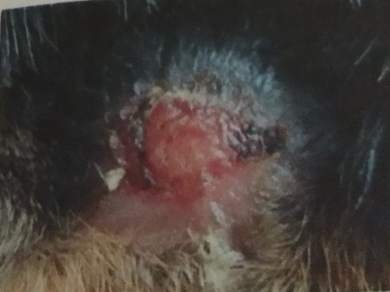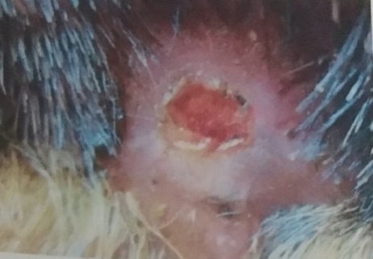

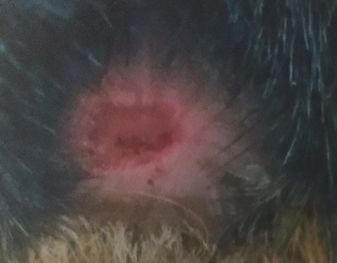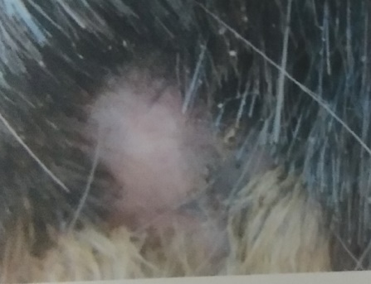 Hari Ke-5 Hari Ke-7

Hari Ke-9 Hari Ke-11

**Lampiran 13.** Perubahan Diameter Luka Bakar Pengobatan Krim kosentrasi 10%

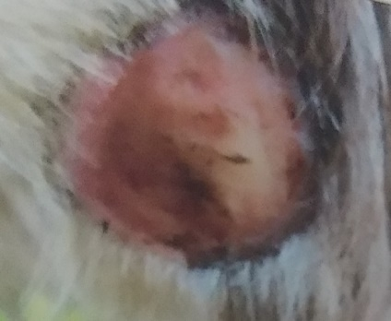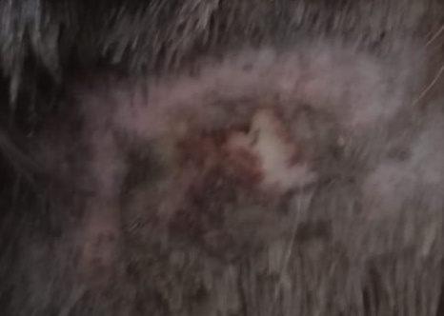

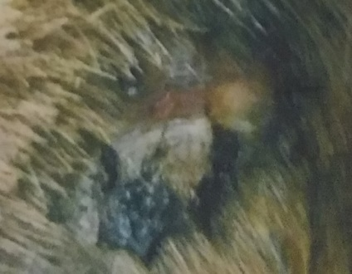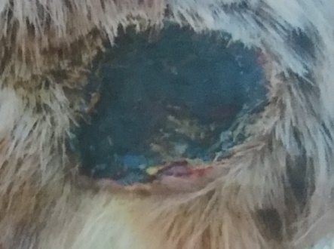 **H**ari Ke-1 Hari Ke-3

Hari Ke-5 Hari Ke-7

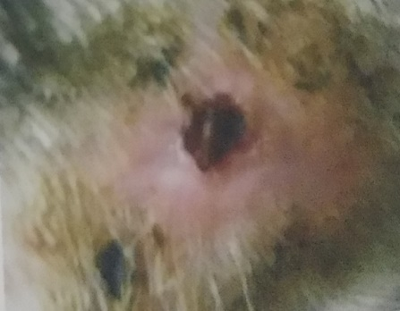

Hari Ke-9 Hari Ke-11

**Lampiran 14.** Perubahan Diameter Luka Bakar di Obati dengan Burnazin

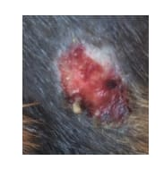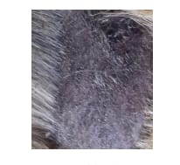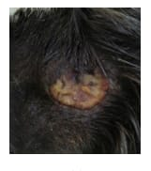

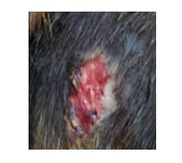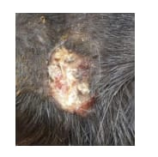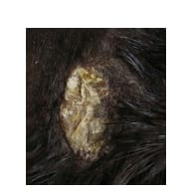 Hari ke-1 Hari ke-3 Hari ke-5

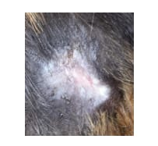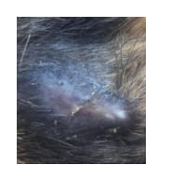 Hari ke-7 Hari ke-9 Hari ke-11

Hari ke-13 Hari ke-15

**Lampiran 15**. Gambar tempat karantina selama pnyembuhan luka bakar

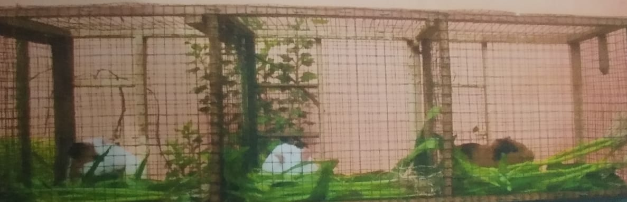

Tempat karantina

**Lampiran 16.** Tabel diameter luka bakar dengan interval pengukutan 2 hari

|  |  |  |  |  |  |  |
| --- | --- | --- | --- | --- | --- | --- |
| Hari | Burnazin | Dasar krim | Tanpa diobati | krim EDU 5 % | Krim EDU 7 % | Krim EDU 10 % |
| 1 | 2 | 2 | 2 | 2 | 2 | 2 |
| 3 | 2,22 | 1,93 | 2,01 | 1,99 | 2 | 1,99 |
| 5 | 2,14 | 1,66 | 1,82 | 1,81 | 1,81 | 1,78 |
| 7 | 1,49 | 1,48 | 1,61 | 1,65 | 167 | 1,61 |
| 9 | 1,33 | 1,31 | 1,48 | 1,48 | 1,49 | 1,11 |
| 11 | 1,02 | 1,01 | 1,24 | 1,31 | 1,3 | 0,65 |
| 13 | 0,46 | 0,76 | 1,12 | 0,53 | 0,53 | 0,25 |
| 15 | 0,22 | 0,54 | 0,63 | 0,61 | 0,33 | 0,36 |
| 17 | 0,1 | 0,24 | 0,65 | 0,31 | 0,1 | 0 |
| 19 | 0,02 | 0,46 | 0,37 | 0,02 | 0 | 0 |
| 21 | 0 | 0,41 | 0,18 | 0 | 0 | 0 |
| 23 | 0 | 0 | 0 | 0 |  | 0 |

**Lampiran 17.** Tabel Deskriftif

|  |  | N | Mean | Std. Deviation | Std. Error | 95% Confidence Interval for Mean | | Min | Max |
| --- | --- | --- | --- | --- | --- | --- | --- | --- | --- |
|  |  | Lower Bound | Upper Bound |
| hari1 | dasar krim | 6 | 2.0000 | .00000 | .00000 | 2.0000 | 2.0000 | 2.00 | 2.00 |
| kontrol positif | 6 | 2.0000 | .00000 | .00000 | 2.0000 | 2.0000 | 2.00 | 2.00 |
| kontrol negatif | 6 | 2.0000 | .00000 | .00000 | 2.0000 | 2.0000 | 2.00 | 2.00 |
| EEDU 5% | 6 | 2.0000 | .00000 | .00000 | 2.0000 | 2.0000 | 2.00 | 2.00 |
| EEDU 7% | 6 | 2.0000 | .00000 | .00000 | 2.0000 | 2.0000 | 2.00 | 2.00 |
| EEDU 10% | 6 | 2.0000 | .00000 | .00000 | 2.0000 | 2.0000 | 2.00 | 2.00 |
| Total | 36 | 2.0000 | .00000 | .00000 | 2.0000 | 2.0000 | 2.00 | 2.00 |
| hari3 | dasar krim | 6 | 2.1333 | .05164 | .02108 | 2.0791 | 2.1875 | 2.10 | 2.20 |
| kontrol positif | 6 | 2.0100 | .07014 | .02864 | 1.9364 | 2.0836 | 1.96 | 2.10 |
| kontrol negatif | 6 | 1.9567 | .07230 | .02951 | 1.8808 | 2.0325 | 1.90 | 2.10 |
| EEDU 5% | 6 | 2.0200 | .06573 | .02683 | 1.9510 | 2.0890 | 1.96 | 2.10 |
| EEDU 7% | 6 | 1.9967 | .05574 | .02275 | 1.9382 | 2.0552 | 1.96 | 2.10 |
| EEDU 10% | 6 | 1.9767 | .06623 | .02704 | 1.9072 | 2.0462 | 1.92 | 2.10 |
| Total | 36 | 2.0156 | .08258 | .01376 | 1.9876 | 2.0435 | 1.90 | 2.20 |
| hari5 | dasar krim | 6 | 1.8400 | .07294 | .02978 | 1.7635 | 1.9165 | 1.78 | 1.98 |
| kontrol positif | 6 | 1.7567 | .03386 | .01382 | 1.7211 | 1.7922 | 1.72 | 1.81 |
| kontrol negatif | 6 | 1.7200 | .02449 | .01000 | 1.6943 | 1.7457 | 1.69 | 1.76 |
| EEDU 5% | 6 | 1.7600 | .03633 | .01483 | 1.7219 | 1.7981 | 1.72 | 1.81 |
| EEDU 7% | 6 | 1.7600 | .05514 | .02251 | 1.7021 | 1.8179 | 1.72 | 1.86 |
| EEDU 10% | 6 | 1.7600 | .03795 | .01549 | 1.7202 | 1.7998 | 1.72 | 1.82 |
| Total | 36 | 1.7661 | .05633 | .00939 | 1.7471 | 1.7852 | 1.69 | 1.98 |
| hari7 | dasar krim | 6 | 1.6767 | .04502 | .01838 | 1.6294 | 1.7239 | 1.60 | 1.72 |
| kontrol positif | 6 | 1.5950 | .10114 | .04129 | 1.4889 | 1.7011 | 1.52 | 1.73 |
| kontrol negatif | 6 | 1.5400 | .06356 | .02595 | 1.4733 | 1.6067 | 1.48 | 1.65 |
| EEDU 5% | 6 | 1.6233 | .08335 | .03403 | 1.5359 | 1.7108 | 1.52 | 1.76 |
| EEDU 7% | 6 | 1.6683 | .05456 | .02227 | 1.6111 | 1.7256 | 1.62 | 1.76 |
| EEDU 10% | 6 | 1.5733 | .12242 | .04998 | 1.4449 | 1.7018 | 1.44 | 1.76 |
| Total | 36 | 1.6128 | .09145 | .01524 | 1.5818 | 1.6437 | 1.44 | 1.76 |
| hari9 | dasar krim | 6 | 1.5500 | .10276 | .04195 | 1.4422 | 1.6578 | 1.35 | 1.65 |
| kontrol positif | 6 | 1.4800 | .07155 | .02921 | 1.4049 | 1.5551 | 1.42 | 1.58 |
| kontrol negatif | 6 | 1.3983 | .10128 | .04135 | 1.2921 | 1.5046 | 1.28 | 1.56 |
| EEDU 5% | 6 | 1.4733 | .06772 | .02765 | 1.4023 | 1.5444 | 1.38 | 1.56 |
| EEDU 7% | 6 | 1.5033 | .09158 | .03739 | 1.4072 | 1.5994 | 1.42 | 1.62 |
| EEDU 10% | 6 | 1.0950 | .52298 | .21351 | .5462 | 1.6438 | .42 | 1.44 |
| Total | 36 | 1.4167 | .26077 | .04346 | 1.3284 | 1.5049 | .42 | 1.65 |
| hari11 | dasar krim | 6 | 1.3550 | .15320 | .06254 | 1.1942 | 1.5158 | 1.10 | 1.56 |
| kontrol positif | 6 | 1.2483 | .07574 | .03092 | 1.1688 | 1.3278 | 1.19 | 1.35 |
| kontrol negatif | 6 | 1.1883 | .07026 | .02868 | 1.1146 | 1.2621 | 1.13 | 1.32 |
| EEDU 5% | 6 | 1.2733 | .10838 | .04425 | 1.1596 | 1.3871 | 1.19 | 1.46 |
| EEDU 7% | 6 | 1.3000 | .10354 | .04227 | 1.1913 | 1.4087 | 1.22 | 1.44 |

|  | EEDU 10% | 6 | .4600 | .41627 | .16994 | .0232 | .8968 | .16 | 1.26 |
| --- | --- | --- | --- | --- | --- | --- | --- | --- | --- |
| Total | 36 | 1.1375 | .36038 | .06006 | 1.0156 | 1.2594 | .16 | 1.56 |
| hari13 | dasar krim | 6 | 1.1500 | .12712 | .05190 | 1.0166 | 1.2834 | .90 | 1.25 |
| kontrol positif | 6 | 1.1217 | .06210 | .02535 | 1.0565 | 1.1868 | 1.08 | 1.22 |
| kontrol negatif | 6 | .8233 | .51126 | .20872 | .2868 | 1.3599 | .15 | 1.20 |
| EEDU 5% | 6 | .8533 | .48755 | .19904 | .3417 | 1.3650 | .22 | 1.28 |
| EEDU 7% | 6 | .5333 | .52561 | .21458 | -.0183 | 1.0849 | .16 | 1.24 |
| EEDU 10% | 6 | .3967 | .25657 | .10474 | .1274 | .6659 | .18 | .80 |
| Total | 36 | .8131 | .44972 | .07495 | .6609 | .9652 | .15 | 1.28 |
| hari15 | dasar krim | 6 | .8467 | .31188 | .12732 | .5194 | 1.1740 | .50 | 1.18 |
| kontrol positif | 6 | .7967 | .46582 | .19017 | .3078 | 1.2855 | .19 | 1.19 |
| kontrol negatif | 6 | .9250 | .20491 | .08366 | .7100 | 1.1400 | .60 | 1.16 |
| EEDU 5% | 6 | .3533 | .27609 | .11271 | .0636 | .6431 | .16 | .80 |
| EEDU 7% | 6 | .3300 | .24487 | .09997 | .0730 | .5870 | .18 | .80 |
| EEDU 10% | 6 | .2333 | .32042 | .13081 | -.1029 | .5696 | .00 | .80 |
| Total | 36 | .5808 | .40716 | .06786 | .4431 | .7186 | .00 | 1.19 |
| hari17 | dasar krim | 6 | .4567 | .36708 | .14986 | .0714 | .8419 | .18 | 1.10 |
| kontrol positif | 6 | .6567 | .35814 | .14621 | .2808 | 1.0325 | .19 | 1.10 |
| kontrol negatif | 6 | .6200 | .39294 | .16042 | .2076 | 1.0324 | .22 | 1.10 |
| EEDU 5% | 6 | .3983 | .35216 | .14377 | .0288 | .7679 | .14 | .90 |
| EEDU 7% | 6 | .1000 | .24495 | .10000 | -.1571 | .3571 | .00 | .60 |
| EEDU 10% | 6 | .0000 | .00000 | .00000 | .0000 | .0000 | .00 | .00 |
| Total | 36 | .3719 | .38485 | .06414 | .2417 | .5022 | .00 | 1.10 |
| hari19 | dasar krim | 6 | .3500 | .29155 | .11902 | .0440 | .6560 | .15 | .90 |
| kontrol positif | 6 | .3750 | .26029 | .10626 | .1018 | .6482 | .20 | .80 |
| kontrol negatif | 6 | .3650 | .31520 | .12868 | .0342 | .6958 | .10 | .90 |
| EEDU 5% | 6 | .1333 | .15055 | .06146 | -.0247 | .2913 | .00 | .40 |
| EEDU 7% | 6 | .0000 | .00000 | .00000 | .0000 | .0000 | .00 | .00 |
| EEDU 10% | 6 | .0000 | .00000 | .00000 | .0000 | .0000 | .00 | .00 |
| Total | 36 | .2039 | .25978 | .04330 | .1160 | .2918 | .00 | .90 |
| hari21 | dasar krim | 6 | .4833 | .46224 | .18871 | -.0018 | .9684 | .00 | .90 |
| kontrol positif | 6 | .1833 | .36009 | .14701 | -.1946 | .5612 | .00 | .90 |
| kontrol negatif | 6 | .2667 | .36697 | .14981 | -.1184 | .6518 | .00 | .90 |
| EEDU 5% | 6 | .0000 | .00000 | .00000 | .0000 | .0000 | .00 | .00 |
| EEDU 7% | 6 | .0000 | .00000 | .00000 | .0000 | .0000 | .00 | .00 |
| EEDU 10% | 6 | .0000 | .00000 | .00000 | .0000 | .0000 | .00 | .00 |
| Total | 36 | .1556 | .31843 | .05307 | .0478 | .2633 | .00 | .90 |
| hari23 | dasar krim | 6 | .0000 | .00000 | .00000 | .0000 | .0000 | .00 | .00 |
| kontrol positif | 6 | .0000 | .00000 | .00000 | .0000 | .0000 | .00 | .00 |
| kontrol negatif | 6 | .0000 | .00000 | .00000 | .0000 | .0000 | .00 | .00 |
| EEDU 5% | 6 | .0000 | .00000 | .00000 | .0000 | .0000 | .00 | .00 |
| EEDU 7% | 6 | .0000 | .00000 | .00000 | .0000 | .0000 | .00 | .00 |
| EEDU 10% | 6 | .0000 | .00000 | .00000 | .0000 | .0000 | .00 | .00 |
| Total | 36 | .0000 | .00000 | .00000 | .0000 | .0000 | .00 | .00 |

**Lampiran 18**. Tabel Anova

| **ANOVA** | | | | | | |
| --- | --- | --- | --- | --- | --- | --- |
|  |  | Sum of Squares | df | Mean Square | F | Sig. |
| hari1 | Between Groups | .000 | 5 | .000 | . | . |
| Within Groups | .000 | 30 | .000 |  |  |
| Total | .000 | 35 |  |  |  |
| hari3 | Between Groups | .116 | 5 | .023 | 5.631 | .001 |
| Within Groups | .123 | 30 | .004 |  |  |
| Total | .239 | 35 |  |  |  |
| hari5 | Between Groups | .047 | 5 | .009 | 4.358 | .004 |
| Within Groups | .064 | 30 | .002 |  |  |
| Total | .111 | 35 |  |  |  |
| hari7 | Between Groups | .087 | 5 | .017 | 2.525 | .051 |
| Within Groups | .206 | 30 | .007 |  |  |
| Total | .293 | 35 |  |  |  |
| hari9 | Between Groups | .818 | 5 | .164 | 3.142 | .021 |
| Within Groups | 1.562 | 30 | .052 |  |  |
| Total | 2.380 | 35 |  |  |  |
| hari11 | Between Groups | 3.396 | 5 | .679 | 17.728 | .000 |
| Within Groups | 1.149 | 30 | .038 |  |  |
| Total | 4.546 | 35 |  |  |  |
| hari13 | Between Groups | 2.773 | 5 | .555 | 3.864 | .008 |
| Within Groups | 4.306 | 30 | .144 |  |  |
| Total | 7.079 | 35 |  |  |  |
| hari15 | Between Groups | 2.827 | 5 | .565 | 5.700 | .001 |
| Within Groups | 2.975 | 30 | .099 |  |  |
| Total | 5.802 | 35 |  |  |  |
| hari17 | Between Groups | 2.177 | 5 | .435 | 4.343 | .004 |
| Within Groups | 3.007 | 30 | .100 |  |  |
| Total | 5.184 | 35 |  |  |  |
| hari19 | Between Groups | .988 | 5 | .198 | 4.316 | .004 |
| Within Groups | 1.374 | 30 | .046 |  |  |
| Total | 2.362 | 35 |  |  |  |
| hari21 | Between Groups | 1.159 | 5 | .232 | 2.909 | .029 |
| Within Groups | 2.390 | 30 | .080 |  |  |
| Total | 3.549 | 35 |  |  |  |
| hari23 | Between Groups | .000 | 5 | .000 | . | . |
| Within Groups | .000 | 30 | .000 |  |  |
| Total | .000 | 35 |  |  |  |

**Lam;piran 19**. Tabel test homogen dan uji duncan

| **Test of Homogeneity of Variances** | | | | |
| --- | --- | --- | --- | --- |
|  | Levene Statistic | df1 | df2 | Sig. |
| hari1 | . | 5 | . | . |
| hari3 | .233 | 5 | 30 | .945 |
| hari5 | 1.009 | 5 | 30 | .429 |
| hari7 | 2.515 | 5 | 30 | .051 |
| hari9 | 20.718 | 5 | 30 | .000 |
| hari11 | 2.369 | 5 | 30 | .063 |
| hari13 | 10.371 | 5 | 30 | .000 |
| hari15 | 2.329 | 5 | 30 | .067 |
| hari17 | 4.329 | 5 | 30 | .004 |
| hari19 | 6.875 | 5 | 30 | .000 |
| hari21 | 12.249 | 5 | 30 | .000 |
| hari23 | . | 5 | . | . |

| **Hari 3** | | | | | | | |
| --- | --- | --- | --- | --- | --- | --- | --- |
| Duncan | |  | |  | |  | |
| perlakuan | | N | | Subset for alpha = 0.05 | | | |
| 1 | | 2 | |
| kontrol negatif | | 6 | | 1.9567 | |  | |
| EEDU 10% | | 6 | | 1.9767 | |  | |
| EEDU 7% | | 6 | | 1.9967 | |  | |
| kontrol positif | | 6 | | 2.0100 | |  | |
| EEDU 5% | | 6 | | 2.0200 | |  | |
| dasar krim | | 6 | |  | | 2.1333 | |
| Sig. | |  | | .136 | | 1.000 | |
| Means for groups in homogeneous subsets are displayed. | | | | | | | |
| **Hari 5** | | | | | | |
| Duncan |  | |  | |  | |
| Perlakuan | N | | Subset for alpha = 0.05 | | | |
| 1 | | 2 | |
| kontrol negatif | 6 | | 1.7200 | |  | |
| kontrol positif | 6 | | 1.7567 | |  | |
| EEDU 5% | 6 | | 1.7600 | |  | |
| EEDU 7% | 6 | | 1.7600 | |  | |
| EEDU 10% | 6 | | 1.7600 | |  | |
| dasar krim | 6 | |  | | 1.8400 | |
| Sig. |  | | .192 | | 1.000 | |
| Means for groups in homogeneous subsets are displayed. | | | | | | |

| **Hari 7** | | | |
| --- | --- | --- | --- |
| Duncan |  |  |  |
| Perlakuan | N | Subset for alpha = 0.05 | |
| 1 | 2 |
| kontrol negatif | 6 | 1.5400 |  |
| EEDU 10% | 6 | 1.5733 | 1.5733 |
| kontrol positif | 6 | 1.5950 | 1.5950 |
| EEDU 5% | 6 | 1.6233 | 1.6233 |
| EEDU 7% | 6 |  | 1.6683 |
| dasar krim | 6 |  | 1.6767 |
| Sig. |  | .121 | .061 |
| Means for groups in homogeneous subsets are displayed. | | | |

| **Hari 9** | | | |
| --- | --- | --- | --- |
| Duncan |  |  |  |
| Perlakuan | N | Subset for alpha = 0.05 | |
| 1 | 2 |
| EEDU 10% | 6 | 1.0950 |  |
| kontrol negatif | 6 |  | 1.3983 |
| EEDU 5% | 6 |  | 1.4733 |
| kontrol positif | 6 |  | 1.4800 |
| EEDU 7% | 6 |  | 1.5033 |
| dasar krim | 6 |  | 1.5500 |
| Sig. |  | 1.000 | .314 |
| Means for groups in homogeneous subsets are displayed. | | | |

| **Hari 11** | | | |
| --- | --- | --- | --- |
| Duncan |  |  |  |
| perlakuan | N | Subset for alpha = 0.05 | |
| 1 | 2 |
| EEDU 10% | 6 | .4600 |  |
| kontrol negatif | 6 |  | 1.1883 |
| kontrol positif | 6 |  | 1.2483 |
| EEDU 5% | 6 |  | 1.2733 |
| EEDU 7% | 6 |  | 1.3000 |
| dasar krim | 6 |  | 1.3550 |
| Sig. |  | 1.000 | .198 |
| Means for groups in homogeneous subsets are displayed. | | | |

| **Hari 13** | | | |
| --- | --- | --- | --- |
| Duncan |  |  |  |
| perlakuan | N | Subset for alpha = 0.05 | |
| 1 | 2 |
| EEDU 10% | 6 | .3967 |  |
| EEDU 7% | 6 | .5333 |  |
| kontrol negatif | 6 | .8233 | .8233 |
| EEDU 5% | 6 | .8533 | .8533 |
| kontrol positif | 6 |  | 1.1217 |
| dasar krim | 6 |  | 1.1500 |
| Sig. |  | .064 | .183 |
| Means for groups in homogeneous subsets are displayed. | | | |

| **Hari 15** | | | |
| --- | --- | --- | --- |
| Duncan |  |  |  |
| perlakuan | N | Subset for alpha = 0.05 | |
| 1 | 2 |
| EEDU 10% | 6 | .2333 |  |
| EEDU 7% | 6 | .3300 |  |
| EEDU 5% | 6 | .3533 |  |
| kontrol positif | 6 |  | .7967 |
| dasar krim | 6 |  | .8467 |
| kontrol negatif | 6 |  | .9250 |
| Sig. |  | .540 | .512 |
| Means for groups in homogeneous subsets are displayed. | | | |

| **Hari 17** | | | | |
| --- | --- | --- | --- | --- |
| Duncan |  |  |  |  |
| perlakuan | N | Subset for alpha = 0.05 | | |
| 1 | 2 | 3 |
| EEDU 10% | 6 | .0000 |  |  |
| EEDU 7% | 6 | .1000 | .1000 |  |
| EEDU 5% | 6 |  | .3983 | .3983 |
| dasar krim | 6 |  | .4567 | .4567 |
| kontrol negatif | 6 |  |  | .6200 |
| kontrol positif | 6 |  |  | .6567 |
| Sig. |  | .588 | .074 | .207 |
| Means for groups in homogeneous subsets are displayed. | | | | |

| **Hari 19** | | | | | | | |
| --- | --- | --- | --- | --- | --- | --- | --- |
| Duncan | |  | |  | |  | |
| perlakuan | | N | | Subset for alpha = 0.05 | | | |
| 1 | | 2 | |
| EEDU 7% | | 6 | | .0000 | |  | |
| EEDU 10% | | 6 | | .0000 | |  | |
| EEDU 5% | | 6 | | .1333 | | .1333 | |
| dasar krim | | 6 | |  | | .3500 | |
| kontrol negatif | | 6 | |  | | .3650 | |
| kontrol positif | | 6 | |  | | .3750 | |
| Sig. | |  | | .317 | | .082 | |
| Means for groups in homogeneous subsets are displayed. | | | | | | | |
| **Hari 21** | | | | | | |
| Duncan |  | |  | |  | |
| perlakuan | N | | Subset for alpha = 0.05 | | | |
| 1 | | 2 | |
| EEDU 5% | 6 | | .0000 | |  | |
| EEDU 7% | 6 | | .0000 | |  | |
| EEDU 10% | 6 | | .0000 | |  | |
| kontrol positif | 6 | | .1833 | | .1833 | |
| kontrol negatif | 6 | | .2667 | | .2667 | |
| dasar krim | 6 | |  | | .4833 | |
| Sig. |  | | .154 | | .091 | |
| Means for groups in homogeneous subsets are displayed. | | | | | | |