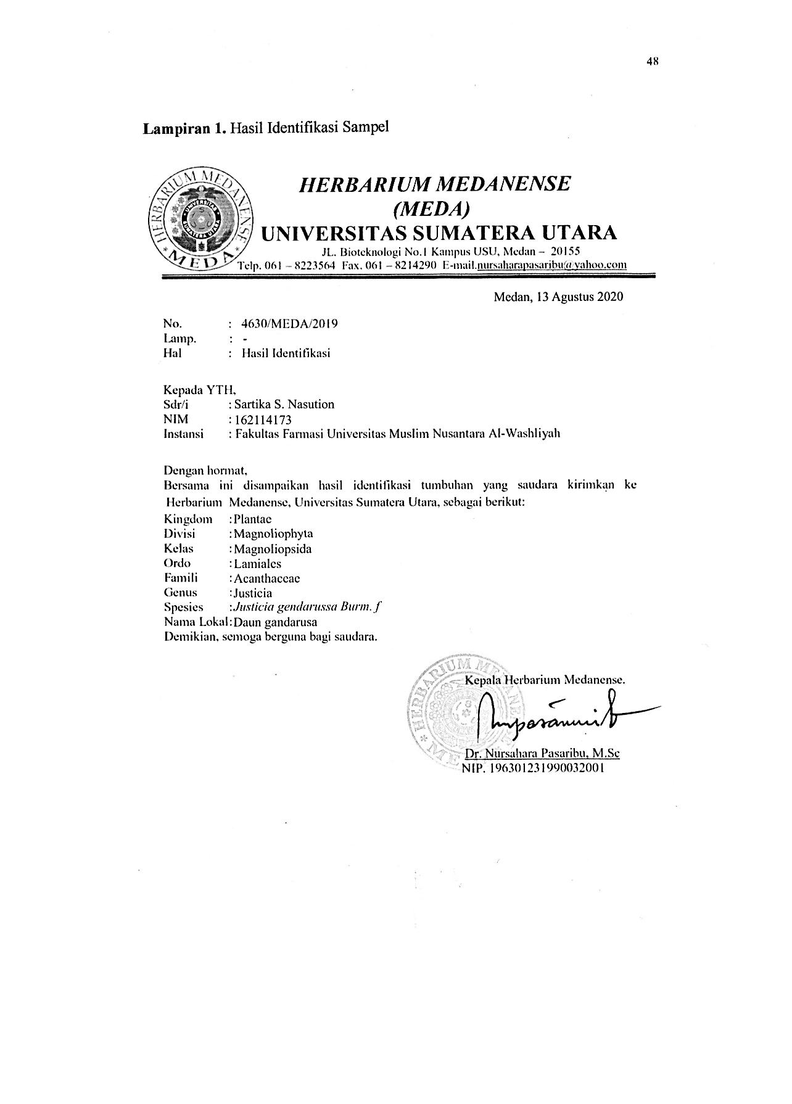
Lampiran 1. Identifikasi tumbuhan

Lampiran 2. Ethical Clearance

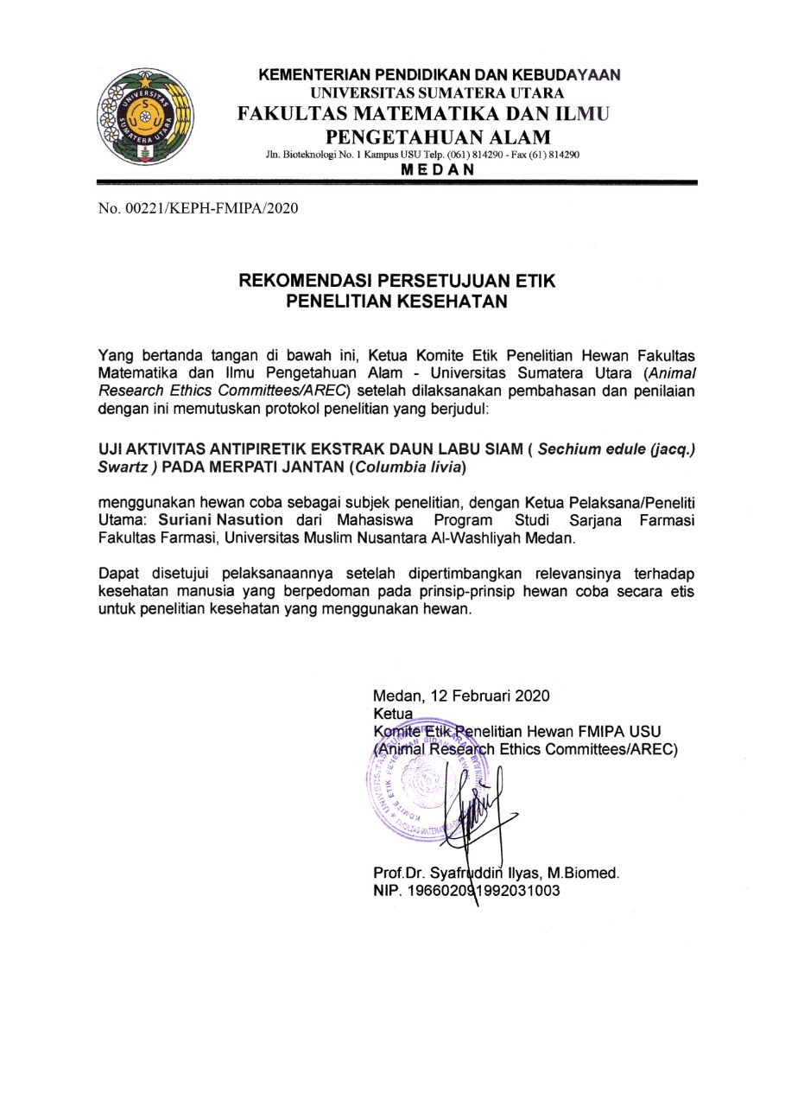

Lampiran 3. Tanaman daun gandarusa dan pemeriksaaan makroskopik simplisia daun gandarusa (Justicia gendarussa Burm. f.)

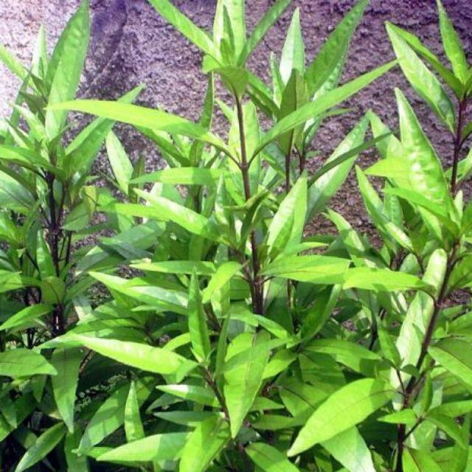
Tanaman daun gandarusa
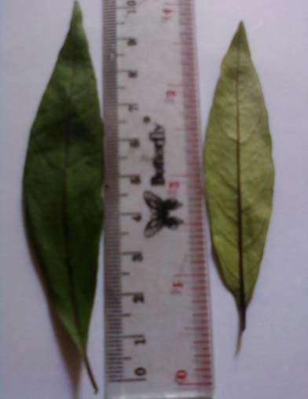
Maksroskopik Simplisis daun gandarusa
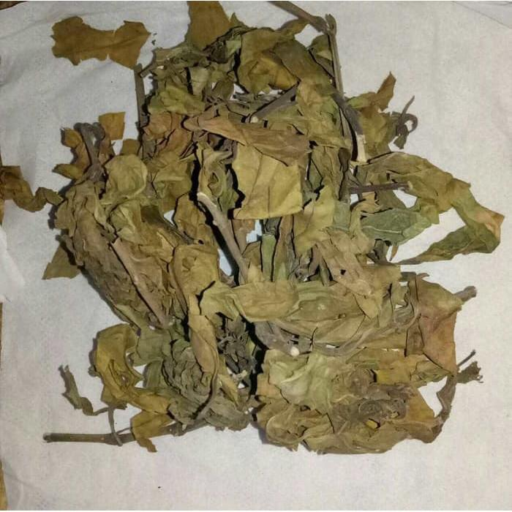Simplisia kering daun gandarusa

Lampiran 4. Serbuk Simplisia Daun gandarusa, Hasil maserasi dan Ekstrak Etanol daun gandarusa

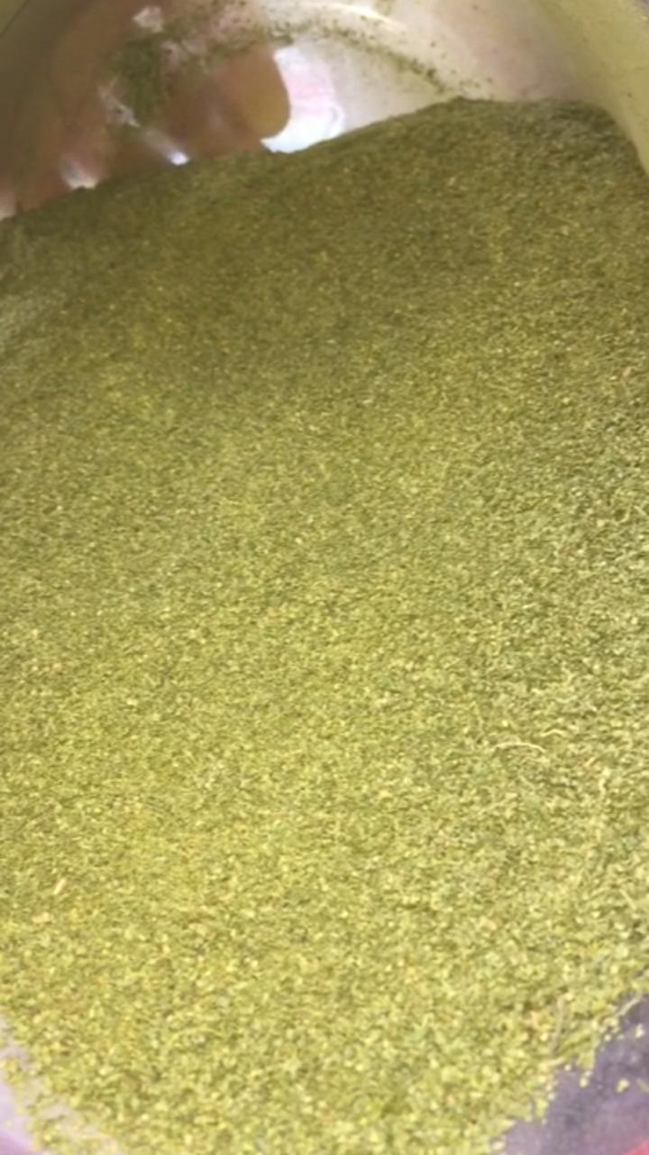
Serbuk daun gandarusa
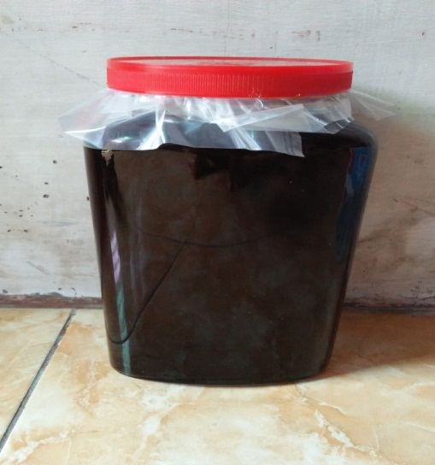
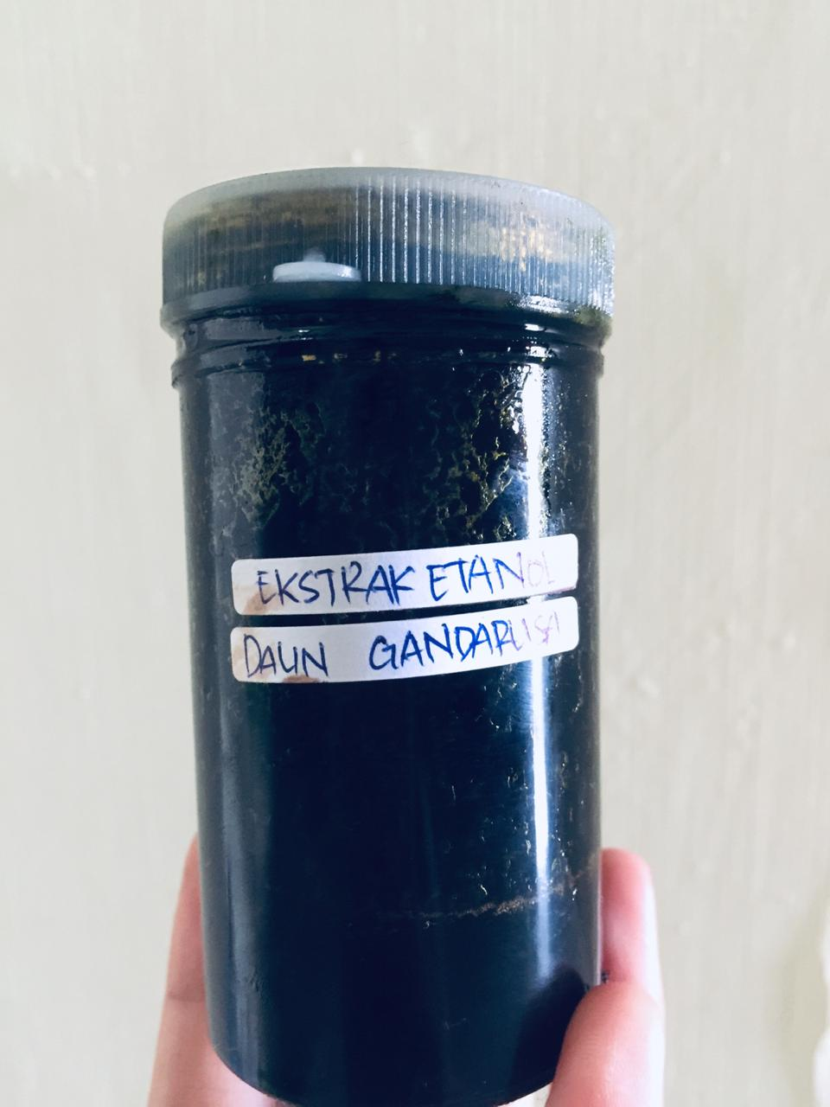
Ekstrak etanol daun gandarusa Maserat daun gandarusa
Vaksin DPT HB Hib (Penginduksi)

Parasetamol (Kontrol Positif)

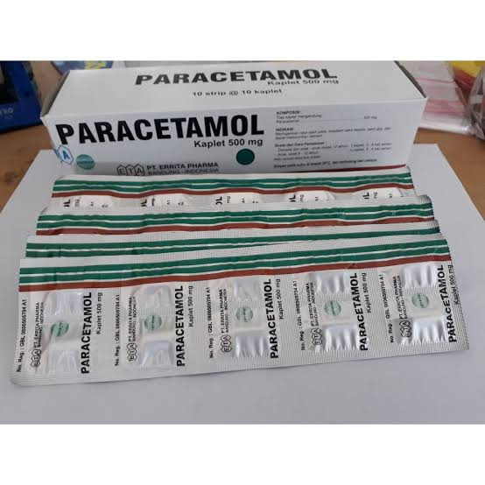

Termometer digital

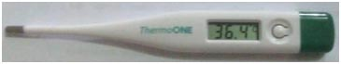

Lampiran 5. Hasil pemeriksaan mikroskop daun gandarusa
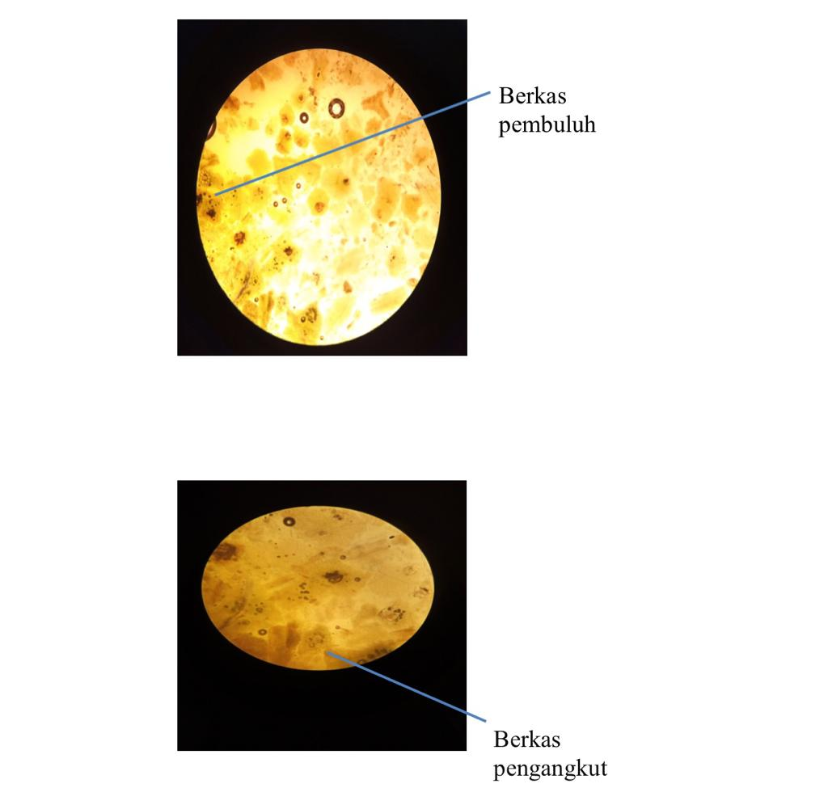
Mikroskopik daun gandarusa
Keterangan:
- Berkas pembuluh bentuk spiral
- Berkas pengangkut

Lampiran 6. Penetapan Karakterisasi Simplisia
- Perhitungan penetapan kadar air simplisia
Berat sampel | Volume awal | Volume akhir
5 g | 1,2 ml | 1,6 ml
5 g | 1.3 ml | 1,7 ml
5 g | 1,3 ml | 1,6 ml
% Kadar air simplisia = $\frac{Volume akhir-Volume awal}{Berat sampel}$ x 100%

- Berat simplisia I = 5 g
% Kadar air = $\frac{1,6ml-1,2ml}{5 g}$ x 100% = 8%
- Berat simplisia II = 5 g
% Kadar air = $\frac{1,7ml-1,3ml}{5 g}$ x 100% = 8%
- Berat simplisia III = 5 g
% Kadar air = $\frac{1,6ml-1,3ml}{5 g}$ x 100% = 6%
% Kadar air rata-rata = $\frac{8\%+ 8\%+6\%}{ 3}$ = 7,3%

Lampiran 6. (Lanjutan)
- Penetapan kadar sari larut dalam air
Berat sampel | Berat cawan kosong | Berat cawan berisi
5 g | 32,7 g | 32,9 g
5 g | 35,9 g | 36,1 g
5 g | 26,4 g | 26,7 g
% Kadar sari larut dalam air = berat cawan isi- berat cawan kosong x 100 X 100%
Berat sampel (g) 20

- Berat simplisia I = 5 g
% Kadar sari larut dalam air = 58,83 g – 58,61g x 100 x 100% = 22 %
5 20
- Berat simplisia I I = 5 g
% Kadar sari larut dalam air = 57,26 g – 57,03 g x 100 x 100% = 23 %
5 20
- Berat simplisia I II = 5 g
% Kadar sari larut dalam air = 57,26 g – 57,03 g x 100 x 100% = 23 %
5 20
% Kadar sari rata-rata = $\frac{ 22\%+23 \%+23 \%}{3}$ = 22,666 %

Lampiran 6. (Lanjutan)
- Penetapan kadar sari larut dalam etanol
Berat sampel | Berat cawan kosong | Berat cawan berisi
5 g | 35,9 g | 36,2 g
5 g | 32,2 g | 32,9 g
5 g | 36,9 g | 37,0 g
% Kadar sari larut dalam etanol = $\frac{\left(Berat cawan berisi - Berat cawan kosong\right) x 5}{Berat sampel}$ x 100%

- Berat simplisia I = 5 g
% Kadar sari larut etanol = $\frac{\left(36,2g-35,9g\right) x 5}{5 g}$ x 100% = 30 %

- Berat simplisia I I = 5 g
% Kadar sari larut etanol = $\frac{\left(32,9g-32,7g\right) x 5}{ 5 g}$ x 100% = 20%

- Berat simplisia I II = 5 g
% Kadar sari larut etanol = $\frac{\left(37,0g-36,9 g\right) x 5}{5 g}$ x 100% = 10 %
% Kadar sari larut etanol rata-rata = $\frac{ 30 \%+20 \%+10 \%}{3}$ = 20 %

Lampiran 6. (Lanjutan)
- Penetapan kadar abu total
Berat sampel | Berat cawan kosong | Berat cawan berisi
2g | 58,23 g | 58,29 g
2g | 57,30 g | 57,34 g
2g | 59,50 g | 59,54 g

% Kadar abu total = $\frac{\left(Berat cawan berisi - Berat cawan kosong\right)}{Berat sampel}$ x 100%

- Berat simplisia I = 2 g
% Kadar abu total = $\frac{58,29g-58,23 g}{2 g}$ x 100% = 3 %

- Berat simplisia I I = 2 g
% Kadar abu total = $\frac{57,34g-57,30 g}{2 g}$ x 100% = 2 %

- Berat simplisia I II = 2 g
% Kadar abu total = $\frac{59,54g-59,50g}{2 g}$ x 100% = 2 %
% Kadar abu total rata-rata = $\frac{ 3 \% + 2\% + 2 \%}{3}$ = 2,3 %

Lampiran 6. (Lanjutan)
- Penetapan kadar abu tidak larut dalam asam
Berat sampel | Berat cawan kosong | Berat cawan berisi
2 g | 63,13 g | 63,18 g
2 g | 65,08 g | 65,12 g
2 g | 60,26 g | 60,30 g

% Kadar abu tidak larut asam = $\frac{\left(Berat cawan berisi - Berat cawan kosong\right)}{Berat sampel}$ x 100%

- Berat simplisia I = 2 g
% Kadar abu tidak larut asam = $\frac{63,18g-63,13 g}{2 g}$ x 100% = 2,5 %

- Berat simplisia I I = 2 g
% Kadar abu tidak larut asam = $\frac{65,12g-65,08 g}{2 g}$ x 100% = 2 %

- Berat simplisia I II = 2 g
% Kadar abu tidak larut asam = $\frac{67,30g-60,26 g}{2 g}$ x 100% = 2 %
% Kadar abu tidak larut asam rata-rata = $\frac{ 2,5 \% + 2 \% + 2\%}{3}$ = 2,16 %

Lampiran 7. Hasil Skrining Fitokimia daun segar, serbuk simplisia, ekstrak etanol daun gandarusa
1. Skrining fitokimia daun segar
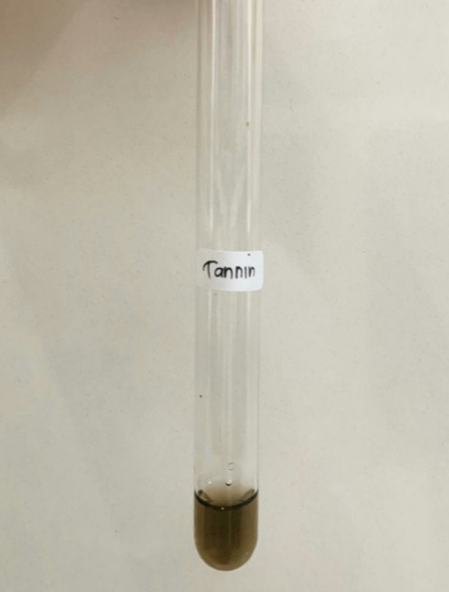
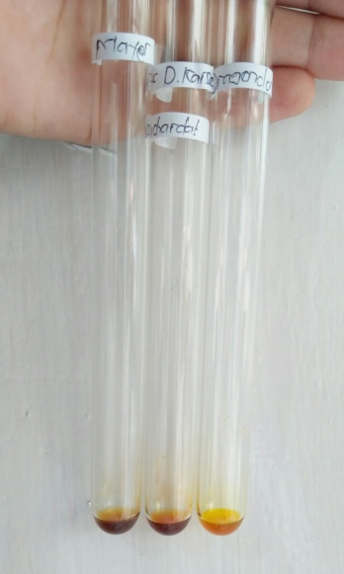
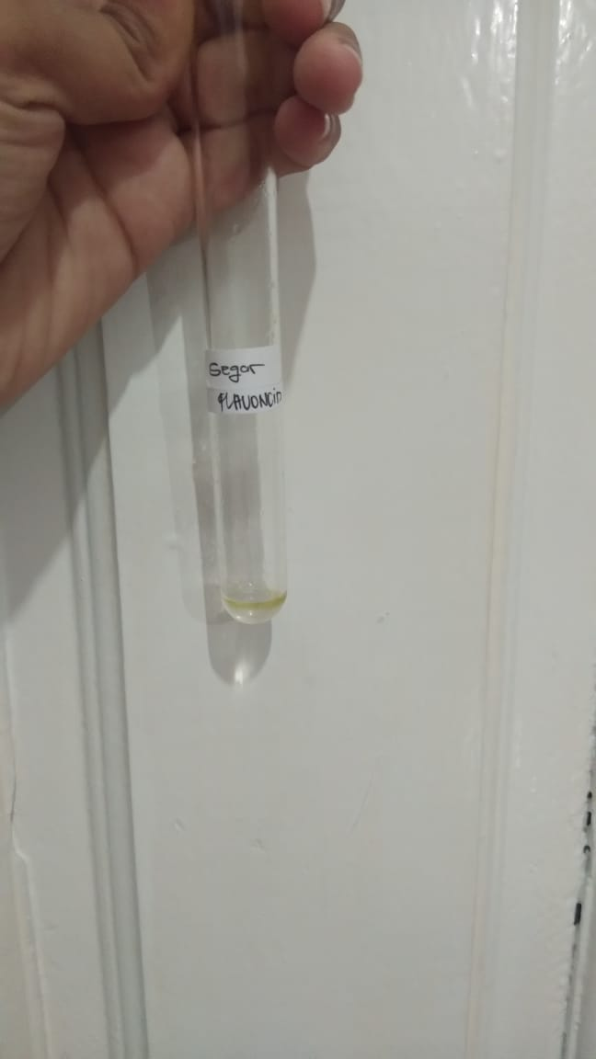

Uji tannin Uji flavonoid Uji alkaloid
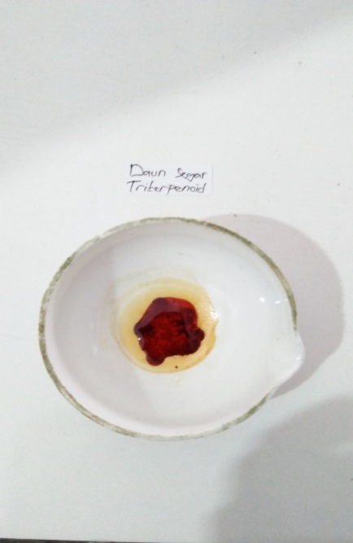
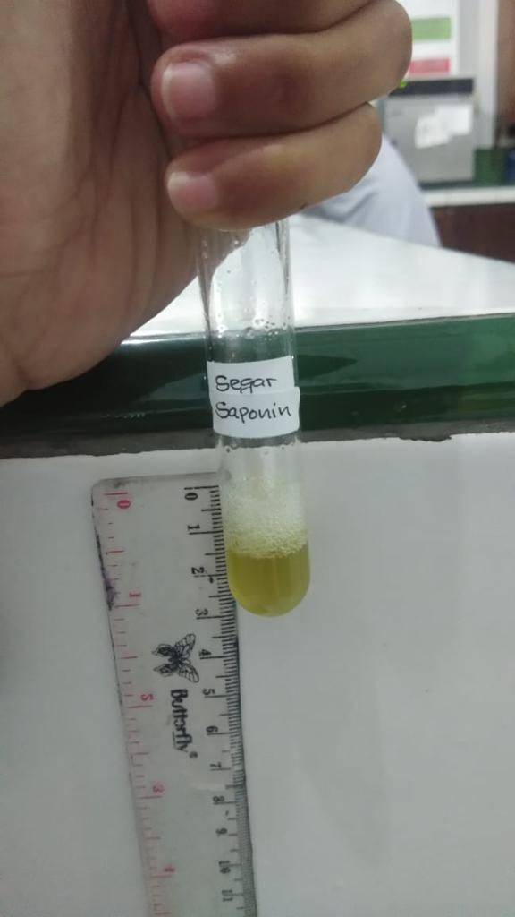
Uji saponin Uji steroid/triterpenoid

Lampiran 7. (lanjutan)
2.Skrining fitokimia serbuk simplisia
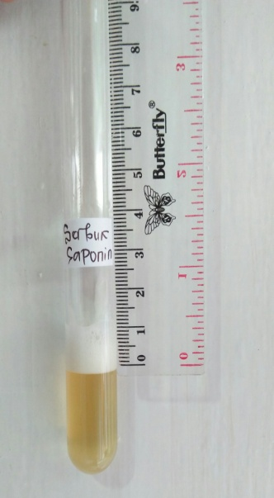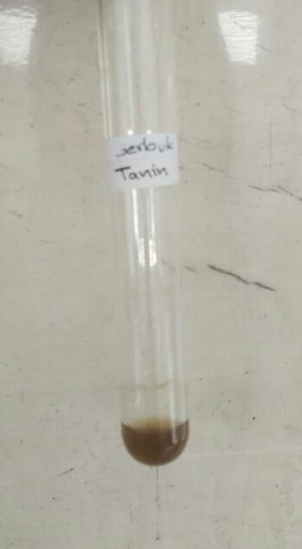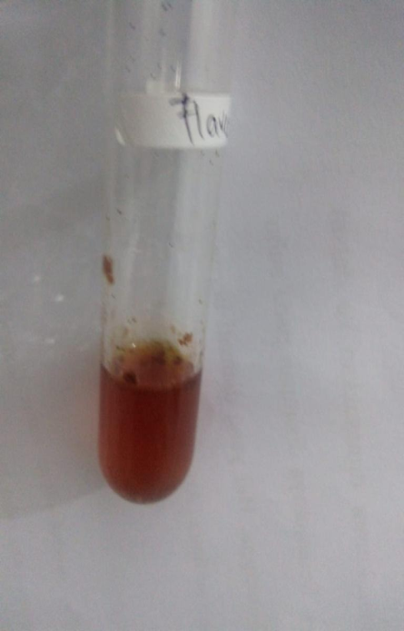
Uji saponin Uji tannin Uji Flavonoid

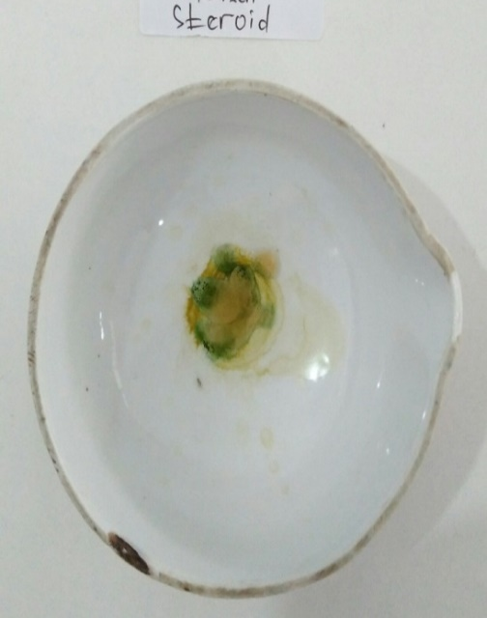
Uji alkaloid Uji steroid/triterpenoid

Lampiran 7. (lanjutan)
3.Skrining fitokimia ekstrak simplisia
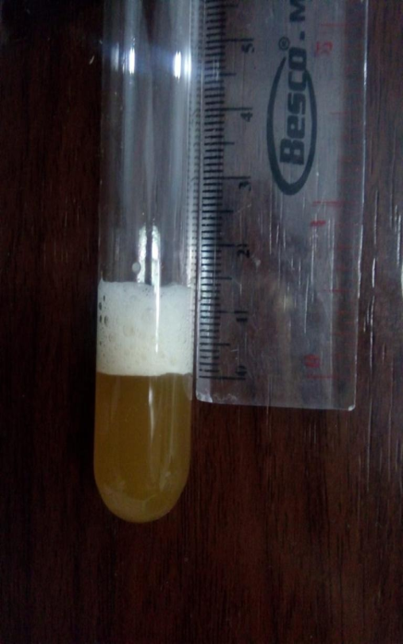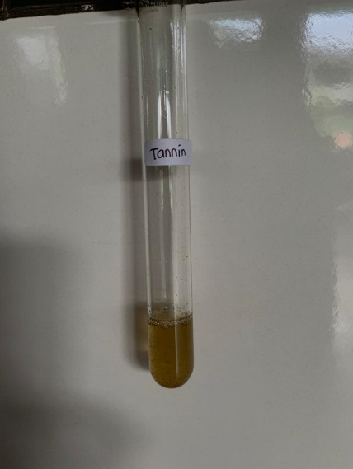
Uji saponin Uji tannin Uji flavonoid

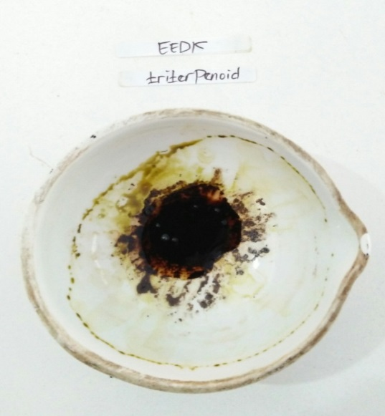
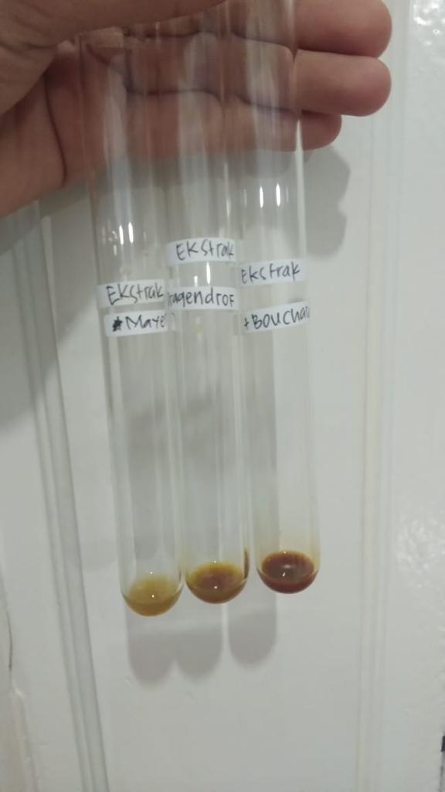

Uji alkaloid Uji steroid/ triterpenoid

Lampiran 8. Bagan alir penelitian, bagan pembutan simplisia, bagan alir pembuatan ekstrak dan bagan alir uji efektivitas antipiretik

- Bagan alir penelitian
Daun Gandarusa Segar
Daun Gandarusa
Simplisia kering
Serbuk simplisia
Karakterisasi Sampel
Dibuat Ekstrak
perkolat
Ekstrak kental
- Penetapan kadar air
- Penetapan kadar abu
- Penetapan kadar abu tidak larut asam
- Penetapan kadar sari larut dalam air
- Penetapan kadar sari larut dalam etanol
Skrining fitokimia
Suspensi Daun Gandarusa
- Alkaloid
- Flavonoid
- Steroid/Triterpenoid
- Saponin
- Glikosida
- Tannin
Uji efektivitas antipiretik pada tikus putih jantan
Dibersihkan dari pengotor
Dicuci bersih dan ditiriskan
Diangin-anginkan
Ditimbang

Dikeringkan pada suhu 40ºC
Ditimbang

Dihaluskan
Ditimbang

DiMaserasi dengan etanol 96%

Diuapkan dengan rotary evaporator

Lampiran 8. (lanjutan)
2.Bagan alir pembuatan simplisia

Daun Gandarusa

Disortasi Basah
Dicuci dengan air mengalir
Ditiriskan
Diangin-anginkan
Dirajang
Ditimbang

Berat Daun Gandarusa setelah dirajang

Dikeringkan di dalam lemari pengering pada suhu ± 40ºC
Disortasi kering
Ditimbang

Berat simplisia 7.000 kg

Dihaluskan menggunakan blender
Ditimbang
Berat serbuk simplisia 1.200 kg

Dimasukkan kedalam wadah tertutup rapat
Serbuk simplisia

Lampiran 8. (lanjutan)
3.Bagan alir pembuatan ekstrak
500 g Serbuk Simplisia Daun Gandarusa

Diekstraksi dengan cara dimaserasi menggunakan pelarut etanol

Ekstrak kental
Karakterisasi simplisia
1.Makroskopik
2.Mikroskopik
3.PK Air
4.PK sari larut dalam etanol
5.PK sari larut dalam air
6.PK abu total
7.PK tidak larut dalam asam

4.PK
Pengujian efektivitas antipiretik terhadap tikus putih jantan

Skrining fitokimia
- Alkaloid
- Flavonoid
- Saponin
- Tanin
- Glikosida
- Steroid/triterpenoid
Suspensi EEDGR
Lampiran 8. (lanjutan)
4.Bagan alir pengujian farmakologi
25 ekor tikus putih jantan

Dipuasakan ± 18 jam
Kelompok 2
( 5 ekor )
Kelompok 5
( 5 ekor )
Pengukuran suhu awal
Kelompok 1
(5 ekor )
Kelompok 4
( 5 ekor )
Kelompok 3
( 5 ekor )
Pengukuran suhu awal 1 jam setelah pemberian vaksin DTP-HB
Diberi EEDGR 200 mg/kg BB
Diberi EEDG 50 mg/kg BB
Kontrol negatif diberi suspensi CMC 0,5%
Diberi EEDGR 100 mg/kg BB
kontrol positif diberi suspensi parasetamol 0,5%
Analisis data
Pengukuran suhu rektak dilakukan setiap 30 menit selama 3 jam

Lampiran 9. Perhitungan dosis
- Perhitungan dosis CMC 0,5%
CMC 0,5% = jumlah cmc / volume suspensi
= 0,5 g / 100 ml
= 500 mg / 100 ml
= 5 mg / ml
Perhitungan CMC 0,5% pada tikus dengan BB = 200 g
50
= X 200 g
100
= 1 ml

- Perhitungan dosis parasetamol
Konversi dosis parasetamol dari manusia (70 kg) ke tikus (200 g) = 0,018
Dosis parasetamol untuk manusia dewasa dengan BB (70 kg) = 500 mg
Maka dosis parasetamol pada tikus = dosis terapi manusia x 0,018
= 500 mg x 0,018
= 9 ml
Tikus 200 g 0,2 kg
9 mg
=
0,2 kg
= 45 mg / kg BB

Konsentrasi suspensi parasetamol
Suspensi parasetamol 0,5% = jumlah parasetamol / volume suspensi
= 5 g / 100 ml
= 500 mg / 100 ml
= 5 mg / ml

Lampiran 9. (lanjutan)
Dosis untuk tikus = Dosis parasetamol X BB tikus
= 45 mg x 0,2 kg
= 9 ml

Volume suspense yang diambil = dosis parasetamol untuk tikus

Konsentrasi suspense parasetamol
= 9 mg

5 mg / ml
= 1,8 ml

3.Perhitungan dosis EEDG 50 mg/kg
- Konsentrasi suspense EEDG
Konsentrasi EEDG 5% = jumlah EEDG / volume suspense
= 5000 mg /100 ml
= 50 mg/ml
- BB tikus 200 g atau 0,2 kg
- Perhitungan dosis 50 mg/kg BB
= 50
X 200 g
1000
= 10 mg
Volume suspensi yang diberikan = Dosis EEDGR

Konsentrasi
= 10 mg

50 mg/ml
= 0,2 ml

Lampiran 9. (lanjutan)
4.Perhitungan dosis EEDG 100 mg/kg BB
- Konsentrasi suspensi EEDG
Konsentrasi EEDG 5% = jumlah EEDG / volume suspense
= 5000 mg / 100 ml
= 50 mg/ml
- BB tikus 200 g atau 0,2 kg
- Perhitungan dosis 100 mg/kg BB
= 100 mg
X 200 g
1000 g
= 20 mg
- Volume suspensi yang diberikan = Dosis EEDG
Konsentrasi
= 20 mg
50 mg/ml
= 0,4 ml
- Perhitungan dosis EEDG 200 mg/kg BB
- Konsentrasi suspensi EEDG
Konsentrasi EEDG 5% = jumlah EEDG / volume suspensi
= 5000 mg / 100 ml
= 50 mg/ml
- BB tikus 200 g atau 0,2 kg
- Perhitungan dosis 200 mg/kg BB
= 20mg
Volume suspensi yang diberikan = dosis EEDG
Konsentrasi
40 mg
50 mg/ml = 0,8 ml

Lampiran 10. Data perlakuan hewan
Perlakuan | Hewan | Suhu awal | Suhu demam | Suhu rektal tikus (⁰C) selang 30 menit
 |  |  |  | 30 | 60 | 90 | 120 | 150 | 180
Kontrol Negatif CMC 0,5% | 1 | 36,8 | 38,3 | 38,2 | 38,2 | 38,1 | 38,0 | 38,0 | 38,0
 | 2 | 36,9 | 38,1 | 38,1 | 38,1 | 38,0 | 37,9 | 37,8 | 37,7
 | 3 | 37,0 | 38,2 | 38,0 | 38,0 | 37,9 | 37,7 | 37,7 | 37,6
 | 4 | 36,9 | 38,3 | 38,2 | 38,2 | 38,0 | 38,0 | 37,9 | 37,9
 | 5 | 37,0 | 38,0 | 37,9 | 37,9 | 37,8 | 37,6 | 37,6 | 37,5
Kontrol positif parasetamol | 1 | 36,6 | 38,0 | 37,7 | 37,5 | 37,4 | 37,2 | 37,1 | 36,8
 | 2 | 36,9 | 38,1 | 37,9 | 37,6 | 37,5 | 37,4 | 37,3 | 36,9
 | 3 | 36,8 | 38,1 | 38,0 | 37,8 | 37,6 | 37,2 | 36,9 | 36,7
 | 4 | 36,7 | 38,2 | 37,6 | 37,4 | 37,4 | 37,3 | 37,2 | 37,0
 | 5 | 36,5 | 38,3 | 37,0 | 37,2 | 37,0 | 36,8 | 36,6 | 36,5
EEDG 50 mg/kg BB | 1 | 36,9 | 38,3 | 38,1 | 37,9 | 37,8 | 37,6 | 37,4 | 37,0
 | 2 | 36,8 | 38,0 | 37,9 | 37,7 | 37,6 | 37,5 | 37,4 | 37,1
 | 3 | 37,0 | 38,1 | 37,9 | 37,6 | 37,5 | 37,4 | 37,2 | 37,0
 | 4 | 36,6 | 38,2 | 38,0 | 37,8 | 37,7 | 37,5 | 37,3 | 37,2
 | 5 | 36,7 | 38,4 | 38,2 | 37,9 | 37,8 | 37,7 | 37,5 | 37,3
EEDG 100 mg/kg BB | 1 | 36,5 | 38,1 | 37,8 | 37,7 | 37,5 | 37,3 | 37,1 | 36,8
 | 2 | 37,0 | 38,2 | 37,7 | 37,6 | 37,5 | 37,4 | 37,2 | 37,1
 | 3 | 36,8 | 38,3 | 38,1 | 37,9 | 37,8 | 37,6 | 36,3 | 36,9
 | 4 | 36,7 | 38,0 | 37,8 | 37,7 | 37,6 | 37,4 | 37,2 | 36,8
 | 5 | 36,6 | 38,2 | 38,0 | 37,8 | 37,7 | 37,5 | 37,4 | 37,0
EEDG 200 mg/kg BB | 1 | 36,8 | 38,0 | 37,8 | 37,5 | 37,4 | 37,2 | 37,0 | 36,8
 | 2 | 36,9 | 38,1 | 37,9 | 37,7 | 37,6 | 37,4 | 37,2 | 36,9
 | 3 | 36,7 | 38,2 | 37,7 | 37,4 | 37,5 | 37,3 | 37,1 | 36,7
 | 4 | 36,9 | 38,0 | 37,9 | 37,5 | 37,4 | 37,3 | 37,1 | 36,9
 | 5 | 37,0 | 38,3 | 38,0 | 37,8 | 37,7 | 37,5 | 37,3 | 37,0

Lampiran 11. Tabel konversi dosis (g).
Konvensi | Mencit  20 g | Tikus  200 g | Marmut  400 g | Kelinci  1,5 kg | Kucing  1,5 kg | Kera  4 kg | Anjing  12 kg | Manusia  70 kg
Mencit  20 g | 1,0 | 7,0 | 12,23 | 27,80 | 29,70 | 64,10 | 124,20 | 387,9
Tikus  200 g | 0,14 | 1,0 | 1,74 | 3,90 | 4,20 | 9,20 | 17,80 | 56,0
Marmut  400 g | 0,08 | 0,57 | 1,0 | 2,25 | 2,40 | 5,20 | 10,20 | 31,50
Kelinci  1,5 g | 0,04 | 0,25 | 0,44 | 1,0 | 1,08 | 2,40 | 4,50 | 14,20
Kucing  1,5 g | 0,03 | 0,23 | 0,41 | 0,92 | 1,0 | 2,20 | 4,10 | 13,0
Kera  4 kg | 0,016 | 0,11 | 0,19 | 0,42 | 0,43 | 0,1 | 1,9 | 6,1
Anjing  12 kg | 0,008 | 0,06 | 0,10 | 0,22 | 1,24 | 0,52 | 1,0 | 3,10
Manusia  70 kg | 0,0026 | 0,018 | 0,031 | 0,07 | 0,076 | 0,16 | 0,32 | 1,0

Lampiran 12. Tabel volume maksimum lambung pada hewan (ml)
Jenis hewan  Uji | Volume maksimum ( ml) sesuai jalur pemberian
 | i.v | i.m | i.p | s.c | p.o
Mencit  (20-30 g) | 0,5 | 0,05 | 1,0 | 0,5-1,0 | 1,0
Tikus  (200 g) | 1,0 | 0,1 | 2-5 | 2-5 | 5,0
Hamster  (50 g) | - | 0,1 | 1-2 | 2,5 | 2,5
Marmut  (250 g) | - | 0,25 | 2-5 | 5,0 | 10,0
Kelinci  (3 kg) | 5-10 | 0,5 | 10-20 | 5-10 | 20,0
Kucing  (3kg) | 5-10 | 1,0 | 10-20 | 5-10 | 50,0
Anjing  (5 kg) | 10-20 | 5,0 | 20-50 | 10,0 | 100,0

Lampiran 13. Hasil SPSS, ANOVA dan Duncan
Descriptives
 |  |  | Statistic | Std. Error
t.0 | Mean |  | 36.800 | .0316
 | 95% Confidence Interval for Mean | Lower Bound | 36.735
 |  | Upper Bound | 36.865
 | 5% Trimmed Mean |  | 36.806
 | Median |  | 36.800
 | Variance |  | .025
 | Std. Deviation |  | .1581
 | Minimum |  | 36.5
 | Maximum |  | 37.0
 | Range |  | .5
 | Interquartile Range |  | .2
 | Skewness |  | -.412 | .464
 | Kurtosis |  | -.846 | .902
t.induksi | Mean |  | 38.160 | .0245
 | 95% Confidence Interval for Mean | Lower Bound | 38.109
 |  | Upper Bound | 38.211
 | 5% Trimmed Mean |  | 38.157
 | Median |  | 38.200
 | Variance |  | .015
 | Std. Deviation |  | .1225
 | Minimum |  | 38.0
 | Maximum |  | 38.4
 | Range |  | .4
 | Interquartile Range |  | .3
 | Skewness |  | .118 | .464
 | Kurtosis |  | -1.120 | .902
t.30 | Mean |  | 37.924 | .0343
 | 95% Confidence Interval for Mean | Lower Bound | 37.853
 |  | Upper Bound | 37.995
 | 5% Trimmed Mean |  | 37.926
 | Median |  | 37.900
 | Variance |  | .029
 | Std. Deviation |  | .1715
 | Minimum |  | 37.6
 | Maximum |  | 38.2
 | Range |  | .6
 | Interquartile Range |  | .3
 | Skewness |  | -.028 | .464
 | Kurtosis |  | -.798 | .902
t.60 | Mean |  | 37.732 | .0486
 | 95% Confidence Interval for Mean | Lower Bound | 37.632
 |  | Upper Bound | 37.832
 | 5% Trimmed Mean |  | 37.734
 | Median |  | 37.700
 | Variance |  | .059
 | Std. Deviation |  | .2428
 | Minimum |  | 37.2
 | Maximum |  | 38.2
 | Range |  | 1.0
 | Interquartile Range |  | .4
 | Skewness |  | -.084 | .464
 | Kurtosis |  | -.224 | .902
t.90 | Mean |  | 37.632 | .0482
 | 95% Confidence Interval for Mean | Lower Bound | 37.533
 |  | Upper Bound | 37.731
 | 5% Trimmed Mean |  | 37.638
 | Median |  | 37.600
 | Variance |  | .058
 | Std. Deviation |  | .2410
 | Minimum |  | 37.0
 | Maximum |  | 38.1
 | Range |  | 1.1
 | Interquartile Range |  | .3
 | Skewness |  | -.235 | .464
 | Kurtosis |  | .798 | .902
t.120 | Mean |  | 37.468 | .0535
 | 95% Confidence Interval for Mean | Lower Bound | 37.358
 |  | Upper Bound | 37.578
 | 5% Trimmed Mean |  | 37.471
 | Median |  | 37.400
 | Variance |  | .071
 | Std. Deviation |  | .2673
 | Minimum |  | 36.8
 | Maximum |  | 38.0
 | Range |  | 1.2
 | Interquartile Range |  | .3
 | Skewness |  | .089 | .464
 | Kurtosis |  | .987 | .902
t.150 | Mean |  | 37.312 | .0628
 | 95% Confidence Interval for Mean | Lower Bound | 37.182
 |  | Upper Bound | 37.442
 | 5% Trimmed Mean |  | 37.311
 | Median |  | 37.300
 | Variance |  | .099
 | Std. Deviation |  | .3140
 | Minimum |  | 36.6
 | Maximum |  | 38.0
 | Range |  | 1.4
 | Interquartile Range |  | .4
 | Skewness |  | .336 | .464
 | Kurtosis |  | .634 | .902
t.180 | Mean |  | 37.084 | .0765
 | 95% Confidence Interval for Mean | Lower Bound | 36.926
 |  | Upper Bound | 37.242
 | 5% Trimmed Mean |  | 37.064
 | Median |  | 37.000
 | Variance |  | .146
 | Std. Deviation |  | .3826
 | Minimum |  | 36.5
 | Maximum |  | 38.0
 | Range |  | 1.5
 | Interquartile Range |  | .5
 | Skewness |  | 1.079 | .464
 | Kurtosis |  | .544 | .902

Tests of Normality
 | Kolmogorov-Smirnovª |  |  | Shapiro-Wilk
 | Statistic | df | Sig. | Statistic | df | Sig.
t.0 | .176 | 25 | .043 | .916 | 25 | .041
t.induksi | .168 | 25 | .067 | .898 | 25 | .016
t.30 | .124 | 25 | .200* | .949 | 25 | .233
t.60 | .090 | 25 | .200* | .982 | 25 | .918
t.90 | .128 | 25 | .200* | .956 | 25 | .345
t.120 | .132 | 25 | .200* | .947 | 25 | .215
t.150 | .155 | 25 | .123 | .955 | 25 | .320
t.180 | .227 | 25 | .002 | .888 | 25 | .010
a. Lilliefors Significance Correction
*. This is a lower bound of the true significance.

ANOVA
 |  | Sum of Squares | df | Mean Square | F | Sig.
t.0 | Between Groups | .172 | 4 | .043 | 2.009 | .132
 | Within Groups | .428 | 20 | .021
 | Total | .600 | 24
t.induksi | Between Groups | .020 | 4 | .005 | .294 | .878
 | Within Groups | .340 | 20 | .017
 | Total | .360 | 24
t.30 | Between Groups | .302 | 4 | .075 | 3.733 | .020
 | Within Groups | .404 | 20 | .020
 | Total | .706 | 24
t.60 | Between Groups | .934 | 4 | .234 | 9.733 | .000
 | Within Groups | .480 | 20 | .024
 | Total | 1.414 | 24
t.90 | Between Groups | .930 | 4 | .233 | 10.026 | .000
 | Within Groups | .464 | 20 | .023
 | Total | 1.394 | 24
t.120 | Between Groups | 1.218 | 4 | .305 | 12.282 | .000
 | Within Groups | .496 | 20 | .025
 | Total | 1.714 | 24
t.150 | Between Groups | 1.802 | 4 | .451 | 15.979 | .000
 | Within Groups | .564 | 20 | .028
 | Total | 2.366 | 24
t.180 | Between Groups | 3.006 | 4 | .751 | 29.583 | .000
 | Within Groups | .508 | 20 | .025
 | Total | 3.514 | 24

t.0
Duncanª
perlakuan | N | Subset for alpha = 0.05
 |  | 1 | 2
PCT | 5 | 36.700
EEDGR100 | 5 | 36.720 | 36.720
EEDGR50 | 5 | 36.800 | 36.800
EEDGR200 | 5 | 36.860 | 36.860
cmc 0,5 % | 5 |  | 36.920
Sig. |  | .127 | .060
Means for groups in homogeneous subsets are displayed.
a. Uses Harmonic Mean Sample Size = 5.000.

t.induksi
Duncanª
perlakuan | N | Subset for alpha = 0.05
 |  | 1
EEDGR200 | 5 | 38.120
PCT | 5 | 38.140
EEDGR100 | 5 | 38.160
cmc 0,5 % | 5 | 38.180
EEDGR50 | 5 | 38.200
Sig. |  | .394
Means for groups in homogeneous subsets are displayed.
a. Uses Harmonic Mean Sample Size = 5.000.

t.30
Duncanª
perlakuan | N | Subset for alpha = 0.05
 |  | 1 | 2 | 3
PCT | 5 | 37.780
EEDGR200 | 5 | 37.860 | 37.860
EEDGR100 | 5 | 37.880 | 37.880
EEDGR50 | 5 |  | 38.020 | 38.020
cmc 0,5 % | 5 |  |  | 38.080
Sig. |  | .306 | .107 | .512
Means for groups in homogeneous subsets are displayed.
a. Uses Harmonic Mean Sample Size = 5.000.

t.60
Duncanª
perlakuan | N | Subset for alpha = 0.05
 |  | 1 | 2 | 3
PCT | 5 | 37.500
EEDGR200 | 5 | 37.580 | 37.580
EEDGR100 | 5 |  | 37.740
EEDGR50 | 5 |  | 37.780
cmc 0,5 % | 5 |  |  | 38.060
Sig. |  | .424 | .066 | 1.000
Means for groups in homogeneous subsets are displayed.
a. Uses Harmonic Mean Sample Size = 5.000.

t.90
Duncanª
perlakuan | N | Subset for alpha = 0.05
 |  | 1 | 2 | 3
PCT | 5 | 37.380
EEDGR200 | 5 | 37.520 | 37.520
EEDGR100 | 5 |  | 37.620
EEDGR50 | 5 |  | 37.680
cmc 0,5 % | 5 |  |  | 37.960
Sig. |  | .162 | .131 | 1.000
Means for groups in homogeneous subsets are displayed.
a. Uses Harmonic Mean Sample Size = 5.000.

t.120
Duncanª
perlakuan | N | Subset for alpha = 0.05
 |  | 1 | 2 | 3
PCT | 5 | 37.180
EEDGR200 | 5 | 37.340 | 37.340
EEDGR100 | 5 |  | 37.440
EEDGR50 | 5 |  | 37.540
cmc 0,5 % | 5 |  |  | 37.840
Sig. |  | .124 | .071 | 1.000
Means for groups in homogeneous subsets are displayed.
a. Uses Harmonic Mean Sample Size = 5.000.

t.150
Duncanª
perlakuan | N | Subset for alpha = 0.05
 |  | 1 | 2 | 3
PCT | 5 | 37.020
EEDGR200 | 5 | 37.140 | 37.140
EEDGR100 | 5 | 37.240 | 37.240
EEDGR50 | 5 |  | 37.360
cmc 0,5 % | 5 |  |  | 37.800
Sig. |  | .063 | .063 | 1.000
Means for groups in homogeneous subsets are displayed.
a. Uses Harmonic Mean Sample Size = 5.000.

t.180
Duncanª
perlakuan | N | Subset for alpha = 0.05
 |  | 1 | 2 | 3
PCT | 5 | 36.780
EEDGR200 | 5 | 36.860
EEDGR100 | 5 | 36.920 | 36.920
EEDGR50 | 5 |  | 37.120
cmc 0,5 % | 5 |  |  | 37.740
Sig. |  | .203 | .061 | 1.000
Means for groups in homogeneous subsets are displayed.

