Lampiran 1.Hasil Determinasi Tumbuhan
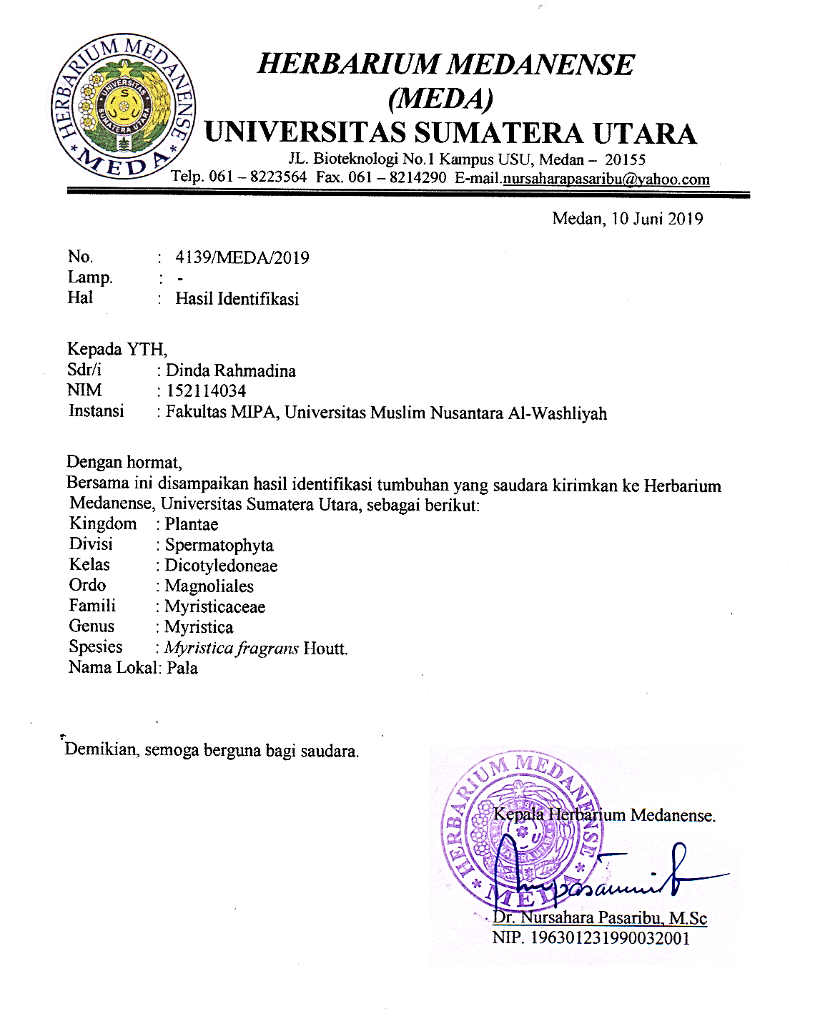

Lampiran 2.Rekomendasi Persetujuan Etik Penelitian Kesehatan

Lampiran 3.Hasil Pemeriksaan Makroskopik Daun Pala (Myristica fragrans
Houtt)

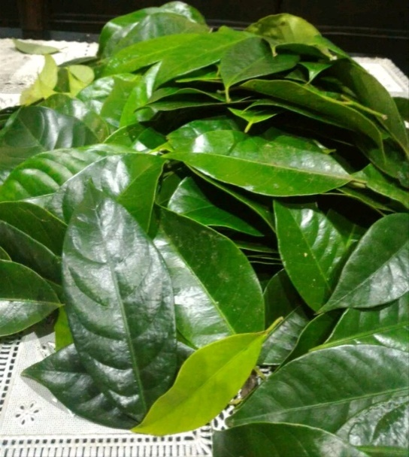
Daun pala segar

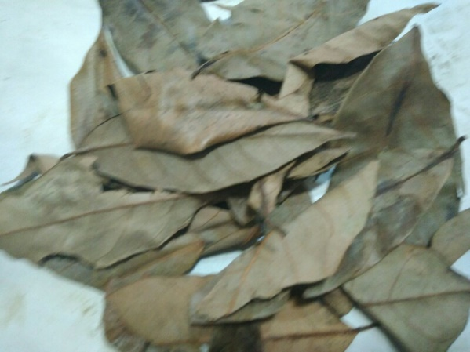
Daun pala kering

Lampiran 4. Hasil Pemeriksaan Mikroskopik Daun Pala
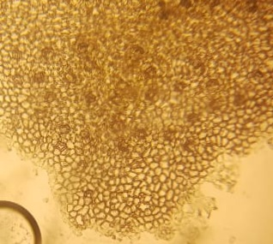
3
1
2
Perbesaran mikroskopik 40 x 10
Ket :
1. Minyak atsiri (kuning)
2. Stomata
3. jaringan (xylem daan floem)

Lampiran 5. Skrining fitokimia
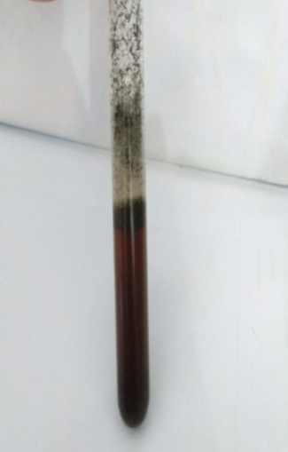
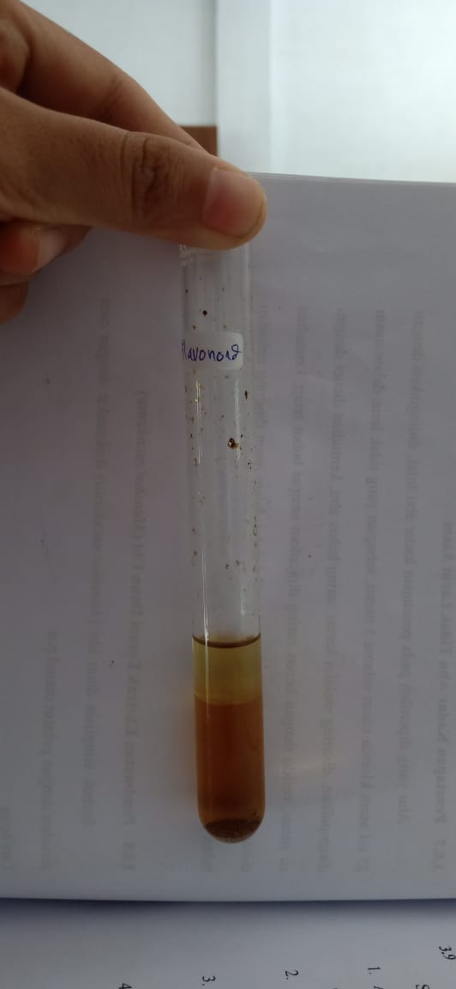
Pemeriksaan Pemeriksaan Pemeriksaan
Flavonoid Saponin Tanin

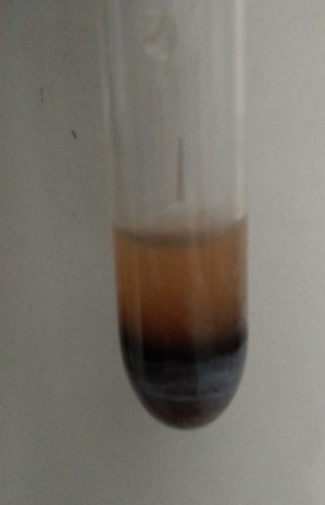
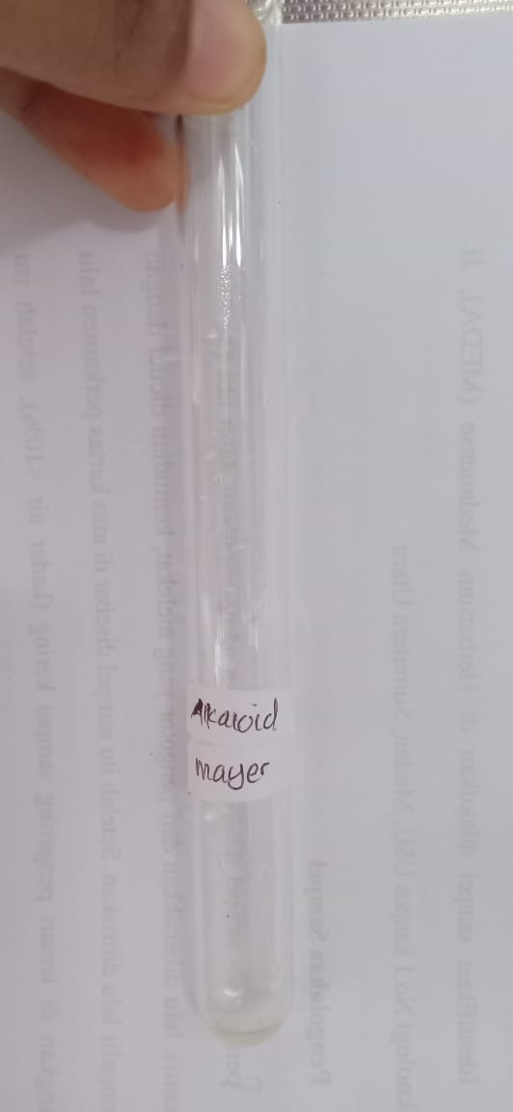
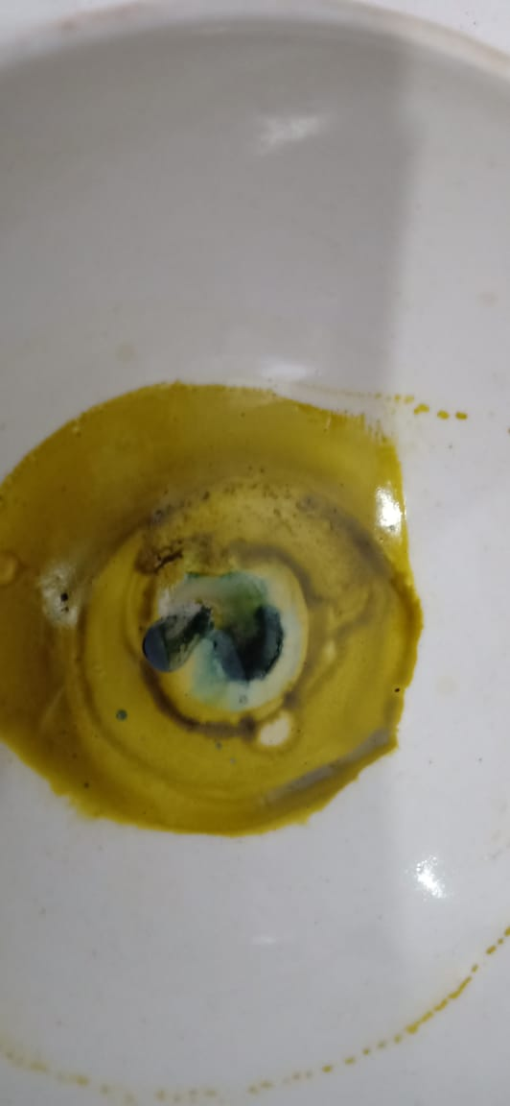

` Pemeriksaan Pemeriksaan Pemeriksaan glikosida
Steroid Alkaloid

Lampiran 6. Alat Rotary Evaporator

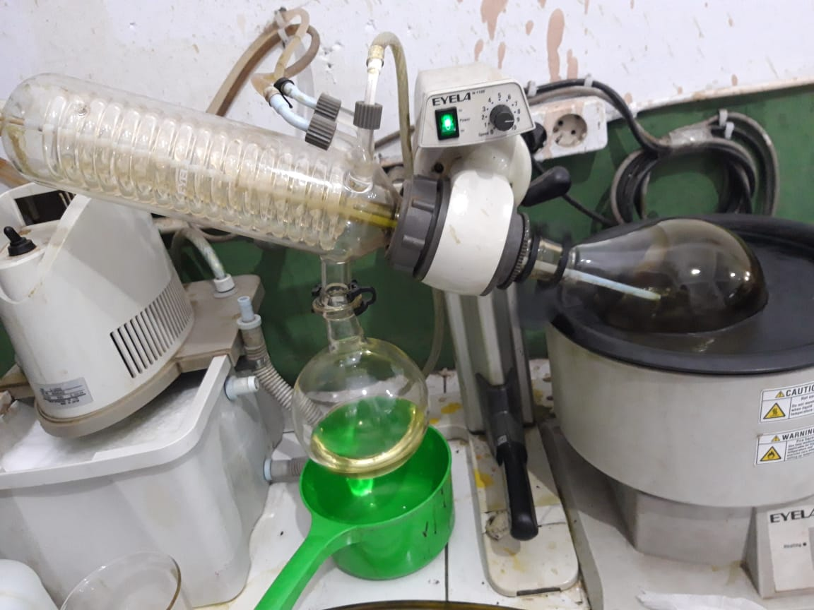
a AlatRotary evaporator

Lampiran 7. Ekstrak Cara Maserasi dan Ekstrak Etanol Daun pala

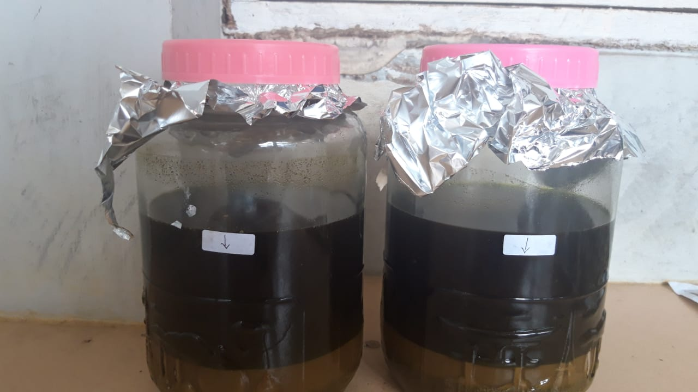
- Ekstrak cara maserasi daun pala

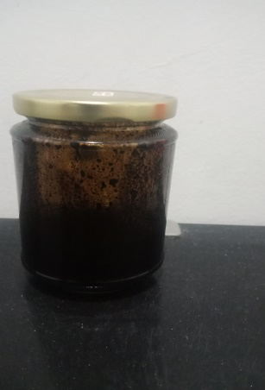
- Ekstrak Etanol daun pala

Lampiran 8.Gambar hewan percobaan
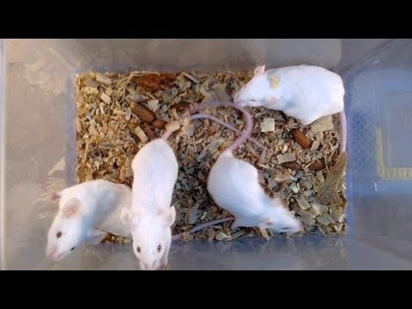
Mencit saat di orientasi
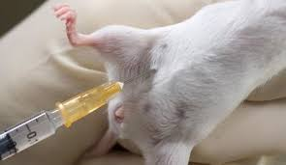
Mencit saat di induksi dengan asam asetat 0,5%
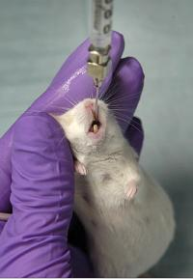
Mencit saat diberi ekstrak melalui oral
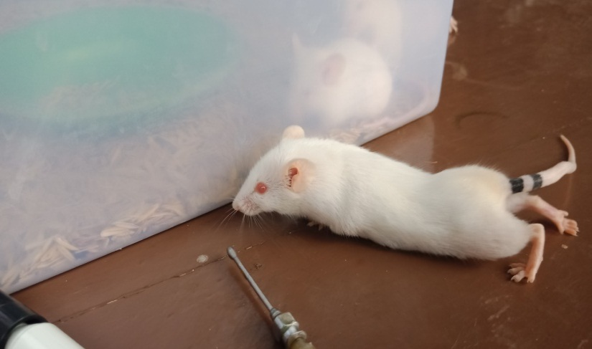
b. Geliat Mencit
Lampiran 9. Perhitungan Hasil Karakterisasi Simplisia Daun Pala (Myristica fragrans Houtt) Perhitungan Penetapan Kadar Air

Kadar Air = $\frac{\text{Volume Air (ml}\text{)}}{\text{Berat} \text{Sampel}\text{ (g)}}\text{ × }\text{100}\text{\%}$
BeratSampel : 5 g
Volume 1 : 1,6 ml
Volume 2 :2,03 ml
Kadar Air : $\frac{0,4 ml}{5 g}\text{ × }\text{100 \% = }\text{8}\text{\%}$

Lampiran 9. ( Lanjutan )
Perhitungan Hasil Karakterisasi Simplisia Daun Pala (Myristica fragrans Houtt) Perhitungan Penetapan Kadar Abu total
Kadar Abu = $\frac{\text{Berat}\text{ Abu (g}\text{)}}{\text{Berat} \text{Sampel}\text{ (g)}}\text{ × }\text{100}\text{\%}$
Perlakuan 1
Berat sampel :2 g
Berat abu :0,059 g
Kadar Abu = $\frac{\text{0}\text{,o59}\text{ g}}{\text{2,00 g}}\text{ × }\text{100}\text{\%}\text{=2,95\%}$
Perlakuan 2
Berat sampel :2 g
Beratabu :0,052 g
Kadar Abu = $\frac{\text{0,052 g}}{\text{2}\text{,00}\text{ g}}\text{ × }\text{100}\text{\%}\text{=2,6}\text{\%}$
Perlakuan 3
Berat sampel :2 g
Beratabu :0,049 g
Kadar Abu = $\frac{\text{0,049 g}}{\text{2}\text{,00}\text{ g}}\text{ × }\text{100}\text{\%= 2,45\%}$
Kadar Abu rata-rata$=\frac{\text{ 2}\text{,95}\text{ +2,6+2,45}}{\text{3}}\text{= 2,6}\text{6}\text{\%}$

Lampiran 9.( Lanjutan )
Perhitungan Hasil Karakterisasi Simplisia Daun Pala (Myristica fragrans Houtt) Perhitungan Penetapan Kadar Tidak Larut Asam
Kadar Abu Tidak Larut Asam = $\frac{\text{Berat}\text{ Abu (g}\text{)}}{\text{Berat} \text{Sampel}\text{ (g)}}\text{ × }\text{100}\text{\%}$
Perlakuan 1
Berat sampel :2 g
Berat abu :0,012 g
Kadar Abu = $\frac{\text{0,012 g}}{\text{2}\text{,00}\text{ g}}\text{ × }\text{100}\text{\%}\text{=0,6\%}$
Perlakuan 2
Berat sampel :2 g
Berat abu :0,011
Kadar Abu = $\frac{\text{0,011 g}}{\text{2}\text{,00}\text{ g}}\text{ × }\text{100}\text{\%}\text{=0,55}\text{\%}$
Perlakuan 3
Berat sampel :2 g
Berat abu :0,012 g
Kadar Abu = $\frac{\text{0,012g}}{\text{2}\text{,00}\text{ g}}\text{ × }\text{100}\text{\%= 0,6\%}$
Kadar A
bu rata-rata$=\frac{\text{ 0,6 +}\text{0,}\text{55+0,6}}{\text{3}}\text{= 0,}\text{4}\text{\%}$

Lampiran 9.( Lanjutan )
Perhitungan Hasil Karakterisasi Simplisia Daun Pala (Myristica fragrans Houtt) Perhitungan Penetapan Kadar Sari Larut Air
Kadar Sari Larut Air = $\frac{\text{Berat}\text{ Sari (g}\text{)}}{\text{BeratSampel}\text{ (g)}}\text{ × }\frac{100}{20}\text{× 100}\text{\%}$
Perlakuan 1
Berat sampel :5 g
Berat sari :0,2150 g
Kadar Sari $=\frac{\text{0}\text{,2150}\text{ g}}{\text{5 g}}\text{ × }\frac{100}{20}\text{× 100\%=}\text{21,41 \%}$
Perlakuan 2
Berat sampel :5 g
Berat sari :0,2170 g
Kadar Sari $=\frac{\text{0}\text{,}\text{2170}\text{ g}}{\text{5 g}}\text{ × }\frac{100}{20}\text{× 100\%=}\text{21,64}\text{\%}$
Perlakuan 3
Berat sampel :5 g
Berat sari :0,2161 g
Kadar Sari $=\frac{\text{0, }\text{2161 }\text{g}}{\text{5 g}}\text{ × }\frac{100}{20}\text{× 100\%=}\text{21}\text{,52}\text{ \%}$
Kadar Sari rata-rata$=\frac{\text{ 21}\text{,41}\text{+}\text{21,64 }\text{+21,52}}{\text{3}}\text{= 21,52\%}$

Lampiran 9. ( Lanjutan )
Perhitungan Hasil Karakterisasi Simplisia daunPala (Myristica fragrans Houtt) Perhitungan Penetapan Kadar Sari Larut Etanol

Kadar Sari Larut Etanol = $\frac{\text{Berat}\text{ Sari (g)}}{\text{BeratSampel}\text{ (g)}}\text{ × }\frac{100}{20}\text{× 100}\text{\%}$
Perlakuan 1
Berat sampel :5 g
Berat sari :0,0585 g
Kadar Sari $=\frac{\text{0}\text{,0585}\text{ g}}{\text{5 g}}\text{ × }\frac{100}{20}\text{× 100\%=}\text{5,83 \%}$
Perlakuan 2
Berat sampel :5 g
Berat sari :0,0565 g
Kadar Sari $=\frac{\text{0,}\text{0565}\text{g}}{\text{5 g}}\text{ × }\frac{100}{20}\text{× 100\%=}\text{5}\text{,62}\text{ \%}$
Perlakuan 3
Berat sampel :5 g
Beratsari :0,0578 g
Kadar Sari $=\frac{\text{0}\text{,0578}\text{ g}}{\text{5 g}}\text{ × }\frac{100}{20}\text{× 100\%=}\text{5,75 \%}$
Kadar Sari rata-rata$=\frac{\text{ 5}\text{,83}\text{ +}\text{5,62 }\text{+5,75}}{\text{3}}\text{= 5,73\%}$

Lampiran 10. Perhitungan Dosis Asam Mefenamat
Dosis Sekali Minum : 500 mg
Dosis Dua kali Minum : 1000 mg
Konversi dosis manusia (70kg) ke mencit (20g) = 0,0026
Dosis asam mefenamat pada mencit = dosis terapi manusia x 0,0026
= 500 mg x 0,0026 = 1,3 mg / 0,02 kg = 65 mg/kg BB
- Perhitungan dosis suspense asam mefenamat 1%
Asam mefenamat 1% = 1g/100ml
= 10 mg/ml
Dosis Mencit ( 25 g) = 65 mg / 1000g x 25g = 1,625 mg
Kosentrasi 1% = 1g /100ml = 1000mg /100ml = 10mg / ml
Volume = dosis / kosentrasi
= 1,625mg / 10 mg /ml= 0,16 ml
- Perhitungan dosis suspense ekstrak etanol daun pala (Myristica fragrans Houtt) dosis 50 mg/kg BB kosentrasi 1%
Dosis = (50 mg / 1000 g) x 25 g = 1,25 mg
Kosentrasi 1% = 1g /100ml = 1000mg /100ml = 10mg / ml
Volume = dosis / kosentrasi
= 1,25 mg / 10 mg /ml= 0,125 ml

Lampiran 10. ( Lanjutan )
- Perhitungan dosis suspense ekstrak etanol daun pala (Myristica fragrans Houtt) dosis 75 mg/kg BB konsentrasi 1%
Dosis = (75 mg /1000 g) x 25 g = 1,875 mg
Kosentrasi 1% = 1g /100ml = 1000mg /100ml = 10mg / ml
Volume = dosis / kosentrasi
= 1,875 mg / 10mg/ml = 0,187 ml
- Perhitungan dosis suspense ekstrak etanol daun pala (Myristica fragrans Houtt) dosis 100 mg/kg BB kosentrasi 1%
Dosis = (100 mg/1000 g) x 25 g = 2,5 mg
Kosentrasi 1% = 1g /100ml = 1000mg /100ml = 10mg / ml
Volume = dosis / kosentrasi
=2,5 mg / 10mg/ml = 0,25 ml

Lampiran 11.Bagan Alir Prosedur Kerja
Pengumpulan Sampel Tumbuhan Daun Pala
Daun Pala 5 Kg

Disortasi Basah

Di cuci dengan air mengalir

Ditiriskan

Ditimbang
Daun Pala

Dikeringkan Dalam Lemari Pengeringan Pada Suhu ± 40⁰ C

Disortasi Kering

Ditimbang Kembali
Berat Kering Daun Pala
530 gram

Dihaluskan menggunakan Blender

Disimpan dalam wadah tertutup
Rapat

Serbuk Simplisia Daun Pala 500 gram

Karakterisasi Simplisia

Lampiran 12.Bagan Alir Karakterisasi Simplisia Daun Pala (Myristica fragrans
Houtt)

Simplisia
Pemeriksaan Makroskopik Simplisia
Dihaluskan

Serbuk Simplisia Daun Pala
(Myristica fragransHoutt)

Karakterisasi Simplisia

Parameter non spesifik
Parameter Spesifik
- Kadar Air
- Kadar sari larut air
- Kadar sari larut etanol
- Kadar abu total
- Kadar abu tidak larut asam
Mikroskopis
Serbuk Simplsia

Lampiran 13.Bagan Alir Pembuatan Ekstrak
Serbuk Simplisia Daun Pala

- Ditimbang serbuk simplisia 500 gram
- Dimasukkan kedalam bejana maserasi
- Ditambahkan 75 bagian pelarut yaitu 3750 ml etanol 96%
- Didiamkan selama 5 hari sambil sesekali diaduk.
- Disaring rendemen setelah 5 hari, filtrate ditampung
Maserat
Ampas

Maserat

- Ditambahkan 25 bagian pelarut (1250 etanol 96%)
- Diendapkan selama 2 hari, disaring kemudian maserat di pekatkan dengan menggunakan alat rotary evaporator.
Ekstrak etanol Tumbuhan Daun Pala 32,5 gram

Lampiran 14.Bagan Alir Penelitian
Mencit Putih Jantan 25 Ekor

Adaptasi selama 14 hari

Induksi dengan asam asetat 0,5 %

Dibagi menjadi
5/kelompok

EETDP 100
Mg/kgBB
EETDP 75
Mg/kgBB
EETDP 50
Mg/kgBB

Kontrol
Positif
Kontrol
Negatif

Pengamatan geliat
Analisis Data

Lampiran 15. Rumus Fereder
(n-1) (t-1) ≥15
Ket :
n= jumlah dalam setiap kelompok
t= jumlah kelompok
= (n-1) (t-1) ≥15
=(n-1) (5-1) ≥15
=(n-1) 4 ≥15
= 4n- 4 ≥15
=4n ≥19
=n ≥ 4,75 ≈ 5
n= 5

Lampiran 16.Tabel volume Maksimum Larutan Sediaan Uji yang DapatDiberikan pada Beberapa Hewan Uji

Hewan dan BB rata-rata | Mencit  20 g | Tikus  200 g | Marmut  400 g | Kelinci  1,5 kg | Kucing  2 kg | Kera  4 kg | Anjing  12 kg | Manusia  70 kg
Mencit  20 g | 1,0 | 7,0 | 12,29 | 27,8 | 28,7 | 64,1 | 124,2 | 387,9
Tikus  200 g | 0,14 | 1,0 | 1,74 | 3,9 | 4,2 | 9,2 | 17,8 | 60,5
Marmut  40 g | 0,08 | 0,57 | 1,0 | 2,25 | 2,4 | 5,2 | 10,2 | 31,5
Kelinci  1,5 g | 0,04 | 0,25 | 0,44 | 1,0 | 1,06 | 2,4 | 4,5 | 14,2
Kucing  2 kg | 0,03 | 0,23 | 0,41 | 0,92 | 1,0 | 2,2 | 4,1 | 13,0
Kera  4 kg | 0,016 | 0,11 | 0,19 | 0,42 | 0,45 | 1,0 | 1,9 | 6,1
Anjing  12 kg | 0,008 | 0,06 | 0,10 | 0,22 | 0,24 | 0,52 | 1,0 | 3,1
Manusia | 0,0026 | 0,018 | 0,031 | 0,07 | 0,76 | 0,16 | 0,32 | 1,0

Lampiran 17. Data Rata-rata Jumlah Geliat Mencit Putih Jantan yang Diinduksi Asam Asetat 1% dan 0,5 % Masing-masing Volume Sebanyak 0,5 ml Diberikan Secara Intraperitoneal Dengan Selang Waktu 5 Menit Selama 1 Jam
konsentrasi | Mencit ke- | Menit ke-
 |  | 5 | 10 | 15 | 20 | 25 | 30 | 35 | 40 | 45 | 50 | 55 | 60 | Jumlah geliat
1% dalam 0,5 ml | 1 | 7 | 20 | 34 | 27 | 27 | 24 | 22 | 21 | 18 | 14 | 12 | 11 | 237
 | 2 | 7 | 22 | 30 | 28 | 26 | 23 | 20 | 18 | 17 | 15 | 12 | 10 | 228
 | 3 | 8 | 23 | 29 | 25 | 24 | 22 | 18 | 17 | 17 | 14 | 11 | 9 | 217
 | 4 | 9 | 24 | 32 | 27 | 24 | 20 | 17 | 13 | 9 | 7 | 5 | 4 | 191
 | 5 | 7 | 22 | 29 | 26 | 23 | 19 | 16 | 14 | 12 | 9 | 6 | 4 | 187
 | 6 | 9 | 22 | 27 | 23 | 20 | 19 | 17 | 14 | 13 | 11 | 10 | 8 | 193
 | Rata-rata | 7,8 | 22,1 | 30,1 | 26 | 24 | 21,1 | 18,3 | 16,1 | 14,3 | 11,6 | 9,3 | 7,6 | 208,8
0,5% dalam 0,5 ml | 1 | 11 | 29 | 24 | 22 | 20 | 19 | 17 | 15 | 13 | 11 | 9 | 7 | 197
 | 2 | 12 | 28 | 26 | 24 | 22 | 19 | 16 | 14 | 12 | 10 | 8 | 6 | 197
 | 3 | 10 | 27 | 25 | 23 | 20 | 18 | 14 | 12 | 9 | 7 | 6 | 4 | 175
 | 4 | 13 | 29 | 27 | 25 | 23 | 18 | 15 | 13 | 11 | 9 | 7 | 5 | 195
 | 5 | 12 | 27 | 25 | 24 | 21 | 17 | 15 | 13 | 9 | 8 | 7 | 4 | 182
 | 6 | 11 | 27 | 24 | 24 | 20 | 18 | 16 | 14 | 11 | 10 | 8 | 6 | 187
 | Rata-rata | 11,5 | 27,8 | 25,1 | 23,3 | 21 | 18,1 | 15,5 | 13,5 | 10,8 | 9,1 | 7,5 | 5,3 | 188,8

Lampiran 18. Data Hasil Pengamatan Geliat Mencit Putih Jantan Setelah Pemberian Suspensi CMC 0,5%, Asam Mefenamat 1% dan
Kelompok Perlakuan | Mencit ke- | Menit ke-
 |  | 5 | 10 | 15 | 20 | 25 | 30 | 35 | 40 | 45 | 50 | 55 | 60 | Jumlah geliat
Kontrol negative suspensi CMC 0,5% | 1 | 35 | 42 | 41 | 37 | 37 | 33 | 31 | 29 | 27 | 25 | 24 | 19 | 380
 | 2 | 33 | 44 | 39 | 34 | 36 | 32 | 30 | 28 | 26 | 25 | 23 | 16 | 366
 | 3 | 34 | 47 | 41 | 38 | 34 | 34 | 32 | 30 | 27 | 25 | 21 | 16 | 378
 | 4 | 35 | 43 | 40 | 35 | 34 | 33 | 30 | 29 | 26 | 25 | 22 | 14 | 366
 | 5 | 33 | 46 | 41 | 37 | 36 | 34 | 31 | 30 | 27 | 26 | 24 | 19 | 384
 | Rata-rata | 34,4 | 44,4 | 40,4 | 36,2 | 35,4 | 33,2 | 30,8 | 29,2 | 26,6 | 25,2 | 22,8 | 16,8 | 374,8
Kontrol  Positif Asam Mefenamat  1 % | 1 | 24 | 34 | 23 | 15 | 10 | 8 | 7 | 5 | 4 | 2 | 1 | 0 | 133
 | 2 | 21 | 33 | 22 | 14 | 9 | 7 | 6 | 4 | 3 | 2 | 2 | 0 | 123
 | 3 | 23 | 37 | 24 | 16 | 10 | 9 | 8 | 7 | 5 | 4 | 2 | 0 | 145
 | 4 | 22 | 37 | 23 | 14 | 9 | 9 | 7 | 4 | 4 | 2 | 1 | 0 | 132
 | 5 | 21 | 36 | 24 | 15 | 11 | 8 | 8 | 4 | 2 | 2 | 0 | 0 | 131
 | Rata-rata | 22,2 | 35,4 | 23,2 | 14,8 | 9,8 | 8,2 | 7,2 | 4,8 | 3,6 | 2,4 | 12 | 0 | 132,8
EETDP 50 mg/kgBB | 1 | 30 | 32 | 31 | 30 | 29 | 29 | 26 | 24 | 21 | 19 | 15 | 11 | 297
 | 2 | 31 | 33 | 29 | 27 | 22 | 20 | 18 | 16 | 14 | 12 | 10 | 5 | 237
 | 3 | 27 | 31 | 26 | 24 | 23 | 22 | 19 | 14 | 13 | 10 | 8 | 7 | 224
 | 4 | 32 | 37 | 35 | 34 | 32 | 27 | 24 | 23 | 21 | 19 | 15 | 10 | 309
 | 5 | 24 | 30 | 29 | 26 | 24 | 21 | 17 | 15 | 12 | 11 | 9 | 7 | 225
 | Rata-rata | 28,8 | 32,6 | 30 | 28,2 | 26 | 23,8 | 20,8 | 18,4 | 16,2 | 14,2 | 11,4 | 8 | 258,4
EETDP 75 mg/kgBB | 1 | 26 | 43 | 36 | 31 | 29 | 25 | 21 | 17 | 14 | 11 | 8 | 4 | 365
 | 2 | 27 | 41 | 35 | 30 | 28 | 24 | 22 | 16 | 13 | 11 | 7 | 5 | 259
 | 3 | 29 | 42 | 37 | 32 | 30 | 26 | 21 | 18 | 16 | 14 | 9 | 5 | 279
 | 4 | 28 | 40 | 36 | 30 | 29 | 24 | 21 | 16 | 15 | 12 | 9 | 6 | 266
 | 5 | 29 | 41 | 37 | 31 | 30 | 25 | 21 | 17 | 16 | 10 | 8 | 4 | 269
 | Rata-rata | 27,8 | 41,4 | 36,2 | 30,8 | 29,2 | 24,8 | 20,8 | 16,8 | 14,8 | 11,6 | 8,2 | 4,8 | 267,2
EETDP 100 mg/kgBB | 1 | 27 | 39 | 35 | 29 | 25 | 19 | 17 | 10 | 8 | 7 | 5 | 3 | 224
 | 2 | 26 | 38 | 31 | 27 | 20 | 16 | 12 | 11 | 8 | 6 | 4 | 2 | 201
 | 3 | 28 | 40 | 33 | 29 | 12 | 11 | 11 | 9 | 9 | 8 | 5 | 3 | 198
 | 4 | 14 | 17 | 10 | 7 | 5 | 4 | 4 | 6 | 5 | 5 | 2 | 0 | 79
 | 5 | 14 | 22 | 17 | 12 | 7 | 7 | 5 | 4 | 4 | 2 | 0 | 0 | 93
 | Rata-rata | 21,6 | 31,2 | 25,2 | 20,8 | 13,8 | 11,4 | 9,8 | 8 | 6,8 | 5,6 | 3,2 | 1,6 | 159
Ekstrak etanol daun pala Dosis50, 75, dan 100 mg/kg BB Selang Waktu 5 Menit Selama 1 Jam

Lampiran 19.Perhitungan SPSS
Tests of Normality^{c}
 | PERLAKUAN |  |  | Kolmogorov-Smirnovª |  |  |  |  |  |  |  |  | Shapiro-Wilk
 |  |  |  | Statistic |  |  |  | df | Sig. |  |  |  | Statistic |  |  | df |  | Sig.
5 Menit | 1 |  |  | .241 |  |  |  | 5 | .200* |  |  |  | .821 |  |  | 5 |  | .119
 | 2 |  |  | .221 |  |  |  | 5 | .200* |  |  |  | .902 |  |  | 5 |  | .421
 | 3 |  |  | .243 |  |  |  | 5 | .200* |  |  |  | .922 |  |  | 5 |  | .544
 | 4 |  |  | .221 |  |  |  | 5 | .200* |  |  |  | .902 |  |  | 5 |  | .421
 | 5 |  |  | .323 |  |  |  | 5 | .096 |  |  |  | .777 |  |  | 5 |  | .052
10 Menit | 1 |  |  | .141 |  |  |  | 5 | .200* |  |  |  | .979 |  |  | 5 |  | .928
 | 2 |  |  | .136 |  |  |  | 5 | .200* |  |  |  | .987 |  |  | 5 |  | .967
 | 3 |  |  | .275 |  |  |  | 5 | .200* |  |  |  | .879 |  |  | 5 |  | .305
 | 4 |  |  | .136 |  |  |  | 5 | .200* |  |  |  | .987 |  |  | 5 |  | .967
 | 5 |  |  | .335 |  |  |  | 5 | .070 |  |  |  | .799 |  |  | 5 |  | .079
15 Menit | 1 |  |  | .136 |  |  |  | 5 | .200* |  |  |  | .987 |  |  | 5 |  | .967
 | 2 |  |  | .231 |  |  |  | 5 | .200* |  |  |  | .881 |  |  | 5 |  | .314
 | 3 |  |  | .218 |  |  |  | 5 | .200* |  |  |  | .950 |  |  | 5 |  | .735
 | 4 |  |  | .231 |  |  |  | 5 | .200* |  |  |  | .881 |  |  | 5 |  | .314
 | 5 |  |  | .300 |  |  |  | 5 | .160 |  |  |  | .858 |  |  | 5 |  | .221
20 Menit | 1 |  |  | .287 |  |  |  | 5 | .200* |  |  |  | .914 |  |  | 5 |  | .490
 | 2 |  |  | .231 |  |  |  | 5 | .200* |  |  |  | .881 |  |  | 5 |  | .314
 | 3 |  |  | .221 |  |  |  | 5 | .200* |  |  |  | .953 |  |  | 5 |  | .758
 | 4 |  |  | .231 |  |  |  | 5 | .200* |  |  |  | .881 |  |  | 5 |  | .314
 | 5 |  |  | .323 |  |  |  | 5 | .097 |  |  |  | .795 |  |  | 5 |  | .074
25 Menit | 1 |  |  | .273 |  |  |  | 5 | .200* |  |  |  | .852 |  |  | 5 |  | .201
 | 2 |  |  | .231 |  |  |  | 5 | .200* |  |  |  | .881 |  |  | 5 |  | .314
 | 3 |  |  | .207 |  |  |  | 5 | .200* |  |  |  | .947 |  |  | 5 |  | .715
 | 4 |  |  | .231 |  |  |  | 5 | .200* |  |  |  | .881 |  |  | 5 |  | .314
 | 5 |  |  | .187 |  |  |  | 5 | .200* |  |  |  | .928 |  |  | 5 |  | .585
30 Menit | 1 |  |  | .231 |  |  |  | 5 | .200* |  |  |  | .881 |  |  | 5 |  | .314
 | 2 |  |  | .231 |  |  |  | 5 | .200* |  |  |  | .881 |  |  | 5 |  | .314
 | 3 |  |  | .275 |  |  |  | 5 | .200* |  |  |  | .879 |  |  | 5 |  | .305
 | 4 |  |  | .231 |  |  |  | 5 | .200* |  |  |  | .881 |  |  | 5 |  | .314
 | 5 |  |  | .171 |  |  |  | 5 | .200* |  |  |  | .962 |  |  | 5 |  | .824
35 Menit | 1 |  |  | .231 |  |  |  | 5 | .200* |  |  |  | .881 |  |  | 5 |  | .314
 | 2 |  |  | .231 |  |  |  | 5 | .200* |  |  |  | .881 |  |  | 5 |  | .314
 | 3 |  |  | .275 |  |  |  | 5 | .200* |  |  |  | .879 |  |  | 5 |  | .305
 | 4 |  |  | .180 |  |  |  | 5 | .200* |  |  |  | .952 |  |  | 5 |  | .754
 | 5 |  |  | .215 |  |  |  | 5 | .200* |  |  |  | .929 |  |  | 5 |  | .593
40Menit | 1 |  |  | .231 |  |  |  | 5 | .200* |  |  |  | .881 |  |  | 5 |  | .314
 | 2 |  |  | .330 |  |  |  | 5 | .079 |  |  |  | .735 |  |  | 5 |  | .051
 | 3 |  |  | .294 |  |  |  | 5 | .181 |  |  |  | .825 |  |  | 5 |  | .127
 | 4 |  |  | .231 |  |  |  | 5 | .200* |  |  |  | .881 |  |  | 5 |  | .314
 | 5 |  |  | .234 |  |  |  | 5 | .200* |  |  |  | .928 |  |  | 5 |  | .585
45 Menit | 1 |  |  | .450 |  |  |  | 5 | .015 |  |  |  | .638 |  |  | 5 |  | .062
 | 2 |  |  | .237 |  |  |  | 5 | .200* |  |  |  | .961 |  |  | 5 |  | .814
 | 3 |  |  | .290 |  |  |  | 5 | .197 |  |  |  | .795 |  |  | 5 |  | .073
 | 4 |  |  | .221 |  |  |  | 5 | .200* |  |  |  | .902 |  |  | 5 |  | .421
 | 5 |  |  | .310 |  |  |  | 5 | .131 |  |  |  | .871 |  |  | 5 |  | .272
50 Menit | 1 |  |  | .141 |  |  |  | 5 | .200* |  |  |  | .979 |  |  | 5 |  | .928
 | 2 |  |  | .237 |  |  |  | 5 | .200* |  |  |  | .961 |  |  | 5 |  | .814
 | 3 |  |  | .290 |  |  |  | 5 | .197 |  |  |  | .795 |  |  | 5 |  | .073
 | 4 |  |  | .254 |  |  |  | 5 | .200* |  |  |  | .914 |  |  | 5 |  | .492
 | 5 |  |  | .197 |  |  |  | 5 | .200* |  |  |  | .943 |  |  | 5 |  | .685
55 Menit | 1 |  |  | .221 |  |  |  | 5 | .200* |  |  |  | .902 |  |  | 5 |  | .421
 | 2 |  |  | .231 |  |  |  | 5 | .200* |  |  |  | .881 |  |  | 5 |  | .314
 | 3 |  |  | .261 |  |  |  | 5 | .200* |  |  |  | .823 |  |  | 5 |  | .124
 | 4 |  |  | .231 |  |  |  | 5 | .200* |  |  |  | .881 |  |  | 5 |  | .314
 | 5 |  |  | .244 |  |  |  | 5 | .200* |  |  |  | .871 |  |  | 5 |  | .272
60 Menit | 1 |  |  | .245 |  |  |  | 5 | .200* |  |  |  | .871 |  |  | 5 |  | .272
 | 3 |  |  | .258 |  |  |  | 5 | .200* |  |  |  | .925 |  |  | 5 |  | .563
 | 4 |  |  | .231 |  |  |  | 5 | .200* |  |  |  | .881 |  |  | 5 |  | .314
 | 5 |  |  | .254 |  |  |  | 5 | .200* |  |  |  | .803 |  |  | 5 |  | .086
*. This is a lower bound of the true significance.
a. Lilliefors Significance Correction
c. 60 is constant when PERLAKUAN = 2. It has been omitted.
Test of Homogeneity of Variances
 |  | Levene Statistic |  |  | df1 |  |  |  |  | df2 |  |  |  | Sig.
5 Menit |  | .197 |  |  | 4 |  |  |  |  | 20 |  |  |  | .530
10 Menit |  | .934 |  |  | 4 |  |  |  |  | 20 |  |  |  | .493
15 Menit |  | .597 |  |  | 4 |  |  |  |  | 20 |  |  |  | .710
20 Menit |  | .229 |  |  | 4 |  |  |  |  | 20 |  |  |  | .201
25 Menit |  | .034 |  |  | 4 |  |  |  |  | 20 |  |  |  | .`150
30 Menit |  | .177 |  |  | 4 |  |  |  |  | 20 |  |  |  | .409
35 Menit |  | .395 |  |  | 4 |  |  |  |  | 20 |  |  |  | .801
40 Menit |  | .136 |  |  | 4 |  |  |  |  | 20 |  |  |  | .690
45 Menit |  | .597 |  |  | 4 |  |  |  |  | 20 |  |  |  | .309
50 Menit |  | .732 |  |  | 4 |  |  |  |  | 20 |  |  |  | .171
55 Menit |  | .069 |  |  | 4 |  |  |  |  | 20 |  |  |  | .670
60 Menit |  | .422 |  |  | 4 |  |  |  |  | 20 |  |  |  | .451
ANOVA
 |  |  |  |  |  | Sum of Squares |  |  | df |  |  | Mean Square |  |  |  |  | F |  | Sig.
5 Menit |  | Between Groups |  |  |  | 525.040 |  |  | 4 |  |  | 131.260 |  |  |  |  | 9.322 |  | .000
 |  | Within Groups |  |  |  | 281.600 |  |  | 20 |  |  | 14.080
 |  | Total |  |  |  | 806.640 |  |  | 24
10 Menit |  | Between Groups |  |  |  | 665.360 |  |  | 4 |  |  | 166.340 |  |  |  |  | 5.853 |  | .003
 |  | Within Groups |  |  |  | 568.400 |  |  | 20 |  |  | 28.420
 |  | Total |  |  |  | 1233.760 |  |  | 24
15 Menit |  | Between Groups |  |  |  | 1112.240 |  |  | 4 |  |  | 278.060 |  |  |  |  | 10.141 |  | .000
 |  | Within Groups |  |  |  | 548.400 |  |  | 20 |  |  | 27.420
 |  | Total |  |  |  | 1660.640 |  |  | 24
20 Menit |  | Between Groups |  |  |  | 1421.360 |  |  | 4 |  |  | 355.340 |  |  |  |  | 13.720 |  | .000
 |  | Within Groups |  |  |  | 518.000 |  |  | 20 |  |  | 25.900
 |  | Total |  |  |  | 1939.360 |  |  | 24
25 Menit |  | Between Groups |  |  |  | 2320.160 |  |  | 4 |  |  | 580.040 |  |  |  |  | 31.118 |  | .000
 |  | Within Groups |  |  |  | 372.800 |  |  | 20 |  |  | 18.640
 |  | Total |  |  |  | 2692.960 |  |  | 24
30 Menit |  | Between Groups |  |  |  | 2122.640 |  |  | 4 |  |  | 530.660 |  |  |  |  | 47.296 |  | .000
 |  | Within Groups |  |  |  | 224.400 |  |  | 20 |  |  | 11.220
 |  | Total |  |  |  | 2347.040 |  |  | 24
35 Menit |  | Between Groups |  |  |  | 1873.600 |  |  | 4 |  |  | 468.400 |  |  |  |  | 46.747 |  | .000
 |  | Within Groups |  |  |  | 200.400 |  |  | 20 |  |  | 10.020
 |  | Total |  |  |  | 2074.000 |  |  | 24
40 Menit |  | Between Groups |  |  |  | 1842.560 |  |  | 4 |  |  | 460.640 |  |  |  |  | 67.941 |  | .000
 |  | Within Groups |  |  |  | 135.600 |  |  | 20 |  |  | 6.780
 |  | Total |  |  |  | 1978.160 |  |  | 24
45 Menit |  | Between Groups |  |  |  | 1893.200 |  |  | 4 |  |  | 473.300 |  |  |  |  | 52.942 |  | .000
 |  | Within Groups |  |  |  | 178.800 |  |  | 20 |  |  | 8.940
 |  | Total |  |  |  | 2072.000 |  |  | 24
50 Menit |  | Between Groups |  |  |  | 1381.040 |  |  | 4 |  |  | 345.260 |  |  |  |  | 53.446 |  | .000
 |  | Within Groups |  |  |  | 129.200 |  |  | 20 |  |  | 6.460
 |  | Total |  |  |  | 1510.240 |  |  | 24
55 Menit |  | Between Groups |  |  |  | 1486.640 |  |  | 4 |  |  | 371.660 |  |  |  |  | 97.293 |  | .000
 |  | Within Groups |  |  |  | 76.400 |  |  | 20 |  |  | 3.820
 |  | Total |  |  |  | 1563.040 |  |  | 24
60 Menit |  | Between Groups |  |  |  | 885.760 |  |  | 4 |  |  | 221.440 |  |  |  |  | 80.818 |  | .000
 |  | Within Groups |  |  |  | 54.800 |  |  | 20 |  |  | 2.740
 |  | Total |  |  |  | 940.560 |  |  | 24
5 Menit
Tukey HSDª
PERLAKUAN |  |  | N |  |  |  | Subset for alpha = 0.05
 |  |  |  |  |  |  | a |  |  |  | b |  |  |  | C
kontrol positif |  |  | 5 |  |  |  | 21.6000
EETDP 100 |  |  | 5 |  |  |  | 22.2000 |  |  |  | 22.2000
EETDP 75 |  |  | 5 |  |  |  | 27.8000 |  |  |  | 27.8000 |  |  |  | 27.8000
EETDP 50 |  |  | 5 |  |  |  |  |  |  |  | 28.8000 |  |  |  | 28.8000
Kontrol negatif |  |  | 5 |  |  |  |  |  |  |  |  |  |  |  | 34.0000
Sig. |  |  |  |  |  |  | .106 |  |  |  | .076 |  |  |  | .106
Means for groups in homogeneous subsets are displayed.
a. Uses Harmonic Mean Sample Size = 5.000.

10 Menit
Tukey HSDª
PERLAKUAN | N | Subset for alpha = 0.05
 |  | a | b | c
kontrol positif | 5 | 31.2000
EETDP 100 | 5 | 33.8000 | 33.8000
EETDP 75 | 5 | 35.0000 | 35.0000 | 35.0000
EETDP 50 | 5 |  | 42.0000 | 42.0000
Kontrol negatif | 5 |  |  | 44.8000
Sig. |  | .791 | .147 | .060
Means for groups in homogeneous subsets are displayed.
a. Uses Harmonic Mean Sample Size = 5.000.

15 Menit
Tukey HSDª
PERLAKUAN | N | Subset for alpha = 0.05
 |  | a | b | c
kontrol positif | 5 | 23.2000
EETDP 100 | 5 | 25.2000
EETDP 75 | 5 | 30.0000 | 30.0000
EETDP 50 | 5 |  | 36.2000 | 36.2000
Kontrol negatif | 5 |  |  | 41.0000
Sig. |  | .278 | .363 | .605
Means for groups in homogeneous subsets are displayed.
a. Uses Harmonic Mean Sample Size = 5.000.
20 Menit
Tukey HSDª
PERLAKUAN | N | Subset for alpha = 0.05
 |  | a | b | c
kontrol positif | 5 | 14.8000
EETDP 100 | 5 | 20.8000 | 20.8000
EETDP 75 | 5 |  | 28.2000 | 28.2000
EETDP 50 | 5 |  |  | 30.8000
Kontrol negatif | 5 |  |  | 36.2000
Sig. |  | .367 | .186 | .134
Means for groups in homogeneous subsets are displayed.
a. Uses Harmonic Mean Sample Size = 5.000.
25 Menit
Tukey HSDª
PERLAKUAN | N | Subset for alpha = 0.05
 |  | a | b | c
kontrol positif | 5 | 9.8000
EETDP 100 | 5 | 13.8000
EETDP 75 | 5 |  | 26.6000
EETDP 50 | 5 |  | 29.2000 | 29.2000
Kontrol negatif | 5 |  |  | 35.4000
Sig. |  | .595 | .873 | .195
Means for groups in homogeneous subsets are displayed.
a. Uses Harmonic Mean Sample Size = 5.000.
30 Menit
Tukey HSDª
PERLAKUAN | N | Subset for alpha = 0.05
 |  | a | b | c
kontrol positif | 5 | 8.2000
EETDP 100 | 5 | 11.4000
EETDP 75 | 5 |  | 23.8000
EETDP 50 | 5 |  | 24.8000
Kontrol negatif | 5 |  |  | 33.2000
Sig. |  | .568 | .989 | 1.000
Means for groups in homogeneous subsets are displayed.
a. Uses Harmonic Mean Sample Size = 5.000.
35 Menit
Tukey HSDª
PERLAKUAN | N | Subset for alpha = 0.05
 |  | a | b | c
kontrol positif | 5 | 7.2000
EETDP 100 | 5 | 9.8000
EETDP 75 | 5 |  | 20.8000
EETDP 50 | 5 |  | 22.4000
Kontrol negatif | 5 |  |  | 30.8000
Sig. |  | .695 | .928 | 1.000
Means for groups in homogeneous subsets are displayed.
a. Uses Harmonic Mean Sample Size = 5.000.
40 Menit
Tukey HSDª
PERLAKUAN | N | Subset for alpha = 0.05
 |  | a | b | c
kontrol positif | 5 | 4.8000
EETDP 100 | 5 | 8.0000
EETDP 75 | 5 |  | 16.8000
EETDP 50 | 5 |  | 18.4000
Kontrol negatif | 5 |  |  | 29.2000
Sig. |  | .328 | .865 | 1.000
Means for groups in homogeneous subsets are displayed.
a. Uses Harmonic Mean Sample Size = 5.000.
45 Menit
Tukey HSDª
PERLAKUAN | N | Subset for alpha = 0.05
 |  | a | b | c
kontrol positif | 5 | 3.6000
EETDP 100 | 5 | 6.8000
EETDP 75 | 5 |  | 14.8000
EETDP 50 | 5 |  | 16.2000
Kontrol negatif | 5 |  |  | 28.6000
Sig. |  | .461 | .944 | 1.000
Means for groups in homogeneous subsets are displayed.
a. Uses Harmonic Mean Sample Size = 5.000.

50 Menit
Tukey HSDª
PERLAKUAN | N | Subset for alpha = 0.05
 |  | a | b | c
kontrol positif | 5 | 2.4000
EETDP 100 | 5 | 5.6000
EETDP 75 | 5 |  | 11.6000
EETDP 50 | 5 |  | 14.2000
Kontrol negatif | 5 |  |  | 23.8000
Sig. |  | .306 | .504 | 1.000
Means for groups in homogeneous subsets are displayed.
a. Uses Harmonic Mean Sample Size = 5.000.

55 Menit
Tukey HSDª
PERLAKUAN | N | Subset for alpha = 0.05
 |  | a | b | c
kontrol positif | 5 | .8000
EETDP 100 | 5 | 3.2000
EETDP 75 | 5 |  | 8.2000
EETDP 50 | 5 |  | 11.4000
Kontrol negatif | 5 |  |  | 22.8000
Sig. |  | .329 | .111 | 1.000
Means for groups in homogeneous subsets are displayed.
a. Uses Harmonic Mean Sample Size = 5.000.

60 Menit
Tukey HSDª
PERLAKUAN | N | Subset for alpha = 0.05
 |  | a | b | c | d
kontrol positif | 5 | .2000
EETDP 100 | 5 | 1.6000
EETDP 75 | 5 |  | 4.8000
EETDP 50 | 5 |  |  | 8.0000
Kontrol negatif | 5 |  |  |  | 16.8000
Sig. |  | .557 | 1.000 | 1.000 | 1.000
Means for groups in homogeneous subsets are displayed.
a. Uses Harmonic Mean Sample Size = 5.000.

