# LAMPIRAN

**Lampiran 1.** Hasil identifikasi tumbuhan melon

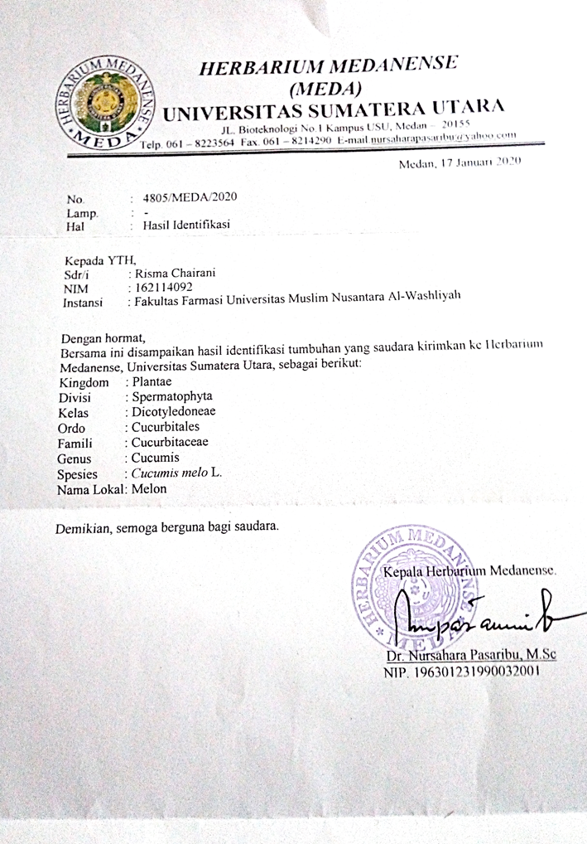

**Lampiran 2.** Bagan alir prosedur kerja

Pengumpulan kulit buah melon

(*Cucumis melo* L)

Disortasi

Dicuci

Ditimbang

Endokap buah melon

Dipotong-potong

Dihaluskan

Disaring

Sari

Skrining

fitokimia

Diformulasi menjadi sediaan *lotion*

Evaluasi sediaan *lotion*

1.Uji kelembaban kulit

1. Pemeriksaan organoleptis
2. Pemeriksaan homogenitas
3. Pemeriksaan pH
4. Uji tipe emulsi
5. Uji daya sebar
6. Uji sentrifugasi
7. Uji viskositas
8. Uji iritasi
9. Uji kesukaan (*Hedonik*)
10. Uji *cycling test*

**Lampiran 3.** Bagan alir pembuatan sediaan *lotion* sari endokap buah melon

Fase Minyak Fase Air

Asam stearat, setil alkohol, dan paraffin liquidum

Natrium benzoat (yang telah dilarutkan terlebih dahulu dengan aquadest panas), sari endokap buah melon, propilen glikol, dan tween 80

Dipanaskan pada suhu 70℃

Dicampur, diaduk hingga homogen

Massa B

Massa A

Dipanaskan pada suhu 70℃

Dipanaskan pada suhu 70℃

FII

(20% Sari Endokap Buah Melon)

FI

(10% Sari Endokap Buah Melon)

F0

(Blanko)

FIII

(30% Sari Endokap Buah Melon)

**Lampiran 4.** Hasil sari endokap buah melon

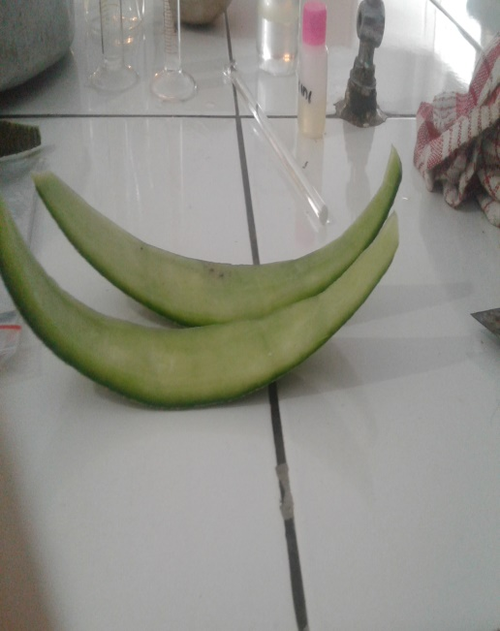

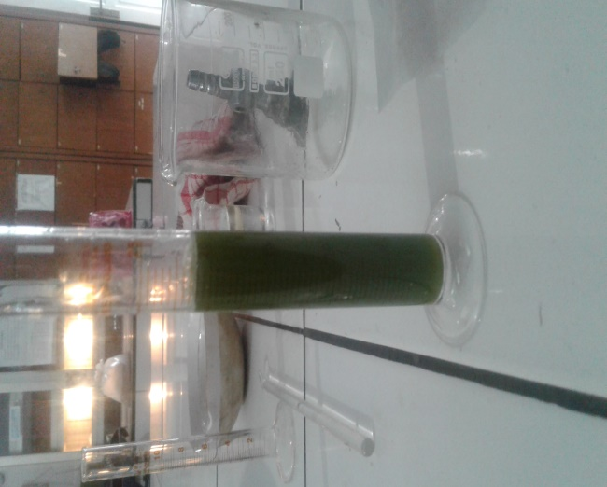

Sari endokap buah melon

Endokap buah melon

**Lampiran 5. 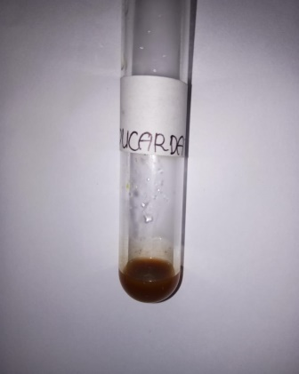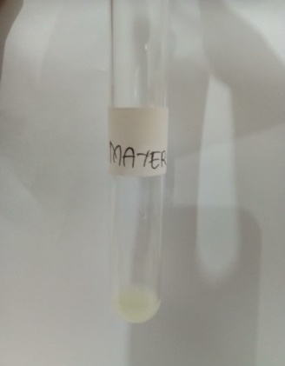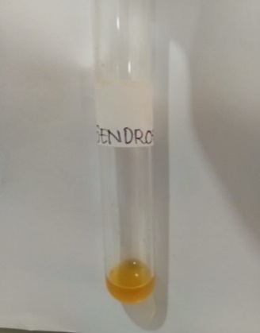**Hasil skrining fitokimia

Uji Alkaloid

(Bouchardat)

Uji Alkaloid

(Dragendroff)

Uji Alkaloid

(Mayer)

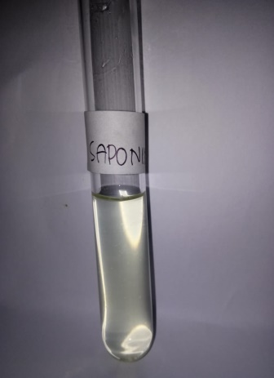

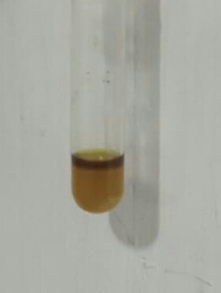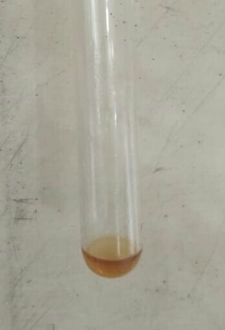

Uji Glikosida

Uji Flavonoid

Uji Saponin

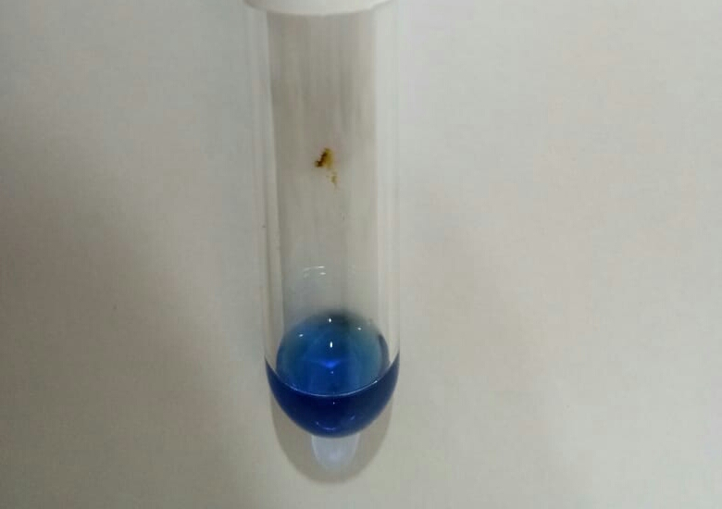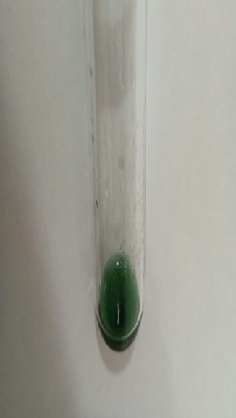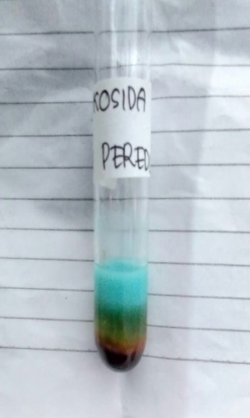

Uji Steroid

Uji Tannin

Uji Glikosida Pereduksi

**Lampiran 6.** Hasil sediaan *lotion*

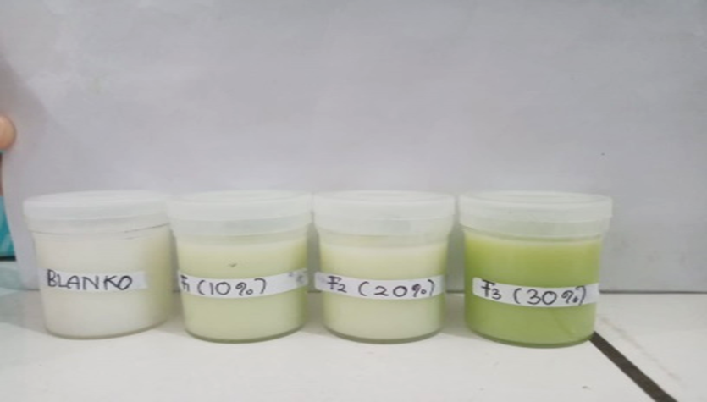

Sediaan *hand and body lotion* dari sari endokap buah melon dari berbagai konsentrasi F0 (Blanko), FI (sari endokap buah melon 10%), FII (sari endokap buah melon 20%) dan FIII (sari endokap buah melon 30%)

**Lampiran 7.** Uji organoleptik

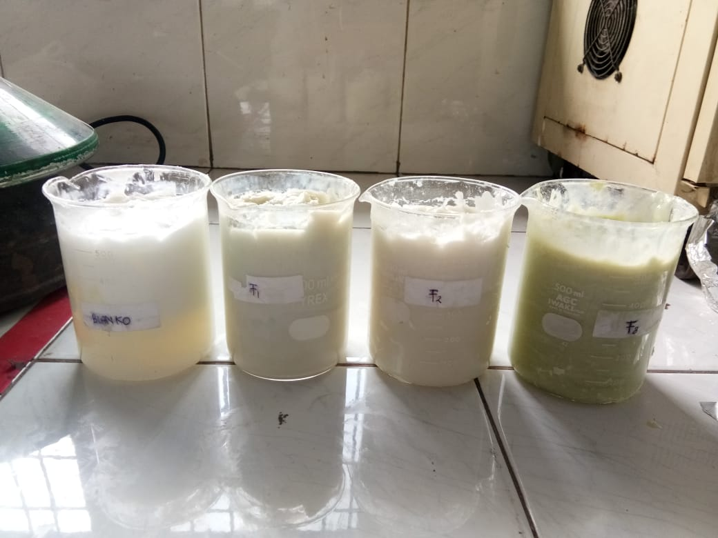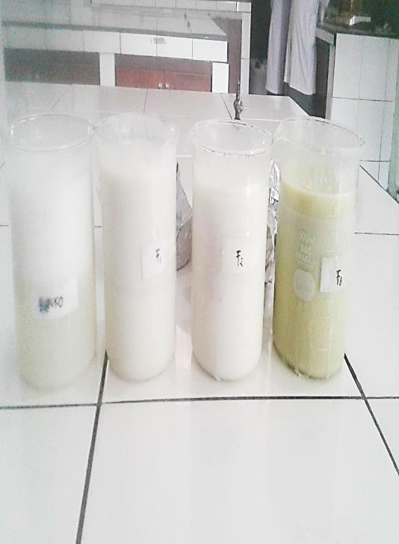

Setelah di *cycling test*

Sebelum di *cycling test*

**Lampiran 8.** Uji homogenitas

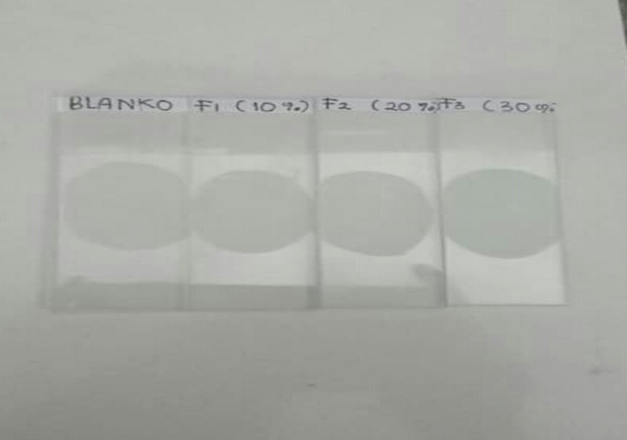

Uji homogenitas sediaan *hand and body lotion* dari sari endokap buah melon

**Lampiran 9.** Uji pH

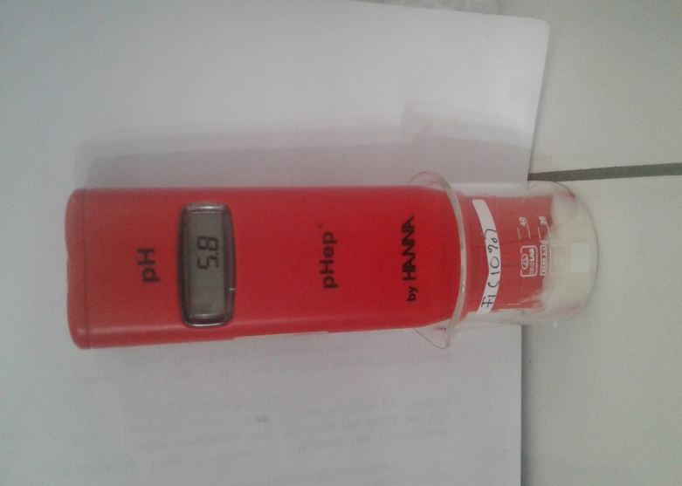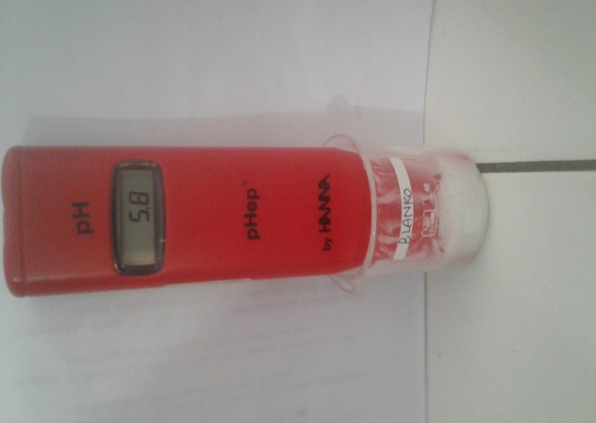

FI (Konsentrasi sari 10%)

F0 (Blanko)

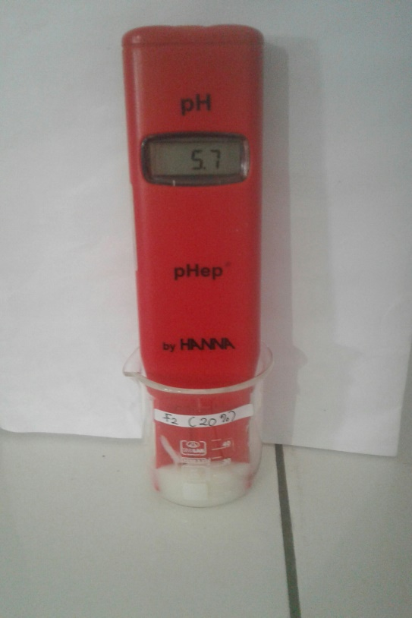

FIII (Konsentrasi sari 30%)

FII (Konsentrasi sari 20%)

**Lampiran 10.** Uji tipe emulsi

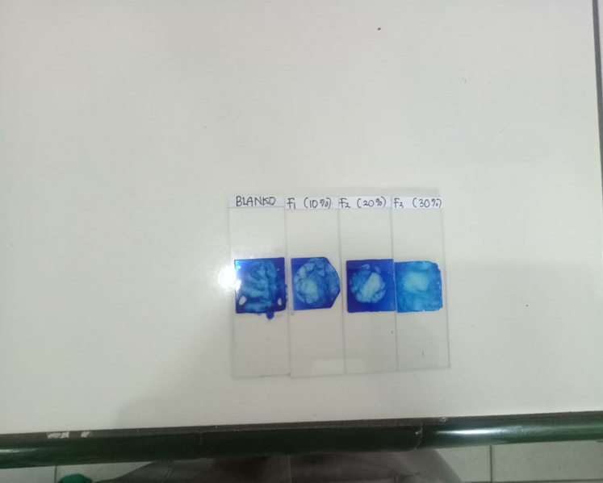

Uji tipe emulsi *hand and bodylotion* sari endokap buah melon

**ampiran 11.**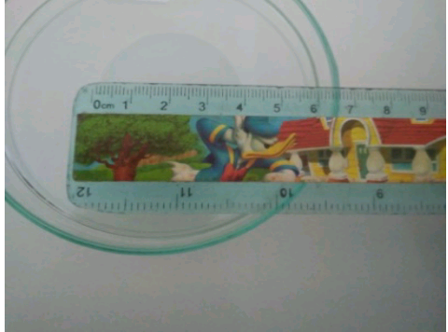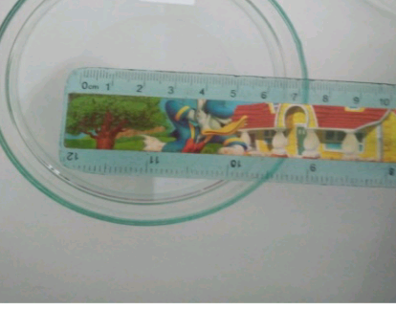 Uji daya sebar

FI (Konsentrasi sari 10%)

F0 (Blanko)



FIII (Konsentrasi sari 30%)

FII (Konsentrasi sari 20%)

**Lampiran 12.** Uji sentrifugasi

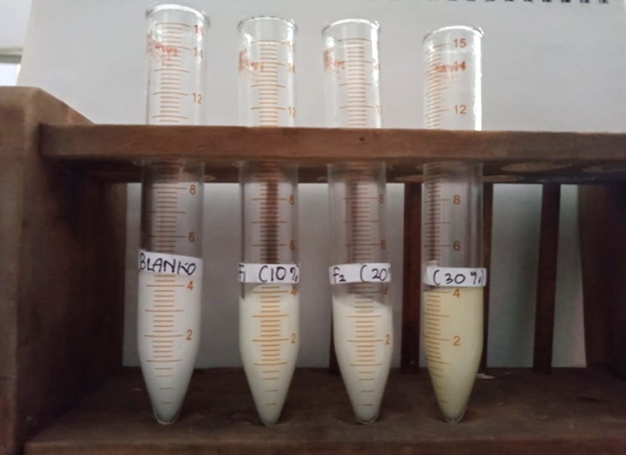

Uji sentrifugasi sediaan *hand and body lotion* sari endokap buah melon

**Lampiran 13.** Uji viskositas

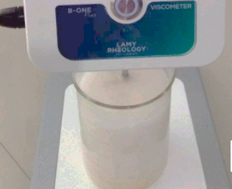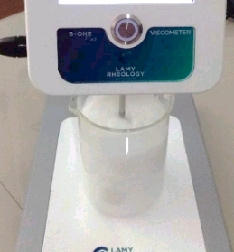

FI (Konsentrasi sari 10%)

F0 (Blanko)





FIII (Konsentrasi sari 30%)

FII (Konsentrasi sari 20%)

**Lampiran 14.** Uji stabilitas (*Cycling test*)

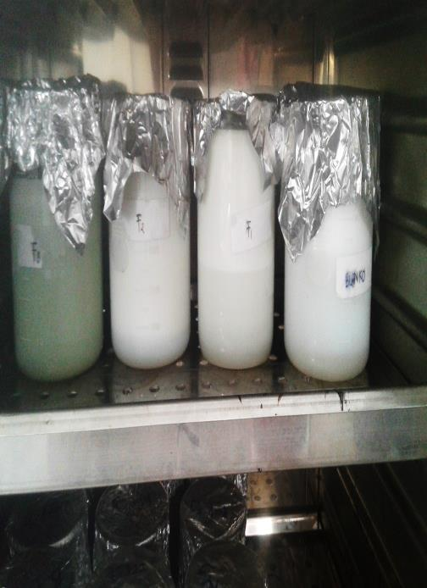

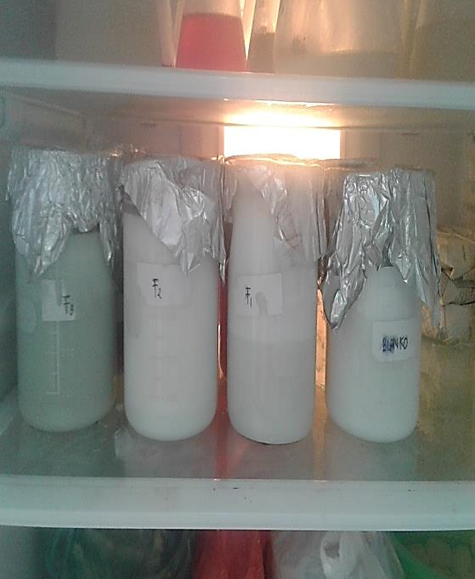

Uji stabilitas pada suhu 40oC

Uji stabilitas pada suhu 4oC

**Lampiran 15.** Uji iritasi

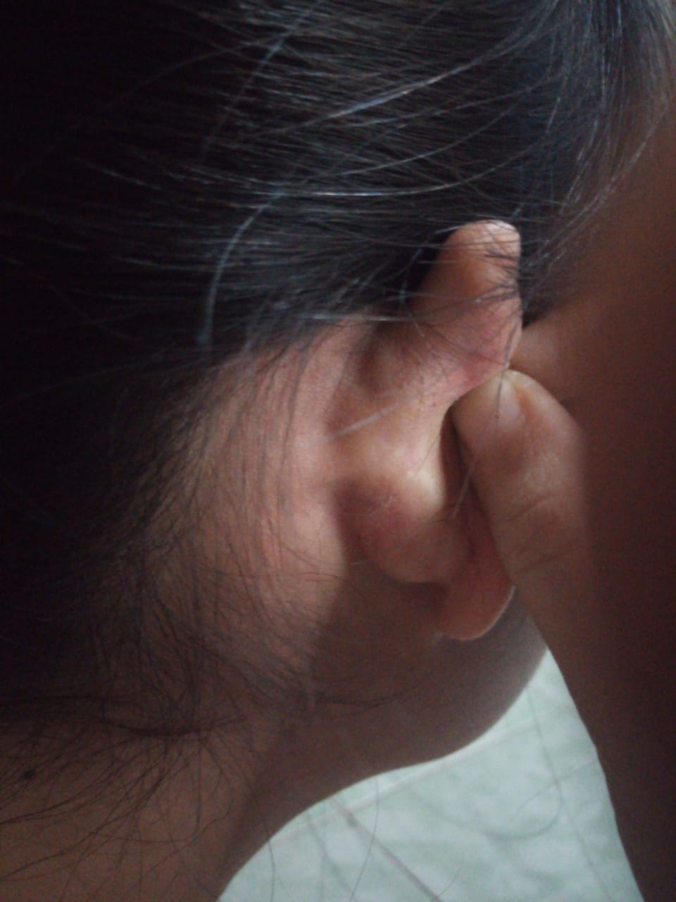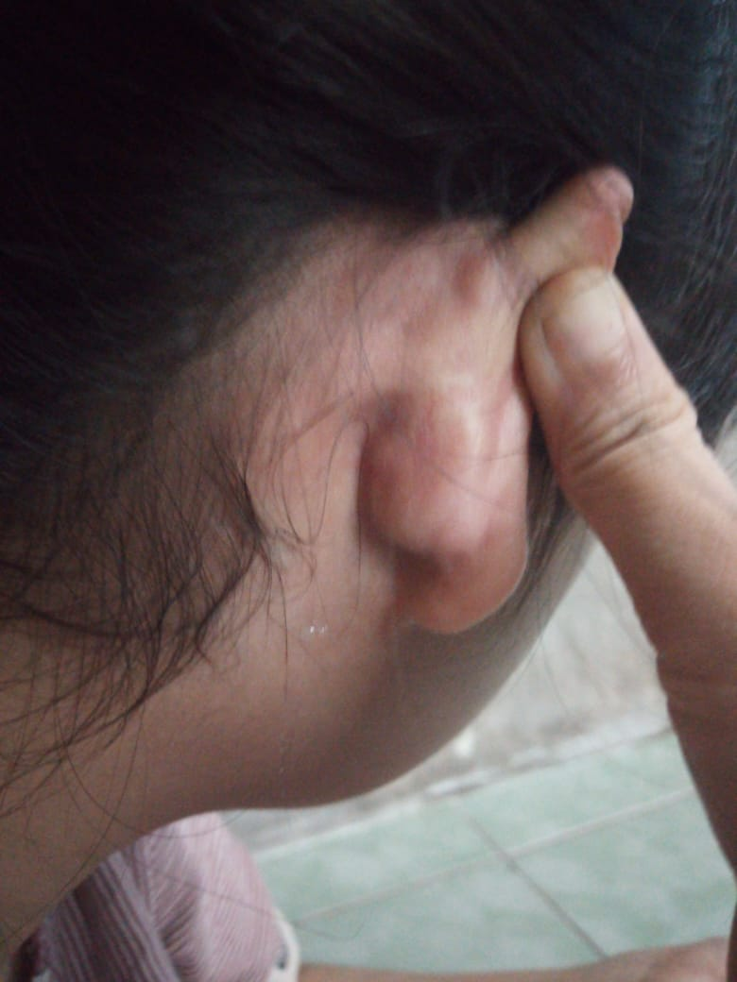

Uji iritasi sediaan *hand and body lotion* sari endokap buah melondi belakang telinga

Setelah penggunaan sediaan *hand and body lotion* sari endokap buah melon selama 24 jam

**Lampiran 16.** Uji Efektivitas sediaan hand and body lotion

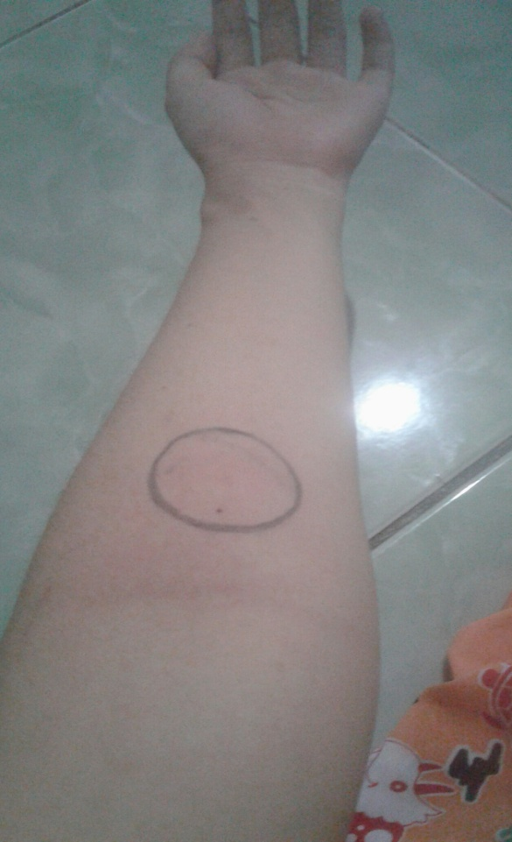

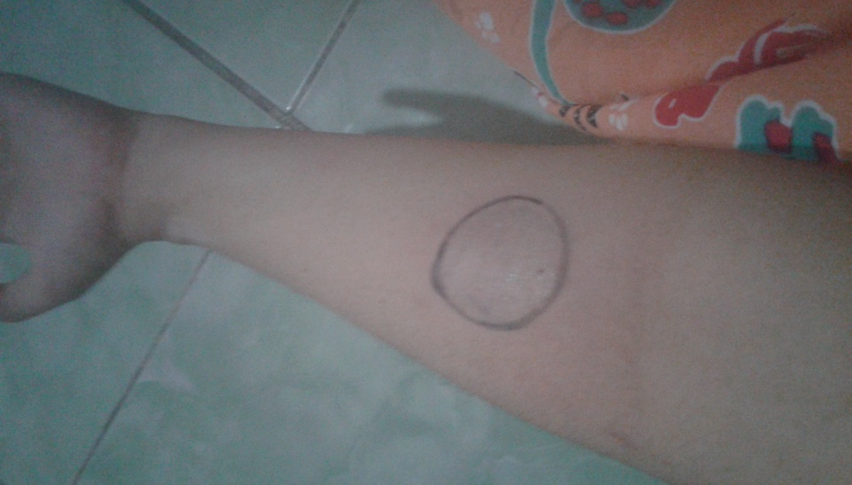

Penggunaan *hand and body lotion* sari endokap buah melon di lengan bawah bagian dalam

Lengan bawah bagian dalam diberi tanda terlebih dahulu sebelum dioleskan *hand and body lotion* sari endokap buah melon

**Lampiran 17.** Alat-alat yang digunakan

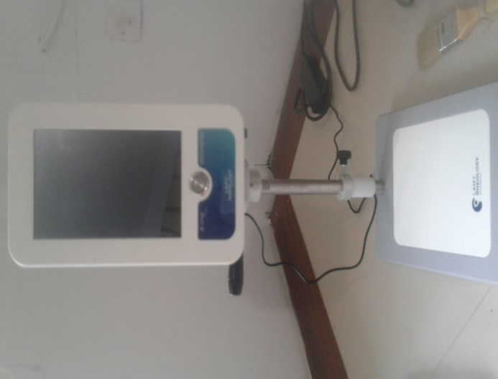

Alat *skin analyzer*

Viskometer

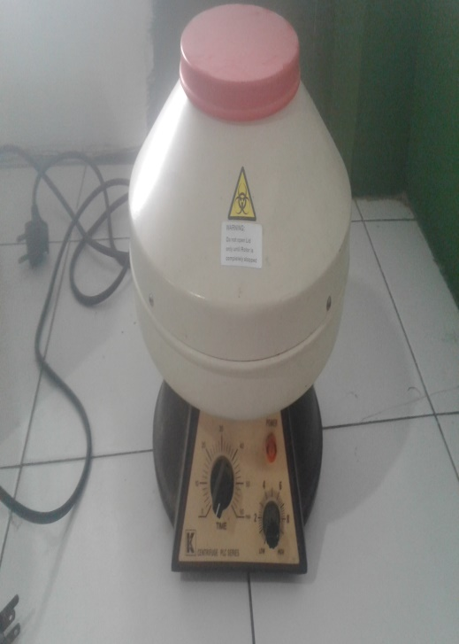

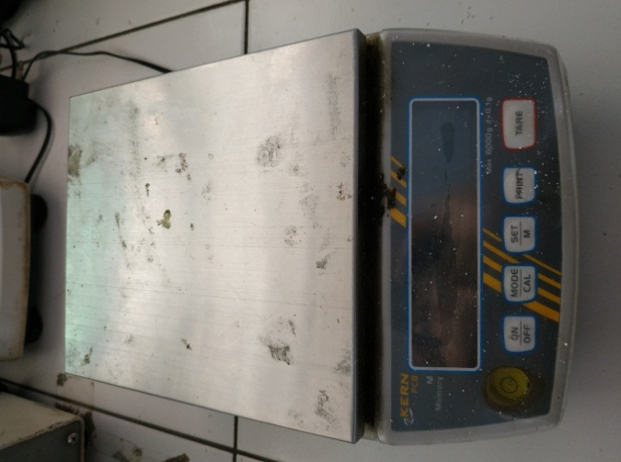

Neraca analitik

Sentrifugator

**Lampiran 17.** (Lanjutan)

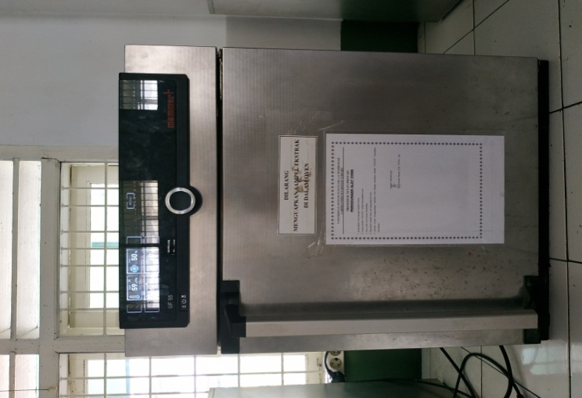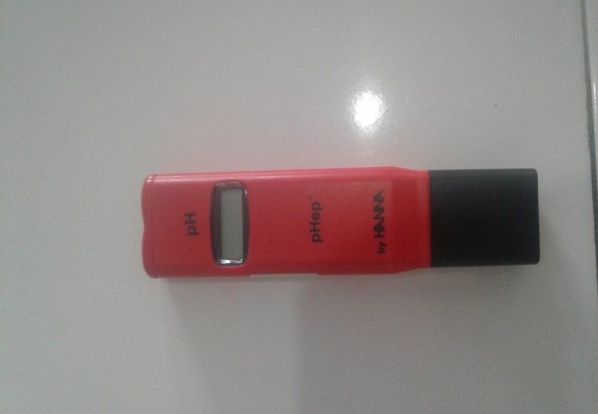

Oven

pH meter

**Lampiran 18.** Kuisioner uji hedonik warna

**KUISIONER UJI HEDONIK WARNA**

Nama :

Umur :

Tanggal :

Nama Sampel : *Hand and body lotion* dari Sari Endokap Buah Melon sebagai Pelembab Kulit

Dihadapan saudari telah tersedia 4 buah formula *Hand and body lotion* dari sari endokap buah melon. Saudari diminta untuk memberikan penilaian terhadap warna sediaan. Penilaian dilakukan dengan memberikan **angka** pada kolom yang telah disediakan dengan kriteria sebagai berikut.

1 = Sangat Tidak Suka (STS)

2 = Tidak Suka (TS)

3 = Kurang Suka (KS)

4 = Suka (S)

5 = Sangat Suka (SS)

|  |  |  |  |  |
| --- | --- | --- | --- | --- |
| **Penilai** | **Formula** | | | |
| F0 | FI | FII | FIII |
| Warna |  |  |  |  |

**Lampiran 19.** Perhitungan uji hedonik warna

**Data Uji Warna Kesukaan**

|  |  |  |  |  |  |  |  |  |
| --- | --- | --- | --- | --- | --- | --- | --- | --- |
| **Panelis** | **Data uji kesukaan warna sediaan** | | | | | | | |
| **Blanko (F0)** | | **FI** | | **FII** | | **FIII** | |
| **Kode** | **Nilai** | **Kode** | **Nilai** | **Kode** | **Nilai** | **Kode** | **Nilai** |
| 1 | TS | 2 | TS | 2 | TS | 2 | S | 4 |
| 2 | KS | 3 | KS | 3 | TS | 2 | S | 4 |
| 3 | KS | 3 | TS | 2 | S | 4 | SS | 5 |
| 4 | TS | 2 | TS | 2 | S | 4 | S | 4 |
| 5 | TS | 2 | TS | 2 | TS | 2 | S | 4 |
| 6 | TS | 2 | TS | 2 | TS | 2 | SS | 5 |
| 7 | KS | 3 | KS | 3 | KS | 3 | S | 4 |
| 8 | TS | 2 | TS | 2 | S | 4 | S | 4 |
| 9 | TS | 2 | S | 4 | S | 4 | S | 4 |
| 10 | S | 4 | TS | 2 | TS | 2 | S | 4 |
| 11 | TS | 2 | KS | 3 | S | 4 | S | 4 |
| 12 | TS | 2 | TS | 2 | S | 4 | S | 4 |
| 13 | S | 4 | KS | 3 | TS | 2 | SS | 5 |
| 14 | TS | 2 | TS | 2 | TS | 2 | S | 4 |
| 15 | KS | 3 | KS | 3 | S | 4 | S | 4 |
| 16 | TS | 2 | S | 4 | S | 4 | S | 4 |
| 17 | KS | 3 | KS | 3 | TS | 2 | SS | 5 |
| 18 | KS | 3 | KS | 3 | KS | 3 | S | 4 |
| 19 | TS | 2 | TS | 2 | TS | 2 | S | 4 |
| 20 | KS | 3 | KS | 3 | KS | 3 | S | 4 |
| 21 | S | 4 | TS | 2 | TS | 2 | S | 4 |
| 22 | KS | 3 | KS | 3 | TS | 2 | S | 4 |
| 23 | TS | 2 | TS | 2 | TS | 2 | S | 4 |
| 24 | KS | 3 | KS | 3 | KS | 3 | S | 4 |
| 25 | TS | 2 | TS | 2 | TS | 2 | S | 4 |
| 26 | TS | 2 | TS | 2 | TS | 2 | S | 4 |
| 27 | KS | 3 | KS | 3 | TS | 2 | S | 4 |
| 28 | TS | 2 | TS | 2 | TS | 2 | SS | 5 |
| 29 | KS | 3 | KS | 3 | KS | 3 | SS | 5 |
| 30 | KS | 3 | KS | 3 | TS | 2 | S | 4 |
| Total | | 78 |  | 77 |  | 81 |  | 126 |
| Rata-rata | | 2,6 |  | 2,5 |  | 2,7 |  | 4,2 |
| SD | | $0,6746$ 746 |  | $0,6228$ 288 |  | $0,8768$ 68 |  | $$0,4298$$ |

**Lampiran 19.** (Lanjutan)

1. F0 (Dasar *lotion* tanpa sampel)

|  |  |  |  |  |
| --- | --- | --- | --- | --- |
| **Panelis** | **Hasil Uji Hedonik Warna** | | | |
| **Kode** | **Nilai Kesukaan (*x*)** | **)** | **)2** |
| 1 | TS | 2 | -0,60 | 0,36 |
| 2 | KS | 3 | 0,40 | 0,16 |
| 3 | KS | 3 | 0,40 | 0,16 |
| 4 | TS | 2 | -0.60 | 0,36 |
| 5 | TS | 2 | -0.60 | 0,36 |
| 6 | TS | 2 | -0.60 | 0,36 |
| 7 | KS | 3 | 0,40 | 0,16 |
| 8 | TS | 2 | -0.60 | 0,36 |
| 9 | TS | 2 | -0.60 | 0,36 |
| 10 | S | 4 | 1,40 | 1,96 |
| 11 | TS | 2 | -0.60 | 0,36 |
| 12 | TS | 2 | -0.60 | 0,36 |
| 13 | S | 4 | 1,40 | 1,96 |
| 14 | TS | 2 | -0.60 | 0,36 |
| 15 | KS | 3 | 0,40 | 0,16 |
| 16 | TS | 2 | -0.60 | 0,36 |
| 17 | KS | 3 | 0,40 | 0,16 |
| 18 | KS | 3 | 0,40 | 0,16 |
| 19 | TS | 2 | -0.60 | 0,36 |
| 20 | KS | 3 | 0,40 | 0,16 |
| 21 | S | 4 | 1,40 | 1,96 |
| 22 | KS | 3 | 0,40 | 0,16 |
| 23 | TS | 2 | -0.60 | 0,36 |
| 24 | KS | 3 | 0,40 | 0,16 |
| 25 | TS | 2 | -0.60 | 0,36 |
| 26 | TS | 2 | -0.60 | 0,36 |
| 27 | KS | 3 | 0,40 | 0,16 |
| 28 | TS | 2 | -0.60 | 0,36 |
| 29 | KS | 3 | 0,40 | 0,16 |
| 30 | KS | 3 | 0,40 | 0,16 |
| Nilai kesukaan rata-rata($\overline{x})=$ 2,6 | | | Nilai total )2 = 13,20 | |

**Lampiran 19.**(Lanjutan)

$Standar deviasi \left(SD\right)=\sqrt{\frac{\sum{{(x-\overline{x})}^{2}}}{n-1}}=\sqrt{\frac{13,20}{30-1}}=0,6746$ SD=&_^?(x-x)^2/n-1=&13,20/30-1=0,6746

Rentang Nilai Hedonik Warna F0

= Nilai rata-rata($\overline{x})$- (SD) $≥ μ ≤$ ≤Nilai rata-rata ($\overline{x})$ + (SD)

= 2,6 – 0,6746 $≥ μ ≤$ 2,6 + 0,6746

= 1,9254 $≥ μ ≤$ 3,2746

**Lampiran 19.** (Lanjutan)

1. FI (Konsentrasi Sari endokap buah melon (*Cucumis melo* L) 10%)

|  |  |  |  |  |
| --- | --- | --- | --- | --- |
| **Panelis** | **Hasil Uji Hedonik Warna** | | | |
| **Kode** | **Nilai Kesukaan (*x*)** | **)** | **)2** |
| 1 | TS | 2 | -0,50 | 0,25 |
| 2 | KS | 3 | 0,50 | 0,25 |
| 3 | TS | 2 | -0,50 | 0,25 |
| 4 | TS | 2 | -0,50 | 0,25 |
| 5 | TS | 2 | -0,50 | 0,25 |
| 6 | TS | 2 | -0,50 | 0,25 |
| 7 | KS | 3 | 0,50 | 0,25 |
| 8 | TS | 2 | -0,50 | 0,25 |
| 9 | S | 4 | 1,50 | 2,25 |
| 10 | TS | 2 | -0,50 | 0,25 |
| 11 | KS | 3 | 0,50 | 0,25 |
| 12 | TS | 2 | -0,50 | 0,25 |
| 13 | KS | 3 | 0,50 | 0,25 |
| 14 | TS | 2 | -0,50 | 0,25 |
| 15 | KS | 3 | 0,50 | 0,25 |
| 16 | S | 4 | 1,50 | 2,25 |
| 17 | KS | 3 | 0,50 | 0,25 |
| 18 | KS | 3 | 0,50 | 0,25 |
| 19 | TS | 2 | -0,50 | 0,25 |
| 20 | KS | 3 | 0,50 | 0,25 |
| 21 | TS | 2 | -0,50 | 0,25 |
| 22 | KS | 3 | 0,50 | 0,25 |
| 23 | TS | 2 | -0,50 | 0,25 |
| 24 | KS | 3 | 0,50 | 0,25 |
| 25 | TS | 2 | -0,50 | 0,25 |
| 26 | TS | 2 | -0,50 | 0,25 |
| 27 | KS | 3 | 0,50 | 0,25 |
| 28 | TS | 2 | -0,50 | 0,25 |
| 29 | KS | 3 | 0,50 | 0,25 |
| 30 | KS | 3 | 0,50 | 0,25 |
| Nilai kesukaan rata-rata( 2,5 | | | Nilai total )2 = 11,25 | |

**Lampiran 19.** (Lanjutan)

$Standar Deviasi \left(SD\right)=\sqrt{\frac{\sum{{(x-\overline{x})}^{2}}}{n-1}}=\sqrt{\frac{11,25}{30-1}}=0,6228$ SD=&_^?(x-x)^2/n-1=&11,25/30-1=0,6228

Rentang Nilai Hedonik Warna FI

= Nilai rata-rata ($\overline{x})$- (SD) $≥ μ ≤$ ≤ilai rata-rata ($\overline{x})$ + (SD)

= 2,5 – 0,6228 $≥ μ ≤$ 2,5 + 0,6228

= 1,8772 $≥ μ ≤$ 3,1228

**Lampiran 19.**(Lanjutan)

1. FII (Konsentrasi Sari endokap buah melon (*Cucumis melo* L) 20%)

|  |  |  |  |  |
| --- | --- | --- | --- | --- |
| **Panelis** | **Hasil Uji Hedonik Warna** | | | |
| **Kode** | **Nilai Kesukaan (*x*)** | **)** | **)2** |
| 1 | TS | 2 | -0,70 | 0,49 |
| 2 | TS | 2 | -0,70 | 0,49 |
| 3 | S | 4 | 1,30 | 1,69 |
| 4 | S | 4 | 1,30 | 1,69 |
| 5 | TS | 2 | -0,70 | 0,49 |
| 6 | TS | 2 | -0,70 | 0,49 |
| 7 | KS | 3 | 0,30 | 0,09 |
| 8 | S | 4 | 1,30 | 1,69 |
| 9 | S | 4 | 1,30 | 1,69 |
| 10 | TS | 2 | -0,70 | 0,49 |
| 11 | S | 4 | 1,30 | 1,69 |
| 12 | S | 4 | 1,30 | 1,69 |
| 13 | TS | 2 | -0,70 | 0,49 |
| 14 | TS | 2 | -0,70 | 0,49 |
| 15 | S | 4 | 1,30 | 1,69 |
| 16 | S | 4 | 1,30 | 1,69 |
| 17 | TS | 2 | -0,70 | 0,49 |
| 18 | KS | 3 | 0,30 | 0,09 |
| 19 | TS | 2 | -0,70 | 0,49 |
| 20 | KS | 3 | 0,30 | 0,09 |
| 21 | TS | 2 | -0,70 | 0,49 |
| 22 | TS | 2 | -0,70 | 0,49 |
| 23 | TS | 2 | -0,70 | 0,49 |
| 24 | KS | 3 | 0,30 | 0,09 |
| 25 | TS | 2 | -0,70 | 0,49 |
| 26 | TS | 2 | -0,70 | 0,49 |
| 27 | TS | 2 | -0,70 | 0,49 |
| 28 | TS | 2 | -0,70 | 0,49 |
| 29 | KS | 3 | 0,30 | 0,09 |
| 30 | TS | 2 | -0,70 | 0,49 |
| Nilai kesukaan rata-rata( 2,7 | | | Nilai total )2 =22,30 | |

**Lampiran 19.** (Lanjutan)

$Standar Deviasi \left(SD\right)=\sqrt{\frac{\sum{{(x-\overline{x})}^{2}}}{n-1}}=\sqrt{\frac{22,30}{30-1}}=0,8768$ SD=&_^?(x-x)^2/n-1=&22,30/30-1=0,8768

Rentang Nilai Hedonik Warna FII

= Nilai rata-rata ($\overline{x})$- (SD) $≥ μ ≤$ ≤ilai rata-rata ($\overline{x})$ + (SD)

= 2,7– 0,8768 $≥ μ ≤$ 2,7 + 0,8768

= 1,8232 $≥ μ ≤$ 3,5768

**Lampiran 19.** (Lanjutan)

1. FIII (Konsentrasi Sari endokap buah melon (*Cucumis melo* L) 30%)

|  |  |  |  |  |
| --- | --- | --- | --- | --- |
| **Panelis** | **Hasil Uji Hedonik Warna** | | | |
| **Kode** | **Nilai Kesukaan (*x*)** | **)** | **)2** |
| 1 | S | 4 | -0,20 | 0,04 |
| 2 | S | 4 | -0,20 | 0,04 |
| 3 | SS | 5 | 0,80 | 0,64 |
| 4 | S | 4 | -0,20 | 0,04 |
| 5 | S | 4 | -0,20 | 0,04 |
| 6 | SS | 5 | 0,80 | 0,64 |
| 7 | S | 4 | -0,20 | 0,04 |
| 8 | S | 4 | -0,20 | 0,04 |
| 9 | S | 4 | -0,20 | 0,04 |
| 10 | S | 4 | -0,20 | 0,04 |
| 11 | S | 4 | -0,20 | 0,04 |
| 12 | S | 4 | -0,20 | 0,04 |
| 13 | SS | 5 | 0,80 | 0,64 |
| 14 | S | 4 | -0,20 | 0,04 |
| 15 | S | 4 | -0,20 | 0,04 |
| 16 | S | 4 | -0,20 | 0,04 |
| 17 | SS | 5 | 0,80 | 0,64 |
| 18 | S | 4 | -0,20 | 0,04 |
| 19 | S | 4 | -0,20 | 0,04 |
| 20 | S | 4 | -0,20 | 0,04 |
| 21 | S | 4 | -0,20 | 0,04 |
| 22 | S | 4 | -0,20 | 0,04 |
| 23 | S | 4 | -0,20 | 0,04 |
| 24 | S | 4 | -0,20 | 0,04 |
| 25 | S | 4 | -0,20 | 0,04 |
| 26 | S | 4 | -0,20 | 0,04 |
| 27 | S | 4 | -0,20 | 0,04 |
| 28 | SS | 5 | 0,80 | 0,64 |
| 29 | SS | 5 | 0,80 | 0,64 |
| 30 | S | 4 | -0,20 | 0,04 |
| Nilai kesukaan rata-rata( $\overline{x})=$ 4,2 | | | Nilai total )2 = 5,36 | |

**Lampiran 19.** (Lanjutan)

$Standar Deviasi \left(SD\right)=\sqrt{\frac{\sum{{(x-\overline{x})}^{2}}}{n-1}}=\sqrt{\frac{5,36}{30-1}}=0,4298$ SD=&_^?(x-x)^2/n-1=&5,36/30-1=0,4298

Rentang Nilai Hedonik Warna FIII

= Nilai rata-rata ($\overline{x})$- (SD) $≥ μ ≤$ ≤Nilai rata-rata ($\overline{x})$ + (SD)

= 4,2 – 0,4298 $≥ μ ≤$ 4,2 + 0,4298

= 3,7702 $≥ μ ≤$ 4,6298

**Lampiran 19.** (Lanjutan)

**DATA HASIL UJI HEDONIK WARNA**

|  |  |  |  |  |
| --- | --- | --- | --- | --- |
| Warna | F0 | FI | FII | FIII |
| Rata-rata nilai kesukaan | 2,6 | 2,5 | 2,7 | 4,2 |
| Standar deviasi | $0,6746$ 746 | $0,6228$ 828 | $0,8768$ 8 | $$0,4298$$ |
| Rentang nilai kesukaan | 1,9254 sampai  3,2746 | 1,8772 sampai 3,1228 | 1,8232 sampai 3,5768 | 3,7702 sampai 4,6298 |

**Lampiran 20.** Kuisioner uji hedonik aroma

**KUISIONER UJI HEDONIK AROMA**

Nama :

Umur :

Tanggal :

Nama Sampel : *Hand and body lotion* dari Sari Endokap Buah Melon sebagai Pelembab Kulit

Dihadapan saudari telah tersedia 4 buah formula *Hand and body lotion* dari Sari Kulit Buah Melon. Saudari diminta untuk memberikan penilaian terhadap aroma sediaan. Penilaian dilakukan dengan memberikan **angka** pada kolom yang telah disediakan dengan kriteria sebagai berikut.

1 = Sangat Tidak Suka (STS)

2 = Tidak Suka (TS)

3 = Kurang Suka (KS)

4 = Suka (S)

5 = Sangat Suka (SS)

|  |  |  |  |  |
| --- | --- | --- | --- | --- |
| **Penilai** | **Formula** | | | |
| F0 | FI | FII | FIII |
| Aroma |  |  |  |  |

**Lampiran 21.** Perhitunga Uji Hedonik Aroma

**Data Uji Hedonik Aroma Sediaan**

|  |  |  |  |  |  |  |  |  |
| --- | --- | --- | --- | --- | --- | --- | --- | --- |
| **Panelis** | **Datauji kesukaan aroma sediaan** | | | | | | | |
| **Blanko (F0)** | | **FI** | | **FII** | | **FIII** | |
| **Kode** | **Nilai** | **Kode** | **Nilai** | **Kode** | **Nilai** | **Kode** | **Nilai** |
| 1 | KS | 3 | KS | 3 | KS | 3 | S | 4 |
| 2 | TS | 2 | TS | 2 | TS | 2 | S | 4 |
| 3 | TS | 2 | TS | 2 | S | 4 | S | 4 |
| 4 | KS | 3 | KS | 3 | TS | 2 | S | 4 |
| 5 | TS | 2 | TS | 2 | S | 4 | S | 4 |
| 6 | KS | 3 | KS | 3 | S | 4 | KS | 3 |
| 7 | TS | 2 | TS | 2 | TS | 2 | KS | 3 |
| 8 | TS | 2 | S | 4 | TS | 2 | S | 4 |
| 9 | TS | 2 | TS | 2 | TS | 2 | S | 4 |
| 10 | KS | 3 | KS | 3 | KS | 3 | KS | 3 |
| 11 | TS | 2 | KS | 3 | S | 4 | S | 4 |
| 12 | TS | 2 | TS | 2 | TS | 2 | SS | 5 |
| 13 | KS | 3 | KS | 3 | KS | 3 | S | 4 |
| 14 | TS | 2 | S | 4 | TS | 2 | S | 4 |
| 15 | KS | 3 | KS | 3 | S | 4 | S | 4 |
| 16 | TS | 2 | TS | 2 | S | 4 | S | 4 |
| 17 | KS | 3 | KS | 3 | KS | 3 | S | 4 |
| 18 | TS | 2 | TS | 2 | TS | 2 | KS | 3 |
| 19 | KS | 3 | KS | 3 | S | 4 | S | 4 |
| 20 | TS | 2 | TS | 2 | TS | 2 | S | 4 |
| 21 | KS | 3 | KS | 2 | S | 4 | S | 4 |
| 22 | TS | 2 | S | 4 | TS | 2 | S | 4 |
| 23 | KS | 3 | KS | 3 | S | 4 | S | 4 |
| 24 | TS | 2 | TS | 2 | TS | 2 | S | 4 |
| 25 | TS | 2 | TS | 2 | S | 4 | S | 4 |
| 26 | TS | 2 | TS | 2 | TS | 2 | S | 4 |
| 27 | KS | 3 | KS | 3 | S | 4 | KS | 3 |
| 28 | S | 4 | KS | 3 | TS | 2 | SS | 5 |
| 29 | S | 4 | KS | 3 | TS | 2 | S | 4 |
| 30 | S | 4 | TS | 2 | TS | 2 | KS | 3 |
| Total | | 77 |  | 79 |  | 86 |  | 120 |
| Rata-rata | | 2,5 |  | 2,6 |  | 2,8 |  | 4,0 |
| SD | | $0,6822$ 822 |  | $0,6694$ 944 |  | $0,9395$ 95 |  | $$0,4912$$ |

**Lampiran 21**.(Lanjutan)

1. F0 (Dasar *lotion* tanpa sampel)

|  |  |  |  |  |
| --- | --- | --- | --- | --- |
| **Panelis** | **Hasil Uji Hedonik Aroma** | | | |
| **Kode** | **Nilai Kesukaan (*x*)** | **)** | **)2** |
| 1 | KS | 3 | 0,50 | 0,25 |
| 2 | TS | 2 | -0,50 | 0,25 |
| 3 | TS | 2 | -0,50 | 0,25 |
| 4 | KS | 3 | 0,50 | 0,25 |
| 5 | TS | 2 | -0,50 | 0,25 |
| 6 | KS | 3 | 0,50 | 0,25 |
| 7 | TS | 2 | -0,50 | 0,25 |
| 8 | TS | 2 | -0,50 | 0,25 |
| 9 | TS | 2 | -0,50 | 0,25 |
| 10 | KS | 3 | 0,50 | 0,25 |
| 11 | TS | 2 | -0,50 | 0,25 |
| 12 | TS | 2 | -0,50 | 0,25 |
| 13 | KS | 3 | 0,50 | 0,25 |
| 14 | TS | 2 | -0,50 | 0,25 |
| 15 | KS | 3 | 0,50 | 0,25 |
| 16 | TS | 2 | -0,50 | 0,25 |
| 17 | KS | 3 | 0,50 | 0,25 |
| 18 | TS | 2 | -0,50 | 0,25 |
| 19 | KS | 3 | 0,50 | 0,25 |
| 20 | TS | 2 | -0,50 | 0,25 |
| 21 | KS | 3 | 0,50 | 0,25 |
| 22 | TS | 2 | -0,50 | 0,25 |
| 23 | KS | 3 | 0,50 | 0,25 |
| 24 | TS | 2 | -0,50 | 0,25 |
| 25 | TS | 2 | -0,50 | 0,25 |
| 26 | TS | 2 | -0,50 | 0,25 |
| 27 | KS | 3 | 0,50 | 0,25 |
| 28 | S | 4 | 1,50 | 2,25 |
| 29 | S | 4 | 1,50 | 2,25 |
| 30 | S | 4 | 1,50 | 2,25 |
| Nilai kesukaan rata-rata( $\overline{x})=$ 2,5 | | | Nilai total )2 = 13,50 | |

**Lampiran 21.** (Lanjutan)

$Standar Deviasi \left(SD\right)=\sqrt{\frac{\sum{{(x-\overline{x})}^{2}}}{n-1}}=\sqrt{\frac{13,50}{30-1}}=0,6822$ SD=&_^?(x-x)^2/n-1=&13,50/30-1=0,6822

Rentang Nilai Hedonik Aroma F0

= Nilai rata-rata ( $\overline{x})$– (SD) $≥ μ ≤$ μ ≤ilai rata-rata ( $\overline{x})$ + (SD)

= 2,5 – 0,6822 $≥ μ ≤$ 2,5 + 0,6822

= 1,8178 $≥ μ ≤$ 3,1822

**Lampiran 21.** (Lanjutan)

b. FI (Konsentrasi Sari endokap buah melon (*Cucumis melo* L) 10%)

|  |  |  |  |  |
| --- | --- | --- | --- | --- |
| **Panelis** | **Hasil Uji Hedonik Aroma** | | | |
| **Kode** | **Nilai Kesukaan (*x*)** | **)** | **)2** |
| 1 | KS | 3 | 0,40 | 0,16 |
| 2 | TS | 2 | -0,60 | 0,36 |
| 3 | TS | 2 | -0,60 | 0,36 |
| 4 | KS | 3 | 0,40 | 0,16 |
| 5 | TS | 2 | -0,60 | 0,36 |
| 6 | KS | 3 | 0,40 | 0,16 |
| 7 | TS | 2 | -0,60 | 0,36 |
| 8 | S | 4 | 1,40 | 1,96 |
| 9 | TS | 2 | -0,60 | 0,36 |
| 10 | KS | 3 | 0,40 | 0,16 |
| 11 | KS | 3 | 0,40 | 0,16 |
| 12 | TS | 2 | -0,60 | 0,36 |
| 13 | KS | 3 | 0,40 | 0,16 |
| 14 | S | 4 | 1,40 | 1,96 |
| 15 | KS | 3 | 0,40 | 0,16 |
| 16 | TS | 2 | -0,60 | 0,36 |
| 17 | KS | 3 | 0,40 | 0,16 |
| 18 | TS | 2 | -0,60 | 0,36 |
| 19 | KS | 3 | 0,40 | 0,16 |
| 20 | TS | 2 | -0,60 | 0,36 |
| 21 | KS | 2 | -0,60 | 0,36 |
| 22 | S | 4 | 1,40 | 1,96 |
| 23 | KS | 3 | 0,40 | 0,16 |
| 24 | TS | 2 | -0,60 | 0,36 |
| 25 | TS | 2 | -0,60 | 0,36 |
| 26 | TS | 2 | -0,60 | 0,36 |
| 27 | KS | 3 | 0,40 | 0,16 |
| 28 | KS | 3 | 0,40 | 0,16 |
| 29 | KS | 3 | 0,40 | 0,16 |
| 30 | TS | 2 | -0,60 | 0,36 |
| Nilai kesukaan rata-rata( $\overline{x})=$ 2,6 | | | Nilai total )2 = 13,00 | |

**Lampiran 21.** (Lanjutan)

$Standar Deviasi \left(SD\right)=\sqrt{\frac{\sum{{(x-\overline{x})}^{2}}}{n-1}}=\sqrt{\frac{13,00}{30-1}}=0,6694$ SD=&_^?(x-x)^2/n-1=&13,00/30-1=0,6694

Rentang Nilai Hedonik Aroma FI

= Nilai rata-rata ( $\overline{x})$– (SD) $≥ μ ≤$ μ ≤ ilai rata-rata ( $\overline{x})$ + (SD)

= 2,6 – 0,6694 $≥ μ ≤$ 2,6+ 0,6694

= 1,9306 $≥ μ ≤$ 3,2694

**Lampiran 21.**(Lanjutan)

c. FII (Konsentrasi Sari endokap buah melon (*Cucumis melo* L) 20%)

|  |  |  |  |  |
| --- | --- | --- | --- | --- |
| **Panelis** | **Hasil Uji Hedonik Aroma** | | | |
| **Kode** | **Nilai Kesukaan (*x*)** | **)** | **)2** |
| 1 | KS | 3 | 0,20 | 0,04 |
| 2 | TS | 2 | -0,80 | 0,64 |
| 2 | S | 4 | 1,20 | 1,44 |
| 4 | TS | 2 | -0,80 | 0,64 |
| 5 | S | 4 | 1,20 | 1,44 |
| 6 | S | 4 | 1,20 | 1,44 |
| 7 | TS | 2 | -0,80 | 0,64 |
| 8 | TS | 2 | -0,80 | 0,64 |
| 9 | TS | 2 | -0,80 | 0,64 |
| 10 | KS | 3 | 0,20 | 0,04 |
| 11 | S | 4 | 1,20 | 1,44 |
| 12 | TS | 2 | -0,80 | 0,64 |
| 13 | KS | 3 | 0,20 | 0,04 |
| 14 | TS | 2 | -0,80 | 0,64 |
| 15 | S | 4 | 1,20 | 1,44 |
| 16 | S | 4 | 1,20 | 1,44 |
| 17 | KS | 3 | 0,20 | 0,04 |
| 18 | TS | 2 | -0,80 | 0,64 |
| 19 | S | 4 | 1,20 | 1,44 |
| 20 | TS | 2 | -0,80 | 0,64 |
| 21 | S | 4 | 1,20 | 1,44 |
| 22 | TS | 2 | -0,80 | 0,64 |
| 23 | S | 4 | 1,20 | 1,44 |
| 24 | TS | 2 | -0,80 | 0,64 |
| 25 | S | 4 | 1,20 | 1,44 |
| 26 | TS | 2 | -0,80 | 0,64 |
| 27 | S | 4 | 1,20 | 1,44 |
| 28 | TS | 2 | -0,80 | 0,64 |
| 29 | TS | 2 | -0,80 | 0,64 |
| 30 | TS | 2 | -0,80 | 0,64 |
| Nilai kesukaan rata-rata( 2,8 | | | Nilai total )2 = 25,60 | |

**Lampiran 21.**(Lanjutan)

$Standar deviasi \left(SD\right)=\sqrt{\frac{\sum{{(x-\overline{x})}^{2}}}{n-1}}=\sqrt{\frac{25,60}{30-1}}=0,9395$ SD=&_^?(x-x)^2/n-1=&25,60/30-1=0,9395

Rentang Nilai Hedonik Aroma FII

= Nilai rata-rata ( $\overline{x})$– (SD) $≥ μ ≤$ μ ≤ilai rata-rata ( $\overline{x})$ + (SD)

= 2,8 – 0,9395 $≥ μ ≤$ 2,8+ 0,9395

= 1,8605 $≥ μ ≤$ 3,7395

**Lampiran 21.**(Lanjutan)

d. FIII (Konsentrasi Sari endokap buah melon (*Cucumis melo* L) 30%)

|  |  |  |  |  |
| --- | --- | --- | --- | --- |
| **Panelis** | **Hasil Uji Hedonik Aroma** | | | |
| **Kode** | **Nilai Kesukaan (*x*)** | **)** | **)2** |
| 1 | S | 4 | 0,00 | 0,00 |
| 2 | S | 4 | 0,00 | 0,00 |
| 3 | S | 4 | 0,00 | 0,00 |
| 4 | S | 4 | 0,00 | 0,00 |
| 5 | S | 4 | 0,00 | 0,00 |
| 6 | KS | 3 | -1,00 | 1,00 |
| 7 | KS | 3 | -1,00 | 1,00 |
| 8 | S | 4 | 0,00 | 0,00 |
| 9 | S | 4 | 0,00 | 0,00 |
| 10 | KS | 3 | -1,00 | 0,00 |
| 11 | S | 4 | 0,00 | 0,00 |
| 12 | SS | 5 | 1,00 | 1,00 |
| 13 | S | 4 | 0,00 | 0,00 |
| 14 | S | 4 | 0,00 | 0,00 |
| 15 | S | 4 | 0,00 | 0,00 |
| 16 | S | 4 | 0,00 | 0,00 |
| 17 | S | 4 | 0,00 | 0,00 |
| 18 | KS | 3 | -1,00 | 1,00 |
| 19 | S | 4 | 0,00 | 0,00 |
| 20 | S | 4 | 0,00 | 0,00 |
| 21 | S | 4 | 0,00 | 0,00 |
| 22 | S | 4 | 0,00 | 0,00 |
| 23 | S | 4 | 0,00 | 0,00 |
| 24 | S | 4 | 0,00 | 0,00 |
| 25 | S | 4 | 0,00 | 0,00 |
| 26 | S | 4 | 0,00 | 0,00 |
| 27 | KS | 3 | -1,00 | 1,00 |
| 28 | SS | 5 | 1,00 | 1,00 |
| 29 | S | 4 | 0,00 | 0,00 |
| 30 | KS | 3 | -1,00 | 1,00 |
| Nilai kesukaan rata-rata( $\overline{x})=$ 4,0 | | | Nilai total )2 = 7,00 | |

**Lampiran 21.** (Lanjutan)

$Standar deviasi \left(SD\right)=\sqrt{\frac{\sum{{(x-\overline{x})}^{2}}}{n-1}}=\sqrt{\frac{7,00}{30-1}}=0,4912$ SD=&_^?(x-x)^2/n-1=&7,00/30-1=0,4912

Rentang Nilai Hedonik Aroma FIII

= Nilai rata-rata ( $\overline{x})$– (SD) $≥ μ ≤$ μ ≤ilai rata-rata ( $\overline{x})$ + (SD)

= 4,0 – 0,4912 $≥ μ ≤$ 4,0 + 0,4912

= 3,5088 $≥ μ ≤$ 4,4912

**Lampiran 21.** (Lanjutan)

**DATA HASIL UJI HEDONIK AROMA**

|  |  |  |  |  |
| --- | --- | --- | --- | --- |
| Aroma | F0 | FI | FII | FIII |
| Rata-rata nilai kesukaan | 2,5 | 2,6 | 2,8 | 4,0 |
| Standar deviasi | 0,6822 | $0,6694$ 694 | $0,9395$ 5 | $$0,4912$$ |
| Rentang nilai kesukaan | 1,8178 sampai 3,1822 | 1,9306 sampai 3,2694 | 1,8605 sampai 3,7395 | 3,5088 sampai 4,4912 |

**Lampiran 22.** Kuisioner Uji Hedonik Aroma

**KUISIONER UJI HEDONIK BENTUK/KONSISTENSI**

Nama :

Umur :

Tanggal :

Nama Sampel : *Hand and body lotion* dari Sari Endokap Buah Melon sebagai Pelembab Kulit

Dihadapan saudari telah tersedia 4 buah formula *Hand and body lotion* dari Sari Endokap Buah Melon. Saudari diminta untuk memberikan penilaian terhadap bentuk/konsistensi sediaan. Penilaian dilakukan dengan memberikan **angka** pada kolom yang telah disediakan dengan kriteria sebagai berikut.

1 = Sangat Tidak Suka (STS)

2 = Tidak Suka (TS)

3 = Kurang Suka (KS)

4 = Suka (S)

5 = Sangat Suka (SS)

|  |  |  |  |  |
| --- | --- | --- | --- | --- |
| **Penilai** | **Formula** | | | |
| F0 | FI | FII | FIII |
| Bentuk/konsistensi |  |  |  |  |

**Lampiran 23.** Perhitungan Uji Hedonik Bentuk/konsistensi

**Data uji hedonik bentuk/konsistensi sediaan**

|  |  |  |  |  |  |  |  |  |
| --- | --- | --- | --- | --- | --- | --- | --- | --- |
| **Panelis** | **Data uji kesukaan bentuk/konsistensi sediaan** | | | | | | | |
| **Blanko (F0)** | | **FI** | | **FII** | | **FIII** | |
| **Kode** | **Nilai** | **Kode** | **Nilai** | **Kode** | **Nilai** | **Kode** | **Nilai** |
| 1 | TS | 2 | TS | 2 | TS | 2 | KS | 3 |
| 2 | KS | 3 | KS | 3 | S | 4 | KS | 3 |
| 3 | TS | 3 | TS | 2 | KS | 3 | KS | 3 |
| 4 | S | 4 | TS | 2 | TS | 2 | S | 4 |
| 5 | TS | 2 | S | 4 | S | 4 | KS | 3 |
| 6 | KS | 3 | KS | 3 | S | 4 | S | 4 |
| 7 | TS | 2 | TS | 2 | TS | 2 | S | 4 |
| 8 | S | 4 | S | 4 | TS | 2 | KS | 3 |
| 9 | KS | 3 | KS | 3 | KS | 3 | KS | 3 |
| 10 | KS | 3 | KS | 3 | TS | 2 | KS | 3 |
| 11 | KS | 3 | KS | 3 | KS | 3 | S | 4 |
| 12 | S | 4 | KS | 3 | KS | 3 | KS | 3 |
| 13 | TS | 2 | S | 4 | S | 4 | KS | 3 |
| 14 | TS | 2 | S | 4 | KS | 3 | KS | 3 |
| 15 | KS | 3 | KS | 3 | KS | 3 | KS | 3 |
| 16 | S | 4 | TS | 2 | TS | 2 | S | 4 |
| 17 | KS | 3 | KS | 3 | TS | 2 | S | 4 |
| 18 | TS | 2 | TS | 2 | TS | 2 | S | 4 |
| 19 | KS | 3 | KS | 3 | KS | 3 | S | 4 |
| 20 | KS | 3 | KS | 3 | S | 4 | S | 4 |
| 21 | S | 4 | KS | 3 | S | 4 | S | 4 |
| 22 | TS | 2 | S | 4 | KS | 3 | KS | 3 |
| 23 | TS | 2 | TS | 2 | S | 4 | KS | 3 |
| 24 | S | 4 | S | 4 | TS | 2 | KS | 3 |
| 25 | KS | 3 | S | 4 | TS | 2 | S | 4 |
| 26 | KS | 3 | KS | 3 | KS | 3 | KS | 3 |
| 27 | TS | 2 | TS | 2 | TS | 2 | KS | 3 |
| 28 | KS | 3 | KS | 3 | KS | 3 | S | 4 |
| 29 | TS | 2 | S | 4 | S | 4 | S | 4 |
| 30 | S | 4 | S | 4 | TS | 2 | S | 4 |
| Total | | 87 |  | 91 |  | 86 |  | 104 |
| Rata-rata | | 2,9 |  | 3,0 |  | 2,8 |  | 3,4 |
| SD | | $0,7588$ 588 |  | $0,7656$ 566 |  | $0,9526$ 26 |  | $$0,5118$$ |

**Lampiran 23.** (Lanjutan)

a. F0 (Dasar *lotion* tanpa sampel)

|  |  |  |  |  |
| --- | --- | --- | --- | --- |
| **Panelis** | **Hasil Uji Hedonik Bentuk/Konsistensi** | | | |
| **Kode** | **Nilai Kesukaan (*x*)** | **)** | **)2** |
| 1 | TS | 2 | -0,90 | 0,81 |
| 2 | KS | 3 | 0,10 | 0,01 |
| 3 | TS | 3 | 0,10 | 0,01 |
| 4 | S | 4 | 1,10 | 1,21 |
| 5 | TS | 2 | -0,90 | 0,81 |
| 6 | KS | 3 | 0,10 | 0,01 |
| 7 | TS | 2 | -0,90 | 0,81 |
| 8 | S | 4 | 1,10 | 1,21 |
| 9 | KS | 3 | 0,10 | 0,01 |
| 10 | KS | 3 | 0,10 | 0,01 |
| 11 | KS | 3 | 0,10 | 0,01 |
| 12 | S | 4 | 1,10 | 1,21 |
| 13 | TS | 2 | -0,90 | 0,81 |
| 14 | TS | 2 | -0,90 | 0,81 |
| 15 | KS | 3 | 0,100 | 0,01 |
| 16 | S | 4 | 1,10 | 1,21 |
| 17 | KS | 3 | 0,10 | 0,01 |
| 18 | TS | 2 | -0,90 | 0,81 |
| 19 | KS | 3 | 0,10 | 0,01 |
| 20 | KS | 3 | 0,10 | 0,01 |
| 21 | S | 4 | 1,10 | 1,21 |
| 22 | TS | 2 | -0,90 | 0,81 |
| 23 | TS | 2 | -0,90 | 0,81 |
| 24 | S | 4 | 1,10 | 1,21 |
| 25 | KS | 3 | 0,10 | 0,01 |
| 26 | KS | 3 | 0,10 | 0,01 |
| 27 | TS | 2 | -0,90 | 0,81 |
| 28 | KS | 3 | 0,10 | 0,01 |
| 29 | TS | 2 | -0,90 | 0,81 |
| 30 | S | 4 | 1,10 | 1,21 |
| Nilai kesukaan rata-rata( $\overline{x})=$ 2,7 | | | Nilai total -x)2 = 16,70 | |

**Lampiran 23.** (Lanjutan)

$Standar deviasi \left(SD\right)=\sqrt{\frac{\sum{{(x-\overline{x})}^{2}}}{n-1}}=\sqrt{\frac{16,70}{30-1}}=0,7588$ SD=&_^?(x-x)^2/n-1=&16,70/30-1=0,7588

Rentang Nilai Hedonik Bentuk/konsistensi F0

= Nilai rata-rata ( $\overline{x})$– (SD) $≥ μ ≤$ μ ≤ilai rata-rata ( $\overline{x})$ + (SD)

= 2,7 – 0,7588 $≥ μ ≤$ μ ≤ 2,7 + 0,7588

= 1,9412 $≥ μ ≤$ 3,4588

**Lampiran 23.** (Lanjutan)

b.FI (Konsentrasi Sari endokap buah melon (*Cucumis melo* L) 10%)

|  |  |  |  |  |
| --- | --- | --- | --- | --- |
| **Panelis** | **Hasil Uji Hedonik Bentuk/Konsistensi** | | | |
| **Kode** | **Nilai Kesukaan (*x*)** | **)** | **)2** |
| 1 | TS | 2 | -1,00 | 1,00 |
| 2 | KS | 3 | 0,00 | 0,00 |
| 3 | TS | 2 | -1,00 | 1,00 |
| 4 | TS | 2 | -1,00 | 1,00 |
| 5 | S | 4 | 1,00 | 1,00 |
| 6 | KS | 3 | 0,00 | 0,00 |
| 7 | TS | 2 | -1,00 | 1,00 |
| 8 | S | 4 | 1,00 | 1,00 |
| 9 | KS | 3 | 0,00 | 0,00 |
| 10 | KS | 3 | 0,00 | 0,00 |
| 11 | KS | 3 | 0,00 | 0,00 |
| 12 | KS | 3 | 0,00 | 0,00 |
| 13 | S | 4 | 1,00 | 1,00 |
| 14 | S | 4 | 1,00 | 1,00 |
| 15 | KS | 3 | 0,00 | 0,00 |
| 16 | TS | 2 | -1,00 | 1,00 |
| 17 | KS | 3 | 0,00 | 0,00 |
| 18 | TS | 2 | -1,00 | 1,00 |
| 19 | KS | 3 | 0,00 | 0,00 |
| 20 | KS | 3 | 0,00 | 0,00 |
| 21 | KS | 3 | 0,00 | 0,00 |
| 22 | S | 4 | 1,00 | 1,00 |
| 23 | TS | 2 | -1,00 | 1,00 |
| 24 | S | 4 | 1,00 | 1,00 |
| 25 | S | 4 | 1,00 | 1,00 |
| 26 | KS | 3 | 0,00 | 0,00 |
| 27 | TS | 2 | -1,00 | 1,00 |
| 28 | KS | 3 | 0,00 | 0,00 |
| 29 | S | 4 | 1,00 | 1,00 |
| 30 | S | 4 | 1,00 | 1,00 |
| Nilai kesukaan rata-rata( 3,0 | | | Nilai total )2 = 17,00 | |

**Lampiran 23.** (Lanjutan)

$Standar deviasi \left(SD\right)=\sqrt{\frac{\sum{{(x-\overline{x})}^{2}}}{n-1}}=\sqrt{\frac{17,00}{30-1}}=0,7656$ SD=&_^?(x-x)^2/n-1=&17,00/30-1=0,7656

Rentang Nilai Hedonik Bentuk/konsistensi FI

= Nilai rata-rata ( $\overline{x})$– (SD) $≥ μ ≤$ μ ≤ilai rata-rata ( $\overline{x})$ + (SD)

= 3,0 – 0,7656 $≥ μ ≤$ 3,0 + 0,7656

= 2,2344 $≥ μ ≤$ 3,7656

**Lampiran 23.** (Lanjutan)

c. FII (Konsentrasi Sari endokap buah melon (*Cucumis melo* L) 20%)

|  |  |  |  |  |  |
| --- | --- | --- | --- | --- | --- |
| **Panelis** | **Hasil Uji Hedonik Bentuk/Konsistensi** | | | | |
| **Kode** | **Nilai Kesukaan (*x*)** | **)** | | **)2** |
| 1 | TS | 2 | -0,80 | | 1,20 |
| 2 | S | 4 | 1,20 | | 1,44 |
| 3 | KS | 3 | 0,20 | | 0,04 |
| 4 | TS | 2 | -0,80 | | 1,20 |
| 5 | S | 4 | 1,20 | | 1,44 |
| 6 | S | 4 | 1,20 | | 1,44 |
| 7 | TS | 2 | -0,80 | | 1,20 |
| 8 | TS | 2 | -0,80 | | 1,20 |
| 9 | KS | 3 | 0,20 | | 0,04 |
| 10 | TS | 2 | -0,80 | | 1,20 |
| 11 | KS | 3 | 0,20 | | 0,04 |
| 12 | KS | 3 | 0,20 | | 0,04 |
| 13 | S | 4 | 1,20 | | 1,44 |
| 14 | KS | 3 | 0,20 | | 0,04 |
| 15 | KS | 3 | 0,20 | | 0,04 |
| 16 | TS | 2 | -0,80 | | 1,20 |
| 17 | TS | 2 | -0,80 | | 1,20 |
| 18 | TS | 2 | -0,80 | | 1,20 |
| 19 | KS | 3 | 0,20 | | 0,04 |
| 20 | S | 4 | 1,20 | | 1,44 |
| 21 | S | 4 | 1,20 | | 1,44 |
| 22 | KS | 3 | 0,20 | | 0,04 |
| 23 | S | 4 | 1,20 | | 1,44 |
| 24 | TS | 2 | -0,80 | | 1,20 |
| 25 | TS | 2 | -0,80 | | 1,20 |
| 26 | KS | 3 | 0,20 | | 0,04 |
| 27 | TS | 2 | -0,80 | | 1,20 |
| 28 | KS | 3 | 0,20 | | 0,04 |
| 29 | S | 4 | 1,20 | | 1,44 |
| 30 | TS | 2 | -0,80 | | 1,20 |
| Nilai kesukaan rata-rata( $\overline{x})=$ 2,8 | | | | Nilai total x-x)2 = 26,32 | |

**Lampiran 23.** (Lanjutan)

$Standar deviasi \left(SD\right)=\sqrt{\frac{\sum{{(x-\overline{x})}^{2}}}{n-1}}=\sqrt{\frac{26,32}{30-1}}=0,9526$ SD=&_^?(x-x)^2/n-1=&26,32/30-1=0,9526

Rentang Nilai Hedonik Bentuk/konsistensi FII

= Nilai rata-rata ( $\overline{x})$– (SD) $≥ μ ≤$ μ ≤ilai rata-rata ( $\overline{x})$ + (SD)

= 2,8 – 0,9526 $≥ μ ≤$ 2,8 + 0,9526

= 1,8474 $≥ μ ≤$ 3,7526

**Lampiran 23.** (Lanjutan)

d.FIII (Konsentrasi Sari endokap buah melon (*Cucumis melo* L) 30%)

|  |  |  |  |  |
| --- | --- | --- | --- | --- |
| **Panelis** | **Hasil Uji Hedonik Bentuk/Konsistensi** | | | |
| **Kode** | **Nilai Kesukaan (*x*)** | **)** | **)2** |
| 1 | KS | 3 | -0,40 | 0,16 |
| 2 | KS | 3 | -0,40 | 0,16 |
| 3 | KS | 3 | -0,40 | 0,16 |
| 4 | S | 4 | 0,60 | 0,36 |
| 5 | KS | 3 | -0,40 | 0,16 |
| 6 | S | 4 | 0,60 | 0,36 |
| 7 | S | 4 | 0,60 | 0,36 |
| 8 | KS | 3 | -0,40 | 0,16 |
| 9 | KS | 3 | -0,40 | 0,16 |
| 10 | KS | 3 | -0,40 | 0,16 |
| 11 | S | 4 | 0,60 | 0,36 |
| 12 | KS | 3 | -0,40 | 0,16 |
| 13 | KS | 3 | -0,40 | 0,16 |
| 14 | KS | 3 | -0,40 | 0,16 |
| 15 | KS | 3 | -0,40 | 0,16 |
| 16 | S | 4 | 0,60 | 0,36 |
| 17 | S | 4 | 0,60 | 0,36 |
| 18 | S | 4 | 0,60 | 0,36 |
| 19 | S | 4 | 0,60 | 0,36 |
| 20 | S | 4 | 0,60 | 0,36 |
| 21 | S | 4 | 0,60 | 0,36 |
| 22 | KS | 3 | -0,40 | 0,16 |
| 23 | KS | 3 | -0,40 | 0,16 |
| 24 | KS | 3 | -0,40 | 0,16 |
| 25 | S | 4 | 0,60 | 0,36 |
| 26 | KS | 3 | -0,40 | 0,16 |
| 27 | KS | 3 | -0,40 | 0,16 |
| 28 | S | 4 | 0,60 | 0,36 |
| 29 | S | 4 | 0,60 | 0,36 |
| 30 | S | 4 | 0,60 | 0,36 |
| Nilai kesukaan rata-rata( $\overline{x})=$ 3,4 | | | Nilai total -x)2 = 7,60 | |

**Lampiran 23.** (Lanjutan)

$Standar deviasi \left(SD\right)=\sqrt{\frac{\sum{{(x-\overline{x})}^{2}}}{n-1}}=\sqrt{\frac{7,60}{30-1}}=0,5188$ SD=&_^?(x-x)^2/n-1=&7,60/30-1=0,5188

Rentang Nilai Hedonik Bentuk/konsistensi FIII

= Nilai rata-rata ( $\overline{x})$– (SD) $≥ μ ≤$ μ ≤ilai rata-rata ( $\overline{x})$ + (SD)

= 3,4 – 0,5188 $≥ μ ≤$ 3,4 + 0,5188

= 2,8812 $≥ μ ≤$ 3,9188

**Lampiran 23.** (Lanjutan)

**DATA HASIL UJI HEDONIK BENTUK/KONSISTENSI**

|  |  |  |  |  |
| --- | --- | --- | --- | --- |
| Bentuk/konsistensi | F0 | FI | FII | FIII |
| Rata-rata nilai kesukaan | 2,7 | 3.0 | 2,8 | 3,4 |
| Standar deviasi | $0,7588$ 588 | $0,7656$ 6 | $$0,9526$$ | 0,5118 |
| Rentang nilai kesukaan | 1,9412 sampai 3,4588 | 2,2344 sampai 3,7656 | 1,8474 sampai 3,7526 | 2,8812 sampai 3,9188 |

**Lampiran 24.** Kuisioner Uji Hedonik Mudah dioleskan

**KUISIONER UJI HEDONIK MUDAH DIOLESKAN**

Nama :

Umur :

Tanggal :

Nama Sampel : *Hand and body lotion* dari Sari Endokap Buah Melon sebagai Pelembab Kulit

Dihadapan saudari telah tersedia 4 buah formula *Hand and body lotion* dari Sari Endokap Buah Melon. Saudari diminta untuk memberikan penilaian terhadap mudah dioleskan sediaan. Penilaian dilakukan dengan memberikan **angka** pada kolom yang telah disediakan dengan kriteria sebagai berikut.

1 = Sangat Tidak Suka (STS)

2 = Tidak Suka (TS)

3 = Kurang Suka (KS)

4 = Suka (S)

5 = Sangat Suka (SS)

|  |  |  |  |  |
| --- | --- | --- | --- | --- |
| **Penilai** | **Formula** | | | |
| F0 | FI | FII | FIII |
| Mudah dioleskan |  |  |  |  |

**Lampiran 25.** Perhitungan Uji Hedonik Mudah dioleskan

**Data Uji Warna Hedonik Mudah dioleskan**

|  |  |  |  |  |  |  |  |  |
| --- | --- | --- | --- | --- | --- | --- | --- | --- |
| **Panelis** | **Data uji kesukaan warna sediaan** | | | | | | | |
| **Blanko (F0)** | | **FI** | | **FII** | | **FIII** | |
| **Kode** | **Nilai** | **Kode** | **Nilai** | **Kode** | **Nilai** | **Kode** | **Nilai** |
| 1 | TS | 2 | TS | 2 | KS | 3 | TS | 2 |
| 2 | KS | 3 | TS | 2 | TS | 2 | KS | 3 |
| 3 | TS | 2 | S | 4 | S | 4 | TS | 2 |
| 4 | TS | 2 | S | 4 | TS | 2 | TS | 2 |
| 5 | TS | 2 | TS | 2 | S | 4 | S | 4 |
| 6 | TS | 2 | TS | 2 | S | 4 | KS | 3 |
| 7 | KS | 3 | KS | 3 | TS | 2 | TS | 2 |
| 8 | TS | 2 | S | 4 | TS | 2 | S | 4 |
| 9 | S | 4 | S | 4 | TS | 2 | KS | 3 |
| 10 | TS | 2 | TS | 2 | KS | 3 | KS | 3 |
| 11 | KS | 3 | S | 4 | S | 4 | KS | 3 |
| 12 | TS | 2 | S | 4 | TS | 2 | KS | 3 |
| 13 | KS | 3 | TS | 2 | KS | 3 | S | 4 |
| 14 | TS | 2 | TS | 2 | TS | 2 | S | 4 |
| 15 | KS | 3 | S | 4 | S | 4 | KS | 3 |
| 16 | S | 4 | S | 4 | S | 4 | TS | 2 |
| 17 | KS | 3 | TS | 2 | KS | 3 | KS | 3 |
| 18 | KS | 3 | KS | 3 | TS | 2 | TS | 2 |
| 19 | TS | 2 | TS | 2 | S | 4 | KS | 3 |
| 20 | KS | 3 | KS | 3 | TS | 2 | KS | 3 |
| 21 | TS | 2 | TS | 2 | S | 4 | KS | 3 |
| 22 | KS | 3 | TS | 2 | TS | 2 | S | 4 |
| 23 | TS | 2 | TS | 2 | S | 4 | TS | 2 |
| 24 | KS | 3 | KS | 3 | TS | 2 | S | 4 |
| 25 | TS | 2 | TS | 2 | S | 4 | S | 4 |
| 26 | TS | 2 | TS | 2 | TS | 2 | KS | 3 |
| 27 | KS | 3 | TS | 2 | S | 4 | TS | 2 |
| 28 | TS | 2 | TS | 2 | TS | 2 | KS | 3 |
| 29 | KS | 3 | KS | 3 | TS | 2 | S | 4 |
| 30 | KS | 3 | TS | 2 | TS | 2 | S | 4 |
| Total | | 77 |  | 81 |  | 86 |  | 91 |
| Rata-rata | | 2,5 |  | 2,7 |  | 2,8 |  | 3,0 |
| SD | | $0,6228$ 228 |  | $0,8768$ 688 |  | $0,9395$ 955 |  | $0,7656$ 566 |

**Lampiran 25.** (Lanjutan)

1. F0 (Dasar *Lotion* tanpa sampel)

|  |  |  |  |  |
| --- | --- | --- | --- | --- |
| **Panelis** | **Hasil Uji Hedonik Warna** | | | |
| **Kode** | **Nilai Kesukaan (*x*)** | **)** | **)2** |
| 1 | TS | 2 | -0,50 | 0,25 |
| 2 | KS | 3 | 0,50 | 0,25 |
| 3 | TS | 2 | -0,50 | 0,25 |
| 4 | TS | 2 | -0,50 | 0,25 |
| 5 | TS | 2 | -0,50 | 0,25 |
| 6 | TS | 2 | -0,50 | 0,25 |
| 7 | KS | 3 | 0,50 | 0,25 |
| 8 | TS | 2 | -0,50 | 0,25 |
| 9 | S | 4 | 1,50 | 2,25 |
| 10 | TS | 2 | -0,50 | 0,25 |
| 11 | KS | 3 | 0,50 | 0,25 |
| 12 | TS | 2 | -0,50 | 0,25 |
| 13 | KS | 3 | 0,50 | 0,25 |
| 14 | TS | 2 | -0,50 | 0,25 |
| 15 | KS | 3 | 0,50 | 0,25 |
| 16 | S | 4 | 1,50 | 2,25 |
| 17 | KS | 3 | 0,50 | 0,25 |
| 18 | KS | 3 | 0,50 | 0,25 |
| 19 | TS | 2 | -0,50 | 0,25 |
| 20 | KS | 3 | 0,50 | 0,25 |
| 21 | TS | 2 | -0,50 | 0,25 |
| 22 | KS | 3 | 0,50 | 0,25 |
| 23 | TS | 2 | -0,50 | 0,25 |
| 24 | KS | 3 | 0,50 | 0,25 |
| 25 | TS | 2 | -0,50 | 0,25 |
| 26 | TS | 2 | -0,50 | 0,25 |
| 27 | KS | 3 | 0,50 | 0,25 |
| 28 | TS | 2 | -0,50 | 0,25 |
| 29 | KS | 3 | 0,50 | 0,25 |
| 30 | KS | 3 | 0,50 | 0,25 |
| Nilai kesukaan rata-rata( 2,5 | | | Nilai total )2 = 11,25 | |

**Lampiran 25.** (Lanjutan)

$Standar Deviasi \left(SD\right)=\sqrt{\frac{\sum{{(x-\overline{x})}^{2}}}{n-1}}=\sqrt{\frac{11,25}{30-1}}=0,6228$ SD=&_^?(x-x)^2/n-1=&11,25/30-1=0,6228

Rentang Nilai Hedonik Mudah dioleskan F0

= Nilai rata-rata ($\overline{x})$- (SD) $≥ μ ≤$ ≤ilai rata-rata ($\overline{x})$ + (SD)

= 2,5 – 0,6228 $≥ μ ≤$ 2,5 + 0,6228

= 1,8772 $≥ μ ≤$ 3,1228

**Lampiran 25.**(Lanjutan)

1. FI (Konsentrasi Sari endokap buah melon (*Cucumis melo* L) 10%)

|  |  |  |  |  |
| --- | --- | --- | --- | --- |
| **Panelis** | **Hasil Uji Hedonik Warna** | | | |
| **Kode** | **Nilai Kesukaan (*x*)** | **)** | **)2** |
| 1 | TS | 2 | -0,70 | 0,49 |
| 2 | TS | 2 | -0,70 | 0,49 |
| 3 | S | 4 | 1,30 | 1,69 |
| 4 | S | 4 | 1,30 | 1,69 |
| 5 | TS | 2 | -0,70 | 0,49 |
| 6 | TS | 2 | -0,70 | 0,49 |
| 7 | KS | 3 | 0,30 | 0,09 |
| 8 | S | 4 | 1,30 | 1,69 |
| 9 | S | 4 | 1,30 | 1,69 |
| 10 | TS | 2 | -0,70 | 0,49 |
| 11 | S | 4 | 1,30 | 1,69 |
| 12 | S | 4 | 1,30 | 1,69 |
| 13 | TS | 2 | -0,70 | 0,49 |
| 14 | TS | 2 | -0,70 | 0,49 |
| 15 | S | 4 | 1,30 | 1,69 |
| 16 | S | 4 | 1,30 | 1,69 |
| 17 | TS | 2 | -0,70 | 0,49 |
| 18 | KS | 3 | 0,30 | 0,09 |
| 19 | TS | 2 | -0,70 | 0,49 |
| 20 | KS | 3 | 0,30 | 0,09 |
| 21 | TS | 2 | -0,70 | 0,49 |
| 22 | TS | 2 | -0,70 | 0,49 |
| 23 | TS | 2 | -0,70 | 0,49 |
| 24 | KS | 3 | 0,30 | 0,09 |
| 25 | TS | 2 | -0,70 | 0,49 |
| 26 | TS | 2 | -0,70 | 0,49 |
| 27 | TS | 2 | -0,70 | 0,49 |
| 28 | TS | 2 | -0,70 | 0,49 |
| 29 | KS | 3 | 0,30 | 0,09 |
| 30 | TS | 2 | -0,70 | 0,49 |
| Nilai kesukaan rata-rata( 2,7 | | | Nilai total )2 =22,30 | |

**Lampiran 25.** (Lanjutan)

$Standar Deviasi \left(SD\right)=\sqrt{\frac{\sum{{(x-\overline{x})}^{2}}}{n-1}}=\sqrt{\frac{22,30}{30-1}}=0,8768$ SD=&_^?(x-x)^2/n-1=&22,30/30-1=0,8768

Rentang Nilai Hedonik Mudah dioleskan FI

= Nilai rata-rata ($\overline{x})$- (SD) $≥ μ ≤$ ≤ilai rata-rata ($\overline{x})$ + (SD)

= 2,7– 0,8768 $≥ μ ≤$ 2,7 + 0,8768

= 1,8232 $≥ μ ≤$ 3,5768

**Lampiran 25.**(Lanjutan)

c. FII (Konsentrasi Sari endokap buah melon (*Cucumis melo* L) 20%)

|  |  |  |  |  |
| --- | --- | --- | --- | --- |
| **Panelis** | **Hasil Uji Hedonik Mudah dioleskan** | | | |
| **Kode** | **Nilai Kesukaan (*x*)** | **)** | **)2** |
| 1 | KS | 3 | 0,20 | 0,04 |
| 2 | TS | 2 | -0,80 | 0,64 |
| 3 | S | 4 | 1,20 | 1,44 |
| 4 | TS | 2 | -0,80 | 0,64 |
| 5 | S | 4 | 1,20 | 1,44 |
| 6 | S | 4 | 1,20 | 1,44 |
| 7 | TS | 2 | -0,80 | 0,64 |
| 8 | TS | 2 | -0,80 | 0,64 |
| 9 | TS | 2 | -0,80 | 0,64 |
| 10 | KS | 3 | 0,20 | 0,04 |
| 11 | S | 4 | 1,20 | 1,44 |
| 12 | TS | 2 | -0,80 | 0,64 |
| 13 | KS | 3 | 0,20 | 0,04 |
| 14 | TS | 2 | -0,80 | 0,64 |
| 15 | S | 4 | 1,20 | 1,44 |
| 16 | S | 4 | 1,20 | 1,44 |
| 17 | KS | 3 | 0,20 | 0,04 |
| 18 | TS | 2 | -0,80 | 0,64 |
| 19 | S | 4 | 1,20 | 1,44 |
| 20 | TS | 2 | -0,80 | 0,64 |
| 21 | S | 4 | 1,20 | 1,44 |
| 22 | TS | 2 | -0,80 | 0,64 |
| 23 | S | 4 | 1,20 | 1,44 |
| 24 | TS | 2 | -0,80 | 0,64 |
| 25 | S | 4 | 1,20 | 1,44 |
| 26 | TS | 2 | -0,80 | 0,64 |
| 27 | S | 4 | 1,20 | 1,44 |
| 28 | TS | 2 | -0,80 | 0,64 |
| 29 | TS | 2 | -0,80 | 0,64 |
| 30 | TS | 2 | -0,80 | 0,64 |
| Nilai kesukaan rata-rata( 2,8 | | | Nilai total )2 = 25,60 | |

**Lampiran 25.** (Lanjutan)

$Standar deviasi \left(SD\right)=\sqrt{\frac{\sum{{(x-\overline{x})}^{2}}}{n-1}}=\sqrt{\frac{25,60}{30-1}}=0,9395$ SD=&_^?(x-x)^2/n-1=&25,60/30-1=0,9395

Rentang Nilai Hedonik Mudah dioleskan FII

= Nilai rata-rata ( $\overline{x})$– (SD) $≥ μ ≤$ μ ≤ilai rata-rata ( $\overline{x})$ + (SD)

= 2,8 – 0,9395 $≥ μ ≤$ 2,8+ 0,9395

= 1,8605 $≥ μ ≤$ 3,7395

**Lampiran 25.** (Lanjutan)

d.FIII (Konsentrasi Sari endokap buah melon (*Cucumis melo* L) 30%)

|  |  |  |  |  |
| --- | --- | --- | --- | --- |
| **Panelis** | **Hasil Uji Hedonik Mudah dioleskan** | | | |
| **Kode** | **Nilai Kesukaan (*x*)** | **)** | **)2** |
| 1 | TS | 2 | -1,00 | 1,00 |
| 2 | KS | 3 | 0,00 | 0,00 |
| 3 | TS | 2 | -1,00 | 1,00 |
| 4 | TS | 2 | -1,00 | 1,00 |
| 5 | S | 4 | 1,00 | 1,00 |
| 6 | KS | 3 | 0,00 | 0,00 |
| 7 | TS | 2 | -1,00 | 1,00 |
| 8 | S | 4 | 1,00 | 1,00 |
| 9 | KS | 3 | 0,00 | 0,00 |
| 10 | KS | 3 | 0,00 | 0,00 |
| 11 | KS | 3 | 0,00 | 0,00 |
| 12 | KS | 3 | 0,00 | 0,00 |
| 13 | S | 4 | 1,00 | 1,00 |
| 14 | S | 4 | 1,00 | 1,00 |
| 15 | KS | 3 | 0,00 | 0,00 |
| 16 | TS | 2 | -1,00 | 1,00 |
| 17 | KS | 3 | 0,00 | 0,00 |
| 18 | TS | 2 | -1,00 | 1,00 |
| 19 | KS | 3 | 0,00 | 0,00 |
| 20 | KS | 3 | 0,00 | 0,00 |
| 21 | KS | 3 | 0,00 | 0,00 |
| 22 | S | 4 | 1,00 | 1,00 |
| 23 | TS | 2 | -1,00 | 1,00 |
| 24 | S | 4 | 1,00 | 1,00 |
| 25 | S | 4 | 1,00 | 1,00 |
| 26 | KS | 3 | 0,00 | 0,00 |
| 27 | TS | 2 | -1,00 | 1,00 |
| 28 | KS | 3 | 0,00 | 0,00 |
| 29 | S | 4 | 1,00 | 1,00 |
| 30 | S | 4 | 1,00 | 1,00 |
| Nilai kesukaan rata-rata( 3,0 | | | Nilai total )2 = 17,00 | |

**Lampiran 25.** (Lanjutan)

$Standar deviasi \left(SD\right)=\sqrt{\frac{\sum{{(x-\overline{x})}^{2}}}{n-1}}=\sqrt{\frac{17,00}{30-1}}=0,7656$ SD=&_^?(x-x)^2/n-1=&17,00/30-1=0,7656

Rentang Nilai Hedonik Mudah dioleskan FIII

= Nilai rata-rata ( $\overline{x})$– (SD) $≥ μ ≤$ μ ≤ilai rata-rata ( $\overline{x})$ + (SD)

= 3,0 – 0,7656 $≥ μ ≤$ 3,0 + 0,7656

= 2,2344 $≥ μ ≤$ 3,7656

**Lampiran 25.** (Lanjutan)

**DATA HASIL UJI HEDONIKMUDAH DIOLESKAN**

|  |  |  |  |  |
| --- | --- | --- | --- | --- |
| Bentuk/konsistensi | F0 | FI | FII | FIII |
| Rata-rata nilai kesukaan | 2,5 | 2,7 | 2,8 | 3.0 |
| Standar deviasi | $0,6228$ 228 | $0,8768$ 868 | $0,9395$ 5 | $$0,7656$$ |
| Rentang nilai kesukaan | 1,8772 sampai 3,1228 | 1,8232 sampai 3,5768 | 1,8605 sampai 3,7395 | 2,2344 sampai 3,7656 |

**Lampiran 26.** Surat pernyataan uji iritasi

**SURAT PERNYATAAN**

Saya yang bertandatangan di bawah ini:

Nama :

Umur :

Alamat :

Menyatakan bersedia menjadi sukarelawan untuk uji iritasi yang dilakukan dalam penelitian Risma Chairani dengan judul penelitian “ **Formulasi sediaan *Hand and body lotion* dengan sari endokap buah melon (*Cucumis melo* L) sebagai pelembab kulit”**.dan memenuhi kriteria sebagai sukarelawan uji sebagai berikut (Dirjen POM, 1985).

1. Wanita berbadan sehat
2. Usia antara 20-30 tahun
3. Tidak ada riwayat penyakit yang berhubungan dengan alergi
4. Bersedia menjadi relawan

Apabila terjadi hal-hal yang tidak diinginkan selama ujiiritasi, sukarelawan tidak akan menuntut kepada peneliti.

Demikian surat pernyataan ini dibuat,atas partisipasinya peneliti mengucapkanterimakasih.

Medan, Maret 2020

Sukarelawan Peneliti

(........................................) RISMA CHAIRANI

**Lampiran 27.** Surat pernyataan uji kelembaban

**SURAT PERNYATAAN**

Saya yang bertanda tangan di bawah ini:

Nama :

Umur :

Alamat :

Menyatakan bersedia menjadi sukarelawan untuk uji kelembapan kulit yang dilakukan dalam penelitian Risma Chairani dengan judul penelitian **“ Formulasi sediaan *Hand and body lotion* dengan sari endokap buah melon (*Cucumis melo* L) sebagai pelembab kulit”**.

Demikian surat pernyataan ini dibuat, atas partisipasinya peneliti mengucapkan terimakasih.

Medan, Maret 2020

Sukarelawan Peneliti

(........................................) RISMA CHAIRANI

**Lampiran 28.** Data uji kelembaban sebelum dan setelah di*cycling test*

**DATA UJI KELEMBABAN**

***CYCLING TEST***

|  |  |  |  |  |  |
| --- | --- | --- | --- | --- | --- |
| **FORMULA** | **PANELIS** | **(%) KADAR AIR PANELIS SEBELUM DI *CYCLING TEST*** | | **(%) KADAR AIR PANELIS SETELAH DI *CYCLING TEST*** | |
| **Sebelum menggunakan *lotion*** | **Setelah menggunakan *lotion*** | **Sebelum menggunakan *lotion*** | **Setelah menggunakan *lotion*** |
| **F0 (Blanko)** | 1 | 38,0  38,0  38,0 | 40,5  40,5  40,5 | 37,0  37,0  37,0 | 40,0  40,0  40,0 |
| **Rata-rata** |  | 38,0 | 40,5 | 37,0 | 40,0 |
|  | 2 | 38,0  38,0  38,0 | 40,9  40,9  40,9 | 39,0  39,0  39,0 | 41,9  41,9  41,9 |
| **Rata – rata** |  | 38,0 | 40,9 | 39,0 | 41,9 |
|  | 3 | 38,0  38,0  38,0 | 41,0  41,0  41,0 | 38,8  38,8  38,8 | 41,4  41,4  41,4 |
| **Rata – rata** |  | 38,0 | 41,0 | 38,8 | 41,4 |
|  | 4 | 39,0  39,0  39,0 | 41,9  41,9  41,9 | 38,2  38,2  38,2 | 41,0  41,0  41,0 |
| **Rata – rata** |  | 39,0 | 41,9 | 38,2 | 41,0 |
|  | 5 | 39,0  39,0  39,0 | 43,0  43,0  43,0 | 38,0  38,0  38,0 | 40,9  40,9  40,9 |
| **Rata – rata** |  | 39,0 | 43,0 | 38,0 | 40,9 |
| **FI (Kons.sari 10%)** | 1 | 39,0  39,0  39,0 | 51,0  51,0  51,0 | 39,0  39,0  39,0 | 49,9  49,9  49,9 |
| **Rata – rata** |  | 39,0 | 51,0 | 39,0 | 49,9 |
|  | 2 | 39,0  39,0  39,0 | 49,9  49,9  49,9 | 39,0  39,0  39,0 | 51,0  51,0  51,0 |
| **Rata – rata** |  | 39,0 | 49,9 | 39,0 | 51,0 |
|  | 3 | 38,0  38,0  38,0 | 50,2  50,2  50,2 | 39,0  39,0  39,0 | 51,4  51,4  51,4 |
| **Rata – rata** |  | 38,0 | 50,2 | 39,0 | 51,4 |
|  | 4 | 38,0  38,0  38,0 | 50,0  50,0  50,0 | 39,0  39,0  39,0 | 51,2  51,2  51,2 |
| **Rata – rata** |  | 38,0 | 50,0 | 39,0 | 51,2 |
|  | 5 | 39,0  39,0  39,0 | 51,2  51,2  51,2 | 38,0  38,0  38,0 | 50,0  50,0  50,0 |
| **Rata – rata** |  | 39,0 | 51,2 | 38,0 | 50,0 |
| **FII (Kons.sari 20%)** | 1 | 38,6  38,6  38,6 | 60,0  60,0  60,0 | 38,6  38,6  38,6 | 60,0  60,0  60,0 |
| **Rata – rata** |  | 38,6 | 60,0 | 38,6 | 60,0 |
|  | 2 | 38,0  38,0  38,0 | 61,0  61,0  61,0 | 38,0  38,0  38,0 | 60,0  60,0  60,0 |
| **Rata – rata** |  | 38,0 | 61,0 | 38,0 | 60,0 |
|  | 3 | 37,0  37,0  37,0 | 59,9  59,9  59,9 | 37,0  37,0  37,0 | 59,0  59,0  59,0 |
| **Rata – rata** |  | 37,0 | 59,9 | 37,0 | 59,0 |
|  | 4 | 38,0  38,0  38,0 | 59,0  59,0  59,0 | 38,0  38,0  38,0 | 58,0  58,0  58,0 |
| **Rata – rata** |  | 38,0 | 59,0 | 38,0 | 58,0 |
|  | 5 | 39,0  39,0  39,0 | 62,0  62,0  62,0 | 39,0  39,0  39,0 | 62,0  62,0  62,0 |
| **Rata – rata** |  | 39,0 | 62,0 | 39,0 | 62,0 |
| **FIII (Kons.sari 30%)** | 1 | 39,0  39,0  39,0 | 99,0  99,0  99,0 | 39,0  39,0  39,0 | 99,0  99,0  99,0 |
| **Rata – rata** |  | 39,0 | 99,0 | 39,0 | 99,0 |
|  | 2 | 38,8  38,8  38,8 | 99,0  99,0  99,0 | 38,8  38,8  38,8 | 99,0  99,0  99,0 |
| **Rata – rata** |  | 38,8 | 99,0 | 38,8 | 99,0 |
|  | 3 | 38,6  38,6  38,6 | 99,0  99,0  99,0 | 38,6  38,6  38,6 | 99,0  99,0  99,0 |
| **Rata – rata** |  | 38,6 | 99,0 | 38,6 | 99,0 |
|  | 4 | 38,0  38,0  38,0 | 96,3  96,3  96,3 | 38,0  38,0  38,0 | 96,0  96,0  96,0 |
| **Rata – rata** |  | 38,0 | 96,3 | 38,0 | 96,0 |
|  | 5 | 37,0  37,0  37,0 | 99,0  99,0  99,0 | 37,0  37,0  37,0 | 99,0  99,0  99,0 |
| **Rata – rata** |  | 37,0 | 99,0 | 37,0 | 99,0 |
| **Kontrol positif/pembanding** | 1 | 38,0  38,0  38,0 | 99,0  99,0  99,0 | 38,0  38,0  38, | 99,0  99,0  99,0 |
| **Rata – rata** |  | 38,0 | 99,0 | 38,0 | 99,0 |
|  | 2 | 39,0  39,0  39,0 | 99,0  99,0  99,0 | 39,0  39,0  39,0 | 99,0  99,0  99,0 |
| **Rata – rata** |  | 39,0 | 99,0 | 39,0 | 99,0 |
|  | 3 | 39,0  39,0  39,0 | 99,0  99,0  99,0 | 39,0  39,0  39,0 | 99,0  99,0  99,0 |
| **Rata – rata** |  | 39,0 | 99,0 | 39,0 | 99,0 |
|  | 4 | 39,0  39,0  39,0 | 98,0  98,0  98,0 | 39,0  39,0  39,0 | 98,0  98,0  98,0 |
| **Rata – rata** |  | 39,0 | 98,0 | 39,0 | 98,0 |
|  | 5 | 39,0  39,0  39,0 | 98,0  98,0  98,0 | 39,0  39,0  39,0 | 98,0  98,0  98,0 |
| **Rata – rata** |  | 39,0 | 98,0 | 39,0 | 98,0 |

**Lampiran 29.** Data peningkatan kadar air setelah pemakaian sediaan

Peningkatan Kadar Air Setelah Pemakaian Sediaan

|  |  |  |  |  |  |  |  |  |
| --- | --- | --- | --- | --- | --- | --- | --- | --- |
| Formula | Panelis | | Kadar air setelah pemakaian sediaan | | | | | |
| Sebelum *cycling test* | | | Setelah *cycling test* | | |
| Kadar air mula-mula | Kadar air | Peningkatan kadar air(%) | Kadar air mula-mula | Kadar air | Peningkatan kadar air (%) |
| F0 (Blanko) | 1 | | 38,0 | 40,5 | 6,57% | 37,0 | 40,0 | 8,10% |
| 2 | | 38,0 | 40,9 | 7,63% | 39,0 | 41,9 | 7,43% |
| 3 | | 38,0 | 41,0 | 7,89% | 38,8 | 41,4 | 6,70% |
| 4 | | 39,0 | 41,9 | 7,43% | 38,2 | 41,0 | 7,32% |
| 5 | | 39,0 | 43,0 | 7,69% | 38,0 | 40,9 | 7,63% |
| Peningkatan kadar air rata-rata = 7,44% | | | | | | = 7,43% | | |
| Standar deviasi = 0,511 | | | | | | = 0,508 | | |
| Peningkatan kadar air sebenarnya = 7,44% ± 0,92% | | | | | | = 7,43% ± 0,91% | | |
| FI (sari kulit buah melon konsentrasi 10%) | | 1 | 39,0 | 51,0 | 30,76% | 39,0 | 49,9 | 27,94% |
| 2 | 39,0 | 49,9 | 27,94% | 39,0 | 51,0 | 30,76% |
| 3 | 38,0 | 50,2 | 32,10% | 39,0 | 51,4 | 31,79% |
| 4 | 38,0 | 50,0 | 31,57% | 39,0 | 51,2 | 31,53% |
| 5 | 39,0 | 51,2 | 31,28% | 38,0 | 50,0 | 31,57% |
| Peningkatan kadar air rata-rata = 30,73% | | | | | | = 30,71% | | |
| Standar deviasi = 1,633 | | | | | | = 1,601 | | |
| Peningkatan kadar air sebenarnya =30,73% ± 2,94% | | | | | | =30,71% ± 2,54% | | |
| FII(sari kulit buah melon konsentrasi 20%) | | 1 | 38,6 | 60,0 | 55,44% | 38,6 | 60,0 | 55,44% |
| 2 | 38,0 | 61,0 | 60,52% | 38,0 | 60,0 | 60,00% |
| 3 | 37,0 | 59,9 | 61,89% | 37,0 | 59,0 | 61,80% |
| 4 | 38,0 | 59,0 | 55,26% | 38,0 | 58,0 | 52,63% |
| 5 | 39,0 | 62,0 | 58,97% | 39,0 | 62,0 | 58,97% |
| Peningkatan kadar air rata-rata = 58,41 % | | | | | | = 57,76 % | | |
| Standar deviasi = 2,984 | | | | | | = 2,844 | | |
| Peningkatan kadar air sebenarnya= 58,41% ± 5,38 % | | | | | | = 57,76% ± 5,27 % | | |
|  | | 1 | 39,0 | 99,0 | 153,84% | 39,0 | 99,0 | 153,84% |
| FIII (sari kulit buah melon konsentrasi30%) | | 2 | 38,8 | 99,0 | 155,15% | 38,8 | 99,0 | 155,15% |
| 3 | 38,6 | 99,0 | 156,47% | 38,6 | 99,0 | 156,47% |
| 4 | 38,0 | 96,3 | 153,42% | 38,0 | 96,0 | 152,63% |
| 5 | 37,0 | 99,0 | 167,56% | 37,0 | 99,0 | 167,56% |
| Peningkatan kadar air rata-rata = 157,28% | | | | | | = 157,13% | | |
| Standar deviasi = $5,865$ 65 | | | | | | = 5,845 | | |
| Peningkatankadar air sebenarnya = 157,28% ± 10,57% | | | | | | =157,13% ± 10,20% | | |
| Kontrol positif/pembanding | | 1 | 38,0 | 99,0 | 160,52% | 38,0 | 99,0 | 160,52% |
| 2 | 39,0 | 99,0 | 153,84% | 39,0 | 99,0 | 153,84% |
| 3 | 39,0 | 99,0 | 153,84% | 39,0 | 99,0 | 153,84% |
| 4 | 39,0 | 98,0 | 151,28% | 39,0 | 98,0 | 151,28% |
| 5 | 39,0 | 98,0 | 151,28% | 39,0 | 98,0 | 151,28% |
| Peningkatan kadar air rata-rata = 154,15% | | | | | | = 154,15% | | |
| Standar deviasi = 3,782 | | | | | | = 3,782 | | |
| Peningkatan kadar air sebenarnya = 154,15% ± 6,81% | | | | | | = 154,15% ± 6,81% | | |

**Lampiran 30.** Perhitungan statistik persen peningkatan kadar air pada sukarelawan/panelis saat menggunakan *lotion*

**Penggunaan *hand and body lotion* sari endokap buah melon konsentrasi 0%**

**Sebelum *Cycling test***

|  |  |  |  |
| --- | --- | --- | --- |
| No | Persentase peningkatan kadar air (%) (X) | **)** | **)2** |
| 1 | 6,57% | -0,89 | 0,7569 |
| 2 | 7,63% | 0,16 | 0,0256 |
| 3 | 7,89% | 0,45 | 0,2025 |
| 4 | 7,43% | -0,01 | 0,0001 |
| 5 | 7,69% | 0,25 | 0,0625 |
| N=5 | $\sum{x}$ = 37,21 % $\overline{X}$ = 7,44 % | | $\sum{(x-\overline{x})2}$ =  1,0476 |

$Standar deviasi \left(SD\right)=\sqrt{\frac{\sum{{(x-\overline{x})}^{2}}}{n-1}}=\sqrt{\frac{1,0476}{5-1}}=0,511$ SD=&_^?(x-x)^2/n-1=&1,0476/5-1=0,511ndar deviasi SD=&_^?(x-x)^2/n-1=&1,0476/5-1=0,511iasi SD=&_^?(x-x)^2/n-1=&1,0476/5-1=0,511

Dasar penolakan data adalah apabila **t**hitung<**t**tabel dengan tingkat kepercayaan 99%

α = 0,01; n = 5; dk = 4 dan ttabel = 4,0321

1. thitung = = = = 3,90

2. thitung = = = = 0,70

3. thitung = = = = 1,97

4. thitung = = = = 0,04

**Lampiran 30.** (Lanjutan)

5. thitung = = = = 1,09

Seluruh thitung dari ke-5 perlakuan < ttabel, dapat disimpulkan bahwa semua data dapat diterima.

**Menghitung hasil sebenarnya**

Peningkatan kadar air rata-rata $\left(\overline{x}\right)$ = 7,44%

Standar deviasi (SD) = 0,511

Peningkatan kadar air rata-rata = ± t (1- ½α) x $\frac{Std. Deviasi}{√n}$

Peningkatan kadar air rata-rata = $\overline{x}$ ± t (1- ½α) x $\frac{SD}{√5}$

Peningkatan kadar air sebenarnya = 7,44% ± 4,0321 x $\frac{0,511}{2,236}$

Persen penurunan jumlah air sebenarnya = (7,44% ± 0,92%)