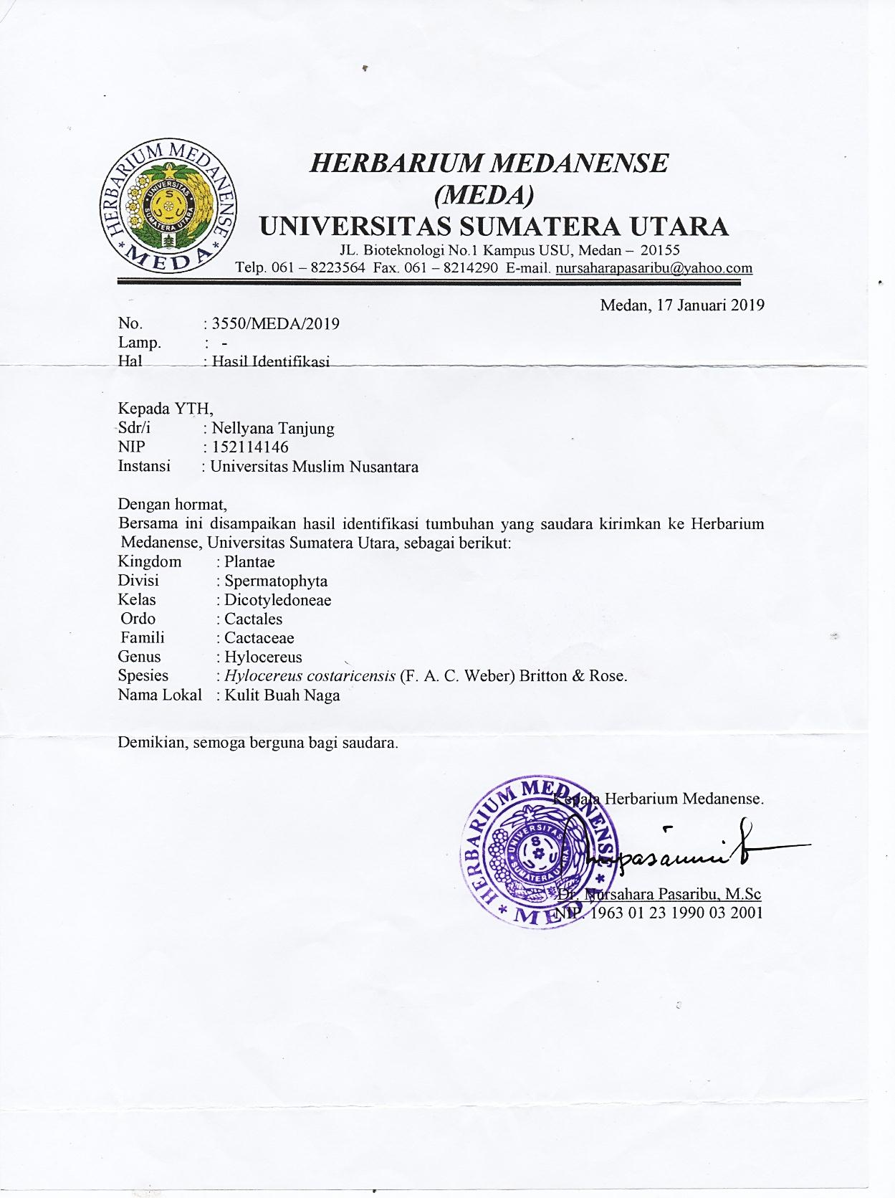**Lampiran 1**. Herbarium Medanense

**Lampiran 2**. Persetujuan Etik Penelitian Kesehatan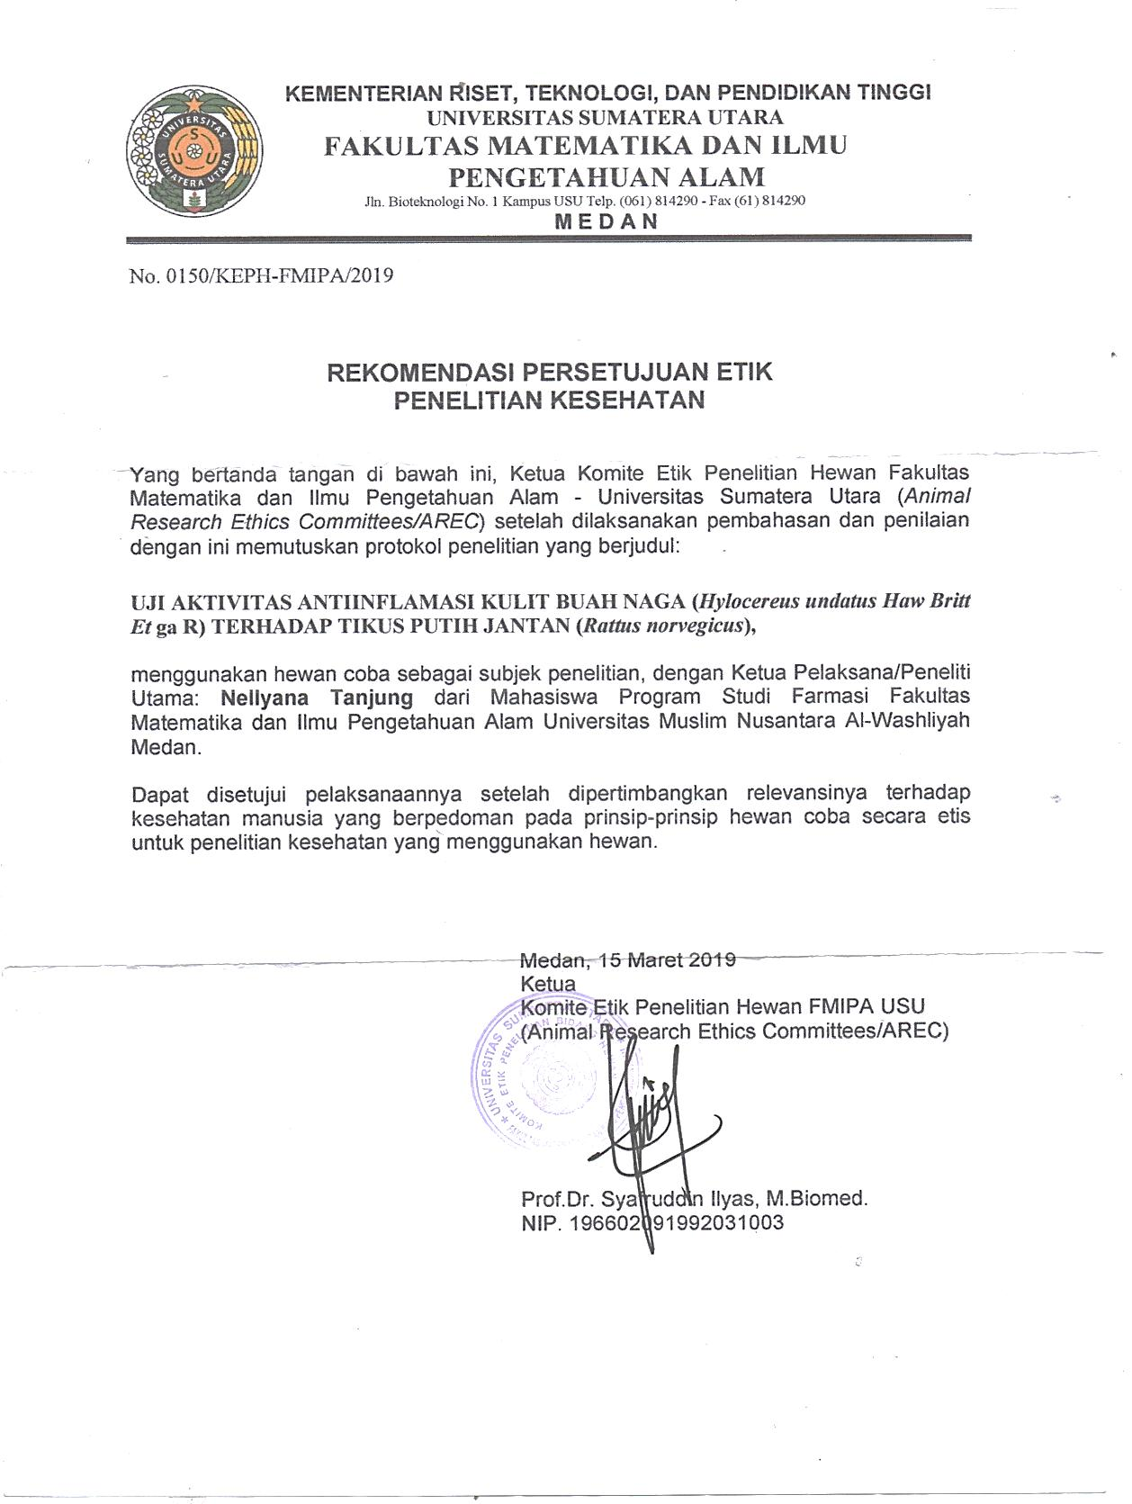

**Lampiran 3. Perhitungan Karakterisasi**

**1.** Perhitungan Penetapan Kadar Air Simplisia Kulit Buah Naga *(Hylocereus costaricensis* F.A.C. Weber Britton & Rose*)*

$$\% kadar air=\frac{V_{2-}V_{1}}{berat sampel}×100\%$$

Keterangan : V1= Volume destilat dari penjenuhan toluen

V2= Volume destilat air dari simplisia

1. Sampel pengulangan 1

V1 = 1,2 mL

V2 = 1,6 mL

Berat simplisia = 5, 00 g

= 8,00 %

1. Sampel pengulangan 2

V1 = 1,4 mL

V2 = 1,8 mL

Berat simplisia = 5, 00 g

= 8,00 %

1. Sampel pengulangan 1

V1 = 1,4 mL

V2 = 1,7 mL

Berat simplisia = 5, 00 g

(Lanjutan)

$\% kadar air =\frac{1,7 mL-1,4 mL}{5,00 g}×100\%$ = 6,00 %

Kadar air rata-rata ==7.33%

2. **Perhitungan penetapan kadar sari larut air**

Kadar sari larut air $=\frac{\left\{\left(berat cawan +sampel\right)-berat cawan kosong\right\}x5}{berat sampel} x 100\%$

1. Sampel pengulangan 1

Berat sampel = 5,00 gram

Berat Cawan Kosong = 43,398 gram

B1= 43,542 gram

B2= 43,541 gram

B3 = 43,542 gram

Brata-rata = 43,541 gram

Kadar sari larut air $=\frac{(43,541-43,398x5}{5,00 gram} x 100\%$ = 12.6 %

1. Sampel pengulangan 2

Berat sampel = 5,00 gram

Berat Cawan Kosong = 45,988 gram

B1= 46,176 gram

B2= 46,176 gram

B3 = 46,176 gram

Brata-rata = 46,176 gram

Kadar sari larut air $=\frac{(46,176-45,988)x5}{5,00 gram} x 100\%$ = 18.8 %

(Lanjutan)

1. Sampel pengulangan 3

Berat sampel = 5,00 gram

Berat Cawan Kosong = 49,476 gram

B1= 49,565 gram

B2= 49,565 gram

B3 = 49,565 gram

Brata-rata = 49,565 gram

Kadar sari larut air $=\frac{(59,565 -59,476)x5}{5,00 gram} x 100\%$ = 8.90 %

Kadar sari larut air rata-rata = $\frac{12.6 \% + 18.8\% + 8.90 \% }{3}$ = 13,43 %

**3. Perhitungan penetapan kadar sari larut etanol**

Kadar sari larut etanol $=\frac{\left\{\left(berat cawan +sampel\right)-berat cawan kosong\right\}x5}{berat sampel} x 100\%$

1. Sampel pengulangan 1

Berat sampel = 5,00 gram

Berat Cawan Kosong = 43,484 gram

B1= 43,544 gram

B2= 43,544 gram

B3 = 43,544 gram

Brata-rata = 43,544 gram

Kadar sari larut etanol $=\frac{(43,544 -43,484)x5}{5,00 gram} x 100\%$ = 6,00%

1. Sampel pengulangan 2

Berat sampel = 5,00 gram

Berat Cawan Kosong = 45,677 gram

B1= 45,817 gram

B2= 45,818 gram

B3 = 45,818 gram

Brata-rata = 45,817 gram

Kadar sari larut etanol $=\frac{(45,817-45,677)x5}{5,00 gram} x 100\%$ = 14,0 %

1. Sampel pengulangan 3

Berat sampel = 5,00 gram

Berat Cawan Kosong = 58,177 gram

B1= 58,324 gram

B2= 58,324 gram

B3 = 58,324 gram

Brata-rata = 58,324 gram

Kadar sari larut etanol $=\frac{(58,324 - 58,177)x5}{5,00 gram} x 100\%$ = 14.7 %

Kadar sari larut etanol rata-rata = $\frac{6,00\% + 14.0\% + 14.7\%}{3}$ = 11.56 %

**4.** **Perhitungan Penetapan Kadar Abu Total**

Kadar abu total $=\frac{\left\{\left(berat cawan +berat isi\right)-berat cawan kosong\right\}}{berat sampel} x 100\%$

1. Sampel pengulangan I

Berat sampel = 2,000 gram

Berat Krus Kosong = 42,920 gram

Berat Krus Isi = 43,225 gram

Kadar abu total $=\frac{(43,225-43,100) }{2,000} x 100\%$ = 6.25 %

1. Sampel pengulangan II

Berat sampel = 2,000 gram

Berat Krus Kosong = 41,162 gram

Berat Krus Isi = 41,259 gram

Kadar abu total $=\frac{(41,259-41,162 )}{2,000} x 100\%$ = 4.85 %

1. Sampel pengulangan III

Berat sampel = 2,000 gram

Berat Krus Kosong = 41,551 gram

Berat Krus Isi = 41,860 gram

Kadar abu total $=\frac{(41,860 – 41,551) }{2,000} x 100\%$ = 10.45 %

Kadar abu total rata-rata = $\frac{6,25 \% + 4,85 \% + 10,45\% }{3}$ = 7.18 %

**5. Perhitungan Penetapan Kadar Abu Tidak Larut Asam**

Kadar abu total $=\frac{\left\{\left(berat cawan+berat isi\right)-berat cawan kosong\right\}}{berat sampel} x 100\%$

1. Sampel pengulangan I

Berat sampel = 2,000 gram

Berat Krus Kosong = 42,552 gram

Berat Krus Isi = 42,559 gram

Kadar abu total $=\frac{(42,559-42,552) }{2,000} x 100\%$ = 0,35 %

1. Sampel pengulangan II

Berat sampel = 2,000 gram

Berat Krus Kosong = 40,860 gram

Berat Krus Isi = 40,868 gram

Kadar abu total $=\frac{(40,860-40,868 )}{2,000} x 100\%$ = 0,40 %

1. Sampel pengulangan III

Berat sampel = 2,000 gram

Berat Krus Kosong = 40,493 gram

Berat Krus Isi = 40,499 gram

Kadar abu total $=\frac{(40,499 – 40,493) }{2,000} x 100\%$ = 0,30 %

Kadar abu total rata-rata = $\frac{0,35\% + 0,40\% + 0,30\% }{3}$ = 0,35

## Lampiran 4. Perhitungan Dosis

## Perhitungan dosis Suspensi CMC 0,5%

Berat Hewan = 165 kg

= $\frac{0,5}{100}$ x 165 kg = 0.825 ml

Pemberian = 0,8 ml

## Perhitungan dosis suspensi ekstrak kulit buah naga 100 mg/kgBB

Berat Hewan = 184 gram

Dosis = $\frac{Dosis (mg)}{1000 gram}$ × BB

= $\frac{100 mg}{1000 gram}$ X 184 gram

= 18.4 mg

Konsentrasi 7.5 % = $\frac{7.5 gram}{100 ml}$ = 75mg/ml

Volume Pemberian = $\frac{Dosis}{Konsentrasi}$ = $\frac{18.4 mg}{75 mg/ml}$ = 0.24 ml

## Perhitungan dosis suspense ekstrak kulit buah naga 200 mg/kgBB

Berat Hewan = 210

Dosis = $\frac{Dosis (mg)}{1000 gram}$ × BB

= $\frac{200 mg}{1000 gram}$ X 210 gram

= 42 mg

Konsentrasi 7.5 % = $\frac{7.5 gram}{100 ml}$ = 75mg/ml

Volume Pemberian = $\frac{Dosis}{Konsentrasi}$ = $\frac{42 mg}{75 mg/ml}$ = 0.56 ml

## Perhitungan dosis suspense ekstrak kulit buah naga 400 mg/kgBB

Berat = 200 gram

Dosis = $\frac{Dosis (mg)}{1000 gram}$ × BB

= $\frac{400 mg}{1000 gram}$ X 200 gram

= 80 mg

Konsentrasi 7.5 % = $\frac{7.5 gram}{100 ml}$ = 75mg/ml

Volume Pemberian = $\frac{Dosis}{Konsentrasi}$ = $\frac{80 mg}{75 mg/ml}$ = 1.06 ml

**Lampiran 5.** Bagan Alir Prosedur Kerja

Pengumpulan sampel kulit buah naga

Disortasi basah

Kulit buah naga 15 kg

Di cuci dengan air mengalir

Ditimbang

Ditiriskan

Kulit buah naga

Dikeringkan Dalam Lemari Pengeringan pada suhu ± 400C

Disortasi Kering

Ditimbang kembali

Berat kering simplisia kulit buah naga 530 gram

Dihaluskan menggunakan blender

Disimpan dalam wadah tertutup rapat

Serbuk Simplisia kulit buah naga 500 gram

Karakterisasi simplisia

**Lampiran 6.** Bagan Alir Karakerisasi Simplisia Kulit Buah Naga (*Hylocereus costaricensis* F.A.C. Weber Britton & Rose)

Simplisia

Pemeriksaan makroskopik simplisia

Dihaluskan

Serbuk simplisia Kulit Buah Naga (*Hylocereus costaricensis* F.A.C. Weber) Britton & Rose)

Karakterisasi Simplisia

Parameter non spesifik

Parameter spesifik

Mikroskopis serbuk simplisia

* -
* - Kadar air
* - Kadar sari larut air
* - Kadar sari larut etanol
* - Kadar abu total
* - Kadar abu tidak larut asam

**Lampiran 7.** Bagan Alir Pembuatan Ekstrak

Serbuk simplisia kulit buah naga

* Ditimbang serbuk simplisia 500 gram
* Dimasukkan ke dalam bejana maserasi
* Ditambahkan75 bagian pelarut yaitu 3750 ml etanol 96 %
* Didiamkan selama 5 hari sambil sesekali diaduk
* Disaring rendemen setelah 5 hari , filtrate ditampung

Maserat

Ampas

Maserat

Ditambahkan 25 bagian pelarut yaitu 1250 etanol 96% (di adkan 5000ml)

Diendapkan 2 hari, tuang endapkan. Pelarut diuapkan menggunakan alat rotary evaporator

Ekstrak kental kulit buah naga 32,5 gram

**Lampiran 8.** Bagan Alir Penelitian

Tikus jantan 25 ekor

Induksi dengan karagenan 1%

Dibagi menjadi 5/kelompok

EEKBN 400 mg/kgBB

Kontrol Negatif

Kontrol positif

EEKBN 100 mg/kgBB

EEKBN 200 mg/kgBB

Pengamatan Selama 6 Jam

Analisis Data

**Lampiran 9.** Tumbuhan Buah Naga (*Hylocereus costaricensis (*F.A.C. Weber) Britton & Rose)

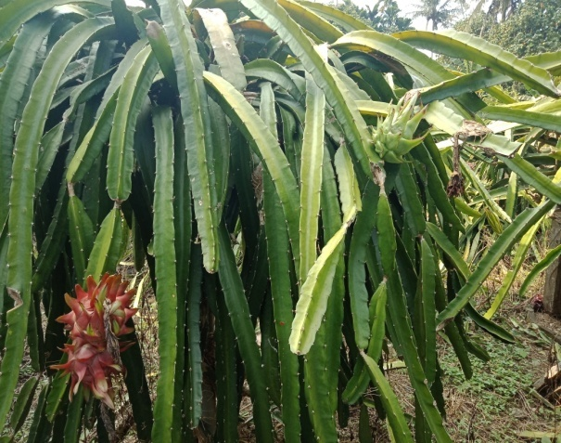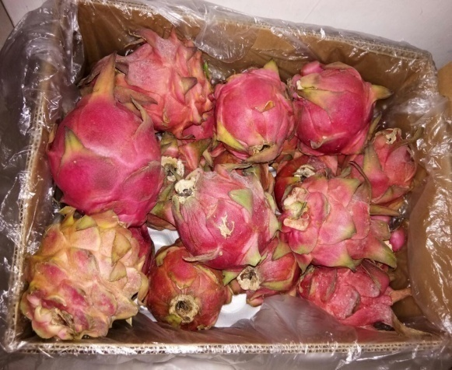

**Lampiran 10** 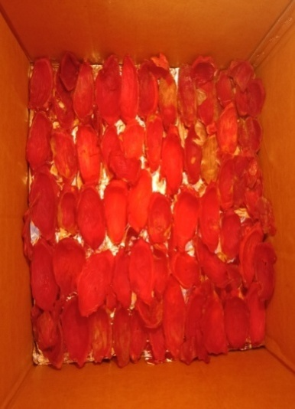Pengolahan Sampel Kulit Buah Naga (*Hylocereus costaricensis (*F.A.C. Weber) Britton & Rose)

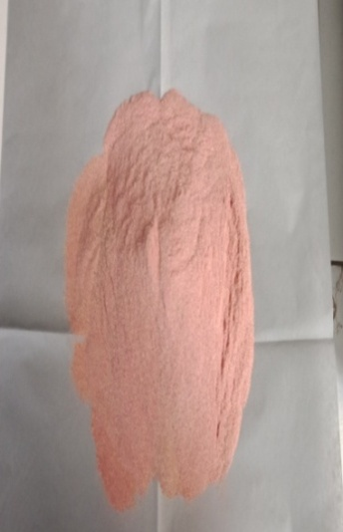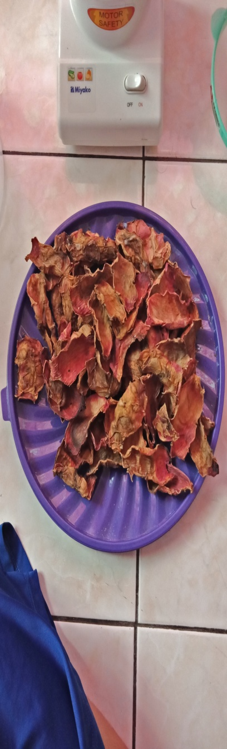

Proses pengeringan Simplisia kulit buah naga Serbuk simplisia

Kulit buah naga kulit buah naga

**Lampiran 11.** Proses EkstraksiTumbuhan Kulit Buah Naga (*Hylocereus*

*Costaricensis (*F.A.C Weber) Britton & Rose)

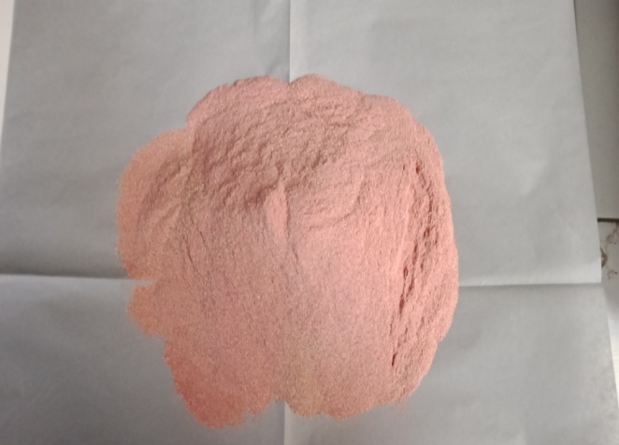 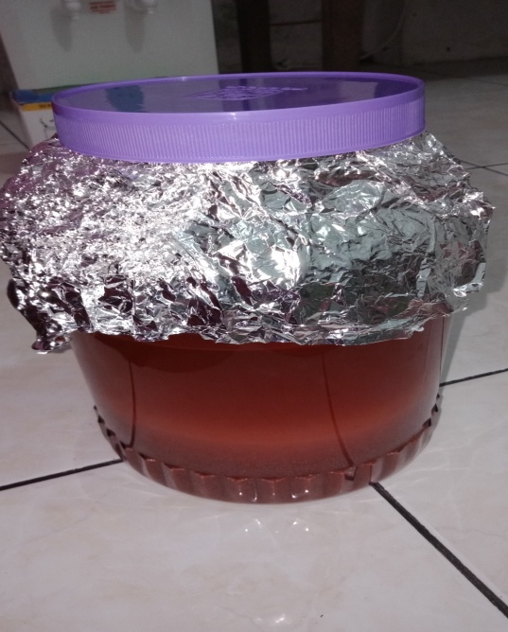

Penimbangan serbuk simplisia Wadah maserasi

Kulit buah naga

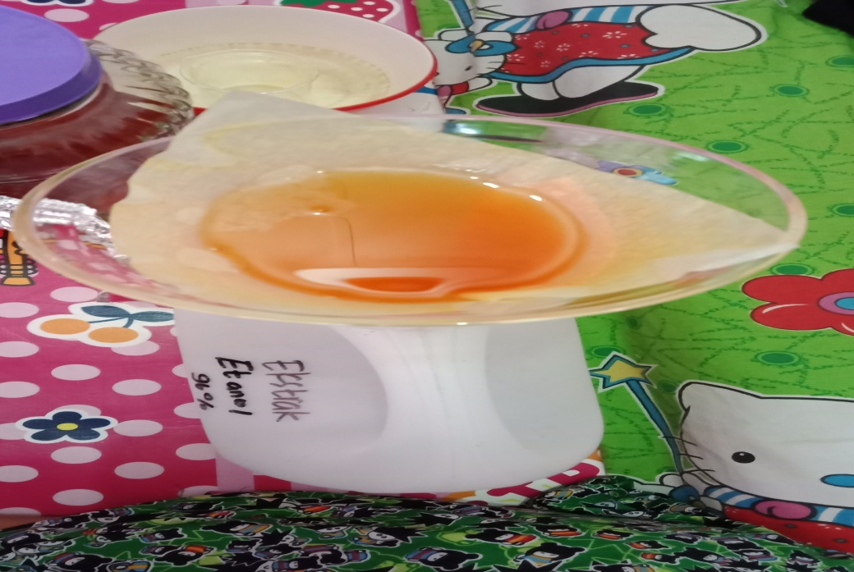 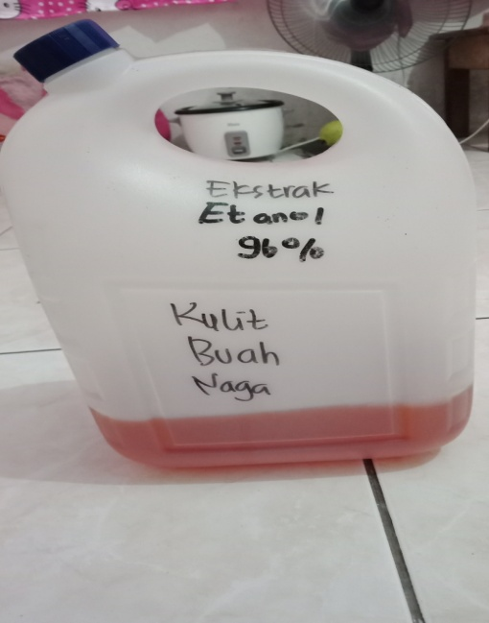

Penyaringan larutan ekstrak Hasil maserat kulit buah naga merah

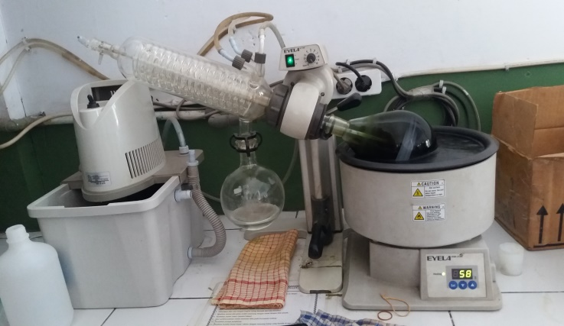 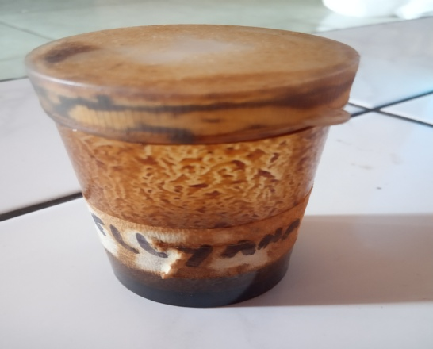

Penguapan ekstrak kulit buah naga Ekstrak kental kulit buah naga

**Lampiran 12.** Pemeriksaan Mikroskopis Simplisia kulit buah naga (*Hylocereus costaricensis (*F.A.C Weber) Britton & Rose*)*

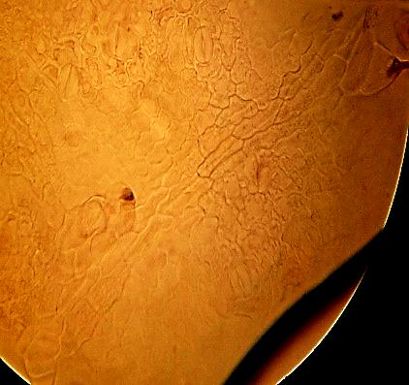

1

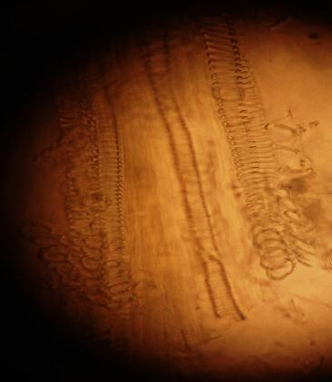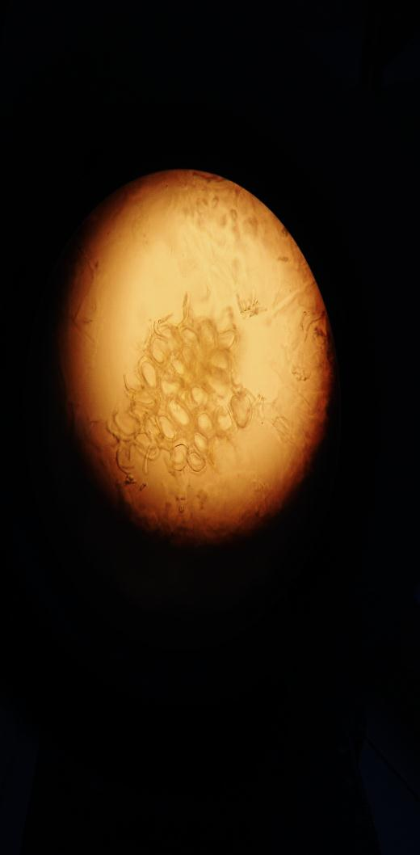

3

2

Keterangan Hasil :

1. Epidermis
2. Jaringan pengangkut dengan penebalan bentuk tangga
3. Sel Parenkim

# Lampiran 13. Pengujian Hewan

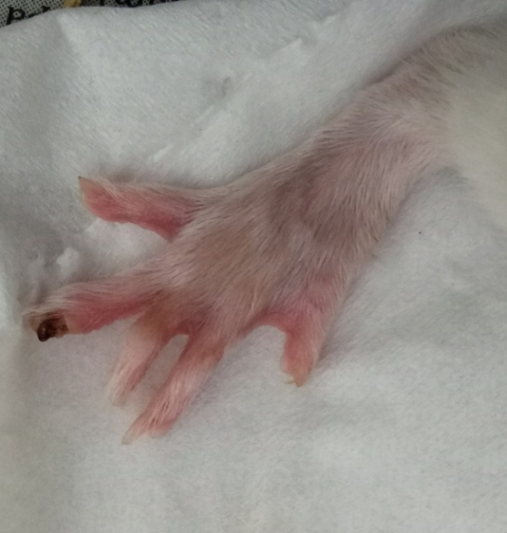

Gambar kaki tikus

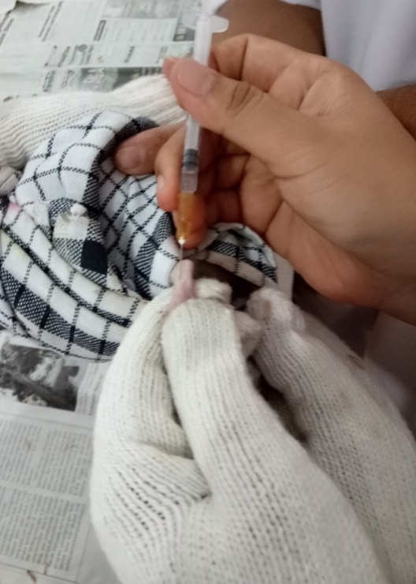

Penyuntikan kaki tikus secara intraplantar

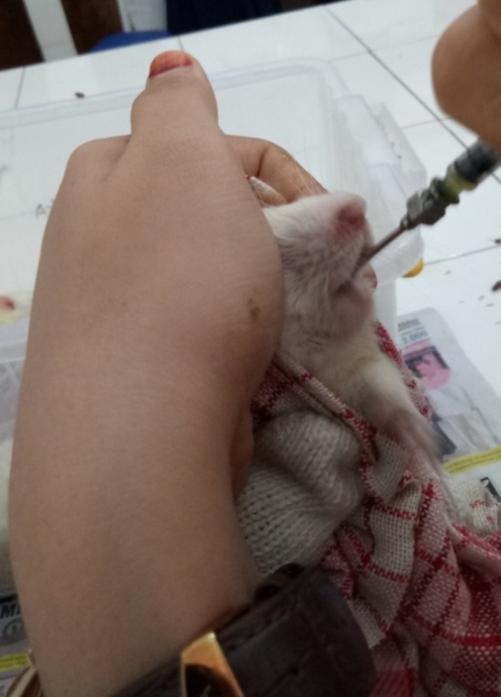

Pemberian oral padatikus

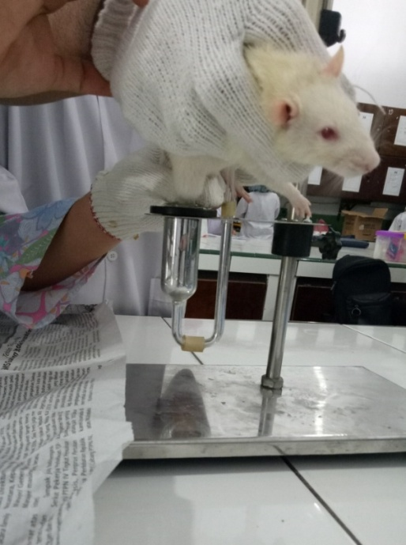

Pengukuran inflamasi dengan pletismometer

|  |  |  |  |  |  |  |  |  |  |  |  |  |  |
| --- | --- | --- | --- | --- | --- | --- | --- | --- | --- | --- | --- | --- | --- |
| **Perlakuan** | **V₀** | **60 menit** | | **120 menit** | | **180 menit** | | **240 menit** | | **300 menit** | | **360 menit** | |
| **V1** | **% Radang** | **V2** | **% Radang** | **V3** | **% Radang** | **V4** | **% Radang** | **V5** | **% Radang** | **V6** | **% Radang** |
| **CMC 0,5%** | 0,050  0,050  0,060  0,050  0,060 | 0,092  0,093  0,088  0,094  0,096 | 84  86  46,667  88  60 | 0,095  0,097  0,093  0,099  0,096 | 90  94  55  98  63,333 | 0,093  0,095  0,091  0,096  0,094 | 86  90  51,667  92  56,667 | 0,086  0,089  0,085  0,090  0,088 | 72  78  41,667  80  46,667 | 0,083  0,084  0,079  0,084  0,080 | 66  68  31,667  68  33,333 | 0,073  0,072  0,071  0,073  0,074 | 46  44  18,333  46  23,333 |
| **Rata-rata** |  |  | 72,933 |  | 80,067 |  | 75,267 |  | 63,667 |  | 53,4 |  | 35,533 |
| **Na Diklofenak** | 0,050  0,070  0,060  0,070  0,060 | 0,090  0,097  0,095  0,096  0,094 | 80  38,571  58,333  37,143  56,667 | 0,093  0,098  0,097  0,099  0,099 | 86  40  61,667  41,428  65 | 0,088  0,090  0,089  0,091  0,092 | 76  28,571  48,333  30  53,333 | 0,076  0,080  0,081  0,087  0,086 | 52  14,286  35  24,286  43,333 | 0,068  0,078  0,073  0,079  0,076 | 36  11,428  21,667  12,857  26,667 | 0,054  0,072  0,063  0,073  0,062 | 8  2,857  8,333  4,286  3,333 |
| **Rata-rata** |  |  | 54,143 |  | 58,819 |  | 47,248 |  | 33,781 |  | 21,724 |  | 5,362 |
| **EEDT 100** | 0,050  0,050  0,060  0,050  0,060 | 0,088  0,086  0,092  0,089  0,093 | 76  72  53,333  78  55 | 0,096  0,095  0,098  0,097  0,099 | 92  90  63,333  88  65 | 0,092  0,090  0,093  0,092  0,095 | 84  80  53,333  86  58,333  72,333 | 0,085  0,082  0,087  0,086  0,090 | 64  70  45  72  50 | 0,078  0,075  0,080  0,078  0,088 | 56  50  33,333  56  46,667 | 0,071  0,070  0,072  0,071  0,074 | 42  40  20  42  23,333 |
| **Rata-rata** |  |  | 66,867 |  | 79,667 |  | 72,333 |  | 60,2 |  | 48,4 |  | 23,333 |
| **EEDT 200** | 0,060  0,060  0,050  0,050  0,060 | 0,091  0,090  0,086  0,085  0,090 | 5,.667  50  72  70  50 | |  | | --- | | 0.094 | | 0.093 | | 0.090 | | 0.089 | | 0.093 | | 56,667  55  80  78  55 | |  | | --- | | 0,097 | | 0,095 | | 0,092 | | 0,091 | | 0,096 | | 61,667  58,333  84  82  60 | |  | | --- | | 0,088 | | 0,085 | | 0,084 | | 0,084 | | 0,087 | | 46,667  41,667  68  68  45 | |  | | --- | | 0,077 | | 0,073 | | 0,072 | | 0,070 | | 0,075 | | 28,333  21,667  44  40  25 | 0,068  0,064  0,070  0,065  0,070 | 13,333  6,667  40  30  16,667 |
| **Rata-rata** |  |  | 58.733 |  | 64.933 |  | 69.2 |  | 53.867 |  | 31.8 |  | 21,333  6,667  6  8  4  3,333 |
| **EEDT 400** | 0,060  0,050  0,050  0,050  0,060 | 0,088  0,086  0,087  0,087  0,089 | 46,667  72  74  74  48,333 | 0,094  0,092  0,095  0,093  0,096 | 56,667  84  90  86  60 | 0,086  0,083  0,088  0,082  0,088 | 43,333  66  76  64  46,667 | 0,079  0,076  0,080  0,075  0,081 | 31,667  52  60  50  35 | 0,070  0,067  0,069  0,066  0,072 | 16.667  34  38  32  20 | 0,064  0,053  0,054  0,052  0,062 |
| **Rata-rata** |  |  | 63 |  | 75,333 |  | 59,2 |  | 45,733 |  | 28,133 |  | 5,6 |

|  |  |  |  |  |  |  |  |  |  |  |  |
| --- | --- | --- | --- | --- | --- | --- | --- | --- | --- | --- | --- |
| **Lampiran 15.** Perhitungan SPSS  **Tests of Normality** | | | | | | | | | | | |
|  | Perlakuan | | Kolmogorov-Smirnova | | | | | Shapiro-Wilk | | | |
|  | Statistic | df | | Sig. | | Statistic | df | | Sig. |
| VO | Kontrol negatif | | .367 | 5 | | .026 | | .984 | 5 | | .626 |
| EEKBN 400 | | .231 | 5 | | .200* | | .881 | 5 | | .314 |
| EEKBN 100 | | .367 | 5 | | .026 | | .984 | 5 | | .506 |
| EEKBN 200 | | .367 | 5 | | .026 | | .974 | 5 | | .806 |
| Kontrol positif | | .367 | 5 | | .026 | | .954 | 5 | | .116 |
| 60 MENIT | Kontrol negatif | | .220 | 5 | | .200* | | .956 | 5 | | .777 |
| EEKBN 400 | | .241 | 5 | | .200* | | .903 | 5 | | .427 |
| EEKBN 100 | | .198 | 5 | | .200* | | .951 | 5 | | .742 |
| EEKBN 200 | | .323 | 5 | | .096 | | .840 | 5 | | .166 |
| Kontrol positif | | .237 | 5 | | .200* | | .961 | 5 | | .814 |
| 120 MENIT | Kontrol negatif | | .198 | 5 | | .200* | | .957 | 5 | | .787 |
| EEKBN 400 | | .268 | 5 | | .200* | | .896 | 5 | | .290 |
| EEKBN 100 | | .136 | 5 | | .200* | | .987 | 5 | | .967 |
| EEKBN 200 | | .310 | 5 | | .131 | | .871 | 5 | | .272 |
| Kontrol positif | | .136 | 5 | | .200* | | .987 | 5 | | .967 |
| 180 MENIT | Kontrol negatif | | .141 | 5 | | .200* | | .979 | 5 | | .928 |
| EEKBN 400 | | .136 | 5 | | .200* | | .987 | 5 | | .967 |
| EEKBN 100 | | .213 | 5 | | .200* | | .963 | 5 | | .826 |
| EEKBN 200 | | .221 | 5 | | .200* | | .915 | 5 | | .501 |
| Kontrol positif | | .224 | 5 | | .200* | | .865 | 5 | | .246 |
| 240 MENIT | Kontrol negatif | | .180 | 5 | | .200* | | .952 | 5 | | .754 |
| EEKBN 400 | | .212 | 5 | | .200* | | .936 | 5 | | .635 |
| EEKBN 100 | | .166 | 5 | | .200* | | .989 | 5 | | .977 |
| EEKBN 200 | | .229 | 5 | | .200* | | .867 | 5 | | .254 |
| Kontrol positif | | .221 | 5 | | .200* | | .915 | 5 | | .501 |
| 300 MENIT | Kontrol negatif | | .265 | 5 | | .200* | | .836 | 5 | | .154 |
| EEKBN 400 | | .207 | 5 | | .200* | | .921 | 5 | | .535 |
| EEKBN 100 | | .284 | 5 | | .200* | | .860 | 5 | | .228 |
| EEKBN 200 | | .159 | 5 | | .200* | | .990 | 5 | | .980 |
| Kontrol positif | | .175 | 5 | | .200* | | .974 | 5 | | .899 |
| 360 MENIT | Kontrol negatif | | .237 | 5 | | .200* | | .961 | 5 | | .814 |
| EEKBN 400 | | .220 | 5 | | .200* | | .917 | 5 | | .509 |
| EEKBN 100 | | .254 | 5 | | .200* | | .914 | 5 | | .492 |
| EEKBN 200 | | .224 | 5 | | .200* | | .865 | 5 | | .246 |
| Kontrol positif | | .180 | 5 | | .200* | | .952 | 5 | | .754 |
| *. This is a lower bound of the true significance. | | | | | | | | | | | |
| **Test of Homogeneity of Variances** | | | | | | | | | | | |
|  | | Levene Statistic | | | df1 | | df2 | | | Sig. | |
| VO | | .542 | | | 4 | | 20 | | | .706 | |
| 60 MENIT | | 1.041 | | | 4 | | 20 | | | .411 | |
| 120 MENIT | | .585 | | | 4 | | 20 | | | .677 | |
| 180 MENIT | | 1.360 | | | 4 | | 20 | | | .283 | |
| 240 MENIT | | 1.734 | | | 4 | | 20 | | | .182 | |
| 300 MENIT | | .821 | | | 4 | | 20 | | | .527 | |
| 360 MENIT | | .770 | | | 4 | | 20 | | | .501 | |

|  |  |  |  |  |  |  |
| --- | --- | --- | --- | --- | --- | --- |
| **ANOVA** | | | | | | |
|  | | Sum of Squares | df | Mean Square | F | Sig. |
| VO | Between Groups | .000 | 4 | .000 | 1.579 | .019 |
| Within Groups | .001 | 20 | .000 |  |  |
| Total | .001 | 24 |  |  |  |
| 60 MENIT | Between Groups | .000 | 4 | .000 | 6.524 | .002 |
| Within Groups | .000 | 20 | .000 |  |  |
| Total | .000 | 24 |  |  |  |
| 120 MENIT | Between Groups | .000 | 4 | .000 | 6.235 | .002 |
| Within Groups | .000 | 20 | .000 |  |  |
| Total | .000 | 24 |  |  |  |
| 180 MENIT | Between Groups | .000 | 4 | .000 | 13.612 | .000 |
| Within Groups | .000 | 20 | .000 |  |  |
| Total | .000 | 24 |  |  |  |
| 240 MENIT | Between Groups | .000 | 4 | .000 | 8.240 | .000 |
| Within Groups | .000 | 20 | .000 |  |  |
| Total | .000 | 24 |  |  |  |
| 300 MENIT | Between Groups | .001 | 4 | .000 | 11.037 | .000 |
| Within Groups | .000 | 20 | .000 |  |  |
| Total | .001 | 24 |  |  |  |
| 360 MENIT | Between Groups | .000 | 4 | .000 | 6.854 | .001 |
| Within Groups | .000 | 20 | .000 |  |  |
| Total | .001 | 24 |  |  |  |

|  |  |  |
| --- | --- | --- |
| **VO** | | |
| TukeyHSDa | | |
| Perlakuan | N | Subset for alpha = 0.05 |
| 1 |
| kontrol positif | 5 | .05400 |
| EEKBN 400 | 5 | .05400 |
| EEKBN 200 | 5 | .05400 |
| Kontrol negatif | 5 | .05600 |
| EEKBN 100 | 5 | .06200 |
| Sig. |  | .279 |
| Means for groups in homogeneous subsets are displayed. | | |
| a. Uses Harmonic Mean Sample Size = 5.000. | | |

|  |  |  |  |  |
| --- | --- | --- | --- | --- |
| **60 MENIT** | | | | |
| TukeyHSDa | | | | |
| Perlakuan | N | Subset for alpha = 0.05 | | |
| 1 | 2 | 3 |
| Kontrol positif | 5 | .08740 |  |  |
| EEKBN 400 | 5 | .08840 | .08840 |  |
| EEKBN 200 | 5 | .08960 | .08960 | .08960 |
| EEKBN 100 | 5 |  | .09260 | .09260 |
| Kontrol negatif | 5 |  |  | .09440 |
| Sig. |  | .662 | .111 | .054 |
| Means for groups in homogeneous subsets are displayed. | | | | |
| a. Uses Harmonic Mean Sample Size = 5.000. | | | | |

|  |  |  |  |
| --- | --- | --- | --- |
| **120 MENIT** | | | |
| TukeyHSDa | | | |
| Perlakuan | N | Subset for alpha = 0.05 | |
| 1 | 2 |
| Kontrol positif | 5 | .09180 |  |
| EEKBN 400 | 5 | .09400 | .09400 |
| EEKBN 200 | 5 |  | .09640 |
| EEKBN 100 | 5 |  | .09700 |
| Kontrol negatif | 5 |  | .09720 |
| Sig. |  | .473 | .148 |
| Means for groups in homogeneous subsets are displayed. | | | |
| a. Uses Harmonic Mean Sample Size = 5.000. | | | |

|  |  |  |  |  |
| --- | --- | --- | --- | --- |
| **180 MENIT** | | | | |
| TukeyHSDa | | | | |
| Perlakuan | N | Subset for alpha = 0.05 | | |
| 1 | 2 | 3 |
| Kontrol positif | 5 | .08540 |  |  |
| EEKBN 400 | 5 |  | .09000 |  |
| EEKBN 200 | 5 |  | .09240 | .09240 |
| EEKBN 100 | 5 |  | .09380 | .09380 |
| Kontrol negatif | 5 |  |  | .09420 |
| Sig. |  | 1.000 | .082 | .695 |
| Means for groups in homogeneous subsets are displayed. | | | | |
| a. Uses Harmonic Mean Sample Size = 5.000. | | | | |
|  | | | | |

|  |  |  |  |  |
| --- | --- | --- | --- | --- |
| **240 MENIT** | | | | |
| TukeyHSDa | | | | |
| Perlakuan | N | Subset for alpha = 0.05 | | |
| 1 | 2 | 3 |
| Kontrol positif | 5 | .07820 |  |  |
| EEKBN 400 | 5 | .08200 | .08200 |  |
| EEKBN 200 | 5 |  | .08560 | .08560 |
| EEKBN 100 | 5 |  | .08600 | .08600 |
| Kontrol negatif | 5 |  |  | .08760 |
| Sig. |  | .283 | .239 | .817 |
| Means for groups in homogeneous subsets are displayed. | | | | |
| a. Uses Harmonic Mean Sample Size = 5.000. | | | | |

|  |  |  |  |  |  |
| --- | --- | --- | --- | --- | --- |
| **300 MENIT** | | | | | |
| TukeyHSDa | | | | | |
| Perlakuan | N | Subset for alpha = 0.05 | | | |
| 1 | 2 | 3 | |
| Kontrol positif | 5 | .06880 |  |  | |
| EEKBN 400 | 5 | .07340 | .07340 |  | |
| EEKBN 200 | 5 | .07480 | .07480 |  | |
| EEKBN 100 | 5 |  | .07980 | .07980 | |
| Kontrol negatif | 5 |  |  | .08200 | |
| Sig. |  | .092 | .065 | .859 | |
| Means for groups in homogeneous subsets are displayed. | | | | | |
| **360 MENIT** | | | | |
| TukeyHSDa | | | | |
| Perlakuan | N | Subset for alpha = 0.05 | | |
| 1 | 2 | 3 |
| Kontrol positif | 5 | .06160 |  |  |
| EEKBN 400 | 5 | .06480 | .06480 |  |
| EEKBN 200 | 5 | .06740 | .06740 | .06740 |
| EEKBN 100 | 5 |  | .07160 | .07160 |
| Kontrol negatif | 5 |  |  | .07260 |
| Sig. |  | .176 | .084 | .263 |
| Means for groups in homogeneous subsets are displayed. | | | | |
| a. Uses Harmonic Mean Sample Size = 5.000. | | | | |