Lampiran 1. Gambar Sampel Salak Pondoh, Salak Padang Sidempuan, Salak Gula Pasir
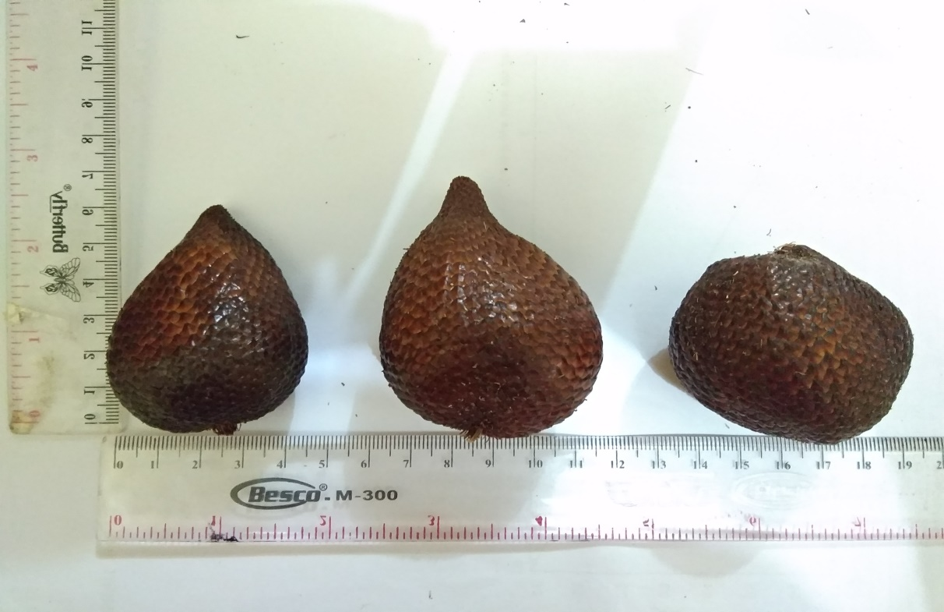MPIRAN
Salak pondoh Salak padang sidempuan Salak gula pasir

Lampiran 2. Gambar Sari Salak Pondoh, Salak Padang Sidempuan, Salak Gula Pasir
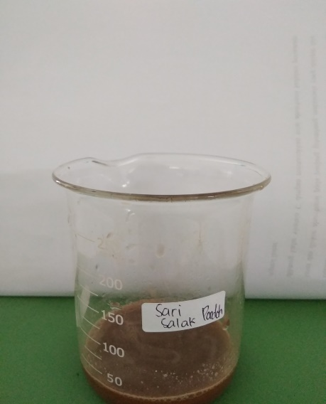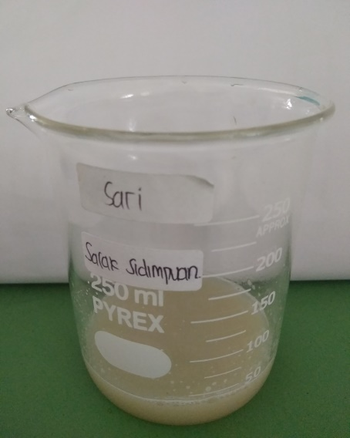
Gambar 1. Sari salak pondoh Gambar 2. Sari salak padang sidempuan
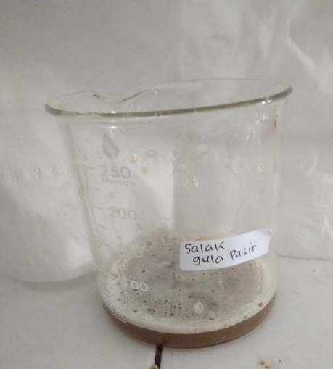
Gambar 2. Sari salak gula pasir

Lampiran 3. Gambar penimbangan sari salak pondoh, salak padang sidempuan, sari salak gula pasir
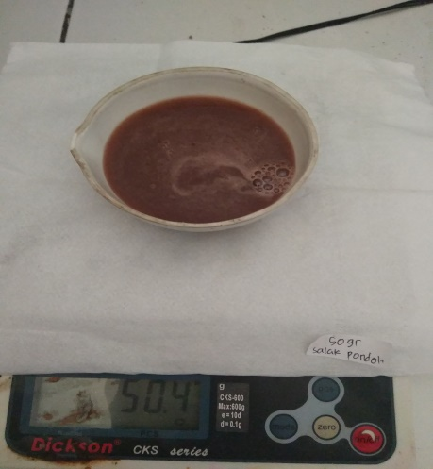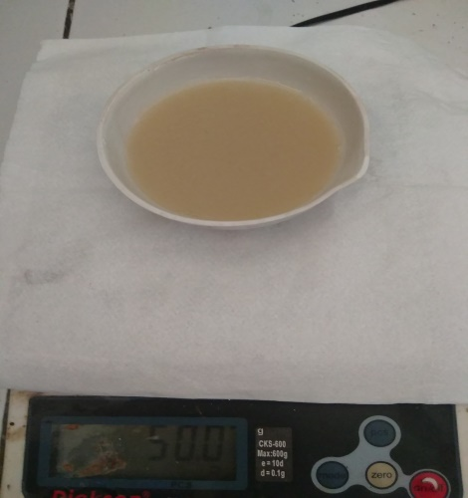
Gambar 1. Sari salak pondoh Gambar 2. Sari salak padang sidempuan
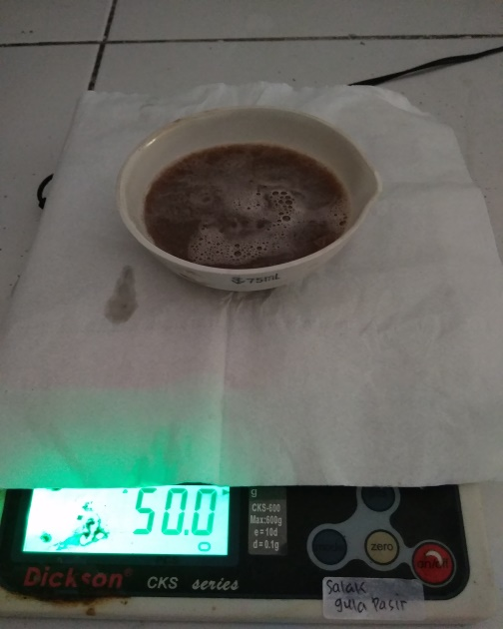
Gambar 3. Sari salak gula pasir

Lampiran 4. Gambar Pembuatan Larutan Sampel
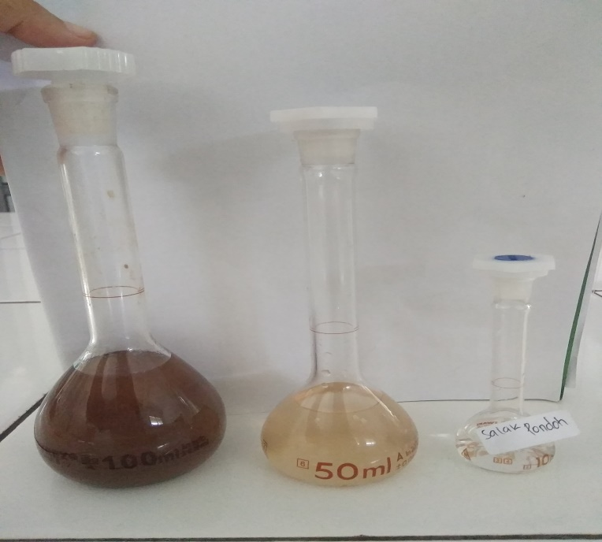
Gambar 1. Hasil pengenceran sari salak pondoh
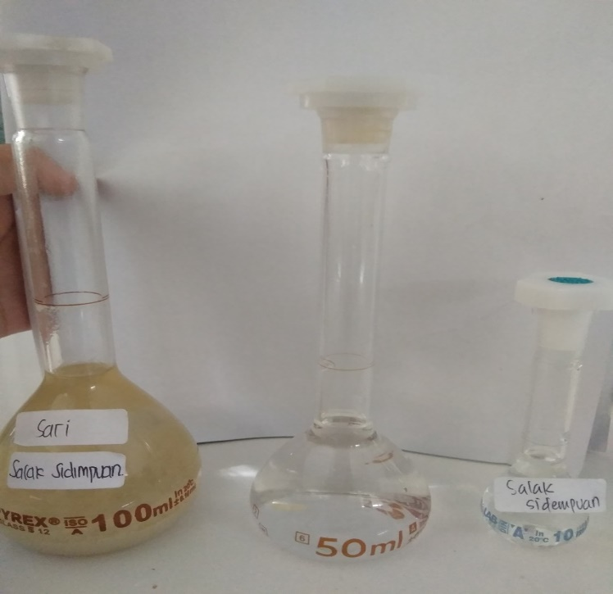
Gambar 2. Hasil pengenceran sari salak padang sidempuan

Lampiran 4. Lanjutan
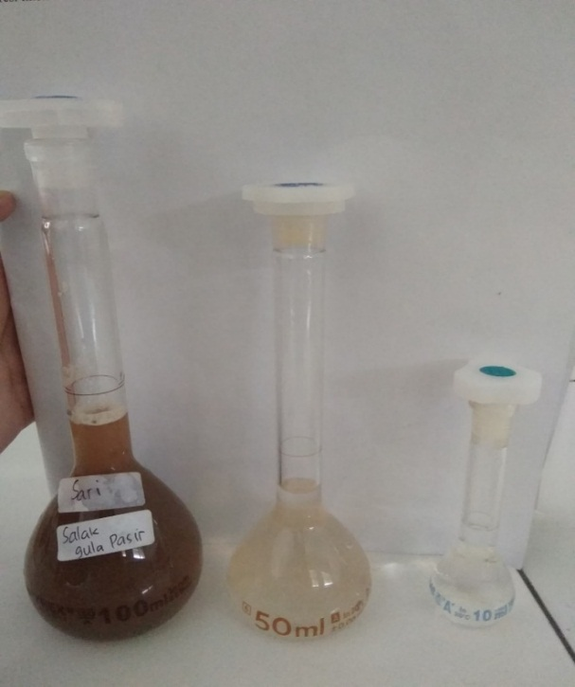
Gambar 3. Hasil pengenceran sari salak gula pasir

Lampiran 5. Gambar Alat
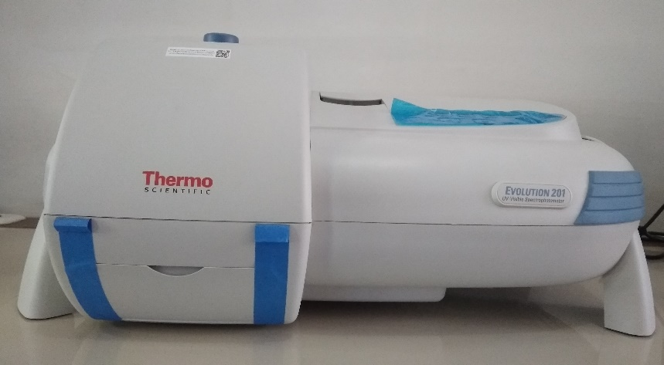
Gambar 1. Spektrofotometer UV-Visible
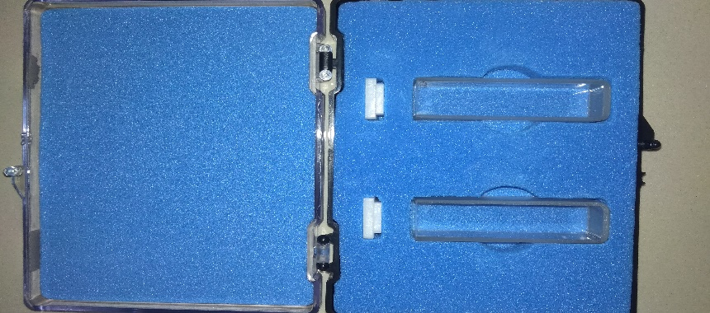
Gambar 2. Kuvet

Lampiran 6. Bagan Alir Pembuatan Larutan Induk
Ditimbang 50 mg Asam Askorbat

Dilarutkan dalam labu tentukur dengan aq hingga 50 ml
Dipipet 2,5 ml (aq ad 50 ml)
Penentuan panjang gelombang maksimum
(5 µg/ml)

Dipipet 3 ml, ad aq 50 ml (6 µg/ml)

Dipipet 3,5 ml, ad aq 50 ml (7 µg/ml)

Dipipet 2,5 ml, ad aq 50 ml (5 µg/ml)

Dipipet 2 ml, ad aq 50 ml (4 µg/ml)

Dipipet 1,5 ml, ad aq 50 ml (3 µg/ml)

Kurva Kalibrasi

LIB II
(100 µg/ml)

LIB I
(C=1000 µg/ml)

Lampiran 7. Bagan Alir Penentuan Kadar Sampel
Sampel
(Salak pondoh, salak padang sidempuan, salak gula pasir)

- Diblender sampai halus
- Diambil sarinya
- Ditimbang 50 g
- Dimasukkan ke dalam labu tentukur 100 ml
Kemudian dicukupkan sampai batas tanda dengan pelarut aquadest
- Disaring menggunakan kertas saring
- Dipipet 3 ml
- Dimasukkan kedalam labu tentukur 10 ml,
- Dipipet 2,5 ml
- Dimasukkan kedalam labu tentukur 10 ml
- cukupkan dengan aquadest hingga tanda batas
- Dimasukkan sampel kedalam kuvet
- Di ukur serapannya
Hasil Serapan

Perlakuan dilakukan sebanyak 6 kali pada setiap sampel

Lampiran 8. Kurva Kadar Sampel

No | Sampel | Kadar rata – rata  mg/100 gram
1 | Salak pondoh | 10,3616
2 | Salak padang sidempuan | 3,6783
3 | Salak gula pasir | 8,94

Lampiran 9. Data Perhitungan Persamaan Regresi dan Koefisien Korelasi Vitamin C
No | Konsentrasi (µg/mL)  (X) | Serapan  (Y) | XY | X² | Y²
1 | 0,00 | 0,00 | 0,00 | 0,00 | 0,00
2 | 3,00 | 0,294 | 0,882 | 9 | 0,0864
3 | 4,00 | 0,384 | 1,536 | 16 | 0,1475
4 | 5,00 | 0,481 | 2,405 | 25 | 0,2314
5 | 6,00 | 0,584 | 3,504 | 36 | 0,3411
6 | 7,00 | 0,699 | 4,893 | 49 | 0,4886
ƩX= 25 |  | ƩY= 2,442 | ƩXY= 13,220 | ƩX²= 135 | ƩY²=1,2949
X rata-rata = 4,167 |  | Y rata-rata= 0,407 | XY rata-rata= 2,2033 | X² rata-rata=22,5 | Y²rata-rata =0,2158

- Persamaan Regresi
Y=aX+b
a= $\frac{\left(∑XY\right)-(∑X)(∑Y)/n}{\left(∑X^{2}\right)-(∑{X)}^{2}/n}$ = $\frac{\left(13,220\right)-(25)(2,442)/6}{\left(135\right)-(25)^{2}/6}$ = $\frac{3,045}{30,833}$= 0,0988

b = (Yrata-rata)-(a)(Xrata-rata)
= 0,407-0,0988(4,167)
= 0,0047
Persamaan Regresi
Y=aX+b
Y=0,0988X+0,0047
- Koefisien Korelasi

r = $\frac{\left(∑XY\right)-(∑X)(∑Y)/n}{√(ƩX^{2}-(ƩX)^{2}/n)(ƩY^{2}-(ƩY)^{2}/n)}$
r = $\frac{\left(13,220\right)-(25)(2,442)/6}{√(135-(25)^{2}/6)(1,2949-(2,442)^{2}/6)}$
r = $\frac{3,045}{√30,8333(0,301)}$
r = $\frac{3,045}{3,0464}$
r = 1
Lampiran 10. Data Perhitungan Konsentrasi dan Kadar dan Kadar sebenarnya Salak Pondoh

No | Berat Sampel  (g) | Serapan (Y) | Konsentrasi (X) | Volume Labu (ml) | FP | Kadar yang diperoleh (mg/100 g)
1 | 50 | 0,397 | 3,9706 | 100 | 13.32 | 10,57
2 | 50 | 0,396 | 3,9605 | 100 | 13,32 | 10,55
3 | 50 | 0,394 | 3,9403 | 100 | 13,32 | 10,49
4 | 50 | 0,381 | 3,8087 | 100 | 13,32 | 10,14
5 | 50 | 0,382 | 3,8188 | 100 | 13,32 | 10,17
6 | 50 | 0,385 | 3,8491 | 100 | 13,32 | 10,25

Perhitungan
- Konsentrasi Terukur
Y=0,0988X+0,0047
Sampel 1
Y=0,0988X+0,0047
0,397 =0,0988X+0,0047
X= $\frac{0,397-0,0047}{0,0988}$
X=3,9706 μg/ml

Sampel 2
Y=0,0988X+0,0047
0,396 =0,0988X+0,0047
X= $\frac{0,396-0,0047}{0,0988}$
X=3,9605 μg/ml

Lampiran 10. Lanjutan
Sampel 3
Y=0,0988X+0,0047
0,394 =0,0988X+0,0047
X= $\frac{0,394-0,0047}{0,0988}$
X=3,9403 μg/ml

Sampel 4
Y=0,0988X+0,0047
0,381 =0,0988X+0,0047
X= $\frac{0,381-0,0047}{0,0988}$
X=3,8087 μg/ml

Sampel 5
Y=0,0988X+0,0047
0,382 =0,0988X+0,0047
X= $\frac{0,382-0,0047}{0,0988}$
X=3,8188 μg/ml

Sampel 6
Y=0,0988X+0,0047
0,385 =0,0988X+0,0047
X= $\frac{0,385-0,0047}{0,0988}$
X=3,8491 μg/ml

- Kadar
Kadar = $\frac{Konsentrasi (μg/ml )× Volume Labu (ml)×(Faktor pengenceran)}{Berat Sampel (g)}$
Kadar = $\frac{Konsentrasi (μg/ml )× Volume Labu (ml)×(Faktor pengenceran)}{Berat Sampel (g)}$
= $\frac{3,9706μg/ml× 100ml×13,32}{50 g}$
=105,77 µg/mg = 0,1057 mg/g = 10,57 mg/100 g
Lampiran 10. Lanjutan
Kadar = $\frac{Konsentrasi (μg/ml )× Volume Labu (ml)×(Faktor pengenceran)}{Berat Sampel (g)}$
= $\frac{3,9605 μg/ml ×100ml×13,32}{50 g}$
=105,50 µg/mg = 0,1055 mg/g = 10,55 mg/100 g
Kadar = $\frac{Konsentrasi (μg/ml )× Volume Labu (ml)×(Faktor pengenceran)}{Berat Sampel (g)}$
= $\frac{3,9403 μg/ml×100ml×13,32}{50 g}$
=104,96 µg/mg= 0,1049 mg/g = 10,49 mg/100 g
Kadar = $\frac{Konsentrasi (μg/ml )× Volume Labu (ml)×(Faktor pengenceran)}{Berat Sampel (g)}$
= $\frac{3,8087 μg/ml×100ml×13,32}{50 g}$
=101,46 µg/mg = 0,1014 mg/g = 10,14 mg/100 g
Kadar = $\frac{Konsentrasi (μg/ml )× Volume Labu (ml)×(Faktor pengenceran)}{Berat Sampel (g)}$
= $\frac{3,8188 μg/ml×100ml×13,32}{50 g}$
=101,73 µg/mg= 0,1017 mg/g = 10,17 mg/100 g
Kadar = $\frac{Konsentrasi (μg/ml )× Volume Labu (ml)×(Faktor pengenceran)}{Berat Sampel (g)}$
= $\frac{3,8491 μg/ml×100ml×13,32}{50 g}$
=102,54 µg/mg=0,1025 mg/g = 10,25 mg/100 g

Lampiran 10. Lanjutan
- Kadar Sebenarnya Vitamin C

No | Kadar (X) | X-Xrata-rata | (X-Xrata-rata)²
1 | 10,57 | 0,2084 | 0,0434
2 | 10,55 | 0,1884 | 0,0354
3 | 10,49 | 0,1284 | 0,0164
4 | 10,14 | 0,2216 | 0,0491
5 | 10,17 | 0,1916 | 0,0367
6 | 10,25 | 0,1116 | 0,0124
ƩX=62,17 |  |  | Ʃ(X-Xrata-rata)²=0,1934
Xrata-rata = 10,3616 |  |  | (X-Xrata-rata)²=0,0322

SD= $\sqrt{\frac{Ʃ(X-Xrata-rata)^{2}}{n-1}}$ = $\sqrt{\frac{0,1934}{6-1}}$ = $\sqrt{0,0386}$ = 0,1964
Pada interval kepercayaan 99% dengan nilai α=0,01, dk=6-1= 5, dan diperoleh nilai $t_{tabel}$ = 4,0321.
t_{hitung} = $|\frac{X-Xrata-rata}{SD/\sqrt{n}}$|
t_{hitung} 1 = $|\frac{X-Xrata-rata}{SD/\sqrt{n}}$| = $|\frac{10,57-10,3616}{0,1964/\sqrt{6}}$| = 2,6017

t_{hitung} 2 = $|\frac{X-Xrata-rata}{SD/\sqrt{n}}$| = $|\frac{10,55-10,3616}{0,1964/\sqrt{6}}$| = 2,3520

t_{hitung} 3 = $|\frac{X-Xrata-rata}{SD/\sqrt{n}}$| = $|\frac{10,49-10,3616}{0,1964/\sqrt{6}}$| = 1,6029

t_{hitung} 4 = $|\frac{X-Xrata-rata}{SD/\sqrt{n}}$| = $|\frac{10,14-10,3616}{0,1964/\sqrt{6}}$| = 2,7665

Lampiran 10. Lanjutan
t_{hitung} 5 = $|\frac{X-Xrata-rata}{SD/\sqrt{n}}$| = $|\frac{10,17-10,3616}{0,1964/\sqrt{6}}$| = 2,3920

t_{hitung} 6 = $|\frac{X-Xrata-rata}{SD/\sqrt{n}}$| = $|\frac{10,25-10,3616}{0,1964/\sqrt{6}}$| = 1,3932

Semua data diterima karena t hitung < t tabel, maka kadar sebenarnya adalah:
µ= Xrata-rata ± |t_{α/2} ($\frac{SD}{\sqrt{n}}$)|
µ= 10,3616 mg ± |9,925 (0,0801)|
µ= 10,3616± 0,3229 mg/100g
Lampiran 11. Data Perhitungan Konsentrasi dan Kadar dan Kadar Sebenarnya Salak Padang Sidempuan
No | Berat Sampel  (g) | Serapan (Y) | Konsentrasi (X) | Volume Labu (ml) | FP | Kadar yang diperoleh (mg/100 g)
1 | 50 | 0,142 | 1,3897 | 100 | 13.32 | 3,7
2 | 50 | 0,140 | 1,3694 | 100 | 13,32 | 3,64
3 | 50 | 0,140 | 1,3694 | 100 | 13,32 | 3,64
4 | 50 | 0,143 | 1,3997 | 100 | 13,32 | 3,72
5 | 50 | 0,142 | 1,3897 | 100 | 13,32 | 3,7
6 | 50 | 0,141 | 1,3795 | 100 | 13,32 | 3,67

Perhitungan
- Konsentrasi Terukur
Y=0,0988X+0,0047
Sampel 1
Y=0,0988X+0,0047
0,142=0,0988X+0,0047
X=$\frac{0,142-0,0047}{0,0988}$
X=1,3897 μg/ml

Sampel 2
Y=0,0988X+0,0047
0,140 =0,0988X+0,0047
X= $\frac{0,140-0,0047}{0,0988}$
X=1,3694 μg/ml

Lampiran 11. Lanjutan
Sampel 3
Y=0,0988X+0,0047
0,140 =0,0988X+0,0047
X= $\frac{0,140-0,0047}{0,0988}$
X=1,3694 μg/ml

Sampel 4
Y=0,0988X+0,0047
0,143 =0,0988X+0,0047
X= $\frac{0,143-0,0047}{0,0988}$
X=1,3997 μg/ml

Sampel 5
Y=0,0988X+0,0047
0,142 =0,0988X+0,0047
X= $\frac{0,142-0,0047}{0,0988}$
X=1,3897 μg/ml

Sampel 6
Y=0,0988X+0,0047
0,141 =0,0988X+0,0047
X= $\frac{0,141-0,0047}{0,0988}$
X=1,3795 μg/ml

Lampiran 11. Lanjutan
- Kadar
Kadar = $\frac{Konsentrasi (μg/ml )× Volume Labu (ml)×(Faktor pengenceran)}{Berat Sampel (g)}$
Kadar = $\frac{Konsentrasi (μg/ml ) × Volume Labu (ml)×(Faktor Pengenceran)}{Berat Sampel}$
= $\frac{1,3897 μg/ml × 100 ml×13,32}{50g}$
=37,02 µg/mg= 0,0370 mg/g = 3,7 mg/100 g
Kadar = $\frac{Konsentrasi (μg/ml ) × Volume Labu (ml)×(Faktor Pengenceran)}{Berat Sampel}$
= $\frac{1,3694 μg/ml × 100 ml×13,32 }{50g}$
=36,48 µg/mg= 0,0364 mg/g = 3,64 mg/100 g
Kadar = $\frac{Konsentrasi (μg/ml ) × Volume Labu (ml)×(Faktor Pengenceran)}{Berat Sampel}$
= $\frac{1,3694 μg/ml × 100 ml ×13,32}{50g}$
=36,48 µg/mg=0,0364 mg/g = 3,64 mg/100 g
Kadar = $\frac{Konsentrasi (μg/ml ) × Volume Labu (ml)×(Faktor Pengenceran)}{Berat Sampel}$
= $\frac{1,3997 μg/ml × 100 ml ×13,32}{50g}$
=37,28 µg/mg=0,0372 mg/g = 3,72 mg/100 g
Kadar = $\frac{Konsentrasi (μg/ml ) × Volume Labu (ml)×(Faktor Pengenceran)}{Berat Sampel}$
= $\frac{1,3897 μg/ml × 100 ml ×13,32}{50g}$
=37,02 µg/mg=0,0370 mg/g = 3,7 mg/100 g
Kadar = $\frac{Konsentrasi (μg/ml ) × Volume Labu (ml)×(Faktor Pengenceran)}{Berat Sampel}$
= $\frac{1,3795 μg/ml × 100 ml ×13,32}{50g}$
=36,74 µg/mg=0,0367 mg/g = 3,67 mg/100 g

Lampiran 11. Lanjutan
- Kadar Sebenarnya Vitamin C
No | Kadar (X) | X-Xrata-rata | (X-Xrata-rata)²
1 | 3,7 | 0,0217 | 0,0004
2 | 3,64 | 0,0383 | 0,0014
3 | 3,64 | 0,0383 | 0,0014
4 | 3,72 | 0,0417 | 0,0017
5 | 3,7 | 0,0217 | 0,0004
6 | 3,67 | 0,0083 | 0,00006
ƩX=22,07 |  |  | Ʃ(X-Xrata-rata)²=0,0053
Xrata-rata = 3,6783 |  |  | (X-Xrata-rata)²=0,0008

SD= $\sqrt{\frac{Ʃ(X-Xrata-rata)^{2}}{n-1}}$ = $\sqrt{\frac{0,0053}{6-1}}$ = $\sqrt{0,0010}$= 0,0316
Pada interval kepercayaan 99% dengan nilai α=0,01, dk=6-1 = 5, dan diperoleh nilai $t_{tabel}$ = 4,0321
t_{hitung} = $|\frac{X-Xrata-rata}{SD/\sqrt{n}}$|
t_{hitung} 1 = $|\frac{X-Xrata-rata}{SD/\sqrt{n}}$| = $|\frac{3,7-3,6783}{0,0316/\sqrt{6}}$| = 1,6821

t_{hitung} 2 = $|\frac{X-Xrata-rata}{SD/\sqrt{n}}$| = $|\frac{3,64-3,6783}{0,0316/\sqrt{6}}$| = 2,9689

t_{hitung} 3 = $|\frac{X-Xrata-rata}{SD/\sqrt{n}}$| = $|\frac{3,64-3,6783}{0,0316/\sqrt{6}}$| = 2,9689

t_{hitung} 4 = $|\frac{X-Xrata-rata}{SD/\sqrt{n}}$| = $|\frac{3,72-3,6783}{0,0316/\sqrt{6}}$| = 3,2325

Lampiran 11. Lanjutan
t_{hitung} 5 = $|\frac{X-Xrata-rata}{SD/\sqrt{n}}$| = $|\frac{3,7-3,6783}{0,0316/\sqrt{6}}$| = 1,6821
t_{hitung} 6 = $|\frac{X-Xrata-rata}{SD/\sqrt{n}}$| = $|\frac{3,67-3,6783}{0,0316/\sqrt{6}}$| = 0,6434

Semua data diterima karena t hitung < t tabel, maka kadar sebenarnya adalah:
µ= Xrata-rata ± |t_{α/2} ($\frac{SD}{\sqrt{n}}$)|
µ= 3,6783 mg ± |4,0321 (0,0129)|
µ= 3,6783 ± 0,0520 mg/100g

Lampiran 12. Data Perhitungan Konsentrasi dan Kadar dan Kadar Sebenarnya Salak Gula Pasir

No | Berat Sampel  (g) | Serapan (Y) | Konsentrasi (X) | Volume Labu (ml) | FP | Kadar yang diperoleh (mg/100 g)
1 | 50 | 0,336 | 3,3532 | 100 | 13.32 | 8,93
2 | 50 | 0,335 | 3,3431 | 100 | 13,32 | 8,9
3 | 50 | 0,334 | 3,3329 | 100 | 13,32 | 8,87
4 | 50 | 0,339 | 3,3836 | 100 | 13,32 | 9,01
5 | 50 | 0,337 | 3,3633 | 100 | 13,32 | 8,95
6 | 50 | 0,338 | 3,3734 | 100 | 13,32 | 8,98

Perhitungan
- Konsentrasi Terukur
Y=0,0988X+0,0047
Sampel 1
Y=0,0988X+0,0047
0,336 = 0,0988X+0,0047
X= $\frac{0,336-0,0047}{0,0988}$
X=3,3532 μg/ml

Sampel 2
Y=0,0988X+0,0047
0,335 =0,0988X+0,0047
X= $\frac{0,335-0,0047}{0,0988}$
X=3,3431 μg/ml

Lampiran 12. Lanjutan
Sampel 3
Y=0,0988X+0,0047
0,334 =0,0988X+0,0047
X= $\frac{0,334-0,0047}{0,0988}$
X=3,3329 μg/ml

Sampel 4
Y=0,0988X+0,0047
0,339 =0,0988X+0,0047
X= $\frac{0,339-0,0047}{0,0988}$
X=3,3836 μg/ml

Sampel 5
Y=0,0988X+0,0047
0,337 =0,0988X+0,0047
X= $\frac{0,337-0,0047}{0,0988}$
X=3,3633 μg/ml

Sampel 6
Y=0,0988X+0,0047
0,338 =0,0988X+0,0047
X= $\frac{0,338-0,0047}{0,0988}$
X=3,3734 μg/ml

- Kadar
Kadar = $\frac{Konsentrasi (Volume Labu)(FP)}{Berat Sampel}$
Kadar = $\frac{Konsentrasi (μg/ml ) × Volume Labu (ml)×(Faktor Pengenceran)}{Berat Sampel}$
= $\frac{3,3532μg/ml×100ml×13,32}{50g}$
=89,32 µg/mg= 0,0893 mg/g = 8,93 mg/100 g
Lampiran 12. Lanjutan
Kadar = $\frac{Konsentrasi (μg/ml ) × Volume Labu (ml)×(Faktor Pengenceran)}{Berat Sampel}$
= $\frac{3,3431 μg/ml×100ml×13,32}{50g}$
=89,06 µg/mg = 0,0890 mg/g = 8,9 mg/100 g
Kadar = $\frac{Konsentrasi (μg/ml ) × Volume Labu (ml)×(Faktor Pengenceran)}{Berat Sampel}$
= $\frac{3,3329μg/ml × 100ml×13,32}{50g}$
=88,78 µg/mg= 0,0887 mg/g = 8,87 mg/100 g
Kadar = $\frac{Konsentrasi (μg/ml ) × Volume Labu (ml)×(Faktor Pengenceran)}{Berat Sampel}$
= $\frac{3,3836μg/ml × 100ml×13,32}{50g}$
=90,13 µg/mg= 0,0901 mg/g = 9,01 mg/100 g
Kadar = $\frac{Konsentrasi (μg/ml ) × Volume Labu (ml)×(Faktor Pengenceran)}{Berat Sampel}$
= $\frac{3,3633μg/ml × 100ml×13,32}{50g}$
=89,59 µg/mg= 0,0895 mg/g = 8,95 mg/100 g
Kadar = $\frac{Konsentrasi (μg/ml ) × Volume Labu (ml)×(Faktor Pengenceran)}{Berat Sampel}$
= $\frac{3,3734μg/ml × 100ml×13,32}{50g}$
=89,86 µg/mg= 0,0898 mg/g = 8,98 mg/100 g

Lampiran 12. Lanjutan
- Kadar Sebenarnya Vitamin C

No | Kadar (X) | X-Xrata-rata | (X-Xrata-rata)²
1 | 8,93 | 0,01 | 0,0001
2 | 8,9 | 0,04 | 0,0016
3 | 8,87 | 0,07 | 0,0049
4 | 9,01 | 0,07 | 0,0049
5 | 8,95 | 0,01 | 0,0001
6 | 8,98 | 0,04 | 0,0016
ƩX=53,64 |  |  | Ʃ(X-Xrata-rata)²=0,0132
Xrata-rata = 8,94 |  |  | (X-Xrata-rata)²=0,0022

SD= $\sqrt{\frac{Ʃ(X-Xrata-rata)^{2}}{n-1}}$ = $\sqrt{\frac{0,0132}{6-1}}$ = $\sqrt{0,0026}$= 0,0509
Pada interval kepercayaan 99% dengan nilai α=0,01, dk=6-1=5, dan diperoleh nilai $t_{tabel}$ = 4,0321.
t_{hitung} = $|\frac{X-Xrata-rata}{SD/\sqrt{n}}$|
t_{hitung} 1 = $|\frac{X-Xrata-rata}{SD/\sqrt{n}}$| = $|\frac{8,93-8,94}{0,0509/\sqrt{6}}$| = 0,4830

t_{hitung} 2 = $|\frac{X-Xrata-rata}{SD/\sqrt{n}}$| = $|\frac{8,9-8,94}{0,0509/\sqrt{6}}$| = 1,9323

t_{hitung} 3 = $|\frac{X-Xrata-rata}{SD/\sqrt{n}}$| = $|\frac{8,87-8,94}{0,0509/\sqrt{6}}$| = 3,3816

t_{hitung} 4 = $|\frac{X-Xrata-rata}{SD/\sqrt{n}}$| = $|\frac{9,01-8,94}{0,0509/\sqrt{6}}$| = 3,3816

Lampiran 12. Lanjutan
t_{hitung} 5 = $|\frac{X-Xrata-rata}{SD/\sqrt{n}}$| = $|\frac{8,95-8,94}{0,0509/\sqrt{6}}$| = 0,4830

t_{hitung} 6 = $|\frac{X-Xrata-rata}{SD/\sqrt{n}}$| = $|\frac{8,98-8,94}{0,0509/\sqrt{6}}$| = 1,9323

Semua data diterima karena t hitung < t tabel, maka kadar sebenarnya adalah:
µ= Xrata-rata ± |t_{α/2} ($\frac{SD}{\sqrt{n}}$)|
µ= 8,94 mg ± |4,0321 (0,0207)|
µ= 8,94 ± 0,0834 mg/100g

Lampiran 13. Persamaan Batas Deteksi dan Batas Kuantitas
Persamaan Regresi
Y=aX+b
Y=0,0988X+0,0047
X₁ =0,00
X₂= 3,00
Y = 0,0988 x 3,00 + 0,0047
= 0,3011
X₃ = 4,00
Y = 0,0988 x 4,00 + 0,0047
= 0,3999
X₄ = 5,00
Y = 0,0988 x 5,00 + 0,0047
= 0,0987
X₅ = 6,00
Y = 0,0988 x 6,00 + 0,0047
= 0,5975
X₈ = 7,00
Y = 0,0988 x 7,00 + 0,0047
= 0,6963

Lampiran 14. Data Perhitungan Batas Deteksi dan Batas Kuantitas
Y = 0,0988X + 0,0047
Slope = 0,0988

No | Konsentrasi (µg/mL)  (X) | Absorbansi  (Y) | Y | (Y-Y1) | (Y-Y1)²
1 | 0,00 | 0,00 | 0,00 | 0,00 | 0,00
2 | 3,00 | 0,294 | 0,3011 | -0,0071 | 0,00005041
3 | 4,00 | 0,384 | 0,3999 | -0,0159 | 0,00025281
4 | 5,00 | 0,481 | 0,4987 | -0,0177 | 0,00031329
5 | 6,00 | 0,584 | 0,5975 | -0,0135 | 0,00018225
6 | 7,00 | 0,699 | 0,6963 | 0,0027 | 0,00000729
 |  |  |  |  | Ʃ=0,00080605

Sy = SD= $\sqrt{\frac{Ʃ(y-y1)^{2}}{n-2}}$ = $\sqrt{\frac{0,00080605}{6-2}}$ = $\sqrt{0,0002015125}$ = 0,014195509
Batas deteksi : $\frac{3Sy/x}{Slope}$ =$\frac{ 3 x 0,014195509}{0,0988}$
= $\frac{ 0,042586527}{0,0988}$
= 0,4310 µg/ml
Batas Kuantitas : $\frac{10Sy/x}{Slope}$ = $\frac{ 10 x 0,014195509}{0,0988}$
= $\frac{ 0,14195509}{0,0988}$
= 1,4368 µg/ml

Lampiran 15. Data Distribusi t

