**Lampiran 1.** Hasil Determinasi Sampel

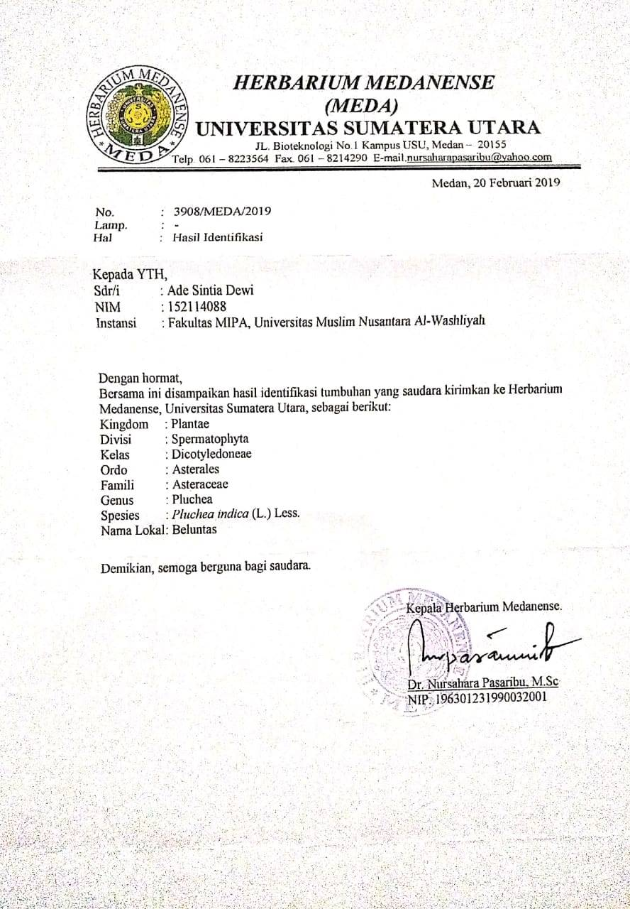

**Lampiran 2.**  Perhitungan Karakterisasi Simplisia Daun Beluntas

**1. Kadar air**

Kadar air = $\frac{\left(Volume akhir air-volume awal air\right)ml}{Bobot simplisia (g)}$ x 100%

|  |  |  |  |
| --- | --- | --- | --- |
| **Perlakuan** | **Volume awal (ml)** | **Volume akhir (ml)** | **Berat simplisia (g)** |
| I | 1,70 | 2,05 | 5,00 |
| II | 1,60 | 1,95 | 5,00 |
| III | 1,60 | 2,00 | 5,00 |

1. Kadar air = $\frac{2,05 ml-1,70 ml}{5}$ x 100% = 7%
2. Kadar air = $\frac{1,95ml-1,60 ml}{5}$ x 100% = 7%
3. Kadar air = $\frac{2,00 ml-1,60 ml}{5}$ x 100% = 8%

Rata-rata = $\frac{7\%+7\%+8\%}{3}$

= 7,33%

**2. Kadar sari larut dalam air**

Kadar sari larut dalam air = $\frac{Berat sari}{Berat simplisia}x\frac{100}{20}x 100\%$

|  |  |  |
| --- | --- | --- |
| **Perlakuan** | **Berat Sampel (g)** | **Berat sari (g)** |
| I | 5,09 | 0,21 |
| II | 5,07 | 0,19 |
| III | 5,04 | 0,21 |

1. Kadar sari larut air = $\frac{0,21}{5,09}x\frac{100}{20}x$ 100% = 20,62 %
2. Kadar sari larut air = $\frac{0,19}{5,07}x\frac{100}{20}x$ 100% = 18,73 %
3. Kadar sari larut air = $\frac{0,21}{5,04}x\frac{100}{20}x$ 100% = 20,83 %

Rata-rata =

= 20,06%

3. Kadar sari larut dalam etanol

Kadar sari larut dalam etanol = $\frac{Berat sari}{Berat simplisia}x\frac{100}{20}x100\%$

|  |  |  |
| --- | --- | --- |
| **Perlakuan** | **Berat Sampel (g)** | **Berat sari (g)** |
| I | 5,01 | 0,17 |
| II | 5,06 | 0,14 |
| III | 5,09 | 0,17 |

1. Kadar sari larut dalam etanol = $\frac{0,17}{5,01}x\frac{100}{20}x$ 100% = 16,96 %
2. Kadar sari larut dalam etanol = $\frac{0,14}{5,06}x\frac{100}{20}x$ 100% = 13,83 %
3. Kadar sari larut dalam etanol = $\frac{0,17}{5,09}x\frac{100}{20}x$ 100% = 16,69 %

Rata-rata =

= 15,82%

4. Kadar abu total

Kadar abu total = $\frac{Berat abu}{Berat simplisia}$ x 100%

|  |  |  |
| --- | --- | --- |
| **Perlakuan** | **Berat Sampel (g)** | **Berat abu (g)** |
| I | 2,0035 | 0,1272 |
| II | 2,0282 | 0,1397 |
| III | 2,0091 | 0,1412 |

1. Kadar abu total = $\frac{0,1272}{2,0035}$ x 100% = 6,3489 %
2. Kadar abu total = $\frac{0,1397}{2,0282}$ x 100% = 6,8879 %
3. Kadar abu total = $\frac{0,1412}{2,0091}$ x 100% = 7,0282 %

Rata-rata = = 6,7459 %

5. Kadar abu tidak larut dalam asam

Kadar abu tidak larut asam = $\frac{Berat abu}{Berat simplisia}$ x 100%

|  |  |  |
| --- | --- | --- |
| **Perlakuan** | **Berat Sampel (g)** | **Berat abu (g)** |
| I | 2,0041 | 0,0199 |
| II | 2,0051 | 0,0210 |
| III | 2,0011 | 0,0205 |

1. Kadar abu tidak larut dalam asam = $\frac{0,0199}{2,0041}$ x 100% = 0,99 %
2. Kadar abu tidak larut dalam asam = $\frac{0,0210}{2,0051}$ x 100% = 1,04 %
3. Kadar abu tidak larut dalam asam = $\frac{0,0205}{2,0011}$ x 100% = 1,02 %

Kadar abu tidak larut dalam asam rata-rata = $\frac{0,99\%+1,04\%+1,02\%}{3}$ = 1,017 %

**Lampiran 3**. Gambar Tumbuhan Beluntas

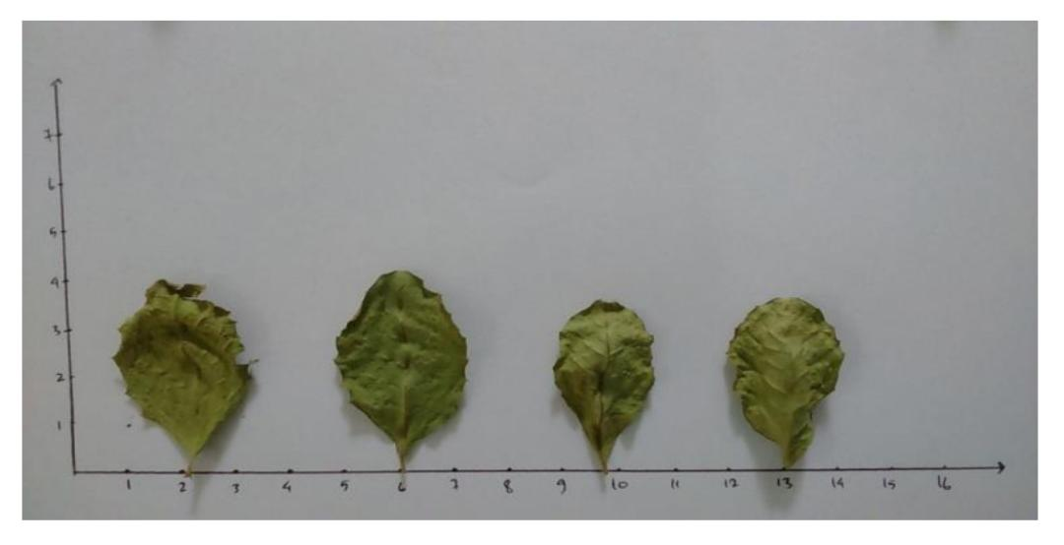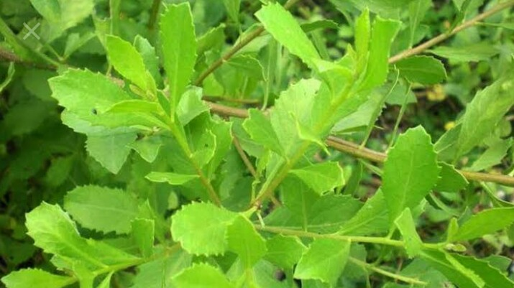

Gambar tumbuhan beluntas Gambar daun beluntas kering

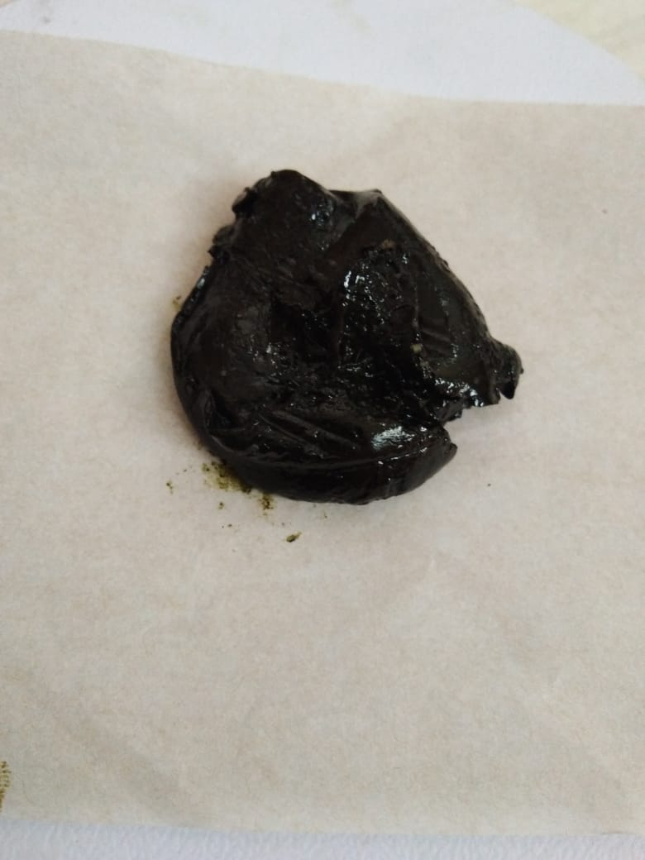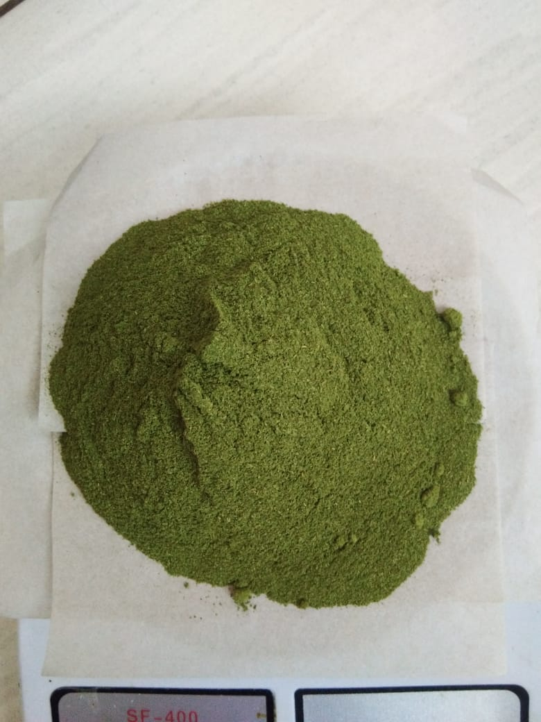

Gambar serbuk simplisia daun beluntas Gambar ekstrak etanol daun

beluntas

**Lampiran 4.** Bagan Alir skrining, karakterisasi dan pembuatan ekstrak

5 kg Daun Beluntas Segar

Dibersihkan

Ditimbang

Dikeringkan

Simplisia kering

Dihaluskan

Ditimbang

500 g serbuk simplisia

Pemeriksaan Maserasi

karakterisasi serbuk dengan etanol

1. Penetapan kadar air
2. Penetapan kadar sari larut dalam air
3. Penetapan kadar sari larut dalam etanol
4. Penetapan kadar abu total
5. Penetapan kadar abu yang tidak larut dalam asam
6. Penetapan kadar abu yang tidak larut dalam asam

Ampas

Maserat I

Diremaserasi

Maserat II

Ampas dibuang

Ditambahkan maserat II

Didestilasi dengan *Rotary evaporator*

Ekstrak kental

**Lampiran 5.** Hasil Identifikasi Jamur *Candida albicans*

Chlasmydospore

Blastpore

Pseudohypha

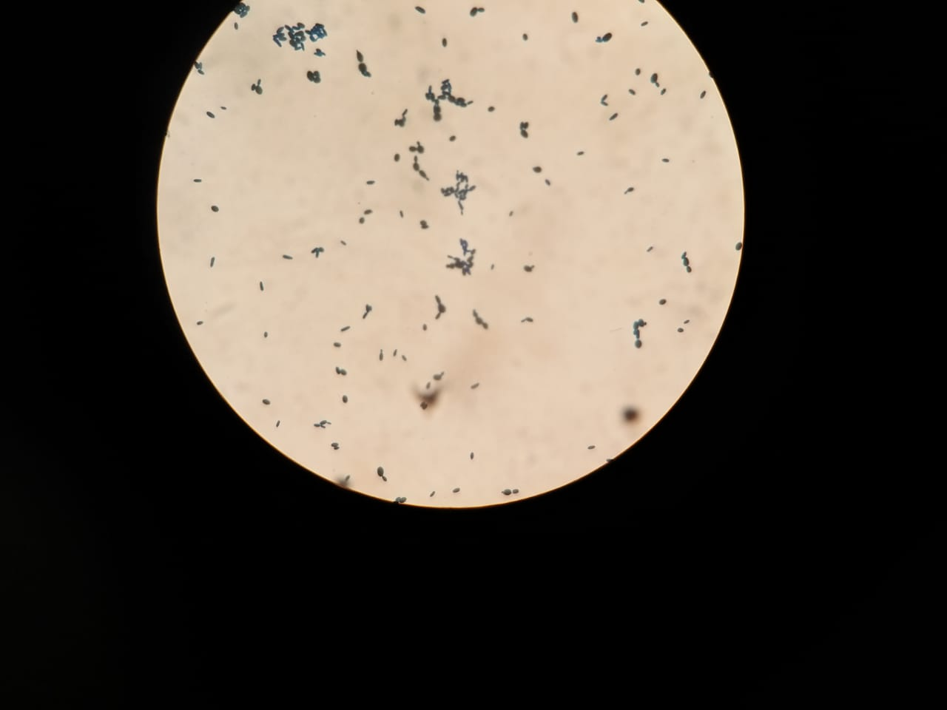

Identifikasi jamur *Candida albicans* dengan menggunakan KOH dan tinta parker kemudian dilihat menggunakan mikroskop dengan perbesaran 1000x (objectif 100x dan okular 10x)



Perbandingan hasil identifikasi jamur *Candida albicans* dengan pewarnaan KOH dan dilihat dengan menggunakan mikroskop.

**Lampiran 6.** Peremajaan Jamur *Candida Albicans*

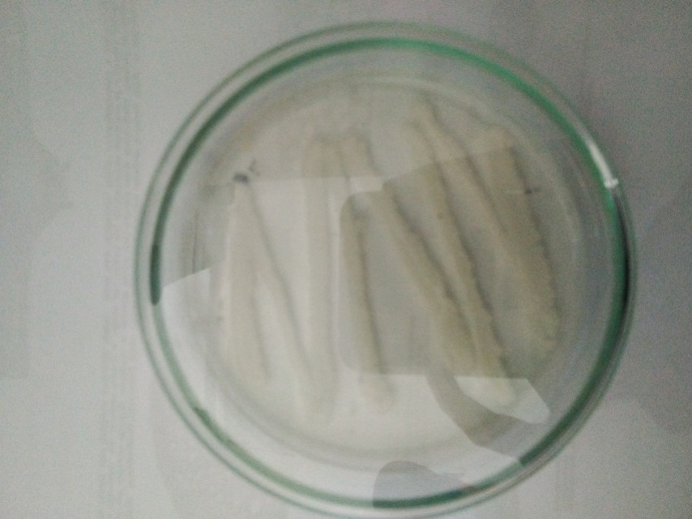

Hasil Peremajaan Jamur *Candida albicans*

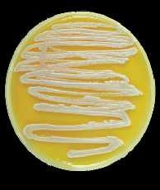

Gambar Pertumbuhan *C. Albicans* pada PDA berbentuk krim berwarna putih, licin disertai bau yang khas.

**Lampiran 7.** Bagan Alir Pengujian Aktivitas Jamur *Candida albicans*

Stok kultur jamur *Candida albicans*

Diambil dengan jarum ose steril

Ditanam pada media PDA miring

Diinkubasi pada suhu 35oC-37oC

Strain murni *Candida albicans*

Diambil dengan jarum ose steril

Disuspensikan dalam 10 ml NaCl 0,9 % steril

Dihomogenkan sampai kekeruhan yang sama dengan

suspensi standar Mc Farland

Suspensi jamur 108 CFU/ml

Dipipet 0,1 ml ke dalam tabung reaksi steril

Ditambah 9,9 ml NaCl 0,9 % steril dan dihomogenkan

Suspensi jamur 106 CFU/ml

Dipipet 0,1 ml ke dalam cawan petri steril

Dituang 20 ml PDA steril cair (45-50oC), dibiarkan memadat

Dibuat lubang dengan *punch hole* pada permukaan media, diteteskan 0,1 ml larutan ekstrak etanol daun beluntas Pra-inkubasi selama 15 menit

Diinkubasi pada suhu 37oC selama 24 jam

Hasil inkubasi

Diukur diameter daerah hambat dengan jangka sorong

Diameter hambat

**Lampiran 8.** Hasil uji aktivitas antijamur sediaan gel cair EEDB terhadap jamur

*Candida albicans*

C

+



B

E

A

D

Keterangan :

A : Blanko

B : Gel EEDB 5%

C : Gel EEDB 10%

D : Gel EEDB 15%

E : Gel EEDB 20%

(*+*) : Kontrol Positif (Resik V)

**Lampiran 9.** Perhitungan Rentang Kesukaan

|  |  |  |  |  |
| --- | --- | --- | --- | --- |
| Panelis | Hasil Uji Kesukaan Bentuk sediaanPada Sukarelawan | | | |
| Kode | Nilai kesukaan (X) | (Xi - ) | (Xi - )2 |
| 1 | SS | 0,0100 | 0,0100 | 0,0100 |
| 2 | S | 0,0100 | 0,0100 | 0,0100 |
| 3 | SS | 0,0100 | 0,0100 | 0,0100 |
| 4 | SS | 0,0100 | 0,0100 | 0,0100 |
| 5 | SS | 0,0100 | 0,0100 | 0,0100 |
| 6 | SS | 0,0100 | 0,0100 | 0,0100 |
| 7 | SS | 0,0100 | 0,0100 | 0,0100 |
| 8 | SS | 0,0100 | 0,0100 | 0,0100 |
| 9 | SS | 0,0100 | 0,0100 | 0,0100 |
| 10 | SS | 0,0100 | 0,0100 | 0,0100 |
| 11 | S | 0,0100 | 0,0100 | 0,0100 |
| 12 | SS | 0,0100 | 0,0100 | 0,0100 |
| 13 | SS | 0,0100 | 0,0100 | 0,0100 |
| 14 | SS | 0,0100 | 0,0100 | 0,0100 |
| 15 | SS | 0,0100 | 0,0100 | 0,0100 |
| 16 | SS | 0,0100 | 0,0100 | 0,0100 |
| 17 | SS | 0,0100 | 0,0100 | 0,0100 |
| 18 | SS | 0,0100 | 0,0100 | 0,0100 |
| 19 | SS | 0,0100 | 0,0100 | 0,0100 |
| 20 | SS | 0,0100 | 0,0100 | 0,0100 |
| Nilai kesukaan rata-rata () = 4,9000 | | | Nilai total (Xi - )2 = 0,0100 | |

Standar deviasi (SD) =



Standar deviasi (SD)== = 0,0229  
Rentang nilai kesukaan warna dari sediaan basis gel *vaginal douth*



= Nilai rata-rata (-0,0229 µ Nilai rata-rata (+0,0229



= 4,9000-0,6407 µ 4,9000+ 0,0229



= 1,4593 µ 2,7407



Dengan cara yang sama dihitung untuk formula lainnya dan untuk kriteria lainnya yaitu Data selengkapnya dapat dilihat pada Lampiran 11, 12, dan 13.

**Lampiran 10.** Data dan Perhitungan Rentang Kesukaan Bentuk Sediaan Secara Organoleptis Terhadap Berbagai Formula Sediaan Gel

Perhitungan rentang kesukaan bentuk sediaan dari berbagai formula

|  |  |  |  |  |  |  |  |  |
| --- | --- | --- | --- | --- | --- | --- | --- | --- |
| Panelis | Hasil uji kesukaan bentuk sediaan dari berbagai formula  sediaan gel | | | | | | | |
| Formula Gel cair EEDB 5% | | Formula Gel cair EEDB 10% | | Formula Gel cair EEDB 15% | | Formula Gel cair EEDB 20% | |
|  | kode | nilai | kode | nilai | kode | nilai | kode | Nilai |
| 1 | SS | 5 | SS | 5 | SS | 5 | SS | 5 |
| 2 | S | 4 | SS | 5 | SS | 5 | SS | 5 |
| 3 | SS | 5 | SS | 5 | SS | 5 | SS | 5 |
| 4 | SS | 5 | SS | 5 | SS | 5 | SS | 5 |
| 5 | SS | 5 | SS | 5 | SS | 5 | SS | 5 |
| 6 | SS | 5 | SS | 5 | SS | 5 | SS | 5 |
| 7 | SS | 5 | S | 4 | SS | 5 | S | 4 |
| 8 | SS | 5 | SS | 5 | SS | 5 | SS | 5 |
| 9 | SS | 5 | SS | 5 | SS | 5 | SS | 5 |
| 10 | SS | 5 | SS | 5 | SS | 5 | SS | 5 |
| 11 | S | 4 | SS | 5 | S | 4 | S | 4 |
| 12 | SS | 5 | SS | 5 | SS | 5 | SS | 5 |
| 13 | SS | 5 | SS | 5 | SS | 5 | SS | 5 |
| 14 | SS | 5 | S | 4 | SS | 5 | SS | 5 |
| 15 | SS | 5 | SS | 5 | SS | 5 | SS | 5 |
| 16 | SS | 5 | SS | 5 | SS | 5 | SS | 5 |
| 17 | SS | 5 | SS | 5 | S | 4 | SS | 5 |
| 18 | SS | 5 | SS | 5 | SS | 5 | SS | 5 |
| 19 | SS | 5 | SS | 5 | SS | 5 | SS | 5 |
| 20 | SS | 5 | SS | 5 | SS | 5 | SS | 5 |

|  |  |  |  |  |
| --- | --- | --- | --- | --- |
|  | Formula Gel cair EEDB 5% | Formula Gel cair EEDB 10% | Formula Gel cair EEDB 15% | Formula Gel cair EEDB 20% |
| Rata-rata nilai kesukaaan = | 4,9000 | 4,8000 | 4,8500 | 4,8000 |
| Standar deviasi = | 0,24523 | 0,32831 | 0,29308 | 0,2052 |
| Rentang nilai kesukaan = | 4,6388 sampai 5,1462 | 4,4717 sanpai 5,1283 | 4,5569 sanpai 5,1431 | 4,5948 sanpai 5,0052 |
| Kriteria | Sangat suka | Sangat suka | Sangat suka | Sangat suka |

**Lampiran 11.** Data dan Perhitungan Rentang Kesukaan WarnaSecara Organoleptis Terhadap Berbagai Formula Sediaan Gel

Perhitungan rentang kesukaan warna dari berbagai formula

|  |  |  |  |  |  |  |  |  |
| --- | --- | --- | --- | --- | --- | --- | --- | --- |
| Panelis | Hasil uji kesukaan warna dari berbagai formula  sediaan gel | | | | | | | |
| Formula Gel cair EEDB 5% | | Formula Gel cair EEDB 10% | | Formula Gel cair EEDB 15% | | Formula Gel cair EEDB 20% | |
|  | kode | nilai | kode | Nilai | kode | nilai | kode | Nilai |
| 1 | S | 4 | SS | 5 | S | 4 | TS | 2 |
| 2 | S | 4 | SS | 5 | S | 4 | KS | 3 |
| 3 | S | 4 | SS | 5 | S | 4 | KS | 3 |
| 4 | SS | 5 | SS | 5 | SS | 5 | KS | 3 |
| 5 | SS | 5 | SS | 5 | SS | 5 | TS | 2 |
| 6 | S | 4 | SS | 5 | S | 4 | TS | 2 |
| 7 | S | 4 | S | 4 | S | 4 | TS | 2 |
| 8 | S | 4 | SS | 5 | S | 4 | TS | 2 |
| 9 | SS | 5 | SS | 5 | SS | 5 | KS | 3 |
| 10 | SS | 5 | SS | 5 | SS | 5 | TS | 2 |
| 11 | SS | 5 | SS | 5 | SS | 5 | KS | 3 |
| 12 | SS | 5 | SS | 5 | SS | 5 | TS | 2 |
| 13 | SS | 5 | SS | 5 | SS | 5 | KS | 3 |
| 14 | SS | 5 | S | 4 | SS | 5 | TS | 2 |
| 15 | S | 4 | SS | 5 | S | 4 | TS | 2 |
| 16 | S | 4 | SS | 5 | S | 4 | TS | 2 |
| 17 | SS | 5 | SS | 5 | SS | 5 | TS | 2 |
| 18 | S | 4 | SS | 5 | S | 4 | KS | 3 |
| 19 | SS | 5 | SS | 5 | SS | 5 | KS | 3 |
| 20 | SS | 5 | SS | 5 | SS | 5 | KS | 3 |

|  |  |  |  |  |
| --- | --- | --- | --- | --- |
|  | Formula Gel cair EEDB 5% | Formula Gel cair EEDB 10% | Formula Gel cair EEDB 15% | Formula Gel cair EEDB 20% |
| Rata-rata nilai kesukaaan = | 4,5000 | 4,8500 | 4,5800 | 1,1540 |
| Standar deviasi = | 0,4103 | 0,2930 | 0,1846 | 0,2564 |
| Rentang nilai kesukaan = | 4,0896 sampai 4,9104 | 4,5569 sanpai 5,1431 | 4,0896sampai 4,9104 | 0,0432 sampai 1,9396 |
| Kriteria | Suka | Sangat suka | Suka | Tidak Suka |

**Lampiran 12.** Data dan Perhitungan Rentang Kesukaan BauSecara Organoleptis Terhadap Berbagai Formula Sediaan Gel

Perhitungan rentang kesukaan bau dari berbagai formula

|  |  |  |  |  |  |  |  |  |
| --- | --- | --- | --- | --- | --- | --- | --- | --- |
| Panelis | Hasil uji kesukaan bentuk sediaan dari berbagai formula  sediaan gel | | | | | | | |
| Formula Gel cair EEDB 5% | | Formula Gel cair EEDB 10% | | Formula Gel cair EEDB 15% | | Formula Gel cair EEDB 20% | |
|  | kode | Nilai | kode | nilai | kode | nilai | kode | Nilai |
| 1 | S | 4 | S | 4 | S | 4 | S | 4 |
| 2 | S | 4 | SS | 5 | SS | 5 | S | 4 |
| 3 | S | 4 | SS | 5 | SS | 5 | S | 4 |
| 4 | SS | 5 | SS | 5 | SS | 5 | SS | 5 |
| 5 | SS | 5 | SS | 5 | SS | 5 | SS | 5 |
| 6 | S | 4 | SS | 5 | SS | 5 | S | 4 |
| 7 | S | 4 | SS | 5 | SS | 5 | S | 4 |
| 8 | S | 4 | SS | 5 | SS | 5 | S | 4 |
| 9 | SS | 5 | SS | 5 | SS | 5 | SS | 5 |
| 10 | SS | 5 | SS | 5 | SS | 5 | SS | 5 |
| 11 | SS | 5 | S | 4 | S | 4 | SS | 5 |
| 12 | SS | 5 | SS | 5 | SS | 5 | SS | 5 |
| 13 | SS | 5 | SS | 5 | SS | 5 | SS | 5 |
| 14 | SS | 5 | SS | 5 | SS | 5 | SS | 5 |
| 15 | S | 4 | SS | 5 | SS | 5 | S | 4 |
| 16 | S | 4 | SS | 5 | SS | 5 | S | 4 |
| 17 | SS | 5 | SS | 5 | SS | 5 | SS | 5 |
| 18 | S | 4 | SS | 5 | SS | 5 | S | 4 |
| 19 | SS | 5 | SS | 5 | SS | 5 | SS | 5 |
| 20 | SS | 5 | SS | 5 | SS | 5 | SS | 5 |

|  |  |  |  |  |
| --- | --- | --- | --- | --- |
|  | Formula Gel cair EEDB 5% | Formula Gel cair EEDB 10% | Formula Gel cair EEDB 15% | Formula Gel cair EEDB 20% |
| Rata-rata nilai kesukaaan = | 4,5000 | 4,8500 | 4,9000 | 4,5000 |
| Standar deviasi = | 0,4103 | 0,2564 | 0,1846 | 0,2564 |
| Rentang nilai kesukaan = | 4,0896 sampai 4,9104 | 4,5936 sampai 5,1064 | 4,7153 sampai 5,0847 | 4,2435 sampai 4,7565 |
| Kriteria | Suka | Sangat suka | Sangat suka | Suka |

**Lampiran 13.** Hasil Uji Statistika Anova One Way Post Hoc Duncan

|  |  |  |  |  |  |
| --- | --- | --- | --- | --- | --- |
| Zonahambat | | | | | |
|  | N | Mean | Std. Deviation | Std. Error | 95% Confidence Interval for Mean |
| Lower Bound |
| Kontrol positif (Resik V ) | 3 | 19,8667 | ,80829 | ,46667 | 17,8588 |
| Konsentrasi 20% | 3 | 18,3333 | ,76376 | ,44096 | 16,4360 |
| Konsentrasi 15% | 3 | 15,6667 | 1,52753 | ,88192 | 11,8721 |
| Konsentrasi 10% | 3 | 13,0667 | 1,36137 | ,78599 | 9,6848 |
| Konsentrasi 5% | 3 | 9,4000 | 1,01489 | ,58595 | 6,8789 |
| Total | 15 | 15,2667 | 3,98975 | 1,03015 | 13,0572 |

|  |  |  |  |  |  |  |  |  |  |  |  |  |  |  |  |  |  |  |
| --- | --- | --- | --- | --- | --- | --- | --- | --- | --- | --- | --- | --- | --- | --- | --- | --- | --- | --- |
| **Test of Homogeneity of Variances**   |  |  |  |  | | --- | --- | --- | --- | | Zonahambat | | | | | Levene Statistic | df1 | df2 | Sig. | | ,771 | 4 | 10 | ,568 | | | | | | | |
| **ANOVA** | | | | | | | | | | | | | |
| Zonahambat | | | | | | | | | | | | |
|  | Sum of Squares | | df | | Mean Square | | | | F | | Sig. | |
| Between Groups | 209,947 | | 4 | | 52,487 | | | | 40,666 | | ,000 | |
| Within Groups | 12,907 | | 10 | | 1,291 | | | |  | |  | |
| Total | 222,853 | | 14 | |  | | | |  | |  | |
| **Zonahambat** | | | | | | | | | | | |
| Duncan | | | | | | | | | | | |
| Formula | | N | | Subset for alpha = 0.05 | | | | | | | |
| 1 | | 2 | | 3 | | 4 | |
| Konsentrasi 5% | | 3 | | 9,4000 | |  | |  | |  | |
| Konsentrasi 10% | | 3 | |  | | 13,0667 | |  | |  | |
| Konsentrasi 15% | | 3 | |  | |  | | 15,6667 | |  | |
| Konsentrasi 20% | | 3 | |  | |  | |  | | 18,3333 | |
| Kontrol positif (Resik V ) | | 3 | |  | |  | |  | | 19,8667 | |
| Sig. | |  | | 1,000 | | 1,000 | | 1,000 | | ,129 | |

**Means Plots**

