ACKNOWLEDGEMENT
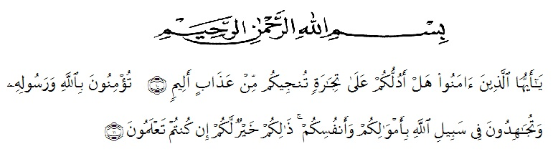

Artinya :
“Hai orang-orang yang beriman, sukakah kamu aku tunjukkan suatu perniagaan yang dapat menyelamatkanmu dari azab yang pedih? (10). (yaitu) kamu beriman kepada Allah dan Rasul-Nya dan berjihad di jalan Allah dengan harta dan jiwamu. Itulah yang lebih baik bagimu, jika kamu mengetahui (1). (As-Shaff ayat 10-11).

Firstly, the writer gives her highest gratitude to Allah SWT for the great mercy, blessing, safety, health and love as well as the most important things is opportunity to complete this thesis with the title “The Use of Audio-Visual Method on the Students’ Speaking Ability” as the fulfillment of the requirements to get degree of English Language Education Study Program in University of Muslim Nusantara Al Washliyah Medan.
Shalawat and Salam to our beloved Prophet Muhammad SAW, the greatest man ever who teaches us the kindness and good life in order to we can be a good Muslim in front of Allah SWT. We hope his salutation in the future day.
In the process of finishing this thesis, the writer has been given many supports and valuable knowledge from many people. Therefore, the researcher would like to express her great appreciation and thanks to:
- Rector of UMN Al Washliyah, Dr. KRT. Hardi Mulyono K. Surbakti who has given the facility during study in this University.
- The Dean of FKIP UMN Al Washliyah, Drs. Samsul Bahri, M.Si, for the counseling and guidance during study in this University.
- The Head of English Department, for giving her much knowledge, suggestion, support, advice, help and encouragement in teaching and educating us in English Department till finish the research.
- Dr. Salamuddin Selian, M.Hum, the first adviser who has given his time, knowledge, suggestion, guidance, comments and correction in completing this thesis.
- Rini Fadhillah Putri, S.Pd., M,Hum, the second adviser who teach her so much support, advice, knowledge, guidance, comments and correction since preliminary of manuscript until completing this thesis.
- The English lecturers of UMN Al Washliyah who teach her much knowledge.
- The Head Master and English teacher of MAS Al Washliyah 21 Firdaus and also the students who has given her an opportunity to conduct a research in the school.
- Special Gratitude for her beloved Father (Asmalik Yus) and Mother (Sri Rezeki), who have given love, support, best pray and everything for her life until she can finish her study from University.
- For her beloved sister (Rizky Asthia, S.Pd and Annisa Akmal) who has given her supports, love and inspires her to work and never give up in finishing this research.
- For her lovely friends (English Department Students of VIII A) who give her advice, help and always there in happiness and sadness. Thanks for this great four years to study and make good friendship with her.
- For her best friends, Tahta Nur Fauziah, Yolandri Lestari, Dwi Rizky Aulia, Nadira Shavifa Aziz, Melinda, Annisa Mariani Rambe, Frisca Ridanti, Asri Fadhilah and Rizky Evionita Putri. Thanks for always besides her to supports her.
- All people who have given her advice, help, guidance, comments, and suggestion. She hopes Allah SWT will reply your kindness to her.

Hopefully, this thesis gives many benefits for the reader and the writer.

Medan, Juli 2020
The writer,

Cindy Asmalia,
NPM. 161244048

