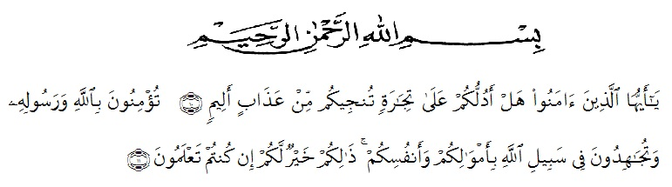**ACKNOWLEDGEMENTS**

Artinya: “Hai, orang-orang yang beriman, sukakah kamu aku tunjukan suatu perniagaan yang dapat menyelamatkanmu dari azab yang pedih? (10) yaitu kamu yang beriman kepada allah dan rasulnya dan berjihad di jalan allah dengan harta dan jiwamu. Itulah yang lebih baik bagimu, jika kamu mengetahui. (11) (As-shaff ayat 10-11).

The writer whises to express her great thank to Allah Swt. The most Gracious and the most merciful. The writer also wants to presents sholawat and salam to the prophet Muhammad SAW. Hopefully the writer will get intercession from him in hereafter later.

In Completing this research, the writer got suggestions, critisms, and guidance from some people. Therefore, the writer would like to expreshim thanks to:

1. Dr. KRT. Hardi Mulyono K. Surbakti. as the Rector of UMN Al Washliyah.
2. Drs. Mhd. Ayyub Lubis, M.Pd, Ph. D., as the Dean of FKIP UMN Al Washliyah.
3. Dra. Hj. Nurjannah, M.Si. as the Head of English Education Department FKIP University of Muslim Nusantara Al Washliyah Medan.
4. Junaidi, S.S., S.Pd., M.Si. as the first consultant, who has painstakingly spent his valuable time to helpful and wisely in advising and encouraging for this skripsi.
5. Vera Kristina, S.Pd., M.Pd. as the second consultant, who has never stopped helping the writer in guiding and correcting the pattern of this skripsi.
6. All of lectures in English Department Teacher Training and Education Faculty of Universitas Muslim Nusantara Al Washliyah Medan for knowledge had given to the within four years’.
7. All the administrative Staff Universitas of Muslim Nusantara Al Washliyah Medan.
8. All of libraries Pemko Medan, Universitas Muslim Nusantara Al Washliyah Medan.
9. Thank you her parents abah amma thank you very so muchfor your supportbecause thanks to you she up to the present level.
10. Thank you to she sist yuli octaviani and my brother rifky thank you so much for helping us a lot and taking the time for she help complete this task.
11. And thank you for her friends who are always loyal to accompany she della gray saleri and risma efrina siregar thank you so much guys .
12. Thank you also for she is friends Novi and Laila, we are just close, but thanks to your sisters, you are very kind, help a lot, she say thank you, Novi Laila, you are the best friends of all .

Finally, the researcher realizes that this her research is still far from being perfect, but she hopes that this research will be useful for the readers. May Allah Swt bless all of us. Aamin ya Rabbal ‘Alamin.

Medan, 01 Juli 2020

The Research

Indah Inayah 161244019