# ACKNOWLEDGEMENT

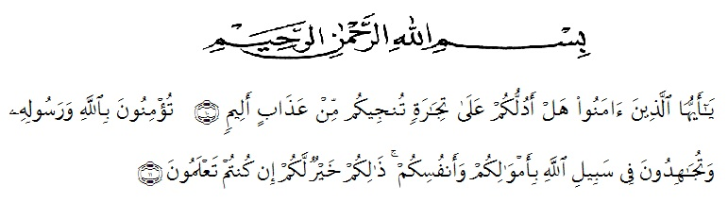

Artinya: “Hai orang-orang yang beriman, sukakah kamu aku tunjukkan suatu perniagaan yang dapat menyelamatkanmu dari azab yang pedih? (10). (yaitu) kamu beriman kepada Allah dan Rasulnya dan berjihad dijalan Allah dengan harta dan jiwamu, itulah yang lebih baik bagimu, jika kamu mengetahui (11), (As-Shaff ayat 10-11).

Alhamdulillahirabil’alamin, the researcher expresses her highest to Allah SWT for blessing, opportunity, love, health and mercy to complete the research. In arranging this research, a lot of people have provided motivation, advice, and support for the researcher. In this valuable chance, the researcher intended to express her gratitude and appreciation to all of them.

1. Dr. KRT. Hardi Mulyono K. Surbakti as the the Rector of Universety Muslim Nusantara Alwasliyah Medan.
2. Drs. Samsul Bahri, M.Pd as the dekan of FKIP UMN Alwashliyah Medan
3. Junaidi, S.S., S.Pd., M.hum as the head of English Department of UMN Alwasliyah.
4. My beloved parents, sister, brother, and all family who have supported the researcher to finish the research on time.
5. Rini Fadhillah PutriS.Pd., M. Hum as the first consultant who gave the researcher supervision, advice, and guidance from the very early stage of this research as well as giving me extraordinary experiences throughout the past few years.
6. Zulfitri, S.S., M.A as the second consultant who helped the researcher patiently finishing the research by giving suggestion, guidance, and correction until the completion.
7. My friend college students of class 8B English department in academic 2019/2020 who always give the researcher a lot of motivation, suggestion and advice.
8. The entire staff at the university who have provided assistance, guidance, and knowledge to the researcher.
9. All parts who could not be mentioned one by one by the researcher that has involved a lot of help so that this thesis could be completed.

This research is far from perfect, but it is expected that it will be useful not only for the researcher but also for the readers. For this reason, constructive thoughtful suggestion and critics are welcomed.

Tanjung Morawa, June 23rd,2020

Tirtaningrum