**ACKNOWLEDGEMENT**

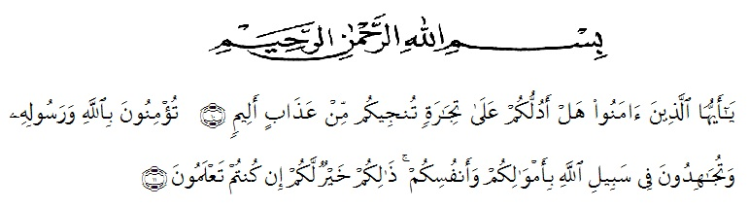

Artinya: “Hai orang-orang yang beriman, sukakahkamuakutunjukkansuatuperniagaan yang dapatmenyelamatkanmudariazab yang pedih? (10). (yaitu) kamuberimankepada Allah danRasulnyadanberjihaddijalan Allah denganhartadanjiwamu, itulah yang lebihbaikbagimu, jikakamumengetahui (11), (As-Shaffayat 10-11).

First of all, the writer says thank you to Allah for giving the writer a lot of things in life. Because of his guidance, the writer can be able to finish this thesis. The writer cannot also finish it without other people’s help. Therefore, in this opportunity the writer would like to express her deep gratitude to the following people:

1. Dr. KRT. HardiMulyono K. Surbakti as the the Rector of Universety Muslim Nusantara Alwasliyah Medan.
2. Drs. SamsulBahri, M.Pd as the dekan of FKIP UMN AlwashliyahMedan
3. Dra. H. Nurjannah, M.Sias the head of English Department of UMN Alwasliyah.
4. My beloved parents, brother, and all family who have supported the researcher to finish the research on time.
5. RiniFadhillahPutriS.Pd.,M.Hum as the first consultant who has given her time during the process of completing the research.
6. Vera Kristina, S.Pd., M.Pd as the second consultant who been patient to guide the writer so that the thesis of the researchers becomes better.
7. My friend college students of class 8B English department in academic year 2019/2020 who always give the writer a lot of suggestion and advice.
8. The entire staff at the university who have provided assistance, guidance, and knowledge to the writer.
9. All parts who could not be mentioned one by one by the writer that has involved a lot of help so that this research could be completed.

By writing this thesis, the writer realizes that this thesis has not perfect. Therefore, the suggestion and critical from the reader is really needed to make this thesis be better. The writer also hopes that the thesis will be useful for everybody who reads it.

Lubuk Pakam, June 6th,2020

Nur Sahara Siregar