THE USE OF MNEMONIC METHOD ON TEACHING
SPEAKING SKILL OF STUDENTS’
AT SMP SWASTA TAMORA 2
TANJUNG MORAWA

Thesis

By:

Frisca Ridanti
NPM 161244027

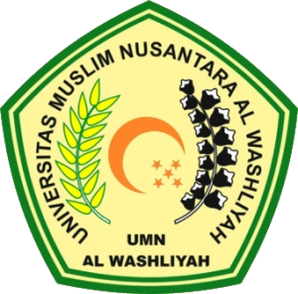

FACULTY OF TEACHER TRAINING AND EDUCATION
UNIVERSTAS MUSLIM NUSANTARA AL WASHLIYAH
MEDAN
2020

THE USE OF MNEMONIC METHOD ON TEACHING
SPEAKING SKILL OF STUDENTS’
AT SMP SWASTA TAMORA 2
TANJUNG MORAWA

A Thesis
Submited to the Departement of English
Language Education In Partial Fulfilment
of the Requirments for the Degree
of Bachelor of Education
By:

Frisca Ridanti
NPM 161244027

FACULTY OF TEACHER TRAINING AND EDUCATION
UNIVERSTAS MUSLIM NUSANTARA AL WASHLIYAH
MEDAN
2020

