APPENDIX A
Question Of Interview with Teacher and Students

Question of interview for the teacher :

- What the method is used most often when learning english, specially speaking?

- What are teacher efforts in processing the material of speaking English for student?

- why the teacher choose mnemonic method to teach speaking english?

Question of interview for the students :
- what do you think about the method is used by the teacher when teaching speaking?

- What do you think about the teacher efforts to to process the material of speaking English for students?

- In your opinion the method used by the teacher are easy to understood?

APPENDIX B
Question Of Questionnaire By The Teacher

Research Questionnaire
selected the choice of each question by putting a chek mark!
(pilihlah pilihan dari setiap pertanyaan dengan membubuhkan tanda centang!)
keterangan:
-strongly agree(sangat setuju)
-agree(setuju)
-undecided(ragu-ragu)
-disagre(tidak setuju)
-strongly disagree(sangat tidak setuju)

- Mnemonic is the easiest method of remembering (mnemonik adalah metode mengingat paling mudah)
- Strongly agree
- Agree
- Undecided
- Disagree
- Strongly disagree
- Mnemonic method is particularly suitable for using teach speaking English(metode mnemonik sangat cocok digunakan untuk mengajarkan berbicara bahasa ingris)
- Strongly agree
- Agree
- Undecided
- Disagreed
- Strongly disagree
- Mnemonic method help teacher to make teaching easier (metode mnemonik membantu guru dalam mempermudah pelajaran)
- Strongly agree
- Agree
- Undecided
- Disagreed
- Strongly disagree
- The type of mnemonic method is very variative (tipe dalam metode mnemonic sangat bervariasi)
- Strongly agree
- Agree
- Undecided
- Disagreed
- Strongly disagree
- The acronym type is not suitable for speaking lesson (tipe akronim kurang cocok digunakan untuk pelajaran berbicara)
- Strongly agree
- Agree
- Undecided
- Disagreed
- Strongly disagree
- Keyword type is better used for speaking (tipe kata kunci lebih cocok digunakan untuk pelajaran berbicara)
- Strongly agree
- Agree
- Undecided
- Disagreed
- Strongly disagree
- Students learn to memorize by mnemonic method more quickly (siswa belajar menghafal lebih cepat dengan metode mnemonic)
- Strongly agree
- Agree
- Undecided
- Disagreed
- Strongly disagree
- The mnemonic method is particularly helpful in honing students speaking skill (metode mnemonik sangat membantu mengasah kemampuan berbicara siswa)
- Strongly agree
- Agree
- Undecided
- Disagreed
- Strongly disagree
- Mnemonic method is a usable method for all lesson ( metode mnemonik termasuk metode yang dapat diigunakan untuk semua pelajaran)
- Strongly agree
- Agree
- Undecided
- Disagreed
- Strongly disagree
- Students become bolder and more confident when speaking English (siswa menjadi lebih berani dan percaya diri saat berbicara bahasa inggris)
- Strongly agree
- Agree
- Undecided
- Disagreed
- Strongly disagree
- Students are more active when learning speaking uses mnemonic method (siswa lebih aktif saat belajar menggunakan metode mnemonik)
- Strongly agree
- Agree
- Undecided
- Disagreed
- Strongly disagree
- Mnemonic method more interisting used for learning (metode mnemonik lebih menarik digunakan untuk belajar)
- Strongly agree
- Agree
- Undecided
- Disagreed
- Strongly disagree
- Mnemonic method helps me to convey the material easily (metode mnemonik membantu saya mengajarkan materi dengan cara lebih mudah)
- Strongly agree
- Agree
- Undecided
- Disagreed
- Strongly disagree
- The atmosphere that emerges become more active and interisting (suasana yang muncul menjadi lebih aktif dan menarik)
- Strongly agree
- Agree
- Undecided
- Disagreed
- Strongly disagree
- The students easily gave off his speaking skill (siswa menjadi mudah mengeluarkan kemapuan berbicaranya)
- Strongly agree
- Agree
- Undecided
- Disagreed
- Strongly disagree
16. I understand how to apply mnemonic method to teach speaking english (saya mengerti bagaimana cara menggunakan metode mnemonic dalam mengajar berbicara bahasa inggris)
- Strongly agree
- Agree
- Undecided
- Disagreed
- Strongly disagree

APPENDIX C
Result Of Teacher and Students Interview

Result of teacher interview :

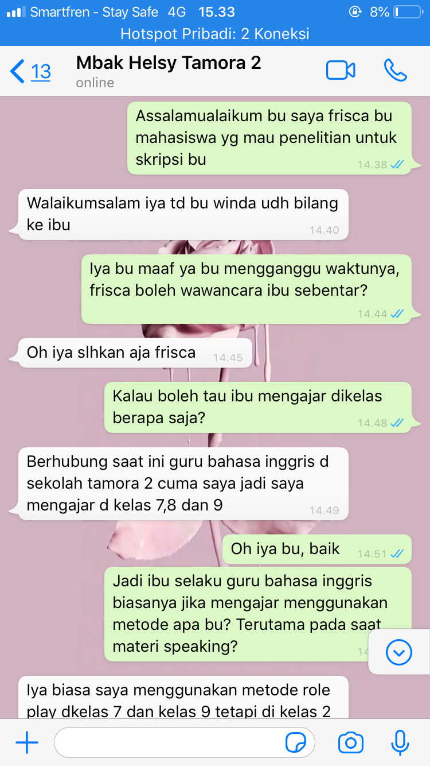

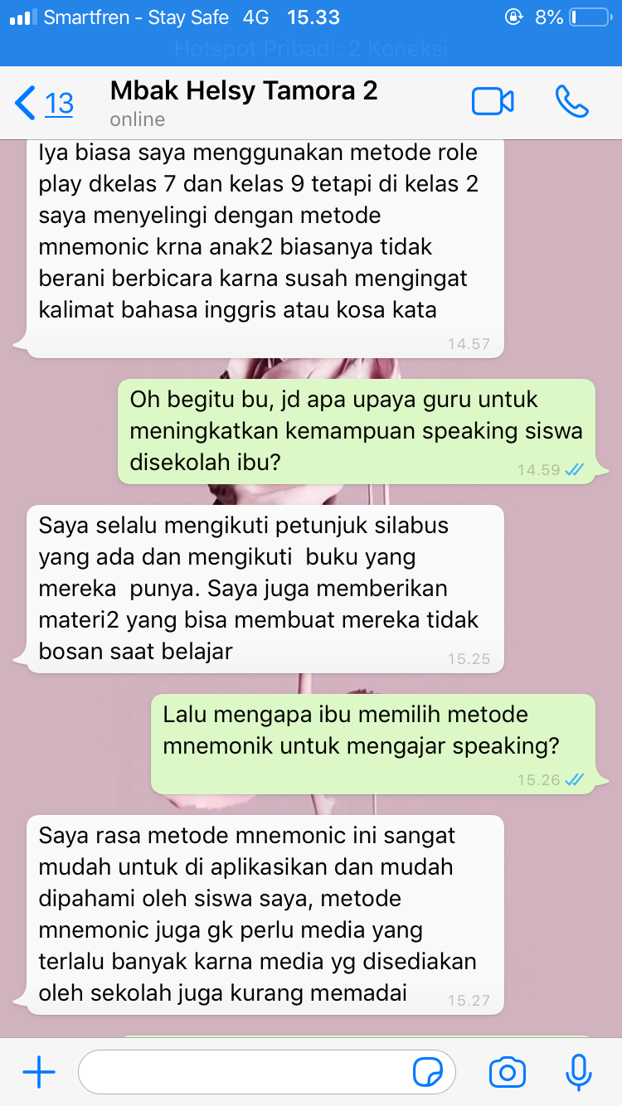
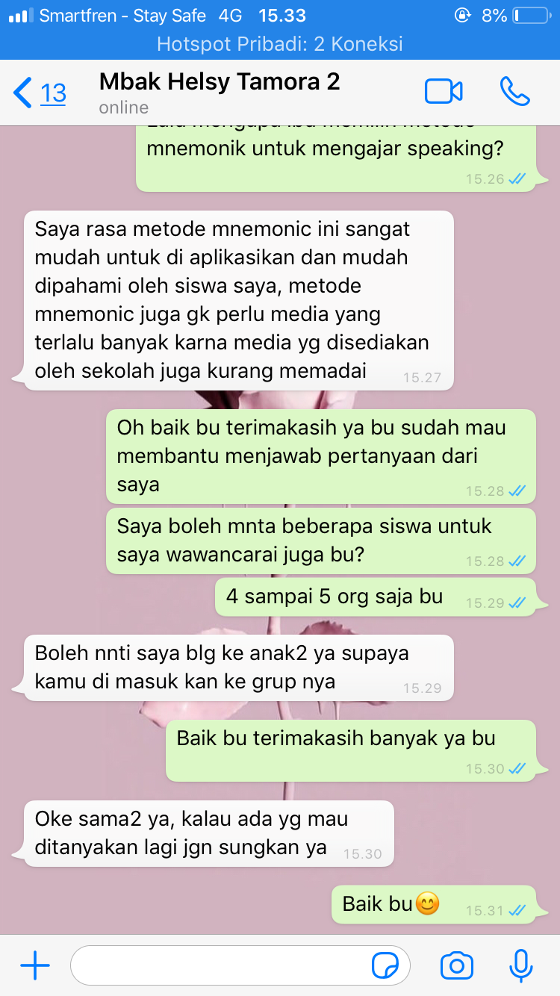
Result of students interview :

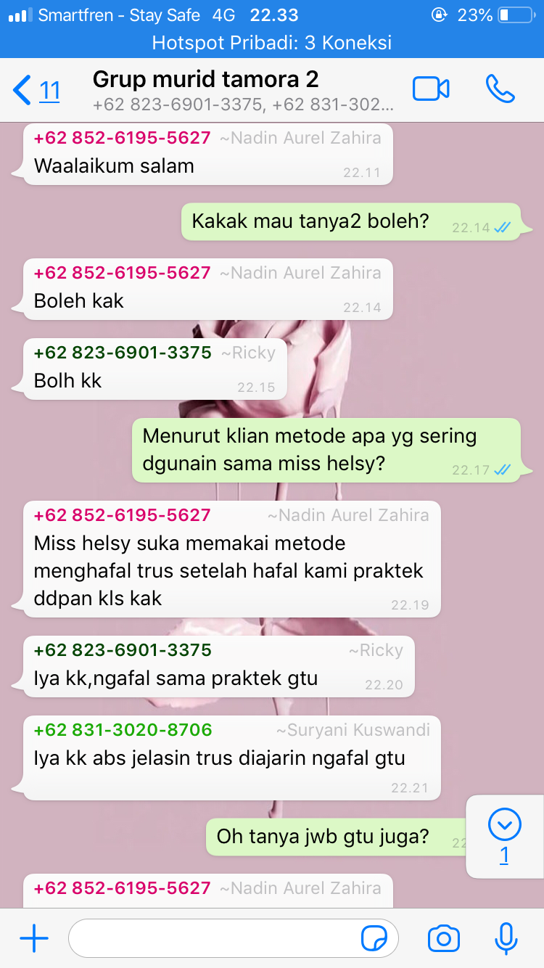

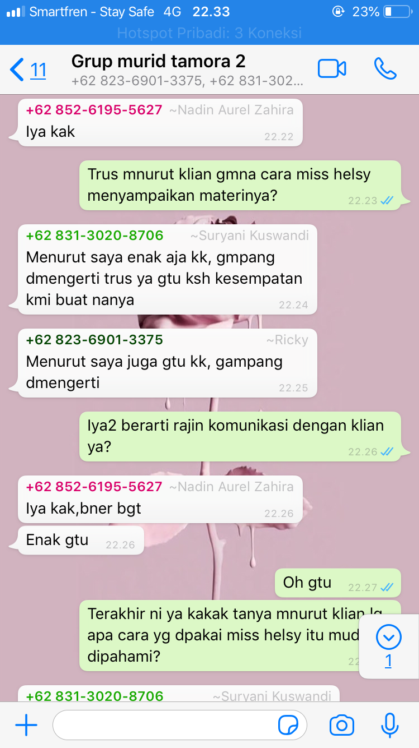
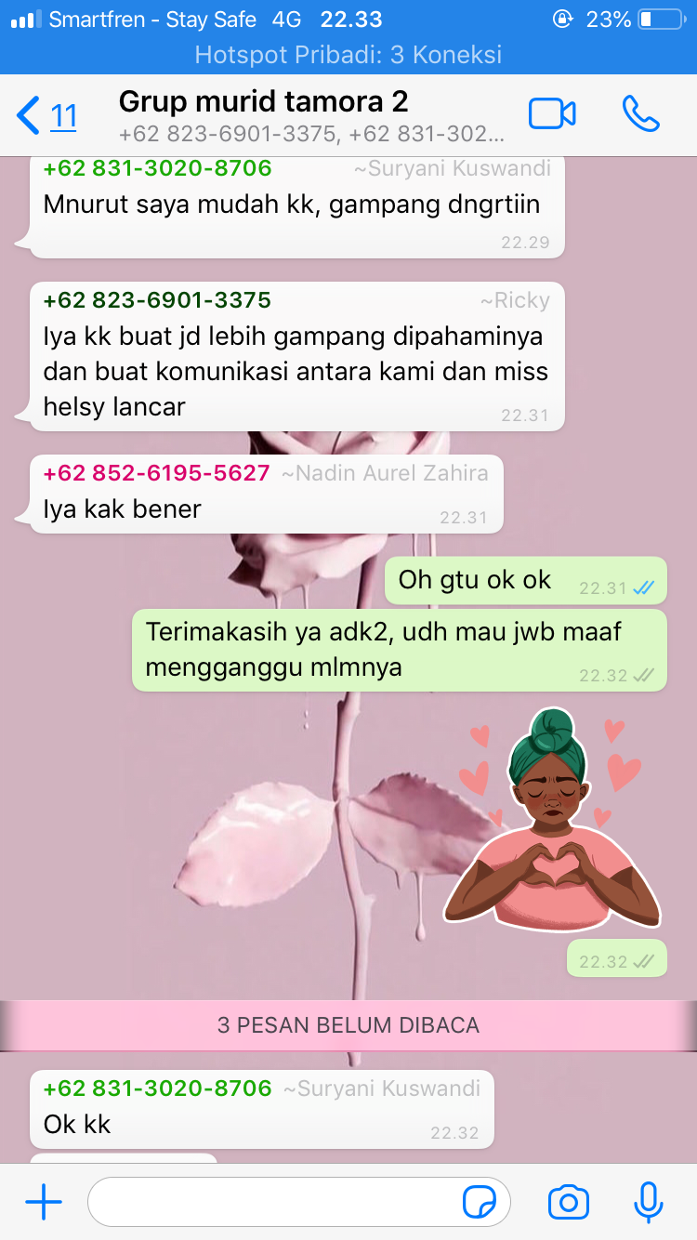
APPENDIX D
Result Of Teacher Quistionnaire

