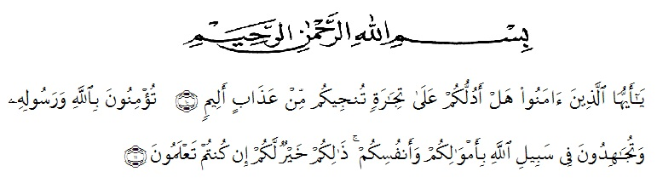
ACKNOWLEDGEMENTS

Wahai orang-orang yang beriman! Maukah kamu aku tunjukkan suatu perniagaan yang dapat menyelamatkan kamu dari azab yang pedih?. (Yaitu) kamu beriman kepada Allah dan Rasul-Nya dan berjihad di jalan Allah dengan harta dan jiwamu. Itulah yang lebih baik bagi kamu jika kamu mengetahuinya. (Quran, Ash-Shaff:10-11)

Allhamdulillahirabil ‘alamin, the writer expresses his highest gratitude to Allah subhanahu wa ta’ala for blessing, love, opportunity, health and mercy to complete this undergraduate thesis. Then sholawat dan salam to the Noble Prophet Mohammad Saw, with his followers.
In conducting this research, the writer received suggestion, assistance, criticism and guidance from many people. The writer, therefore, would like to thank them specially she would like to thank:
- Rector of UMN Al Washliyah, who has given facilities to her during her study at the university,
- The Dean of FKIP UMN Medan and his staffs for guidance an counseling during the study,
- Junaidi, S.Pd, M.Si., the first adviser, who has given her a lot of valuable suggestions, comments and criticism for completing this research,
- Dahlia Sirait, S.Pd, M.Hum., her second adviser, who has never stopped helping her in guiding and correcting the pattern of this research so that this research is complete and perfect,
- The headmaster of SMP Swasta Tamora 2 Tg. Morawa for the facilities given to her in conducting this research,
- The lectures of English Education Department of FKIP UMN Medan for their nice and valuable discussing to enrich the writer knowledge.
- Her special beloved parents who have supported her financially and morally during her academic years at FKIP UMN Medan. The writer prays upon God, may they be in peace and be with charactetristics of pious and devoted human beings,
- Her beloved thanks to her boyfriend, brothers and sisterswho have supported her to finish this research,
- Her beloved thanks to her friends, bidadari surga, hobah gurls, sobat ambyar and classmates who have supported her to finish this research, and
Finally, she realizes that she could not compense the contribution of those people mentioned above. She prays upon God, may the Almighty bless them all in hereafter.
Medan, January 2020
The Writer

Frisca Ridanti

