**ACKNOWLEDGEMENT**

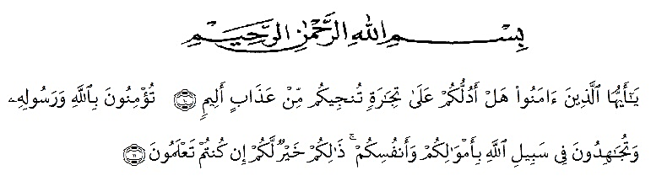

10. Hai orang-orang yang beriman, sukakah kamu aku tunjukkan suatu perniagaan yang dapat menyelamatkanmu dari azab yang pedih?

11. (yaitu) kamu beriman kepada Allah dan RasulNya dan berjihad di jalan Allah dengan harta dan jiwamu. Itulah yang lebih baik bagimu, jika kamu mengetahui.

Alhamdulillahirobbil'alamin, all praises be to Allah, the single power, the Lord of the universe, master of the day of judgment, God all mighty, for all blessings and mercies so the researcher was able to finish this thesis entitled "The Effectiveness of Contextual Teaching and Learning (CTL) on Students’ Writing Skills on Procedure Text at Eight Grade MTs Hizhil Qur’an Islamic Center Medan. Peace be upon Prophet Muhammad SAW, the great leader and good inspiration of word revolution.

The researcher is sure that this thesis would not be completed without the help and supports, and suggestions from several sides. Thus, the researcher would like to express her deepest thanks to all of those who had helped, supported, and suggested her during the process of writing this thesis. This goes to:

1. **Dr. KRT. Hardi Mulyono K. Surbakti**  as the Rector of University of Muslim Nusantara Al Washliyah Medan.
2. **Drs. Samsul Bahri, M.Si** as the Dean of Teacher Training and Edcucation University of Muslim Nusantara Al Washliyah Medan who has given recommendation her to carry out this research.
3. **Dra. Hj. Nurjannah, M.Si** as the Head of English Education Department.
4. **Rosmita Ambarita, S.Pd., M.Hum** as the adviser I who has given suggestion, ideas, advices, support, comments, motivations and guidance in finishing this research.
5. **Reni Sapitri, S.Pd., M.Hum** as the adviser II who has given suggestion, ideas, advices, support, comments, motivations and guidance in finishing this research.
6. All the lectures and officials employees of English education and Teacher Training Faculty of University of Muslim Al Washliyah Medan.
7. **Dahrin Harahap, S.PdI, M.Si** as the Headmaster of MTs Hifzhil Qur’an Islamic Center Medan for her permission to the researcher to conduct the research in this school.
8. **Melfa Hairany, S.Pd** as the English teacher of the eleventh grade students of MTs Hifzhil Qur’an Islamic Center Medan for his kindness to allow the researcher to do the research in these classes.
9. My parents who has given support and motivation to conducting this research.
10. My brother and sister who has given support, suggestion and motivation to conducting this research.
11. The Eight grade students of MTs Hifzhil Qur’an Islamic Center Medan for their participants and support during the research.
12. All researchers' friends and my close friend **Rani Butar Butar, Rizky Paujiah Pohan, Suryani, Eliska Youlanda, and Dwi Anggraini, Hanifan Nurfadlah, Siti Aisyah Panjaitan** that researcher cannot mention all for the help. The researcher realizes that this thesis is still far from being perfect.

The researcher realizes that this thesis is still far from being perfect. Thus, the researcher accepts for every criticisms and suggestion. Finally, the researcher expects that this thesis will be beneficial for people who read it.

Medan, 07 July 2020

Nora Elida Harahap

NPM. 1612444126