ACKNOWLEDGEMENTS

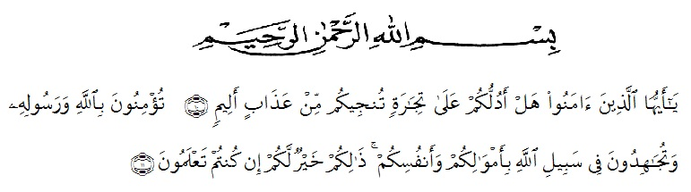
Artinya:“Hai orang-orang yang beriman, sukakah kamu Aku tunjukkan suatu perniagaan yang dapat menyelamatkan kamu dari azab yang pedih? (yaitu) kamu beriman kepada Allah dan Rasul-Nya dan berjihad di jalan-Nya dengan harta dan jiwamu, itulah yang lebih baik bagimu jika kamu mengetahuinya.”
(QS. ash-Shaff: 10-12).
Alhamdulillahi rabbil ‘alamin, the writer expresses her highest gratitude to Allah Subhanahu wa ta’ala for blessing, love, opportunity, health, and mercy in completing this thesis entitled “An Analysis of Teaching Process In Ihsaan Dyslexia Student in Tare Zameen Par Movie” as the fulfilment to get degree of Sarjana Pendidikan at English Department, University of Muslim Nusantara Al Washliyah Medan. Shalawat is also sent to Prophet Muhammad shallallahu ‘alaihi wa sallam who had delivered the truth to human beings in general and Muslim in particular.

Therefore, the writer would like to express her great appreciation and special thanks to :
- Dr. H. KRT Hardi Mulyono K Surbakti, SE., MAP as the rector University of Muslim Nusantara Al Wasliyah Medan.
- Rini Fadhillah Putri, S.Pd, M.Hum as the first adviser who has contributed her time, knowledge, suggestion, guidance, comment or correction since the preliminary of manuscript until the completion of this thesis and to help the writer on supervising the draft writing it this thesis.
- Yulia Sari Harahap, S.Pd, M.Hum. the scond adviser who has contributed her time, knowledge, suggestion, and comment to help the writer on supervising the draft writing this thesis.
- All lecturer at the English Department who have dedicated their valuable knowledge for her during the academic year at UMN Al Washliyah Medan.
- Her beloved parents Sri Hartono and Almh. Rusiani for all helps, attention, hard work, material support, and pray which give the writer spirit to finish the thesis.
- Her beloved sister and her husband, Siska Haryani and Hendra who deserved their gratitude for their encouragement.
- Her beloved brother and sister Sandi Haryanto and Selly Adriyani who give spirit and attention to finish this thesis.

- Her beloved friends Dinda Redno Triyandari, Rizky Yusrina Sari,
M. Ryanto Syah putra, Pitri Yani, Neni Wahyuni, Diah Untari, Dina Utari, Nur Hasanah Syahfitri, who give spirit, attention, and motivated the writer to finish this thesis
- Her beloved friends at Moslem Student Club in Pancur Batu, thank you very much for all attention and motivated for the writer to finish this thesis.
- Her beloved friends at LDK RJ and KAMMI in UMN Al Washliyah Medan, thank you very much for all attention and motivated for the writer to finish this thesis.
- Her beloved friends, all classmate in FKIP UMN Al Washliyah Medan especialy the VIII-A, her best friends in class, Rizka Rahmadhani, Yolandri Lestari, Indah Putri Sari, Rafiqa Zahra, Aisyah, Ninda, Nurina, thank for all helps, attention and motivated for the writer to finish this thesis.
Finally, the writer offers her regads and blessing to all of those whose supported her in any respect during completion of this thesis, the writer cannot mention their name one by one.
Medan, July 2020
The writer

Silvi Dewi Handayani

