APPENDIX A

Questionnaire

**Questionnaire: Perceptions of Corrective Feedback in EFL Writing**

# Demographic Information

a)What is your gender?

Male

Female

b) How do you describe your English proficiency?

I am an intermediate English learner (i.e. first-year university students in English major).

I am an upper-intermediate English learner (i.e. second-year university students in English major).

I am an advanced English learner (e.g., third-year university students in English major).

# Questions

1. Using the scale given below, please indicate your opinion for the following statements (write down the number in the space provided on the left of each item).

1=Strongly Disagree; 2=Disagree; 3=Neutral; 4=Agree; 5=Strongly Agree

* 1. Grammar instruction is essential for mastering the writing of English.

* 1. Study of grammar improves my writing skill of English.

* 1. I believe that my English writing will improve quickly if I study and practice English grammar.

* 1. I like studying English grammar

* 1. I need more grammar instruction in my English writing classes.

* 1. I keep the English grammar rules in mind when I am writing in English.

* 1. I think that language practice in real contexts is more important than grammar instruction in the classroom.

1. What is your opinion about correcting your errors in your English writings by your lecturer? Please check one of the following options and then **provide a reason for your choice** in the space given.

They are not important at all.

They are not important.

I have neutral opinion on it.

They are important.

They are very important.

Reason: __________________________________________________________________

1. What kind of errors would you prefer to be corrected? Please provide **your rank** for the following errors.

1. Grammar errors; 2. Vocabulary errors; 3. Spelling errors; 4. Organization errors; 5. Punctuation errors

Your Rank:

1. If there are many errors in your writing, what do you prefer your lecturer to do? Check one of the answers and then provide a reason for your choice.

My lecturer should correct all errors.

My lecturer should correct major errors but not the minor ones.

My lecturer should only correct errors that interfere with communicating ideas.

My lecturer should not correct grammatical errors, and should focus on the content only.

Reason: _________________________________________________________________

1. Please indicate your opinion for the degree of usefulness of each of the following technique. Then provide a brief explanation after each technique in the space given.

1=Very useless; 2=Useless; 3=Neither useful nor useless; 4=Useful; 5=Very useful

|  |  |  |  |  |  |
| --- | --- | --- | --- | --- | --- |
|  | 1 | 2 | 3 | 4 | 5 |
| a. Underlining the error without correcting it Example: He drive home every day. |  |  |  |  |  |
| b. Underlining the error and then directing you to a source for information Example: He drive home every day. (*see session two in grammar book*) |  |  |  |  |  |
| c. Indicating the type of error without locating or correcting it Example: He drive home every day.*(subject verb agreement)* |  |  |  |  |  |
| d. Locating the error (e.g., by underlying it) and also indicating the type of errorExample: He drive home every day.*(subject verb agreement)* |  |  |  |  |  |
| e. Underlining the error and then correcting it Example: He drive home every day. *(drives)* |  |  |  |  |  |
| f. Correcting the error and then providing an explanation for the correction  Example: He drive home every day. *(drives) you need to add a third person singular “s” to the verb must agree with its subject.* |  |  |  |  |  |
| g. Simply indicating that you have an error in the sentence by putting a cross next to it without locating or correcting the error Example: ‘He drive home every day.’ **×** |  |  |  |  |  |
| h. Asking my classmate (s) to correct the error. |  |  |  |  |  |

1. What do you think when your instructor(s) writes extended comments on your assignments? Please check one of the following options and then **provide a reason for your choice**.

They are not important at all.

They are not important.

I have neutral opinion on it.

They are important.

They are very important.

Reason: ______________________________________________________________

1. How carefully do you review the correction of errors made by your lecturer?
   1. I will not read them
   2. I will read them, but won’t correct the errors
   3. I will read them, and correct the major errors
   4. I will carefully read them, and correct all the errors.

1. When do you want your lecturer to provide feedback on your grammatical errors when you are writing your composition?
   1. On the first draft
   2. On the second draft
   3. On all drafts
   4. On the final draft

1. When do you want your lecturer to provide feedback on your content and organization when you are writing your composition?
   1. On the first draft
   2. On the second draft
   3. On all drafts
   4. On the final draft
2. How useful do you find oral communications between lecturer and students about written errors?
3. Do you think that lecturer should ask students to identify their own errors?

Yes/No

1. What do you think lecturer should do when students make errors in their writings?

13) Is there any problem regarding how lecturer treat students’ errors? Do you have any suggestion for your lecturer(s))?

14) How do you think your errors should be corrected?

15) What do you usually do when you get back your writing with the teacher’s comments and feedback?

**The End**

**Thank you for your participation**

APPENDIX B

Result

**Name: Violanda Ajeng Pachira**

# Demographic Information

a)What is your gender?

Male

**Female ✓**

b) How do you describe your English proficiency?

I am an intermediate English learner (i.e. first-year university students in English major).

**I am an upper-intermediate English learner (i.e. second-year university students in English major).** **✓**

I am an advanced English learner (e.g., third-year university students in English major).

# Questions

1. Using the scale given below, please indicate your opinion for the following statements (write down the number in the space provided on the left of each item).

1=Strongly Disagree; 2=Disagree; 3=Neutral; 4=Agree; 5=Strongly Agree

* 1. Grammar instruction is essential for mastering the writing of English. (4)
  2. Study of grammar improves my writing skill of English. (4)
  3. I believe that my English writing will improve quickly if I study and practice English grammar. (5)
  4. I like studying English grammar. (5)
  5. I need more grammar instruction in my English writing classes. (4)
  6. I keep the English grammar rules in mind when I am writing in English. (4)
  7. I think that language practice in real contexts is more important than grammar instruction in the classroom. (4)

1. What is your opinion about correcting your errors in your English writings by your lecturer? Please check one of the following options and then **provide a reason for your choice** in the space given.

They are not important at all.

They are not important.

I have neutral opinion on it.

They are important.

**Theyare very important. ✓**

Reason:because by correcting my writing errors with the lecturer I will make me understand better the good governance and bemer and that can also motivate me more better than before

1. What kind of errors would you prefer to be corrected? Please provide **your rank** for the following errors.

1. Grammar errors; 2. Vocabulary errors; 3. Spelling errors; 4. Organization errors; 5. Punctuation errors

Your Rank:1

1. If there are many errors in your writing, what do you prefer your lecturer to do? Check one of the answers and then provide a reason for your choice.

**My lecturer should correct all errors. ✓**

My lecturer should correct major errors but not the minor ones.

My lecturer should only correct errors that interfere with communicating ideas.

My lecturer should not correct grammatical errors, and should focus on the content only.

Reason: because if all errors are corrected then the possibility of errors will not be repeated again

1. Please indicate your opinion for the degree of usefulness of each of the following technique. Then provide a brief explanation after each technique in the space given.

1=Very useless; 2=Useless; 3=Neither useful nor useless; 4=Useful; 5=Very useful

|  |  |  |  |  |  |
| --- | --- | --- | --- | --- | --- |
|  | 1 | 2 | 3 | 4 | 5 |
| a. Underlining the error without correcting it Example: He drive home every day. |  |  | explaining the mistakes is more important |  |  |
| b. Underlining the error and then directing you to a source for information Example: He drive home every day. (*see session two in grammar book*) |  |  |  | useful to re-read the mistakes and correct them |  |
| c. Indicating the type of error without locating or correcting it Example: He drive home every day.*(subject verb agreement)* |  |  | you should immediately be notified of the error |  |  |
| d. Locating the error (e.g., by underlying it) and also indicating the type of errorExample: He drive home every day.*(subject verb agreement)* |  |  |  | in order to quickly fix the error |  |
| e. Underlining the error and then correcting it Example: He drive home every day. *(drives)* |  |  |  | in order to directly know and not to repeat the mistakes |  |
| f. Correcting the error and then providing an e xplanation for the correction  Example: He drive home every day. *(drives) you need to add a third person singular “s” to the verb must agree with its subject.* |  |  |  |  | more effective and easy to understand |
| g. Simply indicating that you have an error in the sentence by putting a cross next to it without locating or correcting the error Example: ‘He drive home every day.’ **×** | this is the wrong way |  |  |  |  |
| h. Asking my classmate (s) to correct the error. | You have to do it yourself |  |  |  |  |

1. What do you think when your instructor(s) writes extended comments on your assignments? Please check one of the following options and then **provide a reason for your choice**.

They are not important at all.

They are not important.

I have neutral opinion on it.

They are important.

**They are very important.** **✓**

Reason: Because if my instructor gives a long comment, it has a purpose and purpose so that I am more careful in doing my work so that I don't have many mistakes.

1. How carefully do you review the correction of errors made by your lecturer?
   1. I will not read them
   2. I will read them, but won’t correct the errors
   3. I will read them, and correct the major errors
   4. **I will carefully read them, and correct all the errors. ✓**
2. When do you want your lecturer to provide feedback on your grammatical errors when you are writing your composition?
   1. **On the first draft ✓**
   2. On the second draft
   3. On all drafts
   4. On the final draft
3. When do you want your lecturer to provide feedback on your content and organization when you are writing your composition?
   1. **On the first draft ✓**
   2. On the second draft
   3. On all drafts
   4. On the final draft
4. How useful do you find oral communications between lecturer and students about writtenerrors?

= very useful because with the communication between the lecturer with me will be able to make me understand more about the mistakes that I made in my writing.

1. Do you think that lecturer should ask students to identify their own errors?

Yes/No

= NO

1. What do you think lecturer should do when students make errors in their writings?

= encouraging, motivating, and giving direction to the mistakes made by letting them know where they are.

13) Is there any problem regarding how lecturer treat students’ errors? Do you have any suggestion foryour lecturer(s))?

= So far the lecturer only indicating the type of error without locating or correcting it. So, I hope the lecturer can write it down or tell verbally what the writing error.

14) How do you think your errors should be corrected?

= yes she must correct my mistakes so that in the future I do not make mistakes again by fixing and providing an explanation to correct them.

15) What do you usually do when you get back your writing with the teacher’s comments and feedback?

= thank you for the correction that was notified to me and try to improve it.

**The End**

**Thank you for your participation**

**Name: Arni Mutiara**

# Demographic Information

a)What is your gender?

Male

Female 🗸

b) How do you describe your English proficiency?

I am an intermediate English learner (i.e. first-year university students in English major). 🗸

I am an upper-intermediate English learner (i.e. second-year university students in English major).

I am an advanced English learner (e.g., third-year university students in English major).

# Questions

1) Using the scale given below, please indicate your opinion for the following statements (write down the number in the space provided on the left of each item).

1=Strongly Disagree; 2=Disagree; 3=Neutral; 4=Agree; 5=Strongly Agree

* 1. (4) Grammar instruction is essential for mastering the writing of English.

* 1. (4) Study of grammar improves my writing skill of English.

* 1. (4) I believe that my English writing will improve quickly if I study and practice English grammar.

* 1. (3) I like studying English grammar

* 1. (4) I need more grammar instruction in my English writing classes.

* 1. (5) I keep the English grammar rules in mind when I am writing in English.

* 1. (3) I think that language practice in real contexts is more important than grammar instruction in the classroom.

1. What is your opinion about correcting your errors in your English writings by your lecturer? Please check one of the following options and then **provide a reason for your choice** in the space given.

They are not important at all.

They are not important.

I have neutral opinion on it.

They are important.

They are very important. 🗸

Reason: I think it is very important so in the next,writing error does not happen again and it is better that the error is made clear where the fault is.

1. What kind of errors would you prefer to be corrected? Please provide **your rank** for the following errors.

1. Grammar errors; 2. Vocabulary errors; 3. Spelling errors; 4. Organization errors; 5. Punctuation errors

Your Rank: **1**

1. If there are many errors in your writing, what do you prefer your lecturer to do? Check one of the answers and then provide a reason for your choice.

My lecturer should correct all errors. 🗸

My lecturer should correct major errors but not the minor ones.

My lecturer should only correct errors that interfere with communicating ideas.

My lecturer should not correct grammatical errors, and should focus on the content only.

Reason:

My lecturer should correct all errors.So, I don't repeat the writing error again and I can increase my knowledge while learning about the mistakes I've made.

1. Please indicate your opinion for the degree of usefulness of each of the following technique. Then provide a brief explanation after each technique in the space given.

1=Very useless; 2=Useless; 3=Neither useful nor useless; 4=Useful; 5=Very useful

|  |  |  |  |  |  |
| --- | --- | --- | --- | --- | --- |
|  | 1 | 2 | 3 | 4 | 5 |
| a. Underlining the error without correcting it Example: He drive home every day. |  |  | explaining the mistakes is more important |  |  |
| b. Underlining the error and then directing you to a source for information Example: He drive home every day. (*see session two in grammar book*) |  |  |  | useful to re-read the mistakes and correct them |  |
| c. Indicating the type of error without locating or correcting it Example: He drive home every day.*(subject verb agreement)* |  |  | you should immediately be notified of the error |  |  |
| d. Locating the error (e.g., by underlying it) and also indicating the type of errorExample: He drive home every day.*(subject verb agreement)* |  |  |  | in order to quickly fix the error |  |
| e. Underlining the error and then correcting it Example: He drive home every day. *(drives)* |  |  |  | in order to directly know and not to repeat the mistakes |  |
| f. Correcting the error and then providing an explanation for the correction  Example: He drive home every day. *(drives) you need to add a third person singular “s” to the verb must agree with its subject.* |  |  |  |  | more effective and easy to understand |
| g. Simply indicating that you have an error in the sentence by putting a cross next to it without locating or correcting the error Example: ‘He drive home every day.’ **×** | this is the wrong way |  |  |  |  |
| h. Asking my classmate (s) to correct the error. | You have to do it yourself |  |  |  |  |

1. What do you think when your instructor(s) writes extended comments on your assignments? Please check one of the following options and then **provide a reason for your choice**.

They are not important at all.

They are not important.

I have neutral opinion on it.

They are important.

They are very important. 🗸

Reason: Extended comments like this are needed to know as much detail as possible and prove well what mistakes have been made.

1. How carefully do you review the correction of errors made by your lecturer?
   1. I will not read them
   2. I will read them, but won’t correct the errors
   3. **I will read them, and correct the major errors**
   4. I will carefully read them, and correct all the errors.

1. When do you want your lecturer to provide feedback on your grammatical errors when you are writing your composition?
   1. On the first draft
   2. On the second draft
   3. On all drafts
   4. **On the final draft**
2. When do you want your lecturer to provide feedback on your content and organization when you are writing your composition?
   1. On the first draft
   2. On the second draft
   3. **On all drafts**
   4. On the final draft
3. How useful do you find oral communications between lecturer and students about written errors?

= very useful

1. Do you think that lecturer should ask students to identify their own errors?

Yes/No = No

1. What do you think lecturer should do when students make errors in their writings?

= Tell the location of the error and explain as detailed as possible what the writing error

13) Is there any problem regarding how lecturer treat students’ errors? Do you have any suggestion for your lecturer(s))?

= So far the lecturer only indicating the type of error without locating or correcting it. So, I hope the lecturer can write it down or tell verbally what the writing error.

14) How do you think your errors should be corrected?

= Correcting the error and then providing an explanation for the correction.

15) What do you usually do when you get back your writing with the teacher’s comments and feedback?

= improve it and repeat it with the truth in the next exercises.

**The End**

**Thank you for your participation**

**Name: Intan Sari**

# Demographic Information

a)What is your gender?

Male

* Female

b) How do you describe your English proficiency?

I am an intermediate English learner (i.e. first-year university students in English major).

* I am an upper-intermediate English learner (i.e. second-year university students in English major).

I am an advanced English learner (e.g., third-year university students in English major).

# Questions

1 Using the scale given below, please indicate your opinion for the following statements (write down the number in the space provided on the left of each item).

1=Strongly Disagree; 2=Disagree; 3=Neutral; 4=Agree; 5=Strongly Agree

* 1. Grammar instruction is essential for mastering the writing of English. 5

* 1. Study of grammar improves my writing skill of English. 4

* 1. I believe that my English writing will improve quickly if I study and practice English grammar. 5

* 1. I like studying English grammar 3

* 1. I need more grammar instruction in my English writing classes. 5

* 1. I keep the English grammar rules in mind when I am writing in English. 3

* 1. I think that language practice in real contexts is more important than grammar instruction in the classroom. 3

1. What is your opinion about correcting your errors in your English writings by your lecturer? Please check one of the following options and then **provide a reason for your choice** in the space given.

They are not important at all.

They are not important.

I have neutral opinion on it.

* They are important.

They are very important.

Reason: For me correcting my errors in my English writing is important because from the errors, I will know and I will learn more from it and then I think that learn from the errors can make me memorize it and not make the same errors in my english writing.

1. What kind of errors would you prefer to be corrected? Please provide **your rank** for the following errors.

1. Grammar errors; 2. Vocabulary errors; 3. Spelling errors; 4. Organization errors; 5. Punctuation errors

Your Rank: 1. grammar errors; 2. Vocabulary errors; 4. Organization errors

1. If there are many errors in your writing, what do you prefer your lecturer to do? Check one of the answers and then provide a reason for your choice.

My lecturer should correct all errors.

* My lecturer should correct major errors but not the minor ones.

My lecturer should only correct errors that interfere with communicating ideas.

My lecturer should not correct grammatical errors, and should focus on the content only.

Reason: I think that the minor errors not really important, so the lecturer doesn’t need to focus too much on it, for the minor errors the lectures can give some advices.

1. Please indicate your opinion for the degree of usefulness of each of the following technique. Then provide a brief explanation after each technique in the space given.

1=Very useless; 2=Useless; 3=Neither useful nor useless; 4=Useful; 5=Very useful

|  |  |  |  |  |  |
| --- | --- | --- | --- | --- | --- |
|  | 1 | 2 | 3 | 4 | 5 |
| a. Underlining the error without correcting it Example: He drive home every day. |  |  | 3 |  |  |
| b. Underlining the error and then directing you to a source for information Example: He drive home every day. (*see session two in grammar book*) |  |  |  | 4 |  |
| c. Indicating the type of error without locating or correcting it Example: He drive home every day.*(subject verb agreement)* |  |  | 3 |  |  |
| d. Locating the error (e.g., by underlying it) and also indicating the type of errorExample: He drive home every day.*(subject verb agreement)* |  |  |  |  | 5 |
| e. Underlining the error and then correcting it Example: He drive home every day. *(drives)* |  |  |  | 4 |  |
| f. Correcting the error and then providing an explanation for the correction  Example: He drive home every day. *(drives) you need to add a third person singular “s” to the verb must agree with its subject.* |  |  |  |  | 5 |
| g. Simply indicating that you have an error in the sentence by putting a cross next to it without locating or correcting the error Example: ‘He drive home every day.’ **×** | 1 |  |  |  |  |
| h. Asking my classmate (s) to correct the error. |  |  | 3 |  |  |

1. What do you think when your instructor(s) writes extended comments on your assignments? Please check one of the following options and then **provide a reason for your choice**.

They are not important at all.

They are not important.

I have neutral opinion on it.

They are important.

* They are very important.

Reason: what I think when my intructor writes entended comments to my assignment is very important because as I said before from the comments I will know what did the errors I have made and try to fix it in the next assignment.

1. How carefully do you review the correction of errors made by your lecturer?
   1. I will not read them
   2. I will read them, but won’t correct the errors
   3. **I will read them, and correct the major errors**
   4. I will carefully read them, and correct all the errors.
2. When do you want your lecturer to provide feedback on your grammatical errors when you are writing your composition?
   1. On the first draft
   2. On the second draft
   3. **On all drafts**
   4. On the final draft
3. When do you want your lecturer to provide feedback on your content and organization when you are writing your composition?
   1. On the first draft
   2. On the second draft
   3. On all drafts
   4. **On the final draft**
4. How useful do you find oral communications between lecturer and students about written errors?

Answer: I think oral communications between lecturer and students about errors is very useful, because from the communication between students and the lecturer will help the studens to have a good writing skills.

1. Do you think that lecturer should ask students to identify their own errors?

Yes/No =Yes, I do

1. What do you think lecturer should do when students make errors in their writings?

Ans: The lecturer should give some advice or tell about the errors in writings and then ask they to learn more about the errors.

13) Is there any problem regarding how lecturer treat students’ errors? Do you have any suggestion for your lecturer(s))?

Ans: So far, I not find any problem about how lecturer treat their students’.

14) How do you think your errors should be corrected?

Ans: I think for the first the lecturer should make mark in their students paper. And then tell the erorrs and how come the errors can happen.

15) What do you usually do when you get back your writing with the teacher’s comments and feedback?

Ans: I usually think why there is errors in my writing, and then I will rewrite again with the comments that the teacher gave to me.

**The End**

**Thank you for your participation**

APPENDIX C

The Process of Collecting Data

(Online)

**The Process of Collecting data**

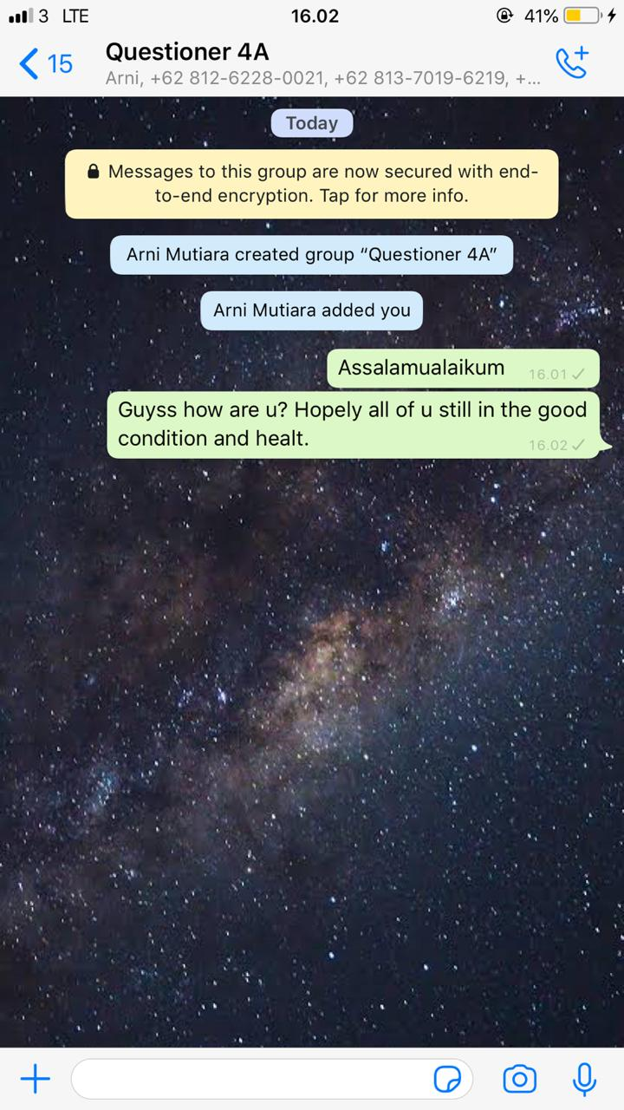 In the middle of pandemic situation, school, university, office, even shopping center are closed. All people could not do the normal activity outside and have to obey the new government’s rules to stay at home and doing the social distancing or self quarantine. This action is believed to reduce the number of Corona Virus in Indonesia. Seeing the situation above, the researcher took the advantage of social media. The researcher chose WhatsApp as the media because it was easy to use and get in touch to the subject of the research. All the activities were done from home. In order to collect the data of this research the researcher conducted several steps to make it easier to handle the data to be process.

**CREATING A GROUP**

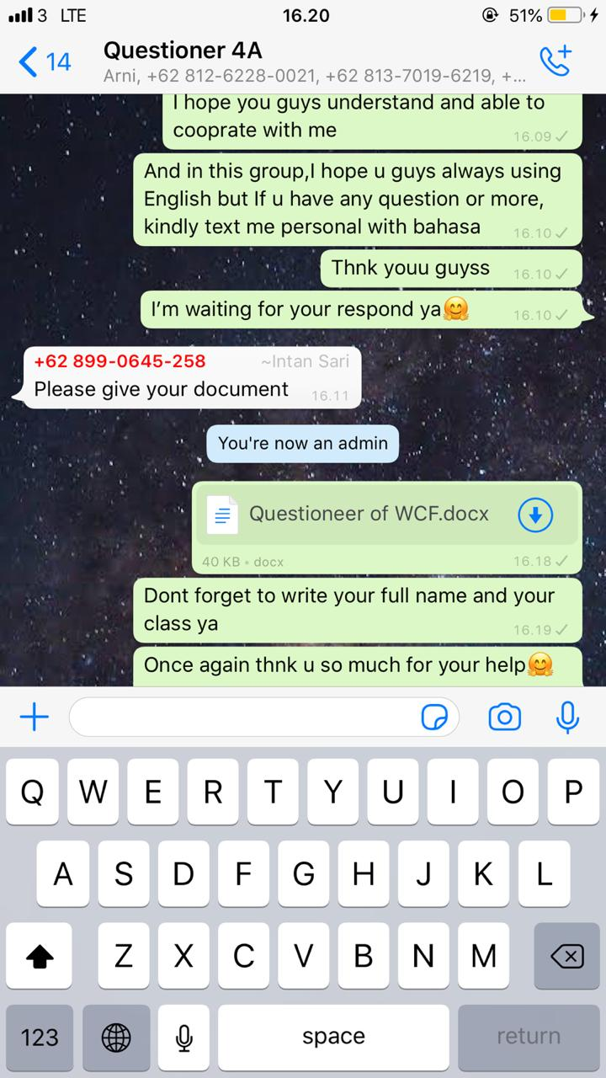

**SHARE THE QUESTIONAIRE TO SUBJECT OF THE RESEARCH**

The data were collected by means of close-ended questionaire items with multiple choices or Likert scale formats. The qualitative data were collected with open-ended questions. The qualitative data were collected to explore the rationales behind their preferences. The questionnaires were distributed to 10 EFL learners in the English department of Universitas Muslim Nusantara Al Washliyah. The primary purpose of the questionnaire was to elicit the participants’ perceptions of WCF and the reasons behind their opinions.

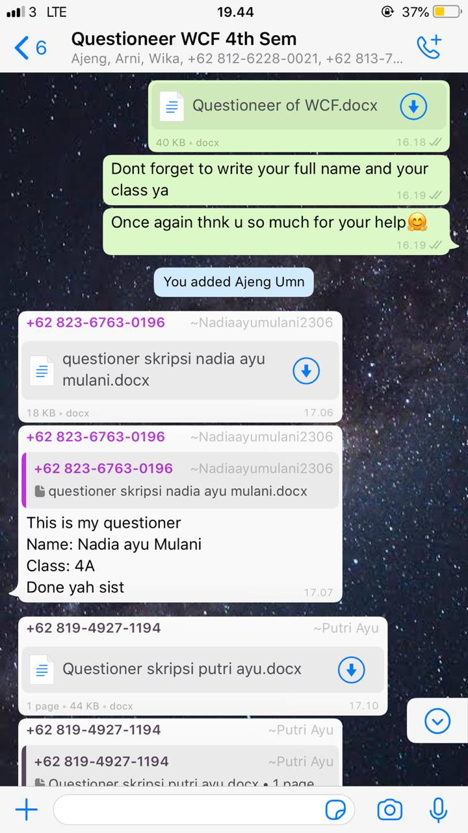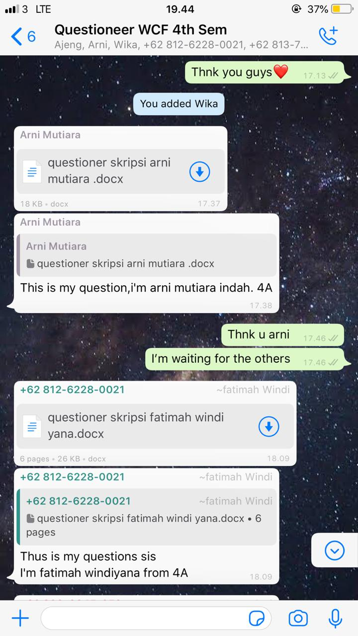

**THE PARTICIPANTS GAVE THEIR FEEDBACK TOWARD THE QUESTIONNAIRE**

**QUESTIONAIRE TO SUBJECT OF THE RESEARCH**

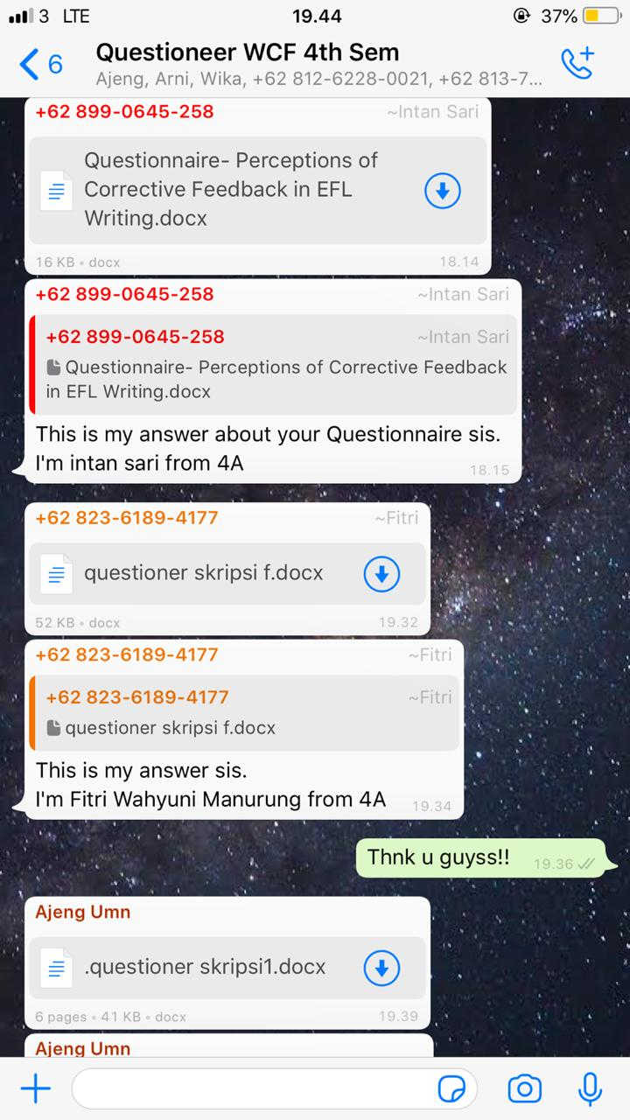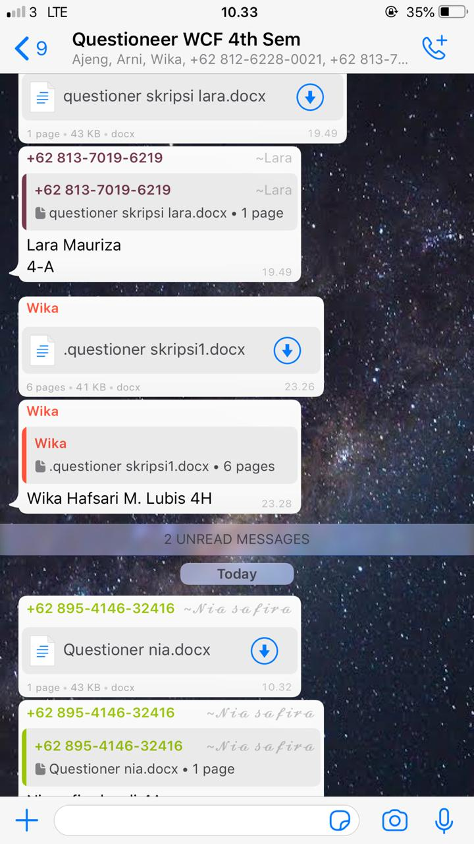

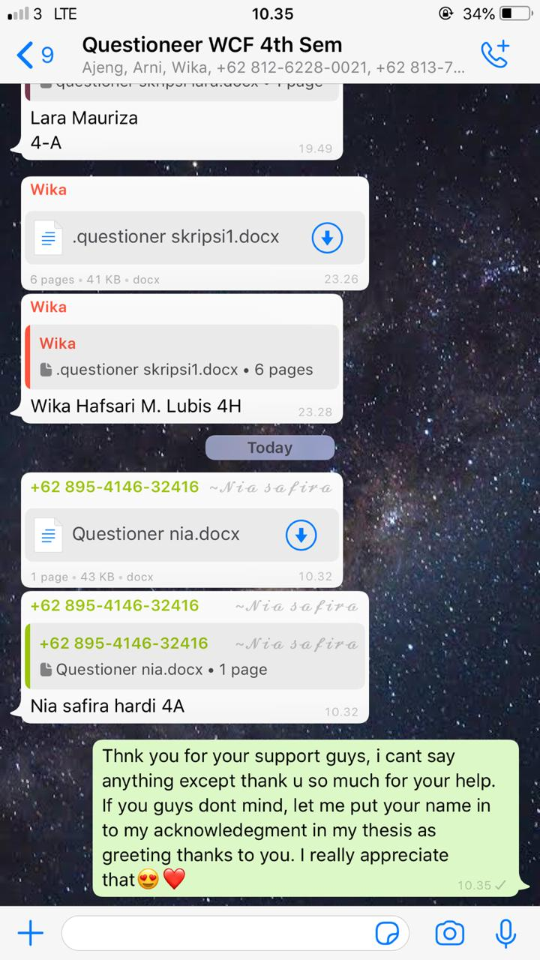

**ALL DATA COLLECTED**

The pictures above showed the proof of the process of collecting data by using Whatsapp group. The participants are very cooperated and give so much support to this research. After collecting all data, the researcher analyzed and illustrated the result.