**ACKNOWLEDGEMENTS**

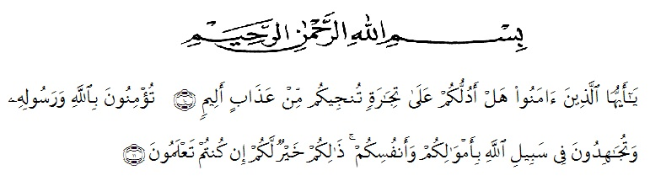

Meaning : *“*O ye who believe, how dare I show you a business that can save you from a painful Penalty? (10). (That is) you believe in Allah and His Messenger and strive in the way of Allah with your wealth and your soul. That's what is better for you if you know it, (11)”.

(As-Shaff verses 10-11)

Praise and great gratitude submitted to Almighty God, Allah SWT who always gives her gracious mercy and blessing that has helped the writer in finishing this thesis entitled EFL Learners’ Perception of Written Corrective Feedback For Freshman in Universitas Muslim Nusantara Al Washliyah. This thesis as one of a requirements of achieving the degree of Bachelor at English Study Program of the Faculty of Teachers Training and Educations of Universitas Muslim Nusantara. Sholawat and sallam may Allah SWT send them to our Prophet Muhammad SAW, (peace be upon him), his families, his companions, and his followers. The best messenger for people all over the world. This world becomes peace because of his hard effort in giving the human being advices. In

accomplishing this thesis, the writer would like to thank to all of those who have given the contribution so that this thesis can be finished. The writer would like to deliver this thank to :

1. Dr. H. KRT. Hardi Mulyono K Surbakti, SE., MAP the Rector of UMN Al Washliyah, who has given facilities to her during the study at the University,
2. Drs. Samsul Bahri, M.Si the Dekan of FKIP UMN Al Washliyah Medan and his staffs for guidance during the study,
3. Zulfitri, S.S., M.A the Head of EnglishLanguage Education Deaprtment which has provided in valuable guidance and assistance for writer.
4. Rini Fadhillah Putri, S.Pd, M.Hum as the first consultant, who has given me a lot of valuable suggestions, comments and criticism for completing this thesis,
5. Yugi Diraga Prawiyata, S.Pd, M.Hum as the second consultant, who has never stopped give support and helping her in guiding and correcting the pattern of this thesis so that this thesis complete and perfect,
6. The lectures of English Language Department of FKIP UMN Al Washliyah Medan for their kind and valuable suggestions to enrich the writer’s knowledge,
7. The greatest thanks and appreciation dedicated to her mother Aslinda Julita Sinulingga, her beloved father Satari Tarigan who always give her support, her brother Jakaria Tarigan who always give encouragement, advices and love,
8. Her incredible family of PIRANHA. Thank you so much for accompanying her in this up and down prosess, Love you guys so much, Anisa, Aisyah, Reka, Mita and Windi,
9. Her beloved high school friends, Ally, Devi, Fira and Dewo who always completely support her in every situation,
10. Also special thanks to WANGI KOPI that gave her the facilities of free wifi and printer so she can finish this thesis,
11. Finally, to all her friends in IV-A & H English Department, Ajeng, Wika, Arni, Fatimah, Lara, Putri, Fitri, Nadia, Nia and Intan, thank you for working together with her to finish this thesis,

Finally, the writer realizes that could not recompense the contribution of those people mentioned above, the writer pray upon to Allah, may the Almighty blessed them all in hereafter.

Medan, July 2020

The writer

**Yessica Sabrina Tarigan**