**ACKNOWLEDGEMENTS**

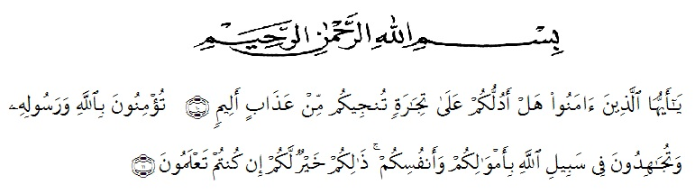

Meaning : *“*O ye who believe, how dare I show you a business that can save you from a painful Penalty? (10). (That is) you believe in Allah and His Messenger and strive in the way of Allah with your wealth and your soul. That's what is better for you if you know it, (11)” (As-Shaff verses 10-11).

Praise and great gratitude submitted to Almighty God, Allah SWT who always gives his gracious mercy and blessing that has helped the writer in finishing this thesis entitled: The Effect of Using Word Square Media on Students’ Vocabulary Achievement. This thesis as one of requirements of achieving the degree of Bachelor at English Study Program of the Faculty of Teachers Training and Educations of Muslim Nusantara University Al Washliyah.

Sholawat and sallam may Allah send to our Prophet Muhammad SAW, (peace be upon him), his families, his companions, and his followers. The best messenger for people all over the world. This world becomes peace because of his hard effort in giving the human being advices.

In accomplishing this thesis, she deservedly would like to acknowledge her deepest appreciation to the following people who has helped and supported her in finishing the thesis:

1. H. Hardi Mulyono, S.E., M.AP, as Rector of UMN Al Washliyah, who has given facilities to her during her study at the University.
2. Drs. Samsul Bahrim, M,Si as Dean of FKIP UMN Al Washliyah Medan and his staffs for guidance during the study.
3. Drs. Junaidi, S.S., S.Pd, M.Si, as the head of English Department who has given a lot of valuable suggestions, comments, and criticism for completing this research.
4. Nurhafni Siregar,S.Pd, M.Hum, as the first adviser, who has given her a lot of valuable suggestions, comments and criticism for completing this research.
5. Yulia Sari Harahap, S.Pd,M.Hum, as the second adviser, who has never stopped give support and help her in guiding and correcting the pattern of this research so this research complete and perfect.
6. Santuso, S.Pd as the headmaster of MTs PP Raudlatul Hasanah and all the teachers for the facilities given to her in conducting this research.
7. The lectures of English Language Department of FKIP UMN Al Washliyah Medan for their kind and valuable suggestions to enrich the writer’s knowledge.
8. The librarian of FKIP UMN Al Washliyah Medan for the books needed in conducting this research.
9. Her special beloved parents, who have supported her financially and morally during her academics years at FKIP UMN Al Washliyah Medan. The writer prays Allah SWT, may they be in patience and be with characteristics of pious human beings.
10. Her beloved husband (Jaka Saputra) and her beloved son (Akhdan Ziyad S) who have supported her to finish this research.
11. Finally, all of her friends (Riska Amelia, linda Sari, Silvi Puji, Susi Rezkita and Candra Kirana who have encouraged her in finishing this research. thanks for support, motivation and suggestion for the writer.

Finally, the writer realizes that could not recompense the contribution of those people mentioned above, the writer prays upon to Allah, may the Almighty blessed them all in their lifes.

Medan,

The writer

**Rahmadaninta**