ACKNOWLEDGEMENT

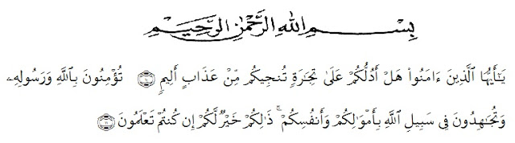
Artinya : “Hai orang-orang yang beriman, sukakah kamu aku tunjukkan suatu perniagaan yang dapat menyelamatkanmu dari azab yang pedih?(10). (Yaitu) kamu beriman kepada Allah dan RasulNya dan berjihad di jalan Allah dengan harta dan jiwamu. Itulah yang lebih baik bagimu, jika kamu mengetahui. (11) (As-Shaff ayat 10-11)”
Alhamdulillahirabbil ‘alamin, the researcher expresses her highest gratitude to Allah subhanuwata’ala for blessing, love, opportunity, health, and mercy to complete this thesis.
Shalawat is also sent to Prophet Muhammad Shallallahu ‘alaihiwasallam who had delivered the truth to human beings in general and Muslim in particular.
This study would have never been fully accomplished without the support and assistance of many people. It will be impossible to mention all but some very special persons deserve her respect gratitude.
Firstly the writer would like to take this opportunity to extend her sincere thankfulness to H. HardiMulyono, S.E. MAP, as a Rector of University Muslim Nusantara Al Washilyah Medan. Drs. M. AyyubLubis, M.Pd, Ph.D, as Dekan of FKIP University Muslim Nusantara Al Washliyah Medan. Drs H.M. Khalid, M.Hum, as the Head of the English Department.
Secondly is Drs. H. M. Khalid, M.Hum, as the First Consultant who has given her a lot of valuable suggestions, comments, and criticisms for completing this research.
Next isRosmitaAmbarita, S.Pd, M.Hum, as the Second Consultant who has never stooped helping her in guiding and correction the pattern of this research.
All staffs of FKIP Universitas Muslim Nusantara Al Washliyah Medan, for facilities that have been given to researcher during studied in the faculty. The librarian of FKIP UMN Al Washliyah Medan, UINSU , for the books needed in conducting this research. All her beloved lectures of English Section of Language Department FKIP UMN Al Washliyah Medan, thanks for their nice and valuable discussing to improve her knowledge.
The special thanks of indebtedness is directed to her beloved mother and father “Mr. MakmurSimbolon and Ms. Sunardiah” who have supported her and always given her love, care, and everything. The writer’s beloved families who have given support her to finish this research. And the lastly her best friends “AyuKartika, Chairunnisa, Karina Rawi, Devi EkaYulitaTarigan and IndraSukma” who have encouraged, given motivation, and helped her in complicating the data to finish this research and all of her beloved classmates in VIII B English Department of Universitas Muslim Nusantara Al Washliyah Medan.
Finally, the writer submits everything to Allah SWT and the writer hopes this thesis can gives many benefits for the readers and the writers.

Medan,2018
The Writer

Eka Budi Utami
141244033

